2024 • Volume 48 • https://doi.org/10.33321/cdi.2024.48.8 • Electronic publication date: 10/04/2024

A severe case of swimmer’s itch in Victoria, Australia with bullous eruption
Michael Sangiorgio, Karen Liu, Lachlan Lau, Charlotte Krones, Adrian Tramontana, James Molton, Alex Nirenberg

Abstract
Cutaneous schistosomiasis (swimmer’s itch) is an itchy maculopapular rash that follows skin penetration by cercariae of nonhuman schistosomes, during fresh or brackish water exposure. It is typically a mild skin reaction that settles in one to three weeks.
Here we describe a case of severe swimmer’s itch acquired in Victoria, Australia, with widespread bullous lesions on water-exposed areas of skin. This case presented a diagnostic challenge and is unique given the severity of the reaction and the geographic occurrence; the condition rarely causes bullae, and to date has been reported only in more northern latitudes of Australia. With climate change trends, swimmer’s itch is likely to become increasingly prevalent in more temperate regions, illustrating the importance of clinician awareness of this condition.
Keywords: Swimmer’s itch; cercarial dermatitis; avian schistosomiasis

Case
A 56-year-old woman presented to our health service in February 2023 with a seven-day history of a progressive pruritic cutaneous eruption after swimming in the Jawbone Marine Sanctuary in Williamstown, Victoria. The Marine Sanctuary is a coastal haven with a wide range of marine and bird life (including marine snails) in diverse habitats (Figure 1).¹ The sanctuary has access to Port Phillip Bay, but freshwater runoff from a creek and stormwater drains create episodes of brackish water.¹

Figure 1: Jawbone Marine Sanctuary, Victoria, Australiaª
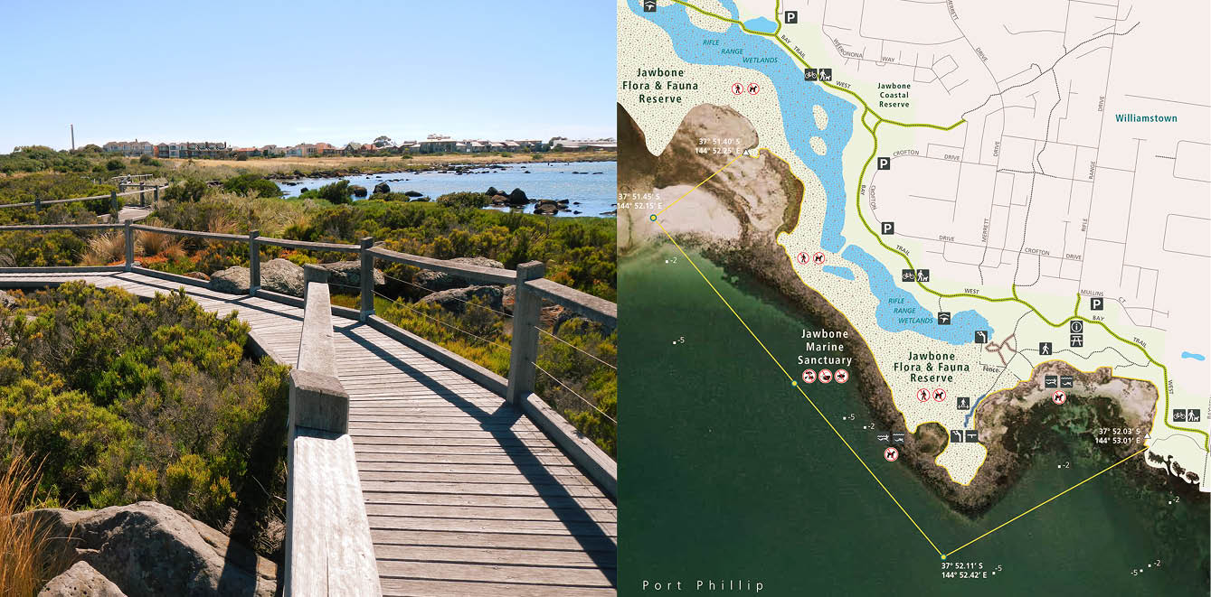
a Image credit: Parks Victoria. Source of images: https://www.parks.vic.gov.au/places-to-see/parks/jawbone-marine-sanctuary.
The case’s past medical history included type II diabetes mellitus, hypertension, and dyslipidaemia. Medications were empagliflozin–metformin 12.5 mg – 1000 mg BD; sitagliptin 100 mg daily; dulaglutide 1.5 mg SC weekly; perindopril 2.5 mg daily; and rosuvastatin 5 mg nocte. She reported no medication allergies.
At the sanctuary, she spent 90–120 minutes in waist-deep warm water (air temperature 34 °C), mostly snorkelling face-down, with occasional short periods standing. The water was clear, with yellow-white sand, and with no visible flora or fauna. Whilst in the water, she experienced a sensation of something crawling on her, and of her legs being bitten; after exiting, she did not immediately shower or change and waited until returning home to do so, about two hours later.
The next morning, she developed an erythematous maculopapular rash on her lower limbs; over the next 48 hours, this spread to her upper limbs, face, neck, upper chest and back. Lesions were confined to areas of skin exposed to water. She also described tingling in the affected areas which continued for several days.
Over the next five days, the lesions evolved into bullae with surrounding erythema; she then presented to hospital. She denied systemic symptoms.
She reported no prior history of any rashes after swimming. This was her first occasion swimming in the Marine Sanctuary, although she swam regularly during summer months at beaches in Port Phillip Bay.
Her brother and ten-year-old nephew were also at the sanctuary that day but swam mostly in deeper water, and showered earlier (one hour) after swimming. They developed a similar, but milder maculopapular rash, without bullae, on exposed areas of skin. Their rash largely resolved within one week.
On examination, the patient was afebrile and haemodynamically stable. There were numerous lesions on the legs, forearms, upper back, and face with confluent bullae (up to 3–4cm length) and surrounding erythema; some bullae had ruptured and had begun to crust over (Figures 2–4).
Figure 2: Progression of facial rash (from left to right): 9 days post exposure, 12 days post exposure, 5 weeks post exposure and 9 weeks post exposure
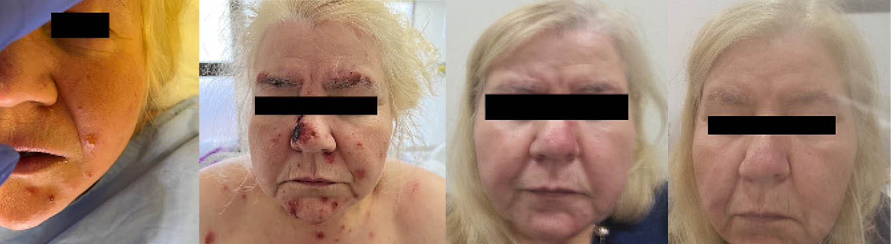
Figure 3: Progression of upper limb rash (from left to right): 9 days post exposure, 12 days post exposure, 5 weeks post exposure and 9 weeks post exposure
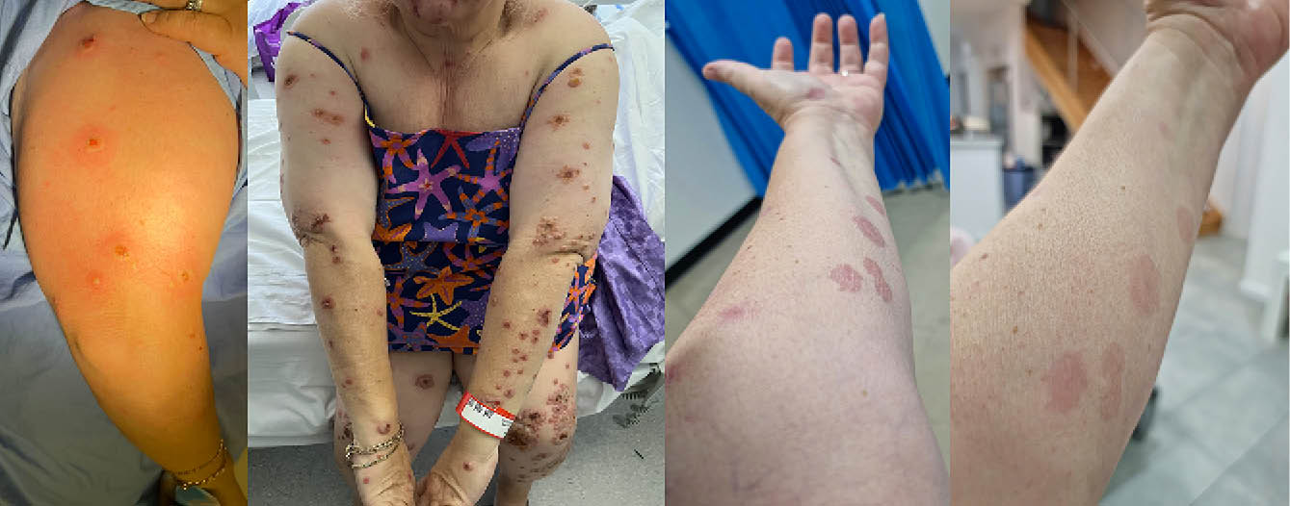
Figure 4: Progression of lower limb rash (from left to right): 9 days post exposure, 12 days post exposure, 5 weeks post exposure and 9 weeks post exposure
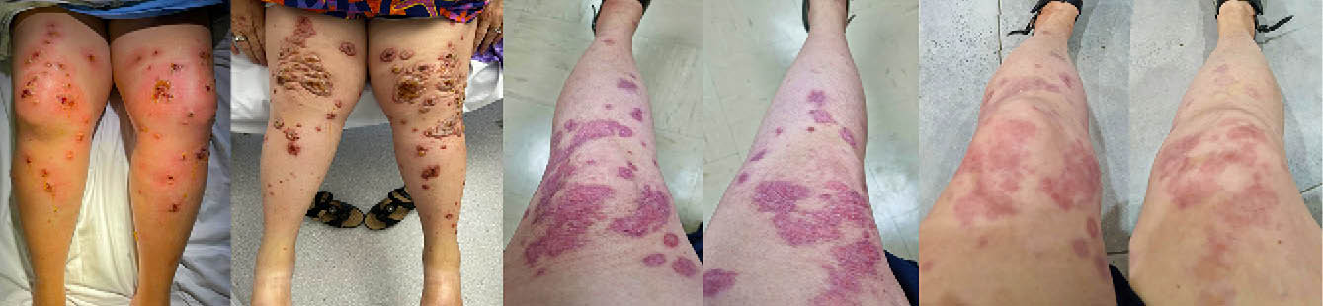
Notably, areas covered by swimwear were completely spared. The largest and highest densities of bullae were on areas with the longest exposure to the water (anterior lower limbs, face, lateral upper limbs).
Mucosal lesions were absent, and there was no lymphadenopathy.
On presentation, she was commenced on oral flucloxacillin for presumed staphylococcal skin infection and discharged. However, after further worsening of the rash, she re-presented within 24 hours and antibiotics were changed to trimethoprim–sulfamethoxazole.
Full blood examination (including eosinophils), urea and electrolytes, and liver enzymes were normal. C-reactive protein was raised (144 mg/L) (Table 1).
Histopathology of skin biopsies showed spongiosis with perivascular lymphocytic infiltrate, consistent with a spongiotic dermatitis; direct immunofluorescence was negative (Figures 5, 6). Bacterial (including mycobacteria) and fungal culture, viral PCR (herpes simplex virus, varicella zoster virus) and acid-fast-bacilli testing were also negative.
She was diagnosed with a severe case of cercarial dermatitis. Antibiotics were ceased, and a tapering course of oral prednisolone (initially 50 mg), oral antihistamines, and topical steroids (betamethasone dipropionate 0.05% ointment and methylprednisolone aceponate 0.1% fatty ointment) were commenced.
Two weeks after discharge, she had marked improvement of her rash, with subsequent resolution. After completion of her steroid course, there was no recurrence and only post inflammatory erythema (Figures 2–4). She was advised to avoid swimming in wildlife sanctuaries to prevent future recurrence.

Table 1: Laboratory results
Category | Testa | Result | Normal range | Comments
Full blood count | Haemoglobin | 141 g/L | 115–165
 | White cell count | 10.8 × 109/L | (4.0–11.0) × 109
 | Neutrophils | 6.5 × 109/L | (2.0–8.0) × 109
 | Eosinophils | 0.3 × 109/L | < 0.5 × 109
Urea, electrolytes, and creatinine | Urea | 4.4 mmol/L | 3.0–10.0
 | Creatinine | 71 µmol/L | 40–90
Inflammatory and autoimmune screen | CRP | 150 mg/L | < 10
 | ESR | 25 mm/h | < 20
 | ANA | Negative
 | ANCA | Weakly positive
 | MPO-ANCA | Negative
 | PR3-ANCA | Negative
Skin antibodies and autoantibodies | Intercellular substance IgG antibody | Negative |  | Targets adhesion proteins within the epidermis; assists in diagnosing intra-epidermal blistering disorders
 | Basement membrane zone IgG antibody | Negative |  | Targets the basement membrane zone; assists in diagnosis of sub-epidermal blistering disorders
 | BP 180 | Negative |  | Positive result supports the diagnosis of bullous pemphigoid
 | BP 230 | Negative
 | Dsg1 | Negative |  | Positive result supports the diagnosis of pemphigus
 | Dsg3 | Negative
 | Envoplakin | Negative |  | A significant diagnostic marker for paraneoplastic pemphigus
 | Collagen type VII | Negative |  | A subgroup of bullous pemphigoid patients experiencing relapse shows the presence of collagen type VII antibodies
a CRP: C-reactive protein; ESR: erythrocyte sedimentation rate; ANA: antinuclear antibody; ANCA: anti-neutrophilic cytoplasmic antibody; MPO-: myeloperoxidase; PR3-: proteinase 3; IgG: immunoglobulin G; BP: bullous pemphigoid; Dsg: desmoglein.

Figure 5: Histopathology of skin biopsy (Hematoxylin and eosin, 100× magnification), showing epidermal spongiosis and predominantly perivascular inflammation
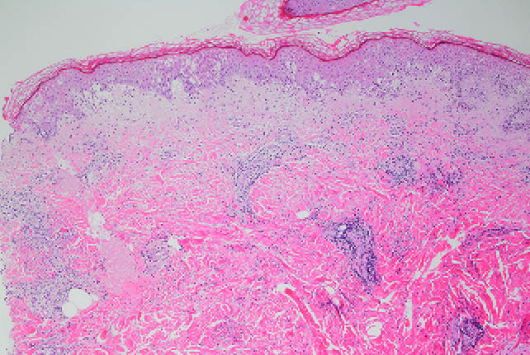
Figure 6: Histopathology of skin biopsy (Hematoxylin and eosin, 200× magnification), showing a predominantly lymphocytic dermal inflammatory cell infiltrate, with a small number of eosinophils
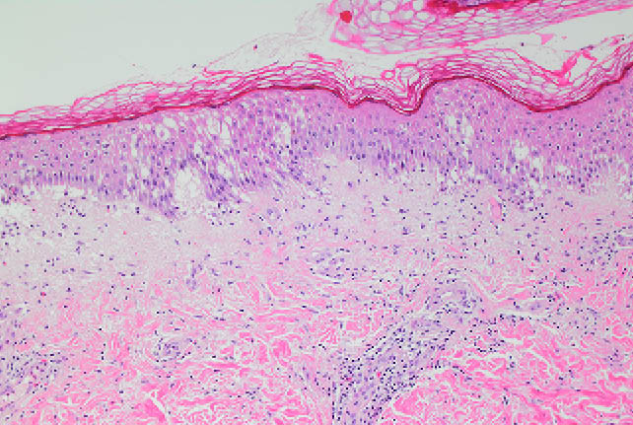

Discussion
Cercarial dermatitis (swimmer’s itch) is caused by an allergic reaction to the penetration of nonhuman schistosome larvae (cercariae) into human skin. Cercariae are the larval forms of the parasite released from aquatic snails, found in warm shallow water with a sandy or vegetated base.2
Nonhuman schistosomes are found worldwide. They are digenetic (sexually reproducing) trematodes that live in the blood vessels of birds or mammals (definitive host); the schistosomes produce eggs which pass out in the host’s faeces, and hatch into miracidia, which penetrate an intermediate snail host, then develop into cercariae, which are regularly released into the water. Humans are a dead end host: cercariae penetrating human skin cannot migrate, and die within the subcutaneous tissues inciting a hypersensitivity reaction.3
Swimmer’s itch is common in tropical and temperate parts of the world. It occurs mainly in freshwater lakes in temperate climates, but is also observed in brackish water.4 Due to the temperature-dependent development of cercariae, it is more frequent during summer months.5
However, swimmer’s itch is relatively uncommon in Australia, perhaps due to under-reporting of the condition. Cases have been reported in Queensland, New South Wales, and Western Australia; and in freshwater, brackish water, and saltwater.6–8
The typical presentation is of a pruritic, papular eruption of the lower limbs, occurring after standing or swimming in warm shallow water; covered skin (which cercariae cannot penetrate) is protected.2 Within hours of exposure, an itch or a transient tingling sensation can occur, and small red spots appear marking sites of cercarial penetration. Significant itch develops over several hours, with discrete erythematous papules which may lead to blistering if severe.9 The rash usually resolves within one to three weeks.2
The diagnosis is clinical. Skin biopsy findings are usually nonspecific; some reports note a hypersensitivity reaction with inflammatory eosinophilic infiltrate. In one report where the patient presented after three days of symptoms, cercariae were seen in the epidermis of the biopsy specimen.10 However, direct histologic evidence is rare, as cercariae die within 24 hours of entering skin and are completely destroyed at 72 hours.3
Treatment is symptomatic. Oral antihistamines and topical steroids reduce the symptoms; for severe cases, a short course of oral prednisolone may be used. Prevention is based around protective swimwear, avoiding swimming in morning hours and shallow waters, and showering and/or towel drying after swimming.5
Our clinical diagnosis was based upon the exposure history, examination findings, clinical course with complete resolution, and investigations excluding alternative causes. In particular, the exposure history (with all family members affected by water exposure), and the eruption’s distribution (with sparing of covered skin, and highest density of lesions on most water-exposed skin), were consistent with cercarial dermatitis.
One important differential diagnosis was Vibrio vulnificus wound infection, which can occur with wound exposure to salt or brackish water, and produce bullous skin lesions; however, this was excluded by the absence of sepsis and negative microbiology. Another differential was of seabather’s eruption, which occurs after saltwater exposure and which can cause vesicular or pustular lesions (and systemic symptoms in some cases). However, seabather’s eruption usually affects areas covered by swimwear, in particular tight-fitting areas, and also areas subject to friction (e.g. axillae, inner thighs); this contrasts with the distribution of lesions in our patient’s case. In addition, symptoms of seabather’s eruption typically worsen upon rinsing with freshwater such as showering (which results in toxin discharge from the causative thimble jellyfish, Linuche unguiculata).11,12 Neither the patient nor her affected relatives reported an exacerbation of symptoms after showering.
Other differentials were of an autoimmune or drug reaction; however, neither explained the eruption’s discrete distribution and its lack of recurrence after cessation of corticosteroids.
Factors associated with severity of swimmer’s itch have not been extensively described. Previous exposure to cercariae can result in sensitisation, with the subsequent reaction being more severe and manifesting sooner with a more prolonged clinical course.5 Logically it would be expected that severity would depend on degree of exposure to cercariae. The concentrations of waterbird and/or snail hosts in a location would also be presumed to correlate with the severity of reactions via effect on cercariae numbers. High concentrations of cercariae occur with high air and sea surface temperatures, and coastal currents concentrate cercariae around shallow estuary outlets.3
In one prospective study of swimmer’s itch incidence and severity conducted in Douglas Lake (Michigan, United States of America) during July 2000, severity of an episode was strongly associated with total time in the water and with time in shallow water.4 Severity was also highest for morning water exposures and lowest in the late evening, consistent with temporal variation in the release of cercariae.4
This is the first reported case in Australia of cercarial dermatitis with widespread bullous eruption. This case’s severity made the diagnosis more challenging. Contributors to severity were the ideal climatic conditions for cercariae and the degree of shallow water exposure. In particular, the patient spent significantly more time in shallow water than her family (who had milder reactions), and this differential exposure factor was significant in the severity of her reaction.
This is also the first case of cercarial dermatitis reported in Victoria. Since the early 2000s, cercarial dermatitis has also been reported in other parts of the world which previously had few or no cases, and given the temperature-dependent development of cercariae, climate change is postulated to be a key factor in this trend.13
A Victorian climate science report from 2019 described average temperature increases of 1.0 °C since official records began in 1910, with mean sea levels in Williamstown increasing by 2 mm per year since 1966. If the current rate of warming continues, Victoria is projected to warm on average by 2.8–4.3 °C by the 2090s compared to 1986–2005.14 Other climate-related factors may also be contributory. An Australian report on the 2022 Japanese encephalitis virus (JEV) outbreak identified significant climate change-related alteration in migration and breeding patterns of waterbirds (including known avian schistosome vector species) as contributory to the viruses’ unexpected emergence and spread.15 The diversity of avian schistosomes found around the world is due to the ability of migratory birds to carry parasites across large distances.13 These alterations in waterbird movements and behaviours may also contribute to the condition’s spread, by introducing cercariae into new locations. Given these trends, it is likely that more cases will be observed in southern Australasia in the future.
Cercarial dermatitis is an under-recognised condition in Australasia, and, in the context of climate change trends, is likely to become increasingly prevalent in more southern parts of the region, as well as to present with more severe manifestations. Local clinicians should be aware of the condition, its broad spectrum of clinical presentations, and its evolving epidemiology, as early identification has important public health implications. This case also highlights the importance of a thorough clinical history including environmental and potential infectious exposures in diagnosis of the condition.

Acknowledgements
We graciously acknowledge the cooperation of our patient, who kindly consented to use of their photos in this publication. We also acknowledge Parks Victoria, who consented to the re-use of images from their website.

Author details
Dr Michael Sangiorgio1
Dr Karen Liu2
Dr Lachlan Lau2
Dr Charlotte Krones2
Dr Adrian Tramontana3
Dr James Molton3
Dr Alex Nirenberg4
- Advanced Trainee, General and Acute Care Medicine, Western Health, Victoria, Australia
- Basic Physician Trainee, Western Health, Victoria, Australia
- Infectious Diseases Physician, Western Health, Victoria, Australia
- Dermatopathologist, Dorevitch Pathology, Victoria, Australia
Corresponding author
Dr Michael Sangiorgio
Footscray Hospital, 160 Gordon Street Footscray VIC 3011
Phone: (03) 8345 6666
Email: mgiorgio212@gmail.com

References
- Parks Victoria. Jawbone Marine Sanctuary (Jawbone Marine Sanctuary, Local Port of Port Phillip). [Internet.] Melbourne: Victoria State Government, Parks Victoria. [Accessed in May 2023.] Available from: https://www.parks.vic.gov.au/places-to-see/sites/jawbone-marine-sanctuary.
- Rademaker M, Numan H. Swimmer’s itch. [Webpage.] Auckland: New Zealand Dermatological Society, DermNet; September 2021. [Accessed in May 2023.] Available from: https://dermnetnz.org/topics/swimmers-itch.
- Kolářová L, Horák P, Skírnisson K, Marečková H, Doenhoff M. Cercarial dermatitis, a neglected allergic disease. Clin Rev Allergy Immunol. 2013;45(1):63–74. doi: https://doi.org/10.1007/s12016-012-8334-y.
- Verbrugge LM, Rainey JJ, Reimink RL, Blankespoor HD. Prospective study of swimmer’s itch incidence and severity. J Parasitol. 2004;90(4):697–704. doi: https://doi.org/10.1645/GE-237R.
- Al-Jubury A, Bygum A, SusannaTracz E, Koch CN, Buchmann K. Cercarial dermatitis at public bathing sites (Region Zealand, Denmark): a case series and literature review. Case Rep Dermatol. 2021;13(3):360–5. doi: https://doi.org/10.1159/000516981.
- Frew JW, Henderson CJ, McCrossin ID. The early bird and the worm: a case of cercarial dermatitis. Med J Aust. 2016;204(3):122–3. doi: https://doi.org/10.5694/mja15.00802.
- Appleton CC, Lethbridge RC. Schistosome dermatitis in the Swan Esturary, Western Australia. Med J Aust. 1979;1(5):141–5. doi: https://doi.org/10.5694/j.1326-5377.1979.tb128947.x.
- Hurley M, Hearnden M, Blair D, Kay B. Larval trematodes in freshwater snails at the Ross River Reservoir, northern Australia, with emphasis on Trichobilharzia sp(p)., causative agents of swimmer’s itch. Aust J Mar Freshw Res. 1994;45(4):563–7. doi: https://doi.org/10.1071/MF9940563.
- Sridhar J, Deo R. Marine and other aquatic dermatoses. Indian J Dermatol. 2017;83(1):66-78. doi: https://doi.org/10.4103/0019-5154.198052.
- Tremaine AM, Whittemore DE, Gewirtzman AJ, Bartlett BL, Mendoza N, Rapini RPet al. An unusual case of swimmer’s itch. J Am Acad Dermatol. 2009;60(1):174–6. doi: https://doi.org/10.1016/j.jaad.2008.07.060.
- Rademaker M, Ngan V. Sea bather’s eruption. [Webpage.] Auckland: New Zealand Dermatological Society, DermNet; January 2021. [Accessed in October 2023.] Available from: https://dermnetnz.org/topics/sea-bathers-eruption.
- Tomchik RS, Russell MT, Szmant AM, Black NA. Clinical perspectives on seabather’s eruption, also known as ‘sea lice’. JAMA. 1993;269(13):1669–72. doi: https://doi.org/10.1001/jama.1993.03500130083037.
- Horák P, Mikeš L, Lichtenbergová L, Skála V, Soldánová M, Brant SV. Avian schistosomes and outbreaks of cercarial dermatitis. Clin Microbiol Rev. 2015;28(1):165-190. doi: https://doi.org/10.1128/CMR.00043-14.
- Victoria State Government Department of Environment, Land, Water and Planning. Victoria’s climate science: Report 2019. Melbourne: Victoria State Government Department of Environment, Land, Water and Planning; 2019. Available from: https://www.climatechange.vic.gov.au/__data/assets/pdf_file/0029/442964/Victorias-Climate-Science-Report-2019.pdf.
- Purnell C. The role of waterbirds in Australia’s 2022 Japanese Encephalitis outbreak – a rapid synthesis. Sydney: Wildlife Health Australia / Melbourne: BirdLife Australia; June 2022. Available from: https://wildlifehealthaustralia.com.au/Portals/0/Documents/Ongoing%20Incidents/Role_of_waterbirds_Aus_2022-JEV-outbreak_RapidSsynthesis_BirdLifeAustralia.pdf.

Communicable Diseases Intelligence
Communicable Diseases Intelligence (CDI) is a peer-reviewed scientific journal published by the Health Protection Policy & Surveillance Division, Department of Health and Aged Care. The journal aims to disseminate information on the epidemiology, surveillance, prevention and control of communicable diseases of relevance to Australia.
© 2024 Commonwealth of Australia as represented by the Department of Health and Aged Care
ISSN: 2209-6051 Online
This journal is indexed by Index Medicus and Medline.
This publication is licensed under a Creative Commons Attribution-NonCommercial-NoDerivatives 4.0 International Licence (CC BY-NC-ND) available from https://creativecommons.org/licenses/by-nc-nd/4.0/legalcode (Licence). You must read and understand the Licence before using any material from this publication.
Restrictions
The Licence does not cover, and there is no permission given for, use of any of the following material found in this publication (if any):
- the Commonwealth Coat of Arms (by way of information, the terms under which the Coat of Arms may be used can be found at www.pmc.gov.au/resources/commonwealth-coat-arms-information-and-guidelines);
- any logos (including the Department of Health and Aged Care’s logo) and trademarks;
- any photographs and images;
- any signatures; and
- any material belonging to third parties.
Disclaimer
Opinions expressed in Communicable Diseases Intelligence are those of the authors and not necessarily those of the Australian Government Department of Health and Aged Care or the Communicable Diseases Network Australia. Data may be subject to revision.
Enquiries
Enquiries regarding any other use of this publication should be addressed to the CDI Editor at: cdi.editor@health.gov.au
Communicable Diseases Network Australia
Communicable Diseases Intelligence contributes to the work of the Communicable Diseases Network Australia. www.health.gov.au/cdna
Editor: Christina Bareja • Deputy Editor: Simon Petrie • Design and Production: Lisa Thompson
Editorial Advisory Board: David Durrheim, Mark Ferson, Clare Huppatz, John Kaldor, Martyn Kirk, Meru Sheel and Stephanie Williams
Contacts
CDI is produced by:
Health Protection Policy & Surveillance Division, Australian Government Department of Health and Aged Care,
GPO Box 9848, (MDP 6) CANBERRA ACT 2601
Website: www.health.gov.au/cdi
Email: cdi.editor@health.gov.au
Submit an Article
You are invited to submit your next communicable disease related article to the Communicable Diseases Intelligence (CDI) for consideration. More information regarding CDI can be found at: www.health.gov.au/cdi.
Further enquiries should be directed to: cdi.editor@health.gov.au.

