2024 • Volume 48 • https://doi.org/10.33321/cdi.2024.48.2 • Electronic publication date: 24/06/2024

Surveillance of adverse effects following immunisation in Australia, COVID-19 vaccines, 2021
Catherine Glover, Lucy Deng, Claire Larter, Catherine Brogan, Olivia Richardson, Yuanfei Anny Huang, Elspeth Kay, Kristine Macartney and Nicholas Wood

Abstract
This report summarises Australia’s spontaneous (passive) surveillance data for adverse events following immunisation (AEFI) for coronavirus disease 2019 (COVID-19) vaccines in 2021 reported to the Therapeutic Goods Administration (TGA). The TGA strongly promoted and facilitated adverse event reporting in preparation for, and during, the COVID-19 vaccine rollout as a core component of the most intensive vaccine safety monitoring ever conducted in Australia.
There were 111,348 AEFI reports for COVID-19 vaccines administered in 2021, an annual AEFI reporting rate of 271.4 per 100,000 doses of COVID-19 vaccines administered to people aged ≥ 12 years. The annual AEFI reporting rate for non-COVID-19 vaccines in 2021 was 30.6 per 100,000 doses administered to people of all ages.
Overall, the most frequently reported symptoms were headache, adverse events classified as ‘gastrointestinal nonspecific symptoms and therapeutic procedures’, myalgia, pyrexia and fatigue, which were consistent with common expected adverse events following COVID-19 vaccines used in Australia. The most commonly reported adverse events of special interest were myocarditis and/or pericarditis, followed by thrombosis and thromboembolism, and anaphylaxis. Of all COVID-19 vaccine AEFI reports, 762 (0.7%) included a fatal outcome, of which over 80% were in people aged ≥ 60 years. Thirteen deaths reported in 2021 were assessed as likely to be causally linked to vaccination.
This report confirms the value of spontaneous post-marketing vaccine pharmacovigilance, especially in the context of new vaccines using novel vaccine technologies and near whole-of-population pandemic vaccination programs. The most frequently reported AEFI for COVID-19 vaccines were common, mild and temporary (lasting 1 or 2 days), and consistent with clinical trial and active surveillance data.
Ongoing safety monitoring detected rare, unexpected conditions, such as myocarditis/pericarditis and thrombosis with thrombocytopenia syndrome (TTS), which were investigated and confirmed as safety signals, resulting in changes to vaccine recommendations and product information. The outcomes of TGA monitoring were published in weekly vaccine safety reports. Overall, COVID-19 vaccine safety monitoring provided critical information on the risks of vaccine related adverse events that enabled decisionmakers to undertake informed risk-benefit assessments.
Keywords: AEFI; adverse events; vaccines; surveillance; immunisation; COVID-19; Australia

Introduction
Australia commenced its coronavirus disease 2019 (COVID-19) vaccination program in February 2021, two months after COVID-19 vaccines first became available internationally outside of a clinical trial setting in December 2020.1 Three COVID-19 vaccine brands, Comirnaty (manufactured by Pfizer-BioNTech; also known as BNT162b2; mRNA vaccine), Vaxzevria (manufactured by Oxford-AstraZeneca; also known as AZD1222; adenoviral vector vaccine), and Spikevax (manufactured by Moderna; also known as mRNA-1273; mRNA vaccine), were available as part of the COVID-19 vaccination program in 2021, with population eligibility, time interval between doses, and access to vaccines and brands varying over time according to evolving national vaccination policies and vaccine availability, as outlined in Appendix A, Tables A.1 and A.2.
As with all vaccines used in Australia, post-marketing surveillance of adverse events following immunisation (AEFI) occurred through a national spontaneous (passive) surveillance system managed by the Therapeutic Goods Administration (TGA). This system was enhanced in preparation for the COVID-19 vaccine rollout to encourage adverse event reporting, to prepare for rapid signal detection and investigation, and to establish arrangements both for sharing information with all key stakeholders including international regulators and for communicating new safety findings publicly. The TGA’s monitoring relied on reviewing and analysing adverse events report data, working with international regulators, and reviewing medical literature, media, and other potential sources of new safety information. The system can rapidly detect, investigate and respond to emerging vaccine safety issues identified, including rare and unexpected AEFI that may not have been detected in pre-registration vaccine trials.2
An AEFI is defined as any untoward medical occurrence that follows immunisation and that does not necessarily have a causal relationship with the usage of the vaccine.3 The AEFI may be an unfavourable or unintended sign, abnormal laboratory finding, symptom, or disease. AEFI can be caused by the vaccine(s) or can be a coincidental event, and can be classified into the following categories:3
- vaccine product-related reaction;
- vaccine quality defect-related reaction;
- immunisation error-related reaction;
- immunisation anxiety-related reaction; and
- coincidental event.
AEFI are reported to the TGA by state and territory health departments, health professionals, vaccine companies and consumers (members of the public).4 All reported AEFI are entered into the Australian Adverse Event Management System (AEMS) database. Where the initial report contains insufficient information, the TGA may contact the reporter or relevant state or territory health department to elicit further information. The TGA continually analyses AEFI data to detect new potential safety issues or changes to known safety issues that may require regulatory action.
This report summarises national spontaneous surveillance data for COVID-19 vaccine AEFI reported to the TGA in 2021. AEFI reports following non-COVID-19 vaccines in 2021 are analysed and presented in a separate report.5

Methods

AEFI data
De-identified data on all AEFI reported to the TGA from 1 January 2021 to 31 December 2021 and stored in the AEMS database were released to the National Centre for Immunisation Research and Surveillance (NCIRS) in May 2022. Please refer to previous reports for a detailed description of the surveillance system.6,7

Vaccine data
Vaccines were identified by trade name (standardised term in the TGA reference dataset), and where the trade name was not specified, the generic name (active ingredients associated with a trade name) and reported product name (product name used by the reporter). All AEFI reports that included COVID-19 vaccines with a role in relation to the reported adverse event of ‘suspect’ were included in analysis, including reports with both non-COVID-19 and COVID-19 vaccines. In addition, only accepted reports were included. To be accepted, the report must contain sufficient information to be valid, a condition requiring four key elements: a reporter; a patient; one or more suspected medicines or vaccines; and one or more reaction terms. Valid reports were accepted by the TGA with a default decision type of ‘causality possible’.

Adverse event data
AEFI reports included reaction terms comprising symptoms, signs, and/or diagnoses which had been coded by TGA staff, as part of routine spontaneous surveillance activities, using the Medical Dictionary for Regulatory Activities (MedDRA®).8,9 MedDRA lower level terms (LLT) were derived from the reporters’ descriptions of the reactions, and were in turn mapped to associated preferred terms (PT), following standardised MedDRA algorithms.
Standardised MedDRA queries (SMQ) are sets of MedDRA terms that have been grouped after extensive testing, analysis, and expert discussion to facilitate pharmacovigilance investigation.10 For this report, the MedDRA Browser SMQ Analysis tool was used to group related PT to an SMQ in order to reduce the number of unique PT under analysis while providing meaningful results. A narrow search was performed to increase the specificity of the PT to SMQ mapping.11 As individual PT may map to zero, one, or more than one SMQ, the term reported (PT or SMQ) was chosen as described in Appendix A, Table A.3. Following the decision process, a one-to-one PT-SMQ mapping was performed to ensure that each PT was counted only once and that there was no overlap in terms between SMQ.
The PT/SMQ were numerically ranked by frequency, and the 50 most frequent PT/SMQ were summarised, with ties determined using the minimum method (i.e. different PT/SMQ reported the same number of times received the same minimum ranking possible). The 20 most frequently reported PT/SMQ were also reported for each age group and for each COVID-19 vaccine brand.

Adverse events of special interest
Adverse events of special interest (AESI), defined as pre-specified, medically important events potentially associated with a vaccine requiring careful monitoring and confirmation by specialised studies,12 were sourced from the Brighton Collaboration and Safety Platform for Emergency Vaccines list of COVID-19 AESI.13 The AESI list was refined to include only AESI for which case definitions and companion guides including narrow-search MedDRA codes were available:14–23
- acute disseminated encephalomyelitis;
- anaphylaxis;
- aseptic meningitis;
- Bell’s palsy and facial nerve palsy;
- encephalitis/encephalomyelitis;
- generalised convulsion;
- Guillain-Barré syndrome;
- myocarditis and/or pericarditis;
- thrombocytopenia; and
- thrombosis and thromboembolism.
Thrombosis and thromboembolism is a broad AESI and its companion guide includes the PT ‘thrombosis with thrombocytopenia syndrome’ in addition to several other PT.23 Reports with PT that mapped to the MedDRA codes for one of the above AESI were identified as having reported the associated AESI, and AESI were summarised by frequency and reporting rates per 100,000 COVID-19 vaccine doses. The AESI PT list is available upon request.

AEFI report data
AEFI reports were defined by unique identifiers provided by the TGA. Each report was assigned a date based on the earliest COVID-19 vaccine date associated with the report; where a vaccine date was missing, the earliest symptom onset date was used; and where dates for both vaccine and symptom onset were missing, the received date (the date on which the sender (reporter) of the case first received the minimum valid information, as described above, from the primary source) was used. Where the date of birth was available, it was used to calculate age at time of COVID-19 vaccination, symptom onset, or received date; where it was missing, the age at symptom onset provided to the TGA by the reporter was used. Reports were grouped by age (12–15, 16–59, and ≥ 60 years) according to broad policy recommendations for vaccination; reports with age younger than 12 years were excluded, as this age group was not recommended to receive COVID-19 vaccination in Australia in 2021.24

Serious and non-serious AEFI
AEFI reports were coded as ‘serious’ or ‘non-serious’ based on criteria used by the World Health Organization (WHO)25 and by the US Vaccine Adverse Events Reporting System,26 where an adverse event report is defined as ‘serious’ if it meets one or more of the following criteria: (1) results in death; (2) is life-threatening; (3) requires inpatient hospitalisation or prolongation of existing hospitalisation; (4) results in persistent or significant disability/incapacity; (5) is a congenital anomaly/birth defect; or (6) is a medically important event or reaction.
The seriousness classification is applied by Australian sponsors (vaccine companies) to vaccine AEFI reports to ensure they meet legislated requirements. For other AEFI reports submitted to the TGA, the seriousness classification either reflects the view of the reporter or may have been applied following review by the TGA.
In addition, the TGA can seek expert causality assessment advice from a Vaccine Safety Investigation Group (VSIG), which consists of clinical experts in domains including infectious diseases, vaccinology, haematology, respiratory medicine, immunology and public health, together with a consumer representative and, often, a communication expert. The purpose of the VSIG is to provide independent specialist immunisation (and other relevant) expertise to assist the TGA in investigating and undertaking regulatory action for vaccine safety signals of concern. Where required, the VSIG uses an internationally accepted method27 to conduct causality assessments; that is, to rate the level of certainty of a link between the event and vaccine.28 We summarised the VSIG assessments that occurred for people vaccinated in 2021.

Reported deaths
All COVID-19 AEFI reports where a fatal outcome was reported were reviewed in detail by the TGA. This review was designed to assess whether the medical condition(s) that caused death represented an emerging safety concern with a vaccine. For each report the TGA received, a team of staff including clinicians considered the strength of the evidence for a link between vaccination and the condition that caused the death using a standardised process based on the WHO guidelines. When a cause for the events that resulted in death was not medically obvious, not stated and could not be determined from the initial report, the TGA requested further information from the reporter.
For analysis, the age at death was calculated using date of birth and date of death, where available. Where date of death was not recorded, the most recent COVID-19 vaccination date prior to death was used. Where no COVID-19 vaccination date was recorded, the age in years on the report form was used. We summarised the number of AEFI reports following COVID-19 vaccination with a fatal outcome reported in the AEMS by age, time between the most recent COVID-19 vaccination date and death, sender type, and most recent COVID-19 vaccine dose number. We also summarised the most common PT/SMQ with an outcome of ‘fatal’.

Safety monitoring
The TGA conducts analyses across all AEFI reports, to detect rare or emerging safety signals. Medical literature, media, and other potential sources of new safety information are monitored and compared to local data by the TGA, who also collaborate with international regulators to review global safety data. This process is in addition to other safety monitoring processes, including the safety monitoring responsibilities of vaccine sponsors.

Safety investigations
The TGA safety monitoring processes are used to identify potential new safety issues for a vaccine. When the TGA detects a potential new safety issue, an investigation is undertaken to identify the strength of evidence between the medical condition and a vaccine product. In the context of rapidly emerging evidence in the COVID-19 pandemic, the TGA investigation process is considered a ‘point in time’ assessment of the known information, and is repeated when new evidence comes to light. This ensures that the TGA investigation process is responsive and adaptive in a rapidly changing environment. If the TGA identifies a new safety issue, it responds with appropriate regulatory action. This can include negotiating with the vaccine sponsor to add warnings to the product information; providing safety information to vaccine providers; making changes to labelling or packaging; or, in very serious matters, suspending use of the vaccine. We summarised the main safety topics that underwent a TGA-initiated targeted investigation in 2021 and the outcomes of this work at the end of 2021. A targeted investigation may be initiated by the TGA following a preliminary assessment of information arising from reporting patterns, overseas regulators, published literature and other sources of safety data. As new information arises about a potential issue, multiple targeted investigations may be undertaken and investigations may occur through other processes such as the TGA’s review of sponsor safety data. As a result, Table 8 does not capture the total number of investigations performed by the TGA, or the regulatory action that occurred subsequently for these safety issues in 2022 or beyond. In addition, safety data informs clinical guidance and actions on use of the vaccines in Australia, as provided by the Australian Technical Advisory Group on Immunisation (ATAGI) and published in immunisation program guidelines (such as the Australian Immunisation Handbook and ATAGI COVID-19 vaccination guidance).

Data analysis
All data cleaning and analyses were performed using R version 4.0.3. Average annual population-based AEFI reporting rates were calculated for each state and territory and by age group using June 2021 population estimates obtained from the Australian Bureau of Statistics.29 AEFI reporting rates per 100,000 administered doses were estimated for the year 2021 and by month. The number of administered doses of each of the vaccines given was obtained from the Australian Immunisation Register (AIR), a national population-based register.30 Confidence intervals presented are 95% exact binomial confidence intervals for proportions.

Notes on interpretation
The data reported here are provisional, particularly for the fourth quarter of 2021 due to reporting delays and the late onset of some reported AEFI.
As this report analysed data from the AEMS database, the numbers published in this report may be different to the numbers found in the Database of Adverse Event Notifications (DAEN) – medicines, a public online database maintained by the TGA that contains reports of adverse events for all medicines and vaccines.31 The AEMS database includes more detailed information on each AEFI report and incorporates amendments and updates to reports when additional information is made available to the TGA. As the data for this analysis were extracted from AEMS in May 2022, there may be discrepancies with the DAEN – medicines, which is a live database that reflects new information made available to the TGA after May 2022.

Results
There were 111,348 reports in the AEMS database where the date of COVID-19 vaccination (or onset of adverse event or received date, if vaccination date was not reported) was between 1 January and 31 December 2021. Of all reports, 61,417 (55.2%) included Comirnaty; 45,768 (41.1%) included Vaxzevria; 3,890 (3.5%) included Spikevax; 472 (0.4%) reports included a COVID-19 vaccine with the trade name not reported. Note that more than one COVID-19 vaccine (of the same or a different brand) may be reported in one AEFI report.
Of reports with sex reported (N = 107,847), there were 73,091 AEFI reports (67.8%) in females and 34,756 (32.2%) in males; 3,501 reports (3.1% of total) did not report sex. Of reports with Indigenous status reported (N = 52,308), there were 1,401 AEFI reports (2.7%) in people who identified as Aboriginal and/or Torres Strait Islander; Indigenous status was not reported in 59,040 reports (53.0% of total).
Of reports with age or date of birth reported (N = 106,340), there were 2,006 AEFI reports (1.9%) in adolescents aged 12–15 years; 76,748 (72.2%) in people aged 16–59 years; and 27,586 (25.9%) in adults aged ≥ 60 years; age was not reported for 5,008 AEFI reports (4.5% of total).
Over half of AEFI reports (70,770; 63.6%) were reported directly to the TGA by a jurisdictional (state or territory) health department; 26.5% (29,461) were reported by consumers; 9.2% (10,296) were reported by health professionals; and 0.6% (711) were reported by pharmaceutical companies. There were also 110 reports (0.1%) reported by a regulatory authority, distributor or other organisation.

Reporting rate
The overall COVID-19 vaccine AEFI reporting rate for 2021 was 271.4 (95% confidence interval [95% CI]: 269.8–273.0) per 100,000 doses in people aged ≥ 12 years and 507.8 (95% CI: 504.9–510.8) per 100,000 total population aged ≥ 12 years.
The AEFI reporting rate per 100,000 doses was highest in people aged 16–59 years (284.4 per 100,000 doses; 95%CI: 282.4–286.4), followed by people aged ≥ 60 years (228.4 per 100,000 doses; 95%CI: 225.7–231.1). Adolescents aged 12–15 years had the lowest AEFI reporting rate at 105.9 per 100,000 doses (95%CI: 101.3–110.6) (Table 1). AEFI reporting rates were highest following Vaxzevria in all age groups. Noting that Vaxzevria was not approved for use in people aged < 18 years; 90.2% of the AEFI reports for this vaccine in adolescents aged 12–15 years (37 of 41 reports) included the PT ‘vaccination error’. AEFI reporting rates following Comirnaty and Spikevax were similar within each age group (Table 1).
Population-based COVID-19 vaccine AEFI reporting patterns varied between states and territories. Victoria, New South Wales and Queensland had the highest number of AEFI reports, whilst the highest AEFI reporting rates by population were in Tasmania, Victoria, and the Northern Territory (Table 2).
Monthly AEFI reporting fluctuated in 2021, with peaks in April, June, and August (Figure 1), consistent with vaccine distribution quantities during the program. The number of AEFI reports following Vaxzevria was highest for vaccination dates in March and April in people aged 16–59 years and ≥ 60 years, respectively, while it was highest for vaccination dates in August for Comirnaty and in October for Spikevax (Figure 2).
Table 1: Adverse events following immunisation (AEFI) reporting rates for COVID-19 vaccines listed as ‘suspected’ in reports of AEFI in the Adverse Event Management System database in 2021, by age group
Age group | Vaccinea | AEFI reports (n)b | Vaccine dosesc | Reporting rates per  100,000 doses (95% CI)d
12–15 years | COVID-19 (all brands) | 2,006 | 1,894,038 | 105.9 (101.3–110.6)
 | Comirnaty | 1,701 | 1,678,226 | 101.4 (96.6–106.3)
 | Vaxzevriae | 41e | 303e | 13,531.4 (9,888.3–17,906.1)e
 | Spikevax | 261 | 215,509 | 121.1 (106.9–136.7)
16–59 years | COVID-19 (all brands) | 76,852 | 27,024,762 | 284.4 (282.4–286.4)
 | Comirnaty | 53,261 | 21,456,765 | 248.2 (246.1–250.3)
 | Vaxzevria | 20,421 | 4,371,974 | 467.1 (460.7–473.5)
 | Spikevax | 3,001 | 1,195,997 | 250.9 (242–260)
≥ 60 years | COVID-19 (all brands) | 27,669 | 12,113,445 | 228.4 (225.7–231.1)
 | Comirnaty | 3,995 | 2,789,661 | 143.2 (138.8–147.7)
 | Vaxzevria | 23,124 | 8,986,203 | 257.3 (254–260.7)
 | Spikevax | 408 | 337,544 | 120.9 (109.4–133.2)
a COVID-19 (all brands) includes reports with specified COVID-19 brands as well as reports where the brand was not specified.
b Number of AEFI reports in which the vaccine was coded as ‘suspected’ of causal involvement in the reported adverse event and the vaccination was administered between 1 January and 31 December 2021. More than one vaccine may be coded as ‘suspected’ or ‘interacting’ if several were administered or reported at the same time.
c Number of vaccine doses recorded on the Australian Immunisation Register and administered between 1 January and 31 December 2021.
d 95% CI: 95% confidence interval.
e Vaxzevria was not approved for use in people aged <18 years; 37/41 AEFI reports for this group (90.2%) included the preferred term ‘medication error’.
Table 2: Adverse event following immunisation reports in the Adverse Event Management System database for COVID-19 vaccines in 2021, by jurisdiction
Jurisdictiona | AEFI reports  n (%) | Annual reporting rate per 100,000 populationb
 |  | Overall (95% CI)c | Aged  12–15 yearsd | Aged  16–59 yearsd | Aged  ≥ 60 yearsd | Serious  AEFIe
ACT | 1,982 (1.8) | 543.1 (519.5–567.5) | 152.0 | 513.0 | 632.7 | 73.2
NSW | 22,920 (20.6) | 328.4 (324.2–332.7) | 77.4 | 306.7 | 400.7 | 66.3
NT | 1,292 (1.2) | 633.3 (599.3–6 68.7) | 165.4 | 679.8 | 560.5 | 94.1
Qld | 19,446 (17.5) | 438.9 (432.7–445.1) | 185.1 | 448.0 | 452.2 | 67.3
SA | 7,126 (6.4) | 466.4 (455.7–477.3) | 178.1 | 465.5 | 477.3 | 66.5
Tas. | 3,896 (3.5) | 831.9 (806.1–858.3) | 205.6 | 904.6 | 767.5 | 104.8
Vic. | 40,727 (36.6) | 716.2 (709.3–723.2) | 228.4 | 776.3 | 527.7 | 86.1
WA | 12,331 (11.1) | 544.6 (535–554.3) | 149.1 | 540.3 | 488.6 | 75.0
Unknown | 1,628 (1.5) | — | — | — | — | —
Australia | 111,348 (100) | 507.8 (504.9–510.8) | 157.8 | 516.2 | 476.7 | 75.2
a ACT: Australian Capital Territory; NSW: New South Wales; NT: Northern Territory; Qld: Queensland; SA: South Australia; Tas.: Tasmania; Vic.: Victoria; WA: Western Australia.
b Average annual rates per 100,000 population aged ≥ 12 years calculated using June 2021 population estimates from the Australian Bureau of Statistics.
c 95% CI: 95% confidence interval.
d Includes only AEFI reports where an age or date of birth has been reported.
e An adverse event report is defined as ‘serious’ if it meets one or more of the following criteria: (1) results in death; (2) is life-threatening; (3) requires inpatient hospitalisation or prolongation of existing hospitalisation; (4) results in persistent or significant disability/incapacity; (5) is a congenital anomaly/birth defect or; (6) is a medically important event or reaction.
Figure 1: Adverse event following immunisation reports for COVID-19 vaccines in the Adverse Event Management System database in 2021ª
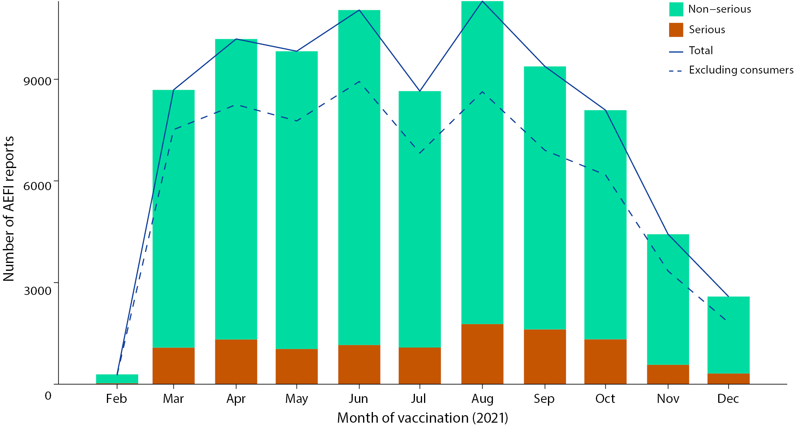
a Reports are excluded from the figure where the date of vaccination was not recorded, or vaccination was recorded for January 2021; or where Spikevax vaccination was recorded as before September 2021, or Vaxzevria vaccination was recorded as before March 2021.
Figure 2: Adverse event following immunisation reports for COVID-19 vaccines in the Adverse Event Management System database in 2021, by age group and brandª
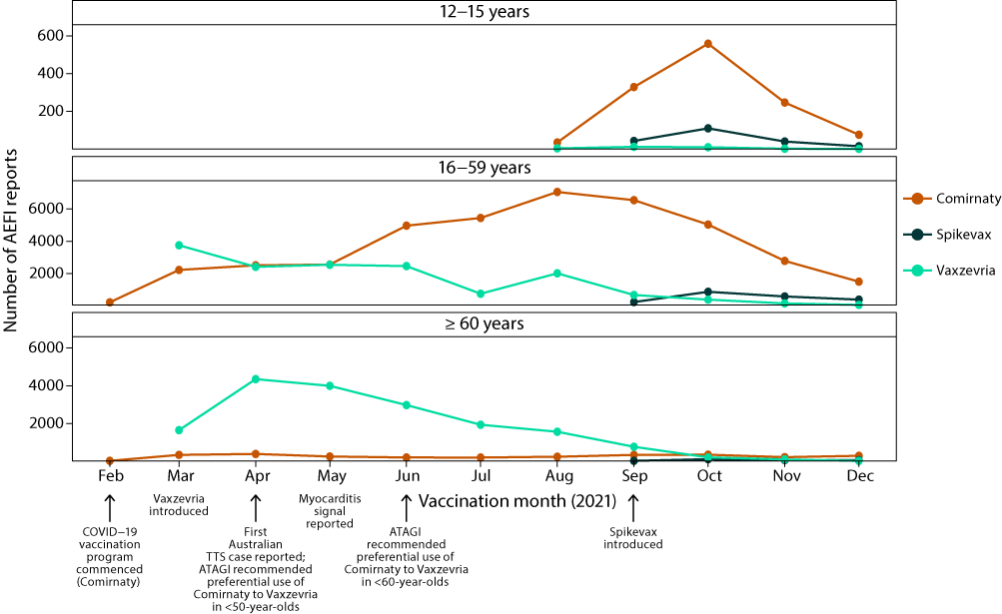
a Reports are excluded from the figure where the date of vaccination was not recorded, or vaccination was recorded for January 2021; where Spikevax vaccination was recorded as before September 2021; where 12–15 year-old adolescent vaccination was recorded as before August 2021; and where Vaxzevria vaccination was recorded in February.

Adverse effects
Overall, the five most frequently reported PT or SMQ for all COVID-19 vaccines were: headache (28,739 reports; 25.8%); gastrointestinal nonspecific symptoms and therapeutic procedures (22,186 reports; 19.9%; hereafter abbreviated to ‘gastrointestinal nonspecific symptoms’); myalgia (17,851 reports; 16.0%); pyrexia (15,674 reports; 14.1%); and fatigue (13,503 reports; 12.1%) (Table 3). The twenty most frequently reported PT or SMQ were similar across age groups. Chest pain was the most commonly reported event in adolescents aged 12–15 years, with reports decreasing in relative frequency with increasing age (Figure 3). Cardiorespiratory-related events were reported more frequently relative to other events in this age group compared to the other age groups. In people aged 16–59 and ≥ 60 years, the five most frequently reported symptoms were identical (Figure 3 and Table 3). The most frequently reported PT or SMQ following Comirnaty and Vaxzevria were also headache, gastrointestinal nonspecific symptoms and myalgia, while following Spikevax they were chest pain, gastrointestinal nonspecific symptoms and headache (Figure 4 and Table 4).
Table 3: The 50 most frequently reported adverse events classified by MedDRAª Preferred Terms or Standardised MedDRA queries in reports of adverse events following immunisation (AEFI) with COVID-19 vaccines in the Adverse Event Management System database in 2021
PT or SMQb | AEFI reports n (%)c | One PT only n (%)d,e | Aged  12–15 years n (%)e,f | Aged  16–59 years n (%)e,f | Aged  ≥ 60 years n (%)e,f | Serious  AEFI  n (%)e,f
Headache | 28,739 (25.8) | 1,234 (4.3) | 325 (1.1) | 20,025 (69.7) | 7,000 (24.4) | 3,118 (10.8)
Gastrointestinal nonspecific symptoms and therapeutic procedures | 22,186 (19.9) | 982 (4.4) | 454 (2.0) | 15,418 (69.5) | 5,363 (24.2) | 2,795 (12.6)
Myalgia | 17,851 (16) | 264 (1.5) | 148 (0.8) | 13,008 (72.9) | 3,800 (21.3) | 1,725 (9.7)
Pyrexia | 15,674 (14.1) | 246 (1.6) | 251 (1.6) | 11,131 (71.0) | 3,498 (22.3) | 1,757 (11.2)
Fatigue | 13,503 (12.1) | 163 (1.2) | 139 (1.0) | 9,253 (68.5) | 3,451 (25.6) | 1,784 (13.2)
Injection site reaction | 11,878 (10.7) | 1,666 (14.0) | 174 (1.5) | 8,744 (73.6) | 2,482 (20.9) | 860 (7.2)
Dizziness | 11,506 (10.3) | 1,262 (11.0) | 261 (2.3) | 8,659 (75.3) | 2,159 (18.8) | 1,619 (14.1)
Lethargy | 11,218 (10.1) | 81 (0.7) | 164 (1.5) | 8,690 (77.5) | 1,978 (17.6) | 1,092 (9.7)
Arthralgia | 11,217 (10.1) | 263 (2.3) | 82 (0.7) | 8,088 (72.1) | 2,526 (22.5) | 1,203 (10.7)
Chest pain | 10,733 (9.6) | 1189 (11.1) | 472 (4.4) | 8,830 (82.3) | 1,068 (10.0) | 2,445 (22.8)
Chills | 10,068 (9.0) | 98 (1.0) | 61 (0.6) | 6,882 (68.4) | 2,619 (26.0) | 810 (8.0)
Hypersensitivity | 9,026 (8.1) | 2,565 (28.4) | 172 (1.9) | 6,265 (69.4) | 2,214 (24.5) | 1,025 (11.4)
Dyspnoea | 8,672 (7.8) | 215 (2.5) | 200 (2.3) | 6,680 (77.0) | 1,511 (17.4) | 2,048 (23.6)
Paraesthesia | 6,188 (5.6) | 701 (11.3) | 33 (0.5) | 4,971 (80.3) | 917 (14.8) | 965 (15.6)
Palpitations | 4,775 (4.3) | 320 (6.7) | 95 (2.0) | 3,975 (83.2) | 521 (10.9) | 1,032 (21.6)
Injection site pain | 4,700 (4.2) | 281 (6.0) | 50 (1.1) | 3,425 (72.9) | 977 (20.8) | 477 (10.1)
Pain in extremity | 4,373 (3.9) | 368 (8.4) | 47 (1.1) | 2,861 (65.4) | 1,168 (26.7) | 646 (14.8)
Lymphadenopathy | 4,105 (3.7) | 753 (18.3) | 68 (1.7) | 3,455 (84.2) | 385 (9.4) | 432 (10.5)
Noninfectious myocarditis/pericarditis | 4,041 (3.6) | 1,147 (28.4) | 214 (5.3) | 3,538 (87.6) | 170 (4.2) | 1,412 (34.9)
Chest discomfort | 3,749 (3.4) | 185 (4.9) | 96 (2.6) | 3,115 (83.1) | 416 (11.1) | 776 (20.7)
Influenza like illness | 3,680 (3.3) | 617 (16.8) | 29 (0.8) | 2,484 (67.5) | 962 (26.1) | 407 (11.1)
Malaise | 3,611 (3.2) | 64 (1.8) | 50 (1.4) | 2,108 (58.4) | 1,217 (33.7) | 577 (16.0)
Haemodynamic oedema, effusions and fluid overload | 3,380 (3.0) | 259 (7.7) | 26 (0.8) | 2,245 (66.4) | 978 (28.9) | 695 (20.6)
Syncope | 3,199 (2.9) | 813 (25.4) | 176 (5.5) | 2,509 (78.4) | 430 (13.4) | 498 (15.6)
Embolic and thrombotic events, venous | 2,850 (2.6) | 1,296 (45.5) | 3 (0.1) | 1,010 (35.4) | 1781 (62.5) | 1,129 (39.6)
Presyncope | 2,751 (2.5) | 1,096 (39.8) | 108 (3.9) | 2,319 (84.3) | 275 (10.0) | 308 (11.2)
Hyperhidrosis | 2,493 (2.2) | 24 (1.0) | 56 (2.2) | 1,847 (74.1) | 467 (18.7) | 370 (14.8)
Hypertension | 2,471 (2.2) | 170 (6.9) | 10 (0.4) | 1,650 (66.8) | 727 (29.4) | 503 (20.4)
Cough | 2,386 (2.1) | 68 (2.8) | 18 (0.8) | 1,676 (70.2) | 589 (24.7) | 401 (16.8)
Tachycardia | 2,254 (2.0) | 123 (5.5) | 63 (2.8) | 1,762 (78.2) | 319 (14.2) | 460 (20.4)
Pain | 2,045 (1.8) | 62 (3.0) | 19 (0.9) | 1,387 (67.8) | 538 (26.3) | 278 (13.6)
Pruritus | 2,021 (1.8) | 214 (10.6) | 14 (0.7) | 1,439 (71.2) | 490 (24.2) | 219 (10.8)
Hypoaesthesia | 1,961 (1.8) | 134 (6.8) | 13 (0.7) | 1,572 (80.2) | 282 (14.4) | 460 (23.5)
Menstrual disorder | 1,945 (1.7) | 115 (5.9) | 29 (1.5) | 1,747 (89.8) | 25 (1.3) | 255 (13.1)
Decreased appetite | 1,794 (1.6) | 5 (0.3) | 21 (1.2) | 950 (53.0) | 723 (40.3) | 251 (14.0)
Concomitant disease aggravated | 1,661 (1.5) | 459 (27.6) | 19 (1.1) | 1,101 (66.3) | 447 (26.9) | 389 (23.4)
Vision blurred | 1,661 (1.5) | 89 (5.4) | 36 (2.2) | 1,120 (67.4) | 416 (25.0) | 307 (18.5)
Taste and smell disorders | 1,600 (1.4) | 192 (12.0) | 4 (0.2) | 1,165 (72.8) | 341 (21.3) | 218 (13.6)
Hearing impairment | 1,592 (1.4) | 477 (30.0) | 24 (1.5) | 1,115 (70.0) | 346 (21.7) | 311 (19.5)
Migraine | 1,578 (1.4) | 246 (15.6) | 6 (0.4) | 1,310 (83.0) | 182 (11.5) | 307 (19.5)
Fibrin D dimer increased | 1,570 (1.4) | 26 (1.7) | 4 (0.3) | 701 (44.6) | 844 (53.8) | 710 (45.2)
Tremor | 1,514 (1.4) | 30 (2.0) | 20 (1.3) | 1,001 (66.1) | 423 (27.9) | 287 (19.0)
Back pain | 1,483 (1.3) | 70 (4.7) | 10 (0.7) | 952 (64.2) | 434 (29.3) | 246 (16.6)
Insomnia | 1,483 (1.3) | 59 (4.0) | 7 (0.5) | 1,057 (71.3) | 334 (22.5) | 185 (12.5)
Angioedema | 1,390 (1.2) | 110 (7.9) | 23 (1.7) | 1,074 (77.3) | 241 (17.3) | 197 (14.2)
Asthenia | 1,376 (1.2) | 11 (0.8) | 10 (0.7) | 820 (59.6) | 460 (33.4) | 298 (21.7)
Vestibular disorders | 1,348 (1.2) | 237 (17.6) | 9 (0.7) | 889 (65.9) | 380 (28.2) | 252 (18.7)
Medication errors | 1,319 (1.2) | 685 (51.9) | 83 (6.3) | 766 (58.1) | 267 (20.2) | 132 (10.0)
Anaphylactic/anaphylactoid shock conditions | 1,196 (1.1) | 571 (47.7) | 13 (1.1) | 996 (83.3) | 155 (13.0) | 337 (28.2)
Herpes zoster | 1,174 (1.1) | 696 (59.3) | 5 (0.4) | 694 (59.1) | 407 (34.7) | 196 (16.7)
a MedDRA: Medical Dictionary for Regulatory Activities.
b PT or SMQ: preferred terms or standardised MedDRA queries.
c Number of AEFI reports in which the PT or SMQ was reported. More than one PT/SMQ may be recorded on the same report.
d AEFI reports where only one PT or SMQ was reported.
e Percentages are calculated for the number of AEFI reports where the PT or SMQ was reported.
f Includes only AEFI reports where an age or date of birth has been reported.
g An adverse event report is defined as ‘serious’ if it meets one or more of the following criteria: (1) results in death; (2) is life-threatening; (3) requires inpatient hospitalisation or prolongation of existing hospitalisation; (4) results in persistent or significant disability/incapacity; (5) is a congenital anomaly/birth defect or; (6) is a medically important event or reaction. The seriousness classification is applied by Australian sponsors (vaccine companies) to vaccine AEFI reports to ensure they meet legislated requirements. For other AEFI reports submitted to the Therapeutic Goods Administration (TGA), the seriousness classification either reflects the view of the reporter or may have been applied following review by the TGA.
Figure 3: The twenty most frequently reported adverse events classified by MedDRA Preferred Terms or Standardised MedDRA queries in reports of adverse events following immunisation (AEFI) with COVID-19 vaccines in the Adverse Event Management System database in 2021,ª by age group
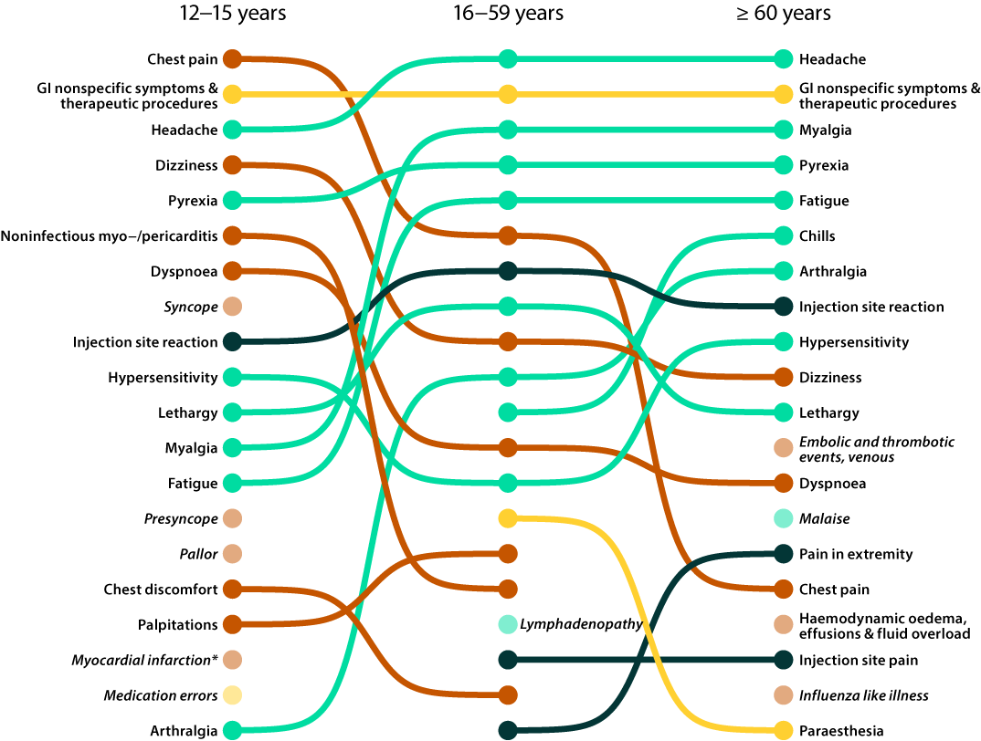
a Top twenty PT/SMQ for each age group ranked by frequency (most common at top). Colours indicate PT/SMQ grouping (orange: cardiorespiratory, green: systemic, emerald: local, yellow: other). Transparent and italicised PT/SMQ are in the top 20 for the listed age group, but are ranked < 20 for other age groups.
b Myocardial infarction is an SMQ that captures PT relating to increased troponin; 100% of AEFI reports for adolescents aged 12-15 years with this SMQ had PT relating to increased troponin, and none of them had any other PT relating to myocardial infarction (e.g. (acute) myocardial infarction, angina unstable, coronary artery occlusion, acute coronary syndrome, coronary artery thrombosis, coronary artery embolism, acute cardiac event, blood creatine phosphokinase MB increased).
Figure 4: The twenty most frequently reported adverse events classified by MedDRA Preferred Terms or Standardised MedDRA queries in reports of adverse events following immunisation (AEFI) with COVID-19 vaccines in the Adverse Event Management System database in 2021,ª by brand
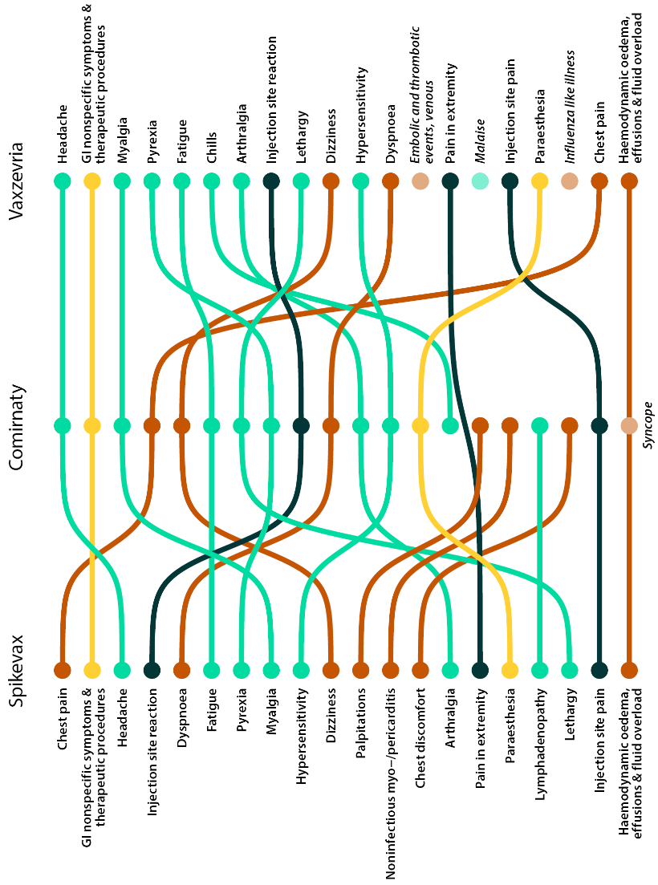
a Top twenty PT/SMQ for each brand ranked by frequency (most common at top). Colours indicate PT/SMQ grouping (orange: cardiorespiratory, green: systemic, emerald: local, yellow: other). Transparent and italicised PT/SMQ are in the top 20 for the listed brand, but are ranked < 20 for other brands.

Table 4: The 50 most frequently reported adverse events classified by MedDRAª Preferred Terms or Standardised MedDRA queries in reports of adverse events following immunisation (AEFI) with COVID-19 vaccines in the Adverse Event Management System database in 2021
PT or SMQb | AEFI reports  n (%)c | Comirnaty  n (%)d,e | Vaxzevria  n (%)d,e | Spikevax  n (%)d,e
Headache | 28,739 (25.8) | 12,739 (44.3) | 15,174 (52.8) | 728 (2.5)
Gastrointestinal nonspecific symptoms and therapeutic procedures | 22,186 (19.9) | 11,322 (51.0) | 10,029 (45.2) | 773 (3.5)
Myalgia | 17,851 (16) | 8,120 (45.5) | 9,255 (51.8) | 429 (2.4)
Pyrexia | 15,674 (14.1) | 6,139 (39.2) | 8,964 (57.2) | 518 (3.3)
Fatigue | 13,503 (12.1) | 6,545 (48.5) | 6,365 (47.1) | 557 (4.1)
Injection site reaction | 11,878 (10.7) | 6,000 (50.5) | 5,213 (43.9) | 648 (5.5)
Dizziness | 11,506 (10.3) | 7,389 (64.2) | 3,670 (31.9) | 418 (3.6)
Lethargy | 11,218 (10.1) | 6,372 (56.8) | 4,605 (41.1) | 235 (2.1)
Arthralgia | 11,217 (10.1) | 5,336 (47.6) | 5,547 (49.5) | 290 (2.6)
Chest pain | 10,733 (9.6) | 8,091 (75.4) | 1,784 (16.6) | 841 (7.8)
Chills | 10,068 (9.0) | 3,785 (37.6) | 6,064 (60.2) | 178 (1.8)
Hypersensitivity | 9,026 (8.1) | 5,052 (56.0) | 3,542 (39.2) | 422 (4.7)
Dyspnoea | 8,672 (7.8) | 5,790 (66.8) | 2,301 (26.5) | 574 (6.6)
Paraesthesia | 6,188 (5.6) | 4,071 (65.8) | 1,848 (29.9) | 255 (4.1)
Palpitations | 4,775 (4.3) | 3,711 (77.7) | 727 (15.2) | 333 (7.0)
Injection site pain | 4,700 (4.2) | 2,570 (54.7) | 1,925 (41.0) | 184 (3.9)
Pain in extremity | 4,373 (3.9) | 2,132 (48.8) | 1,967 (45.0) | 260 (5.9)
Lymphadenopathy | 4,105 (3.7) | 3,202 (78.0) | 651 (15.9) | 246 (6.0)
Noninfectious myocarditis/pericarditis | 4,041 (3.6) | 3,467 (85.8) | 260 (6.4) | 326 (8.1)
Chest discomfort | 3,749 (3.4) | 2,745 (73.2) | 689 (18.4) | 310 (8.3)
Influenza like illness | 3,680 (3.3) | 1,760 (47.8) | 1,808 (49.1) | 109 (3.0)
Malaise | 3,611 (3.2) | 1,497 (41.5) | 1,929 (53.4) | 163 (4.5)
Haemodynamic oedema, effusions and fluid overload | 3,380 (3.0) | 1,771 (52.4) | 1,424 (42.1) | 181 (5.4)
Syncope | 3,199 (2.9) | 2,246 (70.2) | 795 (24.9) | 153 (4.8)
Embolic and thrombotic events, venous | 2,850 (2.6) | 591 (20.7) | 2,235 (78.4) | 28 (1.0)
Presyncope | 2,751 (2.5) | 2,162 (78.6) | 522 (19.0) | 62 (2.3)
Hyperhidrosis | 2,493 (2.2) | 1,362 (54.6) | 1,006 (40.4) | 122 (4.9)
Hypertension | 2,471 (2.2) | 1,551 (62.8) | 849 (34.4) | 62 (2.5)
Cough | 2,386 (2.1) | 1,441 (60.4) | 839 (35.2) | 93 (3.9)
Tachycardia | 2,254 (2.0) | 1,487 (66.0) | 637 (28.3) | 121 (5.4)
Pain | 2,045 (1.8) | 921 (45.0) | 1,030 (50.4) | 98 (4.8)
Pruritus | 2,021 (1.8) | 1,276 (63.1) | 678 (33.5) | 65 (3.2)
Hypoaesthesia | 1,961 (1.8) | 1,248 (63.6) | 597 (30.4) | 115 (5.9)
Menstrual disorder | 1,945 (1.7) | 1,569 (80.7) | 235 (12.1) | 135 (6.9)
Decreased appetite | 1,794 (1.6) | 518 (28.9) | 1,190 (66.3) | 82 (4.6)
Concomitant disease aggravated | 1,661 (1.5) | 997 (60.0) | 563 (33.9) | 106 (6.4)
Vision blurred | 1,661 (1.5) | 825 (49.7) | 747 (45.0) | 83 (5.0)
Taste and smell disorders | 1,600 (1.4) | 955 (59.7) | 572 (35.8) | 73 (4.6)
Hearing impairment | 1,592 (1.4) | 928 (58.3) | 596 (37.4) | 69 (4.3)
Migraine | 1,578 (1.4) | 893 (56.6) | 602 (38.1) | 87 (5.5)
Fibrin D dimer increased | 1,570 (1.4) | 362 (23.1) | 1,189 (75.7) | 25 (1.6)
Tremor | 1,514 (1.4) | 746 (49.3) | 675 (44.6) | 84 (5.5)
Back pain | 1,483 (1.3) | 754 (50.8) | 663 (44.7) | 56 (3.8)
Insomnia | 1,483 (1.3) | 793 (53.5) | 641 (43.2) | 42 (2.8)
Angioedema | 1,390 (1.2) | 895 (64.4) | 441 (31.7) | 56 (4.0)
Asthenia | 1,376 (1.2) | 660 (48.0) | 644 (46.8) | 68 (4.9)
Vestibular disorders | 1,348 (1.2) | 732 (54.3) | 568 (42.1) | 46 (3.4)
Medication errors | 1,319 (1.2) | 689 (52.2) | 583 (44.2) | 97 (7.4)
Anaphylactic/anaphylactoid shock conditions | 1,196 (1.1) | 884 (73.9) | 279 (23.3) | 32 (2.7)
Herpes zoster | 1,174 (1.1) | 624 (53.2) | 525 (44.7) | 26 (2.2)
a MedDRA: Medical Dictionary for Regulatory Activities.
b PT or SMQ: preferred terms or standardised MedDRA queries.
c Number of AEFI reports in which the PT or SMQ was reported. More than one PT/SMQ may be recorded on the same report.
d Includes AEFI reports with the listed vaccine brand; more than one vaccine may be reported on the same report.
e Percentages are calculated for the number of AEFI reports where the PT or SMQ was reported.

Serious adverse effects
The proportion of AEFI reports where the outcome was categorised as serious was similar across the three vaccine brands: 14.9% for Comirnaty; 14.6% for Vaxzevria; and 16.2% for Spikevax (Table 5).
Table 5: COVID-19 vaccines listed as ‘suspected’ in reports of adverse events following immunisation (AEFI) in the Adverse Event Management System database in 2021
Vaccine | AEFI reports  n (%)a | One suspected vaccine only  n (%)b,c | Age groupd |  |  | Serious  AEFI^{c,e}
 |  |  | 12–15 years  n (%)c,d | 16–59 years  n (%)c,d | ≥ 60 years  n (%)c,d
Comirnaty | 61,417 (55.2) | 58,079 (94.6) | 1,701 (2.8) | 53,261 (86.7) | 3,995 (6.5) | 9,131 (14.9)
Vaxzevria | 45,768 (41.1) | 44,307 (96.8) | 41 (0.1) | 20,421 (44.6) | 23,124 (50.5) | 6,681 (14.6)
Spikevax | 3,890 (3.5) | 3,606 (92.7) | 261 (6.7) | 3,001 (77.1) | 408 (10.5) | 632 (16.2)
COVID-19 (unspecified) | 472 (0.4) | 457 (96.8) | 3 (0.6) | 169 (35.8) | 142 (30.1) | 86 (18.2)
a Number of AEFI reports in which the vaccine was coded as ‘suspected’ of causal involvement in the reported adverse event and the vaccination was administered between 1 January and 31 December 2021.
b AEFI reports where only one vaccine was suspected of causal involvement in a reported adverse event.
c Percentages are calculated for the number of AEFI reports where the vaccine was suspected of causal involvement in the event.
d Includes only AEFI reports where an age or date of birth has been reported.
e An adverse event report is defined as ‘serious’ if it meets one or more of the following criteria: (1) results in death; (2) is life-threatening; (3) requires inpatient hospitalisation or prolongation of existing hospitalisation; (4) results in persistent or significant disability/incapacity; (5) is a congenital anomaly/birth defect or; (6) is a medically important event or reaction. The seriousness classification is applied by Australian sponsors (vaccine companies) to vaccine AEFI reports to ensure they meet legislated requirements. For other AEFI reports submitted to the Therapeutic Goods Administration (TGA), the seriousness classification either reflects the view of the reporter or may have been applied following review by the TGA.

Adverse events of special interest
The most frequently reported AESI were, in order: myocarditis and/or pericarditis; thrombosis and thromboembolism (including thrombocytosis with thrombocytopenia syndrome: TTS); and anaphylaxis (Table 6). Over 85% of people who reported myocarditis and/or pericarditis and anaphylaxis were aged 16–59 years, while nearly 60% of people who reported thrombosis and thromboembolism were aged ≥ 60 years. Fewer than 5 AESI per 100,000 doses were reported for most events, with three notable exceptions. Reports of myocarditis and/or pericarditis following Comirnaty and Spikevax in adolescents and adults aged 12–15 and 16–59 years ranged from 10.2 to 23.9 per 100,000 doses. For thrombosis and thromboembolism following Vaxzevria in people aged 16–59 and ≥ 60 years, there were 14.7 and 20.9 reports per 100,000 doses respectively; while for thrombocytopenia following Vaxzevria in people aged 16–59 and ≥ 60 years, there were 5.1 and 6.4 reports per 100,000 doses respectively (Figure 5).
To 31 December 2021, there were 170 cases of TTS classified as confirmed or probable by the TGA. Of these, 147 (83 confirmed, 64 probable) related to a first dose of Vaxzevria and 23 to a second dose (5 confirmed, 18 probable). Additionally for Vaxzevria, the TGA received, but had not assessed for causality as at 31 December 2021, 170 reports of suspected Guillain-Barré syndrome (GBS), 86 reports of suspected immune thrombocytopenia (ITP) and seven reports of suspected capillary leak syndrome (CLS).32
Table 6: Adverse events of special interest (AESI) reported in reports of adverse events following immunisation with COVID-19 vaccines in the Adverse Event Management System database in 2021
AESI | AEFI reports  n (%)a | One suspected vaccine only  n (%)b,c | Age groupd |  |  | Serious  AEFIc,e
 |  |  | 12–15 years  n (%)c,d | 16–59 years  n (%)c,d | ≥ 60 years  n (%)c,d
Myocarditis and/or pericarditis | 4,030 (3.6) | 3,546 (88) | 211 (5.2) | 3,495 (86.7) | 204 (5.1) | 1,426 (35.4)
Thrombosis and thromboembolism | 3,384 (3) | 3,116 (92.1) | 5 (0.1) | 1,264 (37.4) | 2,024 (59.8) | 1,340 (39.6)
Anaphylaxis | 1,188 (1.1) | 1,158 (97.5) | 13 (1.1) | 990 (83.3) | 153 (12.9) | 333 (28)
Bell's palsy and facial nerve palsy | 1,017 (0.9) | 958 (94.2) | 8 (0.8) | 737 (72.5) | 245 (24.1) | 229 (22.5)
Thrombocytopenia | 990 (0.9) | 876 (88.5) | 8 (0.8) | 358 (36.2) | 598 (60.4) | 608 (61.4)
Generalised convulsion | 822 (0.7) | 782 (95.1) | 35 (4.3) | 631 (76.8) | 131 (15.9) | 239 (29.1)
Guillain-Barré Syndrome | 218 (0.2) | 185 (84.9) | 0 (0) | 94 (43.1) | 113 (51.8) | 147 (67.4)
Encephalitis/  encephalomyelitis | 23 (0.02) | 23 (100) | 0 (0) | 8 (34.8) | 15 (65.2) | 19 (82.6)
Aseptic meningitis | 22 (0.02) | 20 (90.9) | 0 (0) | 21 (95.5) | 1 (4.5) | 6 (27.3)
Acute disseminated encephalomyelitis | 11 (0.01) | 8 (72.7) | 0 (0) | 2 (18.2) | 9 (81.8) | 9 (81.8)
a Number of AEFI reports in which the vaccine was coded as ‘suspected’ of causal involvement in the reported adverse event and the vaccination was administered between 1 January and 31 December 2021.
b AEFI reports where only one vaccine was suspected of causal involvement in a reported adverse event.
c Percentages are calculated for the number of AEFI reports where the vaccine was suspected of causal involvement in the event.
d Includes only AEFI reports where an age or date of birth has been reported.
e An adverse event report is defined as ‘serious’ if it meets one or more of the following criteria: (1) results in death; (2) is life-threatening; (3) requires inpatient hospitalisation or prolongation of existing hospitalisation; (4) results in persistent or significant disability/incapacity; (5) is a congenital anomaly/birth defect or; (6) is a medically important event or reaction. The seriousness classification is applied by Australian sponsors (vaccine companies) to vaccine AEFI reports to ensure they meet legislated requirements. For other AEFI reports submitted to the Therapeutic Goods Administration (TGA), the seriousness classification either reflects the view of the reporter or may have been applied following review by the TGA.

Figure 5: Adverse event of special interest (AESI) rates per 100,000 doses following immunisation with COVID-19 vaccines in the Adverse Event Management System database in 2021, by age group and brand
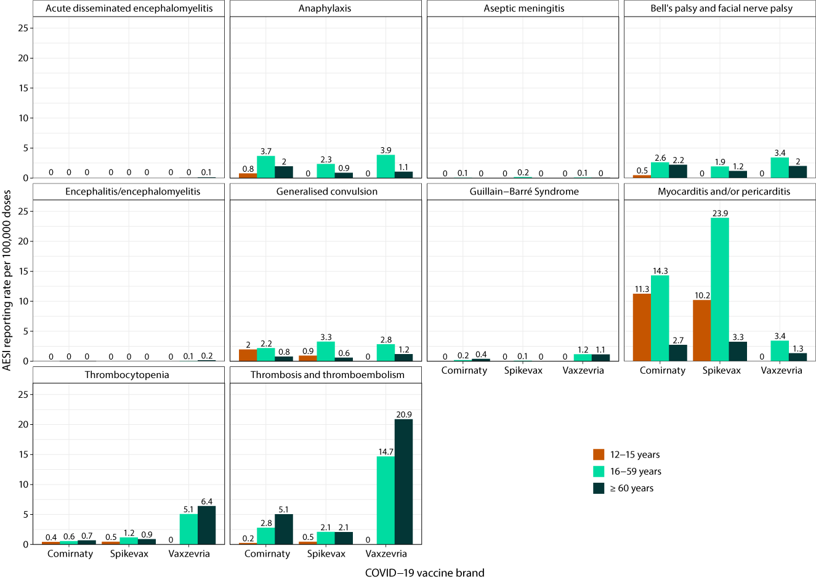

VSIG meetings
In addition to detailed review of many cases by the TGA, eleven VSIG meetings were convened to assess 31 AEFI cases following COVID-19 vaccinations in 2021. The first VSIG meetings were convened in April 2021 in response to emerging information regarding TTS following vaccination with Vaxzevria. A total of 23 suspected TTS cases following vaccination with Vaxzevria were reviewed by the VSIG, of which 11 were found likely to be related to vaccination (one of which was fatal) and 12 were either unlikely to be related to vaccination or medical evidence was insufficient to confirm a link with vaccination (of which three cases were fatal). A further seven fatal cases of TTS (six confirmed and one probable) following Vaxzevria were reported by the TGA in its COVID-19 vaccine weekly safety reports but were not reviewed by a VSIG, given the established causal link between TTS and Vaxzevria, and the cases were classified as probable or confirmed TTS.
Seven of the remaining eight cases reviewed by a VSIG were fatal: two cases of GBS and one case of ITP following Vaxzevria were considered likely to be related to vaccination, while two cases of myocarditis following Comirnaty and one case of CLS following Vaxzevria were inconsistent with being caused by vaccination; and a VSIG could not conclusively determine if a fatal case of pulmonary embolism without thrombocytopenia was related to Vaxzevria vaccination. The final case reviewed by a VSIG was suspected multisystem inflammatory syndrome following Comirnaty, but the VSIG concluded that there was insufficient medical information to determine if it was related to the vaccine.

Death following vaccination
Of the 111,348 AEFI reports following a COVID-19 vaccination in 2021, there were 762 (0.7%) which reported an outcome of death following vaccination, of which 13 were assessed by medical specialists, including VSIG, as likely to be linked to vaccination. More than 80% of these 762 reports were in people aged ≥ 60 years (Table 7). The median age at death was 76 years and the median time between the most recent COVID-19 vaccination and death was 10 days (range: 0–261 days).
The majority of the reports of death were sent to the TGA by jurisdictional health departments (N = 473; 62.1%), followed by health professionals directly (N = 109; 14.3%). Eighty-five reports (11.2%) were sent by other sender types (e.g. distributor or other organisation), of which the majority (71) were coroners courts. There were 79 reports sent by consumers (10.4%) and 16 reports sent by pharmaceutical companies (2.1%). Reporting of a death to the TGA does not mean that the vaccine caused the death or that the reporting doctor/individual considers that it was caused by a vaccine. The TGA strongly encourages consumers and health professionals to report suspected adverse events, particularly serious events, even if there is only a very small chance a vaccine was the cause.
Where dose information was recorded, the majority of deaths were reported following a first dose of a COVID-19 vaccine (N = 383; 66.1%), while 183 reports (31.6%) were reported after a second dose of a COVID-19 vaccine, and 13 reports (2.2%) were reported after a third or booster dose of a COVID-19 vaccine. Dose information was not recorded for 183 reports (24% of total reports of death).
The five most commonly reported PT/SMQ with a fatal outcome for people aged < 60 years were: adverse event following immunisation; embolic and thrombotic events, venous; shock-associated circulatory or cardiac conditions (excluding torsade de pointes); haemorrhagic central nervous system vascular conditions; and other ischaemic heart disease. The five most commonly reported PT/SMQ with a fatal outcome for people aged ≥ 60 years were adverse event following immunisation; shock-associated circulatory or cardiac conditions (excluding torsade de pointes); concomitant disease progression; embolic and thrombotic events, venous; and cerebrovascular accident. If death was the only reported information without accompanying clinical details, then the MedDRA term ‘adverse event following immunisation’ was used by the TGA to capture that there was an adverse event, albeit unidentified, that had a fatal outcome.
Of the 13 deaths that were assessed as likely to be linked to vaccination, eight were associated with TTS cases, two were linked to GBS, two were related to very rare conditions involving the nervous system, and one was a case of ITP.
Table 7: Age distribution and median time to death for reports of death following immunisation with COVID-19 vaccines in the Adverse Event Management System database in 2021
Age at death (years) | AEFI reports n (%)a | Median time to death (days)
10–19 | 5 (0.7%) | 16
20–29 | 5 (0.7%) | 10.5
30–39 | 11 (1.5%) | 4.5
40–49 | 33 (4.5%) | 13
50–59 | 66 (9.0%) | 8
60–69 | 118 (16.1%) | 12
70–79 | 192 (26.2%) | 10
80–89 | 174 (23.8%) | 10
90–99 | 124 (16.9%) | 6.5
100+ | 4 (0.5%) | 4
Unknown | 30 | 17
a Percentages are calculated from the 732 reports for which age at death was recorded.

Safety monitoring
Table 8 summarises the safety topics that were subject to TGA-initiated safety investigations on COVID-19 vaccines in 2021 and some of the respective actions taken as a result of these investigations. In the context of rapidly emerging data and evidence, each topic listed in Table 8 may represent multiple separate and iterative investigations performed over time as new evidence came to light. This ensured that the TGA safety monitoring was responsive and adaptive to current issues. Vaccine product information and national COVID-19 vaccine program guidance for Comirnaty and Vaxzevria were updated following these investigations to provide more information on twelve separate safety issues in 2021. Table 8 captures data until the end of 2021 and does not capture the number of investigations, all regulatory or program actions undertaken, or actions that occurred for these safety topics after this time.
Table 8: Safety topics investigated for COVID-19 vaccines undertaken by the Therapeutic Goods Administration (TGA) in 2021ª
Vaccine(s) | Potential adverse event investigated | Outcome/status at the end of 2021
Comirnaty | Myocarditis/pericarditis | Product information updated (Section 4.4 and 4.8)b
 | Lymphadenopathy | Ongoing monitoringc
 | Risk of facial swelling in people with a history of injections with dermal fillers | Ongoing monitoringd
 | Anxiety related reaction/syncope | Product information updated (Section 4.4)e
 | Erythema multiforme | Product information updated (Section 4.8)f
 | Diarrhoea and vomiting | Product information updated (Section 4.8)
 | Hypersensitivity reactions, pain in arm | Product information updated (Section 4.8)
 | Spontaneous abortion | Ongoing monitoring
 | Cardiac failure | Ongoing monitoring
 | Glomerulonephritis and nephrotic syndrome | Ongoing monitoring
 | Bronchitis/lower respiratory tract infection | Ongoing monitoring
 | Chillblains | Ongoing monitoring
 | Oral herpes and mouth ulcers | Ongoing monitoring
 | Laryngitis, tonsilitis, and tonsillar inflammation | Ongoing monitoring
 | Acute pancreatitis | Ongoing monitoring
 | Cerebral venous sinus thrombosis | Ongoing monitoring
 | Hyperthyroidism | Ongoing monitoring
 | Hypertension and increased blood pressure | Ongoing monitoring
 | Appendicitis | Ongoing monitoring
Vaxzevria | Guillain-Barré syndrome | Product information updated (Section 4.4 and 4.8); causality statement updatedg
 | Capillary leak syndrome | Product information updated (Section 4.4 and 4.8); referred to VSIGh,i
 | Venous thromboembolism | Product information updated (Section 4.4)
 | Syncope and anxiety related reactions | Product information updated (Section 4.4)j
 | Thrombocytopaenia including Immune thrombocytopaenia and associated bleeding events | Product information updated (Section 4.4 and 4.8)
 | Cerebral venous sinus thrombosis | Product information updated (Section 4.8)
 | Retinal vessel thrombosis and occlusion | Ongoing monitoring
 | Acute aseptic arthritis | Ongoing monitoring
 | Acute disseminated encephalomyelitis, encephalitis, and encephalopathy | Ongoing monitoring
 | Cholecystitis/cholelithiasis | Ongoing monitoring
 | Balance disorder including vertigo and vestibular neuronitis | Ongoing monitoring
 | Giant cell arteritis | Ongoing monitoring
 | Increased blood glucose | Ongoing monitoring
 | Thrombophlebitis | Ongoing monitoring
 | Toxic epidermal necrolysis | Ongoing monitoring
Spikevax | Myocarditis/pericarditis | Ongoing monitoring
All COVID-19 vaccines | Hearing loss, hearing disorders including deafness and tinnitus | Ongoing monitoring
 | Acute kidney injury | Ongoing monitoring
 | Trigeminal neuralgia | Ongoing monitoring
 | Herpes zoster infection | Ongoing monitoringk
Comirnaty, Vaxzevria | Menstrual bleeding disorder | Ongoing monitoring
 | Cerebrovascular accident | Ongoing monitoring
 | Liver injury (including autoimmune hepatitis) | Ongoing monitoring
 | Stress cardiomyopathy | Ongoing monitoring
 | Bell’s palsy | Ongoing monitoring
 | Erythema multiforme | Ongoing monitoring
 | Haemophagocytic lymphohistiocytosis | Ongoing monitoring
a A targeted investigation may be initiated by the TGA following a preliminary assessment of information arising from reporting patterns, overseas regulators, published literature and other sources of safety data. As new information arises about a potential issue, multiple targeted investigations may be undertaken and investigations may occur through other processes such as the TGA’s review of Sponsor safety data. Regardless of the number of times the TGA reviewed a safety topic, it will only appear once in Table 8.
b https://www.tga.gov.au/news/covid-19-vaccine-safety-reports/covid-19-vaccine-weekly-safety-report-20-05-2021#section-372.
c https://www.tga.gov.au/periodic/covid-19-vaccine-weekly-safety-report-12-08-2021.
d https://www.tga.gov.au/periodic/covid-19-vaccine-weekly-safety-report-19-08-2021.
e https://www.tga.gov.au/periodic/covid-19-vaccine-weekly-safety-report-03-06-2021.
f https://www.tga.gov.au/periodic/covid-19-vaccine-weekly-safety-report-06-01-2022.
g https://www.tga.gov.au/news/covid-19-vaccine-safety-reports/covid-19-vaccine-weekly-safety-report-20-05-2021#section-348.
h VSIG: Vaccine Safety Investigation Group.
i https://www.tga.gov.au/periodic/covid-19-vaccine-weekly-safety-report-15-07-2021.
j https://www.tga.gov.au/periodic/covid-19-vaccine-weekly-safety-report-03-06-2021.
k https://www.tga.gov.au/news/covid-19-vaccine-safety-reports/covid-19-vaccine-weekly-safety-report-10-06-2021#section-488.

Discussion
In the first year of COVID-19 vaccination in Australia, the annual AEFI reporting rate for all COVID-19 vaccines was 271.4 per 100,000 doses administered to people aged ≥ 12 years.
The COVID-19 AEFI reporting rate was 507.8 per 100,000 population, in people aged ≥ 12 years, reflecting that many people received more than one dose of vaccine. These reporting rates were markedly greater (38-fold) than the annual AEFI reporting rate for non-COVID-19 vaccines of 13.4 per 100,000 population (all ages) for the same year,5 and they were also higher than the highest rate previously reported of 22.3 per 100,000 population (all ages) in 2010 following the pandemic H1N1 influenza vaccine program and the febrile seizure safety event related to a brand of seasonal influenza vaccine in children aged < 5 years.
The high population-based COVID-19 AEFI reporting rate was heavily influenced by the considerable number of COVID-19 vaccine doses administered in 2021. Overall, 73.4% of adolescents aged 12–15 years and 91.6% of people aged ≥ 16 years had received two doses of COVID-19 vaccine by the end of the year.33 A third dose and/or booster dose was also recommended in October 2021.24,34 In total, more than 41 million COVID-19 vaccine doses were administered to people aged ≥ 12 years in 2021 (Table 1).
The annual dose-based AEFI reporting rate was still greater than the annual AEFI reporting rate for non-COVID-19 vaccines of 30.6 per 100,000 doses (all ages) for the same year.5 This likely reflected both heightened awareness of adverse events and increased engagement in reporting adverse events from both immunisation providers and the general public following the introduction of the new pandemic COVID-19 vaccines. This is a phenomenon commonly seen with the introduction of new vaccines, but it occurred to a scale never previously observed in Australia and was likely amplified by the pandemic context, unprecedented media coverage, population-wide vaccination recommendations, and jurisdictional mandatory vaccination policies in certain settings. Increased engagement in AEFI reporting for COVID-19 vaccines is also evident through comparing the rates of expected AEFI (e.g. headache, injection site reactions) reported by participants in clinical trials for different vaccine types. While the rates of expected AEFI were similar between clinical trials for COVID-19 vaccines and influenza vaccines (for example, headache and injection site reactions were experienced by >10% of both COVID-19 and influenza recipients in clinical trials), the volume of reports received by the TGA surveillance system for such expected AEFI was larger for COVID-19 vaccines than for influenza vaccines.5,35–40
The proportion of AEFI reports reported by consumers in 2001 was higher for COVID-19 vaccines than for non-COVID-19 vaccines (26.5% vs 6.4%). This likely reflects the increased consumer awareness of AEFI and promotion of reporting by the TGA and other authorities in order to maximise the sensitivity of vaccine safety surveillance to detect any signals. The true proportion of consumer reports is likely to be even higher, as consumers can also report to a health professional or to their jurisdictional (state and territory) health department, as well as directly to the TGA. The TGA and vaccine program guidelines continue to encourage reporting as an important element of monitoring the safety of vaccines.
The number of AEFI reports per month reflects the vaccine rollout and uptake over time, with most of the primary series doses having been administered between March and October 2021 (Figure 1). There was an increase in AEFI reports in people aged 16–59 years following Comirnaty from June, contemporaneous with the identification of myocarditis and pericarditis cases following Comirnaty vaccines. In the same month, ATAGI recommended preferential use of Comirnaty over Vaxzevria in people aged < 60 years due to increased risk of TTS, increasing Comirnaty uptake and associated AEFI reports in this age group.41 While the number of AEFI reports for Spikevax was lower than for Comirnaty, the AEFI reporting rate per 100,000 doses was similar between the two vaccines (Table 1).
AEFI reporting rates varied between states and territories, though the differences were similar to AEFI reporting rates for non-COVID-19 vaccines for each state and territory for 2021 and historically. This suggests that the variation between jurisdictions more likely reflects differences in reporting behaviour, rather than true differences in AEFI occurrence or as a result of differences in vaccine quality, handling and/or administration between jurisdictions.
Overall, the top twenty PT/SMQ reported in each age group largely consisted of common, expected adverse events following COVID-19 vaccines. Chest pain and other cardiorespiratory symptoms were more commonly reported (relative to other PT/SMQ) in adolescents aged 12–15 years (Figure 3), despite low rates of myocarditis following COVID-19 vaccines reported in this age group. This may reflect individual or parental alertness and anxiety around the risk of myocarditis and pericarditis. Medication error was also in the top twenty PT/SMQ in the 12–15-year age group, highlighting the challenges of a population-wide vaccination rollout, with multiple vaccine brands, doses and evolving eligibility criteria contributing to program complexity and thereby increasing the risk of administration errors. Venous embolic and thrombotic events were in the top twenty PT/SMQ for people aged ≥ 60 years. This likely reflected that venous thromboembolic events were common in this age group in general (and not just after vaccination), and therefore there was an increased chance of this common event being temporally associated with a vaccination event when the whole population was being vaccinated.
The proportion of serious adverse events reported following COVID-19 vaccination was consistent between brands at around 14%, but was higher than the proportion of serious adverse events following non-COVID-19 vaccines in 2021 (6.5%) and than that reported in the US Vaccine Adverse Event Reporting System (VAERS).42 The seriousness classification reflected the view of the reporter, which may be subjective in the case of consumer reporting, or based on limited information in the report in the case of classification by a state/territory health department or the TGA. Providers and consumers have been encouraged to report all adverse events, but in particular serious and/or unexpected AEFI following COVID-19 vaccination.43–46 Due to the novelty and therefore unfamiliarity of expected COVID-19 vaccine AEFI, it was possible that a larger proportion of the reported AEFI were considered serious by reporters in comparison with vaccines that had been in use for a longer duration of time with well-established post-marketing safety profiles.
Reports of a fatal outcome following COVID-19 vaccination were rare, and mostly occurred in people aged 60 years and over (Table 7). More than three-quarters of reports with fatal outcomes were sent by jurisdictional health departments or health professionals. While the official diagnosed cause of death for an individual may not be reported to the TGA, it is notable that several of the most common PT/SMQ on reports with outcomes recorded as ‘fatal’ generally aligned with the most common causes of death in the general population, such as ischaemic heart disease (examples of potentially corresponding PT/SMQ included thrombotic events, myocardial infarction) and cerebrovascular disease (an example of PT/SMQ was cerebrovascular accident).47 The PT of concomitant disease progression, which was the fourth most common PT/SMQ on AEFI reports with outcomes of ‘fatal’, also aligned with chronic diseases being the leading causes of death in the general population. In addition, the median age at death following COVID-19 vaccination in AEMS (76 years) was similar to the median age of all deaths in 2021 (79.1 years). With large-scale vaccination programs and an increase in the number of people being vaccinated, it was likely that some people would experience a new illness or die, from any cause, in the days to weeks following vaccination. While many of these events are often coincidental, the TGA has continually analysed all AEFI reports, including deaths, to identify rare or emerging safety signals (Table 8), and has convened VSIGs as required. Where relevant, product information has been updated to reflect any changes to the safety profile of COVID-19 vaccines in use based on post-marketing safety surveillance both locally and internationally.
The highest AESI reporting rates were observed for myocarditis and/or pericarditis following Comirnaty and Spikevax in adolescents and adults aged 12–15 and 16–59 years, as well as thrombosis and thromboembolism and thrombocytopenia following Vaxzevria in people aged 16–59 and ≥ 60 years. While these AESI reports reflected true safety signals that prompted further investigation by the TGA, they were also common events in older adulthood (in particular thrombosis and thromboembolism and thrombocytopenia), and some of these reports were likely to be coincidental. The emergence of cases reporting these AESI was documented in real time by the TGA in news releases and weekly safety reports, and the TGA conducted further investigations to assess and characterise these safety signals by brand, dose, and age group (Table 8).48–54 The results of these investigations were published in COVID-19 vaccine weekly safety reports.55 Reporting rates for other AESI were low and consistent across age groups and brands.
These national spontaneous surveillance data were complemented by AusVaxSafety, an active sentinel vaccine safety surveillance system, which also monitored COVID-19 vaccines from the commencement of the vaccination rollout.56,57 The most common solicited symptoms reported in AusVaxSafety data were local pain, fatigue, headache, and myalgia, which were similar to the most commonly reported AEFI in the AEMS data of headache, gastrointestinal nonspecific symptoms and therapeutic procedures, myalgia, pyrexia and fatigue. While the data from both systems cannot be directly compared due to differences in methodology, they provided complementary data on the safety of vaccines used in Australia.
There are some limitations to this analysis. AEFI reports can vary significantly in the amount of detail, completeness, and quality of information, and are not always verified against clinical notes. AEFI reports can include multiple vaccines, vaccination dates, AEFI, and AEFI onset dates. Based on the information provided, it is not always possible to associate specific vaccines with specific AEFI and AEFI onset dates. The seriousness criteria for AEFI reports can be applied differently based on the report source and is not always based on verified clinical data, so it may not capture all medically important events, and in addition may capture non-serious events; therefore, the seriousness classification of an AEFI report cannot be directly interpreted as an indicator of safety. While annual AEFI reporting rates can be estimated, they cannot be interpreted as incidence rates due to factors such as potential under-reporting (i.e. not all adverse events are reported, which is often a feature of spontaneous surveillance systems), stimulated reporting (from increased awareness of potential adverse events of vaccines newly introduced to the National Immunisation Program or covered in the media), and the variable quality and completeness of information provided in individual notifications.6 Indigenous status is not always reported in all AEFI reports and therefore AEFI rates in Aboriginal and Torres Strait Islander people are likely to be underestimates. Vaccination data from the Australian Immunisation Register, which are used to calculate AEFI rates per 100,000 vaccine doses, may include COVID-19 vaccines administered overseas when COVID-19 vaccines or specific brands were not available in Australia. This reduced the reliability of monthly AEFI reporting rates per 100,000 doses by vaccine brand and age group (see Appendix A, Figure A.1 and Figure A.2). Finally, the AEFI reported here are not necessarily causally related to vaccination. The TGA strongly encourages consumers and health professionals to report suspected adverse events, even if there is only a very small chance a vaccine was the cause. With large-scale vaccination programs, it is inevitable by chance that some people will experience a new illness or die within a few days or weeks of vaccination. These events are often coincidental, rather than being caused by the vaccine.

Conclusion
In conclusion, there was an unprecedentedly large number of AEFI reports observed following the introduction of COVID-19 vaccines in 2021, which resulted in a high dose-based AEFI reporting rate. While the most frequently reported AEFI were common and expected adverse events following COVID-19 vaccines, and were consistent with clinical trial and active surveillance data, rare and unexpected (and ultimately causally associated) adverse events, specifically myocarditis/pericarditis and TTS, were also thoroughly investigated. Other adverse events and deaths reported following COVID-19 vaccination also underwent detailed assessments and analyses by the TGA; where appropriate, independent causality assessments were undertaken. These safety investigations resulted in changes to the vaccine program recommendations and product information. The outcomes of TGA monitoring were communicated in weekly vaccine safety reports and via a number of other channels. Overall, safety monitoring provided critical information on the risks of COVID-19 vaccine related adverse events that enabled decisionmakers to undertake informed risk-benefit assessments.

Acknowledgments
We would like to acknowledge and thank Aditi Dey, Han Wang, Alexandra Hendry, and Tristan Franks at NCIRS for providing historical context and code and vaccine dose data from the Australian Immunisation Register.

Author details
Catherine Glover,1
Lucy Deng,¹
Claire Larter,²
Catherine Brogan,²
Olivia Richardson,²
Yuanfei Anny Huang,¹
Elspeth Kay,²
Kristine Macartney,¹
Nicholas Wood¹
- National Centre for Immunisation Research and Surveillance, The University of Sydney and The Children’s Hospital at Westmead, Sydney, Australia
- Pharmacovigilance Branch, Therapeutic Goods Administration, Department of Health and Aged Care, Canberra, Australia
Corresponding author
Yuanfei Anny Huang
National Centre for Immunisation Research and Surveillance, Locked Bag 4001, Westmead NSW 2145, Sydney, Australia
Phone: +61 2 9391 9267
Email: yuanfei.huang@health.nsw.gov.au

References
- National Health Service [England] (NHS). Landmark moment as first NHS patient receives COVID-19 vaccination. [Webpage.] London: Government of the United Kingdom, Department of Health and Social Care, NHS; 8 December 2020. Available from: https://www.england.nhs.uk/2020/12/landmark-moment-as-first-nhs-patient-receives-covid-19-vaccination/.
- Australian Government Department of Health and Aged Care, Therapeutic Goods Administration (TGA). TGA safety monitoring of medicines: Steps following the identification of a potential safety concern. [Webpage.] Canberra: Australian Government Department of Health and Aged Care, TGA; 30 October 2018. Available from: https://www.tga.gov.au/safety/safety/safety-monitoring-medicines/tga-safety-monitoring-medicines#steps.
- Council for International Organizations of Medical Sciences (CIOMS) c/o World Health Organization (WHO). Definition and Application of Terms for Vaccine Pharmacovigilance: Report of CIOMS/WHO Working Group on Vaccine Pharmacovigilance. Geneva: CIOMS; 2012. Available from: https://www.who.int/vaccine_safety/initiative/tools/CIOMS_report_WG_vaccine.pdf.
- Australian Technical Advisory Group on Immunisation (ATAGI). Australian Immunisation Handbook. Canberra: Australian Government Department of Health and Aged Care; 2020. Available from: https://immunisationhandbook.health.gov.au/.
- Glover C, Deng L, Larter C, Brogan C,Richardson O, Huang YA et al. Surveillance of adverse events following immunisation in Australia annual report, 2021. Commun Dis Intell (2018). 2024;48. doi: https://doi.org/10.33321/cdi.2024.48.1.
- Lawrence G, Boyd I, McIntyre P, Isaacs D. Surveillance of adverse events following immunisation: Australia 2002 to 2003. Commun Dis Intell Q Rep. 2004;28(3):324–38.
- Lawrence G, Menzies R, Burgess M, McIntyre P, Wood N, Boyd I et al. Surveillance of adverse events following immunisation: Australia, 2000–2002. Commun Dis Intell Q Rep. 2003;27(3):307–23.
- Brown EG. Using MedDRA: implications for risk management. Drug Saf. 2004;27(8):591–602. doi: https://doi.org/10.2165/00002018-200427080-00010.
- Brown EG, Wood L, Wood S. The medical dictionary for regulatory activities (MedDRA). Drug Saf. 1999;20(2):109–17. doi: https://doi.org/10.2165/00002018-199920020-00002.
- Medical Dictionary for Regulatory Activities (MedDRA). Standardised MedDRA Queries. [Webpage.] Herndon VA: MedDRA: 2023. Available from: https://www.meddra.org/standardised-meddra-queries.
- Medical Dictionary for Regulatory Agencies (MedDRA). Introductory Guide for Standardised MedDRA Queries (SMQs) (Version 23.0). Geneva: International Council for Harmonisation of Technical Requirements for Pharmaceuticals for Human Use, MedDRA; 2020. Available from: https://admin.meddra.org/sites/default/files/guidance/file/SMQ_intguide_23_0_English.pdf.
- WHO. COVID-19 vaccines: safety surveillance manual – Monitoring and responding to adverse events of special interest. Geneva: WHO; 22 December 2020. Available from: https://www.who.int/publications/m/item/WHO-MHP-RPQ-PVG-2021.5.
- Safety Platform for Emergency vACcines (SPEAC). Updated (October 2022) COVID-19 AESI including status of associated Brighton case definitions. Basel: Brighton Collaboration, SPEAC; 31 October 2022. Available from: https://brightoncollaboration.us/wp-content/uploads/2022/11/Updated-COVID-19-AESI-list_Oct2022.pdf.
- Law B, SPEAC. SO2 – D2.5.2.1 – AESI Case Definition Companion Guide for 1st Tier AESI: Acute Disseminated Encephalomyelitis (ADEM). Basel: Brighton Collaboration, SPEAC; 11 February 2021. Available from: https://brightoncollaboration.us/wp-content/uploads/2021/03/SPEAC_D2.5.2.1_ADEM-Case-Definition-Companion-Guide_V1.0_format12063-1.pdf.
- Law B, SPEAC. SO2 – D2.5.2.1 – AESI Case Definition Companion Guide for 1st Tier AESI Anaphylaxis. Basel: Brighton Collaboration, SPEAC; 5 February 2021. Available from: https://brightoncollaboration.us/wp-content/uploads/2021/03/SPEAC_D2.5.2.1_Anaphylaxis-Case-Definition-Companion-Guide_V1.0-12070-1.pdf.
- Law B, SPEAC. SO2 – D2.5.2.1 – AESI Case Definition Companion Guide for 1st Tier AESI: Aseptic Meningitis. Basel: Brighton Collaboration, SPEAC; 21 February 2021. Available from: https://brightoncollaboration.us/wp-content/uploads/2021/03/SPEAC_D2.5.2.1_Aseptic-Meningitis-Case-Definition-Companion-Guide_V1.0_format12069-1.pdf.
- Law B, SPEAC. SO2 – D2.5.2.1 – AESI Case Definition Companion Guide for 1st Tier AESI: Facial Nerve Palsy. Basel: Brighton Collaboration; 11 February 2021. Available from: https://brightoncollaboration.us/wp-content/uploads/2021/10/SPEAC_D2.5.2.1_Facial-Nerve-Palsy-Case-Definition-Companion-Guide_V1.0_format12067-1.pdf.
- Law B, SPEAC. SO2 – D2.5.2.1 – AESI Case Definition Companion Guide for 1st Tier AESI: Acute Encephalitis. Basel: Brighton Collaboration, SPEAC; 21 February 2021. Available from: https://brightoncollaboration.us/wp-content/uploads/2021/03/SPEAC_D2.5.2.1_Encephalitis-Case-Definition-Companion-Guide_V1.0_format12064-1.pdf.
- Law B, SPEAC. SO2 – D2.5.2.1 – AESI Case Definition Companion Guide for 1st Tier AESI: Generalized Convulsion. Basel: Brighton Collaboration, SPEAC; 15 February 2021. Available from: https://brightoncollaboration.us/wp-content/uploads/2021/03/SPEAC_D2.5.2.1_Generalised-Convulsion-Case-Definition-Companion-Guide-V1.0_format12068-1.pdf.
- Law B, SPEAC. SO2 – D2.5.2.1 – AESI Case Definition Companion Guide for 1st Tier AESI: Guillain Barré and Miller Fisher Syndromes. Basel: Brighton Collaboration, SPEAC; 9 February 2021. Available from: https://brightoncollaboration.us/wp-content/uploads/2021/03/SPEAC_D2.5.2.1-GBS-Case-Definition-Companion-Guide_V1.0_format12062-1.pdf.
- Law B, SPEAC. SO2 – D2.5.2.2 – AESI Case Definition Companion Guide for 2nd Tier AESI: Myocarditis and Pericarditis. Basel: Brighton Collaboration, SPEAC; 13 May 2022. Available from: https://brightoncollaboration.us/wp-content/uploads/2022/05/SPEAC_D2.5.2.2_Myocarditis-companion-guide_codes-updated_BL_2022_May12.pdf.
- Law B, SPEAC. SO2 – D2.5.2.1 – AESI Case Definition Companion Guide for 1st Tier AESI: Thrombocytopenia. Basel: Brighton Collaboration, SPEAC; 8 February 2021. Available from: https://brightoncollaboration.us/wp-content/uploads/2021/03/SPEAC_D2.5.2.1-Thrombocytopenia-Case-Definition-Companion-Guide_V1.0_format12065-1.pdf.
- Law B, Villaescusa MR, SPEAC. AESI Case Definition Companion Guide: Thrombosis and Thromboembolism. Basel: Brighton Collaboration, SPEAC; 10 October 2022. Available from: https://zenodo.org/records/7181081.
- National Centre for Immunisation Research and Surveillance (NCIRS). Significant events in COVID-19 vaccination practice in Australia. Sydney: NCIRS; April 2023. Available from: https://ncirs.org.au/sites/default/files/2023-04/COVID-19-history-April%202023.pdf.
- Uppsala Monitoring Centre. WHO Collaborating Centre for International Drug Monitoring. [Website.] Uppsala: Uppsala Monitoring Centre; 2020. Available from: http://www.who-umc.org/.
- Zhou W, Pool V, Iskander JK, English-Bullard R, Ball R, Wise RP et al. Surveillance for safety after immunization: Vaccine Adverse Event Reporting System (VAERS)—United States, 1991–2001. MMWR Surveill Summ. 2003;52(1):1–24.
- WHO. Causality assessment of an adverse event following immunization (‎AEFI)‎: user manual for the revised WHO classification, 2nd ed., 2019 update. Geneva: WHO; 16 April 2021. Available from: https://www.who.int/publications/i/item/9789241516990.
- TGA. COVID-19 vaccine weekly safety report - 02-12-2021. [Webpage.] Canberra: Australian Government Department of Health and Aged Care, TGA; 2 December 2021. Available from: https://www.tga.gov.au/news/covid-19-vaccine-safety-reports/covid-19-vaccine-weekly-safety-report-02-12-2021.
- Australian Bureau of Statistics. National, state and territory population. Reference period: June 2021. [Webpage.] Canberra: Australian Bureau of Standards; 16 December 2021. Available from: https://www.abs.gov.au/statistics/people/population/national-state-and-territory-population/jun-2021.
- Australian Government: Services Australia. Australian Immunisation Register. [Webpage.] Canberra: Services Australia. Available from: https://www.servicesaustralia.gov.au/australian-immunisation-register.
- Australian Government Department of Health and Aged Care, TGA. Database of Adverse Event Notifications. [Internet.] Canberra: Australian Government Department of Health and Aged Care. [Accessed on 26 March 2013.] Available from: http://www.tga.gov.au/safety/daen.htm.
- TGA. COVID-19 vaccine weekly safety report – 06-01-2022. [Webpage.] Canberra: Australian Government Department of Health and Aged Care, TGA; 6 January 2022. Available from: https://www.tga.gov.au/news/covid-19-vaccine-safety-reports/covid-19-vaccine-weekly-safety-report-06-01-2022.
- Hull B, Hendry A, Dey A, Brotherton J, Macartney K, Beard F. Annual immunisation coverage report 2021 - 14 October 2022. Commun Dis Intell (2018). 2023;47. doi: https://doi.org/10.33321/cdi.2023.47.47.
- NCIRS. COVID-19 vaccination – summary for immunisation providers. Sydney: NCIRS; 22 October 2021. Available from: https://www.ncirs.org.au/sites/default/files/2021-10/COVID-19%20vaccination%20-%20summary%20for%20immunisation%20providers_22%20Oct%202021_FINAL.pdf.
- TGA. Australian Product Information – Comirnaty™ (BNT162b2 [mRNA]) COVID-19 Vaccine. Canberra: Australian Government Department of Health and Aged Care, TGA; 26 October 2021. Available from: https://www.tga.gov.au/sites/default/files/comirnaty-pi.pdf.
- TGA. Australian Product Information – Spikevax (Elasomeran) COVID-19 Vaccine. Canberra: Australian Government Department of Health and Aged Care, TGA; 9 August 2021. Available from: https://www.ebs.tga.gov.au/ebs/picmi/picmirepository.nsf/pdf?OpenAgent=&id=CP-2021-PI-01968-1.
- TGA. Australian Product Information Vaxzevria® (previously COVID-19 Vaccine AstraZeneca) (ChAdOx1-S) solution for injection. Canberra: Australian Government Department of Health and Aged Care, TGA; 16 February 2021. Available from: https://www.ebs.tga.gov.au/ebs/picmi/picmirepository.nsf/pdf?OpenAgent=&id=CP-2021-PI-01194-1.
- TGA. Australian Product Information – Vaxigrip Tetra® (Influenza Virus Haemagglutinin) Suspension for Injection. Canberra: Australian Government Department of Health and Aged Care, TGA; 20 May 2019. Available from: https://www.ebs.tga.gov.au/ebs/picmi/picmirepository.nsf/pdf?OpenAgent&id=CP-2019-PI-01524-1.
- TGA. Australian Product Information Afluria® Quad (influenza virus haemagglutinin). Canberra: Australian Government Department of Health and Aged Care, TGA; 22 July 2016. Available from: https://www.ebs.tga.gov.au/ebs/picmi/picmirepository.nsf/pdf?OpenAgent&id=CP-2020-PI-02487-1.
- TGA. Australian Product Information Fluad® Quad (influenza virus haemagglutinin). Canberra: Australian Government Department of Health and Aged Care, TGA; 1 October 2019. Available from: https://www.ebs.tga.gov.au/ebs/picmi/picmirepository.nsf/pdf?OpenAgent&id=CP-2020-PI-02419-1.
- Australian Government Department of Health and Aged Care. ATAGI statement on revised recommendations on the use of COVID-19 Vaccine AstraZeneca, 17 June 2021. [Webpage.] Canberra: Australian Government Department of Health and Aged Care; 17 June 2021. Available from: https://www.health.gov.au/news/atagi-statement-on-revised-recommendations-on-the-use-of-covid-19-vaccine-astrazeneca-17-june-2021.
- Rosenblum HG, Gee J, Liu R, Marquez PL, Zhang B, Strid P et al. Safety of mRNA vaccines administered during the initial 6 months of the US COVID-19 vaccination programme: an observational study of reports to the Vaccine Adverse Event Reporting System and v-safe. Lancet Infect Dis. 2022;22(6):802–12. doi: https://doi.org/10.1016/S1473-3099(22)00054-8.
- Australian Capital Territory Government Department of Health (ACT Health). COVID-19 vaccine enhanced surveillance and adverse event following immunisation (AEFI) reporting for healthcare professionals. Canberra: ACT Health; 22 February 2021. Available from: https://www.health.act.gov.au/sites/default/files/2021-03/COVID-19%20vaccine%20enhanced%20surveillance%20and%20adverse%20event%20following%20immunisation%20%28AEFI%29%20reporting%20for%20health%20professionals_%20V2.pdf.
- New South Wales Government Department of Health (NSW Health). Adverse events following immunisation (AEFI). [Webpage.] Sydney: NSW Health; 2022. Available from: https://www.health.nsw.gov.au/immunisation/Pages/aefi.aspx.
- Government of Western Australia Department of Health (WA Health). COVID-19 immunisation: safety of COVID-19 vaccines. [Webpage.] Perth: WA Health; 2022. Available from: https://ww2.health.wa.gov.au/Articles/A_E/Coronavirus/COVID19-vaccination-program/Safety-of-COVID19-vaccines.
- Australian Government Department of Health and Aged Care. Reporting and managing adverse vaccination events. [Webpage.] Canberra: Australian Government Department of Health and Aged Care; 11 July 2023. Available from: https://www.health.gov.au/topics/immunisation/immunisation-information-for-health-professionals/reporting-and-managing-adverse-vaccination-events.
- Australian Bureau of Statistics. Causes of Death, Australia: reference period 2022. [Webpage.] Canberra: Australian Bureau of Statistics; 27 September 2023. Available from: https://www.abs.gov.au/statistics/health/causes-death/causes-death-australia/latest-release.
- TGA. COVID-19 vaccine weekly safety report - 17-03-2021. [Webpage.] Canberra: Australian Government Department of Health and Aged Care, TGA; 17 March 2021. Available from: https://www.tga.gov.au/news/covid-19-vaccine-safety-reports/covid-19-vaccine-weekly-safety-report-17-03-2021.
- TGA. COVID-19 vaccine weekly safety report – 07-04-2021. [Webpage.] Canberra: Australian Government Department of Health and Aged Care, TGA; 7 April 2021. Available from: https://www.tga.gov.au/news/covid-19-vaccine-safety-reports/covid-19-vaccine-weekly-safety-report-07-04-2021.
- TGA. Specific clotting condition reported after COVID-19 vaccination. [Webpage.] Canberra: Australian Government Department of Health and Aged Care, TGA; 2 April 2021. Available from: https://www.tga.gov.au/news/media-releases/specific-clotting-condition-reported-after-covid-19-vaccination.
- TGA. AstraZeneca ChAdOx1-S COVID-19 vaccine - Updated safety advisory - rare and unusual blood clotting syndrome (thrombosis with thrombocytopenia). [Webpage.] Canberra: Australian Government Department of Health and Aged Care, TGA; 9 April 2021. Available from: https://www.tga.gov.au/news/media-releases/astrazeneca-chadox1-s-covid-19-vaccine.
- TGA. COVID-19 vaccine weekly safety report – 20-05-2021. [Webpage.] Canberra: Australian Government Department of Health and Aged Care, TGA; 20 May 2021. Available from: https://www.tga.gov.au/news/covid-19-vaccine-safety-reports/covid-19-vaccine-weekly-safety-report-20-05-2021.
- TGA. COVID-19 vaccine weekly safety report – 10-06-2021. [Webpage.] Canberra: Australian Government Department of Health and Aged Care, TGA; 10 June 2021. Available from: https://www.tga.gov.au/news/covid-19-vaccine-safety-reports/covid-19-vaccine-weekly-safety-report-10-06-2021.
- TGA. Pfizer COVID-19 vaccine (COMIRNATY) – Addition of safety information about myocarditis and pericarditis to Product Information. [Webpage.] Canberra: Australian Government Department of Health and Aged Care, TGA; 23 July 2021. Available from: https://www.tga.gov.au/news/media-releases/pfizer-covid-19-vaccine-comirnaty-addition-safety-information-about-myocarditis-and-pericarditis-product-information.
- TGA. COVID-19 vaccine safety reports. [Webpage.] Canberra: Australian Government Department of Health and Aged Care, TGA; 2021. Available from: https://www.tga.gov.au/news/covid-19-vaccine-safety-reports.
- Australian Government Department of Health and Aged Care. Vaccine safety in Australia. AusVaxSafety summary report 2021. Canberra: Australian Government Department of Health and Aged Care; 29 September 2022. Available from: https://www.health.gov.au/resources/publications/vaccine-safety-in-australia-ausvaxsafety-summary-report-2021.
- Deng L, Glover C, Dymock M, Pillsbury A, Marsh JA, Quinn HE et al. The short term safety of COVID-19 vaccines in Australia: AusVaxSafety active surveillance, February – August 2021. Med J Aust. 2022;217(4):195–202. doi: https://doi.org/10.5694/mja2.51619.

Appendix A
Table A.1: Changes in COVID-19 immunisation policy and program and significant safety events in 2021²⁴
Month | Change
January | Comirnaty approved for ≥ 16 years by TGA
February | Vaxzevria approved for ≥ 18 years by TGA
 | COVID-19 vaccination commences for Phase 1a population group, with Comirnaty
March | COVID-19 vaccination with Vaxzevria commences
 | COVID-19 vaccination commences for Phase 1b population group
April | First thrombosis with thrombocytopenia syndrome case reported in Australia
 | ATAGI recommends preferential use of Comirnaty to Vaxzevria in < 50-year-olds due to risk of TTS
May | COVID-19 vaccination commences for Phase 2a population group
 | First reports of myocarditis following Comirnaty in Australia
June | ATAGI recommends preferential use of Comirnaty to Vaxzevria in < 60-year-olds due to risk of TTS
 | ATAGI/RANZCOGa recommends COVID-19 vaccination for pregnant women
 | Janssen approved for ≥ 18 years by TGAb
July | ATAGI recommends individuals ≥18 years to receive any available vaccine, including Vaxzevria
 | ATAGI advises the dose interval between first and second dose of Vaxzevria can be short-ened to 4 weeks in outbreak situations
 | Comirnaty approved for 12–15 years by TGA
August | Spikevax approved for ≥ 18 years by TGA
 | COVID-19 vaccination commences for Phase 2b population
September | Spikevax approved for ≥12 years by TGA
 | COVID-19 vaccination with Spikevax commences
 | COVID-19 vaccination commences for Phase 3 population
October | Comirnaty booster dose approved for ≥ 18 years by TGA
November | COVID-19 booster program commences
December | Spikevax booster dose approved for for ≥18 years by TGA
 | Comirnaty approved for 5–11 years by TGAb
a RANZGOC: Royal Australian and New Zealand College of Obstetricians and Gynaecologists.
b Vaccine not used or not in circulation.
Table A.2: National COVID-19 vaccination program phases
Phase | Population group
1a | - Quarantine and border workers
 | - Frontline health care workers
 | - Aged care and disability care staff
 | - Aged care and disability care residents
1b | - Healthcare workers currently employed and not included in Phase 1a
 | - Household contacts of quarantine and border workers
 | - Critical and high risk workers who are currently employed including defence, police, fire, emergency services and meat processing
 | - Essential outbound travellers with a travel exemption
 | - Elderly people aged ≥ 80 years
 | - Elderly people aged ≥ 70 years
 | - Aboriginal and Torres Strait Islander people aged ≥ 50 years
 | - Adults with an underlying medical condition or significant disability
2a | - People aged ≥ 50 years
 | - Aboriginal and Torres Strait Islander people ≥ 16–49 years
 | - Other critical and high risk workers
2b | - People aged 16–49 years
3 | - People aged < 16 years
Table A.3: Description of PT to SMQ mapping
Number of SMQs mapped | Term reported
0 | PT
1 | SMQ
> 1 (different levels) | SMQ of highest level (most descriptive)
> 1 (same level) | SMQ preferred following clinician review and adjudication, or PT if preferred SMQ could not be chosen
Figure A.1: Adverse event following immunisation (AEFI) reporting rates per 100,000 COVID-19 vaccine doses in 2021, by age and brandª
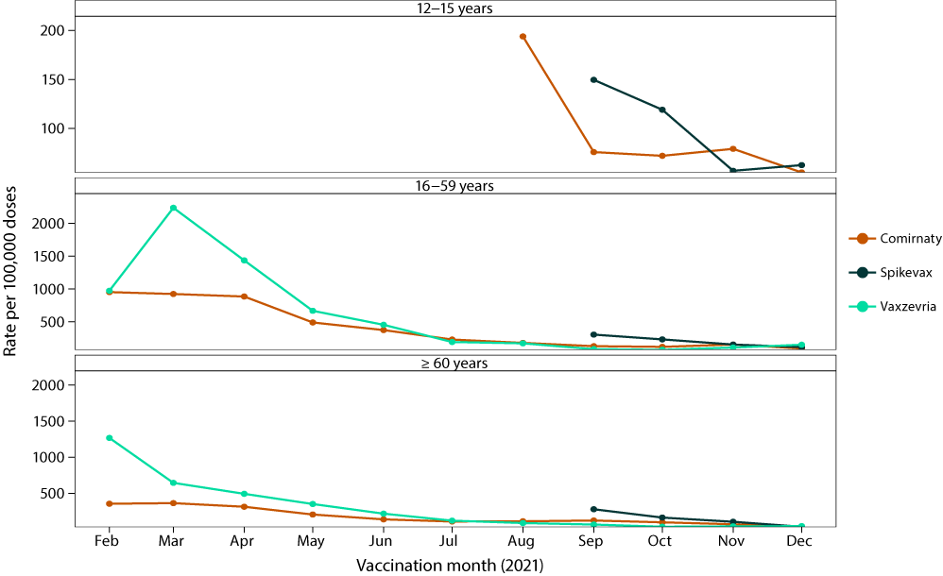
a Reports are excluded from the figure where the date of vaccination was not recorded, or vaccination was recorded for January 2021; where Spikevax vaccination was recorded as before September 2021; where 12–15 year-old adolescent vaccination was recorded as before August 2021; and where Vaxzevria vaccination was recorded for adolescents aged 12–15 years or in February.
Figure A.2: Adverse event following immunisation (AEFI) reporting rates per 100,000 COVID-19 vaccine doses in 2021, by brandª
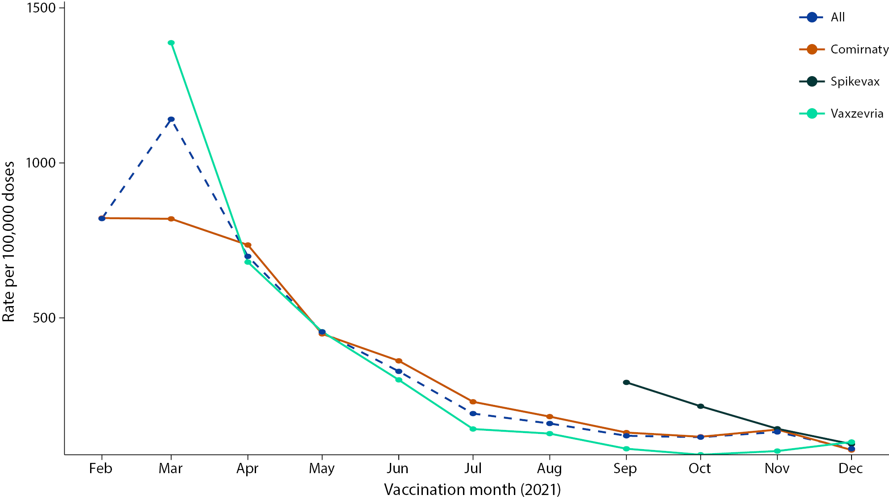
a Reports are excluded from the figure where the date of vaccination was not recorded, or vaccination was recorded for January 2021; or where Spikevax vaccination was recorded as before September 2021; or Vaxzevria vaccination was recorded as before March 2021.

About Communicable Diseases Intelligence
Communicable Diseases Intelligence (CDI) is a peer-reviewed scientific journal published by the Health Protection Policy & Surveillance Division, Department of Health and Aged Care. The journal aims to disseminate information on the epidemiology, surveillance, prevention and control of communicable diseases of relevance to Australia.
© 2024 Commonwealth of Australia as represented by the Department of Health and Aged Care
ISSN: 2209-6051 Online
This journal is indexed by Index Medicus and Medline.
This publication is licensed under a Creative Commons Attribution-NonCommercial-NoDerivatives 4.0 International Licence (CC BY-NC-ND) available from https://creativecommons.org/licenses/by-nc-nd/4.0/legalcode (Licence). You must read and understand the Licence before using any material from this publication.
Restrictions
The Licence does not cover, and there is no permission given for, use of any of the following material found in this publication (if any):
- the Commonwealth Coat of Arms (by way of information, the terms under which the Coat of Arms may be used can be found at www.pmc.gov.au/resources/commonwealth-coat-arms-information-and-guidelines);
- any logos (including the Department of Health and Aged Care’s logo) and trademarks;
- any photographs and images;
- any signatures; and
- any material belonging to third parties.
Disclaimer
Opinions expressed in Communicable Diseases Intelligence are those of the authors and not necessarily those of the Australian Government Department of Health and Aged Care or the Communicable Diseases Network Australia. Data may be subject to revision.
Enquiries
Enquiries regarding any other use of this publication should be addressed to the CDI Editor at: cdi.editor@health.gov.au
Communicable Diseases Network Australia
Communicable Diseases Intelligence contributes to the work of the Communicable Diseases Network Australia. www.health.gov.au/cdna
Editor: Christina Bareja • Deputy Editor: Simon Petrie • Design and Production: Lisa Thompson
Editorial Advisory Board: David Durrheim, Mark Ferson, Clare Huppatz, John Kaldor, Martyn Kirk, Meru Sheel and Stephanie Williams
Contacts
CDI is produced by:
Health Protection Policy & Surveillance Division, Australian Government Department of Health and Aged Care,
GPO Box 9848, (MDP 6) CANBERRA ACT 2601
Website: www.health.gov.au/cdi
Email: cdi.editor@health.gov.au
Submit an Article
You are invited to submit your next communicable disease related article to the Communicable Diseases Intelligence (CDI) for consideration. More information regarding CDI can be found at: www.health.gov.au/cdi.
Further enquiries should be directed to: cdi.editor@health.gov.au

