COVID-19 Australia: Epidemiology Report 64
Reporting period ending 31 July 2022
COVID-19 National Incident Centre Surveillance Team

Summary

Four-week reporting period (4–31 July 2022)
As of report 62 onward, the case data provided in this report includes both confirmed cases and probable cases (cases positive via rapid antigen test) reported to the National Notifiable Diseases Surveillance System (NNDSS), unless otherwise specified. Case definitions for confirmed and probable cases are in accordance with the coronavirus disease 2019 (COVID-19) Series of National Guidelines for Public Health Units (SoNG).
At the time of extraction, probable cases were not yet available from the Northern Territory, or Tasmania; nor from Victoria since 29 July 2022. At the time of extraction, Queensland was only reporting probable cases with a rapid antigen test conducted in a clinical setting; probable cases with a self-administered rapid antigen test were not reported to NNDSS. Due to transmission issues, data are incomplete for confirmed cases from Western Australia since 29 June 2022.
Trends – Nationally, weekly case numbers increased from late June 2022 until the week ending 24 July 2022. In the reporting period 4–31 July 2022, there were 426,919 confirmed and 550,375 probable cases of COVID-19 reported in Australia to NNDSS. In the most recent reporting fortnight, a total of 517,430 confirmed and probable cases were notified (an average of 36,959 cases per day), compared to 459,864 in the previous fortnight (32,847 cases per day).
Age group – In the reporting period 4–31 July 2022, the highest case rate was observed among adults aged 90 years and over, whilst the lowest rate was among children aged 12 to 15 years. Over the first three weeks of the reporting period, case rates increased across all age groups, prior to stabilising or decreasing in the final week. For the entire Omicron wave to date (15 December 2021 – 31 July 2022), the highest case notification rate has been in adults aged 18 to 29 years.
Aboriginal and Torres Strait Islander persons – In the reporting period 4–31 July 2022, there were 21,996 new cases notified in Aboriginal and Torres Strait Islander people. In the entire Omicron wave to date (15 December 2021 – 31 July 2022), there have been 247,300 cases of COVID-19 notified in Aboriginal and Torres Strait Islander people, representing 3% of all cases (247,300 / 7,928,353) reported to NNDSS.
Severity – The overall crude case fatality rate in the current BA.5 wave is 0.11%, which is similar to the rate observed during the BA.2 (0.09%) and BA.1 (0.14%) waves, and notably lower than the rate observed during the Delta wave (0.70%). In the current reporting period, there was one notified case of paediatric inflammatory multisystem syndrome temporally associated with SARS-CoV-2 (PIMS-TS).

Keywords: SARS-CoV-2; novel coronavirus; 2019-nCoV; coronavirus disease 2019; COVID-19; acute respiratory disease; epidemiology; Australia
Virology - For samples collected in the four-week period 4–31 July 2022, all sequences were assigned against Omicron or recombinants consisting of two Omicron lineages, with BA.5 constituting 73% (3,651/ 5,001) of sequences during this period. BA.5 is now the predominant sub-lineage being sequenced, and the proportion of BA.2 sequences has decreased substantially. Of the Omicron sequences in AusTrakka to date, 34.9% are BA.1; 52.4% are BA.2; 9.9% are BA.5; and the remaining sequences were made up of BA.3 and BA.4.
Acute respiratory illness – Based on self-reported FluTracking data, the prevalence of fever and cough in the community over this reporting period decreased from a peak of 3.1% in the week ending 10 July 2022 to 2.3% in the week ending 31 July 2022. There was also an overall decrease in the prevalence of runny nose and sore throat symptoms, decreasing to 1.7% in the most recent reporting week.
International situation – According to the World Health Organization (WHO), cumulative global COVID-19 cases stood at over 574 million, with over 6.3 million deaths reported globally, as of 31 July 2022. In Australia’s near region, the South East Asia and Western Pacific Regions reported 8,017,210 cases and 9,020 deaths in the four-week period to 31 July 2022. Compared to the previous four-week reporting period, new cases increased substantially in both South East Asia and the Western Pacific, whilst new deaths increased significantly in South East Asia and remained stable in the Western Pacific.
This reporting period covers the four-week period of 4–31 July 2022. Within this period, data for each week is compared. The previous reporting period was the preceding four weeks (6 June – 3 July 2022).¹ The focus of this report is on the epidemiological situation in Australia since the beginning of the current Omicron wave. For the purposes of this report, 15 December 2021 is used as a proxy for the beginning of this wave. This date was chosen as, from this date onwards, the majority of sequenced cases were Omicron. Readers are encouraged to consult prior reports in this series for information on the epidemiology of COVID-19 in Australia.
From report 46 onward, and unless otherwise specified, tabulated data and data within the text, except those relating to severity, are extracted from the National Notifiable Diseases Surveillance System (NNDSS) based on ‘notification received date’ rather than ‘diagnosis date’ (see the Technical Supplement for definitions).² As a case’s diagnosis date can be several days prior to the date of its notification, there is potential for newly-notified cases to be excluded from the case count in the current reporting period when reporting by ‘diagnosis date’. Using ‘notification received date’ ensures that the case count for the reporting period better reflects the number of newly-notified cases. From report 64 onward, all figures, apart from those relating to severity, are also based on ‘notification received date’ to better reflect the current reported trends in local transmission and to match data within the text. All tables and figures related to severity data extracted from NNDSS are based on ‘diagnosis date’ to better capture the true onset of severe illness and to enable a more accurate understanding of infection risk and disease severity.
From report 59 onwards, cases are no longer separated into ‘locally acquired’ or ‘overseas acquired’. This change in reporting practice has been applied because—as a result of community transmission levels, of the increase in international arrivals, and of reduced quarantine and testing requirements—the ability of jurisdictions to accurately report place of acquisition has been greatly reduced. Accordingly, from report 59 onwards, all case numbers should be interpreted as the aggregate of all places of acquisition.
As of report 62 onward, the case data provided in this report includes both confirmed cases and probable cases reported to the NNDSS. In accordance with the COVID-19 SoNG, a confirmed case requires laboratory definitive evidence. In accordance with the COVID-19 SoNG, a probable case requires laboratory suggestive evidence. For the purposes of this report, only probable cases from 5 January 2022 are included.
Due to the dynamic nature of the NNDSS, numbers may be subject to revision and may vary from numbers previously reported and from case notifications released by states and territories.

Background and data sources
See the Technical Supplement for general information on COVID-19 including modes of transmission, common symptoms, and severity.²

Activity

COVID-19 trends

(NNDSS and jurisdictional reporting to the National Incident Centre)
Cumulatively, from the beginning of the pandemic to 31 July 2022, jurisdictions within Australia have reported 9,377,409 COVID-19 cases to the National Incident Centre (Table 1). In the same time period, there have been 4,559,867 confirmed and 3,630,350 probable cases of COVID-19 reported to NNDSS nationally. The difference in these case numbers arises because probable cases are not yet systematically reported by all jurisdictions to NNDSS. The analyses in this report include both confirmed and probable cases reported to the NNDSS, unless otherwise specified.
In the four-week period 4–31 July 2022, there were 426,919 confirmed and 550,375 probable cases of COVID-19 reported in Australia to NNDSS. In the most recent reporting fortnight, a total of 517,430 confirmed and probable cases were notified (an average of 36,959 cases per day), compared to 459,864 in the previous fortnight (32,847 cases per day). In the week ending 31 July 2022, case rates were highest in the Australian Capital Territory at 1,364 per 100,000 population per week, followed by South Australia (1,288 per 100,000 population per week).
Table 1: Confirmed and probable COVID-19 cases by jurisdiction, 1 January 2020 – 31 July 2022^{a,b}
 | Australia (total) | ACT | NSW | NT | Qld | SA | Tas. | Vic. | WA
Cases – PCR confirmed | 4,546,924 | 113,311 | 1,780,959 | 20,533 | 596,852 | 425,607 | 54,515 | 1,102,151 | 452,996
Cases – RAT probable | 4,830,485 | 77,536 | 1,406,178 | 70,462 | 891,317 | 277,788 | 176,485 | 1,318,769 | 611,950
Cases – total | 9,377,409 | 190,847 | 3,187,137 | 90,995 | 1,488,169 | 703,395 | 231,000 | 2,420,920 | 1,064,946
a Source: jurisdictional reporting to the National Incident Centre.
b ACT: Australian Capital Territory; NSW: New South Wales; NT: Northern Territory; Qld: Queensland; SA: South Australia; Tas.: Tasmania; Vic.: Victoria; WA: Western Australia.

Table 2: Confirmed and probable COVID-19 cases by jurisdiction and date of notification, Australia, 15 December 2021 – 31 July 2022^{a,b}
Jurisdiction | Reporting period |  |  |  |  |  | Current Omicron wave
 | 4–17 July 2022 |  |  | 18–31 July 2022 |  |  | 15 December 2021 – 31 July 2022
 | Confirmed | Probable | Total | Confirmed | Probable | Total | Confirmed | Probable | Total
ACT | 9,626  (56.8%) | 7,321  (43.2%) | 16,947 | 7,150  (55.8%) | 5,660  (44.2%) | 12,810 | 112,404  (58.9%) | 78,547  (41.1%) | 190,951
NSW | 80,030  (51.1%) | 76,563  (48.9%) | 156,593 | 94,813  (49.1%) | 98,161  (50.9%) | 192,974 | 1,686,528  (57.6%) | 1,243,121  (42.4%) | 2,929,649
NT^{c} | 690  (99.3%) | 5  (0.7%) | 695 | 670  (99.7%) | 2  (0.3%) | 672 | 17,799  (99.6%) | 66  (0.4%) | 17,865
Qld^{c} | 16,251  (78.8%) | 4,361  (21.2%) | 20,612 | 35,629  (86.2%) | 5,718  (13.8%) | 41,347 | 609,414  (91.3%) | 57,799  (8.7%) | 667,213
SA | 25,133  (46.0%) | 29,537  (54.0%) | 54,670 | 26,443  (49.5%) | 27,012  (50.5%) | 53,455 | 426,388  (59.6%) | 289,457  (40.4%) | 715,845
Tas.^{c} | 3,861  (100.0%) | 0  (0.0%) | 3,861 | 3,176  (100.0%) | 0  (0.0%) | 3,176 | 53,504  (100.0%) | 0  (0.0%) | 53,504
Vic.^{c} | 38,488  (28.0%) | 98,892  (72.0%) | 137,380 | 40,538  (28.5%) | 101,552  (71.5%) | 142,090 | 956,730  (42.0%) | 1,320,782  (58.0%) | 2,277,512
Wa^{d} | 18,355  (26.6%) | 50,751  (73.4%) | 69,106 | 26,066  (36.8%) | 44,840  (63.2%) | 70,906 | 452,682  (42.1%) | 623,132  (57.9%) | 1,075,814
Australia | 192,434  (41.8%) | 267,430  (58.2%) | 459,864 | 234,485  (45.3%) | 282,945  (54.7%) | 517,430 | 4,315,449  (54.4%) | 3,612,904  (45.6%) | 7,928,353
a Source: NNDSS extract from 3 August 2022 for notifications from 15 December 2021 to 31 July 2022.
b ACT: Australian Capital Territory; NSW: New South Wales; NT: Northern Territory; Qld: Queensland; SA: South Australia; Tas.: Tasmania; Vic.: Victoria; WA: Western Australia.
c At the time of extraction, probable cases were not yet available from the Northern Territory, or Tasmania; nor from Victoria since 29 July. At the time of extraction, Queensland was only reporting cases where testing was conducted in a clinical setting; probable cases with self-administered testing were not reported to NNDSS.
d Due to transmission issues, data are incomplete for confirmed cases from Western Australia since 29 June 2022.
Since the emergence of the Omicron variant in Australia, there have so far been three distinct waves of transmission, defined by the predominant Omicron subvariant circulating. The first wave, driven by the BA.1 subvariant, occurred from mid-December 2021 to February 2022, with a peak in cases observed in early January 2022. From March 2022, the BA.2 subvariant was the predominant strain; in this second Omicron wave, there was a primary peak in early April and a secondary peak in late May 2022. In early July 2022, BA.5 (including sub-lineages) became the predominant subvariant detected in Australia, driving a third wave of transmission, with an apparent peak in the week ending 24 July 2022. Case numbers since January 2022 are an underestimate, as probable cases are not yet systematically reported from all jurisdictions.

Figure 1: Confirmed and probable weekly COVID-19 notified cases by notification date, Australia, 29 November 2021 – 31 July 2022ª
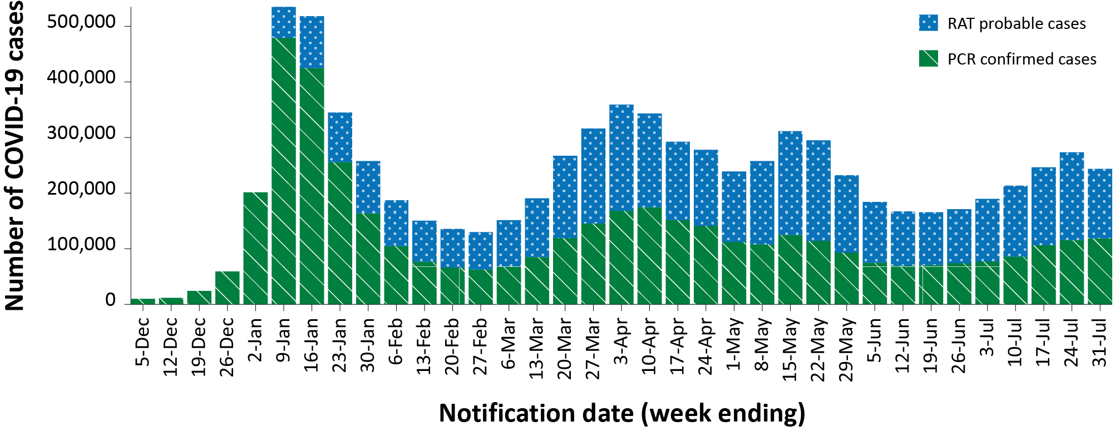
a Source: NNDSS extract from 3 August 2022 for notifications from 29 November 2021 to 31 July 2022. At the time of extraction, probable cases were not yet available from the Northern Territory, or Tasmania; nor from Victoria since 29 July. At the time of extraction, Queensland was only reporting cases where testing was conducted in a clinical setting; probable cases with self-administered testing were not reported to NNDSS. Due to transmission issues, data are incomplete for confirmed cases from Western Australia since 29 June 2022.

Demographic features

(NNDSS)
In the reporting period 4–31 July 2022, the highest case rate was observed among adults aged 90 years and over, whilst the lowest rate was among children aged 12 to 15 years (Appendix A, Table A.1). Over the first three weeks of the reporting period, case rates increased across all age groups, prior to stabilising or decreasing in the final week (Figure 2a). For the entire Omicron wave to date (15 December 2021 – 31 July 2022), the highest case rate has been in adults aged 18 to 29 years. For this age group, the weekly notification rate peaked in the week ending 9 January 2022 at 5,605 cases per 100,000 population. Among paediatric age groups, the highest notification rate during the reporting period was in children aged 12 to 17 years (Figure 2b).

Figure 2: Confirmed and probable COVID-19 case rates for (a) all ages and (b) children, by age group by notification week, Australia, 29 November 2021 – 31 July 2022ª
a
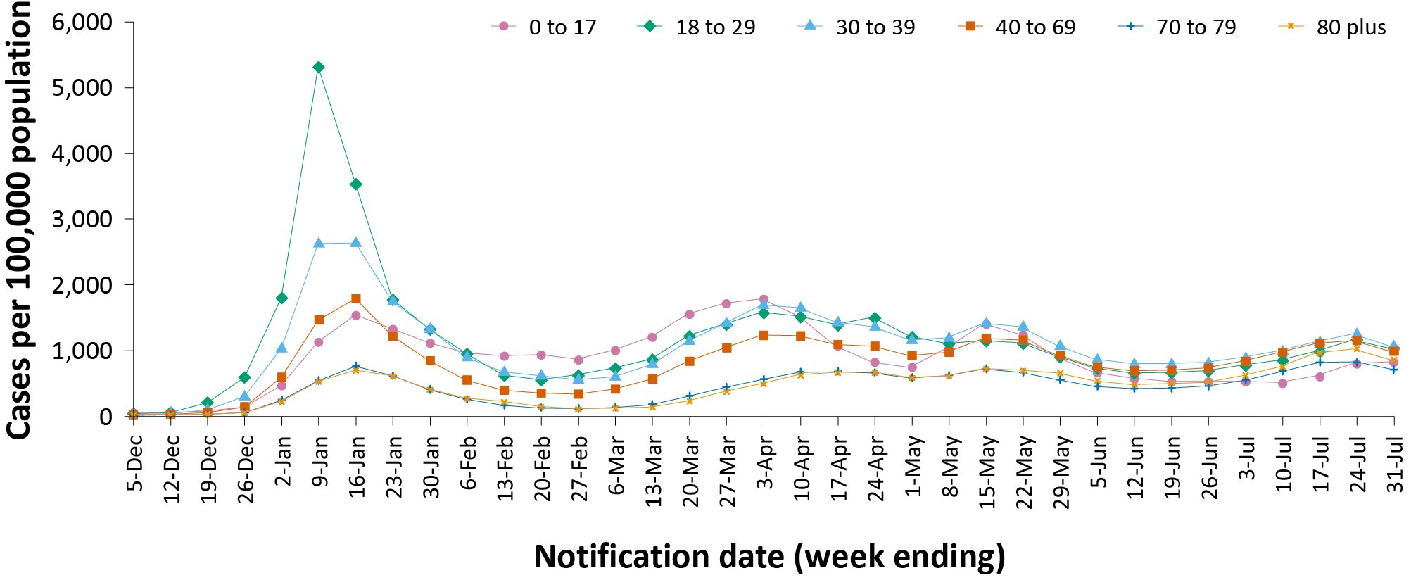
b
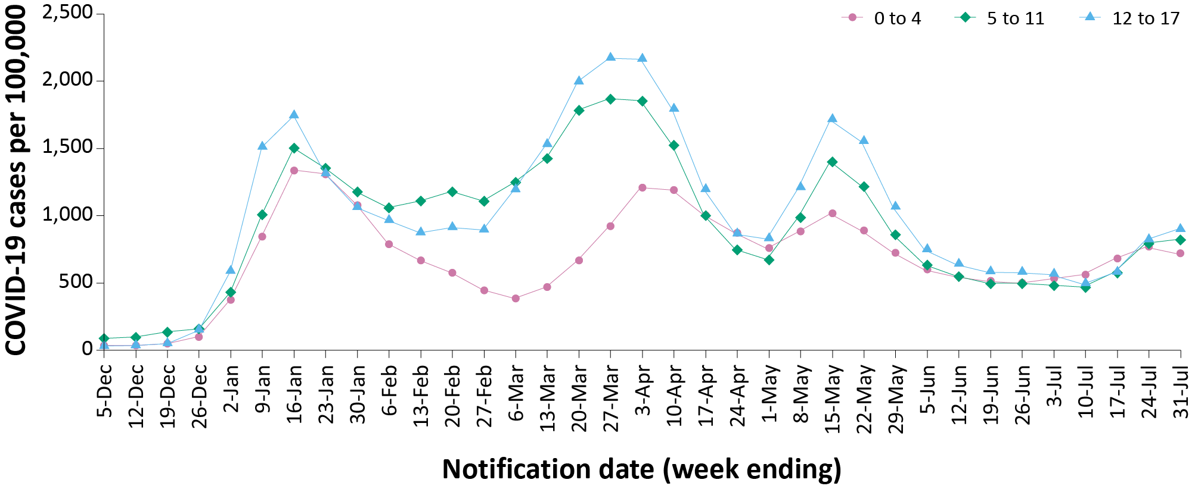
a Source: NNDSS extract from 3 August 2022 for notifications from 29 November 2021 to 31 July 2022. At the time of extraction, probable cases were not yet available from the Northern Territory, or Tasmania; nor from Victoria since 29 July. At the time of extraction, Queensland was only reporting cases that were conducted in a clinical setting; self-administered probable cases were not reported to NNDSS. Due to transmission issues, data are incomplete for confirmed cases from Western Australia since 29 June 2022.

Aboriginal and Torres Strait Islander persons

(NNDSS)
Overall, since the start of the pandemic, Indigenous status is unknown for approximately 17% of COVID-19 cases. Therefore, the number of cases classified as Aboriginal and Torres Strait Islander people is likely an under-representation. During the reporting period, there were 21,996 new COVID-19 cases notified in Aboriginal and Torres Strait Islander people (Table 3). In the current Omicron wave (15 December 2021 – 31 July 2022) there have been 247,300 cases of COVID-19 notified in Aboriginal and Torres Strait Islander people, representing 3% (247,300/7,928,353) of all COVID-19 cases in the Omicron wave to date.
Table 3: Confirmed and probable cases of COVID-19 among Aboriginal and Torres Strait Islander peoples by jurisdiction and date of notification, Australia, 15 December 2021 – 31 July 2022ª
Jurisdiction | 4–10 July 2022 | 11–17 July 2022 | 18–24 July 2022 | 25–31 July 2022 | 15 December 2021 – 31 July 2022 (Omicron wave)
Australian Capital Territory | 143 | 112 | 124 | 84 | 3,337
New South Wales | 2,066 | 2,248 | 3,539 | 3,395 | 104,060
Northern Territory^{b} | 57 | 72 | 89 | 86 | 3,580
Queensland^{b} | 380 | 613 | 773 | 916 | 36,177
South Australia | 312 | 430 | 545 | 422 | 18,899
Tasmania^{b} | 58 | 57 | 63 | 38 | 1,800
Victoria^{b} | 670 | 841 | 1,038 | 834 | 28,473
Western Australia^{c} | 527 | 460 | 543 | 461 | 50,974
Total | 4,213 | 4,833 | 6,714 | 6,236 | 247,300
a Source: NNDSS extract from 3 August 2022 for notifications from 15 December 2021 to 31 July 2022.
b At the time of extraction, probable cases were not yet available from the Northern Territory, or Tasmania; nor from Victoria since 29 July. At the time of extraction, Queensland was only reporting cases that were conducted in a clinical setting; self-administered probable cases were not reported to NNDSS.
c Due to transmission issues, data are incomplete for confirmed cases from Western Australia since 29 June 2022.
Of the COVID-19 cases notified in Aboriginal and Torres Strait Islander people from 15 December 2021 to date, 50% (124,296/247,300) lived in a regional or remote area (Table 4). It should be noted that the reliance on RATs for diagnosing COVID-19 is greater in regional and remote areas than in major cities, resulting in a larger under-representation of cases in regional and remote areas than in major cities, due to the incomplete capture of probable cases in NNDSS.

Table 4: Confirmed and probable cases of COVID-19 among Aboriginal and Torres Strait Islander people by area of remoteness, Australia, 15 December 2021 – 31 July 2022ª
Jurisdiction^{b,c} | Major city |  |  | Inner regional |  |  | Outer regional |  |  | Remote^{d}
 | Confirmed | Probable | Total | Confirmed | Probable | Total | Confirmed | Probable | Total | Confirmed | Probable | Total
ACT | 1,958  (59.8%) | 1,315  (40.2%) | 3,273 | 20  (76.9%) | 6  (23.1%) | 26 | 4  (50.0%) | 4  (50.0%) | 8 | 1  (100.0%) | 0  (0.0%) | 1
NSW | 33,466  (59.9%) | 22,408  (40.1%) | 55,874 | 15,644  (46.6%) | 17,907  (53.4%) | 33,551 | 4,470  (38.3%) | 7,195  (61.7%) | 11,665 | 795  (33.4%) | 1,586  (66.6%) | 2,381
NT^{e} | 0  (0.0%) | 0  (0.0%) | 0 | 0  (0.0%) | 0  (0.0%) | 0 | 1,063  (99.4%) | 6  (0.6%) | 1,069 | 2,245  (98.5%) | 34  (1.5%) | 2,279
Qld^{e} | 9,111  (95.3%) | 453  (4.7%) | 9,564 | 5,301  (92.4%) | 435  (7.6%) | 5,736 | 8,376  (57.5%) | 6,201  (42.5%) | 14,577 | 1,583  (25.4%) | 4,657  (74.6%) | 6,240
SA | 6,057  (60.2%) | 4,003  (39.8%) | 10,060 | 1,033  (51.9%) | 956  (48.1%) | 1,989 | 2,296  (57.2%) | 1,720  (42.8%) | 4,016 | 1,846  (69.3%) | 816  (30.7%) | 2,662
Tas.^{e} | 16  (100.0%) | 0  (0.0%) | 16 | 1,233  (100.0%) | 0  (0.0%) | 1,233 | 530  (100.0%) | 0  (0.0%) | 530 | 12  (100.0%) | 0  (0.0%) | 12
Vic.^{e} | 5,788  (35.5%) | 10,512  (64.5%) | 16,300 | 2,204  (24.1%) | 6,934  (75.9%) | 9,138 | 530  (17.7%) | 2,459  (82.3%) | 2,989 | 1  (8.3%) | 11  (91.7%) | 12
Wa^{f} | 9,635  (36.7%) | 16,635  (63.3%) | 26,270 | 1,118  (30.9%) | 2,496  (69.1%) | 3,614 | 1,250  (20.0%) | 4,998  (80.0%) | 6,248 | 4,554  (31.8%) | 9,766  (68.2%) | 14,320
Australia | 66,031  (54.4%) | 55,326  (45.6%) | 121,357 | 26,553  (48.0%) | 28,734  (52.0%) | 55,287 | 18,519  (45.1%) | 22,583  (54.9%) | 41,102 | 11,037  (39.5%) | 16,870  (60.5%) | 27,907
a Source: NNDSS extract from 3 August 2022 for notifications from 15 December 2021 to 31 July 2022. Excludes cases with an overseas place of residence, and where place of residence is unknown.
b ACT: Australian Capital Territory; NSW: New South Wales; NT: Northern Territory; Qld: Queensland; SA: South Australia; Tas.: Tasmania; Vic.: Victoria; WA: Western Australia.
c Cases are classified based on jurisdiction of notification not jurisdiction of residence. Some cases are notified to a different jurisdiction to their location of residence.
d ‘Remote’ here also includes areas classified as ‘very remote’.
e At the time of extraction, probable cases were not yet available from the Northern Territory, or Tasmania; nor from Victoria since 29 July. At the time of extraction, Queensland was only reporting cases that were conducted in a clinical setting; self-administered probable cases were not reported to NNDSS.
f Due to transmission issues, data are incomplete for confirmed cases from Western Australia since 29 June 2022.
Nationally, there have been 212 COVID-19 associated deaths reported in Aboriginal and Torres Strait Islander people from the start of the pandemic to 31 July 2022. This comprises 66 from New South Wales, 60 from Queensland, 34 from the Northern Territory, 27 from Western Australia, 12 from Victoria, 11 from South Australia and two from the Australian Capital Territory. An additional 447 Aboriginal and Torres Strait Islander cases have been admitted to intensive care units (ICU) nationally. During the Omicron wave to date, the overall notification rate, to NNDSS, of severe cases (measured as those who were admitted to ICU or died) in Aboriginal and Torres Strait Islander people was 60 per 100,000 population, compared to 17 per 100,000 population during the Delta wave (Table 5). The higher rates of severe illness during the Omicron wave may be attributed to the significantly higher levels of disease transmission in the community during the Omicron wave, rather than the Omicron variant inherently causing more severe illness compared to the Delta variant. Note that ICU status in NNDSS is likely incomplete.

Table 5: Confirmed and probable COVID-19 cases in Aboriginal and Torres Strait Islander people by age and highest level of illness severity, Australia, 1 January 2020 to 31 July 2022
Age group (years) | 15 December 2021 – 31 July 2022  (Omicron wave) |  |  |  | 16 June 2021 – 14 December 2021  (Delta wave) |  |  |  | 1 January 2020 – 31 July 2022  (Pandemic to date)
 | ICUª | Diedª | ICU  or  diedª | Rate ICU  or  died^{b} | ICUª | Diedª | ICU  or  diedª | Rate ICU  or  died^{b} | ICUª | Diedª | ICU  or  diedª | Rate ICU  or  died^{b}
0–17 | 39 | 1 | 39 | 12 | 8 | 0 | 8 | 2 | 47 | 1 | 47 | 14
18–59 | 182 | 63 | 236 | 57 | 86 | 11 | 90 | 22 | 269 | 74 | 327 | 78
60+ | 102 | 123 | 201 | 356 | 27 | 14 | 34 | 60 | 131 | 137 | 237 | 420
All | 323 | 187 | 476 | 60 | 121 | 25 | 132 | 17 | 447 | 212 | 611 | 77
a ‘ICU’ and ‘died’ are not mutually exclusive categories; ‘died’ can include cases who died with or without prior admission to ICU. Therefore, the number of cases admitted to ICU or having died will not equal the sum of cases in ICU or died.
b Rate per 100,000 population for the given time period.

Vaccinations

(Department of Health and Aged Care)
As of 31 July 2022, a total of 62,318,828 doses of COVID-19 vaccine had been administered (Table 6), of which 39,478,683 doses were administered by the Commonwealth in primary care or aged care and disability facilities. Nationally, the number of eligible people who have had three or more doses was 14,097,289 (71.3%). Nationally, 19,818,587 people aged 16 years and over (> 95%) were fully vaccinated. Among children aged 12–15 years, 1,044,806 (84.0%) had received at least one dose, including 988,223 (79.4%) who were fully vaccinated. Among children aged 5–11 years, 1,189,216 (52.2%) had received at least one dose, including 923,813 (40.6%) who were fully vaccinated.

Table 6: Total number of vaccinations administered, by jurisdiction, Australia, as at 31 July 2022ª
Jurisdiction^{b} | Total number of doses administered | Percentage of eligible people who have had three or more doses
Australian Capital Territory | 1,638,832 | 79.7%
New South Wales | 19,364,004 | 69.0%
Northern Territory | 606,363 | 78.5%
Queensland | 11,820,556 | 64.3%
South Australia | 4,352,872 | 75.1%
Tasmania | 1,418,613 | 73.8%
Victoria | 16,290,083 | 73.5%
Western Australia | 6,827,505 | 82.8%
Total | 62,318,828 | 71.3%
a Source: Australian Government Department of Health and Aged Care website.³
b ‘Jurisdiction’ refers to state/territory of residence.

Severity

(NNDSS, FluCAN, SPRINT-SARI)
Given the delay between illness onset and severe illness, and so as to provide a more accurate assessment of severity, cases with an onset in the last two weeks have been excluded from analyses on the weekly rate of cases with severe illness (defined as cases admitted to ICU or died) and on the proportion of cases admitted to ICU or died.
In the current wave, the notification rate of cases with severe illness peaked in the week ending 16 January 2022, at approximately 4.5 severe cases per 100,000 population per week (Figure 3). Since early May 2022, severe cases have remained relatively stable at approximately 1.1 cases per 100,000 population per week. Rates of severe cases continue to be greater in older age groups (Figure 4).

Figure 3: COVID-19 cases, deaths and ICU admissions, Australia, by date of onset, Australia, 31 May 2021 to 31 July 2022^{a,b}
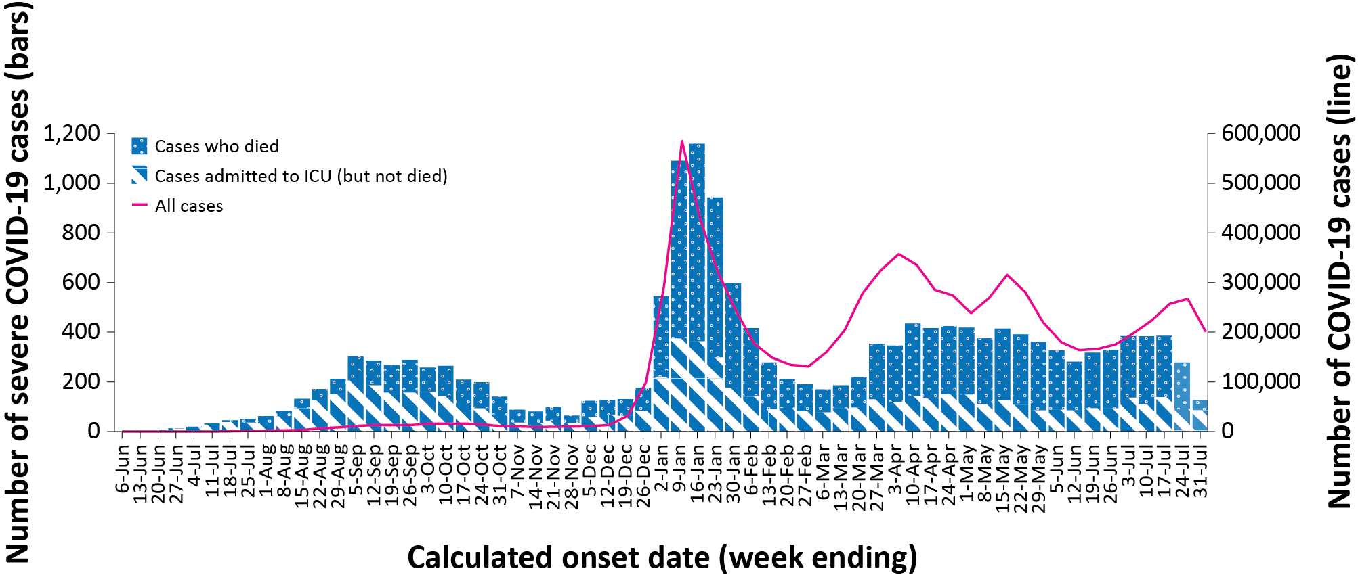
a Source: NNDSS extract from 3 August 2022 for notifications to 31 July 2022. At the time of extraction, probable cases were not yet available from the Northern Territory, or Tasmania; nor from Victoria since 29 July. At the time of extraction, Queensland was only reporting cases that were conducted in a clinical setting; self-administered probable cases were not reported to NNDSS. Due to transmission issues, data are incomplete for confirmed cases from Western Australia since 29 June 2022.
b The shaded bars at the right represent the most recent two reporting weeks and should be interpreted with caution, as cases with an illness onset in these weeks may not have yet developed severe disease.

Figure 4: Age-specific rates of COVID-19 cases admitted to ICU or died, by date of diagnosis, Australia, 31 May 2021 to 17 July 2022ª
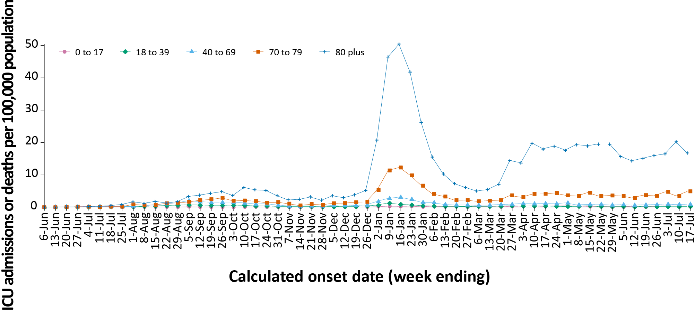
a Source: NNDSS extract from 3 August 2022 for notifications to 31 July 2022. Includes cases with an illness onset from 31 May 2021 to 17 July 2022; cases with an illness onset in the last two weeks (18 July – 31 July 2022) were excluded to account for the delay between onset and development of severe illness.

Hospitalisation and ICU admissions
Between 15 December 2021 and 31 July 2022, there were 6,475 hospital admissions with confirmed COVID-19 reported at Influenza Complications Alert Network (FluCAN) sentinel sites, including 7% (433/6,475) admitted directly to ICU. In the current reporting period to 31 July 2022, there were 502 admissions with COVID-19 reported, including 5% (27/502) who were admitted directly to ICU. From the start of the Omicron wave to 31 July 2022, there were 3,259 COVID-19 cases admitted to ICUs participating in the sentinel surveillance system, Short Period Incidence Study of Severe Acute Respiratory Infection (SPRINT-SARI),⁶ with 282 of these admitted during this reporting period (4–31 July 2022).
Since 15 December 2021, for patients admitted to FluCAN sentinel sites with confirmed COVID-19, the median length of stay was 3 days (interquartile range, IQR: 1–7); mean (standard deviation, SD) = 6.2 days (16.2). This is lower than the median length of stay observed during the Delta wave, which was 6 days (IQR: 3–10); mean (SD) = 8.3 days (16.8).

Risk factors for severe disease
Comorbidity data extracted from SPRINT-SARI reflect the sickest patients with COVID-19 who are managed in ICU; data are therefore not generalisable to all cases (Table 7). In adult patients admitted to ICU with COVID-19 since 15 December 2021, the most prevalent comorbidity was diabetes, followed by cardiac disease and obesity (a body mass index of > 30 or weight over 120 kg). Of those adult patients admitted to ICU since 15 December 2021 for whom comorbidity data was known, 75% (1,617/2,147) had at least one comorbidity; 25% of patients (530/2,147) had none of the listed comorbidities recorded.

Table 7: Comorbidities for adult COVID-19 cases (aged greater than or equal to 18 years) amongst those admitted to ICU, Australia, 15 December 2021 – 31 July 2022ª
Comorbidity | ICU casesª (n = 2,147) (%)
Cardiac disease (n = 2,125) | 530 (25%)
Chronic respiratory condition (n = 2,124)^{b} | 502 (24%)
Diabetes (n = 2,113) | 709 (34%)
Obesity (n = 2,085) | 526 (25%)
Chronic renal disease (n = 2,109) | 329 (16%)
Chronic neurological condition (n = 2,113) | 132 (6%)
Malignancy (n = 2,120) | 256 (12%)
Chronic liver disease (n = 2,118) | 116 (6%)
Immunosuppression (n = 2,100) | 387 (18%)
Number of specified comorbidities (n = 2,147)^{c}
No comorbidities | 530 (25%)
One or more | 1,617 (75%)
Two or more | 1,019 (47%)
Three or more | 535 (25%)
a Source: SPRINT-SARI. Only includes adult cases (≥ 18 years old) and excludes those with missing data on comorbidities or where comorbidity is unknown.
b Includes asthma.
c Includes chronic respiratory conditions, cardiac disease (excluding hypertension), immunosuppressive condition/therapy, diabetes, obesity, liver disease, renal disease and neurological disorder.

Figure 5: PIMS-TS cases reported to PAEDS, by sample month and level of care required, Australia, 1 June 2020 – 31 July 2022ª
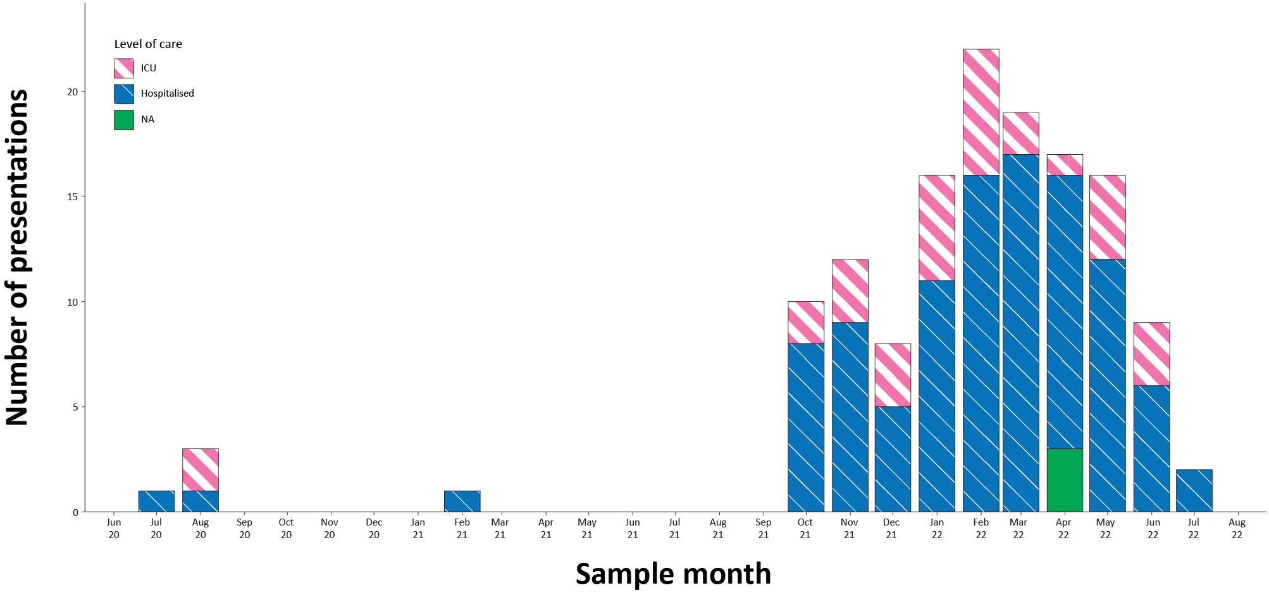 a Source: PAEDS.

PIMS-TS

(PAEDS)
Since the start of the pandemic to 31 July 2022, there have been 136 cases of paediatric inflammatory multisystem syndrome temporally associated with SARS-CoV-2 (PIMS-TS) reported to PAEDS, including 101 cases reported in 2022 and one in the current reporting period. The majority of PIMS-TS cases to date have occurred in those aged 5 to < 12 years (55%; 75/136), followed by those aged 6 months to < 5 years (24%; 33/136). To date, there have been no PIMS-TS associated deaths.

COVID-19 deaths
There were 1,147 COVID-19-associated deaths among COVID-19 cases notified during the reporting period (4–31 July 2022). This brings the total number of COVID-19-associated deaths reported in NNDSS to 11,012 (Table 8). The overall crude case fatality rate in the current BA.5 wave is 0.11%, which is similar to the rate observed during the BA.2 (0.09%) and BA.1 (0.14%) waves, and notably lower than the rate observed during the Delta wave (0.70%) (Table 9).

Table 8: Deaths associated with COVID-19 by reporting period, Australia, 1 January 2020 – 31 July 2022^{a,b}
Jurisdiction^{c} | 4–10 July 2022 | 11–17 July 2022 | 18–24 July 2022 | 25– 31 July 2022 | 15 December 2021 –  31 July 2022  (Omicron wave) | 1 January 2020 –  31 July 2022  (Pandemic to date)
ACT | 3 (1.0%) | 1 (0.3%) | 5 (1.5%) | 3 (1.4%) | 78 (0.9%) | 105 (1.0%)
NSW | 126 (41.7%) | 115 (39.2%) | 137 (41.5%) | 87 (39.2%) | 3,538 (40.5%) | 4,246 (38.6%)
NT^{d} | 2 (0.7%) | 0 (0.0%) | 2 (0.6%) | 1 (0.5%) | 59 (0.7%) | 60 (0.5%)
Qld^{d} | 72 (23.8%) | 66 (22.5%) | 59 (17.9%) | 34 (15.3%) | 1,598 (18.3%) | 1,609 (14.6%)
SA | 0 (0.0%) | 0 (0.0%) | 2 (0.6%) | 1 (0.5%) | 534 (6.1%) | 538 (4.9%)
Tas.^{d} | 1 (0.3%) | 0 (0.0%) | 5 (1.5%) | 1 (0.5%) | 27 (0.3%) | 53 (0.5%)
Vic.^{d} | 93 (30.8%) | 103 (35.2%) | 117 (35.5%) | 95 (42.8%) | 2,617 (30.0%) | 4,114 (37.4%)
WA^{e} | 5 (1.7%) | 8 (2.7%) | 3 (0.9%) | 0 (0.0%) | 278 (3.2%) | 287 (2.6%)
Total | 302 (100.0%) | 293 (100.0%) | 330 (100.0%) | 222 (100.0%) | 8,729 (100.0%) | 11,012 (100.0%)
a Source: NNDSS, extract from 3 August 2022 for deaths to 31 July 2022.
b Deaths are categorised into time periods using date of death. Deaths with a missing date of death are classified using date of illness onset.
c ACT: Australian Capital Territory; NSW: New South Wales; NT: Northern Territory; Qld: Queensland; SA: South Australia; Tas.: Tasmania; Vic.: Victoria; WA: Western Australia.
d At the time of extraction, probable cases were not yet available from the Northern Territory, or Tasmania; nor from Victoria since 29 July. At the time of extraction, Queensland was only reporting cases that were conducted in a clinical setting; self-administered probable cases were not reported to NNDSS.
e Due to transmission issues, data are incomplete for confirmed cases from Western Australia since 29 June 2022

Table 9: COVID-19 associated case fatality rates, among cases notified to NNDSS, by age group and date of onset, 1 January 2020 to 17 July 2022^{a,b}
Age group | BA.5  15 June – 17 July 2022 | BA.2  1 March – 14 June 2022 | BA.1  15 December 2021 – 28 February 2022 | Omicron  15 December 2021 – 17 July 2022 | Delta  16 June – 14 December 2021 | Pandemic  1 January 2020 – 17 July 2022
0–4 | < 0.05% | < 0.05% | < 0.05% | < 0.05% | 0.00% | < 0.05%
5–11 | < 0.05% | 0.00% | < 0.05% | < 0.05% | < 0.05% | < 0.05%
12–15 | 0.00% | 0.00% | < 0.05% | < 0.05% | < 0.05% | < 0.05%
16–17 | 0.00% | < 0.05% | 0.00% | < 0.05% | 0.00% | < 0.05%
18–29 | < 0.05% | < 0.05% | < 0.05% | < 0.05% | < 0.05% | < 0.05%
30–39 | < 0.05% | < 0.05% | < 0.05% | < 0.05% | 0.06% | < 0.05%
40–49 | < 0.05% | < 0.05% | < 0.05% | < 0.05% | 0.19% | < 0.05%
50–59 | < 0.05% | < 0.05% | 0.05% | < 0.05% | 0.66% | < 0.05%
60–69 | 0.07% | 0.10% | 0.25% | 0.13% | 1.94% | 0.18%
70–79 | 0.40% | 0.42% | 1.17% | 0.60% | 6.21% | 0.77%
80–89 | 1.38% | 1.87% | 5.05% | 2.50% | 14.89% | 3.08%
90+ | 3.90% | 5.24% | 10.89% | 6.19% | 27.92% | 7.33%
Unknown | 0.00% | 0.11% | 0.00% | < 0.05% | 0.00% | < 0.05%
Total | 0.11% | 0.09% | 0.14% | 0.11% | 0.70% | 0.14%
a Source: NNDSS, extract from 3 August 2022 for deaths to 31 July 2022. At the time of extraction, probable cases were not yet available from the Northern Territory, or Tasmania; nor from Victoria since 29 July. At the time of extraction, Queensland was only reporting cases that were conducted in a clinical setting; self-administered probable cases were not reported to NNDSS. Due to transmission issues, data are incomplete for confirmed cases from Western Australia since 29 June 2022.
b To account for the lag between illness onset and the development of severe illness, cases with an onset date in the last two weeks have been excluded from calculations of the case fatality rate.

Genomic surveillance and virology

(Communicable Disease Genomics Network, AusTrakka and jurisdictional sequencing laboratories)
Nationally, 2.69% of COVID-19 cases have been sequenced since the start of the pandemic in January 2020, based on jurisdictional reporting (Table 10). Case numbers and sequencing proportion are based on PCR results only, as rapid antigen tests do not allow for sequencing. The significant rise in case numbers nationally during recent reporting periods has required jurisdictional laboratories to move towards sequencing for surveillance purposes, resulting in a drop in the overall sequencing proportion. However, overall output of number of cases sequenced remains similar to, or higher than, previous periods (Figure 6).

Figure 6: Samples in AusTrakka from 7 February 2022 to 31 July 2022, by lineage and date of collectionª
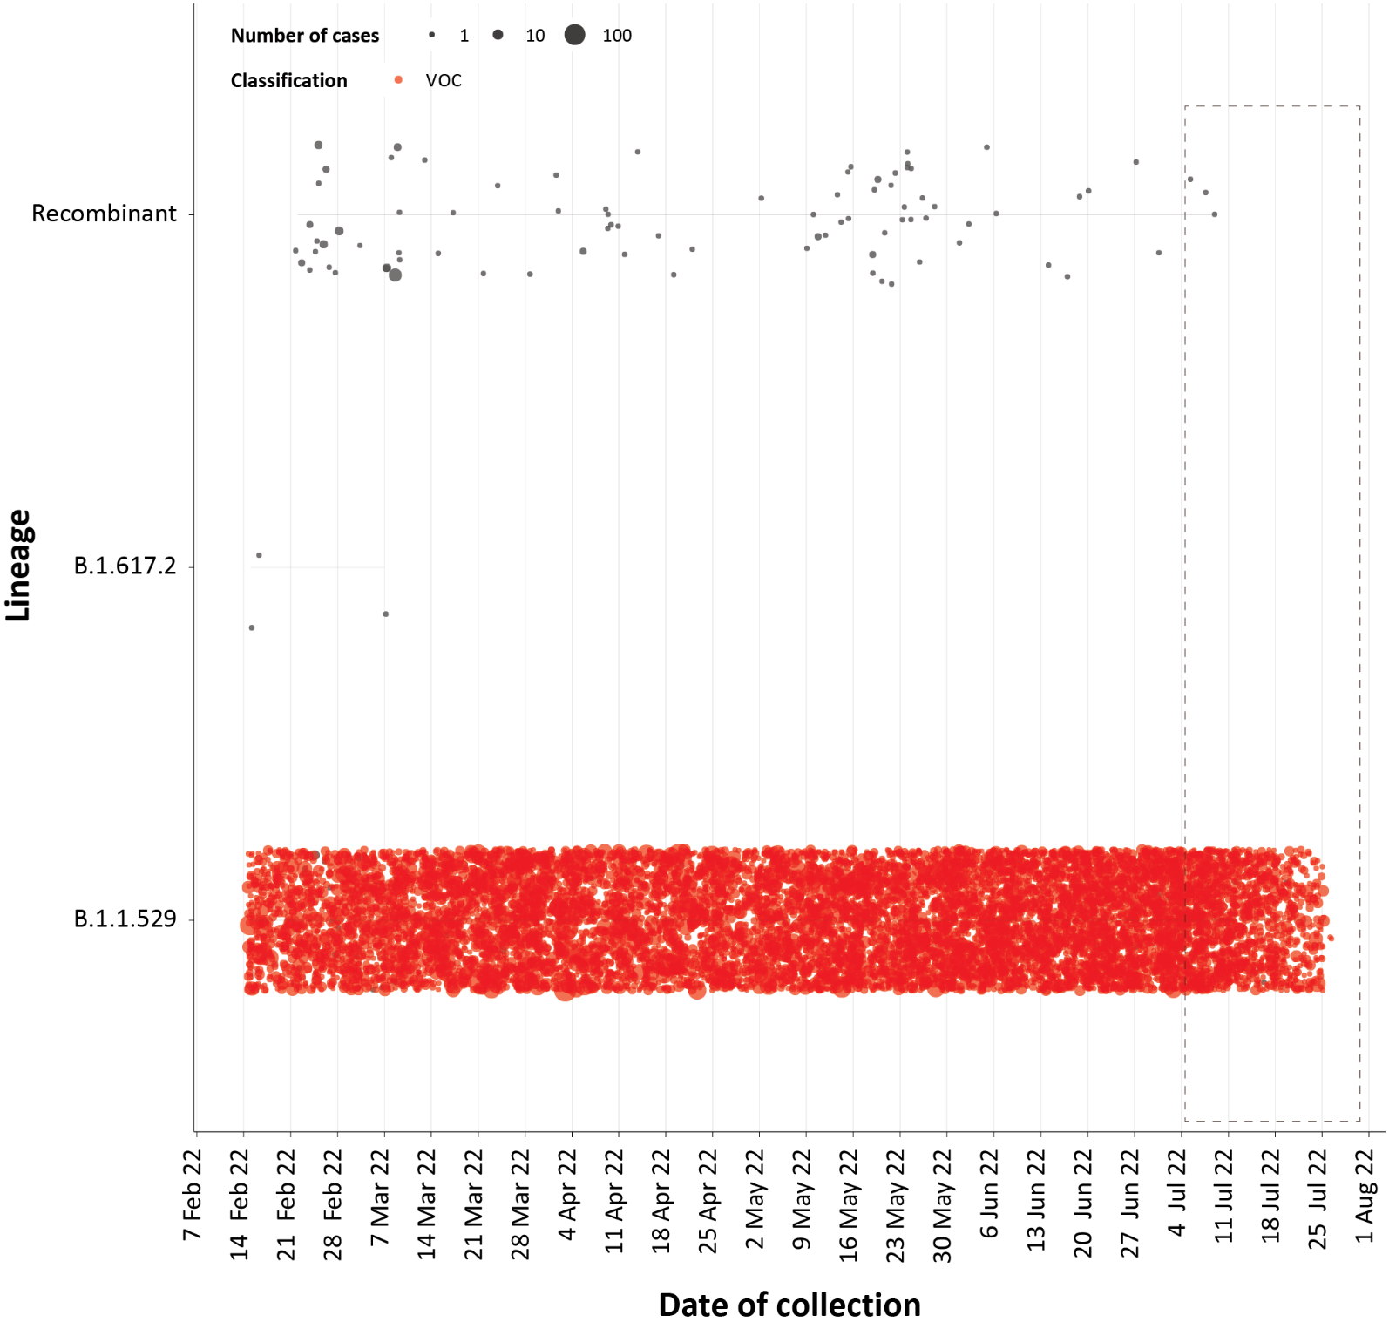
a The current reporting period (4 July to 31 July 2022) is marked by the dashed lines, and variant of concern samples are coloured red. The size of the circle is proportional to the number of samples in the lineage at each time point.

Figure 7: Sequences in AusTrakka by Omicron sub-lineage and collection date, 6 June to 31 July 2022ª
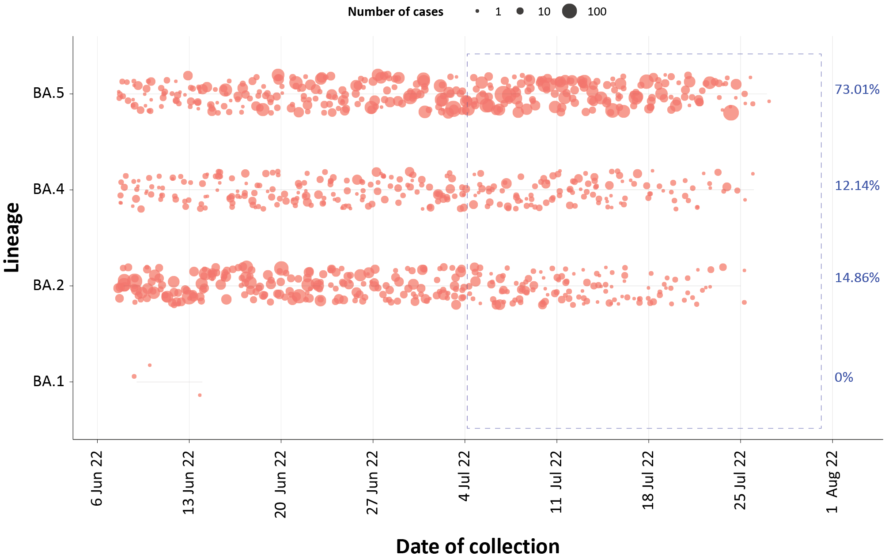
a The current reporting period (4 July to 31 July 2022) is marked by the dashed lines. The size of the circle is proportional to the number of samples in the lineage at each time point.
Table 10: Australian SARS-CoV-2 genome sequences and proportion of positive cases sequenced, 4 July – 31 July 2022 and cumulative to date
Measure | Reporting period  4 July – 31 July 2022 | Cumulative  23 January 2020 – 31 July 2022
SARS-CoV-2 cases sequencedª | 9,846 | 124,098
Percentage of positive cases sequenced^{b} | 2.13% | 2.69%
a Total SARS-CoV-2 case numbers as reported by jurisdictional laboratories based on PCR results only. Cases identified via rapid antigen testing are reported differently by each jurisdiction and cannot be followed up for sequencing. They are therefore not included in the sequencing proportions reported here. Sequencing of samples from cases identified in the reporting period may be in process at the time of reporting. Remaining unsequenced samples may be due to jurisdictional sequencing strategy, or where samples have been deemed unsuitable for sequencing (typically because viral loads were too low for sequencing to be successful).
b Based on individual jurisdictional reports of sequences and case numbers. Calculations of the percentage of cases sequenced based on the number of sequences available in AusTrakka may not always be up-to-date, since this may include duplicate samples from cases and may not represent all available sequence data.

Variants of concern (VOC)
AusTrakka is actively monitoring and reporting on one lineage currently designated as a Variant of Concern (VOC) by international organisations, including the World Health Organization (WHO): Omicron (B.1.1.529). The Omicron variant displays a characteristic set of mutations, including a number of variations in the genomic region encoding the spike protein thought to have the potential to increase transmissibility and/or immune evasion. The CDGN VOC working group demoted four previously-designated VOCs (Alpha (B.1.1.7); Beta (B.1.351), Delta (B.1.617) Gamma (P.1)) due to the sustained absence of any cases in Australia, and very limited prevalence globally. Further information on variants is available in the Technical Supplement.²
All 5,001 sequences from samples collected within the reporting period were assigned to Omicron or recombinants consisting of two Omicron lineages. The predominant sub-lineage is currently BA.5 (3,651/5001). Of the Omicron sequences in AusTrakka to date: 34.9% are BA.1; 52.4% are BA.2; 0.001% are BA.3; 2.8% are BA.4 and 9.9% are BA.5. All sub-sub-lineages have been collapsed into their respective major sub-lineage.

Testing

(State and territory reporting)
From the commencement of the pandemic to 31 July 2022, over 76 million PCR tests for SARS-CoV-2 have been conducted nationally. Jurisdictional PCR testing rates are driven by current case numbers, testing policies and numbers of people experiencing symptoms. The number, rates and percent positivity of RATs cannot be calculated, as there is currently no reporting of negative RATs.
During the four-week reporting period (4–31 July 2022), nearly two million PCR tests were conducted. In the week ending 31 July 2022, PCR percent positivity rates decreased across all jurisdictions, with the exception of Qld, which had the highest positivity at over 40% (Figure 8).

Figure 8: SARS-CoV-2 polymerase chain reaction (PCR) testing rates per 1,000 population and percent positivity by jurisdiction and date of notification, 29 November 2021 – 31 July 2022ª
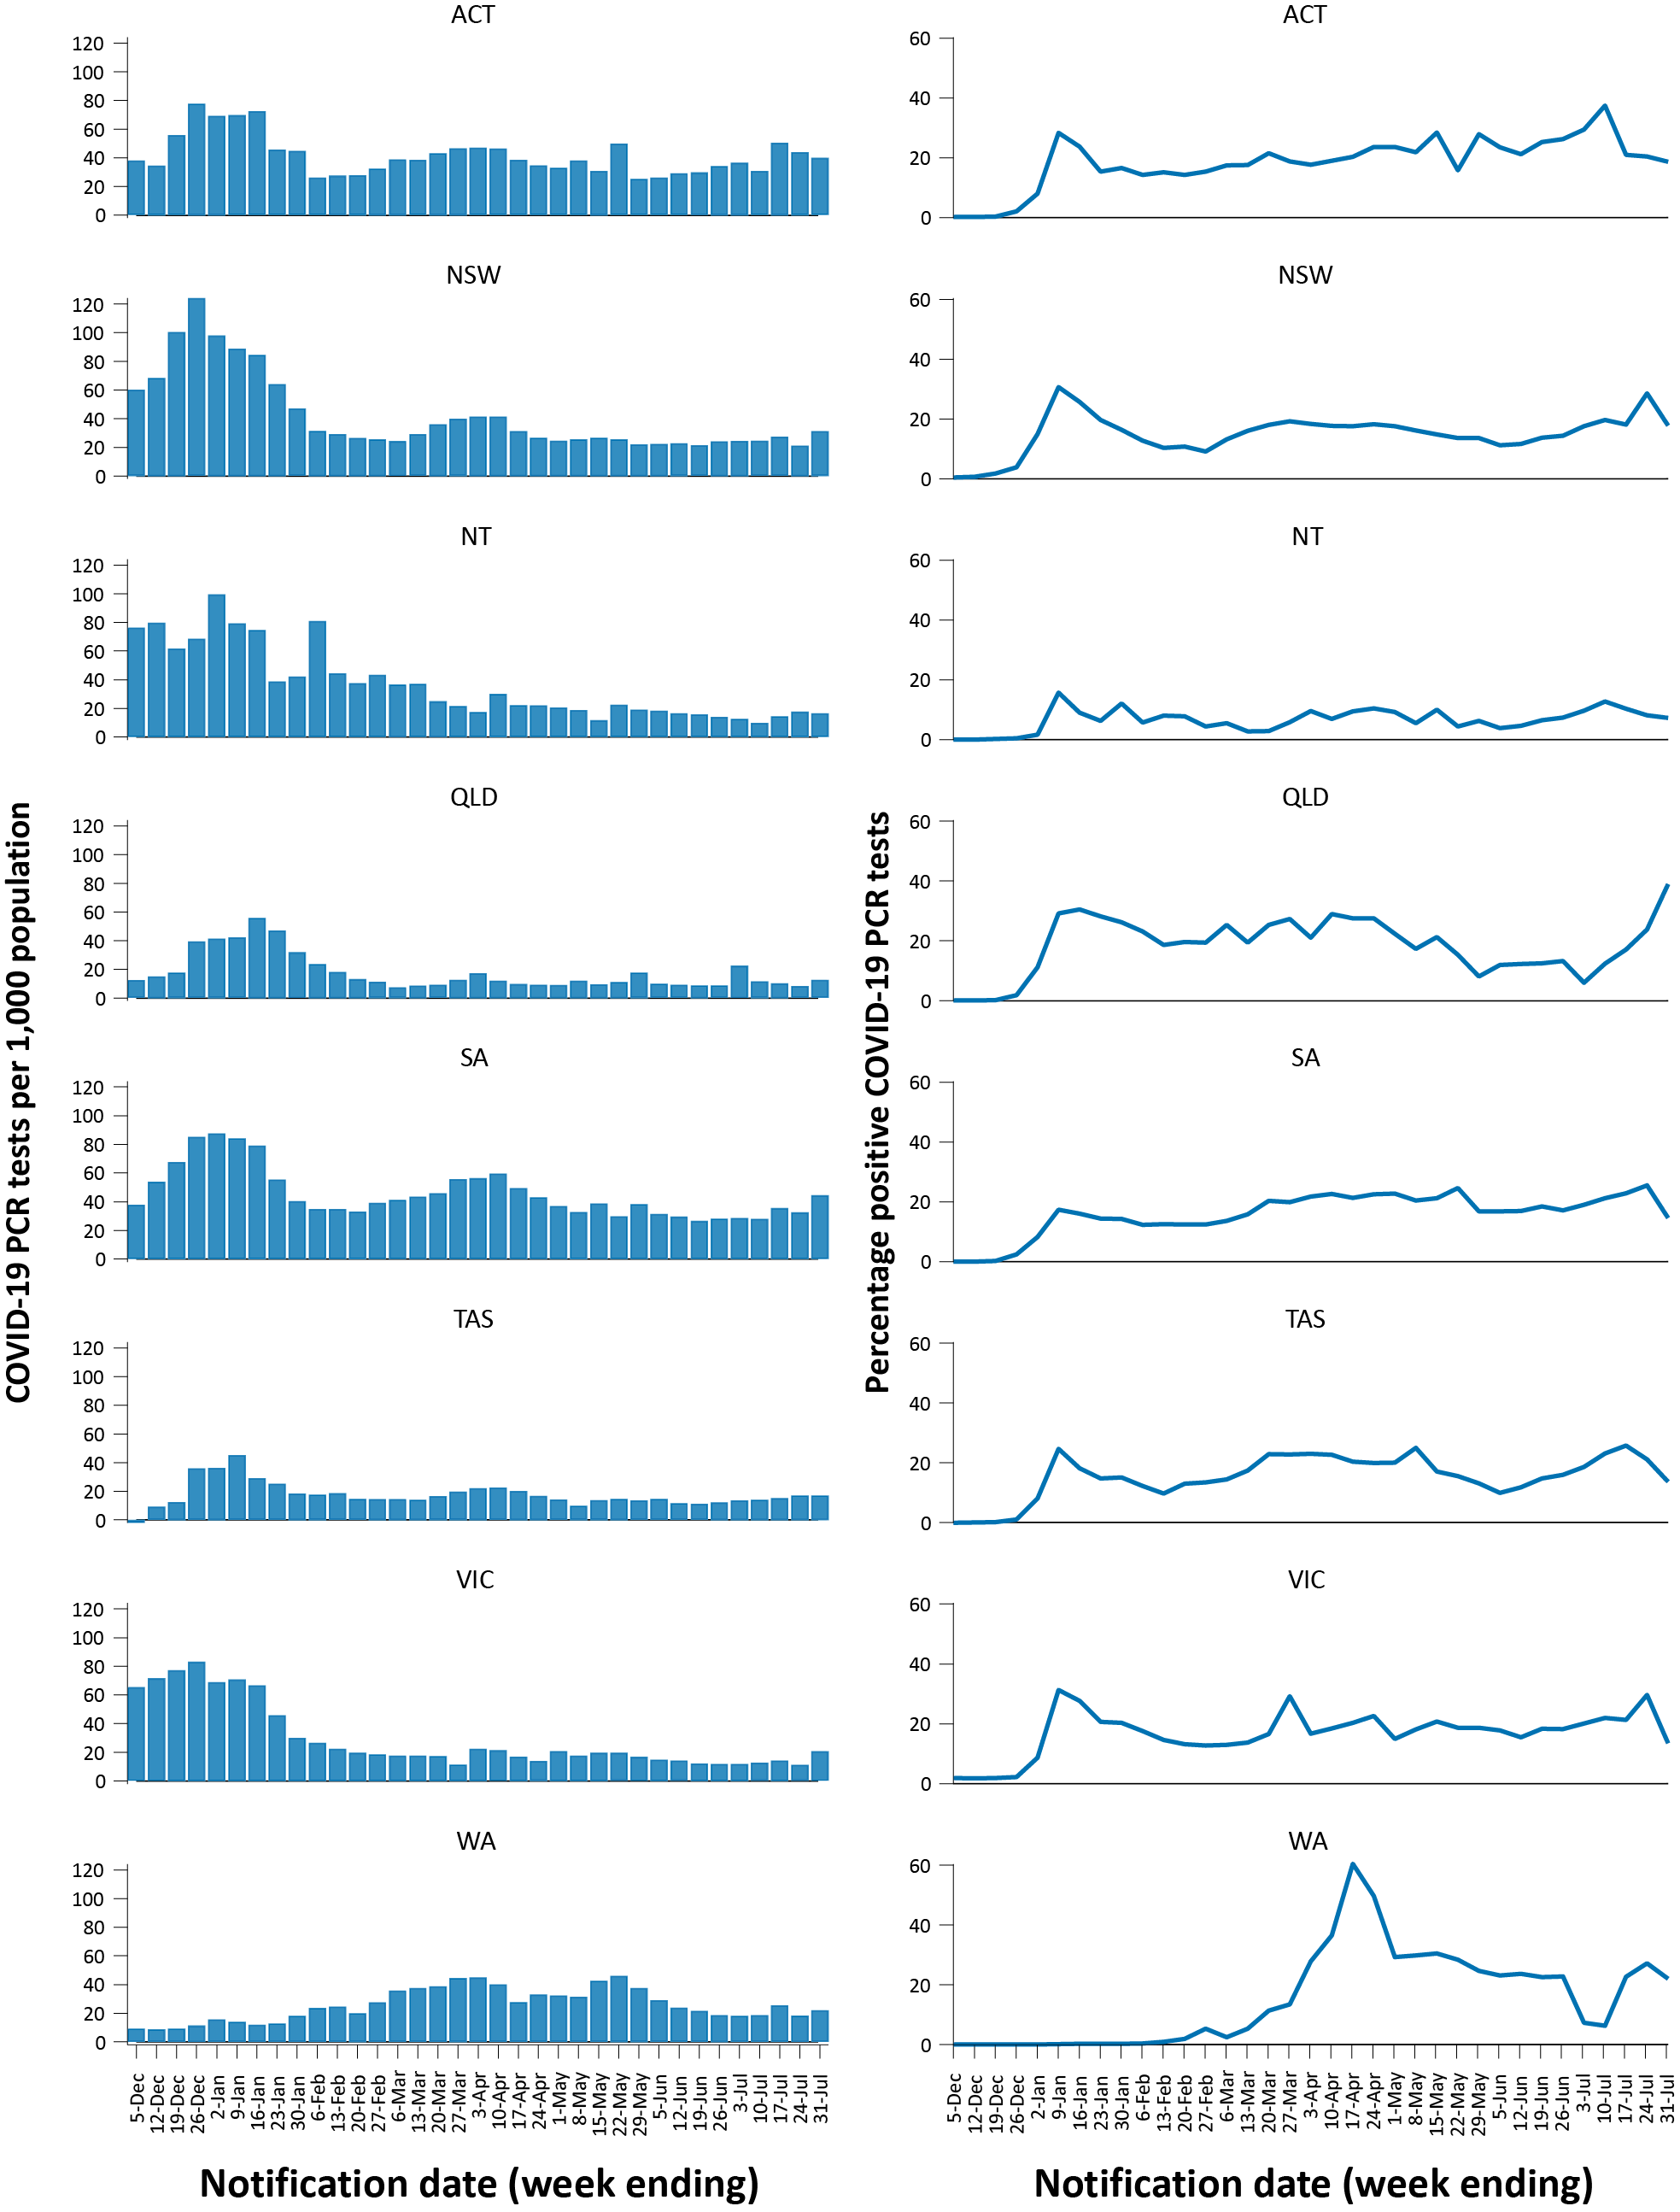

a Source: testing data provided by jurisdictions to the NIR daily, current to 31 July 2022; case data extracted from NNDSS on 3 August 2022 for cases with a notification date up to 31 July 2022; population data based on Australian Bureau of Statistics (ABS) Estimated Resident Population (ERP) as at June 2021. Note: due to transmission issues, data are incomplete for Western Australia since 29 June 2022.

Acute respiratory illness

(FluTracking, ASPREN, and Commonwealth Respiratory Clinics)
Based on self-reported FluTracking data,⁸ the prevalence of fever and cough in the community over this reporting period decreased from a peak of 3.1% in the week ending 10 July 2022 to 2.3% in the week ending 31 July 2022 (Figure 9). There was also an overall decrease in the prevalence of runny nose and sore throat symptoms, decreasing to 1.7% in the most recent reporting week.

Figure 9: Weekly trends in respiratory illness amongst FluTracking survey participants (age-standardised) compared to the average of the previous five years, Australia, 1 January 2020 – 31 July 2022^{a,b}
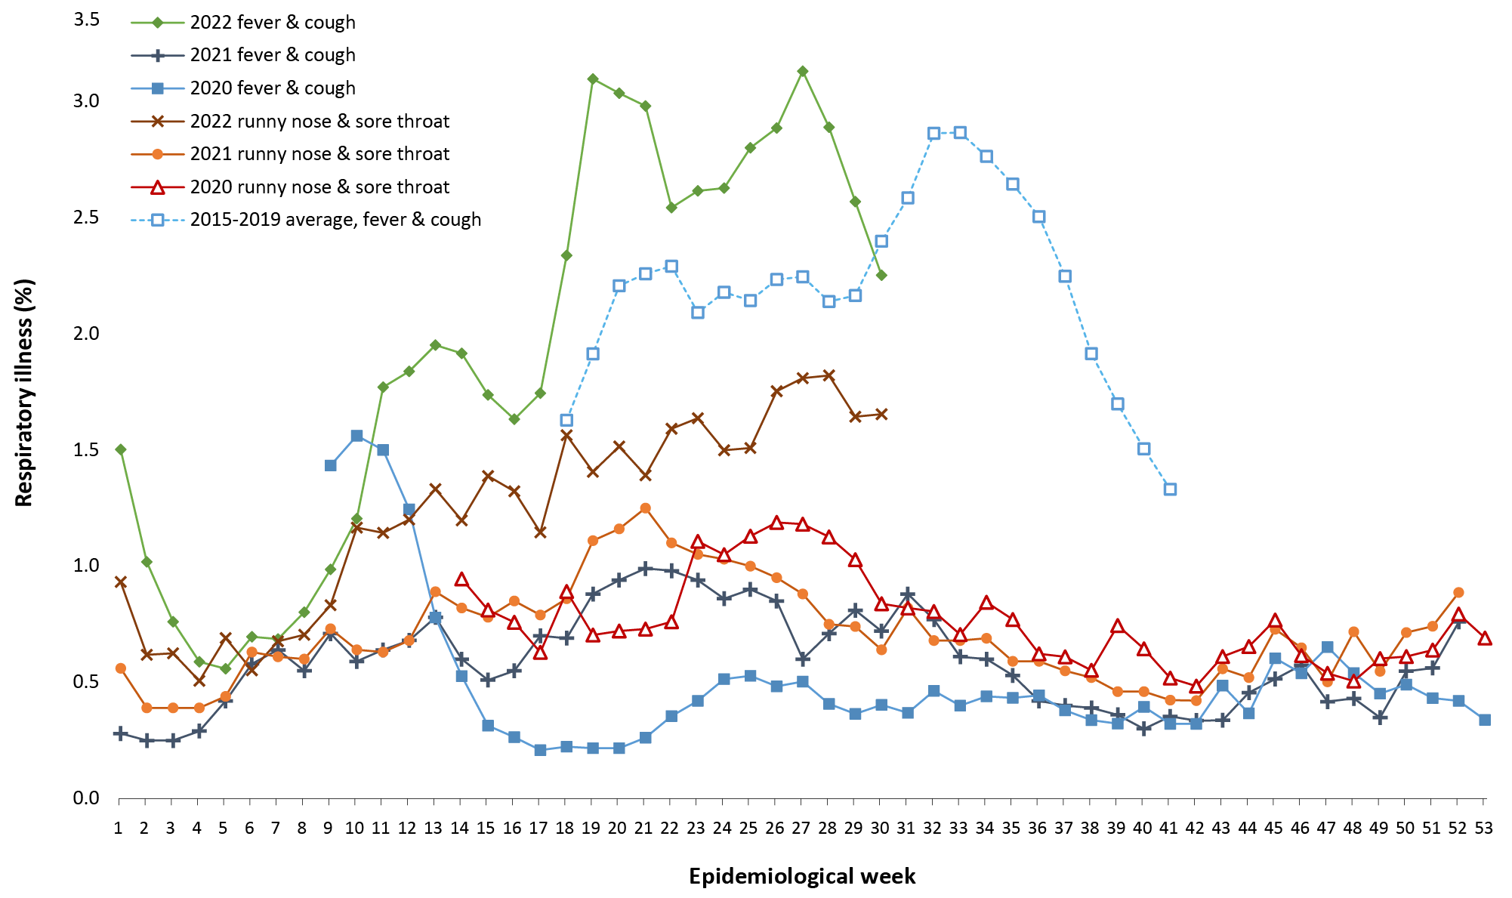
a Epidemiological weeks are a standardised method for numbering weeks across years, with the first epidemiological week of any year ending on the first Saturday in January.
b In years prior to 2020, FluTracking was activated during the main Influenza season from May to October. A historical average beyond the week ending 11 October (epidemiological week 41) is therefore not available. In 2020, FluTracking commenced ten weeks early to capture data for COVID-19. Data on runny nose and sore throat were only collected systematically after 29 March 2020, therefore a historical average for this symptom profile is unavailable.
Over the reporting period, FluTracking data indicated that 34% of participants with ‘fever and cough’ were tested for SARS-CoV-2 with a PCR test and 87% were tested using a RAT (noting that in some instances RATs will be followed up by a PCR test for the same case). Of those with runny nose and sore throat, 16% were tested for SARS-CoV-2 using a PCR test and 72% were tested using a RAT. In the current reporting period, the percent positivity for fever and cough symptoms increased by approximately 10% compared to the previous reporting period for both PCR and RAT, to 54% and 55%, respectively. For runny nose and sore throat symptoms, the percent positivity remained relatively stable for both testing methods, at 20% for PCR and 11% for RAT. Note that participants with one set of symptoms are not excluded from having the other. It is important to acknowledge that there may be legitimate reasons why people did not get tested, including barriers to accessing testing. Symptoms reported to FluTracking are not specific to COVID-19 and may also be due to infections with other respiratory pathogens and chronic diseases, such as asthma.
From 4 July to 31 July 2022, of presentations to Commonwealth Respiratory Clinics that were tested for SARS-CoV-2, 15% (10,983/75,190) were found to be positive. The most commonly reported symptom amongst presentations that tested positive for COVID-19 was sore throat (56%), followed by cough (54%) and tiredness (44%).
Since the start of 2022, of those presenting to sentinel ASPREN sites with influenza-like illness who were tested for respiratory viruses, 62% (380/610) tested positive. Among those positive, the most common virus detected was influenza A (40%; 153/380), followed by rhinovirus (24%; 90/380); of those testing positive, 12% (47/380) were positive for SARS-CoV-2.

Countries and territories in Australia’s near region
According to WHO, countries and territories in the South East Asian and Western Pacific regions reported 8,017,210 newly-confirmed cases and 9,020 deaths in the four-week period to 31 July 2022. Compared to the previous four-week reporting period, new cases increased substantially in both South East Asia and the Western Pacific, whilst new deaths increased significantly in South East Asia and remained stable in the Western Pacific.⁹ In total, since the start of the pandemic, over 131 million cases and over one million deaths have been reported in the two regions.¹⁰
Table 11 outlines new cases and deaths in the four-week period to 31 July 2022 and cumulative cases and deaths for the pandemic in selected countries with the highest number of new cases in the South East Asian region and the Western Pacific region.
Table 11: Cumulative cases and deaths, and new cases and deaths reported in the four-week period to 31 July 2022 for selected countries in Australia’s near region according to WHOª
Country | Cumulative cases | New cases reported in the last 4 weeks | Change in new cases in the last 4 weeks^{b} | Cumulative deaths | New deaths reported in the last 4 weeks | Change in new deaths in the last 4 weeks^{b}
South East Asian region
India | 44,019,811 | 517,382 | +59% | 526,357 | 1,158 | +128%
Indonesia | 6,207,098 | 113,181 | +205% | 156,993 | 244 | +82%
Thailand | 4,590,176 | 60,071 | -5% | 31,385 | 685 | +29%
Bangladesh | 2,005,257 | 26,568 | +6% | 29,291 | 129 | +316%
Western Pacific region
Japan | 12,553,010 | 3,177,038 | +586% | 32,507 | 1,199 | +109%
Republic of Korea | 19,776,050 | 1,386,439 | +514% | 25,047 | 477 | +53%
Australia | 9,326,644 | 1,169,815 | +49% | 11,669 | 1,739 | +37%
China | 5,616,120 | 774,163 | -49% | 23,627 | 2,128 | -48%
New Zealand | 1,603,378 | 252,844 | +58% | 2,245 | 738 | +125%
a Source: World Health Organization Coronavirus (COVID-19) Dashboard, accessed 3 August 2022.
b Percent change in the number of newly confirmed cases/deaths in the most recent four-week period compared to the four weeks prior.
As of 31 July 2022, over 574 million COVID-19 cases and approximately 6.3 million deaths have been reported globally since the start of the pandemic, with a global case fatality rate (CFR) of 1.1%. The two regions reporting the largest burden of disease over the past four weeks were the European region (42% of total cases) and the Western Pacific region (27% of total cases).

Acknowledgements
We thank public health staff from incident emergency operations centres and public health units in state and territory health departments, and the Australian Government Department of Health and Aged Care, along with state and territory public health laboratories. We thank those who have provided data from surveillance systems, such as Commonwealth respiratory clinics, ASPREN, FluTracking, FluCAN, SPRINT-SARI, Communicable Disease Genomics Network, AusTrakka and jurisdictional sequencing laboratories.

Author details

Corresponding author
COVID-19 National Incident Centre Surveillance Team
Australian Government Department of Health and Aged Care, GPO Box 9484, MDP 14, Canberra, ACT 2601.
Email: epi.coronavirus@health.gov.au

References
- COVID-19 National Incident Room Surveillance Team. COVID-19 Australia: Epidemiology Report 63: Reporting period ending 3 July 2022. Commun Dis Intell (2018). 2022;46. doi: https://doi.org/10.33321/cdi.2022.46.49.
- COVID-19 National Incident Room Surveillance Team. Technical supplement. COVID-19 Australia: Epidemiology reporting. Commun Dis Intell (2018). 2021;45. doi: https://doi.org/10.33321/cdi.2021.45.2.
- Australian Government Department of Health and Aged Care. Vaccination numbers and statistics. [Internet.] Canberra: Australian Government Department of Health and Aged Care; 2022. [Accessed on 1 August 2022.] Available from: https://www.health.gov.au/initiatives-and-programs/covid-19-vaccines/numbers-statistics.
- Australian Government Department of Health and Aged Care. Australian Technical Advisory Group on Immunisation (ATAGI). [Webpage.] Canberra: Australian Government Department of Health and Aged Care; 2022. [Accessed on 4 July 2022.] Available from: https://www.health.gov.au/committees-and-groups/australian-technical-advisory-group-on-immunisation-atagi .
- Australian Government Department of Health, Australian Technical Advisory Group on Immunisation (ATAGI). ATAGI advice on the definition of fully vaccinated. Canberra: Australian Government Department of Health and Aged Care; 14 December 2021. [Accessed on 25 July 2022.] Available from: https://www.health.gov.au/sites/default/files/documents/2021/12/atagi-advice-on-the-definition-of-fully-vaccinated.pdf.
- Australian and New Zealand Intensive Care Research Centre (ANZIC-RC). SPRINT-SARI: Short period incidence study of severe acute respiratory infection. [Internet.] Melbourne: Monash University, ANZIC-RC; 2020. Available from: https://www.monash.edu/medicine/sphpm/anzicrc/research/sprint-sari.
- Communicable Diseases Genomics Network (CDGN). AusTrakka. [Website.] Melbourne: CDGN; 2020. Available from: https://www.cdgn.org.au/austrakka.
- Dalton C, Durrheim D, Fejsa J, Francis L, Carlson S, d’Espaignet ET et al. Flutracking: a weekly Australian community online survey of influenza-like illness in 2006, 2007 and 2008. Commun Dis Intell Q Rep. 2009;33(3):316–22.
- World Health Organization (WHO). Weekly epidemiological update on COVID-19 – 3 August 2022. [Internet.] Geneva: WHO; 3 August 2022. [Accessed on 4 August 2022.] Available from: https://www.who.int/publications/m/item/weekly-epidemiological-update-on-covid-19---3-august-2022.
- WHO. WHO Coronavirus Disease (COVID-19) dashboard. [Internet.] Geneva: WHO; 2021. Available from: https://covid19.who.int/.

Appendix A: Supplementary figures and tables
Table A.1: COVID-19 cases and rates per 100,000 population, by age group, sex, and notification received date, Australia, 15 December 2021 – 31 July 2022^{a,b}

Age group | Four-week reporting period |  |  |  |  |  | Current ‘Omicron’ wave
 | 4–31 July 2022 |  |  |  |  |  | 15 December 2021 – 31 July 2022
 | Cases |  |  | Rate per 100,000 population |  |  | Cases |  |  | Rate per 100,000 population
 | Male | Female | People | Male | Female | People | Male | Female | People | Male | Female | People
0–4 | 19,148 | 18,541 | 41,638 | 2,447 | 2,511 | 2,738 | 169,938 | 161,751 | 365,218 | 21,716 | 21,907 | 24,013
5–11 | 28,811 | 26,555 | 60,748 | 2,453 | 2,385 | 2,655 | 337,765 | 321,626 | 733,835 | 28,760 | 28,881 | 32,072
12–15 | 15,136 | 14,988 | 33,263 | 2,318 | 2,423 | 2,616 | 197,787 | 200,693 | 448,066 | 30,289 | 32,445 | 35,237
16–17 | 7,817 | 9,336 | 19,135 | 2,576 | 3,260 | 3,244 | 89,249 | 102,435 | 210,354 | 29,410 | 35,774 | 35,665
18–29 | 66,458 | 82,781 | 163,994 | 3,208 | 4,161 | 4,038 | 710,192 | 823,049 | 1,641,935 | 34,286 | 41,371 | 40,433
30–39 | 68,674 | 82,774 | 167,332 | 3,684 | 4,320 | 4,426 | 596,064 | 702,952 | 1,410,079 | 31,972 | 36,684 | 37,298
40–49 | 60,499 | 73,166 | 147,910 | 3,705 | 4,402 | 4,489 | 483,440 | 577,631 | 1,156,461 | 29,610 | 34,749 | 35,097
50–59 | 56,554 | 69,461 | 140,139 | 3,685 | 4,317 | 4,458 | 378,576 | 437,819 | 882,970 | 24,666 | 27,213 | 28,087
60–69 | 43,322 | 49,259 | 101,822 | 3,267 | 3,490 | 3,719 | 256,674 | 279,684 | 575,045 | 19,353 | 19,813 | 21,003
70–79 | 26,971 | 28,035 | 59,529 | 2,851 | 2,785 | 3,049 | 146,091 | 143,787 | 305,582 | 15,444 | 14,283 | 15,650
80–89 | 12,551 | 15,030 | 29,211 | 3,239 | 3,075 | 3,333 | 61,524 | 67,575 | 134,253 | 15,875 | 13,825 | 15,320
90 + | 3,478 | 6,725 | 10,504 | 4,471 | 4,665 | 4,733 | 15,123 | 27,212 | 43,583 | 19,441 | 18,877 | 19,637

a Source: NNDSS, extract from 3 August 2022 for notifications to 31 July 2022. At the time of extraction, probable cases were not yet available from the Northern Territory, or Tasmania; nor from Victoria since 29 July. At the time of extraction, Queensland was only reporting cases that were conducted in a clinical setting; self-administered probable cases were not reported to NNDSS. Data was not available from Western Australia since 29 June 2022.
b Population data based on Australian Bureau of Statistics (ABS) Estimated Resident Population (ERP) as at June 2021.

Communicable Diseases Intelligence
ISSN: 2209-6051 Online

Communicable Diseases Intelligence (CDI) is a peer-reviewed scientific journal published by the Office of Health Protection and Response, Department of Health and Aged Care. The journal aims to disseminate information on the epidemiology, surveillance, prevention and control of communicable diseases of relevance to Australia.

Editor: Noel Lally
Deputy Editor: Simon Petrie
Design and Production: Kasra Yousefi
Editorial Advisory Board: David Durrheim, Mark Ferson, John Kaldor, Martyn Kirk and Linda Selvey

Website: http://www.health.gov.au/cdi

Contacts
CDI is produced by the Office of Health Protection and Response, Australian Government Department of Health and Aged Care, GPO Box 9848, (MDP 6) CANBERRA ACT 2601

Email: cdi.editor@health.gov.au

Submit an Article
You are invited to submit your next communicable disease related article to the Communicable Diseases Intelligence (CDI) for consideration. More information regarding CDI can be found at: http://health.gov.au/cdi.
Further enquiries should be directed to: cdi.editor@health.gov.au.

This journal is indexed by Index Medicus and Medline.

Creative Commons Licence - Attribution-NonCommercial-NoDerivatives CC BY-NC-ND
© 2022 Commonwealth of Australia as represented by the Department of Health and Aged Care
This publication is licensed under a Creative Commons Attribution-NonCommercial-NoDerivatives 4.0 International Licence from https://creativecommons.org/licenses/by-nc-nd/4.0/legalcode (Licence). You must read and understand the Licence before using any material from this publication.

Restrictions
The Licence does not cover, and there is no permission given for, use of any of the following material found in this publication (if any):
- the Commonwealth Coat of Arms (by way of information, the terms under which the Coat of Arms may be used can be found at www.itsanhonour.gov.au);
- any logos (including the Department of Health and Aged Care’s logo) and trademarks;
- any photographs and images;
- any signatures; and
- any material belonging to third parties.

Disclaimer
Opinions expressed in Communicable Diseases Intelligence are those of the authors and not necessarily those of the Australian Government Department of Health and Aged Care or the Communicable Diseases Network Australia. Data may be subject to revision.

Enquiries
Enquiries regarding any other use of this publication should be addressed to the Communication Branch, Department of Health and Aged Care, GPO Box 9848, Canberra ACT 2601, or via e-mail to: copyright@health.gov.au

Communicable Diseases Network Australia
Communicable Diseases Intelligence contributes to the work of the Communicable Diseases Network Australia.
http://www.health.gov.au/cdna

Eligible persons are defined in accordance with recommendations by the Australian Technical Advisory Group on Immunisation as at the conclusion of the reporting period for this report.⁴
Individuals who are considered ‘fully vaccinated’ against COVID-19 are those who have received a complete schedule of a Therapeutic Goods Administration (TGA) approved COVID-19 vaccine and are at least seven days post their second dose, with doses at least 14 days apart. This is with the exception of the Jansenn (Johnson and Johnson) vaccine, where people are regarded as ‘fully vaccinated’ seven days after a single dose.⁵

