COVID-19 Australia: Epidemiology Report 56
Reporting period ending 5 December 2021
COVID-19 National Incident Room Surveillance Team
The reporting schedule for the COVID-19 epidemiology reports is to change following this fortnight’s report. The next report (Epidemiology Report 57) will cover a six-week period, owing to the summer shutdown, and will be released in late January 2022. Future reports, commencing with Epidemiology Report 58, will then be produced on a four-weekly schedule, rather than fortnightly.

Summary

Two-week reporting period
Trends – The daily average of 1,369 cases for this reporting period was higher than the previous fortnight’s daily average of 1,285 cases. There were 19,164 cases of coronavirus disease 2019 (COVID-19) reported this fortnight, bringing the 2021 cumulative case count to 189,316 cases.
Local cases – More than 99% (19,002/19,164) of COVID-19 cases reported this fortnight were locally acquired (including cases under initial investigation). The majority of these cases were reported in Victoria (82%; 15,592/19,002), followed by New South Wales (17%; 3,217/19,002).
Clusters and high-risk settings – On 26 November 2021, the World Health Organization (WHO) declared variant B.1.1.529 (now labelled as Omicron) a variant of concern (VOC). As at 5 December 2021, there were 28 confirmed cases with the Omicron variant detected in Australia, with 25 in New South Wales, two in the Australian Capital Territory and one in the Northern Territory. Of these cases, 11 were overseas acquired and 17 were locally acquired. To date, no cases with this variant in Australia have been reported to be hospitalised for treatment of COVID-19.
As at 5 December 2021, a total of 61 locally-acquired cases had been reported in the Northern Territory since 5 November 2021. These cases were part of two genomically linked clusters: an initial four cases detected in Darwin and Katherine between 5 and 10 November 2021, and 57 cases detected in Katherine, Robinson River, Binjari and Lajamanu since 15 November 2021.
A total of 34 locally-acquired cases has been reported in South Australia since 1 December 2021. Most of these cases were connected to a cluster in Norwood, South Australia.
A total of three locally-acquired cases has been reported in the Gold Coast, Queensland between 4 and 5 December 2021. The source of infection for the initial case in this cluster remains under investigation.
Aboriginal and Torres Strait Islander persons – During the reporting period, there were 404 new cases notified in Aboriginal and Torres Strait Islander people, of whom 209 were from Victoria, 173 were from New South Wales, 20 were from the Northern Territory, one was from the Australian Capital Territory and one was from South Australia. To date in 2021, there have been 8,807 cases and 20 deaths reported among Aboriginal and Torres Strait Islander people. Of locally-acquired cases notified in Aboriginal and Torres Strait Islander people in 2021 to date, 42% (3,709/8,802) lived in a regional or remote area.
Overseas-acquired cases – There were 149 overseas-acquired cases this reporting period, with the largest number of such cases reported in New South Wales (72%; 108/149), followed by Victoria (16%; 24/149).
Severity – In 2021, based on the highest level of severity reported for cases with an illness onset up to 21 November 2021, 0.7% of cases were reported to have died, a 1.1% of cases required intensive care and a 7.9% required admission to hospital, noting that cases may be hospitalised for reasons other than clinical COVID-19-related care. Given the delay between illness onset and severe illness, cases with an onset in the last two weeks were excluded from the analysis on severity. During the reporting period, 70 new COVID-19-associated deaths were notified.
Vaccinations – As at 5 December 2021, there had been 39,663,971 doses of COVID-19 vaccine administered in Australia. Nationally, 19,152,475 people aged 16 years or over (92.9%) had received at least one dose, including 18,163,730 people aged 16 or over (88.1%) who were fully vaccinated.

Four-week reporting period
Virology – On 26 November 2021, a new variant, B.1.1.529 (Omicron) was designated a VOC by the WHO. Nationally, SARS-CoV-2 strains from 21% of COVID-19 cases have been sequenced during the pandemic. During 2021, there has been an increase in the number of cases infected with SARS-CoV-2 variants of concern in Australia. AusTrakka actively monitors and reports on these variants and has so far identified 24,153 samples of Delta (B.1.617.2); 515 samples of Alpha (B.1.1.7); 84 samples of Beta (B.1.351); 12 samples of Omicron (B.1.1.529) and six samples of Gamma (P.1) in Australia.
International situation – According to the WHO, cumulative global COVID-19 cases stood at more than 264 million, with over 5.2 million deaths reported globally, as of 5 December 2021. In Australia’s near region, the South East Asia and Western Pacific Regions reported over 1.2 million newly-confirmed cases and over 27,000 deaths in the four-week period to 5 December 2021.
Keywords: SARS-CoV-2; novel coronavirus; 2019-nCoV; coronavirus disease 2019; COVID-19; acute respiratory disease; epidemiology; Australia

Two-week reporting period (22 November – 5 December 2021)
This reporting period covers the two-week period 22 November – 5 December 2021, with data for this period compared to that from the previous two-week reporting period (8–21 November 2021).¹ The focus of this report is on the epidemiological situation in Australia since the beginning of 2021. Readers are encouraged to consult prior reports in this series for information on the epidemiology of cases in Australia in 2020.
Included in this report, with a reporting period of four weeks, are sections on genomic surveillance and virology, acute respiratory illness, testing, public health response measures, and the international situation. The reporting period for these topics is 8 November – 5 December 2021. For comparability, the previous reporting period is the preceding four weeks (11 October – 7 November 2021).²
From report 47 onward, the section on severity is included in the two-week reporting period; previously, a four-week reporting period had been adopted for that section.
From report 46 onward, and unless otherwise specified, tabulated data and data within the text are extracted from the National Interoperable Notifiable Diseases Surveillance System (NINDSS) based on ‘notification received date’ rather than ‘diagnosis date’ (see the Technical Supplement for definitions).³ As a case’s diagnosis date can be several days prior to the date of its notification, there is potential for newly-notified cases to be excluded from the case count in the current reporting period when reporting by ‘diagnosis date’. Using ‘notification received date’ ensures that the case count for the reporting period better reflects the number of newly-notified cases. As the graphs presented in this report, based on NINDSS data, reflect a larger time period (i.e. year to date and entire pandemic), these will continue to be based on diagnosis date to enable a more accurate understanding of infection risk and local transmission.

Background and data sources
See the Technical Supplement for general information on COVID-19 including modes of transmission, common symptoms and severity.³

Activity

COVID-19 trends

(NINDSS and jurisdictional reporting to NIR)
The number of cases reported this fortnight was slightly higher than the number reported in the previous fortnight. A total of 19,164 cases were notified in this two-week reporting period (an average of 1,369 cases per day), compared to 18,000 cases (an average of 1,285 cases per day) in the previous reporting period. The majority of cases occurred in Victoria (81%; 15,616/19,164), followed by New South Wales (17%; 3,325/19,164) (Table 1).

Table 1: COVID-19 notifications by jurisdiction and source of acquisition, with a notification received date of 22 November – 5 December 2021ª
Source^{b} | ACT | NSW | NT | Qld | SA | Tas. | Vic. | WA | Australia
Overseas | 2 | 108 | 4 | 3 | 5 | 0 | 24 | 3 | 149
Locally acquired - acquired within jurisdiction of notification | 95 | 3,108 | 26 | 7 | 26 | 0 | 5,975 | 0 | 9,237
Locally acquired - acquired interstate | 13 | 69 | 1 | 11 | 12 | 0 | 0 | 0 | 106
Under initial investigation | 1 | 40 | 0 | 1 | 0 | 0 | 9,617 | 0 | 9,659
Missing source of acquisition | 0 | 0 | 0 | 7 | 6 | 0 | 0 | 0 | 13
Total new cases | 111 | 3,325 | 31 | 29 | 49 | 0 | 15,616 | 3 | 19,164
a Source: NINDSS, extract from 8 December 2021 for notifications to 5 December 2021.
b ACT: Australian Capital Territory; NSW: New South Wales; NT: Northern Territory; Qld: Queensland; SA: South Australia; Tas.: Tasmania; Vic.: Victoria; WA: Western Australia.
In the year to date, from 1 January to 5 December 2021, there have been 189,316 COVID-19 cases reported nationally. Until the week ending 20 June 2021, the number of weekly cases diagnosed this year had been below 180 cases per week. Since then, cases increased and there were over 1,000 cases diagnosed each week from the week ending 25 July 2021 to the start of September and over 10,000 cases diagnosed each week from the start of September until late October 2021 (Figure 1). Excluding the most recent week, the number of cases has increased slightly over the last three weeks, though case numbers have remained below 10,000 each week. Case numbers for the most recent week are likely an underestimate as additional cases may be identified in the coming week that have a diagnosis date in this period. The current peak in 2021 is over 15,000 cases per week, which occurred in the week ending 3 October 2021. This peak considerably surpasses the two distinct peaks experienced in March and July of 2020, when new cases diagnosed per week reached approximately 2,700 and 3,000, respectively (Figure 1). Cumulatively, since the beginning of the pandemic, there have been 217,725 COVID-19 cases reported in Australia to 5 December 2021.

Figure 1: COVID-19 notified cases by source of acquisition and diagnosis date, 2 March 2020 – 5 December 2021^{a,b}
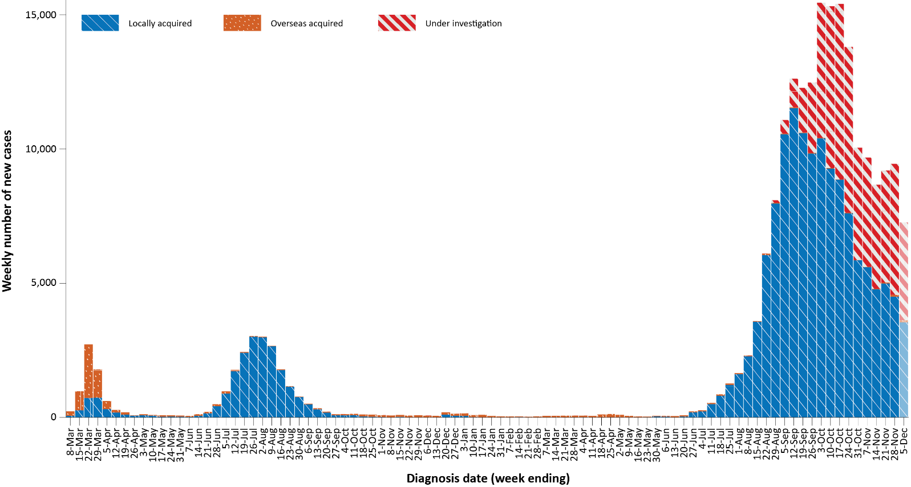
a Source: NINDSS, extract from 8 December 2021 for notifications to 5 December 2021.
b The lighter bar at the right represents the most recent reporting week and should be interpreted with caution as additional cases may be identified in the coming week that have a diagnosis date during this period.

Source of acquisition

(NINDSS)
In this reporting period, > 99% of cases notified (19,002/19,164) were considered to be acquired within Australia, comprising 48% (9,237/19,164) identified as cases acquired within the reporting jurisdiction, 50% (9,659/19,164) categorised as cases under initial investigation, and 106 interstate-acquired cases; < 1% of cases (149/19,164) were overseas acquired and 13 cases were missing a source of acquisition (Table 1). Victoria reported the majority of locally-acquired cases (82%; 15,592/19,002) in this fortnight, followed by New South Wales (17%; 3,217/19,002) and the Australian Capital Territory (1%; 109/19,002). Cases acquired within the jurisdiction of notification were reported in the Australian Capital Territory, New South Wales, the Northern Territory, Queensland, South Australia, and Victoria. The Australian Capital Territory, New South Wales, the Northern Territory, Queensland and South Australia reported infections that were acquired in another jurisdiction. Tasmania and Western Australia did not report any locally-acquired cases.
For 2021 to date, Victoria has had the highest notification rate for locally-acquired cases with 1,609.1 notifications per 100,000 population, followed by New South Wales with a rate of 942.2 notifications per 100,000 population and the Australian Capital Territory with a rate of 471.8 notifications per 100,000 population (Table 2).
Table 2: Locally-acquired COVID-19 case numbers and rates per 100,000 population by jurisdiction and reporting period, Australia, with a notification received date from 1 January to 5 December 2021ª
Jurisdiction | Reporting period | Reporting period | Cases this year
 | 22 November – 5 December 2021 | 8–21 November 2021 | 1 January – 5 December 2021
 | Number of cases^{b} | Number of cases^{b} | Number of cases^{b} | Rate per 100,000 population^{c}
ACT | 109 | 187 | 2,035 | 471.8
NSW | 3,217 | 2,956 | 76,959 | 942.2
NT | 27 | 34 | 81 | 32.9
Qld | 19 | 6 | 286 | 5.5
SA | 38 | 0 | 79 | 4.5
Tas. | 0 | 0 | 3 | 0.6
Vic. | 15,592 | 14,766 | 107,758 | 1,609.1
WA | 0 | 0 | 16 | 0.6
Australia | 19,002 | 17,949 | 187,217 | 728.5
a Source: NINDSS, extract from 8 December 2021 for notifications to 5 December 2021.
b This total includes cases under initial investigation and excludes overseas-acquired cases and with a missing source of acquisition. In reports prior to report 51, cases under initial investigation were excluded from this total.
c Population data based on Australian Bureau of Statistics (ABS) Estimated Resident Population (ERP) as at June 2020. The ABS June 2020 ERP was ACT: 431,325; NSW: 8,168,893; NT: 246,283; Qld: 5,176,044; SA: 1,770,494; Tas.: 540,781; Vic.: 6,696,630; WA: 2,663,976; Australia: 25,698,093.
In the reporting period, New South Wales reported the largest number of overseas-acquired cases (72%; 108/149), followed by Victoria (16%; 24/149) (Table 1). In the past 28 days (8 November to 5 December 2021), 11% (22/200) of confirmed overseas-acquired cases reported to the NINDSS had an unknown country of acquisition. Cases acquired in the United Kingdom (23%; 41/178) were the most numerous of those with an identified country of acquisition in the past 28 days, followed by the United States of America (12%; 22/178).
Since May 2021, the proportion of air arrivals diagnosed with COVID-19 has remained at less than 1%. On 1 November 2021, several states changed quarantine requirements for vaccinated arrivals. Since then, there has been a substantial increase in the number of air arrivals; however, the proportion of overseas-acquired cases amongst these arrivals has remained less than 1%. The number of cases acquired in different countries is influenced by travel patterns of returning Australians, travel restrictions, and the prevalence of COVID-19 in the country of travel.

Demographic features

(NINDSS)
In this reporting period, the largest proportion of cases occurred in children aged 5 to 11 years (21%; 4,048/19,164). Notification rates were also highest in people aged 5 to 11, at 177.8 per 100,000 population, over twice that of the next highest age group. For this year, the highest rate of infection has been in those aged 5 to 11 years with a rate of 1,134.5 infections per 100,000 population, followed by people aged 18 to 29 (1,006.3 per 100,000 population) (Figure 2; Appendix A, Table A.1). Adults aged 70 to 79 years have had the lowest rate of infection this year.
In 2021, notification rates were higher among males than females in most age groups, though rates were similar among males and females in those aged 0 to 15 years and were also similar in those over 90 years old (Figure 2; Appendix A, Table A.1). The median age of cases in this reporting period was 29 years (range: 0 to 102 years; interquartile range, IQR: 11 to 46 years).
Figure 2: Cumulative COVID-19 cases for the calendar year to date, by age group and sex, Australia, with a notification received date of 1 January 2021 – 5 December 2021^{a,b}

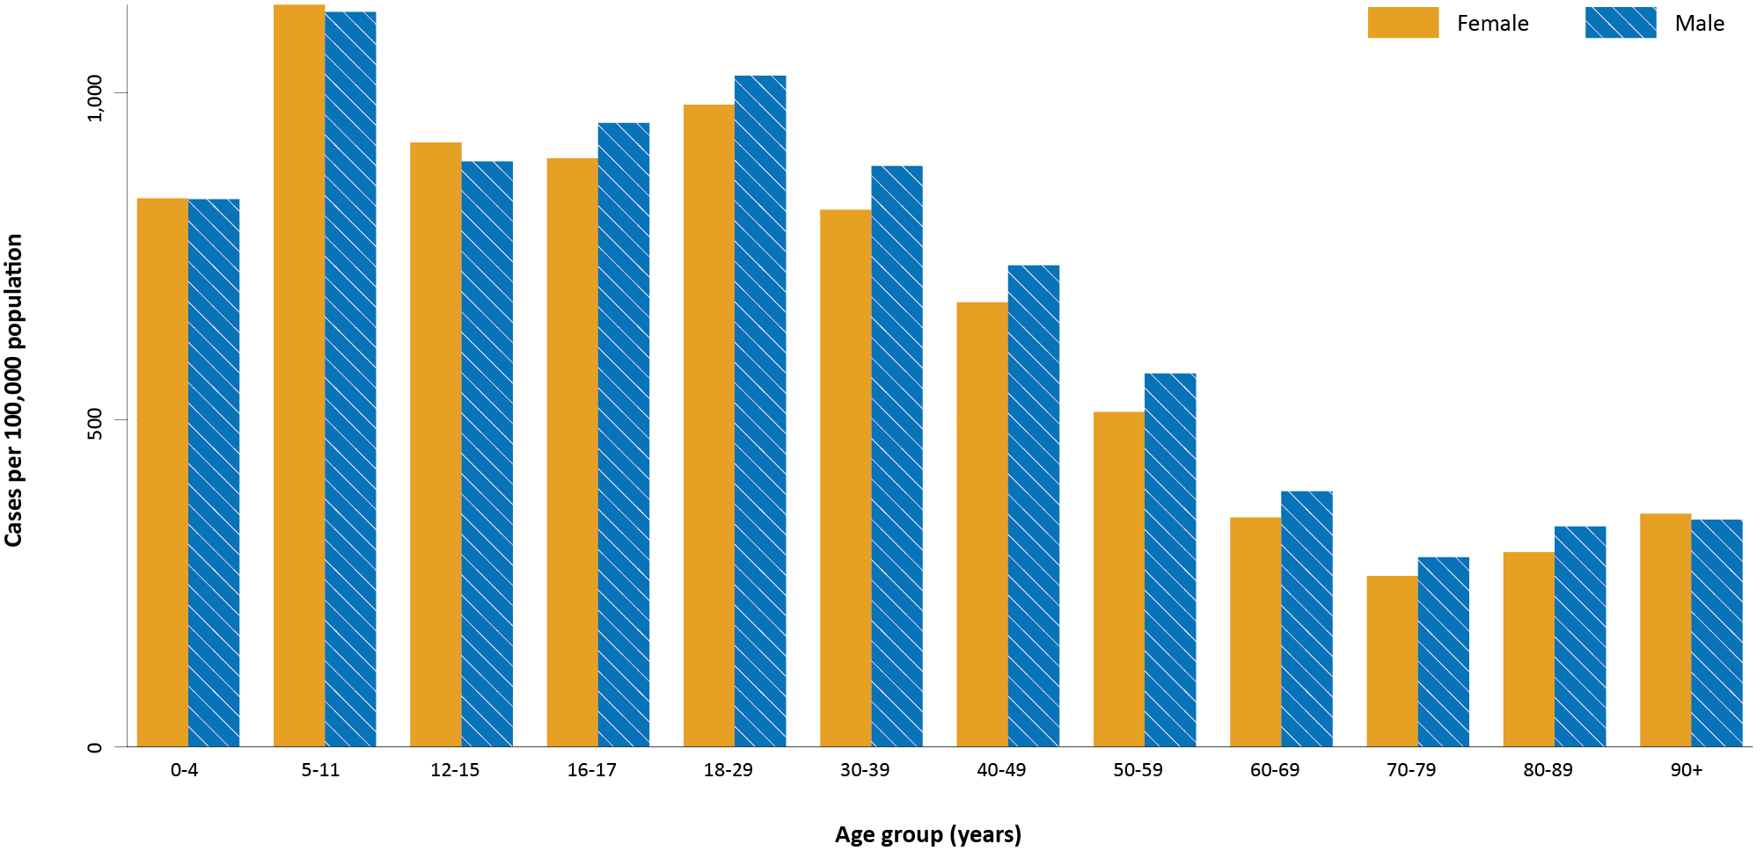
a Source: NINDSS, extract from 8 December 2021 for notifications to 5 December 2021.
b Note that, from Epidemiology Report 55 onwards, the age groups have been changed to match those used to report severity.

Aboriginal and Torres Strait Islander persons

(NINDSS)
During the reporting period, there were 404 new cases notified in Aboriginal and Torres Strait Islander people, with 209 from Victoria, 173 from New South Wales, 20 from the Northern Territory, and one each from the Australian Capital Territory and South Australia. Since the beginning of 2021, there have been 8,807 confirmed cases of COVID-19 notified in Aboriginal and Torres Strait Islander people, representing 5% (8,807/189,316) of all confirmed cases this year. Of the locally-acquired cases notified in Aboriginal and Torres Strait Islander people in 2021 to date, 42% (3,709/8,802) resided in a regional or remote area (Table 3).

Table 3: Confirmed cases of COVID-19 among Aboriginal and Torres Strait Islander peoples by place of acquisition and area of remoteness, 1 January – 5 December 2021ª
Jurisdiction | Locally acquired, Australia^{b} |  |  |  |  |  | Overseas acquired | Total
 | Major city | Inner regional | Outer regional | Remote^{c} | Overseas resident | Unknown
ACT | 236 | 0 | 0 | 0 | 0 | 1 | 0 | 237
NSW | 3,979 | 1,778 | 710 | 361 | 5 | 50 | 1 | 6,884
NT | 0 | 0 | 3 | 51 | 0 | 0 | 0 | 54
Qld | 4 | 2 | 6 | 0 | 0 | 0 | 3 | 15
SA | 1 | 0 | 0 | 0 | 0 | 0 | 0 | 1
Tas. | 0 | 1 | 0 | 0 | 0 | 0 | 0 | 1
Vic. | 815 | 555 | 242 | 0 | 0 | 2 | 0 | 1,614
WA | 0 | 0 | 0 | 0 | 0 | 0 | 1 | 1
Australia | 5,035 | 2,336 | 961 | 412 | 5 | 53 | 5 | 8,807
a Source: NINDSS, extract from 8 December 2021 for notifications to 5 December 2021.
b ‘Locally acquired’ includes cases under initial investigation. Note, in reports prior to report 52, ‘locally acquired’ excluded cases under initial investigation.
c ‘Remote’ here also includes areas classified as ‘very remote’.
The majority of cases reported in Aboriginal and Torres Strait Islander people in 2021 have been associated with the Sydney metropolitan and regional outbreaks in New South Wales. There have been 6,882 locally-acquired cases reported in Aboriginal and Torres Strait Islander people in New South Wales since 16 June 2021 when the Sydney metropolitan outbreak began, with 41% (2,848/6,882) of these cases reported in regional and remote residents. In Victoria, there have been 1,614 locally-acquired Aboriginal and Torres Strait Islander cases reported since the start of the Victorian outbreak on 5 August 2021, with 49% (797/1,614) of these cases in regional residents. In the Australian Capital Territory, there have been 237 cases reported in Aboriginal and Torres Strait Islander people since the start of the outbreak, representing approximately 12% of cases overall in this jurisdiction. The Northern Territory has reported 51 locally-acquired cases in Aboriginal and Torres Strait Islander people, with the first case reported on 15 November 2021.
Cumulatively, since the beginning of the epidemic in Australia, there have been 8,962 cases in Aboriginal and Torres Strait Islander people, representing approximately 4% (8,962/217,725) of all confirmed cases in Australia. Indigenous status was unknown for approximately 19% (41,676/217,725) of confirmed cases, with the majority of these associated with more recently-reported cases, especially in Victoria and New South Wales. Since the start of the pandemic, there have been 20 COVID-19-associated deaths in Aboriginal and Torres Strait Islander people, 17 in New South Wales, two in Victoria and one in the Northern Territory.
To date, the majority of Aboriginal and Torres Strait Islander cases were reported as locally acquired (91%; 8,176/8,962), with 37 cases that were overseas acquired and 749 cases under investigation (most of which are known to be locally acquired). The median age of locally-acquired Aboriginal and Torres Strait Islander cases is 20 years old (range 0 to 99 years, IQR: 9 to 35 years), while the median age of overseas-acquired cases is 39 years old (range 7 to 75 years; IQR: 26 to 57 years). Overall, the proportions of cases among males and females were similar at 49% and 51% of cases, respectively.
Given the delay between onset and severe illness, cases with an onset in the last two weeks were excluded from the following analysis on severity. In 2021, based on the highest level of severity reported for cases with an illness onset up to 21 November 2021, 0.2% of cases in Aboriginal and Torres Strait Islander people were reported to have died, 1.0% of cases required intensive care and a further 9.4% required admission to hospital (Table 4). Note that hospitalisation data in NINDSS should be interpreted with caution: hospitalisation is not always reflective of severe illness, as cases may be hospitalised for reasons other than clinical COVID-19-related care; additionally, hospitalisation and intensive care unit (ICU) status in NINDSS is likely incomplete.
Table 4: COVID-19 cases in Aboriginal and Torres Strait Islander people by age group and highest level of illness severity, 1 January 2021 – 21 November 2021ª
Age group | Count |  |  |  |  | % of total cases by age group
 | Not severe^{b} | Hospitalised only | ICU | Died | Total cases | Hospitalised only | ICU | Died
 |  | (not ICU or died) | (but not died) |  |  | (not ICU or died) | (but not died)
0–4 | 981 | 52 | 0 | 0 | 1,033 | 5.0% | 0.0% | 0.0%
5–11 | 1,585 | 34 | 2 | 0 | 1,621 | 2.1% | 0.1% | 0.0%
12–15 | 772 | 31 | 2 | 0 | 805 | 3.9% | 0.2% | 0.0%
16–17 | 339 | 23 | 3 | 0 | 365 | 6.3% | 0.8% | 0.0%
18–29 | 1,677 | 206 | 13 | 0 | 1,896 | 10.9% | 0.7% | 0.0%
30–39 | 1,013 | 155 | 15 | 0 | 1,183 | 13.1% | 1.3% | 0.0%
40–49 | 642 | 127 | 16 | 3 | 788 | 16.1% | 2.0% | 0.4%
50–59 | 379 | 78 | 17 | 5 | 479 | 16.3% | 3.5% | 1.0%
60–69 | 149 | 59 | 12 | 5 | 225 | 26.2% | 5.3% | 2.2%
70–79 | 31 | 25 | 6 | 4 | 66 | 37.9% | 9.1% | 6.1%
80–89 | 8 | 5 | 0 | 3 | 16 | 31.3% | 0.0% | 18.8%
90+ | 1 | 2 | 0 | 0 | 3 | 66.7% | 0.0% | 0.0%
Unknown | 0 | 0 | 0 | 0 | 0 | 0.0% | 0.0% | 0.0%
Total | 7,577 | 797 | 86 | 20 | 8,480 | 9.4% | 1.0% | 0.2%
a Source: NINDSS, extract from 8 December 2021. Includes cases notified from 1 January 2021, with an illness onset up to 21 November 2021. Cases with an illness onset in the last two weeks (22 November to 5 December 2021) were excluded to account for the delay between onset and development of severe illness.
b ‘Not severe’ includes all cases that were not hospitalised, admitted to ICU or died.

Vaccinations

(Department of Health)
As of 5 December 2021, a total of 39,663,971 doses of COVID-19 vaccine had been administered (Table 5), including 1,135,851 doses provided to aged care and disability residents. Nationally, 19,152,475 people aged 16 years or over (92.9%) had received at least one dose. This includes 18,163,730 people aged 16 years or over (88.1%) who were fully vaccinated (Table 5). Among people aged 12–15 years, 954,282 people (76.7%) had received at least one dose, including 845,025 (67.9%) who were fully vaccinated.

Table 5: Total number of vaccinations administered, by jurisdiction, Australia, 5 December 2021ª
Jurisdiction | Total number of doses administered | Percentage of people aged 16 and over who have had at least one dose^{b} | Percentage of people aged 16 and over who are fully vaccinated
ACT | 967,198 | > 99% | > 95%
NSW | 13,000,675 | 94.7% | 92.8%
NT | 388,949 | 87.9% | 79.0%
Qld | 7,356,778 | 87.4% | 78.7%
SA | 2,627,267 | 90.3% | 82.7%
Tas. | 859,014 | 94.7% | 88.5%
Vic. | 10,751,059 | 93.4% | 91.3%
WA | 3,713,031 | 87.6% | 77.9%
Aged care and disability facilities^{c} | 1,135,851 | NA | NA
Primary care^{d} | 22,455,247 | NA | NA
Total | 39,663,971 | 92.9% | 88.1%
a Source: Australian Government Department of Health website.⁴
b Includes people who are fully vaccinated.
c Commonwealth vaccine doses administered in aged care and disability facilities.
d Commonwealth vaccine doses administered in primary care settings.

Clusters and outbreaks

Omicron cases
On 26 November 2021, after a sudden and rapid increase in cases of SARS-CoV-2 variant B.1.1.529 in Southern Africa, the WHO classified this variant as a new variant of concern (VOC) named Omicron.⁵ As at 5 December 2021, there were 28 confirmed cases with the Omicron variant detected in Australia, with 25 in New South Wales, two in the Australian Capital Territory and one in the Northern Territory. Of these cases, 11 were overseas acquired and 17 were locally acquired. To date, no cases have been reported to be hospitalised for treatment of COVID-19.

Northern Territory outbreak – Northern Territory
As at 5 December 2021, there had been 61 locally-acquired cases reported in the Northern Territory since 5 November 2021. An initial four cases were detected between 5 November and 10 November 2021, associated with a traveller from Melbourne. Exposure sites from these cases were identified in both Darwin and Katherine local government areas. A second cluster, which, as of 5 December 2021, comprised 57 locally-acquired cases in Katherine, Robinson River, Binjari and Lajamanu, was first reported on 15 November 2021. The two Delta variant clusters were genomically linked; however, the epidemiological link remains under investigation as at the end of the current reporting period. A total of 27 locally-acquired cases was reported in the Northern Territory this reporting period, compared with 34 cases in the previous reporting period.

South Australia
A total of 34 locally-acquired cases has been reported in South Australia since 1 December 2021. Most of these cases are connected to a cluster in Norwood, South Australia. The initial case was believed to be an interstate traveller who attended an event in Norwood on 27 November 2021.

Queensland
A total of three locally-acquired cases has been reported in the Gold Coast, Queensland since 4 December 2021. The source of infection for the initial case in this cluster remains under investigation.

Severity (NINDSS, SPRINT-SARI)

Hospitalisation and intensive care unit admission
Given the delay between illness onset and severe illness, to provide a more accurate assessment of the highest level of severity, cases with an onset in the last two weeks were excluded from the analysis. In 2021, based on the highest level of severity reported for cases with an illness onset up to 21 November 2021, 0.7% of cases were reported to have died; a further 1.1% of cases required intensive care; and a further 7.9% were admitted to hospital (Table 6).
Table 6: COVID-19 cases by age group and highest level of illness severity, 1 January 2021 – 21 November 2021ª
Age group | Count |  |  |  |  | % of cases
 | Not severe^{b} | Hospitalised only | ICU | Died | Total cases | Hospitalised only | ICU | Died
 |  | (not ICU or died) | (not died) |  |  | (not ICU or died) | (not died)
0–4 | 11,690 | 484 | 6 | 0 | 12,180 | 4.0% | <0.05% | 0.0%
5–11 | 21,970 | 343 | 11 | 1 | 22,325 | 1.5% | <0.05% | <0.05%
12–15 | 10,246 | 281 | 10 | 2 | 10,539 | 2.7% | 0.1% | <0.05%
16–17 | 4,982 | 164 | 14 | 0 | 5,160 | 3.2% | 0.3% | 0.0%
18–29 | 37,083 | 2,275 | 182 | 8 | 39,548 | 5.8% | 0.5% | <0.05%
30–39 | 26,991 | 2,393 | 286 | 17 | 29,687 | 8.1% | 1.0% | 0.1%
40–49 | 18,628 | 2,143 | 348 | 40 | 21,159 | 10.1% | 1.6% | 0.2%
50–59 | 12,970 | 1,879 | 453 | 103 | 15,405 | 12.2% | 2.9% | 0.7%
60–69 | 6,904 | 1,551 | 374 | 177 | 9,006 | 17.2% | 4.2% | 2.0%
70–79 | 2,971 | 1,125 | 179 | 291 | 4,566 | 24.6% | 3.9% | 6.4%
80–89 | 1,171 | 785 | 42 | 349 | 2,347 | 33.4% | 1.8% | 14.9%
90+ | 308 | 185 | 1 | 150 | 644 | 28.7% | 0.2% | 23.3%
Age unknown | 7 | 1 | 0 | 0 | 8 | 12.5% | 0.0% | 0.0%
Total | 155,921 | 13,609 | 1,906 | 1,138 | 172,574 | 7.9% | 1.1% | 0.7%
a NINDSS, extract from 8 December 2021. Includes cases notified from 1 January 2021, with an illness onset up to 21 November 2021; cases with an illness onset in the last two weeks (22 November to 5 December 2021) were excluded to account for the delay between onset and development of severe illness.
b ‘Not severe’ includes all cases that were not hospitalised, admitted to ICU or died.
Note that hospitalisation data in NINDSS should be interpreted with caution: hospitalisation is not always reflective of severe illness, as cases may be hospitalised for reasons other than clinical COVID-19-related care; additionally, hospitalisation and intensive care unit (ICU) status in NINDSS is likely incomplete.
In the year to date to 5 December 2021, there were 2,126 COVID-19 cases admitted to ICUs participating in the sentinel surveillance system, Short Period Incidence Study of Severe Acute Respiratory Infection (SPRINT-SARI),⁶ with 88 of these admitted during this reporting period (22 November – 5 December 2021).

Risk factors for severe disease
The proportion of cases who were admitted to hospital generally increased as a person’s age increased (Table 6).
Comorbidity data extracted from SPRINT-SARI reflect the sickest patients with COVID-19 managed in ICU; data are therefore not generalisable to all cases (Table 7). In patients admitted to ICU with COVID-19 since 1 February 2021, the most prevalent comorbidity was obesity (a body mass index of > 30 or weight over 120 kg), followed by diabetes. Of those adult patients admitted to ICU this year for whom comorbidity data was known, 64% (1,123/1,758) had at least one comorbidity; 36% (635/1,758) of patients had none of the listed comorbidities recorded.
Table 7: Comorbidities for adult COVID-19 cases (aged greater than or equal to 18 years) amongst those admitted to ICU, Australia, 1 February 2021 – 5 December 2021ª
Comorbidity | ICU casesª (n = 1,758) (%)
Cardiac disease (n = 1,749) | 196 (11)
Chronic respiratory condition (n = 1,751) ^{b} | 270 (15)
Diabetes (n = 1,739) | 500 (29)
Obesity (n = 1,711) | 584 (34)
Chronic renal disease (n = 1,747) | 96 (6)
Chronic neurological condition (n = 1,745) | 50 (3)
Malignancy (n = 1,748) | 58 (3)
Chronic liver disease (n = 1,749) | 45 (3)
Immunosuppression (n = 1,745) | 72 (4)
Number of specified comorbidities (n = 1,758) ^{a,b,c}
One or more | 1,123 (64)
Two or more | 498 (28)
Three or more | 172 (10)
No comorbidities | 635 (36)
a Source: SPRINT-SARI.⁶ Only includes adult cases (≥ 18 years old) and excludes those with missing data on comorbidities or where comorbidity is unknown.
b Includes asthma.
c Includes chronic respiratory conditions, cardiac disease (excluding hypertension), immunosuppressive condition/therapy, diabetes, obesity, liver disease, renal disease and neurological disorder.

COVID-19 deaths
In the past two weeks, there were 70 deaths associated with COVID-19: 59 in Victoria, ten in New South Wales and one in the Northern Territory. This brings the total number of COVID-19-associated deaths in 2021 to 1,154 (Table 8).
Table 8: Deaths associated with COVID-19 by reporting period, Australia, 1 January 2020 – 5 December 2021ª
Reporting period | Number of deaths
Reporting period 22 November – 5 December 2021 | 70
Year to date (2021) 1 January – 5 December 2021 | 1,154
Epidemic to date 1 January – 5 December 2021 | 2,062
a Source: NINDSS, extract from 8 December 2021 for notifications to 5 December 2021.

Four-week reporting period (11 October – 7 November 2021)

Genomic surveillance and virology

(Communicable Disease Genomics Network, AusTrakka and jurisdictional sequencing laboratories)
Nationally, 21% of COVID-19 cases have been sequenced since the start of the pandemic in January 2020, based on jurisdictional reporting (Table 9).
Table 9: Australian SARS-CoV-2 genome sequences and proportion of positive cases sequenced, 8 November – 5 December 2021 and cumulative to date
Measure | Reporting period  8 November – 5 December 2021 | Cumulative  23 January 2020 – 5 December 2021
SARS-CoV-2 cases sequencedª | 3,130 | 45,360
Percentage of positive cases sequenced^{b} | 8.5% | 21%
a Based on individual jurisdictional reports of sequences and case numbers. Calculations of the percentage of cases sequenced based on the number of sequences available in AusTrakka⁷ may not always be up-to-date, since this may include duplicate samples from cases and may not represent all available sequence data.
b Total SARS-CoV-2 case numbers as reported by jurisdictional laboratories. In most jurisdictions, sequencing has been attempted on all suitable samples (one sample per case). Sequencing of samples from cases identified in the reporting period may be in process at the time of reporting. Remaining unsequence^{d} samples may be due to jurisdictional sequencing strategy, or where samples have been deemed unsuitable for sequencing (typically because viral loads were too low for sequencing to be successful).

Variants of concern
AusTrakka is actively monitoring and reporting on the five lineages designated VOCs by international organisations, including the World Health Organization: Alpha (B.1.1.7); Beta (B.1.351); Gamma (P.1); Delta (B.1.617.2) and Omicron (B.1.1.529) (Table 10). Omicron emerged in Southern Africa in November 2021,⁸ and was designated a VOC by the WHO on 26 November 2021.⁵ All five variants display characteristic sets of mutation, including a number of variations in the genomic region encoding the spike protein thought to have the potential to increase transmissibility and/or immune evasion.^{9,10} On 1 June 2021, WHO announced a new nomenclature system for VOCs, using letters of the Greek alphabet,¹¹ to facilitate communication and reduce stigmatisation associated with geography-based colloquial terms. On 27 September 2021, Kappa (B.1.617.1), which had been classified as a VOC in Australia, was reclassified as a Variant of Interest (VOI) by the Communicable Diseases Genomics Network Variants of Concern Taskforce. As such, Kappa is no longer included in AusTrakka VOC reporting.
Further information on variants is available in the Technical Supplement.³

Table 10: Australian SARS-CoV-2 genome sequences in AusTrakka identified as variants of concern, 23 January 2020 – 5 December 2021ª
VOC lineage | Number of samples
B.1.1.7 (Alpha)^{b} | 515
B.1.351 (Beta) | 84
P.1 (Gamma) | 6
B.1.617.2 (Delta)^{c} | 24,153
B.1.1.529 (Omicron)^{d} | 12
a The number of sequences may have reduced from previous reports due to de-duplication and the adoption of a new genomic coverage threshold.
b Includes Q sublineages.
c Includes AY sublineages.
d Includes Omicron-like sequences.

Testing

(State and territory reporting)
Between 1 January and 3 December 2021, over 37 million COVID-19 tests have been conducted nationally. During the four-week testing reporting period (6 November to 3 December 2021), over 3.3 million individuals were tested, at a rate of 130.6 individuals tested per 1,000 population, noting that individuals tested in multiple weeks could be counted more than once (Table 11). It should be noted that jurisdictional testing rates are driven by current case numbers, testing policies and numbers of people experiencing symptoms.
In the past three months, testing rates decreased since peaking in mid-August to mid-September 2021 (Figure 4; Figure 5). Testing rates then dropped between mid-September and late-October, then remained steady throughout November. In the past week, testing rates increased in all age groups apart from people aged 0 to 19 years, for whom rates decreased. Those aged 20 to 39 years continued to have the highest rates of testing, followed by those aged 40 to 59 years old.
The percent positivity remains low and stable, at 1.1% for the four-week reporting period. Between the weeks ending 24 September 2021 and 22 October 2021, the percent positivity increased, from approximately 1.1% to 1.5%, while testing rates remained high (Figure 5). The increase in percent positivity during this period was mainly driven by an increased percent positivity in Victoria (Table 12).

Figure 3: Samples in AusTrakka from 21 June to 5 December 2021, by lineage and date of collectionª
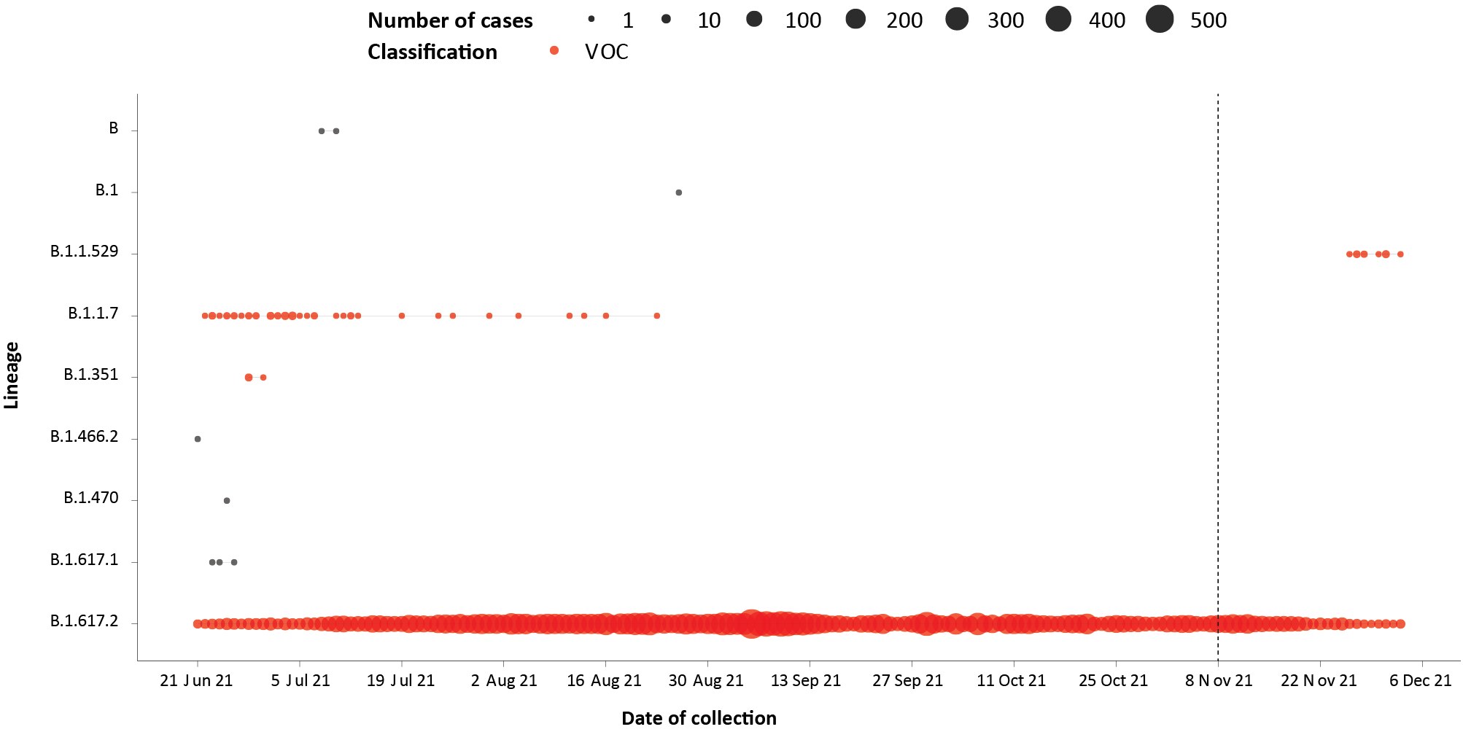
a The start of the current reporting period (8 November – 5 December 2021) is marked by the dotted line, and variant-of-concern samples are coloured red. The size of the circle is proportional to the number of samples in the lineage at each time point.

Figure 4: SARS-CoV-2 polymerase chain reaction (PCR) testing rates per 1,000 population per week by age group and notification received date, Australia, 26 December 2020 – 3 December 2021^{a,b,c}
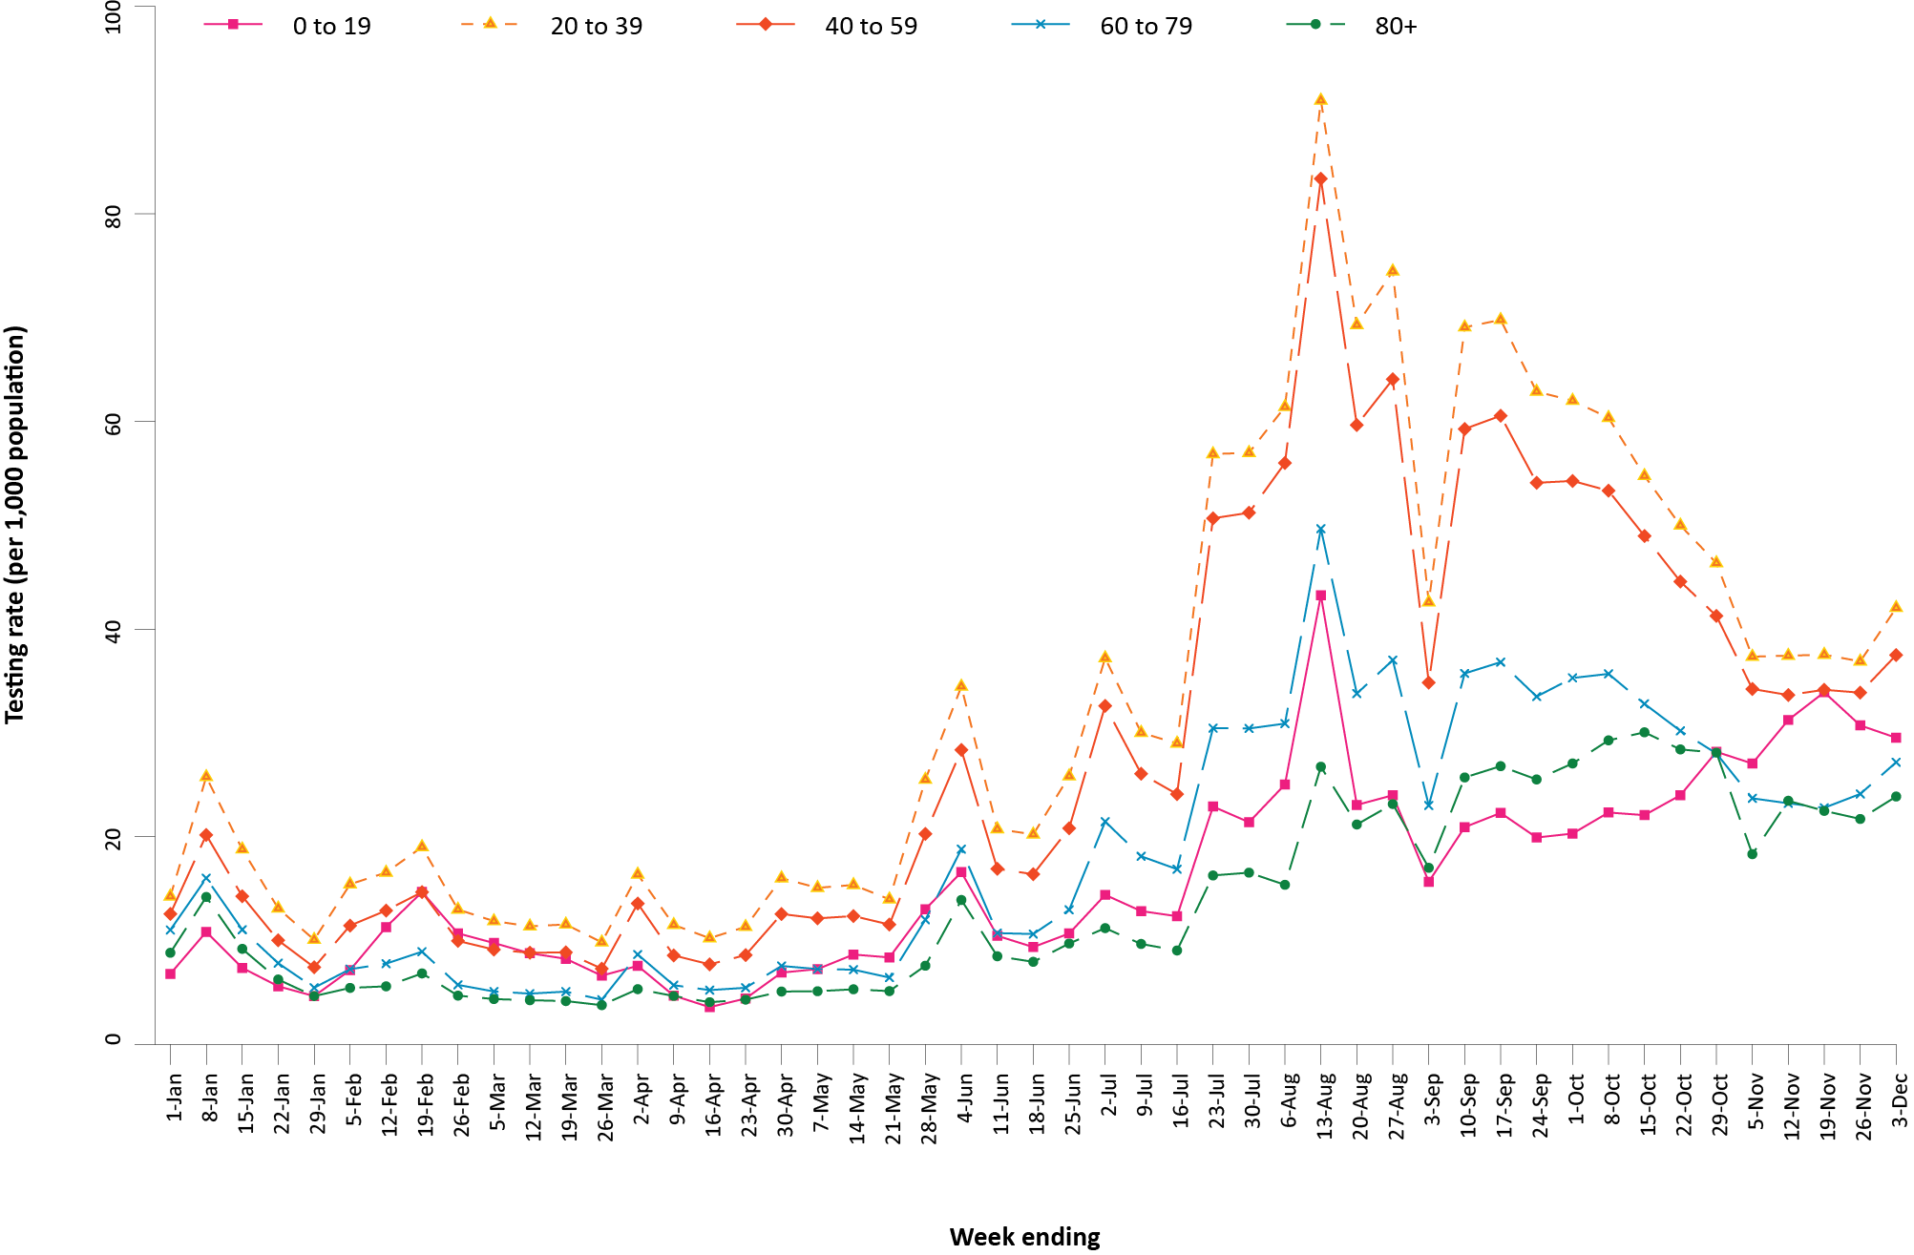
a Source: testing data provided by jurisdictions to the NIR weekly, current to 3 December 2021; population data based on Australian Bureau of Statistics (ABS) Estimated Resident Population (ERP) as at June 2020.
b The jurisdictions reporting each week (i.e. the denominator population) may vary.
c From 22 May to 4 June and 26 June to 9 July, data for Queensland were unavailable. From 19 June 2021 to 16 July 2021, data for New South Wales were unavailable. From 28 August to 3 September 2021, data for New South Wales and the Australian Capital Territory were unavailable. From 30 October to 5 November 2021, data for Victoria were unavailable.

Figure 5: SARS-CoV-2 polymerase chain reaction (PCR) testing rates per 1,000 population per week and percent positivity by specimen date, Australia, 26 December 2020 – 3 December 2021^{a,b,c}
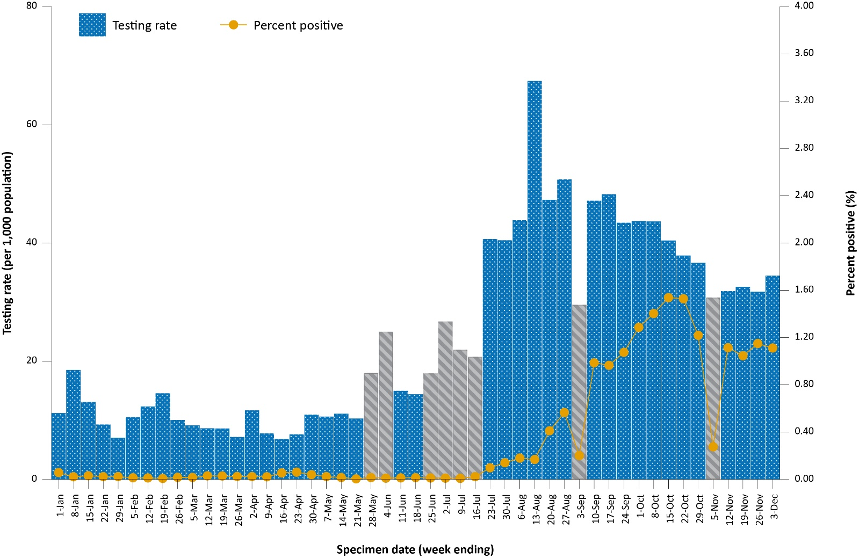
a Source: testing data provided by jurisdictions to the NIR weekly, current to 3 December 2021; case data extracted from NINDSS on 8 December 2021 for cases with a specimen date up to 3 December 2021; population data based on Australian Bureau of Statistics (ABS) Estimated Resident Population (ERP) as at June 2020.
b The jurisdictions reporting each week (i.e. the denominator population) may vary.
c Grey bars indicate weeks where jurisdictional reporting was incomplete. From 22 May to 4 June and from 26 June to 9 July, data for Queensland were unavailable. From 19 June 2021 to 16 July 2021, data for New South Wales were unavailable. From 28 August to 3 September 2021, data for New South Wales and the Australian Capital Territory were unavailable. From 30 October to 5 November 2021, data for Victoria were unavailable.

Table 11: Individuals undergoing diagnostic tests for SARS-CoV-2,ª by jurisdiction and reporting period, with a notification received date of 6 November – 3 December 2021
Jurisdiction | Individuals testedª |  |  | Individuals testedª
 | 20 November – 3 December 2021 |  |  | 6–19 November 2021
 | nb | Positivity (%) | Per 1,000 population^{c} | nb | Positivity (%) | Per 1,000 population^{c}
ACT | 38,684 | 0.30 | 90 | 42,721 | 0.43 | 99
NSW | 814,221 | 0.40 | 100 | 835,589 | 0.36 | 102
NT | 24,971 | 0.12 | 101 | 23,636 | 0.14 | 96
Qld | 97,614 | 0.02 | 19 | 92,441 | < 0.01 | 18
SA | 93,348 | 0.05 | 53 | 48,500 | < 0.01 | 27
Tas. | 9,523 | < 0.01 | 18 | 9,296 | < 0.01 | 17
Vic. | 595,260 | 2.65 | 89 | 579,937 | 2.52 | 87
WA | 27,438 | < 0.01 | 10 | 23,669 | 0.03 | 9
Australia | 1,701,059 | 1.13 | 66 | 1,655,789 | 1.08 | 64
a In order to more accurately reflect positivity rates, numbers of individuals tested is presented rather than total number of tests. The number of individuals tested is the sum of number of individuals tested in each week (Saturday to Friday) in each jurisdiction. Individuals who were tested in more than one week could be counted more than once.
b Total cumulative tests counts the total number of tests performed, not the number of individuals tested.
c Population data based on Australian Bureau of Statistics (ABS) Estimated Resident Population (ERP) as at June 2020.

Acute respiratory illness

(FluTracking, ASPREN, and Commonwealth Respiratory Clinics)
Based on self-reported FluTracking data,¹² prevalence of fever and cough in the community remained at < 1% but increased slightly compared to the previous four-week reporting period (Figure 6). Runny nose and sore throat symptoms in the community also increased during this reporting period compared to the previous four weeks, with the prevalence in the community remaining low at < 1%.

Figure 6: Weekly trends in respiratory illness amongst FluTracking survey participants (age-standardised) compared to the average of the previous five years, Australia, by epidemiological week,ª 1 March 2020 – 5 December 2021^{b}
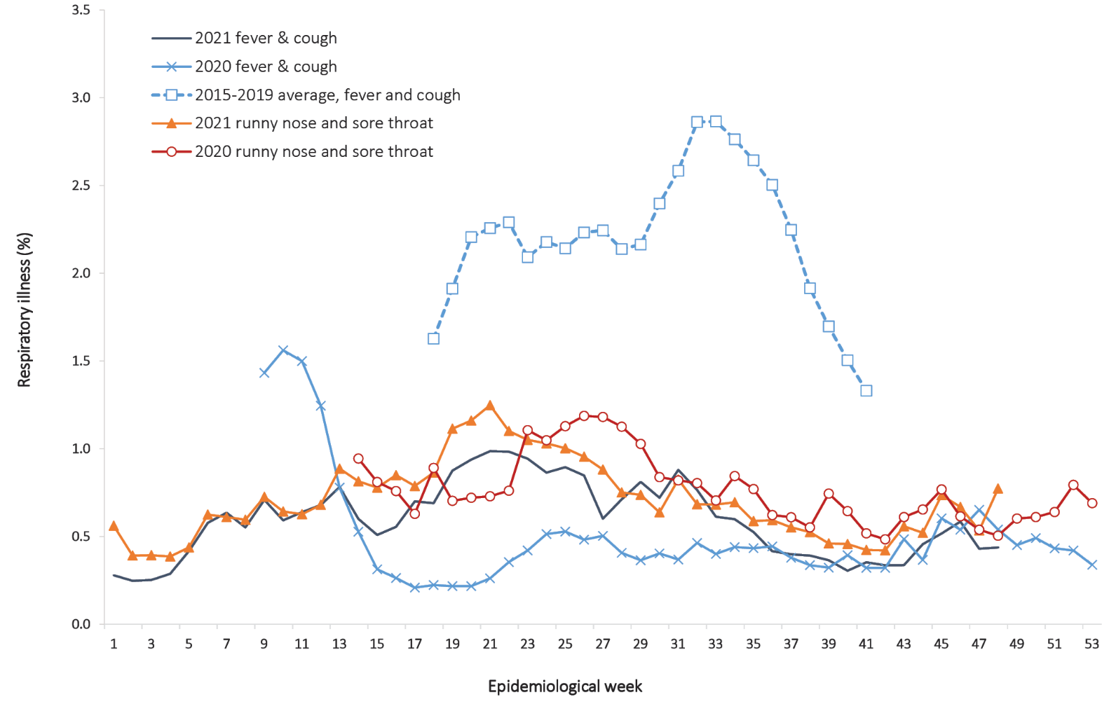
a Epidemiological weeks are a standardised method for numbering weeks across years, with the first epidemiological week of any year ending on the first Saturday in January.
b In years prior to 2020, FluTracking was activated during the main Influenza season from May to October. A historical average beyond the week ending 11 October (epidemiological week 41) is therefore not available. In 2020, FluTracking commenced ten weeks early to capture data for COVID-19. Data on runny nose and sore throat were only collected systematically after 29 March 2020, therefore a historical average for this symptom profile is unavailable.
In this reporting period, acute respiratory illness was highest in those aged 0 to 9 years and those aged 30 to 39 years, based on both self-reported FluTracking data and presentations to Commonwealth Respiratory Clinics. Females reported respiratory illness more frequently than males. Rates of fever and cough by jurisdiction ranged from 2.7 per 1,000 FluTracking participants in New South Wales to 4.5 per 1,000 participants in Tasmania. Rates of runny nose and sore throat ranged from 4.3 per 1,000 FluTracking participants in the Queensland to 9.9 per 1,000 FluTracking participants in the Australian Capital Territory.
FluTracking data indicated that 55% of those in the community with ‘fever and cough’ and 34% of those with ‘runny nose and sore throat’ were tested for SARS-CoV-2. This represents a slight decrease in SARS-CoV-2 testing for both sets of symptoms since the previous reporting period. In the four-week reporting period, testing rates for fever and cough were highest in Victoria and lowest in Western Australia, while testing rates for runny nose and sore throat were highest in New South Wales and Victoria, and lowest in Western Australia. It is important to acknowledge that there may be legitimate reasons why people did not get tested, including barriers to accessing testing. Symptoms reported to FluTracking are not specific to COVID-19 and may also be due to chronic diseases.
During this reporting period, there were 116,705 assessments at Commonwealth Respiratory Clinics. Of these, there were 105,570 assessments with consent to share information, with 97% (102,603/105,570) tested for SARS-CoV-2. There were 926 cases reported at these clinics in this reporting period, representing a percent positivity of < 1% (926/102,603).

Public health response measures
Since COVID-19 first emerged internationally, Australia has implemented public health measures informed by the disease’s epidemiology. States and territories have decision making authority in relation to public health measures and have implemented or eased restrictions at their own pace (Figure 7; Appendix A, Table A.2), depending on the local public health and epidemiological situation, and in line with the ‘Framework for National Reopening’.¹³ Nationwide requirements regarding air travel, including pre-flight testing for travellers entering Australia and requirements to wear face masks when flying domestically or internationally, remain in place.

Figure 7: COVID-19 notifications in Australia by week of diagnosis and jurisdiction, 31 May – 5 December 2021, with timing of key public health measures

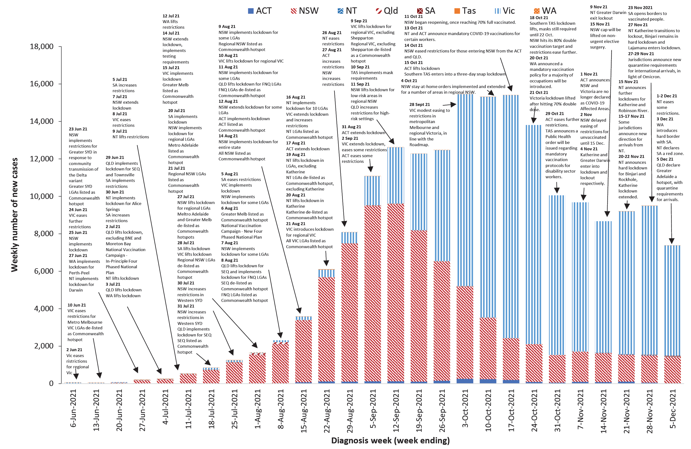

Countries and territories in Australia’s near region
According to WHO, countries and territories in the South East Asian and Western Pacific regions reported 1,290,006 newly-confirmed cases and 27,282 deaths in the four-week period to 5 December 2021, bringing the cumulative cases in the two regions to over 55 million, and cumulative deaths in these regions to over 855,000.¹⁴ New case numbers have continued to trend downward in the south east Asian region, driven by decreasing cases in Indonesia and Thailand, while the number of new deaths has remained steady. Both the number of new cases and new deaths in the Western Pacific Region in the past four weeks have remained steady compared to the previous four-week period. The highest numbers of new cases in the Western Pacific region during the four-week period to 5 December 2021 were in Viet Nam, Malaysia and South Korea.¹⁵
Table 12 outlines the new cases and deaths in the four-week period to 5 December 2021 and cumulative cases and deaths for the pandemic in selected countries with the highest number of new cases in the South East Asian region and the Western Pacific region.
Table 12: Cumulative cases and deaths, and new cases and deaths reported in the four-week period to 5 December 2021 for selected countries in Australia’s near region according to WHOª
Country | Cumulative cases | New cases reported in the last 4 weeks | Change in new cases in the last 4 weeks^{b} | Cumulative deaths | New deaths reported in the last 4 weeks | Change in new deaths in the last 4 weeks^{b}
South East Asian region
India | 34,633,255 | 277,719 | -31% | 473,326 | 12,535 | +23%
Thailand | 2,141,241 | 173,242 | -33% | 20,944 | 1,280 | -35%
Sri Lanka | 567,682 | 22,426 | +19% | 14,461 | 605 | +15%
Myanmar | 524,407 | 17,591 | -38% | 19,141 | 320 | -53%
Indonesia | 4,257,685 | 9,520 | -53% | 143,867 | 322 | -64%
Western Pacific region
Viet Nam | 1,294,778 | 333,740 | +167% | 26,061 | 3,591 | +77%
Malaysia | 2,654,474 | 152,508 | -10% | 30,574 | 1,318 | -34%
Republic of Korea | 473,033 | 93,099 | +92% | 3,852 | 885 | +126%
Singapore | 268,659 | 52,879 | -42% | 746 | 266 | -19%
Australia | 216,554 | 37,680 | -30% | 2,042 | 237 | -38%
a Source: World Health Organization Coronavirus (COVID-19) Dashboard,14 accessed 8 December 2021.
b Percent change in the number of newly confirmed cases/deaths in the most recent four-week period compared to the four weeks prior.
As of 5 December 2021, over 264 million COVID-19 cases and 5.2 million deaths have been reported globally, with a global case fatality rate (CFR) of 2%. The two regions reporting the largest burden of disease over the past four weeks were the European Region (67% of cases) and the Region of the Americas (21% of cases).

Acknowledgements
We thank public health staff from incident emergency operations centres and public health units in state and territory health departments, and the Australian Government Department of Health, along with state and territory public health laboratories. We thank those who have provided data from surveillance systems, such as Commonwealth respiratory clinics, ASPREN, FluTracking, FluCAN, SPRINT-SARI, Communicable Disease Genomics Network, AusTrakka and jurisdictional sequencing laboratories.

Author details

Corresponding author
COVID-19 National Incident Room Surveillance Team
Australian Government Department of Health, GPO Box 9484, MDP 14, Canberra, ACT 2601.
Email: epi.coronavirus@health.gov.au

References
- COVID-19 National Incident Room Surveillance Team. COVID-19 Australia: Epidemiology Report 55: Reporting period ending 21 November 2021. Commun Dis Intell (2018). 2021;45. doi: https://doi.org/10.33321/cdi.2021.45.65.
- COVID-19 National Incident Room Surveillance Team. COVID-19 Australia: Epidemiology Report 54: Reporting period ending 7 November 2021. Commun Dis Intell (2018). 2021;45. doi: https://doi.org/10.33321/cdi.2021.45.62.
- COVID-19 National Incident Room Surveillance Team. Technical supplement. COVID-19 Australia: Epidemiology reporting. Commun Dis Intell (2018). 2021;45. doi: https://doi.org/10.33321/cdi.2021.45.2.
- Australian Government Department of Health. Vaccination numbers and statistics. [Internet.] Canberra: Australian Government Department of Health; 2021. [Accessed on 7 December 2021.] Available from: https://www.health.gov.au/initiatives-and-programs/covid-19-vaccines/numbers-statistics.
- World Health Organization (WHO). Classification of Omicron (B.1.1.529): SARS-CoV-2 Variant of Concern. [Internet.] Geneva: WHO; 26 November 2021. [Accessed on 10 Decmber 2021.] Available from: https://www.who.int/newsroom/statements/26-11-2021-classification-of-omicron-(b.1.1.529)-sars-cov-2-variant-of-concern.
- Australian and New Zealand Intensive Care Research Centre (ANZIC-RC). SPRINT-SARI: Short period incidence study of severe acute respiratory infection. [Internet.] Melbourne: Monash University, ANZIC-RC; 2020. Available from: https://www.monash.edu/medicine/sphpm/anzicrc/research/sprint-sari.
- Communicable Diseases Genomics Network (CDGN). AusTrakka. [Website.] Melbourne: CDGN; 2020. Available from: https://www.cdgn.org.au/austrakka.
- Network for Genomic Surveillance in South Africa (NGS-SA). Recording: Briefing on COVID-19 and vaccination programme developments 25 November 2021. [Video recording.] Durban: NGS-SA; 25 November 2021. [Accessed on 10 December 2021.] Available from: https://sacoronavirus.co.za/2021/11/25/recording-briefing-on-covid-19-and-vaccination-programme-developments-25-november-2021/.
- World Health Organization (WHO). Coronavirus disease (COVID-19) Weekly Epidemiological Update and Weekly Operational Update. [Internet.] Geneva: WHO; June 2021. [Accessed on 14 October 2021.] Available from: https://www.who.int/emergencies/diseases/novel-coronavirus-2019/situation-reports/.
- Allen H, Vusirikala A, Flannagan J, Twohig KA, Zaidi A, Groves N et al. Increased household transmission of COVID-19 cases associated with SARS-CoV-2 Variant of Concern B.1.617.2: a national case-control study. Knowledge Hub (khub); 2021. [Accessed on 14 October 2021.] Available from: https://khub.net/documents/135939561/405676950/Increased+Household+Transmission+of+COVID-19+Cases+-+national+case+study.pdf/7f7764fb-ecb0-da31-77b3-b1a8ef7be9aa.
- WHO. Tracking SARS-CoV-2 variants. [Internet.] Geneva: WHO; 15 June 2021. [Accessed on 14 October 2021.] Available from: https://www.who.int/en/activities/tracking-SARS-CoV-2-variants/.
- Dalton C, Durrheim D, Fejsa J, Francis L, Carlson S, d’Espaignet ET et al. Flutracking: a weekly Australian community online survey of influenza-like illness in 2006, 2007 and 2008. Commun Dis Intell Q Rep. 2009;33(3):316–22.
- Australian Government Department of Health. Framework for national reopening – October 2020. [Internet.] Canberra: Australian Government Department of Health; 23 October 2020. [Accessed on 10 November 2020.] Available from: https://www.health.gov.au/resources/publications/framework-for-national-reopening-october-2020.
- WHO. WHO Coronavirus Disease (COVID-19) dashboard. [Internet.] Geneva: WHO; 2021. Available from: https://covid19.who.int/.
- WHO. Weekly epidemiological update on COVID-19 – 7 December 2021. [Internet.] Geneva: WHO; 7 December 2021. [Accessed on 8 December 2021.] Available from: https://www.who.int/publications/m/item/weekly-epidemiological-update-on-covid-19---7-december-2021.
- Australian Capital Territory Government. ACT Pathway Forward brought forward by two weeks. [Internet.] Canberra: Australian Capital Territory Government; 9 November 2021. [Accessed on 8 December 2021.] Available from: https://www.covid19.act.gov.au/news-articles/next-step-in-act-pathway-forward-brought-forward-by-two-weeks.
- Australian Capital Territory Government. ACT COVID-19 Update – 12 November 2021. [Internet.] Canberra: Australian Capital Territory Government; 12 November 2021. [Accessed on 8 December 2021.] Available from: https://www.covid19.act.gov.au/news-articles/act-covid-19-update-12-november-2021.
- Australian Capital Territory Government. ACT COVID-19 Update – 21 November 2021. [Internet.] Canberra: Australian Capital Territory Government; 21 November 2021. [Accessed on 8 December 2021.] Available from: https://www.covid19.act.gov.au/news-articles/act-covid-19-update-21-november-2021.
- Australian Capital Territory Government. ACT COVID-19 Update – 25 November 2021. [Internet.] Canberra: Australian Capital Territory Government; 25 November 2021. [Accessed on 8 December 2021.] Available from: https://www.covid19.act.gov.au/news-articles/act-covid-19-update-25-november-2021.
- Australian Capital Territory Government. Quarantine requirements re-introduced for all international arrivals. [Internet.] Canberra: Australian Capital Territory Government; 27 November 2021. [Accessed on 8 December 2021.] Available from: https://www.covid19.act.gov.au/news-articles/quarantine-requirements-re-introduced-for-all-international-arrivals.
- Australian Capital Territory Government. Quarantine requirements to continue for international arrivals. [Internet.] Canberra: Australian Capital Territory Government; 30 November 2021. [Accessed on 8 December 2021.] Available from: https://www.covid19.act.gov.au/news-articles/quarantine-requirements-to-continue-for-international-arrivals2.
- Government of New South Wales Department of Health (NSW Health). Elective surgery to return to full capacity for patients in Greater Sydney. [Internet.] Sydney: Government of New South Wales, NSW Health; 12 November 2021. [Accessed on 8 December 2021.] Available from: https://www.health.nsw.gov.au/news/Pages/20211112_01.aspx.
- NSW Health. COVID-19 (Coronavirus) statistics. [Internet.] Sydney: Government of New South Wales, NSW Health; 27 November 2021. [Accessed on 8 December 2021.] Available from: https://www.health.nsw.gov.au/news/Pages/20211127_00.aspx.
- NSW Health. Public health alert - cases identified on international flight. [Internet.] Sydney: Government of New South Wales, NSW Health; 28 November 2021. [Accessed on 8 December 2021.] Available from: https://www.health.nsw.gov.au/news/Pages/20211128_00.aspx.
- Northern Territory Government. COVID-19 Update: Lockout extended for Darwin, new exposure sites, no new cases. [Internet.] Darwin: Northern Territory Government; 8 November 2021. [Accessed on 9 December 2021.] Available from: https://coronavirus.nt.gov.au/updates/items/2021-11-08-covid-19-update-lockout-extended-for-darwin,-new-exposure-sites,-no-new-cases.
- Northern Territory Government. Positive wastewater in Katherine, Darwin to exit mask mandate. [Internet.] Darwin: Northern Territory Government; 12 November 2021. [Accessed on 9 December 2021.] Available from: https://coronavirus.nt.gov.au/updates/items/2021-11-12-positive-wastewater-in-katherine,-darwin-to-exit-mask-mandate.
- Northern Territory Government. COVID-19 Update: Katherine mask mandate extended. [Internet.] Darwin: Northern Territory Government; 13 November 2021. [Accessed on 9 December 2021.] Available from: https://coronavirus.nt.gov.au/updates/items/2021-11-13-covid-19-update-katherine-mask-mandate-extended.
- Northern Territory Government. Positive cases in the NT, lockdowns in Katherine, Robinson River and surrounds. [Internet.] Darwin: Northern Territory Government; 15 November 2021. [Accessed on 9 December 2021.] Available from: https://coronavirus.nt.gov.au/updates/items/2021-11-15-positive-cases-in-the-nt,-lockdowns-in-katherine,-robinson-river-and-surrounds.
- Northern Territory Government. COVID-19 Update: Nine new cases recorded in the NT. [Internet.] Darwin: Northern Territory Government; 16 November 2021. [Accessed on 9 December 2021.] Available from: https://coronavirus.nt.gov.au/updates/items/2021-11-16-covid-19-update-nine-new-cases-recorded-in-the-nt.
- Northern Territory Government. One new case recorded in the NT. [Internet.] Darwin: Northern Territory Government; 20 November 2021. [Accessed on 9 December 2021.] Available from: https://coronavirus.nt.gov.au/updates/items/2021-11-20-one-new-case-recorded-in-the-nt.
- Northern Territory Government. COVID-19 Update: Nine new cases of COVID-19. [Internet.] Darwin: Northern Territory Government; 20 November 2021. [Accessed on 9 December 2021.] Available from: https://coronavirus.nt.gov.au/updates/items/2021-11-20-covid-19-update-nine-new-cases-of-covid-19.
- Northern Territory Government. Two new cases recorded in the NT. [Internet.] Darwin: Northern Territory Government; 22 November 2021. [Accessed on 9 December 2021.] Available from: https://coronavirus.nt.gov.au/updates/items/2021-11-22-two-new-cases-recorded-in-the-nt.
- Northern Territory Government. One new cases recorded in the NT. [Internet.] Darwin: Northern Territory Government; 25 November 2021. [Accessed on 9 December 2021.] Available from: https://coronavirus.nt.gov.au/updates/items/2021-11-25-one-new-case-recorded-in-the-nt.
- Northern Territory Government. No new cases recorded in the NT. [Internet.] Darwin: Northern Territory Government; 26 November 2021. [Accessed on 9 December 2021.] Available from: https://coronavirus.nt.gov.au/updates/items/2021-11-26-no-new-cases-recorded-in-the-nt.
- Northern Territory Government. COVID-19 Update: Two new cases in the NT. [Internet.] Darwin: Northern Territory Government; 27 November 2021. [Accessed on 9 December 2021.] Available from: https://coronavirus.nt.gov.au/updates/items/2021-11-27-covid-19-update-two-new-cases-in-the-nt.
- Northern Territory Government. COVID-19 Update: Lajamanu enters into lockdown. [Internet.] Darwin: Northern Territory Government; 27 November 2021. [Accessed on 9 December 2021.] Available from: https://coronavirus.nt.gov.au/updates/items/2021-11-27-covid-19-update-lajamanu-enters-into-lockdown.
- Northern Territory Government. COVID-19 Update: Three new cases recorded in the NT. [Internet.] Darwin: Northern Territory Government; 1 December 2021. [Accessed on 9 December 2021.] Available from: https://coronavirus.nt.gov.au/updates/items/2021-12-01-covid-19-update-three-new-cases-recorded-in-the-nt.
- Northern Territory Government. One new case recorded in the NT. [Internet.] Darwin: Northern Territory Government; 2 December 2021. [Accessed on 9 December 2021.] Available from: https://coronavirus.nt.gov.au/updates/items/2021-12-02-one-new-case-recorded-in-the-nt.
- Northern Territory Government. COVID-19 Update: Two new cases recorded in the NT. [Internet.] Darwin: Northern Territory Government; 3 December 2021. [Accessed on 9 December 2021.] Available from: https://coronavirus.nt.gov.au/updates/items/2021-12-03-covid-19-update-two-new-cases-recorded-in-the-nt.
- Queensland Health. Greater Katherine named as hotspot. [Internet.] Brisbane: Queensland Government, Queensland Health; 15 November 2021. [Accessed on 9 December 2021.] Available from: https://www.health.qld.gov.au/news-events/doh-media-releases/releases/greater-katherine-named-as-hotspot.
- Queensland Health. Queensland declares Greater Adelaide a hotspot. [Internet.] Brisbane: Queensland Government, Queensland Health; 4 December 2021. [Accessed on 9 December 2021.] Available from: https://www.health.qld.gov.au/news-events/doh-media-releases/releases/queensland-declares-greater-adelaide-a-hotspot.
- SA Health. COVID-19 update 384. [Internet.] Adelaide: Government of South Australia, SA Health; 15 November 2021. [Accessed on 9 December 2021.] Available from: https://www.sahealth.sa.gov.au/wps/wcm/connect/public+content/sa+health+internet/conditions/infectious+diseases/covid-19/about+covid-19/latest+updates/covid-19+round+up+reports/covid-19+update+384.
- SA Health. COVID-19 update 386. [Internet.] Adelaide: Government of South Australia, SA Health; 17 November 2021. [Accessed on 9 December 2021.] Available from: https://www.sahealth.sa.gov.au/wps/wcm/connect/public+content/sa+health+internet/conditions/infectious+diseases/covid-19/about+covid-19/latest+updates/covid-19+round+up+reports/covid-19+update+386.
- SA Health. COVID-19 update 389. [Internet.] Adelaide: Government of South Australia, SA Health; 23 November 2021. [Accessed on 9 December 2021.] Available from: https://www.sahealth.sa.gov.au/wps/wcm/connect/public+content/sa+health+internet/conditions/infectious+diseases/covid-19/about+covid-19/latest+updates/covid-19+round+up+reports/covid-19+update+389.
- SA Health. COVID-19 update 391. [Internet.] Adelaide: Government of South Australia, SA Health; 29 November 2021. [Accessed on 9 December 2021.] Available from: https://www.sahealth.sa.gov.au/wps/wcm/connect/public+content/sa+health+internet/conditions/infectious+diseases/covid-19/about+covid-19/latest+updates/covid-19+round+up+reports/covid-19+update+391.
- SA Health. COVID-19 update 392. [Internet.] Adelaide: Government of South Australia, SA Health; 30 November 2021. [Accessed on 9 December 2021.] Available from: https://www.sahealth.sa.gov.au/wps/wcm/connect/public+content/sa+health+internet/conditions/infectious+diseases/covid-19/about+covid-19/latest+updates/covid-19+round+up+reports/covid-19+update+392.
- Premier of Tasmania. PRESS CONFERENCE - 01 DECEMBER 2021. [Internet.] Hobart: Tasmanian Government, Office of the Premier; 1 December 2021. [Accessed on 9 December 2021.] Available from: https://www.premier.tas.gov.au/covid-19_updates/press_conference_-_01_december_2021. .
- Victoria State Government Department of Health and Human Services (DHHS). Coronavirus update for Victoria – 13 November 2021. [Internet.] Melbourne: Victoria State Government, DHHS; 13 November 2021. [Accessed on 9 December 2021.] Available from: https://www.health.vic.gov.au/media-releases/coronavirus-update-for-victoria-13-november-2021.
- DHHS. Coronavirus update for Victoria – 18 November 2021. [Internet.] Melbourne: Victoria State Government, DHHS; 18 November 2021. [Accessed on 9 December 2021.] Available from: https://www.health.vic.gov.au/media-releases/coronavirus-update-for-victoria-18-november-2021.
- DHHS. Coronavirus update for Victoria – 24 November 2021. [Internet.] Melbourne: Victoria State Government, DHHS; 24 November 2021. [Accessed on 9 December 2021.] Available from: https://www.health.vic.gov.au/media-releases/coronavirus-update-for-victoria-24-november-2021.
- DHHS. Domestic border permits to end. [Internet.] Melbourne: Victoria State Government, DHHS; 25 November 2021. [Accessed on 9 December 2021.] Available from: https://www.health.vic.gov.au/media-releases/domestic-border-permits-to-end.
- DHHS. New public health rules for overseas travellers to Victoria. [Internet.] Melbourne: Victoria State Government, DHHS; 27 November 2021. [Accessed on 9 December 2021.] Available from: https://www.health.vic.gov.au/media-releases/new-public-health-rules-for-overseas-travellers-to-victoria.
- DHHS. Coronavirus update for Victoria – 5 December 2021. [Internet.] Melbourne: Victoria State Government, DHHS; 5 December 2021. [Accessed on 9 December 2021.] Available from: https://www.health.vic.gov.au/media-releases/coronavirus-update-for-victoria-5-december-2021.
- Government of Western Australia. Northern Territory transitions to a ‘low risk’ jurisdiction. [Internet.] Perth: Government of Western Australia, Department of the Premier and Cabinet; 16 November 2021. [Accessed on 9 December 2021.] Available from: https://www.wa.gov.au/government/announcements/northern-territory-transitions-low-risk-jurisdiction.
- Government of Western Australia. Border controls strengthened with South Australia. [Internet.] Perth: Government of Western Australia, Department of the Premier and Cabinet; 27 November 2021. [Accessed on 9 December 2021.] Available from: https://www.wa.gov.au/government/announcements/border-controls-strengthened-south-australia.
- Government of Western Australia. WA introduces hard border with South Australia. [Internet.] Perth: Government of Western Australia, Department of the Premier and Cabinet; 2 December 2021. [Accessed on 9 December 2021.] Available from: https://www.wa.gov.au/government/announcements/wa-introduces-hard-border-south-australia-0.

Appendix A: Supplementary figures and tables
Table A.1: COVID-19 cases and rates per 100,000 population, by age group, sex, and notification received date, Australia, 5 December 2021^{a,b}
Age group^{c} | This reporting period |  |  |  |  |  | This year
 | 22 November 2021 – 5 December 2021 |  |  |  |  |  | 1 January 2021 – 5 December 2021
 | Cases |  |  | Rate per 100,000 population |  |  | Cases |  |  | Rate per 100,000 population
 | Male | Female | People | Male | Female | People | Male | Female | People | Male | Female | People
0–4 | 546 | 492 | 1,048 | 68.2 | 65.1 | 67.3 | 6,704 | 6,333 | 13,092 | 836.9 | 838.2 | 841.1
5–11 | 2,053 | 1,979 | 4,048 | 175.7 | 178.6 | 177.8 | 13,122 | 12,569 | 25,824 | 1123.3 | 1134.2 | 1134.4
12–15 | 473 | 450 | 930 | 74.0 | 74.4 | 74.8 | 5,716 | 5,589 | 11,350 | 894.7 | 923.8 | 912.5
16–17 | 136 | 168 | 306 | 45.4 | 59.2 | 52.4 | 2,858 | 2,554 | 5,433 | 953.6 | 899.4 | 930.9
18–29 | 1,685 | 1,708 | 3,397 | 78.2 | 82.3 | 80.3 | 22,105 | 20,354 | 42,562 | 1025.6 | 981.3 | 1006.3
30–39 | 1,305 | 1,518 | 2,827 | 70.3 | 79.8 | 75.2 | 16,483 | 15,606 | 32,181 | 887.6 | 820.9 | 856.3
40–49 | 1,263 | 1,304 | 2,574 | 77.5 | 78.3 | 78.1 | 11,998 | 11,316 | 23,366 | 735.8 | 679.3 | 708.8
50–59 | 874 | 842 | 1,721 | 57.4 | 52.7 | 55.1 | 8,688 | 8,175 | 16,904 | 570.5 | 511.6 | 541.7
60–69 | 570 | 583 | 1,156 | 43.6 | 41.9 | 42.9 | 5,100 | 4,873 | 10,001 | 390.3 | 350.5 | 370.8
70–79 | 352 | 348 | 702 | 38.6 | 36.0 | 37.3 | 2,640 | 2,525 | 5,179 | 289.6 | 260.9 | 275.5
80–89 | 163 | 184 | 347 | 43.9 | 38.8 | 41.1 | 1,249 | 1,409 | 2,670 | 336.7 | 297.4 | 316.1
90 and over | 31 | 77 | 108 | 42.4 | 55.7 | 51.1 | 254 | 492 | 746 | 347.1 | 356.1 | 353.0
a Source: NINDSS, extract from 8 December 2021 for notifications up to 5 December 2021. Excludes cases where age or sex data is missing.
b Population data based on Australian Bureau of Statistics (ABS) Estimated Resident Population (ERP) as at June 2020.
c From report 55, the age groups have been changed to match those used to report severity.

Table A.2: State and territory changes to COVID-19 restrictions, Australia, 8 November 2021 – 5 December 2021
ACT
- On 9 November 2021, with ACT reaching 95% eligible population fully vaccinated, the ACT Government brought forward the ACT Pathway Forward by two weeks. Changes included:16
  - No more limits on home visits or informal outdoor gatherings
  - Indoor and outdoor entertainment venues with fixed seating able to host events at 100% seated capacity
  - Restrictions on cinemas and swimming pools relaxed
  - Organised sport recommenced with 1 per 2 sqm in indoor settings
  - Moved to a default one person per two square metre density limit (1 per 2 sqm) across most indoor settings and industries, including hospitality and retail.
  - No density limits applied in outdoor spaces for most activities, and events able to have more people before requiring an exemption.
  - Drinking while standing permitted at licenced venues, cafes and restaurants.
  - Nightclubs reopened. Dancing is back.
  - Face masks only required in high risk settings, such as hospitals and aged care facilities, on public transport, and in schools and some businesses settings.
- On 12 November 2021, the ACT Public Health Directions were updated. The Minister for Health signed an extension of the Public Health Emergency Declaration until 12 February 2022.¹⁷
- From 8:00 am 22 November 2021, visitor restrictions eased at all ACT hospitals, community health centres and walk-in centres allowing two visitors per patient, per day during visiting hours.¹⁸
- As at 11:59 pm 25 November 2021, Indoor Play Centres were allowed to open, provided they have a COVID Safe Plan in place that has been endorsed by the Office of the Chief Health Officer. These businesses are still be required to operate with 1 person per 2 square metres within each indoor and outdoor space (excluding staff).¹⁹
- On 27 November 2021, ACT Health announced anyone in the ACT who has been in South Africa, Lesotho, Botswana, Zimbabwe, Mozambique, Malawi, Namibia, and/or Eswatini in the past 14 days must get a COVID-19 PCR test and quarantine immediately. From 11:59 pm 27 November 2021, ACT Health also implemented quarantine requirements for fully vaccinated overseas travellers who have not been in these countries. These travellers were required to quarantine until 11:59 pm 30 November 2021.¹⁹
- On 27 November 2021, further quarantine arrangements were announced for international travellers arriving in the ACT:²⁰
  - Those already in the ACT who had recently arrived from overseas and had travelled from/spent time in the countries listed above in the past 14 days:
    - should have a COVID-19 PCR test as soon as possible. If they had not had an initial test within 24 hours of arrival to Australia, they must get tested.
    - are required to quarantine at their current residence/accommodation until 14 days have passed since last in the listed country.
  - Those arriving from the listed countries on or after 11:59 pm 27 November 2021 intending to travel to the ACT are required to:
    - quarantine at the port of entry to Australia regardless of vaccination status.
    - follow the requirements of the jurisdiction of their port of entry to Australia.
  - Those who are fully vaccinated, arriving from countries other than those listed above intending to travel to the ACT:
    - need to follow the requirements of the jurisdiction of their port of entry to Australia.
    - if the port of entry allows onward travel to the ACT, travellers are required to complete a Declaration Form within 24 hours prior to arrival into the ACT.
    - are required to quarantine at their ACT residence/accommodation until 11:59 pm on Tuesday 30 November 2021.
  - International travellers who are not fully vaccinated
    - There is no change to requirements for these travellers.
- On 30 November 2021, the ACT Government announced that international travellers arriving into NSW or Victoria who have been in South Africa, Lesotho, Botswana, Zimbabwe, Mozambique, Namibia, Eswatini and/or Malawi during the 14 day period before arrival must not travel to the ACT until quarantine requirements have been completed at their port of entry.²¹
NSW
- On 12 November 2021, the NSW Government announced the cap will be lifted on non-urgent elective surgery from Monday 15 November 2021.²²
- On 27 November 2021, NSW Health urged all travellers who had been in southern Africa, including South Africa, Lesotho, Botswana, Zimbabwe, Mozambique, Namibia, and Eswatini, in the 14 days before arriving in Australia to get a COVID-19 test and isolate immediately. All people in the household should also isolate until further notice.²³
  - People who have arrived from overseas must have a COVID-19 PCR test within 24 hours of arriving and another test around day six. Travellers who have not been in southern Africa are not required to isolate while waiting for their results unless they have symptoms.
- On 28 November 2021, in light of Omicron, the NSW Government announced travellers arriving in NSW who have been in South Africa, Lesotho, Botswana, Zimbabwe, Mozambique, Namibia, Eswatini, Malawi, and the Seychelles (Seychelles later removed from list) during the 14 day period before their arrival in NSW must enter hotel quarantine for 14 days, irrespective of their vaccination status:²⁴
  - Anyone who has already arrived in NSW who has been in any of the listed African countries within the previous 14 days must immediately get tested and isolate for 14 days.
  - All travellers who have been in any other overseas country during the 14-day period before their arrival in NSW must travel directly to their place of residence or accommodation and isolate for 72 hours.
NT
- On 9 November 2021, Greater Darwin exited lockout.²⁵
- On 12 November 2021, the mask mandate for Greater Darwin finished, while the mask mandate in Katherine was extended for 24 hours until 5:00 pm on Saturday, 13 November 2021, due to positive wastewater results.²⁶
- On 13 November 2021, NT Government announced the mask mandate in Katherine would be extended for 48 hours until 5:00 pm on Monday, 15 November 2021.²⁷
- From 6:00 pm on 15 November 2021, the Municipality of Katherine including Tindal and Robinson River including the surrounding homelands entered into lockdown for 72 hours.²⁸
- On 16 November 2021, the lockdown was extended for the Municipality of Katherine (including Tindal) and Robinson River (including the surrounding homelands) until 6:00 pm on Monday, 22 November2021.²⁹
- From midday 16 November 2021, a mask mandate was put in place across the NT until 6:00 pm on Monday, 22 November 2021.29 On 20 November 2021, the NT-wide mask mandate was lifted, except for the lockdown areas of Katherine and Robinson River.³⁰
- On 20 November 2021, the Binjari community – which is located within the Katherine lockdown area – entered into a hard lockdown. The neighbouring Rockhole community of about 130 people, also went into a hard lockdown.³¹
- On 22 November 2021, the lockdown for the Municipality of Katherine (including Tindal) was extended for a further 48 hours, until 6:00 pm, Wednesday 24 November 2021. Robinson River, including surrounding homelands, transitioned from a lockdown to a lockout until Wednesday 1 December 2021.³²
- On 25 November 2021, Rockhole began transitioning from a hard lockdown to a lockdown at midday. The Binjari community remained in a hard lockdown and the Municipality of Katherine (including Tindal) remained in lockdown.³³
- On 26 November 2021, NT Government announced a new testing direction for travellers from South Australia. Effective 12:01 am 27 November 2021, travellers from South Australia must have a Rapid Antigen Test on arrival into the Northern Territory at the airport or nearest distribution centre if travelling by road or rail. From Monday 29 November 2021, travellers from South Australia must have a negative PCR test 72 hours prior to entering the Northern Territory and have proof of the result.³⁴
- At midday 27 November 2021, the Municipality of Katherine transitioned from a lockdown to a lockout until midday on Tuesday 7 December 2021. Binjari remained in hard lockdown while Robinson River and Rockhole remained in lockout.³⁵
- On 27 November 2021, Lajamanu community and the surrounding homelands entered into a lockdown immediately until 6:00 pm on 11 December 2021.³⁶
- At midday 1 December 2021, Robinson River exited lockout and Lajamanu transitioned from a lockdown to a lockout. Binjari remains in a hard lockdown until Tuesday 7 December 2021. Katherine and Rockhole remain in lockout until midday on Tuesday 7 December 2021.³⁷
- At midday 2 December 2021, Binjari community and surrounding homelands transitioned from a hard lockdown to a lockdown.³⁸
- On 3 December 2021, the Chief Health Officer (CHO) declared South Australia a red zone. Fully-vaccinated arrivals coming to the NT from a COVID-19 red zone can apply to undertake seven days home quarantine. Unvaccinated Territory residents and those who have approval to enter the NT are required to undertake 14 days mandatory supervised quarantine. Unvaccinated people are unable to enter the NT.³⁹
QLD
- On 15 November 2021, following the lockdown announcement by the NT Government, QLD Government declared a hotspot from 6:00 pm, 16 November 2021:⁴⁰
  - Anyone travelling to Queensland from the Greater Katherine region after 6:00 pm 16 November 2021 needs to arrive by air, provide evidence of a negative COVID-19 PCR test result, and those with a suitable home will go into home quarantine for 14 days. Anyone who does not have a suitable home or anyone who does not meet the eligibility for home quarantine is required to complete the quarantine period in a government-arranged hotel.
- On 4 December 2021, Queensland Government declared Greater Adelaide a hotspot from 1:00 am 5 December 2021:⁴¹
- Anyone who has been in Greater Adelaide since 1:00 am on 28 November 2021, and who arrives in Queensland after 1:00 am 5 December 2021, is required to go into 14 days mandatory home or hotel quarantine.
- Anyone arriving after 1:00 am on Monday 6 December 2021 needs to have received a negative COVID-19 PCR test result in the 72 hours prior to arrival. For those who arriving into Queensland prior to 1:00 am on Monday 6 December 2021, a PCR test is required as soon as practicable upon arrival into Queensland.
- Anyone who has been in Greater Adelaide since 1:00 am on 28 November 2021, and who arrives in Queensland before 1:00 am 5 December 2021 or is already in Queensland, must get a test as soon as practicable and isolate at home until a negative result is received.
SA
- On 15 November 2021, SA Government announced that anyone who had visited a COVID-19 exposure location in Queensland and Tasmania, had to quarantine.⁴²
- From 5.25 pm on 17 November 2021, travellers who entered South Australia from Northern Territory were subject to new restrictions.⁴³
- As at 23 November 2021, SA borders opened to vaccinated people.⁴⁴
- On 29 November 2021, in light of Omicron, the SA Government announced all international travellers arriving in SA, including travellers transiting through another Australian state, must now undertake 14 days quarantine.⁴⁵
- From 1 December 2021, SA Government announced patients who present for elective surgery should receive a COVID-19 test in the preceding 72 hours prior to attending and 48 hours prior for paediatric elective surgery patients.⁴⁶

TAS
- On 1 December 2021, TAS Government stated returning Australians seeking to come to Tasmania, regardless of what rules are applied in other jurisdictions, will still need to comply with Tasmania’s current border restrictions which are in place until 15 December 2021. That is, an individual must have a negative test within 72 hours of travel, must be fully vaccinated, and then go into quarantine.⁴⁷
Victoria
- From 12 November 2021, private hospitals in Ballarat, Shepparton, Latrobe, and Bendigo can perform elective surgery at up to 50 per cent capacity per week at each facility. From 15 November 2021, private hospitals in Geelong and metropolitan Melbourne can resume elective surgery up to 50 per cent capacity per week at each facility.⁴⁸
- From 11:59 pm 18 November 2021, nearly all remaining restrictions were lifted state-wide for fully vaccinated people. There were also changes to self-quarantine obligations for COVID-19 positive cases and fully vaccinated close contacts of cases:⁴⁹
  - Cases and contacts who already had quarantine and/or testing requirements in place before 11:59 pm 18 November 2021 are able to follow the new rules that apply to their situation. From 11:59 pm 18 November 2021:
    - Current confirmed cases do not need clearance from the Department to be released at the end of their Day 10.
    - Fully vaccinated people who are currently household contacts can release themselves from 11:59 pm on their Day 7 if they have a negative result from a PCR test taken at or after Day 6.
    - People who are currently non-household contacts can release themselves from 11:59 pm if they have a negative result from a PCR test.
- From 26 November 2021, a variety of workers who are leaving home for work are required to show evidence to their employer that they are fully vaccinated.⁵⁰
- From 6:00 pm on 25 November 2021, the domestic travel permit system ended.⁵¹
- As at 11:59 pm 27 November 2021, anyone arriving in Victoria who has been in one of the listed southern African countries in the past 14 days are required to undertake 14 days’ hotel quarantine. Anyone already in Victoria who has been in any of the listed southern African countries in the past 14 days must get tested and self-isolate for 14 days. All new vaccinated arrivals into Victoria from countries other than the listed countries must quarantine at home for 72 hours.⁵²
- From 9:00 pm Saturday 4 December 2021, fully vaccinated or medically exempt international travellers who enter Victoria after first landing from overseas in another state or territory must get a COVID-19 PCR test within 24 hours and quarantine for 72 hours from their arrival in Australia.⁵³
WA
- NT transitioned from a ‘very low risk’ jurisdiction to a ‘low risk’ jurisdiction at 4:00 pm, Tuesday 16 November 2021, under WA’s controlled border arrangements:⁵⁴
  - Anyone who arrived in WA from the NT on or after 10 November 2021 and has been to an NT exposure site at the specified times is required to:
    - present for a COVID-19 test on arrival (within 48 hours) and on day 12
    - self-quarantine for 14 days from date of exposure.
- Anyone from the NT, including the Darwin, Robinson River and Katherine areas, who did not visit any exposure sites, is advised to get tested if they develop any symptoms that may be related to COVID-19.
- South Australia transitioned from a ‘very low risk’ jurisdiction to a ‘low risk’ jurisdiction at 1:15 pm, Saturday 27 November 2021, under WA’s controlled border arrangements:⁵⁵
  - Anyone who arrived in WA between Tuesday 23 November 2021 and 1:15 pm on Saturday 27 November 2021 who has been at the listed close or casual exposure venues at the specified times is required to:
    - self-quarantine for 14 days
    - be tested within 48 hours, and on day 12
- Western Australia introduced a hard border with South Australia from 12:01 am, Friday 3 December 2021. Under the medium risk category, travel from SA will not be permitted, unless an approved traveller.⁵⁶

Communicable Diseases Intelligence
ISSN: 2209-6051 Online

Communicable Diseases Intelligence (CDI) is a peer-reviewed scientific journal published by the Office of Health Protection and Response, Department of Health. The journal aims to disseminate information on the epidemiology, surveillance, prevention and control of communicable diseases of relevance to Australia.

Editor: Jennie Hood
Deputy Editor: Simon Petrie
Design and Production: Kasra Yousefi
Editorial Advisory Board: David Durrheim, Mark Ferson, John Kaldor, Martyn Kirk and Linda Selvey

Website: http://www.health.gov.au/cdi

Contacts
CDI is produced by the Office of Health Protection and Response, Australian Government Department of Health, GPO Box 9848, (MDP 6) CANBERRA ACT 2601

Email: cdi.editor@health.gov.au

Submit an Article
You are invited to submit your next communicable disease related article to the Communicable Diseases Intelligence (CDI) for consideration. More information regarding CDI can be found at: http://health.gov.au/cdi.
Further enquiries should be directed to: cdi.editor@health.gov.au.

This journal is indexed by Index Medicus and Medline.

Creative Commons Licence - Attribution-NonCommercial-NoDerivatives CC BY-NC-ND
© 2021 Commonwealth of Australia as represented by the Department of Health
This publication is licensed under a Creative Commons Attribution-NonCommercial-NoDerivatives 4.0 International Licence from https://creativecommons.org/licenses/by-nc-nd/4.0/legalcode (Licence). You must read and understand the Licence before using any material from this publication.

Restrictions
The Licence does not cover, and there is no permission given for, use of any of the following material found in this publication (if any):
- the Commonwealth Coat of Arms (by way of information, the terms under which the Coat of Arms may be used can be found at www.itsanhonour.gov.au);
- any logos (including the Department of Health’s logo) and trademarks;
- any photographs and images;
- any signatures; and
- any material belonging to third parties.

Disclaimer
Opinions expressed in Communicable Diseases Intelligence are those of the authors and not necessarily those of the Australian Government Department of Health or the Communicable Diseases Network Australia. Data may be subject to revision.

Enquiries
Enquiries regarding any other use of this publication should be addressed to the Communication Branch, Department of Health, GPO Box 9848, Canberra ACT 2601, or via e-mail to: copyright@health.gov.au

Communicable Diseases Network Australia
Communicable Diseases Intelligence contributes to the work of the Communicable Diseases Network Australia.
http://www.health.gov.au/cdna

SARS-CoV-2 testing (to 3 December 2021) does not align precisely with the epidemiology report’s stated effective date, consistent with the regular reporting arrangements for those data sources.
Previously known as the National Notifiable Diseases Surveillance System (NNDSS).
Almost all cases under initial investigation are known to be locally acquired. Therefore, case numbers and rates of locally-acquired cases reported in this section include cases under initial investigation. However, it is acknowledged that since changes to quarantine requirements for vaccinated overseas arrivals were introduced on 1 November 2021, there may be a small number of overseas-acquired cases that are classified as under initial investigation. The inclusion of cases under initial investigation among jurisdictional locally-acquired case totals differs from the data analysis in reports prior to and including report 50, and represents also a minor change in practice from report 51, in which cases missing a source of acquisition were also included among cases considered to be locally acquired. Accordingly, comparison of locally-acquired case numbers and case rates from this report with values tabulated in previous reports should be undertaken with care.
These data are provided by the national pathogen genomic sequence and analysis platform, AusTrakka,⁷ and from jurisdictional pathogen sequencing laboratories to summarise the genomic epidemiology of SARS-CoV-2 in Australia. Numbers are subject to change retrospectively and sequences are not able to be obtained from all samples (see Technical Supplement).³

