COVID-19 Australia: Epidemiology Report 45
Reporting period ending 4 July 2021
COVID-19 National Incident Room Surveillance Team

Summary
Trends – There has been an increasing trend in locally-acquired cases this fortnight. The daily average number of cases for this reporting period was 29 compared to an average of nine cases per day in the previous fortnight. There were 407 cases of COVID-19 this fortnight, bringing the cumulative case count since the start of the epidemic to 30,485 cases.
Local cases – There were 338 locally-acquired cases reported in Australia this fortnight, representing 83% (338/407) of cases overall. The majority of locally-acquired cases were from New South Wales (87%; 295/338), followed by Queensland (7%; 23/338).
Clusters and high-risk settings – Nearly all locally-acquired cases reported in New South Wales in the reporting period were linked to the ongoing outbreak in the Bondi area of Sydney. The first case in the cluster, reported on 16 June 2021, was a driver transporting international flight crew. Genomic testing results show that this case had the ‘Delta’ SARS-CoV-2 variant of concern (B.1.617.2). Most locally-acquired cases reported in Queensland during the reporting period were associated with a hotel quarantine transmission event that was detected in the community. The first case in this cluster was reported on 20 June 2021, and was genomically linked to international aircrew infected with the ‘Alpha’ variant (B.1.1.7), after quarantining in the same hotel quarantine facility. All locally-acquired cases reported in the Northern Territory during the reporting period were part of an outbreak in a Northern Territory gold mine. The first case in this cluster was reported on 26 June 2021, and had acquired their infection in hotel quarantine in Queensland. Several interstate cases were also linked to this cluster.
Overseas-acquired cases – There were 67 overseas-acquired cases this reporting period, with the equal largest numbers of cases reported in New South Wales and Victoria, each contributing 33% (22/67) of cases.
Aboriginal and Torres Strait Islander persons – Five new Aboriginal and Torres Strait Islander cases were notified this reporting period, all of which were from New South Wales.
Demographics – Among cases notified in this calendar year, the notification rate has been higher among males than females in all age groups, except those aged 10–29 years and those over 90 years of age.
Vaccinations – As at 4 July 2021, there have been 8,255,473 doses of COVID-19 vaccine administered in Australia.
Keywords: SARS-CoV-2; novel coronavirus; 2019-nCoV; coronavirus disease 2019; COVID-19; acute respiratory disease; epidemiology; Australia

This reporting period covers the last two weeks (21 June – 4 July 2021). The previous reporting period is the preceding two weeks (7–20 June 2021).¹ As Australia continues to experience low numbers of COVID-19 cases, this report has transitioned to a brief update on case numbers each fortnight and a more detailed analysis every four weeks. Acute respiratory illness, severity, testing, public health response measures, virology and the international situation are reported in detail on a four-weekly basis and are not included in this report. The latest information on these topics can be found in Epidemiology Report 44,¹ state and territory health websites, the World Health Organization’s weekly situation reports, and the Department of Health’s current situation and case numbers webpage.
These reports focus on the epidemiological situation in Australia since the beginning of this year, 2021. Readers are encouraged to consult prior reports for information on the epidemiology of cases in Australia in 2020.

Background and data sources
See the Technical Supplement for information on coronavirus disease 19 (COVID-19) including modes of transmission, common symptoms and severity.²

Activity

COVID-19 trends

(NNDSS)
In this two-week reporting period, from 21 June to 4 July 2021, there were 407 cases reported. On average, 29 cases were diagnosed each day over this reporting period, representing a greater than threefold increase on the previous reporting period when an average of nine cases were diagnosed each day. The largest number of cases diagnosed this fortnight was from New South Wales (78%; 317/407), followed by Queensland (9%; 36/407) and Victoria (7%; 28/407) (Table 1).

Table 1: COVID-19 notifications by jurisdiction and source of acquisition, with a diagnosis date from 21 June to 4 July 2021ª
Source | ACT | NSW | NT | Qld | SA | Tas. | Vic. | WA | Australia
Overseas | 0 | 22 | 0 | 11 | 10 | 0 | 22 | 2 | 67
Local | 0 | 295 | 5 | 23 | 6 | 0 | 6 | 3 | 338
source known | 0 | 278 | 5 | 17 | 6 | 0 | 6 | 2 | 314
source unknown | 0 | 0 | 0 | 1 | 0 | 0 | 0 | 0 | 1
interstate, source known | 0 | 1 | 0 | 1 | 0 | 0 | 0 | 1 | 3
interstate, source unknown | 0 | 0 | 0 | 0 | 0 | 0 | 0 | 0 | 0
investigation ongoing | 0 | 16 | 0 | 4 | 0 | 0 | 0 | 0 | 20
Under initial investigation | 0 | 0 | 0 | 2 | 0 | 0 | 0 | 0 | 2
Missing source of acquisition | 0 | 0 | 0 | 0 | 0 | 0 | 0 | 0 | 0
Total | 0 | 317 | 5 | 36 | 16 | 0 | 28 | 5 | 407
a Source: National Notifiable Diseases Surveillance System (NNDSS), extract from 6 July 2021 for notifications up to 4 July 2021.
In the year to date, from 1 January 2021 to the end of this reporting period, 4 July 2021, there have been 1,986 COVID-19 cases reported nationally. Cases notified weekly have remained low this year, ranging from approximately 30 to 220 cases per week (Figure 1). This is in contrast to the two distinct peaks in March 2020 and July 2020, with weekly notifications reaching approximately 2,700 and 3,000, respectively (Figure 2).
Cumulatively since the beginning of the epidemic in Australia, there have been 30,485 COVID-19 cases reported nationally (Figure 2).

Figure 1: COVID-19 notified cases by source of acquisition and diagnosis date, 28 December 2020 – 4 July 2021ª
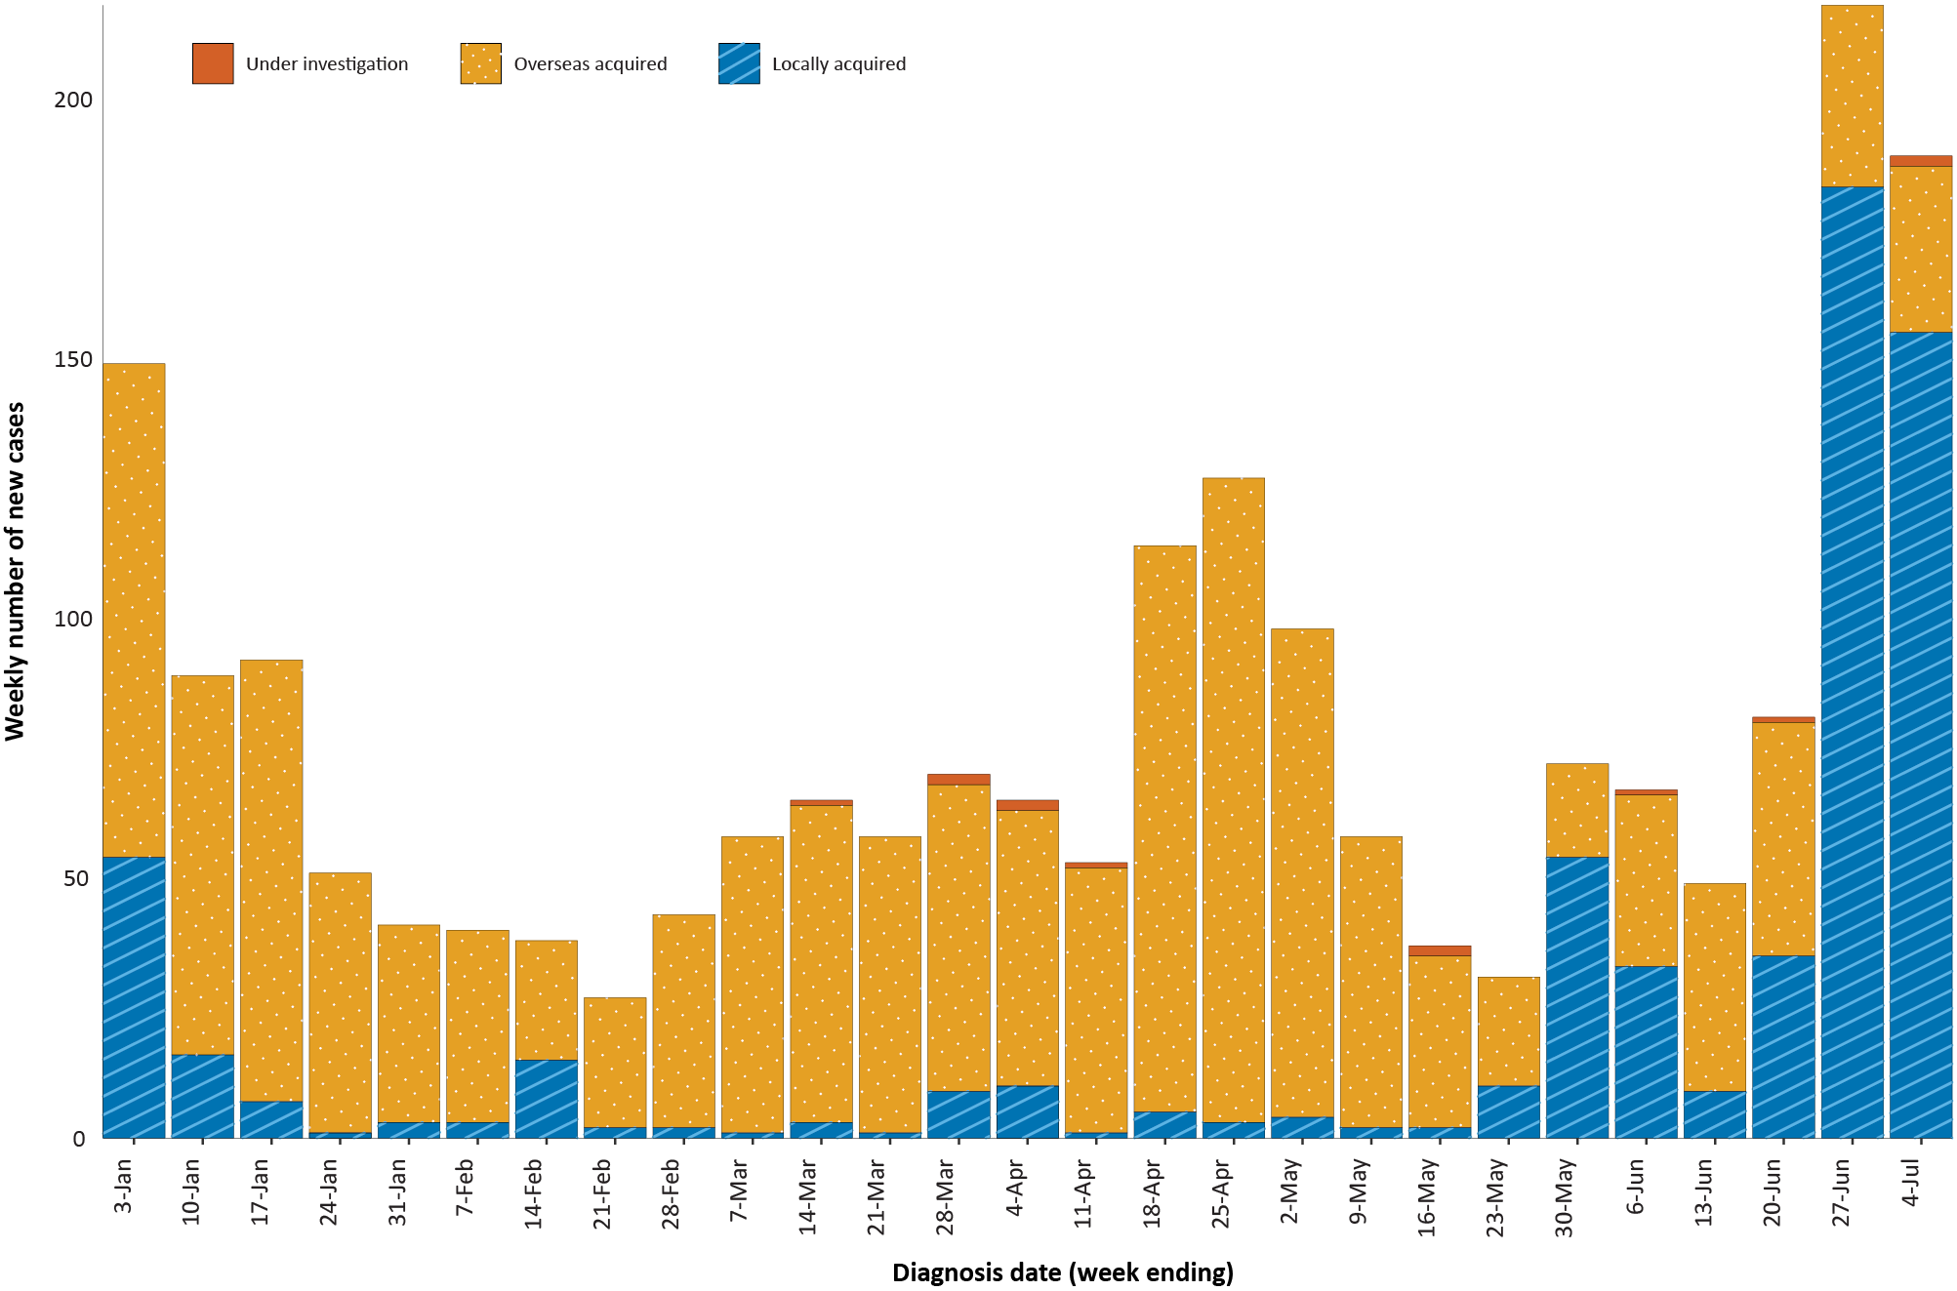
a Source: NNDSS, extract from 6 July 2021 for notifications up to 4 July 2021.

Figure 2: Cumulative COVID-19 notified cases by source of acquisition and diagnosis date, 2 March 2020 – 4 July 2021ª
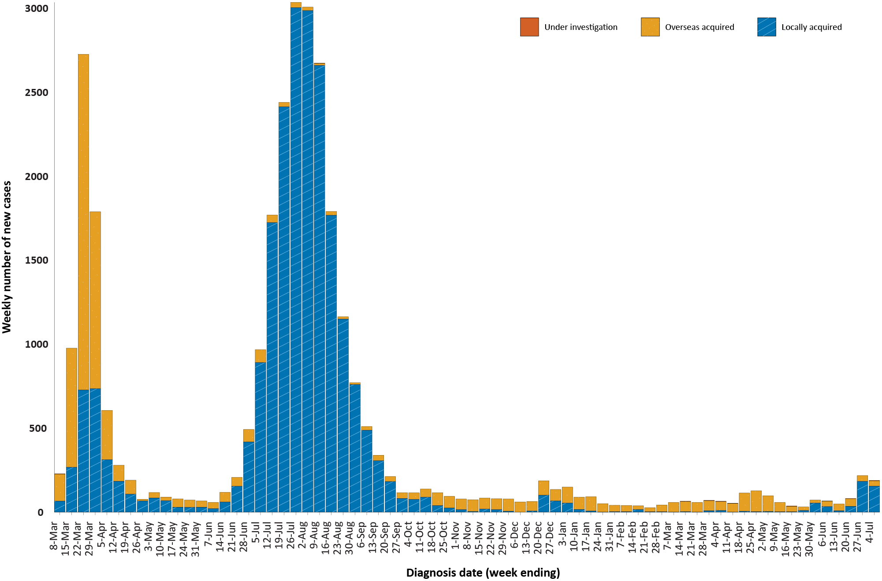
a Source: NNDSS, extract from 6 July 2021 for notifications up to 4 July 2021.

Source of acquisition

(NNDSS)
In this reporting period, the majority of cases were reported as locally acquired (83%; 338/407), with all states and territories except the Australian Capital Territory and Tasmania reporting locally-acquired cases. In this fortnight, 314 locally-acquired cases had a known contact or cluster source; one case from Queensland had an unknown source; and investigations into the source of infection for 20 cases (16 in New South Wales and four in Queensland) were ongoing. At the end of this reporting period, two cases from Queensland were classified as under initial investigation (Table 1).
There were 67 overseas-acquired cases reported in this reporting period, with the largest numbers of cases reported in New South Wales and Victoria, each contributing 33% (22/67) of cases.
Of overseas-acquired cases that reported a country of acquisition, the largest number in this reporting period were from Afghanistan (25%; 14/57), followed by South Africa (18%; 10/57). The country of acquisition was reported as unknown for 15% (10/67) of overseas-acquired cases. The number of cases by country is influenced by travel patterns of returning Australians, by restrictions on travel enforced by the Australian government, and also by the prevalence of COVID-19 in the country the person arrived from.
For 2021 to date, New South Wales had the highest infection rate for locally-acquired cases with 4.35 infections per 100,000 population (Table 2). At the end of this reporting period, there had been zero days since the last locally-acquired case of known source and two days since the last locally-acquired case of unknown source (Table 3).
Table 2: Locally-acquired COVID-19 case numbers and rates per 100,000 population by jurisdiction and reporting period, Australia, with a diagnosis date from 1 January to 4 July 2021ª
Jurisdiction | Reporting period  21 June – 4 July 2021 | Reporting period  7–20 June 2021 | Cases this year  1 January 2021 – 4 July 2021
 | Number of cases^{b} | Number of cases^{b} | Number of cases^{b} | Rate per 100,000 population^{c}
ACT | 0 | 0 | 0 | —
NSW | 295 | 24 | 355 | 4.35
NT | 5 | 0 | 5 | 2.03
Qld | 23 | 4 | 54 | 1.04
SA | 6 | 0 | 6 | 0.34
Tas. | 0 | 0 | 0 | —
Vic. | 6 | 16 | 154 | 2.30
WA | 3 | 0 | 12 | 0.45
Australia | 338 | 44 | 586 | 2.28
a Source: NNDSS, extract from 6 July 2021 for notifications up to 4 July 2021.
b This total does not include cases that are under initial investigation.
c Population data based on Australian Bureau of Statistics (ABS) Estimated Resident Population (ERP) as at June 2020.

Table 3: Days since last locally-acquired COVID-19 case (source unknown and source known), by jurisdiction and diagnosis date, 4 July 2021^{a,b}
Jurisdiction | Locally acquired — source unknown |  | Locally acquired — source known
 | Date of last case | Days since last case | Date of last case | Days since last case
ACT | 21 March 2020 | 470 | 7 July 2020 | 362
NSW | 2 July 2021 | 2 | 4 July 2021 | 0
NT | NA^{c} | NA^{c} | 27 June 2021 | 7
Qld | 1 July 2021 | 3 | 4 July 2021 | 0
SA | 24 March 2020 | 467 | 30 June 2021 | 4
Tas. | 9 August 2020 | 329 | 24 April 2020 | 436
Vic. | 31 May 2021 | 34 | 29 June 2021 | 5
WA | 3 April 2020 | 457 | 27 June 2021 | 7
a Source: NNDSS, extract from 6 July 2021 for notifications up to 4 July 2021.
b This table does not include interstate-acquired cases as those do not represent the acquisition risk for the jurisdiction in which they were identified.
c NA: not applicable. The Northern Territory has not reported any locally-acquired cases with an unknown source of infection.

Demographic features

(NNDSS)
In this reporting period, the largest number of cases occurred in those aged 20 to 39 years (41%; 168/407 cases). For notifications this year, the highest rate of infection is in those aged 30 to 39 years, with a rate of 13.5 infections per 100,000 population (Figure 3; Appendix A, Table A.1). Adults over 80 years of age have the lowest rate of infection this year.

Figure 3: Cumulative COVID-19 cases for the calendar year to date, by age group and sex, Australia, 1 January 2021 to 4 July 2021ª
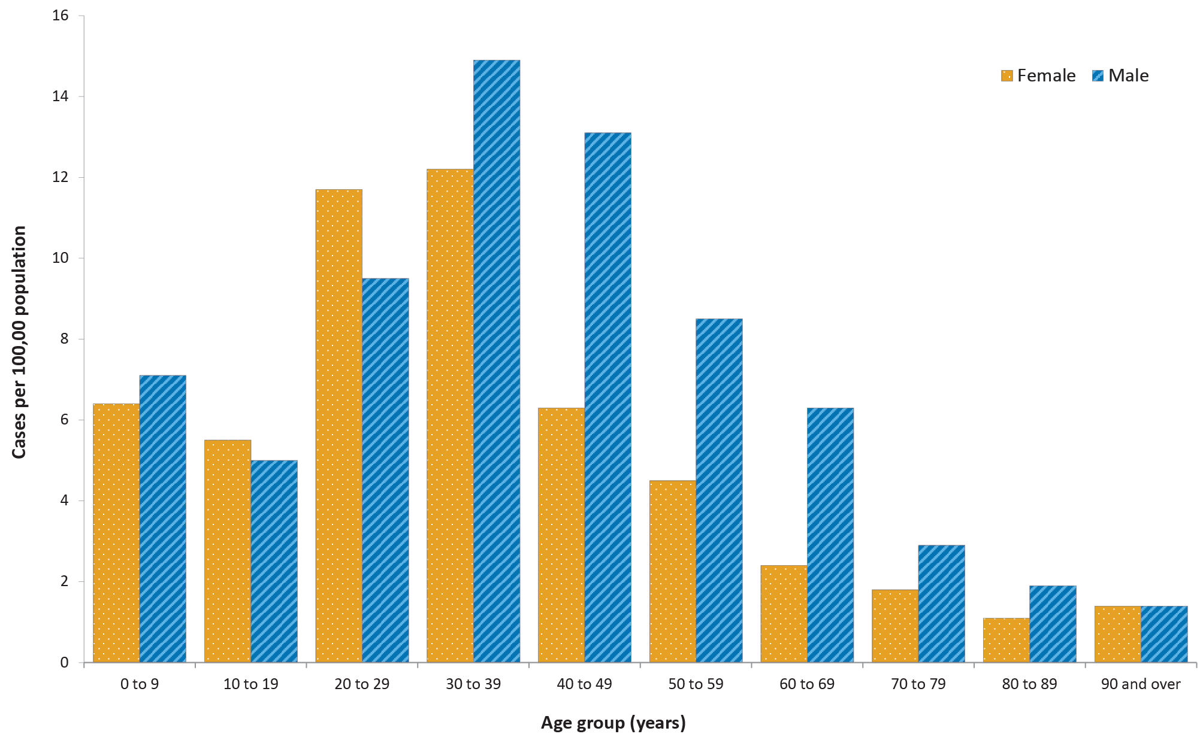
a Source: NNDSS, extract from 6 July 2021 for notifications up to 4 July 2021.
Focusing on cases in this year only, the notification rate is higher in males than females in all age groups except those 10 to 29 years old and those aged 90 years and over (Figure 3). The largest difference in rates this year is in the 40 to 49 years age group, where the cumulative rate among males is 13.2 cases per 100,000 population and among females is 6.3 cases per 100,000 population (Appendix A, Table A.1). The median age of cases in this reporting period is 32 years (range: 1 to 97).

Aboriginal and Torres Strait Islander persons

(NNDSS)
There have been ten confirmed cases of COVID-19 notified in Aboriginal and Torres Strait Islander people since the beginning of 2021. Five new Aboriginal and Torres Strait Islander cases were notified with a diagnosis date within this reporting period, all of which were from New South Wales. Overall, Aboriginal and Torres Strait Islander people represent 0.5% (10/1,887) of all confirmed cases with Indigenous status known this year. The Indigenous status is unknown for 5.0% (99/1,986) of all cases reported this year. The majority of cases in Aboriginal and Torres Strait Islander people in 2021 have been locally acquired (60%; 6/10). The age range of COVID-19 cases in Aboriginal and Torres Strait Islander people in 2021 is 3 to 66 years.

Clusters and high-risk settings

Sydney Metropolitan Outbreak
Nearly all locally-acquired cases reported in New South Wales in the reporting period were linked to the ongoing outbreak in the Bondi area of Sydney. The first case in the cluster, reported on 16 June 2021, was a driver transporting international flight crew. Genomic testing results show that this case had the ‘Delta’ variant of concern (B.1.617.2); however, the sequence did not match the Victorian ‘Delta’ variant outbreak cases. The same sequence had not been seen in Australia previously, but matches one from the United States of America.
Up to 4 July 2021, in New South Wales there have been 277 locally-acquired cases reported since 16 June 2021, when the first case of the Bondi cluster was reported. Of these, 222 have a direct epidemiological link to other cases in the cluster, and a further 38 have direct links to other known cases. Additionally, several interstate acquired-cases have been linked to this cluster, including six in Western Australia, two in Victoria and one in Queensland.

Queensland Alpha cluster
Most locally-acquired cases reported in Queensland during the reporting period were associated with a hotel quarantine transmission event that was detected in the community. The first case in this cluster was reported on 20 June 2021, and was an international flight crew member who tested positive in the community after completing hotel quarantine. Genomic testing has identified this case as having the ‘Alpha’ variant (B.1.1.7) and has linked this case to other international aircrew quarantining in the same hotel quarantine facility. There are a number of genomically-linked outbreaks within this cluster, and investigations are ongoing to establish epidemiological links for a number of cases. As at 4 July 2021, there were 20 cases reported as part of this cluster.

Northern Territory mine outbreak
All locally-acquired cases reported in the Northern Territory during the reporting period were part of an outbreak in a Northern Territory gold mine. The first case in this cluster was reported on 26 June 2021, and had acquired their infection in hotel quarantine in Queensland. Eight locally-acquired cases from the Northern Territory were associated with this cluster. Several interstate-acquired cases have also been linked to the cluster, including six in South Australia, two in Queensland and one in New South Wales. The Queensland and New South Wales cases have been identified as having the ‘Delta’ variant. As at 4 July 2021, there were 17 cases reported as part of this cluster.

Vaccinations

(Department of Health)
As of 4 July 2021, a total of 8,255,473 doses of COVID-19 vaccine have been administered (Table 4), including 444,223 doses provided to aged care and disability residents.

Table 4: Total number of vaccinations administered, by jurisdiction, Australia, 4 July 2021ª
Jurisdiction | Total number of doses administered
ACT | 91,190
NSW | 921,659
NT | 64,243
Qld | 615,144
SA | 251,411
Tas. | 119,344
Vic. | 1,166,277
WA | 320,991
Aged care and disability facilities^{b} | 444,223
Primary care^{c} | 4,260,991
Total | 8,255,473
a Source: Australian Government Department of Health website.3
b Commonwealth vaccine doses administered in aged care and disability facilities.
c Commonwealth vaccine doses administered in primary care settings.

Acknowledgements
We thank public health staff from incident emergency operations centres and public health units in state and territory health departments, and the Australian Government Department of Health, along with state and territory public health laboratories.

Author details

Corresponding author
COVID-19 National Incident Room Surveillance Team
Australian Government Department of Health, GPO Box 9484, MDP 14, Canberra, ACT 2601.
Email: epi.coronavirus@health.gov.au

References
- COVID-19 National Incident Room Surveillance Team. COVID-19 Australia: Epidemiology Report 44: Fortnightly reporting period ending 20 June 2021. Commun Dis Intell (2018). 2021;45. doi: https://doi.org/10.33321/cdi.2021.45.34.
- COVID-19 National Incident Room Surveillance Team. Technical supplement: COVID-19 Australia: epidemiology reporting. Commun Dis Intell (2018). 2021;45. doi: https://doi.org/10.33321/cdi.2021.45.2.
- Australian Government Department of Health. Getting vaccinated for COVID-19: Australia’s vaccine rollout. [Internet.] Canberra: Australian Government Department of Health; 2021. [Accessed on 13 April 2021.] Available from: https://www.health.gov.au/initiatives-and-programs/covid-19-vaccines/getting-vaccinated-for-covid-19#australias-vaccine-rollout.

Appendix A: Supplementary figures and tables
Table A.1: COVID-19 case notifications and rates per 100,000 population, by age group and sex, Australia, 4 July 2021^{a,b,c}
Age group | This reporting period  21 June – 4 July 2021 |  |  |  |  |  | This year only^{d}  1 January 2021 – 4 July 2021
 | Cases |  |  | Rate per 100,000 population |  |  | Cases |  |  | Rate per 100,000 population
 | Male | Female | People | Male | Female | People | Male | Female | People | Male | Female | People
0 to 9 | 24 | 16 | 40 | 1.5 | 1 | 1.3 | 117 | 99 | 216 | 7.1 | 6.4 | 6.8
10 to 19 | 17 | 26 | 43 | 1.1 | 1.7 | 1.4 | 80 | 83 | 163 | 5 | 5.5 | 5.3
20 to 29 | 36 | 48 | 84 | 2 | 2.7 | 2.3 | 174 | 208 | 382 | 9.5 | 11.7 | 10.6
30 to 39 | 48 | 36 | 84 | 2.6 | 1.9 | 2.2 | 276 | 232 | 508 | 14.9 | 12.2 | 13.5
40 to 49 | 33 | 25 | 58 | 2 | 1.5 | 1.8 | 214 | 105 | 319 | 13.1 | 6.3 | 9.7
50 to 59 | 24 | 28 | 52 | 1.6 | 1.8 | 1.7 | 129 | 71 | 200 | 8.5 | 4.5 | 6.4
60 to 69 | 17 | 8 | 25 | 1.3 | 0.6 | 0.9 | 82 | 33 | 115 | 6.3 | 2.4 | 4.3
70 to 79 | 5 | 6 | 11 | 0.5 | 0.6 | 0.6 | 26 | 17 | 43 | 2.9 | 1.8 | 2.3
80 to 89 | 4 | 3 | 7 | 1.1 | 0.6 | 0.8 | 7 | 5 | 12 | 1.9 | 1.1 | 1.4
90 and over | 1 | 1 | 2 | 1.4 | 0.7 | 0.9 | 1 | 2 | 3 | 1.4 | 1.4 | 1.4
a Source: NNDSS, extract from 6 July 2021 for notifications up to 4 July 2021.
b Population data based on Australian Bureau of Statistics (ABS) Estimated Resident Population (ERP) as at June 2020.
c This table only includes cases where sex and age information were known.
d Note the change to focus on rates in this year only. For cumulative rates since the beginning of the epidemic in Australia, readers are encouraged to consult previous reports.

Communicable Diseases Intelligence
ISSN: 2209-6051 Online

Communicable Diseases Intelligence (CDI) is a peer-reviewed scientific journal published by the Office of Health Protection and Response, Department of Health. The journal aims to disseminate information on the epidemiology, surveillance, prevention and control of communicable diseases of relevance to Australia.

Editor: Jennie Hood
Deputy Editor: Simon Petrie
Design and Production: Kasra Yousefi
Editorial Advisory Board: David Durrheim, Mark Ferson, John Kaldor, Martyn Kirk and Linda Selvey

Website: http://www.health.gov.au/cdi

Contacts
CDI is produced by Environmental Health and Health Protection Policy Branch, Office of Health Protection and Response, Australian Government Department of Health, GPO Box 9848, (MDP 6) CANBERRA ACT 2601

Email: cdi.editor@health.gov.au

Submit an Article
You are invited to submit your next communicable disease related article to the Communicable Diseases Intelligence (CDI) for consideration. More information regarding CDI can be found at: http://health.gov.au/cdi.
Further enquiries should be directed to: cdi.editor@health.gov.au.

This journal is indexed by Index Medicus and Medline.

Creative Commons Licence - Attribution-NonCommercial-NoDerivatives CC BY-NC-ND
© 2021 Commonwealth of Australia as represented by the Department of Health
This publication is licensed under a Creative Commons Attribution-NonCommercial-NoDerivatives 4.0 International Licence from https://creativecommons.org/licenses/by-nc-nd/4.0/legalcode (Licence). You must read and understand the Licence before using any material from this publication.

Restrictions
The Licence does not cover, and there is no permission given for, use of any of the following material found in this publication (if any):
- the Commonwealth Coat of Arms (by way of information, the terms under which the Coat of Arms may be used can be found at www.itsanhonour.gov.au);
- any logos (including the Department of Health’s logo) and trademarks;
- any photographs and images;
- any signatures; and
- any material belonging to third parties.

Disclaimer
Opinions expressed in Communicable Diseases Intelligence are those of the authors and not necessarily those of the Australian Government Department of Health or the Communicable Diseases Network Australia. Data may be subject to revision.

Enquiries
Enquiries regarding any other use of this publication should be addressed to the Communication Branch, Department of Health, GPO Box 9848, Canberra ACT 2601, or via e-mail to: copyright@health.gov.au

Communicable Diseases Network Australia
Communicable Diseases Intelligence contributes to the work of the Communicable Diseases Network Australia.
http://www.health.gov.au/cdna

https://www.health.gov.au/news/health-alerts/novel-coronavirus-2019-ncov-health-alert#local-outbreak-information.
https://www.who.int/emergencies/diseases/novel-coronavirus-2019/situation-reports/.
https://www.health.gov.au/news/health-alerts/novel-coronavirus-2019-ncov-health-alert/coronavirus-covid-19-current-situation-and-case-numbers.
Due to data transmission issues, not all cases from the NT associated with this cluster have been recorded in the NNDSS at the time of data extraction on 6 July 2021.

