COVID-19 Australia: Epidemiology Report 38
Reporting period ending 28 March 2021
COVID-19 National Incident Room Surveillance Team

Summary
Two-week reporting period:
Trends – The number of COVID-19 cases reported in Australia remains relatively low. The daily average number of cases for this reporting period was nine, similar to the previous fortnight. There were 125 cases of COVID-19 and no deaths this fortnight, bringing the cumulative case count to 29,192 with 909 deaths.
Local cases – There were 11 locally-acquired cases reported in Australia this fortnight, ten from Queensland and one from New South Wales.
Overseas cases – There were 113 overseas-acquired cases this reporting period. Of these, almost half (47%; 53/113) were reported from Queensland. Of the Queensland overseas-acquired cases with a known country of acquisition, 70% (28/40) were reported as from Papua New Guinea.
Testing – Testing rates decreased by 11% compared to the previous fortnight. The cumulative positivity rate remains low at 0.02%.
Vaccinations –As at 28 March 2021, 541,761 doses of COVID-19 vaccine have been administered to Australians.
Four-week reporting period:
Virology – Nationally, SARS-CoV-2 strains from 58% of COVID-19 cases have been sequenced during the pandemic. During 2021, there has been an increase in the number of cases infected with SARS-CoV-2 variants of concern (VOC) in Australia. AusTrakka is actively monitoring and reporting on these variants and has so far identified 200 samples of B.1.1.7 (a.k.a. VOC-202012/01 or 20I/501Y.V1); 35 samples of B.1.351 (a.k.a. VOC-202012/02 or 20H/501Y.V2); and two samples of P.1 (a.k.a. VOC-202101/02 or 20J/501Y.V3) in Australia.
Severity – For all cases since the beginning of the pandemic, 14% have been admitted to hospital. According to sentinel surveillance data, 19% of hospitalised patients were admitted to an intensive care unit. Australia’s case fatality rate has remained stable at 3.1%, with no COVID-19 related deaths occurring in the past four weeks.
Hospital occupancy – The average daily number of COVID-19 cases in hospital across Australia for the reporting period was 47, a four-fold increase compared to the daily average from the previous reporting period of 12.
Public health measures – An overall easing of restrictions was experienced across most jurisdictions in the reporting period.
International situation – Cumulative global COVID-19 cases and deaths now exceed 126 million and 2.7 million respectively. Papua New Guinea and Timor-Leste both experienced rapidly increasing rates of COVID-19 cases during this reporting period.
This reporting period covers the last two weeks (15–28 March 2021), with data for this period compared to that from the previous two-week reporting period (1–14 March 2021). As Australia continues to experience low numbers of COVID-19 cases, this report has transitioned to a brief update on case numbers each fortnight and a more detailed analysis every four weeks. From this report forward, there will also be a focus on the epidemiological situation in Australia since the beginning of this year, 2021. Readers are encouraged to consult prior reports for information on the epidemiology of cases in Australia in 2020. Included in this report with a reporting period of four weeks are sections on genomic surveillance and virology, acute respiratory illness, severity, public health response measures, and the international situation. The reporting period for these topics covers 1–28 March 2021. For comparability, the previous reporting period is the preceding four weeks (1–28 February 2021).
Keywords: SARS-CoV-2; novel coronavirus; 2019-nCoV; coronavirus disease 2019; COVID-19; acute respiratory disease; epidemiology; Australia

In focus: COVID-19 vaccines
As Australia implements its COVID-19 vaccination program, this section describes the characteristics of the main COVID-19 vaccines, the current rollout schedule in Australia, and how vaccinations are having an effect in countries and territories in our near region.

Current COVID-19 vaccines
The World Health Organization’s vaccine advisory group SAGE (Strategic Advisory Group of Experts on Immunization) has reviewed the evidence and provided recommendations on four vaccines to date (the Pfizer-BioNTech BNT162b2 vaccine, the Moderna mRNA-1273 vaccine, the AstraZeneca – Oxford University AZD1222 vaccine, and the Janssen Ad26.COV2.S vaccine), with all four vaccines determined to be effective and safe.^{1,2} SAGE noted that all of these vaccines will have a beneficial effect on severe disease, and that it is likely there will be some level of protection against transmission.¹ Furthermore, SAGE has recommended these vaccines are prioritised for frontline health workers and older people, who are at a higher risk of being exposed to COVID-19 and having severe disease.¹ The advisory group also assessed the safety of these vaccines in various population groups, including children, pregnant women and those with a compromised immune system, and provided recommendations accordingly.¹

Australia’s vaccination program
Australia’s vaccination program began on 22 February 2021. As at 28 March 2021, a total of 541,761 vaccine doses had been administered to Australians, with 82,542 doses provided to aged care and disability residents.³
Australia’s vaccination program includes two of the four vaccines recommended by WHO: Pfizer and AstraZeneca. These vaccines have been approved by Australia’s Therapeutic Goods Administration (TGA).⁴ The TGA has also approved the manufacture of 50 million doses of the AstraZeneca vaccine locally within Australia.⁵ On 23 March 2021, the TGA approved the first four batches of locally-manufactured AstraZeneca vaccine (832,200 doses) for release.⁶
COVID-19 vaccines in Australia are being delivered as per the National Rollout Strategy, which prioritises the vaccine according to high-risk groups, and reflects the advice of SAGE.⁷ Quarantine and border workers, frontline health care workers and aged care and disability residents and staff were the first population groups to receive the vaccine in Australia.⁷

COVID-19 vaccines in Australia’s near region
Vaccines have been rolled out in a number of countries in Australia’s near region, depending on the local epidemiology, vaccine availability, resources and capacity.⁸ Cambodia, China, India, Indonesia, Japan, Myanmar, Nepal, New Zealand, Singapore and Sri Lanka have all begun vaccination programs. The Australian Government has joined the COVAX Facility as part of a global effort to support rapid, fair and equitable access to COVID-19 vaccines.⁹ Australia is currently supporting efforts to supply and deliver vaccines to Papua New Guinea, where a recent outbreak is straining local resources.¹⁰

Two-week reporting period (15–28 March 2021):

Background and data sources
See the Technical Supplement for information on coronavirus disease 19 (COVID-19) including modes of transmission, common symptoms and severity.¹¹

Activity

COVID-19 trends (NNDSS and jurisdictional reporting to NIR)
In the year to date, from 1 January 2021 to the end of this reporting period 28 March 2021, there have been 724 COVID-19 cases and no deaths reported nationally. The epidemiological curve for COVID-19 cases this year, by source of acquisition, is presented in Figure 1. For comparison, the epidemiological curve for cumulative COVID-19 cases since the beginning of the pandemic in Australia is presented in Figure 2.

Figure 1: COVID-19 notified cases by source of acquisition and diagnosis date, 1 January – 28 March 2021ª
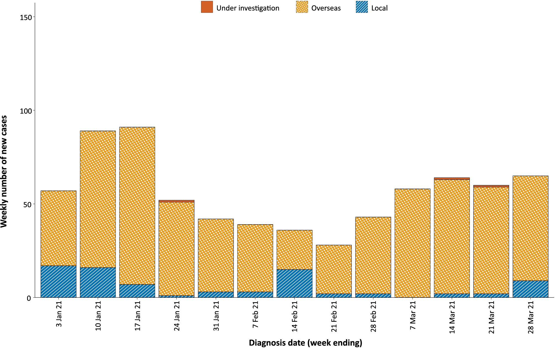
a Source: NNDSS, extract from 1 April 2021, based on diagnosis date.

Figure 2: Cumulative COVID-19 notified cases by source of acquisition and diagnosis date, 1 March 2020 – 28 March 2021ª
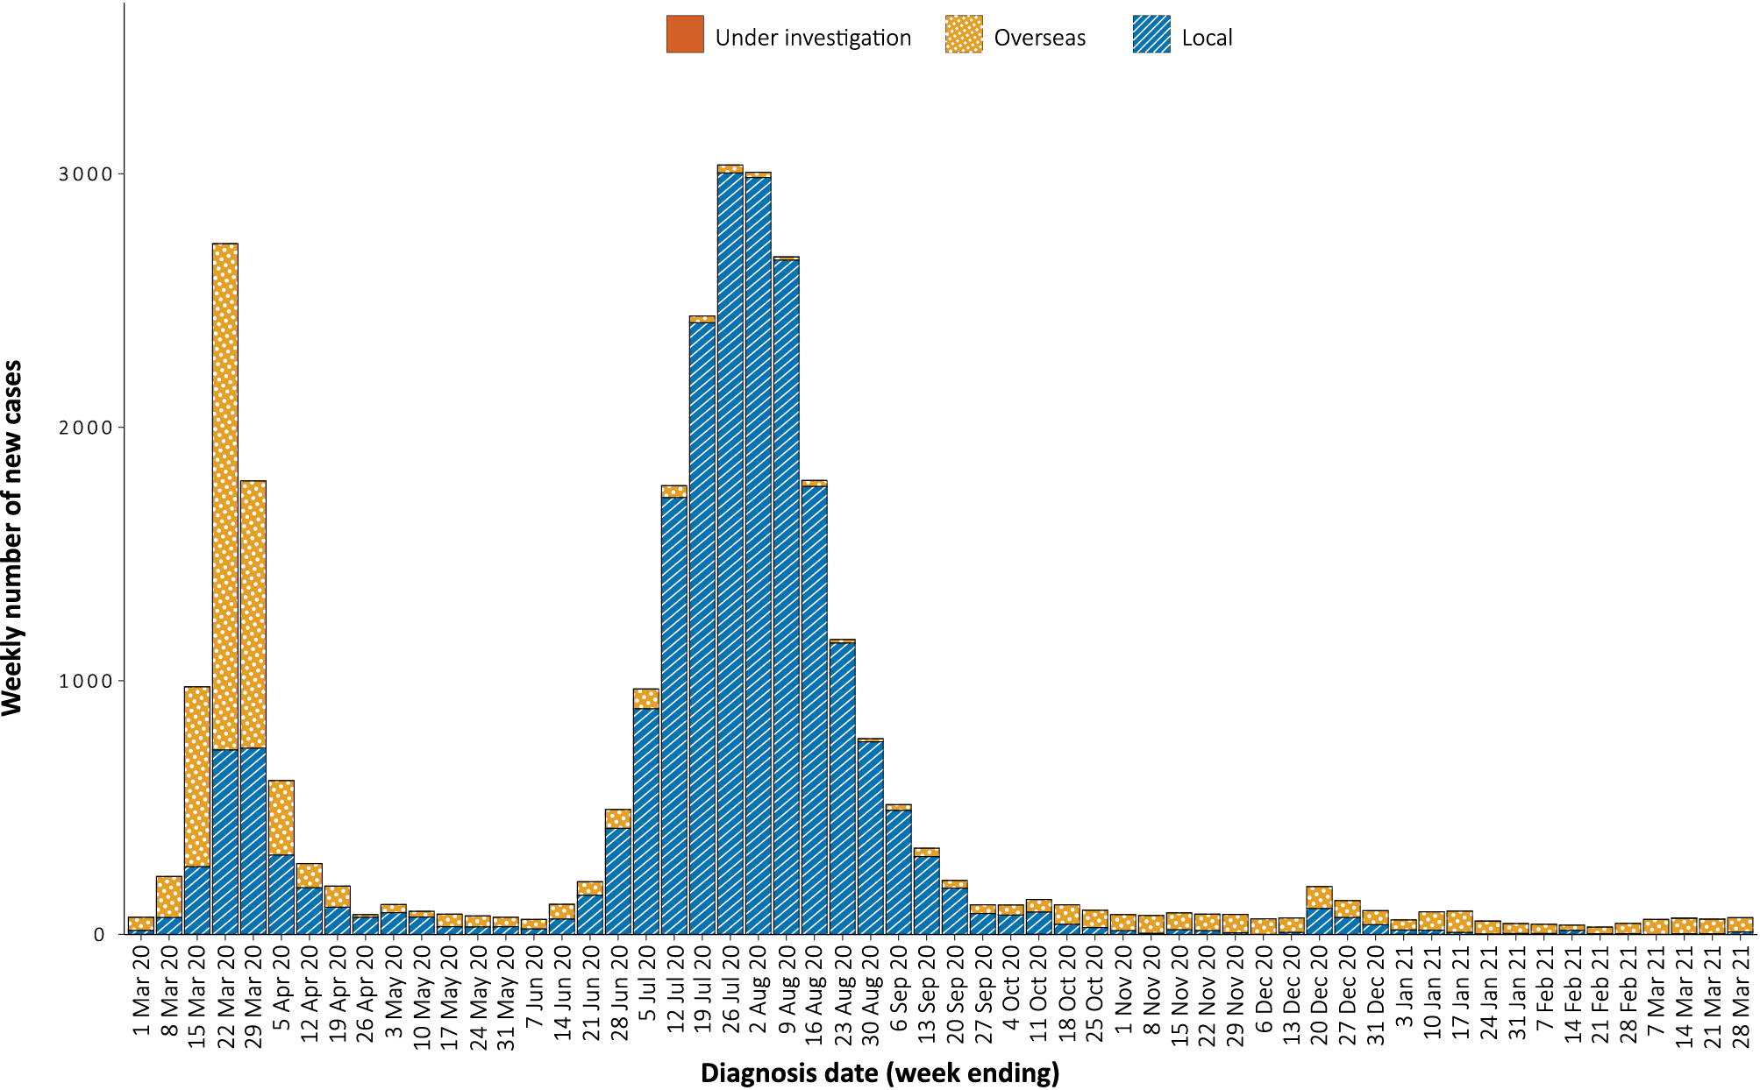
a Source: NNDSS, extract from 1 April 2021, based on diagnosis date.
In this two-week reporting period, from 15 to 28 March 2021, there were 125 cases and no deaths reported. On average, nine cases were notified each day over this reporting period. This is similar to the previous reporting period, in which eight cases were notified on average each day. The largest number of cases diagnosed this fortnight was from Queensland with approximately half of all cases (51%; 64/125), followed by New South Wales (28%; 35/125) (Table 1).

Table 1: COVID-19 notifications by jurisdiction and source of acquisition, 15–28 March 2021ª
Source | NSW | Vic. | Qld | WA | SA | Tas. | NT | ACT | Australia
Overseas | 34 | 1 | 53 | 13 | 12 | 0 | 0 | 0 | 113
Local | 1 | 0 | 10 | 0 | 0 | 0 | 0 | 0 | 11
source known | 1 | 0 | 8 | 0 | 0 | 0 | 0 | 0 | 9
source unknown | 0 | 0 | 2 | 0 | 0 | 0 | 0 | 0 | 2
interstate, source known | 0 | 0 | 0 | 0 | 0 | 0 | 0 | 0 | 0
interstate, source unknown | 0 | 0 | 0 | 0 | 0 | 0 | 0 | 0 | 0
investigation ongoing | 0 | 0 | 0 | 0 | 0 | 0 | 0 | 0 | 0
Under initial investigation | 0 | 0 | 0 | 0 | 0 | 0 | 0 | 0 | 0
Missing source of acquisition | 0 | 0 | 1 | 0 | 0 | 0 | 0 | 0 | 1
Total | 35 | 1 | 64 | 13 | 12 | 0 | 0 | 0 | 125
a Source: NNDSS, extract from 1 April 2021, based on diagnosis date.
Cumulatively since the beginning of the epidemic in Australia, there have been 29,192 COVID-19 cases including 909 deaths reported in Australia, with two distinct peaks in March and July (Figure 2).

Source of acquisition

(NNDSS)
In this reporting period, 90% (113/125) of cases were acquired overseas. There were ten locally-acquired cases in Queensland and one in New South Wales (Table 2). The Queensland cases were associated with an ongoing outbreak that is under investigation, with two initial transmission events traced to a quarantine facility and a health care facility. The New South Wales case was acquired in a hotel quarantine setting. An additional Queensland case was missing ‘source of acquisition’ information at the time of this report.

Table 2: Locally-acquired COVID-19 case numbers and rates per 100,000 population by jurisdiction and reporting period, 28 March 2021ª
Jurisdiction | Reporting period  1–14 March 2021 | Reporting period  15–28 March 2021 | Cases this year  1 January 2021 – 28 March 2021^{b}
 | Number of cases | Number of cases | Number of cases | Rate per 100,000 population^{c}
NSW | 1 | 1 | 29 | 0.36
Vic. | 0 | 0 | 34 | 0.51
Qld | 1 | 10 | 16 | 0.31
WA | 0 | 0 | 1 | 0.04
SA | 1 | 0 | 1 | 0.06
Tas. | 0 | 0 | 0 | —
NT | 0 | 0 | 0 | —
ACT | 0 | 0 | 0 | —
Australia | 3 | 11 | 81 | 0.32
a Source: NNDSS, extract from 1 April 2021, based on diagnosis date.
b Note the change for this report to a focus on cases in this year only, which substantially lowers rates per 100,000 population.
c Population data based on Australian Bureau of Statistics (ABS) Estimated Resident Population (ERP) as at June 2020.
In this reporting period, the largest number of overseas-acquired cases was reported in Queensland (47%; 53/113), followed by New South Wales (30%; 34/113).
The largest numbers of overseas-acquired cases with reported countries of acquisition were from Papua New Guinea (31%; 30/98 of all cases, and notably 70%; 28/40 of Queensland cases), followed by Pakistan (12%; 12/98) and India (11%; 11/98) in this reporting period. The number of cases by country is influenced by travel patterns of returning Australians as well as by the prevalence of COVID-19 in the country the person arrived from.
In 2021, Victoria has the highest infection rate for locally-acquired cases with 0.51 infections per 100,000 population (Table 2). At the end of this reporting period, there had been zero days since the last locally-acquired case of unknown source (Table 3).

Table 3: Days since last locally-acquired COVID-19 case (source unknown and source known), by jurisdiction, 28 March 2021ª
Jurisdiction | Locally acquired — source unknown |  | Locally acquired — source known
 | Date of last case | Days since last case | Date of last case | Days since last case
NSW | 15 January 2021 | 72 | 15 March 2021 | 13
Vic. | 30 December 2020 | 88 | 24 February 2021 | 32
Qld | 28 March 2021 | 0 | 28 March 2021 | 0
WA | 3 Apr 2020 | 359 | 28 January 2021 | 59
SA | 24 March 2020 | 369 | 27 November 2020 | 121
Tas. | 9 August 2020 | 231 | 24 April 2020 | 338
NT^{b} | NA | NA | 3 April 2020 | 359
ACT | 21 March 2020 | 372 | 7 July 2020 | 264
a Source: NNDSS, extract from 1 April 2021, based on diagnosis date. Note that discrepancies in dates between this and previous reports are due to a change to use diagnosis date for all tables.
b The Northern Territory has not reported any locally acquired cases with an unknown source of infection.

Demographic features

(NNDSS)
In this reporting period, the largest number of cases occurred in those aged 30 to 39 years (24%; 30/125 cases). For all notifications to date, the highest rate of infection is in those aged 90 and over with a rate of 386.8 per 100,000 population (Figure 3; Appendix A, Table A.1). Children under 10 years old have the lowest rate of infection (48.5 cases per 100,000 population), despite comparable testing rates in this age group.

Figure 3: Cumulative rate of COVID-19 cases per 100,000 population, by age group and sex, 23 January 2020 – 28 March 2021ª
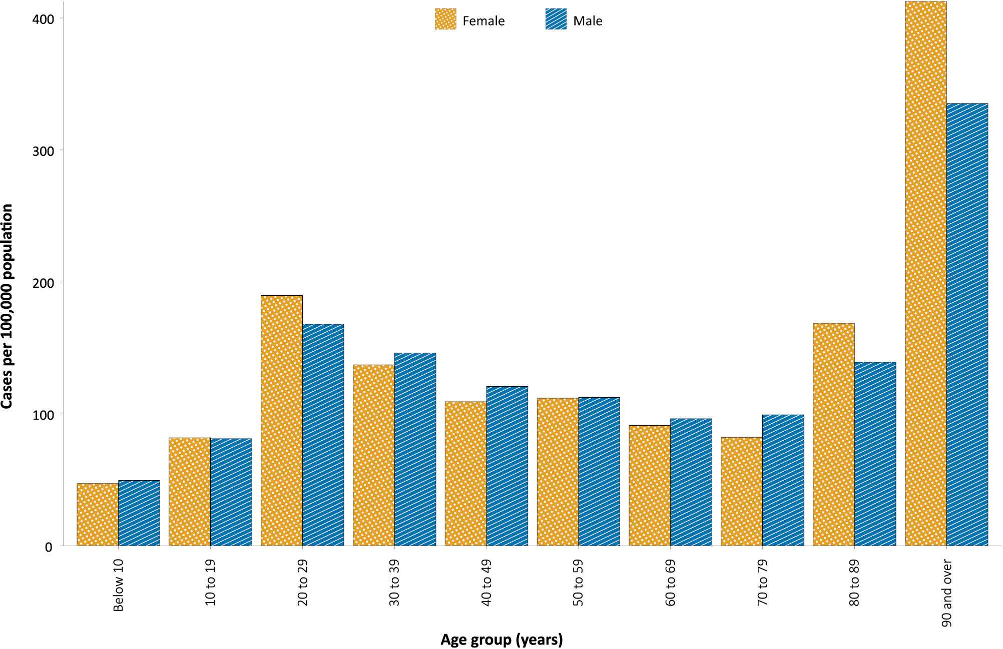
a Source: NNDSS, extract from 1 April 2021, based on diagnosis date.
Cumulatively, the male-to-female rate ratio of cases is approximately 1:1 in most age groups. Notification rates are higher among females than among males in the 20–29 years age group and those aged ≥ 80 years old, and higher among males than among females in the 70–79 years age group (Figure 3). The largest difference in cumulative rates is in the 90 years and over age group, where the cumulative rate among males is 335.2 cases per 100,000 population and among females is 412.6 cases per 100,000 population (Appendix A, Table A.1).
The median age of cases in this reporting period is 33 years (interquartile range, IQR: 25 to 49). This is the same as the median age of cases this year, which is also 33 years (IQR: 25 to 45). The median age of all cases since the beginning of the epidemic in Australia is somewhat higher at 37 years (IQR: 25–56), reflecting a shift in the demographic features of cases over time. Whereas there were higher numbers of locally-acquired cases in 2020, including many cases in residential aged care facilities, most cases in 2021 have been acquired overseas and in a younger cohort of international travellers.

Aboriginal and Torres Strait Islander persons

(NNDSS)
There have been 150 confirmed cases of COVID-19 notified in Aboriginal and Torres Strait Islander people since the beginning of the epidemic. No new overseas-acquired Aboriginal and Torres Strait Islander cases were notified in the reporting period. Overall, Aboriginal and Torres Strait Islander people represent approximately 0.5% (150/28,961) of all confirmed cases with Indigenous status known. The majority of locally-acquired cases in Aboriginal and Torres Strait Islander people have been reported in major cities of Australia (79%; 92/116), with only a very small number of cases (n < 10) reported in outer regional Australia or remote or very remote Australia.
The median age of COVID-19 cases in Aboriginal and Torres Strait Islander people is 31 years old (IQR: 21–50), which is younger than for non-Indigenous cases where the median age is 37 years old (IQR: 25–56). The notification rate across all age groups is higher in non-Indigenous people than in Aboriginal and Torres Strait Islander people. The age-standardised Aboriginal and Torres Strait Islander:non-Indigenous notification rate ratio is 0.2. This indicates that the Aboriginal and Torres Strait Islander population has a significantly lower COVID-19 case rate than the non-Indigenous population, after accounting for differences in age structure.

Testing

(State and territory reporting)
As at 26 March 2021, a cumulative total of 3,319,507 individuals have undergone diagnostic testing for SARS-CoV-2 in Australia this year since 1 January 2021. The cumulative nationwide proportion of positive tests for 2021 remains low at 0.02% (Table 4).

Table 4: Individuals undergoing diagnostic tests for SARS-CoV-2,ª by jurisdiction and reporting period, 1 January - 26 March 2021
Jurisdiction | Individuals tested  13– 26 March 2021 |  |  | Individuals tested  27 February – 12 March 2021 |  |  | Cumulative individuals tested  in 2021 to 26 March
 | n | Positivity (%) | Per 1,000 population^{b} | n | Positivity (%) | Per 1,000 population^{b} | n | Positivity (%) | Per 1,000 population^{b}
NSW | 142,197 | 0.03 | 17.4 | 160,902 | 0.02 | 19.7 | 1,147,609 | 0.02 | 140.6
Vic. | 177,598 | 0.00 | 26.5 | 203,709 | < 0.01 | 30.4 | 1,344,660 | < 0.01 | 200.8
Qld | 21,257 | 0.28 | 4.1 | 20,257 | 0.23 | 3.9 | 166,502 | 0.10 | 32.2
WA | 18,054 | 0.05 | 6.8 | 22,027 | 0.05 | 8.3 | 246,947 | 0.02 | 92.8
SA | 27,059 | 0.05 | 15.3 | 29,387 | 0.04 | 16.6 | 275,275 | 0.02 | 155.6
Tas. | 7,484 | 0.00 | 13.8 | 7,287 | 0.00 | 13.5 | 42,497 | 0.00 | 78.6
NT | 7,678 | 0.00 | 31.2 | 7,138 | 0.01 | 29.0 | 47,008 | 0.05 | 191.1
ACT | 5,761 | 0.00 | 13.4 | 7,707 | 0.06 | 17.9 | 49,010 | 0.01 | 113.7
Australia | 407,088 | 0.03 | 15.9 | 458,414 | 0.03 | 17.9 | 3,319,507 | 0.02 | 129.2
a In order to more accurately reflect positivity rates, numbers of individuals tested is presented rather than total number of tests.
b Population data based on Australian Bureau of Statistics (ABS) Estimated Resident Population (ERP) as at June 2020.

During this reporting period, 407,088 individuals were tested nationally, with a positivity rate of 0.03%. Queensland experienced a higher rate of positivity in this reporting period, which is expected given the increase in cases in the region. Jurisdictional testing rates are driven by both current case numbers and numbers of people experiencing symptoms. The low national positivity rate, along with high rates of testing, indicates a low incidence of COVID-19 nationally.
For the two-week period ending 26 March 2021, testing rates decreased among all age groups (Figure 4). Testing rates among children and young adults aged 0–19 years tended to be lower than those of other age groups, while rates among the 20–39 year age groups have remained high throughout the entirety of the pandemic.
Figure 4: SARS-CoV-2 polymerase chain reaction (PCR) testing rates per 1,000 population per week by age group, Australia, 1 May 2020 – 26 March 2021^{a,b}
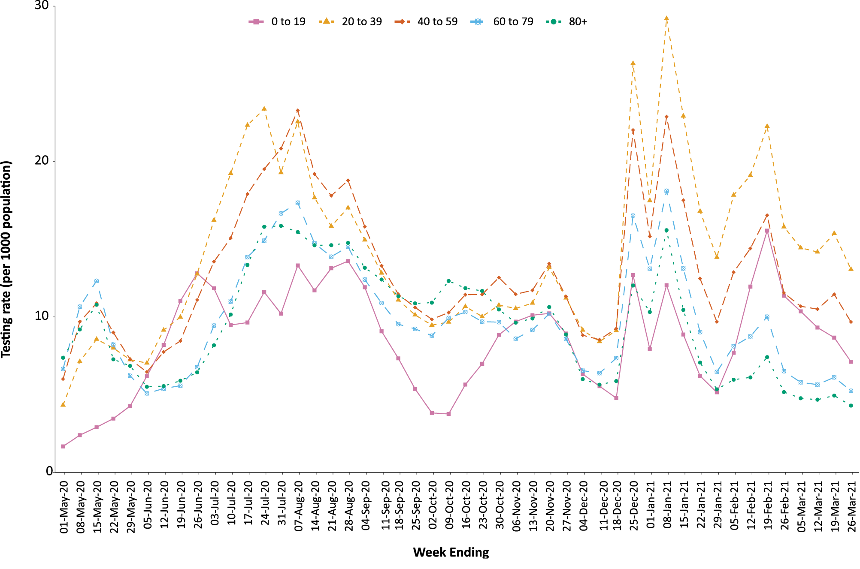
a Source: Data provided by jurisdictions to the NIR weekly, current up to 26 March 2021.
b The jurisdictions reporting each week (i.e. the denominator population) may vary.
In future reports, SARS-CoV-2 diagnostic testing will be reported on a four-weekly basis. The next analysis of this topic will therefore occur in epidemiology report 40.

Vaccinations

(Department of Health)
As of 28 March 2021, a total of 541,761 doses of COVID-19 vaccine have been administered (Table 5), including 82,542 doses provided to aged care and disability residents.
Table 5: Total number of vaccinations administered, by jurisdiction, Australia, 28 March 2021ª
Jurisdiction | Total number of doses administered
NSW | 96,273
Vic. | 86,282
Qld | 59,126
WA | 45,091
SA | 22,787
Tas. | 13,091
NT | 7,027
ACT | 9,746
Commonwealth^{b} | 82,542
Primary care^{c} | 119,796
Total | 541,761
a Source: Australian Government Department of Health website.3
b Administered in aged care and disability facilities.
c Administered in primary care settings.

Four-week reporting period (1–28 March 2021):

Genomic surveillance and virology

(Communicable Disease Genomics Network, AusTrakka and jurisdictional sequencing laboratories)
Nationally, 58% of COVID-19 cases have been sequenced over the duration of the pandemic, based on jurisdictional reporting (Table 6, Figure 5).

Figure 5: Samples in AusTrakka since 4 January 2021, by lineage and date of collectionª
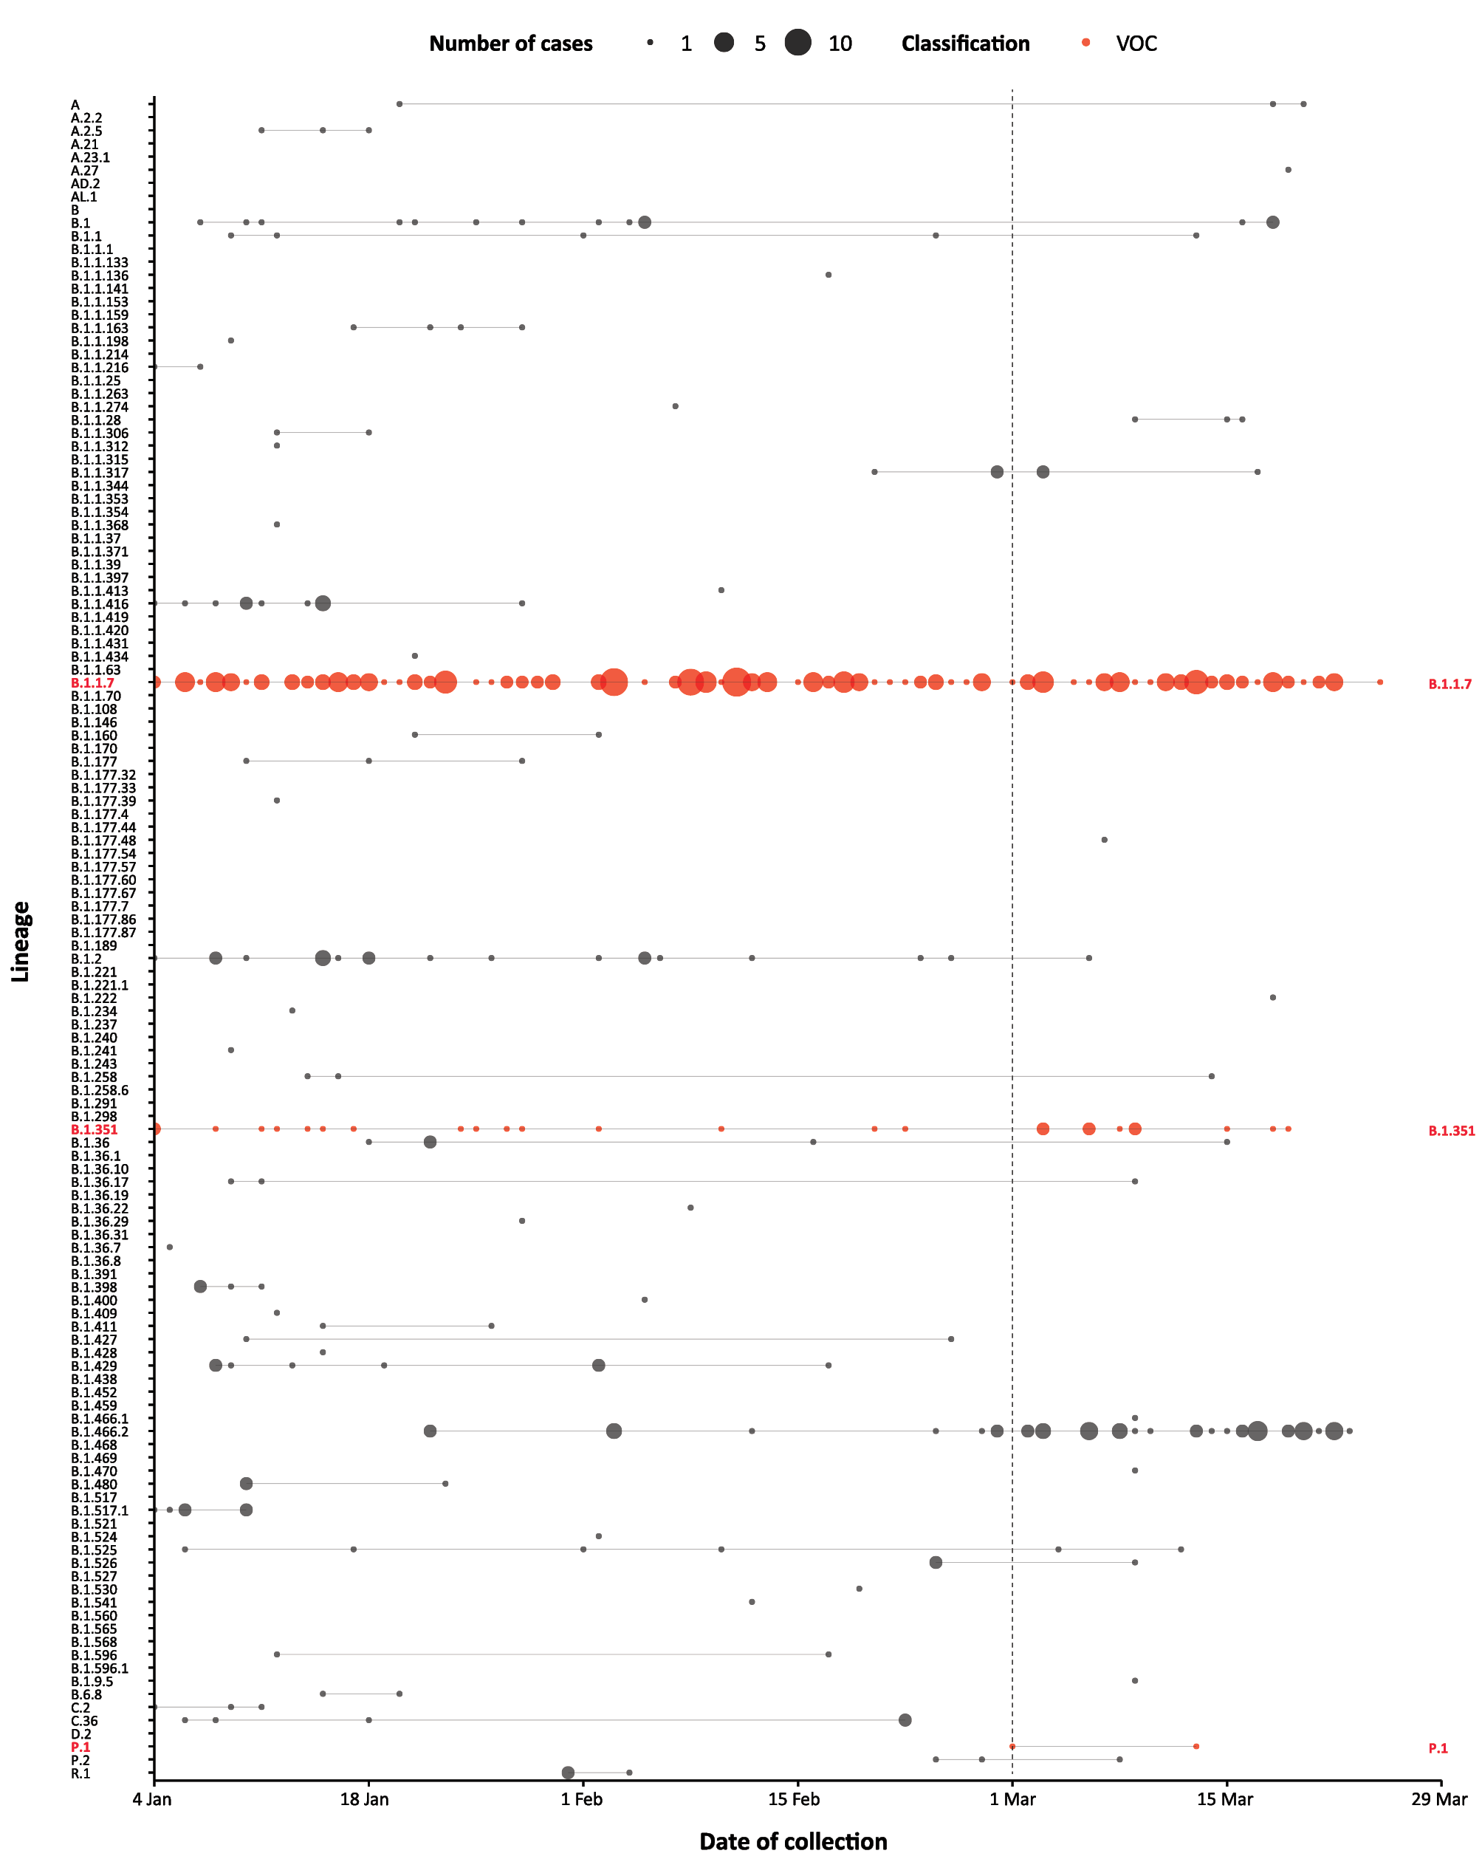
a The start of the current reporting period (1 March – 28 March 2021) is marked by the dotted line, and variant of concern samples are coloured red. The size of the circle is proportional to the number of samples in the lineage at each time point.
Table 6: Australian SARS-CoV-2 genome sequences and proportion of positive cases sequenced, 1–28 March 2021 and cumulative to date
Measure | Reporting period  1–28 March 2021 | Cumulative 23 January 2020  – 28 March 2021
SARS-CoV-2 cases sequencedª | 182 | 16,869
Percentage of positive cases sequenced^{b} | 58% | 58%
a Based on individual jurisdictional reports of sequences and case numbers. Calculations of the percentage of cases sequenced based on the number of sequences available in AusTrakka may not always be up-to-date, since this may include duplicate samples from cases and may not represent all available sequence data.
b In most jurisdictions sequencing has been attempted on all suitable samples (one sample per case). Sequencing of samples from cases identified in the reporting period may be in process at the time of reporting. Remaining unsequenced samples may be due to jurisdictional sequencing strategy, or where samples have been deemed unsuitable for sequencing (typically, because viral loads were too low for sequencing to be successful).
Table 7: Australian SARS-CoV-2 genome sequences in AusTrakka, identified as variants of concern (VOC) to 28 March 2021
VOC lineage | B.1.1.7 | B.1.351 | P.1
Number of samples | 200 | 35 | 2

Variants of concern
AusTrakka is actively monitoring and reporting on the three lineages designated Variants of Concern (VOC) by international organisations, including the World Health Organisation: B.1.1.7; B.1.351; and P.1 (Table 7). All three variants display characteristic sets of mutation, including a number of variations in the genomic region encoding the spike protein thought to have the potential to increase transmissibility and/or immune evasion.¹³ Further information on variants is available in the Technical Supplement.¹¹

Acute respiratory illness

(FluTracking and Commonwealth Respiratory Clinics)
Based on self-reported FluTracking data,¹⁴ prevalence of fever and cough in the community remained low at 0.7% or less (Figure 6). Runny nose and sore throat symptoms in the community remained stable during this reporting period and the prevalence in the community remained at less than 1%.

Figure 6: Weekly trends in respiratory illness amongst FluTracking survey participants (age-standardised) compared to the average of the previous five years, Australia, 1 March 2020 – 28 March 2021ª
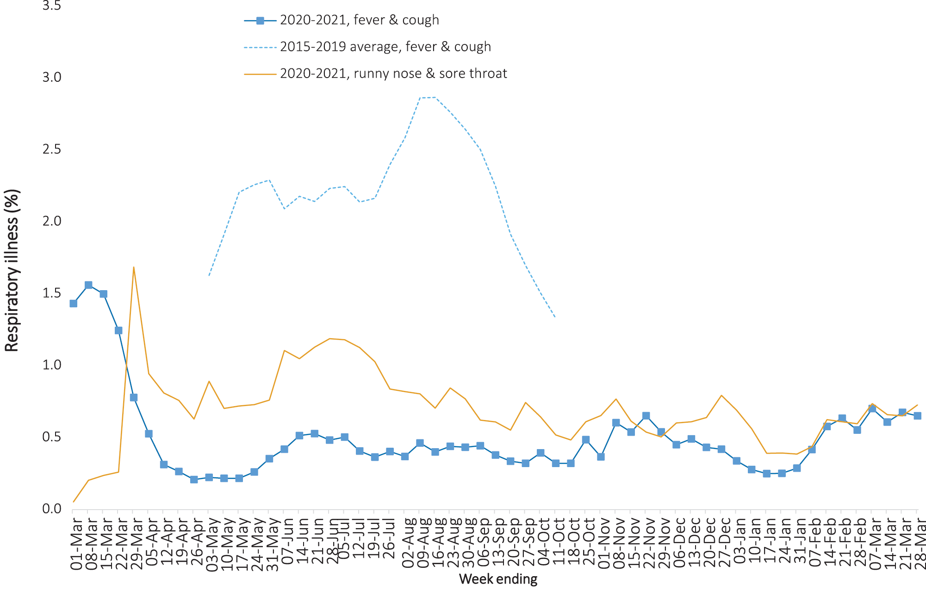
a In years prior to 2020, FluTracking was activated during the main Influenza season from May to October. A historical average beyond the week ending 11 October is therefore not available. In 2020, FluTracking commenced 10 weeks early to capture data for COVID-19. Data on runny nose and sore throat were only collected systematically after 29 March 2020, therefore a historical average for this symptom profile is unavailable.
In this reporting period, acute respiratory illness was highest in those aged under 10 years old, based on both self-reported FluTracking data and presentations to Commonwealth Respiratory Clinics. Females reported respiratory illness more frequently than males. Rates of fever and cough by jurisdiction ranged from 2.7/1,000 FluTracking participants in the Australian Capital Territory to 6.3/1,000 participants in Victoria.
FluTracking data indicated that 48.7% of those in the community with ‘fever and cough’ and 17.1% of those with ‘runny nose and sore throat’ were tested for SARS-CoV-2. This represented slight decreases in testing for both ‘fever and cough’ and ‘sore throat and runny nose’ since the previous reporting period. Testing rates varied by jurisdiction and symptom. For fever and cough, rates were lowest in Western Australia and highest in New South Wales. For runny nose and sore throat, rates were lowest in the Northern Territory and highest in Victoria. It is important to acknowledge that there may be legitimate reasons why people did not get tested, including barriers to accessing testing. Symptoms reported to Flutracking were not specific to COVID-19 and may also be due to chronic diseases.
During this reporting period, there were 67,100 assessments at Commonwealth Respiratory Clinics with 90.1% tested for SARS-CoV-2. There were no cases reported at these clinics in this reporting period.
In patients experiencing influenza-like illness in this reporting period who were tested through the Australian Sentinel Practice Research Network (ASPREN) and Victorian Sentinel Practice Influenza Network (VicSPIN) general practitioner (GP) sentinel surveillance systems, the most frequent respiratory viruses detected were rhinoviruses.
Based on FluTracking data, the rate of self-reported fever and cough among Aboriginal and Torres Strait Islander peoples was higher than that observed in all other participants in the first two weeks of this reporting period, but similar in the last two weeks. The rate for health care worker participants reporting these symptoms during this period was similar to that observed for all other participants for the last two weeks of this reporting period, but lower in the first two weeks, based on FluTracking data.

Severity

(NNDSS, FluCAN, SPRINT-SARI)

Hospitalisation
Based on NNDSS data since the beginning of the epidemic, there have been 28,079 COVID-19 cases where hospitalisation status is known. Of these cases, 14% (3,858/28,079) were hospitalised, although some individuals may have been hospitalised for isolation rather than clinical reasons). The proportion of those hospitalised admitted to an intensive care unit (ICU) has been estimated from Influenza Complications Alert Network (FluCAN)¹⁵ sentinel surveillance system data at 19% (data for those hospitalised between 29 February 2020 and 28 February 2021). During this reporting period, there have been four cases admitted to ICU at sentinel sites.¹⁶
The few cases captured in hospital sentinel surveillance systems in 2021 do not provide sufficient data to enable reporting on characteristics and outcomes in detail for the hospitalised cohort in the year-to-date. Analyses for those captured in these systems in 2020 have been previously presented in detail in report 28 (data to 25 October 2020).¹⁷

COVID-19 deaths
Overall, the crude case fatality rate (CFR) remains stable at 3.1%, with no cases reported as having died since 18 October 2020.¹⁸ The cumulative CFR increases with advancing age; this underpins, in part, the rationale behind the staged roll-out of the vaccine program, which targets first those at most risk of severe disease and death from COVID-19. Of all age groups, the highest CFR occurred in those aged over 90 years, with 50% of infected males of that age passing away due to COVID-19.

Hospital occupancy

(State and territory reporting)
The average daily number of COVID-19 cases in hospital during the past four weeks across the country was 47; this was a fourfold increase on the previous reporting period’s daily average of 12 (1–28 February 2021). Hospitalised cases during this four-week reporting period were distributed across only four jurisdictions, with Queensland carrying the large majority of hospitalised cases (daily average of 41 individuals). As shown in Figure 7, the national trend of increasing numbers of hospitalised cases in this reporting period is largely driven by the increase in hospitalised cases in Queensland. It should be noted that current local hospitalisation policies for cases differ across jurisdictions. In some states and territories, cases who test positive may be routinely transferred to hospital for isolation rather than clinical care. ICU occupancy due to COVID-19 reached a daily maximum of three individuals during the reporting period; all were being treated in Queensland ICUs.

Figure 7: Number of daily hospitalised confirmed cases of COVID-19 cases, by jurisdiction, 1–28 March 2021ª
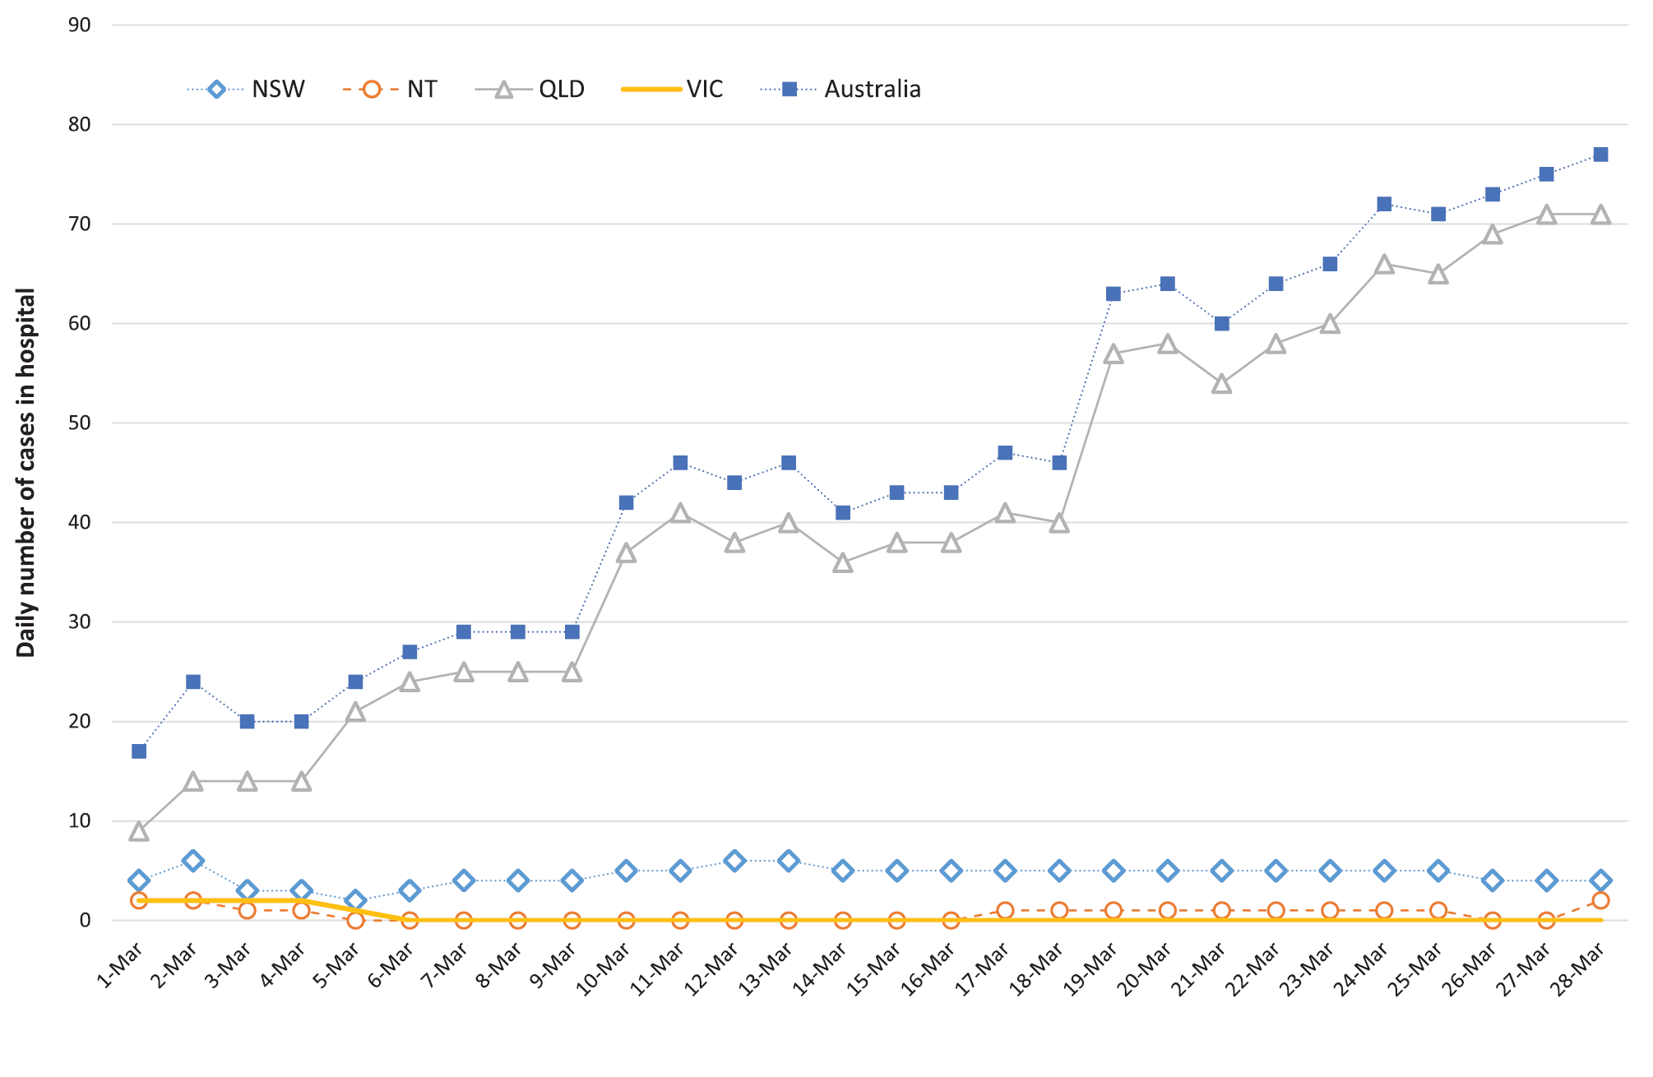
a Source: Daily report from jurisdictional health departments.

Public health response measures
Public health measures implemented since 1 January 2021 are represented in Figure 8, with measures implemented during the current reporting period summarised in Table 8. States and territories have decision-making authority in relation to public health measures and have implemented or eased restrictions at their own pace, depending on the local public health and epidemiological situation, and in line with the ‘Framework for National Reopening’.¹⁹

Table 8: State and territory changes to COVID-19 restrictions, Australia, 1–28 March 2021
Jurisdiction | Summary of changes to COVID-19 restrictions
New South Wales | From 8 March, New South Wales eased the following restrictions at schools:²⁰  - Parents and caregivers can enter school grounds and attend school sports,  - All extra-curricular and social events can resume, if COVID-19 safety plans are used.  From 17 March, New South Wales eased the following restrictions:²¹  - Drinking while standing up at indoor venues, pubs and clubs is now allowed.  From 19 March, New South Wales eased the following restrictions:²¹  - Indoor gatherings of up to 100 people are allowed,  - Outdoor gathers of up to 200 people are allowed,  - No restrictions on dancing and singing at venues and events,  - Nightclubs may be open but must be COVID Safe.
Victoria | From 26 March, Victoria eased the following restrictions:²²  - Up to 100 people allowed at a private residence per day,  - Outdoor gatherings increased to 200 people,  - Workplaces with a COVIDSafe Plan can have workers return following density restrictions of 1 person per 2sqm,  - Masks no longer required in retail settings. Masks are still required in public transport, rideshare vehicles, taxis and sensitive settings,  - Indoor non-seated venues increased to 75% capacity with a limit of 1000 people per space.  From 26 March, the Queensland Local Government Areas of Brisbane and Moreton Bay were declared an orange zone. Individuals entering Victoria since 12 March from these areas must immediately self-isolate until a negative result is received.
Queensland | From 8 March, Queensland eased the following restrictions:²³  - Up to 200 people or one person per 2 square metres, whichever is greater, can attend a wedding ceremony or funeral service.  From 13 March, Queensland eased the following restrictions:²⁴  - Gatherings at private properties cap increased to 100 people,  - Gatherings in public outdoor spaces cap increased to 500 people,  - Camping grounds no longer subject to density restrictions, can operate at full capacity,  - Full capacity for ticketed venues, patrons encouraged to wear masks on entrance and exit of venue,  - Dancing allowed in all indoor and outdoor venues, subject to one person per 2 square metre rule,  - Number of people allowed in lifts increased to six people.  From 13 March, Queensland placed restrictions on:²³  - All non-essential visits to hospitals, residential aged care facilities, disability accommodation services and correctional facilities in Greater Brisbane will cease.
Western Australia | From 15 March, Western Australia eased the following restrictions:²⁵  - Increased capacity at seated indoor and outdoor venues to 75% of capacity or one person per 2 square metres, whichever is greater.  From 27 March, Western Australia declared Queensland ‘low risk’.26 All arrivals from Queensland must self-quarantine for 14 days and present for a COVID-19 test on day 11.
South Australia | No further easing of restrictions.²⁷
Tasmania | From 23 March, Tasmania eased the following restrictions:²⁸  Places of worship, churches and funeral homes can have up to 250 people or 75% of seated capacity, whichever is fewer. Staff and those assisting in the provision of the service are not included in this capacity.
Australian Capital Territory | From 6 March, Australian Capital Territory made it mandatory for patrons of all restricted businesses, venues and facilities to use the ‘Check in CBR’ app.²⁹
Northern Territory | No further easing of restrictions.³⁰
Figure 8: COVID-19 notifications in Australia by week of diagnosis and jurisdiction, 1 January – 28 March 2021, with timing of key public health measures
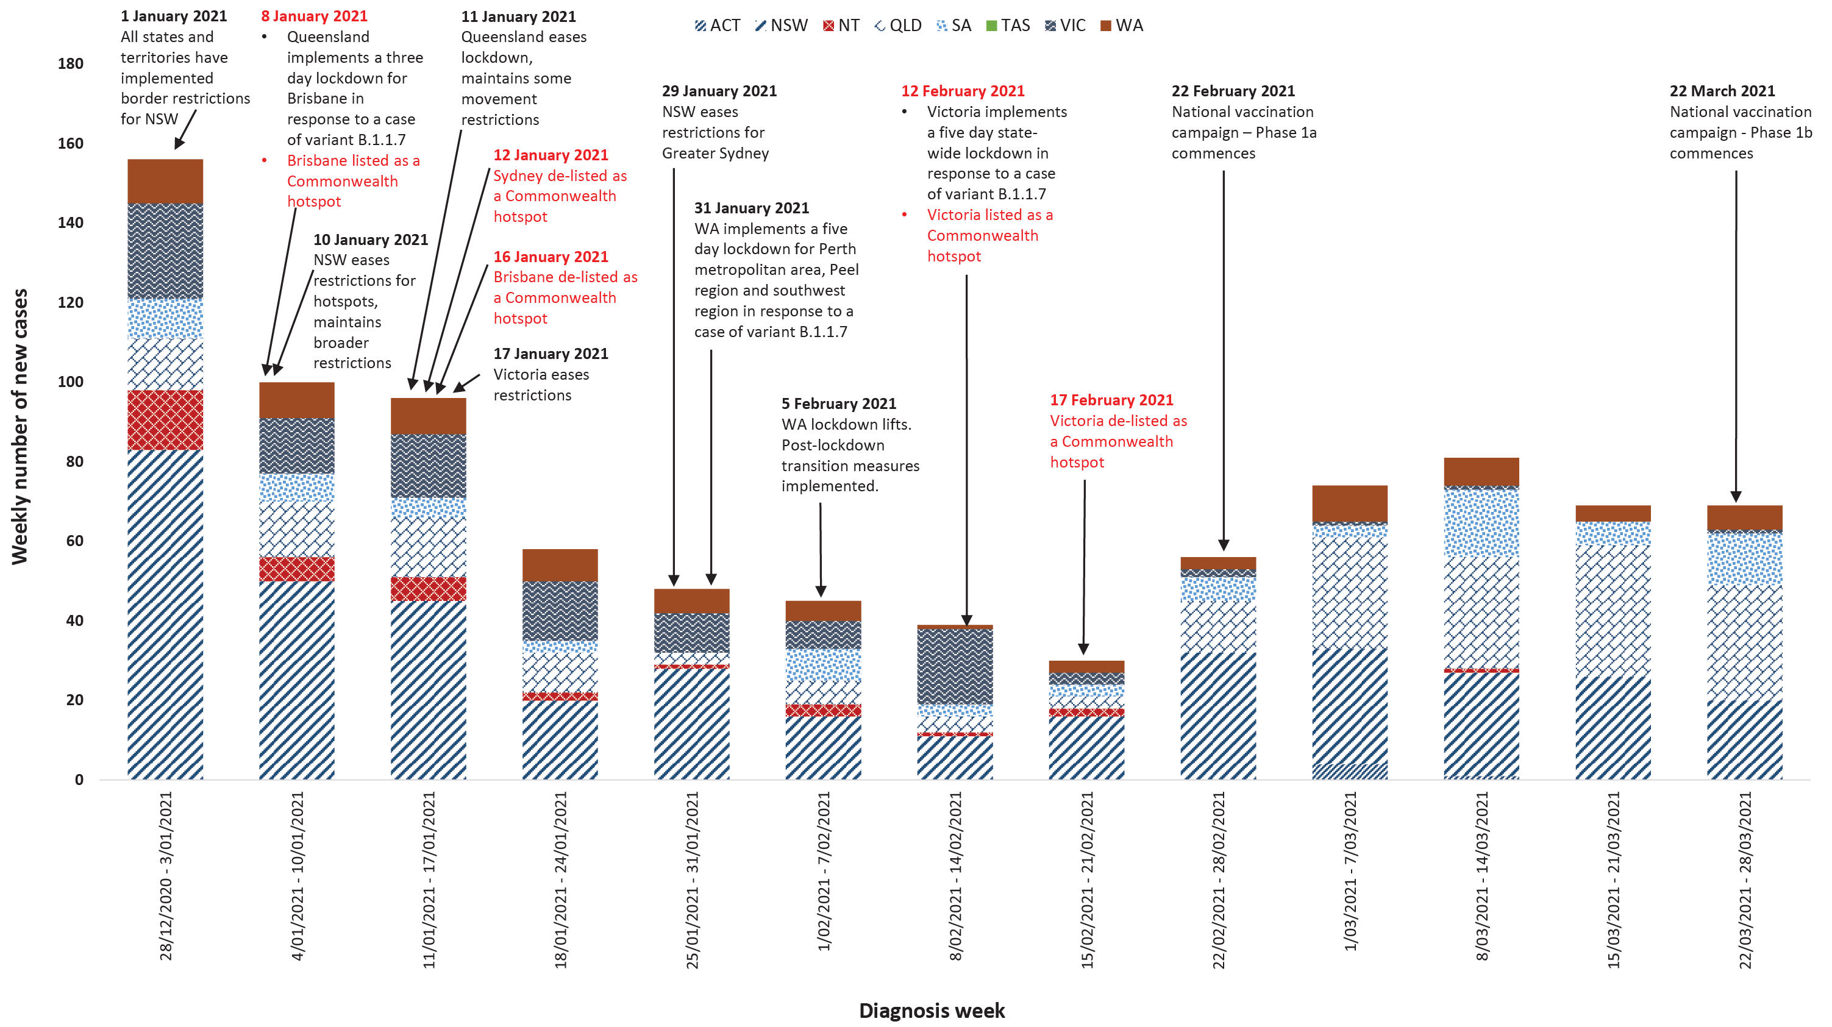

Nationally, new public health measures have been implemented in response to cases of SARS-CoV-2 variants of concern. Nationwide requirements involving air travel remain including pre-flight testing for travellers entering Australia and requirements to wear face masks when flying domestically or internationally. The national vaccination rollout of Phase 1a has continued this month and Phase 1b has commenced across jurisdictions this month.

Countries and territories in Australia’s near region
According to the World Health Organization (WHO), 46 countries and territories in the South East Asian (SEARO) and Western Pacific (WPRO) regions reported 1,342,131 newly-confirmed cases and 12,078 deaths in the four-week period from 1 March to 28 March 2021, bringing the cumulative cases in the two regions to 16.5 million and 249,098 cumulative deaths.³¹ In the Western Pacific, case numbers increased by 19.3% (238,254 new cases) in the last four weeks, while 46.7% fewer new deaths (2,354 new deaths) were reported compared to the previous four-week period. Similarly in South East Asia, reported new cases increased in the four-week period by 67% while new deaths remained at a similar number (1,102,877 new cases and 9,724 new deaths), compared to the preceding four-week period. Countries and territories that experienced the greatest rate of increase in new cases were:
- Papua New Guinea (776%);
- Timor-Leste (754%);
- New Caledonia (473%);
- Bangladesh (316%);
- Philippines (172%); and
- India (150%).
Trends in reporting new deaths are increasing in several countries (India, Bangladesh and Papua New Guinea), indicating that while regional trends indicate a decrease or stabilisation in deaths, this trend masks the nature of the epidemic in individual countries.
Fourteen Pacific Island countries reported no new cases in the past month.
Table 9 outlines the current transmission classification set by WHO for Australia’s near region. Under WHO’s classification, Australia has a transmission classification of ‘clusters of cases’.

Table 9: Transmission patterns for countries in Australia’s near region according to WHO, 28 March 2021^{a,b}
Category | Country
No cases  Countries/territories/areas with no cases | American Samoa, Cook Islands, Democratic People’s Republic of Korea, Kiribati, Marshall Islands, Federated States of Micronesia, Nauru, Niue, Palau, Pitcairn Islands, Samoa, Solomon Islands, Tokelau, Tonga, Tuvalu and Vanuatu
Sporadic cases  Countries/territories/areas with one or more cases, imported or locally detected | Bhutan, Cambodia, Fiji, French Polynesia, Lao PDR, New Caledonia, Singapore, Wallis and Futuna
Clusters of cases  Countries/territories/areas experiencing cases, clustered in time, geographic location and/or by common exposures | Australia, Brunei Darussalam, China, Guam, India, Japan, Malaysia, Maldives, Mongolia, Myanmar, Nepal, New Zealand, Republic of Korea, Sri Lanka, Thailand, Timor-Leste and Vietnam
Community transmission  Countries /territories/areas experiencing larger outbreaks of local transmission defined through an assessment of factors including, but not limited to:  large numbers of cases not linkable to transmission chains large numbers of cases from sentinel lab surveillance or increasing positive tests through sentinel samples (routine systematic testing of respiratory samples from established laboratories) multiple unrelated clusters in several areas of the country/territory/area. | Bangladesh, Indonesia, Papua New Guinea and Philippines
a Source: World Health Organization Weekly Operational Update for 29 March 2021.32
b Classifications according to WHO.
Globally, reported new cases increased by 15.6% while 20% fewer deaths were reported in the past four weeks since 28 February 2021 (12,916,858 reported new cases; 2,768,952 new deaths), with a global case fatality rate (CFR) of 2.2%. The global case increase was driven by increases in South East Asia (67%), the Eastern Mediterranean (39.7%), Europe (30.3%) and the Western Pacific (19.3%). To date, over 126 million COVID-19 cases and 2.7 million deaths have been reported globally. Two regions continue to report the largest burden of disease, with the Region of the Americas accounting for around 43.7% of all new cases and 48.1% of all newly-reported deaths, and Europe accounting for 35% of all new cases and 34.5% of newly reported deaths. The highest number of newly-reported cases in the past four weeks were in:
- Brazil – experiencing community transmission (1,948,784 new cases; representing a 45.7% increase)
- United States of America – experiencing community transmission (1,684,728 which represents 32.6% fewer cases);
- India – experiencing clusters of cases (reported 874,893 new cases, an almost 150% increase);
- France – experiencing community transmission (763,849 new cases, representing a 40.2% increase);
- Italy – experiencing clusters of cases (604,628 reported new cases, representing a 65.2% increase);
- Poland – experiencing community transmission (544,005 new cases, representing a 181% increase).
The highest number of deaths from COVID-19 in the last four weeks were reported in:
- Brazil (54,277 deaths, representing a 79.9% increase in deaths);
- United States of America (36,243 deaths, representing 50.7% fewer deaths);
- Mexico (16,388 deaths, representing 41.3% fewer deaths);
- Russian Federation (11,618 deaths, representing 10.2% fewer deaths);
- Italy (10,129 deaths, representing a 9.8% increase in deaths).
For many countries, vaccine rollout began in December 2020 but global distribution remains significantly uneven and well below 50% coverage in countries of high transmission.³³ In some countries, vaccine rollout suggests association with fewer deaths, particularly in older age groups, however further analysis is required to determine vaccination efficacy for reducing transmission.³⁴ Public health prevention measures and periods of restriction of community mobility remain the primary means to reduce transmission, particularly as new strains emerge and circulate simultaneously. WHO has recently published a position paper on the scientific, ethical, legal and technological considerations on the introduction of requirements for ‘proof’ (as distinguished from a certificate) of COVID-19 vaccination for outgoing or incoming international travellers. WHO’s present position is that national authorities should not introduce requirements of proof of COVID-19 vaccination for international travel as a condition for departure or entry. This is because the efficacy of vaccines in preventing transmission is not yet clear, and global vaccine supply is limited. WHO will revise their recommendations as evidence about existing and new COVID-19 vaccines is compiled.³⁵ An international summary by WHO Region can be found in the WHO Epidemiological Update dated 31 March 2021.^{31,32}

Acknowledgements
We thank public health staff from incident emergency operations centres and public health units in state and territory health departments, and the Australian Government Department of Health, along with state and territory public health laboratories. We thank those who have provided data from surveillance systems, such as Commonwealth respiratory clinics, ASPREN, Flutracking, FluCAN, Communicable Disease Genomics Network, AusTrakka and jurisdictional sequencing laboratories.

Author details

Corresponding author
COVID-19 National Incident Room Surveillance Team
Australian Government Department of Health, GPO Box 9484, MDP 14, Canberra, ACT 2601.
Email: epi.coronavirus@health.gov.au

References
- World Health Organization (WHO). Weekly epidemiological update - 23 February 2021. [Internet.] Geneva: WHO; 23 February 2021. [Accessed on 30 March 2021.] Available from: https://www.who.int/publications/m/item/weekly-epidemiological-update---23-february-2021.
- WHO. Weekly epidemiological update - 16 March 2021. [Internet.] Geneva: WHO; 16 March 2021. [Accessed on 30 March 2021.] Available from: https://www.who.int/publications/m/item/weekly-epidemiological-update---16-march-2021.
- Australian Government Department of Health. Getting vaccinated for COVID-19: Australia’s vaccine rollout. [Internet.] Canberra: Australian Government Department of Health; 30 March 2021. [Accessed on 30 March 2021.] Available from: https://www.health.gov.au/initiatives-and-programs/covid-19-vaccines/getting-vaccinated-for-covid-19#australias-vaccine-rollout.
- Therapeutic Goods Administration (TGA). COVID-19 vaccine approval process. [Internet.] Canberra: Australian Government Department of Health, TGA; 26 March 2021. [Accessed on 30 March 2021.] Available from: https://www.tga.gov.au/covid-19-vaccine-approval-process.
- TGA. TGA approves CSL - Seqirus to manufacture AstraZeneca COVID-19 vaccine in Australia. [Internet.] Canberra: Australian Government Department of Health, TGA; 21 March 2021. [Accessed on 30 March 2021.] Available from: https://www.tga.gov.au/media-release/tga-approves-csl-seqirus-manufacture-astrazeneca-covid-19-vaccine-australia.
- TGA. Melbourne-made COVID-19 vaccine now available. [Internet.] Canberra: Australian Government Department of Health, TGA; 23 March 2021. [Accessed on 30 March 2021.] Available from: https://www.tga.gov.au/media-release/melbourne-made-covid-19-vaccine-now-available.
- Australian Government Department of Health. COVID-19 vaccination – Australia’s COVID-19 vaccine national roll-out strategy. [Internet.] Canberra: Australian Government Department of Health; 17 February 2021. [Accessed on 30 March 2021.] Available from: https://www.health.gov.au/resources/publications/covid-19-vaccination-australias-covid-19-vaccine-national-roll-out-strategy.
- Johns Hopkins University & Medicine Coronavirus Resource Center. Understanding vaccination progress: vaccination progress across the world. [Internet.] Baltimore: Johns Hopkins University & Medicine; 2021. [Accessed on 30 March 2021.] Available from: https://coronavirus.jhu.edu/vaccines/international.
- Australian Government Department of Health. Australia’s vaccine agreements: COVAX facility. [Internet.] Canberra: Australian Government Department of Health; 22 February 2021. [Accessed on 30 March 2021.] Available from: https://www.health.gov.au/node/18777/australias-vaccine-agreements#covax-facility.
- Australian Government Department of the Prime Minister and Cabinet. Australia supporting Papua New Guinea’s COVID-19 response. [Internet.] Canberra: Australian Government Department of Prime Minister and Cabinet; 17 March 2021. [Accessed on 30 March 2021.] Available from: https://www.pm.gov.au/media/australia-supporting-papua-new-guineas-covid-19-response.
- COVID-19 National Incident Room Surveillance Team. Technical supplement. COVID-19 Australia: Epidemiology reporting. Commun Dis Intell (2018). 2021;45. doi: https://doi.org/10.33321/cdi.2021.45.2.
- Communicable Diseases Genomics Network (CDGN). AusTrakka. [Website.] Melbourne: CDGN; 2020. Available from: https://www.cdgn.org.au/austrakka.
- WHO. Coronavirus disease (COVID-19) weekly epidemiological update and weekly operational update. [Internet.] Geneva: WHO; 30 March 2021. [Accessed on 30 March 2021.] Available from: https://www.who.int/emergencies/diseases/novel-coronavirus-2019/situation-reports/.
- Dalton C, Durrheim D, Fejsa J, Francis L, Carlson S, d’Espaignet ET et al. Flutracking: a weekly Australian community online survey of influenza-like illness in 2006, 2007 and 2008. Commun Dis Intell Q Rep. 2009;33(3):316–22.
- Monash Health. FluCAN (Influenza surveillance): FluCAN (The Influenza Complications Alert Network). [Internet.] Melbourne: Monash Health; 2020. Available from: https://monashhealth.org/services/monash-infectious-diseases/research/influenza-research/flucan-influenza-surveillance-2/.
- Australian and New Zealand Intensive Care Society (ANZICS). SPRINT-SARI: Short period incidence study of severe acute respiratory infection. [Internet.] Camberwell: ANZICS; 2020. Available from: https://www.anzics.com.au/current-active-endorsed-research/sprint-sari/.
- COVID-19 National Incident Room Surveillance Team. COVID-19 Australia: Epidemiology Report 28: Fortnightly reporting period ending 25 October 2020. Commun Dis Intell (2018). 2020;44. doi: https://doi.org/10.33321/cdi.2020.44.84.
- COVID-19 National Incident Room Surveillance Team. COVID-19 Australia: Epidemiology Report 34: Reporting period ending 31 January 2021. Commun Dis Intell (2018). 2021;45. doi: https://doi.org/10.33321/cdi.2021.45.8.
- Australian Government Department of Health. Framework for national reopening – October 2020. [Internet.] Canberra: Australian Government Department of Health; 23 October 2020. [Accessed on 10 November 2020.] Available from: https://www.health.gov.au/resources/publications/framework-for-national-reopening-october-2020.
- Government of New South Wales. Restrictions ease for NSW schools. [Internet.] Sydney: Government of New South Wales; 5 March 2021. [Accessed on 12 March 2021.] Available from: https://www.nsw.gov.au/news/restrictions-ease-for-nsw-schools.
- Government of New South Wales. What you can do in NSW. [Internet.] Sydney: Government of New South Wales; 2021. [Accessed on 18 March 2021.] Available from: https://www.nsw.gov.au/covid-19/rules/what-you-can-do-nsw.
- Victoria State Government. Coronavirus update for Victoria - 26 March 2021. [Internet.] Melbourne: Victoria State Government; 26 March 2021. [Accessed on 31 March 2021.] Available from: https://www.dhhs.vic.gov.au/coronavirus-update-victoria-26-march-2021.
- Queensland Health. COVID-19 update: Queensland COVID-19 statistics. [Internet.] Brisbane: Queensland Government, Queensland Health; 2021. [Accessed on 15 March 2021.] Available from: https://www.qld.gov.au/health/conditions/health-alerts/coronavirus-covid-19/current-status/urgent-covid-19-update.
- Queensland Government. Queensland’s COVID safe future. Update: easing of restrictions for greater Brisbane. Brisbane: Queensland Government; 2021. [Accessed on 15 March 2021.] Available from: https://www.covid19.qld.gov.au/__data/assets/pdf_file/0016/127150/DPC7309-COVID-19-Restrictions-roadmap.pdf.
- Government of Western Australia. Changes to capacity for venues. [Internet.] Perth: Government of Western Australia; 5 March 2021. [Accessed on 15 March 2021.] Available from: https://www.wa.gov.au/government/announcements/changes-capacity-venues.
- Government of Western Australia. WA border controls strengthened with Queensland. [Internet.] Perth: Government of Western Australia; 27 March 2021. [Accessed on 31 March 2021.] Available from: https://www.wa.gov.au/government/announcements/wa-border-controls-strengthened-queensland.
- South Australia Health (SA Health). COVID-19 health information. [Internet.] Adelaide: Government of South Australia, SA Health; 2021. [Accessed on 31 March 2021.] Available from: https://www.sahealth.sa.gov.au/wps/wcm/connect/public+content/sa+health+internet/conditions/infectious+diseases/covid-19.
- Tasmanian Government. Coronavirus disease (COVID-19). Important community updates. [Internet.] Hobart: Tasmanian Government; 2021. [Accessed on 31 March 2021.] Available from: https://coronavirus.tas.gov.au/facts/important-community-updates.
- Australian Capital Territory Government. Check In CBR app to be made mandatory. [Internet.] Canberra: Australian Capital Territory Government; 2021. [Accessed on 30 March 2021.] Available from: https://www.covid19.act.gov.au/news-articles/check-in-cbr-app-to-be-made-mandatory.
- Northern Territory Government. Coronavirus (COVID-19): updates. [Internet.] Darwin: Northern Territory Government; 2021. [Accessed on 30 March 2021.] Available from: https://coronavirus.nt.gov.au/updates.
- WHO. Weekly epidemiological update - 30 March 2021. [Internet.] Geneva: WHO; 31 March 2021. [Accessed on 1 April 2021.] Available from: https://www.who.int/publications/m/item/weekly-epidemiological-update---31-march-2021.
- WHO. Weekly operational update on COVID-19 - 29 March 2021. [Internet.] Geneva: WHO; 29 March 2021. [Accessed on 30 March 2021.] Available from: https://www.who.int/publications/m/item/weekly-operational-update-on-covid-19---29-march-2021.
- Our World in Data. Statistics and research: coronavirus (COVID-19) vaccinations. [Internet.] Oxford: University of Oxford, Our World in Data; 2021. [Accessed on 30 March 2021.] Available from: https://ourworldindata.org/covid-vaccinations.
- Public Health England. Impact of COVID-19 vaccines on mortality in England: December 2020 to February 2021. London: Public Health England; 2021. [Accessed on 30 March 2021.] Available from: https://assets.publishing.service.gov.uk/government/uploads/system/uploads/attachment_data/file/972592/COVID-19_vaccine_impact_on_mortality_240321.pdf.
- WHO. News updates: latest news from WHO on COVID-19 and other breaking health stories. Vaccine passports/certificates and international travel. [Internet.] Geneva: WHO; 9 March 2021. [Accessed on 30 March 2021.] Available from: https://www.who.int/news-room/news-updates.

Appendix A: Supplementary figures and tables
Table A.1: COVID-19 case notifications and rates per 100,000 population, by age group and sex, Australia, 28 March 2021
Age group | This reporting period  1–28 March 2021 |  |  |  |  |  | Cumulative  23 January 2020 – 28 March 2021
 | Cases |  |  | Rate per 100,000 population |  |  | Cases |  |  | Rate per 100,000 population
 | Male | Female | People | Male | Female | People | Male | Female | People | Male | Female | People
0 to 9 | 5 | 10 | 15 | 0.3 | 0.6 | 0.5 | 812 | 734 | 1,546 | 49.6 | 47.4 | 48.5
10 to 19 | 7 | 1 | 8 | 0.4 | 0.1 | 0.3 | 1,276 | 1,216 | 2,492 | 81.3 | 81.9 | 81.6
20 to 29 | 12 | 17 | 29 | 0.6 | 0.9 | 0.8 | 3,117 | 3,419 | 6,557 | 167.8 | 189.9 | 179.2
30 to 39 | 22 | 8 | 30 | 1.2 | 0.4 | 0.8 | 2,656 | 2,545 | 5,216 | 146.0 | 137.1 | 141.9
40 to 49 | 11 | 1 | 12 | 0.7 | 0.1 | 0.4 | 1,955 | 1,807 | 3,790 | 120.8 | 109.1 | 115.7
50 to 59 | 11 | 3 | 14 | 0.7 | 0.2 | 0.5 | 1,694 | 1,760 | 3,461 | 112.4 | 111.9 | 112.4
60 to 69 | 8 | 4 | 12 | 0.6 | 0.3 | 0.5 | 1,223 | 1,225 | 2,450 | 96.3 | 91.2 | 93.7
70 to 79 | 3 | 1 | 4 | 0.3 | 0.1 | 0.2 | 864 | 758 | 1,622 | 99.3 | 82.2 | 90.5
80 to 89 | 0 | 0 | 0 | 0.0 | 0.0 | 0.0 | 497 | 778 | 1,275 | 139.1 | 168.7 | 155.7
90 and over | 0 | 0 | 0 | 0.0 | 0.0 | 0.0 | 230 | 551 | 782 | 335.2 | 412.6 | 386.8

Communicable Diseases Intelligence
ISSN: 2209-6051 Online

Communicable Diseases Intelligence (CDI) is a peer-reviewed scientific journal published by the Office of Health Protection and Response, Department of Health. The journal aims to disseminate information on the epidemiology, surveillance, prevention and control of communicable diseases of relevance to Australia.

Editor: Jennie Hood
Deputy Editor: Simon Petrie
Design and Production: Kasra Yousefi
Editorial Advisory Board: David Durrheim, Mark Ferson, John Kaldor, Martyn Kirk and Linda Selvey

Website: http://www.health.gov.au/cdi

Contacts
CDI is produced by Environmental Health and Health Protection Policy Branch, Office of Health Protection and Response, Australian Government Department of Health, GPO Box 9848, (MDP 6) CANBERRA ACT 2601

Email: cdi.editor@health.gov.au

Submit an Article
You are invited to submit your next communicable disease related article to the Communicable Diseases Intelligence (CDI) for consideration. More information regarding CDI can be found at: http://health.gov.au/cdi.
Further enquiries should be directed to: cdi.editor@health.gov.au.

This journal is indexed by Index Medicus and Medline.

Creative Commons Licence - Attribution-NonCommercial-NoDerivatives CC BY-NC-ND
© 2021 Commonwealth of Australia as represented by the Department of Health
This publication is licensed under a Creative Commons Attribution-NonCommercial-NoDerivatives 4.0 International Licence from https://creativecommons.org/licenses/by-nc-nd/4.0/legalcode (Licence). You must read and understand the Licence before using any material from this publication.

Restrictions
The Licence does not cover, and there is no permission given for, use of any of the following material found in this publication (if any):
- the Commonwealth Coat of Arms (by way of information, the terms under which the Coat of Arms may be used can be found at www.itsanhonour.gov.au);
- any logos (including the Department of Health’s logo) and trademarks;
- any photographs and images;
- any signatures; and
- any material belonging to third parties.

Disclaimer
Opinions expressed in Communicable Diseases Intelligence are those of the authors and not necessarily those of the Australian Government Department of Health or the Communicable Diseases Network Australia. Data may be subject to revision.

Enquiries
Enquiries regarding any other use of this publication should be addressed to the Communication Branch, Department of Health, GPO Box 9848, Canberra ACT 2601, or via e-mail to: copyright@health.gov.au

Communicable Diseases Network Australia
Communicable Diseases Intelligence contributes to the work of the Communicable Diseases Network Australia.
http://www.health.gov.au/cdna

These data are provided by the national pathogen genomic sequence and analysis platform, AusTrakka,¹² and from jurisdictional pathogen sequencing laboratories to summarise the genomic epidemiology of SARS-CoV-2 in Australia. Numbers are subject to change retrospectively and sequences are not able to be obtained from all samples (see Technical Supplement).¹¹

