COVID-19, Australia: Epidemiology Report 9:
Reporting week ending 23:59 AEDT 29 March 2020
COVID-19 National Incident Room Surveillance Team
An error occurred in the legend for Figure 8 (Confirmed cases of overseas acquired COVID-19 infection (n = 2,352) by Standard Australian Classification of Countries) as originally published, which inadvertently omitted the key depicting the confirmed cases from Sub-Saharan Africa. This has now been amended.

Summary
This is the ninth epidemiological report for coronavirus disease 2019 (COVID-19), reported in Australia as at 23:59 Australian Eastern Daylight Time [AEDT] 29 March 2020. It includes data on COVID-19 cases diagnosed in Australia, the international situation and a review of current evidence.
Keywords: SARS-CoV-2; novel coronavirus; 2019-nCoV; coronavirus disease 2019; COVID-19; acute respiratory disease; case definition; epidemiology; Australia
The following epidemiological data are subject to change both domestically and internationally due to the rapidly evolving situation. Australian cases are still under active investigation. While every effort has been made to standardise the investigation of cases nationally, there may be some differences between jurisdictions. For further information relating to the data incorporated in this series of reports, please refer to the Frequently Asked Questions addressed within the appendix to this report.

In Australia:
- There have been 4,159 confirmed cases, including 15 deaths, reported in Australia up to 23:59 AEDT 29 March 2020. Of confirmed cases, the highest proportion of cases have been from New South Wales (48%), followed by Queensland (18%) and Victoria (16% );
- Forty-two percent of the total number of cases reported so far have been during the current reporting week;
- Hospitalisation status was recorded for 2,129 cases, of which 19% were reported to have been hospitalised due to their COVID-19 infection. Of these hospitalised cases, ICU (Intensive Care Unit) status was recorded for 176 cases, of which 22% (n = 38) were admitted to an ICU, with five cases requiring ventilation; and
- The rate of increase in cases has lowered over the reporting week. Whilst the effects of border and recently-introduced social distancing measures are likely having an effect, it is too soon to tell whether this trend will be sustained.
Internationally:
- A total of 634,813 cases have been reported globally across 189 countries, territories and regions;
- The USA has overtaken Italy as the country with most reported cases (n = 103,321), however, the European Region continues to be the most heavily affected, with Italy, Spain and Germany accounting for 60% (n = 217,267) of all cases in the region; and
- A total of 29,891 deaths have been reported globally with over 70% (n = 21,427) reported in the European Region.

Australian situation
As at 23:59 AEDT 29 March 2020, there were 4,159 confirmed cases, including 16 deaths in Australia, reported to the National Notifiable Diseases Surveillance System (NNDSS) (Table 1, Figure 1). Of the 4,159 confirmed cases, 48% were reported in NSW, 18% from Qld, 16% from Vic, 8% from WA, 7% from SA, 2% from ACT, 1% from Tas, and 0.3% from NT (Figures 2, 3). The rate of cases in Australia per 100,000 population was 16.4; in comparison, the rate per 100,000 population was 7.0 in the previous reporting period. Most cases are reported to reside within major metropolitan areas, with a small number of cases reported outside these areas (Figures 2, 3).
During the current reporting week, 2,355 cases were reported; this is a 136% increase from cases reported during the previous reporting period. The median time between onset of symptoms and laboratory testing was two days (range 0–32 days).
The median age of notified cases in Australia was 48 years (range 0–98 years), with the largest number of cases in the 20–29 years age group (Figure 4). The highest rate of disease was among those in the 60–69 years age group (Figure 4). Notifications by gender were approximately equal, although there was some variation across age groups.
Of the symptoms reported, cough (70%) was the most common. Forty-nine percent reported headache, 47% reported fever, 45% reported sore throat, and 34% reported runny nose (Figure 5). Only 2% or fewer of all cases reported either pneumonia or acute respiratory disease (ARD). An analysis of symptom combinations highlights that cough is the predominant clinical presentation in combination with fever and/or sore throat (Figure 6).
Hospitalisation status was recorded for 2,129 cases, of which 18.9% (n = 402) were reported to have been hospitalised due to their COVID-19 infection. The median age of hospitalised cases was 58 years (range 0–98 years), with the highest proportion of cases in the 60–69 years age group. The most commonly reported comorbid condition among hospitalised cases was diabetes (6.2%), followed by cardiac disease (6.0%). Of these hospitalised cases, ICU (Intensive Care Unit) status was recorded for 176 cases of which 22% (n = 38) were recorded being admitted to an ICU, with five cases requiring ventilation.
Fifteen COVID-19 deaths were confirmed in Australia up to 29 March 2020. The median age was 81 years (range 67–94 years). Four of these deaths were in an aged care facility, four were associated with cruise ships and the other seven cases were acquired in the community. Seven of the cases were male and eight were female. The period between the date of illness onset and death ranged from 0 to 12 days. Of the 15 confirmed deaths, three reported having comorbidities, including diabetes, chronic respiratory conditions and stroke.
Of cases with a reported place of acquisition (2,964 of 4,159), 79% (n = 2,352) had a recent international travel history and 21% (n = 612) were considered to have been locally acquired (Figure 7). The majority of overseas-acquired cases (Figure 8) reported a travel history to the European Region, the Americas Region or on board cruise ships. Of the locally-acquired cases, the majority were considered to be contacts of a confirmed case, with a very small number of cases not able to be epidemiologically linked to a confirmed case. For the remainder of cases where a place of acquisition has not been reported, these cases are currently under public health investigation. The distribution of the source of infection for cases varied by jurisdiction.
Of the 4,159 confirmed cases, 27 cases (0.6%) were reported in Aboriginal and Torres Strait Islander persons. These 27 cases have been reported across several jurisdictions with the majority of cases reported in areas classified as ‘major cities of Australia’ based on the case’s usual place of residence. Completeness of the Indigenous status field was approximately 73%, with 11% of cases with a reported value of unknown.

Cluster and outbreak investigations
Investigations are taking place in states and territories in relation to a number of clusters and outbreaks of COVID-19. To date the largest outbreaks have been associated with cruise ships.
Clusters:
- The term ‘cluster’ in relation to COVID-19 refers to two or more cases that are epidemiologically related in time, place or person where a common source (such as an event or within a community) of infection is suspected but not yet established.

Outbreaks:
- The term ‘outbreak’ in relation to COVID-19 refers to two or more cases among a specific group of people and/or over a specific period of time where illness is associated with a common source (such as an event or within a community).
Closed environments, close contact between travellers from various countries, and crew transfers between voyages make cruise ships a unique environment for rapid disease transmission.¹ Cruise ships account for a substantial proportion of COVID-19 cases in Australia. Of cases with a reported place of acquisition, 23% (n = 670) were considered to have acquired their infection at sea.
During the period 7 to 23 February 2020, the largest outbreak of COVID-19 cases outside of mainland China occurred on the Diamond Princess cruise ship. Of the 3,711 passengers and crew, 712 (19.2%) were confirmed as having COVID-19 including 56 residents of Australia.
Between 7 and 29 March 2020, at least 17 cruise ships have docked in Australia and 9 have confirmed cases of COVID-19. This includes the Ruby Princess which docked on 19 March 2020 and at the time of reporting was associated with 215 cases.

Figure 1: Confirmed cases of COVID-19 infection, Australia, by date of illness onsetª
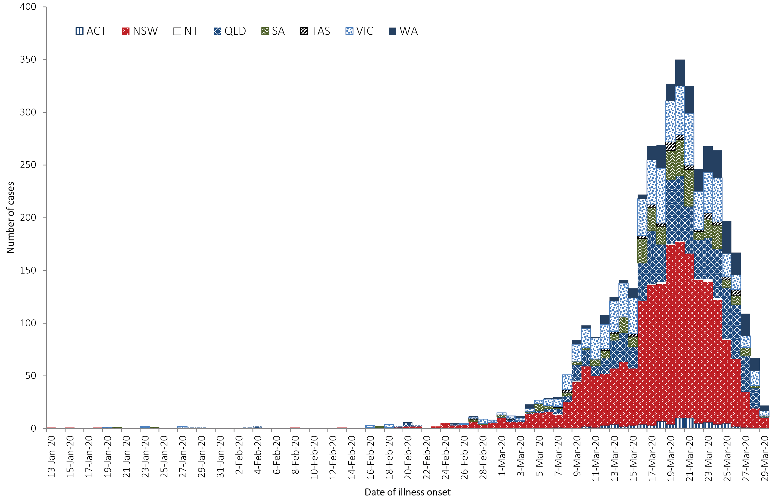
a Recently reported cases shown in the graph should be interpreted with caution as there can be delays in reporting.
Figure 2: Confirmed cases of COVID-19, Australia, by location of usual residence and statistical area level 3, as at 23 March 2020ª
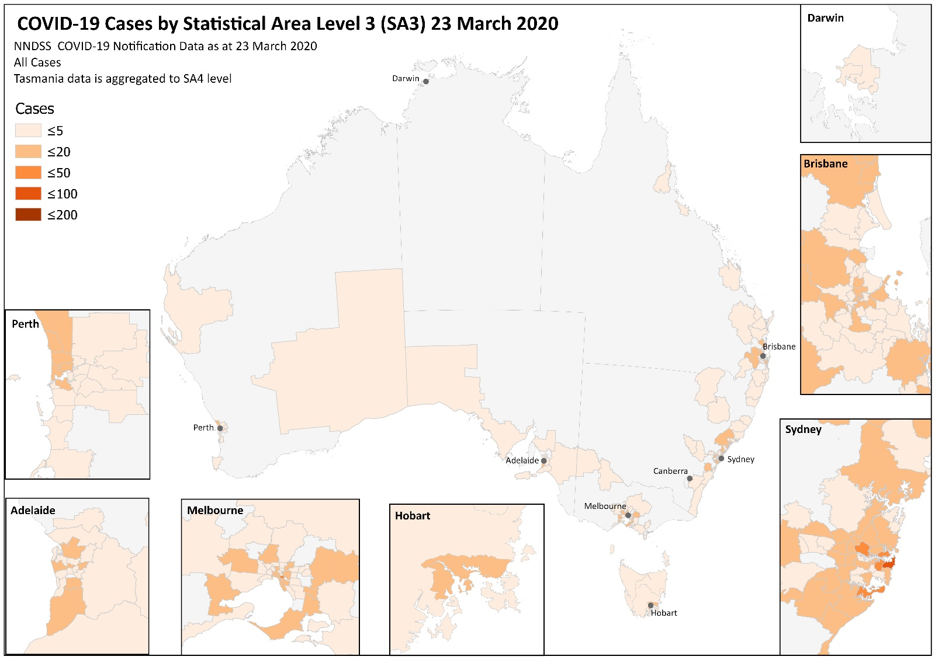
a Represents the usual location of residence of a case, which does not necessarily mean that this is the place where they acquired their infection or were diagnosed. Overseas residents who do not have a usual place of residence in Australia are not shown.
Figure 3: Confirmed cases of COVID-19, Australia, by location of usual residence and statistical area level 3, as at 1 April 2020ª
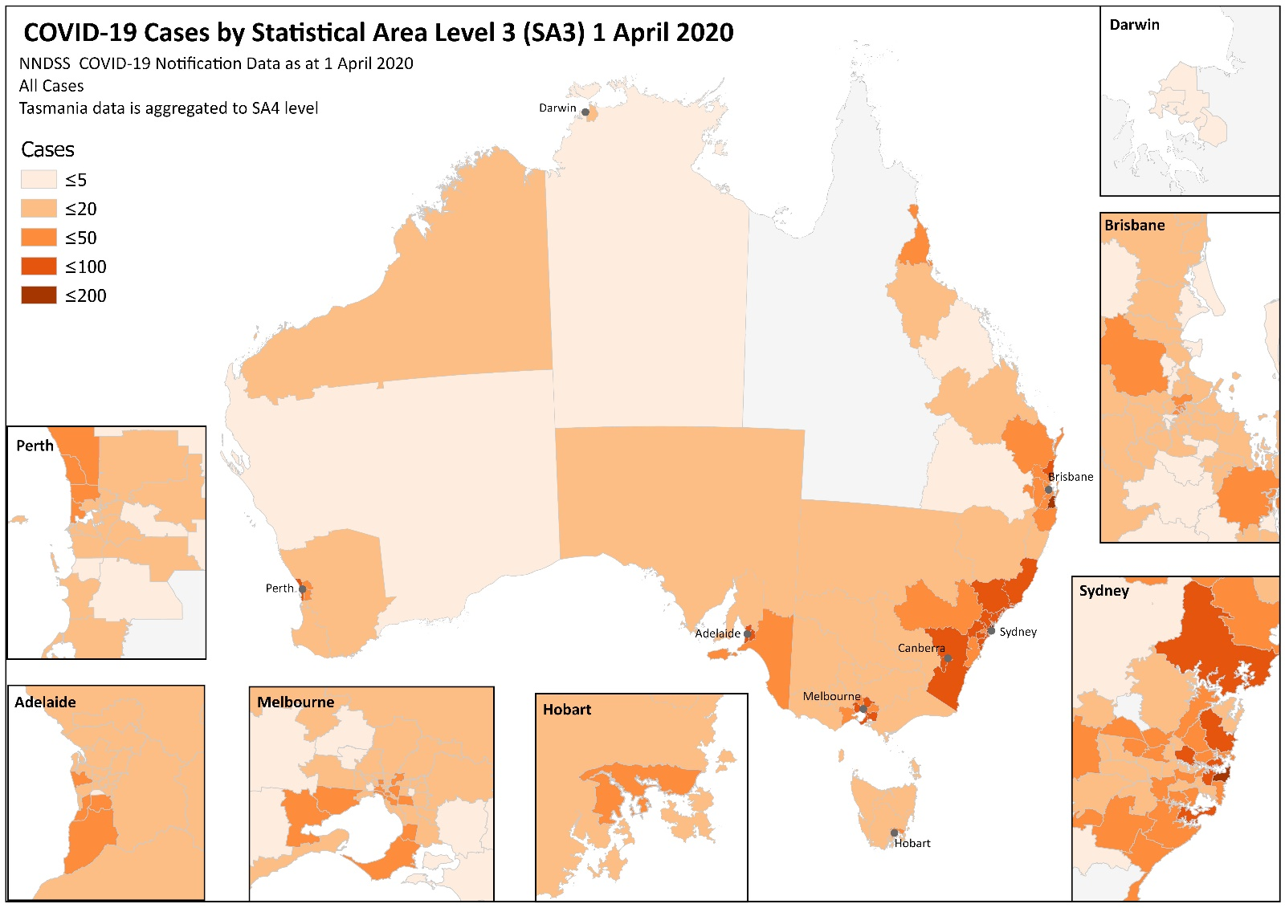
a Represents the usual location of residence of a case, which does not necessarily mean that this is the place where they acquired their infection or were diagnosed. Overseas residents who do not have a usual place of residence in Australia are not shown.
Table 1: Cumulative notified cases of confirmed COVID-19 and diagnostic tests performed, Australia, by jurisdiction
Jurisdictionª | Number of new cases this reporting week^{b}  (00:00 AEDT 23 March to 23:59 AEDT 29 March 2020) | Total cases^{b}  (to 23:59 AEDT 29 March 2020) | Cases per 100,000 population | Cumulative number of tests performed  (proportion of tests positive %)
NSW | 1,215 | 1,981 | 24.5 | 91,308 (2.2%)
Vic | 360 | 673 | 10.2 | 28,941 (2.3%)
Qld | 376 | 738 | 14.5 | 45,107 (1.6%)
WA | 144 | 313 | 11.9 | 13,337 (2.3%)
SA | 167 | 304 | 17.4 | 24,737 (1.2%)
Tas | 38 | 59 | 11.0 | 1,720 (3.4%)
NT | 10 | 14 | 5.7 | 1,881 (0.7%)
ACT | 45 | 77 | 18.0 | 4,230 (1.8%)
Total | 2,355 | 4,159 | 16.4 | 211,261 (2.0%)
a NSW = New South Wales, Vic = Victoria, Qld = Queensland, WA = Western Australia, SA = South Australia, Tas = Tasmania, NT = Northern Territory, ACT = Australian Capital Territory.
b Due to the dynamic nature of the NNDSS, data in this extract are subject to retrospective revision and may vary from data reported in previously published reports and reports of notification data by states and territories.

Figure 4: Case numbers and rates of COVID-19 cases, Australia, by age and sex
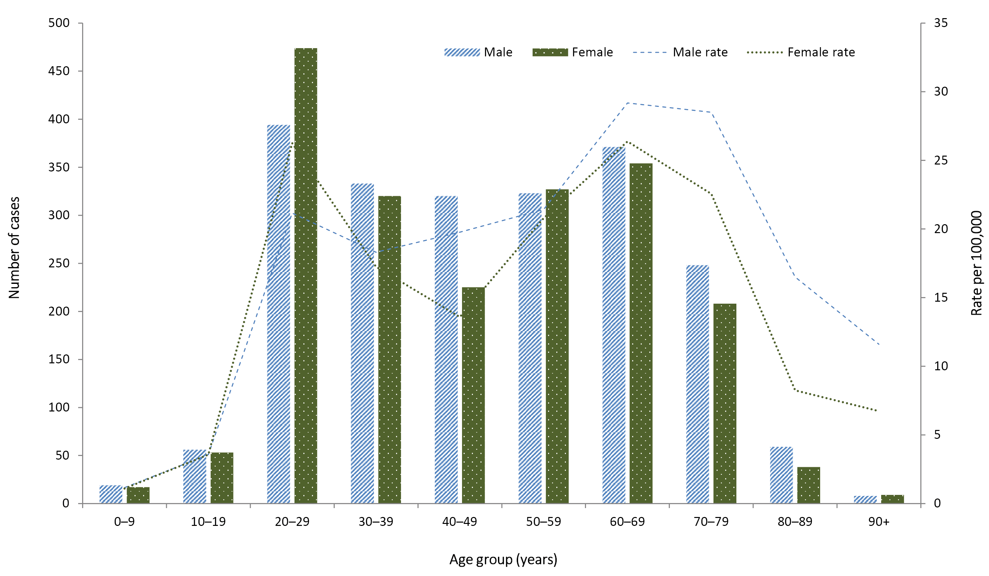

Figure 5: Frequency of COVID-19 symptoms in confirmed cases, Australia (n = 2,257)
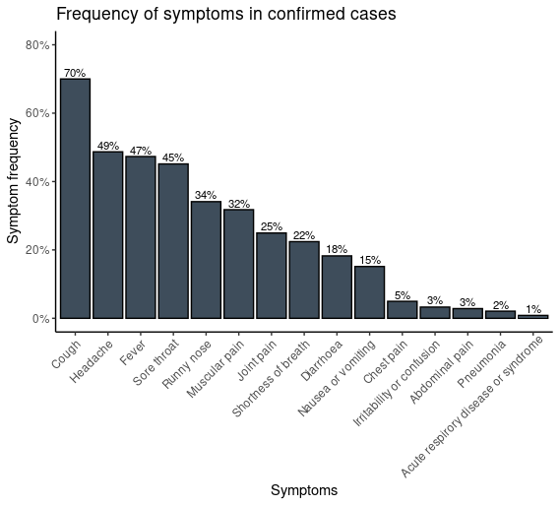
Figure 6: Variation in combinations of COVID-19 symptoms in confirmed cases, Australiaª
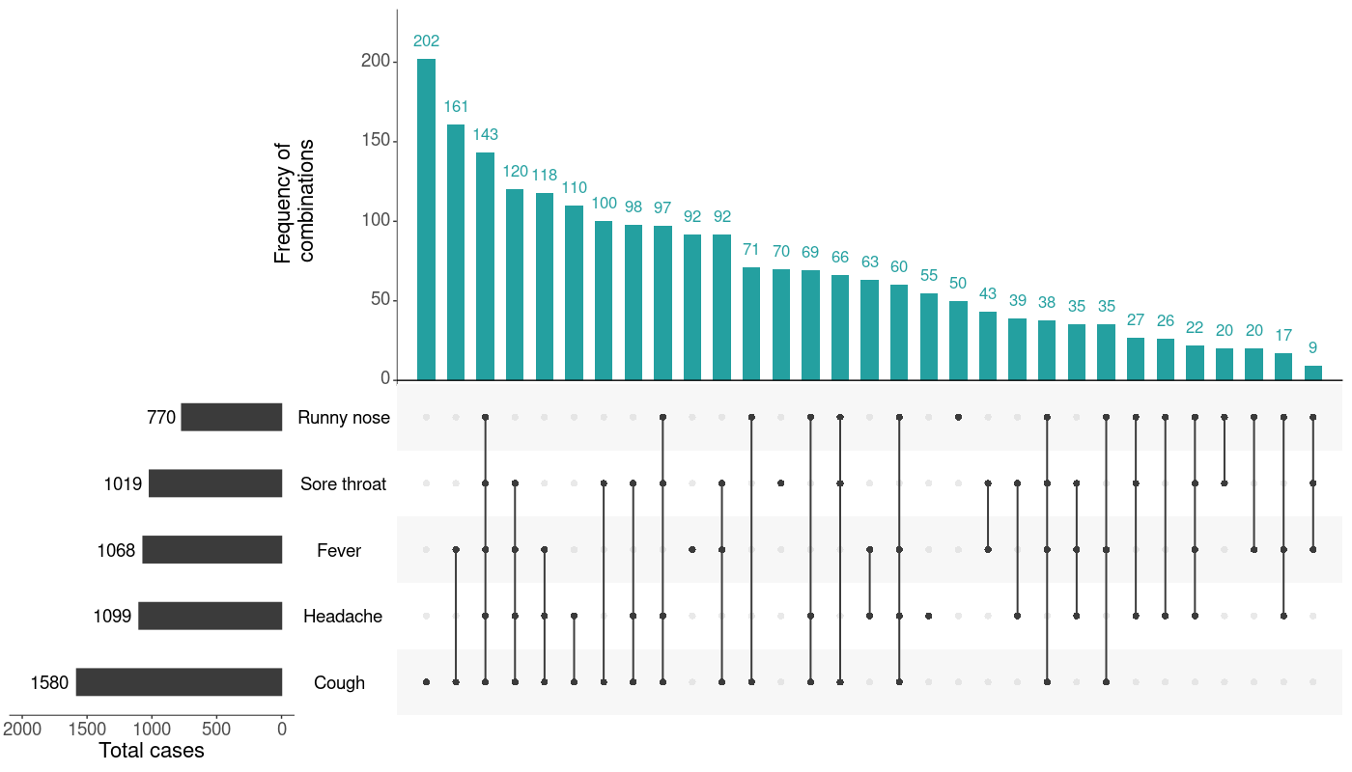
a This figure shows the variation in combinations of symptoms observed in reported cases (n = 2,257) for the five most frequently observed symptoms (cough, headache, fever, sore throat, runny nose). The horizontal bars on the left show the frequency of symptom occurrence in any combination with other symptoms. The circles and lines indicate particular combinations of symptoms observed in individual patients. The vertical green bars indicate the frequency of occurrence of the corresponding combination of symptoms.

Figure 7: Number of COVID-19 cases by place of acquisition over time, Australia (n = 4,159)ª
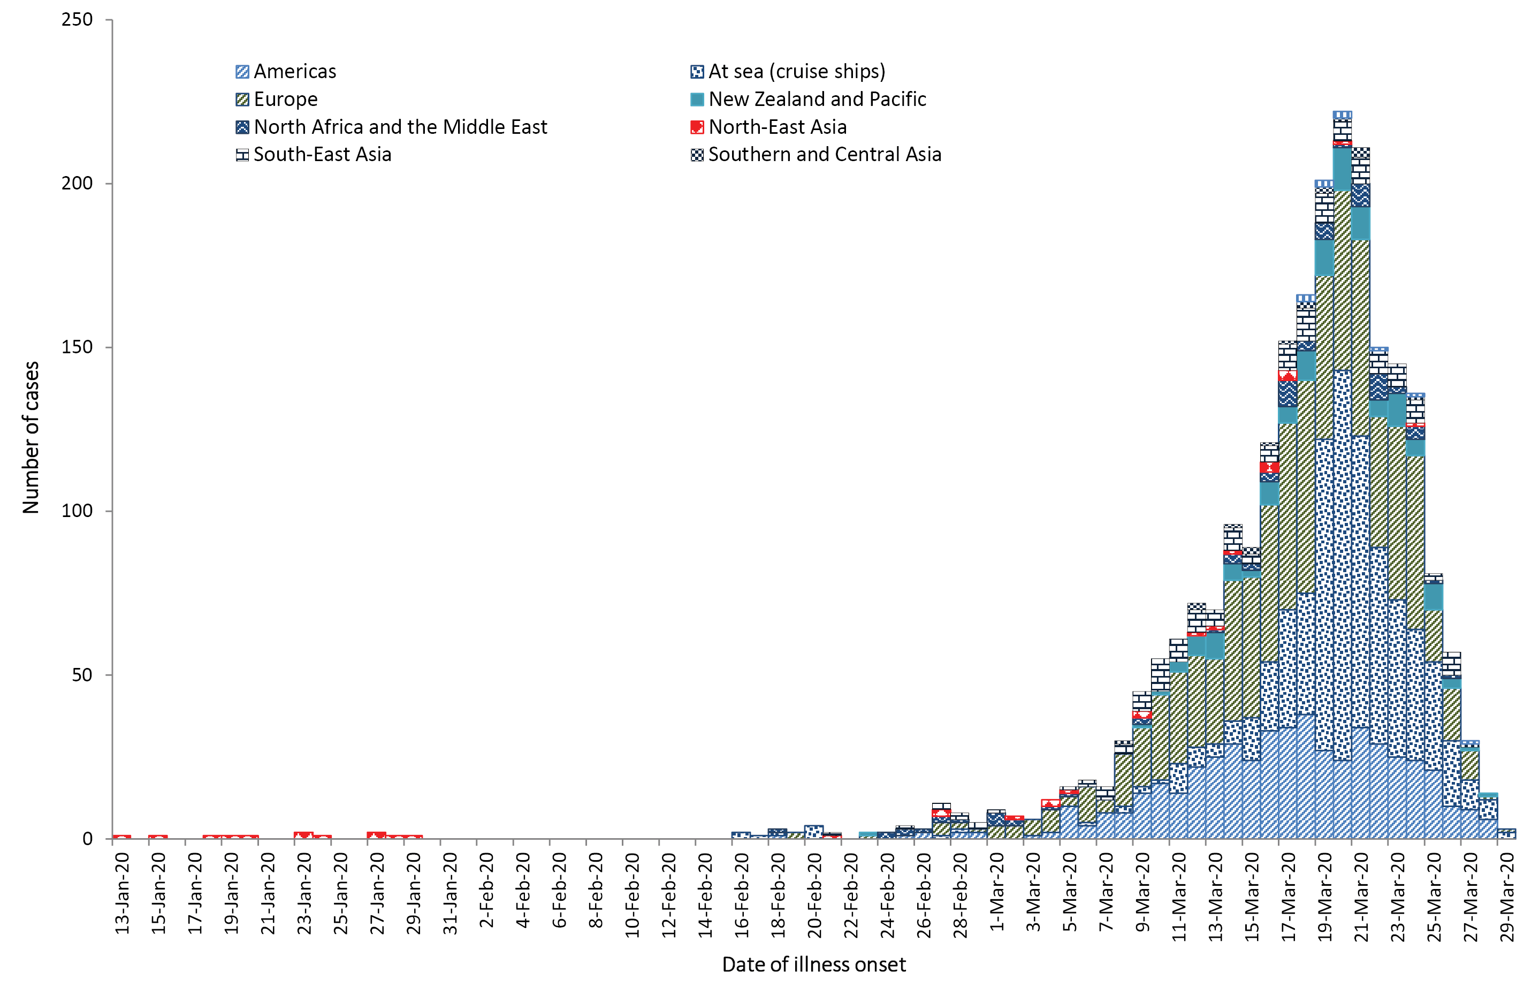
a Recently reported cases shown in the graph should be interpreted with caution as there can be delays in reporting.
Figure 8: Confirmed cases of overseas acquired COVID-19 infection (n = 2,352) by Standard Australian Classification of Countries (SACC)ª
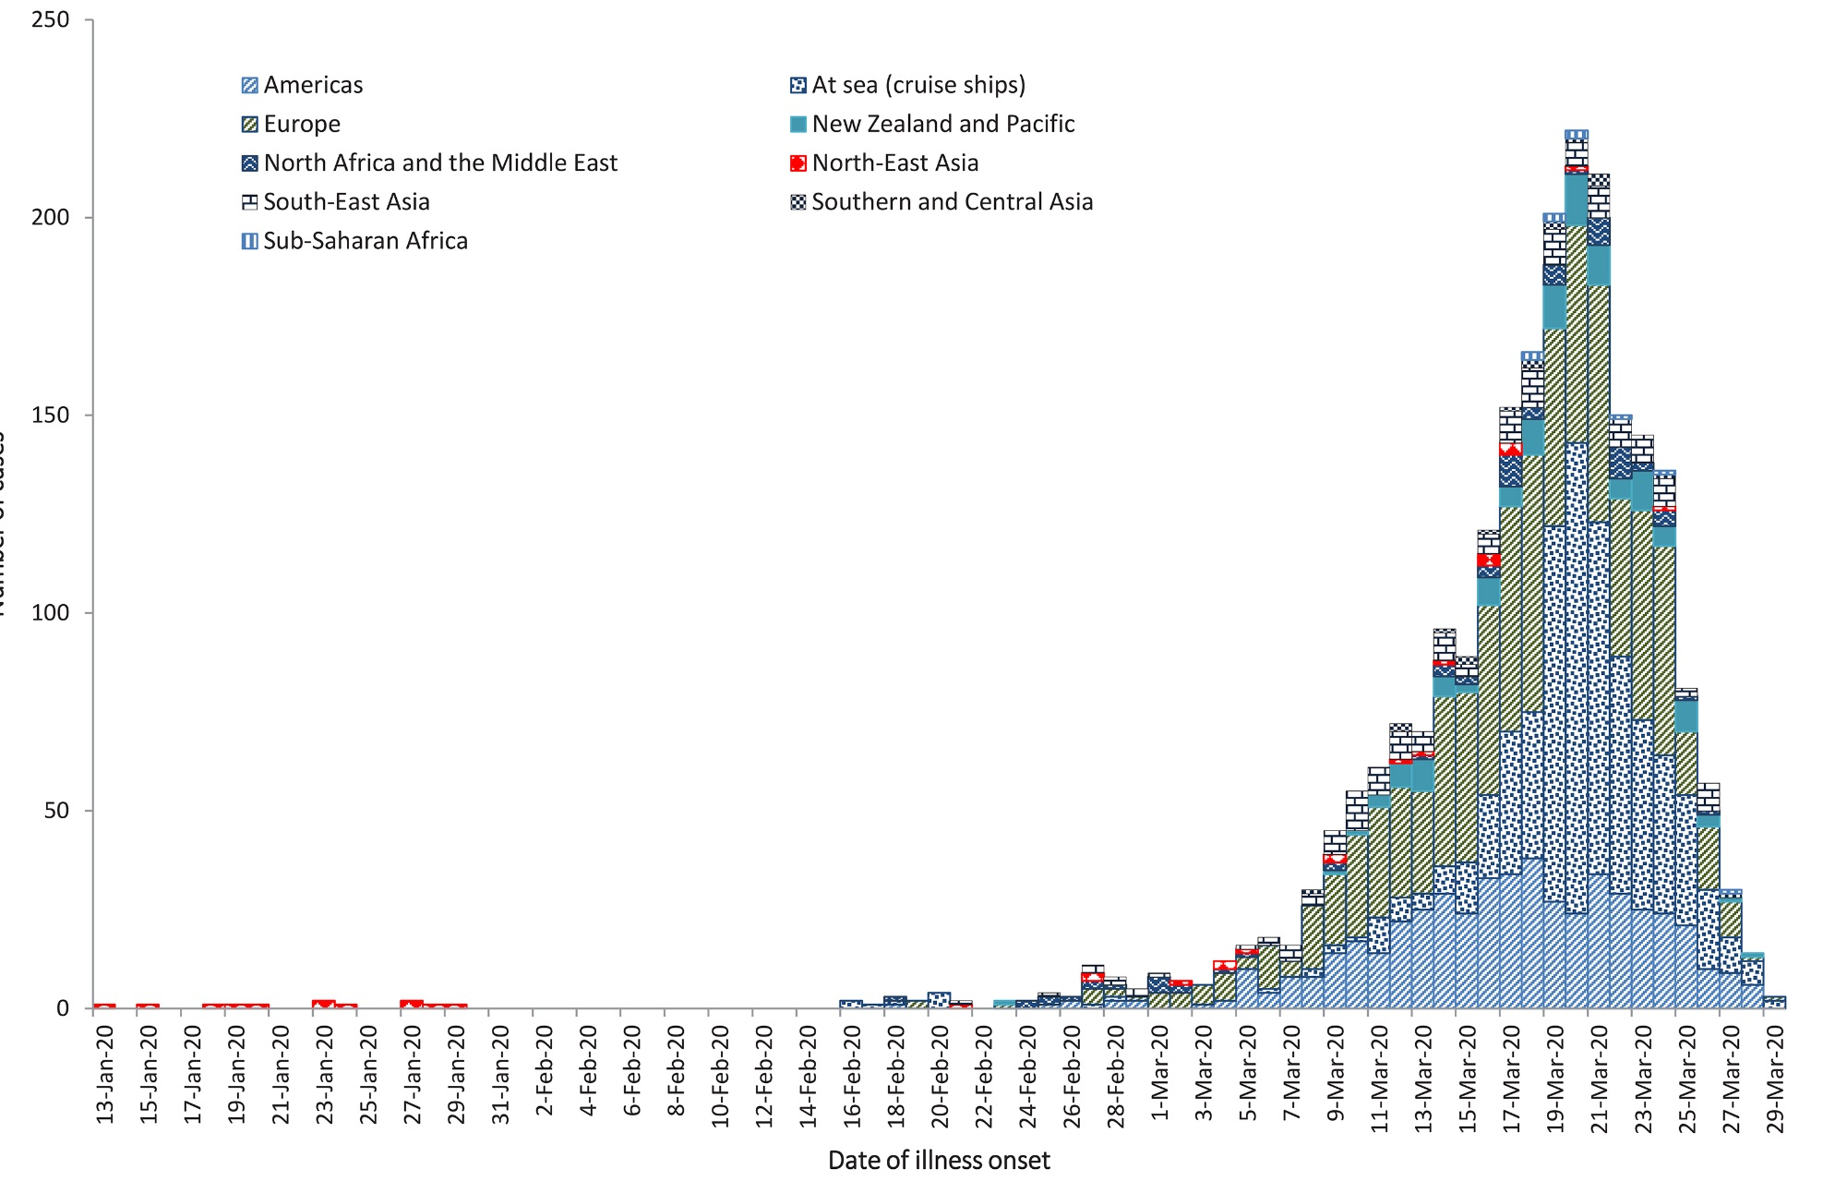
a Recently reported cases shown in the graph should be interpreted with caution as there can be delays in reporting.

International situation
As at 23:59 AEDT 29 March 2020, the number of confirmed COVID-19 cases reported to the World Health Organization (WHO) was 634,813 globally.² 57% (n = 361,031) of all reported cases are from the European Region, 19% (n = 120,792) are from the Region of the Americas, and 16% (n = 102,788) are from the Western Pacific Region. The most affected countries with the highest number of reported cases across these regions are respectively Italy (n = 92,672), the United States of America (n = 103,321) and China, including special administrative regions (n = 82,341).
The number of new cases reported globally has continued to increase. As of the last reporting week, 15 countries, territories and areas reported cases of COVID-19 for the first time, bringing the total to 189 countries, territories and areas globally. The USA has now overtaken Italy as the country with most reported cases; however, the European Region continues to be the most heavily affected, with Italy, Spain and Germany accounting for 60% (n = 217,267) of all cases in the region. Of all the countries, territories and areas with known transmission classification (n = 189), 79% (n = 149) have reported local transmission of COVID-19.
The reported epidemiology varies by country with the trajectory of different countries’ outbreaks after their first 100 cases showing variation. Figure 9 highlights that for a number of countries outside of mainland China which have reported more than 100 cases, their rates of increase continue to be high, particularly USA, Italy and Spain. For several other countries or regions including Singapore, Japan and Hong Kong there continues to be a slow rate of increase in their number of new cases, with the Republic of Korea reporting very few new cases each day. Reported case numbers will be influenced by rates of testing, case definition, and case detection as well as overall health system capacity.
Border measures such as travel bans and mandatory 14-day quarantine for all return travellers have been put in place to reduce the risk of imported cases into Australia.
Globally, 29,891 deaths have been reported. Over 70% of deaths (n = 21,427) have been reported in the European Region, followed by 12% (n = 3,626) in the Western Pacific Region, and 9% (n = 2,668) in the Eastern Mediterranean Region. Italy, Spain, France and the United Kingdom have reported over 1,000 deaths in each respective country, contributing to a combined total of 89% (n = 19,043) of deaths reported in the region. In the Western Pacific Region, 91% (n = 3,306) of all deaths are reported from China. Iran accounts for 94% (n = 2,517) of all deaths in the Eastern Mediterranean Region. The global proportion of cases that are reported to have died is 4.7%. This proportion is likely to be an overestimate due to variable levels of under-ascertainment of cases, especially those with mild infections. For several other countries or regions including the Republic of Korea, there continues to be a slow increase in their number of deaths, with few new deaths reported in the Republic of Korea each day (Figure 10).

Figure 9: Number of COVID-19 cases (logarithmic scale) by selected country and days since passing 100 cases, up to 29 March 2020
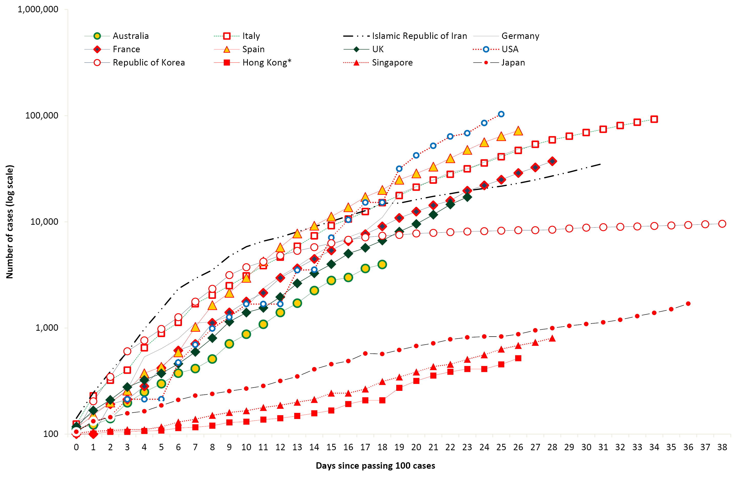
Figure 10: Number of COVID-19 deaths (logarithmic scale) by selected country and days since passing 50 deaths, up to 29 March 2020
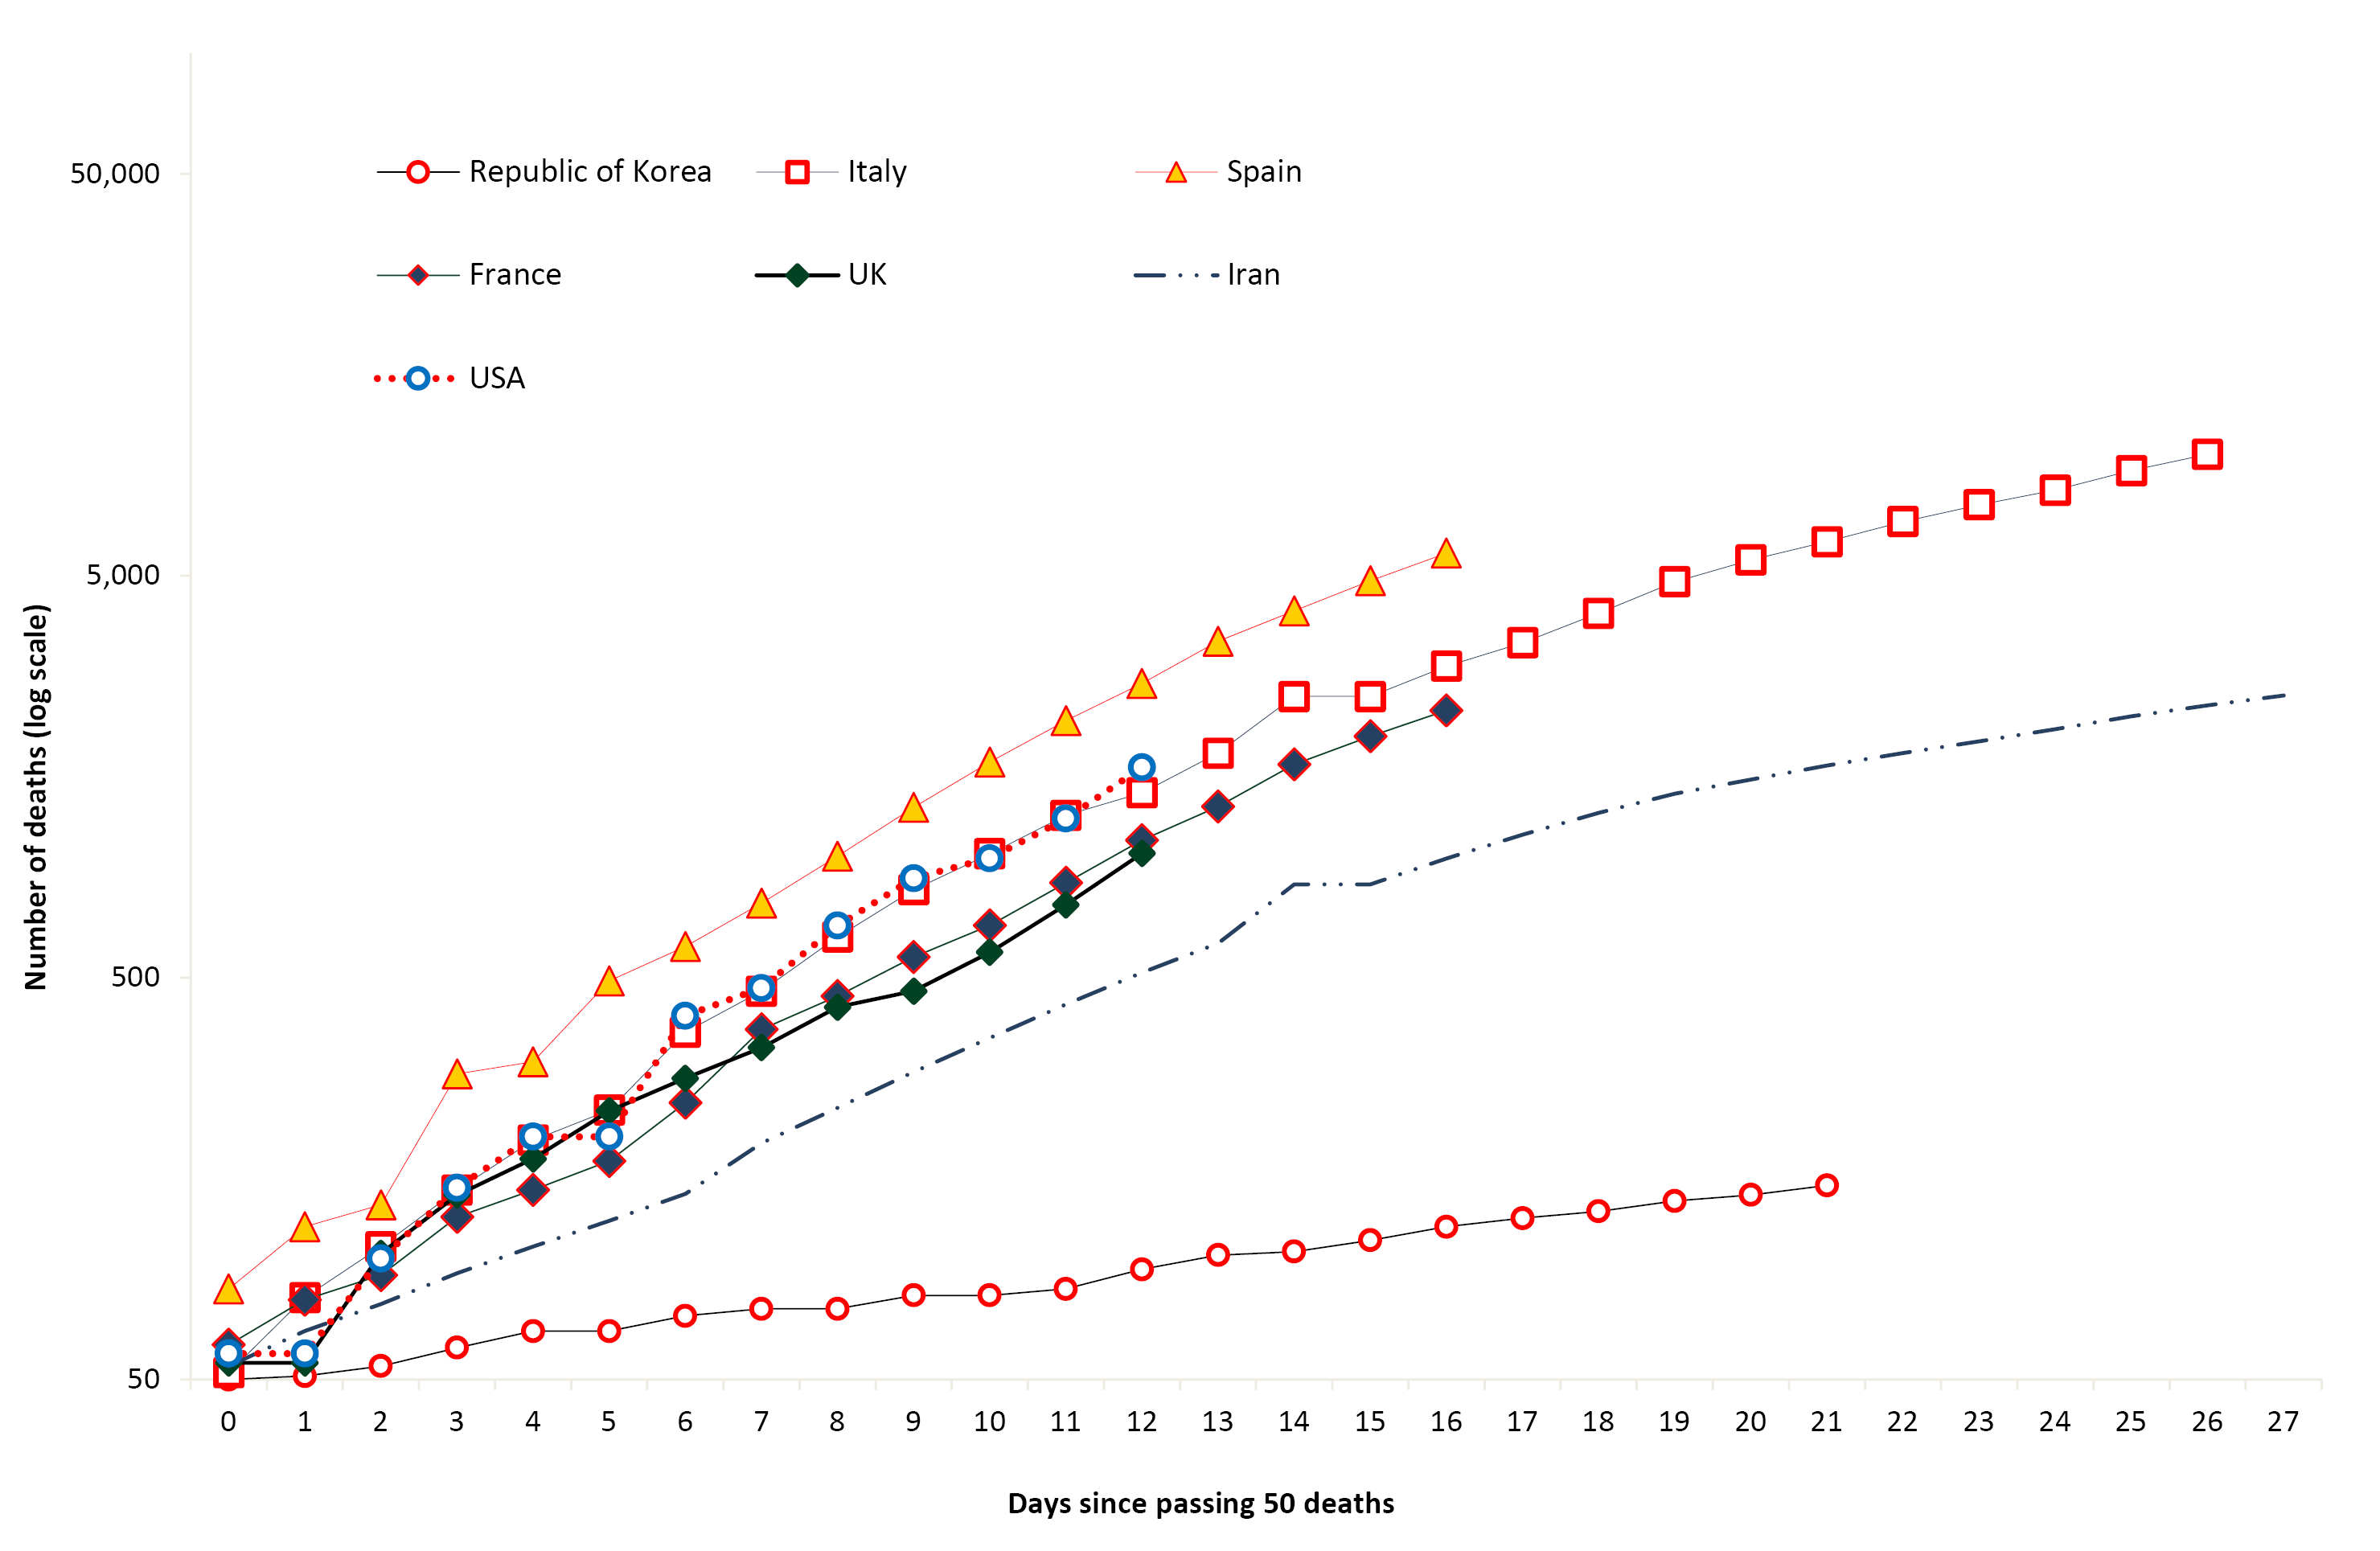

Epidemiological features of COVID-19
The current estimates on epidemiological parameters including severity, transmissibility and incubation period are uncertain. Estimates are likely to change as more information becomes available.

Transmission
Human-to-human transmission of SARS-CoV-2 is via droplets and fomites from an infected person to a close contact.³ COVID-19 can often present as a common cold-like illness, including in stools.⁴ A virological analysis of nine hospitalised cases found active virus replication in upper respiratory tract tissues, with pharyngeal virus shedding during the first week of symptoms.⁴ However, current evidence does not support airborne or faecal-oral spread as major factors in transmission.³
A study in China showed household contacts and those who travelled with a confirmed COVID-19 case was associated with an increased risk of infection.⁵ The study also examined the average time from symptom onset to disease confirmation among cases who were identified through contact-based surveillance (i.e. monitoring and testing of close contacts of confirmed COVID-19 cases) and symptom-based surveillance (i.e. symptomatic screening at airports, community fever monitoring and testing of hospital patients). Cases identified through contact-based surveillance were associated with a 2.3 day decrease from symptom onset to disease confirmation and a 1.9 day decrease from symptom onset to isolation, compared to cases found by symptom-based surveillance. Modelling studies suggest that undocumented infections are the source for over three-quarters of documented cases and effective contact tracing increases the probability of control.^{5,6}

Incubation period
Estimates of median incubation period, based on seven published studies, are 5 to 6 days (ranging from 0 to 14 days).⁷ Patients with long incubation periods do occasionally occur, however they are likely to be ‘outliers’ who should be studied further but are unlikely to represent a change in epidemiology of the virus.⁷

Molecular epidemiology
Since December 2019, the virus has diversified into multiple lineages as it has spread globally with some degree of geographical clustering. The whole genome sequences currently available from Australian cases are mostly in returned travellers from China, the Islamic Republic of Iran, Europe and the USA, and thereby reflect this global diversity. Recent work describes an emerging clade linked to the epidemic in the Islamic Republic of Iran.⁸

Clinical features
A recently published meta-analysis supports previous research that COVID-19 presents as mild illness in the majority of cases with fever and cough being the most commonly reported symptoms. Severe or fatal outcomes tend to occur in the elderly or those with comorbid conditions.^{3,9}
Some COVID-19 patients show neurological signs such as headache, nausea and vomiting. There is evidence that SARS-CoV-2 viruses are not always confined to the respiratory tract and may invade the central nervous system inducing neurological symptoms.¹⁰ As such, it is possible that invasion of the central nervous system is partially responsible for the acute respiratory failure of COVID-19 patients.¹⁰
Examination of cases and their close contacts in China found a positive association between age and time from symptom onset to recovery. Median time to recovery was estimated to be 27 days in 20–29 year olds, 32 days in 50–59 year olds, and 36 days in those aged over 70 years. The study also found an association between clinical severity and time from symptom onset to time to recovery. Compared to people with mild disease, those with moderate and severe disease were associated with a 19% and 58% increase in time to recovery, respectively.⁵
A retrospective cohort study looking at risk factors for mortality among patients with COVID-19 who have experienced a definite outcome found an increase in the odds of in-hospital death associated with older age, higher sequential organ failure assessment score and elevated blood d-dimer levels on admission.¹¹ Detectable SARS-CoV-2 RNA persisted for a median of 20 days in survivors and until death in non-survivors.¹¹
Several studies have identified cardiovascular implications resulting from COVID-19 infection.^{12–14} Vascular inflammation has been observed in a number of cases and may be a potential mechanism for myocardial injury which can result in cardiac dysfunction and arrhythmias.

Treatment
Current clinical management of COVID-19 cases focuses on early recognition, isolation, appropriate infection control measures and provision of supportive care.¹⁵ Whilst there is no specific antiviral treatment currently recommended for patients with suspected or confirmed SARS-CoV-2 infection, multiple clinical trials are underway to evaluate a number of therapeutic agents, including remdesivir, lopinavir/ritonavir, and chloroquine.¹⁶

Public health response
A summary of the key events that have been associated with the emergence of COVID-19, including Australia’s public health response activities is provided in Figures 11 and 12. Since COVID-19 first emerged internationally, public health responses in Australia have continued to evolve with the changing body of knowledge and epidemiological profile, both from overseas and in Australia. During the current reporting period, the Australian Health Protection Principal Committee have issued advice to inform the national public health response to the pandemic including suspension of all non-urgent elective surgery in both public and private sectors, scaling up of social distancing measures, limits to both indoor and outdoor public gatherings, and mandatory 14-day quarantine in their port of arrival for all travellers entering Australia.^{17–19}

Figure 11. Timeline of COVID-19 related events, including Australian public health response activities, from 31 December 2019 to 15 March 2020
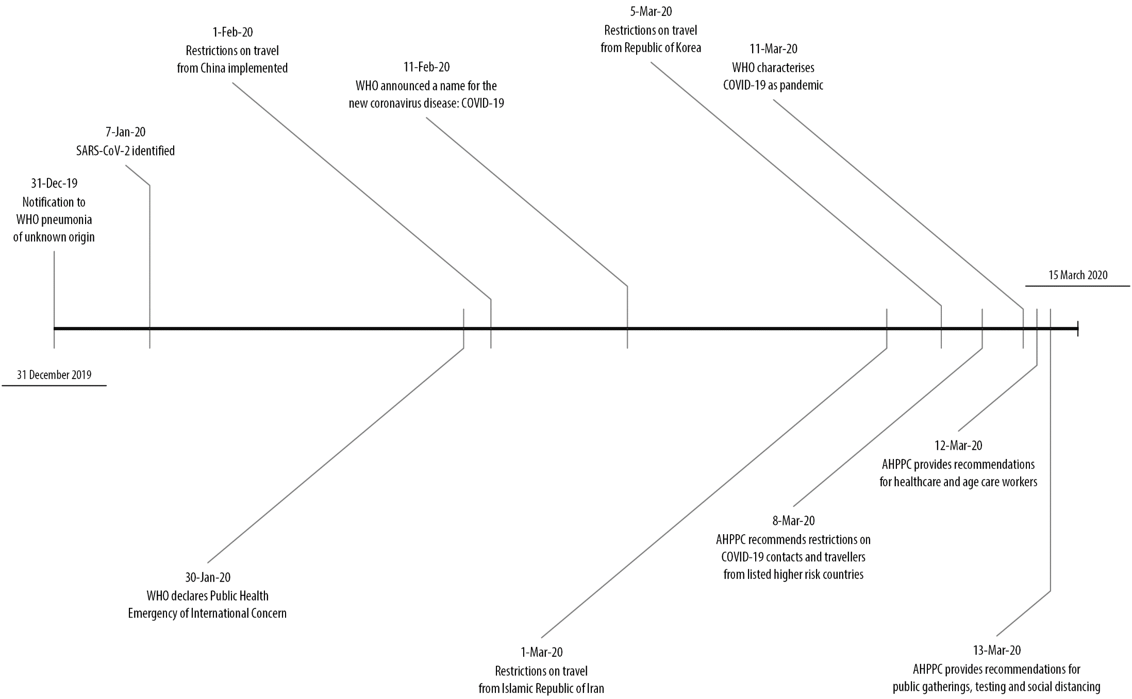
Figure 12. Timeline of COVID-19 related events, including Australian public health response activities, from 15 to 29 March 2020
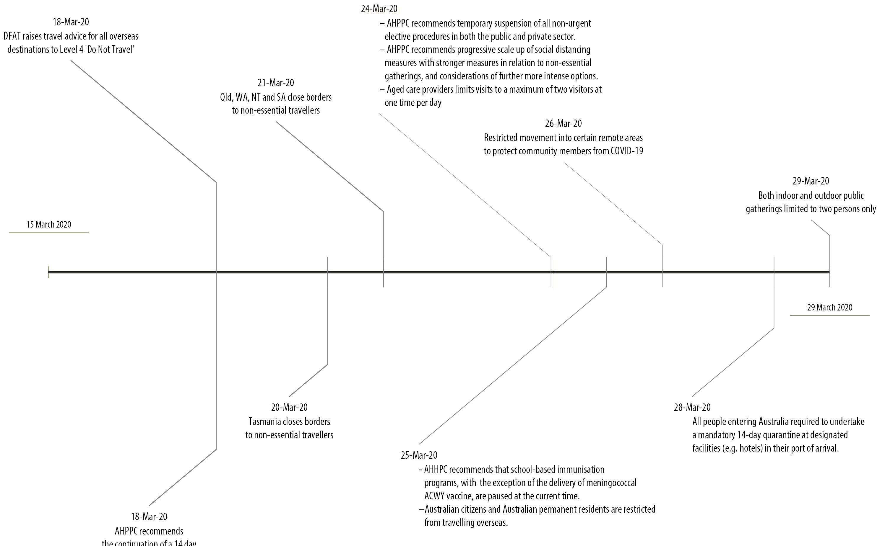

Methods
Data for this report were current as at 23:59 hours AEDT, 29 March 2020.
This report outlines what is known epidemiologically on COVID-19 in Australia and from publicly available data from WHO Situation Reports, other countries’ official updates and the scientific literature. Data on domestic cases in this report were collected from the NNDSS and additionally informed by jurisdictional health department media releases. The Communicable Diseases Network Australia (CDNA) developed the case definition for probable, suspect and confirmed cases, which was modified at different time points during the outbreak (Table 2). Data were analysed using SAS to describe the epidemiology of COVID-19 in Australia and the progress of the epidemic. Data for the international cases of COVID-19 by country were compiled from the latest WHO Situation Report. Case definitions may vary by country making comparisons difficult. Rapid reviews of the current state of knowledge on COVID-19 were conducted from the literature using PubMed.
Table 2: Australian COVID-19 case definition²⁰ as of 29 March 2020
Version: 2.4 | Date of development: 26 March 2020
Confirmed case | A person who tests positive to a validated specific SARS-CoV-2 nucleic acid test or has the virus identified by electron microscopy or viral culture.
Probable case | A person with fever ( 38 °C) or history of fever (e.g. night sweats, chills) OR acute respiratory infection (e.g. cough, shortness of breath, sore throat) AND who is a household contact of a confirmed or probable case of COVID-19, where testing has not been conducted.
Suspect case | A person who meets the following epidemiological and clinical criteria:
 | Epidemiological criteria | Clinical criteria | Action
 | Very high risk  - Close contact in 14 days before illness onset with a confirmed or probable case  - International travel in the 14 days prior to illness onset  - Cruise ship passengers and crew who have travelled in the 14 days prior to illness onset | Fever (≥ 38 °C) or history of fever  OR  Acute respiratory infection (e.g. cough, shortness of breath, sore throat) | Test
 | High risk setting  1. Two or more cases of illness clinically consistent with COVID-19 in the following settings:  - Aged care and other residential care facilities  - Military operational settings  - Boarding schools  - Correctional facilities  - Detention centres  - Aboriginal rural and remote communities, in consultation with the local PHU  - Settings where COVID-19 outbreaks have occurred, in consultation with the local PHU  2. Individual patients with illness clinically consistent with COVID-19 in a geographically localised area with elevated risk of community transmission, as defined by PHUs | Fever (≥ 38 °C) or history of fever (e.g. night sweats, chills)  OR  Acute respiratory infection (e.g. cough, shortness of breath, sore throat) | Test (on site for aged care residents, where feasible)
 | Moderate risk  - Healthcare workers, aged or residential care workers | Fever (≥ 38 °C) or history of fever (e.g. night sweats, chills)  OR  Acute respiratory infection (e.g. cough, shortness of breath, sore throat) | Test
 | Background risk  (No epidemiological risk factors) | Hospitalised patients with fever (≥ 38 °C)  AND  Acute respiratory symptoms (e.g. cough, shortness of breath, sore throat) of an unknown case | Test

Acknowledgements
This report represents surveillance data reported through CDNA as part of the nationally-coordinated response to COVID-19. We thank public health staff from incident emergency operations centres in state and territory health departments, and the Australian Government Department of Health, along with state and territory public health laboratories. We thank John Grewar for providing the R-code to produce Figure 6.

Author details

Corresponding author
COVID-19 National Incident Room Surveillance Team, Communicable Disease Epidemiology and Surveillance Section, Health Protection Policy Branch, Australian Government Department of Health, GPO Box 9484, MDP 14, Canberra, ACT 2601.
Email: epi.coronavirus@health.gov.au

References
- Moriarty LF, Plucinski MM, Marston BJ, Kurbatova EV, Knust B, Murray EL et al. Public health responses to COVID-19 outbreaks on cruise ships – worldwide, February–March 2020. MMWR Morb Mortal Wkly Rep. 2020;69(12):347–52.
- World Health Organization (WHO). Coronavirus disease 2019 (COVID-19) situation report – 69: 29 March 2020. Geneva: WHO; 2020. [Accessed on 30 March 2020.] Available from: https://www.who.int/docs/default-source/coronaviruse/situation-reports/20200329-sitrep-69-covid-19.pdf.
- WHO. Report of the WHO-China joint mission on coronavirus disease 2019 (COVID-19). Geneva: WHO; 2020. [Accessed on 1 March 2020.] Available from: https://www.who.int/docs/default-source/coronaviruse/who-china-joint-mission-on-covid-19-final-report.pdf.
- Zhou F, Yu T, Du R, Fan G, Liu Y, Liu Z et al. Clinical course and risk factors for mortality of adult inpatients with COVID-19 in Wuhan, China: a retrospective cohort study. Lancet. 2020. doi: https://doi.org/10.1016/S0140-6736(20)30566-3.
- Bi Q, Wu Y, Mei S, Ye C, Zou X, Zhang Z et al. Epidemiology and transmission of COVID-19 in Shenzhen China: analysis of 391 cases and 1286 of their close contacts. medRxiv. 2020. doi: https://doi.org/10.1101/2020.03.03.20028423.
- Li R, Pei S, Chen B, Song Y, Zhang T, Yang W et al. Substantial undocumented infection facilitates the rapid dissemination of novel coronavirus (SARS-CoV2). Science. 2020. doi: https://doi.org/10.1126/science.abb3221.
- WHO. Coronavirus disease 2019 (COVID-19) situation report – 29: 18 February 2020. Geneva: WHO; 2020. [Accessed on 15 March 2020.] Available from: https://www.who.int/docs/default-source/coronaviruse/situation-reports/20200218-sitrep-29-covid-19.pdf.
- Eden JS, Rockett R, Carter I, Rahman H, de Ligt J, Hadfield J et al. An emergent clade of SARS-CoV-2 linked to returned travellers from Iran. bioRxiv. 2020. doi: https://doi.org/10.1101/2020.03.15.992818.
- Sun P, Qie S, Liu Z, Ren J, Xi JJ. Clinical characteristics of 50466 patients with 2019-nCoV infection. medRxiv. 2020. doi: https://doi.org/10.1101/2020.02.18.20024539.
- Li Y, Bai W, Hashikawa T. The neuroinvasive potential of SARS-CoV2 may be at least partially responsible for the respiratory failure of COVID-19 patients. J Med Virol. 2020. doi: https://doi.org/10.1002/jmv.25728.
- Woelfel R, Corman VM, Guggemos W, Seilmaier M, Zange S, Mueller MA et al. Clinical presentation and virological assessment of hospitalized cases of coronavirus disease 2019 in a travel-associated transmission cluster. medRxiv. 2020. doi: https://doi.org/10.1101/2020.03.05.20030502.
- Inciardi RM, Lupi L, Zaccone G, Italia L, Raffo M, Tomasoni D et al. Cardiac involvement in a patient with coronavirus disease 2019 (COVID-19). JAMA Cardiol. 2020. doi: https://doi.org/10.1001/jamacardio.2020.1096.
- Guo T, Fan Y, Chen M, Wu X, Zhang L, He T et al. Cardiovascular implications of fatal outcomes of patients with coronavirus disease 2019 (COVID-19). JAMA Cardiol. 2020. doi: https://doi.org/10.1001/jamacardio.2020.1017.
- Madjid M, Safavi-Naeini P, Solomon SD, Vardeny O. Potential effects of coronaviruses on the cardiovascular system: a review. JAMA Cardiol. 2020. doi: https://doi.org/10.1001/jamacardio.2020.1286.
- WHO. Clinical management of severe acute respiratory infection when novel coronavirus (nCoV) infection is suspected. [Internet.] Geneva: WHO; 2020. [Accessed on 23 February 2020.] Available from: https://www.who.int/publications-detail/clinical-management-of-severe-acute-respiratory-infection-when-novel-coronavirus-(ncov)-infection-is-suspected.
- Harrison, C. Coronavirus puts drug repurposing on the fast track. Nat Biotechnol. 2020. doi: https://doi.org/10.1038/d41587-020-00003-1.
- Australian Government Department of Health. Australian Health Protection Principal Committee (AHPPC) advice to National Cabinet on 24 March 2020: a statement from the Australian Health Protection Principal Committee about the temporary suspension of all non-urgent elective surgery. [Internet.] Canberra: Australian Government Department of Health; 24 March 2020. [Accessed on 1 April 2020.] Available from: https://www.health.gov.au/news/australian-health-protection-principal-committee-ahppc-advice-to-national-cabinet-on-24-march-2020.
- Australian Government Department of Health. Read the latest statements from the Australian Health Protection Principal Committee (AHPPC) about coronavirus (COVID-19). [Internet.] Canberra: Australian Government Department of Health; 24 March 2020. [Accessed on 1 April 2020.] Available from: https://www.health.gov.au/news/australian-health-protection-principal-committee-ahppc-advice-to-national-cabinet-on-24-march-2020-0.
- Australian Government Department of Home Affairs. COVID-19 and the border: airline industry and passengers. [Internet.] Canberra: Australian Government Department of Home Affairs; 2020. [Accessed on 1 April 2020.] Available from: https://covid19.homeaffairs.gov.au/airline-industry-and-passengers.
- Australian Government Department of Health. Novel coronavirus 2019 (2019-nCoV) - CDNA national guidelines for public health units. [Internet.] Canberra: Australian Government Department of Health; 2020. [Accessed on 24 March 2020.] Available from: https://www1.health.gov.au/internet/main/publishing.nsf/Content/7A8654A8CB144F5FCA2584F8001F91E2/$File/interim-COVID-19-SoNG-v2.4.pdf.

Appendix A: Frequently asked questions
Q: Can I request access to the COVID-19 data behind your CDI weekly reports?
A: National notification data on COVID-19 confirmed cases is collated in the National Notifiable Disease Surveillance System (NNDSS) based on notifications made to state and territory health authorities under the provisions of their relevant public health legislation.
Normally, requests for the release of data from the NNDSS requires agreement from states and territories via the Communicable Diseases Network Australia, and, depending on the sensitivity of the data sought and proposed, ethics approval may also be required.
Due to the COVID-19 response, unfortunately, specific requests for NNDSS data have been put on hold. We are currently looking into options to be able to respond to data requests in the near future.
We will continue to publish regular summaries and analyses of the NNDSS dataset and recommend the following resources be referred to in the meantime:
- NNDSS summary tables: http://www9.health.gov.au/cda/source/cda-index.cfm
- Daily case summary of cases: https://www.health.gov.au/news/health-alerts/novel-coronavirus-2019-ncov-health-alert/coronavirus-covid-19-current-situation-and-case-numbers
- Communicable Diseases Intelligence COVID-19 weekly epidemiology report: https://www1.health.gov.au/internet/main/publishing.nsf/Content/novel_coronavirus_2019_ncov_weekly_epidemiology_reports_australia_2020.htm
- State and territory public health websites.

Q: Can I request access to data at post-code level of confirmed cases?
A: Data at this level cannot be released without ethics approval and permission would need to be sought from all states and territories via the Communicable Diseases Network Australia. As noted above, specific requests for NNDSS data are currently on hold.
A GIS/mapping analysis of cases will be included in each Communicable Diseases Intelligence COVID-19 weekly epidemiology report. In order to protect privacy of confirmed cases, data in this map will be presented at SA3 level.

Q. Where can I find more detailed data on COVID-19 cases?
A: We are currently looking into ways to provide more in-depth epidemiological analyses of COVID-19 cases, with regard to transmission and severity, including hospitalisation. These analyses will continue to be built upon in future iterations of the weekly Communicable Diseases Intelligence report.

Communicable Diseases Intelligence
ISSN: 2209-6051 Online

Communicable Diseases Intelligence (CDI) is a peer-reviewed scientific journal published by the Office of Health Protection, Department of Health. The journal aims to disseminate information on the epidemiology, surveillance, prevention and control of communicable diseases of relevance to Australia.

Editor: Tanja Farmer
Deputy Editor: Simon Petrie
Design and Production: Kasra Yousefi
Editorial Advisory Board: David Durrheim, Mark Ferson, John Kaldor, Martyn Kirk and Linda Selvey

Website: http://www.health.gov.au/cdi

Contacts
Communicable Diseases Intelligence is produced by:
Health Protection Policy Branch, Office of Health Protection, Australian Government Department of Health
GPO Box 9848, (MDP 6) CANBERRA ACT 2601

Email: cdi.editor@health.gov.au

Submit an Article
You are invited to submit your next communicable disease related article to the Communicable Diseases Intelligence (CDI) for consideration. More information regarding CDI can be found at: http://health.gov.au/cdi.
Further enquiries should be directed to: cdi.editor@health.gov.au.

This journal is indexed by Index Medicus and Medline.

Creative Commons Licence - Attribution-NonCommercial-NoDerivatives CC BY-NC-ND
© 2019 Commonwealth of Australia as represented by the Department of Health
This publication is licensed under a Creative Commons Attribution-NonCommercial-NoDerivatives 4.0 International Licence from https://creativecommons.org/licenses/by-nc-nd/4.0/legalcode (Licence). You must read and understand the Licence before using any material from this publication.

Restrictions
The Licence does not cover, and there is no permission given for, use of any of the following material found in this publication (if any):
- the Commonwealth Coat of Arms (by way of information, the terms under which the Coat of Arms may be used can be found at www.itsanhonour.gov.au);
- any logos (including the Department of Health’s logo) and trademarks;
- any photographs and images;
- any signatures; and
- any material belonging to third parties.

Disclaimer
Opinions expressed in Communicable Diseases Intelligence are those of the authors and not necessarily those of the Australian Government Department of Health or the Communicable Diseases Network Australia. Data may be subject to revision.

Enquiries
Enquiries regarding any other use of this publication should be addressed to the Communication Branch, Department of Health, GPO Box 9848, Canberra ACT 2601, or via e-mail to: copyright@health.gov.au

Communicable Diseases Network Australia
Communicable Diseases Intelligence contributes to the work of the Communicable Diseases Network Australia.
http://www.health.gov.au/cdna

Data were extracted on 30 March 2020 with data reported to 29 March 2020. Due to the dynamic nature of the NNDSS, data in this extract are subject to retrospective revision and may vary from data published in previous reports and reports of notification data by states and territories.
Data obtained on 1 April 2020.

