COVID-19 Australia: Epidemiology Report 71
Reporting period ending 12 February 2023
COVID-19 Epidemiology and Surveillance Team
Table 6 of this report, on p. 11 of 20, is in error due to the miscalculation of one data column. Please refer to this report’s Erratum (https://doi.org/10.33321/cdi.2023.47.26) to view the corrected Table 6.

Summary

Four-week reporting period (16 January 2023 – 12 February 2023)

Case definitions for confirmed and probable cases are in accordance with the coronavirus disease 2019 (COVID-19) Series of National Guidelines for Public Health Units (SoNG).
The Australian Capital Territory did not supply hospitalisation data from 12 November to 24 November 2022, due to technical reasons.
Trends – A fourth Omicron wave of COVID-19 transmission began in late October 2022, driven by a combination of existing and newly emerging Omicron subvariants. Following the peak of this wave in mid-December 2022, case numbers have been decreasing nationally. In the four-week period 16 January – 12 February 2023, there were 26,423 confirmed and 51,295 probable cases of COVID-19 reported in Australia to the National Notifiable Diseases Surveillance System (NNDSS). In the most recent reporting fortnight, a total of 35,509 confirmed and probable cases were notified (an average of 2,536 cases per day), compared to 42,209 in the previous fortnight (an average of 3,015 cases per day).
Age group – Since late December 2022, notification rates have decreased across all age groups, with rates highest among adults aged 30 years and over. In the current reporting period 16 January – 12 February 2023, the highest notification rate was observed among adults aged 80 years and over whilst the lowest rates were among people aged 19 years or less. For the entire Omicron wave to date (15 December 2021 – 12 February 2023), the highest notification rate has been in adults aged 20 to 29 years.
Aboriginal and Torres Strait Islander people – In the reporting period 16 January – 12 February 2023, there were 3,127 new cases notified in Aboriginal and Torres Strait Islander people. In the current Omicron wave (15 December 2021 – 12 February 2023) there have been 392,993 cases notified in Aboriginal and Torres Strait Islander people, representing 3.6% (392,993/10,779,420) of all cases in the Omicron wave to date.
Severity – The overall crude case fatality rate in the current fourth Omicron wave is 0.32%, which is higher than third wave (0.21%). The current case fatality rate is likely overestimated due to changes in case ascertainment and underreporting of non-severe cases. Since the start of the pandemic to 12 February 2023, there have been 170 cases of paediatric inflammatory multisystem syndrome temporally associated with SARS-CoV-2 (PIMS-TS) reported to PAEDS, including two in the current reporting period and two new cases in the previous reporting period.
Virology – For samples collected in the four-week period 16 January – 12 February 2023, all 3,993 samples were assigned against Omicron or recombinants involving Omicron lineages. There is currently significant diversity in the range of sub- and sub-sub-lineages circulating within Australia. During the current reporting period more than 200 unique lineages have been identified. BA.2 and recombinant lineages made up similar proportions of sequences identified, with 40.1 % of sequences identified as BA.2 and 39.6% found to be recombinant lineage. The proportion of BA.5 and its sub lineages is slowly declining, constituting 19.3% of all lineages available for analysis in AusTrakka in the current reporting period. Of the Omicron sequences in AusTrakka to date, 19.9% are BA.1; 39.2% are BA.2; <0.001% are BA.3; 3.8% are BA.4 and 32.2% are BA.5. All sub-lineages have been collapsed into respective major sub-lineages. Recombinants make up 4.9% of all Omicron sequences to date.
International situation – According to the World Health Organization (WHO), cumulative global COVID-19 cases stood at over 755 million COVID-19 cases and over 6.8 million deaths as of 12 February 2023. For the South-East Asia and Western Pacific regions combined, there were 3,616,486 new cases and 32,380 deaths in the four-week period to 12 February 2023. Compared with the previous four-week reporting period, new cases and new deaths decreased in the Western Pacific region and the South-East Asia region. In total, since the start of the pandemic, over 261 million cases and over 1.2 million deaths have been reported in the two regions.
Keywords: SARS-CoV-2; novel coronavirus; 2019-nCoV; coronavirus disease 2019; COVID-19; acute respiratory disease; epidemiology; Australia
This reporting period covers the four-week period of 16 January – 12 February 2023. Within this period, data for each week is compared. The previous reporting period was the preceding four weeks (19 December 2022 – 15 January 2023).¹ The focus of this report is on the epidemiological situation in Australia since the beginning of the Omicron wave. For the purposes of this report, 15 December 2021 is used as a proxy for the beginning of this wave. This date was chosen as from this date onwards, most sequenced strains from cases were Omicron. Readers are encouraged to consult prior reports in this series for information on the epidemiology of coronavirus disease 2019 (COVID-19) in Australia.
Methods of data analysis in these reports have periodically changed over the course of this reporting series to date. Please refer to the Technical Supplement for details of such changes, and for definitions of terminology.²
Unless otherwise specified, tabulated data, data within the text, and figures, except those relating to severity, are extracted from the National Notifiable Diseases Surveillance System (NNDSS) based on ‘notification received date’. All tables and figures related to severity data extracted from NNDSS are based on ‘diagnosis date’ to better capture the true onset of severe illness and to enable a more accurate understanding of infection risk and disease severity.
The case data provided includes both confirmed cases and probable cases reported to the NNDSS, as defined in accordance with the COVID-19 series of national guidelines (SoNG).³ For the purposes of this report, only probable cases from 5 January 2022 are included.
In this reporting period, population data for Aboriginal and Torres Strait Islander people has been updated (from 2016) and is now based on Australian Bureau of Statistics (ABS) Estimated Resident Population (ERP) as at 2021. There has been an increase of 185,600 Aboriginal and Torres Strait Islander people (23.2%) since the previous ERP (June 2016). Therefore, notification rate comparisons with previous reports should be undertaken with caution.
Several jurisdictions have stopped reporting SARS-CoV-2 polymerase chain reaction (PCR) denominator testing data, therefore testing rates and percent positivity calculations are no longer included in this report.
Due to the dynamic nature of data in the NNDSS, numbers may be subject to revision and may vary from numbers previously reported and from case notifications released by states and territories.

Background and data sources
See the Technical Supplement for general information on COVID-19 including modes of transmission, common symptoms, and severity.²

Activity

COVID-19 trends

(NNDSS and jurisdictional reporting to the National Incident Centre)
Cumulatively, from the beginning of the pandemic to 12 February 2023, jurisdictions within Australia have reported 11,014,058 COVID-19 cases to the NNDSS. Nationally, case notifications have been decreasing since late December 2022. In the four-week period 16 January – 12 February 2023, there were 26,423 confirmed and 51,295 probable cases of COVID-19 reported in Australia to NNDSS (Table 1). In the most recent reporting fortnight, a total of 35,509 confirmed and probable cases were notified (an average of 2,536 cases per day), compared to 42,209 in the previous fortnight (an average of 3,015 cases per day).
Since the emergence of the Omicron variant in Australia, there have been four distinct waves of transmission, defined by the predominant Omicron subvariant circulating. The first wave, driven by the BA.1 subvariant, occurred from mid-December 2021 to February 2022, with a peak in cases observed in early January 2022. From March 2022, the BA.2 subvariant was the predominant strain; in this second Omicron wave, there was a primary peak in early April and a secondary peak in late May 2022 (Figure 1). In early July 2022, BA.5 (including sub-lineages) became the predominant subvariant detected in Australia, driving a third wave of transmission which peaked in the week ending 24 July 2022. A fourth wave of transmission commenced in late October 2022, driven by a combination of existing and newly emerging Omicron subvariants. This wave peaked during the week ending 11 December 2022 (Figure 1).
In October 2022, mandatory reporting of positive rapid antigen tests (RATs) ceased in several jurisdictions. Therefore, the current data in NNDSS will underestimate the true incidence of disease in the community.

Figure 1: Confirmed and probable weekly COVID-19 notified cases by notification date, Australia, 29 November 2021 – 12 February 2023ª
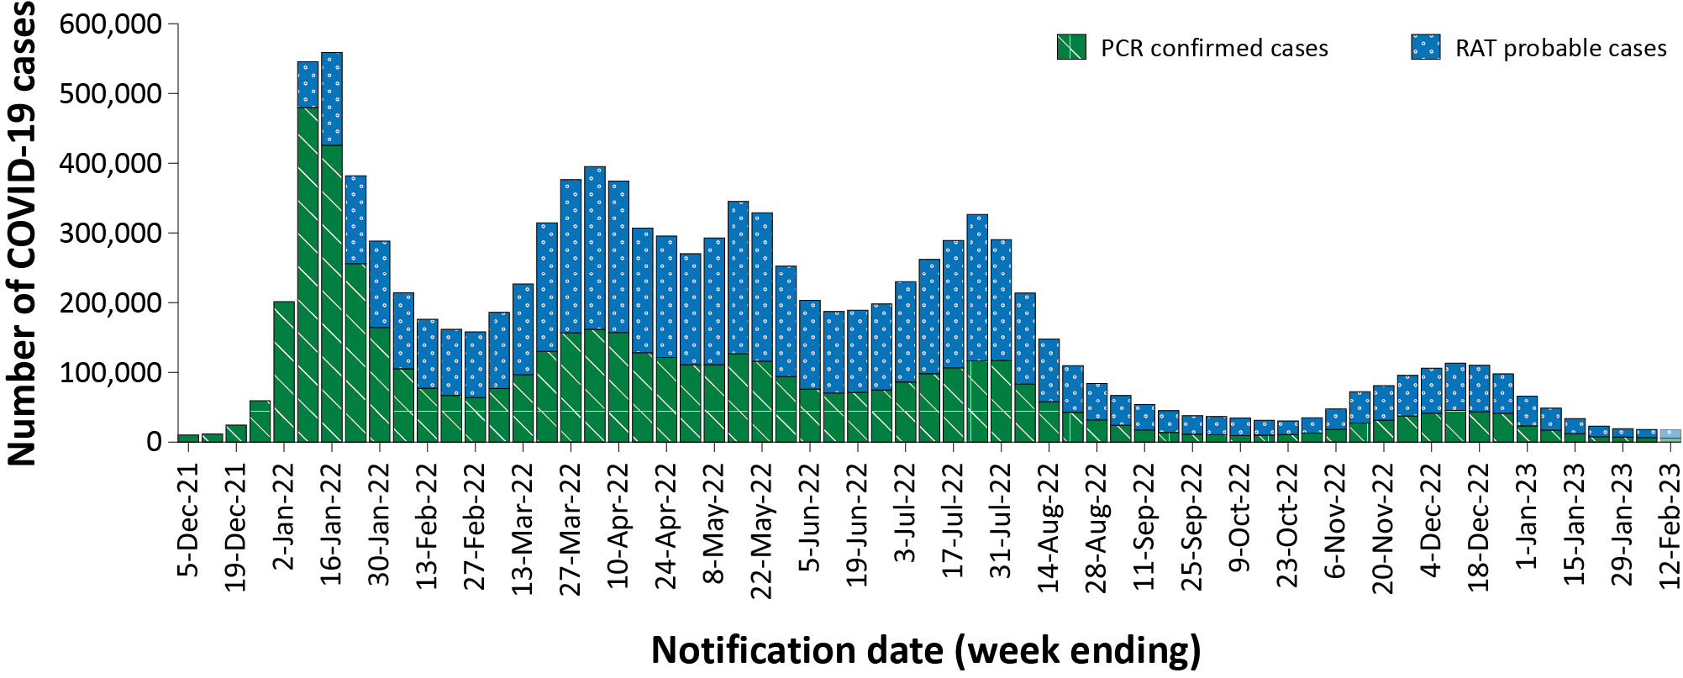
a Source: NNDSS extract from 21 February 2023 for notifications from 29 November 2021 to 12 February 2023.
Table 1: Confirmed and probable COVID-19 cases by jurisdiction and date of notification, Australia, 15 December 2021 – 12 February 2023^{a,b,c}
Jurisdiction | Reporting period |  |  |  |  |  | Current Omicron wave
 | 16–29 January 2023 |  |  | 30 January – 12 February 2023 |  |  | 15 December 2021 – 12 February 2023
 | Confirmed | Probable | Total | Confirmed | Probable | Total | Confirmed | Probable | Total
ACT | 382  (32.7%) | 787  (67.3%) | 1,169 | 165  (18.6%) | 721  (81.4%) | 886 | 129,669  (56.5%) | 99,936  (43.5%) | 229,605
NSW | 7,983  (52.0%) | 7,372  (48.0%) | 15,355 | 6,417  (51.2%) | 6,123  (48.8%) | 12,540 | 2,055,824  (56.8%) | 1,565,639  (43.2%) | 3,621,463
NT | 184  (41.7%) | 257  (58.3%) | 441 | 125  (43.3%) | 164  (56.7%) | 289 | 23,340  (22.2%) | 81,573  (77.8%) | 104,913
Qld | 2,121  (25.2%) | 6,281  (74.8%) | 8,402 | 1,745  (23.6%) | 5,639  (76.4%) | 7,384 | 665,675  (40.5%) | 979,429  (59.5%) | 1,645,104
SA | 1,551  (44.9%) | 1,903  (55.1%) | 3,454 | 1,183  (41.5%) | 1,668  (58.5%) | 2,851 | 509,696  (58.0%) | 369,369  (42.0%) | 879,065
Tas. | 227  (21.9%) | 811  (78.1%) | 1,038 | 110  (15.4%) | 602  (84.6%) | 712 | 64,514  (22.6%) | 220,952  (77.4%) | 285,466
Vic. | 1,542  (21.8%) | 5,536  (78.2%) | 7,078 | 1,191  (18.7%) | 5,190  (81.3%) | 6,381 | 1,075,793  (39.4%) | 1,652,729  (60.6%) | 2,728,522
WA | 928  (17.6%) | 4,344  (82.4%) | 5,272 | 569  (12.7%) | 3,897  (87.3%) | 4,466 | 493,456  (38.4%) | 791,826  (61.6%) | 1,285,282
Australia | 14,918  (35.3%) | 27,291  (64.7%) | 42,209 | 11,505  (32.4%) | 24,004  (67.6%) | 35,509 | 5,017,967  (46.6%) | 5,761,453  (53.4%) | 10,779,420
a Source: NNDSS extract from 21 February 2023 for notifications from 15 December 2021 to 12 February 2023.
b ACT: Australian Capital Territory; NSW: New South Wales; NT: Northern Territory; Qld: Queensland; SA: South Australia; Tas.: Tasmania; Vic.: Victoria; WA: Western Australia.
c Cases are classified based on jurisdiction of notification not jurisdiction of residence. Some cases are notified to a different jurisdiction than their location of residence.

Demographic features

(NNDSS)
Since late December 2022, notification rates have decreased across all age groups, with rates highest among adults aged 40 years and over (Figure 2). In the current reporting period 16 January – 12 February 2023, the highest notification rate was observed among adults aged 80 years and over whilst the lowest rates were among people aged 19 years or less (Appendix A, Table A.1). For the entire Omicron wave to date (15 December 2021 – 12 February 2023), the highest notification rate has been in adults aged 20 to 29 years (Appendix A, Table A.1). For this age group, the weekly notification rate peaked in the week ending 9 January 2022 at approximately 5,600 cases per 100,000 population (not depicted).
Figure 2: Confirmed and probable COVID-19 notification rates for ten-year age groups by notification week, Australia, 27 June 2022 – 12 February 2023^{a,b}
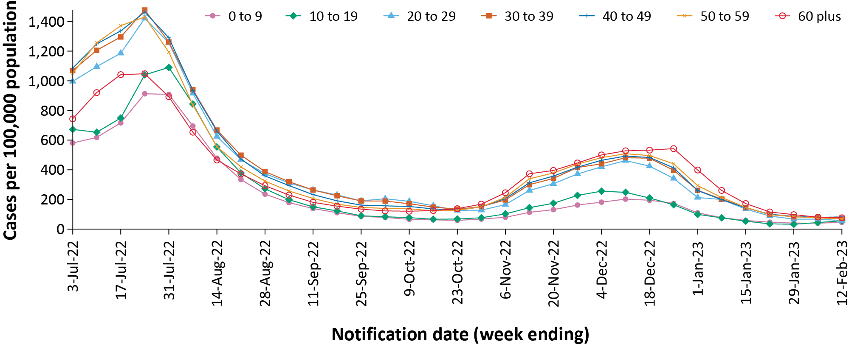
a Source: NNDSS extract from 21 February 2023 for notifications from 27 June 2022 to 12 February 2023.
b Population data based on Australian Bureau of Statistics (ABS) Estimated Resident Population (ERP) as at June 2022.

Aboriginal and Torres Strait Islander persons

(NNDSS)
Overall, since the start of the pandemic, Indigenous status is unknown for approximately 13.4% of COVID-19 cases in NNDSS. Therefore, the number of cases classified as Aboriginal and Torres Strait Islander people is likely an under-representation. During the reporting period, there were 3,127 new cases notified in Aboriginal and Torres Strait Islander people (Table 2). In the Omicron wave (15 December 2021 – 12 February 2023) there have been 392,993 cases notified in Aboriginal and Torres Strait Islander people, representing 3.6% (392,993/10,779,420) of all cases in the Omicron wave to date.
Of the COVID-19 cases notified in Aboriginal and Torres Strait Islander people from 15 December 2021 to date, and where location of residence was known, 55.4% (216,033/390,284) lived in a regional or remote area (Table 3). Most cases reported in outer regional and remote areas since the start of the Omicron wave were diagnosed using RATs, at 71.6% (52,327/73,105) and 73.4% (36,375/49,546), respectively. It should be noted that the reliance on RATs for diagnosing COVID-19 is greater in regional and remote areas than in major cities, resulting in a larger under-representation of cases in regional and remote areas than in major cities, due to the changes in reporting requirements of positive RATs.
Table 2: Confirmed and probable cases of COVID-19 among Aboriginal and Torres Strait Islander peoples by jurisdiction and date of notification, Australia, 15 December 2021 – 12 February 2023ª
Jurisdiction^{b,c} | 16–22 January 2023 | 23–29 January 2023 | 30 January – 5 February 2023 | 6–12 February 2023 | 15 December 2021 –  12 February 2023 (Omicron wave)
ACT | 8 | 4 | 5 | 6 | 4,067
NSW | 277 | 298 | 244 | 238 | 131,920
NT | 93 | 75 | 49 | 42 | 25,425
Qld | 247 | 184 | 224 | 202 | 98,426
SA | 66 | 44 | 56 | 51 | 22,996
Tas. | 18 | 15 | 11 | 10 | 16,451
Vic. | 40 | 27 | 34 | 29 | 35,146
WA | 134 | 119 | 156 | 121 | 58,562
Australia | 883 | 766 | 779 | 699 | 392,993
a Source: NNDSS extract from 21 February 2023 for notifications from 15 December 2021 to 12 February 2023.
b ACT: Australian Capital Territory; NSW: New South Wales; NT: Northern Territory; Qld: Queensland; SA: South Australia; Tas.: Tasmania; Vic.: Victoria; WA: Western Australia.
c Cases are classified based on jurisdiction of notification not jurisdiction of residence. Some cases are notified to a different jurisdiction than their location of residence.
Table 3: COVID-19 cases among Aboriginal and Torres Strait Islander people by area of remoteness, Australia, 15 December 2021 – 12 February 2023ª
Jurisdiction^{b,c} | Major city | Inner regional | Outer regional | Remoted
ACT | 4,013 | 37 | 12 | 1
NSW | 70,948 | 42,604 | 14,661 | 2,993
NT | 68 | 18 | 7,887 | 16,459
Qld | 36,025 | 22,717 | 28,876 | 10,701
SA | 12,449 | 2,466 | 4,843 | 3,124
Tas. | 203 | 10,009 | 5,811 | 287
Vic. | 20,015 | 11,343 | 3,735 | 17
WA | 30,530 | 4,188 | 7,280 | 15,964
Australia | 174,251 | 93,382 | 73,105 | 49,546
a Source: NNDSS extract from 21 February 2023 for notifications from 15 December 2021 to 12 February 2023. Excludes cases with an overseas place of residence, and where place of residence is unknown.
b ACT: Australian Capital Territory; NSW: New South Wales; NT: Northern Territory; Qld: Queensland; SA: South Australia; Tas.: Tasmania; Vic.: Victoria; WA: Western Australia.
c Cases are classified based on jurisdiction of notification not jurisdiction of residence. Some cases are notified to a different jurisdiction than their location of residence.
d ‘Remote’ here also includes areas classified as ‘very remote’.
Nationally, there have been 330 COVID-19 associated deaths reported in Aboriginal and Torres Strait Islander people from the start of the pandemic to 12 February 2023 (Table 4). This comprises 110 from New South Wales; 94 from Queensland; 48 from the Northern Territory; 38 from Western Australia; 20 from South Australia; 16 from Victoria; and two each from the Australian Capital Territory and Tasmania. Additionally, 596 Aboriginal and Torres Strait Islander cases have been admitted to intensive care units (ICU) nationally. During the fourth Omicron wave, the notification rate, to NNDSS, of severe cases (measured as those who were admitted to ICU or died) in Aboriginal and Torres Strait Islander people was 9.9 per 100,000 population, compared to 18.5 per 100,000 population during the third wave (Table 4). It should be noted that ICU status in NNDSS is likely incomplete.
Table 4: Confirmed and probable COVID-19 cases in Aboriginal and Torres Strait Islander people by age and highest level of illness severity, Australia, 1 January 2020 to 12 February 2023 ^{a,b,c}
Age group (years) | Fourth Omicron wave  24 October 2022 – 12 February 2023 |  |  |  | Third Omicron wave  15 June – 23 October 2022 |  |  |  | 15 December 2021  – 12 February 2023  (Omicron wave to date) |  |  |  | 1 January 2020  – 12 February 2023  (Pandemic to date)
 | ICU^{a,c} | Diedª | ICU or died^{a,c} | Rate ICU or died^{b,c} | ICU^{a,c} | Diedª | ICU or died^{a,c} | Rate ICU or died^{b,c} | ICU^{a,c} | Diedª | ICU or diedª | Rate ICU or died^{b} | ICU^{a,c} | Diedª | ICU or died^{a,c} | Rate ICU or died^{b,c}
0 to 9 | 6 | 0 | 6 | 2.8 | 10 | 1 | 11 | 5.1 | 36 | 2 | 37 | 17.2 | 38 | 2 | 39 | 18.2
10 to 19 | 2 | 0 | 2 | 1.0 | 6 | 0 | 6 | 2.9 | 34 | 0 | 34 | 16.4 | 44 | 0 | 44 | 21.3
20 to 29 | 4 | 0 | 4 | 2.4 | 6 | 0 | 6 | 3.6 | 58 | 0 | 58 | 35.1 | 73 | 0 | 73 | 44.2
30 to 39 | 6 | 2 | 7 | 5.6 | 9 | 2 | 11 | 8.9 | 39 | 11 | 49 | 39.5 | 58 | 11 | 68 | 54.8
40 to 49 | 8 | 1 | 9 | 9.1 | 9 | 5 | 12 | 12.1 | 62 | 28 | 83 | 83.7 | 84 | 33 | 106 | 106.9
50 to 59 | 16 | 5 | 21 | 23.9 | 30 | 19 | 44 | 50.1 | 95 | 51 | 138 | 157.2 | 123 | 57 | 169 | 192.5
60 plus | 18 | 31 | 48 | 55.9 | 36 | 62 | 92 | 107.2 | 145 | 212 | 328 | 382.3 | 176 | 227 | 366 | 426.6
All | 60 | 39 | 97 | 9.9 | 106 | 89 | 182 | 18.5 | 469 | 304 | 727 | 73.9 | 596 | 330 | 865 | 87.9
a ‘ICU’ and ‘died’ are not mutually exclusive categories; ‘died’ can include cases who died with or without prior admission to ICU. Therefore, the number of cases admitted to ICU or having died will not equal the sum of cases in ICU or died.
b Rate per 100,000 population for the given time period. Aboriginal and Torres Strait Islander population data based on Australian Bureau of Statistics (ABS) Estimated Resident Population (ERP) as at 2021.
c The Australian Capital Territory did not supply hospitalisation data from 12 November to 24 November 2022 due to technical reasons.

Severity

(NNDSS, FluCAN, SPRINT-SARI)
Given the delay between illness onset and severe illness, and to provide a more accurate assessment of severity, cases with an onset in the last two weeks have been excluded from analyses on the weekly rate of cases with severe illness (defined as cases admitted to ICU or died) and on the proportion of cases admitted to ICU or died.
Following the emergence of the Omicron wave, the notification rate of cases with severe illness peaked in mid-January 2022, at approximately 1,200 severe cases per week (not depicted). In comparison, the peak of the third Omicron wave was less at 887 severe cases per week (week ending 24 July 2022; Figure 3). From the start of the fourth Omicron wave in late October 2022, there was a gradual increase in the notification rate of cases with severe illness, with a peak observed in the week ending 18 December 2022; since then, rates of severe illness have continued to decrease (Figure3).
Rates of severe illness continue to be greater in older age groups, with the highest rates among those aged 60 years and older (Figure 4). Among this age group, there have been three notable peaks in severe illness since the emergence of Omicron: in the week ending 16 January 2022 (17.2 cases per 100,000 population; not depicted), in the week ending 24 July 2022 (13.3 cases per 100,000 population) and in the week ending 18 December 2022 (6.8 cases per 100,000 population; Figure 4). In comparison, rates of severe illness in younger age groups have remained relatively low and stable throughout the Omicron waves (Figure 4).
Figure 3: COVID-19 cases, deaths and ICU admissions, Australia, by date of onset, Australia, 27 June 2022 to 12 February 2023^{a,b}
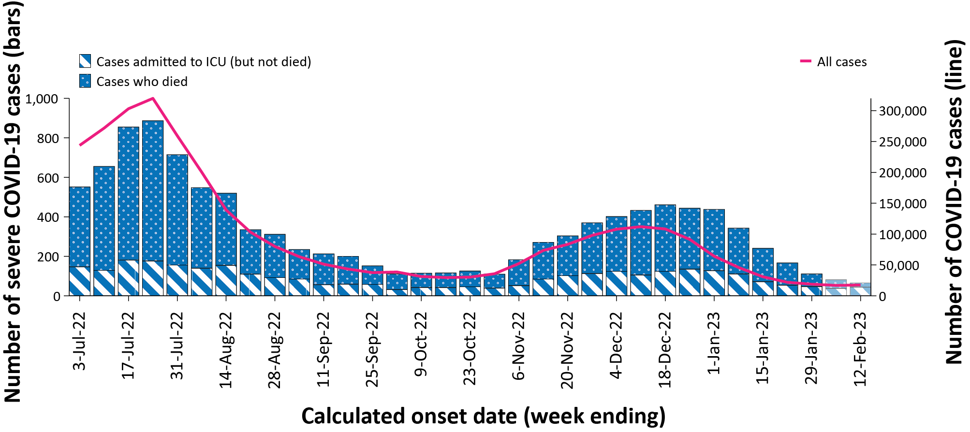
a Source: NNDSS extract from 21 February 2023 for notifications to 12 February 2023. The Australian Capital Territory did not supply hospitalisation data from 12 November to 24 November 2022 due to technical reasons.
b The shaded bars at the right represent the most recent two reporting weeks and should be interpreted with caution, as cases with an illness onset in these weeks may not have yet developed severe disease.
Figure 4: Age-specific rates of COVID-19 cases admitted to ICU or died, by date of diagnosis, Australia, 27 June 2022 to 29 January 2023^{a, b}
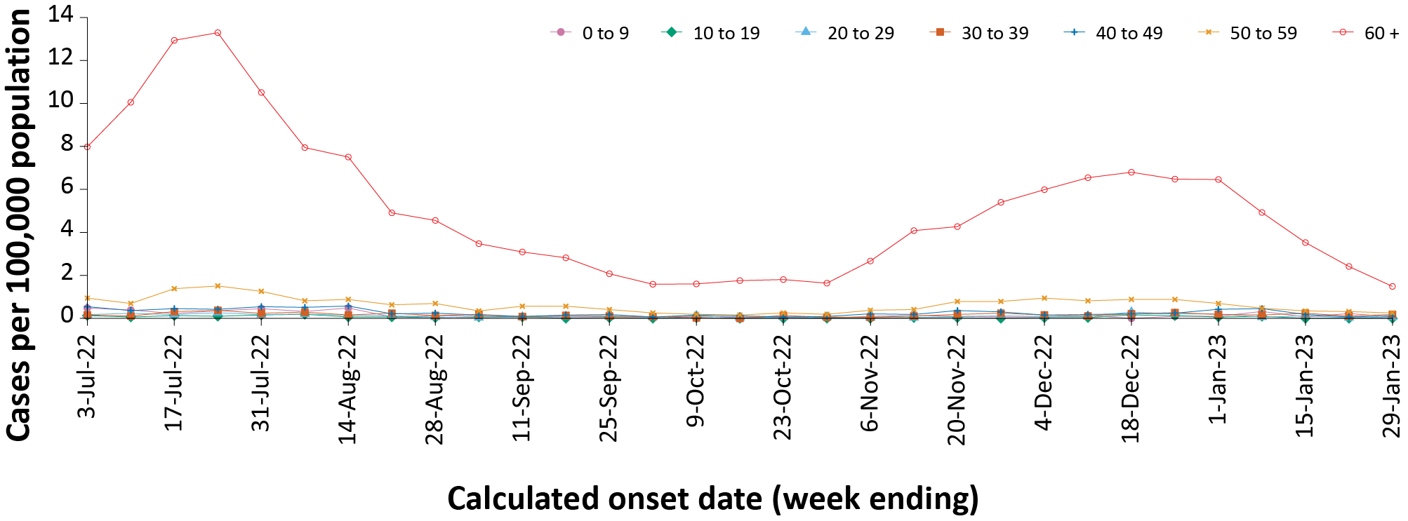
a Source: NNDSS extract from 21 February 2023 for notifications to 12 February 2023. Includes cases with an illness onset from 27 June 2022 to 29 January 2023; cases with an illness onset in the last two weeks (5–12 February 2023) were excluded to account for the delay between onset and development of severe illness. The Australian Capital Territory did not supply hospitalisation data from 12 November to 24 November 2022 due to technical reasons.
b Population data based on Australian Bureau of Statistics (ABS) Estimated Resident Population (ERP) as at June 2022.
Figure 5: PIMS-TS cases reported to PAEDS, by sample month and level of care required, Australia, 1 June 2021 – 12 February 2023ª
v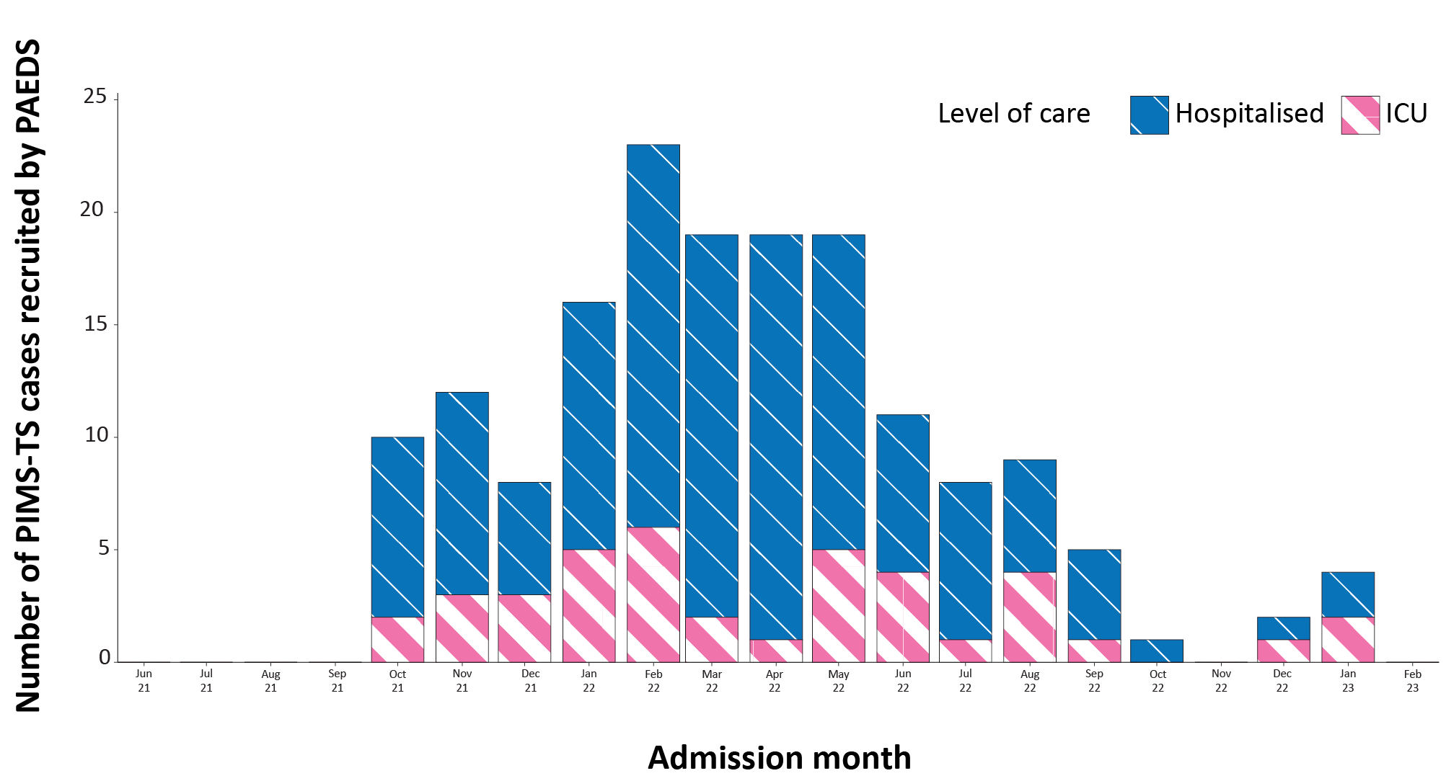
a Source: PAEDS.

Hospitalisation and ICU admissions
Between 15 December 2021 and 12 February 2023, there were 13,388 hospital admissions with confirmed COVID-19 reported at Influenza Complications Alert Network (FluCAN) sentinel sites, including 6% (745/13,388) admitted directly to ICU. During the four-week reporting period (16 January –12 February 2023) there were 135 admissions with COVID-19 reported at FluCAN sentinel sites, with 7% (10/135) admitted directly to ICU.
Since the start of the fourth Omicron wave (24 October 2022), for patients admitted to FluCAN sentinel sites with confirmed COVID-19, the median length of stay was 3 days (interquartile range, IQR: 1–6); mean = 6.1 days (standard deviation, SD: 23.4). This is on par with the median length of stay observed during the third Omicron wave (3 days [IQR: 1–7]; mean = 6.1 days [SD: 12.0]).
From the start of the Omicron wave to 12 February 2023, there were 5,395 COVID-19 cases admitted to ICUs participating in the sentinel surveillance system—Short Period Incidence Study of Severe Acute Respiratory Infection (SPRINT-SARI)⁴—with 92 of these admitted during this reporting period (16 January – 12 February 2023).

Risk factors for severe disease
Comorbidity data extracted from SPRINT-SARI reflect the sickest patients with COVID-19 who are managed in ICU; data are therefore not generalisable to all cases (Table 5). In adult patients admitted to ICU with COVID-19 since 15 December 2021, where comorbidity information was available, the most prevalent comorbidity was diabetes, followed by cardiac disease. Of those adult patients admitted to ICU since 15 December 2021 for whom comorbidity data was known, 77% (3,003/3,885) had at least one of the listed comorbidities.

Table 5: Comorbidities for adult COVID-19 cases (aged greater than or equal to 18 years) amongst those admitted to ICU, Australia, 15 December 2021 – 12 February 2023ª
Comorbidity | ICU casesª (n = 3,885) (%)
Cardiac disease (n = 3,861) | 1,096 (28%)
Chronic respiratory condition^{b} (n = 3,863) | 950 (25%)
Diabetes (n = 3,814) | 1,243 (33%)
Obesity (n = 3,819) | 776 (20%)
Chronic renal disease (n = 3,852) | 631 (16%)
Chronic neurological condition (n = 3,853) | 315 (8%)
Malignancy (n = 3,863) | 586 (15%)
Chronic liver disease (n = 3,847) | 230 (6%)
Immunosuppression (n = 3,821) | 692 (18%)
Number of specified comorbidities (n = 3,885)^{c}
No comorbidities | 882 (23%)
One or more | 3,003 (77%)
Two or more | 1,904 (49%)
Three or more | 987 (25%)
a Source: SPRINT-SARI. Only includes adult cases (≥ 18 years old) and excludes those with missing data on comorbidities or where comorbidity is unknown.
b Includes asthma.
c Includes chronic respiratory conditions, cardiac disease (excluding hypertension), immunosuppressive condition/therapy, diabetes, obesity, liver disease, renal disease, and neurological disorder.

Paediatric Inflammatory Multisystem Syndrome - Temporally Associated with SARS-CoV-2

(Paediatric Active Enhanced Disease Surveillance)
Since the start of the pandemic to 12 February 2023, there have been 170 cases of paediatric inflammatory multisystem syndrome - temporally associated with SARS-CoV-2 (PIMS-TS) reported to the Paediatric Active Enhanced Disease Surveillance network (PAEDS), including two in the current reporting period and two new cases from the previous reporting period. The majority of PIMS-TS cases to date have occurred in those aged 5 to < 12 years (52%; 88/170), followed by those aged 6 months to < 5 years (28%; 48/170). To date, there have been no PIMS-TS associated deaths.

COVID-19 deaths
There were 481 COVID-19-associated deaths notified during the reporting period (16 January – 12 February 2023). In total there have been 19,300 COVID-19-associated deaths reported in NNDSS since the start of the pandemic (Table 6). Note that the considerable increase in total COVID-19 associated deaths in this report, compared to previous reports, is due to reconciliation activities by jurisdictions: approximately 700 deaths from one jurisdiction (with a date of death occurring in 2022) which were previously not captured in NNDSS have now been included. The overall crude case fatality rate in the current fourth Omicron wave is 0.32%, which is higher than the rate observed during the third wave (0.21%), and notably less than observed during the Delta wave (0.71%) (Table 7). It should be noted that the current case fatality rate is likely to be overestimated, due to changes in case ascertainment and under-reporting of non-severe cases.

Table 6: Deaths associated with COVID-19 by reporting period, Australia, 1 January 2020 – 12 February 2023^{a,b,c}
Jurisdiction^{c} | Reporting period (16 January – 12 February 2023) | Fourth Omicron wave  24 October 2022 –  12 February 2023 | Third Omicron wave  15 June –  23 October 2022 | 15 December 2021 –  12 February 2023  (Omicron wave) | 1 January 2020 –  12 February 2023  (Pandemic to date)
ACT | 3 (0.6%) | 31 (1.0%) | 114 (1.2%) | 200 (1.2%) | 215 (1.1%)
NSW | 119 (24.7%) | 936 (28.9%) | 2,905 (31.2%) | 5,722 (33.6%) | 6,422 (33.3%)
NT | 1 (0.2%) | 12 (0.4%) | 34 (0.4%) | 90 (0.5%) | 91 (0.5%)
Qld | 75 (15.6%) | 449 (13.8%) | 1,524 (16.4%) | 2,753 (16.2%) | 2,760 (14.3%)
SA | 39 (8.1%) | 266 (8.2%) | 756 (8.1%) | 1,319 (7.8%) | 1,328 (6.9%)
Tas. | 7 (1.5%) | 56 (1.7%) | 157 (1.7%) | 230 (1.4%) | 244 (1.3%)
Vic. | 211 (43.9%) | 1,241 (38.3%) | 3,230 (34.7%) | 5,742 (33.8%) | 7,281 (37.7%)
WA | 26 (5.4%) | 251 (7.7%) | 597 (6.4%) | 949 (5.6%) | 959 (5.0%)
Australia | 481 (100.0%) | 3,242 (100.0%) | 9,317 (100.0%) | 17,005 (100.0%) | 19,300 (100.0%)
a Source: NNDSS, extract from 22 November 2022 for deaths to 12 February 2023.
b Deaths are categorised into time periods using date of death. Deaths with a missing date of death are classified using date of illness onset.
c ACT: Australian Capital Territory; NSW: New South Wales; NT: Northern Territory; Qld: Queensland; SA: South Australia; Tas.: Tasmania; Vic.: Victoria; WA: Western Australia.
Table 7: COVID-19 associated case fatality rates, among cases notified to NNDSS, by age group and date of onset, 1 January 2020 to 29 January 2023^{a,b,c,d}
Age group | Fourth Omicron wave  24 October 2022 –  29 January 2023 | Third Omicron wave  15 June –  23 October 2022 | Omicron  15 December 2021 –  29 January 2023 | Delta  16 June – 14 December 2021 | Pandemic  1 January 2020 –  29 January 2023
0–9 | 0.00% | < 0.05% | < 0.05% | < 0.05% | < 0.05%
10–19 | 0.00% | < 0.05% | < 0.05% | < 0.05% | < 0.05%
20–29 | < 0.05% | < 0.05% | < 0.05% | < 0.05% | < 0.05%
30–39 | < 0.05% | < 0.05% | < 0.05% | 0.06% | < 0.05%
40–49 | < 0.05% | < 0.05% | < 0.05% | 0.18% | < 0.05%
50–59 | 0.05% | < 0.05% | < 0.05% | 0.65% | 0.05%
60 + | 1.02% | 1.03% | 0.99% | 6.13% | 1.10%
Australia | 0.32% | 0.21% | 0.16% | 0.71% | 0.18%
a Source: NNDSS, extract from 21 February 2023 for deaths to 29 January 2023.
b To account for the lag between illness onset and the development of severe illness, cases with an onset date in the last two weeks have been excluded from calculations of the case fatality rate.
c A value of 0.00% indicates that no COVID-19 associated fatalities occurred during the indicated period for the specified age group.
d Crude case fatality rates which reflect number of deaths as a proportion of reported COVID-19 cases during specific periods, noting these rates are likely overestimated due to underreporting of cases.

Genomic surveillance and virology

(Communicable Disease Genomics Network, AusTrakka and jurisdictional sequencing laboratories)
Nationally, 3.26% of COVID-19 cases have been sequenced since the start of the pandemic in January 2020, based on jurisdictional reporting of confirmed cases (Table 8). Case numbers and sequencing proportions are based on polymerase chain reaction (PCR) results only, as rapid antigen tests do not allow for sequencing. Case numbers have been dropping since late 2022, and referrals of positive PCR samples to some sequencing laboratories have decreased significantly, resulting in changes to sequencing strategies across the country. However, the proportion of cases sequenced each reporting period has risen over the past few months. Changes in case numbers and availability of testing may cause these proportions to fluctuate over the coming months.
Table 8: Australian SARS-CoV-2 genome sequences and proportion of positive cases sequenced, 16 January – 12 February 2023 and cumulative to date ^{a,b}
Measure | Reporting period  16 January – 12 February 2023 | Cumulative  23 January 2020 – 12 February 2023
SARS-CoV-2 cases sequencedª | 3,993 | 175,721
Percentage of positive cases sequenced^{b} | 14.70% | 3.26%
a Total SARS-CoV-2 case numbers as reported by jurisdictional laboratories based on PCR results only. Cases identified via rapid antigen testing are reported differently by each jurisdiction and cannot be followed up for sequencing. They are therefore not included in the sequencing proportions reported here. Sequencing of samples from cases identified in the reporting period may be in process at the time of reporting. Remaining unsequenced samples may be due to jurisdictional sequencing strategy, or where samples have been deemed unsuitable for sequencing (typically because viral loads were too low for sequencing to be successful).
b Based on individual jurisdictional reports of sequences and case numbers. Calculations of the percentage of cases sequenced based on the number of sequences available in AusTrakka may not always be up to date, since this may include duplicate samples from cases and may not represent all available sequence data.

Figure 6: Omicron sub-lineages proportions in Australia since 1 January 2022 by sample collection date ^{a,b,c}
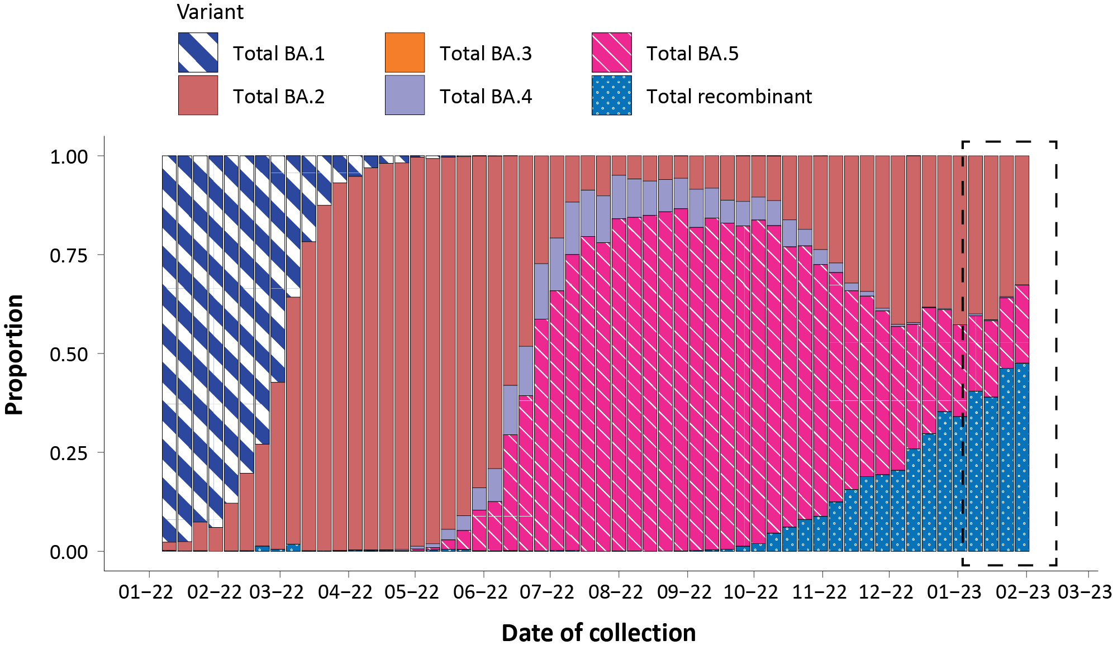
a Sequences in AusTrakka; aggregated by week.
b The current reporting period (16 January to 12 February 2023) is marked by the dashed lines.
c Proportions in the figure may not be representative when sequence numbers are small. Data may change week-to-week as sequences with older collection dates are uploaded. These numbers are not equivalent to number of cases, as there may be duplicates in the AusTrakka data. Newly designated Omicron sub-lineages have been collapsed into parent lineages BA.1, BA.2, BA.3, BA.4 and BA.5, with recombinants grouped separately.

Figure 7: Samples in AusTrakka since 30 May 2022, by lineage and date of collection ^{a,b}
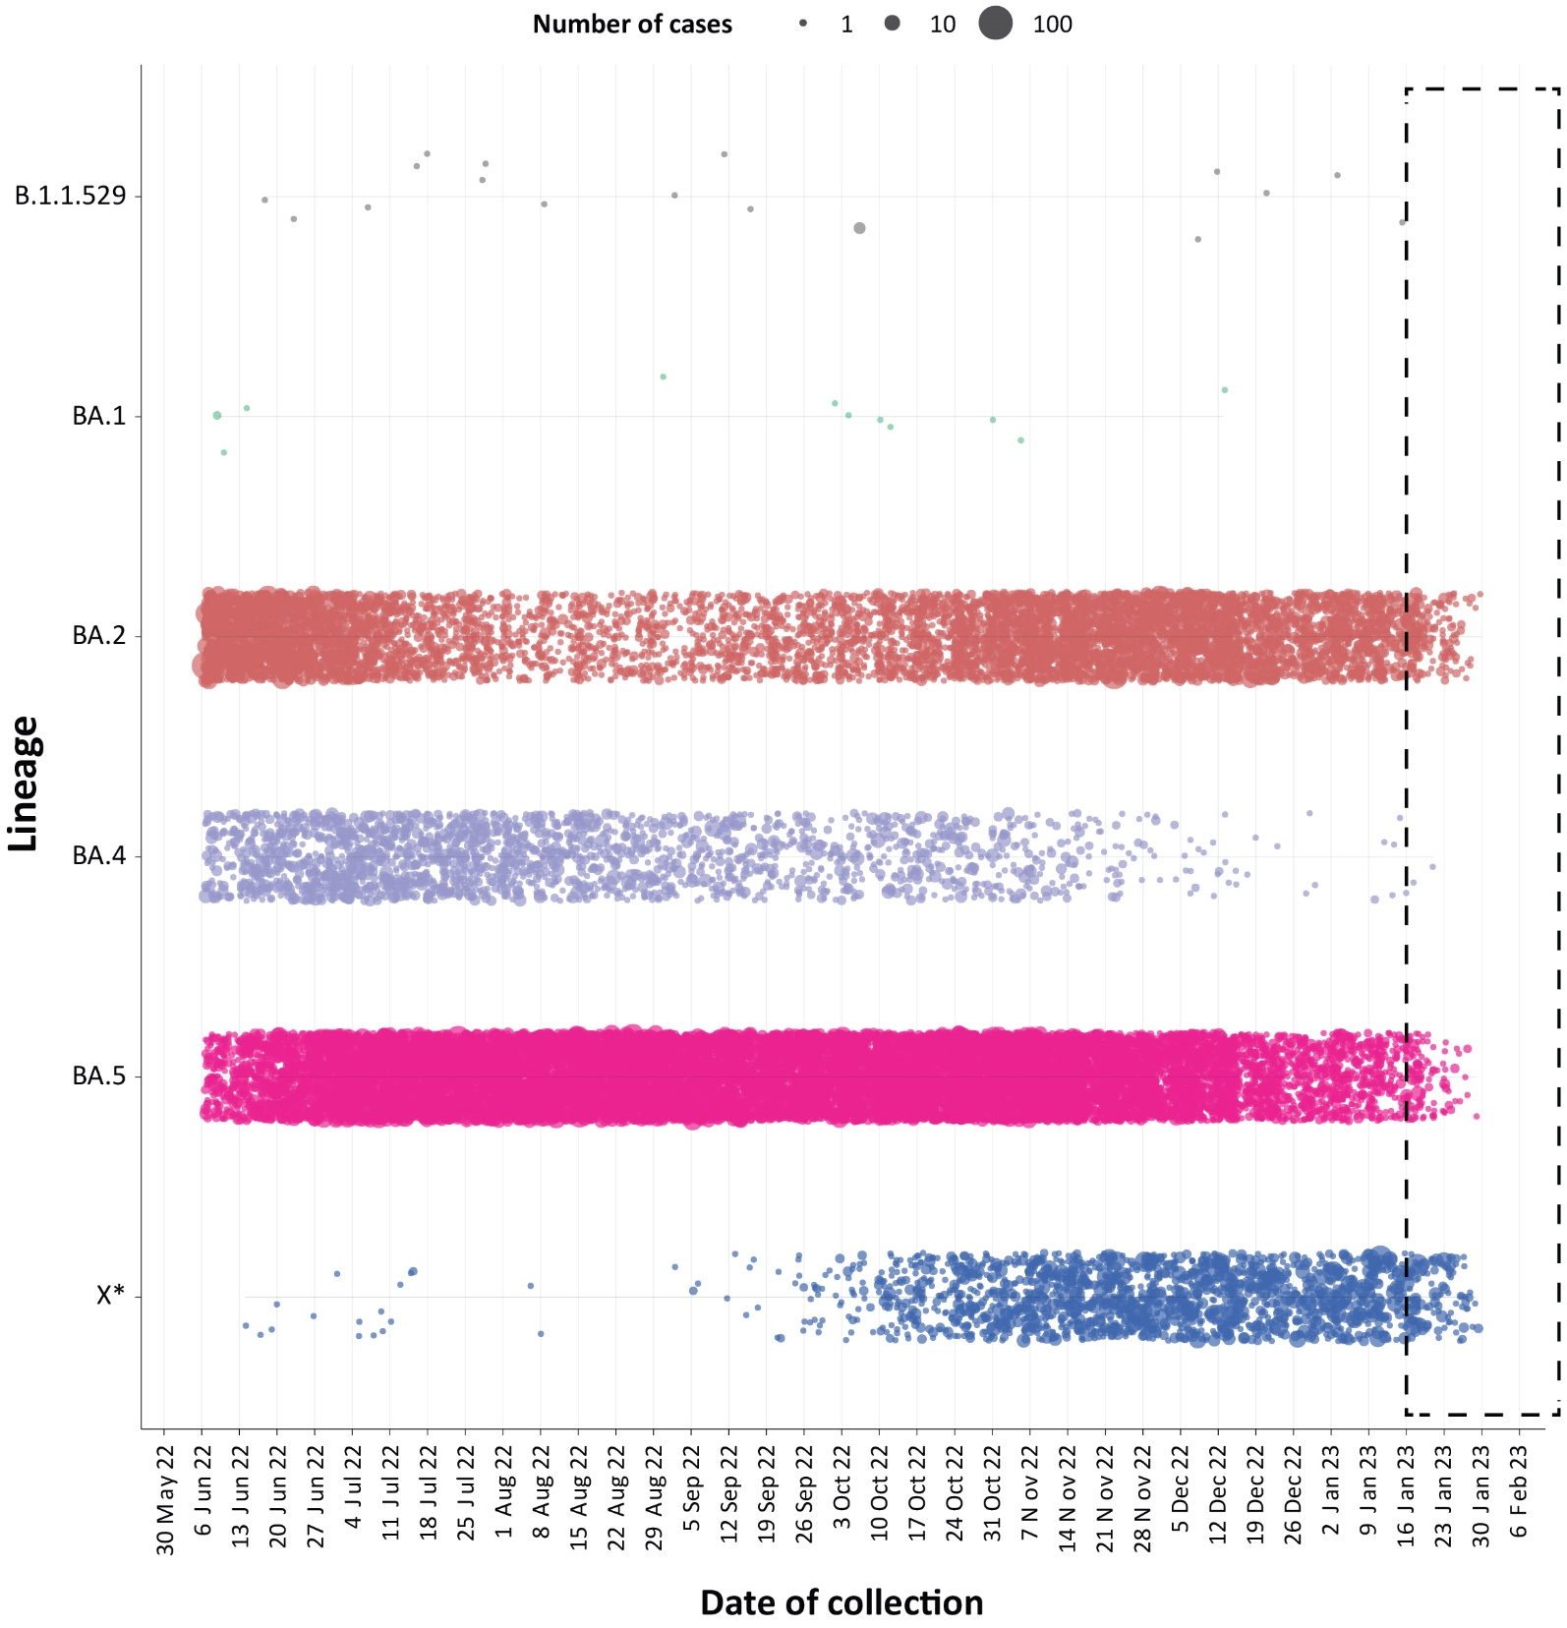
a The current reporting period (16 January to 12 February 2023) is marked by the dashed lines. The size of each dot is proportional to the number of sequences observed in each jurisdiction each day.
b Newly designated Omicron sub-lineages have been collapsed into parent lineages BA.1, BA.2, BA.3, BA.4 and BA.5 and recombinants are designated by X*.

Variants of concern (VOC)
AusTrakka⁵ is actively monitoring and reporting on one lineage and its associated sub- and sub-sub-lineages, currently designated as a Variant of Concern (VOC) by international organisations, including the World Health Organization (WHO): Omicron (B.1.1.529). The Omicron variant displays a characteristic set of mutations, including a number of variations in the genomic region encoding the spike protein thought to have the potential to increase transmissibility and/or immune evasion.^{6,7} Further information on variants is available in the Technical Supplement.²
Unlike previous periods in Australia’s COVID-19 waves, where one or two dominant lineages were the main driver of disease, there is currently significant diversity in the range of sub-sub-lineages circulating within Australia. During this reporting period, more than 200 unique lineages have been identified, and it is likely that there are more that are not being characterised through whole genome sequencing. This diversity of circulating lineages has sometimes been referred to as a ‘variant soup’. Many of these circulating lineages will die out without causing a significant disease burden, but others appear to have stronger growth potential.
Lineages such as BQ.1 (sub-sub-lineage of BA.5), BA.2.75 and associated sub-lineages such as BR, XBB (recombinant of BJ.1/BA.2.10 and BM.1.1.1/BA.2.75.3), including the sub-lineage XBB.1.5 which is showing significant growth in the United Stated, have emerged with strong signals both within and across different jurisdictions and are being monitored by AusTrakka and the Communicable Disease Genomics Network (CDGN) VOC working group due to their increasing prevalence.
All 3,993 sequences from samples collected within the reporting period were assigned to Omicron or recombinants consisting of Omicron lineages. There have been five major sub-lineages defined under B.1.1.529: BA.1, BA.2, BA.3, BA.4 and BA.5, and a large number of sub-lineages, including recombinants, under these; all are designated Omicron. BA.2 and recombinant lineages made up very similar proportions of sequences collected between 16 January and 12 February 2023, with 40.1% of sequences identified as BA.2 and 39.6% of sequences found to be a recombinant lineage. BA.5 made up 19.3% of all lineages available for analysis in AusTrakka and collected in this reporting period.
Of the Omicron sequences in AusTrakka to date, 19.9% are BA.1; 39.2% are BA.2; < 0.001% are BA.3; 3.8% are BA.4 and 32.2% are BA.5. All sub-sub-lineages have been collapsed into respective major sub-lineages. Recombinants make up 4.9% of all Omicron sequences to date.

Acute respiratory illness

(FluTracking, ASPREN, and Commonwealth Respiratory Clinics)
Based on self-reported FluTracking data,⁸ there has been an overall decreasing trend in the prevalence of both ‘fever and cough’ and ‘runny nose and sore throat’ symptoms in the community since late December 2022. In the last two weeks of the current reporting period (ending 12 February 2023) the prevalence of both fever and cough and runny nose and sore throat symptoms in the community started to increase again (Figure 8; Figure 9).
Over the reporting period, FluTracking data indicated that 16.1% of participants with ‘fever and cough’ were tested for SARS-CoV-2 with a PCR test and 77.5% were tested using a RAT (noting that in some instances RATs will be followed up by a PCR test for the same case). Of those with runny nose and sore throat, 3.4% were tested for SARS-CoV-2 using a PCR test and 57.2% were tested using a RAT. In the current reporting period, the percent positivity for fever and cough symptoms decreased slightly compared to the previous reporting period for both PCR and RAT, to 32.2% and 42.4%, respectively. For runny nose and sore throat symptoms, the percent positivity increased slightly for PCR and decreased for RAT to 17.4% and 6.8%, respectively. Note that participants with one set of symptoms are not excluded from having the other. It is important to acknowledge that there may be legitimate reasons why people did not get tested, including barriers to accessing testing. Symptoms reported to FluTracking are not specific to COVID-19 and may also be due to infections with other respiratory pathogens and to chronic diseases, such as asthma.
From 16 January to 12 February 2023, of presentations to Commonwealth Respiratory Clinics that were tested for SARS-CoV-2, 7.5% (833/11,042) were found to be positive. Since the start of the pandemic, the most commonly reported symptoms among presentations that tested positive for COVID-19 were sore throat (57%) and cough (57%), followed by tiredness (45%).
Since the start of 2023 to 12 February 2023, of those presenting to sentinel ASPREN sites with influenza-like illness who were tested for respiratory viruses, 45.8% (11/24) tested positive. Among those positive, the most common virus detected was influenza A (36.4%; 4/11), followed by SARS-CoV-2 (27.3%; 3/11).
Figure 8: Weekly trends in fever and cough amongst FluTracking survey participants (age-standardised) compared to the average of the previous five years, Australia, 1 January 2020 – 12 February 2023ª
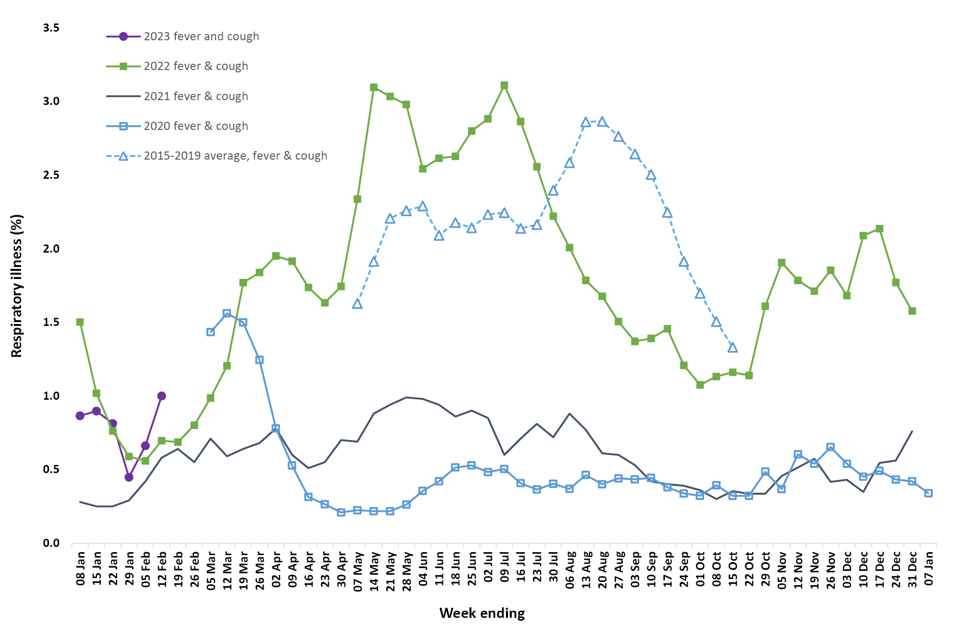
a In years prior to 2020, FluTracking was activated during the main Influenza season from May to October. A historical average beyond the week ending 11 October (epidemiological week 41) is therefore not available. In 2020, FluTracking commenced ten weeks early to capture data for COVID-19.

Figure 9: Weekly trends in runny nose and sore throat symptoms amongst FluTracking survey participants (age-standardised), Australia, 29 March 2020 – 12 February 2023ª
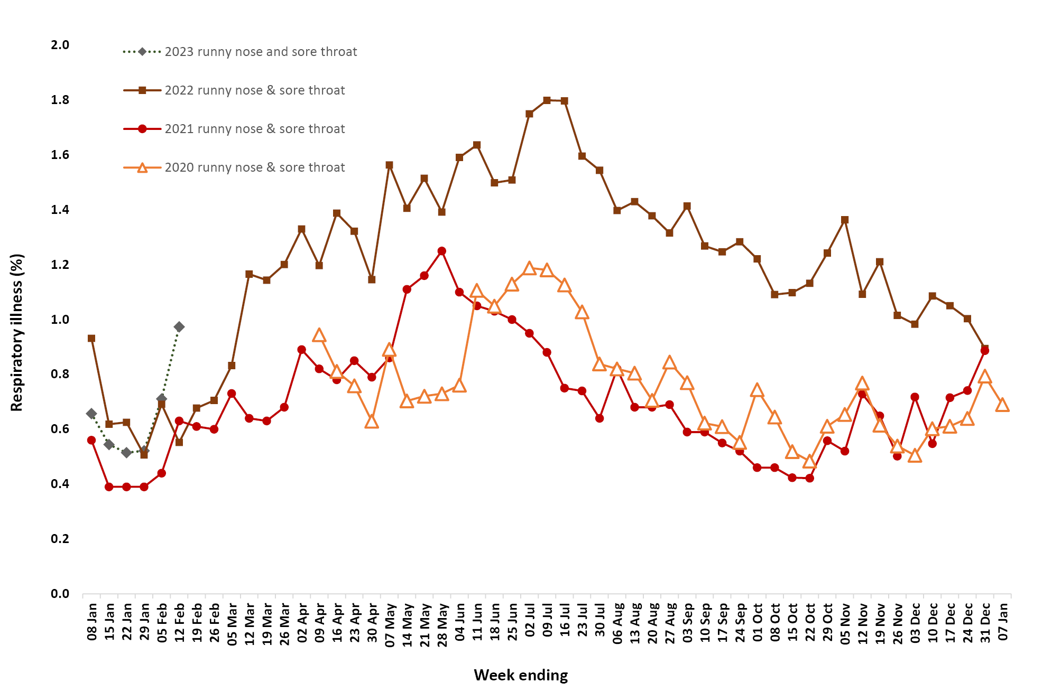
a Data on runny nose and sore throat were only collected systematically after 29 March 2020, therefore a historical average for this symptom profile is unavailable.

Countries and territories in Australia’s near region
According to WHO, countries and territories in the South-East Asia and Western Pacific regions reported 3,616,486 new cases and 32,380 deaths in the four-week period to 12 February 2023.⁹ Compared with the previous four-week reporting period, new cases and new deaths decreased in the Western Pacific region and the South-East Asia region.⁹ In total, since the start of the pandemic, over 261 million cases and over 1.2 million deaths have been reported in the two regions.^{,11}
In the four-week period 16 January to 12 February 2023, changes in COVID-19 cases and deaths are highlighted in selected countries in the South-East Asia region and the Western Pacific region (Table 9). In the previous four weeks, at the country level, the highest number of in new cases and deaths were reported from Japan (1,627,259 and 8,294) and China (1,273,265 and 20,979) (Table 9). Australia reported the greatest change in deaths in the last four weeks (+104%), which was due to reconciliation activities by jurisdictions; approximately 700 deaths from one jurisdiction, with a date of death occurring in 2022, were included that were previously not captured in NNDSS (Table 9).
As of 12 February 2023, over 755 million COVID-19 cases and over 6.8 million deaths have been reported globally since the start of the pandemic, with a global case fatality rate (CFR) of approximately 0.90%. The two regions reporting the largest burden of disease over the past four weeks were the Western Pacific (54% of total cases) and the Americas (27% of total cases).⁹
Table 9: Cumulative cases and deaths, and new cases and deaths reported in the four-week period to 12 February 2023 for selected countries in Australia’s near region according to WHO ^{a,b,c}
Country | Cumulative cases | New cases reported in the last 4 weeks | Change in new cases in the last 4 weeks^{b} | Cumulative deaths | New deaths reported in the last 4 weeks | Change in new deaths in the last 4 weeks^{b}
South-East Asia region
Indonesia | 6,732,799 | 6,713 | -59% | 160,864 | 137 | -58%
India | 44,684,118 | 3,078 | -40% | 530,750 | 24 | -56%
Thailand | 4,727,628 | 1,743 | -75% | 33,894 | 102 | -64%
Bangladesh | 2,037,679 | 311 | -29% | 29,444 | 3 | 0%
Myanmar | 633,866 | 116 | -41% | 19,490 | 0 | -100%
Western Pacific region
Japan | 32,935,611 | 1,627,259 | -61% | 70,558 | 8,294 | -7%
China | 98,787,124 | 1,273,265 | -98% | 118,867 | 20,979 | -68%
Republic of Korea | 30,350,199 | 543,308 | -66% | 33,736 | 787 | -49%
Australia | 11,326,032 | 87,108 | -71% | 18,190 | 1,511^{c} | +104%
New Zealand | 2,144,266 | 46,580 | -33% | 2,502 | 109 | +4%
a Source: World Health Organization Coronavirus (COVID-19) Dashboard, accessed 24 February 2023, for data until 12 February 2023.
b Percent change in the number of newly confirmed cases/deaths in the most recent four-week period compared to the four weeks prior.
c On Monday 13 February 2023, there was a considerable increase in total COVID-19 reported deaths in the NNDSS due to reconciliation activities by jurisdictions; approximately 700 deaths from one jurisdiction were included that were previously not captured in NNDSS, with a date of death occurring in 2022.

Acknowledgements
We thank public health staff from incident emergency operations centres and public health units in state and territory health departments, and the Australian Government Department of Health and Aged Care, along with state and territory public health laboratories. We thank those who have provided data from surveillance systems, such as Commonwealth respiratory clinics, ASPREN, FluTracking, FluCAN, SPRINT-SARI, Communicable Disease Genomics Network, AusTrakka and jurisdictional sequencing laboratories.

Author details

Corresponding author
COVID-19 Epidemiology and Surveillance Team
Australian Government Department of Health and Aged Care, GPO Box 9484, MDP 14, Canberra, ACT 2601.
Email: epi.coronavirus@health.gov.au

References
- COVID-19 National Incident Room Surveillance Team. COVID-19 Australia: Epidemiology Report 70: Reporting period ending 15 January 2023. Commun Dis Intell (2018). 2023;47. doi: https://doi.org/10.33321/cdi.2023.47.12.
- COVID-19 National Incident Room Surveillance Team. Technical supplement. COVID-19 Australia: Epidemiology reporting. Commun Dis Intell (2018). 2021;45. doi: https://doi.org/10.33321/cdi.2021.45.2.
- Australian Government Department of Health and Aged Care. Coronavirus (COVID-19) – CDNA National Guidelines for Public Health Units. [Internet.] Canberra: Australian Government Department of Health and Aged Care; 14 October 2022. [Accessed on 9 November 2022.] Available from: https://www.health.gov.au/resources/publications/coronavirus-covid-19-cdna-national-guidelines-for-public-health-units.
- Australian and New Zealand Intensive Care Research Centre (ANZIC-RC). SPRINT-SARI: Short period incidence study of severe acute respiratory infection. [Internet.] Melbourne: Monash University, ANZIC-RC; 2020. Available from: https://www.monash.edu/medicine/sphpm/anzicrc/research/sprint-sari.
- Communicable Diseases Genomics Network (CDGN). AusTrakka. [Website.] Melbourne: CDGN; 2020. Available from: https://www.cdgn.org.au/austrakka.
- World Health Organization (WHO). Coronavirus disease (COVID-19) Weekly Epidemiological Updates and Monthly Operational Updates. [Internet.] Geneva: WHO; January 2023. [Accessed on 30 January 2023.] Available from: https://www.who.int/emergencies/diseases/novel-coronavirus-2019/situation-reports/.
- Allen H, Vusirikala A, Flannagan J, Twohig KA, Zaidi A, Groves N et al. Increased household transmission of COVID-19 cases associated with SARS-CoV-2 Variant of Concern B.1.617.2: a national case-control study. Knowledge Hub (khub); 2021. [Accessed on 30 January 2023.] Available from: https://khub.net/documents/135939561/405676950/Increased+Household+Transmission+ of+COVID-19+Cases+-+national+case+study.pdf/7f7764fb-ecb0-da31-77b3-b1a8ef7be9aa.
- Dalton C, Durrheim D, Fejsa J, Francis L, Carlson S, d’Espaignet ET et al. Flutracking: a weekly Australian community online survey of influenza-like illness in 2006, 2007 and 2008. Commun Dis Intell Q Rep. 2009;33(3):316–22.
- WHO. Weekly epidemiological update on COVID-19 – 15 February 2023. [Internet.] Geneva: WHO; 15 February 2023. [Accessed on 24 February 2023.] Available from: https://www.who.int/publications/m/item/weekly-epidemiological-update-on-covid-19---15-february-2023.
- World Health Organization (WHO). Weekly epidemiological update on COVID-19 – 1 February 2023. [Internet.] Geneva: WHO; 1 February 2023. [Accessed on 9 March 2023.] Available from: https://www.who.int/publications/m/item/weekly-epidemiological-update-on-covid-19---1-february-2023.
- WHO. WHO Coronavirus Disease (COVID-19) dashboard. [Internet.] Geneva: WHO; 2021. Available from: https://covid19.who.int/.

Appendix A: Supplementary figures and tables
Table A.1: COVID-19 cases and rates per 100,000 population, by age group, sex, and notification received date, Australia, 15 December 2021 – 12 February 2023^{a,b,c,d}
Age group | Four-week reporting period |  |  |  |  |  | Current ‘Omicron’ wave
 | 16 January – 12 February 2023 |  |  |  |  |  | 15 December 2021 – 12 February 2023
 | Cases |  |  | Rate per 100,000 population |  |  | Cases |  |  | Rate per 100,000 population
 | Male | Female | People^{d} | Male | Female | People^{d} | Male | Female | Peopled | Male | Female | People^{d}
0–9 | 2,583 | 2,339 | 5,418 | 160.9 | 154.3 | 173.6 | 497,743 | 473,287 | 1,093,312 | 31,010.1 | 31,218.8 | 35,029.3
10–19 | 2,381 | 2,592 | 5,370 | 145.9 | 168.4 | 169.3 | 628,723 | 667,814 | 1,434,264 | 38,521.2 | 43,391.8 | 45,228.1
20–29 | 3,358 | 5,672 | 9,699 | 190.7 | 336.1 | 281.2 | 770,372 | 925,892 | 1,824,667 | 43,738.9 | 54,869.9 | 52,908.4
30–39 | 4,475 | 7,417 | 12,727 | 237.8 | 386.8 | 335.0 | 783,324 | 958,491 | 1,892,085 | 41,632.8 | 49,980.6 | 49,801.8
40–49 | 4,070 | 6,822 | 11,574 | 247.7 | 405.8 | 348.2 | 644,799 | 799,999 | 1,568,920 | 39,249.8 | 47,590.3 | 47,202.3
50–59 | 3,794 | 6,005 | 10,386 | 242.0 | 370.9 | 325.9 | 518,413 | 630,179 | 1,238,068 | 33,067.4 | 38,922.8 | 38,849.9
60–69 | 3,690 | 4,981 | 9,139 | 272.7 | 345.5 | 327.0 | 369,011 | 421,406 | 845,161 | 27,274.4 | 29,230.5 | 30,242.4
70–79 | 3,278 | 3,375 | 7,013 | 337.8 | 322.1 | 347.5 | 229,459 | 233,458 | 488,492 | 23,646.2 | 22,282.1 | 24,205.3
80–89 | 1,872 | 2,042 | 4,167 | 465.2 | 410.0 | 462.7 | 100,062 | 112,357 | 221,884 | 24,863.5 | 22,556.8 | 24,638.6
90 + | 538 | 997 | 1,670 | 709.4 | 717.7 | 777.7 | 25,051 | 46,142 | 73,666 | 33,033.1 | 33,217.7 | 34,304.1
a Source: NNDSS, extract from 21 February 2023 for notifications to 12 February 2023.
b Population data based on Australian Bureau of Statistics (ABS) Estimated Resident Population (ERP) as at June 2022.
c Excludes cases where age was unknown.
d Total cases includes those where sex was unknown and those classified as X, i.e., persons who reported their sex as another term, other than male or female.

Communicable Diseases Intelligence
ISSN: 2209-6051 Online

Communicable Diseases Intelligence (CDI) is a peer-reviewed scientific journal published by the Office of Health Protection, Department of Health and Aged Care. The journal aims to disseminate information on the epidemiology, surveillance, prevention and control of communicable diseases of relevance to Australia.

Editor: Noel Lally
Deputy Editor: Simon Petrie
Design and Production: Kasra Yousefi
Editorial Advisory Board: David Durrheim, Mark Ferson, Clare Huppatz, John Kaldor, Martyn Kirk, Meru Sheel and Steph Williams

Website: http://www.health.gov.au/cdi

Contacts
CDI is produced by the Office of Health Protection, Australian Government Department of Health and Aged Care, GPO Box 9848, (MDP 6) CANBERRA ACT 2601

Email: cdi.editor@health.gov.au

Submit an Article
You are invited to submit your next communicable disease related article to the Communicable Diseases Intelligence (CDI) for consideration. More information regarding CDI can be found at: http://health.gov.au/cdi.
Further enquiries should be directed to: cdi.editor@health.gov.au.

This journal is indexed by Index Medicus and Medline.

Creative Commons Licence - Attribution-NonCommercial-NoDerivatives CC BY-NC-ND
© 2023 Commonwealth of Australia as represented by the Department of Health and Aged Care
This publication is licensed under a Creative Commons Attribution-NonCommercial-NoDerivatives 4.0 International Licence from https://creativecommons.org/licenses/by-nc-nd/4.0/legalcode (Licence). You must read and understand the Licence before using any material from this publication.

Restrictions
The Licence does not cover, and there is no permission given for, use of any of the following material found in this publication (if any):
- the Commonwealth Coat of Arms (by way of information, the terms under which the Coat of Arms may be used can be found at www.itsanhonour.gov.au);
- any logos (including the Department of Health and Aged Care’s logo) and trademarks;
- any photographs and images;
- any signatures; and
- any material belonging to third parties.

Disclaimer
Opinions expressed in Communicable Diseases Intelligence are those of the authors and not necessarily those of the Australian Government Department of Health and Aged Care or the Communicable Diseases Network Australia. Data may be subject to revision.

Enquiries
Enquiries regarding any other use of this publication should be addressed to the Communication Branch, Department of Health and Aged Care, GPO Box 9848, Canberra ACT 2601, or via e-mail to: copyright@health.gov.au

Communicable Diseases Network Australia
Communicable Diseases Intelligence contributes to the work of the Communicable Diseases Network Australia.
http://www.health.gov.au/cdna

