COVID-19 Australia: Epidemiology Report 60
Reporting period ending 10 April 2022
COVID-19 National Incident Room Surveillance Team

Summary

Four-week reporting period (14 March – 10 April 2022)
The case data provided in this report includes confirmed cases reported to the National Interoperable Notifiable Disease Surveillance System (NINDSS). The case data does not include cases that are positive on rapid antigen tests (RAT) only. Therefore, case numbers, particularly since January 2022, will under-represent the incidence of disease in the community. Due to NINDSS transmission issues, data are not available since 8 April 2022 for the Northern Territory, since 29 March 2022 for Western Australia, and 9 April 2022 for South Australia.
Trends – In the last four weeks from 14 March to 10 April 2022, there were 522,745 polymerase chain reaction (PCR) confirmed cases of coronavirus disease 2019 (COVID-19) reported in Australia. In the most recent fortnight, a total of 265,077 confirmed cases were notified (an average of 18,934 cases per day), compared to 257,668 in the previous fortnight (an average of 18,404 cases per day).
Age group – In the four weeks ending 10 April 2022, the highest PCR-confirmed notification rate was observed among children aged 12 to 15 years and the lowest rate was among those age 70 years and over. Across all age groups, weekly case notification rates appear to have converged over the four-week reporting period. For the entire Omicron wave to date (15 December 2021 – 10 April 2022), the highest PCR confirmed notification rate was in adults aged 18 to 29 years.
Aboriginal and Torres Strait Islander persons – Between 14 March and 10 April 2022, there were 15,648 new PCR confirmed cases notified in Aboriginal and Torres Strait Islander people. In the current Omicron wave (15 December 2021 – 10 April 2022) there have been 77,912 confirmed cases of COVID-19 notified in Aboriginal and Torres Strait Islander people, representing 3.2% (77,912/2,470,874) of all confirmed cases; 20% of confirmed cases notified in that same period had an unknown or missing Indigenous status. Therefore, the number of cases classified as Aboriginal and Torres Strait Islander people is likely an underestimate.
Severity – During the reporting period to 27 March 2022, the notification rate of confirmed cases with severe illness remained relatively stable at approximately 0.7 cases per 100,000 population per week. In the current wave, severe cases peaked in the week ending 16 January 2022, at approximately 3.7 per 100,000 population per week. This rate of severe cases is more than three times the peak observed during the Delta wave, of 1.2 per 100,000 population in the week ending 5 September 2021.
Virology – Nationally, SARS-CoV-2 strains from 2.9 % of COVID-19 cases have been sequenced from the start of the pandemic. Of the cases in AusTrakka, 33,007 are the Omicron Variant of Concern (VOC); 61.8% are the BA.1 sub-lineage; 14.5% are of the BA.1.1 sub-lineage; and 23.6% are of the BA.2 sub-lineage. There has been a notable shift in the number of cases sequenced as BA.2 since late February 2022, accompanied by a reduction in BA.1 and BA.1.1.
Acute respiratory illness – Based on self-reported FluTracking data, over the four-week reporting period, there was an increase in the prevalence of both fever and cough, and runny nose and sore throat symptoms in the community: in the week ending 10 April 2022, 1.9% of survey participants reported fever and cough symptoms and 1.4% of participants reported runny nose and sore throat. The current rate of both sets of symptoms is higher than that observed during the peak of the Omicron wave in January 2022.
International situation – According to the World Health Organization (WHO), cumulative global COVID-19 cases stood at more than 496 million, with over 6 million deaths reported globally, as of 10 April 2022. In Australia’s near region, the South East Asia and Western Pacific Regions reported over 18 million cases and over 35,000 deaths in the four-week period to 10 April 2022.
Keywords: SARS-CoV-2; novel coronavirus; 2019-nCoV; coronavirus disease 2019; COVID-19; acute respiratory disease; epidemiology; Australia
This reporting period covers the four-week period of 14 March – 10 April 2022. Within this period, data for each week is compared. The previous reporting period was the preceding four weeks (14 February – 13 March 2022).¹
The focus of this report is on the epidemiological situation in Australia since the beginning of the current Omicron wave. For the purposes of this report, 15 December 2021 is used as a proxy for the beginning of this wave. This date was chosen as, from this date onwards, the majority of sequenced cases were Omicron. Readers are encouraged to consult prior reports in this series for information on the epidemiology of coronavirus disease 2019 (COVID-19) in Australia.
From report 46 onward, and unless otherwise specified, tabulated data and data within the text are extracted from the National Interoperable Notifiable Diseases Surveillance System (NINDSS) based on ‘notification received date’ rather than ‘diagnosis date’ (see the Technical Supplement for definitions).² As a case’s diagnosis date can be several days prior to the date of its notification, there is potential for newly-notified cases to be excluded from the case count in the current reporting period when reporting by ‘diagnosis date’. Using ‘notification received date’ ensures that the case count for the reporting period better reflects the number of newly-notified cases. As the graphs presented in this report, based on NINDSS data, reflect a longer time period (i.e. year to date and entire pandemic), these will continue to be based on diagnosis date to enable a more accurate understanding of infection risk and local transmission.
Further, as a result of community transmission levels, the increase in international arrivals and reduced quarantine and testing requirements, the ability of jurisdictions to accurately report place of acquisition has greatly reduced. From report 59 onwards, cases will no longer be separated into ‘locally acquired’ or ‘overseas acquired’. Due to NINDSS transmission issues, data are not available for Western Australia since 29 March 2022, for the Northern Territory since 8 April 2022 and for South Australia since 9 April 2022.

Background and data sources
See the Technical Supplement for general information on COVID-19 including modes of transmission, common symptoms and severity.²

Activity

COVID-19 trends

(NINDSS and jurisdictional reporting to the National Incident Centre)
Cumulatively, from the beginning of the pandemic to 10 April 2022, jurisdictions within Australia have reported 5,019,012 COVID-19 cases (polymerase chain reaction [PCR] confirmed and rapid antigen test [RAT] probable cases) to the National Incident Centre (Table 1). In the same time period, there have been 2,965,940 PCR confirmed cases of COVID-19 reported to NINDSS nationally. The difference in these case numbers is largely due to the current exclusion of RAT probable cases from the NINDSS data. As RAT probable cases were yet to be reliably reported to NINDSS by all jurisdictions, the remaining analyses in this report are limited to PCR confirmed cases only.
Table 1: PCR confirmed and RAT positive COVID-19 cases by jurisdiction, 1 January 2020 – 10 April 2022^{a,b}
 | Australia (total) | ACT | NSW | NT | Qld | SA | Tas. | Vic. | WA
Cases – PCR confirmed cases | 2,965,940 | 56,778 | 1,238,988 | 14,134 | 462,520 | 234,025 | 31,472 | 790,764 | 137,259
Cases – RAT positive cases | 2,053,072 | 32,732 | 641,995 | 41,469 | 408,890 | 97,578 | 82,868 | 619,423 | 128,117
Cases – total | 5,019,012 | 89,510 | 1,880,983 | 55,603 | 871.410 | 331,603 | 114,340 | 1,410,187 | 265,376
a Source: Jurisdictional reporting to the National Incident Centre.
b ACT: Australian Capital Territory; NSW: New South Wales; NT: Northern Territory; Qld: Queensland; SA: South Australia; Tas.: Tasmania; Vic.: Victoria; WA: Western Australia.
In the last four weeks from 14 March to 10 April 2022, there were over 522,745 PCR confirmed cases of COVID-19 reported in Australia. In the most recent fortnight, a total of 265,077 confirmed cases were notified (an average of 18,934 cases per day), compared to 257,668 in the previous fortnight (18,404 cases per day). In the week ending 10 April 2022, PCR case rates were highest in South Australia at 1,181 per 100,000 population, followed by the Australian Capital Territory (876 per 100,000 population) and New South Wales (717 per 100,000 population) (Table 2).
Prior to December 2021, the number of cases diagnosed each week had peaked in October 2021, at approximately 15,000 cases diagnosed per week. From December 2021, confirmed case numbers increased steeply to a peak of over 450,000 cases diagnosed in the week ending 9 January 2022, then declined until week ending 27 February 2022. From 28 February to 27 March 2022, PCR confirmed case numbers increased gradually (Figure 1). As trends are presented using diagnosis date rather than notification date, case numbers for the most recent week are likely an underestimate; additional cases may be identified in the coming week that have a diagnosis date in these periods. In addition, case numbers since January 2022 are an underestimate as RAT probable cases are excluded from these counts.

Figure 1: Confirmed weekly COVID-19 notified cases by diagnosis date, 13 December 2021 – 10 April 2022^{a,b}
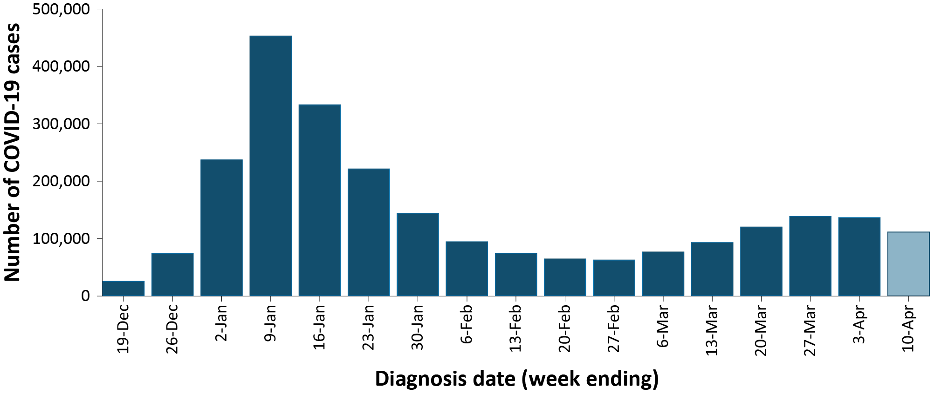
a Source: NINDSS, extract from 11 April 2022 for notifications to 10 April 2022.
b The lighter bar at the right represents the most recent reporting week and should be interpreted with caution, as additional cases may be identified in the coming week that have a diagnosis date during this period.
Table 2: PCR confirmed COVID-19 cases by jurisdiction and date of notification, 15 December 2021 – 10 April 2022^{a,b}
Jurisdiction | Reporting period |  |  |  |  |  |  |  | Current ‘Omicron’ wave
 | 14–20 March 2022 |  | 21–27 March 2022 |  | 28 March – 3 April 2022 |  | 4–10 April 2022 |  | 15 December 2021 – 10 April 2022
 | No. of cases | Rate^{c} | No. of cases | Rate^{c} | No. of cases | Rate^{c} | No. of cases | Rate^{c} | No. of cases | Rate^{c}
ACT | 4,051 | 937.2 | 3,792 | 877.2 | 3,574 | 826.8 | 3,737 | 864.5 | 54,013 | 12,495.3
NSW | 53,255 | 650.3 | 62,663 | 765.2 | 61,360 | 749.3 | 57,851 | 706.4 | 1,004,550 | 12,266.7
NT^{d} | 181 | 73.5 | 313 | 127.1 | 411 | 166.8 | 368 | 149.4 | 12,373 | 5,022.8
Qld | 12,173 | 233.1 | 18,089 | 346.5 | 18,926 | 362.5 | 17,220 | 329.8 | 447,898 | 8,578.5
SA^{d} | 17,019 | 959.8 | 20,327 | 1,146.3 | 22,224 | 1,253.3 | 20,952 | 1,181.6 | 227,621 | 12,836.4
Tas. | 2,068 | 381.9 | 2,444 | 451.4 | 2,735 | 505.1 | 2,642 | 487.9 | 31,113 | 5,745.9
Vic. | 18,962 | 285.2 | 22,018 | 331.1 | 24,523 | 368.8 | 25,994 | 390.9 | 642,919 | 9,669.2
WA^{d} | 10,567 | 394.1 | 9,746 | 363.4 | 2,559 | 95.4 | 1 | 0.0 | 50,387 | 1,879.0
Australia | 118,276 | 459.5 | 139,392 | 541.6 | 136,312 | 529.6 | 128,765 | 500.3 | 2,470,874 | 9,599.6
a Source: NINDSS, extract from 11 April 2022 for notifications from 15 December 2021 to 10 April 2022.
b ACT: Australian Capital Territory; NSW: New South Wales; NT: Northern Territory; Qld: Queensland; SA: South Australia; Tas.: Tasmania; Vic.: Victoria; WA: Western Australia.
c Rates are per 100,000 population for the given time period. Population data based on Australian Bureau of Statistics (ABS) Estimated Resident Population (ERP) as at June 2021. The ABS June 2021 ERP was ACT: 432,266; NSW: 8,189,266; NT: 246,338; Qld: 5,221,170; SA: 1,773,243; Tas.: 541,479; Vic.: 6,649,159; WA: 2,681,633; Australia: 25,739,256.
d Due to NINDSS transmission issues, data are not available (NA) since 8 April 2022 for the Northern Territory, since 29 March 2022 for Western Australia, and 9 April for South Australia.

Demographic features

(NINDSS)
In the reporting period between 14 March and 10 April 2022, the highest PCR confirmed notification rate was observed among children aged 12 to 15 years and the lowest rate was among those age 70 years and over (Appendix A, Table A.1). Across all age groups, weekly case notification rates have converged over the four-week reporting period (Figure 2a). For the entire Omicron wave to date (15 December 2021 – 10 April 2022), the highest PCR confirmed notification rate was in adults aged 18 to 29 years (Appendix A, Table A.1). For this age group, the weekly notification rate peaked in the week ending 9 January 2022 at over 4,400 cases per 100,000 population.
Among paediatric age groups, the highest notification rate during the reporting period was in children aged 12 to 17 years (Figure 2b). Among children, cases notification rates were similar from mid-January 2022 to early February 2022. However, from early February to early March 2022, case rates among children diverged, with rates decreasing in infants aged 0 to 4 years, and rates remaining steady in children aged 5 to 17 years. In the most recent reporting period, case rates among paediatric age groups have once again converged, with rates in those aged 5 to 17 years decreasing and rates in children aged 0 to 4 years increasing.

Figure 2: PCR confirmed COVID-19 case rates for (a) all ages and (b) children, by age group by week, Australia, 29 November 2021 – 10 April 2022ª
a
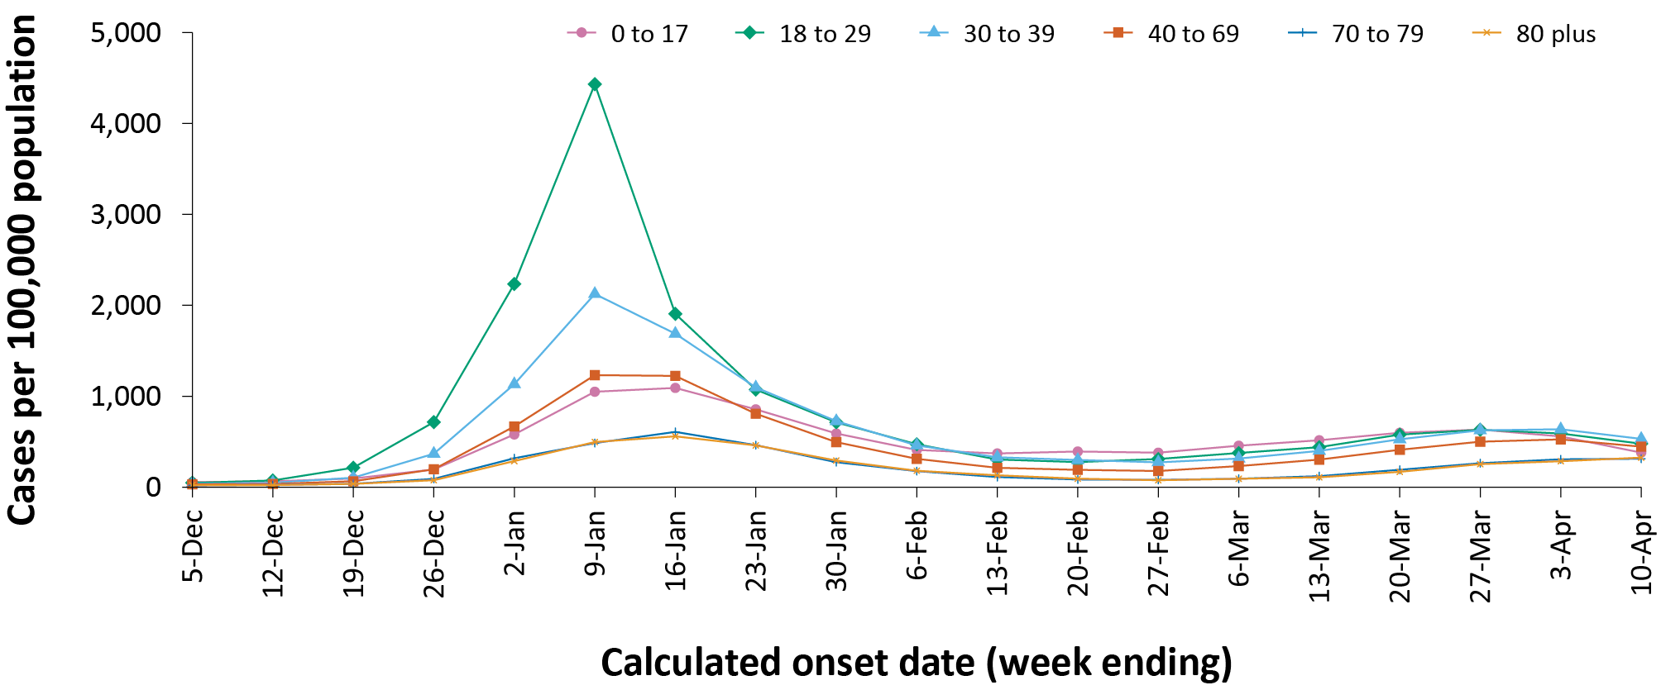
b
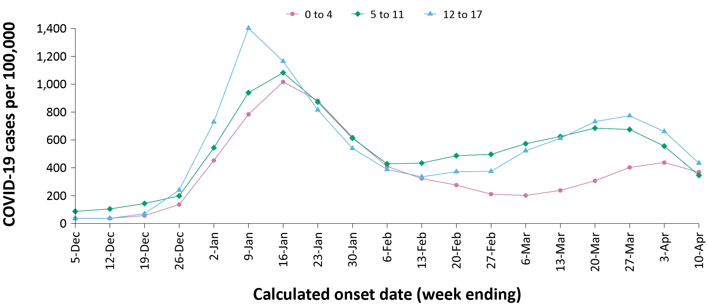
a Source: NINDSS, extract from 11 April 2022 for notifications from 29 November 2021 to 10 April 2022.

Aboriginal and Torres Strait Islander persons

(NINDSS)
Overall, since the start of the pandemic, Indigenous status is unknown for 20% of confirmed cases. Therefore, the number of cases classified as Aboriginal and Torres Strait Islander people is likely an underrepresentation.
During the reporting period, there were 15,648 new confirmed cases notified in Aboriginal and Torres Strait Islander people (Table 3). In the current Omicron wave (15 December 2021 – 10 April 2022) there have been 77,912 confirmed cases of COVID-19 notified in Aboriginal and Torres Strait Islander people, representing 3.2% (77,912/2,470,874) of all confirmed cases.
Table 3: PCR confirmed cases of COVID-19 among Aboriginal and Torres Strait Islander peoples by jurisdiction and calendar year, by date of notification, 15 December 2021 – 10 April 2022ª
Jurisdiction | 14–20 March 2022 | 21–27 March 2022 | 28 March – 3 April 2022 | 4–10 April 2022 | 15 December 2021 – 10 April 2022 (Omicron wave)
Australian Capital Territory | 85 | 79 | 66 | 67 | 1,037
New South Wales | 1,583 | 1,949 | 1,962 | 1,726 | 36,543
Northern Territory^{b} | 28 | 37 | 62 | 33 | 2,630
Queensland | 503 | 588 | 661 | 486 | 19,115
South Australia^{b} | 523 | 518 | 552 | 433 | 7,846
Tasmania | 94 | 117 | 102 | 81 | 1,072
Victoria | 178 | 185 | 224 | 194 | 5,760
Western Australia^{b} | 969 | 1,314 | 249 | 0 | 3,909
Total | 3,963 | 4,787 | 3,878 | 3,020 | 77,912
a Source: NINDSS, extract from 11 April 2022 for notifications to 10 April 2022.
b Due to NINDSS transmission issues, data are not available for South Australia (SA) since 9 April 2022, or the Northern Territory (NT) from 8 April 2022 or for Western Australia (WA) from 29 March 2022. The number of cases reported for SA, NT and WA in the current wave will be incomplete.
Of the PCR confirmed cases notified in Aboriginal and Torres Strait Islander people from 15 December 2021 to date, 49% (37,844/77,912) resided in a regional or remote area (Table 4). It should be noted that the reliance on RATs for diagnosing COVID-19 is greater in regional and remote areas than in major cities, resulting in a larger under-count of cases in regional and remote areas than in major cities when counting PCR confirmed cases only.
Nationally, there have been 107 deaths among PCR confirmed cases reported in Aboriginal and Torres Strait Islander people since the start of the pandemic to 10 April 2022. This comprises 47 from New South Wales; 24 from Queensland; 18 from the Northern Territory; eight from South Australia; six from Western Australia; and four from Victoria. An additional 274 Aboriginal and Torres Strait Islander cases have been admitted to intensive care units (ICU) nationally. During the Omicron wave, the overall notification rate, to NINDSS, of severe cases (measured as those who were admitted to ICU or died) in Aboriginal and Torres Strait Islander people was 26.9 per 100,000 population, compared to 16.2 per 100,000 population during the Delta wave (Table 5). The higher rates of severe illness during the Omicron wave is due to the significantly higher levels of disease transmission in the community during the Omicron wave, rather than the Omicron variant inherently causing more severe illness compared to the Delta variant. Note that ICU status in NINDSS is likely incomplete.

Table 4: PCR confirmed cases of COVID-19 among Aboriginal and Torres Strait Islander people by area of remoteness, 15 December 2021 – 10 April 2022ª
Jurisdiction^{b} | Major city | Inner regional | Outer regional | Remote^{c} | Overseas resident | Unknown | Missing source | Total
Australian Capital Territory | 1,002 | 15 | 4 | 0 | 0 | 16 | 0 | 1,037
New South Wales | 21,692 | 10,752 | 3,215 | 593 | 12 | 265 | 14 | 36,543
Northern Territory^{d} | 0 | 0 | 737 | 1,726 | 0 | 164 | 3 | 2,630
Queensland | 6,985 | 3,851 | 7,022 | 1,227 | 1 | 28 | 1 | 19,115
South Australia^{d} | 3,966 | 644 | 1,673 | 1,413 | 79 | 68 | 3 | 7,846
Tasmania | 9 | 705 | 348 | 7 | 0 | 1 | 2 | 1,072
Victoria | 3,850 | 1,468 | 422 | 0 | 0 | 19 | 1 | 5,760
Western Australia^{d} | 1,825 | 180 | 315 | 1,527 | 2 | 60 | 0 | 3,909
Australia | 39,329 | 17,615 | 13,736 | 6,493 | 94 | 621 | 24 | 77,912
a Source: NINDSS, extract from 11 April 2022 for notifications to 10 April 2022.
b Cases are classified based on jurisdiction of notification not jurisdiction of residence. Some cases are notified to a different jurisdiction to their location of residence.
c ‘Remote’ here also includes areas classified as ‘very remote’.
d Due to NINDSS transmission issues, data are not available for South Australia (SA) since 9 April 2022, or the Northern Territory (NT) from 8 April 2022 or for Western Australia (WA) from 29 March 2022. The number of cases reported for SA, NT and WA in the current wave will be incomplete.
Table 5: PCR confirmed COVID-19 cases in Aboriginal and Torres Strait Islander people by age and highest level of illness severity, Australia, 1 January 2020 to 10 April 2022
Age group (years) | 15 December 2021 – 10 April 2022  (Omicron wave) |  |  |  | 16 June 2021 – 14 December 2021  (Delta wave) |  |  |  | 1 January 2020 – 10 April 2022  (Pandemic to date)
 | ICUª | Diedª | ICU or diedª | Rate ICU or died^{b} | ICUª | Diedª | ICU or diedª | Rate ICU or died^{b} | ICUª | Diedª | ICU or diedª | Rate ICU or died^{b}
0–17 | 13 | 1 | 13 | 4.0 | 8 | 0 | 8 | 2.5 | 21 | 1 | 21 | 6.5
18–59 | 87 | 27 | 109 | 26.1 | 84 | 11 | 88 | 21.1 | 172 | 38 | 198 | 47.5
60+ | 54 | 54 | 93 | 164.8 | 26 | 14 | 33 | 58.5 | 82 | 68 | 128 | 226.8
All | 154 | 82 | 215 | 26.9 | 118 | 25 | 129 | 16.2 | 275 | 107 | 347 | 43.5
a ICU and died are not mutually exclusive, ‘died’ can include cases who died with or without prior admission to ICU. Therefore, the number of cases admitted to ICU or having died will not equal the sum of cases in ICU or died.
b Rate per 100,000 population for the given time period.

Vaccinations

(Department of Health)
As of 10 April 2022, a total of 56,923,565 doses of COVID-19 vaccine had been administered (Table 6), including 1,269,307 doses provided to aged care and disability residents. Nationally, 20,643,927 people aged 12 years or over (94.4%) were fully vaccinated. Among children aged 5–11 years, 1,197,488 (52.6%) had received at least one dose, including 734,335 (52.6%) who were fully vaccinated. Nationally, 13,135,431 people aged 16 years and over (63.7%) had received more than two doses.
Table 6: Total number of vaccinations administered, by jurisdiction, Australia, 10 April 2022ª
Jurisdiction^{b} | Total number of doses administered | Percentage of people aged 12 and over who have had two or more doses
Australian Capital Territory | 1,477,270 | > 99%
New South Wales | 17,667,708 | 93.8%
Northern Territory | 559,746 | 87.8%
Queensland | 10,783,788 | 90.6%
South Australia | 3,922,809 | 92.2%
Tasmania | 1,279,797 | 97.7%
Victoria | 14,995,449 | 93.2%
Western Australia | 6,236,998 | 96.0%
Aged care and disability facilities^{c,d} | 1,269,307 | NA
Primary care^{d,e} | 34,801,265 | NA
Total | 56,923,565 | 94.4%
a Source: Australian Government Department of Health website.⁴
b Jurisdictions refer to state of residence.
c Commonwealth vaccine doses administered in aged care and disability facilities.
d NA: not applicable.
e Commonwealth vaccine doses administered in primary care settings.

Severity

(NINDSS, SPRINT-SARI)
Given the delay between illness onset and severe illness, cases with an onset in the last two weeks were excluded from analyses on the weekly rate of cases with severe illness (defined as cases admitted to ICU or died) and on the proportion of cases admitted to ICU or died.
During the reporting period to 27 March 2022, the notification rate of confirmed cases with severe illness remained relatively stable at approximately 0.7 cases per 100,000 population per week. In the current wave, severe cases peaked in the week ending 16 January 2022, at approximately 3.7 per 100,000 population per week (Figure 3). This is more than three times the peak rate of severe cases observed during the Delta wave, of 1.2 per 100,000 population in the week ending 5 September 2021. Rates of severe cases continue to be greater in older age groups (Figure 4).

ICU admissions
Since the start of the Omicron wave to 10 April 2022, there were 1,893 COVID-19 cases admitted to ICUs participating in the sentinel surveillance system, Short Period Incidence Study of Severe Acute Respiratory Infection (SPRINT-SARI), ⁵ with 115 of these admitted during this reporting period (14 March – 10 April 2022).

Risk factors for severe disease
Comorbidity data extracted from SPRINT-SARI reflect the sickest patients with COVID-19 managed in ICU; data are therefore not generalisable to all cases (Table 7). In patients admitted to ICU with COVID-19 since 15 December 2021, the most prevalent comorbidity was diabetes, followed by obesity (a body mass index of > 30 or weight over 120 kg). Of those adult patients admitted to ICU since 15 December 2021 for whom comorbidity data was known, 75% (1,157/1,542) had at least one comorbidity; 25% of patients (385/1,542) had none of the listed comorbidities recorded.
Figure 3: COVID-19 cases, deaths and ICU admissions, Australia, by date of onset, Australia, 31 May 2021 to 10 April 2022^{a,b}
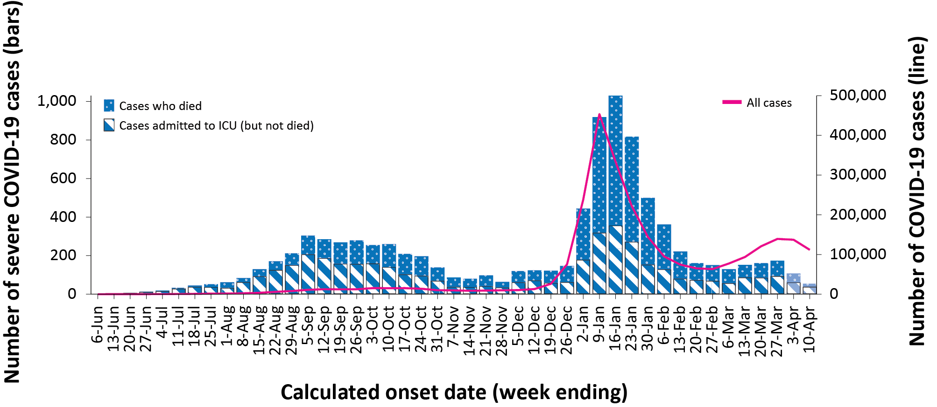
a NINDSS, extract from 11 April 2022, for cases notified to 10 April 2022.
b The shaded bars at the right represent the most recent two reporting weeks and should be interpreted with caution as cases with an illness onset in these weeks may not have yet developed severe disease.
Figure 4: Age-specific rates of COVID-19 cases admitted to ICU or died, by date of diagnosis, Australia, 31 May 2021 to 27 March 2022ª
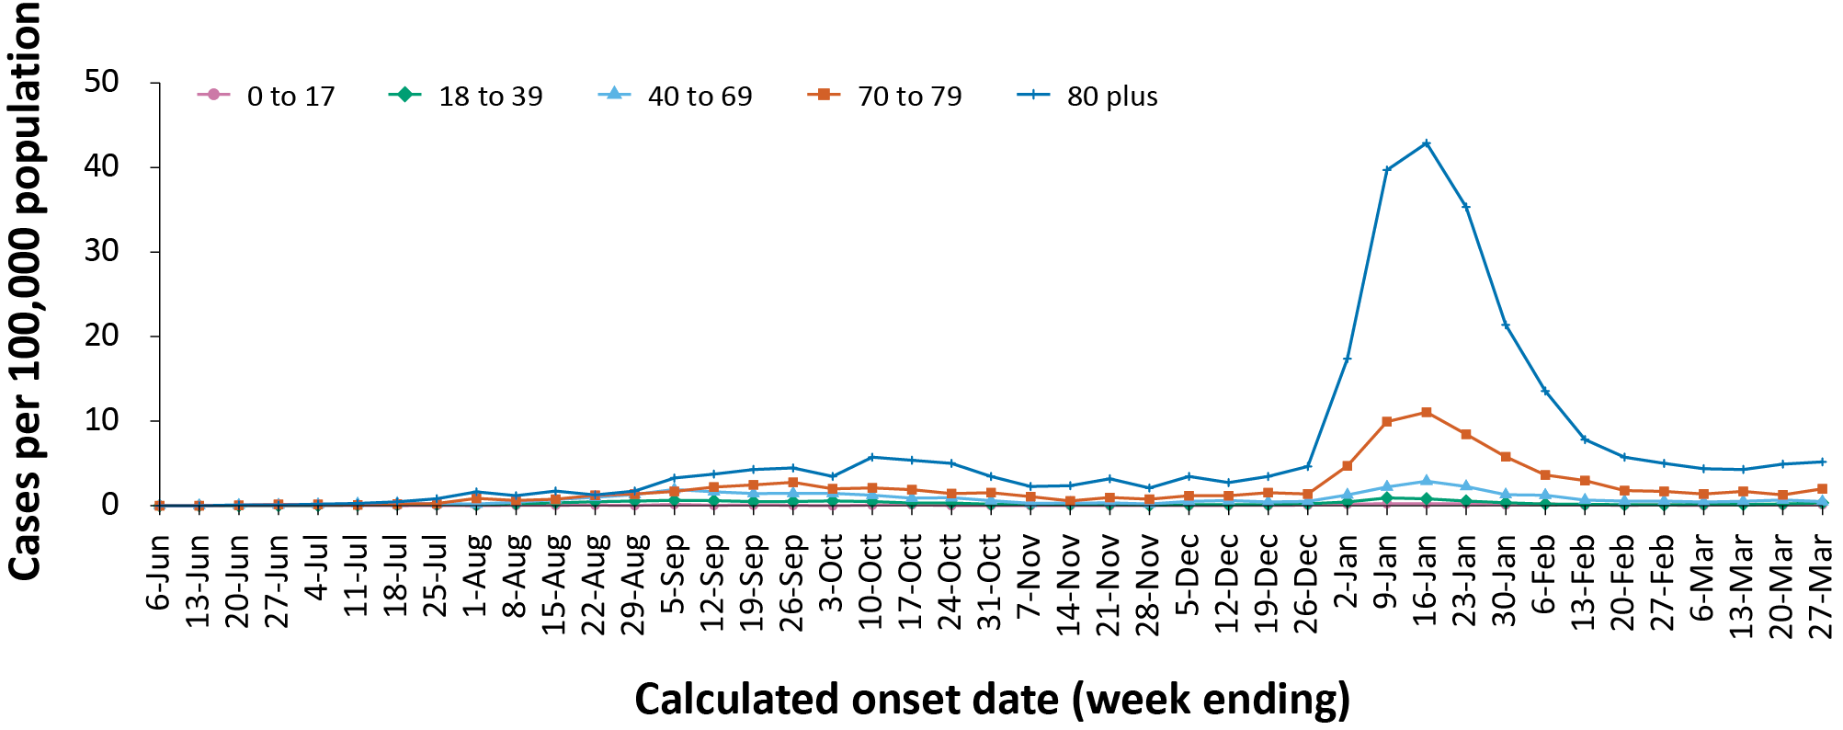
a NINDSS, extract from 11 April 2022. Includes cases with an illness onset up to 27 March; cases with an illness onset in the last two weeks (28 March – 10 April 2022) were excluded to account for the delay between onset and development of severe illness.

Table 7: Comorbidities for adult COVID-19 cases (aged greater than or equal to 18 years) amongst those admitted to ICU, Australia, 15 December 2021 – 10 April 2022ª
Comorbidity | ICU casesª (n = 1,542) (%)
Cardiac disease (n = 1,528) | 363 (24%)
Chronic respiratory condition (n = 1,530)^{b} | 364 (24%)
Diabetes (n = 1,527) | 544 (36%)
Obesity (n = 1,496) | 419 (28%)
Chronic renal disease (n = 1,515) | 222 (15%)
Chronic neurological condition (n = 1,518) | 83 (6%)
Malignancy (n = 1,524) | 167 (11%)
Chronic liver disease (n = 1,524) | 80 (5%)
Immunosuppression (n = 1,523) | 242 (16%)
Number of specified comorbidities (n = 1,542)^{c}
No comorbidities | 385 (25%)
One or more | 1,157 (75%)
Two or more | 733 (48%)
Three or more | 366 (24%)
a Source: SPRINT-SARI. Only includes adult cases (≥ 18 years old) and excludes those with missing data on comorbidities or where comorbidity is unknown.
b Includes asthma.
c Includes chronic respiratory conditions, cardiac disease (excluding hypertension), immunosuppressive condition/therapy, diabetes, obesity, liver disease, renal disease and neurological disorder.

COVID-19 deaths
There were 346 COVID-19 associated deaths among PCR-confirmed cases notified during the reporting period. The weekly number of deaths decreased over the four weeks, with 54 deaths reported in the most recent week, compared with 103 in the week ending 20 March 2022. This brings the total number of COVID-19-associated deaths among confirmed cases reported in NINDSS to 5,813 (Table 8).

Table 8: Deaths associated with COVID-19 by reporting period, Australia, 1 January 2020 – 10 April 2022^{a,b}
Jurisdiction^{c} | 14–20 March 2022 | 21–27 March 2022 | 28 March – 3 April 2022 | 4 – 10 April 2022 | 15 December 2021 – 10 April 2022  (Omicron wave) | 1 January 2020 – 10 April 2022  (Pandemic to date)
ACT | 1 (1.0%) | 0 (0.0%) | 2 (2.0%) | 4 (7.4%) | 27 (0.8%) | 39 (0.7%)
NSW | 37 (35.9%) | 31 (34.1%) | 56 (57.1%) | 30 (55.6%) | 1,499 (42.0%) | 2,192 (37.7%)
NT | 2 (1.9%) | 1 (1.1%) | 2 (2.0%) | 0 (0.0%) | 26 (0.7%) | 27 (0.5%)
Qld | 25 (24.3%) | 13 (14.3%) | 15 (15.3%) | 4 (7.4%) | 619 (17.4%) | 626 (10.8%)
SA | 9 (8.7%) | 14 (15.4%) | 3 (3.1%) | 1 (1.9%) | 269 (7.5%) | 273 (4.7%)
Tas. | 1 (1.0%) | 0 (0.0%) | 0 (0.0%) | 0 (0.0%) | 10 (0.3%) | 24 (0.4%)
Vic. | 17 (16.5%) | 28 (30.8%) | 19 (19.4%) | 15 (27.8%) | 1,075 (30.1%) | 2,582 (44.4%)
WA | 11 (10.7%) | 4 (4.4%) | 1 (1.0%) | 0 (0.0%) | 41 (1.1%) | 50 (0.9%)
Total | 103 (100.0%) | 91 (100.0%) | 98 (100.0%) | 54 (100.0%) | 3,566 (100.0%) | 5,813 (100.0%)
a Source: NINDSS, extract from 11 April 2022 for deaths to 10 April 2022.
b Deaths are categorised into time periods using date of death. Deaths with a missing date of death are classified using date of illness onset.
c ACT: Australian Capital Territory; NSW: New South Wales; NT: Northern Territory; Qld: Queensland; SA: South Australia; Tas.: Tasmania; Vic.: Victoria; WA: Western Australia.
Across all age groups, the population mortality rate for the current Omicron wave to date has equalled or exceeded that of the entire Delta wave. For those aged 70 years and over, the population mortality rate during the Omicron wave is more than double that observed during the Delta wave (Table 9). The higher mortality rates during the Omicron wave are due to the significantly higher levels of disease transmission in the community during the Omicron wave, rather than the Omicron variant inherently causing more severe illness compared to the Delta variant.

Table 9: COVID-19 associated deaths notified to NINDSS, by age group and date of onset, 1 January 2020 to 10 April 2022ª
Age group (years) | 15 December 2021 – 10 April 2022 (Omicron wave) |  | 16 June 2021 – 14 December 2021  (Delta wave) |  | 1 January 2020 – 10 April 2022  (Pandemic to date)
 | Deaths | Population mortality rate^{b} | Deaths | Population mortality rate^{b} | Deaths | Population mortality rate^{b}
0–4 | 5 | 0.3 | 0 | 0.0 | 5 | 0.3
5–11 | 2 | 0.1 | 1 | < 0.05 | 3 | 0.1
12–15 | 1 | 0.1 | 1 | 0.1 | 2 | 0.2
16–17 | 0 | 0.0 | 0 | 0.0 | 0 | 0.0
18–29 | 10 | 0.2 | 8 | 0.2 | 19 | 0.5
30–39 | 34 | 0.9 | 22 | 0.6 | 58 | 1.5
40–49 | 56 | 1.7 | 47 | 1.4 | 105 | 3.2
50–59 | 122 | 3.9 | 121 | 3.8 | 258 | 8.2
60–69 | 332 | 12.1 | 213 | 7.8 | 582 | 21.3
70–79 | 736 | 37.7 | 363 | 18.6 | 1,258 | 64.4
80–89 | 1,302 | 148.6 | 438 | 50.0 | 2,116 | 241.5
90+ | 863 | 388.8 | 226 | 101.8 | 1,407 | 633.9
Unknown | 0 | — | 0 | — | 0 | —
Total | 3,463 | 13.5 | 1,440 | 5.6 | 5,813 | 22.6
a Source: NINDSS, extract from 11 April 2022.
b Population mortality rates are presented per 100,000 population for the given time period.

Genomic surveillance and virology

(Communicable Disease Genomics Network, AusTrakka and jurisdictional sequencing laboratories)
Nationally, 2.92% of COVID-19 cases have had SARS-CoV-2 isolates sequenced since the start of the pandemic, based on jurisdictional reporting (Table 10). Case numbers and sequencing proportion are based on PCR results only, as rapid antigen tests do not allow for sequencing. The significant rise in case numbers nationally during this reporting period has required jurisdictional laboratories to sample isolates to sequence for surveillance purposes, resulting in a drop in the overall proportion sequenced. However, the overall output of the number of cases sequenced per reporting period remains similar to, or higher than, previous reporting periods (Figure 5).

Table 10: Australian SARS-CoV-2 genome sequences and proportion of positive cases sequenced, 14 March – 10 April 2022 and cumulative to date
Measure | Reporting period  14 March 2022 – 10 April 2022 | Cumulative  23 January 2020 – 10 April 2022
SARS-CoV-2 cases sequencedª | 8,871 | 86,623
Percentage of positive cases sequenced^{b} | 1.55% | 2.92%
a Based on individual jurisdictional reports of sequences and case numbers. Calculations of the percentage of cases sequenced based on the number of sequences available in AusTrakka may not always be up-to-date, since this may include duplicate samples from cases and may not represent all available sequence data.
b Total SARS-CoV-2 case numbers as reported by jurisdictional laboratories based on PCR results only. Cases identified via rapid antigen testing are reported differently by each jurisdiction and cannot be followed up for sequencing. They are therefore not included in the sequencing proportions reported here. Sequencing of samples from cases identified in the reporting period may be in process at the time of reporting. Remaining unsequenced samples may be due to jurisdictional sequencing strategy, or where samples have been deemed unsuitable for sequencing (typically because viral loads were too low for sequencing to be successful).
Figure 5: Samples in AusTrakka from 10 November 2021 to 10 April 2022, by lineage and date of collectionª
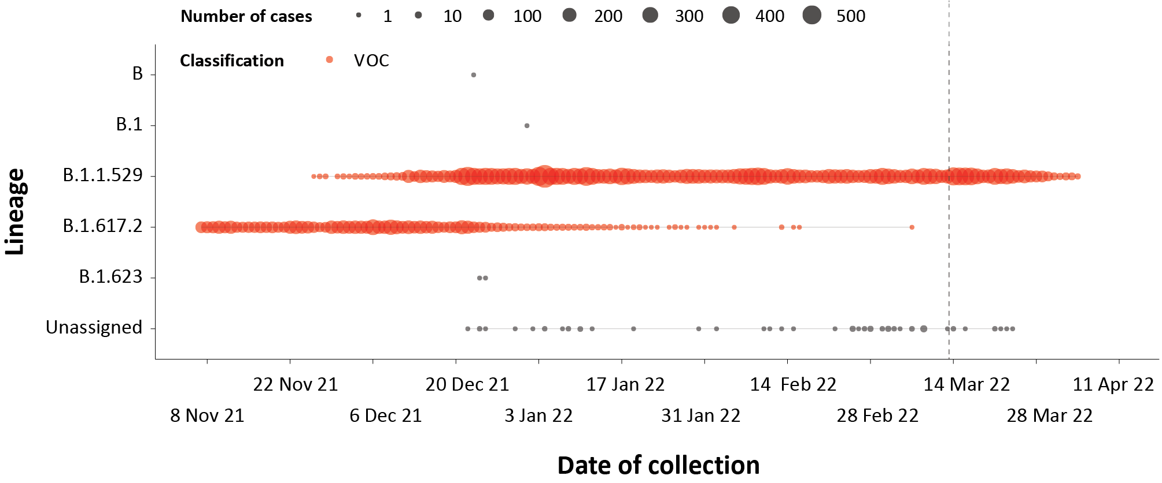
a The start of the current reporting period (14 March to 10 April 2022) is marked by the dotted line, and variant of concern samples are coloured red. The size of the circle is proportional to the number of samples in the lineage at each time point.

Variants of concern (VOC)
Of the cases in AusTrakka to date, 31,510 have been identified as the Delta VOC (including AY sublineages) and 33,007 have been identified as the Omicron VOC (including Omicron-like sequences). Of those identified as Omicron, 61.8% are of the BA.1 sub-lineage; 14.5% are of the BA.1.1 sub-lineage; and 23.6% are of the BA.2 sub-lineage. There has been a notable increase in the proportion of the BA.2 sub-lineage in samples collected since late February 2022 (Figure 6). For samples collected in the last 21 days (21 March to 10 April 2022), the BA.2 sub-lineage constituted 88.7% (2,087/2,353) of the Omicron sequences (Figure 6).
Further information on variants is available in the Technical Supplement. ²

Figure 6: Sequences in AusTrakka by Omicron sub-lineage and collection date, 14 February to 10 April 2022ª
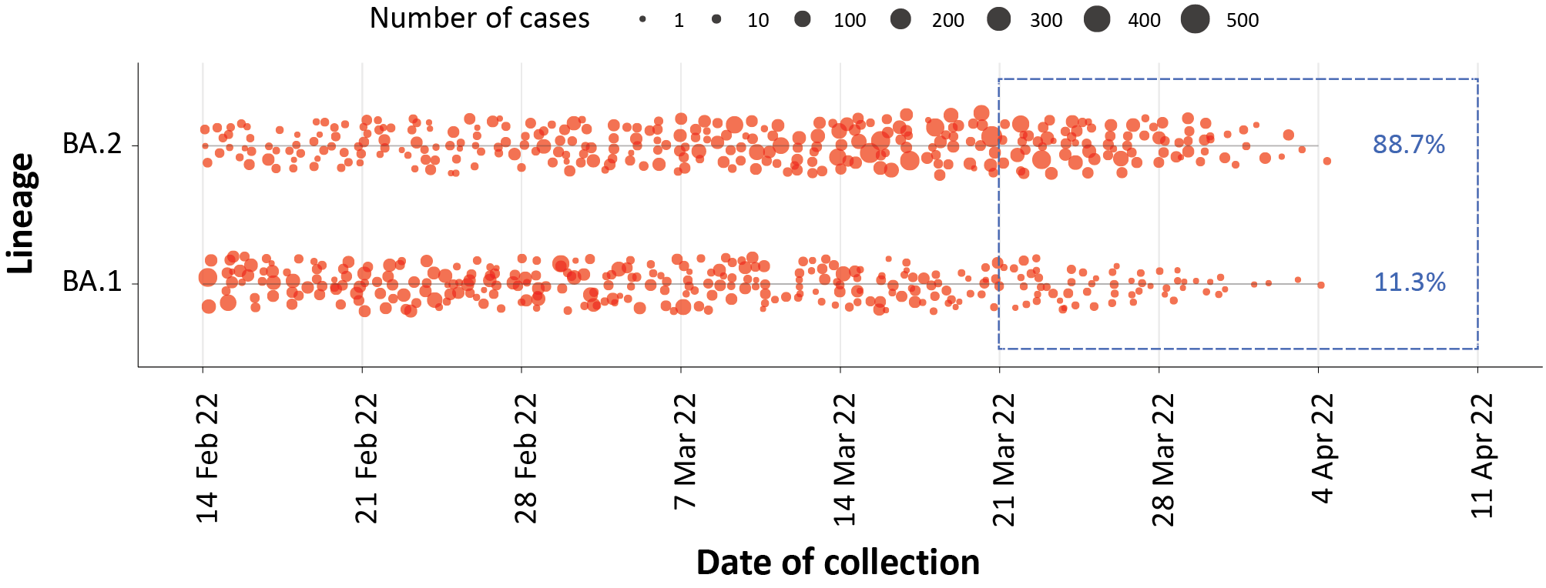
a The size of each dot is proportional to the number of sequences observed in each jurisdiction each day. The blue rectangle and numbers in blue show the proportion of each sub-lineage in the past 21-day period.

Testing

(State and territory reporting)
From the commencement of the pandemic to 10 April 2022, over 67.7 million COVID-19 PCR tests have been conducted nationally. Jurisdictional PCR testing rates are driven by current case numbers, testing policies and numbers of people experiencing symptoms. The number, rates and percent positivity of RATs cannot be calculated, as there is currently no reporting of negative RATs.
During the four-week reporting period from 14 March 2022 to 10 April 2022, over 3 million PCR tests were conducted. During the reporting period, weekly PCR testing rates increased across most jurisdictions, with the largest increase occurring in South Australia (Figure 7). In the week ending 10 April 2022, PCR percent positivity was below 20% in all jurisdictions, except Queensland and Tasmania.

Figure 7: SARS-CoV-2 polymerase chain reaction (PCR) testing rates per 1,000 population and percent positivity by jurisdiction and date of notification, 31 May 2021 – 10 April 2022ª
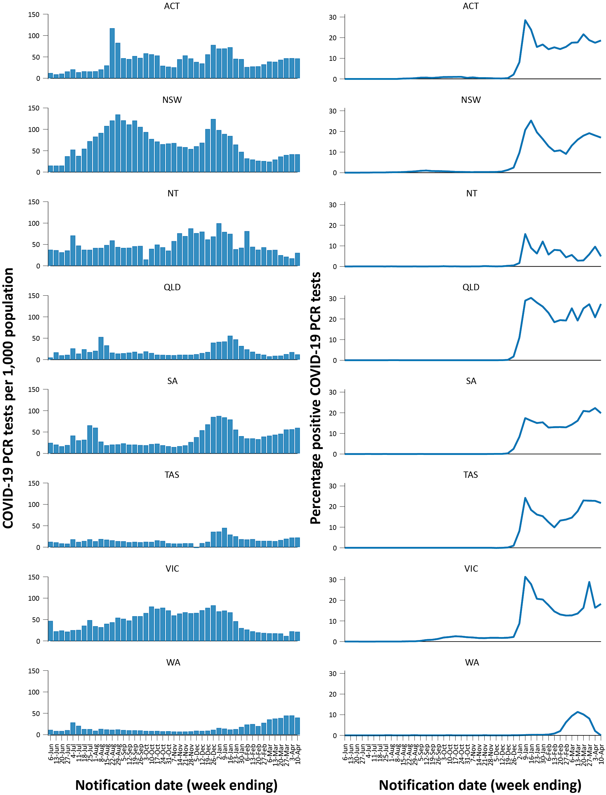
a Source: testing data provided by jurisdictions to the NIR daily, current to 10 April 2022; case data extracted from NINDSS on 11 April 2022 for cases with a notification date up to 10 April 2022; population data based on Australian Bureau of Statistics (ABS) Estimated Resident Population (ERP) as at June 2021.

Acute respiratory illness

(FluTracking, ASPREN, and Commonwealth Respiratory Clinics)
Based on self-reported FluTracking data, ⁷ prevalence of fever and cough in the community over this reporting period increased from 1.78% to 1.94% (Figure 8). This is higher than the rate observed during the peak of cases in the Omicron wave in January 2022 which was 1.5%. The prevalence of runny nose and sore throat symptoms also increased throughout the reporting period from 1.16% to 1.35%, which is notably higher than the prevalence of 0.9% that was observed for runny nose and sore throat symptoms during the apparent peak of the Omicron wave (9 to16 January 2022).
Figure 8: Weekly trends in respiratory illness amongst FluTracking survey participants (age-standardised) compared to the average of the previous five years, Australia, by epidemiological week,ª 1 January 2021 – 10 April 2022^{b}
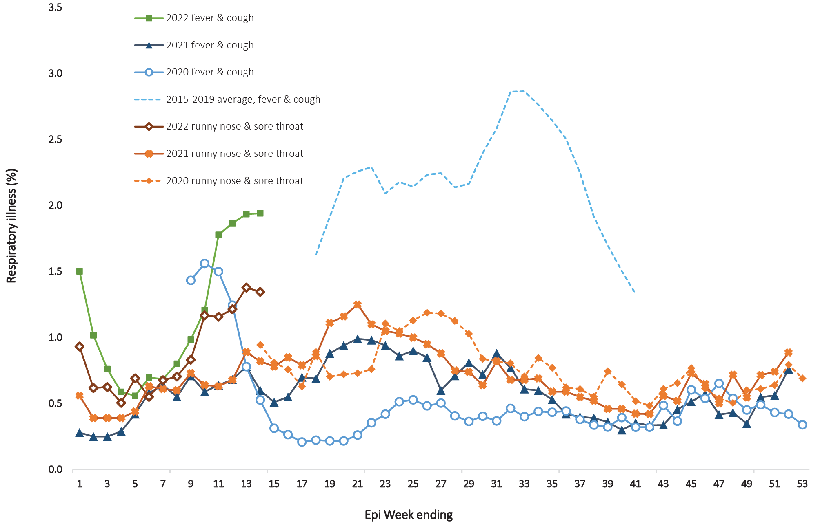
a Epidemiological weeks are a standardised method for numbering weeks across years, with the first epidemiological week of any year ending on the first Saturday in January.
b In years prior to 2020, FluTracking was activated during the main Influenza season from May to October. A historical average beyond the week ending 11 October (epidemiological week 41) is therefore not available. In 2020, FluTracking commenced ten weeks early to capture data for COVID-19. Data on runny nose and sore throat were only collected systematically after 29 March 2020, therefore a historical average for this symptom profile is unavailable.
In this reporting period, acute respiratory illness was highest in those aged 0 to 9 years, based on both self-reported FluTracking data and presentations to Commonwealth Respiratory Clinics. Throughout the reporting period, fever and cough symptoms were observed more commonly in younger age groups and decreased with age, whilst the rate of runny nose and sore throat symptoms were highest in those aged 30 to 49 years.
Rates of fever and cough by jurisdiction ranged from 8.0 per 1,000 FluTracking participants in Western Australia to 17.2 per 1,000 participants in South Australia. Rates of runny nose and sore throat ranged from 8.4 per 1,000 FluTracking participants in Western Australia to 13.6 per 1,000 FluTracking participants in the Australian Capital Territory. Overall, rates for both sets of symptoms increased significantly from the previous reporting period.
Over the reporting period, FluTracking data indicated that 39% of those in the community with ‘fever and cough’ were tested for SARS-CoV-2 with a PCR test and 88% were tested using a RAT (noting that in some instances RATs will be followed up by a PCR test for the same case). Of those with runny nose and sore throat, 18% were tested for SARS-CoV-2 using a PCR test and 79% were tested using a RAT. Of those with fever and cough who tested for SARS-CoV-2, 61% who were tested with a PCR test, and 58% who were tested with a RAT, were positive. In comparison, of participants with runny nose and sore throat who tested for SARS-CoV-2, 21% of those tested by PCR, and 10% of those tested by RAT, tested positive. Note that participants with one set of symptoms are not excluded from having the other.
In the most recent four-week period, testing rates for fever and cough were highest in South Australia for PCR (59.9%) and in the Northern Territory for RATs (97.8%), while rates were lowest in Queensland for PCR (21.5%) and in the Australian Capital Territory for RATs (80.8%). Testing rates for runny nose and sore throat were highest in South Australia for PCR (36.6%) and in Victoria for RATs (84.2%), whilst rates were lowest in the Northern Territory for PCR (7.3%) and in South Australia for RATs (66.1%). It is important to acknowledge that there may be legitimate reasons why people did not get tested, including barriers to accessing testing. Symptoms reported to FluTracking are not specific to COVID-19 and may also be due to chronic diseases.
From 14 March to 10 April 2022, there were 92,783 assessments at Commonwealth Respiratory Clinics. Of these, there were 84,194 assessments with consent to share information, with 92% (77,449/84,194) tested for SARS-CoV-2. Of those who tested, 19% (14,748/77,449) were found to be positive.

Countries and territories in Australia’s near region
According to WHO, countries and territories in the South East Asian and Western Pacific regions reported 18,367,550 newly-confirmed cases and 35,454 deaths in the four-week period to 10 April 2022, bringing the cumulative cases in the two regions to over 107 million, and cumulative deaths in these regions to over 998,000. ⁸ New case numbers in the South East Asian region over this four-week reporting period have decreased by more than 50% in comparison to the previous four week reporting period, whilst new cases in the Western Pacific region have increased by almost a third. The increase of new cases in the Western Pacific region during the reporting period was largely driven by cases in Japan, the Republic of Korea and Vietnam. ⁹ The number of new deaths in the four-week reporting period have followed the same pattern as cases, with decreases in the South East Asian region compared to the previous four weeks, and increases in the Western Pacific region.
Table 11 outlines the new cases and deaths in the four-week period to 10 April 2022 and cumulative cases and deaths for the pandemic in selected countries with the highest number of new cases in the South East Asian region and the Western Pacific region.
As of 10 April 2022, over 496 million COVID-19 cases and over 6 million deaths have been reported globally since the start of the pandemic, with a global case fatality rate (CFR) of 1.2%. The two regions reporting the largest burden of disease over the past four weeks were the European region (38% of total cases) and the Western Pacific region (18% of total cases).
Table 11: Cumulative cases and deaths, and new cases and deaths reported in the four-week period to 10 April 2022 for selected countries in Australia’s near region according to WHOª
Country | Cumulative cases | New cases reported in the last 4 weeks | Change in new cases in the last 4 weeks^{b} | Cumulative deaths | New deaths reported in the last 4 weeks | Change in new deaths in the last 4 weeks^{b}
South East Asian region
Indonesia | 3,883,485 | 698,660 | +18% | 26,083 | 2,374 | +86%
Thailand | 6,032,707 | 142,212 | -87% | 155,626 | 3,460 | -51%
India | 43,035,271 | 44,280 | -88% | 521,685 | 5,835 | -19%
Bangladesh | 42,222 | 24,602 | +141% | 14 | 7 | +250%
Nepal | 612,341 | 6,994 | -88% | 19,434 | 25 | -75%
Western Pacific region
Republic of Korea | 15,333,670 | 8,777,238 | +69% | 19,421 | 9,026 | +172%
Vietnam | 10,169,929 | 4,266,782 | +25% | 42,794 | 1504 | -38%
Japan | 4,837,231 | 1,673,464 | +153% | 6,550 | 979 | -4%
Australia | 6,991,687 | 1,271,293 | -33% | 28,646 | 2,617 | -55%
Philippines | 4,317,706 | 516,670 | -34% | 35,280 | 1560 | -3%
a Source: World Health Organization Coronavirus (COVID-19) Dashboard, accessed 13 April 2022.
b Percent change in the number of newly confirmed cases/deaths in the most recent four-week period compared to the four weeks prior.

Acknowledgements
We thank public health staff from incident emergency operations centres and public health units in state and territory health departments, and the Australian Government Department of Health, along with state and territory public health laboratories. We thank those who have provided data from surveillance systems, such as Commonwealth respiratory clinics, ASPREN, FluTracking, FluCAN, SPRINT-SARI, Communicable Disease Genomics Network, AusTrakka and jurisdictional sequencing laboratories.

Author details

Corresponding author
COVID-19 National Incident Room Surveillance Team
Australian Government Department of Health, GPO Box 9484, MDP 14, Canberra, ACT 2601.
Email: epi.coronavirus@health.gov.au

References
- COVID-19 National Incident Room Surveillance Team. COVID-19 Australia: Epidemiology Report 59: Reporting period ending 13 March 2022. Commun Dis Intell (2018). 2022;46. doi: https://doi.org/10.33321/cdi.2022.46.25.
- COVID-19 National Incident Room Surveillance Team. Technical supplement. COVID-19 Australia: Epidemiology reporting. Commun Dis Intell (2018). 2021;45. doi: https://doi.org/10.33321/cdi.2021.45.2.
- Australian Government Department of Health. Coronavirus disease 2019 (COVID-19): CDNA national guidelines for public health units. [Internet.] Canberra: Australian Government Department of Health; 14 January 2022. [Accessed on 21 January 2022.] Available from: https://www1.health.gov.au/internet/main/publishing.nsf/Content/cdna-song-novel-coronavirus.htm.
- Australian Government Department of Health. Vaccination numbers and statistics. [Internet.] Canberra: Australian Government Department of Health; 2022. [Accessed on 11 April 2022.] Available from: https://www.health.gov.au/initiatives-and-programs/covid-19-vaccines/numbers-statistics.
- Australian and New Zealand Intensive Care Research Centre (ANZIC-RC). SPRINT-SARI: Short period incidence study of severe acute respiratory infection. [Internet.] Melbourne: Monash University, ANZIC-RC; 2020. Available from: https://www.monash.edu/medicine/sphpm/anzicrc/research/sprint-sari.
- Communicable Diseases Genomics Network (CDGN). AusTrakka. [Website.] Melbourne: CDGN; 2020. Available from: https://www.cdgn.org.au/austrakka.
- Dalton C, Durrheim D, Fejsa J, Francis L, Carlson S, d’Espaignet ET et al. Flutracking: a weekly Australian community online survey of influenza-like illness in 2006, 2007 and 2008. Commun Dis Intell Q Rep. 2009;33(3):316–22.
- World Health Organization (WHO). WHO Coronavirus Disease (COVID-19) dashboard. [Internet.] Geneva: WHO; 2021. Available from: https://covid19.who.int/.
- WHO. Weekly epidemiological update on COVID-19 – 12 April 2022. [Internet.] Geneva: WHO; 15 March 2022. [Accessed on 17 March 2022.] Available from: https://www.who.int/publications/m/item/weekly-epidemiological-update-on-covid-19---12-april-2022.

Appendix A: Supplementary figures and tables
Table A.1: COVID-19 cases and rates per 100,000 population, by age group, sex, and notification received date, Australia, 15 December 2021 – 10 April 2022^{a,b}
Age group | Four-week reporting period |  |  |  |  |  | Current ‘Omicron’ wave
 | 14 March – 10 April 2022 |  |  |  |  |  | 15 December 2021 – 10 April 2022
 | Cases |  |  | Rate per 100,000 population |  |  | Cases |  |  | Rate per 100,000 population
 | Male | Female | People | Male | Female | People | Male | Female | People | Male | Female | People
0–4 | 12,142 | 11,356 | 23,650 | 1,551.6 | 1,538.0 | 1,555.0 | 56,022 | 51,629 | 108,368 | 7,158.9 | 6,992.3 | 7,125.2
5–11 | 27,301 | 26,124 | 53,721 | 2,324.6 | 2,345.8 | 2,347.9 | 112,977 | 107,516 | 221,762 | 9,619.8 | 9,654.5 | 9,692.1
12–15 | 17,594 | 18,731 | 36,505 | 2,694.3 | 3,028.2 | 2,870.9 | 59,898 | 62,775 | 123,374 | 9,172.6 | 10,148.6 | 9,702.5
16–17 | 6,414 | 7,220 | 13,712 | 2,113.6 | 2,521.5 | 2,324.8 | 30,449 | 35,022 | 65,896 | 10,033.6 | 12,230.8 | 11,172.4
18–29 | 43,415 | 51,096 | 94,899 | 2,095.9 | 2,568.3 | 2,336.9 | 303,110 | 331,816 | 639,697 | 14,633.2 | 16,678.7 | 15,752.8
30–39 | 40,455 | 49,149 | 89,934 | 2,169.9 | 2,564.9 | 2,378.8 | 207,042 | 230,632 | 440,322 | 11,105.3 | 12,035.7 | 11,646.9
40–49 | 36,509 | 44,110 | 80,871 | 2,236.1 | 2,653.6 | 2,454.3 | 154,815 | 178,470 | 334,900 | 9,482.0 | 10,736.3 | 10,163.8
50–59 | 27,789 | 30,059 | 58,015 | 1,810.6 | 1,868.3 | 1,845.5 | 117,533 | 127,627 | 246,390 | 7,657.9 | 7,932.7 | 7,837.7
60–69 | 18,985 | 19,253 | 38,358 | 1,431.5 | 1,363.9 | 1,401.0 | 76,485 | 76,956 | 154,146 | 5,767.0 | 5,451.6 | 5,630.1
70–79 | 11,253 | 10,077 | 21,429 | 1,189.6 | 1,001.0 | 1,097.4 | 41,301 | 36,965 | 78,734 | 4,366.2 | 3,671.9 | 4,032.2
80–89 | 4,555 | 4,247 | 8,860 | 1,175.3 | 868.9 | 1,011.0 | 16,465 | 16,324 | 33,091 | 4,248.5 | 3,339.7 | 3,776.1
90+ | 1,005 | 1,658 | 2,701 | 1,292.0 | 1,150.1 | 1,217.0 | 3,711 | 6,271 | 10,148 | 4,770.7 | 4,350.1 | 4,572.3
a Source: NINDSS, extract from 11 April 2022 for notifications up to 10 April 2022. Excludes cases where age or sex data is missing.
b Population data based on Australian Bureau of Statistics (ABS) Estimated Resident Population (ERP) as at June 2021.

Communicable Diseases Intelligence
ISSN: 2209-6051 Online

Communicable Diseases Intelligence (CDI) is a peer-reviewed scientific journal published by the Office of Health Protection and Response, Department of Health. The journal aims to disseminate information on the epidemiology, surveillance, prevention and control of communicable diseases of relevance to Australia.

Editor: Noel Lally
Deputy Editor: Simon Petrie
Design and Production: Kasra Yousefi
Editorial Advisory Board: David Durrheim, Mark Ferson, John Kaldor, Martyn Kirk and Linda Selvey

Website: http://www.health.gov.au/cdi

Contacts
CDI is produced by the Office of Health Protection and Response, Australian Government Department of Health, GPO Box 9848, (MDP 6) CANBERRA ACT 2601

Email: cdi.editor@health.gov.au

Submit an Article
You are invited to submit your next communicable disease related article to the Communicable Diseases Intelligence (CDI) for consideration. More information regarding CDI can be found at: http://health.gov.au/cdi.
Further enquiries should be directed to: cdi.editor@health.gov.au.

This journal is indexed by Index Medicus and Medline.

Creative Commons Licence - Attribution-NonCommercial-NoDerivatives CC BY-NC-ND
© 2022 Commonwealth of Australia as represented by the Department of Health
This publication is licensed under a Creative Commons Attribution-NonCommercial-NoDerivatives 4.0 International Licence from https://creativecommons.org/licenses/by-nc-nd/4.0/legalcode (Licence). You must read and understand the Licence before using any material from this publication.

Restrictions
The Licence does not cover, and there is no permission given for, use of any of the following material found in this publication (if any):
- the Commonwealth Coat of Arms (by way of information, the terms under which the Coat of Arms may be used can be found at www.itsanhonour.gov.au);
- any logos (including the Department of Health’s logo) and trademarks;
- any photographs and images;
- any signatures; and
- any material belonging to third parties.

Disclaimer
Opinions expressed in Communicable Diseases Intelligence are those of the authors and not necessarily those of the Australian Government Department of Health or the Communicable Diseases Network Australia. Data may be subject to revision.

Enquiries
Enquiries regarding any other use of this publication should be addressed to the Communication Branch, Department of Health, GPO Box 9848, Canberra ACT 2601, or via e-mail to: copyright@health.gov.au

Communicable Diseases Network Australia
Communicable Diseases Intelligence contributes to the work of the Communicable Diseases Network Australia.
http://www.health.gov.au/cdna

Previously known as the National Notifiable Diseases Surveillance System (NNDSS).
These data are provided by the national pathogen genomic sequence and analysis platform, AusTrakka,⁶ and from jurisdictional pathogen sequencing laboratories to summarise the genomic epidemiology of SARS-CoV-2 in Australia. Numbers are subject to change retrospectively and sequences are not able to be obtained from all samples (see Technical Supplement).²

