COVID-19 Australia: Epidemiology Report 24
Fortnightly reporting period ending 30 August 2020
COVID-19 National Incident Room Surveillance Team
Unless indicated, the source of all data, including notified cases of COVID-19 and associated deaths, is the National Notifiable Diseases Surveillance System (NNDSS) to 30 August 2020. Due to the dynamic nature of NNDSS data, data in this report are subject to retrospective revision and may vary from data reported in published NNDSS reports and reports of notification data by states and territories. Case numbers for the most recent dates of illness onset may be subject to revision, due to reporting delays.
Confirmed cases in Australia | Last reporting periodª  3—16 August | This reporting periodª  17—30 August | Cumulative^{b}  As at 30 August 2020
Notifications | 4,501 | 1,751 | 25,686
Deaths | 136 | 26 | 577
a Based on diagnosis date.
b Based on notification date.

Summary (17—30 August)
- The number of new cases reported nationally this fortnight was 1,751, a 61% decrease from the previous fortnight (4,501). On average this represented 125 cases diagnosed each day over the reporting period, a decrease from 322 cases per day over the previous reporting period.
- 94% (1,640) of all cases were reported in Victoria, with a smaller number of cases reported from New South Wales (86), Queensland (19), Western Australia (5) and South Australia (1).
- In Victoria, the majority of cases (1,528; 93%) were locally acquired, with a further 112 (7%) under investigation at the time of analysis, but likely also to be locally acquired.
- Of the remaining 111 cases reported, 22 (20%) were overseas acquired; 82 (74%) were locally acquired, predominantly in NSW, and 7 (6%) were reported as under investigation.
- The continued decrease in new cases observed this fortnight in Victoria is likely associated with the enhanced public health measures that are currently in place in Victoria. Locally-acquired cases which were predominantly associated with several interconnected clusters continued to be reported in NSW. In Qld a cluster of cases associated with a youth detention centre was identified.
- A total of 26 deaths was reported from cases diagnosed in this reporting period, all from Victoria and aged 75 years or older.
- Testing rates remain high across all jurisdictions, with an overall positivity rate for the reporting period of 0.27%. Victoria reported a positivity rate of 0.90% for this reporting period; in all other jurisdictions the positivity rate was 0.03% or lower.
Keywords: SARS-CoV-2; novel coronavirus; 2019-nCoV; coronavirus disease 2019; COVID-19; acute respiratory disease; epidemiology; Australia
Figure 1. New and cumulative COVID-19 notifications by diagnosis week ending 30 August 2020,ª Australia
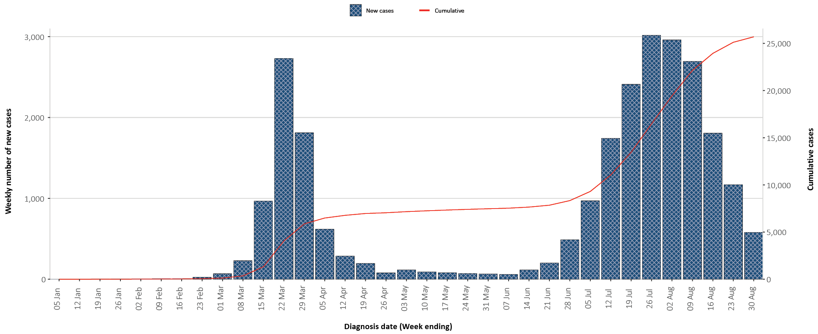
a Illnesses that began within 7 days prior to 30 August 2020 may not yet be reported and interpretation of trends during this period should be undertaken with caution.

Australian cases: descriptive epidemiology

Transmission trends
Since the first case of COVID-19 was identified in Australia, all states and territories have experienced COVID-19 cases, with some jurisdictions experiencing higher numbers and more community-associated transmission. These differences arise from factors including state demographics, population size, and patterns of overseas arrivals.
As at 30 August 2020 there were 25,686 COVID-19 cases, including 577 deaths, reported nationally with two distinct peaks in March and July (Figure 2). During this reporting period, there were 1,751 cases, including 26 deaths recorded. On average, 125 cases were diagnosed each day over the reporting period, a decrease from 322 cases per day over the previous reporting period. The majority of the recently-diagnosed cases were from Victoria (1,640; 94%), followed by New South Wales (86; 5%). A small number of cases were reported in Queensland (19), Western Australia (5), and South Australia (1). No new cases were reported from Tasmania, the Northern Territory or the Australian Capital Territory. Most cases in this period were reported to reside in major metropolitan areas (Figure 3 and Figure B.2).

Figure 2. COVID-19 notifications, Victoria and all other jurisdictions, by week and source of acquisition, as at 30 August 2020
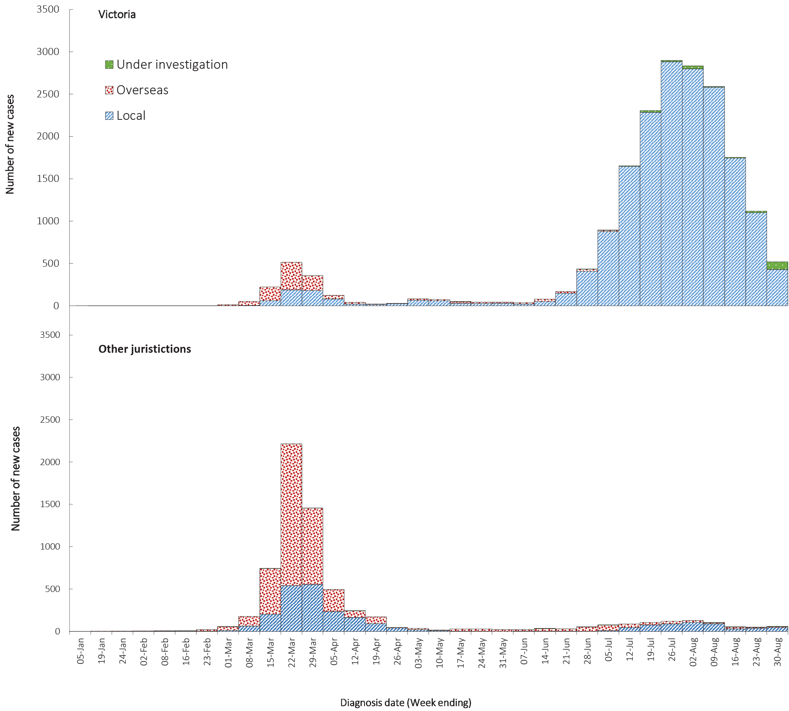

Figure 3. Heat map showing COVID-19 locally-acquired case notifications by place of residence, Australia, 17 to 30 August 2020ª
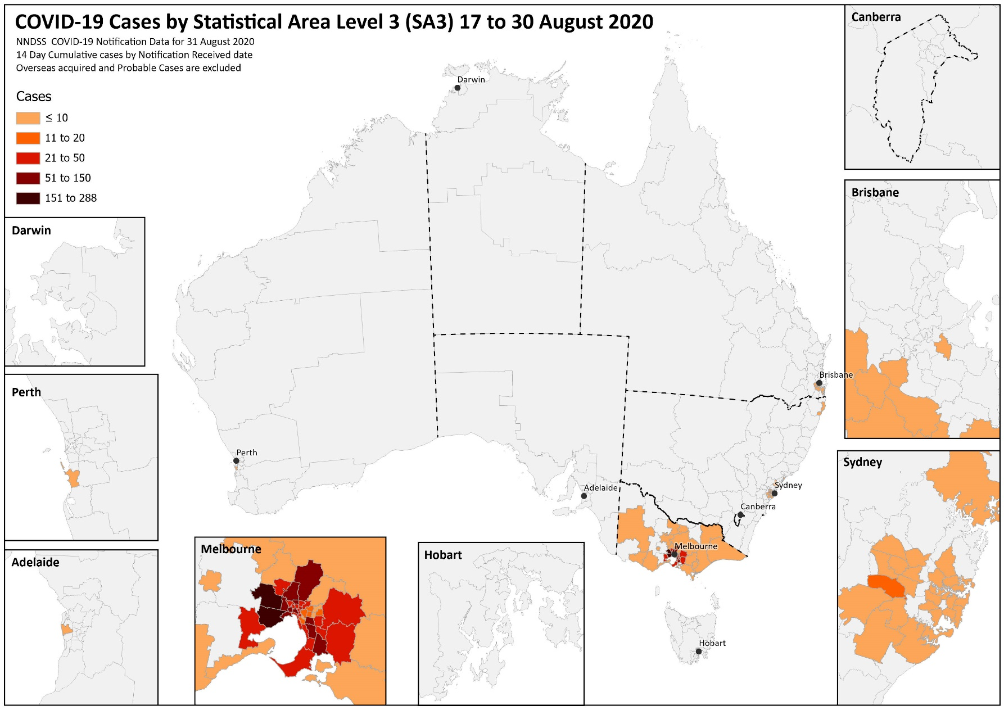
a Source: NNDSS

While there has been a continued decline in case numbers from Victoria, there is still a degree of ongoing community transmission. During this reporting period locally-acquired cases linked to interconnected clusters continued to be reported in NSW, and in Qld a cluster of cases associated with a youth detention centre was identified.

Source of acquisition
For this reporting period, 92% of all cases were reported as locally acquired. Of these locally-acquired cases the source of acquisition for 15% (247/1,751) of cases could not be identified, which is consistent with the previous reporting period (15%; 566/3,767). In total, 7% (119) of all cases remain under investigation and less than 2% were reported as overseas acquired (Table 1).
Table 1. COVID-19 notifications by jurisdiction and source of acquisition, 17—30 August 2020
Source | NSW | Vic | Qld | WA | SA | Tas | NT | ACT | Australia
Overseas | 18 | 0 | 0 | 4 | 0 | 0 | 0 | 0 | 22
Local—source known | 54 | 1,291 | 17 | 0 | 1 | 0 | 0 | 0 | 1,363
Local—source unknown | 10 | 237 | 0 | 0 | 0 | 0 | 0 | 0 | 247
Under investigation | 4 | 112 | 2 | 1 | 0 | 0 | 0 | 0 | 119
Total | 86 | 1,640 | 19 | 5 | 1 | 0 | 0 | 0 | 1,751

For this reporting period, 94% of cases have been reported from Victoria (1,640/1,751) with 79% (1.291/1,640) of these cases reported as locally acquired with known source, 14% (237/1,640) as locally acquired with unknown source, 7% as under investigation (though likely locally acquired), and no cases are reported as overseas acquired (Table 1). In Victoria the proportion of cases reported as under investigation at the time of each report continues to decrease, and the proportion of cases considered to have an unknown source is also declining over time.
Excluding Victoria, for all other cases (111) in this reporting period: 65% (72/111) are reported as locally acquired with known source; 9% (10/111) of cases are reported as locally acquired with unknown source; 20% (22/111) of cases are reported as overseas acquired (note, no overseas-acquired cases were reported in Victoria); and 6% of cases reported are under investigation (Table 1). Overseas-acquired cases were reported from NSW (18) and WA (4) and were travellers in hotel quarantine from repatriation flights. These proportions are similar to the previous reporting period. Excluding those reported in Victoria, the majority of cases (77%; 86/111) were reported by NSW and an increasing proportion were reported in Queensland (17%; 19/111).
The national rate of infection in locally-acquired cases in this reporting period was 6.8 cases per 100,000 population, which is a decrease from the rate observed in the previous reporting period (17.6 cases per 100,000 population, Table 2). Cumulatively, the infection rate to date for all locally-acquired cases is highest in Victoria with 272.6 infections per 100,000 population with Tasmania reporting the second highest rate with 27.9 infections per 100,000, followed by New South Wales with 22.3 infections per 100,000 population.

Table 2. Locally-acquired COVID-19 case numbers and rates per 100,000 population by jurisdiction and reporting period, as at 30 August 2020
Jurisdiction | Reporting period  3—16 August |  | Reporting period  17—30 August |  | Cumulative cases
 | Number of cases | Rates per 100,000 population | Number of cases | Rates per 100,000 population | Number of cases | Rates per 100,000 population
NSW | 116 | 1.4 | 68 | 0.8 | 1,804 | 22.3
Vic | 4,343 | 65.8 | 1,640 | 24.9 | 17,979 | 272.6
Qld | 5 | 0.1 | 19 | 0.4 | 274 | 5.4
WA | 2 | 0.1 | 1 | 0.0 | 101 | 3.9
SA | 1 | 0.1 | 1 | 0.1 | 150 | 8.6
Tas | 1 | 0.2 | 0 | 0.0 | 149 | 27.9
NT | 0 | 0.0 | 0 | 0.0 | 6 | 2.4
ACT | 0 | 0.0 | 0 | 0.0 | 29 | 6.8
Australia | 4,468 | 17.6 | 1,729 | 6.8 | 20,492 | 80.8

In Victoria, the rate of infection for locally-acquired cases decreased from 65.8 per 100,000 population (last reporting period) to 24.9 per 100,000 population (this reporting period). For this reporting period, the infection rate in all other jurisdictions was less than 0.8 per 100,000 population.

Clusters and outbreaks
Nationally, excluding New South Wales, for the fortnight ending 30 August, there were a total of 152 open outbreaks (defined as those where a new epidemiologically-linked case was identified in the previous 14 days). Of these, most were reported from Victoria, with open outbreaks also reported from Queensland. Outbreaks were reported most frequently from residential aged care settings (70) followed by workplaces (29), hospitals (24), healthcare facilities (10) and educational facilities (10). Outbreaks ranged in size, with the largest outbreak encompassing 217 cases in a residential aged care facility. Prominent workplace settings included warehouses, abattoirs/meat packing facilities, distribution centres and manufacturers.
Residents of aged care facilities are at increased risk of COVID-19 infection due to the environment of communal living facilities and are more vulnerable to serious complications if they do become infected. As at 30 August 2020, there have been 3,723 cases of COVID-19 associated with 207 residential aged care facilities, with 2,103 recoveries and 412 deaths. 1,870 of these cases occurred in aged care residents, with the remaining 1,853 cases occurring in care staff. The Commonwealth is actively supporting services with reported incidents and outbreaks of COVID-19 providing access to personal protective equipment and additional staffing resources where required. Advice and guidelines have been provided to aged care services, including the release of an outbreak management guide.^{1,2}

Table 3. Diagnostic tests performed in Australia, by jurisdiction, as at 30 August 2020ª
Jurisdiction | Tests performed |  |  | Tests performed |  |  | Cumulative tests performed
 | 3 August - 16 August |  |  | 17 August—30 August |  |  | to 30 August
 | N | Positivity (%) | Per 100,000 population ^{a,b} | N | Positivity (%) | Per 100,000 population ^{a,b} | N | Positivity (%) | Per 100,000 population ^{a,b}
NSW | 324,940 | 0.05 | 4,017 | 324,275 | 0.03 | 4,008 | 2,157,255 | 0.19 | 26,666
Vic | 305,590 | 1.71 | 4,633 | 251,145 | 0.90 | 3,808 | 2,210,447 | 0.86 | 33,512
Qld | 164,787 | 0.00 | 3,235 | 163,530 | 0.02 | 3,210 | 888,924 | 0.13 | 17,449
WA | 74,366 | 0.01 | 2,837 | 56,036 | 0.00 | 2,138 | 376,562 | 0.12 | 14,364
SA | 35,279 | 0.01 | 2,014 | 52,335 | 0.02 | 2,987 | 337,403 | 0.19 | 19,259
Tas | 8,770 | 0.01 | 1,641 | 8,539 | 0.00 | 1,598 | 87,292 | 0.26 | 16,333
NT | 5,316 | 0.00 | 2,162 | 4,850 | 0.00 | 1,972 | 35,377 | 0.09 | 14,385
ACT | 12,369 | 0.00 | 2,899 | 9,961 | 0.00 | 2,334 | 74,969 | 0.15 | 17,569
Australia | 931,417 | 0.58 | 3,673 | 870,671 | 0.27 | 3,433 | 6,168,229 | 0.42 | 24,322
a Data in this table are based on reports of notification by states and territories.
b Population data based on Australian Bureau of Statistics (ABS) Estimated Resident Population (ERP) as at 30 June 2019.

Testing
As at 30 August 2020, a total of 6,168,229 tests have been conducted in Australia. High rates of testing have continued across the country, with the cumulative proportion of positive tests remaining low at less than 0.5% (Table 3). With the exception of Victoria, the cumulative testing positivity in individual jurisdictions is lower than 0.3%.
During this reporting period 870,671 tests were conducted nationally, with a positivity rate of 0.27%. All states except Victoria reported a positivity rate of 0.03% or lower. Victoria reported a positivity rate of 0.90%, which is a decrease from the previous reporting period (1.71%). The low national positivity rate, along with high rates of testing, suggests an overall low prevalence of COVID-19 nationally.
For the fortnight ending 28 August 2020, testing rates were consistently high across age groups less than 60 years, and were lower in those aged 60 years and older (Figure 4). This was mostly driven by very high testing rates in those aged 19 years and under in NSW.
Figure 4. SARS-CoV-2 (PCR) testing rates per 1,000 population per week by age group^{a,b} Australia, 1 May to 28 August 2020
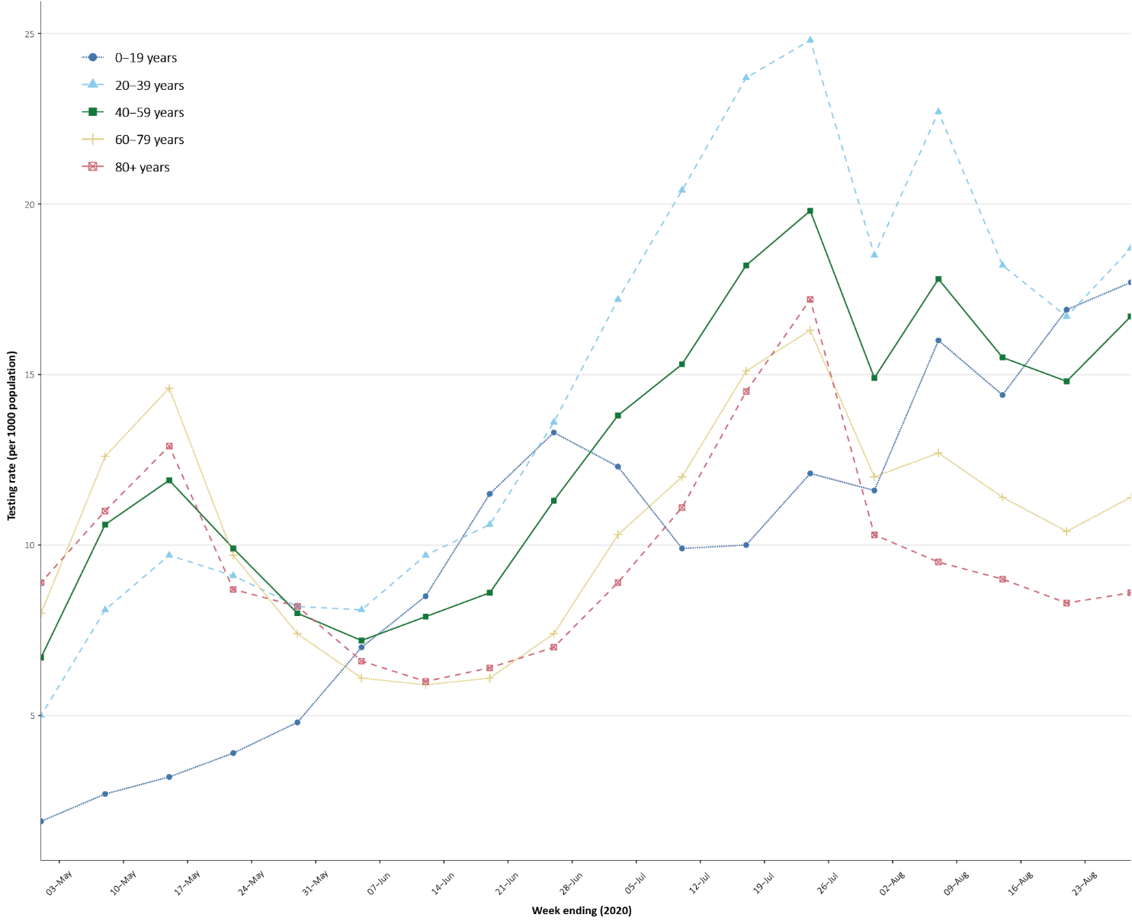
a Data provided by jurisdictions to the National Incident Room (NIR) weekly.
b The jurisdictions reporting each week (i.e. the denominator population) may vary.

Viral genomics
There are currently 7,175 SARS-CoV-2 genome sequences available from Australian cases on the global sequence repository, GISAID. These sequences are dispersed throughout the global lineages, reflecting multiple concurrent introductions into Australia.^{3–5} Recent Australian SARS-CoV-2 sequences from the last month include 77 collected from NSW and 6 from South Australia. Most of these sequences from the last month belong to the B.1.1.25 lineage, reflecting ongoing local transmission of this lineage.

Aboriginal and Torres Strait Islander persons
There have been 134 cases of COVID-19 notified in Aboriginal and Torres Strait Islander persons. This represents approximately 0.5% of all confirmed cases. Table 4 compares the remoteness of cases in Aboriginal and Torres Strait Islander persons with those in the non-Indigenous population. Approximately 20% (31) of all cases notified in Aboriginal and Torres Strait Islander persons are reported as acquired overseas, with almost half of these (14 cases) associated with cruise ships.
Table 4. COVID-19 notifications by Aboriginal and Torres Strait Islander status by jurisdiction, source of acquisition and remoteness classification as at 30 August 2020ª
 | Locally-acquired |  |  |  | Overseas-acquired | Unknown^{b} | Total
 | Major Cities of Australia | Inner Regional Australia | Outer Regional Australia | Remote / Very Remote Australia
Aboriginal and Torres Strait Islander | 78 | 15 | 6 | 3 | 31 | 1 | 134
non-Indigenous | 18,960 | 874 | 225 | 21 | 5,163 | 309 | 25,552
a Excludes 1 probable Aboriginal and Torres Strait Islander case.
b Includes 29 non-Indigenous cases classified as overseas residents who were diagnosed in Australia.

The median age of COVID-19 cases in Aboriginal and Torres Strait Islander persons is 33 years (interquartile range, IQR: 22–51), which is younger than for non-Indigenous cases where the median age is 37 years (IQR: 25–57).
By sex, there is a higher proportion of cases in Aboriginal and Torres Strait Islander females (59%; 79 cases) than in non-Indigenous females (51%; 13,078 cases). The differences observed in sex for Aboriginal and Torres Strait Islander people likely reflect the small number of cases rather than any specific transmission pattern.
Overall, Aboriginal and Torres Strait Islander males are reporting a slightly higher proportions of cases in the under 29 and in the 60 to 69 year age groups compared to non-Indigenous. This group also reports a lower proportion of cases in both the 40–49 and 50–59 year age groups compared to non-Indigenous males (Figure 5). Aboriginal and Torres Strait Islander males report no cases 80 years or older.
Figure 5. National COVID-19 notifications by age group and sex, Aboriginal and Torres Strait Islander persons and non-Indigenous Australiansª as at 30 August 2020
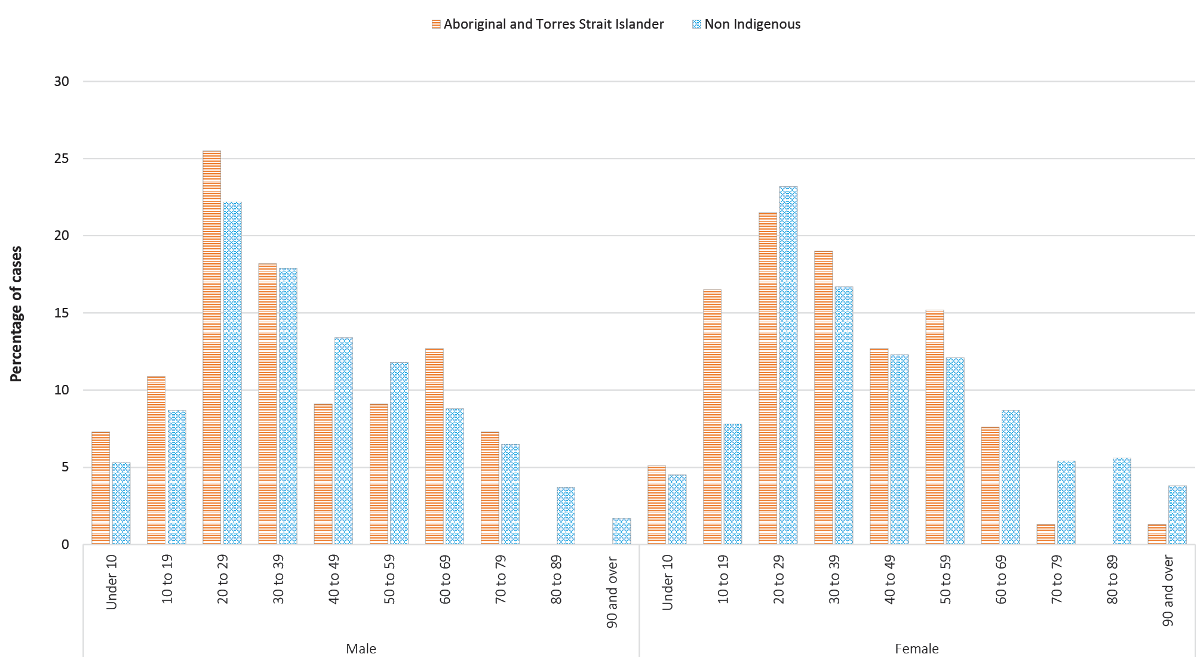
a ‘non-Indigenous’ includes one person identified as gender X, and 88 non-Indigenous Australians with unknown gender.

Aboriginal and Torres Strait Islander females are reporting a much higher proportion of cases in the 10–19 year age group (17%) than is seen among non-Indigenous females (8%), though there are only 10 cases that are included in this age and sex grouping and small changes may have a large impact on proportions. However, rates in females aged 70 years and over are much lower than those in non-Indigenous females aged 70 years and over (Figure 5).

Demographics of cases
Historically, cases of COVID-19 have been reported in all age groups. In this reporting period, the largest number of cases has again occurred in those aged 20–29 years (383 cases), with the highest rate of infection for this period again occurring in the 90 years and older age group (51.3 per 100,000 population). This is a decrease from the previous reporting period where a rate of 82.9 cases per 100,000 population was reported for this age group. Additionally, for all notifications to date, the highest rate of infection remains in those aged 90 years and over with a rate of 351.3 per 100,000 population (Appendix B, Table B.1).
Children aged 0–9 years continue to have the lowest rate of infection (39.4 cases per 100,000 population), with testing rates comparable to other age groups (Figure 6). In this reporting period, school-aged children (defined as those aged 5 to 17 years) accounted for 11% of all cases, which is a higher proportion than they comprise in cumulative cases (8%).

Figure 6. COVID-19 cases, by age group and sex, at 30 August 2020, Australia
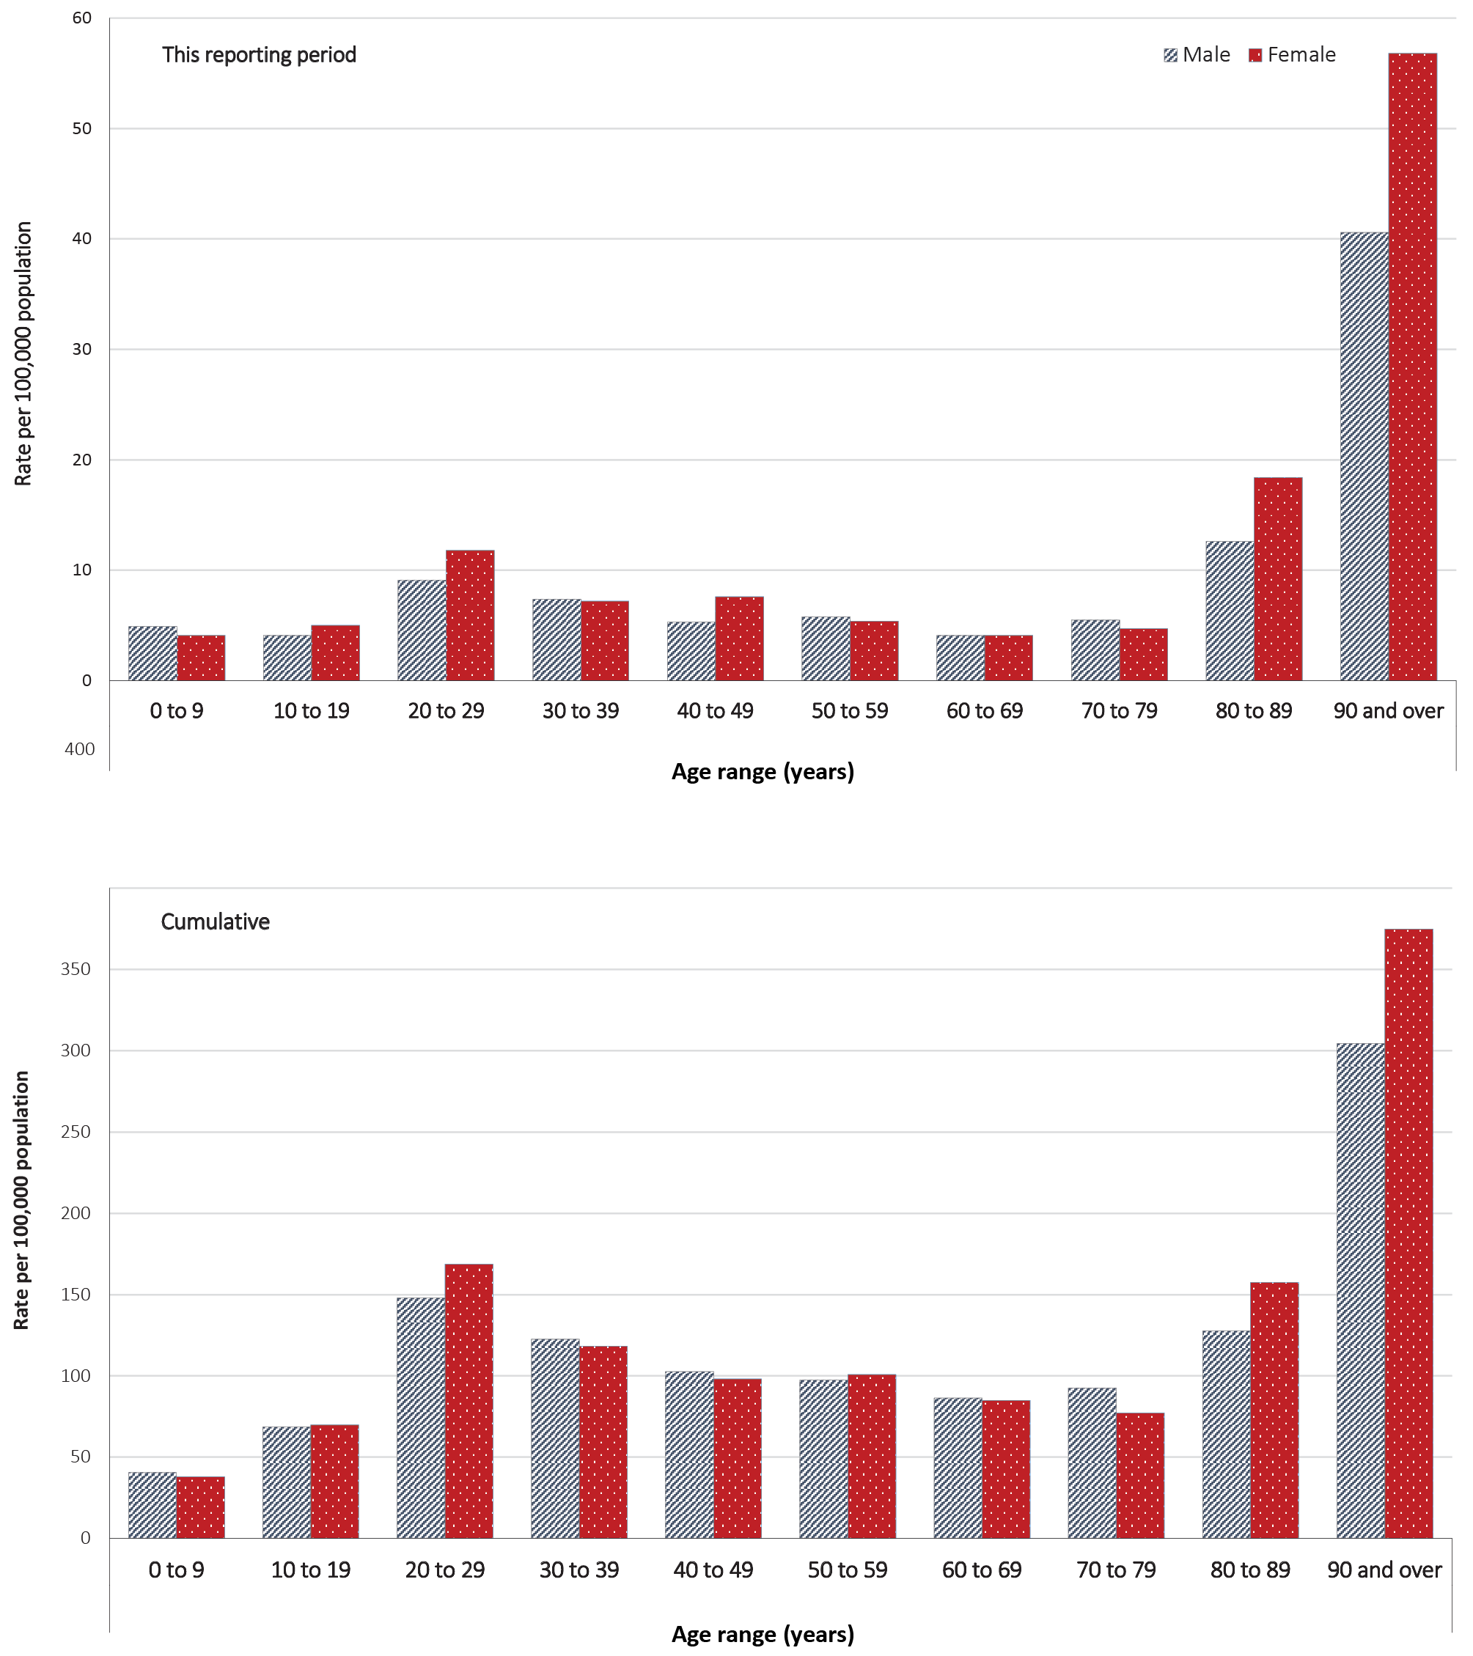
Cumulatively, all cases show a median age of 37 years (IQR: 25 to 57) which has not changed from the previous report. Prior to 1 June 2020, the population diagnosed was slightly older, with a median age of 46 years (IQR: 29 to 62) reflecting the primary source of acquisition via cruise ships and overseas travel. In cases reported after 1 June, the median age is 35 years (IQR: 24 to 54) reflecting household, possibly family-based, transmission in Victoria. The age distribution of cases in this reporting period is slightly older than those reported in the second peak overall; the median age in this reporting period is 37 years (IQR: 24 to 59).
Cumulatively, males show a higher per capita rate in more age groups than females (Figure 6), although females now account for a majority of cases aged 80 years and over. The largest difference between the two categories is seen in the 90 years and over age group where males report a cumulative rate of 304.5 cases per 100,000 population and females report a higher rate of 374.7 cases per 100,000 population (Table B.1). In this reporting period, higher rates in each age group predominantly continue to be in females, with a far higher rate in females 90 or over (56.8 infections per 100,000 population, compared to 40.6 infections per 100,000 population in males).

Severity

Hospitalisations
Using NNDSS data, the current estimated hospitalisation rate for all confirmed cases to date in Australia is 13%. This estimate aligns with: that provided by a hospital-notification data linkage study for NSW cases (12.4% of notified cases to 19 April hospitalised);⁶ early estimates from the United States of America (12% cases hospitalised between 12 February and 16 March 2020);⁷ and recent estimates from Canada (10% 11,091/111,733).⁸
Length of hospital stay for patients with confirmed COVID-19 generally increases with advancing age (Table 5). Those aged 60–79 years admitted to an intensive care unit (ICU) remain those who stayed the longest in hospital. The sentinel cohort of hospitalised COVID-19 patients captured in the Influenza Complications Alert Network (FluCAN) stayed an average of 8.8 days in hospital [Median: 6; IQR: 3–12]. While comparison internationally is difficult due to disparity in sample sizes, the Australian length of stay estimates are shorter than those published for European countries (median 12 days).³ The European data also showed that length of stay increased with age, with people aged over 60 years staying for a median time of 10 days (mean:13–14 days).³
Table 5. Hospital length-of-stay for confirmed COVID-19 cases discharged alive from sentinel sites by ICU/high dependency unit (HDU) admission status (median, IQR and mean, standard deviation (SD))
Age group (years) | General wardª |  |  | ICU/HDU^{b}
 | N | Median (IQR) | Mean (SD) | N | Median (IQR) | Mean (SD)
Under 5 | 16 | 2.0 (0.5–6.5) | 4.4 (5.6) | < 5 | 52 | 52
5–17 | 12 | 4.0 (0.5–6.5) | 4.2 (4.0) | 3 | 5.0 (1.0–25.0) | 10.3 (12.9)
18–39 | 39 | 4.0 (1.0–8.0) | 5.9 (6.5) | 38 | 6.0 (5.0–11.0) | 9.45 (11.3)
40–59 | 52 | 4.0 (2.0–10.0) | 7.9 (10.3) | 114 | 11 (8.0–20.0) | 15.7 (14.2 )
60–79 | 53 | 7.0 (4.0–13.0) | 9.8 (8.0) | 137 | 23.9 (10.0–33.0) | 23.9 (17.3)
80 and over | 21 | 10.0 (7.0–13.0) | 11.0 (7.8) | 5 | 13.0 (11.0–15.0) | 12.6 (4.5)
Total | 193 | 5.0 (2.0–10.0) | 7.8 (8.3) | 291 | 14.0 (8.0–25.0) | 18.7 (16.2)
a Source: FluCAN,⁹ excludes patients admitted to ICU.
b Source: SPRINT-SARI.¹⁰

Intensive care admissions
Of hospitalised cases captured in the FluCAN sentinel surveillance system since March 16, 2020 (n = 241), forty-nine (20%) were admitted to an ICU. This is a similar proportion to ICU admission estimates in Canada (2,214/11,091; 20%)⁸ and the United Kingdom (3001/18,183; 17%).¹¹
Figure 7 shows the pattern in daily admissions to ICU in sentinel sites contributing to the Short Period Incidence Study of Severe Acute Respiratory Infection Study (SPRINT-SARI) over time relative to the national epidemic curve. While scales differ, clear synergy and a time delay between case number and ICU admission patterns can be seen. Prior to June, ICU admissions followed a similar rapid rise to that of the epidemic curve, while the more recent surge in case numbers is accompanied by a more stable and sustained pattern in daily ICU admissions.
Figure 7. Weekly COVID-19 notifications and weekly admissions to ICU, Australia, 20 January – 25 August 2020
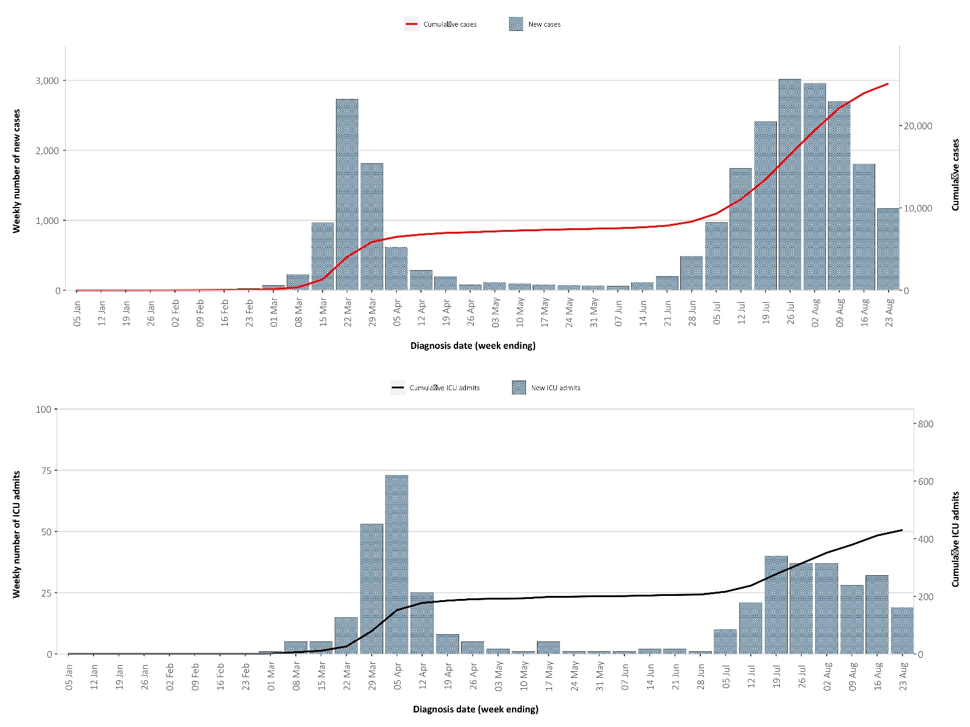
a Source: FluCAN (n = 380) from 16 March to 28 August 2020.

Figure 8. Age/sex distribution for COVID-19 cases admitted to hospitalª
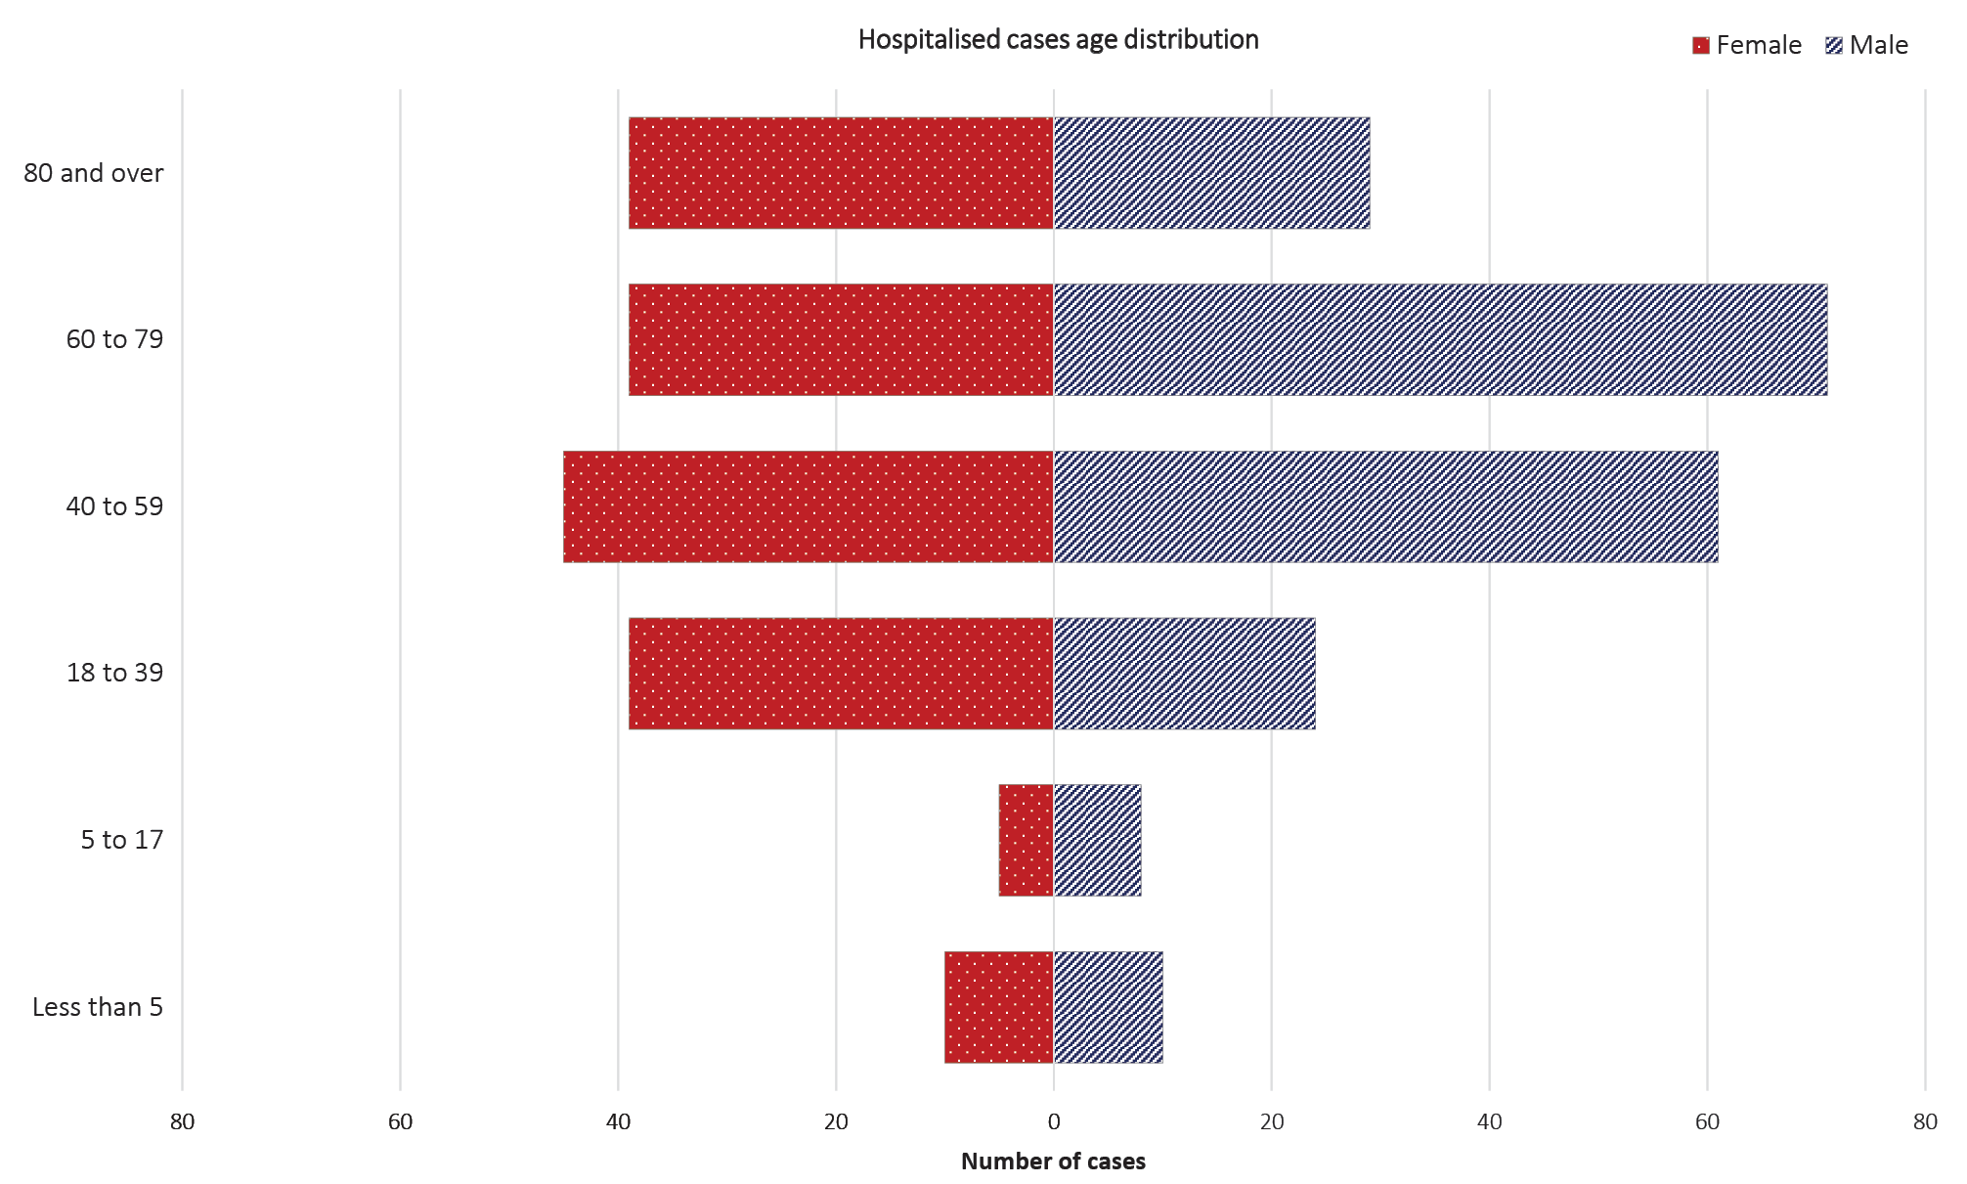
Figure 9. Age/sex distribution for COVID-19 patients admitted to ICUª
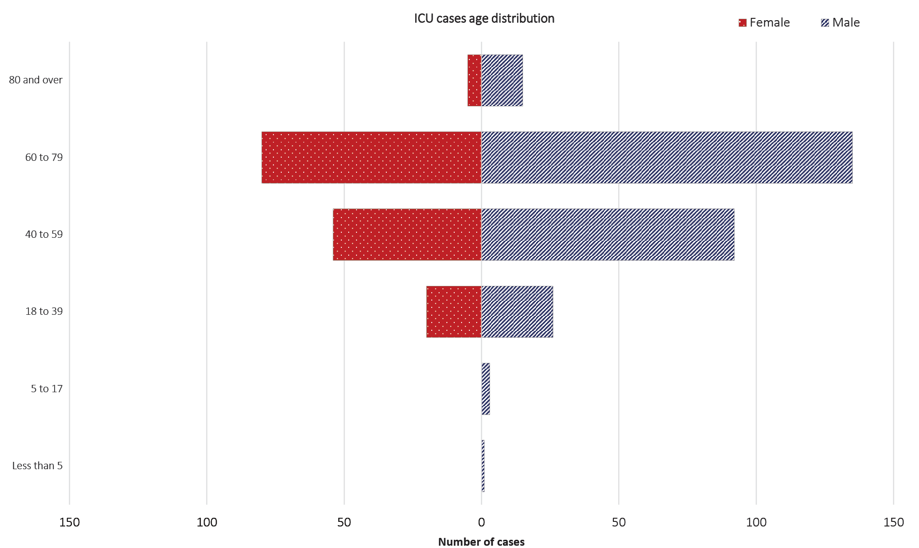
a Source: SPRINT-SARI (n = 434) from 27 February to 31 August 2020.

Of those admitted to ICU with confirmed COVID-19 (n = 434), forty-nine percent were subject to invasive ventilation for at least one hour on at least one day during their ICU stay. Length of stay in ICU for those discharged alive (n = 293) ranged from zero to 65 days (median 4; IQR 2–14); while for non-survivors length of stay was between zero and 40 days (median 9; IQR 5–19). These estimates are comparatively longer than those reported in the United Kingdom [4 days (IQR 2–8) in survivors and 6 days (3–9) in non-survivors]^{12,13} which could reflect that Australian ICUs continue to operate within capacity.

Characteristics of those with severe COVID-19 disease
Higher disease severity, as indicated by hospitalisation, admission to ICU, and death, has been associated with increased age and comorbidities.⁸ The median ages of cases who have been hospitalised in sentinel sites (58 years; IQR 39–73) and admitted to ICU (62 years; IQR 50–70) are higher than for cases overall (37 years; IQR 15–57).
The numbers of males to females are similar among hospitalised cases (1.1:1). However, substantially more males than females have been admitted to the ICU (ratio: 1.7:1). For both hospitalised and ICU-admitted COVID-19 patients, the male to female ratio increases with advancing age category (Figures 8 and 9).
Of all those hospitalised (n = 380), fewer than five (< 1.5%) identified as of Aboriginal and/or Torres Strait Islander origin, none of whom were admitted to ICU. The field capturing these data was 98% complete.

Comorbidities
There is a growing global body of evidence that links various comorbidities to a higher risk of severe COVID-19 disease. In May 2020, the Australian Medical Association (AMA) released a list of comorbidities for which such evidence had emerged which included hypertension, diabetes, cardiovascular disease, respiratory disease and cerebrovascular disease.¹⁴ Obesity (defined as a body mass index > 30) has also been flagged as a significant risk factor for a worse outcome from COVID-19 infection.¹⁵ In Australian hospitalised patients, the most prevalent comorbidity was cardiac disease (35%) (Table 6); this compares to a similar rate amongst hospitalised cases in the UK (30.9%).¹¹ Diabetes was also common across both levels of hospitalisation and amongst those who died while in hospital (45%). A history of smoking (current or past smoker) was identified in 31% of those hospitalised (101/332) and 13% of those admitted to ICU (48/382).

Table 6. Comorbidities amongst hospitalised COVID-19 cases, cases admitted to ICU and those who have died in hospital from COVID-19 (number of cases, proportion of cases) as at 30 August 2020
Comorbidity | Hospitalised  casesª  (n=380) | ICU  cases^{b}  (n = 434) | Deaths in hospital^{c}  (n=49)
Cardiac disease | 85 (35) | 59 (15) | 16 (33)
Chronic respiratory condition^{c} | 71 (30) | 78 (20) | 14 (29)
Diabetes | 80 (34) | 123 (32) | 22 (45)
Obesity | 50 (23) | 100 (26) | 14 (29)
Chronic renal disease | 17 (7) | 23 (6) | 10 (20)
Chronic neurological condition | 65 (28) | 5 (1) | 1 (2)
Malignancy | 22 (9) | 21 (5.3) | 9 (18)
Chronic liver disease | 10 (4) | 14 (4) | 4 (8)
Immunosuppression | 32 (14) | 28 (7) | 10 (21)
Number of specified comorbidities^{d}
One or more | 208 (55) | 252 (64) | 41 (84)
Two or more | 110 (29) | 129 (33) | 30 (61)
Three or more | 41 (11) | 49 (12) | 18 (36)
No comorbidities | 36 (15) | 142 (36) | 8 (16)
a Source: FluCAN; excludes those with missing data on comorbidities or where comorbidity is unknown.
b Source: SPRINT-SARI; excludes those with missing data on comorbidities or where comorbidity is unknown.
c Includes asthma.
d Includes chronic respiratory conditions, cardiac disease (excluding hypertension), immunosuppressive condition/therapy, diabetes, obesity, liver disease, renal disease and neurological disorder.

Overall, case fatality rates have increased in the past four weeks (from 1.3 to 2.3%). Of all cases, the highest proportion of deaths have occurred in males aged > 80 years (CFR = 28.0) (Table 7). Comparison of case-fatality rates across levels of hospitalisation should be interpreted with caution as the sample sizes and data sources vary. The death rate was highest for those COVID-19 patients aged over 80 years and admitted to ICU; in this group 64% admitted to ICU with COVID-19 passed away. Among all cases hospitalised in sentinel sites since March 16, the CFR stands at 10.9%, which is dramatically lower than the aggregated value of 24% observed in European hospitalised cases (data from 22 countries)¹⁶ and Canadian hospitalised cases (33%).⁸ Overall mortality rates among those admitted to ICU with confirmed COVID-19 (CFR= 13%; 51/434) in Australia are also substantially lower than those reported internationally. In UK, the non-survival rate amongst those admitted to ICU was reported at 52% (871/1,689).¹²

Table 7. Number of fatalities and case fatality rate (CFR) for all cases, hospitalised cases and cases admitted to ICU, by age group and gender, Australia
 | All casesª  n (CFR)^{d} |  |  | Hospitalisation^{b}  n (CFR) |  |  | ICU^{c}  n (CFR)
 | Male | Female | Persons | Male | Female | Persons | Male | Female | Persons
Under 50 | 4 (0.05) | 0 (0) | 4 (0.02) | 0 (0.0) | 0 (0.0) | 0 (0.0) | 1 (1.9) | 0 (0.0) | 1 (1.2)
50–64 | 14 (0.7) | 6 (0.3) | 20 (0.5) | 1 (3.5) | 0 (0.0) | 0 (1.9) | 8 (11.1) | 3 (7.0) | 11 (9.6)
65–79 | 77 (6.1) | 46 (3.9) | 123 (5.1) | 5 (15.6) | 1 (4.8) | 6 (11.2) | 20 (24.4) | 8 (17.0) | 28 (21.7)
80 + | 187 (28.0) | 243 (19.8) | 430 (22.7) | 10 (47.6) | 10 (47.6) | 20 (47.6) | 9 (75.0) | 2 (50.0) | 11 (64)
Total | 282 (2.3) | 295 (2.3) | 577 (2.3) | 16 (12.4) | 12 (9.45) | 28 (10.9) | 38 (17.4) | 13 (10.2) | 51 (13.0)
a Source: NNDSS (Total cases = 25,599).
b Source: FluCAN, includes 21 sentinel hospitals (Total cases = 380).
c Source: SPRINT-SARI, includes 77 sentinel ICU/HDUs (Total cases = 434).
d CFR expressed as a percentage.

Acute respiratory illness surveillance
Our current understanding of COVID-19 indicates that approximately 80% of infections are mild and that the most common symptoms are consistent with an acute respiratory illness (ARI) and/or influenza-like illness (ILI). It is therefore important to monitor trends in the number of people reporting symptoms of mild respiratory illnesses (syndromic surveillance) in the community and in primary care settings.
At a national level, the surveillance systems and programs that provide this information within Australia are the online FluTracking syndromic surveillance system, the Australian Sentinel Practices Research Network (ASPREN) and Victoria Sentinel Practice Influenza Network (VicSPIN) general practice (GP) sentinel surveillance systems, and the Commonwealth GP Respiratory Clinics. These systems are not specific to COVID-19; they monitor any respiratory illness experienced in the reporting period.
FluTracking is an online syndromic surveillance system which monitors ILI in the community. During the influenza season, participants receive a weekly email survey which collects data on the rate of ILI-related symptoms and healthcare seeking behaviour in communities. The survey usually commences at the beginning of May each year but commenced at the end of February in 2020 to support the COVID-19 response. Approximately 70,000 to 85,000 people participate in FluTracking across Australia each week.
Based on self-reported FluTracking data, fever and cough in the community continues to be low nationally, much lower than the historical average for this time of year (Figure 10). It is recommended that anyone experiencing cold or flu-like symptoms, such as a cough, fever, sore throat, shortness of breath or runny nose, even if these are mild, should get tested for COVID-19 as soon as possible.

Figure 10. Weekly trends in respiratory illness amongst FluTracking survey participants (age standardised), 2020 and average of the previous five yearsª
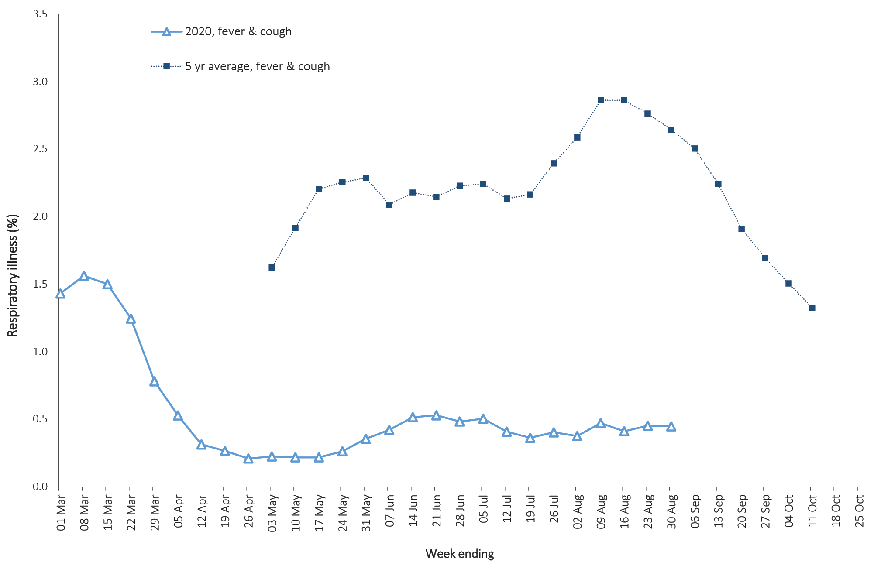
a FluTracking commenced 10 weeks early in 2020 in response to COVID-19.

In patients experiencing influenza-like illness in the last fortnight and tested through the ASPREN and VicSPIN GP sentinel surveillance systems, the most frequent respiratory viruses detected were rhinoviruses and adenoviruses.
In response to COVID-19, the Australian Government rapidly established GP Respiratory Clinics throughout Australia. To ensure access to care and testing, clinics are open to those with symptoms of mild to moderate respiratory illness. While these clinics diagnose a small proportion of COVID-19 cases in Australia, the case histories obtained by these clinics are comprehensive and also offer a unique opportunity to compare and contrast COVID-19 and non-COVID-19 illness.
Over the two-week reporting period, 68,085 assessments were recorded for patients who consented to share information, of whom 66,078 (97.1%) were tested for SARS-CoV-2, 47 of which were positive (numbers were correct as at 1 September 2020).
Based on all presentations to these clinics to date, the principal symptoms reported in COVID-19 cases were cough (40%), sore throat (33%), tiredness (29%), runny nose (23%), and fever (20%) (Figure 11).

Figure 11. Symptom profile in COVID-19 vs non-COVID-19 presentations, Australia, as at 30 August 2020
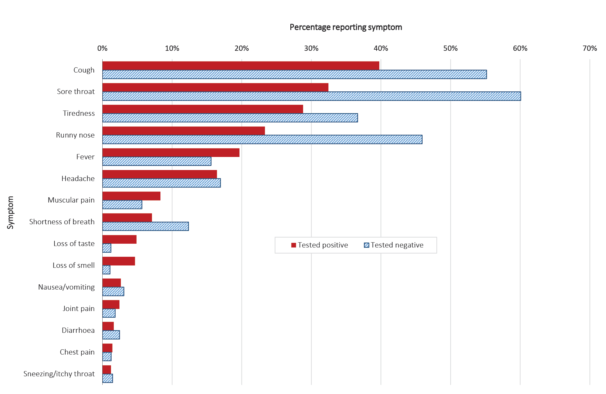

Public health response measures
Since COVID-19 first emerged internationally, Australia has implemented public health measures informed by the disease’s epidemiology (Figure 12). On Friday 8 May, the Australian Government announced a three-step framework for easing COVID-19 restrictions, with states and territories easing restrictions at their own pace depending on the current public health situation and local epidemiology.

Figure 12. COVID-19 notifications in Australia by week of diagnosis and jurisdiction to 30 August 2020 with timing of key public health measures
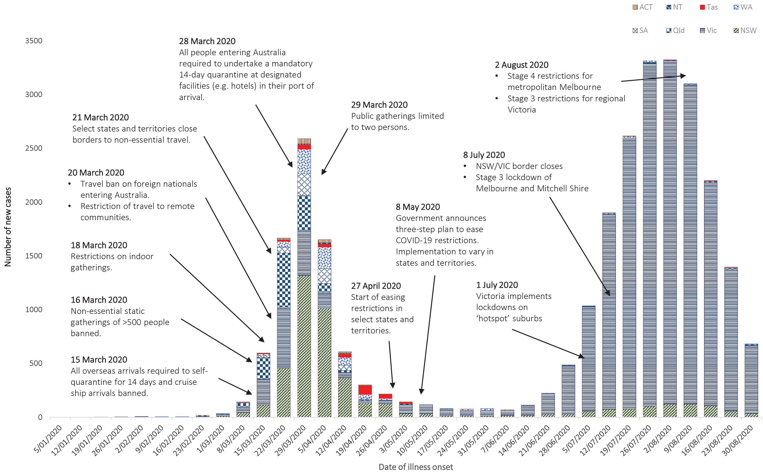

During the previous reporting period, South Australia re-implemented some restrictions on private gatherings,¹⁷ and several states strengthened domestic border restrictions (Queensland, South Australia, Tasmania).^{17–19} Conversely, the Australian Capital Territory commenced step 3 easing of restrictions.^{20,21}
During the current reporting period (Table 8), in response to clusters of cases, Queensland implemented localised restrictions on visitors to Residential Aged Care Facilities and hospitals, and gatherings in households and public spaces.²² South Australia eased restrictions on gatherings and eased domestic border restrictions for border communities and transiting travellers.²³
Table 8. State and territory changes to COVID-19 restrictions, from 3 August to 30 August 2020
Jurisdiction | Summary of changes to COVID-19 restrictions
New South Wales | No changes to restrictions during this reporting period.²⁴
Victoria | From 5 August the following restrictions were implemented:²⁵  Stage 3 stay at home restrictions apply across regional Victoria  Business restrictions implemented across metropolitan Melbourne including requirements for high-risk industries  Worker permits required for employees working on work sites  From 7 August all services and industries operating required to have a COVIDSafe Plan.
Queensland | From 2 August the following restrictions were implemented:¹⁸  Enhanced border measures  Restrictions on visitors to aged care and hospitals in local government areas with clusters (further areas added on 22 August)
Western Australia | No further easing of restrictions has occurred during this reporting period.²⁶
South Australia | From 5 August the following restrictions were implemented:¹⁷  A cap of 10 people for gatherings in private homes  Food and beverages (including alcohol) are only consumed by patrons while seated at tables, away from any bar or ordering area  From 14 August the following restrictions were adjusted:  A cap of 20 people for gatherings in private homes (up to 10 guests)  Private gatherings (other than private residence) restricted to 100 people  From 28 August the following restrictions were eased:  Up to 50 people permitted in private homes  Border restrictions eased for border communities and transiting passengers
Tasmania | No further easing of restrictions has occurred during this reporting period.¹⁹
Australian Capital Territory | From 10 August the following restrictions were eased:^{20,21}  Gatherings of up to 100 people permitted indoors and outdoors (1 person per 4 square metres)  Additional businesses permitted to reopen including casinos, food-courts, steam-based services, brothels and strip clubs, and 24 hour gyms.  Businesses, venues and facilities which reopen require to have a COVID Safety Plan
Northern Territory | No further easing of restrictions has occurred during this reporting period.²⁷

International situation
On 30 August 2020, more than 216 countries, regions and areas had reported 24,854,748 COVID-19 cases and 838,926 deaths to the World Health Organization (WHO).²⁸ All data reported below are drawn from the WHO Dashboard extracted on 31 August 2020 unless otherwise specified. The Americas and Europe continue to be the epicentres of the pandemic with the former representing approximately 53% of cumulative cases and 55% of cumulative deaths, and the latter representing 17% of cases and 26% of deaths. The global case fatality rate (CFR) is approximately 3.4% and is decreasing as case identification improves. The global cumulative per capita rates are 323.6 cases and 10.9 deaths per 100,000 population.
- By country, the largest numbers of cases are from: the United States of America (5,855,521); Brazil (3,804,803); and India (3,542,733).
- By country, the largest numbers of deaths are from: the United States of America (180,689); Brazil (119,504); and India (64,498).
In the previous fortnight the regions reporting the largest numbers of new cases were the Americas (49%, a decrease from 54%) and South East Asia (29%, in increase from 25%), led predominantly by the countries highlighted above, indicating that South East Asia’s burden of global cases is increasing.

Western Pacific Region
To date, the Western Pacific Region remains the least-affected region globally, reporting the lowest number of COVID-19 cases and deaths relative to other regions. The cumulative number of cases in the region stands at 487,571, with 77,982 new cases reported in the previous fortnight (a 14% decrease). This represents 2.2% of the global total number of new cases in this reporting period. Cumulatively, the Western Pacific region accounts for 2% of all cases globally and 1.3% of all deaths. The region reports a cumulative rate of 25.7 cases per 100,000 people (compared to 323.5 cases per 100,000 globally) and a mortality rate of 0.6 deaths per 100,000 population (compared to 10.9 deaths per 100,000 globally).
The highest numbers of overall cases in the region have been observed in the Philippines, China and Japan (Figure 13). In the past fortnight the highest number of new cases has been observed in the Philippines, representing 71% of new regional cases. Cambodia, Fiji, New Caledonia and Lao People’s Democratic Republic did not report any new cases in this reporting period.

Figure 13. Number of COVID-19 cases (logarithmic scale) by selected country and days since passing 100 cases, up to 30 August 2020
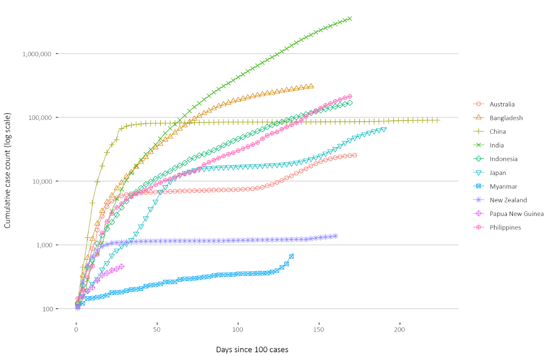
In New Zealand, the ‘Auckland August Cluster’ is the only remaining locally-acquired cluster, accounting for most of New Zealand’s 107 new cases in the past fortnight. By 31 August 2020, the cluster was linked to a total of 141 cases.²⁹ Auckland returned to Alert Level 2 on 30 August 2020, joining the rest of New Zealand.³⁰ Alert Level 2 will remain in place until at least 6 September 2020.
In Papua New Guinea, as of 30 August 2020 the nation had reported 459 cases and 5 deaths. In the previous fortnight 184 new cases were reported, a 13% decrease from the previous reporting period. The majority of cases were reported from Western Province and are linked to a large local cluster at a mining site.³¹

South East Asia Region
In the past fortnight, the South East Asia region has seen a large increase in new case numbers. Cumulatively the region has reported approximately 4.07 million cases and 75,276 deaths, with 1,032,980 cases reported in the last fortnight (a 37% increase). The region accounts for 16.4% of global cumulative cases and 8.9% of global cumulative deaths. Regionally, the per capita burden of disease is increasing, with the cumulative case rate now at 204 cases (increased from 148.9 cases) and 3.8 deaths (increased from 2.9 deaths) per 100,000 population in this reporting period.
The majority of new cases in the South East Asia region remain largely concentrated in India where 953,051 new cases were reported, comprising 92% of new cases reported regionally in the previous fortnight (Figure 13).
The Republic of the Union of Myanmar reported its first case of local transmission in the Sittwe township of Rakhine State on 16 August (Figure 13). In the fortnight since, confirmed cases have doubled to 749, largely concentrated in Rakhine, which has resulted in a widespread government response of community testing and extending preventative measures until 30 September.³²
Indonesia reported the highest case fatality rate of 4.3 deaths per 100,000 cases compared to 1.1 for the region.

Data considerations
Data were extracted from the NNDSS on 1 September 2020 for notifications received up to 30 August. Due to the dynamic nature of the NNDSS, numbers presented in this report are subject to revision and may vary from numbers previously reported and from case notifications released by states and territories.

Definitions
“Cluster” in relation to COVID-19 refers to two or more cases (who do not reside in the same household) that are epidemiologically related in time, place or person where a common source (such as an event or within a community) of infection is suspected but not yet established.
“COVID-19” is the disease caused by a novel coronavirus that emerged in China in late 2019. ‘CO’ stands for corona-, ‘V’ stands for virus, ‘ID’ stands for infectious disease, and ‘-19’ refers to the year that this disease was first reported.
“COVID-19 associated death” is defined for surveillance purposes as a death in a probable or confirmed COVID-19 case, unless there is a clear alternative cause of death that cannot be related to COVID-19 (e.g. trauma).³³ There should be no period of complete recovery from COVID-19 between illness and death. Where a Coroner’s report is available, these findings are to be observed.
“Date of illness onset” is derived from data collected by the NNDSS and represents the diagnosis date, or reported true onset of disease date. If unknown, the earliest of specimen collection date, notification date or notification receive date is used.
“Notification received date” is reported in the NNDSS and represents the date the case is first notified on the NNDSS. As notification can only occur after testing is completed and information processed, counts for a defined period will vary according to the date type used.
“Outbreak” in relation to COVID-19 refers to two or more cases (who do not reside in the same household) among a specific group of people and/or over a specific period of time where illness is associated with a common source (such as an event or within a community). Some states and territories may report a single case associated with a residential aged care facility as an outbreak.
“SARS-CoV-2” is the virus that causes the disease COVID-19. It is a betacoronavirus genetically related to the 2003 Severe acute respiratory syndrome coronavirus (SARS-CoV).

Acknowledgements
This report represents surveillance data reported through CDNA as part of the nationally-coordinated response to COVID-19. We thank public health staff from incident emergency operations centres in state and territory health departments, and the Australian Government Department of Health, along with state and territory public health laboratories.

Author details

Corresponding author
COVID-19 National Incident Room Surveillance Team, Australian Government Department of Health, GPO Box 9484, MDP 14, Canberra, ACT 2601. Email: epi.coronavirus@health.gov.au

References
- Australian Government Department of Health. Coronavirus (COVID-19) advice for the health and aged care sector. [Internet.] Canberra: Australian Government Department of Health; 2020. [Accessed 13 August 2020.] Available from: https://www.health.gov.au/news/health-alerts/novel-coronavirus-2019-ncov-health-alert/coronavirus-covid-19-advice-for-the-health-and-aged-care-sector.
- Communicable Diseases Network Australia (CDNA). Coronavirus disease 2019 (COVID-19) outbreaks in residential care facilities: CDNA national guidelines for the prevention, control and public health management of COVID-19 outbreaks in residential care facilities in Australia. Canberra: Australian Government Department of Health, CDNA; 13 March 2020. [Accessed on 13 August 2020.] Available from: https://www.health.gov.au/sites/default/files/documents/2020/03/coronavirus-covid-19-guidelines-for-outbreaks-in-residential-care-facilities.pdf.
- Rockett RJ, Arnott A, Lam C, Sadsad R, Timms V, Gray KA et al. Revealing COVID-19 transmission in Australia by SARS-CoV-2 genome sequencing and agent-based modeling. Nat Med. 2020. doi: https://doi.org/10.1038/s41591-020-1000-7.
- Seemann T, Lane C, Sherry N, Duchene S, Goncalves da Silva A, Caly L et al. Tracking the COVID-19 pandemic in Australia using genomics. medRxiv. 2020 doi: https://doi.org/10.1101/2020.05.12.20099929.
- Eden JS, Rockett R, Carter I, Rahman H, de Ligt J, Hadfield J et al. An emergent clade of SARS-CoV-2 linked to returned travellers from Iran. Virus Evol. 2020;6(1):veaa027. doi: https://doi.org/10.1093/ve/veaa027.
- Government of New South Wales. COVID-19 weekly surveillance in NSW: epidemiological week 23, ending 6 June 2020. Sydney: Government of New South Wales; 10 June 2020. [Accessed on 31 August 2020.] Available from: https://www.health.nsw.gov.au/Infectious/covid-19/Documents/covid-19-surveillance-report-20200606.pdf.
- CDC COVID-19 Response Team. Severe outcomes among patients with Coronavirus Disease 2019 (COVID-19) - United States, February 12-March 16, 2020. MMWR Morb Mortal Wkly Rep. 2020;69(12):343-6.
- Statistics Canada. Table 13-10-0775-01. Detailed preliminary information on cases of COVID-19: 4 Dimensions (Aggregated data), Public Health Agency of Canada. [Internet.] Ottawa: Statistics Canada; 2020. [Accessed on 31 August 2020.] Available from: https://www150.statcan.gc.ca/t1/tbl1/en/tv.action?pid=1310077501.
- Monash Health. FluCAN (Influenza surveillance): FluCAN (The Influenza Complications Alert Network) [Internet.] Melbourne: Monash Health; 2020. Available from: https://monashhealth.org/services/monash-infectious-diseases/research/influenza-research/flucan-influenza-surveillance-2/.
- Australian and New Zealand Intensive Care Society (ANZICS). SPRINT-SARI: Short period incidence study of severe acute respiratory infection. [Internet.] Camberwell: ANZICS; 19 March 2020. [Accessed on 9 July 2020.] Available from: https://www.anzics.com.au/current-active-endorsed-research/sprint-sari/.
- Docherty AB, Harrison EM, Green CA, Hardwick HE, Pius R, Norman L et al. Features of 20 133 UK patients in hospital with covid-19 using the ISARIC WHO Clinical Characterisation Protocol: prospective observational cohort study. BMJ. 2020;369:m1985. doi: http://dx.doi.org/10.1136/bmj.m1985.
- Intensive Care National Audit and Research Centre (ICNARC). ICNARC report on COVID-19 in critical care 24 July 2020. London: ICNARC; 2020. [Accessed on 4 August 2020.] Available from: https://www.icnarc.org/Our-Audit/Audits/Cmp/Reports.
- ICNARC. Table Appendix 2020-07-31.xlsx. [Downloadable resource.] London: ICNARC; 2020. [Accessed on 4 August 2020.] Available from: https://www.icnarc.org/DataServices/Attachments/Download/c31dd38d-d77bea11-9124-00505601089b.
- Zappala C. Predicting a worse COVID-19 outcome. Chicago: American Medical Association; 8 May 2020. [Accessed on 2 September 2020.] Available from: https://ama.com.au/sites/default/files/AMA_PPE_Chris_Zappala_PREDICTING_WORSE_COVID19_OUTCOME.pdf.
- Petrakis D, Margină D, Tsarouhas K, Tekos F, Stan M, Nikitovic N et al. Obesity – a risk factor for increased COVID19 prevalence, severity and lethality (Review). Mol Med Rep. 2020;22(1):9–19.
- European Centre for Disease Prevention and Control (ECDC). COVID-19 surveillance report: Week 26, 2020. [Internet.] Solna: ECDC; 4 July 2020. [Accessed on 9 July 2020.] Available from: https://covid19-surveillance-report.ecdc.europa.eu/.
- Government of South Australia. COVID-19 response: COVID response updates. [Internet.] Adelaide: Government of South Australia; 28 August 2020. [Accessed on 1 September 2020.] Available from: https://www.covid-19.sa.gov.au/recovery.
- Queensland Government. Border restrictions. [Internet.] Brisbane: Queensland Government; 2020. [Accessed on 1 September 2020.] Available from: https://www.qld.gov.au/health/conditions/health-alerts/coronavirus-covid-19/current-status/public-health-directions/border-restrictions.
- Tasmanian Government. Coronavirus disease (COVID-19): important community updates. [Internet.] Hobart: Tasmanian Government; 31 August 2020. [Accessed on 1 September 2020.] Available from: https://coronavirus.tas.gov.au/facts/important-community-updates.
- Australian Capital Territory Government. Canberra’s recovery plan: easing of restrictions. [Internet.] Canberra: Australian Capital Territory Government; 21 August 2020. [Accessed on 1 September 2020.] Available from: https://www.covid19.act.gov.au/community/canberra-recovery.
- Australian Capital Territory Government. COVID-19: summary of key changes. [Internet.] Canberra: Australian Capital Territory Government; 2020. [Accessed on 1 September 2020.] Available from: https://www.covid19.act.gov.au/what-you-can-do/faqs-changes-to-restrictions/summary-of-key-changes.
- Queensland Government. Urgent COVID-19 update. [Internet.] Brisbane: Queensland Government; 2020. [Accessed on 1 September 2020.] Available from: https://www.qld.gov.au/health/conditions/health-alerts/coronavirus-covid-19/current-status/urgent-covid-19-update.
- Government of South Australia. COVID-19 response: COVID response updates. [Internet.] Adelaide: Government of South Australia; 28 August 2020. [Accessed on 1 September 2020.] Available from: https://www.covid-19.sa.gov.au/response.
- Government of New South Wales. What you can and can’t do under the rules. [Internet.] Sydney: Government of New South Wales; 2020. [Accessed on 1 September 2020.] Available from: https://www.nsw.gov.au/covid-19/what-you-can-and-cant-do-under-rules.
- Department of Health and Human Services (DHHS). Victoria’s restriction levels. [Internet.] Melbourne: Victoria State Government, DHHS; 2020. [Accessed on 1 September 2020.] Available from: https://www.dhhs.vic.gov.au/victorias-restriction-levels-covid-19.
- Government of Western Australia. COVID-19 coronavirus: WA Roadmap. [Internet.] Perth: Government of Western Australia; 2020. [Accessed on 1 September 2020.] Available from: https://www.wa.gov.au/organisation/department-of-the-premier-and-cabinet/covid-19-coronavirus-wa-roadmap.
- Northern Territory Government. Roadmap to the new normal: other information. [Internet.] Darwin: Northern Territory Government; 2020. [Accessed on 4 August 2020.] Available from: https://coronavirus.nt.gov.au/roadmap-new-normal#section2.
- World Health Organization (WHO). WHO Coronavirus Disease (COVID-19) dashboard. [Internet.] Geneva: WHO; 30 August 2020. [Accessed on 31 August 2020.] Available from: https://covid19.who.int/.
- New Zealand Government Ministry of Health. COVID-19 - Significant clusters. [Internet.] Wellington: New Zealand Government Ministry of Health; 2020. [Accessed on 31 August 2020.] Available from: https://www.health.govt.nz/our-work/diseases-and-conditions/covid-19-novel-coronavirus/covid-19-current-situation/covid-19-current-cases/covid-19-significant-clusters.
- New Zealand Government. Current alert level. [Internet.] Wellington: New Zealand Government; 2020. [Accessed on 20 August 2020.] Available from: https://covid19.govt.nz/covid-19/current-alert-level/.
- Papua New Guinea National Department of Health, WHO Representative Office for Papua New Guinea. Papua New Guinea Coronavirus Disease 2019 (COVID-19) Health Situation Report #35: 24 August 2020. Port Moresby: Papua New Guinea National Department of Health; 2020. [Accessed on 31 August 2020.] Available from: https://www.who.int/docs/default-source/wpro---documents/countries/papua-new-guinea/covid-19/png-covid-19-health-situation-report-35.pdf?sfvrsn=24731343_2.
- Ministry of Health and Sports (Myanmar) Department of Public Health Central Epidemiology Unit. Situation Report 145: 30 August 2020. Naypyidaw: Government of Myanmar Ministry of Health and Sports; 30 August 2020. [Accessed on 1 Sept 2020.] Available from: http://mohs.gov.mm/su/pwgi6286PW.
- Australian Government Department of Health. Coronavirus Disease 2019 (COVID-19): CDNA National guidelines for public health units. [Internet.] Canberra: Australian Government Department of Health; 24 August 2020. [Accessed on 3 September 2020.] Available from: https://www1.health.gov.au/internet/main/publishing.nsf/Content/cdna-song-novel-coronavirus.htm.
- WHO. Report of the WHO-China joint mission on coronavirus disease 2019 (COVID-19). [Internet.] Geneva: WHO; 2020. [Accessed 1 Mar 2020.] Available from: https://www.who.int/docs/default-source/coronaviruse/who-china-joint-mission-on-covid-19-final-report.pdf.
- Harding H, Broom A, Broom J. Aerosol-generating procedures and infective risk to healthcare workers from SARS-CoV-2: the limits of the evidence. J Hosp Infect. 2020;105(4):717–25.
- Morawska L, Milton DK. It is time to address airborne transmission of COVID-19. Clin Infect Dis. 2020;ciaa939. doi: https://doi.org/10.1093/cid/ciaa939.
- WHO. Transmission of SARS-CoV-2: implications for infection prevention precautions. [Internet.] Geneva: WHO; 9 July 2020. [Accessed on 28 July 2020.] Available from: https://www.who.int/news-room/commentaries/detail/transmission-of-sars-cov-2-implications-for-infection-prevention-precautions.
- Pulinx B, Kieffer D, Michiels I, Petermans S, Strybol D, Delvaux S et al. Vertical transmission of SARS-CoV-2 infection and preterm birth. Eur J Clin Microbiol Infect Dis. 2020. doi: https://doi.org/10.1007/s10096-020-03964-y.
- ECDC. Rapid risk assessment: Paediatric inflammatory multisystem syndrome and SARS-CoV-2 infection in children – 15 May 2020. Solna: ECDC; 2020. [Accessed on 19 May 2020.] Available from: https://www.ecdc.europa.eu/sites/default/files/documents/covid-19-risk-assessment-paediatric-inflammatory-multisystem-syndrome-15-May-2020.pdf.
- WHO. Coronavirus disease 2019 (COVID-19) situation report – 29. [Internet.] Geneva: WHO; 2020. [Accessed 22 Feb 2020.] Available from: https://www.who.int/docs/default-source/coronaviruse/situation-reports/20200218-sitrep-29-covid-19.pdf.
- Pung R, Chiew CJ, Young BE, Chin S, Chen M, Clapham HE. Investigation of three clusters of COVID-19 in Singapore: implications for surveillance and response measures. Lancet. 2020;395(10229):1039–46.
- Park M, Cook AR, Lim JT, Sun Y, Dickens BL. A systematic review of COVID-19 epidemiology based on current evidence. J Clin Med. 2020;9(4):967.
- WHO. Coronavirus disease 2019 (COVID-19) situation report – 73. [Internet.] Geneva: WHO; 2020. [Accessed on 4 August 2020.] Available from: https://www.who.int/docs/default-source/coronaviruse/situation-reports/20200402-sitrep-73-Covid-19.pdf.
- WHO. Criteria for releasing COVID-19 patients from isolation: scientific brief. [Internet.] Geneva: WHO; 17 June 2020. [Accessed on 4 August 2020.] Available from: https://www.who.int/news-room/commentaries/detail/criteria-for-releasing-covid-19-patients-from-isolation.
- Wölfel R, Corman VM, Guggemos W, Seilmaier M, Zange S, Müller MA et al. Virological assessment of hospitalized patients with COVID-2019. Nature. 2020. doi: https://doi.org/10.1038/s41586-020-2196-x.
- He X, Lau EHY, Wu P, Deng X, Wang J, Hao X. Temporal dynamics in viral shedding and transmissibility of COVID-19. Nat Med. 2020;26(5):672-675.
- WHO Regional Office for the Eastern Mediterranean. Transmission of COVID-19 by asymptomatic cases. [Internet.] Geneva: WHO; 11 June 2020. [Accessed on 4 August 2020.] Available from: http://www.emro.who.int/health-topics/corona-virus/transmission-of-covid-19-by-asymptomatic-cases.html.
- Lennon NJ, Bhattacharyya RP, Mina MJ, Rehm HL, Hung DT, Smole S et al. Comparison of viral levels in individuals with or without symptoms at time of COVID-19 testing among 32,480 residents and staff of nursing homes and assisted living facilities in Massachusetts. medRxiv. 2020. doi: https://doi.org/10.1101/2020.07.20.20157792.
- Cheng HY, Jian SW, Liu DP, Ng TC, Huang WT, Lin HH. Contact tracing assessment of COVID-19 transmission dynamics in Taiwan and risk at different exposure periods before and after symptom onset. JAMA Intern Med. 2020. doi: https://doi.org/10.1001/jamainternmed.2020.2020.
- Chandrashekar A, Liu J, Martinot AJ, McMahan K, Mercado NB, Peter L et al. Deng W, Bao L, Liu J, Xiao C, Liu J, Xue J et al. SARS-CoV-2 infection protects against rechallenge in rhesus macaques. Science. 2020;eabc4776. doi: https://doi.org/10.1126/science.abc4776.
- Deng W, Bao L, Liu J, Xiao C, Liu J, Xue J et al. Primary exposure to SARS-CoV-2 protects against reinfection in rhesus macaques. Science. 2020;eabc5343. doi: https://doi.org/10.1126/science.abc5343.
- Seow J, Graham C, Merrick B, Acors S, Steel KJA, Hemmings O et al. Longitudinal evaluation and decline of antibody responses in SARS-CoV-2 infection. medRxiv. 2020. doi: https://doi.org/10.1101/2020.07.09.20148429.
- Korea Centers for Disease Control and Prevention (KCDC). Division of risk assessment and international cooperation. Findings from investigation and analysis of re-positive cases. [Internet.] Cheongju: Government of South Korea, KCDC; 2020. [Accessed on 24 May 2020.] Available from: https://www.cdc.go.kr/board/board.es?mid=a30402000000&bid=0030&act=view&list_no=367267&nPage=1.
- Sun P, Qie S, Liu Z, Ren J, Li K, Xi JJ. Clinical characteristics of hospitalized patients with SARS-CoV-2 infection: A single arm meta-analysis. J Med Virol. 2020;92(6):612–7. doi: https://doi.org/10.1002/jmv.25735.
- Li B, Bai W, Hashikawa T. The neuroinvasive potential of SARS-CoV-2 may be at least partially responsible for the respiratory failure of COVID-19 patients. J Med Virol. 2020. doi: https://doi.org/10.1002/jmv.25728.
- Mao L, Jin H, Wang M, Hu Y, Chen S, He Q et al. Neurological manifestations of hospitalized patients with coronavirus disease 2019 in Wuhan, China. JAMA Neurol. 2020;e201127. doi: https://doi.org/10.1001/jamaneurol.2020.1127.
- Drew DA, Nguyen LH, Steves CJ, Menni C, Freydin M, Varsavsky T et al. Rapid implementation of mobile technology for real-time epidemiology of COVID-19. Science. 2020;368(6497):1362–7. doi: https://doi.org/10.1126/science.abc0473.
- Ellul MA, Benjamin L, Singh B,Lant S, Michael BD, Easton A et al. Neurological associations of COVID-19. Lancet Neurol. 2020. doi: https://doi.org/10.1016/S1474-4422(20)30221-0.
- Venkatakrishnan AJ, Puranik A, Anand A, Zemmour D, Yao X, Wu X et al. Knowledge synthesis of 100 million biomedical documents augments the deep expression profiling of coronavirus receptors. Elife. 2020;9:e58040. doi: https://doi.org/10.7554/eLife.58040.
- Brann DH, Tsukahara T, Weinreb C, Lipovsek M, Van den Berge K, Gong B et al. Non-neural expression of SARS-CoV-2 entry genes in the olfactory epithelium suggests mechanisms underlying anosmia in COVID-19 patients. Sci Adv. 2020;6(31):eabc5801. doi: https://doi.org/10.1126/sciadv.abc5801.
- Inciardi RM, Lupi L, Zaccone G, Italia L, Raffo M, Tomasoni D et al. Cardiac involvement in a patient with coronavirus disease 2019 (COVID-19). JAMA Cardiol. 2020. doi: https://doi.org/10.1001/jamacardio.2020.1096.
- Guo T, Fan Y, Chen M, Wu X, Zhang L, He T et al. Cardiovascular implications of fatal outcomes of patients with coronavirus disease 2019 (COVID-19). JAMA Cardiol. 2020. doi: https://doi.org/10.1001/jamacardio.2020.1017.
- Madjid M, Safavi-Naeini P, Solomon SD, Vardeny O. Potential effects of coronaviruses on the cardiovascular system: a review. JAMA Cardiol. 2020. doi: https://doi.org/10.1001/jamacardio.2020.1286.
- Riphagen S, Gomez X, Gonzalez-Martinez C, Wilkinson N, Theocharis P. Hyperinflammatory shock in children during COVID-19 pandemic. Lancet. 2020. doi: https://doi.org/10.1016/S0140-6736(20)31094-1.
- Morand A, Urbina D, Fabre A. COVID-19 and Kawasaki like disease: the known-known, the unknown-known and the unknown-unknown. Preprints. 2020;2020050160. doi: https://doi.org/10.20944/preprints202005.0160.v1.
- WHO. Clinical management of severe acute respiratory infection when novel coronavirus (nCoV) infection is suspected. [Internet.] Geneva: WHO; 2020. [Accessed 23 Feb 2020.] Available from: https://www.who.int/publications-detail/clinical-management-of-severe-acute-respiratory-infection-when-novel-coronavirus-(ncov)-infection-is-suspected.
- Harrison C. Coronavirus puts drug re-purposing on the fast track. Nat Biotechnol. 2020. doi: https://doi.org/10.1038/d41587-020-00003-1.
- Wang M, Cao R, Zhang L, Yang X, Liu J, Xu M et al. Remdesivir and chloroquine effectively inhibit the recently emerged novel coronavirus (2019-nCoV) in vitro. Cell Research. 2020;30;269–71.
- Tang W, Cao Z, Han M, Wang Z, Chen W, Sun W et al. Hydroxychloroquine in patients with mainly mild to moderate coronavirus disease 2019: open label, randomised controlled trial. BMJ. 2020. doi: https://doi.org/10.1136/bmj.m1849.
- Cao B, Wang Y, Wen D, Liu W, Wang J, Fan G et al. A trial of lopinavir–ritonavir in adults hospitalized with severe Covid-19. N Engl J Med. 2020;382:1787–99.
- WHO. “Solidarity” clinical trial for COVID-19 treatments. [Internet.] Geneva: WHO; 2020. [Accessed on 4 August 2020.] Available from: https://www.who.int/emergencies/diseases/novel-coronavirus-2019/global-research-on-novel-coronavirus-2019-ncov/solidarity-clinical-trial-for-covid-19-treatments.
- National Institute of Allergy and Infectious Diseases (NIAID). NIH Clinical Trial Shows Remdesivir Accelerates Recovery from Advanced COVID-19. [Internet.] Bethesda: Government of the United States of America, National Institutes of Heath, NIAID; 2020. [Accessed on 19 May 2020.] Available from: https://www.niaid.nih.gov/news-events/nih-clinical-trial-shows-remdesivir-accelerates-recovery-advanced-covid-19.
- Wang Y, Zhang D, Du G, Du R, Zhao J, Jin Y et al. Remdesivir in adults with severe COVID-19: a randomised, double-blind, placebo-controlled, multicentre trial. Lancet. 2020;395(10236);1569–78.
- Therapeutic Goods Administration (TGA). Australia’s first COVID treatment approved. [Internet.] Canberra: Australian Government Department of Health, TGA; 10 July 2020. [Accessed on 4 August 2020.] https://www.tga.gov.au/media-release/australias-first-covid-treatment-approved.
- WHO. Draft landscape of COVID-19 candidate vaccines. [Internet.] Geneva: WHO; 2020. [Accessed on 4 August 2020.] Available from: https://www.who.int/publications/m/item/draft-landscape-of-covid-19-candidate-vaccines.
- University of Oxford. Low-cost dexamethasone reduces death by up to one third in hospitalised patients with severe respiratory complications of COVID-19. [News release.] Oxford: University of Oxford; 16 June 2020. [Accessed on 24 June 2020.] Available from: https://www.recoverytrial.net/files/recovery_dexamethasone_statement_160620_final.pdf.

Appendix A: Background
Last updated 4 August 2020
Epidemiological parameters of SARS-CoV-2 infection and COVID-19 disease are under investigation and are likely to change as more information becomes available. The information provided in this Appendix comes from peer-reviewed and official sources. Pre-prints that have not been peer reviewed have been referenced and are identified in the text.

Modes of transmission
Human-to-human transmission of SARS-CoV-2 is primarily via droplets and fomites from an infected person to a close contact.³⁴
Airborne transmission may occur through medical aerosol generating procedures, and although there are limited studies in the literature to evaluate the risk of specific procedures, it is prudent for health care workers to continue to undertake appropriate precautions.³⁵ The potential for transmission by aerosols in other settings is the subject of discussion.³⁶
SARS-CoV-2 may cause intestinal infection and viral shedding in faeces has been reported, but there are no reports of faecal-oral transmission.³⁷
There is limited information about the potential for vertical transmission; however, SARS-CoV-2 RNA has been detected in placental tissue and amniotic fluid associated with a stillbirth in Belgium,³⁸ suggesting it may be possible under some circumstances.
Several studies suggest that children do not play a key role in transmission and are unlikely to be the primary source of infections.³⁹ Studies from the EU have suggested that child-to-adult transmission is uncommon.^{40,41}

Incubation period
A systematic review of published and preprint studies has estimated the median incubation period of COVID-19 as between 5 and 6 days (ranging from 1 to 14 days).^{42,43}

Infectious period
The infectious period is not well described due to a lack of studies using virus isolation to assess the presence of viable SARS-CoV-2 over time following infection.⁴⁴
Viral RNA has been identified in respiratory tract specimens 1–2 days prior to symptom onset, and has been observed after symptom cessation.⁴⁵ A retrospective analysis of 77 pairs of primary and secondary cases suggested that infectiousness may commence from 2.3 days before symptom onset, peaking at 0.7 days before symptom onset. It also suggested 44% of secondary cases may have been infected before the primary case was symptomatic.⁴⁶
Cases can be infectious while not displaying symptoms, although it is not clear whether these individuals are pre-symptomatic or truly asymptomatic. Current World Health Organization (WHO) advice is that asymptomatic individuals are less infectious than people who display symptoms.⁴⁷ However, a cross-sectional study in Massachusetts USA of residents and staff in aged care settings demonstrated that viral shedding was similar between people who were symptomatic and not symptomatic at the time of sampling.⁴⁸ This study has not yet been peer reviewed.
Viral RNA levels peak in the first week of illness, suggesting transmission is most likely to occur early with infectivity gradually decreasing over time.⁴⁵ In a Taiwanese study examining over 2,500 close contacts of 100 patients with COVID-19, all 22 secondary cases had their first exposure to the index case within six days of symptom onset. No infections were documented in the 850 contacts whose exposure was after six days.⁴⁹

Immunology
No correlates of immunity have been established but two challenge trials of rhesus macaques suggest that individuals with neutralising antibody titres between 8 and 200 were protected from clinical signs of disease (but not viral shedding) when exposed to SARS-CoV-2 at 28 and 35 days after initial challenge.^{50,51} Cell-mediated immunity has also been demonstrated in recovered people, but the importance of cell-mediated and humoral immunity in clinical recovery and protection against infection and disease requires further study.
In a study of nine cases in Germany, around 50% of the patients seroconverted occurred seven days after symptom onset, and all patients had seroconverted by 14 days. Infectious virus was not able to be isolated from naso/oropharyngeal and sputum samples after the first 8 days of illness.⁴⁵
The duration of humoral antibody response is not well characterised. A cohort study of 96 SARS-CoV-2 infected people in the United Kingdom demonstrated that serum neutralising antibody responses waned after 40 days post infection, and individuals who had experienced milder symptoms had no neutralisation response at around 60 days post infection.⁵² This study has not been peer reviewed.
The potential for reinfection or recrudescence of infection is also unclear. However, analysis from the Korea Centres for Disease Control and Prevention, of 108 cases who tested positive after previously being cleared from isolation, found live virus was unable to be cultured from any cases selected for testing.⁵³

Viral genomics
Since December 2019, the virus has diversified into multiple lineages as it has spread globally, with some degree of geographical clustering. Genomic epidemiology continues to be used to support epidemiological investigations, particularly for confirming presumed transmission pathways. It has proven particularly useful for linking those cases classified as ‘locally acquired – contact not identified’ to known genomic clusters, highlighting the utility of virus sequencing to informing the public health response.^{3,4}

Clinical features
COVID-19 presents as mild illness in the majority of cases, with cough and fever the most commonly reported symptoms (see Appendix B). Severe or fatal outcomes are more likely to occur in the elderly or those with comorbid conditions.^{34,54}
Some COVID-19 patients show neurological signs such as headache, nausea and vomiting. There is evidence that SARS-CoV-2 viruses are not always confined to the respiratory tract and may invade the central nervous system causing neurological signs and symptoms. As such, it is possible that invasion of the central nervous system is partially responsible for the acute respiratory failure of COVID-19 patients.⁵⁵
Impairment or loss of the sense of smell (hyposmia/anosmia) or taste (hypoguesia/aguesia) is commonly associated with COVID-19.^{56–58} This is supported by research finding a biological mechanism for the SARS-CoV-2 virus to cause olfactory dysfunction.^{59,60} Case reports have also linked SARS-CoV-2 infection with less common neurological syndromes including encephalopathy, encephalitis, Guillian-Barré syndrome and acute cerebrovascular disease.⁵⁸
Several studies have also identified linked cardiovascular diseases to COVID-19.^{61–63} Vascular inflammation has been observed in a number of cases and may be a potential mechanism for myocardial injury which can result in cardiac dysfunction and arrhythmias.
COVID-19 disease in children is more likely to be mild and self-limiting, compared to adults. Internationally, children make up a small proportion of confirmed COVID-19 cases, with those shown to be infected either presenting with milder symptoms than adults or remaining asymptomatic. However, the greater likelihood of mild clinical presentation in children may result in lower testing and case detection in this cohort. Studies have also shown that hospital admission is inversely related to age. From European reporting, death associated with COVID-19 has been rare among those aged less than 15 years, with 4 deaths reported from 44,695 cases, as at 13 May 2020.³⁹
There have been reports of a rare clinical presentation of paediatric inflammatory multisystem syndrome resembling Kawasaki disease temporally associated with SARS-CoV-2 infection in children. However, evidence of the association between COVID-19 and the development of a Kawasaki-like disease is currently inconclusive and further investigation is needed due to variability in clinical presentations in reported paediatric cases.^{64,65}

Treatment
Current clinical management of COVID-19 cases focuses on early recognition, isolation, appropriate infection control measures and provision of supportive care.⁶⁶ Whilst there is no specific antiviral treatment currently recommended for patients with suspected or confirmed SARS-CoV-2 infection, multiple clinical trials are underway to evaluate a number of therapeutic agents, including remdesivir, lopinavir/ritonavir, and chloroquine or hydroxychloroquine.^{67,68}
An open-label randomised controlled trial did not find a significant impact of hydroxychloroquine treatment on disease progression for hospitalised patients with mild to moderate COVID-19, with those receiving treatment also reporting a higher number of adverse events.⁶⁹ Similarly, an open-label randomised controlled trial of lopinavir/ritonavir among hospitalised patients found no benefit for time to clinical improvement.⁷⁰ WHO announced the interruption of clinical trials of hydroxychloroquine and lopinavir/ritonavir under the ‘Solidarity Trial’ on 4 July 2020.⁷¹
Results for remdesivir treatment have been mixed, with one randomised double-blind placebo-controlled trial finding patients recovered 31% faster and a lower mortality rate (8.0% compared with 11.6% among placebo patients),⁷² while another found no effect.⁷³ The Therapeutic Goods Administration has granted provisional approval for use of remdesivir in hospitalised adults and adolescents with severe COVID-19 symptoms.⁷⁴
As at 27 July 2020, the WHO reports that at least 25 candidate vaccines are in clinical trials and 139 are in preclinical evaluation.⁷⁵
Research from the UK has found dexamethasone could significantly reduce death in critically ill patients.⁷⁶ Yet to be published, the preliminary findings announcing by Oxford University reported a 30% reduction in deaths for patients with severe respiratory symptoms. Reduced mortality was observed in ventilated cases and cases requiring oxygen support. No benefit was observed for mild to moderate cases. There are no barriers to the use of dexamethasone in Australian patients who are critically ill, such as cases who require ventilation or oxygen support.⁷⁶

Appendix B: Supplementary figures and tables
Table B.1. COVID-19 case notifications and rates per 100,000 population, by age group and sex, 30 August 2020, Australiaª
Age Group | This reporting period 17—30 August 2020 |  |  |  |  |  | Cumulative
 | Cases |  |  | Rate per 100,000 population |  |  | Cases |  |  | Rate per 100,000 population
 | Male | Female | Total | Male | Female | Total | Male | Female | Total | Male | Female | Total
0—9 | 80 | 63 | 143 | 4.9 | 4.1 | 4.5 | 664 | 589 | 1,254 | 40.6 | 38 | 39.4
10—19 | 65 | 74 | 139 | 4.1 | 5 | 4.5 | 1,080 | 1,036 | 2,116 | 68.7 | 69.7 | 69.2
20—29 | 169 | 213 | 383 | 9.1 | 11.8 | 10.4 | 2,755 | 3,043 | 5,825 | 147.9 | 168.6 | 158.8
30—39 | 134 | 133 | 267 | 7.4 | 7.2 | 7.3 | 2,227 | 2,192 | 4,438 | 122.5 | 118.2 | 120.8
40—49 | 86 | 126 | 214 | 5.3 | 7.6 | 6.5 | 1,662 | 1,623 | 3,316 | 102.7 | 98 | 101.3
50—59 | 88 | 85 | 173 | 5.8 | 5.4 | 5.6 | 1,469 | 1,587 | 3,066 | 97.4 | 100.9 | 99.5
60—69 | 52 | 55 | 107 | 4.1 | 4.1 | 4.1 | 1,098 | 1,139 | 2,239 | 86.4 | 84.9 | 85.7
70—79 | 48 | 43 | 91 | 5.5 | 4.7 | 5.1 | 806 | 711 | 1,517 | 92.6 | 77.1 | 84.6
80—89 | 45 | 85 | 130 | 12.6 | 18.4 | 15.9 | 457 | 726 | 1,183 | 127.8 | 157.5 | 144.5
90 + | 28 | 76 | 104 | 40.6 | 56.8 | 51.3 | 210 | 501 | 712 | 304.5 | 374.7 | 351.3
a Cases and rates for persons include 5 cases with unknown gender.
Figure B.1. Variation in combinations of COVID-19 symptoms in confirmed cases as at 30 August 2020, Australiaª
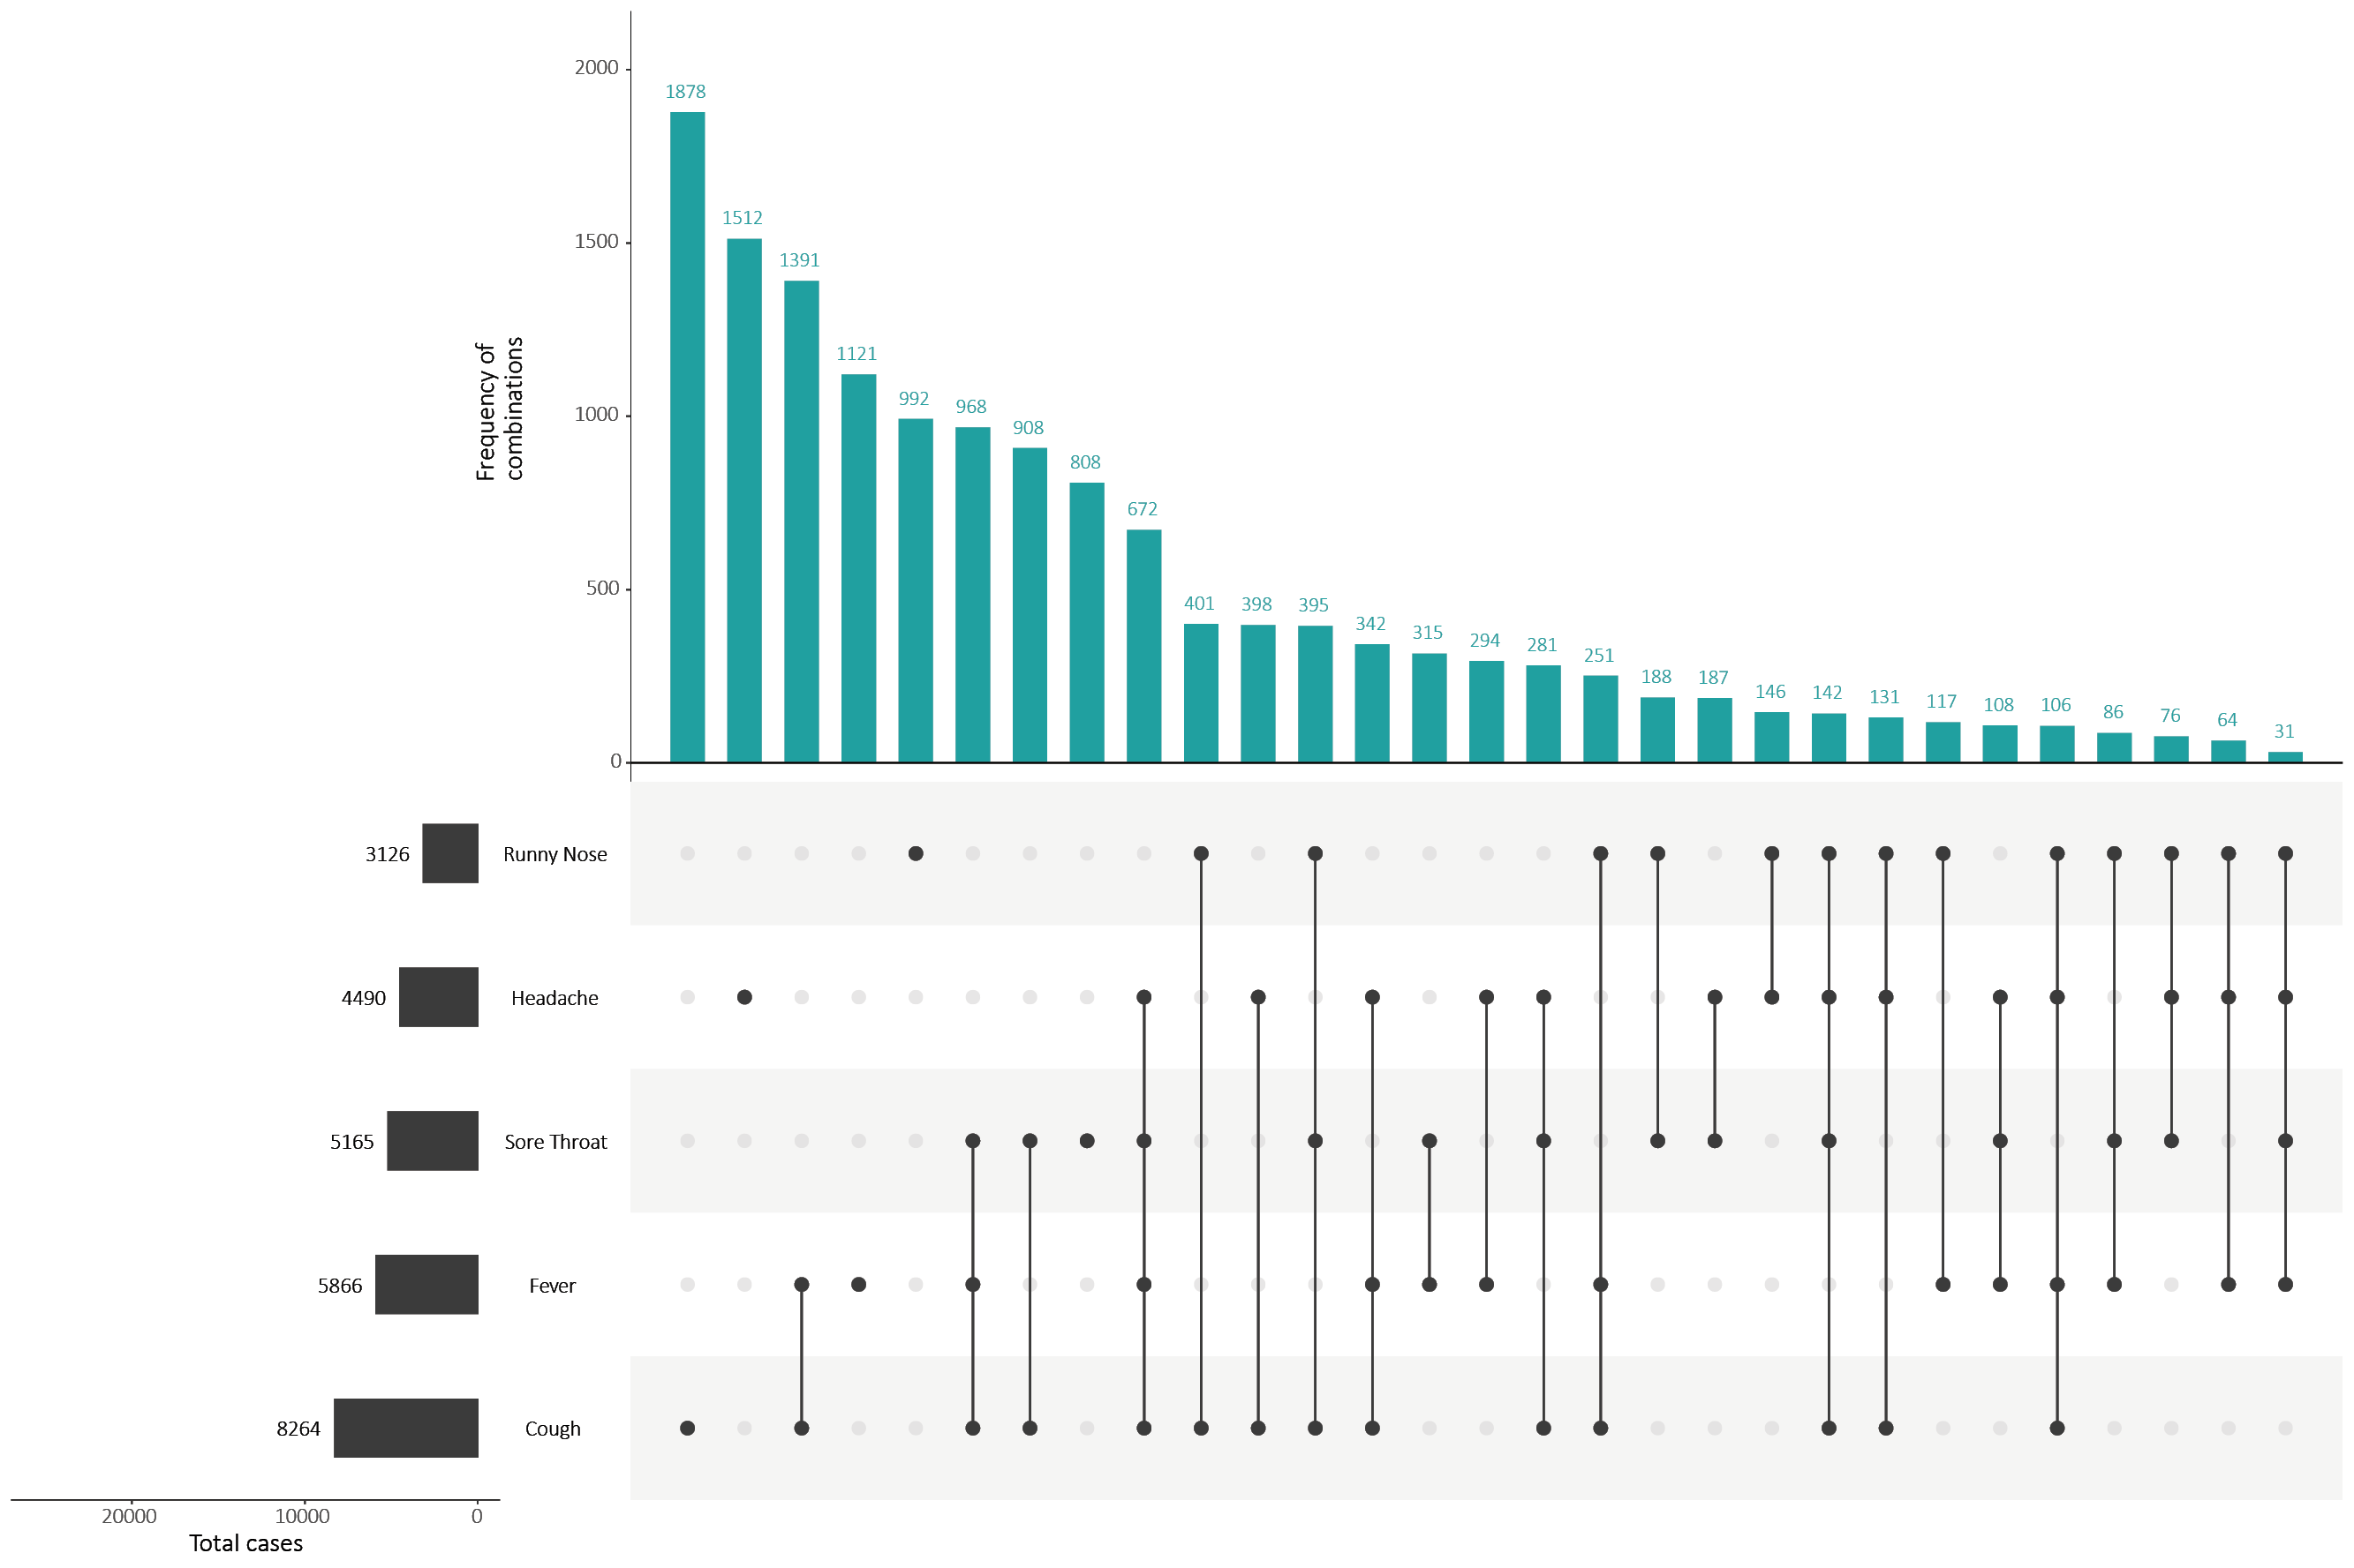
a This figure shows the variation in combinations of symptoms observed in reported cases (n = 12,636) for the five most frequently observed symptoms (cough, fever, headache, sore throat, runny nose). The horizontal bars on the left show the frequency of symptom occurrence in any combination with other symptoms. The circles and lines indicate particular combinations of symptoms observed in individual patients. The vertical green bars indicate the frequency of occurrence of the corresponding combination of symptoms.

Figure B.2. Heat map showing COVID-19 locally-acquired case notifications by place of residence, Australia, 17–30 August 2020
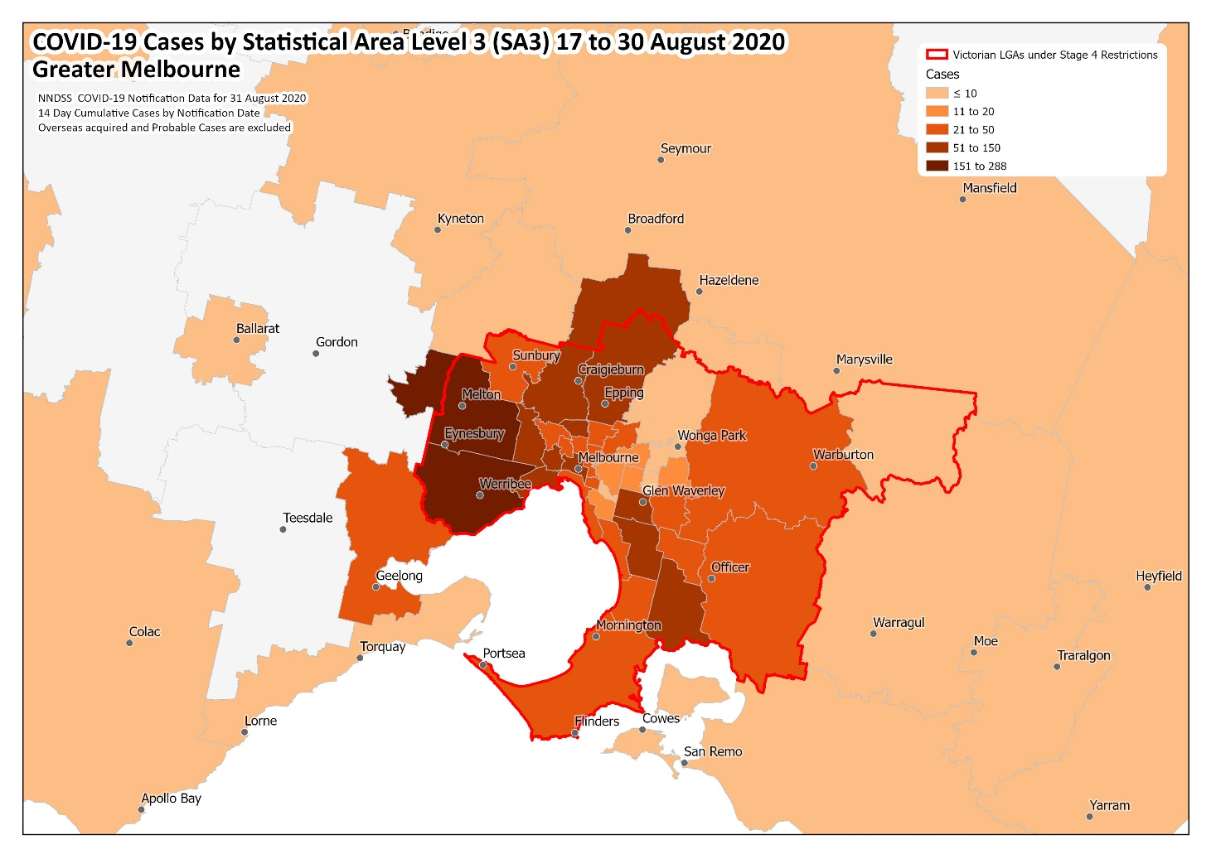
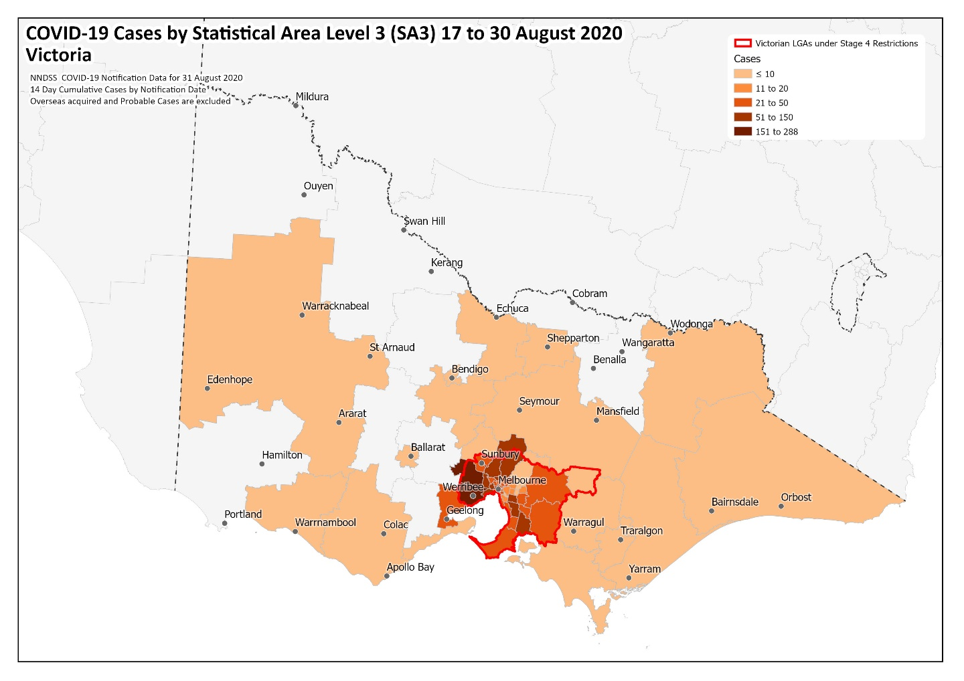
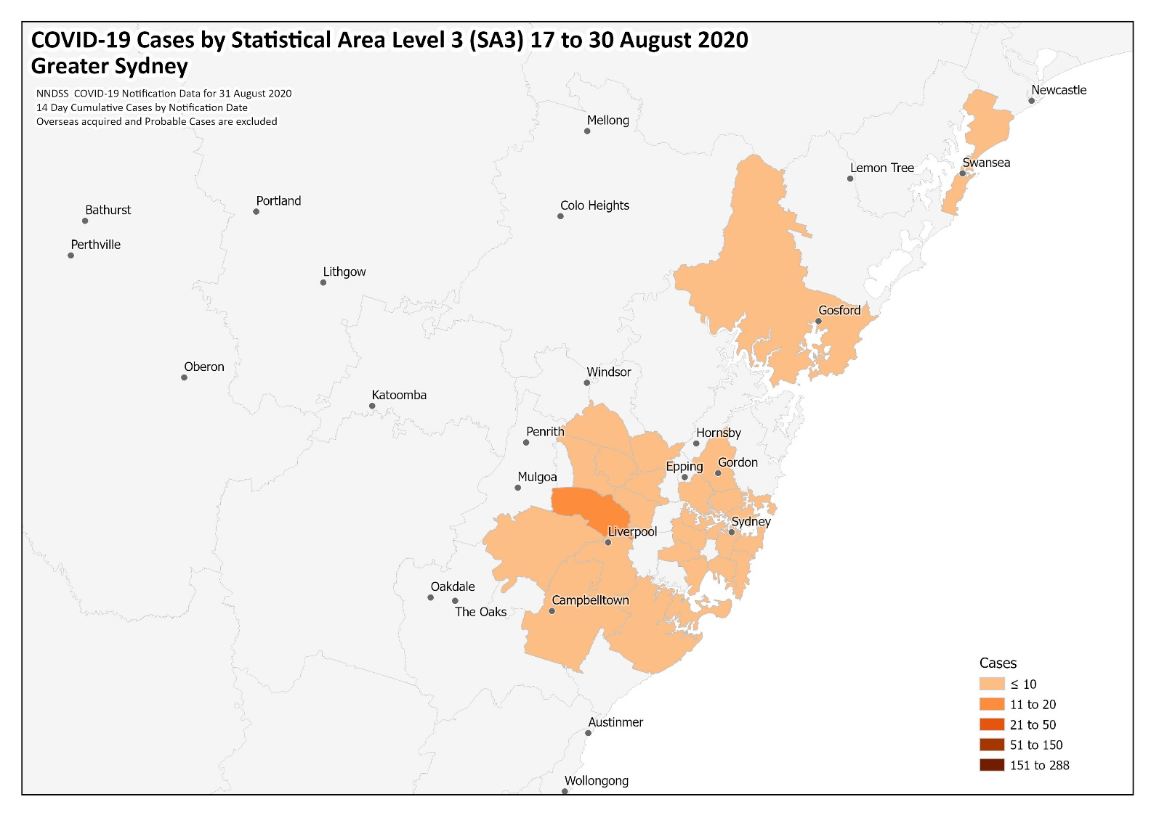

Appendix C: Frequently asked questions
Q: Can I request access to the COVID-19 data behind your CDI fortnightly reports?
A: National notification data on COVID-19 confirmed cases is collated in the National Notifiable Disease Surveillance System (NNDSS) based on notifications made to state and territory health authorities under the provisions of their relevant public health legislation.
Normally, requests for the release of data from the NNDSS requires agreement from states and territories via the Communicable Diseases Network Australia, and, depending on the sensitivity of the data sought and proposed, ethics approval may also be required.
Due to the COVID-19 response, unfortunately, specific requests for NNDSS data have been put on hold. We are currently looking into options to be able to respond to data requests in the near future.
We will continue to publish regular summaries and analyses of the NNDSS dataset and recommend the following resources be referred to in the meantime:
- NNDSS summary tables: http://www9.health.gov.au/cda/source/cda-index.cfm
- Daily case summary of cases: https://www.health.gov.au/news/health-alerts/novel-coronavirus-2019-ncov-health-alert/coronavirus-covid-19-current-situation-and-case-numbers
- Communicable Diseases Intelligence COVID-19 epidemiology report: https://www1.health.gov.au/internet/main/publishing.nsf/Content/novel_coronavirus_2019_ncov_weekly_epidemiology_reports_australia_2020.htm
- State and territory public health websites.
Q: Why have the reports changed from weekly to fortnightly?
A: The change to fortnightly reporting is to allow more time for an in-depth analysis of the NNDSS data, therefore enhancing the contents of the report.
Q: Can I request access to data at post-code level of confirmed cases?
A: Data at this level cannot be released without ethics approval and permission would need to be sought from all states and territories via the Communicable Diseases Network Australia. As noted above, specific requests for NNDSS data are currently on hold.
Where current or recent reported case numbers are high enough to justify it, a GIS/mapping analysis of cases will be included in the Communicable Diseases Intelligence COVID-19 epidemiology report. In order to protect privacy of confirmed cases, data in this map will be presented at SA3 level.
Q: Where can I find more detailed data on COVID-19 cases?
A: We are currently looking into ways to provide more in-depth epidemiological analyses of COVID-19 cases, with regard to transmission and severity, including hospitalisation. These analyses will continue to be built upon in future iterations of the Communicable Diseases Intelligence report.

Communicable Diseases Intelligence
ISSN: 2209-6051 Online

Communicable Diseases Intelligence (CDI) is a peer-reviewed scientific journal published by the Office of Health Protection, Department of Health. The journal aims to disseminate information on the epidemiology, surveillance, prevention and control of communicable diseases of relevance to Australia.

Editor: Tanja Farmer
Deputy Editor: Simon Petrie
Design and Production: Kasra Yousefi
Editorial Advisory Board: David Durrheim, Mark Ferson, John Kaldor, Martyn Kirk and Linda Selvey

Website: http://www.health.gov.au/cdi

Contacts
Communicable Diseases Intelligence is produced by:
Health Protection Policy Branch, Office of Health Protection, Australian Government Department of Health
GPO Box 9848, (MDP 6) CANBERRA ACT 2601

Email: cdi.editor@health.gov.au

Submit an Article
You are invited to submit your next communicable disease related article to the Communicable Diseases Intelligence (CDI) for consideration. More information regarding CDI can be found at: http://health.gov.au/cdi.
Further enquiries should be directed to: cdi.editor@health.gov.au.

This journal is indexed by Index Medicus and Medline.

Creative Commons Licence - Attribution-NonCommercial-NoDerivatives CC BY-NC-ND
© 2020 Commonwealth of Australia as represented by the Department of Health
This publication is licensed under a Creative Commons Attribution-NonCommercial-NoDerivatives 4.0 International Licence from https://creativecommons.org/licenses/by-nc-nd/4.0/legalcode (Licence). You must read and understand the Licence before using any material from this publication.

Restrictions
The Licence does not cover, and there is no permission given for, use of any of the following material found in this publication (if any):
- the Commonwealth Coat of Arms (by way of information, the terms under which the Coat of Arms may be used can be found at www.itsanhonour.gov.au);
- any logos (including the Department of Health’s logo) and trademarks;
- any photographs and images;
- any signatures; and
- any material belonging to third parties.

Disclaimer
Opinions expressed in Communicable Diseases Intelligence are those of the authors and not necessarily those of the Australian Government Department of Health or the Communicable Diseases Network Australia. Data may be subject to revision.

Enquiries
Enquiries regarding any other use of this publication should be addressed to the Communication Branch, Department of Health, GPO Box 9848, Canberra ACT 2601, or via e-mail to: copyright@health.gov.au

Communicable Diseases Network Australia
Communicable Diseases Intelligence contributes to the work of the Communicable Diseases Network Australia.
http://www.health.gov.au/cdna

This report addresses indicators listed in the CDNA National Surveillance Plan 2020.
https://www.gisaid.org/

