COVID-19, Australia: Epidemiology Report 21
Fortnightly reporting period ending 19 July 2020
COVID-19 National Incident Room Surveillance Team
Unless indicated, the source of all data, including notified cases of COVID-19 and associated deaths, is the National Notifiable Diseases Surveillance System (NNDSS) to 19 July 2020. Due to the dynamic nature of NNDSS data, data in this report are subject to retrospective revision and may vary from data reported in published NNDSS reports and reports of notification data by states and territories. Case numbers for the most recent dates of illness onset may be subject to revision, due to reporting delays.

Confirmed cases in Australia | As at 19 July 2020 | 6 to 19 July
Notifications | 12,636 | 3,791
Deaths | 147 | 37

Summary
Over the past fortnightly reporting period (6 to 19 July):
- The number of new cases reported nationally increased from 897 in the previous fortnight (22 June to 5 July) to 3,791 (6 to 19 July).
- The large increase in cases is due to multiple epidemiologically-linked outbreaks across a range of settings and locations in Victoria (94%; 3,575 cases), with very few cases reported by other jurisdictions (216) in this reporting period.
- Of the 3,575 cases reported in Victoria, all except one were reported as locally acquired. The majority of these cases were linked to several outbreaks.
- Of the 216 cases reported from other jurisdictions, approximately 55% (119 cases) were locally acquired.
- A total of 37 deaths were reported, all from Victoria.
- On average, 271 cases were reported each day over the reporting period, an increase from 54 cases per day over the previous reporting period.
- Testing rates have increased across all jurisdictions, predominantly in Victoria, with the nationwide cumulative positivity rate remaining very low at less than 0.5%.
Figure 1: New and cumulative COVID-19 notifications by date of illness onset, Australia
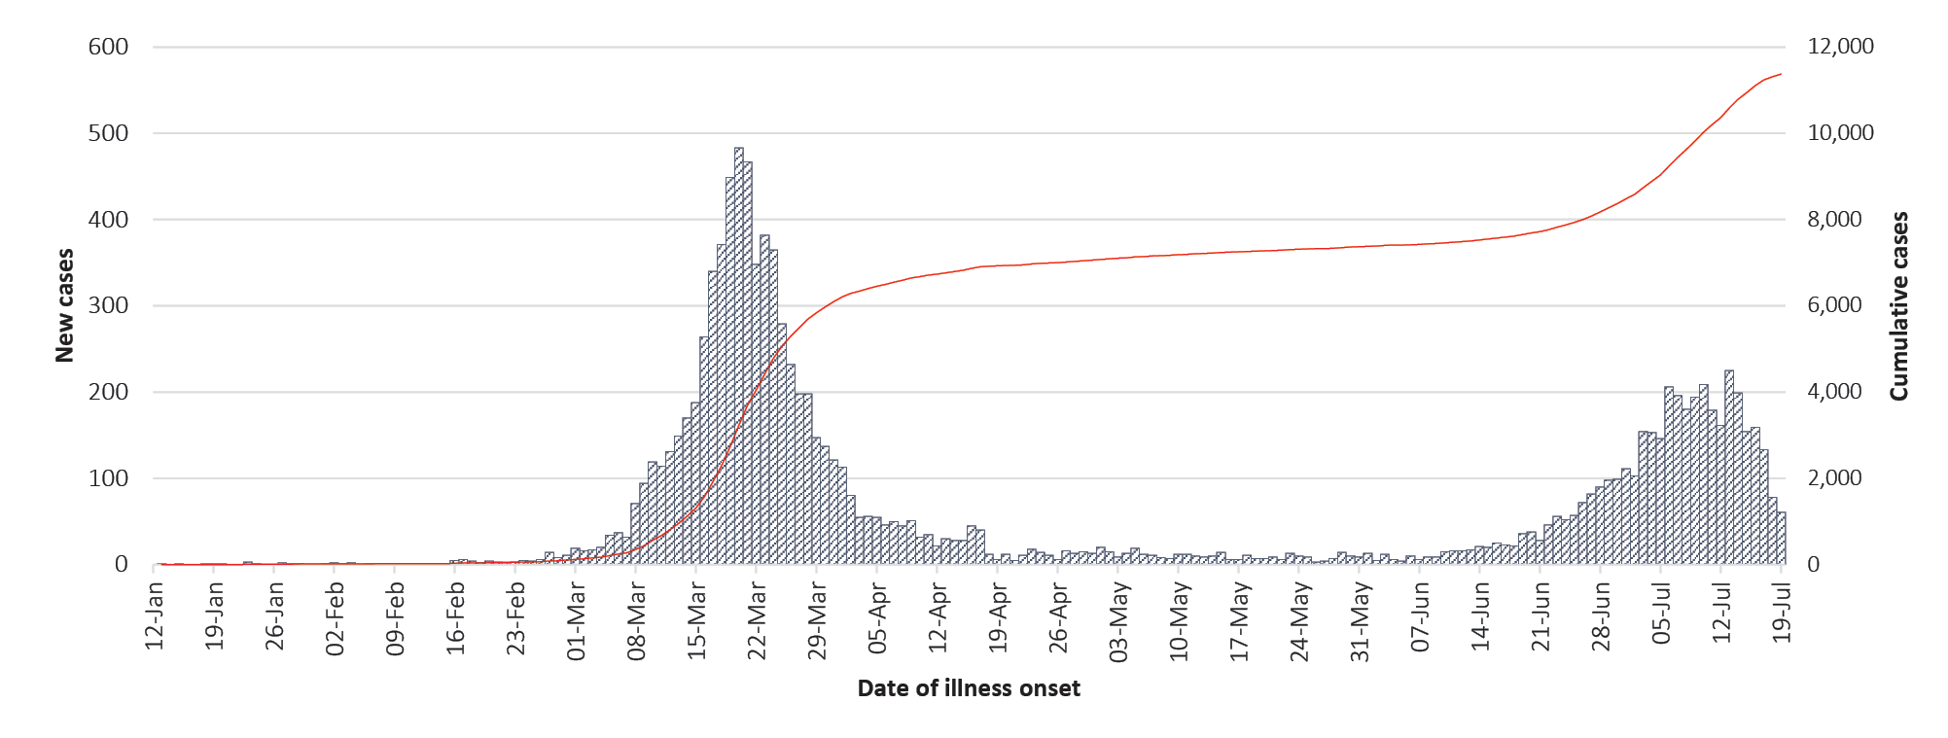
As at 19 July, a small proportion of cases have experienced severe disease, requiring hospitalisation or intensive care, with some fatalities. The cumulative crude case fatality rate amongst Australian cases is 1.2%. People who are older and have one or more comorbidity are more likely to experience severe disease.
Keywords: SARS-CoV-2; novel coronavirus; 2019-nCoV; coronavirus disease 2019; COVID-19; acute respiratory disease; epidemiology; Australia

In focus: COVID-19 in the Aboriginal and Torres Strait Islander population
As at 19 July, there have been 99 cases of COVID-19 notified in Aboriginal and Torres Strait Islander persons. This represents approximately 0.8% of all confirmed cases. There were no cases notified in this population between 28 May and 27 June. Since 27 June there has been a slow increase in notifications (Figure 2). To date, there have been no cases in this population reported in the NT, with NSW and Vic reporting 37 cases each (Table 1). Completeness of reporting in the Indigenous field remains steady at 86%.
Figure 2: National COVID-19 notifications in Aboriginal and Torres Strait Islander population by notification date, cumulative and new cases, Australia
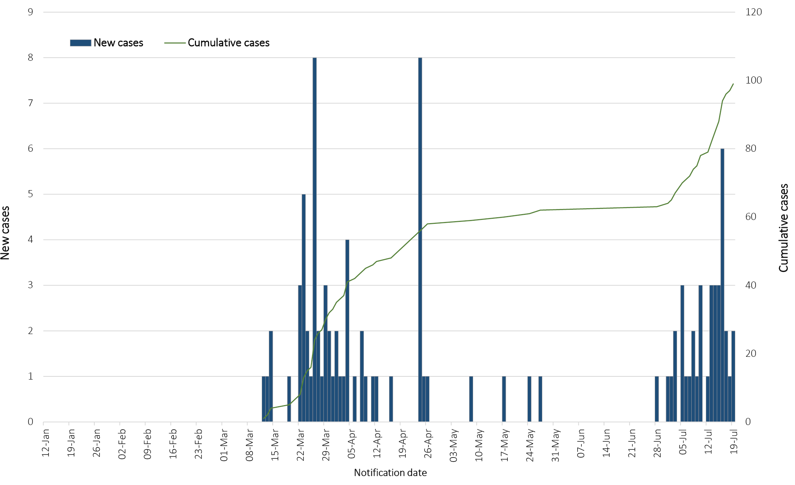

Table 1: COVID-19 notifications among Aboriginal and Torres Strait Islander persons by jurisdiction, source of acquisition and remoteness classification as at 19 July 2020ª
Jurisdiction | Locally acquired^{b} |  |  |  | Overseas acquired | Unknown | Total
 | Major Cities of Australia | Inner Regional Australia | Outer Regional Australia | Remote Australia
NSW | 16 | 5 | 1 | 0 | 15 | 0 | 37
Vic | 30 | 3 | 1 | 0 | 2 | 1 | 37
Qld | 3 | 0 | 0 | 0 | 6 | 0 | 9
WA | 0 | 0 | 0 | 0 | 1 | 0 | 1
SA | 2 | 0 | 0 | 0 | 0 | 0 | 2
Tas | 0 | 0 | 5 | 1 | 6 | 0 | 12
NT | 0 | 0 | 0 | 0 | 0 | 0 | 0
ACT | 0 | 0 | 0 | 0 | 1 | 0 | 1
Total | 51 | 8 | 7 | 1 | 31 | 1 | 99
a Excludes probable cases.
b ‘Locally acquired’ comprises all cases without an overseas or unknown place of acquisition.
Approximately 31% (31) of all cases notified in Aboriginal and Torres Strait Islander persons are reported as being acquired overseas (Table 1), with almost half (14/31) of these cases associated with cruise ships. For locally-acquired cases, 69% are associated with contact with a confirmed case and/or outbreak and 24% are locally acquired with contact unknown. Of the locally-acquired cases: 76% were reported as residing in Major Cities of Australia; 22% were reported as residing in Inner or Outer Regional Australia; and 1% (1) was reported as residing in Remote or Very Remote Australia (Table 1).
The median age of COVID-19 cases in Aboriginal and Torres Strait Islander persons is 30 years (interquartile range, IQR: 21.5–48.0), which is younger than for non-Indigenous cases [median age 39 years (IQR: 26.0–57.0)]. Cumulatively, Aboriginal and Torres Strait Islander persons are reporting a higher proportion of cases in school-aged children (13%) compared to non-Indigenous cases (6%) and a lower proportion of cases in people aged 65 years and over (8% compared to 12% of non-Indigenous cases) (Figure 3).

Figure 3: National COVID-19 notifications by age group and sex, Aboriginal and Torres Strait Islander persons and non-Indigenous Australiansª
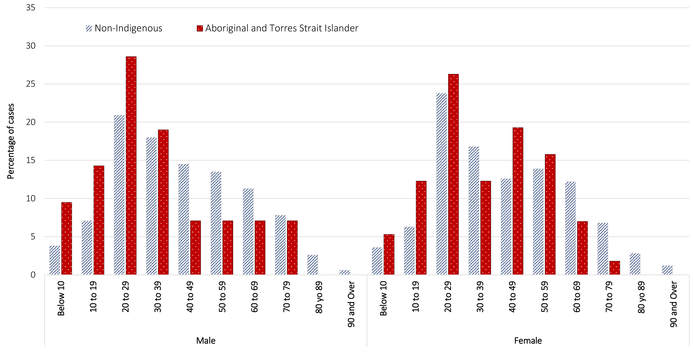
a ‘Non-Indigenous’ includes one person identified as gender X, and 88 non-Indigenous Australians with unknown gender.
By gender, there is a higher proportion of cases in Aboriginal and Torres Strait Islander females (58%, 57 cases) than in non-Indigenous females (48%, 6,064 cases). The differences observed in gender for Aboriginal and Torres Strait Islander people likely reflect the small number of cases rather than any specific transmission pattern. Overall, Aboriginal and Torres Strait Islander males are reporting a slightly higher proportion of cases in the 20–29 year age group (29%) compared to non-Indigenous cases (21%); Aboriginal and Torres Strait Islander females are reporting a higher proportion of cases in the 40–49 year age group (19%) than is seen among non-Indigenous cases (13%) (Figure 3).
Of all cases that have been notified in Aboriginal and Torres Strait Islander persons, 11 cases were reported as requiring hospitalisation (4 male and 7 female). The median age for hospitalisation was 46 years. No cases have been reported as requiring admission to an intensive care unit (ICU) and no COVID-19 related deaths have been reported.
Data on symptoms are reported for all cases in Aboriginal and Torres Strait Islander people. However, 14% of these are reported as ‘symptoms unknown’. Of the cases with known symptoms, the most common symptoms reported were cough (61%), sore throat (38%), fever and headache (35% each). Overall, reported symptoms were similar to the proportions reported in non-Indigenous cases, with headache and cough reported more frequently in cases in Aboriginal and Torres Strait Islander people.

Australian cases: descriptive epidemiology

National trends
Since the first case of COVID-19 was identified in Australia, all states and territories have experienced COVID-19 cases, with some jurisdictions experiencing higher numbers and more community associated transmission. These differences arise from factors including state demographics, population size, patterns of overseas arrivals in the beginning of the pandemic, and ongoing repatriation flights being concentrated in Melbourne and Sydney.
In this reporting period, 61% (2,341) of cases are reported as locally acquired in Victoria (Table 2). Due to the scale of the outbreak, 32% (1,230) of all cases reported in this period are under investigation, though they are likely locally acquired.
Table 2: COVID-19 notifications by jurisdiction and source of acquisition, 6 to 19 July
Source | NSW | Vic | Qld | WA | SA | Tas | NT | ACT | Australia
Overseas | 56 | 1 | 5 | 34 | 1 | 0 | 1 | 0 | 98
Local | 98 | 1,587 | 0 | 1 | 0 | 0 | 0 | 3 | 1,689
Local unknown | 9 | 763 | 0 | 0 | 0 | 0 | 0 | 2 | 774
Under investigation | 6 | 1,224 | 0 | 0 | 0 | 0 | 0 | 0 | 1,230
Total | 169 | 3,575 | 5 | 35 | 1 | 0 | 1 | 5 | 3,791
Figure 4 shows Australian cases by Statistical Area Level 3 in this reporting period, noting that cases that are overseas residents or acquired their infection overseas are not included.

Figure 4: Australian COVID-19 cases by Statistical Area Level 3,ª 6–19 July 2020
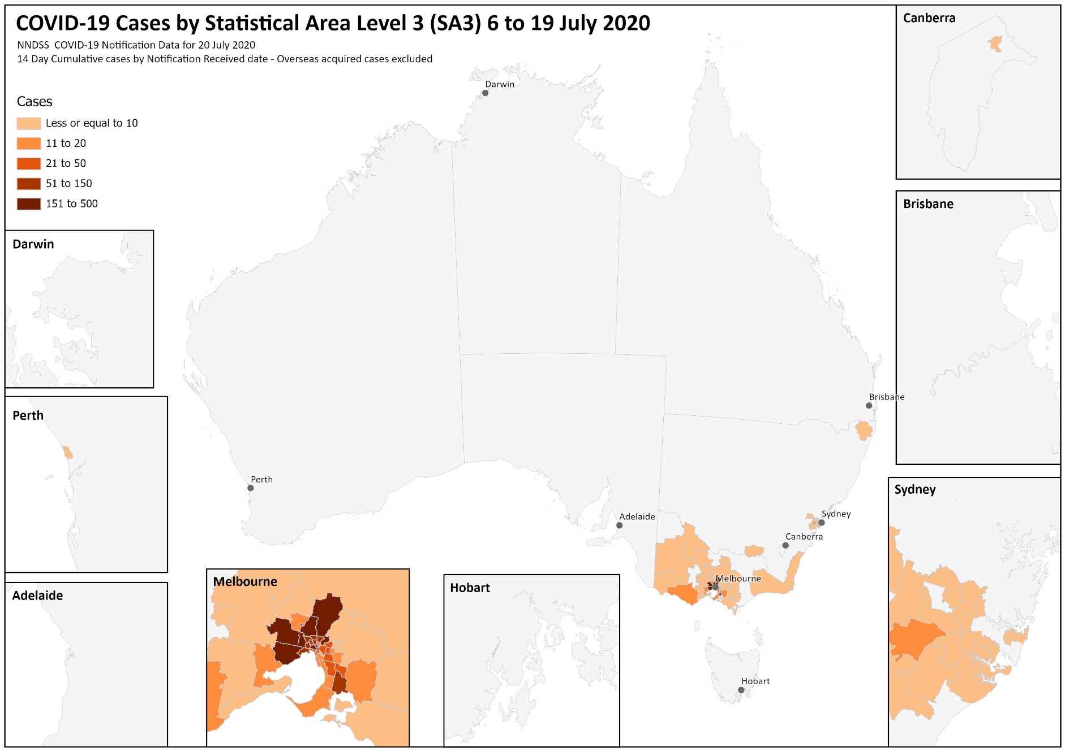
a These maps require caution especially when drawing inferences about areas of current transmission. The allocation of a case to an SA3 area is based on a case’s postcode of Australian residence and does not necessarily represent the area where they acquired their infection, or were tested or managed. Cases that are overseas residents or acquired their infection overseas are not included in this mapping.

In this reporting period, the national rate of infection was 15.0 per 100,000 population (Table 3). However, Victoria’s rate of infection for this period was 54.2 per 100,000 population, more than three times the national average. This is the highest rate of infection that Victoria has reported to date, and has exceeded the peak per capita rate of New South Wales (22.9 cases per 100,000 people) at the height of their outbreak (Figure 5).

Figure 5: COVID-19 case notifications 12 January to 19 July 2020 for Victoria, New South Wales and Queensland
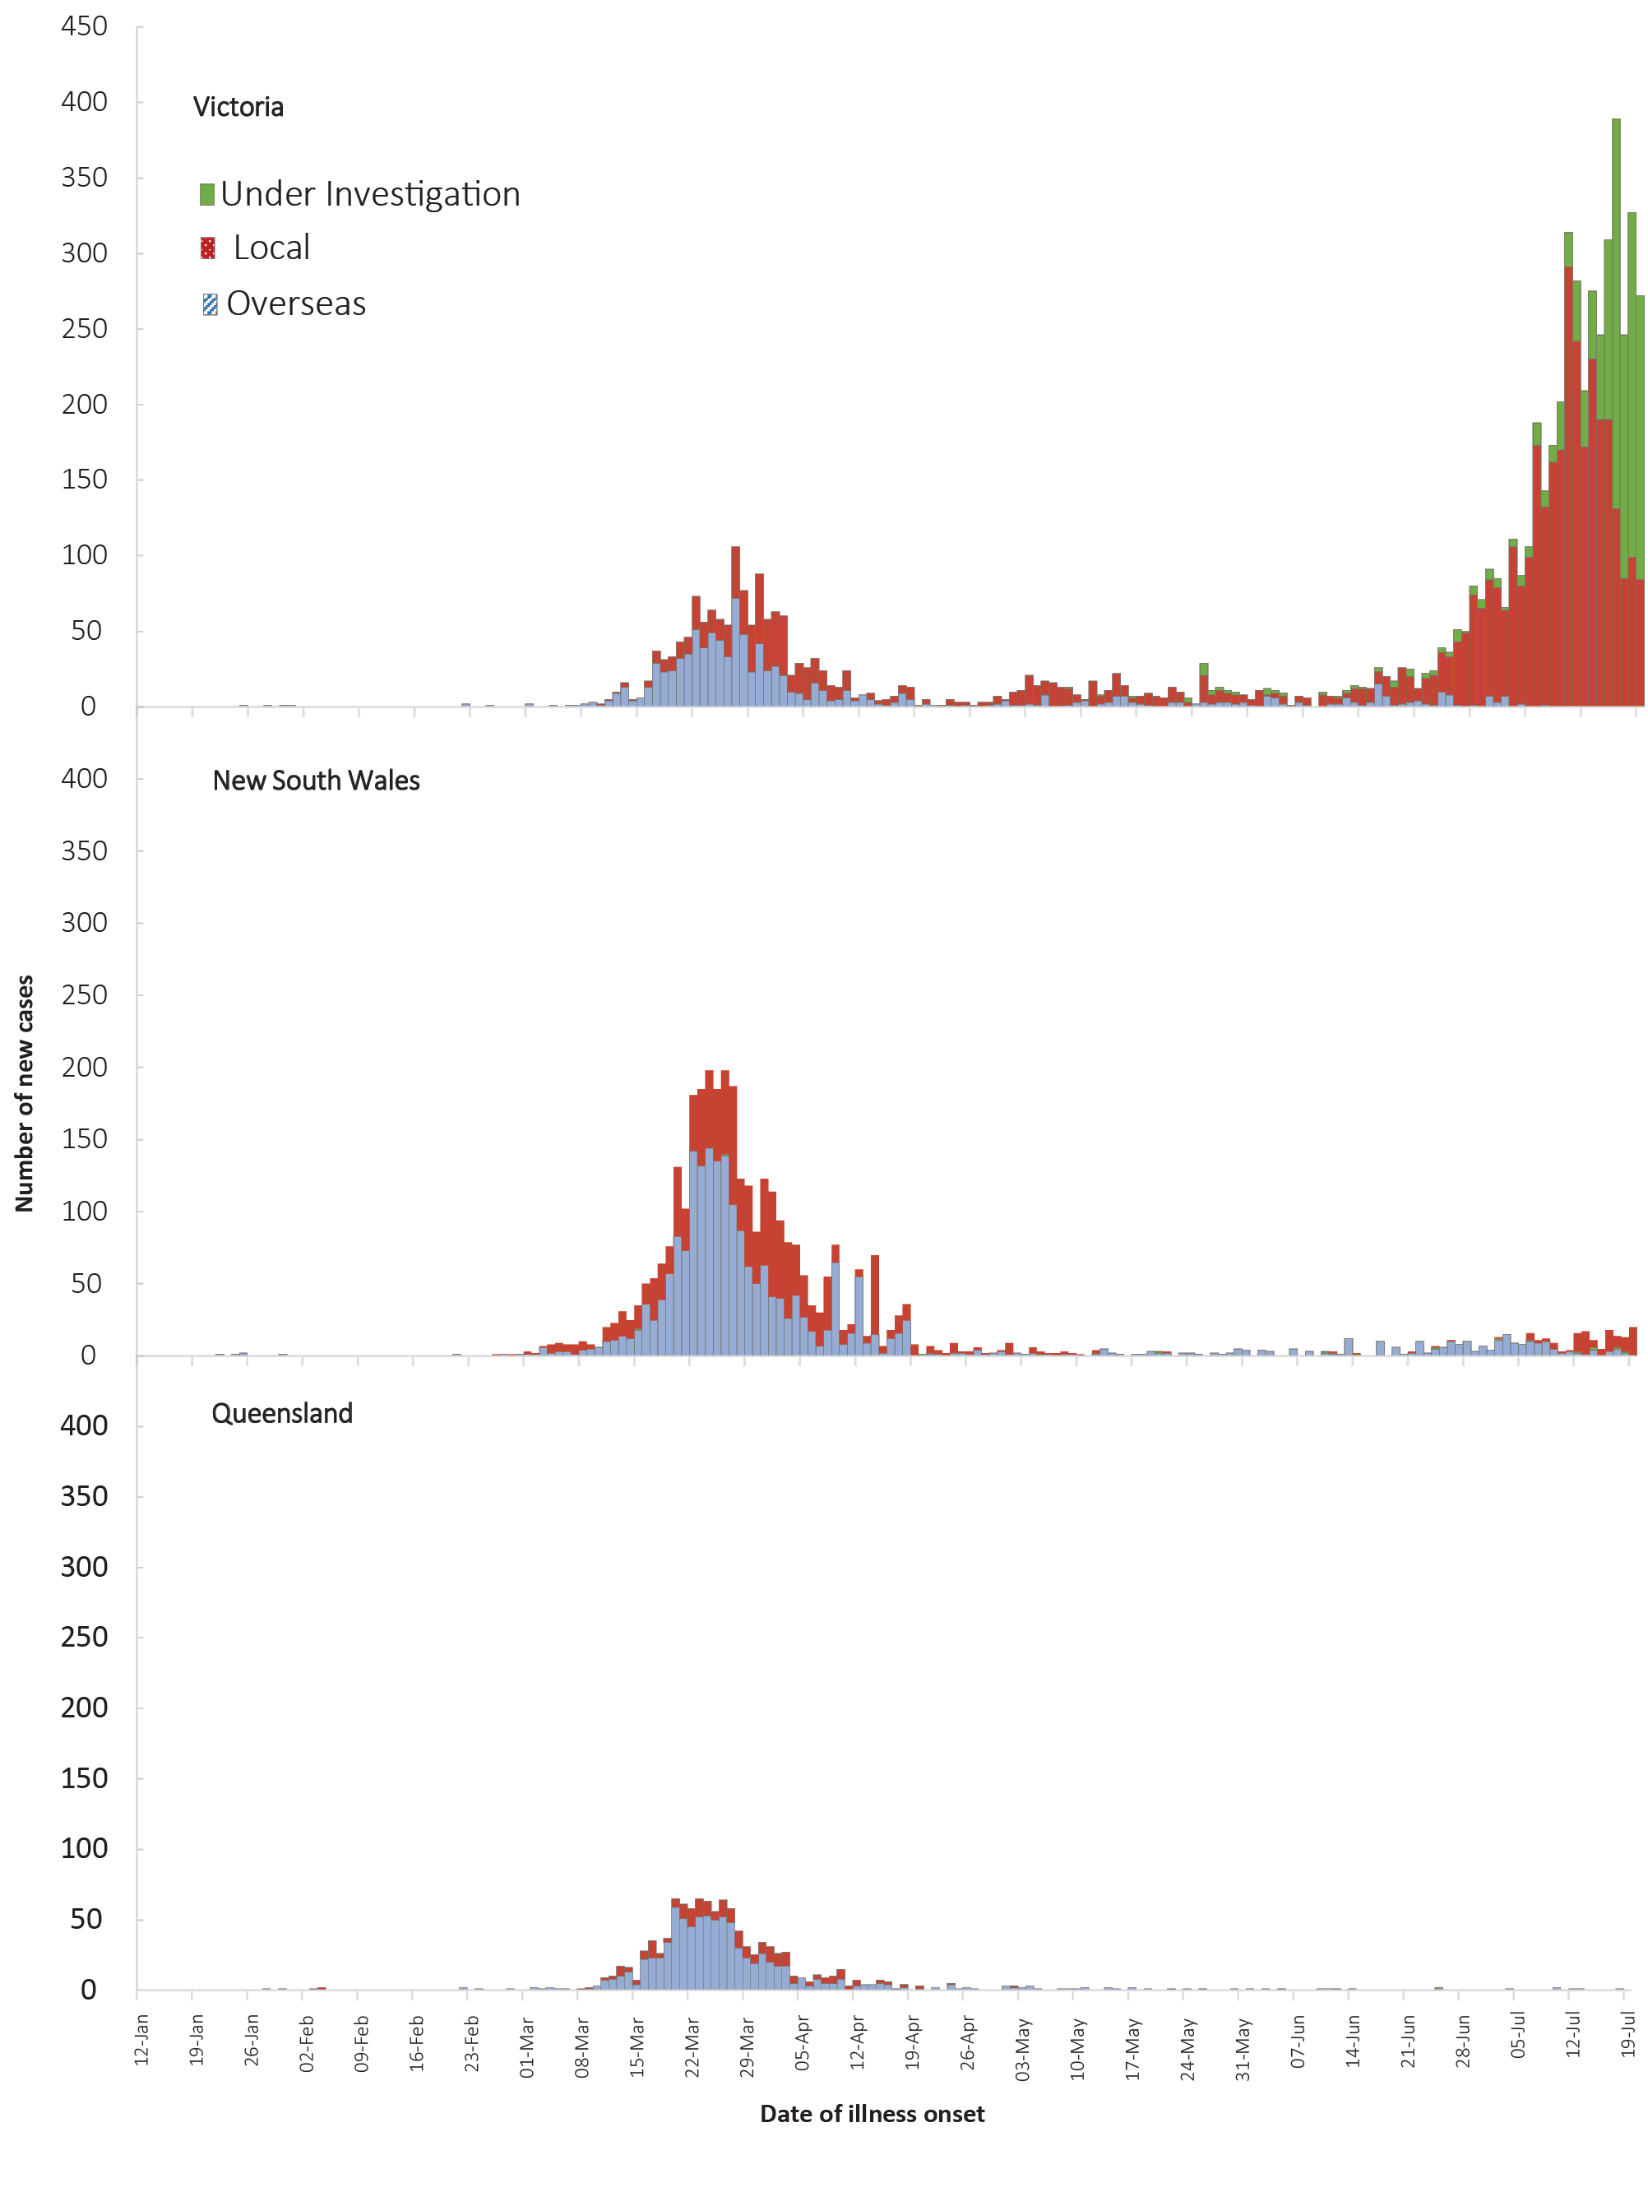
Figure 6: Number of new case notifications in Australia, by source of acquisition
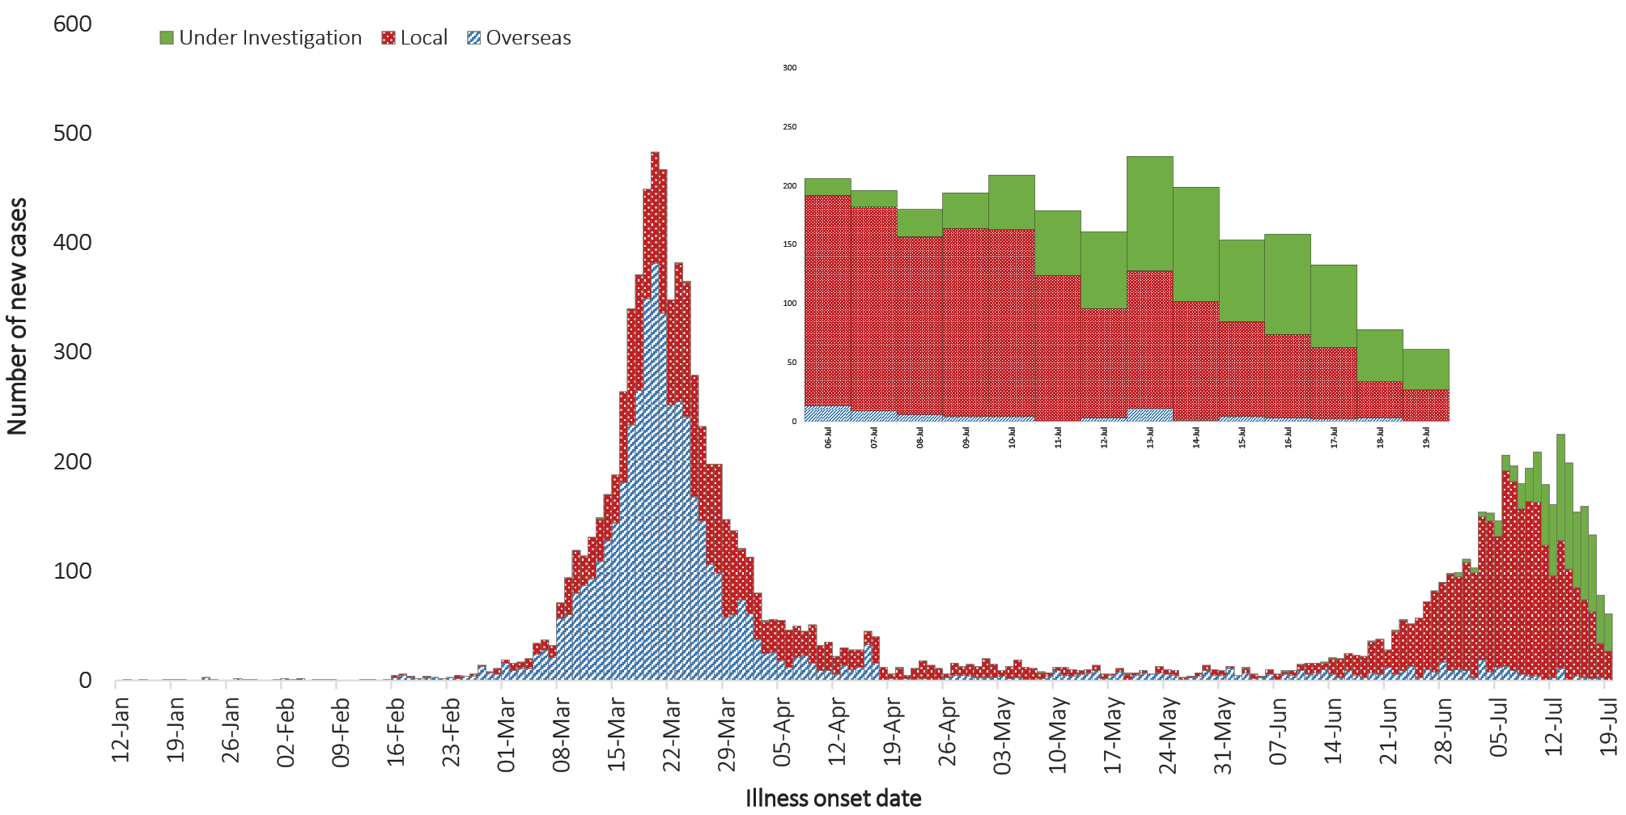
Table 3: COVID-19 fortnightly notifications, cumulative total cases and rates per 100,000 population, Australia
Jurisdiction | Cases notified  22 June—5 July |  | Cases notified  6—19 July |  | Total cases
 | Number of cases | Rates per 100,000 population | Number of cases | Rates per 100,000 population | Number of cases | Rates per 100,000 population
NSW | 113 | 1.40 | 169 | 2.09 | 3,626 | 44.82
Vic | 919 | 13.93 | 3,575 | 54.20 | 6,471 | 98.10
Qld | 3 | 0.06 | 5 | 0.10 | 1,075 | 21.10
WA | 7 | 0.27 | 35 | 1.34 | 647 | 24.68
SA | 4 | 0.23 | 1 | 0.06 | 445 | 25.40
Tas | 0 | 0.00 | 0 | 0.00 | 228 | 42.66
NT | 1 | 0.41 | 1 | 0.41 | 31 | 12.61
ACT | 0 | 0.00 | 5 | 1.17 | 113 | 26.48
Australia | 1,047 | 4.13 | 3,719 | 14.95 | 12,636 | 49.82

Source of acquisition
As at 19 July 2020, Australia has recorded 12,636 cases of COVID-19. Of these, 49% are reported as locally acquired, 40% are reported as overseas acquired, and 11% remain under investigation (Figure 3).
For this reporting period, 65% of cases were locally acquired, 3% were overseas acquired, and 32% were under investigation at time of reporting. The number and proportion of locally-acquired cases has continued to increase, largely due to outbreaks in Victoria. Of all locally-acquired cases in this reporting period, the source of acquisition for 69% of cases was found to be a contact of a case or in a known cluster; 31% were unable to be linked to another case. This included 8 cases where a contact could not be identified but interstate travel had occurred.
The largest numbers of all overseas-acquired cases were related to cruise-ship travel (31%) or to travel originating in the European region (29%) or the Americas (19%). Travel included returning from holidays and chartered repatriation flights. Overseas-acquired cases reported in this fortnight were predominantly reported from NSW (57%) and WA (35%) and were detected in travellers in hotel quarantine from repatriation flights.

Testing
During this reporting period, 763,028 tests were conducted nationally with an overall positivity rate of less than 0.5%. All states except Victoria reported a positivity lower than 0.11% for this fortnight. Victoria reported a positivity rate of 0.84% for this period.
A total of 3,476,463 tests have been conducted in Australia. High rates of testing have continued across the country with the cumulative proportion of positive tests remaining low at less than 0.5% in each jurisdiction (Table 4). The low positivity rate indicates widespread testing in the community and supports the observation of low levels of disease in these areas.

Table 4: Diagnostic tests performed as at 19 July 2020, Australia, by jurisdictionª
Jurisdiction | Tests performed  22 June—5 July |  | Tests performed  6—19 July |  |  | Cumulative tests performed to 19 July
 | N | Positivity (%) | N |  | Positivity (%) | N | Positivity (%) | Per 100,000 population ^{a,b}
NSW | 216,615 | 0.19 |  | 238,653 | 0.06 | 1,181,085 | 0.30 | 14,600
Vic | 267,370 | 0.70 |  | 377,015 | 0.84 | 1,305,186 | 0.44 | 19,787
Qld | 115,884 | 0.01 |  | 68,567 | 0.01 | 459,139 | 0.23 | 9,012
WA | 29,948 | 0.04 |  | 28,545 | 0.11 | 219,758 | 0.30 | 12,544
SA | 23,802 | 0.01 |  | 27,336 | 0.00 | 188,428 | 0.24 | 7,188
Tas | 8,909 | 0.00 |  | 8,023 | 0.00 | 60,957 | 0.37 | 11,405
NT | 3,215 | 0.05 |  | 5,159 | 0.02 | 19,907 | 0.16 | 8,095
ACT | 6,368 | 0.00 |  | 9,730 | 0.05 | 42,003 | 0.27 | 9,844
Australia | 672,111 | 0.28 |  | 763,028 | 0.44 | 3,476,463 | 0.34 | 13,705
a Data in this table are based on reports of notification by states and territories.
b Population data based on Australian Bureau of Statistics (ABS) Estimated Resident Population (ERP) as at 30 June 2019.
Figure 7: COVID-19 cases, by age group and sex, 6–19 July 2020, Australia
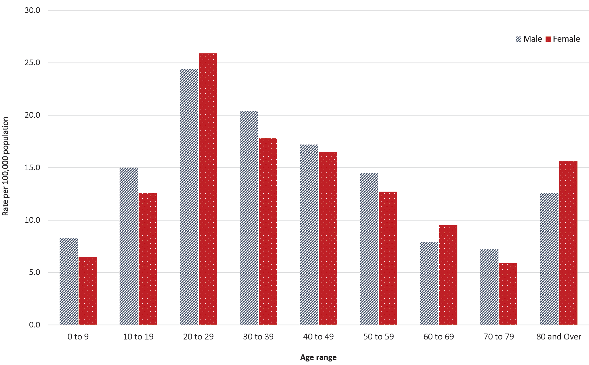
For this reporting period, Victoria has reported a positivity rate of 0.84%, which is an increase from the previous reporting period (0.70%). The number of tests conducted in Victoria has increased by approximately 109,000 this reporting period to support active case finding in outbreak settings.
Table 5: Number and case fatality rate (CFR) for all cases, hospitalised cases and cases admitted to ICU, by age group and gender, Australia
 | All cases |  |  | Hospitalisation |  |  | ICU
 | Male | Female | Persons | Male | Female | Persons | Male | Female | Persons
 | Number
Total | 6,426 | 6,121 | 12,636 | 822 | 748 | 1572 | 197 | 110 | 307
 | Case fatality rate (%)
Under 50 | 0.0 | 0.0 | 0.0 | 0.4 | 0.0 | 0.2 | 0.0 | 0.0 | 0.0
50–64 | 0.6 | 0.2 | 0.4 | 3.0 | 1.5 | 2.3 | 8.9 | 2.7 | 6.5
65–79 | 3.7 | 2.4 | 3.1 | 10.6 | 7.6 | 9.4 | 17.1 | 9.5 | 14.5
80 and over | 21.9 | 18.0 | 19.8 | 32.1 | 28.8 | 30.4 | 57.1 | 25.0 | 45.5
All age groups | 1.3 | 1.0 | 1.2 | 8.5 | 6.8 | 7.7 | 13.7 | 6.4 | 11.1

Demographics of cases
Historically, cases of COVID-19 have been reported across all age groups; however in recent reporting periods a shift to younger populations is observed (see Appendix B, Table B.1). Cumulatively cases show a mean age of 42.0 and a median age of 39 years (IQR: 26 to 57). Prior to April, the population diagnosed was slightly older, with a median age of 47 (IQR: 29 to 62) reflecting the source of acquisition being primarily cruise ships. In this reporting period, the median age is 33 (IQR: 23 to 49).
Cumulatively, people in the 20–29 years age group have the highest rate of COVID-19 infection (77.0 cases per 100,000 population), followed by the 30–39 years age group (59.8 cases per 100,000 population) and then 60–69 years (56.5 cases per 100,000 population) (Table B.1). Children aged 0–9 years continue to have the lowest rate (14.9 cases per 100,000 population). Across most age groups, males show a higher rate of infection than females, with the exception being in the 20–29 years age group. The largest difference in rates between genders is observed in the 70–79 age group where males are diagnosed with COVID-19 almost 30% more than females.
In this reporting period, approximately 13.9% of cases notified are 0 to 18 years old, compared to 22.3% in the previous reporting period. A similar trend is seen with school aged children (5 to 17 years) where the total number of cases reported has increased, but the proportion within the age group decreased. In this reporting period there are 410 cases reported in this age group, which represents 10.8% of all cases. For the previous reporting period, 161 cases were reported, representing 18% of all cases for that reporting period.

Severity
Of total cases notified in Australia, approximately 12% (n = 1,572) were admitted to hospital. Of hospitalised cases, 20% (n = 307) were admitted to ICU (Table 3) and 8% (n = 127) were ventilated. 41% of ICU patients required ventilation. Higher disease severity, as indicated by hospitalisation, admission to ICU, and death, has been associated with increased age.¹ The median ages of cases who have been hospitalised (61 years; IQR 43–73), admitted to ICU (64 years; IQR 51–72) and ventilated (65 years; IQR 55–72) are higher than for cases overall (42 years; IQR 26–57).
Canada has reported a similar severity profile, with 14% of cases hospitalised, of which 20% were admitted to the ICU and 4% required mechanical ventilation.² Higher rates have been observed across the EU/EEA with 31% (data from 23 countries) of reported cases requiring hospitalisation and 14% (data from 16 countries) being admitted to the ICU and/or requiring respiratory support.³
Proportions vary considerably between countries and are affected by each country’s underlying health and testing strategies, with some European countries only testing hospitalised individuals for COVID-19. There is also variation in the way different countries classify and report hospitalisations. The European region also reported a decrease in both the hospitalisation and severe hospitalisation rate with increasing age beyond 80 years, which is not seen in the Australian data. This was hypothesised to reflect clinical decisions about the use of hospital resources for people in this age group and was observed in the data from many countries.³
Among Australian cases, the case fatality rate (CFR) for males is higher than females of the same age across all age groups examined (Table 3). Of all deaths in Australia, the mean age is 80.7 years, while the median age is 82.0 (IQR: 75.5 to 88.5). The youngest death occurred in a person aged 42 years. Overall fatality rates by age group are similar to those observed in China and Italy as of 17 March 2020,⁴ but lower than those observed for the European region when aggregated.³
The CFR of Australian hospitalised cases was 7.7%, which was similar to Canadian cases which were hospitalised (8%),⁵ but dramatically lower than the aggregated value of 25% observed in European cases (data from 21 countries).³ Australian results are based on small numbers of cases and therefore may not be directly comparable to results from other countries.

Symptom profile
The symptoms reported by COVID-19 cases in Australia are consistent with a mild respiratory infection in the majority of cases. The principal symptoms reported in cases (Figure B.1) were cough (51%), fever (37%), sore throat (32%) and headache (25%). Other symptoms reported include malaise, lethargy or fatigue (26%), and loss of taste or smell (12%). These are currently not standard fields in NNDSS, and are likely to under-represent those presenting with these symptoms. A small number of cases reported more severe symptoms, with pneumonia and/or acute respiratory disease (ARD) reported in 2% of cases with symptoms.
In more severe cases cough, fever and shortness of breath were the most common symptoms reported, as well as an increasing proportion reporting malaise/lethargy/fatigue or acute respiratory syndrome/pneumonia with increasing severity. The proportion reporting a loss of taste or smell dropped with increasing severity. The completeness of the symptom field in the NNDSS was 98%, with 83% of records indicating known symptoms.
The symptom profile of Australian cases is broadly similar to the symptoms reported by COVID-19 cases internationally. Among EU/EEA countries and the UK, a dry or productive cough and fever/chills were the most commonly reported symptoms.³ Differences in reported symptoms will be influenced by differences in surveillance strategies and symptom reporting across countries.

Public health response measures
Since COVID-19 first emerged internationally, Australia has implemented public health measures informed by the disease’s epidemiology (Figure 8). Key aspects of Australia’s evolving public health response are summarised in previous reports. On Friday 8 May, the Australian Government announced a three-step framework for easing COVID-19 restrictions, with states and territories easing restrictions at their own pace depending on the current public health situation and local epidemiology. During this reporting fortnight, most states and territories have completed moving through the three-step framework for easing restrictions (see Table 6).
Table 6: State and territory changes to COVID-19 restrictions, from 6 to 19 July 2020
Jurisdiction | Summary of changes to COVID-19 restrictions
New South Wales | From 8 July, the border between New South Wales and Victoria was closed to non-essential travellers.⁶  From 14 July the following restrictions were implemented:⁷  Pubs restricted to a maximum of 10 per group with alcohol only permitted for seated customers
Victoria | From 8 July the following restrictions were implemented:8  Stay at home orders in place for residents of metropolitan Melbourne and Mitchell Shire  Non-essential businesses required to close including pubs, bars, clubs, nightclubs, hotels, physical recreation facilities and entertainment facilities
Queensland | From 10 July the Queensland border reopened to persons travelling from New South Wales, Western Australia, South Australia, Tasmania, the Australian Capital Territory and the Northern Territory. Persons from COVID-19 hotspots including Victoria are restricted from entry.⁹
Western Australia | No further easing of restrictions has occurred during this reporting period.¹⁰
South Australia | No further easing of restrictions has occurred during this reporting period.^{11,12}
Tasmania | From 9 July the following additional border measures were implemented:¹³  Any visitor who has spent time in Victoria in the prior 14 days is not permitted to travel to Tasmania  Tasmanian residents travelling from Victoria required to quarantine for 14 days in government provided accommodation
Australian Capital Territory | No further easing of restrictions has occurred during this reporting period.¹⁴
Northern Territory | From 17 July interstate arrivals who are not from a declared hotspot no longer required to self-quarantine. Travellers from declared hotspots continue to need to self-quarantine upon entry.¹⁵

Figure 8: COVID-19 notifications in Australia by date of illness onset, to 19 July 2020 with timing of key public health measures
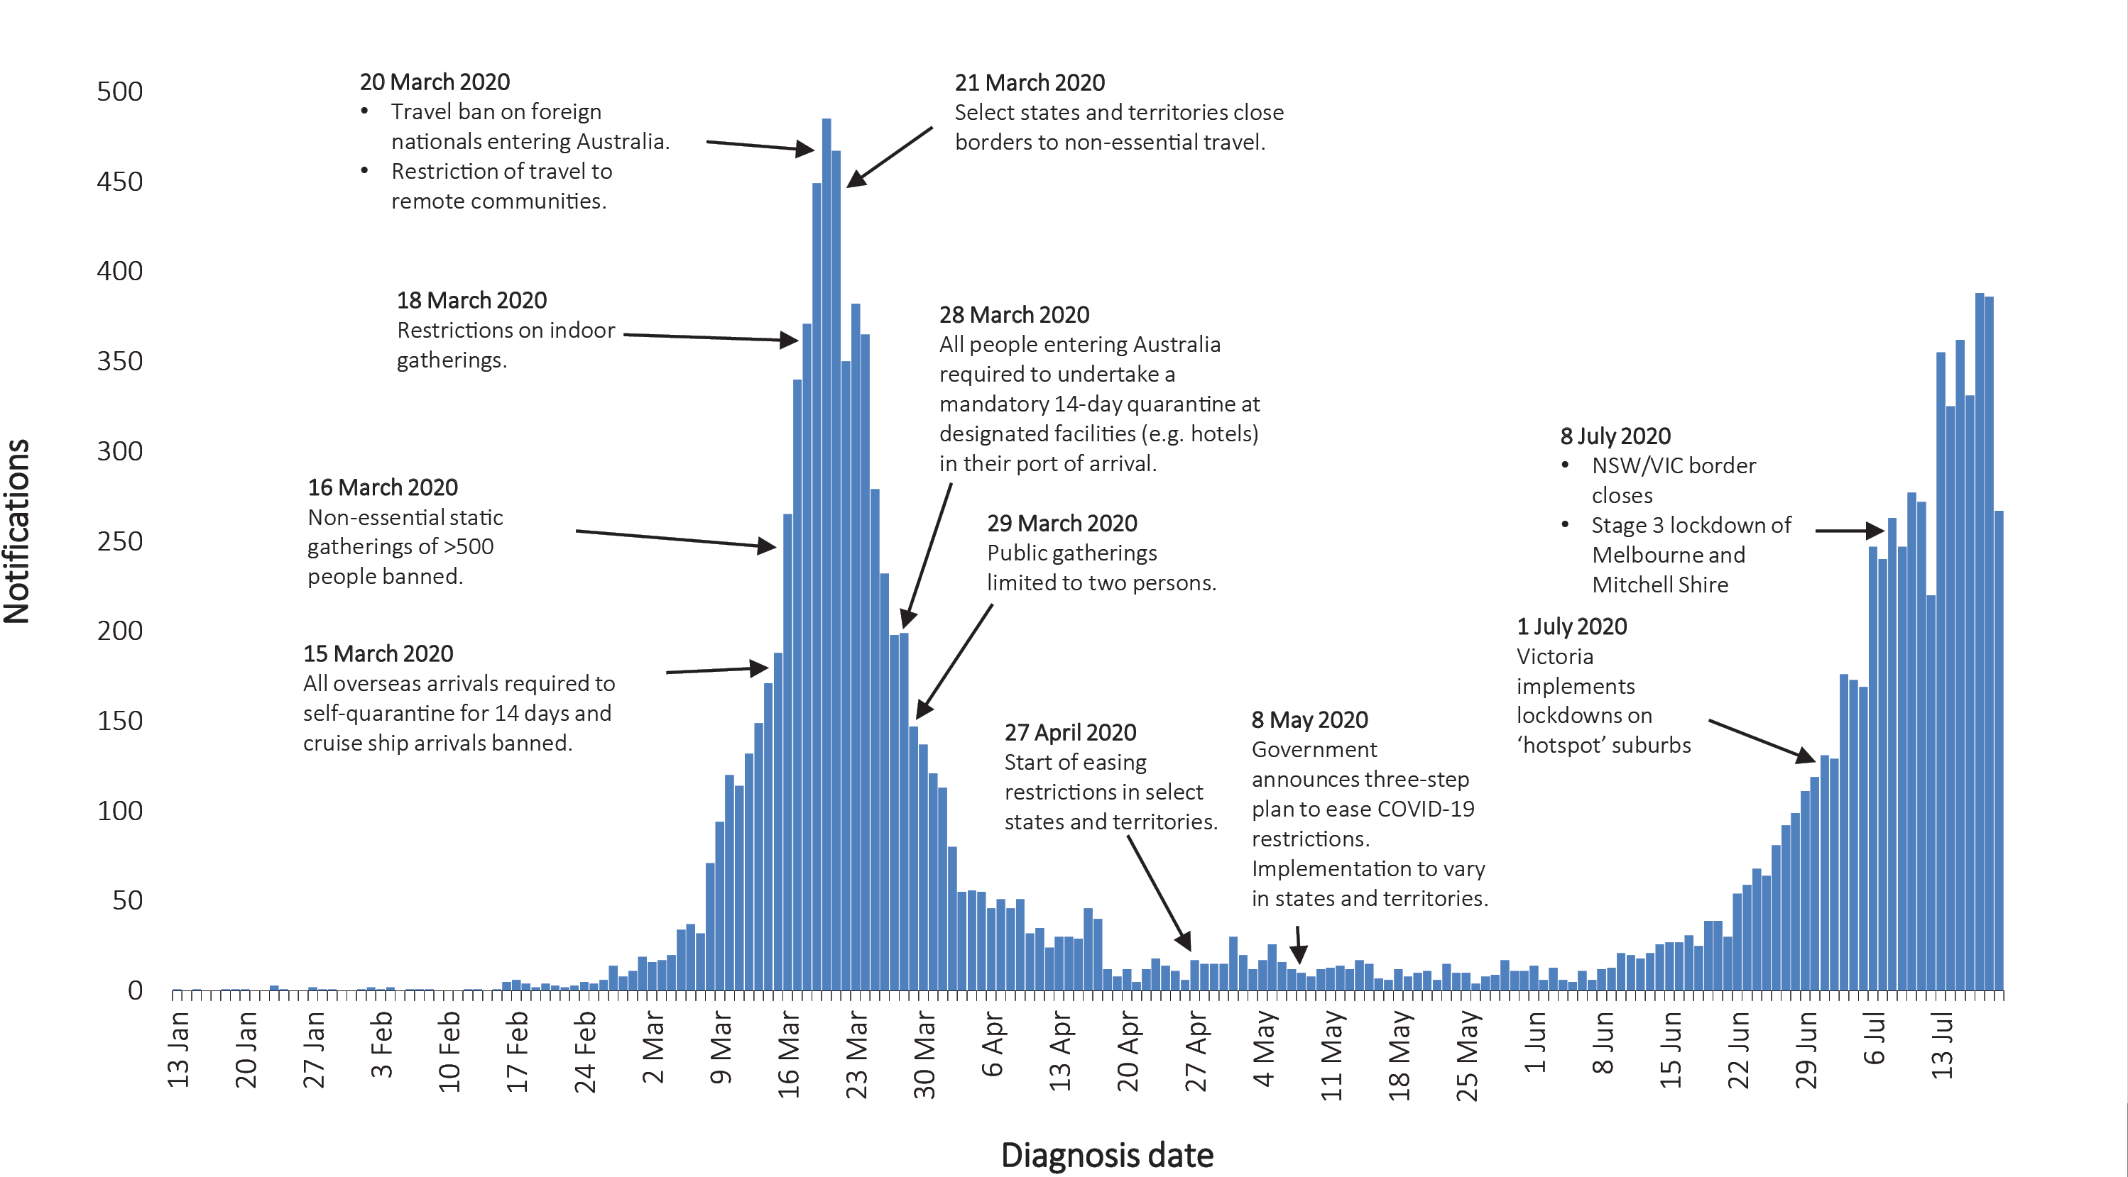

During the current reporting period, due to the evolving epidemiological and public health situation in Victoria and New South Wales, both states have re-implemented some restrictions. In Victoria, residents of greater Melbourne and Mitchell Shire have been subject to a stay-at-home order since 8 July, also referred to as a ‘stage 3’ lockdown.¹⁶ Residents are only permitted to leave their home for: shopping for food or essential items; providing care or seeking medical treatment; exercise; or work or study if they cannot work from home.¹⁶ Residents of regional and remote Victoria have continued to abide by restrictions as adjusted on 22 June,¹⁷ and have not been subject to additional restrictions. On 8 July, the border between New South Wales and Victoria was closed to non-essential travellers. In New South Wales from 14 July, restrictions on pubs were implemented to reduce the size of groups gathering.
During this reporting period, there has been a significant increase in the number of reported cases in Victoria. As a result, from 1 July Victoria implemented targeted lockdowns in suburbs with high case numbers. Residents in selected postcodes in Melbourne are now only permitted to leave their homes for essential reasons (school, work, exercise, shopping for food and supplies, or care and caregiving). In addition, on 6 July it was announced that from 7 July, residents from the Greater Melbourne area would not be permitted to enter New South Wales, and from 8 July the border between Victoria and New South Wales would close. While other states and territories have continued to ease restrictions, most states and territories have announced that people travelling from Victoria will be subject to a 14-day quarantine after domestic border restrictions are eased.

International situation
On 19 July 2020, more than 216 countries, regions and areas had reported 14,043,176 COVID-19 cases and 597,583 deaths to WHO.¹⁸ All data are drawn from the WHO unless otherwise specified. The Americas and Europe continue to be the epicentres of the pandemic with the former representing approximately 53% of cumulative cases and 51% of cumulative deaths, and the latter representing 22% of cases and 35% of deaths. The global case fatality rate (CFR) is approximately 4.3%. The global cumulative rates are 182.8 cases and 7.8 deaths per 100,000 population.
- By country, the largest numbers of cumulative cases are from: the United States of America (3,544,143); Brazil (2,012,151); and India (1,038,716).
- By country, the largest numbers of cumulative deaths are from: the United States of America (137,674); Brazil (76,688); and the United Kingdom (45,233).
In the previous fortnight, the largest numbers of cases have been reported by the Americas (59%) and the South East Asia (16%) regions, led predominantly by the countries highlighted above. South Africa, the Russian Federation, Mexico and Colombia also comprise a large proportion of new cases recorded in the previous fortnight, with each accounting for over 2% of the total cases reported.

Western Pacific Region
To date, the Western Pacific Region is the least affected on the globe, reporting the lowest number of COVID-19 cases and deaths. The cumulative number of cases in the region stands at approximately 260,000, with approximately 35,000 new cases reported in the previous fortnight (16% increase). This represents 1.2% of the global total number of new cases reported in the period. Cumulatively, the Western Pacific region accounts for 1.9% of all cases globally and 1.3% of all deaths. This region has so far reported a cumulative rate of 13.6 cases per 100,000 people and a mortality rate of 0.4 deaths per 100,000 population, which is low when compared to the global rates.
The majority of the cases in the region are observed in China, the Philippines and Singapore. Their epidemic trajectories are shown in Figure 9. In the past fortnight, the greatest numbers of new cases have been observed in the Philippines (65%), Japan (14%) and Singapore (9%). Three countries/territories (Brunei Darussalam, Lao People’s Democratic Republic and French Polynesia) did not report any new cases in the previous fortnight.
Figure 9: Number of COVID-19 cases (logarithmic scale) by selected country and days since passing 100 cases, up to 19 July 2020
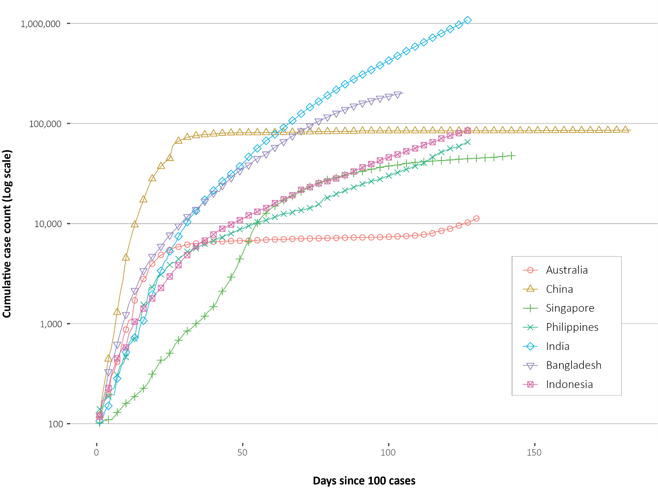
In the past month, several countries in the region which have passed their initial peak are now attributing a large proportion of their new cases to clusters. According to media reports, an outbreak in north western China in the cities of Urumqi and Kashgar has led to the re-implementation of restrictions including travel bans, mass health screening and a cessation of group activities.¹⁹ In Singapore, the outbreak in migrant workers living in dormitories continues. Though the rate of new infections has slowed, there continues to be a high proportion of new cases occurring in this population group.²⁰

South East Asia Region
In this fortnight, the South East Asia Region has seen a large growth in new case numbers. Cumulatively the region reports approximately 1.39 million cases and 33,500 deaths, with approximately 459,000 cases reported in the last fortnight (52% increase). The region accounts for 9.7% of global cumulative cases and 5.5% of global cumulative deaths. Regionally, the per capita burden of disease is relatively low, compared to the global rates, at 67.5 cases and 1.6 deaths per 100,000 population.
The majority of the cases in the region are observed in India, Bangladesh and Indonesia, which also comprise the greatest proportion of new cases in the previous fortnight, at 85%, 9% and 5% respectively. Their epidemic trajectories are shown in Figure 9. India reported the greatest rise in case count, increasing by 60% over the reporting period. The Maldives is the most-affected country in the region per capita, reporting 538 cases per 100,000 people. Only Timor-Leste did not report a case in the previous fortnight.
Testing rates in these major three countries have improved over time. India has completed approximately 14.05 million tests and has increased its testing to over 300,000 samples per day.²¹ Cumulatively, India’s positivity rate is approximately 7%; however in the last week, on average, its positivity was approximately 10%, suggesting that the epidemic has not yet been controlled. Cumulatively, Bangladesh has conducted approximately 1.04 million tests, with 88,000 tests in the last week; its current positivity rate is 20%.²²

Data considerations
Data were extracted from the NNDSS on 28 July 2020 for notifications received up to 19 July 2020. Due to the dynamic nature of the NNDSS, numbers presented in this report are subject to revision and may vary from numbers previously reported and from case notifications released by states and territories.

Definitions
‘Date of illness onset’ is derived from data collected by the NNDSS and represents the diagnosis date, or reported true onset of disease date. If unknown, the earliest of specimen collection date, notification date or notification receive date is used.
‘Notification received date’ is reported in the NNDSS and represents the date the case is first notified on the NNDSS. As notification can only occur after testing is completed and information processed, counts for a defined period will vary according to the date type used.
‘Cluster’ in relation to COVID-19 refers to two or more cases (who do not reside in the same household) that are epidemiologically related in time, place or person where a common source (such as an event or within a community) of infection is suspected but not yet established.
‘Outbreak’ in relation to COVID-19 refers to two or more cases (who do not reside in the same household) among a specific group of people and/or over a specific period of time where illness is associated with a common source (such as an event or within a community). Some states and territories may report a single case associated with a residential aged care facility as an outbreak.

Acknowledgements
This report represents surveillance data reported through CDNA as part of the nationally-coordinated response to COVID-19. We thank public health staff from incident emergency operations centres in state and territory health departments, and the Australian Government Department of Health, along with state and territory public health laboratories.

Author details

Corresponding author
COVID-19 National Incident Room Surveillance Team, Australian Government Department of Health, GPO Box 9484, MDP 14, Canberra, ACT 2601. Email: epi.coronavirus@health.gov.au

References
- COVID-19 National Incident Room Surveillance Team. COVID-19, Australia: Epidemiology Report 16: Reporting week ending 23:59 AEST 17 May 2020. Commun Dis Intell (2018). 2020;44. doi: https://doi.org/10.33321/cdi.2020.44.45.
- Public Health Agency of Canada (PHAC). Coronavirus disease 2019 (COVID-19). Epidemiology update. Updated: June 22, 2020, 7 pm EDT. [Internet.] Ottawa: Government of Canada, PHAC; 2020. [Accessed on 30 July 2020.] Available from: https://health-infobase.canada.ca/covid-19/epidemiological-summary-covid-19-cases.html.
- European Centre for Disease Prevention and Control (ECDC). COVID-19 surveillance report: Week 29, 2020. [Internet.] Solna: ECDC; 25 July 2020. [Accessed on 30 July 2020.] Available from: https://covid19-surveillance-report.ecdc.europa.eu/.
- Zheng Z, Peng F, Xu B, Zhao J, Liu H, Peng J et al. Risk factors of critical & mortal COVID-19 cases: a systematic literature review and meta-analysis. J Infect. 2020. doi: https://doi.org/10.1016/j.jinf.2020.04.021.
- PHAC. Detailed preliminary information on cases of COVID-19: 6 Dimensions (Aggregated data), Public Health Agency of Canada. [Internet.] Ottawa: Government of Canada, PHAC; 2020. [Accessed on 30 July 2020.] Available from: https://www150.statcan.gc.ca/t1/tbl1/en/tv.action?pid=1310077401.
- Government of New South Wales. NSW-Victoria border restrictions. [Internet.] Sydney: Government of New South Wales; 2020. [Accessed on 29 July 2020.] Available from: https://www.nsw.gov.au/covid-19/what-you-can-and-cant-do-under-rules/border-restrictions.
- Government of New South Wales. What you can and can’t do under the rules. [Internet.] Sydney: Government of New South Wales; 2020. [Accessed on 29 July 2020.] Available from: https://www.nsw.gov.au/covid-19/what-you-can-and-cant-do-under-rules.
- Department of Health and Human Services (DHHS). Victoria’s restriction levels. [Internet.] Melbourne: Victoria State Government, DHHS; 2020. [Accessed on 29 July 2020.] Available from: https://www.dhhs.vic.gov.au/victorias-restriction-levels-covid-19.
- Queensland Government. Roadmap to easing Queensland’s restrictions. A step-down approach to COVID-19. Brisbane: Queensland Government; 2020. [Accessed on 29 July 2020.] Available from: https://www.covid19.qld.gov.au/__data/assets/pdf_file/0016/127150/DPC7309-COVID-19-Restrictions-roadmap.pdf.
- Government of Western Australia. COVID-19 coronavirus: WA Roadmap. Phase 4. [Internet.] Perth: Government of Western Australia; 2020. [Accessed on 29 July 2020.] Available from: https://www.wa.gov.au/organisation/department-of-the-premier-and-cabinet/covid-19-coronavirus-wa-roadmap#phase4.
- Government of South Australia. South Australian roadmap for easing COVID-19 restrictions. Adelaide: Government of South Australia; 2020. [Accessed on 29 July 2020.] Available from: https://www.covid-19.sa.gov.au/__data/assets/pdf_file/0012/195879/200059.4-COVID-19-RoadMap-19June-V7.pdf.
- Government of South Australia. Recovery from COVID-19. [Internet.] Adelaide: Government of South Australia; 2020. [Accessed on 29 July 2020.] Available from: https://www.covid-19.sa.gov.au/recovery.
- Tasmanian Government. Roadmap to recovery. [Internet.] Hobart: Tasmanian Government; 2020. [Accessed on 29 July 2020.] Available from: https://coronavirus.tas.gov.au/families-community/roadmap-to-recovery.
- Australian Capital Territory Government. COVID-19: Summary of key changes. [Internet.] Canberra: Australian Capital Territory Government; 2020. [Accessed on 29 July 2020.] Available from: https://www.covid19.act.gov.au/faqs-old/summary-of-key-changes.
- Northern Territory Government. Roadmap to the new normal. [Internet.] Darwin: Northern Territory Government; 2020. [Accessed on 29 July 2020.] Available from: https://coronavirus.nt.gov.au/roadmap-new-normal.
- DHHS. Restrictions: Metropolitan Melbourne and Mitchell Shire. [Internet.] Melbourne: State Government of Victoria, DHHS; 2020. [Accessed on 29 July 2020.] Available from: https://www.dhhs.vic.gov.au/restrictions-metropolitan-melbourne-and-mitchell-shire-covid-19.
- DHHS. Restrictions: rest of Victoria. [Internet.] Melbourne: State Government of Victoria, DHHS; 2020. [Accessed on 29 July 2020.] Available from: https://www.dhhs.vic.gov.au/restrictions-rest-victoria-covid-19.
- World Health Organization (WHO). WHO Coronavirus Disease (COVID-19) dashboard. [Internet.] Geneva: WHO; 19 July 2020. [Accessed on 20 July 2020.] Available from: https://covid19.who.int/.
- Associated Press. Coronavirus outbreak in China’s Xinjiang Region spreads to second city. [Internet.] New York City: Time Magazine; 20 July 2020. [Accessed on 29 July 2020.] Available from: https://time.com/5868895/xinjiang-coronavirus-outbreak/.
- Singapore Government Ministry of Health. COVID-19 Situation report. Data updated as of: 30 July 2020. [Internet.] Singapore Government Ministry of Health; 2020. [Accessed on 31 July 2020.] Available from: https://covidsitrep.moh.gov.sg/.
- Roser M, Ritchie H, Ortiz-Ospina E, Hasell J. Statistics and research: Coronavirus pandemic (COVID-19). [Website.] Oxford: Our World in Data; 2020. [Accessed on 30 July 2020.] https://ourworldindata.org/coronavirus.
- WHO. COVID-19: 20 July 2020. Morbidity and Mortality Weekly Update (MMWU) #21. Bangladesh: WHO; 2020. [Accessed on 29 July 2020.] Available from: https://www.who.int/docs/default-source/searo/bangladesh/covid-19-who-bangladesh-situation-reports/who-covid-19-update-21-20200720.pdf.
- WHO. Report of the WHO-China joint mission on coronavirus disease 2019 (COVID-19). [Internet.] Geneva: WHO; 2020. [Accessed 1 Mar 2020.] Available from: https://www.who.int/docs/default-source/coronaviruse/who-china-joint-mission-on-covid-19-final-report.pdf.
- Wölfel R, Corman VM, Guggemos W, Seilmaier M, Zange S, Müller MA et al. Virological assessment of hospitalized patients with COVID-2019. Nature. 2020. doi: https://doi.org/10.1038/s41586-020-2196-x.
- Cheng HY, Jian SW, Liu DP, Ng TC, Huang WT, Lin HH. Contact tracing assessment of COVID-19 transmission dynamics in Taiwan and risk at different exposure periods before and after symptom onset. JAMA Intern Med. 2020. doi: https://doi.org/10.1001/jamainternmed.2020.2020.
- Korea Centers for Disease Control and Prevention (KCDC). Division of risk assessment and international cooperation. Findings from investigation and analysis of re-positive cases. [Internet.] Cheongju: Government of South Korea, KCDC; 2020. [Accessed on 24 May 2020.] Available from: https://www.cdc.go.kr/board/board.es?mid=a30402000000&bid=0030&act=view&list_no=367267&nPage=1.
- Zhu Y, Bloxham CJ, Hulme KD, Sinclair JE, Tong ZW, Steele LE et al. Children are unlikely to have been the primary source of household SARS-CoV-2 infections. medRxiv. 2020. doi: https://doi.org/10.1101/2020.03.26.20044826.
- Gudbjartsson DF, Helgason A, Jonsson H, Magnusson OT, Melsted P, Norddahl GL et al. Spread of SARS-CoV-2 in the Icelandic population. N Engl J Med. 2020. doi: https://doi.org/10.1056/NEJMoa2006100.
- ECDC. Rapid risk assessment: Paediatric inflammatory multisystem syndrome and SARS-CoV-2 infection in children – 15 May 2020. Solna: ECDC; 2020. [Accessed on 19 May 2020.] Available from: https://www.ecdc.europa.eu/sites/default/files/documents/covid-19-risk-assessment-paediatric-inflammatory-multisystem-syndrome-15-May-2020.pdf.
- WHO. Coronavirus disease 2019 (COVID-19) situation report – 29. [Internet.] Geneva: WHO; 2020. [Accessed 22 Feb 2020.] Available from: https://www.who.int/docs/default-source/coronaviruse/situation-reports/20200218-sitrep-29-covid-19.pdf.
- Pung R, Chiew CJ, Young BE, Chin S, Chen M, Clapham HE. Investigation of three clusters of COVID-19 in Singapore: implications for surveillance and response measures. Lancet. 2020;395(10229):1039–46.
- Rockett RJ, Arnott A, Lam C, Sadsad R, Timms V, Gray KA et al. Revealing COVID-19 transmission by SARS-CoV-2 genome sequencing and agent based modelling. bioRxiv. doi: https://doi.org/10.1101/2020.04.19.048751.
- Nextstrain team. Genomic epidemiology of novel coronavirus – Oceania-focused subsampling. [Internet.] [Accessed on 5 May 2020.] Available online: https://nextstrain.org/ncov/oceania?c=division&f_country=Australia&l=radial.
- Seemann T, Lane C, Sherry N, Duchene S, Goncalves da Silva A, Caly L et al. Tracking the COVID-19 pandemic in Australia using genomics. medRxiv. 2020 doi: https://doi.org/10.1101/2020.05.12.20099929.
- Sun P, Qiu S, Liu Z, Ren J, Xi JJ. Clinical characteristics of 50466 patients with 2019-nCoV infection. medRxiv. 2020. doi: https://doi.org/10.1101/2020.02.18.20024539.
- Li B, Bai W, Hashikawa T. The neuroinvasive potential of SARS-CoV-2 may be at least partially responsible for the respiratory failure of COVID-19 patients. J Med Virol. 2020. doi: https://doi.org/10.1002/jmv.25728.
- Mao L, Jin H, Wang M, Hu Y, Chen S, He Q et al. Neurological manifestations of hospitalized patients with coronavirus disease 2019 in Wuhan, China. JAMA Neurol. 2020;e201127. doi: https://doi.org/10.1001/jamaneurol.2020.1127.
- Drew DA, Nguyen LH, Steves CJ, Wolf J, Spector TC, Chan AT. Rapid implementation of mobile technology for real-time epidemiology of COVID-19. medRxiv. 2020. doi: https://doi.org/10.1101/2020.04.02.20051334.
- Venkatakrishnan AJ, Puranik A, Anand A, Zemmour D, Yao X, Wu X et al. Knowledge synthesis from 100 million biomedical documents augments the deep expression profiling of coronavirus receptors. bioRxiv. 2020. doi: https://doi.org/10.1101/2020.03.24.005702.
- Brann DH, Tsukahara T, Weinreb C, Logan DW, Datta SR. Non-neural expression of SARS-CoV-2 entry genes in the olfactory epithelium suggests mechanisms underlying anosmia in COVID-19 patients. bioRxiv. 2020. doi: https://doi.org/10.1101/2020.03.25.009084.
- Inciardi RM, Lupi L, Zaccone G, Italia L, Raffo M, Tomasoni D et al. Cardiac involvement in a patient with coronavirus disease 2019 (COVID-19). JAMA Cardiol. 2020. doi: https://doi.org/10.1001/jamacardio.2020.1096.
- Guo T, Fan Y, Chen M, Wu X, Zhang L, He T et al. Cardiovascular implications of fatal outcomes of patients with coronavirus disease 2019 (COVID-19). JAMA Cardiol. 2020. doi: https://doi.org/10.1001/jamacardio.2020.1017.
- Madjid M, Safavi-Naeini P, Solomon SD, Vardeny O. Potential effects of coronaviruses on the cardiovascular system: a review. JAMA Cardiol. 2020. doi: https://doi.org/10.1001/jamacardio.2020.1286.
- Riphagen S, Gomez X, Gonzalez-Martinez C, Wilkinson N, Theocharis P. Hyperinflammatory shock in children during COVID-19 pandemic. Lancet. 2020. doi: https://doi.org/10.1016/S0140-6736(20)31094-1.
- Morand A, Urbina D, Fabre A. COVID-19 and Kawasaki like disease: the known-known, the unknown-known and the unknown-unknown. Preprints. 2020;2020050160. doi: https://doi.org/10.20944/preprints202005.0160.v1.
- WHO. Clinical management of severe acute respiratory infection when novel coronavirus (nCoV) infection is suspected. [Internet.] Geneva: WHO; 2020. [Accessed 23 Feb 2020.] Available from: https://www.who.int/publications-detail/clinical-management-of-severe-acute-respiratory-infection-when-novel-coronavirus-(ncov)-infection-is-suspected.
- Harrison C. Coronavirus puts drug re-purposing on the fast track. Nat Biotechnol. 2020. doi: https://doi.org/10.1038/d41587-020-00003-1.
- Wang M, Cao R, Zhang L, Yang X, Liu J, Xu M et al. Remdesivir and chloroquine effectively inhibit the recently emerged novel coronavirus (2019-nCoV) in vitro. Cell Research. 2020;30;269–71.
- Tang W, Cao Z, Han M, Wang Z, Chen W, Sun W et al. Hydroxychloroquine in patients with mainly mild to moderate coronavirus disease 2019: open label, randomised controlled trial. BMJ. 2020. doi: https://doi.org/10.1136/bmj.m1849.
- Cao B, Wang Y, Wen D, Liu W, Wang J, Fan G et al. A trial of lopinavir–ritonavir in adults hospitalized with severe Covid-19. N Engl J Med. 2020;382:1787–99.
- National Institute of Allergy and Infectious Diseases (NIAID). NIH Clinical Trial Shows Remdesivir Accelerates Recovery from Advanced COVID-19. [Internet.] Bethesda: Government of the United States of America, National Institutes of Heath, NIAID; 2020. [Accessed on 19 May 2020.] Available from: https://www.niaid.nih.gov/news-events/nih-clinical-trial-shows-remdesivir-accelerates-recovery-advanced-covid-19.
- Wang Y, Zhang D, Du G, Du R, Zhao J, Jin Y et al. Remdesivir in adults with severe COVID-19: a randomised, double-blind, placebo-controlled, multicentre trial. Lancet. 2020;395(10236);1569–78.
- University of Oxford. Low-cost dexamethasone reduces death by up to one third in hospitalised patients with severe respiratory complications of COVID-19. [News release.] Oxford: University of Oxford; 16 June 2020. [Accessed on 24 June 2020.] Available from: https://www.recoverytrial.net/files/recovery_dexamethasone_statement_160620_final.pdf.

Appendix A: Background
The current estimates on epidemiological parameters including severity, transmissibility and incubation period are uncertain. Estimates are likely to change as more information becomes available.

Transmission
Human-to-human transmission of SARS-CoV-2 is via droplets and fomites from an infected person to a close contact.²³ Several studies have detected that viral RNA levels peak in the first week of illness, suggesting transmission is most likely to occur early in the illness with infectivity gradually decreasing over time.²⁴ In a Taiwanese study examining over 2,500 close contacts of 100 patients with COVID-19, all 22 secondary cases had their first exposure to the index case within six days of symptom onset. No infections were documented in the 850 contacts whose exposure was after six days.²⁵
Viral RNA has been identified in respiratory track specimens 1–2 days prior to symptom onset, and has been observed after symptom cessation.²⁴ In 50% of the patients, seroconversion occurred after seven days with a range of up to 14 days; this seroconversion was not followed by a rapid decline in viral load.²⁴ However, the detection of viral RNA does not always correlate with transmission risk. A study of nine patients with mild COVID-19 infection found infectious virus was not able to be isolated from naso/oropharyngeal and sputum samples after the first 8 days of illness, despite continued high viral RNA levels.²⁴ Recent analysis from the Korea Centres for Disease Control and Prevention of cases who tested positive after previously being cleared from isolation found live virus was unable to be cultured from any cases selected for testing (n = 108).²⁶
Several studies suggests that children do not play a key role in transmission and are unlikely to be the primary source of infections.²⁷ Studies out of the EU have suggested that child to adult transmission is uncommon.^{28,29}
Current evidence does not support airborne or faecal-oral spread as major factors in transmission.²³

Incubation period
Estimates of median incubation period, based on seven published studies, are 5 to 6 days (ranging from 1 to 14 days). Patients with long incubation periods do occasionally occur; however, they are likely to be ‘outliers’ who should be studied further but who are unlikely to represent a change in epidemiology of the virus.^{30,31}

Molecular epidemiology
Since December 2019, the virus has diversified into multiple lineages as it has spread globally, with some degree of geographical clustering. The whole genome sequences currently available from Australian cases are dispersed across these lineages, reflecting multiple concurrent introductions into Australia.^{32–34} Multiple genomic clusters, closely related sequences reflecting local transmission chains, have also been identified in Australia.^{32,33} Genomic epidemiology has successfully been used to link many cases that were epidemiologically classified as ‘locally-acquired – contact not identified’ to known genomic clusters, highlighting the utility of virus sequencing to informing the public health response.^{32,33}

Clinical features
COVID-19 presents as mild illness in the majority of cases, with cough and fever being the most commonly reported symptoms. Severe or fatal outcomes are more likely to occur in the elderly or those with comorbid conditions.^{23,35}
Some COVID-19 patients show neurological signs such as headache, nausea and vomiting. There is evidence that SARS-CoV-2 viruses are not always confined to the respiratory tract and may invade the central nervous system inducing neurological symptoms. As such, it is possible that invasion of the central nervous system is partially responsible for the acute respiratory failure of COVID-19 patients.³⁶
There is some evidence to suggest that impairment or loss of the sense of smell (hyposmia/anosmia) or taste (hypoguesia/aguesia) is associated with COVID-19.^{37,38} This is supported by research finding a biological mechanism for the SARS-CoV-2 virus to cause olfactory dysfunction.^{39,40}
Several studies have identified cardiovascular implications resulting from COVID-19.^{41–43} Vascular inflammation has been observed in a number of cases and may be a potential mechanism for myocardial injury which can result in cardiac dysfunction and arrhythmias.
COVID-19 disease in children is more likely to be mild and self-limiting, compared to adults. Internationally, children make up a small proportion of confirmed COVID-19 cases, with those shown to be infected either presenting with milder symptoms than adults or remaining asymptomatic, a similar pattern has been observed with SARS and MERS. However, the greater likelihood of mild clinical presentation in children may result in lower testing and case detection in this cohort. Studies have also shown that hospital admission is inversely related to age. From European reporting, death associated with COVID-19 has been rare among those aged less than 15 years, with 4 deaths reported from 44,695 cases, as at 13 May 2020.²⁹
There have been reports of a rare clinical presentation of paediatric inflammatory multisystem syndrome resembling Kawasaki disease temporally associated with SARS-CoV-2 infection in children. However, evidence of the association between COVID-19 and the development of a Kawasaki like disease is currently inconclusive and further investigation is needed due to variability in clinical presentations in reported paediatric cases.^{44,45}

Treatment
Current clinical management of COVID-19 cases focuses on early recognition, isolation, appropriate infection control measures and provision of supportive care.⁴⁶ Whilst there is no specific antiviral treatment currently recommended for patients with suspected or confirmed SARS-CoV-2 infection, multiple clinical trials are underway to evaluate a number of therapeutic agents, including remdesivir, lopinavir/ritonavir, and chloroquine or hydroxychloroquine.^{47,48}
An open-label randomised controlled trial did not find a significant impact of hydroxychloroquine treatment on disease progression for hospitalised patients with mild to moderate COVID-19, with those receiving treatment also reporting a higher number of adverse events.⁴⁹ Similarly, an open-label randomised controlled trial of lopinavir/ritonavir among hospitalised patients found no benefit for time to clinical improvement.⁵⁰
Results for remdesivir treatment have been mixed, with one randomised double-blind placebo-controlled trial finding patients recovered 31% faster and there was a lower mortality rate (8.0% compared with 11.6% among placebo patients),⁵¹ while another found no effect.⁵² Taiwan Food and Drug Administration (TFDA) has recently approved remdesivir for the treatment of patients with severe SARS-CoV-2 infection based on preliminary evidence on its safety and effectiveness. Further trials are required to assess the effectiveness of these treatments on COVID-19. Multiple COVID-19 vaccines have commenced clinical trials.
Research from the UK has found dexamethasone could significantly reduce death in critically ill patients.⁵³ Yet to be published, the preliminary findings announcing by Oxford University reported a 30% reduction in deaths for patients with severe respiratory symptoms. Reduced mortality was observed in ventilated cases and cases requiring oxygen support. No benefit was observed for mild to moderate cases.

Appendix B: Supplementary figures and tables
Table B.1: COVID-19 case notifications and rates per 100,000 population, by age group and gender, 6 to 19 July 2020, Australiaª
Age Group | This reporting period |  |  |  |  |  | Cumulative
 | Cases |  |  | Rate per 100,000 population |  |  | Cases |  |  | Rate per 100,000 population
 | Male | Female | Total | Male | Female | Total | Male | Female | Total | Male | Female | Total
0—10 | 135 | 100 | 238 | 8.3 | 6.5 | 7.5 | 249 | 221 | 474 | 15.2 | 14.3 | 14.9
10—20 | 235 | 188 | 426 | 15 | 12.6 | 13.9 | 458 | 389 | 850 | 29.1 | 26.2 | 27.8
20—30 | 455 | 468 | 928 | 24.4 | 25.9 | 25.3 | 1345 | 1456 | 2825 | 72.2 | 80.7 | 77.0
30—40 | 371 | 331 | 705 | 20.4 | 17.8 | 19.2 | 1155 | 1025 | 2196 | 63.5 | 55.3 | 59.8
40—50 | 279 | 274 | 556 | 17.2 | 16.5 | 17 | 927 | 776 | 1734 | 57.3 | 46.9 | 53.0
50—60 | 218 | 199 | 417 | 14.5 | 12.7 | 13.5 | 863 | 851 | 1721 | 57.2 | 54.1 | 55.9
60—70 | 100 | 127 | 229 | 7.9 | 9.5 | 8.8 | 727 | 746 | 1476 | 57.2 | 55.6 | 56.5
70—80 | 63 | 54 | 117 | 7.2 | 5.9 | 6.5 | 501 | 413 | 914 | 57.6 | 44.8 | 51.0
80—90 | 45 | 72 | 117 | 12.6 | 15.6 | 14.3 | 163 | 170 | 333 | 45.6 | 36.9 | 40.7
a Cases and rates for persons include 5 cases with unknown gender.

Figure B.1: Variation in combinations of COVID-19 symptoms in confirmed cases as at 19 July 2020, Australiaª
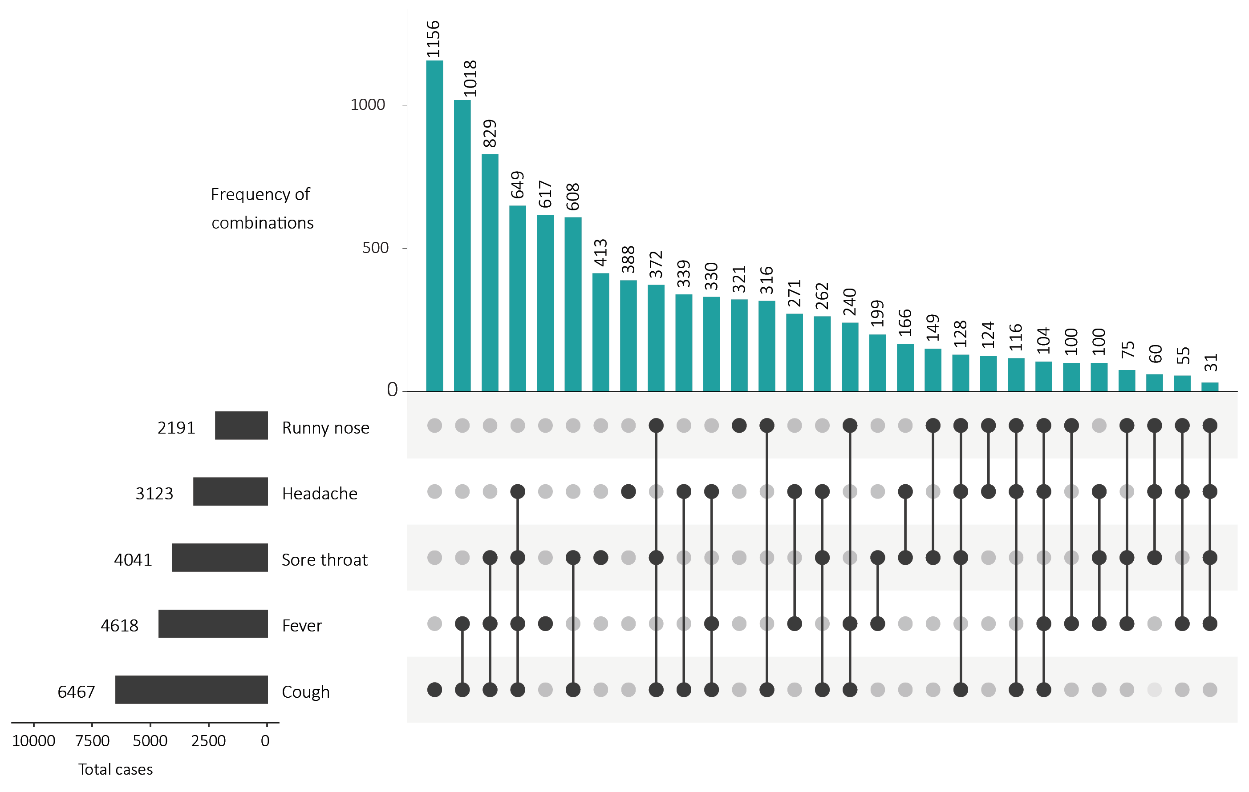
a This figure shows the variation in combinations of symptoms observed in reported cases (n = 12,636) for the five most frequently observed symptoms (cough, fever, headache, sore throat, runny nose). The horizontal bars on the left show the frequency of symptom occurrence in any combination with other symptoms. The circles and lines indicate particular combinations of symptoms observed in individual patients. The vertical green bars indicate the frequency of occurrence of the corresponding combination of symptoms.

Appendix C: Frequently asked questions
Q: Can I request access to the COVID-19 data behind your CDI fortnightly reports?
A: National notification data on COVID-19 confirmed cases is collated in the National Notifiable Disease Surveillance System (NNDSS) based on notifications made to state and territory health authorities under the provisions of their relevant public health legislation.
Normally, requests for the release of data from the NNDSS requires agreement from states and territories via the Communicable Diseases Network Australia, and, depending on the sensitivity of the data sought and proposed, ethics approval may also be required.
Due to the COVID-19 response, unfortunately, specific requests for NNDSS data have been put on hold. We are currently looking into options to be able to respond to data requests in the near future.
We will continue to publish regular summaries and analyses of the NNDSS dataset and recommend the following resources be referred to in the meantime:
• NNDSS summary tables: http://www9.health.gov.au/cda/source/cda-index.cfm
• Daily case summary of cases: https://www.health.gov.au/news/health-alerts/novel-coronavirus-2019-ncov-health-alert/coronavirus-covid-19-current-situation-and-case-numbers
• Communicable Diseases Intelligence COVID-19 epidemiology report: https://www1.health.gov.au/internet/main/publishing.nsf/Content/novel_coronavirus_2019_ncov_weekly_epidemiology_reports_australia_2020.htm
• State and territory public health websites.
Q: Why have the reports changed from weekly to fortnightly?
A: The change to fortnightly reporting is to allow more time for an in-depth analysis of the NNDSS data, therefore enhancing the contents of the report.
Q: Can I request access to data at post-code level of confirmed cases?
A: Data at this level cannot be released without ethics approval and permission would need to be sought from all states and territories via the Communicable Diseases Network Australia. As noted above, specific requests for NNDSS data are currently on hold.
Where current or recent reported case numbers are high enough to justify it, a GIS/mapping analysis of cases will be included in the Communicable Diseases Intelligence COVID-19 epidemiology report. In order to protect privacy of confirmed cases, data in this map will be presented at SA3 level.
Q: Where can I find more detailed data on COVID-19 cases?
A: We are currently looking into ways to provide more in-depth epidemiological analyses of COVID-19 cases, with regard to transmission and severity, including hospitalisation. These analyses will continue to be built upon in future iterations of the Communicable Diseases Intelligence report.

Communicable Diseases Intelligence
ISSN: 2209-6051 Online

Communicable Diseases Intelligence (CDI) is a peer-reviewed scientific journal published by the Office of Health Protection, Department of Health. The journal aims to disseminate information on the epidemiology, surveillance, prevention and control of communicable diseases of relevance to Australia.

Editor: Tanja Farmer
Deputy Editor: Simon Petrie
Design and Production: Kasra Yousefi
Editorial Advisory Board: David Durrheim, Mark Ferson, John Kaldor, Martyn Kirk and Linda Selvey

Website: http://www.health.gov.au/cdi

Contacts
Communicable Diseases Intelligence is produced by:
Health Protection Policy Branch, Office of Health Protection, Australian Government Department of Health
GPO Box 9848, (MDP 6) CANBERRA ACT 2601

Email: cdi.editor@health.gov.au

Submit an Article
You are invited to submit your next communicable disease related article to the Communicable Diseases Intelligence (CDI) for consideration. More information regarding CDI can be found at: http://health.gov.au/cdi.
Further enquiries should be directed to: cdi.editor@health.gov.au.

This journal is indexed by Index Medicus and Medline.

Creative Commons Licence - Attribution-NonCommercial-NoDerivatives CC BY-NC-ND
© 2020 Commonwealth of Australia as represented by the Department of Health
This publication is licensed under a Creative Commons Attribution-NonCommercial-NoDerivatives 4.0 International Licence from https://creativecommons.org/licenses/by-nc-nd/4.0/legalcode (Licence). You must read and understand the Licence before using any material from this publication.

Restrictions
The Licence does not cover, and there is no permission given for, use of any of the following material found in this publication (if any):
- the Commonwealth Coat of Arms (by way of information, the terms under which the Coat of Arms may be used can be found at www.itsanhonour.gov.au);
- any logos (including the Department of Health’s logo) and trademarks;
- any photographs and images;
- any signatures; and
- any material belonging to third parties.

Disclaimer
Opinions expressed in Communicable Diseases Intelligence are those of the authors and not necessarily those of the Australian Government Department of Health or the Communicable Diseases Network Australia. Data may be subject to revision.

Enquiries
Enquiries regarding any other use of this publication should be addressed to the Communication Branch, Department of Health, GPO Box 9848, Canberra ACT 2601, or via e-mail to: copyright@health.gov.au

Communicable Diseases Network Australia
Communicable Diseases Intelligence contributes to the work of the Communicable Diseases Network Australia.
http://www.health.gov.au/cdna

