The geography of Ross River virus infection in South Australia, 2000-2013
Jingwen Liu, Alana Hansen, Scott Cameron and Peng Bi

Abstract

Introduction
Ross River virus (RRV) disease is Australia’s most common arthropod-borne disease which has an important impact on population health and productivity. The aim of this study was to identify the spatial and temporal distribution of RRV notifications during 2000–2013 in South Australia (SA).

Methods
The epidemiologic patterns of RRV notifications in SA from January 2000 to December 2013 were examined at a statistical local area (SLA) level. Spatial-temporal analyses were conducted using patient-reported place of exposure to characterise the recurrence of RRV infection stratified by age and sex.

Results
During the study period, a total of 3,687 RRV disease notifications were recorded in the state with state-wide mean annual rates of 16.8 cases per 100,000 persons and a 1:1.32 male:female ratio. The SLAs reporting cases of RRV disease exhibited spatial and temporal variation. Notified cases of RRV disease occurred more frequently in summer and autumn. A geographic expansion was observed of the area within which RRV cases occur. The comparison of age- and sex-standardised incidence rates, calculated by place of residence and patient-reported place of exposure, highlights the importance of using the latter to accurately display geospatial disease trends over time. Areas with the largest proportion of visitor cases and having the highest risk were mostly along the River Murray, which provides many vector mosquito habitats.

Conclusion
Although public health interventions should be considered in all SLAs where RRV occurs, we suggest that priority should be given to the Riverland areas identified as highest risk.
Keywords: Ross River virus, geography, epidemiology, South Australia

Introduction
Ross River virus (RRV) disease is the most common endemic arthropod-borne disease in Australia, with an annual average number of over 4,700 notifications.¹ The clinical symptoms of RRV infection typically comprise of polyarthritis, fever, lethargy and myalgia. Symptoms generally persist for 3 to 6 months, but maybe longer for some patients.² It has been proposed that the economic cost of RRV is tens of millions of dollars annually in Australia, excluding the costs of physical and mental suffering of patients.³ Currently, mosquito control and personal protection from mosquito bites are the main mitigation measures for the disease.²
RRV has been isolated from over 40 species of mosquitoes.⁴ In Australia, the most common RRV vectors are Culex annulirostris in inland regions, and Aedes vigilax and Aedes camptorhynchus in coastal regions.⁴ Macropods (kangaroos and wallabies) and other marsupials (e.g. possums) can be vertebrate hosts of the virus and there can be spill-over of infection to humans via the zoonotic cycle.⁵ Studies have also indicated that other wild animals and domestic livestock including sheep, birds, and horses may be implicated in RRV transmission.^{5,6}
In South Australia, studies have shown that RRV is mainly clustered along the Murray River where large inundated areas appear after intermittent floods.⁷⁻⁹ The necessity of examining the RRV incidence at a regional scale has been acknowledged because the spatial transmission trends of RRV disease are obfuscated by cumulating cases, and by using averages in spatial analysis.¹⁰ There has been a lack of detailed information about the spatial and temporal trends of RRV disease in South Australia (SA); this study fills a gap in this area.
The purpose of this study was to identify the spatial distribution of RRV notifications, and to assess the transmission patterns of RRV infection during 2000–2013 in SA. This study provides new analysis of RRV epidemiology and robust information to aid in the identification of epidemics (defined in this context as periods when the number of cases is significantly higher than expected).
Human ethics approval was gained by the Human Research Ethics Committees of the South Australian Department for Health and Wellbeing (HREC/17/SAH/134) and the University of Adelaide.

Methods
Data regarding notified cases of RRV disease from January 2000 to December 2013, comprising of notification date, calculated onset date, age groups, sex, primary place of exposure to infection and place of residence were obtained from the South Australian Department for Health and Wellbeing. Each notification was confirmed by laboratory detection of RRV-specific immunoglobulin M (IgM) or a significant rise in RRV-specific immunoglobulin G (IgG) antibody level (≥ fourfold increase in IgG titre). Population data and a digital base map were sourced from the Australian Bureau of Statistics (ABS). Census data from 2006, midway through the study period, were used to define the SLA boundaries for geographic mapping.
Cases of RRV were first plotted by calculating the monthly notifications of RRV disease during the period 2000–2013. The dataset was then grouped into seven two-year periods to investigate the spatial and temporal distributions. Age- and sex-standardised incidence rates (SIRs)¹¹ were calculated for each SLA (n=128) according to patient-reported primary place of exposure using the direct standardisation method as follows:
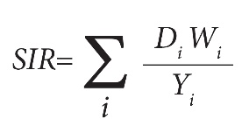
where D_{i} denotes age- and sex-specific incidence, Y_{i} is the population size in the ith age- and sex-specific group, and W_{i} represents the weight applied for the ith group.
To determine the spatial differences using different geo-referencing, SIRs were then calculated using place of residence and patient-reported place of exposure for each SLA.
The geographic information system ArcGIS Pro (v. 2.1.0) was used to display the spatial distributions of disease.¹² Both place of residence and patient-reported place of exposure were used, and these data were geo-coded to the digital SLA map. Cases with unknown area of both place of residence and patient-reported place of exposure, or disease acquired outside SA, were excluded from the spatial analysis. When a primary place of exposure was not identifiable to SLA level (e.g. ‘South Australia’ only) or was not listed, the place of residence was used.⁹ The primary place of exposure with ‘Riverland (indeterminate)’ was reassigned proportionally in the SLAs that belong to the Riverland region.
Global Moran’s I was used to test the presence of significant spatial autocorrelation of SIRs using the spatial autocorrelation tool in ArcGIS Pro.¹³ Such measurement is based on SIR values in each SLA and their corresponding locations. The Moran’s I index is bounded by -1 and 1, which helps to evaluate departures from spatial randomness (i.e. Moran’s I index equal to 0), with a positive value indicating clustering of data points. Shared boundary features were included in the calculation based on the Euclidean distance between polygons with shared boundaries,¹⁴ as this conceptualisation of the spatial relationship has been shown to be suitable for this type of modelling.¹⁵

Results
During the study period, 3,687 RRV notifications were recorded at a statewide mean annual rate of 16.8 cases per 100,000 persons. Of these, 3,445 (93.4%) cases were included in the spatial analysis. Figure 1 highlights the four epidemics that occurred during this period, suggesting a general pattern of epidemics which occur every three to four years.⁷ The epidemics became larger in terms of the notified RRV cases after 2001, and the baseline case numbers were generally higher after, than before, an epidemic which occurred in 2005–2006. The 2010–2011 epidemic, with over 1400 notifications, was the largest on record in SA.^{7,16} There was high seasonal variability across the study period, with more than 70% of notifications occurring in the summer and autumn (Figure 1). The peak months (December-January) accounted for roughly 35% of the total notifications.

Figure 1: RRV notifications per month, SA, January 2000 to December 2013.
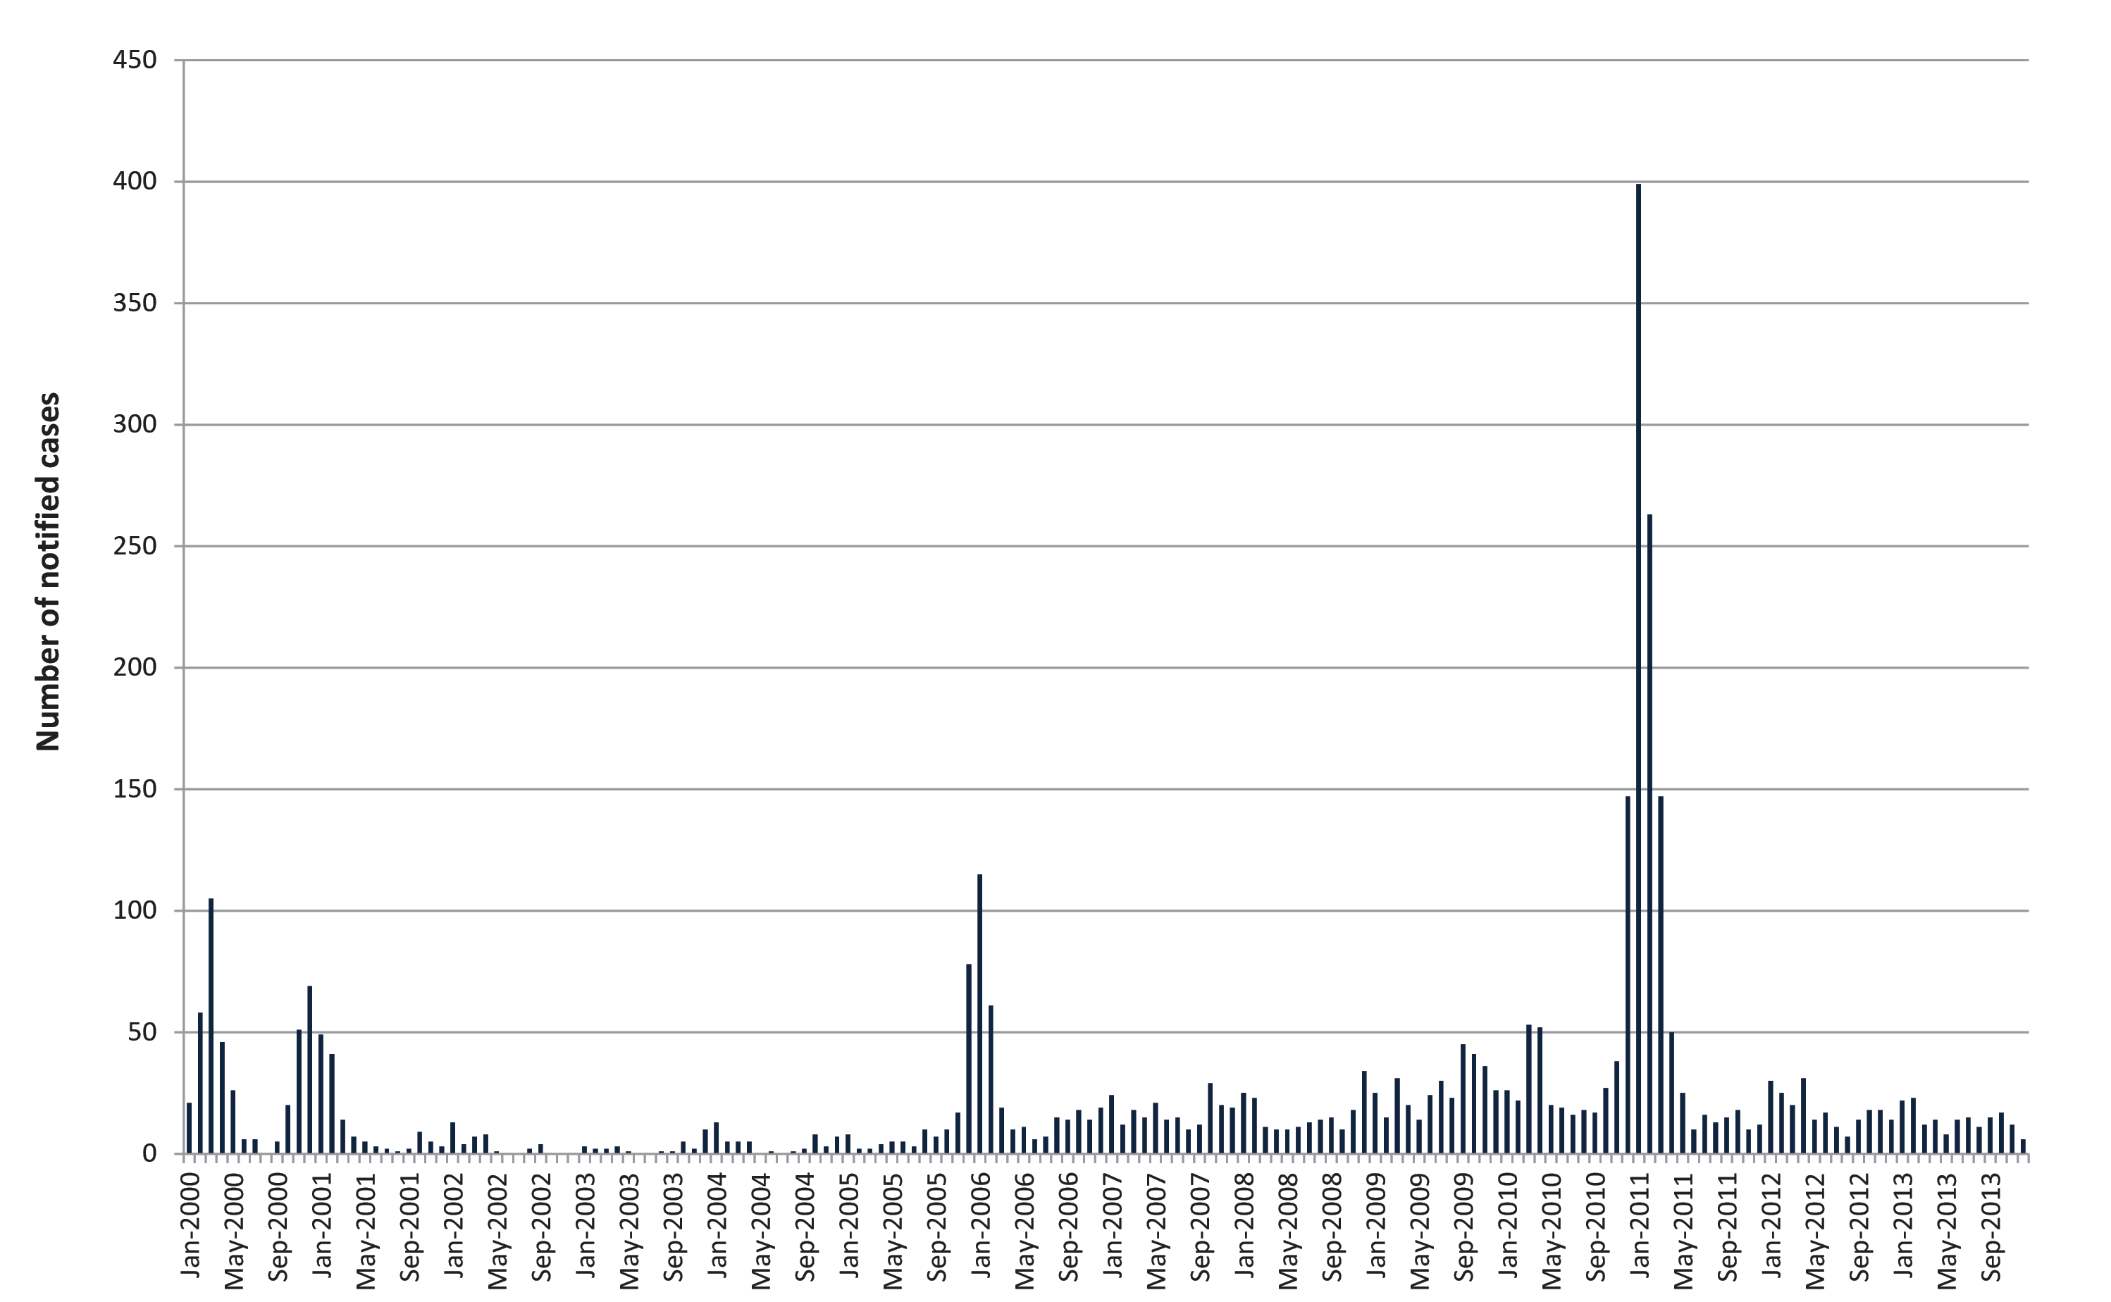
Figure 2 shows the distribution of RRV disease rates by age and sex. The disease notifications were highest in the 30- to 59-year age group (25.0 cases per 100,000 persons), with comparable levels of 10.3 and 12.0 cases per 100,000 persons for the 0–29 and ≥ 60 year age groups, respectively. A gender bias was evident, with males accounting for 42% of notification (14.5 cases per 100,000 persons) and females 58% (19.1 cases per 100,000 persons), with a Chi-square test yielding p = 0.011.
Figure 2: Age and sex distribution of RRV rates, SA, January 2000 to December 2013
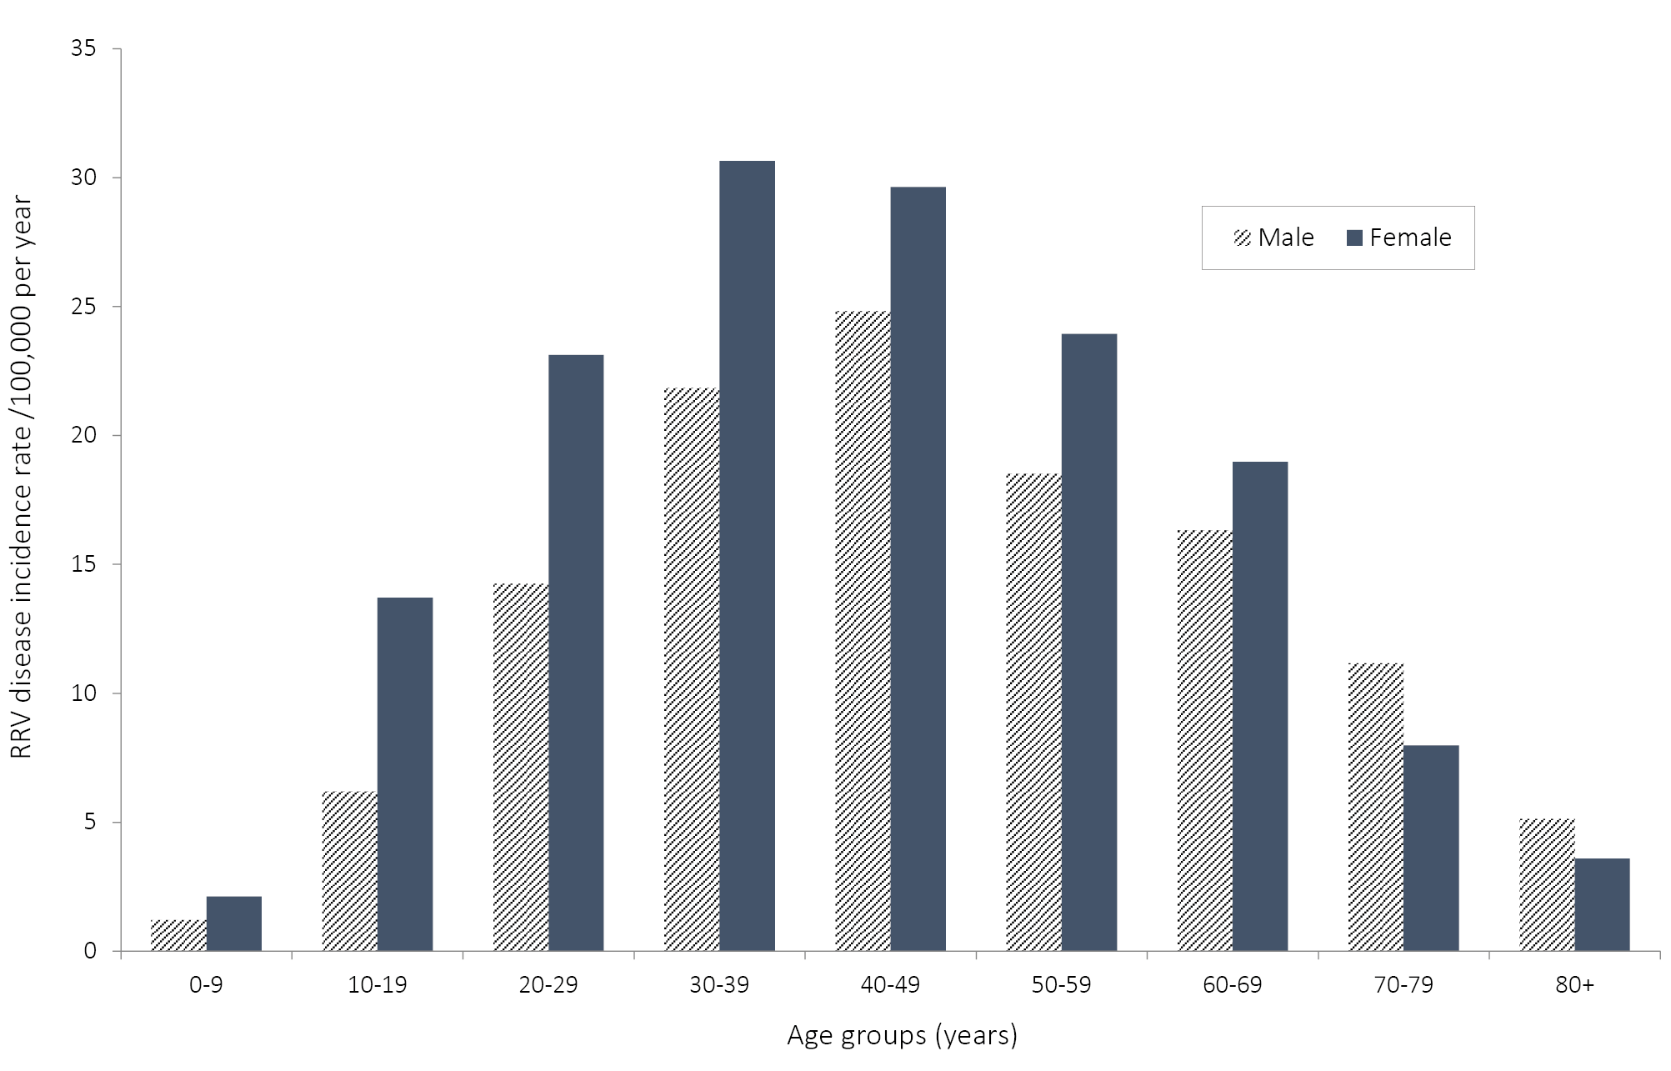
Figure 3 shows the spatial distribution of cumulative SIRs for each SLA in SA every two year period from 2000 to 2013. There were large variations in the disease SIRs among individual SLAs, especially during epidemics. Geographically, the highest SIRs were observed in the south-eastern regions along the River Murray. In 2000–2001, there was significant RRV disease activity (cumulative SIR > 100 cases per 100,000 persons) in coastal regions such as Elliston (DC), Lower Eyre Peninsula (DC), the Coorong (DC), Robe (DC), and the Far North region. During 2002–2003 and 2004–2005, the activity was distributed sporadically along the coastal and the Riverland regions (cumulative SIR < 100 cases per 100,000 persons), with no cases being reported in either Elliston (DC) or Robe (DC). In 2006–2007, the RRV disease activity again appeared along the south-eastern coastal regions of the state and tended to be further north in 2008–2009. In the 2010–2011 epidemic, the disease activity occurred in more than 85% of the SLAs in SA. In the following years, the notifications from the south-eastern coastal regions declined. Overall, the notifications were mostly acquired from the SLAs in rural SA and became more widespread during the study period (Figure 3). A reference map and the SIRs of RRV notifications comparing 2000–2006 and 2007–2013 are provided in the Appendix, in figure A1 and A2.

Figure 3: Cumulative age- and sex-standardised incidence rates (SIRs) (per 100,000 persons) of RRV notifications for each SLA over different periods in SA, 2000–2013. Inserts indicate the most densely populated areas. 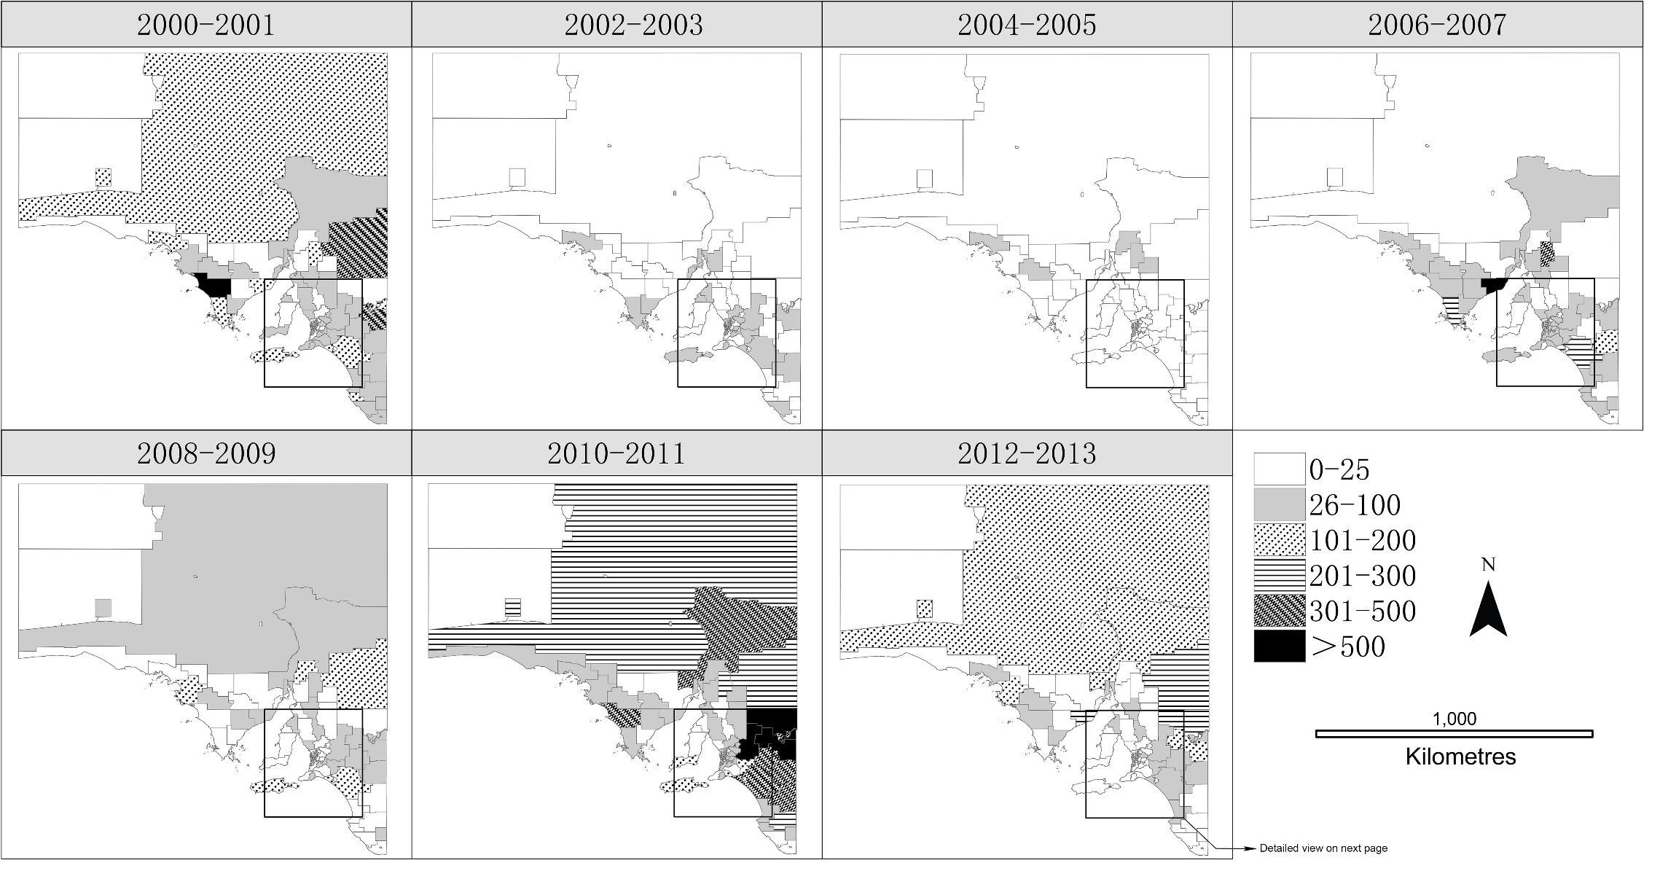

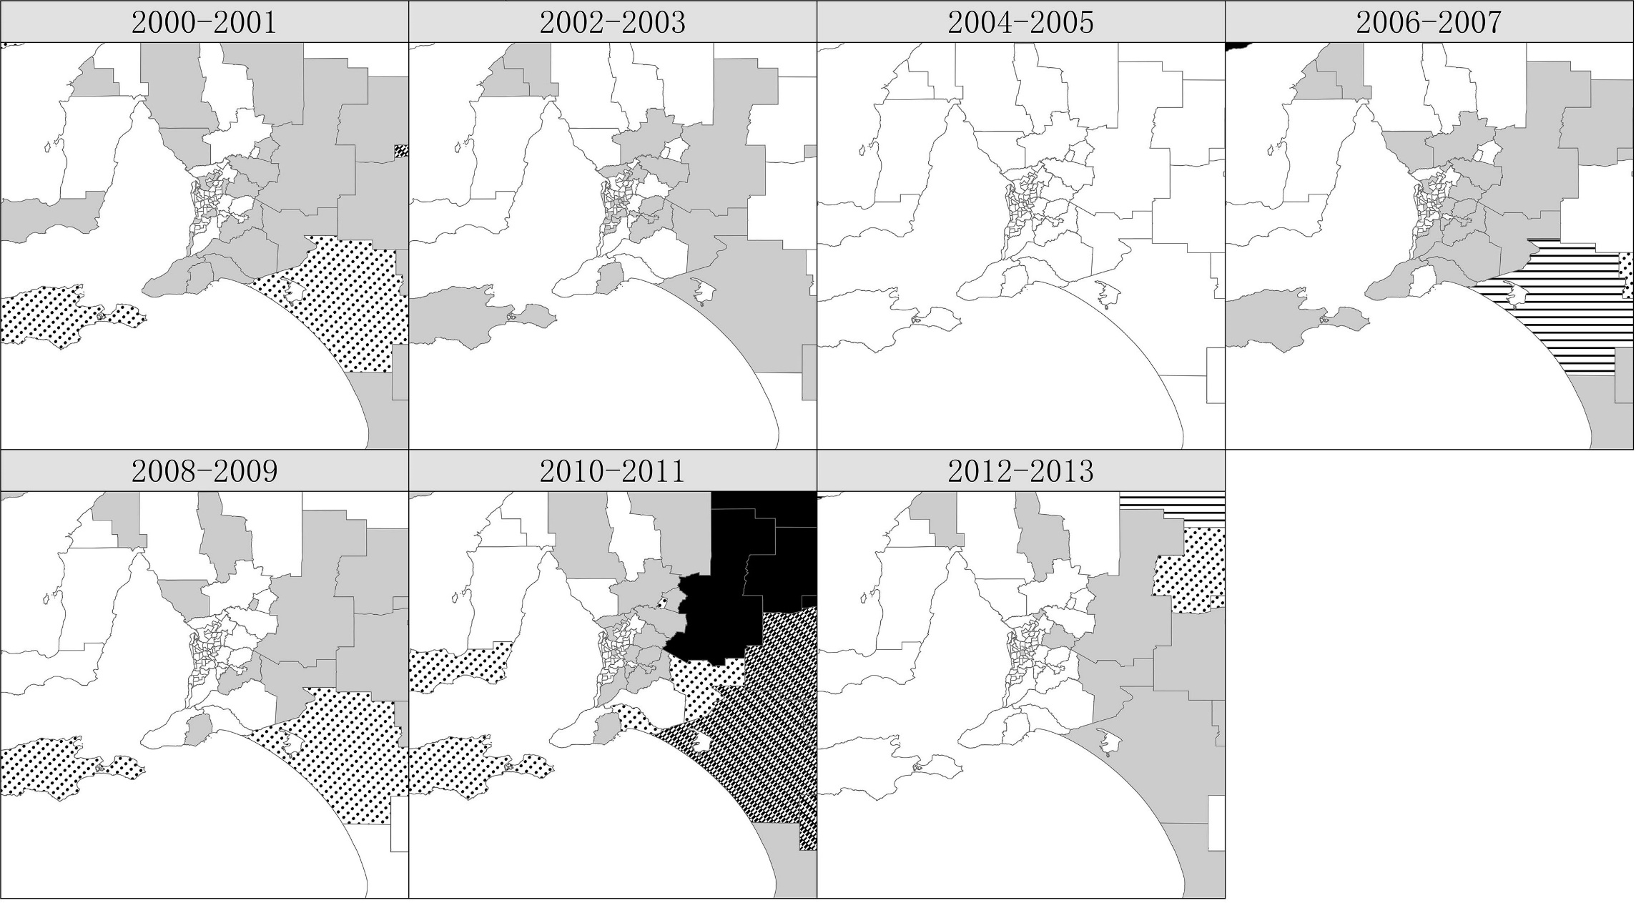
As shown in Figure 4, the place of residence differed from the patient-reported place of exposure (at the SLA level) in 564 cases (16%). The SLAs identified as the most common non-residence place of exposure were the Unincorp. Riverland (87%), Mid Murray (DC) (49%) and Renmark Paringa (DC) – Paringa (42%). All SLAs around metropolitan Adelaide had lower than average SIRs using either place of residence or place of exposure.

Figure 4: Cumulative age- and sex-standardised incidence rates (SIRs) of RRV for each SLA in SA calculated using (a) patient’s place of residence and (b) patient-reported primary place of exposure. Inserts indicate Metropolitan Adelaide and surrounding areas.
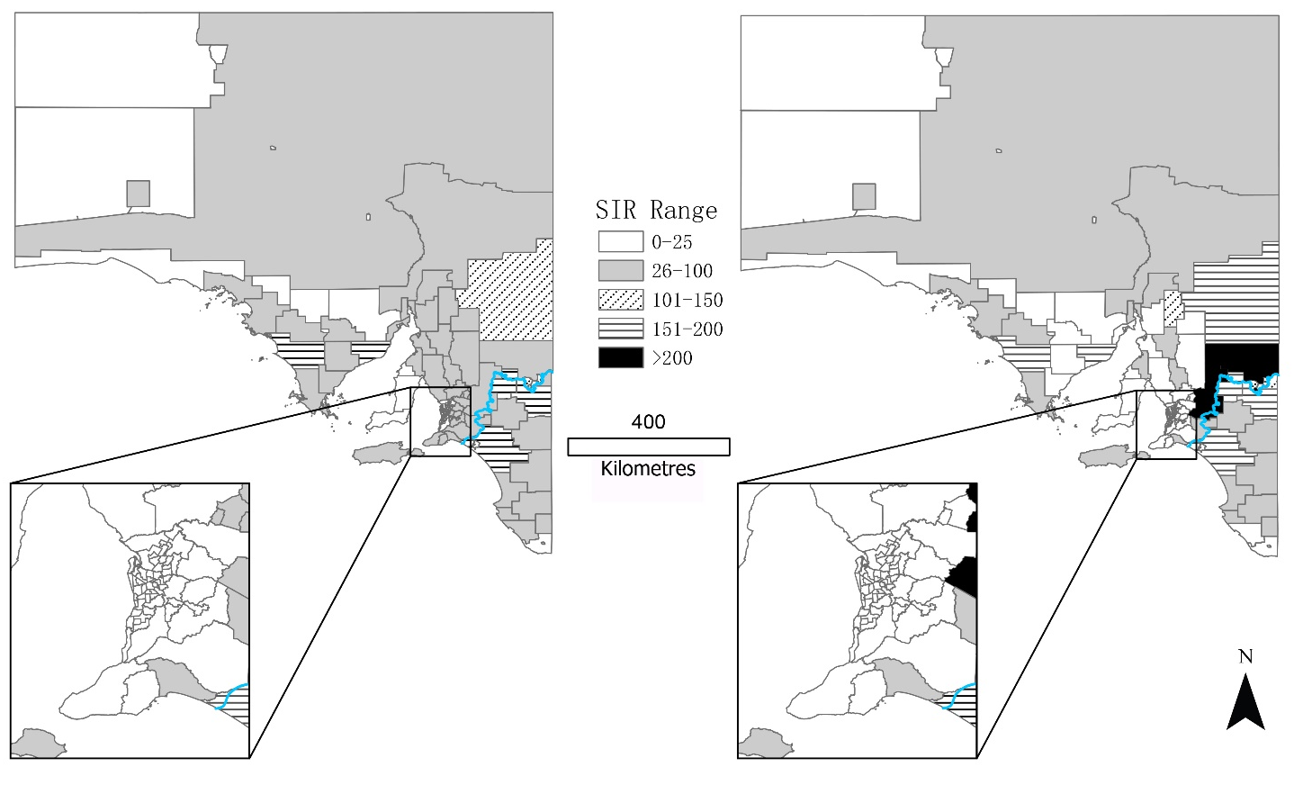

Table 1 shows the ranking of SLAs where primary place of exposure had cumulative SIRs > 100 (per 100,000 persons). Thirteen of the SLAs had a cumulative SIR > 100 when using primary place of exposure, while 9 of these also had a cumulative SIR > 100 when using place of residence. These SLAs were considered to be the areas of highest risk in SA; most (62%) are bordered by the Murray River.
Table 1: SLAs identified as high risk (with SIRs >100 cases per 100,000 persons) determined from primary place of exposure.ª
SLA | Pop | Place of exposure |  | Place of residence
 |  | Cases | SIRs  (/100,000) | Cases | SIRs  (/100,000)
Unincorp. Riverland | 132 | 17 | 733.13 | 2 | 71.09
Mid Murray (DC) | 8325 | 233 | 205.81 | 118 | 92.99
Loxton Waikerie (DC) – East | 7438 | 196 | 196.72 | 172 | 171.52
Loxton Waikerie (DC) – West | 4663 | 116 | 188.60 | 95 | 154.79
Elliston (DC) | 1175 | 27 | 167.99 | 26 | 161.96
The Coorong (DC) | 5865 | 130 | 163.54 | 120 | 150.48
Renmark Paringa (DC) – Renmark | 7995 | 175 | 163.06 | 143 | 133.10
Franklin Harbour (DC) | 1322 | 27 | 156.65 | 27 | 156.65
Unincorp. Pirie | 272 | 5 | 154.08 | 4 | 116.03
Berri & Barmera (DC) – Barmera | 4294 | 80 | 147.00 | 67 | 122.83
Berri & Barmera (DC) – Berri | 7072 | 132 | 134.58 | 110 | 111.60
Renmark Paringa (DC) – Paringa | 1866 | 35 | 129.45 | 21 | 77.77
Orroroo/Carrieton (DC) | 968 | 11 | 128.14 | 7 | 83.73
a SIRs calculated by applying cumulative age- and sex-specific RRV disease incidence rates from the whole state population, to the population in each SLA.
Spatial autocorrelation of cumulative SIRs of RRV disease was evident in the analysis. The Moran’s I statistics when calculating SIRs for two-year periods (Figure 3), ranged from 0.06 (p < 0.001) during 2010–2011 to 0.37 (p < 0.001) during 2012–2013. In Figure 4 using data from the whole study period, Moran’s I statistics were higher: i.e. 0.54 (p < 0.001) and 0.55 (p < 0.001) using place of residence and primary place of exposure as geo-reference location, respectively.

Discussion
This study illustrates the spatial-temporal characteristics of RRV notifications in SA across a 14-year study period. To the best of our knowledge, this is the first attempt to assess temporal trends and distribution patterns of RRV in SA using patient-reported primary place of exposure as the location field (Figure 3). This information may be useful for further investigation of factors contributing to the epidemiology of the disease.
The findings indicate that there were three epidemics of RRV disease in SA in the decade before the record outbreak of 2010–2011; the latter outbreak accounted for almost 40% of all cases over the study period. The data suggest that the number of notifications of RRV disease is rising in both epidemic and non-epidemic years. Although the effect of false positive test results for virus-specific IgM cannot be discounted, the increase in the number of notifications may reflect an actual increase in RRV incidence, given the consistency in notification practices.¹⁷ This contrasts with the observations of Horwood and Bi (2005) who examined RRV notification data from 1992 to 2003,⁷ identifying an outbreak of over 800 cases in 1992–1993. The two studies suggest an increasing trend of RRV incidence in SA. Since the methods of diagnosis and reporting of RRV disease were consistent in the period of 1992–2013 over the two studies, such comparisons can be meaningful.
Our results are highly consistent with the strong seasonal pattern of RRV disease that has been reported in previous studies^{2,7,8,16,18} and are aligned to the seasonal activity of mosquito species.¹⁹ Generally, the transmission of RRV infection in SA occurs during summer and autumn, with peaks recorded during the month of January which coincides with the peak prevalence of the predominant vector species in the Riverland region (Culex annulirostris) from mid-summer to autumn.²⁰ A number of the notifications in the study occurred during the winter months; and while some may not be false positives, the data do not necessarily indicate the disease has been acquired during winter. Rather, with the disease producing long-lasting symptoms, it is likely that delays have occurred in cases visiting a medical practitioner and getting tested for RRV. The coastal region of SA, where there are coastal salt marshes and mangroves, contains major breeding sites for several mosquito species including Aedes camptorhynchus and Aedes vigilax.²¹ In this region, a large summer population of mosquitoes can emerge following a series of spring tides. Aedes camptorhynchus is the most abundant mosquito species in the metropolitan area of SA, and a previous study has shown the density to be a significant factor for RRV transmission in the River Murray valley.¹⁸
In this study, the transmission of RRV infection was reported in males and females across all age groups, although women aged 30-39 years were most affected with statistically significant differences in RRV rates between genders. The statistically significant higher infection rates among females are consistent with previous studies in other states,^{21,22} but contrast to a previous study in South Australia which indicated higher rates in males than females.⁷ The reasons for the differences in incidence rates among different genders and age groups remain speculative. However, a possible explanation may relate to differences in physiologic factors between genders, as females usually have higher heart rates, and factors relating to exhaled breath, host odours or substances on the skin’s surface may contribute to more frequent mosquito bites.²³ Another possible reason could be the differences in health-seeking behaviours as males can be less likely to present with symptoms to a health service.²⁴ While males can undertake more outdoor activities and have higher occupational exposure thus putting themselves more at risk, they can also be less likely to heed health warnings or to use personal repellents. Regarding age, the middle-aged population may be more at risk of RRV due to more time spent outdoors for recreational activities, and therefore greater exposure to mosquitoes. Only 1% of the notified cases occurred in children < 10 years of age, similar to previous studies showing that clinically-apparent infections are rare in children.^{2,21} Further study is warranted to determine the differences in risk factors related to infection in certain subgroups.
The findings indicate that the spatial distribution of RRV disease incidence varied over time. Such geographical variations may be due to a combination of the underlying changes in environmental and climate factors, differences in predominant mosquito species and/or the influence of mosquito control programs.²⁵ It is not surprising that the highest-risk areas cluster in the lower reaches of the Riverland, as the activities of mosquito vectors and vertebrate hosts are heavily reliant on water for breeding. Non-immune/susceptible reservoirs play a significant role in RRV infection ecology, for both the maintenance and transmission of the virus. Although macropod species are generally identified as important reservoir hosts, studies have shown that in the Riverland region it is cattle, sheep, and wild birds that are important for RRV transmission.^{6,10} Species reservoir status will be dependent on the competence and viraemic potential of the host species, as reported in a recent review study in relation to the non-human reservoirs of RRV.⁵ In addition, moderate soil-water balance, which is particularly relevant to dry inland river flood plains, has been reported as the most influential landscape features of RRV transmission.²⁶ In a previous study, a positive association between water flow of the Murray River and RRV notifications has been reported.⁸
Our findings are consistent with studies which have identified regions around metropolitan Adelaide as low risk and the areas bordering the Murray River as being high RRV infection risk regions.⁷⁻⁹ Additionally, mapping of the disease incidence clearly demonstrates that the geographic distribution of the notified RRV cases has expanded across the study period, along with the increasing incidence rate of the disease in SA. This is consistent with the patterns observed in studies of RRV and other mosquito-borne diseases such as Barmah Forest virus in SA and Queensland.^{7,25,27,28} Evidence of positive spatial auto-correlation of RRV notifications across the state occurred in several periods, suggesting that similar SIRs are more likely to appear in neighbouring regions. This supports the appropriate use of RRV notification data aggregated according to SLAs in further investigations of regional specific climatic and environmental determinants of the disease.
In many studies, place of residence is used as a proxy for the primary place of exposure. However, this may introduce bias and can give a false indication of where mosquito control efforts should be concentrated.^{21,22} Such approximations could be problematic in monitoring RRV disease cases in SA, as most of the population resides in the non-endemic areas around metropolitan Adelaide and may contract the disease as a result of travel into endemic areas.^{7,9} In this study, the majority of the SLAs identified as having high risk (cumulative SIRs > 100 cases per 100,000 persons) have an increase in SIRs when using patient-reported place of exposure (Table 1). The highest risk areas tend to be riverine tourist locations, which is consistent with the findings from other studies in SA that cases may be occurring in visitors to these areas.^{7,9}
This study has several strengths. In contrast to previous studies that have used averaged or aggregated data,^{9,10} we utilised 14 years of patient-level data to represent recent trends in RRV transmission in SA. Incidence at the SLA level was examined biennially, demonstrating a clear spatial dynamic of disease transmission thereby providing detailed information identifying high-risk SLAs. This study may also provide fundamental knowledge for generating predictive models that can facilitate improved disease control measures.
This study also has limitations. For those cases with unknown primary place of exposure, the place of residence was used as a proxy; therefore, misclassification bias is inevitable to some extent. The number of notified cases is generally considered an under-estimate of the number of actual cases (i.e. notified fraction)⁷ and should be interpreted with caution. Furthermore, commercial RRV kits can provide false positives and lead to over-diagnosis of the disease.²⁹ It is therefore difficult to precisely estimate the true number of cases. Nevertheless, such approximations of the true incidence rates may not be problematic in the analysis, as the findings provide a clear picture of disease trends, which is reliable when a consistent disease definition is used. Additionally, as the laboratory diagnostic methods changed in SA after December 2013 when IgM testing ceased, it is difficult to compare the number of notifications after that time with those in this study.
In conclusion, the inter-SLA variation in disease incidence risk implies that environmental and ecological factors play a part in the RRV transmission. This detailed epidemiologic information at the SLA level may be useful to public health authorities in SA, contributing to the better utilization of limited resources to the high-risk areas, during the high-risk seasons and for the high-risk subgroups.

Acknowledgements
We are very grateful to the South Australian Department for Health and Wellbeing for providing the data. We are also thankful for statistical advice from Dr Jana Bednarz. We would like to further extend our gratitude to Dr. Jianjun Xiang, Dr Susan Williams and Dr Michael Tong who have commented on early versions of the manuscript.

Author details
Alana Hansen
Jingwen Liu
Scott Cameron
Peng Bi
School of Public Health, University of Adelaide, South Australia

Corresponding author
Alana Hansen
School of Public Health, Level 9, AHMS Building, The University of Adelaide SA 5005 Australia.
Tel: +61 8 8313 1043
Email: alana.hansen@adelaide.edu.au

References
- National Notifiable Diseases Surveillance System. [Internet.] Canberra: Australian Government Department of Health; 2018. Available from: http://www9.health.gov.au/cda/source/rpt_4.cfm.
- Harley D, Sleigh A, Ritchie S. Ross River virus transmission, infection, and disease: a cross-disciplinary review. Clin Microbiol Rev. 2001;14(4):909–32.
- Russell RC. Vectors vs. humans in Australia--who is on top down under? An update on vector-borne disease and research on vectors in Australia. J Vector Ecol. 1998;23(1):1–46.
- Russell RC. Ross River virus: ecology and distribution. Annu Rev Entomol. 2002;47:1–31.
- Stephenson EB, Peel AJ, Reid SA, Jansen CC, McCallum H. The non-human reservoirs of Ross River virus: a systematic review of the evidence. Parasit Vectors. 2018;11(1):188.
- Flies EJ, Flies AS, Fricker SR, Weinstein P, Williams CR. Regional comparison of mosquito bloodmeals in South Australia: implications for Ross River virus ecology. J Med Entomol. 2016;53(4):902–10.
- Horwood CM, Bi P. The incidence of Ross River virus disease in South Australia, 1992 to 2003. Commun Dis Intell Q Rep. 2005;29(3):291–6.
- Bi P, Hiller JE, Cameron AS, Zhang Y, Givney R. Climate variability and Ross River virus infections in Riverland, South Australia, 1992–2004. Epidemiol Infect. 2009;137(10):1486–93.
- Flies EJ, Williams CR, Weinstein P, Anderson SJ. Improving public health intervention for mosquito-borne disease: the value of geovisualization using source of infection and LandScan data. Epidemiol Infect. 2016;144(14):3108–19.
- Flies EJ, Weinstein P, Anderson SJ, Koolhof I, Foufopoulos J, Williams CR. Ross River virus and the necessity of multiscale, eco-epidemiological analyses. J Infect Dis. 2018;217(5):807–15.
- Schoenbach VJ, Rosamond WD. Understanding the fundamentals of epidemiology: an evolving text. Second edition. Chapel Hill, North Carolina: University of North Carolina; 2000.
- ESRI ArcGIS Pro. Version 2.1.0. Redlands: CA: Environmental Systems Research Institute; 2018.
- Lee J, Wong D. Statistical Analysis with ArcView GIS. First edition. Wiley; 2000.
- Anselin L, Syabri I, Kho Y. GeoDa: An introduction to spatial data analysis. Geogr Anal. 2006;38(1):15–22.
- ArcGIS Pro: Modeling spatial relationships. [Internet]. Redlands, CA: Environmental Systems Research Institute. [Accessed 31 January 2020.] Available from: https://pro.arcgis.com/en/pro-app/tool-reference/spatial-statistics/modeling-spatial-relationships.htm#GUID-F6CB66DC-6B46-42BE-96C2-EEFF4BFC13D9
- Kelly-Hope LA, Purdie DM, Kay BH. Ross River virus disease in Australia, 1886–1998, with analysis of risk factors associated with outbreaks. J Med Entomol. 2004;41(2):133–50.
- Selvey LA, Donnelly JA, Lindsay MD, Pottumarthy-Boddu S, D’Abrera VC, Smith DW. Ross River virus infection surveillance in the Greater Perth Metropolitan area – has there been an increase in cases in the winter months? Commun Dis Intell Q Rep. 2014;38(2):E115–22.
- Williams CR, Fricker SR, Kokkinn MJ. Environmental and entomological factors determining Ross River virus activity in the River Murray Valley of South Australia. Aust N Z J Public Health. 2009;33(3):284–8.
- Weinstein P. An ecological approach to public health intervention: Ross River virus in Australia. Environ Health Perspect. 1997;105(4):364–6.
- Dhileepan K. Mosquito seasonality and arboviral disease incidence in Murray Valley, southeast Australia. Med Vet Entomol. 1996;10(4):375–84.
- Yu W, Mengersen K, Dale P, Mackenzie JS, Toloo GS, Wang X et al. Epidemiologic patterns of Ross River virus disease in Queensland, Australia, 2001–2011. Am J Trop Med Hyg. 2014;91(1):109–18.
- Gatton ML, Kelly-Hope LA, Kay BH, Ryan PA. Spatial-temporal analysis of Ross River virus disease patterns in Queensland, Australia. Am J Trop Med Hyg. 2004;71(5):629–35.
- Lindsay S, Ansell J, Selman C, Cox V, Hamilton K, Walraven G. Effect of pregnancy on exposure to malaria mosquitoes. Lancet. 2000;355(9219):1972.
- Ek S. Gender differences in health information behaviour: a Finnish population-based survey. Health Promot Int. 2015;30(3):736–45.
- Naish S, Hu W, Mengersen K, Tong S. Spatio-temporal patterns of Barmah Forest virus disease in Queensland, Australia. PLoS One. 2011;6(10):e25688.
- Walsh MG, Webb C. Hydrological features and the ecological niches of mammalian hosts delineate elevated risk for Ross River virus epidemics in anthropogenic landscapes in Australia. Parasit Vectors. 2018; 11(1):192.
- Hu W, Tong S, Mengersen K, Oldenburg B. Exploratory spatial analysis of social and environmental factors associated with the incidence of Ross River virus in Brisbane, Australia. Am J Trop Med Hyg. 2007;76(5):814–9.
- Tong S, Bi P, Hayes J, Donald K, Mackenzie J. Geographic variation of notified Ross River virus infections in Queensland, Australia, 1985–1996. Am J Trop Med Hyg. 2001;65(3):171–6.
- Farmer JF, Suhrbier A. Interpreting paired serology for Ross River virus and Barmah Forest virus diseases. Aust J Gen Pract. 2019;48(9):645–49

Appendices
Appendix Figure A1.Statistical local areas in south-eastern region of South Australia.
The dashed line represents the state’s largest river- the River Murray. Statistical local areas: Loxton-W: Loxton-Waikerie (DC) -West, Loxton-E: Loxton-Waikerie (DC) -East, BB-Ba: Berri & Barmera (DC) -Barmera, BB-Be: Berri & Barmera (DC) -Berri, RP-R: Renmark Paringa (DC) -Renmark, RP-P: Renmark Paringa (DC) –Paringa.
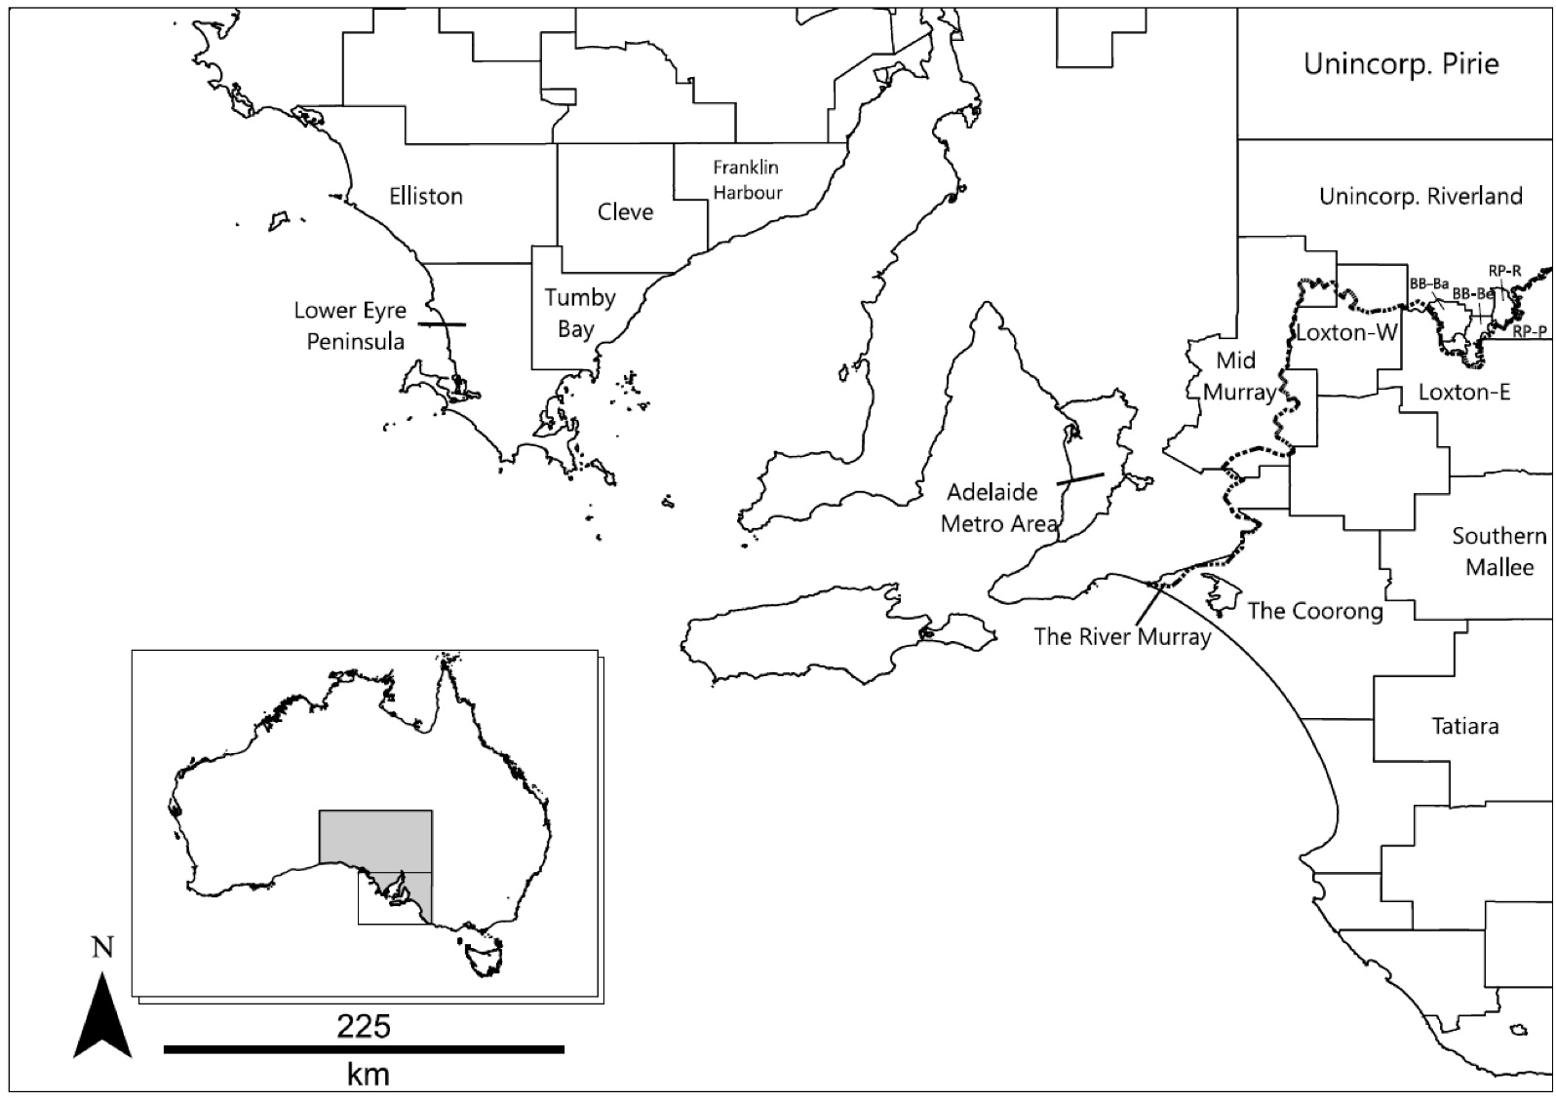
Appendix Figure A2. Age- and sex-standardised incidence rates (per 100,000 person-years) of Ross River virus notifications for each statistical local area over two different periods in South Australia, 2000-2013. Inserts indicate the most densely populated areas in South Australia.
(a) SIR from 2000 to 2006 (b) SIR from 2007 to 2013
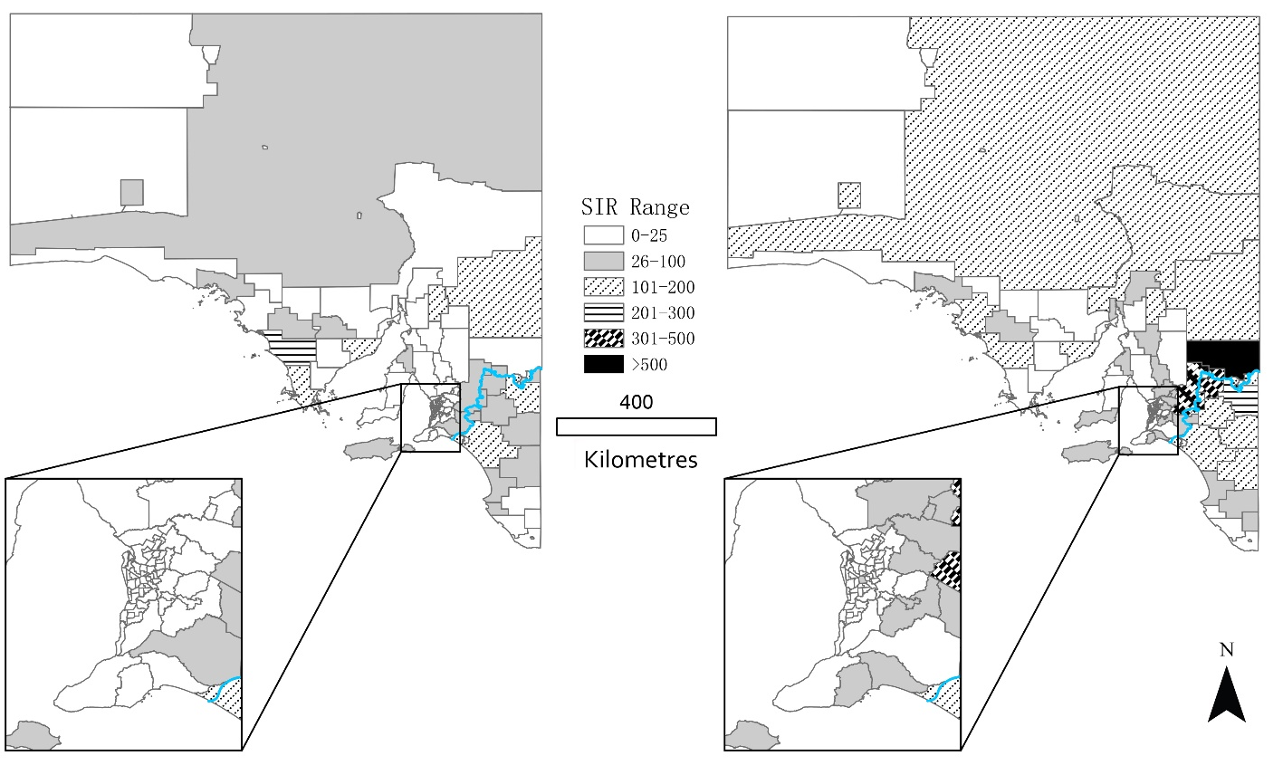

Communicable Diseases Intelligence
ISSN: 2209-6051 Online

Communicable Diseases Intelligence (CDI) is a peer-reviewed scientific journal published by the Office of Health Protection, Department of Health. The journal aims to disseminate information on the epidemiology, surveillance, prevention and control of communicable diseases of relevance to Australia.

Editor: Tanja Farmer
Deputy Editor: Simon Petrie
Design and Production: Kasra Yousefi
Editorial Advisory Board: David Durrheim, Mark Ferson, John Kaldor, Martyn Kirk and Linda Selvey

Website: http://www.health.gov.au/cdi

Contacts
Communicable Diseases Intelligence is produced by:
Health Protection Policy Branch, Office of Health Protection, Australian Government Department of Health
GPO Box 9848, (MDP 6) CANBERRA ACT 2601

Email: cdi.editor@health.gov.au

Submit an Article
You are invited to submit your next communicable disease related article to the Communicable Diseases Intelligence (CDI) for consideration. More information regarding CDI can be found at: http://health.gov.au/cdi.
Further enquiries should be directed to: cdi.editor@health.gov.au.

This journal is indexed by Index Medicus and Medline.

Creative Commons Licence - Attribution-NonCommercial-NoDerivatives CC BY-NC-ND
© 2020 Commonwealth of Australia as represented by the Department of Health
This publication is licensed under a Creative Commons Attribution-NonCommercial-NoDerivatives 4.0 International Licence from https://creativecommons.org/licenses/by-nc-nd/4.0/legalcode (Licence). You must read and understand the Licence before using any material from this publication.

Restrictions
The Licence does not cover, and there is no permission given for, use of any of the following material found in this publication (if any):
- the Commonwealth Coat of Arms (by way of information, the terms under which the Coat of Arms may be used can be found at www.itsanhonour.gov.au);
- any logos (including the Department of Health’s logo) and trademarks;
- any photographs and images;
- any signatures; and
- any material belonging to third parties.

Disclaimer
Opinions expressed in Communicable Diseases Intelligence are those of the authors and not necessarily those of the Australian Government Department of Health or the Communicable Diseases Network Australia. Data may be subject to revision.

Enquiries
Enquiries regarding any other use of this publication should be addressed to the Communication Branch, Department of Health, GPO Box 9848, Canberra ACT 2601, or via e-mail to: copyright@health.gov.au

Communicable Diseases Network Australia
Communicable Diseases Intelligence contributes to the work of the Communicable Diseases Network Australia.
http://www.health.gov.au/cdna

District Council
‘Unincorp.’ – a region of land that is not governed by a local municipal corporation

