Australian National Enterovirus Reference Laboratory annual report, 2017
Jason A Roberts, Linda K Hobday, Aishah Ibrahim and Bruce R Thorley

Abstract
Australia monitors its polio-free status by conducting surveillance for cases of acute flaccid paralysis (AFP) in children less than 15 years of age, as recommended by the World Health Organization (WHO). Cases of AFP in children are notified to the Australian Paediatric Surveillance Unit or the Paediatric Active Enhanced Disease Surveillance System and faecal specimens are referred for virological investigation to the National Enterovirus Reference Laboratory. In 2017, no cases of poliomyelitis were reported from clinical surveillance and Australia reported 1.33 non-polio AFP cases per 100,000 children, meeting the WHO performance criterion for a sensitive surveillance system. Three non-polio enteroviruses, coxsackievirus B1, echovirus 11 and enterovirus A71, were identified from clinical specimens collected from AFP cases. Australia established enterovirus and environmental surveillance systems to complement the clinical system focussed on children and an ambiguous vaccine-derived poliovirus type 2 was isolated from sewage in Melbourne. In 2017, 22 cases of wild polio were reported with three countries remaining endemic: Afghanistan, Nigeria and Pakistan.
Keywords: poliovirus, acute flaccid paralysis, surveillance, enterovirus, poliomyelitis, eradication, vaccination

Introduction
Australia has established clinical and virological surveillance schemes to monitor its polio-free status. The clinical surveillance follows the World Health Organization (WHO) recommendation of investigating cases of acute flaccid paralysis (AFP) in children less than 15 years of age due to a higher risk of poliovirus infection. AFP cases are ascertained either by clinicians notifying the Australian Paediatric Surveillance Unit (APSU) via a monthly report card or through the Paediatric Active Enhanced Disease Surveillance System (PAEDS) at five sentinel tertiary paediatric hospitals.^{1,2} The WHO recommends that two faecal specimens be collected for virological investigation at least 24 hours apart and within 14 days of the onset of paralysis from cases of AFP to exclude poliovirus as the causative agent. It is a requirement of the WHO polio eradication program that the specimens are tested in a WHO-accredited laboratory, which for Australia is the National Enterovirus Reference Laboratory (NERL) at the Victorian Infectious Diseases Reference Laboratory (VIDRL), at the Peter Doherty Institute for Infection and Immunity. The clinical and laboratory data from AFP cases in children is reviewed by the Polio Expert Panel (PEP) and reported to the WHO as evidence of Australia’s continued polio-free status.
Enterovirus and environmental surveillance programs were established as virological surveillance for poliovirus to complement the clinical surveillance program focussed on AFP cases in children. Non-polio enteroviruses, such as enterovirus A71 and enterovirus D68, have been associated with AFP.^{3,4} Non-paralytic poliovirus infection may manifest clinically from a mild febrile illness to meningitis or meningoencephalitis. The Enterovirus Reference Laboratory Network of Australia (ERLNA) involves public diagnostic virology laboratories reporting enterovirus typing results from clinical specimens to exclude poliovirus involvement and establish the epidemiology of non-polio enteroviruses (NPEVs) in Australia. Most poliovirus infections are asymptomatic with the virus shed for weeks in the faeces of infected persons. WHO supports the testing of environmental samples, such as raw sewage and river water, as a means of detecting the presence of wild poliovirus in polio-free countries.
The number of wild polio cases worldwide decreased from 37 in 2016 to 22 in 2017.⁵ Afghanistan and Pakistan accounted for all of the cases, with 14 and 8 reported, respectively. While Nigeria has not reported any wild polio cases since August 2016, the country has not been declared polio-free due to inadequate surveillance in inaccessible regions with ongoing security issues.⁶ Globally, only wild poliovirus serotype 1 was detected in 2017, with the last report of wild poliovirus type 3 in Nigeria in November 2012.⁵ The global eradication of wild poliovirus type 2 was certified in September 2015, with the last detection reported in India in 1999.⁷ No importation of wild poliovirus from endemic countries has been reported worldwide since 2014, an indication of wild poliovirus transmission being restricted to the last remaining reservoirs.
In 2017, outbreaks of paralytic polio caused by circulating vaccine-derived poliovirus were reported in the Democratic Republic of Congo and Syria.^{8,9,10} WHO have declared the international spread of wild poliovirus and circulating vaccine-derived poliovirus to be a Public Health Emergency of International Concern since May 2014. The situation has been assessed every three months since then and the declaration has remained in place with countries known to be exporting wild poliovirus and circulating vaccine-derived poliovirus required to ensure all residents and long-term visitors are vaccinated between four weeks and 12 months prior to international travel.¹¹
This report summarises the polio surveillance program in Australia for 2017, encompassing clinical surveillance for AFP cases in children and virological surveillance for poliovirus.

Methods

Acute flaccid paralysis surveillance
Paediatricians reviewing a patient less than 15 years of age presenting with AFP, or clinicians reviewing a patient of any age with suspected poliomyelitis, are requested to notify the NERL. Poliovirus infection, including suspected poliomyelitis, is notifiable under the Nationally Notifiable Disease Surveillance System.¹² Paediatricians notify AFP cases to the APSU via a monthly report card. Upon receipt of the notification, the AFP National Surveillance Coordinator based within the NERL forwards a clinical questionnaire for the clinician to complete. Alternatively, AFP cases are ascertained by PAEDS nursing staff from medical records and are enrolled in the surveillance program with parental or guardian consent.
According to the WHO surveillance criterion two faecal specimens must be collected more than 24 hours apart due to intermittent virus shedding, and within 14 days of the onset of paralysis, while the virus titre remains high, to be classified as adequate. The faecal specimens are tested free of charge by the NERL.
The PEP, a subcommittee of the Communicable Disease Network of Australia, reviews the clinical and laboratory data for all notified cases of AFP, irrespective of whether they are an eligible or ineligible case. An eligible case is an Australian child less than 15 years of age with AFP (including Guillain-Barré syndrome and transverse myelitis) or an Australian of any age with suspected polio.

The PEP classifies cases of AFP as:
- Poliomyelitis due to wild poliovirus, vaccine-derived poliovirus (VDPV) or vaccine-associated paralytic poliomyelitis (VAPP);
- Polio-compatible if there is insufficient evidence to exclude poliomyelitis;
- Non-polio AFP or;
- Non-AFP.
The clinician is contacted if the PEP requires more information regarding the AFP case before a final classification can be made. After each PEP meeting the Australian AFP case classifications are forwarded to WHO for inclusion in the global AFP surveillance data published in the Weekly Epidemiological Record. Ineligible cases are not reported to WHO.
The WHO AFP surveillance performance indicator for a polio non-endemic country is 1 case of non-polio AFP per 100,000 children aged less than 15 years.¹³ For Australia in 2017, this equated to 45 cases, based on the Australian Bureau of Statistics population data released in December 2016. An AFP surveillance scheme that satisfies the WHO surveillance performance indicator is deemed sufficiently sensitive to detect a wild poliovirus importation in children of that country. The WHO surveillance performance indicator for laboratory testing is that at least 80% of notified AFP cases have adequate faecal specimens collected and tested in a WHO-accredited laboratory.

Virus culture
Upon receipt at the NERL, faecal specimens are treated with minimum essential medium containing Earle’s salts and extracted with chloroform, which enteroviruses are resistant to, for removal of bacteria and fungi. The suspension is clarified via centrifugation and the supernatant inoculated onto the two mammalian cell lines recommended by WHO for the isolation of poliovirus: L20B (a transgenic mouse epithelial cell line expressing the human poliovirus receptor, CD155) and RD-A (human rhabdomyosarcoma).^{14,15}
Two WHO real-time reverse transcription polymerase chain reaction (RT-PCR) tests are used to determine whether a poliovirus is a wild strain, oral poliomyelitis vaccine (OPV) strain (Sabin-like) or a vaccine-derived poliovirus (VDPV), in a process known as intratypic differentiation (ITD).¹⁶ The NERL sequences the complete poliovirus viral protein 1 (VP1) genomic region, which contains a major neutralising antibody binding site. The VP1 genomic sequence provides valuable biological information, including the number of mutations within a significant region of the OPV virus strain, and it enables phylogenetic analysis of wild poliovirus to rapidly determine the likely source of the virus, as utilised in the 2007 wild poliovirus importation.¹⁷

Environmental surveillance
Environmental samples are processed by the NERL according to the two-phase separation procedure published by WHO.¹⁸ In brief, 800 ml of sewage is collected as a grab sample prior to any biological or chemical treatment and referred to the NERL within 24 hours. At the laboratory 500 ml of the sample is vigorously shaken at 4 ºC with dextran, polyethylene glycol and sodium chloride. The mixture is incubated overnight at 4 ºC in a separating funnel and the lower organic phase collected the next day and clarified using chloroform treatment and centrifugation. The sample extract is inoculated onto the L20B and RD-A cell lines and observed microscopically for cytopathic effect as for faecal specimens. All enterovirus isolates from cell culture are typed by nucleic acid sequencing as described in the Methods section for enterovirus surveillance.

Enterovirus surveillance
The ERLNA was established primarily as a means of detecting imported poliovirus amongst untyped enteroviruses from clinical specimens. The network consists of nine public sector diagnostic virology laboratories in the Australian Capital Territory (Canberra Hospital), New South Wales (Royal Prince Alfred Hospital and the Institute of Clinical Pathology and Medical Research), Queensland (Queensland Health and Scientific Services), South Australia (SA Pathology), Tasmania (Royal Hobart Hospital), Victoria (Royal Children’s Hospital and VIDRL) and Western Australia (Queen Elizabeth II Medical Centre).
The NERL encourages members of the ERLNA to perform their own enterovirus typing. It has advised members of the ERLNA on enterovirus detection, supplied laboratory and computer analysis protocols and performed tests in parallel with other laboratories for quality assurance purposes. The NERL receives untyped enteroviruses from four laboratories for typing on a regular basis. The other laboratories perform their own enterovirus typing and report the results to the NERL for inclusion in the national enterovirus database.
The NERL screens clinical specimens for enterovirus using a real-time RT-PCR directed to highly conserved sequence in the 5’ non-translated region (NTR).¹⁹ Enterovirus typing is primarily performed using an in-house nested RT-PCR assay, the first round of the assay amplifies the entire capsid-encoding region of the virus and the second round targets a fragment of the VP3/VP1 genomic region. In instances where the typing assay does not amplify a suitable fragment for sequencing and serotype determination, a second semi-nested RT-PCR assay targeting the 5’NTR is employed to determine the enterovirus species and may exclude poliovirus. PCR products are sequenced using Illumina MiSeq next-generation sequencing when full genome or complete capsid sequences are required or if virus mixtures were detected by Sanger sequencing methodology.

Results

Classification of AFP cases
A total of 84 notifications of AFP cases involving children less than 15 years of age were received in 2017 (Table 1). The PEP classified 60 cases as non-polio AFP, a rate of 1.33 cases per 100,000 children less than 15 years of age, which exceeds the WHO AFP surveillance performance criterion for a polio-free country of one case of non-polio AFP per 100,000 children (Table 2, Figure 1). Guillain-Barré syndrome and transverse myelitis were the most common cause of non-polio AFP in 2017, with the PEP classifying 25 and 15 cases, respectively, with these two conditions.

Figure 1. Non-polio acute flaccid paralysis rate, Australia 1995 to 2017ª
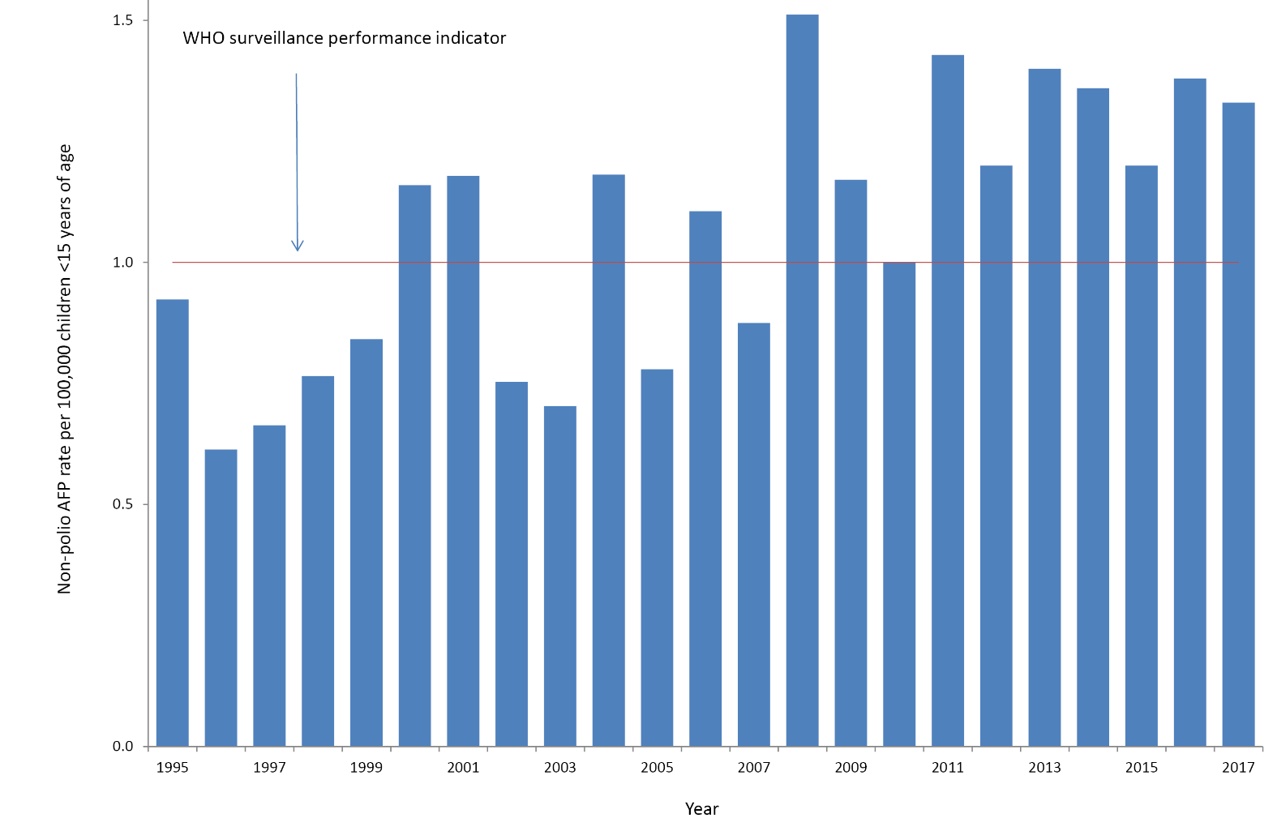
a The WHO AFP surveillance performance indicator for a polio non-endemic country is one case per 100,000 children <15 years of age, which is indicated by the red line.
Table 1: Notification of acute flaccid paralysis cases, 2017 by state or territory
State or territory | Estimated population aged <15 yearsª | Expected number of AFP cases in 2017 | Total number of notifications | Ineligible notifications | Duplicate notifications | Eligible cases with final classification by PEP^{b} | Non-polio AFP rate per 100,000 children
ACT | 75,253 | 1.0 | 1 | 0 | 0 | 1 | 1.00
NSW | 1,441,734 | 14.0 | 19 | 1 | 2 | 16 | 1.14
NT | 53,838 | 0.5 | 1 | 0 | 0 | 1 | 2.00
Qld | 952,770 | 9.5 | 25 | 2 | 7 | 16 | 1.68
SA | 300,058 | 3.0 | 6 | 0 | 1 | 5 | 1.67
Tas | 94,091 | 1.0 | 3 | 0 | 0 | 3 | 3.00
Vic | 1,117,860 | 11.0 | 18 | 1 | 8 | 9 | 0.82
WA | 503,225 | 5.0 | 11 | 2 | 0 | 9 | 1.80
Australia | 4,538,829 | 45.0 | 84 | 6 | 18 | 60 | 1.33
a Australian Bureau of Statistics, estimated population at 30 June 2016. Available at www.abs.gov.au.
b Includes one case classified as polio-compatible in Victoria.
Table 2: Australia’s surveillance for cases of acute flaccid paralysis, 2017, compared with the main World Health Organization performance indicators
WHO surveillance performance indicator for AFP cases in children <15 years | Performance of Australia’s AFP surveillance
≥1.0 non-polio AFP case / 100,000 children (45 cases for Australia in 2017) | 60 cases classified as non-polio AFP | 1.33 (60 / 45) non-polio AFP cases / 100,000 children <15 years
≥80% of classified AFP cases with adequate specimens (2 faecal specimens collected at least 24 hours apart and within 14 days of onset of paralysis | 24 AFP cases with adequate specimens collected | 40% (24 / 60) classified non-polio AFP cases with adequate specimens

One of the AFP cases from Victoria was classified by the PEP as polio-compatible with a final diagnosis of motor axonal neuropathy. Some symptoms were suggestive of enterovirus infection and stool specimens were not collected to confirm or exclude poliovirus infection. The case was included in the non-polio AFP data in Table 1, to be consistent with the reporting system used by WHO for Australia.
Eighteen cases were notified by more than one source, whether by two or more clinicians or a clinician through APSU and the PAEDS systems. Six notifications were deemed to be ineligible due to the patient’s age being greater than 14 years or the clinical presentation was subsequently determined not to be AFP.

Notification of AFP cases by state and territory
In 2017, AFP cases were notified from all jurisdictions in Australia (Table 1). The non-polio AFP rates for eligible cases by jurisdiction exceeded the WHO AFP surveillance performance indicator of one case per 100,000 children in all states and territory except Victoria with a non-polio AFP rate of 0.82 per 100,000 children less than 15 years of age.

Faecal collection from AFP cases
A total of 71 faecal specimens from 39 of the 60 eligible cases were tested at the NERL in 2017. Twenty-four AFP cases met the WHO criterion for specimen testing with two faecal specimens collected within 14 days of the onset of paralysis representing 40% of the cases classified as non-polio AFP compared to the WHO criterion of 80% of cases (Figure 2, Table 2). The proportion of cases with at least one specimen collected within 14 days of the onset of paralysis was 55%, while 75% of cases had a specimen collected any time after the onset of paralysis. No poliovirus was detected in any of the specimens. The following non-polio enteroviruses were identified from stool specimens collected from four non-polio AFP cases with the jurisdiction indicated in brackets: coxsackievirus B1 (South Australia), echovirus 11 (separate cases in ACT and Queensland) and enterovirus A71 (Queensland).

Figure 2. Adequate faecal specimen collection rate, Australia 1995 to 2017ª
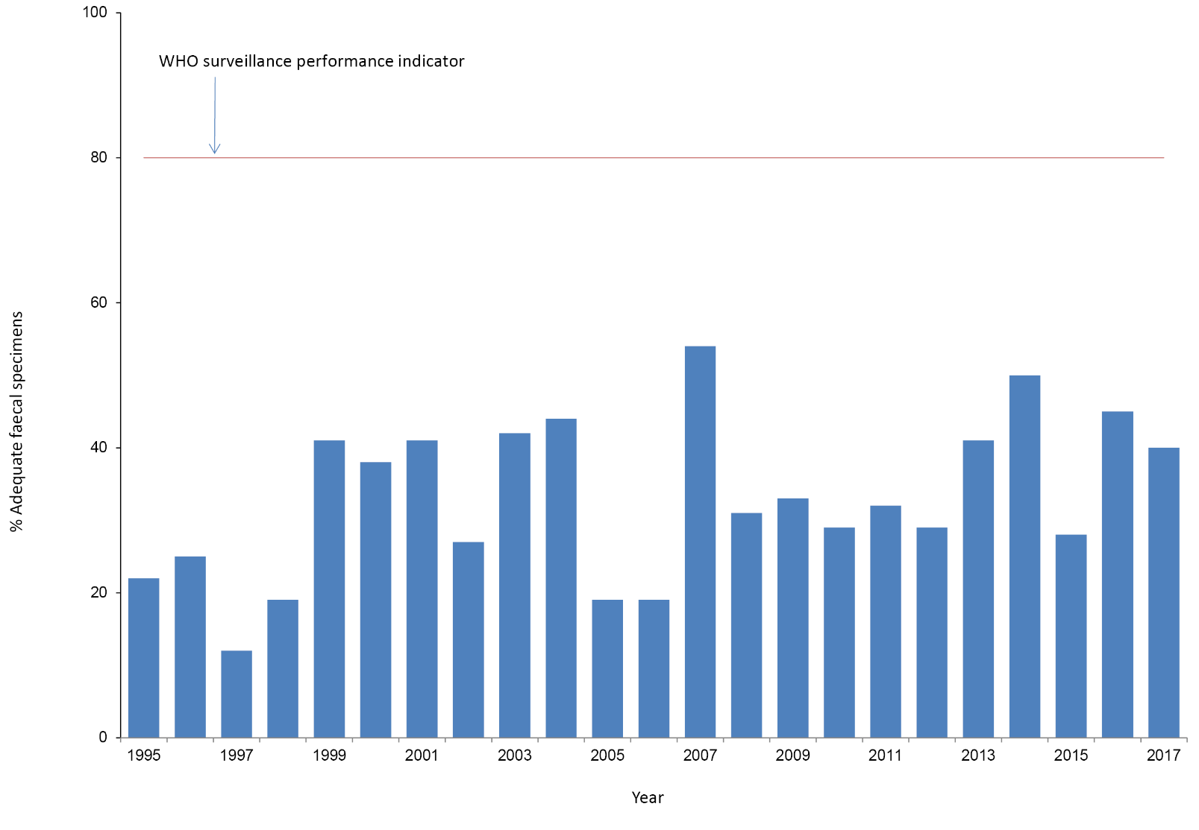
a The WHO criteriion for adequate specimen collection is two faecal specimens collected more than 24 hours apart and within 14 days of the onset of paralysis from 80% of the cases classified as non-polio AFP, which is indicated by the red line.
Table 3: Results reported by the NERL, 2017.
Result | Specimens from AFP cases involving children < 15 years of age | Specimens from AFP cases involving patients ≥15 years of age | Environmental Surveillance | Enterovirus Surveillance | Total
Vaccine-derived poliovirus type 2 | 0 | 0 | 1 | 0 | 1
Poliovirus type 3 Sabin-like | 0 | 0 | 1 | 0 | 1
Non-polio enterovirus | 7 | 0 | 4 | 193 | 204
No enterovirus identified | 64 | 2 | 0 | 26 | 92
Total | 71 | 2 | 6 | 219 | 298

Table 4: Enterovirus test results from samples originating in Australia, 1995 to 2017.
Year | Poliovirus |  | Non-polio enterovirus | No enterovirus detected | EVID results referredª | Total samples reviewed
 | Sabin-like | Non-Sabin-like
1995 | 190 | 0 | 200 | 13 | 0 | 403
1996 | 224 | 0 | 198 | 9 | 0 | 431
1997 | 124 | 0 | 76 | 0 | 0 | 200
1998 | 52 | 0 | 15 | 4 | 0 | 71
1999^{b} | 60 | 1 | 9 | 9 | 0 | 79
2000 | 45 | 0 | 44 | 47 | 0 | 136
2001^{b} | 46 | 5 | 33 | 75 | 0 | 159
2002 | 36 | 0 | 21 | 49 | 0 | 106
2003 | 9 | 0 | 15 | 47 | 0 | 71
2004 | 6 | 0 | 26 | 61 | 0 | 93
2005 | 18 | 0 | 10 | 39 | 0 | 67
2006 | 2 | 0 | 6 | 71 | 29 | 108
2007^{c} | 0 | 2 | 32 | 115 | 107 | 256
2008 | 0 | 0 | 20 | 92 | 77 | 189
2009^{d} | 1 | 0 | 63 | 78 | 113 | 255
2010 | 0 | 0 | 170 | 39 | 108 | 317
2011 | 0 | 0 | 174 | 61 | 205 | 440
2012 | 0 | 0 | 155 | 97 | 123 | 375
2013e | 1 | 0 | 242 | 198 | 230 | 671
2014 | 0 | 0 | 68 | 128 | 506 | 702
2015^{f} | 12 | 0 | 185 | 96 | 168 | 461
2016 | 0 | 0 | 242 | 143 | 227 | 612
2017^{g} | 1 | 1 | 204 | 92 | 173 | 471
a Enterovirus Identification (EVID) results include retrospective data made available via the ERNLA.
b Untyped enterovirus or uncharacterised poliovirus isolates were referred for further testing after completion of a laboratory inventory. The 6 isolates (one in 1999 and five in 2001) tested as non-Sabin-like and were subsequently identified as wild type poliovirus prototype strains and were destroyed.
c Wild poliovirus type 1 was imported from Pakistan.
d A Sabin-like poliovirus type 1 was identified from an unimmunised infant.
e A Sabin-like poliovirus type 2 was identified from an infant who was immunised overseas with oral polio vaccine and hospitalised with diarrhoea upon return to Australia.
f Ten archived Sabin-like poliovirus type 1 samples were identified during a laboratory clean-up. Single isolations of Sabin-like poliovirus type 2 and type 3 were identified from sewage.
g A Sabin-like poliovirus type 3 and an amibiguous VDPV2 (non-Sabin-like) was isolated from sewage.

Environmental surveillance
Environmental surveillance was established at a wastewater treatment plant in Melbourne from October 2017. Six collections were tested and a type 2 vaccine-derived poliovirus and a type 3 Sabin-like poliovirus were isolated on separate occasions as well as NPEVs from the four other samples. Enterovirus infections are ubiquitous and the isolation of NPEVs from sewage acts as an indicator of the quality of the collection and test procedures.

Enterovirus surveillance
A total of 193 NPEVs were typed by the NERL and an additional 173 by members of the Enterovirus Reference Laboratory Network of Australia from clinical specimens (Tables 3 and 4). No polioviruses were reported amongst the enterovirus typings. The most common types of NPEV identified by the laboratory network, in order of decreasing frequency, were coxsackievirus A6 associated with hand, foot and mouth disease and echovirus 30, echovirus 6 and coxsackievirus B5 all associated with meningitis.

Polio regional reference laboratory activities
As part of its role as a Polio Regional Reference Laboratory, in 2017, the NERL received a total of 75 specimens from AFP cases referred from Pacific Island countries (16 cases) and Papua New Guinea (27 cases). Poliovirus was not isolated from any of the AFP cases but NPEVs were reported from eight AFP cases from the Pacific Islands and 10 cases from Papua New Guinea.

Quality assurance programs
In 2017, the NERL was accredited as a WHO Polio Regional Reference Laboratory through participation in the annual WHO quality assurance panels for poliovirus isolation, intratypic differentiation and sequencing. The laboratory also successfully participated in the Royal College of Pathologists of Australasia quality assurance panel for enterovirus detection by RT-PCR and the Quality Control for Molecular Diagnostics (QCMD) pilot panel for enterovirus typing.

Discussion
Australia has met the WHO non-polio AFP surveillance target for the tenth year in a row, reporting 1.33 cases per 100,000 children less than 15 years of age. The notification of AFP cases via the APSU monthly report card and the PAEDS system has routinely met the international standard that assesses whether an imported case of polio in children less than 15 years of age would be detected, although a gap in AFP surveillance was noted at the sub-national level in Victoria based on the WHO surveillance target for the first time since 2006.¹³ PAEDS routinely performs retrospective audits at the hospitals where it operates to identify any missed cases of AFP as a check of the system’s performance and none were identified in Victoria.² Australia has never met the strict WHO surveillance target for adequate stool collection from 80% of the non-polio AFP cases; however 55% of the cases had at least one specimen collected within 14 days of the onset of paralysis. The APSU, PAEDS and members of the PEP and the National Certification Committee for Polio Eradication in Australia have endeavoured to improve the rate of adequate faecal specimen collection from AFP cases through provision of information to clinicians and presentations at tertiary paediatric hospitals.
Enterovirus and environmental surveillance act as supplements to the AFP surveillance program in Australia providing additional means of monitoring Australia’s polio-free status. Poliovirus was not identified through enterovirus surveillance in 2017, but a Sabin-like poliovirus type 3 and a type 2 vaccine-derived poliovirus were isolated from sewage. The Sabin-like poliovirus type 3 would have been associated with a visitor or returned traveller from a country that still uses oral polio vaccine since Australia replaced this vaccine with inactivated polio vaccine in 2005. Long-term replication of an oral polio vaccine strain of poliovirus can lead to a vaccine-derived poliovirus that has a significant number of changes compared to the prototype strain. Sequence analysis of the type 2 vaccine-derived poliovirus isolated from sewage indicated the source was likely to be from an individual with a primary immunodeficiency but was classified by WHO as an ambiguous vaccine-derived poliovirus as the ultimate source was not known. The ambiguous vaccine-derived poliovirus was not detected again after a further six months of sampling at the same site.
More than 99% of poliovirus infections are asymptomatic, which makes environmental surveillance a sensitive means of screening for poliovirus in both polio endemic and polio-free countries. In Pakistan, it was estimated that wild poliovirus circulation was detected in environmental samples before AFP cases in nearly 60% of cases and on average nearly four months before reports of wild poliovirus transmission were made through AFP surveillance.²⁰ WHO initiated a global expansion plan for environmental surveillance from 2014 to 2016, to monitor both the eradication of wild poliovirus and the emergence of vaccine-derived poliovirus after the withdrawal of poliovirus type 2 from the oral polio vaccine in 2016.²¹ The introduction of at least one dose of trivalent inactivated polio vaccine in the routine immunisation schedule of all countries using oral polio vaccine was to act as insurance against an outbreak of type 2 vaccine-derived poliovirus, which can occur in areas with low polio vaccine coverage. However a global shortage of inactivated polio vaccine during the scale-up in manufacturing left up to 43 countries without stocks or having to delay the introduction of the vaccine.²² The 43 countries were considered to be at low risk of a type 2 vaccine-derived poliovirus outbreak but this reinforces the need for all countries to maintain sensitive polio surveillance systems for importations of wild poliovirus and vaccine-derived poliovirus.

Acknowledgements
The authors thank the clinicians and healthcare workers who participated in the AFP surveillance program in 2017 as well as the teams at APSU and PAEDS. The active involvement of the laboratory members of the ERLNA is gratefully acknowledged. The poliovirus surveillance program co-ordinated by the NERL is funded by the Australian Government Department of Health, the Victorian government Department of Health and VIDRL.

Author details
Dr Jason Roberts, Senior Medical Scientist¹
Ms Linda Hobday, Medical Scientist, National AFP Surveillance Coordinator¹
Mrs Aishah Ibrahim, Medical Scientist¹
A/Prof. Bruce Thorley, Senior Medical Scientist, Laboratory Head¹
- National Enterovirus Reference Laboratory, Victorian Infectious Diseases Reference Laboratory, Doherty Institute, 792 Elizabeth St, Melbourne 3000, Victoria, Australia

Corresponding author
A/Prof. Bruce Thorley
Senior Medical Scientist, Laboratory Head, National Enterovirus Reference Laboratory, Victorian Infectious Diseases Reference Laboratory, Locked Bag 815, CARLTON SOUTH VIC 3053.
Telephone: +61 3 9342 9607.
Facsimile: +61 3 9342 9665.
Email: bruce.thorley@mh.org.au

References
- Australian Paediatric Surveillance Unit (APSU). Study Protocol, Acute Flaccid Paralysis. [Internet.] APSU, 2014. [Accessed: 28 March 2018.] Available from: http://www.apsu.org.au/assets/current-studies/AFP-Study-Protocol-June-2014.pdf
- McRae J, Quinn HE, McCartney K. Paediatric Active Enhanced Disease Surveillance (PAEDS) annual report 2015: prospective hospital-based surveillance for serious paediatric conditions. Commun Dis Intell Q Rep. 2017;41(3):E280–8.
- Midgley CM, Jackson MA, Selvarangan R, Turabelidze G, Obringer E, Johnson D et al. Severe respiratory illness associated with enterovirus D68 – Missouri and Illinois, 2014. MMWR Morb Mortal Wkly Rep. 2014;63(36):798–9.
- Solomon T, Lewthwaite P, Perera D, Cardosa MJ, McMinn P, Ooi MH. Virology, epidemiology, pathogenesis, and control of enterovirus 71. Lancet Infect Dis. 2010;10(11):778–90.
- World Health Organization (WHO). Global wild poliovirus 2013-2018. [Intenet.] WHO, 2018. [Accessed: 28 March 2018.] Available from: http://polioeradication.org/wp-content/uploads/2018/03/global-wild-poliovirus-2013-2018-20180320.pdf
- Nnadi C, Damisa E, Esapa L, Braka F, Waziri N, Siddique A et al. Continued endemic wild poliovirus transmission in security compromised areas — Nigeria, 2016. MMWR Morb Mortal Wkly Rep. 2017;66(7):190–3.
- World Health Organization (WHO). Global eradication of wild poliovirus type 2 declared. [Internet.] WHO, 2015. [Accessed: 28 March 2018.] Available from: http://www.polioeradication.org/mediaroom/newsstories/Global-eradication-of-wild-poliovirus-type-2-declared/tabid/526/news/1289/Default.aspx
- Alleman MM, Chitale R, Burns CC, Iber J, Dybdahl-Sissoko N, Chen Q et al. Vaccine-derived poliovirus outbreaks and events — three provinces, Democratic Republic of the Congo, 2017. MMWR Morb Mortal Wkly Rep. 2018;67(10):300–5.
- Previsani N, Singh H, St. Pierre J, Boualam L, Fournier-Caruana J, Sutter RW et al. Progress toward containment of poliovirus type 2 — worldwide, 2017. MMWR Morb Mortal Wkly Rep. 2017;66(24):649–52.
- World Health Organization (WHO). Circulating vaccine-derived poliovirus. [Internet.] WHO, 2018. [Accessed: 28 March 2018.] Available from: http://polioeradication.org/polio-today/polio-now/this-week/circulating-vaccine-derived-poliovirus/
- World Health Organization (WHO). Fifteenth meeting of the Emergency Committee under the International Health Regulations (2005) regarding the international spread of poliovirus. [Internet.] WHO, 2017. [Accessed: 28 March 2018.] Available from: http://www.who.int/mediacentre/news/statements/2017/ihr-emergency-committee-polio/en/
- Department of Health. Poliovirus infection. [Internet.] Australian Government, Department of Health, 2015. [Accessed: 28 March 2018.] Available from: http://www.health.gov.au/internet/main/publishing.nsf/Content/cda-surveil-nndss-casedefs-cd_polio.htm
- World Health Organization (WHO). Poliomyelitis. In WHO-recommended standards for surveillance of selected vaccine-preventable diseases. (WHO/V&B/03.01) Geneva: WHO, Department of Vaccines and Biologicals, 2003.
- Wood DJ, Hull B. L20B cells simplify culture of polioviruses from clinical samples. J Med Virol. 1999;58(2):188–92.
- World Health Organization (WHO). Polio Laboratory Manual, 4th edition. (WHO/IVB/04.10) Geneva: WHO, Department of Immunization, Vaccines and Biologicals, 2004.
- Kilpatrick DR, Yang CF, Ching K, Vincent A, Iber J, Campagnoli R et al. Rapid group-, serotype-, and vaccine strain-specific identification of poliovirus isolates by real-time reverse transcription PCR using degenerate primers and probes containing deoxyinosine residues. J Clin Microbiol. 2009;47(6):1939–41.
- Stewardson AJ, Roberts JA, Beckett CL, Prime HT, Loh PS, Thorley BR et al. An imported case of poliomyelitis in Melbourne, Australia. Emerg Infect Dis. 2009;15(1):63–5.
- World Health Organization (WHO). Guidelines for environmental surveillance of poliovirus circulation. (WHO/V&B/03.03) Geneva: WHO, Department of Vaccines and Biologicals, 2003.
- Roberts, JA. Thesis. “Chapter 2: Development of a Novel Enterovirus Detection and Super-Speciation Assay”, An integrated bioinformatics and computational biophysics approach to enterovirus surveillance and research. RMIT University, 2014: 62-109. [Accessed: 27 March 2018.] Available from: https://researchbank.rmit.edu.au/view/rmit:162129
- Cowger TL, Burns CC, Sharif S, Gary HE, Iber J, Henderson E et al. The role of supplementary environmental surveillance to complement acute flaccid paralysis surveillance for wild poliovirus in Pakistan – 2011–2013. PLoS ONE. 2017;12(7): e0180608.
- World Health Organization (WHO). Polio environmental surveillance expansion plan. Geneva: WHO, 2015.
- Lewis I, Ottosen A, Rubin J, Blanc DC, Zipursky S, Wootton E. A supply and demand management perspective on the accelerated global introductions of inactivated poliovirus vaccine in a constrained supply market. J Infect Dis. 2017:216 (Suppl 1);S33–39.

Communicable Diseases Intelligence
ISSN: 2209-6051 Online

Communicable Diseases Intelligence (CDI) is a peer-reviewed scientific journal published by the Office of Health Protection, Department of Health. The journal aims to disseminate information on the epidemiology, surveillance, prevention and control of communicable diseases of relevance to Australia.

Editor: Tanja Farmer
Deputy Editor: Simon Petrie
Design and Production: Kasra Yousefi
Editorial Advisory Board: David Durrheim, Mark Ferson, John Kaldor, Martyn Kirk and Linda Selvey

Website: http://www.health.gov.au/cdi

Contacts
Communicable Diseases Intelligence is produced by:
Health Protection Policy Branch, Office of Health Protection, Australian Government Department of Health
GPO Box 9848, (MDP 6) CANBERRA ACT 2601

Email: cdi.editor@health.gov.au

Submit an Article
You are invited to submit your next communicable disease related article to the Communicable Diseases Intelligence (CDI) for consideration. More information regarding CDI can be found at: http://health.gov.au/cdi.
Further enquiries should be directed to: cdi.editor@health.gov.au.

This journal is indexed by Index Medicus and Medline.

Creative Commons Licence - Attribution-NonCommercial-NoDerivatives CC BY-NC-ND
© 2020 Commonwealth of Australia as represented by the Department of Health
This publication is licensed under a Creative Commons Attribution-NonCommercial-NoDerivatives 4.0 International Licence from https://creativecommons.org/licenses/by-nc-nd/4.0/legalcode (Licence). You must read and understand the Licence before using any material from this publication.

Restrictions
The Licence does not cover, and there is no permission given for, use of any of the following material found in this publication (if any):
- the Commonwealth Coat of Arms (by way of information, the terms under which the Coat of Arms may be used can be found at www.itsanhonour.gov.au);
- any logos (including the Department of Health’s logo) and trademarks;
- any photographs and images;
- any signatures; and
- any material belonging to third parties.

Disclaimer
Opinions expressed in Communicable Diseases Intelligence are those of the authors and not necessarily those of the Australian Government Department of Health or the Communicable Diseases Network Australia. Data may be subject to revision.

Enquiries
Enquiries regarding any other use of this publication should be addressed to the Communication Branch, Department of Health, GPO Box 9848, Canberra ACT 2601, or via e-mail to: copyright@health.gov.au

Communicable Diseases Network Australia
Communicable Diseases Intelligence contributes to the work of the Communicable Diseases Network Australia.
http://www.health.gov.au/cdna

telephone 03-9342 9607, email enterovirus@vidrl.org.au
http://www.apsu.org.au/
http://www.who.int/wer/en/

