Antimicrobial resistance and antibiotic use in Timor-Leste: building surveillance capacity with a One Health approach
Joshua R Francis, Nevio Sarmento, Anthony D K Draper, Ian Marr, Shawn Ting, Nicholas Fancourt, Lucsendar Alves, Karen Champlin, Alexander Bongers and Jennifer Yan
The Menzies School of Health Research (Menzies) has been awarded a Fleming Fund country grant to work with the Timor-Leste Ministry of Health (MoH) and Ministry of Agriculture and Fisheries (MAF) on a One Health project to build capacity for surveillance of antimicrobial resistance (AMR) and antimicrobial use (AMU) in the human and agriculture sectors in Timor-Leste. The Fleming Fund is a £265 million United Kingdom (UK) aid investment to tackle AMR in low- and middle-income countries around the world. The program is managed by the UK Department of Health and Social Care, in partnership with Mott MacDonald, the Fleming Fund Grant Management Agent.

One Health approach to antimicrobial resistance
Antimicrobial resistance poses an enormous risk to human and animal health globally. Rates of AMR are escalating, particularly affecting people in low- and middle-income countries,¹ with corresponding high rates of AMR in animals observed in similar settings.² Strategies for reducing the impact of AMR include infection prevention and control through vaccination and improved water, sanitation and hygiene, as well as limiting unnecessary use of antibiotics. The problem of AMR is one that exemplifies the need for a One Health approach to finding solutions.³
Figure 1. Signing of the Memorandum of Understanding between Menzies School of Health Research and the Timor-Leste Ministry of Agriculture and Fisheries, Hotel Timor, Dili, Timor-Leste, 13 September 2019.
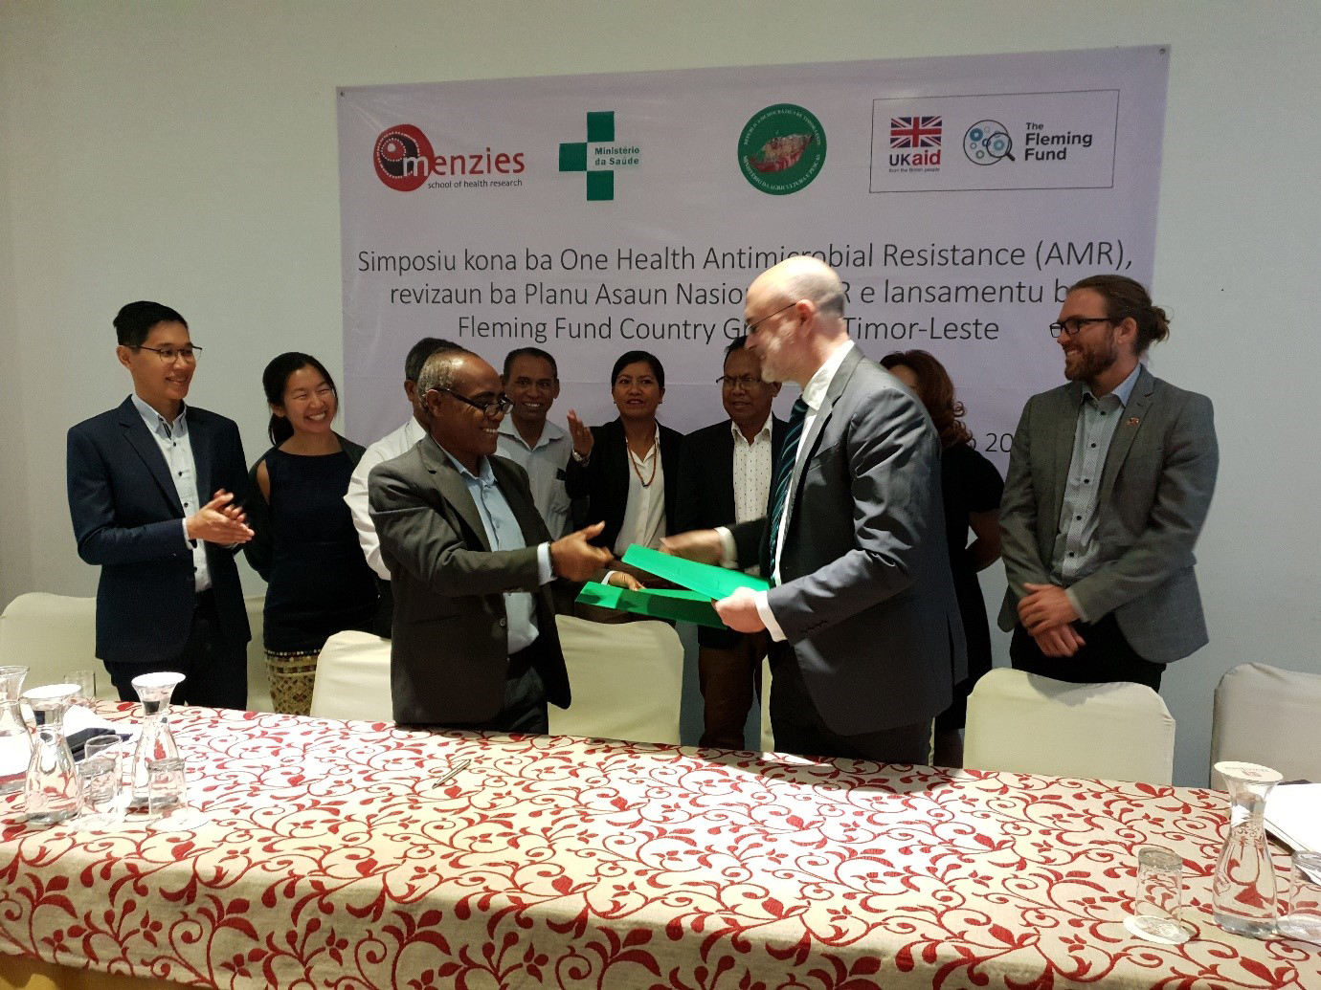

Current situation in Timor-Leste
Data from Southeast Asia indicate high rates of resistance in Gram-negative infections, including those caused by extended-spectrum beta-lactamase-producing organisms, and carbapenemase-producing Enterobacteriaceae.⁴ Data from Timor-Leste are limited but suggest similarly high rates of Gram-negative resistance.^{5,6} Capacity for routine diagnostic microbiology is improving at the National Health Laboratory in Timor-Leste, with support from Menzies, the Northern Territory Department of Health and the Indo-Pacific Centre for Health Security.⁷ However, routine AMR surveillance is not yet established. In the Veterinary Diagnostic Laboratory in Timor-Leste, antimicrobial susceptibility testing is yet to be introduced. No recent data on AMR in animals have been published. Routine surveillance of antibiotic use does not occur in human or animal health sectors, and restrictions on use are rarely enforced.

Plans to address antimicrobial resistance in Timor-Leste
Recognising the need for action to address AMR and its impacts on health, the Timor-Leste MoH and MAF have agreed on a National Action Plan for AMR, outlining a One Health approach to developing capacity for AMR surveillance and implementing antimicrobial stewardship activities across human and animal health. The Menzies Fleming Fund project will support both Ministries to achieve the aims of the national action plan, through coordinated capacity building and mentoring activities, data collection and sharing, infrastructure improvements and targeted implementation research designed to evaluate and inform health systems changes over the two years of the project.
The project was formally launched on Friday 13 September 2019 in Dili, with the signing of a Memorandum of Understanding (MOU) between Menzies and the MAF (Figure 1). Along with the existing MOU between Menzies and the MoH, this provides a platform for ongoing multisector collaboration with one of Australia’s nearest neighbours, to tackle health challenges that are truly global and span the full spectrum of One Health.

Author details
Joshua R Francis^{1,2}
Nevio Sarmento¹
Anthony D K Draper^{1,3}
Ian Marr¹
Shawn Ting¹
Nicholas Fancourt^{1,2}
Lucsendar Alves¹
Karen Champlin¹
Alexander Bongers¹
Jennifer Yan^{1,2}
- Global and Tropical Health Division, Menzies School of Health Research, Darwin, Australia
- Department of Paediatrics, Royal Darwin Hospital, Darwin, Australia
- Centre for Disease Control, Top End Health Service, Darwin, Australia

Contributing author
Dr Joshua Francis
Global and Tropical Health Division, Menzies School of Health Research, Darwin, Australia
Telephone: +61 8 892 28649
Email: josh.francis@menzies.edu.au

References
- Collignon P, Beggs JJ, Walsh TR, Gandra S, Laxminarayan R. Anthropological and socioeconomic factors contributing to global antimicrobial resistance: a univariate and multivariable analysis. Lancet Planet Health. 2018;2(9):e398–405.
- Van Boeckel TP, Pires J, Silvester R, Zhao C, Song J, Criscuolo NG et al. Global trends in antimicrobial resistance in animals in low- and middle-income countries. Science. 2019;365(6459). pii: eaaw1944.
- Singh PK. One Health approach to tackle antimicrobial resistance in South East Asia. BMJ. 2017;358:j3625.
- Zellweger RM, Carrique-Mas J, Limmathurotsakul D, Day NPJ, Thwaites GE, Baker S. A current perspective on antimicrobial resistance in Southeast Asia. J Antimicrob Chemother. 2017;72(11):2963–72.
- Tebano G, la Martire G, Sarmento N, Francis JR. Antibiotic resistance in Timor-Leste: A systematic review of evidence. J Antimicrob Chemother. 2018;73(4):1110–1.
- Marr I, Sarmento N, O’Brien M, Lee K, Gusmao C, de Castro G et al. Antimicrobial resistance in urine and skin isolates in Timor-Leste. J Glob Antimicrob Resist. 2018;13:135–8.
- Draper ADK, Francis JR. Surveillance Training, Research Opportunities, National Guidelines for Timor-Leste (STRONG TL). N T Dis Control Bull. 2018;25(4):24–5.

Communicable Diseases Intelligence
ISSN: 2209-6051 Online

Communicable Diseases Intelligence (CDI) is a peer-reviewed scientific journal published by the Office of Health Protection, Department of Health. The journal aims to disseminate information on the epidemiology, surveillance, prevention and control of communicable diseases of relevance to Australia.

Editor: Cindy Toms
Deputy Editor: Simon Petrie
Design and Production: Kasra Yousefi
Editorial Advisory Board: David Durrheim, Mark Ferson, John Kaldor, Martyn Kirk and Linda Selvey

Website: http://www.health.gov.au/cdi

Contacts
Communicable Diseases Intelligence is produced by:
Health Protection Policy Branch, Office of Health Protection, Australian Government Department of Health
GPO Box 9848, (MDP 6) CANBERRA ACT 2601

Email: cdi.editor@health.gov.au

Submit an Article
You are invited to submit your next communicable disease related article to the Communicable Diseases Intelligence (CDI) for consideration. More information regarding CDI can be found at: http://health.gov.au/cdi.
Further enquiries should be directed to: cdi.editor@health.gov.au.

This journal is indexed by Index Medicus and Medline.

Creative Commons Licence - Attribution-NonCommercial-NoDerivatives CC BY-NC-ND
© 2019 Commonwealth of Australia as represented by the Department of Health
This publication is licensed under a Creative Commons Attribution-NonCommercial-NoDerivatives 4.0 International Licence from https://creativecommons.org/licenses/by-nc-nd/4.0/legalcode (Licence). You must read and understand the Licence before using any material from this publication.

Restrictions
The Licence does not cover, and there is no permission given for, use of any of the following material found in this publication (if any):
- the Commonwealth Coat of Arms (by way of information, the terms under which the Coat of Arms may be used can be found at www.itsanhonour.gov.au);
- any logos (including the Department of Health’s logo) and trademarks;
- any photographs and images;
- any signatures; and
- any material belonging to third parties.

Disclaimer
Opinions expressed in Communicable Diseases Intelligence are those of the authors and not necessarily those of the Australian Government Department of Health or the Communicable Diseases Network Australia. Data may be subject to revision.

Enquiries
Enquiries regarding any other use of this publication should be addressed to the Communication Branch, Department of Health, GPO Box 9848, Canberra ACT 2601, or via e-mail to: copyright@health.gov.au

Communicable Diseases Network Australia
Communicable Diseases Intelligence contributes to the work of the Communicable Diseases Network Australia.
http://www.health.gov.au/cdna

