2025 • Volume • • Electronic publication date:

Prevalence of Murray Valley encephalitis virus antibodies in northern Victoria following the 2023 outbreak: a cross-sectional serological survey

Marie Heloury, Joshua Szanyi, Maxwell Braddick, Alexander Fidao, Madeleine J Marsland, Tilda N Thomson, Mitch Batty, Suellen Nicholson, Theo Karapanagiotidis, Kylie Carville,   
Anna-Jane Glynn-Robinson, Chuan Kok Lim, Naveen Tenneti, Anthony Zheng, William Cross, Jim Black, Helen O’Brien

# Abstract

Following the first outbreak of Murray Valley encephalitis in Victoria, Australia, since 1974, a serological survey was conducted in 2023 and 2024 to estimate the seroprevalence of Murray Valley encephalitis virus (MVEV) antibodies among residents in the north of the state. Between October 2023 and April 2024, a total of 507 residents from 11 local government areas in northern Victoria — Mildura, Swan Hill, Campaspe, Gannawarra, Greater Bendigo, Loddon, Greater Shepparton, Moira, Wodonga, Wangaratta, and Indigo — were tested for MVEV total antibody. Seroprevalence was 2.0% (95% confidence interval: 1.1–3.6%), comparable to background levels of seropositivity prior to the 2023 outbreak. No strong associations were identified between a range of potential risk or protective factors and MVEV seropositivity. Low seroprevalence suggests that the population in this region remains immunologically vulnerable to MVEV infection. Ongoing vector control and efforts to prevent mosquito bites will be critical in preventing flavivirus transmission in northern Victoria during future mosquito seasons.

Keywords: Murray Valley encephalitis virus; serology; seroprevalence; flavivirus infections; vector control; mosquito vectors; epidemiology; Victoria; cross-sectional studies

# Introduction

Murray Valley encephalitis virus (MVEV) is a mosquito-borne flavivirus that was first isolated in 1951 during an encephalitis outbreak in the Murray Valley region of south-eastern Australia.1 The epidemiology of MVEV in the region has since been characterised by discrete outbreaks of encephalitis separated by long periods of no detected disease activity in humans.2 This pattern is thought to be facilitated by the maintenance of enzootic foci in northern Australia, in a cycle involving the freshwater mosquito *Culex annulirostris* as a vector and waterbirds as amplifying hosts that migrate to the south-east of the country during floods.3,4 Human infection is not believed to result in sufficient viraemia to enable onward transmission.5

Asymptomatic MVEV infection is common, with an estimated 1 in 150 to 1 in 1000 infected individuals developing clinical disease.3 However, when symptomatic infection does occur, disease can be severe, characterised by encephalitis, progressive neurological deterioration, and a reported case fatality rate that ranges widely from approximately 15% to 85%.2,6 Only an estimated 40% of survivors fully recover, with the remainder experiencing long-term neurological sequelae.3 There is no specific treatment available for symptomatic MVEV infection and management is supportive. Laboratory diagnosis of MVEV infection is generally achieved via serological testing, but the interpretation of results is complex for several reasons, including serological cross-reactivity with other flaviviruses, unknown duration of seropositivity following infection, and the antibody response from vaccination such as JEV vaccination.2

In October 2022, extensive flooding occurred in areas of the Murray-Darling Basin in northern Victoria and southern New South Wales following unusually high levels of rainfall.2 Large numbers of mosquitoes were subsequently detected in northern Victoria as part of the state’s mosquito surveillance program, followed by the identification of MVEV in mosquito traps across 11 local government areas (LGAs), most frequently in the north-west of the state.2 Six human cases of Murray Valley encephalitis (MVE) were confirmed in Victoria between January and March 2023, five of which were fatal.2 This was the first confirmed detection of human MVEV infection in Victoria since 1974, although serological evidence of equine infection and seroconversion of sentinel chickens were both detected in early 2011.7,8 This MVEV outbreak followed the emergence of Japanese encephalitis virus (JEV) for the first time in southern Australia in early 2022.2 Due to shared ecological factors, it is hypothesised that the risk areas for JEV overlap with those of MVEV.

Despite the 2023 outbreak being the fourth proven outbreak of MVEV in south-eastern Australia since isolation of the virus in 1951, limited data are available regarding the ecology of MVEV in the region, individual-level risk factors for infection, or how common prior infection is in the population. Notified clinical cases are likely to represent a minority of infected individuals.2 In 2022, a JEV serological survey was conducted in northern Victoria in which samples were also tested for MVEV antibodies.9 While MVEV seroprevalence in this 2022 study was 3%, recruitment ceased in December 2022 (prior to the 2023 outbreak), and recruitment location selection was primarily informed by JEV epidemiology. North-western regions of Victoria, where MVEV mosquito detections and human encephalitis cases occurred during the 2023 outbreak, were also under-represented.9

Accordingly, in the current study we aimed to determine the prevalence of MVEV antibody seropositivity and risk factors associated with seropositivity in a population of northern Victorian residents in late 2023 to early 2024, following the 2023 MVEV outbreak.

# Methods

We report our study in accordance with the STROBE statement on cross-sectional studies.10

## Participant recruitment

Participant recruitment took place from 23 October 2023 to 16 April 2024 in 11 LGAs across three regions in northern Victoria, Australia: Mildura, Swan Hill, Campaspe, Gannawarra, Greater Bendigo, and Loddon LGAs (in the Loddon Mallee region); Greater Shepparton and Moira LGAs (in the Goulburn Valley region); and Wodonga, Indigo, and Wangaratta LGAs (in the Ovens Murray region). These LGAs were selected based on MVEV detections in mosquitoes during the 2022–2023 mosquito breeding season and on likely vector exposure locations for MVE cases in the 2023 outbreak,2 to capture a population of northern Victorians presumed to be at high risk of MVEV infection. With an estimated population seroprevalence of 3%, a minimum sample size of 500 participants was required to assess MVEV seroprevalence with a precision of 1.5% and a confidence level of 95%.

Individuals of all ages were eligible to participate if they currently lived in one of the 11 included LGAs. Individuals were not eligible to participate if they had been vaccinated for JEV, or had been previously diagnosed with MVEV, JEV, or West Nile virus Kunjin subtype (KUNV) infection due to the risk of serological cross-reactivity. Most participants were recruited when attending pathology collection sites for unrelated pathology testing. The study was also advertised via social media, mass media, and through community organisations in the included LGAs.

## Data collection

Participants provided written consent through an online form and completed an online questionnaire about potential risk and protective factors for MVEV infection. This included demographic information, occupational history, proximity to water sources, leisure activities, time spent outdoors, close contact with water birds, and avoidance of mosquito bites. For participants aged less than 18 years, consent was provided by an accompanying parent or guardian. Following completion of the consent form and questionnaire, a blood sample was collected by a phlebotomist at a participating pathology collection centre in a serum-separating tube and transported within 24 hours of collection to the Victorian Infectious Diseases Reference Laboratory (VIDRL) in Melbourne.

Blood samples were tested at VIDRL for MVEV total antibody using an in-house defined epitope blocking (DEB) enzyme-linked immunosorbent assay (ELISA). This DEB ELISA was accredited by the National Association of Testing Authorities (NATA) in 2011 and validated against a MVEV haemagglutination inhibition test and a MVEV microneutralisation test on samples from the 1974 MVE outbreak. Samples positive for MVEV total antibody were tested for JEV total antibody and KUNV total antibody using DEB ELISAs. Samples positive for MVEV total antibody, JEV total antibody and/or KUNV total antibody were tested for MVEV immunoglobulin M (IgM), JEV IgM, and/or KUNV IgM respectively with an immunofluorescence assay (IFA). All positive samples were retested to ensure reproducibility. Participants who tested positive for MVEV total antibody were invited to complete a follow-up questionnaire to collect more detailed information about their history of mosquito-borne viral infections, vaccination history, and travel history.

## Statistical analysis

The primary outcome was MVEV total antibody seroprevalence, with 95% confidence intervals (95% CIs) derived assuming a binomial distribution. Prevalence odds ratios (PORs) for exposures, risk and protective factors were calculated with corresponding 95% CIs using logistic regression for continuous variables and Fisher’s exact test for categorical variables. All analyses were undertaken in R version 4.3.1.11

## Ethics approval

Ethical approval for this study was granted by the Victorian Department of Health and Department of Families, Fairness and Housing Human Research Ethics Committee (reference HREC/101670/DOH-2023-396684).

# Results

A total of 583 participants were recruited across the 11 included LGAs. Sixty-four individuals consented to participate but did not have a blood sample collected and were therefore excluded from the analysis. In addition, 12 blood samples were collected for testing where a completed consent form and questionnaire were not received from the participants. These samples were destroyed and are not included in the analysis. The final sample comprised 507 individuals.

The age of participants ranged from 5 to 99 years (median 55 years); 65.7% (n = 333) were female; 1.4% (n = 7) identified as Aboriginal and 0.4% (n = 2) identified as Torres Strait Islander (Table 1). Participation per LGA ranged from 54 per 100,000 inhabitants in Loddon to 151 per 100,000 inhabitants in Wangaratta (Figure 1a).

In total, ten samples (2.0%; 95% CI: 1.1–3.6%) tested positive for MVEV total antibody by DEB ELISA (Table 2). Of the ten samples positive for MVEV total antibody, eight were also positive for JEV or KUNV total antibody by DEB ELISA (six were positive for JEV total antibody, one was positive for KUNV total antibody, and one was positive for both JEV total antibody and MVEV IgM). None of the participants who tested positive for JEV total antibody or KUNV total antibody tested positive for JEV IgM or KUNV IgM (Figure 2). MVEV total antibody seropositivity ranged from 0.0% in Loddon, Indigo, Moira, Greater Shepparton, and Swan Hill to 8.3% (95% CI: 1.5–35.4%) in Gannawarra (Figure 1b). The majority of MVEV seropositive participants (70.0%; n = 7) resided in the Loddon Mallee region in the north-west of Victoria (Greater Bendigo, Campaspe, Gannawarra, and Mildura LGAs).

The age of MVEV total antibody seropositive participants ranged from 18 to 87 years (median 68 years), and the POR for MVEV total antibody seropositivity per one-year increase in age was 1.02 (95% CI: 0.99–1.06). Fifty percent of MVEV seropositive participants were male, and none identified as Aboriginal or Torres Strait Islander. Most MVEV total antibody seropositive participants (90.0%; n = 9) were born in Australia, and the remaining one participant was born in a country where MVEV and JEV are not endemic.

Of the ten MVEV total antibody seropositive participants, six completed the follow-up questionnaire. Three reported a history of recreational travel to regions with historic MVEV activity for greater than one month, such as the Top End or Barkly region in the Northern Territory or northern Queensland.12 None reported being vaccinated against or infected with dengue fever or yellow fever, but one reported past infection with Ross River virus.

Table 3 shows the associations between MVEV seropositivity and the potential risk and protective factors included in the study. Many of the hypothesised risk or protective factors had PORs > 1, but confidence intervals were generally very wide and, in all cases, crossed the null. For example, seropositive participants reported more frequent exposure to standing water sources (POR 3.4; 95% CI: 0.7–33.1) and water birds (POR 2.4; 95% CI: 0.6–10.8) than did seronegative participants.

Table 1: Demographic characteristics of Murray Valley encephalitis virus seropositive and seronegative individuals across 11 local government areas in northern Victoria, October 2023 to April 2024

| Demographic factor | Category | MVEV seropositive, n (%) N = 10 | MVEV seronegative, n (%) N = 497 | Total participants,  n (%) N = 507 |
| --- | --- | --- | --- | --- |
| Age | 0–9 | 0 (0.0%) | 3 (0.6%) | 3 (0.6%) |
| 10–19 | 1 (10.0%) | 11 (2.2%) | 12 (2.4%) |
| 20–39 | 1 (10.0%) | 136 (27.4%) | 137 (27.0%) |
| 40–59 | 1 (10.0%) | 136 (27.4%) | 137 (27.0%) |
| 60–79 | 6 (60.0%) | 179 (36.0%) | 185 (36.5%) |
| ≥ 80 | 1 (10.0%) | 32 (6.4%) | 33 (6.5%) |
| Gendera | Male | 5 (50.0%) | 168 (33.8%) | 173 (34.1%) |
| Female | 5 (50.0%) | 328 (66.0%) | 333 (65.7%) |
| Aboriginal or Torres Strait Islander status | Not Aboriginal or Torres Strait Islander | 10 (100%) | 485 (97.6%) | 495 (97.6%) |
| Aboriginal | 0 (0.0%) | 7 (1.4%) | 7 (1.4%) |
| Torres Strait Islander | 0 (0.0%) | 2 (0.4%) | 2 (0.4%) |
| Prefer not to say | 0 (0.0%) | 3 (0.6%) | 3 (0.6%) |
| Country of birth | Australia | 9 (90.0%) | 445 (89.6%) | 454 (89.6%) |
| Other country | 1 (10.0%) | 52 (10.4%) | 53 (10.4%) |

a One participant selected ‘I use a different term (please specify)’ but did not specify the term.

Figure 1: Participant enrolment per 100,000 population (a) and percentage of participants who were Murray Valley encephalitis virus total antibody seropositive (b) in each included local government area

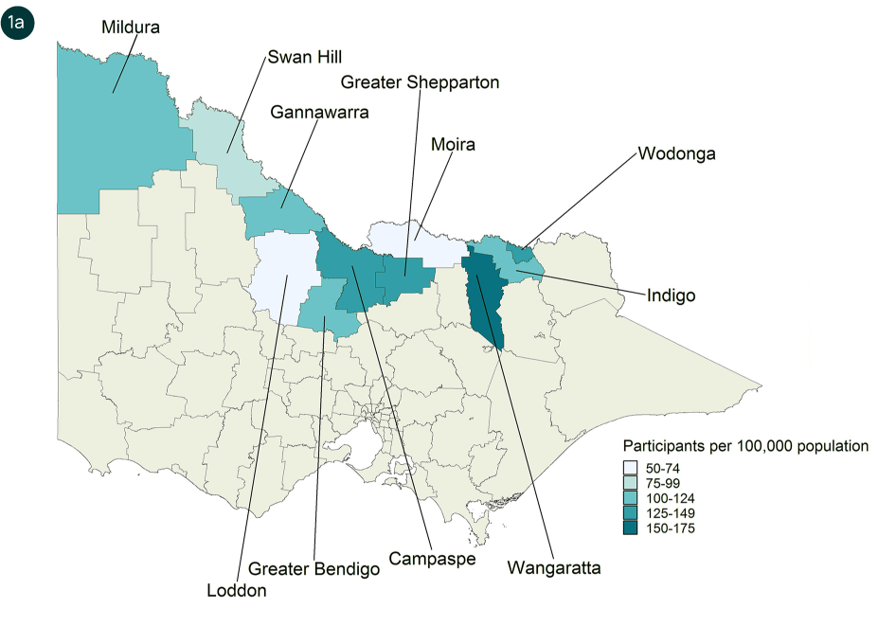

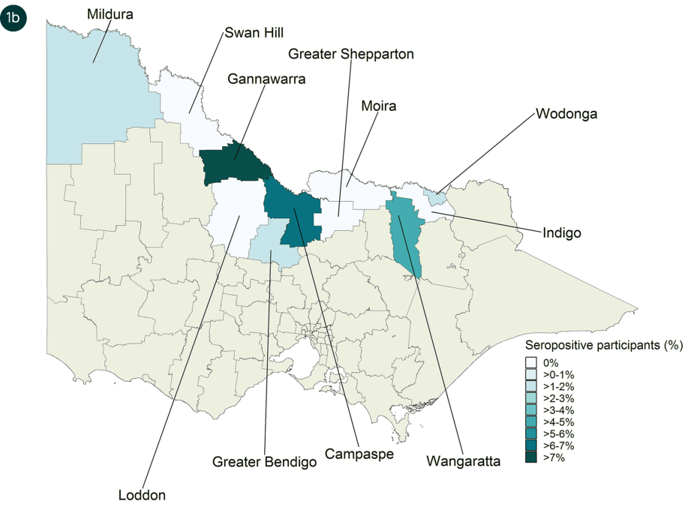

Table 2: Murray Valley encephalitis virus seropositivity across 11 local government areas in northern Victoria, October 2023 to April 2024

| Residential local government area | Number seropositive | Total participants | % seropositive (95% CI)a |
| --- | --- | --- | --- |
| Mildura | 1 | 60 | 1.7% (0.3–8.6%) |
| Swan Hill | 0 | 19 | 0.0% (0.0–16.8%) |
| Campaspe | 3 | 49 | 6.1% (2.1–16.5%) |
| Gannawarra | 1 | 12 | 8.3% (0.4–35.4%) |
| Greater Bendigo | 2 | 123 | 1.6% (0.4–5.7%) |
| Loddon | 0 | 4 | 0.0% (0.0–49.0%) |
| Greater Shepparton | 0 | 99 | 0.0% (0.0–3.7%) |
| Moira | 0 | 19 | 0.0% (0.0–16.8%) |
| Wodonga | 1 | 58 | 1.7% (0.3–9.1%) |
| Indigo | 0 | 20 | 0.0% (0.0–16.1%) |
| Wangaratta | 2 | 44 | 4.6% (1.3–15.1%) |
| Total | 10 | 507 | 2.0% (1.1–3.6%) |

a 95% CI: 95% confidence interval.

Figure 2: Flavivirus assay reactivity among Murray Valley encephalitis virus total antibody seropositive participants

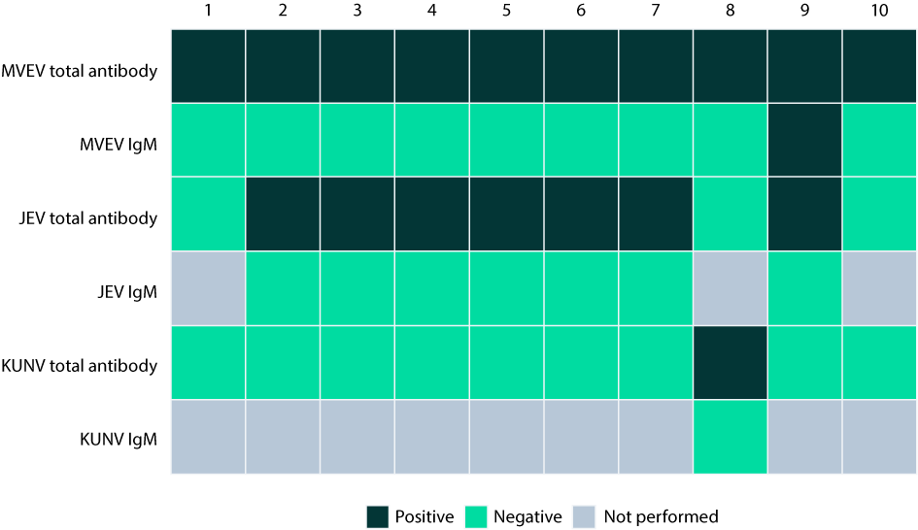

Table 3: Presence of risk and protective factors for Murray Valley encephalitis virus infection among Murray Valley encephalitis virus total antibody seropositive and seronegative participants

| Categorya | Exposure variable | MVEV seropositive,  n (%) | MVEV seronegative, n (%) | Prevalence odds ratio (95% CI)b |
| --- | --- | --- | --- | --- |
| **Occupationc** | Abattoir or meat worker | 0 (0.0%) | 2 (0.4%) | 0 (0.0–276.4) |
| Animal shooter or hunter | 0 (0.0%) | 4 (0.8%) | 0 (0.0–82.7) |
| Council worker (e.g., environmental health officer or outdoor staff) | 0 (0.0%) | 3 (0.6%) | 0 (0.0–129.3) |
| Animal transport driver | 0 (0.0%) | 4 (0.8%) | 0 (0.0–82.7) |
| Farmer | 1 (10.0%) | 34 (6.7%) | 1.51 (0.0–11.5) |
| Pest controller | 0 (0.0%) | 1 (0.2%) | 0 (0.0–1881.3) |
| Laboratory worker | 0 (0.0%) | 4 (0.8%) | 0 (0.0–82.6) |
| Veterinarian, veterinary technician or nurse | 0 (0.0%) | 1 (0.2%) | 0 (0.0–1881.3) |
| Wildlife or zoo worker | 0 (0.0%) | 1 (0.2%) | 0 (0.0–1881.3) |
| Other outdoor occupation | 0 (0.0%) | 30 (5.9%) | 0 (0.0–7.3) |
| **Water sources** | Standing water sources present around the home or gardend | 8 (80.0%) | 269 (53.0%) | 3.4 (0.7–33.1) |
| Bodies of water within 5 km of work or residencec,e | 5 (50.0%) | 255 (50.3%) | 0.9 (0.2–4.2) |
| **Time spent outdoors; mosquito bites** | More than 3 hours spent outdoors per day | 5 (50.0%) | 198 (39.1%) | 2.0 (0.4–11.9) |
| More than 4 days spent outdoors at dusk or dawn per week | 6 (60.0%) | 235 (46.4%) | 1.3 (0.3–6.4) |
| More than 1 day with mosquito bites per week | 5 (50.0%) | 245 (48.3%) | 1.2 (0.2–12.1) |
| **Leisure activitiesc** | Land-based activities (camping, bushwalking, picnicking, hunting, gardening or birdwatching) | 9 (90.0%) | 408 (80.5%) | 2.0 (0.3–87.8) |
| Water-based activities (fresh-water fishing, water sports or boating) | 2 (20.0%) | 82 (16.2%) | 1.3 (0.1–6.6) |
| **Animal exposure** | Exposure or close contact with waterbirds such as herons | 5 (50.0%) | 144 (28.4%) | 2.4 (0.6–10.8) |
| **Protection against mosquito bites** | Using mosquito repellent when outdoors during the summer (≥ 25% of the time) | 7 (70.0%) | 383 (75.6%) | 0.7 (0.6–4.2) |
| Wearing protective clothes outside in summer (≥ 25% of the time) | 8 (80.0%) | 332 (65.5%) | 2.0 (0.4–19.4) |
| Using mosquito preventing devices (≥ 25% of the time) | 7 (70.0%) | 297 (58.6%) | 1.6 (0.4–9.5) |
| Presence of insect screens on all doors and windows at home | 9 (90.0%) | 422 (83.2%) | 1.6 (0.2–71.0) |

a Participants could select multiple responses within each category.

b 95% CI: 95% confidence interval.

c Since 1 November 2022.

d e.g., watering cans, flowerpots, bird baths, open water containers.

e i.e., pools, irrigation systems, wetlands, rivers or creeks.

Discussion

This study is the first to quantify MVEV antibody seropositivity in Victoria in the wake of the 2023 MVEV outbreak, which resulted in six confirmed and two suspected (with clinical and epidemiological evidence but cross-reactivity on flavivirus assays) cases of encephalitis, and five deaths. The MVEV total antibody seropositivity in this study was 2.0% (95% CI: 1.1–3.6%). We did not find strong evidence of any associations between the possible risk and protective factors included in our analysis and MVEV total antibody seropositivity.

MVEV total antibody seroprevalence in this study is comparable to background levels of seropositivity found in northern Victoria in 2022 prior to the 2023 outbreak (3.0%; 95% CI: 1.9%– 4.5%) using the same DEB ELISA.9 The 2022 serosurvey was conducted with the primary aim of investigating the prevalence and distribution of JEV antibody, but also included testing for antibodies to MVEV. Recruitment locations for the 2022 serosurvey were similar to those in our study; however, almost 70% of participants in the prior study resided in the Ovens Murray region in north-eastern Victoria (which includes Wangaratta, Wodonga, and Indigo LGAs) and less than 10% resided in the Loddon Mallee region in the north-west. In contrast, we attempted to obtain a more geographically representative sample in our study, with approximately 50% of participants in our study residing in the Loddon Mallee region. It is interesting to note that in the 2022 study, JEV, MVEV and KUNV antibody seroprevalence was highest in the Loddon Mallee region. MVEV detections in trapped mosquitoes in early 2023 were consistently highest in the Loddon Mallee region,2 where 70% of seropositive participants in our study resided. Participant inclusion in both studies was biased towards women and older individuals. For example, more than 40% of participants in both studies were aged 60 years and older.

A serological survey of stored serum and blood donor samples from eight LGAs in the Murray Valley region was also conducted in 2011, and found that 2.2% of the 1,115 included samples (95% CI: 1.3–3.0%) were positive for MVEV antibodies.13 Another survey, conducted around the same time on residual pathology samples, found seropositivity of 3.0% (95% CI: 1.3–5.8%), with seropositivity only seen among people born before 1974.14 It is somewhat reassuring that MVEV seropositivity does not appear to have increased dramatically since then, which would have indicated that more extensive transmission occurred in 2023 than was suggested by notified encephalitis cases and other surveillance data. However, our findings may highlight ongoing immunological vulnerability to MVEV infection in the community during future mosquito seasons. The persistence of low seroprevalence across these studies may suggest low-level human spillover between larger outbreaks. While immunological vulnerability is likely necessary to facilitate outbreaks such as seen in 2023, the complex ecological factors that precipitate such events require further study.

Given that MVEV infections are relatively uncommon, and that the virus is thought to be confined to Australia and New Guinea, there are few additional studies from outside Victoria available for comparison. One notable seroprevalence study surveyed a small remote Aboriginal community in northwestern Australia, where MVEV epidemiology is characterised by frequent seasonal cases rather than intermittent outbreaks. This study found an MVEV seroprevalence of 53%, indicative of recurrent population exposure to the virus and high levels of asymptomatic infection.4

Seroprevalence studies of MVEV’s close serogroup relatives, namely JEV and West Nile virus (WNV), also provide further context for our findings. Following the famous index outbreak of WNV in New York in 1999, a seroprevalence of 2.6% was estimated.15 More recently, following three years of consecutive WNV cases in Greece, the seroprevalence was reported at 2.1%.16 As our findings suggest for MVEV in Victoria, these studies concluded that the magnitude of the preceding WNV outbreaks was underestimated by notified clinical cases alone. It is notable that both jurisdictions have experienced subsequent outbreaks of WNV, consistent with ongoing population vulnerability at this level of seropositivity.17,18

Among the ten participants who tested positive for MVEV total antibody in our study, seven also tested positive for JEV total antibody. Cross-reactivity among antibodies against Japanese encephalitis serogroup viruses, including JEV, MVEV and KUNV, is common.19 In the absence of direct virologic confirmatory testing, immune cross-reactivity to flaviviruses means that prior exposures (and indeed acute infections) can be challenging to definitively ascribe to a specific virus.20,21 These findings are consistent with a clinical case series from Australia where 12 of 27 described MVEV cases demonstrated detectable JEV immunoglobulin G (IgG) or total antibody on serological testing.22

Accordingly, in the presence of a single time point result, it is not possible to know whether individuals testing positive for antibodies to both MVEV and JEV in our study have truly been infected with both viruses in the past, or whether cross-reactivity has occurred. While DEB assays are intended to offer greater diagnostic specificity and assist in differentiating antibodies derived from distinct flavivirus infections,23 there is a paucity of data available to quantify the degree of cross-reactivity that occurs with these assays, particularly in the non-acute setting. Flavivirus antibody kinetics are also poorly understood. The emergence of JEV in areas of MVEV circulation in southern Australia heightens the dilemma of serological cross-reactivity and this study highlights a need for further serological assessment of interspecies cross-reactivity between locally circulating flaviviruses.22

This study had several strengths. Recruitment location selection was informed by epidemiological intelligence data such as MVEV mosquito detections and known MVEV infections in early 2023, with more equal representation of LGAs in the northern Victorian region than in the 2022 JEV serosurvey. The study was conducted following a known outbreak, collected data on a comprehensive set of possible risk and protective factors for MVEV infection, and tested blood samples for MVEV antibodies using the current gold-standard laboratory assay.22,23 Furthermore, a large geographic area of almost 60,000 km2 was covered by this serosurvey,24 with recruitment targets in each LGA informed by population size in order to attempt to obtain a geographically representative sample.

However, this study was also subject to several limitations. As discussed, the known cross-reactivity of flavivirus serological assays creates uncertainty as to whether seropositivity for MVEV in our study was truly due to infection with MVEV as opposed to another flavivirus. While efforts were made to promote representative recruitment across LGAs, recruitment was non-random. Accordingly, in terms of demographic factors such as age, recruiting a truly representative sample of the underlying population in the region was difficult to achieve and some demographic groups were over-represented in our study cohort compared to the general population in the region.25 For example, older people are typically more likely to seek medical care than younger people.26 Because recruitment primarily occurred at pathology collection centres this was reflected in our sample: 43% of participants in our study were aged 60 years and older, compared to 28% in the included LGAs.25 Because older individuals may have been exposed to MVEV during the 1974 outbreak, over-representation of this group could result in an over-estimation of seroprevalence. Our seroprevalence estimates may also therefore have been affected by differences in the distribution of behavioural risk factors for MVEV infection across age groups. Women were also over-represented in our study compared to the general population. The Murray region is home to many Aboriginal and Torres Strait Islander communities, and future studies should seek better representation of Aboriginal and Torres Strait Islander participants. Furthermore, while the study was powered to provide an adequate level of precision in seroprevalence estimates across the entire geographical area of interest, it was not powered to detect small associations between seropositivity and any of the included risk or protective factors. Therefore, we are unable to decisively point towards risk or protective factors for MVEV infection in this analysis.

In conclusion, we did not detect a discernible increase in MVEV seropositivity since the 2023 outbreak when comparing to similar studies conducted in 2022 and 2011. This supports the hypothesis that the 2023 outbreak was, in fact, relatively small, suggests ongoing immunological vulnerability to flavivirus infection in the northern Victorian community, and underscores the importance of ongoing mosquito control interventions and behavioural measures to avoid mosquito bites in the region during future mosquito seasons. This is likely to become increasingly important as flavivirus epidemiology continues to vary under the influence of climate change.27 Useful next steps may include longitudinal serosurveys and additional research regarding assay cross-reactivity to better interpret serological data in the context of co-circulating flaviviruses in Victoria, particularly following the emergence of JEV. However, this will be a challenge given the small number of cases likely to be definitively diagnosed using molecular methods.

# Acknowledgments

We wish to thank all participants who volunteered to be part of this study, Dorevitch Pathology and Austin Pathology for facilitating blood sample collection, and the Ovens Murray, Loddon Mallee, and Goulburn Valley Local Public Health Unit staff who assisted with participant recruitment. We thank Monash Rural Health Mildura and Monash Rural Health Bendigo for their support for the study, and specifically Mitchell Brusamarello, Eric Arsanious, and Jordan Hendy (Monash Rural Health Mildura), Georgia Sgroi, Yajat Dua, James Venturini, Brittney Andrews and Aidan Hanrahan (Monash Rural Health Bendigo), and Simone Hill-Rennie and Paris Panozzo (The University of Melbourne Rural Clinical School - Shepparton) for assisting with participant recruitment. Finally, we wish to thank staff at the Victorian Infectious Diseases Reference Laboratory for performing serological testing (particularly Di Karamalakis and Kim Lynn Vo) and reporting of results.

## Declaration of interests

None to declare.

## Role of the funding source

This project was funded by the Victorian Department of Health. Marie Heloury is funded by the Victorian Infectious Diseases Reference Laboratory (VIDRL) and the Commonwealth Scientific and Industrial Research Organisation (CSIRO).

## Data sharing statement

The data used in this analysis are not able to be shared.

# Author details

Ms Marie Heloury,1,2,3,[1]

Dr Joshua Szanyi,1,i

Dr Maxwell Braddick,1,4

Mr Alexander Fidao,1

Dr Madeleine J Marsland,1,3

Ms Tilda N Thomson,1,3

Dr Mitch Batty,2

Mrs Suellen Nicholson,2,4

Mr Theo Karapanagiotidis,2

Ms Kylie S Carville,2,4

Ms Anna-Jane Glynn-Robinson,3

Dr Chuan Kok Lim,2,4

Dr Naveen Tenneti,5,6

Dr Anthony Zheng,7,8

Dr William Cross,9

Prof Jim Black,1

Dr Helen O’Brien1

1. Communicable Diseases Section, Victorian Department of Health, Melbourne, 3000, Australia

Victorian Infectious Diseases Reference Laboratory, Melbourne Health, The Peter Doherty Institute for Infection and Immunity, Melbourne, 3000, Australia

Australian National University, Canberra, 2600, Australia

Department of Infectious Diseases, The Peter Doherty Institute for Infection and Immunity, The University of Melbourne, Melbourne, 3000, Australia

Loddon Mallee Public Health Unit, Bendigo Health, Bendigo, 3550, Australia

Violet Vines Centre for Rural Health Research, La Trobe Rural Health School, La Trobe University, P.O. Box 199, Bendigo, VIC, 3552, Australia

Ovens Murray Public Health Unit, Albury Wodonga Health, Wodonga, 3690, Australia

School of Clinical Medicine, University of New South Wales, 559 East St, East Albury NSW 2640 Australia

Goulburn Valley Public Health Unit, Goulburn Valley Health, Shepparton, 3630, Australia

Corresponding author

Ms Marie Heloury

Health Protection Branch, Public Health Division,

Department of Health, 20 Lonsdale Street, Melbourne, Victoria 3000 Australia

Email: [helourym@gmail.com](mailto:helourym@gmail.com)

# References

1. Burnet FM. Murray Valley encephalitis. *Am J Public Health Nations Health*. 1952;42(12):1519–21. doi: <https://doi.org/10.2105/ajph.42.12.1519>.
2. Braddick M, O’Brien HM, Lim CK, Feldman R, Bunter C, Neville P et al. An integrated public health response to an outbreak of Murray Valley encephalitis virus infection during the 2022–2023 mosquito season in Victoria. *Front Public Health*. 2023;11:1256149. doi: <https://doi.org/10.3389/fpubh.2023.1256149>.
3. Knox J, Cowan RU, Doyle JS, Ligtermoet MK, Archer JS, Burrow JNC et al. Murray Valley encephalitis: a review of clinical features, diagnosis and treatment. *Med J Aust*. 2012;196(5):322–6. doi: <https://doi.org/10.5694/mja11.11026>.
4. Broom AK, Lindsay MDA, Wright AE, Smith DW, Mackenzie JS. Epizootic activity of Murray Valley encephalitis and Kunjin viruses in an Aboriginal community in the southeast Kimberley region of Western Australia: results of mosquito fauna and virus isolation studies. *Am J Trop Med Hyg*. 2003;69(3):277–83. doi: <https://doi.org/10.4269/ajtmh.2003.69.277>.
5. Hollidge BS, González-Scarano F, Soldan SS. Arboviral encephalitides: transmission, emergence, and pathogenesis. *J Neuroimmune Pharmacol*. 2010;5(3):428–42.   
   doi: <https://doi.org/10.1007/s11481-010-9234-7>.
6. Mackenzie JS, Smith DW, Broom AK, Bucens MR. Australian encephalitis in Western Australia, 1978–1991. *Med J Aust*. 1993;158(9):591–5. doi: <https://doi.org/10.5694/j.1326-5377.1993.tb137623.x>.
7. Selvey LA, Dailey L, Lindsay M, Armstrong P, Tobin S, Koehler AP et al. The changing epidemiology of Murray Valley encephalitis in Australia: the 2011 outbreak and a review of the literature. *PLoS Negl Trop Dis*. 2014;8(1):e2656. doi: <https://doi.org/10.1371/journal.pntd.0002656>.
8. Roche SE, Wicks R, Garner MG, East IJ, Paskin R, Moloney BJ et al. Descriptive overview of the 2011 epidemic of arboviral disease in horses in Australia. *Aust Vet J*. 2013;91(1–2):5–13. doi: <https://doi.org/10.1111/avj.12018>.
9. Marsland MJ, Thomson TN, O’Brien HM, Peach E, Bellette J, Humphreys N et al. Serosurvey for Japanese encephalitis virus antibodies following an outbreak in an immunologically naive population, Victoria, 2022: a cross-sectional study. *Med J Aust*. 2024;220(11):566–72. doi: <https://doi.org/10.5694/mja2.52344>.
10. von Elm E, Altman DG, Egger M, Pocock SJ, Gøtzsche PC, Vandenbroucke JP. The Strengthening the Reporting of Observational Studies in Epidemiology (STROBE) statement: guidelines for reporting observational studies. *Lancet*. 2007;370(9596):1453–7.   
    doi: <https://doi.org/10.1016/S0140-6736(07)61602-X>.
11. R Core Team. R: A Language and Environment for Statistical Computing. [Application.] Vienna: R Foundation for Statistical Computing; 2021. Available from: <https://www.R-project.org/>.
12. Floridis J, McGuinness SL, Kurucz N, Burrow JN, Baird R, Francis JR. Murray Valley encephalitis virus: an ongoing cause of encephalitis in Australia’s north. *Trop Med Infect Dis*. 2018;3(2):49. doi: <https://doi.org/10.3390/tropicalmed3020049>.
13. Williams SA, Richards JS, Faddy HM, Leydon J, Moran R, Nicholson S et al. Low seroprevalence of Murray Valley encephalitis and Kunjin viruses in an opportunistic serosurvey, Victoria 2011. *Aust N Z J Public Health*. 2013;37(5):427–33. doi: <https://doi.org/10.1111/1753-6405.12113>.
14. Doyle JS, Nicholson S, Leydon JA, Moran RJ, Catton MG. Opportunistic serological surveillance for Murray Valley encephalitis virus in Victoria, February–May 2011. *Med J Aust*. 2012;197(3):150. doi: <https://doi.org/10.5694/mja12.10221>.
15. Mostashari F, Bunning ML, Kitsutani PT, Singer DA, Nash D, Cooper MJ et al. Epidemic West Nile encephalitis, New York, 1999: results of a household-based seroepidemiological survey. *Lancet*. 2001;358(9278):261–4. doi: <https://doi.org/10.1016/S0140-6736(01)05480-0>.
16. Hadjichristodoulou C, Pournaras S, Mavrouli M, Marka A, Tserkezou P, Baka A et al. West Nile virus seroprevalence in the Greek population in 2013: a nationwide cross-sectional survey. *PLoS One*. 2015;10(11):e0143803. doi: <https://doi.org/10.1371/journal.pone.0143803>.
17. Pervanidou D, Vakali A, Georgakopoulou T, Panagiotopoulos T, Patsoula E, Koliopoulos G et al. West Nile virus in humans, Greece, 2018: the largest seasonal number of cases, 9 years after its emergence in the country. *Euro Surveill*. 2020;25(32):1900543.   
    doi: <https://doi.org/10.2807/1560-7917.ES.2020.25.32.1900543>.
18. United States Centers for Disease Control and Prevention (US CDC). Data and maps for West Nile. [Webpage.] Atlanta: United States Government Department of Health and Human Services, CDC; 2024. Available from: <https://www.cdc.gov/west-nile-virus/data-maps/?CDC_AAref_Val=https://www.cdc.gov/westnile/statsmaps/data-and-maps.html>.
19. Maeki T, Tajima S, Ando N, Wakimoto Y, Hayakawa K, Kutsuna S et al. Analysis of cross-reactivity among flaviviruses using sera of patients with dengue showed the importance of neutralization tests with paired serum samples for the correct interpretations of serological test results for dengue. *J Infect Chemother*. 2023;29(5):469–74. doi: <https://doi.org/10.1016/j.jiac.2023.01.015>.
20. Rathore APS, St John AL. Cross-reactive immunity among flaviviruses. *Front Immunol*. 2020;11:334. doi: <https://doi.org/10.3389/fimmu.2020.00334>.
21. Gomes da Silva P, Seixas dos Reis JA, Nogueira Rodrigues M, da Silva Ardaya Q, Mesquita JR. Serological cross-reactivity in zoonotic flaviviral infections of medical importance. *Antibodies (Basel)*. 2023;12(1):18. doi: <https://doi.org/10.3390/antib12010018>.
22. Howard-Jones AR, Mahar JE, Proudmore K, Butel-Simoes G, Eden JS, Neave MJ et al. Diagnostic and phylogenetic perspectives of the 2023 Murray Valley encephalitis virus outbreak in Australia. [Preprint.] *Lancet Microbe*. Amsterdam: Elsevier, SSRN; 6 February 2024. Available from: <https://doi.org/10.2139/ssrn.4714415>.
23. Hall RA, Broom AK, Hartnett AC, Howard MJ, Mackenzie JS. Immunodominant epitopes on the NS1 protein of MVE and KUN viruses serve as targets for a blocking ELISA to detect virus-specific antibodies in sentinel animal serum. *J Virol Methods*. 1995;51(2–3):201–10.   
    doi: <https://doi.org/10.1016/0166-0934(94)00105-p>.
24. Victoria State Government. 2015 Local Government Area Profiles. [Webpage.] Melbourne: Victoria State Government; 9 March 2018. Available from: <https://discover.data.vic.gov.au/dataset/2015-local-government-area-profiles>.
25. Australian Bureau of Statistics. Regional population by age and sex: reference period 2023. [Webpage.] Canberra; Australian Bureau of Statistics; 29 August 2024. Available from: <https://www.abs.gov.au/statistics/people/population/regional-population-age-and-sex/2023>.
26. Australian Institute of Health and Welfare (AIHW). *Older Australians*. Canberra: Australian Government; 2 July 2024. Available from: <https://www.aihw.gov.au/reports/older-people/older-australians/contents/health/health-care-gps-specialists>.
27. Pendrey CGA, Martin GE. Japanese encephalitis clinical update: changing diseases under a changing climate. *Aust J Gen Pract*. 2023;52(5):275–80. doi: <https://doi.org/10.31128/AJGP-07-22-6484>.

© Commonwealth of Australia as represented by the Department of Health and Aged Care

ISSN: 2209-6051 Online

This journal is indexed by Index Medicus and Medline.

Creative Commons Licence

This publication is licensed under a Creative Commons Attribution-NonCommercial-NoDerivatives 4.0 International Licence (CC BY-NC-ND) available from <https://creativecommons.org/licenses/by-nc-nd/4.0/legalcode> (Licence). You must read and understand the Licence before using any material from this publication.

Restrictions

The Licence does not cover, and there is no permission given for, use of any of the following material found in this publication (if any):

* the Commonwealth Coat of Arms (by way of information, the terms under which the Coat of Arms may be used can be found on the Department of Prime Minister and Cabinet website;
* any logos (including the Department of Health and Aged Care’s logo) and trademarks;
* any photographs and images;
* any signatures; and
* any material belonging to third parties.

Disclaimer

Opinions expressed in *Communicable Diseases Intelligence* are those of the authors and not necessarily those of the Department of Health and Aged Care or the Communicable Diseases Network Australia. Data may be subject to revision.

Enquiries

Enquiries regarding any other use of this publication should be addressed to the CDI Editor at: [cdi.editor@health.gov.au](mailto:cdi.editor@health.gov.au).

Communicable Diseases Network Australia

Communicable Diseases Intelligence contributes to the work of the [Communicable Diseases Network Australia](http://www.health.gov.au/cdna).

About Communicable Diseases Intelligence

*Communicable Diseases Intelligence* (CDI) is a peer-reviewed scientific journal published by the Health Security & Emergency Management Division, Department of Health and Aged Care. The journal aims to disseminate information on the epidemiology, surveillance, prevention and control of communicable diseases of relevance to Australia.

**Editor**: Christina Bareja • **Deputy Editor**: Simon Petrie • **Design and Production**: Lisa Thompson

**Editorial Advisory Board**: David Durrheim, Mark Ferson, Clare Huppatz, John Kaldor, Martyn Kirk and Meru Sheel

Submit an Article

Submit your next communicable disease related article to CDI for consideration. [Information for authors](https://www1.health.gov.au/internet/main/publishing.nsf/Content/cda-pubs-cdi-auth_inst.htm) and details on how to [submit your publication](https://www1.health.gov.au/internet/main/publishing.nsf/Content/cda-pubs-cdi-auth_inst.htm#submission_package) is available on our website, or by email at [cdi.editor@health.gov.au](mailto:cdi.editor@health.gov.au).

Contact us

Communicable Diseases Intelligence (CDI)

Health Security & Emergency Management Division

Department of Health and Aged Care

GPO Box 9848, CANBERRA ACT 2601

Website: [www.health.gov.au/cdi](http://www.health.gov.au/cdi)

Email: [cdi.editor@health.gov.au](mailto:cdi.editor@health.gov.au)

1. Equal first authors.