2025 • Volume • • Electronic publication date:

A delayed diagnosis of lymphatic filariasis in a returned traveller from the Philippines

George P Drewett, Hedayat Pourhadi, Jordan Kahn, Shio Yen Tio, Craig Aboltins

# Abstract

A 71-year-old Australian-born man with previous extended travel to the Philippines presented with bilateral lymphoedema, fevers and rigors. Examination of a nocturnal blood film revealed microfilariae of *Wuchereria bancrofti*, confirming a diagnosis of Bancroftian filariasis. This case highlights the challenges of diagnosing and managing lymphatic filariasis in non-endemic regions.

Keywords: *Wuchereria bancrofti*; Australia; lymphoedema; travel medicine; tropical medicine; lymphatic filariasis

# Case

A 71-year-old man presented to the emergency department with a two-week history of worsening pain and lower limb swelling, associated with fever and rigors, without other localising symptoms. His medical history was significant for multiple complications of alcohol misuse, including cirrhosis and alcohol induced dementia; metabolic complications including type 2 diabetes mellitus; and several recent episodes of pancreatitis requiring hospitalisation. He also had a history of mental ill health, including significant depression and anxiety. His examination revealed a temperature of 40 °C, and his lower limbs demonstrated severe bilateral oedema with dramatic skin changes as shown in Figure 1a. His C-reactive protein was elevated at 129 mg/L. He was diagnosed with acute bacterial cellulitis and commenced on intravenous (IV) cefazolin and metronidazole.

In the two years prior, he had attended multiple dermatology and vascular outpatient appointments investigating his leg swelling, where a diagnosis of *elephantiasis nostras verrucosa*, or non-filarial elephantiasis, was made. Additionally, he had multiple emergency department attendances for leg pain, cellulitis, depression and suicidality in the context of his lower limb symptoms.

Figure 1: The patient’s legs before (a) and after (b) treatment, consistent with grade IV lymphoedema (elephantiasis). The filarial parasite *Wuchereria bancrofti* on blood film (c)

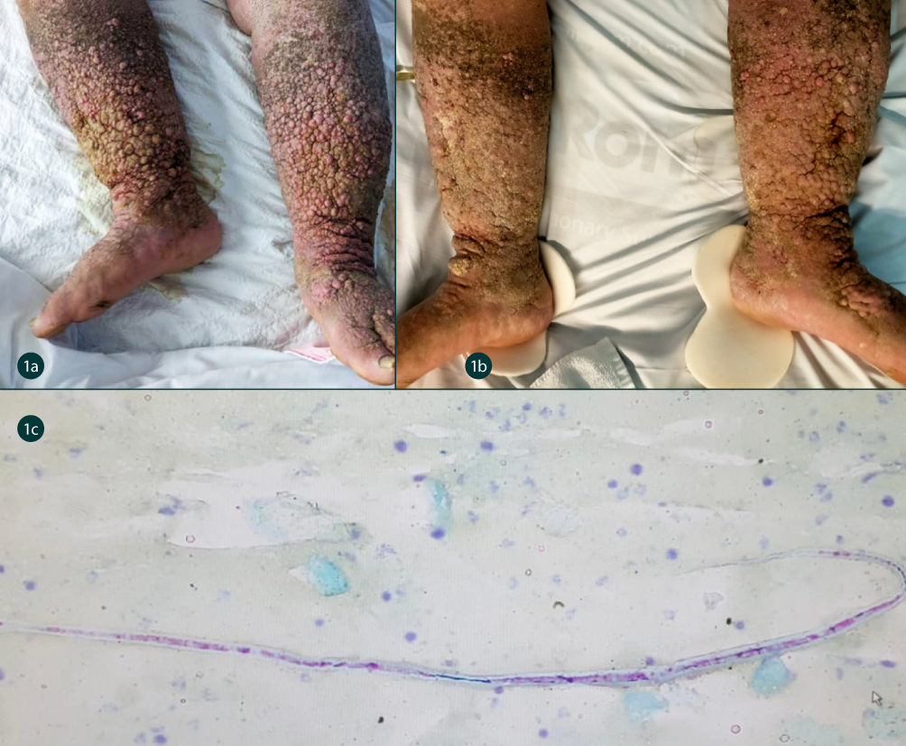

He was born and lived in Australia, although had travelled extensively through Asia and Europe in his youth. Until two years prior to his presentation, he had spent much of the previous decade in Davao in the southern Philippines, where he lived nearby a river spending significant time around freshwater. As Davao province is endemic for the filarial parasites *Wuchereria bancrofti* and *Brugia malayi*,1 this history raised suspicion for filariasis, and nocturnal blood films were collected demonstrating numerous microfilariae (Figure 1c). A diagnosis of Bancroftian filariasis was made. Of note, he had not visited West or sub-Saharan Africa, South America, or the Arabian Peninsula, making co-infection with *Onchocerca volvulus* or *Loa loa* unlikely.

For the filariasis, he was treated with a single dose of diethylcarbamazine (DEC) 6 mg/kg and doxycycline 100 mg twice daily for six weeks. He also completed a course of antibiotics for secondary cellulitis. This led to some improvement in his chronic skin changes (Figure 1b), and significant relief from pain, although residual symptoms persisted, and he was successfully discharged home. Blood film for confirmation of clearance of microfilaria was not obtained post-treatment. Dermatology remained involved in his care following discharge in order to optimise his skin care and minimise risk of further secondary infection. Unfortunately, however, he re-presented several months later with streptococcal bacteraemia secondary to lower limb cellulitis, and did not survive. Consent was obtained from the patient’s next of kin for the publication of this report.

# Discussion

Bancroftian filariasis, caused by the filarial worm *Wuchereria bancrofti*, is a mosquito-borne parasitic infection endemic to much of Asia, the Pacific, and Africa. While considerable progress has been made in recent decades in its control, significant pockets of endemicity remain. Regionally, filariasis remains prevalent particularly in Papua New Guinea, the Philippines, Fiji, Samoa, and other Pacific Islands.2

In the Philippines, *W. bancrofti* demonstrates nocturnal periodicity.1 As such, diagnostic yield from blood film examination is increased when samples are collected overnight.

Unlike several other vector-borne infections, filarial infection typically requires multiple exposures over a sustained period to establish. Accordingly, this infection is most commonly seen in current or former residents of endemic areas; it is uncommon in travellers from non-endemic areas spending brief periods in zones of transmission. Additionally, initial signs of infection may appear months to years after a person has been infected depending on intensity of infection and host immune response, making clinical diagnosis a challenge. While several diagnostic modalities, including examination of nocturnal blood film for microfilariae, serology for antifilarial immunoglobulin G1 (IgG1) and IgG4, and direct ultrasonography of inguinal lymph nodes or hydrocoeles are available, none of these methods are highly sensitive.3 Finally, due to its infrequency in non-endemic regions and diagnostic challenges, diagnosis is often delayed or overlooked.

Globally, treatment and control of lymphatic filariasis is predominantly via mass drug administration (MDA) campaigns, during which annual treatment with DEC and albendazole, with or without ivermectin, is administered to the entire at-risk population.4 Where there is co-endemicity with onchocerciasis, DEC should not be used and where there is co-endemicity with *Loa loa*, both ivermectin and DEC should not be used, due to the risk of dangerous host inflammatory response to the dying parasites.5

Not much is published about the Australian experience of lymphatic filariasis; however, a case series by Jeremaiah et al provides a good overview of the management of some recent cases.3 Unfortunately, as antihelminthics are effective at treating the microfilarial stage but have limited to no activity against the adult worm, they are less useful in the treatment of individual patients. For individual cases, the role of doxycycline in the treatment of lymphatic filariasis is now well established.6,7 This is in large part due to its activity against the bacterial endosymbionts of the *Wolbachia* genus which are important in filarial embryogenesis, leading to sterilisation and eventual demise of the adult worms. Despite this, once chronic skin changes have established, these are generally only partially reversible. As such, the importance of early diagnosis and treatment to reduce the risk of complications, and the importance of skin care once chronic changes are present, is emphasised.

Further, as our case demonstrated, the psychological sequelae of filariasis can be severe, with 12–72% of patients experiencing significant psychosocial disability and up to 20% reporting suicidality.8,9 Clinicians working in travel medicine and infectious diseases are advised to maintain a high degree of suspicion for lymphatic filariasis in the right clinical context, in order to minimise diagnostic delay and resultant harm. Additionally, screening for lymphatic filariasis in individuals returning from endemic areas who have not received MDA may be considered in order to identify and treat active infection prior to the development of sequelae.

# Author details

George P Drewett,1,2,3

Hedayat Pourhadi,1

Jordan Kahn,1

Shio Yen Tio,1

Craig Aboltins.1,3

1. Department of Infectious Diseases, Northern Health, Epping, Victoria, Australia
2. Department of Medicine, Alice Springs Hospital, Alice Springs, Northern Territory, Australia
3. Melbourne Medical School, Faculty of Medicine, Dentistry and Health Sciences, University of Melbourne, Parkville, Victoria, Australia

Corresponding author

George Drewett

Northern Health, Epping VIC 3076

Telephone: +61 3 8405 8000

Email: George.Drewett@nh.org.au

# References

1. Kron M, Walker E, Hernandez L, Torres E, Libranda-Ramirez B. Lymphatic filariasis in the Philippines. *Parasitol Today*. 2000;16(8):329–33. doi: https://doi.org/10.1016/s0169-4758(00)01705-1.
2. Cromwell EA, Schmidt CA, Kwong KT, Pigott DM, Mupfasoni D, Biswas G et al. The global distribution of lymphatic filariasis, 2000–18: a geospatial analysis. *Lancet Glob Health*. 2020;8(9):e1186–94. doi: https://doi.org/10.1016/S2214-109X(20)30286-2.
3. Jeremiah CJ, Aboltins CA, Stanley PA. Lymphatic filariasis in Australia: an update on presentation, diagnosis and treatment. *Med J Aust*. 2011;194(12):655–7.   
   doi: https://doi.org/10.5694/j.1326-5377.2011.tb03154.x.
4. World Health Organization (WHO). Lymphatic filariasis. [Online fact sheet.] Geneva: WHO; 2 October 2024. Available from: https://www.who.int/news-room/fact-sheets/detail/lymphatic-filariasis.
5. Francis H, Awadzi K, Ottesen EA. The Mazzotti reaction following treatment of onchocerciasis with diethylcarbamazine: clinical severity as a function of infection intensity. *Am J Trop Med Hyg*. 1985;34(3):529–36. doi: https://doi.org/10.4269/ajtmh.1985.34.529.
6. Mand S, Debrah AY, Klarmann U, Batsa L, Marfo-Debrekyei Y, Kwarteng A et al. Doxycycline improves filarial lymphedema independent of active filarial infection: a randomized controlled trial. *Clin Infect Dis*. 2012;55(5):621–30. doi: https://doi.org/10.1093/cid/cis486.
7. Taylor MJ, Makunde WH, McGarry HF, Turner JD, Mand S, Hoerauf A. Macrofilaricidal activity after doxycycline treatment of *Wuchereria bancrofti*: a double-blind, randomised placebo-controlled trial. *Lancet*. 2005;365(9477):2116–21. doi: https://doi.org/10.1016/S0140-6736(05)66591-9.
8. Ali O, Mengiste A, Semrau M, Tesfaye A, Fekadu A, Davey G. The impact of podoconiosis, lymphatic filariasis, and leprosy on disability and mental well-being: a systematic review. *PLoS Negl Trop Dis*. 2021;15(7):e0009492. doi: https://doi.org/10.1371/journal.pntd.0009492.
9. Krishna Kumari A, Harichandrakumar KT, Das LK, Krishnamoorthy K. Physical and psychosocial burden due to lymphatic filariasis as perceived by patients and medical experts. *Trop Med Int Health*. 2005;10(6):567–73. doi: https://doi.org/10.1111/j.1365-3156.2005.01426.x.

© Commonwealth of Australia as represented by the Department of Health and Aged Care

ISSN: 2209-6051 Online

This journal is indexed by Index Medicus and Medline.

Creative Commons Licence

This publication is licensed under a Creative Commons Attribution-NonCommercial-NoDerivatives 4.0 International Licence (CC BY-NC-ND) available from https://creativecommons.org/licenses/by-nc-nd/4.0/legalcode (Licence). You must read and understand the Licence before using any material from this publication.

Restrictions

The Licence does not cover, and there is no permission given for, use of any of the following material found in this publication (if any):

* the Commonwealth Coat of Arms (by way of information, the terms under which the Coat of Arms may be used can be found on the Department of Prime Minister and Cabinet website;
* any logos (including the Department of Health and Aged Care’s logo) and trademarks;
* any photographs and images;
* any signatures; and
* any material belonging to third parties.

Disclaimer

Opinions expressed in *Communicable Diseases Intelligence* are those of the authors and not necessarily those of the Department of Health and Aged Care or the Communicable Diseases Network Australia. Data may be subject to revision.

Enquiries

Enquiries regarding any other use of this publication should be addressed to the CDI Editor at: cdi.editor@health.gov.au.

Communicable Diseases Network Australia

Communicable Diseases Intelligence contributes to the work of the [Communicable Diseases Network Australia](http://www.health.gov.au/cdna).

About Communicable Diseases Intelligence

*Communicable Diseases Intelligence* (CDI) is a peer-reviewed scientific journal published by the Health Security & Emergency Management Division, Department of Health and Aged Care. The journal aims to disseminate information on the epidemiology, surveillance, prevention and control of communicable diseases of relevance to Australia.

**Editor**: Christina Bareja • **Deputy Editor**: Simon Petrie • **Design and Production**: Lisa Thompson

**Editorial Advisory Board**: David Durrheim, Mark Ferson, Clare Huppatz, John Kaldor, Martyn Kirk and Meru Sheel

Submit an Article

Submit your next communicable disease related article to CDI for consideration. [Information for authors](https://www1.health.gov.au/internet/main/publishing.nsf/Content/cda-pubs-cdi-auth_inst.htm) and details on how to [submit your publication](https://www1.health.gov.au/internet/main/publishing.nsf/Content/cda-pubs-cdi-auth_inst.htm#submission_package) is available on our website, or by email at [cdi.editor@health.gov.au](mailto:cdi.editor@health.gov.au).

Contact us

Communicable Diseases Intelligence (CDI)

Health Security & Emergency Management Division

Department of Health and Aged Care

GPO Box 9848, CANBERRA ACT 2601

Website: [www.health.gov.au/cdi](http://www.health.gov.au/cdi)

Email: [cdi.editor@health.gov.au](mailto:cdi.editor@health.gov.au)