Vaccine Preventable Diseases and Vaccination Coverage in Aboriginal and Torres Strait Islander People, Australia, 2011–2015
National Centre for Immunisation Research and Surveillance (NCIRS) by Sally Ioannides, Frank Beard, Natasha Larter, Katrina Clark, Han Wang, Alexandra Hendry, Brynley Hull, Aditi Dey, Clayton Chiu, Julia Brotherton, Sanjay Jayasinghe, Kristine Macartney and Peter McIntyre, The Children’s Hospital at Westmead, The University of Sydney
Communicable Diseases Intelligence
ISSN: 2209-6051 online
http://Health.gov.au/cdi

Contents
Contents 1
Table of figures 2
Preface 4
Provision of data 4
Advisory Group (for input into development of report and review of final draft) 4
Executive summary 5
Background 5
Achievements 5
Challenges 6
Next steps 9
Further reading on specific VPDs in Aboriginal and Torres Strait Islander people 9
Introduction 10
Vaccine Preventable Diseases 11
Haemophilus influenzae type b disease 11
Hepatitis A 15
Hepatitis B 21
Human papillomavirus 27
Seasonal influenza 34
Measles 40
Meningococcal disease 45
Mumps 49
Pertussis 54
Pneumococcal disease 58
Rotavirus 65
Varicella-zoster virus infection 69
Rare diseases 75
Diphtheria and Tetanus 75
Poliomyelitis 79
Rubella 80
Vaccination Coverage 82
Key points 82
The Australian National Immunisation Program 82
The Australian Childhood Immunisation Register 86
Vaccination coverage estimates from the Australian Childhood Immunisation Register for Aboriginal and Torres Strait Islander children versus other children 87
References 104
Appendix A: Technical notes on methods and interpretation of vaccine preventable diseases and vaccination coverage data 111
General issues regarding data on vaccine preventable diseases 111
Aboriginal and Torres Strait Islander status identification in the datasets used in this report 111
Aboriginal and Torres Strait Islander status identification in notification data 112
Other issues to be noted when interpreting notification data 112
Other issues to be noted when interpreting hospitalisation data 113
Other issues to be noted when interpreting death data 114
Vaccination Coverage 115
Appendix B: ICD codes used for hospitalisations and deaths 118
Appendix C: Summary of notifications in Australia, for vaccine preventable diseases, 2011 to 2015, by Aboriginal and Torres Strait islander status 119
Appendix D: Summary of hospitalisations and deaths in Australia, for vaccine preventable diseases, 2011 to 2015, by Aboriginal and Torres Strait Islander status 121
Appendix E: Vaccination coverage (%), by state or territory and birth cohort 123

Table of figures
Figure 1: Hepatitis A notification rates, all jurisdictions, 2006 to 2015,* by Aboriginal and Torres Strait Islander status 13
Figure 2: Hepatitis A notification rates, all jurisdictions, 2006 to 2015,* by Aboriginal and Torres Strait Islander status 17
Figure 3: Hepatitis A hospitalisation rates, selected jurisdictions,* 2006 to 2015,† by Aboriginal and Torres Strait Islander status 18
Figure 4: Acute hepatitis B* notification rates, all jurisdictions, 2006 to 2015†, by Aboriginal and Torres Strait Islander status 23
Figure 5: Hepatitis B* hospitalisation rates, selected jurisdictions,† 2006 to 2015,‡ by Aboriginal and Torres Strait Islander status 25
Figure 6: Proportion of Aboriginal and Torres Strait Islander and non-Indigenous Australian-born women diagnosed with genital warts at first visit to a sexual health clinic, 2004–2014 29
Figure 7: Proportion of Aboriginal and Torres Strait Islander and non-Indigenous Australian-born men diagnosed with genital warts at first visit to sexual health clinic, 2004–2014 30
Figure 8: High-grade abnormality detection rate per 1,000 women screened, by age, 2004–2015, Northern Territory 31
Figure 9: High grade abnormality detection rate per 1,000 women screened, by age, 2001–2015, Australia 32
Figure 10: Influenza hospitalisation rates, selected jurisdictions,* 2006 to 2015,† by age and Aboriginal and Torres Strait Islander status 38
Figure 11: Measles notification rates, all jurisdictions, 2006 to 2015,* by Aboriginal and Torres Strait Islander status 42
Figure 12: Meningococcal disease notification rates, all jurisdictions 2006 to 2015,* by Aboriginal and Torres Strait Islander status and serogroup† 47
Figure 13: Mumps notification rates, all jurisdictions, 2006 to 2015,* by Aboriginal and Torres Strait Islander status 51
Figure 14: Mumps hospitalisation rates, selected jurisdictions,* 2006 to 2015,† by Aboriginal and Torres Strait Islander status 52
Figure 15: Pertussis hospitalisation rates, selected jurisdictions,* 2006 to 2015,† by Aboriginal and Torres Strait Islander status 57
Figure 16: Invasive pneumococcal disease notification rates, all jurisdictions, 2006 to 2015,* by age and Aboriginal and Torres Strait Islander status 62
Figure 17: Invasive pneumococcal disease notification rates for four vaccine serotype groups, all jurisdictions, 2006–2010 compared with 2011–2015, by age and Aboriginal and Torres Strait Islander status* 63
Figure 18: Rotavirus hospitalisation rates, selected jurisdictions,* 2006 to 2015,† by age (<5 years) and Aboriginal and Torres Strait Islander status 67
Figure 19: Varicella (chickenpox) hospitalisation rates, selected jurisdictions,* 2006 to 2015,† by Aboriginal and Torres Strait Islander status 72
Figure 20: Herpes zoster (shingles) hospitalisation rates, selected jurisdictions,* 2006 to 2015,† by Aboriginal and Torres Strait Islander status 73
Figure 21: Trends in 12-, 24- and 60-month ‘fully immunised’ vaccination coverage estimates, Australia, 2011 to 2015 by Aboriginal and Torres Strait Islander status 87
Figure 22: ‘Fully immunised’ coverage at 12 months of age*in Aboriginal and Torres Strait Islander children by Statistical Area 4 (SA4),† Australia, 2015. 88
Figure 23: Rotavirus vaccine coverage at 12 months by Aboriginal and Torres Strait Islander status – Rotarix® jurisdictions versus RotaTeq® jurisdictions, 2015 92
Figure 24: Trends in coverage estimates for hepatitis A* vaccine for Aboriginal and Torres Strait Islander children by quarter of vaccination and jurisdiction, Australia,† 2011 to 2015 93
Figure 25: Trends in coverage estimates for the fourth dose of pneumococcal* vaccine for Aboriginal and Torres Strait Islander children by quarter of vaccination and jurisdiction, Australia,† 2011 to 2015 94
Figure 26: Coverage of at least one dose of seasonal influenza vaccine administered in 2015 to children aged 6 months to <5 years, by jurisdiction and Aboriginal and Torres Strait Islander status 95
Figure 27: DTP3, MMR1, MENC1 and MMR2 vaccination delay by Aboriginal and Torres Strait Islander status, Australia, 2015 96
Figure 28: Timeliness* of the third dose of DTPa vaccine (DTP3), by Aboriginal and Torres Strait Islander status, Australia, 2015 97
Figure 29: Timeliness* of the first dose of MMR vaccine (MMR1), by Aboriginal and Torres Strait Islander status, Australia, 2015 98
Figure 30: Timeliness* of the second dose of MMR vaccine (MMR2), by Aboriginal and Torres Strait Islander status, Australia, 2015 99
Figure 31: Vaccination delay for Aboriginal and Torres Strait Islander children for the third dose of pneumococcal conjugate vaccine, by jurisdiction, Australia, 2015 101
Figure 32: Trends in recorded vaccination objection status and vaccination status of Aboriginal and Torres Strait Islander children aged 12 months to <7 years, Australia, 2011–2015 102

Vaccine Preventable Diseases and Vaccination Coverage in Aboriginal and Torres Strait Islander People, Australia, 2011–2015
National Centre for Immunisation Research and Surveillance (NCIRS) by Sally Ioannides, Frank Beard, Natasha Larter, Katrina Clark, Han Wang, Alexandra Hendry, Brynley Hull, Aditi Dey, Clayton Chiu, Julia Brotherton, Sanjay Jayasinghe, Kristine Macartney and Peter McIntyre, The Children’s Hospital at Westmead, The University of Sydney

Preface
This report on vaccine preventable diseases and vaccination coverage in Aboriginal and Torres Strait Islander people is the fourth in the series, which highlights the benefits of immunisation programs on the health of Aboriginal and Torres Strait Islander people over time.
The National Centre for Immunisation Research and Surveillance (NCIRS) respects the great diversity, wealth of experience and cultural context of Aboriginal and Torres Strait Islander people. This is the first report of the series to have Aboriginal and Torres Strait Islander co-authors: Natasha Larter, a proud Yuin woman, and Katrina Clark, a proud Barkindji woman.
NCIRS wishes to acknowledge the following organisations and individuals for their assistance with and contribution to this report.

Provision of data
The Communicable Disease Epidemiology and Surveillance Section, Office of Health Protection, Australian Government Department of Health, and the Communicable Diseases Network Australia, for data from the National Notifiable Diseases Surveillance System.
The Australian Institute of Health and Welfare for data from the National Hospital Morbidity Database.
The Department of Human Services for vaccination coverage data from the Australian Childhood Immunisation Register.
The Victorian Cytology Service (VCS) and the Australian Government Department of Health for HPV vaccination data from the National HPV Vaccination Program Register.
The Australian Coordinating Registry, state and territory registries of births, deaths and marriages, state and territory coroners, and the National Coronial Information System for cause of death data.

Advisory Group (for input into development of report and review of final draft)

National Aboriginal Community Controlled Health Organisation nominees
Amanda Jones (National Aboriginal Community Controlled Health Organisation)
Dr Vicki Slinko (Queensland Aboriginal and Islander Health Council)

Australian Government Department of Health nominee
Kate Pennington (Australian Government Department of Health)

Vaccine preventable disease experts
Professor Ross Andrews (Menzies School of Health Research)
Associate Professor Julia Brotherton (Victorian Cytology Service)

Additional expert peer review
Professor John Kaldor (The Kirby Institute, UNSW)
Associate Professor Stephen Lambert (Queensland Health/The University of Queensland)

Manuscript editing and librarianship support
Deepika Jindal (NCIRS)
Dr Catherine King (NCIRS)

Other support
Dr Santhini Kumaran for report planning and preparation
NCIRS is supported by the Australian Government Department of Health, the NSW Ministry of Health, The Children’s Hospital at Westmead and The University of Sydney. The opinions expressed in this report are those of the authors and do not necessarily represent the views of these agencies.

Executive summary

Background
This report, which focuses on the 2011–2015 period, is the fourth comprehensive NCIRS report on vaccine preventable diseases (VPDs) and vaccination coverage in Aboriginal and Torres Strait Islander people. As with previous reports, it aims to analyse and assess routinely collected data on notifications, hospital admissions, deaths and vaccination coverage; time trends and support service delivery; policy development; and further research on the prevention of VPDs in Aboriginal and Torres Strait Islander people. Recent peer-reviewed publications, providing more in-depth analysis and commentary on specific VPDs in Aboriginal and Torres Strait Islander people (all of which are referred to in relevant sections of the report), are listed at the end of the executive summary.
This report identifies a range of achievements, through positive impacts of immunisation programs on the health of Aboriginal and Torres Strait Islander people, as well as some continuing challenges. Key achievements and challenges are summarised below.

Achievements
Since the introduction of the Haemophilus influenzae type b (Hib) vaccine in 1993, invasive Hib disease notification rates have decreased by more than 99% in both Aboriginal and Torres Strait Islander and other Australian children aged <5 years. Encouragingly, notification rate ratios for Aboriginal and Torres Strait Islander people versus other Australians were lower across all age groups in the 2011–2015 period compared with the 2006–2010 period, with the overall (all ages) rate ratio decreasing from 12.9 to 4.5.
Following the introduction of the national hepatitis A immunisation program in 2005 targeted at Aboriginal and Torres Strait Islander children aged 12–24 months in Western Australia, South Australia, the Northern Territory and Queensland (the four jurisdictions with the highest rate of disease), hepatitis A disease notification rates in Aboriginal and Torres Strait Islander people declined sharply and have remained lower than those in other Australians since 2007. The hepatitis A notification rate for all ages combined in Aboriginal and Torres Strait Islander people was half that in other people over the 2011–2015 period, with no hepatitis A notifications or hospitalisations reported in Aboriginal and Torres Strait Islander children aged <5 years over the five-year period. The targeted program appears to have also provided substantial herd protection to older children and adults, both Aboriginal and Torres Strait Islander and other Australians, within the four targeted jurisdictions, despite relatively modest hepatitis A vaccination coverage.
Low rates of acute hepatitis B notifications and hospitalisations in both Aboriginal and Torres Strait Islander people and other Australians aged <15 years reflect the success of the universal infant hepatitis B immunisation program, which began in 2000 following targeted programs in the preceding decade.
Human papillomavirus (HPV)-related disease has been included in this report for the first time. Since the introduction of the HPV vaccination program in 2007 in Australia, remarkable reductions in HPV infection, genital warts and cervical pre-cancers have been recorded. Available data suggest that Aboriginal and Torres Strait Islander people are benefitting to a similar extent as other Australians from these reductions.
Endemic measles transmission has been eliminated from Australia. While measles continues to be imported from overseas on a sporadic basis, notification and hospitalisation rates in Aboriginal and Torres Strait Islander people continue to remain low and similar to those in other Australians.
Routine meningococcal C vaccination for children at 12 months of age, implemented from 2003, has resulted in near elimination of serogroup C disease across all age groups in both Aboriginal and Torres Strait Islander people and other Australians.
Diphtheria, tetanus and rubella are rare in Australia due to long-standing immunisation programs. Australia was declared free of endemic polio transmission in 2000, and there were no notifications of polio in this reporting period. There have also been significant decreases in the burden of rotavirus, varicella (chickenpox) and invasive pneumococcal disease in both Aboriginal and Torres Strait Islander and other children as a result of immunisation programs introduced in the 2000s.
Estimates of ‘fully immunised’ vaccination coverage for Aboriginal and Torres Strait Islander children improved between 2011 and 2015, with the coverage differential between Aboriginal and Torres Strait Islander and other children during the time period halving at 12 months of age and disappearing completely at 60 months of age, with coverage almost three percentage points higher at 60 months of age in Aboriginal and Torres Strait Islander children by the end of 2015.

Challenges
While the incidence of invasive Hib disease is now very low, disease rates in Aboriginal and Torres Strait Islander children aged <5 years remain around 10 times higher than those in other children. Environmental and social disadvantage factors, including household crowding, high smoking rates and lack of access to culturally appropriate health services, are the most likely causes for continuing disparity. Timeliness of vaccination is also an important modifiable factor, with 18% lower coverage in Aboriginal and Torres Strait Islander children for the three primary doses of Hib-containing vaccine at less than 7 months of age.
Acute hepatitis B notification and hospitalisation rates over this period were several times higher in Aboriginal and Torres Strait Islander people aged 15–49 years than those in other Australians in the same age group, which suggests ongoing horizontal transmission of infection. While current Australian guidelines recommend hepatitis B vaccination be offered to all Aboriginal and Torres Strait Islander people, vaccination for Aboriginal and Torres Strait Islander adults is not currently funded under the National Immunisation Program (NIP). Modelling has shown that a funded program for Aboriginal and Torres Strait Islander adults could have a considerable impact on the prevention of acute hepatitis B infection and subsequent chronic infections.
Influenza hospitalisation rates remain significantly higher across all age groups in Aboriginal and Torres Strait Islander people compared to those in other Australians. It is important that influenza vaccination for Aboriginal and Torres Strait Islander people of all ages, now almost entirely funded through the NIP, is promoted.
Meningococcal B disease incidence remains several times higher in Aboriginal and Torres Strait people than that in other Australians. It is likely that overcrowding and environmental tobacco exposure contribute to this higher incidence. The incidence of meningococcal W and Y disease began to increase in both Aboriginal and Torres Strait Islander and other Australians towards the end of this reporting period and continued to increase in 2016 and 2017.
There were large outbreaks of mumps in Western Australia towards the end of the reporting period, predominantly in Aboriginal adolescents and young adults living in remote communities with high vaccination coverage. Waning of immunity to mumps appears to be a particular issue globally in settings where there is a high force of infection. In late 2017, the United States Advisory Committee on Immunization Practices recommended a third dose of mumps-containing vaccine for groups at increased risk for mumps in an outbreak.
Pertussis notification rates in Aboriginal and Torres Strait Islander infants are 1.6 times higher than those in other infants. To protect this vulnerable age group, focus should be on improving the timeliness of the first two infant doses and uptake of maternal pertussis immunisation during pregnancy.
The disparity in invasive pneumococcal disease notification rates between Aboriginal and Torres Strait Islander people and other Australians almost doubled in this reporting period compared to that in 2007–2010. Relatively high levels of non-vaccine–type disease and colonisation in Aboriginal and Torres Strait Islander people mean that in addition to improving vaccination coverage and timeliness, measures to address non-vaccine factors, such as household crowding and smoking, are also required.
The decline in rotavirus hospitalisation rates has been less pronounced, in relative terms, in Aboriginal and Torres Strait Islander children versus other children, with the hospitalisation rate in Aboriginal and Torres Strait Islander infants remaining particularly high. Improved timeliness of rotavirus vaccination would increase coverage, which lags coverage in other infants by 11% at 12 months of age. This may be related to the strict upper-age cut-offs for rotavirus vaccines and more frequent delayed vaccination of Aboriginal and Torres Strait Islander infants.
Coverage estimates for vaccines recommended and funded for Aboriginal and Torres Strait Islander children only (i.e. hepatitis A vaccine, a fourth [booster] dose of pneumococcal vaccine and annual seasonal influenza vaccine) remain considerably lower than those for vaccines funded for all children. Timeliness of vaccination in Aboriginal and Torres Strait Islander children also remains an ongoing concern. Limited data are available on vaccination coverage in Aboriginal and Torres Strait Islander adults.
The results in this report are affected by the completeness and accuracy of Aboriginal and Torres Strait Islander status reporting in routinely collected data. Because of under-reporting of Aboriginal and Torres Strait Islander status, rates presented here should be considered minimum estimates of the true burden of disease. In recognising this issue, we respectfully acknowledge the history of dispossession and intergenerational trauma that affects the lives of many Aboriginal and Torres Strait Islander people. We recognise that the provision of culturally appropriate health care services and systems are vital to support self-identification and prioritisation of the collection of these data.

Next steps
Ongoing monitoring of VPD burden and vaccination coverage in Aboriginal and Torres Strait Islander people is important to document further achievements and to inform policy and program measures to address existing and emerging disparities. The expanded ‘whole of life’ Australian Immunisation Register (AIR) should facilitate monitoring of coverage in Aboriginal and Torres Strait Islander adults. Attention to data quality and completeness at point of collection and within the AIR will be critical, especially given the relative lack of accuracy/completeness in Aboriginal and Torres Strait Islander status reporting to Medicare for adults historically compared to that for children in more recent birth cohorts. There is also a need to continue to improve the recording of Aboriginal and Torres Strait Islander status on school HPV vaccine consent forms, to facilitate monitoring of coverage, and reporting to cancer registers to monitor the impact of immunisation on cervical and other HPV related cancers.
There are likely to be a number of changes to the NIP over the next few years which may assist in efforts to reduce the burden of VPDs in Aboriginal and Torres Strait Islander people. In February 2018, the Australian Government announced that the meningococcal ACWY vaccine would replace meningococcal C vaccine at the 12 months of age schedule point in the NIP from mid-2018. It will be important to monitor disease trends in the wake of this policy change.
New vaccines and schedules, along with improving coverage and timeliness of existing vaccines, are important measures to reduce the burden of VPDs in Aboriginal and Torres Strait Islander people. However, closing the gap fully will also require concerted efforts to improve living conditions; to address the effects of other social determinants of health; and to improve access to effective and culturally appropriate health care for Aboriginal and Torres Strait Islander people.

Further reading on specific VPDs in Aboriginal and Torres Strait Islander people
Sheel M, Beard F, Quinn H, Dey A, Kirk M, Koehler A, Markey P, McIntyre P, Macartney K. Australian vaccine preventable disease epidemiological review series: varicella-zoster virus infections, 1998-2015. Commun Dis Intell (2018). 2018;42. pii: S2209-6051(18)00002-7. Epub 2018 Sep 12.
Sheel M, Beard F, Dey A, Macartney K, McIntyre PB. Rates of hospitalisation for herpes zoster may warrant vaccinating Indigenous Australians under 70. Med J Aust. 2017;207:395–6.
Thompson C, Dey A, Fearnley E, Polkinghorne B, Beard F. Impact of the national targeted Hepatitis A immunisation program in Australia: 2000–2014. Vaccine. 2017;35:170–6.
Archer BN, Chiu CK, Jayasinghe SH, Richmond P, McVernon J, Lahra MM, Andrews RM, McIntyre PB. Epidemiology of invasive meningococcal B disease in Australia, 1999–2015: priority populations for vaccination. Med J Aust. 2017;207:382–7.
Wattiaux AL, Yin JK, Beard F, Wesselingh S, Cowie B, Ward J, Macartney K. Hepatitis B immunization for indigenous adults, Australia. Bull World Health Organ. 2016;94:826–34A.
Li-Kim-Moy J, Yin JK, Patel C, Beard FH, Chiu C, Macartney KK, McIntyre PB. Australian vaccine preventable disease epidemiological review series: Influenza 2006 to 2015. Commun Dis Intell Q Rep. 2016;40:E482–95.
Menzies RI, Bremner KM, Wang H, Beard FH, McIntyre PB. Long-term trends in invasive Haemophilus influenzae type b disease among indigenous Australian children following use of PRP-OMP and PRP-T vaccines. Pediatr Infect Dis J. 2015;34:621–6.
Jayasinghe S, Chiu C, Menzies R, Lehmann D, Cook H, Giele C, Krause V, McIntyre P. Evaluation of impact of 23 valent pneumococcal polysaccharide vaccine following 7 valent pneumococcal conjugate vaccine in Australian Indigenous children. Vaccine. 2015;33:6666–74.
Bag SK, Dey A, Wang H, Beard F. Australian vaccine preventable disease epidemiological review series: mumps 2008-2012. Commun Dis Intell Q Rep. 2015;39:E10–18.

Introduction
This is the fourth report on vaccine preventable diseases (VPDs) and vaccination coverage in Aboriginal and Torres Strait Islander people. The first (1999–2002) was published in 2004, the second (2003–2006) in 2008 and the third (2006–2010) in 2013.^{1–3}
As a result of continued improvements in the quality of data on Aboriginal and Torres Strait Islander status in national health datasets, this report is substantially more comprehensive than previous reports. Notification, hospital admission and death data are presented for all jurisdictions for the current reporting period 2011 to 2015. Notification trends are reported for all jurisdictions for the period 2006 to 2015, and hospitalisation trends are reported for six jurisdictions (all except Tasmania and the Australian Capital Territory which did not meet Australian Institute of Health and Welfare (AIHW) Aboriginal and Torres Strait Islander reporting standards)^{4,5} for the period 2006 to 2015. National vaccination coverage data were obtained from the Australian Childhood Immunisation Register (ACIR), using data as at 31 March 2016. For all datasets, records with unknown or missing Aboriginal and Torres Strait Islander status were combined with those identified as non-Indigenous and reported under the category ‘other’. The term ‘non-Indigenous’ is only used when referring to the category outside the scope of the data used in this report e.g. publications which specifically report data in people identified as non-Indigenous. Refer to Appendix A for more detail on data sources and methods and to Appendix B for the International Classification of Diseases codes used for hospitalisation and death data.
This report is modelled on two other regularly published national reports: Summary of national surveillance data on vaccine preventable diseases in Australia (produced by NCIRS) and The health and welfare of Australia’s Aboriginal and Torres Strait Islander peoples (produced by AIHW and the Australian Bureau of Statistics [ABS]). This report provides a comprehensive and detailed comparison of disease burden and vaccination coverage in Aboriginal and Torres Strait Islander people and other Australians not available in these other reports.
Diseases responsible for a substantial burden of illness in Aboriginal and Torres Strait Islander people are presented in individual chapters, and diseases that are now rare due to longstanding successful immunisation programs are combined in a single chapter. Data are provided for all diseases and vaccines included in the National Immunisation Program (NIP) for the period of analysis. Human papillomavirus (HPV) has been included for the first time in this report. However, due to differences in the sources of routinely collected data on HPV disease impact and vaccine coverage, it is reported in a different format. Tuberculosis is not included in this or other reports in this series, as control of tuberculosis in Australia is primarily underpinned by effective diagnosis and treatment, with limited use of BCG vaccine. Data on tuberculosis, including in Aboriginal and Torres Strait Islander people, are published elsewhere.⁶
An understanding of the demographics of the Aboriginal and Torres Strait Islander population is important to interpret the data in this report. As of 2014, there were 713,600 Aboriginal and Torres Strait Islander people in Australia (3.0% of the total Australian population).⁷ In 2011, 31% of the Aboriginal and Torres Strait Islander population lived in New South Wales, 29% in Queensland, 13% in Western Australia, 10% in the Northern Territory, 7% in Victoria, 6% in South Australia, 4% in Tasmania and 1% in the Australian Capital Territory. More Aboriginal and Torres Strait Islander people live in remote areas compared to non-Indigenous Australians – 21% and 2%, respectively, in 2011.⁷ The Aboriginal and Torres Strait Islander population has a younger age structure than the non-Indigenous population, with median age 22 years versus 38 years, respectively, in 2011 and a higher level of socioeconomic disadvantage across a range of indices.⁷
The aim of this report is to present recent data from routinely collected sources, along with informed commentary, to facilitate culturally appropriate and effective service delivery, policy development and further research to better prevent VPDs in Aboriginal and Torres Strait Islander people. The primary audiences for this report are professionals and students in the health sector, government and academic institutions, but the aim is for the report to be accessible to all those with an interest in improving the health of Aboriginal and Torres Strait Islander people.

Vaccine Preventable Diseases

Haemophilus influenzae type b disease
Haemophilus influenzae is a Gram-negative coccobacillus which can cause infection at various sites. Serotype b of Haemophilus influenzae (Hib) is the leading cause of serious disease, particularly in childhood. It can cause diseases of the respiratory tract, including otitis media, sinusitis and bronchitis. Serious manifestations of Hib disease include meningitis, bacteraemia, epiglottitis, septic arthritis, pericarditis, osteomyelitis, soft tissue abscesses and cellulitis, and death.⁸ Before the Hib vaccine became available, Hib was the most common serious bacterial infection in young children in Australia,⁹ with up to 70% of bacterial meningitis in children attributable to Hib. During the prevaccine era Aboriginal and Torres Strait Islander children had a particularly high incidence of Hib meningitis, among the highest recorded in the world, and with a significantly younger age of onset than that for non-Indigenous children.¹⁰
Relevant vaccine history
1993
Hib vaccine recommended in childhood vaccination schedule for all children. PRP-OMP*-containing vaccines, providing protection at an earlier age than other vaccines, used for Aboriginal and Torres Strait Islander children
2009
Combined DTPa-HepB-IPV-Hib (PRP-T†) vaccine at 2, 4, 6 and 12 months of age used in all jurisdictions
2013
Combined Hib (PRP-T†) and meningococcal C vaccine funded as booster dose for infants aged 12 months
* PRP-OMP: Haemophilus influenzae type b polysaccharide conjugated to the outer membrane protein of Neisseria meningitidis
† PRP-T: Haemophilus influenzae type b polysaccharide conjugated to tetanus toxoid

Results
Notification data are presented for all jurisdictions for the period 2011 to 2015. No hospitalisation or mortality data are presented for invasive Hib disease because the available ICD-10 codes are not type-specific.
A total of 86 notifications of invasive Hib disease were recorded during this reporting period, of which 16 (18.6%) were reported in Aboriginal and Torres Strait Islander people. The highest notification rate (3.3 per 100,000 per year) was seen in Aboriginal and Torres Strait Islander children aged <5 years (Table 1). No cases were recorded in Aboriginal and Torres Strait Islander people aged 5–14, 15–24 and >50 years. Aboriginal and Torres Strait Islander status was reported for 85 of the total 86 notifications during the 2011–2015 period.
Table 1: Hib notifications, all jurisdictions, 2011 to 2015, by age and Aboriginal and Torres Strait Islander status
Age group (years) | Aboriginal and Torres Strait Islander status | Notifications* (2011–2015)
 |  | n | Rate† | Rate ratio | 95% CI for Rate ratio
0–4 | Aboriginal and Torres Strait Islander | 14 | 3.34 | 9.9 | 4.7 – 19.9
 | Other | 24 | 0.34
5–14 | Aboriginal and Torres Strait Islander | 0 | 0.00 | 0.0 | 0.0 – 8.5
 | Other | 9 | 0.07
15–24 | Aboriginal and Torres Strait Islander | 0 | 0.00 | 0.0 | 0.0 – 814.5
 | Other | 1 | 0.01
25–49 | Aboriginal and Torres Strait Islander | 2 | 0.19 | 7.3 | 0.8 – 34.3
 | Other | 10 | 0.03
≥50 | Aboriginal and Torres Strait Islander | 0 | 0.00 | 0.0 | 0.0 – 11.6
 | Other | 26 | 0.07
All ages‡ | Aboriginal and Torres Strait Islander | 16 | 0.28 | 4.5 | 2.1 – 8.9
 | Other | 70 | 0.06
** Notifications where the date of diagnosis was between 1 January 2011 and 31 December 2015.
† Average annual age-specific rate per 100,000 population.
‡ Rates for all ages combined are age-standardised to the Australian Bureau of Statistics Australian population estimates for 2011.
The highest Aboriginal and Torres Strait Islander people versus other Australians notification rate ratio was seen in the 0–4 years age group (RR 9.9, 95% CI 4.7–19.9). Refer to Table 1.
Hib disease notification trend data for all jurisdictions over the decade 2006–2015 are presented for those aged <15 years in Figure 1. Notification rates in Aboriginal and Torres Strait Islander children were higher in every year, ranging from 0.4 to 2.6 per 100,000 per year, with marked fluctuation due to small numbers, while notification rates in other children remained low (0.1 to 0.2) and stable.
Figure 1: Hepatitis A notification rates, all jurisdictions, 2006 to 2015,* by Aboriginal and Torres Strait Islander status
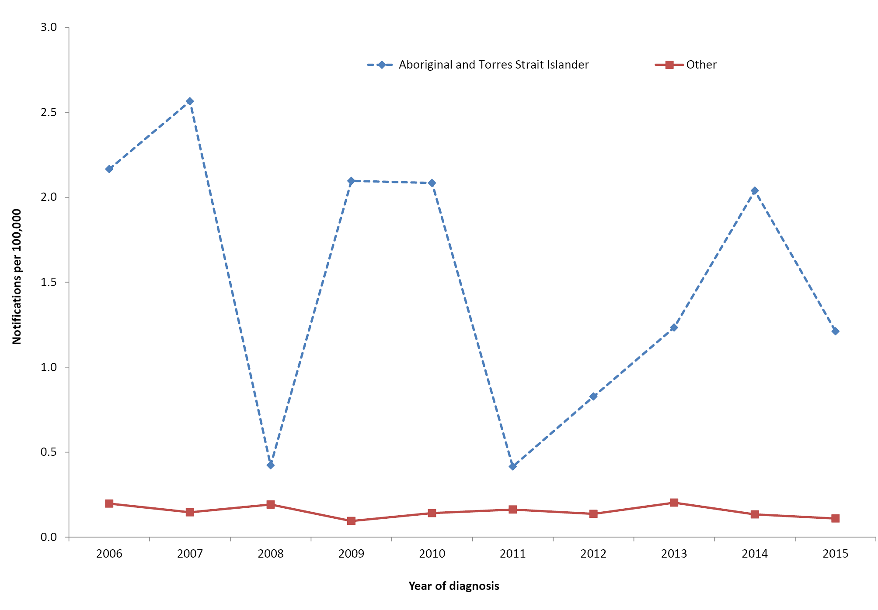
* Notifications where the date of diagnosis was between 1 January 2006 and 31 December 2015.

Discussion
Hib disease notification rates have decreased significantly since the introduction of vaccines in 1993. In studies from the pre-immunisation period (1984–1993), the notification rate for Aboriginal and Torres Strait Islander children aged <5 years was as high as 500 per 100,000, around 10-fold higher than the reported incidence of 40–60 per 100,000 for non-Indigenous children.^{11,12} In this reporting period (2011–2015), two decades after the introduction of Hib vaccines, the notification rate for Aboriginal and Torres Strait Islander children in the 0–4 years age group was 3.3 per 100,000 per year and for other children 0.4 per 100,000 per year, a reduction of more than 99% for both compared to that in the pre-immunisation period. Encouragingly, notification rate ratios for Aboriginal and Torres Strait Islander versus other people decreased across all age groups in this reporting period compared to those in the previous period (2006–2010), from 12.9 to 4.5 overall.² However, while incidence of invasive Hib disease is now very low, rates in Aboriginal and Torres Strait Islander children aged <5 years remain around 10 times higher than those in other children.
In 2009, global shortages of PRP-OMP vaccine necessitated a transition to the PRP-T vaccine for all Australians. This included Aboriginal and Torres Strait Islander children living in jurisdictions with the highest pre-vaccine incidence of Hib disease, where PRP-OMP vaccine had previously been used due to its ability to provide early immunogenicity from the age of 2 months. A previous report analysing data to 2013 found no increase in Hib disease in Aboriginal and Torres Strait Islander children following the replacement of PRP-OMP vaccine by PRP-T,¹³ with our data to the end of 2015 corroborating this finding.
Data from most Indigenous populations worldwide have shown both dramatic decreases in invasive Hib disease and a residual incidence which remains substantially higher than that in corresponding non-Indigenous populations.¹⁴ Adverse environmental factors, including household crowding and high smoking rates, are the most likely causes for continuing disparity and are common to Indigenous populations in developed countries.¹⁵ Studies have shown that Hib nasopharyngeal carriage continues in Aboriginal and Torres Strait Islander children despite high vaccination coverage.¹⁵ It has also been suggested that some Indigenous populations have an increased susceptibility to Hib disease as well as poor immune responses to immunisation.¹⁵ Genetic factors have been implicated in some settings,¹⁴ but a study comparing remote dwelling Aboriginal and Torres Strait Islander children with urban dwelling non-Indigenous children found lesser immune responses to PRP-OMP vaccine only after the first year of life, consistent with environmental rather than genetic factors.¹⁶
Timeliness of vaccination is an important modifiable factor to consider with respect to disparity in disease rates between Aboriginal and Torres Strait Islander and non-Indigenous children, as the median age of disease onset continues to be significantly lower in Aboriginal and Torres Strait Islander children in the post-vaccine era (9.4 versus 17.7 months).¹³ Although vaccination coverage by 12 and 24 months of age is similar in Aboriginal and Torres Strait Islander and other children, late doses are more common in Aboriginal and Torres Strait Islander children, with 62% of Aboriginal and Torres Strait Islander children vaccinated on time, compared with 81% of other children (an 18% differential in timeliness – refer to Vaccination Coverage section).

Hepatitis A
Hepatitis A disease is caused by hepatitis A virus, a picornavirus. Symptoms of hepatitis A are similar to those of other forms of viral hepatitis and include fatigue, malaise, abdominal pain, nausea and vomiting. The typical clinical features of hepatitis A include jaundice, dark urine and pale-coloured stools. The likelihood that infection will be symptomatic increases with age. Infants and children infected with hepatitis A virus usually have mild or no symptoms, while the majority of adults will experience symptoms.⁸ The greatest burden of hepatitis A is in lower- and middle-income countries. In recent years, most cases of hepatitis A in Australia have been associated with travel to endemic countries and foodborne outbreaks.^{17–19}
Relevant vaccine history
1994
First hepatitis A vaccine registered for use in adults
1999
Funded hepatitis A vaccine commenced for Aboriginal and Torres Strait Islander children 18 months to 6 years of age living in North Queensland
2000
List of at-risk individuals for whom hepatitis A vaccination is recommended expanded to include visitors to remote Aboriginal and Torres Strait Islander communities
2005
Hepatitis A vaccination (2 doses) recommended and funded for Aboriginal and Torres Strait Islander children 12–18 months of age residing in the Northern Territory and Western Australia, and 18 and 24 months of age for children residing in Queensland and South Australia
2013
Hepatitis A vaccination (2 doses) scheduled ages for Aboriginal and Torres Strait Islander children in Queensland and South Australia lowered to 12 and 18 months

Results
Hepatitis A notification data by age and Aboriginal and Torres Strait Islander status for all jurisdictions for the period 2011 to 2015 are shown in Table 2. A total of 911 notifications were recorded during this period, 13 (1.4%) of which were reported in Aboriginal and Torres Strait Islander people. Notification rates in Aboriginal and Torres Strait Islander people were lower than those in other people across all age groups. However, the difference was only statistically significant for age groups 5–14 years and all ages combined (Aboriginal and Torres Strait Islander to other notification rate ratio 0.1 [95% CI 0.0–0.5] and 0.5 [95% CI 0.3–0.8], respectively). There were no notifications in Aboriginal and Torres Strait Islander children aged 0–4 years. The highest notification rate in Aboriginal and Torres Strait Islander people was 0.74 per 100,000 per year in the 25–49 years age group, while the highest rate in other people was 1.17 per 100,000 per year in the 15–24 years age group. Of the 911 notifications of hepatitis A over the 2011–2015 period, Aboriginal and Torres Strait Islander status was reported for 96.3%.

Table 2: Hepatitis A notifications, all jurisdictions, 2011 to 2015, by age and Aboriginal and Torres Strait Islander status
Age group (years) | Aboriginal and Torres Strait Islander status | Notifications* (2011–2015)
 |  | n | Rate† | Rate ratio | 95% CI for Rate ratio
0–4 | Aboriginal and Torres Strait Islander | 0 | 0.00 | 0.0 | 0.0 – 1.0
 | Other | 62 | 0.87
5–14 | Aboriginal and Torres Strait Islander | 1 | 0.13 | 0.1 | 0.0 – 0.5
 | Other | 186 | 1.38
15–24 | Aboriginal and Torres Strait Islander | 3 | 0.42 | 0.4 | 0.1 – 1.1
 | Other | 173 | 1.17
25–49 | Aboriginal and Torres Strait Islander | 8 | 0.74 | 0.9 | 0.4 – 1.8
 | Other | 333 | 0.84
≥50 | Aboriginal and Torres Strait Islander | 1 | 0.20 | 0.5 | 0.0 – 3.0
 | Other | 144 | 0.39
All ages‡ | Aboriginal and Torres Strait Islander | 13 | 0.40 | 0.5 | 0.3 – 0.8
 | Other | 898 | 0.81
* Notifications where the date of diagnosis was between 1 January 2011 and 31 December 2015.
† Average annual age-specific rate per 100,000 population.
‡ Rates for all ages combined are age-standardised to the Australian Bureau of Statistics Australian population estimates for 2011.
Trends in hepatitis A notifications are presented for all jurisdictions for the period 2011 to 2015 in Figure 2. Since 2007, notification rates have been consistently lower in Aboriginal and Torres Strait Islander people than those in other people.
Figure 2: Hepatitis A notification rates, all jurisdictions, 2006 to 2015,* by Aboriginal and Torres Strait Islander status
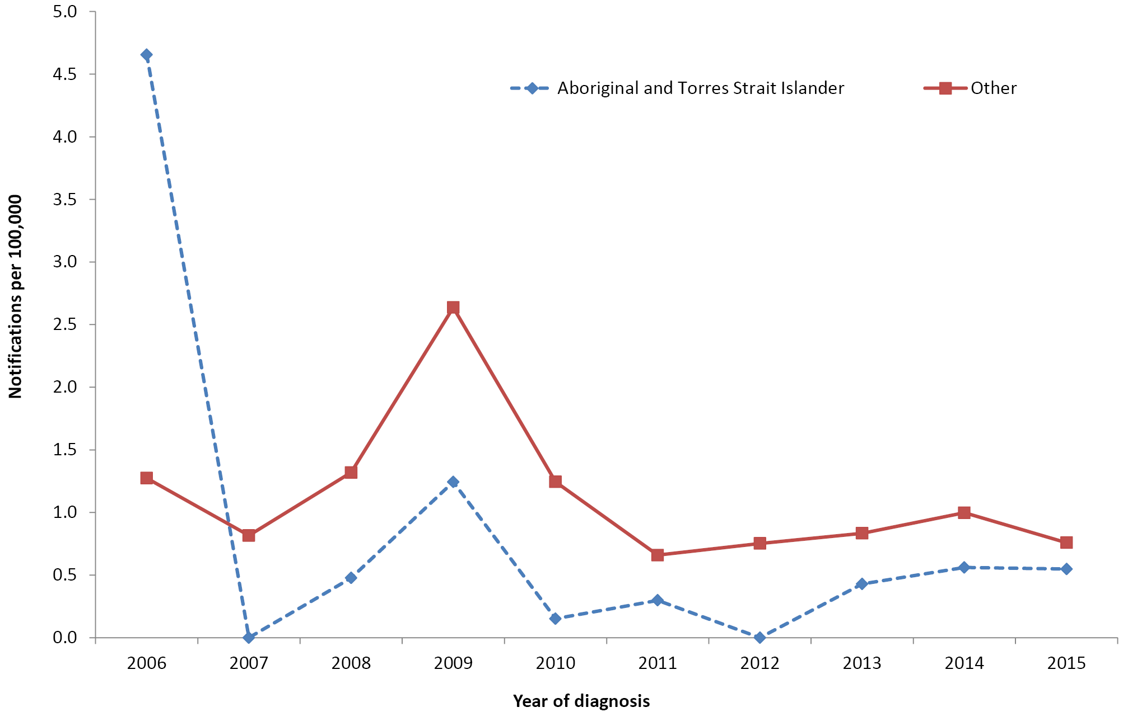
* Notifications where the date of diagnosis was between 1 January 2006 and 31 December 2015
Hospitalisation data for all jurisdictions for the period 2011 to 2015 are shown in Table 3. Of the total 1,157 hospitalisations recorded, 44 (3.9%) were reported in Aboriginal and Torres Strait Islander people. Hospitalisation rates were higher in Aboriginal and Torres Strait Islander people than in others in all age groups ≥15 years. However, the difference was only statistically significant for the 25–49 years age group (notification rate ratio 2.2, 95% CI 1.4–3.4) and for all ages combined (1.6, 95% CI 1.2–2.1).
Trends in hospitalisation data are presented for six jurisdictions (excluding the Australian Capital Territory and Tasmania) for the period 2006 to 2015 (Figure 3). There was a sharp decrease in the hepatitis A hospitalisation rate in Aboriginal and Torres Strait Islander people in 2007, an increase in the rate in other people in 2009, and a generally increasing trend in rates in both Aboriginal and Torres Strait Islander and other people between 2012 and 2015, during which period the hospitalisation rate exceeded the notification rate, irrespective of Aboriginal and Torres Strait Islander status (Figures 2 and 3).
Figure 3: Hepatitis A hospitalisation rates, selected jurisdictions,* 2006 to 2015,† by Aboriginal and Torres Strait Islander status
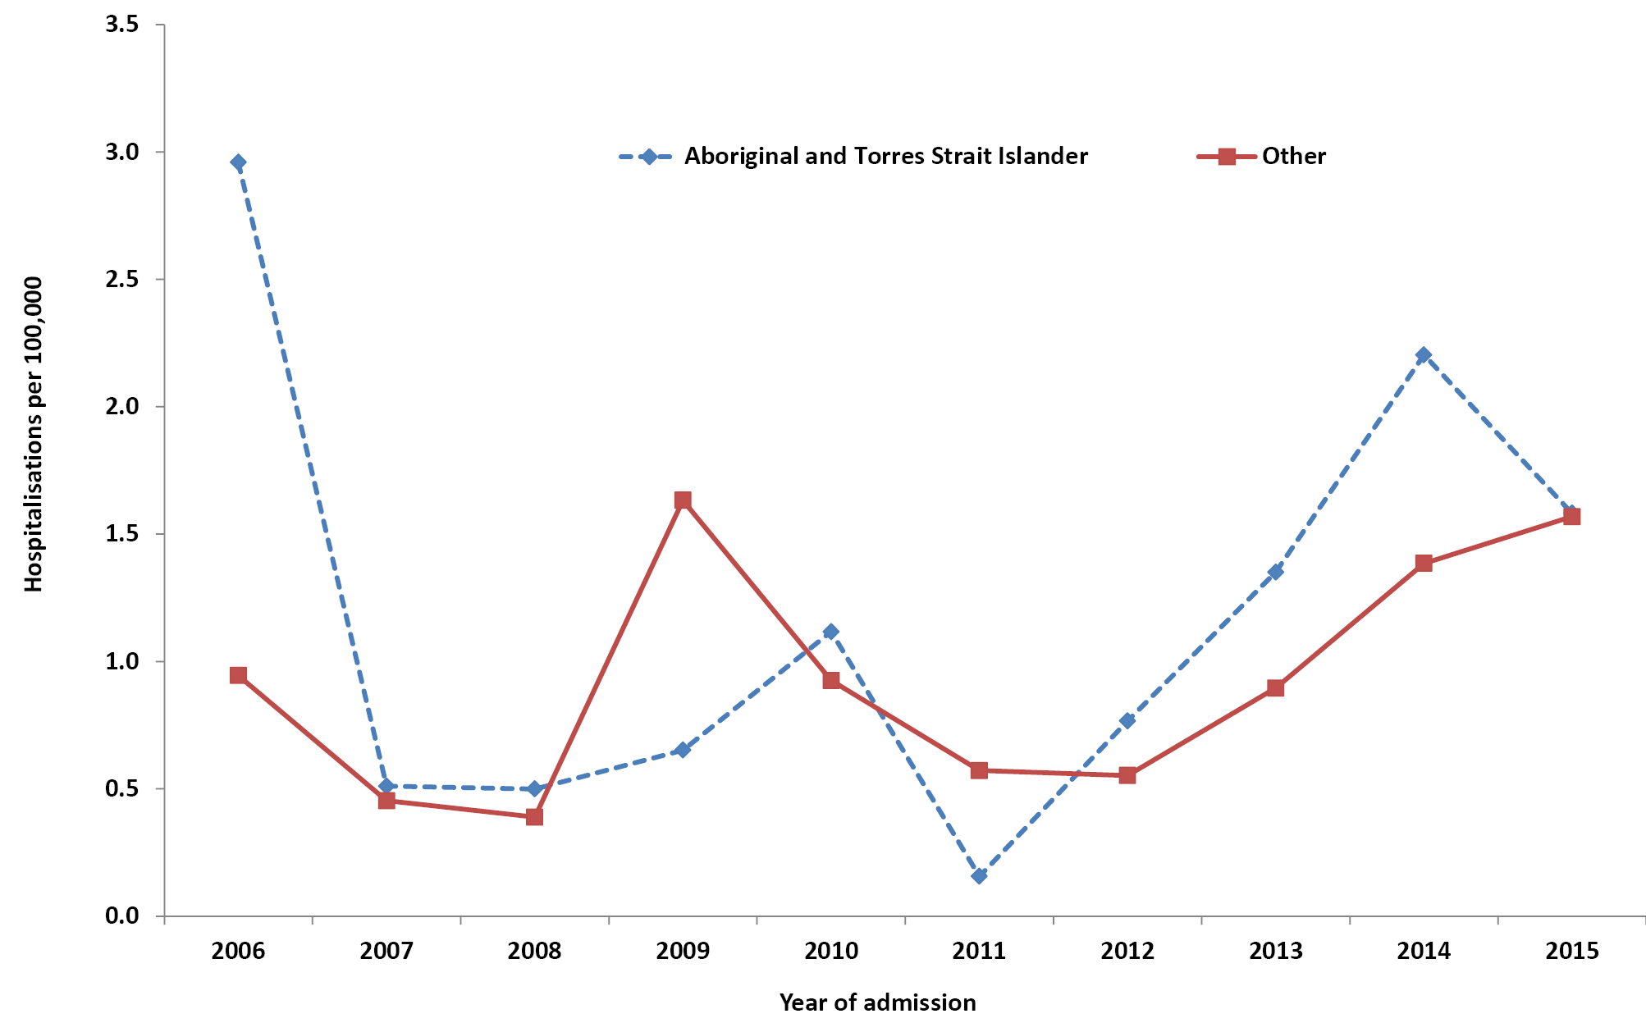
* Jurisdictions with satisfactory data quality 2006–2015 (refer to Appendix A): Northern Territory, Queensland, New South Wales, Victoria, South Australia and Western Australia.
† Hospital admissions where the date of admission was between 1 January 2006 and 31 December 2015.

Table 3: Hepatitis A hospitalisations, all jurisdictions, 2011 to 2015, by age and Aboriginal and Torres Strait Islander status
Age group (years) | Aboriginal and Torres Strait Islander status | Hospitalisations* (2011–2015)
 |  | n | Rate† | Rate ratio | 95% CI for Rate ratio
0–4 | Aboriginal and Torres Strait Islander | 0 | 0.00 | 0.0 | 0.0 – 4.1
 | Other | 17 | 0.24
5–14 | Aboriginal and Torres Strait Islander | 1-4‡ | 0.38 | 0.7 | 0.1 – 2.1
 | Other | 72 | 0.53
15–24 | Aboriginal and Torres Strait Islander | NP‡ | 1.27 | 1.5 | 0.7 – 3.0
 | Other | 122 | 0.82
25–49 | Aboriginal and Torres Strait Islander | 22 | 2.04 | 2.2 | 1.4 – 3.4
 | Other | 360 | 0.91
≥50 | Aboriginal and Torres Strait Islander | 10 | 2.05 | 1.4 | 0.7 – 2.6
 | Other | 542 | 1.46
All ages§ | Aboriginal and Torres Strait Islander | 44 | 1.60 | 1.6 | 1.2 – 2.1
 | Other | 1113 | 0.99
* Hospital admissions where the date of admission was between 1 January 2011 and 31 December 2015.
† Average annual age-specific rate per 100,000 population.
‡ To comply with the AIHW’s data release condition that hospitalisation counts <5 be suppressed in published reports, counts between 1 and 4 are reported as a range; other cell counts may be reported as NP (not published) to avoid potential for back calculation of counts <5.
§ Rates for all ages combined are age-standardised to the ABS Australian population estimates for 2011.
There were 20 deaths reported with hepatitis A recorded as the underlying or associated cause of death for the 2011–2015 period in Australia. Of these deaths, four were reported as having occurred in people identified as Aboriginal or Torres Strait Islander.

Discussion
Following the introduction of the national hepatitis A immunisation program targeted at Aboriginal and Torres Strait Islander young children in Western Australia, South Australia, the Northern Territory and Queensland in late 2005, hepatitis A disease notification rates in Aboriginal and Torres Strait Islander people declined sharply and have remained lower than the rates in other people since 2007. The notification rate for all ages combined in Aboriginal and Torres Strait Islander people was half that in other people over the 2011–2015 period, with no hepatitis A notifications or hospitalisations reported in Aboriginal and Torres Strait Islander children aged <5 years over the five-year period.
Previous published analyses have shown that the targeted program appears to have also provided substantial herd protection to older children and adults, both Aboriginal and Torres Strait Islander and others, within the four targeted jurisdictions, despite relatively modest hepatitis A vaccination coverage.²⁰ Significant, although lesser, decreases in hepatitis A notifications in both Aboriginal and Torres Strait Islander and other populations in non-targeted jurisdictions may also be partly attributable to the targeted program, given the extensive population movement of Aboriginal and Torres Strait Islander people between jurisdictions.²⁰ However other factors, such as increasing vaccination coverage in risk groups (including travellers and men who have sex with men) and seropositive migrants from hepatitis A endemic countries, are also likely to have contributed.²¹ Reasons for the apparent increasing trend over recent years in hepatitis A hospitalisation rates for both Aboriginal and Torres Strait Islander and other people are unclear.
The World Health Organization recommends targeted hepatitis A immunisation programs in countries with low incidence,²² and targeted programs have been estimated to be more cost effective than universal programs in such settings.²³ While this targeted strategy has clearly been effective in Australia to date, it does result in a large pool of susceptible individuals who remain at risk of hepatitis A. This is particularly relevant given the high volume of travel by Australian residents to high hepatitis A incidence countries and during foodborne outbreaks linked to the global food economy. Such an outbreak occurred in Australia in 2009, associated with imported semi-dried tomatoes, and was responsible for the increased number of notifications and hospitalisations seen in that year.²⁴

Hepatitis B
Hepatitis B infection is caused by the hepatitis B virus (HBV). The outcome of acute infection is highly variable, with some people having no symptoms, others experiencing self-limited hepatitis and a third, smaller, group developing fulminant hepatitis. Acute infection can lead to chronic hepatitis B viral infection, which over decades can cause liver fibrosis, cirrhosis, liver failure and hepatocellular carcinoma.⁸ Humans are the only natural reservoir for HBV. Transmission can occur through contact with blood and body fluids (e.g. through unsafe injecting, sexual contact or occupational exposure) and perinatally from mother to child during birth.⁸ Age of acquisition of HBV infection influences both the severity of initial symptoms and the risk of developing chronic infection. Acute symptoms are rare in infants who acquire infection, but approximately 90% will develop chronic infection compared to 30% of children infected between 1 and 4 years of age and <5% of those infected as adults, in whom acute symptoms are common.⁸ The analysis in this report is restricted to acute hepatitis B.
Relevant vaccine history
1980s
Hepatitis B vaccination funded for high-risk infants, including Aboriginal and Torres Strait Islander infants, in some jurisdictions then nationally in 1988
Hepatitis B vaccination recommended for at-risk adults, including all non-immune Aboriginal and Torres Strait Islanders
1990
Neonatal hepatitis B vaccination funded for all infants in the Northern Territory (3-dose schedule: birth, 1 month and 6 months)
1997
Hepatitis B vaccination recommended and funded for all adolescents aged 11–12 years (initially 3-dose schedule using the paediatric formulation; changed to 2-dose of adult formulation at various times since 2001 in different jurisdictions)
2000
Universal infant vaccination included in childhood schedule with a birth dose (within the first seven days of life) of monovalent paediatric hepatitis B vaccine, followed by 3 doses of hepatitis B–containing combination vaccine
2013
Funded adolescent school-based vaccination program ceased (as cohorts vaccinated through universal infant program had reached adolescence)

Results
Hepatitis B notification data are presented for all jurisdictions for the period 2011 to 2015 in Table 4. A total of 865 notifications of acute hepatitis B (infection confirmed to have been acquired within the previous two years) were recorded during this period, of which 76 (8.8%) were reported in Aboriginal and Torres Strait Islander people. Hepatitis B notification rates were significantly higher in Aboriginal and Torres Strait Islander people than those in others, overall (RR 3.1, 95% CI 2.4–3.9) and in the 0–4 years (RR 9.7, 95% CI 2.1–38.2), 15–24 years (RR 8.1, 95% CI 5.0–12.7) and 25–49 years (RR 2.9, 95% CI 2.1–4.0) age groups. Aboriginal and Torres Strait Islander status was reported for 89% of the 865 notifications of acute hepatitis B over the 2011–2015 period.

Table 4: Acute hepatitis B* notifications, all jurisdictions, 2011 to 2015, by age and Aboriginal and Torres Strait Islander status
Age group (years) | Aboriginal and Torres Strait Islander status | Notifications† (2011–2015)
 |  | n | Rate‡ | Rate ratio | 95% CI for Rate ratio
0–4 | Aboriginal and Torres Strait Islander | 4 | 0.95 | 9.7 | 2.1–38.2
 | Other | 7 | 0.10
5–14 | Aboriginal and Torres Strait Islander | 0 | 0.00 | 0.0 | 0.0–25.5
 | Other | 4 | 0.03
15–24 | Aboriginal and Torres Strait Islander | 27 | 3.81 | 8.1 | 5.0–12.7
 | Other | 70 | 0.47
25–49 | Aboriginal and Torres Strait Islander | 42 | 3.89 | 2.9 | 2.1–4.0
 | Other | 523 | 1.32
50+ | Aboriginal and Torres Strait Islander | 3 | 0.61 | 1.2 | 0.3–3.6
 | Other | 185 | 0.50
All ages§ | Aboriginal and Torres Strait Islander | 76 | 2.16 | 3.1 | 2.4–3.9
 | Other | 789 | 0.70
* Infection confirmed to have been acquired within the previous two years.
† Notifications where the date of diagnosis was between 1 January 2011 and 31 December 2015.
‡ Average annual age-specific rate per 100,000 population per year.
§ Rates for all ages combined are age-standardised to the Australian Bureau of Statistics Australian population estimates for 2011.
Notification trends for acute hepatitis B are presented for the period 2006 to 2015 in Figure 4. Notification rates for all ages combined decreased over this period, from 4.7 to 2.1 per 100,000 per year in Aboriginal and Torres Strait Islander people and from 1.4 to 0.6 per 100,000 per year in other people.
Figure 4: Acute hepatitis B* notification rates, all jurisdictions, 2006 to 2015†, by Aboriginal and Torres Strait Islander status
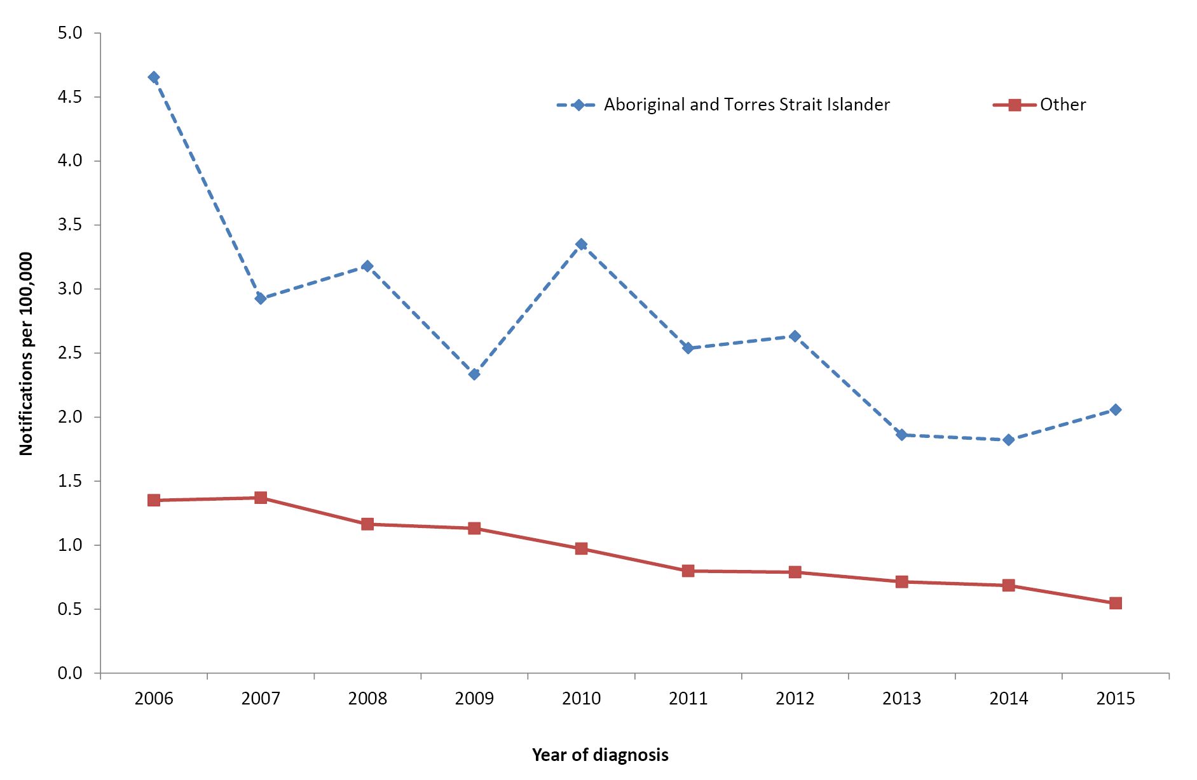
* Infection confirmed to have been acquired within the previous two years.
† Notifications where the date of diagnosis was between 1 January 2006 and 31 December 2015.
Hospital admissions for which hepatitis B was the principal diagnosis are shown for all jurisdictions for the period 2011 to 2015 in Table 5. Of the 583 hospitalisations recorded during this period, 42 (7.2%) were in Aboriginal and Torres Strait Islander people. Hospitalisation rates were significantly higher in Aboriginal and Torres Strait Islander people overall (RR 2.6, 95% CI 1.9–3.6) and in the 15–24 years (RR 6.8, 95% CI 3.2–13.3) and 25–49 years (RR 2.9, 95% CI 1.9–4.3) age groups.

Table 5: Hepatitis B* hospitalisations, all jurisdictions, 2011 to 2015, by age and Aboriginal and Torres Strait Islander status
Age group (years) | Aboriginal and Torres Strait Islander status | Hospitalisations† (2011–2015)
 |  | n | Rate‡ | Rate ratio | 95% CI for Rate ratio
0–4 | Aboriginal and Torres Strait Islander | 0 | 0.00 | 0.0 | 0.0–662.3
 | Other | 1–4§ | 0.01
5–14 | Aboriginal and Torres Strait Islander | 1–4§ | 0.13 | 3.4 | 0.1–30.1
 | Other | 5 | 0.04
15–24 | Aboriginal and Torres Strait Islander | 12 | 1.69 | 6.8 | 3.2–13.3
 | Other | NP§ | 0.25
25–49 | Aboriginal and Torres Strait Islander | 27 | 2.50 | 2.9 | 1.9–4.3
 | Other | 343 | 0.87
50+ | Aboriginal and Torres Strait Islander | 1–4§ | 0.41 | 1.0 | 0.1–3.6
 | Other | 155 | 0.42
All ages|| | Aboriginal and Torres Strait Islander | 42 | 1.26 | 2.6 | 1.9–3.6
 | Other | 541 | 0.48
* Principal cause of admission only, acute hepatitis B only.
† Hospital admissions where the date of admission was between 1 January 2011 and 31 December 2015.
‡ Average annual age-specific rate per 100,000 population.
§ To comply with the AIHW’s data release condition that hospitalisation counts <5 be suppressed in published reports, counts between 1 and 4 are reported as a range; other cell counts may be reported as NP (not published) to avoid potential for back calculation of counts <5.
|| Rates for all ages combined are age-standardised to the Australian Bureau of Statistics Australian population estimates for 2011
Trends in hospitalisations for acute hepatitis B are presented for six jurisdictions (excluding the Australian Capital Territory and Tasmania) over the decade 2006 to 2015 in Figure 5. Hospitalisation rates for all ages combined decreased over this period, from 8.2 to 1.1 per 100,000 per year in Aboriginal and Torres Strait Islander people and from 2.4 to 0.6 per 100,000 per year in other people. Hospitalisation rates in Aboriginal and Torres Strait Islander people fluctuated to a moderate extent due to the relatively small numbers involved.
Figure 5: Hepatitis B* hospitalisation rates, selected jurisdictions,† 2006 to 2015,‡ by Aboriginal and Torres Strait Islander status
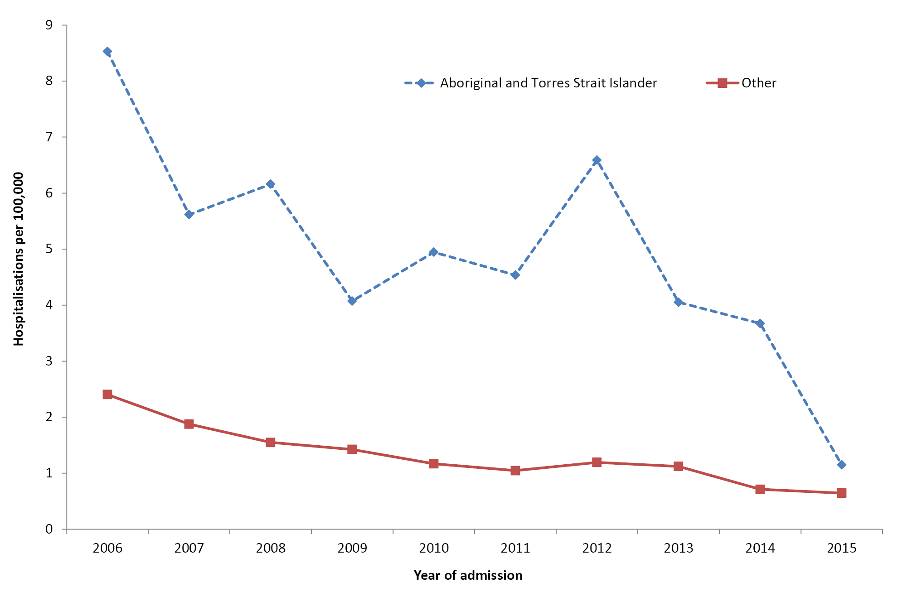
* Principal cause of admission only, acute hepatitis B only.
† Jurisdictions with satisfactory data quality over the whole time period (refer to Appendix A): Northern Territory, Queensland, New South Wales, Victoria, South Australia and Western Australia.
‡ Hospital admissions where the date of admission was between 1 January 2006 and 31 December 2015.
There were 88 deaths in Australia with acute hepatitis B reported as the underlying cause for the period 2011 to 2015. Of these, 11 (12.5%) were reported in Aboriginal and Torres Strait Islander people, with none in people <25 years of age.

Discussion
Low rates of acute hepatitis B notification and hospitalisation in Australians aged <15 years reflect the success of the universal infant hepatitis B immunisation program, which began in 2000 following targeted programs in the preceding decade. While the notification rate was higher in Aboriginal and Torres Strait Islander children aged <5 years compared to that in other children, this was based on only four notifications in the 2011–2015 period, limiting useful interpretation. The highest notification and hospitalisation rates for acute hepatitis B over this period, in both Aboriginal and Torres Strait Islander and other people, were in the 25–49 years age group, which suggests continued horizontal transmission of infection. The significantly higher notification and hospitalisation rates for acute hepatitis B in Aboriginal and Torres Strait Islander people aged 15–24 years compared to those in other people in the same age group may be due to a combination of lower vaccine coverage achieved through adolescent school-based programs and a higher risk of exposure to hepatitis B, whether through sexual contact or practices such as drug injecting, among Aboriginal and Torres Strait Islander people.
Surveillance data such as those presented here have limitations. They underestimate the incidence of acute hepatitis B infection as they do not include asymptomatic infections, unless a person had repeat testing that detected seroconversion. Determination of a case as acute (‘newly acquired’) is heavily reliant on public health follow-up, with the method and intensity of follow-up varying by jurisdiction and over time. Therefore, the acute cases reported here may be an underestimate. Modelling has suggested that true hepatitis B incidence is approximately 10 times higher than that indicated by the notification data.²⁵ The data presented here also do not capture the disease burden from chronic hepatitis B and long-term complications such as cirrhosis and hepatocellular carcinoma. The incidence of hepatocellular carcinoma is up to 10 times greater among Aboriginal and Torres Strait Islander people than that in non-Indigenous people.²⁶
While current Australian guidelines recommend hepatitis B vaccination be offered to all Aboriginal and Torres Strait Islander people,²⁷ vaccination for Aboriginal and Torres Strait Islander adults is not currently funded under the NIP. Modelling has suggested that a funded hepatitis B immunisation program for Aboriginal and Torres Strait Islander adults could have a considerable impact on the prevention of acute and subsequent chronic hepatitis B infections.²⁸

Human papillomavirus
Human papillomavirus (HPV) is a very common, usually transient, and asymptomatic infection of the genital tract in both women and men, with 13 types of HPV classified as carcinogenic.²⁹ When infections with these ‘high-risk’ types persist, HPV can integrate into host epithelial cells and disrupt normal cellular repair mechanisms, and eventually cause cancers of the cervix, anus, penis, vulva and vagina, and oropharynx. Other types of HPV are not associated with cancer, but types 6 and 11 cause genital warts and the rare disease recurrent respiratory papillomatosis, which can be acquired by newborns due to perinatal exposure.
Cervical cancer disproportionately occurs in Aboriginal and Torres Strait Islander women who have twice the incidence and four times the mortality rate from the disease compared to non-Indigenous Australian women.³⁰ As there is no evidence for differential HPV infection rates, the disparity is primarily related to lower participation in cervical screening, which is an effective prevention strategy to reduce the incidence of squamous cell cervical cancers.³¹ Baseline HPV prevalence data collected before the HPV vaccination program commenced indicated that Aboriginal and Torres Strait Islander women had similar rates of HPV types 16 and 18, the most common cancer-causing types, as non-Indigenous Australian women, but in middle age had higher rates of other cancer-causing types detected.³¹
Relevant vaccine history
2006
The quadrivalent HPV vaccine (4vHPV), which protects against cancer-causing HPV types 16 and 18 and types 6 and 11 which cause genital warts, is released in private market
2007
Bivalent HPV vaccine (2vHPV), which protects against cancer-causing HPV types 16 and 18, available in private market
April 2007 – December 2008
School program for girls aged 12–18 years provides 4vHPV vaccine catch-up program in a 3-dose course under the NIP
July 2007 – December 2009
Community-based program provides 4vHPV vaccine in a 3-dose course under the NIP to all females aged 12–26 years in general practice and other community settings
2009 January 2009 – December 2012
Routine 4vHPV vaccine vaccination of females aged 12–13 years through school-based programs, with general practice and community providers giving some missed doses
2013 January 2013 – December 2014
4vHPV school-based vaccine program extended to males, with a catch-up program up to age 15 years
2015 January 2015
Gender-neutral routine 4vHPV vaccine school-based program delivered at age 12–13 years

Results

Vaccination coverage estimates
HPV vaccination coverage estimates for Aboriginal and Torres Strait Islander females have only been published to date for 12–17 years olds eligible for the initial catch-up program during the period 2007–2009 in the Northern Territory and Queensland.³² These data indicated lower coverage with the third (final) dose among Aboriginal and Torres Strait Islander females in both jurisdictions. The Northern Territory also had a lower initiation rate and similar drop off with each dose, compared to similar initiation rates but greater drop off in coverage per dose in Queensland (Northern Territory [dose 1/2/3], Aboriginal and Torres Strait Islander 76/71/64% versus non-Indigenous 86/80/73%; Queensland [dose 1/2/3], Aboriginal and Torres Strait Islander 80/69/54% versus non-Indigenous 84/79/70%).

HPV infection
HPV infection is not a nationally notifiable disease. It is common (estimated 90% lifetime probability of infection),³³ usually asymptomatic and results in no specific public health action. Vaccine impact on HPV infection with targeted HPV types 16, 18, 6, 11 in the population has been estimated in Australia from cervical specimens in young women presenting for cervical screening at selected clinics using sentinel surveillance to compare prevalence in the pre-vaccination (2005–2007) and post-vaccination (2014–2015) periods. These studies have documented dramatic reductions in vaccine-targeted HPV types by 76% in women aged 18–24 years: from 29% in 2005–2007 to 7% by 2011–2012³⁴ and down to 1.5% by 2015.³⁵ A study to estimate the vaccine impact among Aboriginal and Torres Strait Islander women attending culturally appropriate services found a reduction of 93% (from 23.9% to 1.4%) in vaccine-preventable HPV types in women aged 18–26 years between the pre-vaccination and post-vaccination periods.³⁶

Genital warts
Decline in genital warts in young people in Australia was the first documented population-level impact of the vaccine internationally.³⁷ This occurred in both ambulatory patients attending sexual health clinics and those hospitalised. In ambulatory patients, a study reported significant declines in presentations with genital warts among Aboriginal and Torres Strait Islander women aged 12–20 years and 21–30 years and males aged 12–20 years presenting to sexual health clinics between the two periods of 2004–2007 and 2008–2014 (Figure 6 and 7).³⁸ Another study found large declines in hospitalisations with genital warts between the periods 2006–2007 and 2010–2011 and a similar magnitude of decline in Aboriginal and Torres Strait Islander and non-Indigenous women aged 15–24 years (76.1% [95% CI, 71.6%–79.9%] and 86.7% [95% CI, 76.0%–92.7%], respectively).³⁷
Figure 6: Proportion of Aboriginal and Torres Strait Islander and non-Indigenous Australian-born women diagnosed with genital warts at first visit to a sexual health clinic, 2004–2014
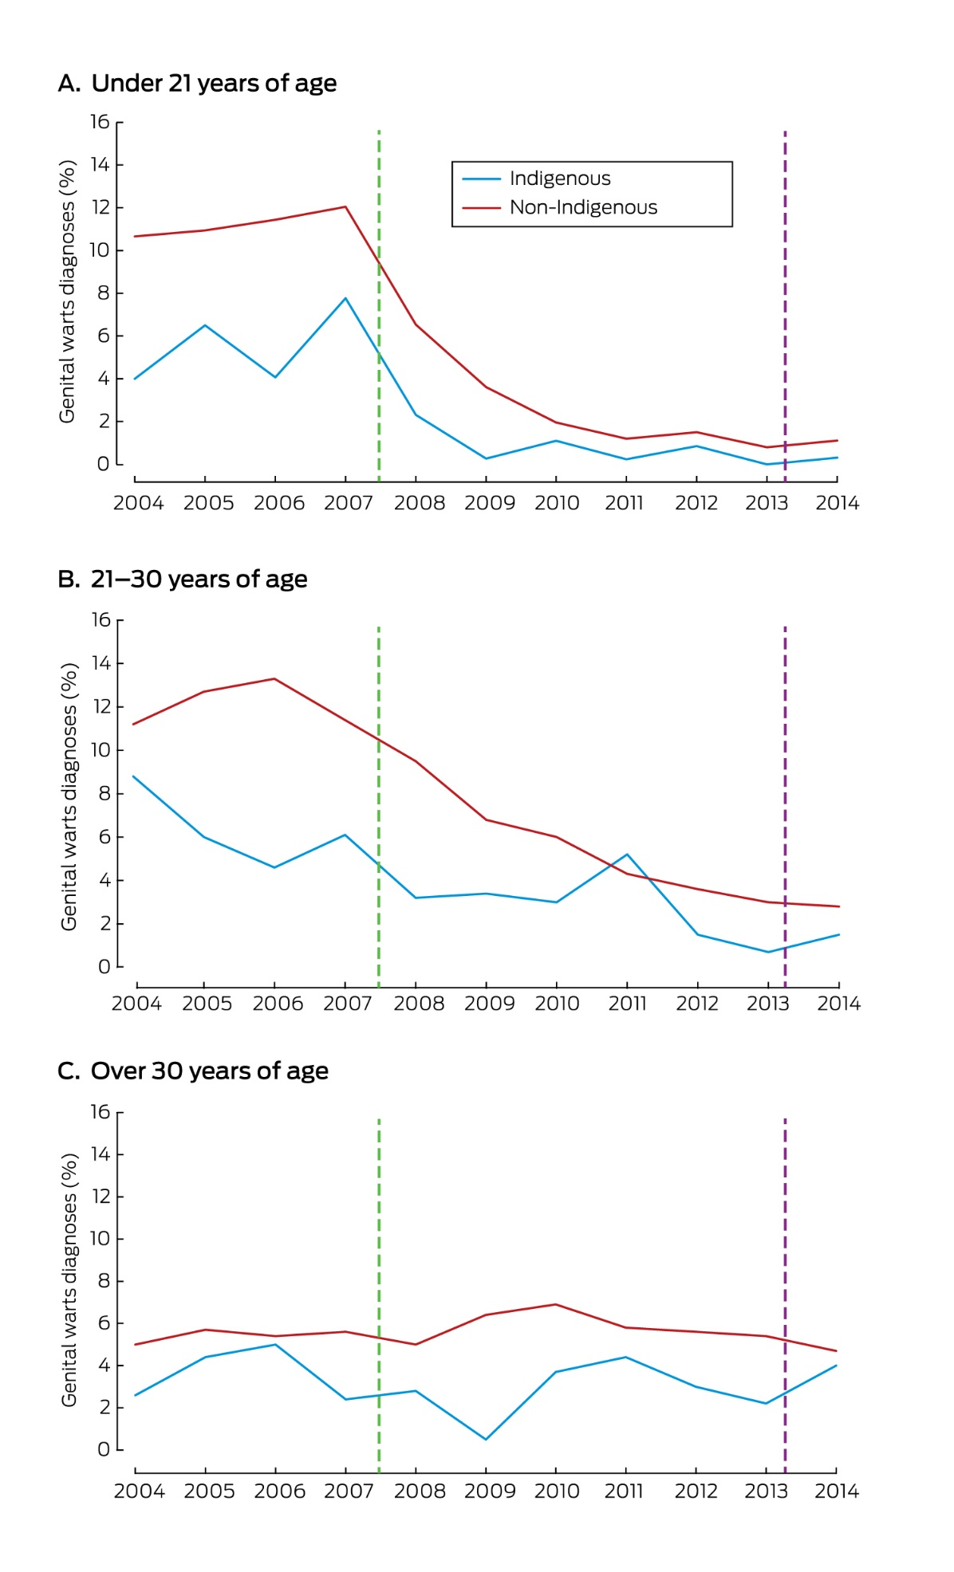
Source: Ali H, McManus H, O’Connor CC, et al. Human papillomavirus vaccination and genital warts in young Indigenous Australians: national sentinel surveillance data. Med J Aust 2017;206:204–9. © Copyright 2017 The Medical Journal of Australia – reproduced with permission.
Figure 7: Proportion of Aboriginal and Torres Strait Islander and non-Indigenous Australian-born men diagnosed with genital warts at first visit to sexual health clinic, 2004–2014
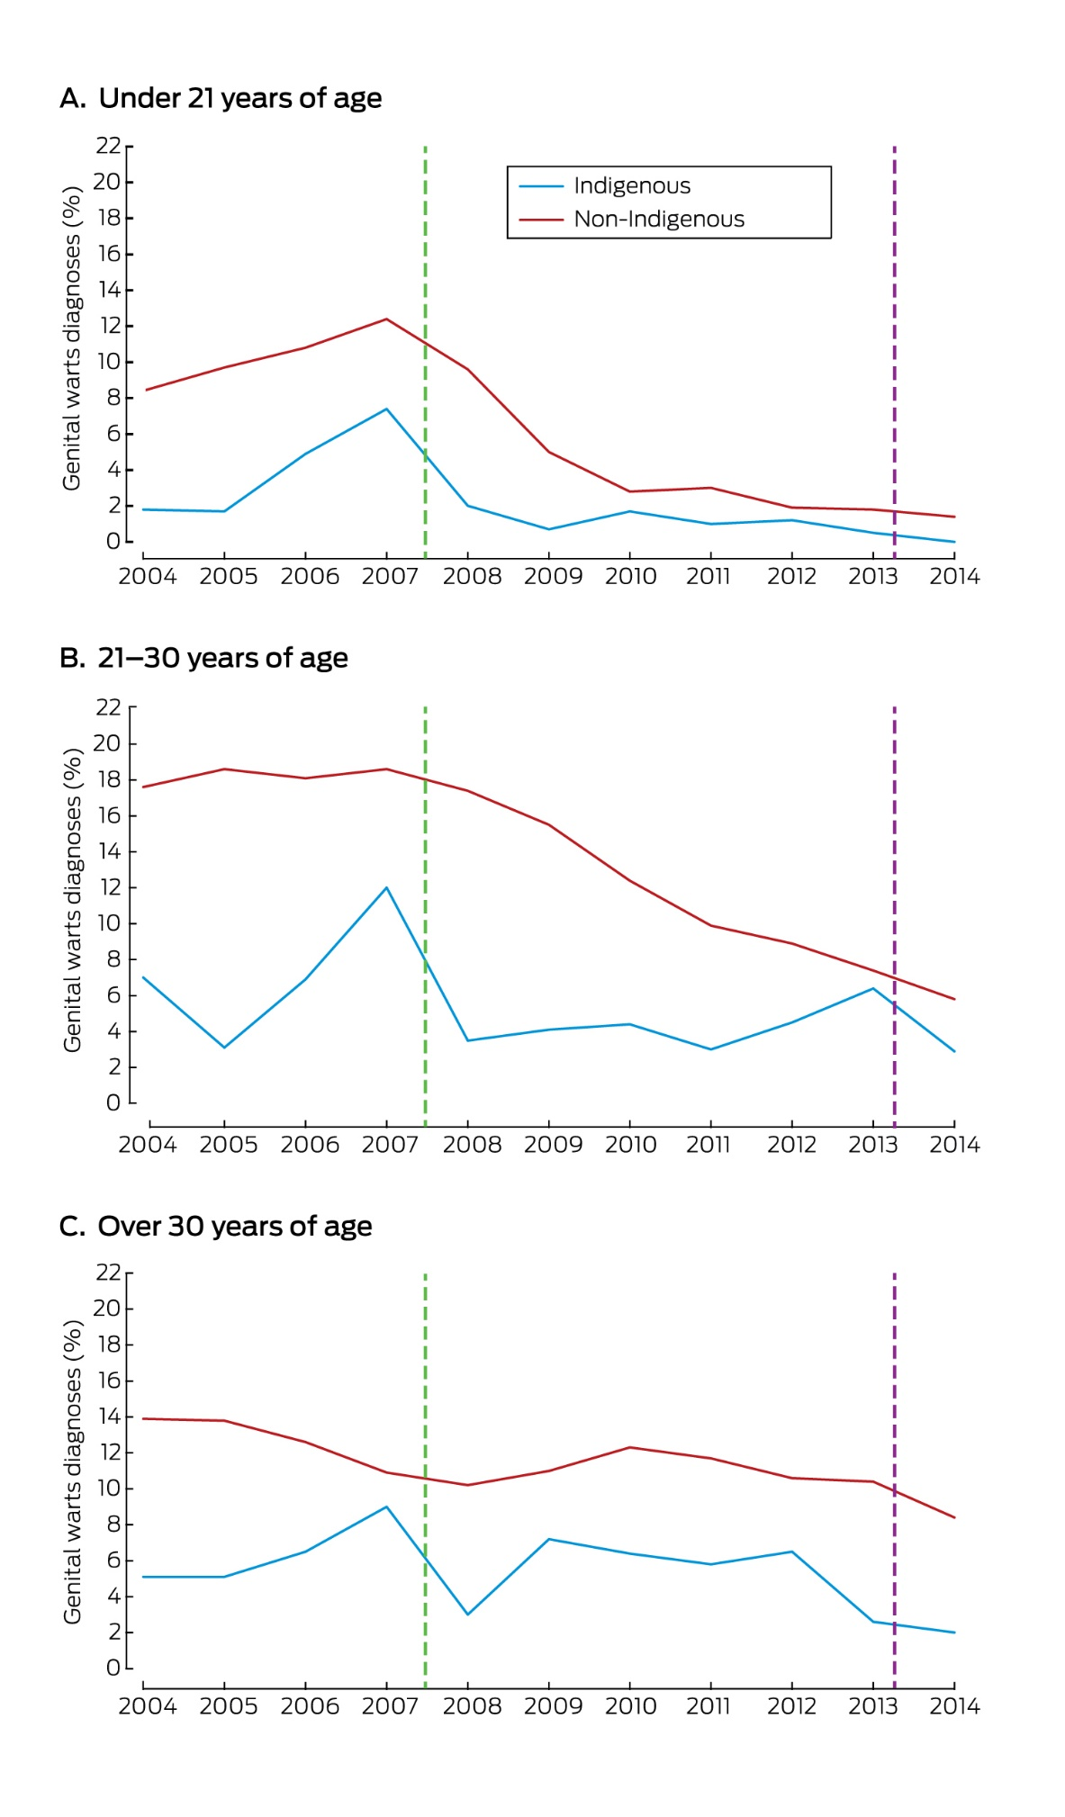
Source: Ali H, McManus H, O’Connor CC, et al. Human papillomavirus vaccination and genital warts in young Indigenous Australians: national sentinel surveillance data. Med J Aust 2017;206:204–9.
© Copyright 2017 The Medical Journal of Australia – reproduced with permission.
Figure 8: High-grade abnormality detection rate per 1,000 women screened, by age, 2004–2015, Northern Territory
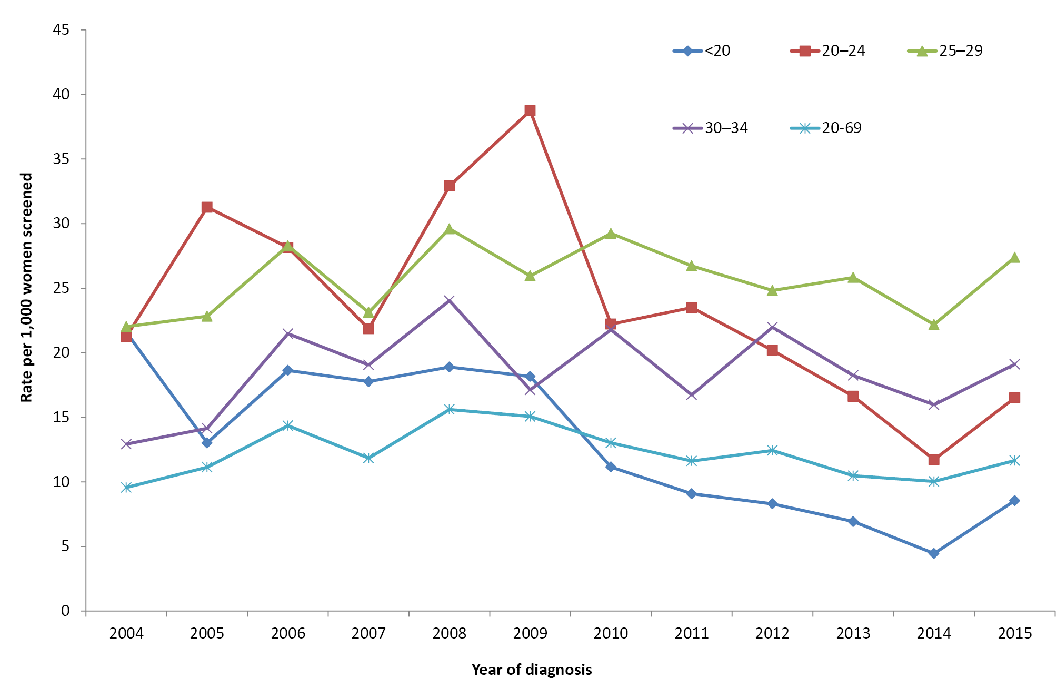
Source: Cervical screening in Australia 2014-2015 (supplementary table S4.11).³⁰

Figure 9: High grade abnormality detection rate per 1,000 women screened, by age, 2001–2015, Australia
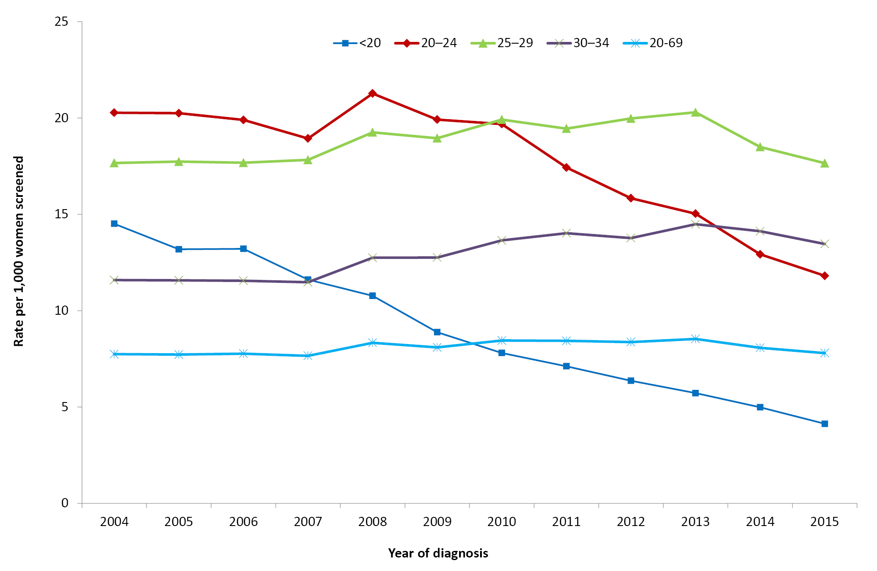
Source: Cervical screening in Australia 2014-2015 (supplementary table S4.11).³⁰

Cervical pre-cancer
Cervical screening aims to detect and then treat lesions of the cervix (known as high-grade cervical intraepithelial neoplasia [CIN]) before they develop into cervical cancer. Australia’s cervical screening registers routinely record screening tests and pre-treatment cervical biopsy results, which has enabled monitoring of the impact of HPV vaccination on the rates of high-grade CIN detected. Rates of high-grade CIN declined rapidly in young women aged <20 years, followed sequentially by a decline in women aged 20–24 years and reversal of the upwards trend in women aged 25–29 years.^{30,39,40}
Cervical screening registers have not routinely received information about the Aboriginal and Torres Strait Islander status of women participating in screening. However, the decline seen in the Northern Territory, where 31% of the female population is Aboriginal and Torres Strait Islander,⁴¹ is similar to that observed nationally (Figures 8 and 9).³⁰ Between 2006 (the year before the vaccine program was introduced) and 2015, the rate of detection of CIN decreased in the Northern Territory women aged <20 and 20–24 years by 54% and 41%, respectively, compared to decreases seen Australia-wide of 69% and 41%. Vaccine coverage achieved in the Northern Territory has been comparable to the coverage in other jurisdictions.⁴⁰

Discussion
Since the introduction of the HPV vaccination program, Australia has observed remarkable reductions in HPV infection, genital warts, cervical precancers and most recently recurrent respiratory papillomatosis.⁴² Available data suggest that Aboriginal and Torres Strait Islander people are benefitting as much as non-Indigenous Australians from the program.
The speed and size of reduction in HPV disease burden likely reflects the large-scale primary vaccination age cohort and catch-up program,⁴³ high vaccine efficacy with accumulating evidence that less than three doses provide a high degree of protection⁴⁴ and greater than expected herd protection.⁴⁵ Recent modelling has suggested that even 30% coverage may generate herd protection and that sustained coverage above 80%, when vaccinating both males and females, is sufficient for longterm elimination of vaccine-targeted HPV types in the population.⁴⁵ All these factors may explain why reduction in disease burden and infection is as substantial among Aboriginal and Torres Strait Islander people despite somewhat lower rates of vaccine course completion.
Challenges remain in the monitoring of HPV vaccine impact among Aboriginal and Torres Strait Islander people. There is a need to continue the improvements already underway in the recording of Aboriginal and Torres Strait Islander status on school HPV vaccine consent forms to facilitate estimation of coverage. It is important that Aboriginal and Torres Strait Islander status is asked about and recorded for all women participating in cervical screening. The new cervical screening program, which is now based on detection of the HPV virus, rather than cellular changes, combined with a new national screening register, should provide the vehicle for a national system of high-quality reporting.⁴⁶ Laboratory accreditation standards now require all pathology providers to transmit Aboriginal and Torres Strait Islander status to the register when reported to them, but do not currently mandate the inclusion of this field on pathology request forms.⁴⁷ It will also be important to ensure high-quality Aboriginal and Torres Strait Islander status reporting to cancer registers as the impact of vaccination on cervical cancer, and in future decades other HPV-related cancers, begins to materialise.

Seasonal influenza
Influenza is an acute respiratory tract infection caused almost exclusively by influenza type A and type B viruses.⁸ The most common serious complications from influenza include exacerbation of underlying chronic pulmonary and cardiopulmonary diseases, such as chronic obstructive pulmonary disease, asthma and congestive heart failure, as well as development of pneumonia (primary viral or bacterial) which may be fatal.⁸ The risk of developing serious complications is higher at both extremes of age and in those with certain underlying medical conditions.⁸ Protection against influenza through vaccination is made more difficult by the capacity of influenza A and B viruses to undergo frequent antigenic change in two surface antigens, haemagglutinin (HA) and neuraminidase (NA), producing variants against which vaccines may not be as effective.⁸ Annual seasonal influenza vaccination is required, with vaccine formulation often changing from year to year.
Relevant vaccine history
1986
Seasonal influenza vaccination recommended for individuals at risk of complications or death from influenza
1994
Seasonal influenza vaccination recommended for Aboriginal and Torres Strait Islander people aged ≥50 years
1999
Seasonal influenza vaccine funded nationally for all Australians aged ≥65 years and Aboriginal and Torres Strait Islander people aged ≥50 years and 15–49 years with medical risk factors
2009
Pandemic influenza A (H1N1) 2009 vaccine registered, recommended and funded
2010
Seasonal influenza vaccine funded for:
- all Aboriginal and Torres Strait Islander people aged ≥15 years
- all persons aged ≥6 months with medical conditions predisposing to severe influenza
- pregnant women
2013
- Seasonal influenza vaccine recommended for children aged 6 months to <5 years
- First inactivated quadrivalent influenza vaccine registered for use in individuals aged ≥3 years
2014
Second inactivated quadrivalent influenza vaccine registered for use in individuals aged ≥6 months
2015
Seasonal influenza vaccine funded for Aboriginal and Torres Strait Islander children aged 6 months to <5 years
List of population groups for which seasonal influenza vaccination recommended further expanded to include Aboriginal and Torres Strait Islander children aged 5–14 years

Results
Notification data for laboratory confirmed cases of influenza are presented in Table 6 for three jurisdictions—South Australia, Western Australia, Northern Territory—with adequate completeness of Aboriginal and Torres Strait Islander status (all >85%, compared to <40% for other jurisdictions) for the period 2011 to 2015. A total of 66,292 notifications were recorded in these three jurisdictions in the reporting period, of which 3832 (5.9%) were in Aboriginal and Torres Strait Islander people, an overall Aboriginal and Torres Strait Islander people versus other Australians rate ratio of 1.3 (95% CI 1.2–1.3). The highest age-specific notification rate and rate ratio was seen in the >50 years age group, with a notification rate of 598.3 per 100,000 per year in Aboriginal and Torres Strait Islander people compared to 282.8 (RR 2.1, 95% CI 2.0–2.3) in the rest of the population. Notification rates in Aboriginal and Torres Strait Islander people were 1.4 times higher than those in the rest of the population in the 0–4 years and 25–49 years age groups, significantly lower for the 5–14 years age group (RR 0.6, 95% CI 0.6–0.7) and similar in those aged 15–24 years (RR 0.9, 95% CI 0.8–1.0).
Table 6: Influenza notifications, selected jurisdictions,* 2011 to 2015, by age and Aboriginal and Torres Strait Islander status
Age group (years) | Aboriginal and Torres Strait Islander status | Notifications† (2011–2015)
 |  | n | Rate‡ | Rate ratio | 95% CI for Rate ratio
0–4 | Aboriginal and Torres Strait Islander | 803 | 722.5 | 1.4 | 1.3–1.5
 | Other | 6,831 | 519.4
5–14 | Aboriginal and Torres Strait Islander | 641 | 287.3 | 0.6 | 0.6–0.7
 | Other | 11,203 | 450.7
15–24 | Aboriginal and Torres Strait Islander | 431 | 215.2 | 0.9 | 0.8–1.0
 | Other | 6,388 | 230.0
25–49 | Aboriginal and Torres Strait Islander | 1,134 | 335.3 | 1.4 | 1.3–1.4
 | Other | 18,519 | 246.6
≥50 | Aboriginal and Torres Strait Islander | 823 | 598.3 | 2.1 | 2.0–2.3
 | Other | 19,519 | 282.8
All ages§ | Aboriginal and Torres Strait Islander | 3,832 | 379.3 | 1.3 | 1.2–1.3
 | Other | 62,460 | 297.6
* South Australia, Western Australia, Northern Territory.
† Notifications where the date of diagnosis was between 1 January 2011 and 31 December 2015.
‡ Average annual age-specific rate per 100,000 population.
§ Rates for all ages combined are age-standardised to the Australian Bureau of Statistics Australian population estimates for 2011.
Data on hospital admissions with influenza as one of the coded diagnoses are presented for all jurisdictions for the period 2011 to 2015 in Table 7. The all-age Aboriginal and Torres Strait Islander versus other hospitalisation rate ratio was 2.4 (95% CI 2.3–2.4), with the highest age-specific hospitalisation rates in the 0–4 years age group (Aboriginal and Torres Strait Islanders 245.6 per 100,000 population per year, others 111.51 [RR 2.2, 95% CI 2.1–2.4]). Hospitalisation rates were significantly higher for Aboriginal and Torres Strait Islander people across all age groups, with the highest rate ratio seen in the 25–49 years age group (RR 3.0, 95% CI 2.8–3.2).

Table 7: Influenza hospitalisations, all jurisdictions, 2011 to 2015, by age and Aboriginal and Torres Strait Islander status
Age group (years) | Aboriginal and Torres Strait Islander status | Hospitalisations* (2011–2015)
 |  | n | Rate† | Rate ratio | 95% CI for Rate ratio
0–4 | Aboriginal and Torres Strait Islander | 1,030 | 245.6 | 2.2 | 2.1–2.4
 | Other | 7,943 | 111.5
5–14 | Aboriginal and Torres Strait Islander | 287 | 35.9 | 1.4 | 1.2–1.5
 | Other | 3,466 | 25.7
15–24 | Aboriginal and Torres Strait Islander | 300 | 42.3 | 2.0 | 1.8–2.3
 | Other | 3,106 | 21.0
25–49 | Aboriginal and Torres Strait Islander | 932 | 86.4 | 3.0 | 2.8–3.2
 | Other | 11,475 | 29.1
≥50 | Aboriginal and Torres Strait Islander | 954 | 195.2 | 2.3 | 2.2–2.5
 | Other | 31,256 | 84.3
All ages‡ | Aboriginal and Torres Strait Islander | 3,503 | 119.3 | 2.4 | 2.3–2.4
 | Other | 57,246 | 50.6
* Hospital admissions where the date of admission was between 1 January 2011 and 31 December 2015.
† Average annual age-specific rate per 100,000 population.
‡ Rates for all ages combined are age-standardised to the Australian Bureau of Statistics Australian population estimates for 2011.
Trends in influenza hospitalisations are presented for six jurisdictions (excluding Australian Capital Territory and Tasmania) for the decade 2006 to 2015 in Figure 10. A small peak in hospitalisations was seen in 2007, followed by a large increase in 2009, in both cases more pronounced in Aboriginal and Torres Strait Islander people, as were the peaks in 2012 and 2014. There was a generally increasing trend in hospitalisations rates from 2006 to 2015 across all age groups. In Aboriginal and Torres Strait Islander people, the greatest increase was in the 5–49 years age group (8.6 per 100,000 in 2006 to 64.7 in 2015), while in other people it was in the >50 years age group (8.6 per 100,000 in 2006 to 140.4 in 2015).
Figure 10: Influenza hospitalisation rates, selected jurisdictions,* 2006 to 2015,† by age and Aboriginal and Torres Strait Islander status
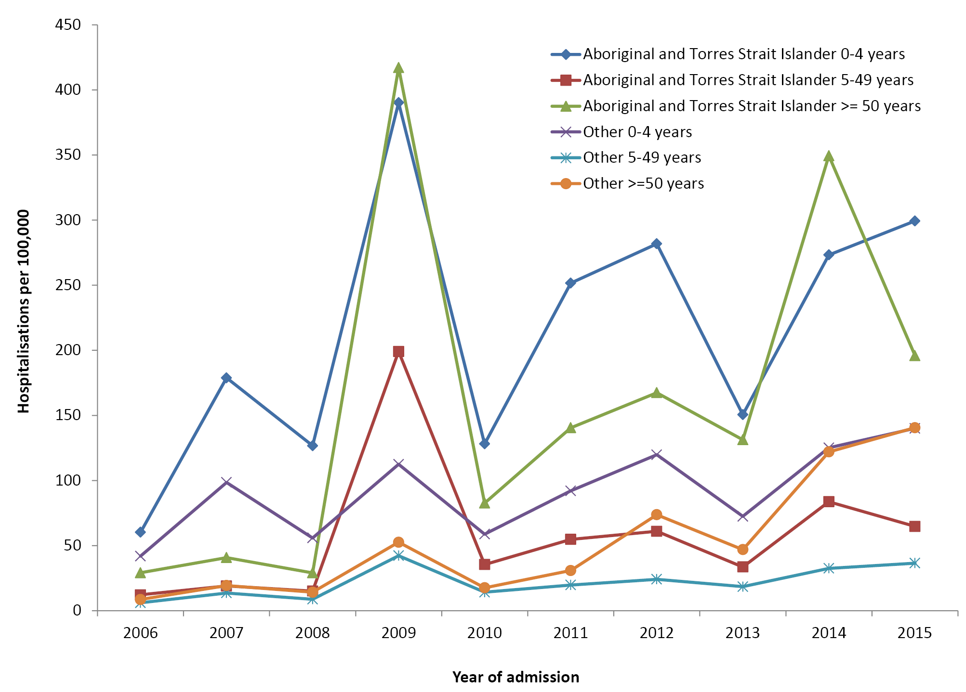
* Jurisdictions with satisfactory data quality for the 2006–2015 period (refer to Appendix A): Northern Territory, Queensland, New South Wales, Victoria, South Australia and Western Australia.
† Hospital admissions where the date of admission was between 1 January 2006 and 31 December 2015.
Between 2011 and 2015, 1138 deaths with influenza as the underlying or associated cause were reported in Australia, with 30 (3%) of these recorded in Aboriginal or Torres Strait Islander people. The annual number of reported deaths increased four-fold, from 93 in 2011 to 371 in 2015.

Discussion
This analysis adds two years (2014–2015) of hospitalisation and death data to a previously published detailed analysis of notification, hospitalisation and death data for influenza in Australia, which included data on Aboriginal and Torres Strait Islander people.⁴⁸ That study analysed notification data for a longer time period (2006–2015), but included only two jurisdictions (Western Australia and the Northern Territory) with ≥90% completeness for Aboriginal and Torres Strait Islander status.⁴⁸ It found significantly higher influenza notification rates in all age groups, with rate ratios from 1.5 in 5–11 years olds to 8.6 in infants aged <6 months when comparing Aboriginal and Torres Strait Islander people with other Australians. In contrast, this analysis also included notification data for South Australia, but only examined the data for five years 2011–2015, and did not find any higher influenza notification rates in Aboriginal and Torres Strait Islander people aged 5–24 years. This difference may be due to the shorter time-frame examined, which did not include the peak years of 2007 and 2009. However, both analyses found significantly higher influenza hospitalisation rates in Aboriginal and Torres Strait Islander people across all age groups with comparable rate ratios.
The increase in notification and hospitalisation rates, and deaths, following the 2009 pandemic may be partly related to increased laboratory testing, with evidence, especially in age groups >5 years, of substantial increases in hospitalisations with a specific code indicating laboratory confirmation.⁴⁸ Increased laboratory testing could also account for at least some of the observed increase in deaths recorded as being associated with influenza. Increased severe morbidity and mortality in Aboriginal and Torres Strait Islander people in the pandemic year of 2009 was thought to be largely attributable to a significantly higher proportion of Aboriginal and Torres Strait Islander people having at least one comorbidity predisposing them to increased severity. This relates especially to younger adults (18–49 years), who have three times higher prevalence of comorbidities than non-Indigenous adults.⁴⁸
Annual seasonal influenza vaccination has been funded for Aboriginal and Torres Strait Islander people aged >50 years since 1999 and all people aged >15 years since 2010, with extension to children aged 6 months to 5 years in 2015. However, influenza vaccination coverage in Aboriginal and Torres Strait Islander children was suboptimal at 12% nationally in 2015.⁴⁹ More detail on seasonal influenza coverage can be found in the Vaccination Coverage section of this report. Given high levels of severe illness and comorbidity in Aboriginal and Torres Strait Islander people, it is important that influenza vaccination of all age groups is promoted and coverage in children increased to a level closer to that achieved for other NIP-funded vaccines.

Measles
Measles is a highly contagious airborne disease that is caused by a morbillivirus. It is characterised by fever, malaise, conjunctivitis, coryza and cough during the prodromal stage followed by the onset of maculopapular rash.⁸ The severity of measles illness, complication rates and clinical outcomes vary with age, but there is increased risk in children aged <5 years and adults aged >20 years. Complications include otitis media, pneumonia, diarrhoea, postinfectious encephalitis, subacute sclerosing panencephalitis (rare) and death.
Relevant vaccine history
1975
Measles vaccine funded for all Australian infants at 12 months of age
1984
MM* vaccination of Aboriginal and Torres Strait Islander children in the Northern Territory scheduled at 9 months of age instead of 12 months
1989
MMR† vaccine recommended and funded on the national schedule at 12 months of age (9 months for Aboriginal and Torres Strait Islander infants in the Northern Territory)
1992
2nd dose of MMR vaccine recommended and funded for all adolescents 10–14 years
1998
- Recommended age for 1st dose of MMR vaccine for Aboriginal and Torres Strait Islander infants in the Northern Territory increased from 9 months to 12 months of age
- Recommended age of 2nd dose of MMR vaccine scheduled at 4–5 years instead of 10–14 years
2000
2nd dose of MMR vaccine scheduled at 4 years instead of 4–5 years
2013
2nd dose of MMR vaccine moved forward to 18 months of age, administered as MMRV‡
* MM: measles and mumps
† MMR: measles, mumps and rubella

‡ MMRV: measles, mumps, rubella and varicella

Results
Notification data for measles are presented for all jurisdictions for the period 2011 to 2015 in Table 8. A total of 964 notifications were recorded, of which 40 (4.1%) were reported in Aboriginal and Torres Strait Islander people. The highest notification rate in both Aboriginal and Torres Strait Islander and other people was in children aged <5 years (3.1 and 2.5 per 100,000 per year, respectively). There were no statistically significant differences between notification rates in Aboriginal and Torres Strait Islander and other people by age group. Of the 964 notifications of measles over the 2011–2015 period, Aboriginal and Torres Strait Islander status was reported for 97.5%.

Table 8: Measles notifications, all jurisdictions, 2011 to 2015, by age and Aboriginal and Torres Strait Islander status
Age group (years) | Aboriginal and Torres Strait Islander status | Notifications* (2011–2015)
 |  | n | Rate† | Rate ratio | 95% CI for Rate ratio
0–4 | Aboriginal and Torres Strait Islander | 13 | 3.10 | 1.2 | 0.7–2.2
 | Other | 177 | 2.48
5–14 | Aboriginal and Torres Strait Islander | 4 | 0.50 | 0.4 | 0.1–1.1
 | Other | 158 | 1.17
15–24 | Aboriginal and Torres Strait Islander | 8 | 1.13 | 0.7 | 0.3–1.3
 | Other | 252 | 1.70
25–49 | Aboriginal and Torres Strait Islander | 15 | 1.39 | 1.7 | 0.9–2.8
 | Other | 328 | 0.83
≥50 | Aboriginal and Torres Strait Islander | 0 | 0.00 | 0.0 | 0.0–38.4
 | Other | 9 | 0.02
All ages‡ | Aboriginal and Torres Strait Islander | 40 | 0.91 | 1.1 | 0.7–1.5
 | Other | 924 | 0.84
* Notifications where the date of diagnosis was between 1 January 2011 and 31 December 2015.
† Average annual age-specific rate per 100,000 population.
‡ Rates for all ages combined are age-standardised to the Australian Bureau of Statistics Australian population estimates for 2011.
Notification trends for measles are presented for all jurisdictions for the period 2006 to 2015 in Figure 11. Notification rates in Aboriginal and Torres Strait Islander people were higher during the second half of the period, although with fluctuation due to low numbers. Notification rates in other people generally increased from 2007 to 2014, with a sharp decline in 2015.
Figure 11: Measles notification rates, all jurisdictions, 2006 to 2015,* by Aboriginal and Torres Strait Islander status
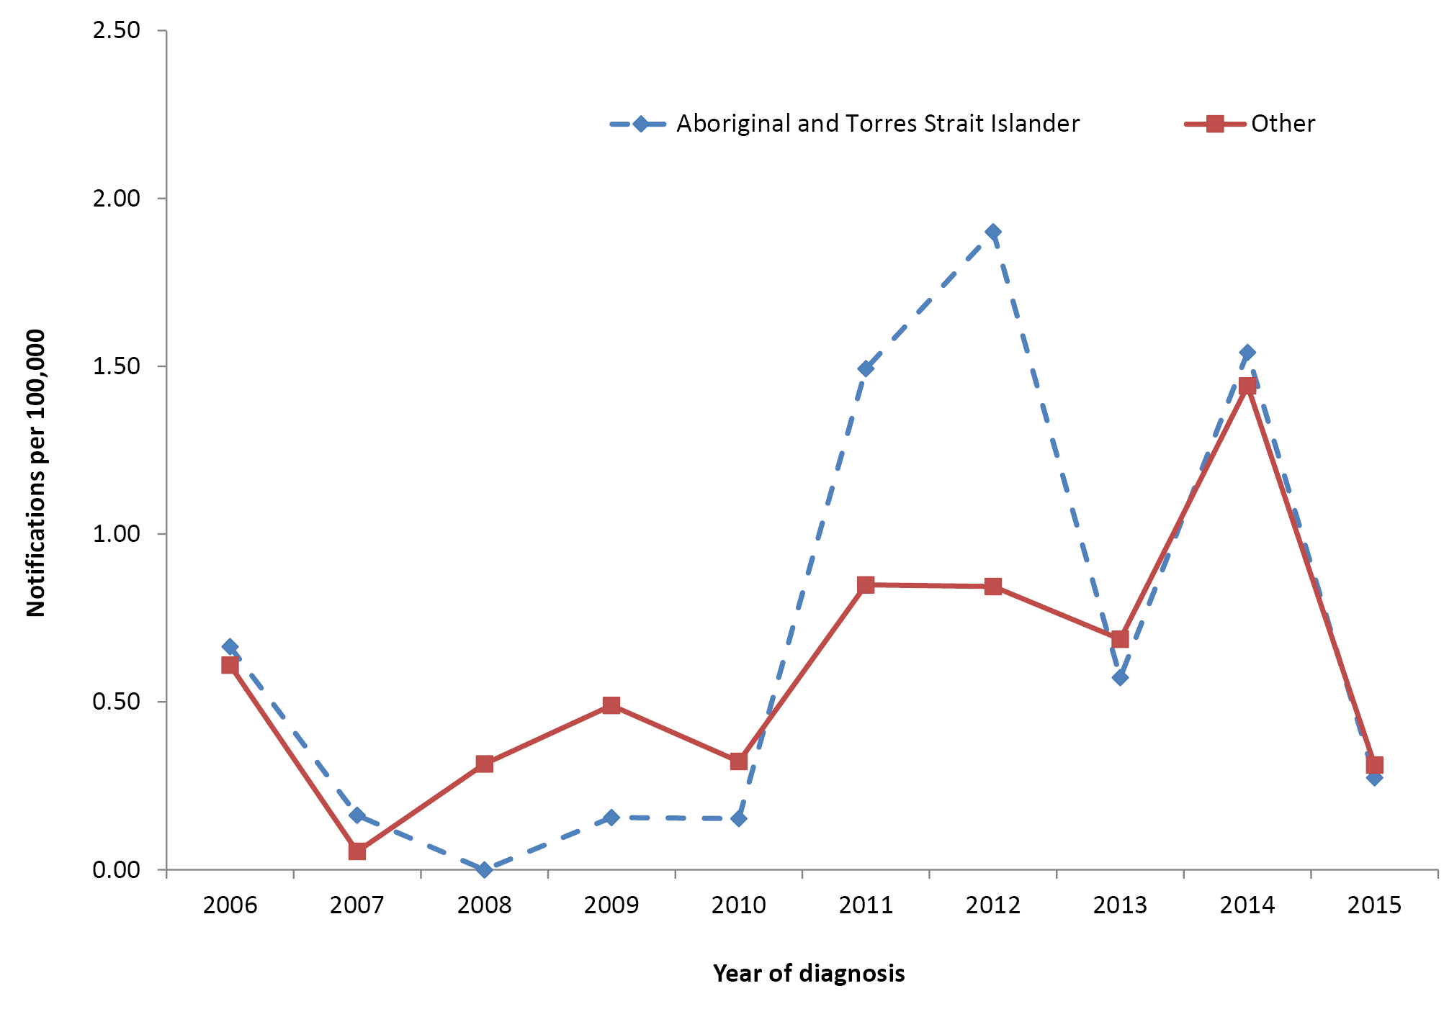
* Notifications where the date of diagnosis was between 1 January 2006 and 31 December 2015.
Hospitalisation data are presented for all jurisdictions for the period 2011 to 2015 in Table 9. Of the 387 hospitalisations recorded, 19 (5.2%) were reported in Aboriginal and Torres Strait Islander people. As with notification rates, the highest hospitalisation rate in both Aboriginal and Torres Strait Islander and other people was in children aged 0–4 years (1.7 and 1.1 per 100,000, per year respectively). The highest Aboriginal and Torres Strait Islander to other rate ratio was in the 25–49 years age group (2.0), but there were no statistically significant differences between hospitalisation rates in Aboriginal and Torres Strait Islander and other people by age group.

Table 9: Measles hospitalisations, all jurisdictions, 2011 to 2015, by age and Aboriginal and Torres Strait Islander status
Age group (years) | Aboriginal and Torres Strait Islander status | Hospitalisations* (2011–2015)
 |  | n | Rate† | Rate ratio | 95% CI for Rate ratio
0–4 | Aboriginal and Torres Strait Islander | 7 | 1.67 | 1.5 | 0.6 – 3.2
 | Other | 81 | 1.14
5–14 | Aboriginal and Torres Strait Islander | 0 | 0.00 | 0.0 | 0.0 – 2.1
 | Other | 31 | 0.23
15–24 | Aboriginal and Torres Strait Islander | 1-4‡ | 0.42 | 0.9 | 0.2 – 2.6
 | Other | 72 | 0.49
25–49 | Aboriginal and Torres Strait Islander | NP‡ | 0.83 | 2.0 | 0.9 – 4.0
 | Other | 162 | 0.41
≥50 | Aboriginal and Torres Strait Islander | 0 | 0.00 | 0.0 | 0.0 – 13.8
 | Other | 22 | 0.06
All ages§ | Aboriginal and Torres Strait Islander | 19 | 0.46 | 1.4 | 0.8 – 2.3
 | Other | 368 | 0.33
* Hospital admissions where the date of admission was between 1 January 2011 and 31 December 2015.
† Average annual age-specific rate per 100,000 population.
‡ To comply with the AIHW’s data release condition that hospitalisation counts <5 be suppressed in published reports, counts between 1 and 4 are reported as a range; other cell counts may be reported as NP (not published) to avoid potential for back calculation of counts <5.
§ Rates for all ages combined are age-standardised to the Australian Bureau of Statistics Australian population estimates for 2011.
Hospitalisation trends are not presented due to the small number of hospitalisations in Aboriginal and Torres Strait Islander people.
There were 1–3 deaths reported in Australia for the period 2011 to 2015 where measles was recorded as the underlying or associated cause of death. None of these deaths were reported in Aboriginal and Torres Strait Islander people.

Discussion
Measles notification and hospitalisation rates in Aboriginal and Torres Strait Islander people remain relatively low and similar to those in other people, with rates highest in the 0–4 years age group. Previously published analysis of Australian notification and hospitalisation data from 2000 through to 2011 found rates to be particularly high in infants aged <1 year, possibly due to decline in placentally transmitted maternal antibodies in women who have vaccine-acquired, as opposed to infection-acquired, immunity.⁵⁰ Similarly, around half of the total notifications (52%, 98/190) and hospitalisations (48%, 42/88) in children aged <5 years that we report for the 2011–2015 period were in infants aged <1 year, including over half of the notifications (54%, 7/13) and hospitalisations (data not presented due to small numbers) in Aboriginal and Torres Strait Islander children in this age group.
Measles vaccination coverage in children is high (refer to Vaccination Coverage section), and endemic measles transmission was verified to be eliminated from Australia in 2014.⁵¹ However, rigorous ongoing surveillance and control measures are required as measles continues to be imported from overseas on a sporadic basis, with limited secondary local transmission in some cases. The largest and most recent outbreak in 2012, predominantly in New South Wales, was associated with 199 cases ^{52,53} with higher rates in Aboriginal and Torres Strait Islander adolescents. Identification and vaccination of nonimmune individuals, particularly prior to travel to measles-endemic countries, may assist in minimising the importation and subsequent spread of wild measles virus.

Meningococcal disease
Meningococcal disease is caused by the meningococcus bacterium (Neisseria meningitidis). There are 13 serogroups of meningococci, of which the most common globally are A, B, C, W and Y. Clinical presentations include meningitis, septicaemia and septic arthritis. The fatality rate of meningococcal disease varies by serogroup and can be up to 10%, with a further 20% suffering permanent disabilities, including gangrene, extensive skin scarring, cerebral infarction, neurosensory hearing loss, cognitive deficits or seizure disorders.⁸
Relevant vaccine history
2003
Meningococcal C conjugate vaccine added to the NIP childhood vaccination schedule at 12 months of age
2003–2007
National meningococcal C catch-up vaccination program for all children 2–19 years of age
2011
First meningococcal ACWY conjugate vaccine registered for use in individuals aged 2–55 years
2013
Combined Hib and meningococcal C vaccine funded for infants aged 12 months
2014
Multicomponent recombinant meningococcal B vaccine available in Australia and recommended for: children <24 months, adolescents aged 15–19 years, children and adults with high-risk medical conditions and laboratory personnel who frequently handle Neisseria meningitidis

Results
Notification data for meningococcal disease are presented for all jurisdictions for the period 2011 to 2015 in Table 10. A total of 966 notifications were recorded during this period, 101 of which were reported in Aboriginal and Torres Strait Islander people. For all ages, the Aboriginal and Torres Strait Islander to other notification rate ratio was 2.4 (95% CI 1.8–3.1). The differential was most marked in the 0–4 years age group (Aboriginal and Torres Strait Islanders 13.8 notifications per 100,000 per year, others 3.2 notifications per 100,000 per year [RR 4.3, 95% CI 3.2–5.8]) and the 5–14 years age group (RR 5.5, 95% CI 3.2–9.3). There was no rate discrepancy for the 15–24 years age group, the age at which the secondary peak for invasive meningococcal disease (particularly meningococcal B) occurs. Of the 966 meningococcal disease notifications over the 2011–2015 period, Aboriginal and Torres Strait Islander status was reported for 96.8%.

Table 10: Meningococcal disease notifications, all jurisdictions, 2011 to 2015, by age group and Aboriginal and Torres Strait Islander status
Age group (years) | Aboriginal and Torres Strait Islander status | Notifications (2011–2015)*
 |  | n | Rate† | Rate ratio | 95% CI for Rate ratio
0–4 | Aboriginal and Torres Strait Islander | 58 | 13.8 | 4.3 | 3.2 – 5.8
 | Other | 227 | 3.2
5–14 | Aboriginal and Torres Strait Islander | 20 | 2.5 | 5.5 | 3.2 – 9.3
 | Other | 61 | 0.45
15–24 | Aboriginal and Torres Strait Islander | 13 | 1.8 | 1.0 | 0.5 – 1.8
 | Other | 265 | 1.8
25–49 | Aboriginal and Torres Strait Islander | 8 | 0.7 | 2.4 | 1.0 – 4.8
 | Other | 123 | 0.3
≥50 | Aboriginal and Torres Strait Islander | 2 | 0.4 | 0.8 | 0.1 – 2.9
 | Other | 189 | 0.5
All ages‡ | Aboriginal and Torres Strait Islander | 101 | 1.9 | 2.4 | 1.8 – 3.1
 | Other | 865 | 0.8
* Notifications where the date of diagnosis was between 1 January 2011 and 31 December 2015.
† Average annual age-specific rate per 100,000 population.
‡ Rates for all ages combined are age-standardised to the Australian Bureau of Statistics Australian population estimates for 2011.
Notification trend data are presented for all ages and jurisdictions for the period 2006 to 2015 in Figure 12. Meningococcal B and C disease notification rate trends are presented separately, with all other identified serogroups combined under ‘serogroup other’. There was a substantial decline in meningococcal B notifications in the Aboriginal and Torres Strait Islander population, from 2.9 per 100,000 in 2006 to 1.7 per 100,000 in 2015, with a similar proportionate decline seen in other people. Notification rates for meningococcal C remained very low for both Aboriginal and Torres Strait Islander and other people over the entire period.
Figure 12: Meningococcal disease notification rates, all jurisdictions 2006 to 2015,* by Aboriginal and Torres Strait Islander status and serogroup†
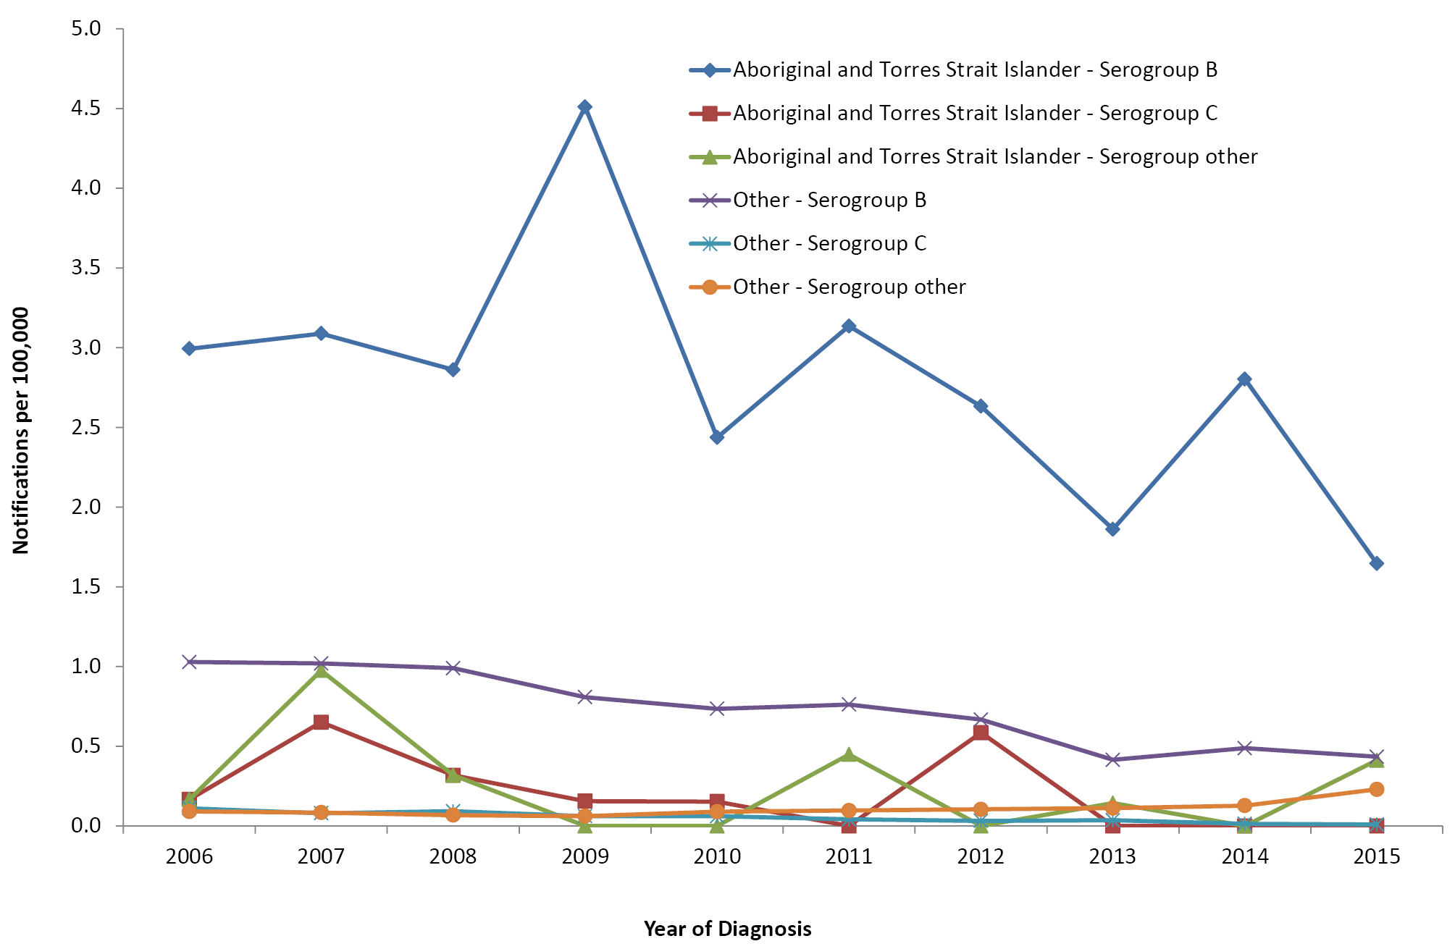
* Notifications where the date of diagnosis was between 1 January 2006 and 31 December 2015.
† ‘Serogroup other’ represents all other identified serogroups; ungroupable and ungrouped serogroups were not included.
There was an increase in the notification rate for other meningococcal serogroups in 2015, with 3 cases of meningococcal W (20% of all groupable disease) recorded in Aboriginal and Torres Strait Islander people and 31 cases of meningococcal W and 22 of meningococcal Y recorded in other people (34% of all groupable disease). Over the period 2006 to 2015, there was 1 notification of meningococcal X disease and 1 notification of meningococcal A disease, with the former in a person identified as Aboriginal and/or Torres Strait Islander. Data completeness for serogroup has improved over time, with the proportion of serogroup identified increasing from 84% in 2006 to 93% in 2015.
Detailed hospitalisation data for meningococcal disease are not reported due to known limitations with interpretation, including inability to exclude duplications due to inter-hospital transfers and readmissions, and noting the almost universal hospital admission of all identified cases of invasive disease. However, during the period 2011 to 2015, hospital admission rates were higher in Aboriginal and Torres Strait Islander people compared to those in others (all ages RR 1.6, 95% CI 1.3–2.1), especially in the 0–4 years (RR 2.8, 95% CI 2.2–3.7) and 5–14 years (RR 3.5, 95% CI 2.3–5.2) age groups.
There were 53 deaths reported in Australia for the period 2011 to 2015 with meningococcal disease recorded as the underlying or associated cause of death, 6 (11%) of which occurred in Aboriginal or Torres Strait Islander people. The highest number of deaths was in the ≥50 years age group (22, 42%).

Discussion
Routine meningococcal C vaccination for children at 12 months of age, implemented from 2003 with initial widespread catch-up for individuals aged 2–19 years, has resulted in near elimination of meningococcal C disease in all age groups.⁵⁴ Meningococcal B disease has also decreased considerably over this time, despite meningococcal B vaccine first becoming available in 2014 and not being funded under the NIP or by any state or territory program. However, serogroup B remained the predominant serogroup during 2011–2015, with the incidence of disease caused by this serogroup remaining several times higher in Aboriginal and Torres Strait people than that in other Australians.⁵⁵ In contrast, there was no historical disparity in the incidence of meningococcal C disease prior to the meningococcal C immunisation program.^{2,55} Household overcrowding has been identified as a key risk factor for meningococcal disease in New Zealand (during a meningococcal B epidemic).⁵⁶ It is likely that overcrowding, along with associated risk factors such as environmental tobacco smoke exposure,⁵⁷ contributes to higher incidence of meningococcal B disease in Aboriginal and Torres Strait Islander people.
Incidence of disease due to meningococcal W and Y started to increase in Australia towards the end of the reporting period, and continued to increase in 2016 and 2017. In 2017 adolescent meningococcal ACWY conjugate vaccination programs were funded by jurisdictional governments in Western Australia, New South Wales, Victoria, Queensland and Tasmania, and by the Australian Capital Territory in early 2018.⁵⁸ Several jurisdictions also funded broader meningococcal ACWY vaccination programs in areas affected by outbreaks, in particular an outbreak of serogroup W disease in Central Australia in 2017 which mostly affected young Aboriginal people in remote communities.⁵⁸ In February 2018, the Australian Government announced that the meningococcal ACWY vaccine would replace meningococcal C vaccine at the 12 months of age schedule point in the NIP from mid-2018.⁵⁹ Trends following these initiatives will be examined in the next of these reports.

Mumps
Mumps is an acute viral disease caused by a paramyxovirus. Mumps infection involves variable pathology and symptomatology; however, the classical presentation is characterised by fever, painful swelling and inflammation of one or more salivary glands, commonly the parotid glands. Up to 30% of cases are sub-clinical.⁸ Complications include orchitis, aseptic meningitis, encephalitis, sensorineural hearing loss and pancreatitis.⁶⁰
Relevant vaccine history
1983
Single dose of MM* vaccine funded for all Australian infants at 12 months of age
1984
Single dose of MM vaccination of Aboriginal and Torres Strait Islander children in the Northern Territory changed from 12 months to 9 months of age
1989
Single dose of MMR† vaccine recommended and funded on the national schedule at 12 months of age (9 months for Aboriginal and Torres Strait Islander infants in the Northern Territory)
1994
MMR funded as 2nd dose of mumps-containing vaccine for adolescent females
1996
MMR funded as 2nd dose of mumps-containing vaccine for all adolescents
1998
- Recommended age for 1st dose of MMR vaccine for Aboriginal and Torres Strait Islander children in the Northern Territory increased from 9 months to 12 months of age
- Recommended age for 2nd dose of MMR vaccine lowered to 4–5 years
2013
2nd dose of MMR vaccine lowered to 18 months of age, given as MMRV‡
* MM: measles and mumps
† MMR: measles, mumps and rubella
‡ MMRV: measles, mumps, rubella and varicella

Results
Notification data for mumps are presented for all jurisdictions for the period 2011 to 2015 in Table 11. Notification rates in Aboriginal and Torres Strait Islander people were significantly higher across all age groups. For all ages combined, the notification rate ratio for Aboriginal and Torres Strait Islander versus other people was 11.7 (95% CI 10.3–13.2). The lowest disparity in age-specific rates was in the 0–4 years age group (RR 2.9, 95% CI 1.3–5.9) and the highest in the 5–14 years age group (RR 18.5, 95% CI 13.8–24.7). The highest notification rates for both Aboriginal and Torres Strait Islander and other people were seen in the 15–24 years age group, with a rate of 20.0 per 100,000 per year for Aboriginal and Torres Strait Islander people and 1.3 per 100,000 per year for other people. Of the 1,404 notifications of mumps over the 2011–2015 period, Aboriginal and Torres Strait Islander status was reported for 83.9%.
Table 11: Mumps notifications, all jurisdictions, 2011 to 2015, by age and Aboriginal and Torres Strait Islander status
Age group (years) | Aboriginal and Torres Strait Islander status | Notifications (2011–2015)*
 |  | n | Rate† | Rate ratio | 95% CI for Rate ratio
0–4 | Aboriginal and Torres Strait Islander | 9 | 2.15 | 2.9 | 1.3–5.9
 | Other | 53 | 0.74
5–14 | Aboriginal and Torres Strait Islander | 101 | 12.64 | 18.5 | 13.8–24.8
 | Other | 92 | 0.68
15–24 | Aboriginal and Torres Strait Islander | 142 | 20.02 | 15.4 | 12.3–19.2
 | Other | 193 | 1.30
25–49 | Aboriginal and Torres Strait Islander | 150 | 13.90 | 12.1 | 10.0–14.6
 | Other | 453 | 1.15
≥50 | Aboriginal and Torres Strait Islander | 15 | 3.07 | 5.8 | 3.2–9.8
 | Other | 196 | 0.53
All ages‡ | Aboriginal and Torres Strait Islander | 417 | 10.35 | 11.7 | 10.3–13.2
 | Other | 987 | 0.89
* Notifications where the date of diagnosis was between 1 January 2011 and 31 December 2015.
† Average annual age-specific rate per 100,000 population.
‡ Rates for all ages combined are age-standardised to the Australian Bureau of Statistics Australian population estimates for 2011.
Trends in mumps notifications are presented for all jurisdictions for the period 2006 to 2015 in Figure 13. Notifications in Aboriginal and Torres Strait Islander people increased in 2007–2008, with a peak rate of 22.6 per 100,000 per year. Rates then returned to being similar to those in other people (below 1 per 100,000) in 2009 and remained low until 2015 when the notification rate in Aboriginal and Torres Strait Islander people increased sharply to 58.1 per 100,000 per year.
Figure 13: Mumps notification rates, all jurisdictions, 2006 to 2015,* by Aboriginal and Torres Strait Islander status
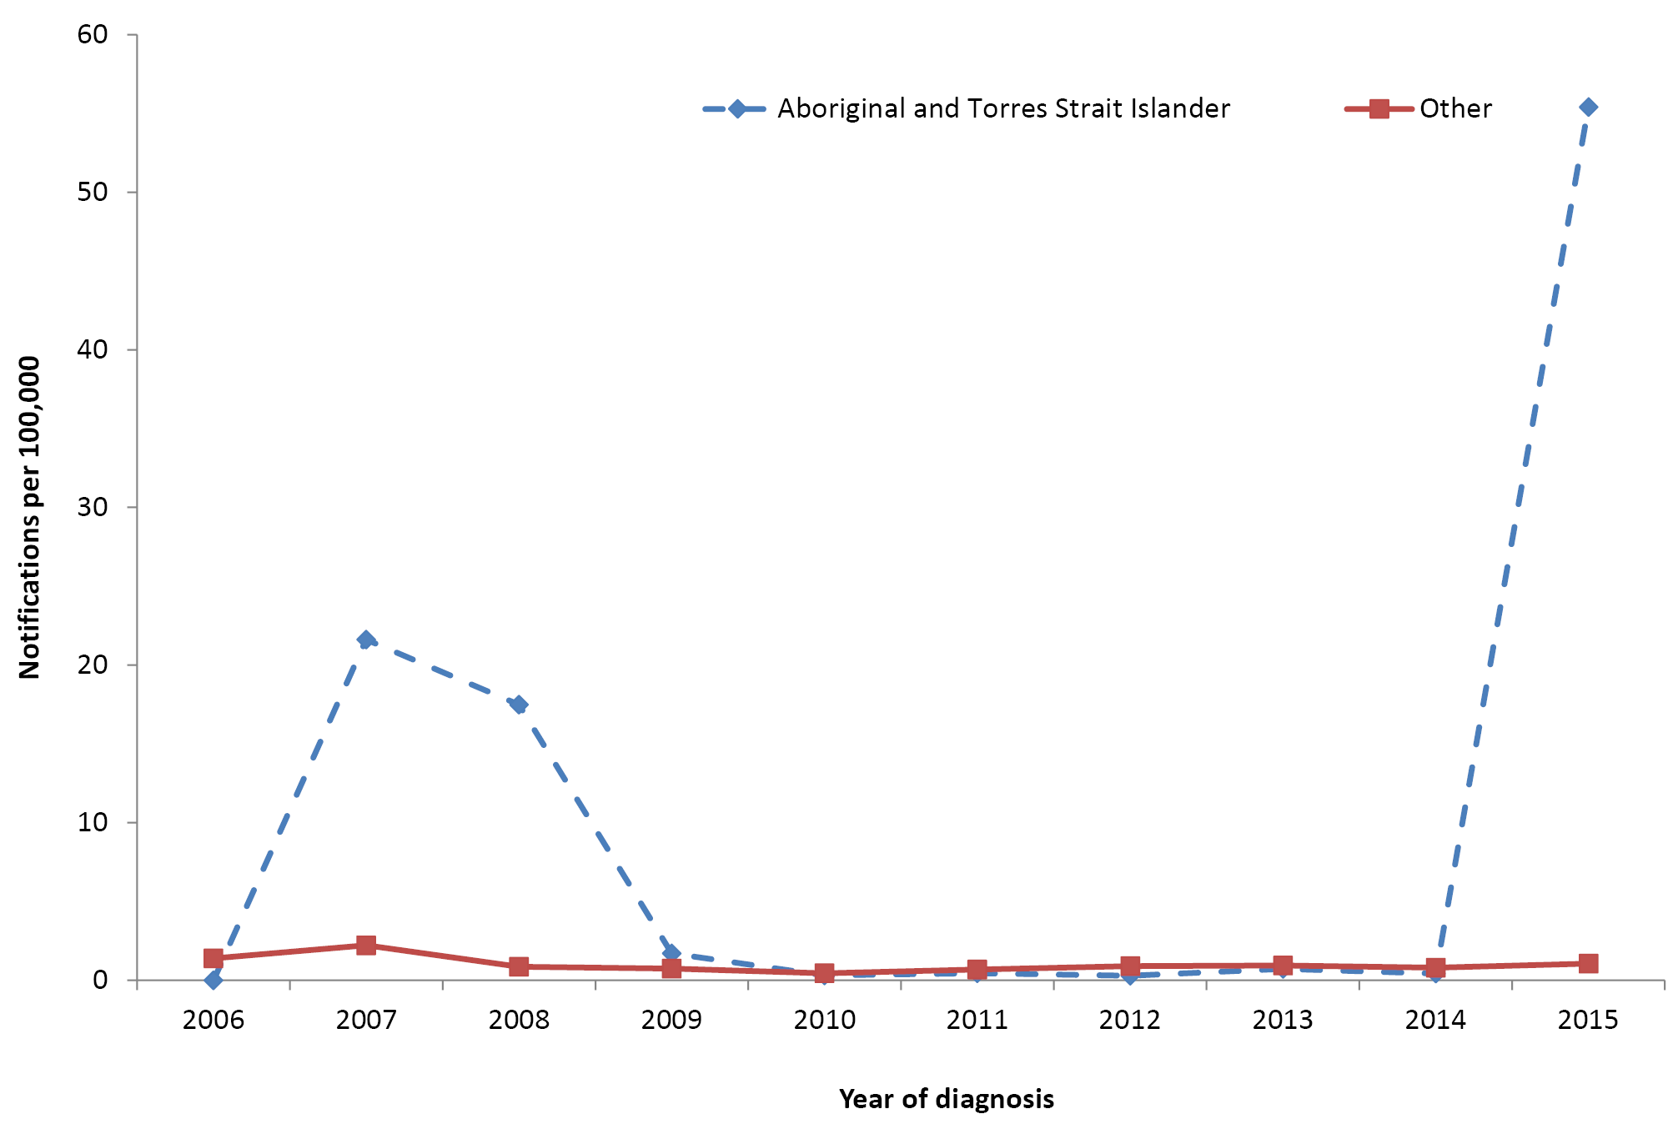
* Notifications where the date of diagnosis was between 1 January 2006 and 31 December 2015.
Hospital admission data are presented for all jurisdictions for the period 2011 to 2015 in Table 12. Hospitalisation rates were slightly higher for Aboriginal and Torres Strait Islander people across all age groups except the 0–4 years age group, although the difference was only statistically significant in the 15–24 years age group (RR 2.7, 95% CI 1.2–5.5). Trends in hospitalisations are presented for six jurisdictions (excluding Australian Capital Territory and Tasmania) in Figure 14 for the period 2006 to 2015. A large increase in hospitalisations in Aboriginal and Torres Strait Islander people was seen in 2007–2008, with another increase in 2015, a pattern similar to disease notifications over the period. Hospitalisation rates in other people remained stable and low over the entire period.
Figure 14: Mumps hospitalisation rates, selected jurisdictions,* 2006 to 2015,† by Aboriginal and Torres Strait Islander status
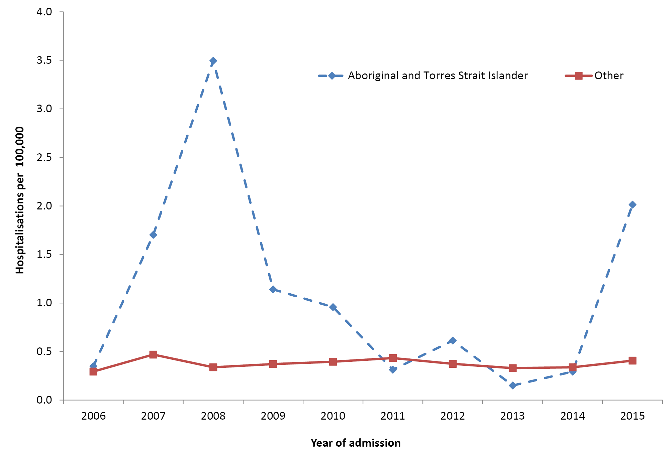
* Jurisdictions with satisfactory data quality over the whole time period (refer to Appendix A): Northern Territory, Queensland, New South Wales, Victoria, South Australia and Western Australia.
† Hospital admissions where the date of admission was between 1 January 2006 and 31 December 2015.

Table 12: Mumps hospitalisations, all jurisdictions, 2011 to 2015, by age and Aboriginal and Torres Strait Islander status
Age group (years) | Aboriginal and Torres Strait Islander status | Hospitalisations (2011–2015)*
 |  | n | Rate† | Rate ratio | 95% CI for Rate ratio
0–4 | Aboriginal and Torres Strait Islander | 1-4‡ | 0.48 | 0.9 | 0.1–3.4
 | Other | 39 | 0.55
5–14 | Aboriginal and Torres Strait Islander | 1-4‡ | 0.50 | 1.6 | 0.4–4.5
 | Other | 41 | 0.30
15–24 | Aboriginal and Torres Strait Islander | 9 | 1.27 | 2.7 | 1.2–5.5
 | Other | 69 | 0.47
25–49 | Aboriginal and Torres Strait Islander | 7 | 0.65 | 1.7 | 0.7–3.5
 | Other | 155 | 0.39
≥50 | Aboriginal and Torres Strait Islander | 1-4‡ | 0.41 | 1.3 | 0.2–4.8
 | Other | 117 | 0.32
All ages§ | Aboriginal and Torres Strait Islander | 24 | 0.63 | 1.7 | 1.0–2.6
 | Other | 421 | 0.38
* Hospital admissions where the date of admission was between 1 January 2011 and 31 December 2015.
† Average annual age-specific rate per 100,000 population.
‡ To comply with the AIHW’s data release condition that hospitalisation counts <5 be suppressed in published reports, counts between 1 and 4 are reported as a range; other cell counts may be reported as NP (not published) to avoid potential for back calculation of counts <5.
§ Rates for all ages combined are age-standardised to the Australian Bureau of Statistics Australian population estimates for 2011.

Discussion
The large increase in mumps notifications in Aboriginal and Torres Strait Islander people at the end of this reporting period was predominantly driven by an outbreak in Western Australia, which began in March 2015 and continued into 2016, and which largely affected Aboriginal adolescents and young adults living in remote communities.⁶¹ The increase in notifications in 2007–2008 was due to epidemiologically linked outbreaks in Aboriginal communities in both Western Australia and the Northern Territory.⁶² It is possible that vaccination of Aboriginal and Torres Strait Islander infants with a mumps-containing vaccine at 9 months of age from 1984 to 1998, due to their higher risk of measles at the time,⁶³ contributed to the Northern Territory outbreak. This is because immune response is poorer in infants immunised at under 12 months of age due to interference from maternal antibodies.²⁷ The notification rate in Aboriginal and Torres Strait Islander people was almost three times higher in 2015 compared to the 2007–2008 average, in contrast to the hospitalisation rate which was 20% lower. This could reflect milder disease overall in the 2015 outbreak, which occurred in a population with high levels of 2-dose vaccination coverage,⁶¹ compared to moderate levels of coverage in the 2007–2008 Western Australia outbreak,⁶⁴ and/or better ascertainment of cases of milder disease in 2015.
It is well documented that mumps antibody levels wane over time following vaccination and effectiveness (approximately 77% for one dose and 85% for two doses) is lower than that for the other components of the MMR vaccine.⁸ In recent years, outbreaks of mumps have been reported worldwide in populations with high 2-dose vaccination coverage.^{65–66} These outbreaks have predominantly occurred in close-contact communities, suggesting that waning of immunity is particularly an issue in settings where there is a high force of infection. In late 2017, the United States Advisory Committee on Immunization Practices recommended a third dose of mumps-containing vaccine for groups at increased risk of mumps during an outbreak.⁶⁷

Pertussis
Pertussis (whooping cough) is caused by Bordetella pertussis, a Gram-negative bacterium.⁸ It is characterised by an insidious onset of symptoms of minor upper respiratory infection, minimal fever and cough which becomes paroxysmal in 1–2 weeks. During the paroxysmal stage, the cough is most severe when the characteristic whoop occurs. Complications include suppurative otitis media, pneumonia, pulmonary hypertension and acute pertussis encephalopathy.⁸
Relevant vaccine history
1942
Pertussis vaccination programs started in most jurisdictions/territories using 3 doses of wholecell pertussis vaccine (Pw)
1975
First national vaccination schedule recommended and funded 4 DTPw* vaccine doses for infants at 3, 4, 5 and 18 months of age
1994
Fifth dose of DTPw vaccine added at 4–5 years of age
1999
DTPa† vaccine recommended and funded for all 5 childhood doses
2003
18-month booster replaced by adolescent dTpa‡ booster; the eligible age group varied in different jurisdictions
2008–2012
dTpa‡ vaccine funded temporarily by various jurisdictions for parents/contacts of infants under cocoon strategy during an epidemic. Program timing and eligibility criteria differed between jurisdictions
2013
A dose of dTpa‡ vaccine recommended for adults aged >65 years, if 10 years or more since the last dose
dTpa‡ vaccine recommended for women, either during pre-pregnancy planning, during the third trimester or as soon as possible after delivery
2014–2015
dTpa vaccine funded for pregnant women by all jurisdictions. Program timing differed between jurisdictions
* DTPw: diphtheria, tetanus and pertussis (whole-cell)
† DTPa: diphtheria, tetanus and pertussis (acellular)
‡ dTpa: diphtheria, tetanus and pertussis (acellular), reduced antigen content

Results
Notification data for pertussis are presented for all jurisdictions for the period 2011 to 2015, for the age groups <1, 1–4, and a summary total for <5 years, in Table 13. Notification data are presented only for children <5 years of age due to poor Aboriginal and Torres Strait Islander status completeness in other age groups (overall completeness for all ages combined 53.6%). A total of 13,509 notifications were recorded during the reporting period in children aged <5 years, 796 (6.0%) of which were reported in Aboriginal and Torres Strait Islander children. The highest pertussis notification rate was in infants aged <1 year, for both Aboriginal and Torres Strait Islander (324.8 per 100,000 per year) and other (197.7 per 100,000 per year) infants. The notification rate ratio for the <1 year age group was 1.6 (95% CI 1.5–1.9) and for <5 years 1.1 (95% CI 1.0–1.1).
Table 13: Pertussis notifications, all jurisdictions, 2011 to 2015, by age (under 5 years of age) and Aboriginal and Torres Strait Islander status
Age group (years) | Aboriginal and Torres Strait Islander status | Notifications (2011–2015)*
 |  | n | Rate† | Rate ratio | 95% CI for Rate ratio
<1 | Aboriginal and Torres Strait Islander | 279 | 324.8 | 1.6 | 1.45–1.86
 | Other | 2,831 | 197.7
1– 4 | Aboriginal and Torres Strait Islander | 517 | 155.0 | 0.9 | 0.82–0.98
 | Other | 9,882 | 173.7
<5 (total) | Aboriginal and Torres Strait Islander | 796 | 189.8 | 1.1 | 0.99–1.14
 | Other | 12,713 | 178.5
* Notifications where the date of diagnosis was between 1 January 2011 and 31 December 2015.
† Average annual age-specific rate per 100,000 population.
Hospital admission data are presented for all jurisdictions and ages for the period 2011 to 2015 in Table 14. A total of 4,548 hospitalisations for pertussis were recorded, of which 307 (6.8%) were reported in Aboriginal and Torres Strait Islander people (Table 14). The highest hospitalisation rates were seen in the <1 year age group (255.0 per 100,000 per year for Aboriginal and Torres Strait Islander and 111.8 per 100,000 per year for other children; RR 2.3, 95% CI 2.0–2.6). Hospitalisation rates in all older age groups were substantially lower, with incidence slightly but non-significantly higher for Aboriginal and Torres Strait Islander people of all ages, with a hospitalisation rate ratio of 1.6 (95% CI 1.44–1.90).

Table 14: Pertussis hospitalisations, all jurisdictions, 2011 to 2015, by age and Aboriginal and Torres Strait Islander status
Age group (years) | Aboriginal and Torres Strait Islander status | Hospitalisations* (2011–2015)
 |  | n | Rate† | Rate ratio | 95% CI for Rate ratio
<1 | Aboriginal and Torres Strait Islander | 219 | 254.98 | 2.28 | 1.97–2.63
 | Other | 1,601 | 111.79
1–4 | Aboriginal and Torres Strait Islander | 22 | 6.60 | 1.0 | 0.65–1.60
 | Other | 360 | 6.33
5–14 | Aboriginal and Torres Strait Islander | 18 | 2.25 | 1.2 | 0.69–1.91
 | Other | 256 | 1.90
15–24 | Aboriginal and Torres Strait Islander | 7 | 0.99 | 2.0 | 0.77–4.28
 | Other | 74 | 0.50
25–49 | Aboriginal and Torres Strait Islander | 17 | 1.58 | 1.3 | 0.78–1.83
 | Other | 463 | 1.17
≥50 | Aboriginal and Torres Strait Islander | 24 | 4.91 | 1.2 | 0.78–1.83
 | Other | 1,487 | 4.01
All ages‡ | Aboriginal and Torres Strait Islander | 307 | 6.20 | 1.6 | 1.44–1.90
 | Other | 4,241 | 3.80
* Hospitalisations where the date of admission was between 1 January 2011 and 31 December 2015.
† Average annual age-specific rate per 100,000 population.
‡ Rates for all ages combined are age-standardised to the Australian Bureau of Statistics Australian population estimates for 2011.
Trends in hospitalisation rates are presented for six jurisdictions (excluding Australian Capital Territory and Tasmania) for the period 2006 to 2015 in Figure 15. There were two peaks in 2009 and 2011, more marked in Aboriginal and Torres Strait Islander people, with subsequent decline.
The Aboriginal and Torres Strait Islander to other people hospitalisation rate ratio was 1.6 in 2015, compared to 2.3 in 2006.
Figure 15: Pertussis hospitalisation rates, selected jurisdictions,* 2006 to 2015,† by Aboriginal and Torres Strait Islander status
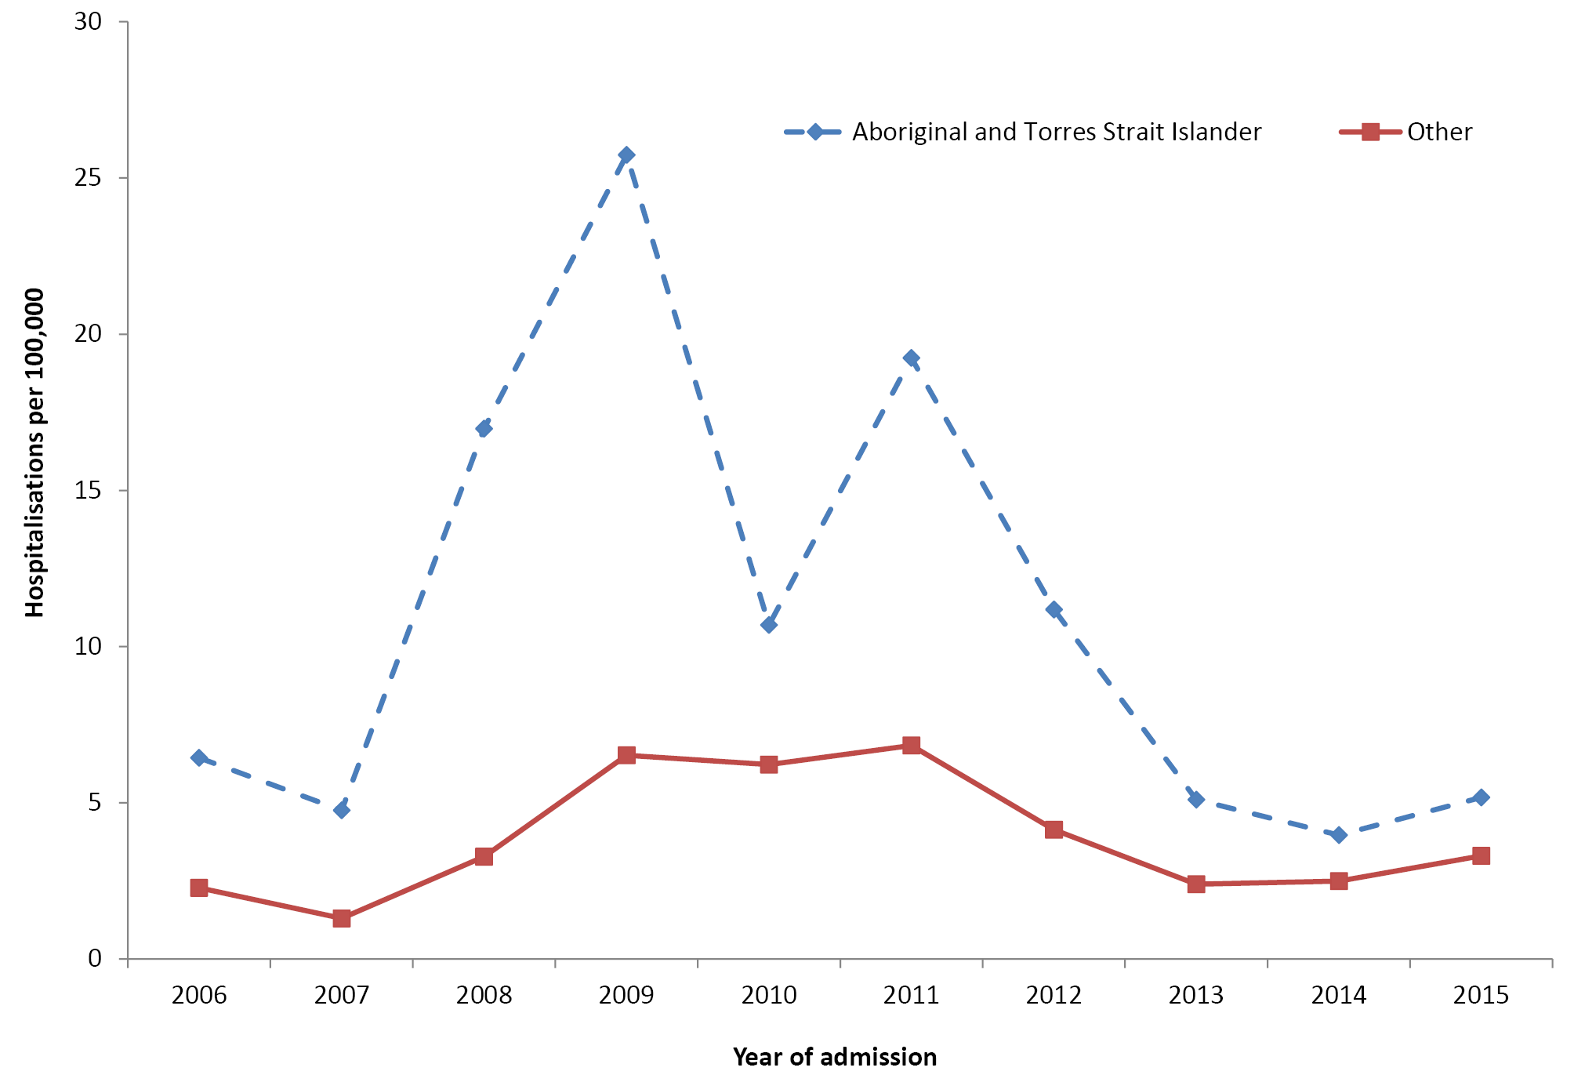
* Jurisdictions with satisfactory data quality 2006–2015; refer to Appendix A (New South Wales, Queensland, South Australia, Western Australia, Northern Territory, Victoria).
† Hospital admissions where the date of admission was between 1 January 2006 and 31 December 2015.
There were 22 deaths reported in Australia for the period 2011 to 2015 with pertussis as the underlying or associated cause of death: six in infants aged <1 year and 16 in adults aged ≥50 years. This was more than twice the 10 deaths reported during the previous 5-year period 2006 to 2010.² No deaths were identified as occurring in Aboriginal or Torres Strait Islander people.

Discussion
As recorded in previous reports, disparities in pertussis between Aboriginal and Torres Strait Islander people and other Australians are largely restricted to infants, with notification rates in this reporting period (2011–2015) 1.6 times higher and hospitalisation rates 2.3 times higher in Aboriginal and Torres Strait Islander infants. A more detailed study of age-specific hospitalisation rates from 1997–1998 to 2001–2002 found hospitalisation rates of 765 per 100,000 per year under the age of 3 months, twice that of non-Indigenous infants in the same age group.⁶⁸ The hospitalisation rate ratio was even greater between 5 and 11 months (around four-fold greater in Aboriginal and Torres Strait Islander infants), coinciding with the period when there was the greatest discrepancy in timely immunisation coverage.⁶⁸ Almost two-thirds of the total notifications (63%, 1,962/3,110) and 89% of the total hospitalisations (1620/1820) in infants aged <1 year that we report for the 2011–2015 period were in those aged <6 months, with the same proportion of notifications (63%) but a slightly lower proportion (76%) of hospitalisations in Aboriginal and Torres Strait Islander infants being in this particularly vulnerable age group.
These data demonstrate that the focus of efforts to reduce the burden of pertussis in Aboriginal and Torres Strait Islander people must be on improving protection of vulnerable infants. This should be done through improved timeliness of infant doses, particularly the first two doses which offer significant protection, and through maternal immunisation during pregnancy.

Pneumococcal disease
Pneumococcal disease is caused by the bacterium Streptococcus pneumoniae (S. pneumoniae). There are over 90 different serotypes of pneumococcus. Pneumococci colonise the upper respiratory tract in adults and, more heavily and often, in children. Pneumococci can spread locally into the upper or lower respiratory tract, causing pneumonia, otitis media or sinusitis. Pneumococci can also enter the blood stream and cause invasive systemic disease such as meningitis, bacteraemia and, less commonly, infection of other sites such as joint, pleural or peritoneal fluid.⁸
Invasive pneumococcal disease (IPD) is diagnosed through the detection of S. pneumoniae in the blood, cerebrospinal fluid or other sterile sites. A presumptive diagnosis of pneumococcal pneumonia can be made through the isolation of S. pneumoniae in the sputum and/or clinical features such as chest X-ray changes.⁶⁹
Relevant vaccine history
1986
23vPPV* funded for children aged over 2 years with increased risk of pneumococcal disease or complications, due to specified underlying conditions, living in north Western Australia and the Northern Territory
1991–1993
23vPPV funded for all Aboriginal and Torres Strait Islander people aged over 2 years living in north Western Australia
1995–1996
23vPPV funded for Aboriginal and Torres Strait Islander people aged ≥50 years in the Northern Territory (1995) and Far North Queensland (1996, including people aged 15–49 years with underlying conditions)
1997
23vPPV recommended for all Aboriginal and Torres Strait Islander adults aged >50 years
1998
23vPPV funded for Aboriginal and Torres Strait Islander adults aged >50 years and other adults aged ≥65 years in Victoria
1999
23vPPV funded nationally for all Aboriginal and Torres Strait Islander adults aged ≥50 years or aged 15–49 years with underlying conditions
2000
23vPPV eligibility in the Northern Territory changed to all Aboriginal and Torres Strait Islander people aged ≥15 years. 23vPPV eligibility in central Australia changed to all Aboriginal and Torres Strait Islander children aged 2–5 years
2001
7vPCV† funded for all Aboriginal and Torres Strait Islander infants in a 3+1 course. A booster dose of 23vPPV was funded in the Northern Territory, Queensland, South Australia and Western Australia
2005
7vPCV funded for all other children (3+0 course) and 23vPPV funded for all adults aged ≥65 years
2009
The Northern Territory replaced 7vPCV and 23vPPV in the routine childhood vaccination schedule with 10vPCV‡ using a 3+1 course
2011
13vPCV§ replaced all other pneumococcal vaccines for all children aged <2 years
2012
A 4th dose (as a booster) of 13vPCV at 12–18 months of age recommended and funded for Aboriginal and Torres Strait Islander children living in the Northern Territory, Queensland, South Australia and Western Australia to replace the 23vPPV booster.
2013 Advice provided that 1st dose of 13vPCV could be given as early as 6 weeks of age
Upper age for which 13vPCV registered for use in children extended to 17 years
2014 Age for which 13vPCV registered for use extended in adults (now registered for use in children from 6 weeks of age and adults)
* 23vPPV: 23-valent pneumococcal polysaccharide vaccine
† 7vPCV: 7-valent pneumococcal conjugate vaccine
‡ 10vPCV: 10-valent pneumococcal conjugate vaccine
§ 13VPCV: 13-valent pneumococcal conjugate vaccine

Results
Notification data for IPD are presented for all jurisdictions for the period 2011 to 2015 in Table 15. Of the total 8316 notifications recorded during the reporting period, 1152 (14%) were reported in Aboriginal and Torres Strait Islander people. Across all ages, the notification rate was 6.5 (95% CI 6.2–6.9) times higher in Aboriginal and Torres Strait Islander people than that in other people. In every age group, notification rates were more than three-fold higher in Aboriginal and Torres Strait Islander people than those in other people, ranging from 3.4 times higher (0–4 years) to 11.1 times higher (25–49 years). Of the 8,316 notifications of IPD over the 2011–2015 period, Aboriginal and Torres Strait Islander status was reported for 89.4%.

Table 15: Invasive pneumococcal disease notification rates, all jurisdictions, 2011 to 2015, by Aboriginal and Torres Strait Islander status
Age group (years) | Aboriginal and Torres Strait Islander status | Notifications* (2011–2015)
 |  | n | Rate† | Rate ratio | 95% CI for Rate ratio
0–4 | Aboriginal and Torres Strait Islander | 178 | 42.4 | 3.4 | 2.8–3.9
 | Other | 900 | 12.6
5–14 | Aboriginal and Torres Strait Islander | 129 | 16.2 | 6.5 | 5.3–8.0
 | Other | 333 | 2.5
15–24 | Aboriginal and Torres Strait Islander | 94 | 13.3 | 9.3 | 7.2–11.9
 | Other | 211 | 1.4
25–49 | Aboriginal and Torres Strait Islander | 444 | 41.2 | 11.1 | 10.0–12.4
 | Other | 1,461 | 3.7
>50 | Aboriginal and Torres Strait Islander | 307 | 62.8 | 5.5 | 4.9–6.1
 | Other | 4,259 | 11.5
All ages‡ | Aboriginal and Torres Strait Islander | 1,152 | 41.2 | 6.5 | 6.2–6.9
 | Other | 7,164 | 6.3
* Notifications where the date of diagnosis was between 1 January 2011 and 31 December 2015.
† Average annual age-specific rate per 100,000 population.
‡ Rates for all ages combined are age-standardised to the Australian Bureau of Statistics Australian population estimates for 2011.
Trends in IPD notifications are presented for all jurisdictions for the period 2006 to 2015 in Figure 16. From a low baseline, immediately after the introduction of conjugate pneumococcal vaccines in 2005, IPD notification rates progressively increased in Aboriginal and Torres Strait Islander people aged ≥50 years and varied in other age groups, such that in 2015, the notification rate was higher than that in 2006 in the 0–4 years age group and similar to that in 2006 in the 5–49 years age group. In particular, there was an increase in disease notifications in the 0–4 and 5–49 years age groups in Aboriginal and Torres Strait Islander people in 2011–2012, reaching a peak of 72 and 64 notifications per 100,000 per year, respectively. In contrast, notification rates in other people increased slightly for those aged 0–4 years up to 2011, decreasing to rates slightly below those in 2006 between 2012 and 2015, whereas notification rates in older age groups remained flat over the decade 2006 to 2015.
Figure 16: Invasive pneumococcal disease notification rates, all jurisdictions, 2006 to 2015,* by age and Aboriginal and Torres Strait Islander status
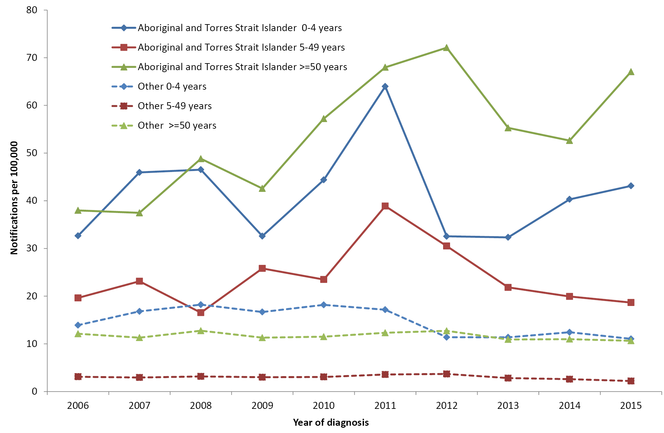
* Notifications where the date of diagnosis was between 1 January 2006 and 31 December 2015.
Pneumococcal vaccines contain a varying number of serotypes (seven in 7-valent pneumococcal conjugate vaccine [7vPCV], an additional six in 13-valent conjugate vaccine [13vPCV] and an additional 11 in 23-valent polysaccharide vaccine [23vPPV]). IPD notification rates by Aboriginal and Torres Strait Islander status and serotypes covered by these vaccines are shown by age group for two 5-year periods (2006–2010 and 2011–2015) in Figure 17.
Figure 17: Invasive pneumococcal disease notification rates for four vaccine serotype groups, all jurisdictions, 2006–2010 compared with 2011–2015, by age and Aboriginal and Torres Strait Islander status*
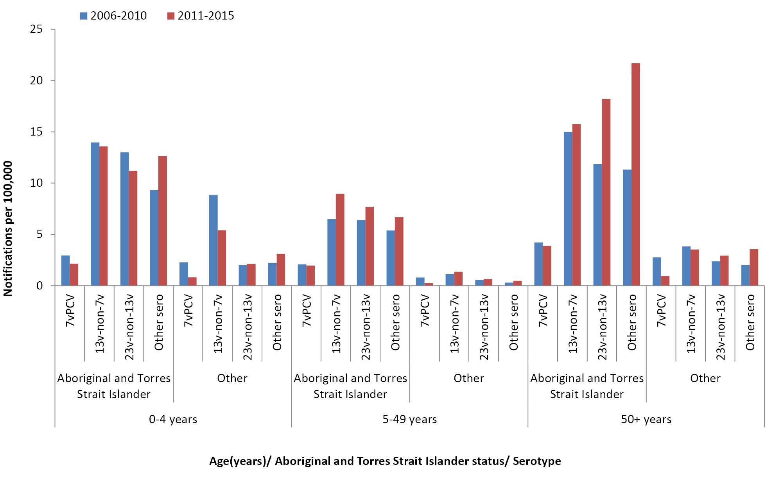
* Excludes cases with unknown serotype
Notification rates per 100,000 per year for IPD caused by serotypes in 7vPCV declined in all age groups, but much less in Aboriginal and Torres Strait Islander people (-27% for 0-4; -5% for 5-49 and -7% for ≥50 year age groups) than in other people (-65% for 0-4, -75% for 5-49, and -64% for ≥50 year age group). In the 0–4 years age group, notification rates of IPD caused by serotypes in 13vPCV but not in 7vPCV (13v–non-7v) remained stable in Aboriginal and Torres Strait Islander children aged 0–4 years but decreased by 39% in other children in the same age group. In the 5–49 years age group, notification rates of IPD caused by serotypes in 13v–non-7v increased by 38% in Aboriginal and Torres Strait Islander people compared with 18% in other people, and in those aged >50 years, there was little change in either group.
Notification rates of IPD caused by serotypes in 23vPPV but not in 13vPCV (23v–non-13v) decreased by 14% in Aboriginal and Torres Strait Islander people aged 0–4 years, but increased by 18% in those aged 5-49 years and by 53% in those aged >50 years, while there were minimal changes in other people across all age groups.
Notification rates of IPD due to ‘other’ (non-vaccine preventable) serotypes increased across all age groups, more markedly in Aboriginal and Torres Strait Islander people, especially those aged >50 years, with a 92% increase in 2011–2015 compared with that in 2006–2011 (Figure 17).
Hospitalisation data for IPD are not presented due to limitations in identifying cases of IPD using discharge diagnosis codes.
There were 223 deaths reported in Australia for the period 2011 to 2015 with IPD recorded as the underlying or associated cause of death, of which 26 (12%) were reported in Aboriginal and Torres Strait Islander people. Eleven of the 26 deaths in Aboriginal and Torres Strait Islander people (42%) were in the >50 years age group, compared to 157 out of 195 (81%) in other people.

Discussion
The disparity in IPD notification rates for all ages combined between Aboriginal and Torres Strait Islander people and other Australians almost doubled in this reporting period (2011–2015) compared to that in the previous period (2007–2010).² The five calendar years 2011–2015 correspond almost exactly to the years during which 13vPCV replaced 7vPCV in the universal NIP infant pneumococcal vaccination schedule. In the 0–4 years age group, which includes children eligible for 13vPCV doses, IPD notifications declined in both Aboriginal and Torres Strait Islander and other children. However, lesser declines in Aboriginal and Torres Strait Islander children resulted in an increase in the notification rate ratio for IPD in 2011–2015 compared to that in 2007–2010. One reason for this is the lower proportion of 13v–non-7v serotype IPD in Aboriginal and Torres Strait Islander children at the time of changeover to 13vPCV, compared with other children, in whom about 80% of the 13v–non7v burden was due to serotype 19A.^{70,71} The other factor contributing to relatively modest impact of 13vPCV in Aboriginal and Torres Strait Islander children is an outbreak of serotype 1 IPD among children living in central and northern parts of the country in 2010–2012.^{72,73} The serotype 1 outbreak primarily affected older Aboriginal children, resulting in a 30% increase in overall IPD notification rates in the 5–14 years age group (from 12.4 per 100,000 per year in 2007–10 to 16.2 per 100,000 per year in 2011–15). IPD due to 23v–non-13v serotypes declined in Aboriginal and Torres Strait Islander children but increased in others. This is unlikely to be related to vaccine changes, particularly as the 23vPPV booster offered to Aboriginal and Torres Strait Islander children in high-incidence jurisdictions was replaced with a 4th 13vPCV dose in 2012. IPD due to vaccine serotypes not included in the 13-valent vaccine increased in the 13vPCV era, in both Aboriginal and Torres Strait Islander and other groups, but to date no dominant replacement serotypes have emerged. ^{19,70}
The markedly higher IPD incidence in Aboriginal and Torres Strait Islander adults is likely contributed to by the relatively higher prevalence of underlying medical conditions, tobacco smoking and hazardous levels of alcohol consumption, all of which increase susceptibility to pneumococcal disease and carriage.^{27,74} The high proportion of IPD due to serotypes not in 13PCV or 23vPPV among Aboriginal and Torres Strait Islander adults is consistent with the wide serotype distribution of colonising pneumococcal serotypes in Aboriginal and Torres Strait Islander children.⁷⁵ Notification rates for IPD due to 13v–non-7v serotypes have not declined in Aboriginal and Torres Strait Islander adults living in Northern Territory, South Australia, Western Australia and Queensland, despite children in those jurisdictions being offered a booster dose of 13vPCV, in contrast to reductions in other adults and experience in First Nations populations in Alaska.⁷⁶ Reductions in 7v serotype IPD in Aboriginal and Torres Strait Islander people were also lower in children aged 0–4 years and negligible in older age groups compared with the reductions in other Australians. Possible contributing factors are poorer timeliness of 13vPCV doses⁴⁹ and a higher density of nasopharyngeal colonisation in Aboriginal and Torres Strait Islander children and adults.⁷⁷
Although improved vaccine coverage and timeliness would be likely to help reduce the vaccinepreventable burden of pneumococcal disease in Aboriginal and Torres Strait Islander people, relatively high levels of non-vaccine–type disease and colonisation mean that additional measures are needed. Vaccines with broader serotype coverage currently under development may have an impact,⁷⁸ but household crowding, tobacco smoke exposure and other non-vaccine factors that play a key role in pneumococcal carriage and disease transmission in Aboriginal and Torres Strait Islander communities also need to be addressed.

Rotavirus
Rotavirus is a common cause of viral gastrointestinal infection in young children.⁸ The severity of rotavirus infection primarily depends on previous exposure to rotavirus. Infections are more likely to be severe in children aged 3–24 months. Rotavirus infection can range from asymptomatic infection to mild diarrhoea to severe gastroenteritis with dehydration. Most disease is mild, but about 1 in 75 children will develop severe disease, causing dehydration.⁸
Relevant vaccine history
2006
Vaccination recommended and funded for infants in the Northern Territory using monovalent rotavirus vaccine in a 2-dose schedule (2 and 4 months of age)
2007
Funded national immunisation commenced, with each state and territory using either a 2-dose schedule of monovalent rotavirus vaccine (2 and 4 months of age) or a 3-dose schedule of multivalent rotavirus vaccine (2, 4 and 6 months of age)
2013
Advice provided that 1st dose of rotavirus vaccine could be given as early as 6 weeks of age

Results
Notification data for rotavirus have not been included in this report, as rotavirus was not nationally notifiable during the whole reporting period. Hospitalisation data for all jurisdictions for the 5 years, 2011 to 2015, are shown in Table 16. Of the total 6,325 hospital admissions coded as rotavirus, 822 (13%) were reported in Aboriginal and Torres Strait Islander people. The highest hospitalisation rates occurred in the 0–4 years age group (172.8 per 100,000 per year for Aboriginal and Torres Strait Islander and 38.3 per 100,000 per year for other children); and Aboriginal and Torres Strait Islander children aged <5 years were 4.5 times (95% CI 4.1–4.9) more likely to be hospitalised. Rates were also higher in Aboriginal and Torres Strait Islander people aged ≥25 years, although these rates were much lower than those in the 0–4 years age group. Overall, Aboriginal and Torres Strait Islander people were 2.9 times (95% CI 2.6–3.2) more likely to be hospitalised than others.

Table 16: Rotavirus hospitalisation rates, all jurisdictions, 2011 to 2015,* by age group and Aboriginal and Torres Strait Islander status
Age group (years) | Aboriginal and Torres Strait Islander status | Hospitalisations (2011 – 2015)*
 |  | n | Rate† | Rate ratio | 95% CI for Rate ratio
0–4 | Aboriginal and Torres Strait Islander | 725 | 172.8 | 4.5 | 4.1–4.9
 | Other | 2731 | 38.3
5–14 | Aboriginal and Torres Strait Islander | 44 | 5.5 | 0.6 | 0.5–0.9
 | Other | 1167 | 8.7
15–24 | Aboriginal and Torres Strait Islander | 5 | 0.7 | 0.8 | 0.3–2.0
 | Other | 126 | 0.9
25–49 | Aboriginal and Torres Strait Islander | 22 | 2.0 | 2.9 | 1.8–4.5
 | Other | 276 | 0.7
>50 | Aboriginal and Torres Strait Islander | 26 | 5.3 | 1.6 | 1.1–2.4
 | Other | 1203 | 3.3
All ages‡ | Aboriginal and Torres Strait Islander | 822 | 14.5 | 2.9 | 2.6–3.2
 | Other | 5503 | 5.0
* Hospital admissions where the date of admission was between 1 January 2011 and 31 December 2015.
† Average annual age-specific rate per 100,000 population.
‡ Rates for all ages combined are age-standardised to the Australian Bureau of Statistics Australian population estimates for 2011.
There were six deaths recorded in Australia for the period 2011 to 2015 with rotavirus reported as the underlying or associated cause of death, none of which were in Aboriginal or Torres Strait Islander people. All recorded deaths were in the >50 years age group.
Trends in rotavirus hospitalisations in children aged <5 years over the decade 2006 to 2015 are shown for six jurisdictions (those with a sufficient level of Aboriginal and Torres Strait Islander completeness) in Figure 18. Comparing the calendar years 2006 and 2015, the hospitalisation rate in Aboriginal and Torres Strait Islander children decreased by 64% in those aged <1 year and by 62% in those aged 1–4 years. However, the reduction in rotavirus hospitalisation rate was proportionally greater among other Australian children (83% in the <1 year age group and 90% in the 1–4 years age group). As a result, the disparity in hospitalisation rates between Aboriginal and Torres Strait Islander and other children increased, from 3.0 times higher in 2006 to 6.2 times higher in 2015 for children aged <1 year, and from 0.8 times lower in 2006 to 3.2 times higher in 2015 in those aged 1–4 years.
Figure 18: Rotavirus hospitalisation rates, selected jurisdictions,* 2006 to 2015,† by age (<5 years) and Aboriginal and Torres Strait Islander status
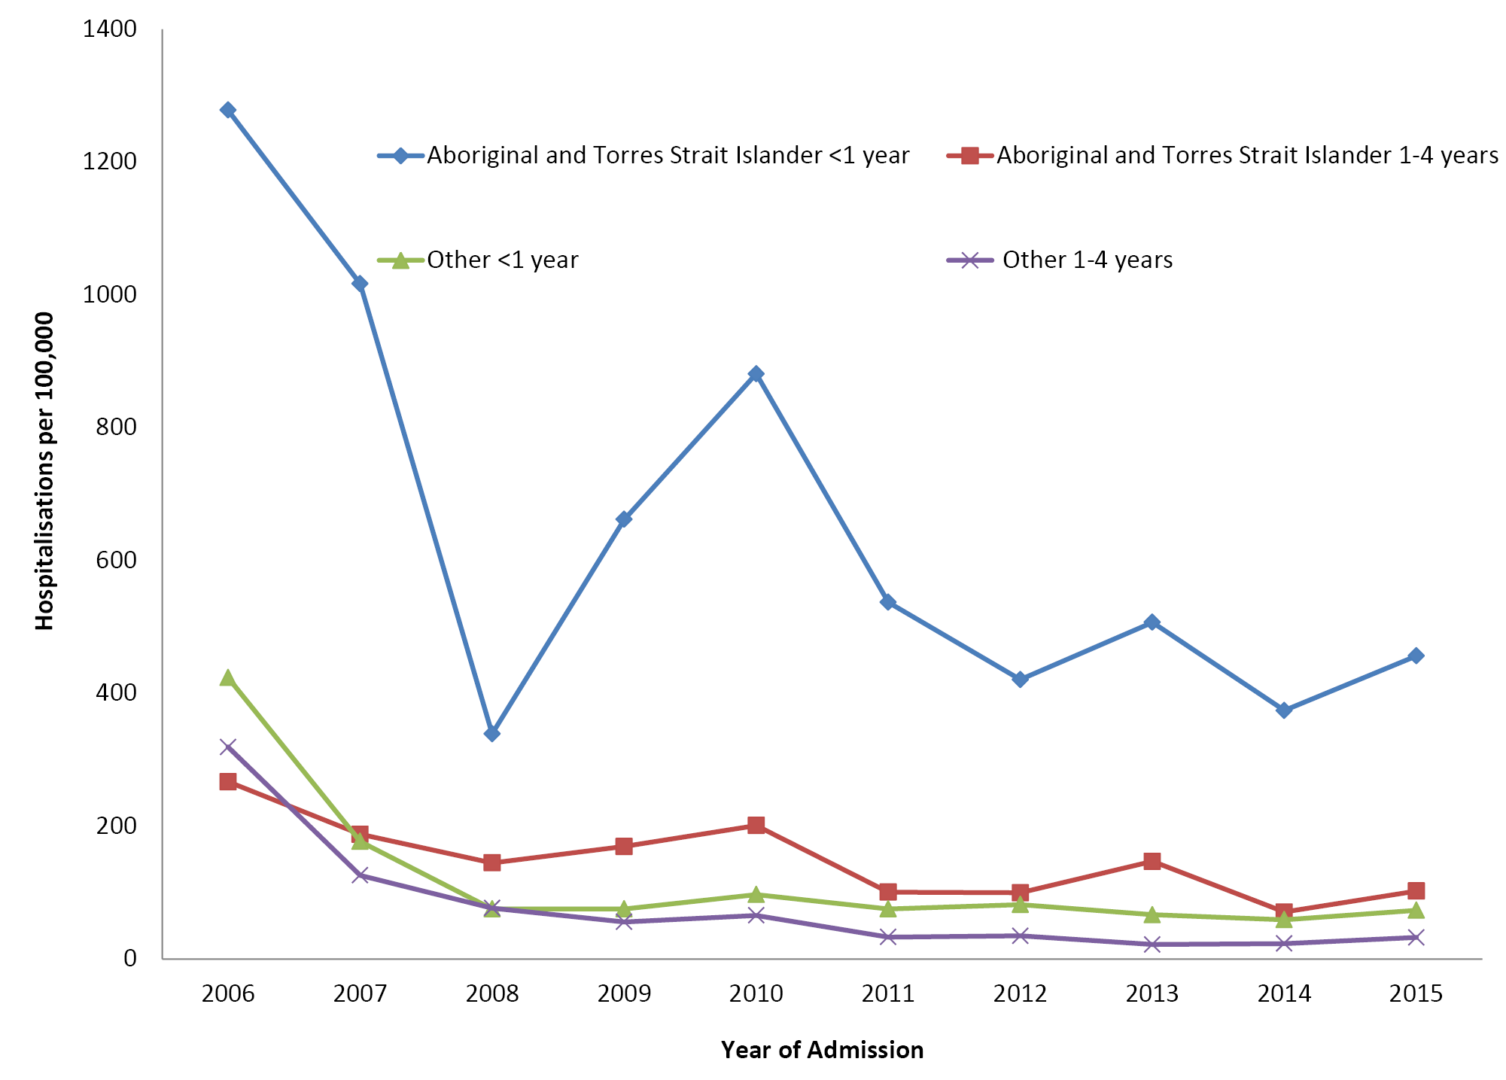
* Jurisdictions with satisfactory data quality over the whole time period; refer to Appendix A (Northern Territory, Queensland, New South Wales, Victoria, South Australia and Western Australia).
† Hospital admissions where the date of admission was between 1 January 2006 and 31 December 2015.

Discussion
After initial steep reductions in the rotavirus hospitalisation rate in all children aged <5 years in the years following the implementation of the national rotavirus immunisation program in 2007, rates were largely stable from 2011 to 2015. The decline in hospitalisation rates has been lower, in relative terms, in Aboriginal and Torres Strait Islander children, with the rate in Aboriginal and Torres Strait Islander infants remaining particularly high. Herd protection effects of the rotavirus immunisation program in older age groups have been documented in previous Australian studies analysing notification⁷⁹ and hospitalisation^{80,81} data. Our analyses show a relatively low hospitalisation rate in all age groups >5 years, but a significantly higher rate in Aboriginal and Torres Strait Islander people aged >25 years than in other adults in the same age group. This could reflect greater circulation of rotavirus in Aboriginal and Torres Strait Islander communities and/or increased vulnerability to more severe disease due to higher prevalence of comorbidities with increasing age.
Rotavirus vaccines have been found to be less effective in resource-poor settings,^{82,83} possibly related to prevalence of other gastrointestinal pathogens, immune compromise, higher maternal antibody levels and/or interference from breast milk.⁸ Such factors could also have an impact in some Aboriginal and Torres Strait Islander communities, although previous estimates of vaccine effectiveness in the Northern Territory have varied.⁸⁴
Two rotavirus vaccines are available and their use has varied by jurisdiction: Rotarix®, a monovalent human G1P[8] vaccine which requires 2 doses (2 and 4 months of age), and RotaTeq®, a pentavalent human-bovine reassortant vaccine containing G1, G2, G3, G4 and P[8] genotypes, which requires 3 doses (2, 4 and 6 months). As of 1 July 2017, Rotarix® became the only vaccine used under the NIP, replacing RotaTeq® vaccine in Western Australia, South Australia, Victoria, and Queensland. While it remains unclear whether the two vaccines differ in their effectiveness against particular genotypes, the vaccination coverage achieved in Aboriginal and Torres Strait Islander children in jurisdictions using the 2-dose schedule of Rotarix® has been substantially higher than that in jurisdictions using the 3-dose RotaTeq® vaccine (refer to Vaccination Coverage section). This is probably related to the strict upper age cut-offs for rotavirus vaccines and more frequent delayed vaccination of Aboriginal and Torres Strait Islander infants. The use of Rotarix® in all jurisdictions from 2017 might thus be expected to improve vaccine coverage, and possibly disease control (although an observational study in the United States has suggested that 2 doses of RotaTeq® may have similar vaccine effectiveness to 2 doses of Rotarix®)⁸⁵ – this will be assessed in the next of these reports.

Varicella-zoster virus infection
The varicella-zoster virus (VZV) causes two distinct diseases, varicella (chickenpox) and herpes zoster (shingles). Varicella is highly contagious and generally a benign, self-limiting illness in children; however, adults have significantly higher morbidity and mortality than children. Acute varicella may be complicated by secondary bacterial infection of the skin, pneumonia, encephalitis, cerebellar ataxia, arthritis, appendicitis, hepatitis, glomerulonephritis, pericarditis and orchitis.⁸ Herpes zoster is a reactivation of VZV that has lain dormant, usually for years, causing a painful, localised rash in a dermatomal distribution. The most common complication of herpes zoster is post-herpetic neuralgia; other potential complications include ophthalmic disease, neurological complications, secondary bacterial infections and scarring.⁸
Relevant vaccine history
2003
Varicella vaccine recommended for all children aged 18 months and 10–13 years without prior history of infection
2005
Varicella vaccination funded nationally, at 18 months and 10–13 years of age, for children without prior history of infection
2006
All jurisdictions commenced school-based catch-up varicella vaccination for one cohort each year of adolescents aged 10–13 years without prior history of infection
2013
MMRV vaccine recommended and funded for the single dose of varicella vaccine scheduled at 18 months of age

Results
VZV infection notifications are not reported, as most are unspecified (not designated as varicella or zoster). Hospitalisation data for varicella are presented for all jurisdictions for the period 2011 to 2015 in Table 17.

Table 17: Varicella (chickenpox) hospitalisations, all jurisdictions, 2011 to 2015,* by age and Aboriginal and Torres Strait Islander status
Age group (years) | Aboriginal and Torres Strait Islander status | Hospitalisations (2011–2015)*
 |  | n | Rate† | Rate ratio | 95% CI for Rate ratio
0–4 | Aboriginal and Torres Strait Islander | 51 | 12.2 | 2.1 | 1.5–2.8
 | Other | 415 | 5.8
5–14 | Aboriginal and Torres Strait Islander | 33 | 4.1 | 1.7 | 1.2–2.5
 | Other | 319 | 2.4
15–24 | Aboriginal and Torres Strait Islander | 21 | 3.0 | 1.5 | 0.9–2.3
 | Other | 291 | 2.0
25–49 | Aboriginal and Torres Strait Islander | 29 | 2.7 | 1.0 | 0.7–1.5
 | Other | 1,026 | 2.6
50+ | Aboriginal and Torres Strait Islander | 17 | 3.5 | 0.7 | 0.4–1.2
 | Other | 1,726 | 4.7
All ages‡ | Aboriginal and Torres Strait Islander | 151 | 3.5 | 1.1 | 0.9–1.3
 | Other | 3,777 | 3.4
* Hospital admissions where the date of admission was between 1 January 2011 and 31 December 2015.
† Average annual age-specific rate per 100,000 population.
‡ Rates for all ages combined are age-standardised to the Australian Bureau of Statistics Australian population estimates for 2011.
A total of 3928 hospital admissions for varicella were recorded during this reporting period, of which 151 (0.5%) were reported in Aboriginal and Torres Strait Islander people (Table 17). Hospitalisation rates were highest in the youngest age group (0–4 years), with the rate in Aboriginal and Torres Strait Islander children twice as high as the rate in other children in this age group (RR 2.1, 95% CI 1.5–2.8). Hospitalisation rates were also higher in Aboriginal and Torres Strait Islander children in the 5–14 years age group (RR 1.7, 95% CI 1.2–2.5). In other age groups, rates of hospitalisation were similar for Aboriginal and Torres Strait Islander and other people.
Of 34,817 hospitalisations for herpes zoster recorded during this reporting period, 562 (1.6%) were reported in Aboriginal and Torres Strait Islander people (Table 18). Hospitalisation rates for herpes zoster increased with age and were higher in Aboriginal and Torres Strait Islander people than in other people in the 5–14 years (RR 1.9, 95% CI 1.2–2.7) and 25–49 years (RR 2.2, 95% CI 1.9–2.6) age groups, but lower in the >50 years age group (RR 0.8, 95% CI 0.7–0.9) (Table 18).

Table 18: Herpes zoster (shingles) hospitalisations, all jurisdictions, 2011 to 2015,* by age and Aboriginal and Torres Strait Islander status
Age group (years) | Aboriginal and Torres Strait Islander status | Hospitalisations (2011–2015)*
 |  | n | Rate† | Rate ratio | 95% CI for Rate ratio
0–4 | Aboriginal and Torres Strait Islander | 8 | 1.91 | 2.0 | 0.8–4.2
 | Other | 68 | 0.95
5–14 | Aboriginal and Torres Strait Islander | 31 | 3.88 | 1.9 | 1.2–2.7
 | Other | 280 | 2.08
15–24 | Aboriginal and Torres Strait Islander | 33 | 4.65 | 1.4 | 0.9–1.9
 | Other | 506 | 3.42
25–49 | Aboriginal and Torres Strait Islander | 170 | 15.76 | 2.2 | 1.9–2.6
 | Other | 2,807 | 7.11
50+ | Aboriginal and Torres Strait Islander | 320 | 65.47 | 0.8 | 0.7–0.9
 | Other | 30,594 | 82.55
All ages‡ | Aboriginal and Torres Strait Islander | 562 | 27.75 | 0.9 | 0.9–1.0
 | Other | 34,255 | 29.70
* Hospital admissions where the date of admission was between 1 January 2011 and 31 December 2015.
† Average annual age-specific rate per 100,000 population.
‡ Rates for all ages combined are age-standardised to the Australian Bureau of Statistics Australian population estimates for 2011.
Trends in the incidence of hospitalisations coded as varicella and herpes zoster are presented separately for six jurisdictions (excluding Australian Capital Territory and Tasmania) for the decade 2006–2015 (Figure 19 and Figure 20). For all age groups combined, varicella hospitalisation rates decreased for both Aboriginal and Torres Strait Islander and other people during the 10-year period, with the gap closing such that rates were similar in 2015. Herpes zoster hospitalisation rates for all age groups combined increased in both Aboriginal and Torres Strait Islander and other people over the period, although with greater fluctuation of rates in Aboriginal and Torres Strait Islander people due to smaller numbers.
Figure 19: Varicella (chickenpox) hospitalisation rates, selected jurisdictions,* 2006 to 2015,† by Aboriginal and Torres Strait Islander status
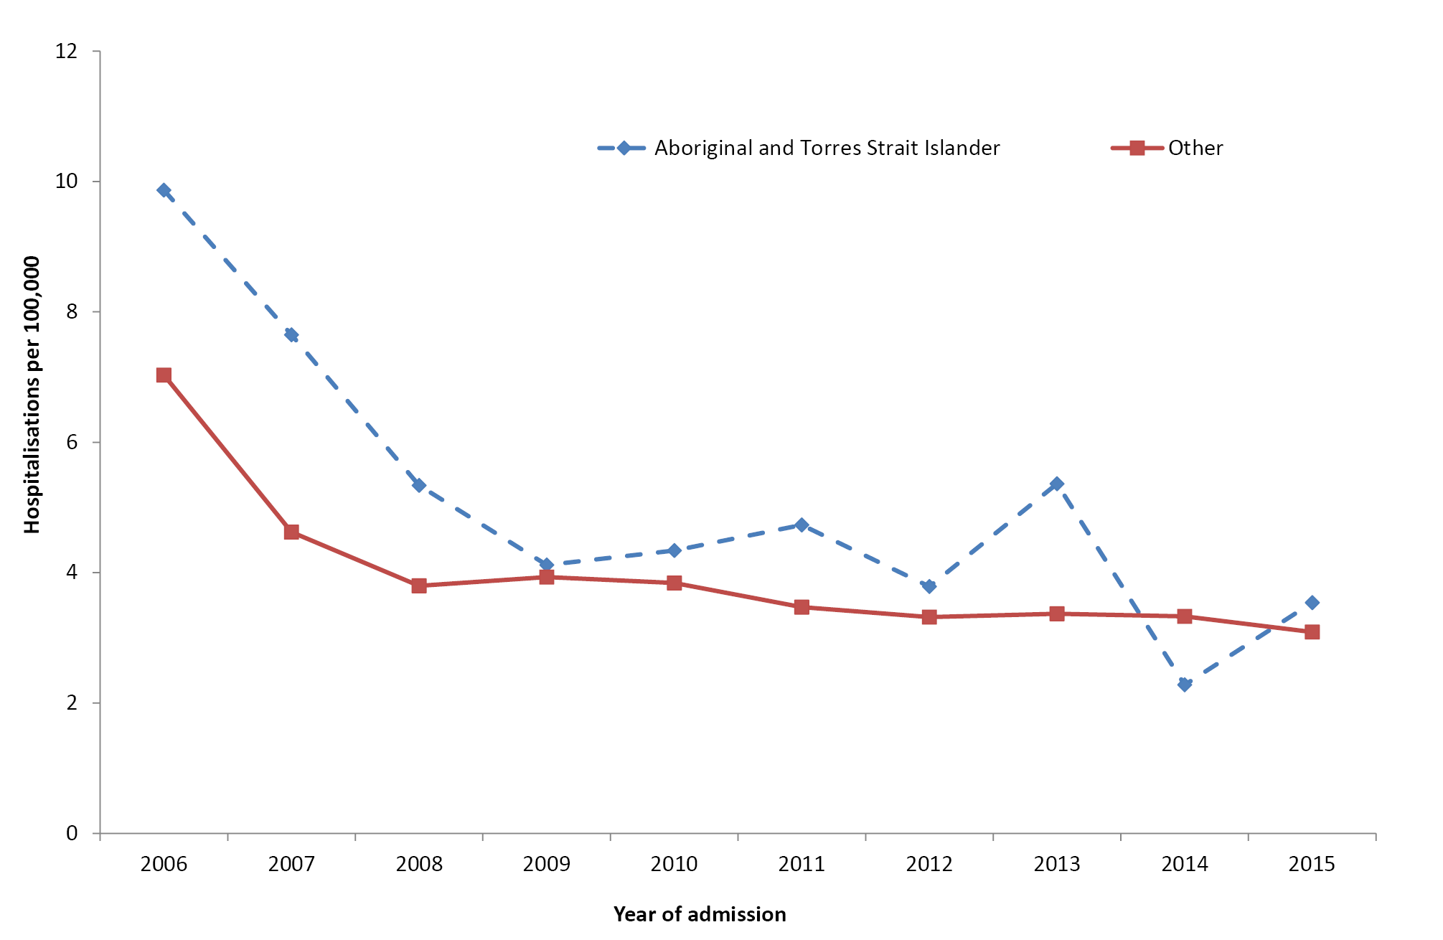
* Jurisdictions with satisfactory data quality over the whole time period; refer to Appendix A (Northern Territory, Queensland, South Australia, Western Australia, New South Wales and Victoria).
† Hospital admissions where the date of admission was between 1 January 2006 and 31 December 2015. Rates for all ages combined are age-standardised to the Australian Bureau of Statistics Australian population estimates for 2011.
Figure 20: Herpes zoster (shingles) hospitalisation rates, selected jurisdictions,* 2006 to 2015,† by Aboriginal and Torres Strait Islander status
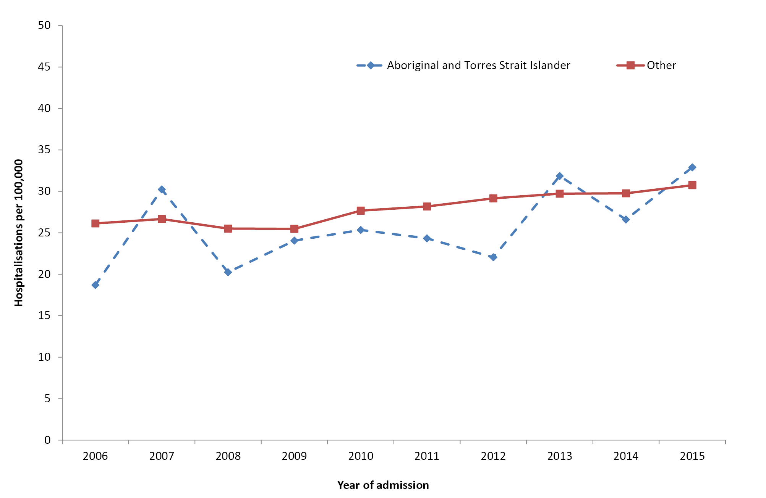
* Jurisdictions with satisfactory data quality over the whole time period; refer to Appendix A (Northern Territory, Queensland, South Australia, Western Australia, New South Wales and Victoria).
† Hospital admissions where the date of admission was between 1 January 2006 and 31 December 2015. Rates for all ages combined are age-standardised to the Australian Bureau of Statistics Australian population estimates for 2011.
There were 55 deaths recorded in Australia for the period 2011 to 2015 with varicella as the underlying or associated cause of death, of which 1–3 were reported in Aboriginal and Torres Strait Islander people. There were 475 deaths recorded in Australia for the period 2011 to 2015 with herpes zoster as the underlying or associated cause of death, of which 1–3 were reported as occurring in Aboriginal and Torres Strait Islander people.

Discussion
Hospitalisation rates for varicella decreased sharply, in both Aboriginal and Torres Strait Islander people and other Australians, in the first 2 years of the introduction of the national varicella immunisation program in 2005, with much more gradual decline since. The overall varicella hospitalisation rate in the 5-year period 2011–2015 was similar for Aboriginal and Torres Strait Islander and other Australians, as opposed to the two-fold disparity observed in the previous 5-year period 2006–2010.² However, the hospitalisation rate in Aboriginal and Torres Strait Islander children aged <15 years remained approximately twice as high as the rate in other children.
Previous analyses of Australian hospitalisation data through to 2013 documented an 84% reduction in hospitalisation rates in the post-varicella vaccine period in children aged 18–59 months, with significant herd protection effects seen in children aged <18 months (67% reduction) and adults in the 20–29 years and 30–39 years age groups (65% and 44% reduction, respectively).⁸⁶ An >85% reduction in neonatal varicella and 100% reduction in congenital varicella have also been demonstrated.⁸⁷
In comparison to varicella, there has been a gradual increase in herpes zoster hospitalisation rates in both Aboriginal and Torres Strait Islander and other people. Other Australian studies have documented increases in notifications of herpes zoster,⁸⁶ along with community-based consultations and emergency department presentations, which may be due to a combination of ageing of the population, greater use of immunosuppressive medications and reduced natural boosting from circulating VZV.^{88–91} The national herpes zoster immunisation program was introduced in November 2016 for people aged 70 years, with a time-limited catch up for those aged up to 79 years. Our analyses showed a slightly lower rate of herpes zoster hospitalisation in Aboriginal and Torres Strait Islander people aged >50 years than that in other people in this age group. However, a previously published and more detailed breakdown by age group for the 2007–2011 period found a significantly higher rate of herpes zoster hospitalisation in Aboriginal and Torres Strait Islander people aged 60–69 years (RR 1.8, 95% CI 1.3–2.5), suggesting there was a case to extend funded vaccination in Aboriginal and Torres Strait Islander people to commence from 60 years, as opposed to the current 70 years.⁹²

Rare diseases
Four vaccine preventable diseases, now rare in Australia due to successful immunisation programs, are discussed together in this section – diphtheria, tetanus, poliomyelitis and rubella. Notification, hospitalisation and death data are presented for all diseases and jurisdictions for the period 2011 to 2015. Refer to the 2016 report Vaccine Preventable Diseases in Australia, 2008 to 2011 for more detailed information on these diseases.⁶⁹

Diphtheria and Tetanus
Relevant vaccine history
No difference in vaccination programs between Aboriginal and Torres Strait Islander and other people
1932
School-based diphtheria vaccination programs commenced
1975
First national vaccination schedule recommended and funded 4 DTPw* doses for infants at 3, 4, 5 and 18 months of age; booster doses of tetanus toxoid recommended every 5 years
1978
4th dose removed from schedule (reinstated 1985)
1982
Booster doses of tetanus toxoid recommended every 10 years (changed to dT from 1984)
1994
5th dose added at 4–5 years of age
1999
DTPa† vaccine recommended and funded for all 5 childhood DTP doses
2000
A single dT booster dose recommended at 50 years of age (unless documented within the last 10 years), replacing the recommendation for dT booster doses every 10 years
2003
18-month booster replaced by adolescent dose; the eligible age group varied by jurisdiction
2008–2012
dTpa‡ vaccine funded temporarily by various jurisdictions for parents/contacts of infants during pertussis epidemic. Program timing and eligibility criteria differed by jurisdiction
2015
Booster dose of DTPa vaccine recommended at 18 months of age (funded from 2016)
* DTPw: Diphtheria-tetanus-pertussis (whole-cell)
† DTPa: Diphtheria-tetanus-pertussis (acellular)
‡ dTpa: Adolescent/adult diphtheria- tetanus-pertussis (acellular)

Diphtheria
Diphtheria is an acute pharyngeal or cutaneous infection caused by toxigenic strains of the bacterium Corynebacterium diphtheriae. The major threat of diphtheria is fatal acute respiratory obstruction. Diphtheria infection can also occur in skin lesions in warm climates and under conditions of poor hygiene.⁸ The severe symptoms of diphtheria are associated with a toxin produced by the organism. Non-toxigenic forms can cause mild respiratory and skin infections.
There were 11 diphtheria notifications during the period 2011 to 2015, with one reported in an Aboriginal and Torres Strait Islander person (Table 19). Of the 11 notifications, Aboriginal and Torres Strait Islander status was reported for eight.
There were 82 diphtheria hospital admissions during the period 2011 to 2015, with 27 (33%) reported in Aboriginal and Torres Strait Islander people (Table 20). The rate of diphtheria hospitalisation was higher in Aboriginal and Torres Strait Islander people in all age groups, the highest rate being in the >50 years age group (1.6 per 100,000 per year). The Aboriginal and Torres Strait Islander people to others hospitalisation rate ratio in this age group was 25.3 (95% CI 9.6–64.1). Given that there were no notifications in Aboriginal and Torres Strait Islander people in this age group, the hospitalisations most likely represent non-toxigenic cutaneous cases or coding errors. Only toxigenic diphtheria is notifiable, and notifications are regarded as the most reliable source of data, as public health follow-up and laboratory confirmation are routine.
Table 19: Notifications* for diphtheria, tetanus, poliomyelitis and rubella, all jurisdictions, 2011 to 2015, by age and Aboriginal and Torres Strait Islander status
Age group  (years) | Aboriginal and Torres Strait Islander status | Diphtheria |  | Tetanus |  | Poliomyelitis |  | Rubella
 |  | n | Rate† | n | Rate† | n | Rate† | n | Rate†
0–4 | Aboriginal and Torres Strait Islander | 0 | 0.00 | 0 | 0.00 | 0 | 0.00 | 2 | 0.48
 | Other | 0 | 0.00 | 0 | 0.00 | 0 | 0.00 | 7 | 0.10
5–14 | Aboriginal and Torres Strait Islander | 0 | 0.00 | 0 | 0.00 | 0 | 0.00 | 0 | 0.00
 | Other | 0 | 0.00 | 0 | 0.00 | 0 | 0.00 | 3 | 0.02
15–24 | Aboriginal and Torres Strait Islander | 1 | 0.14 | 0 | 0.00 | 0 | 0.00 | 0 | 0.00
 | Other | 4 | 0.03 | 2 | 0.01 | 0 | 0.00 | 28 | 0.19
25–49 | Aboriginal and Torres Strait Islander | 0 | 0.00 | 0 | 0.00 | 0 | 0.00 | 0 | 0.00
 | Other | 3 | 0.01 | 4 | 0.01 | 0 | 0.00 | 95 | 0.24
≥50 | Aboriginal and Torres Strait Islander | 0 | 0.00 | 0 | 0.00 | 0 | 0.00 | 0 | 0.00
 | Other | 3 | 0.01 | 13 | 0.04 | 0 | 0.00 | 22 | 0.06
All ages‡ | Aboriginal and Torres Strait Islander | 1 | 0.02 | 0 | 0.00 | 0 | 0.00 | 2 | 0.03
 | Other | 10 | 0.01 | 19 | 0.02 | 0 | 0.00 | 155 | 0.14
* Notification where date of diagnosis was between 1 January 2011 and 31 December 2015.
† Average annual age-specific rate per 100,000 population.
‡ Rates for all ages combined are age-standardised to the Australian Bureau of Statistics Australian population estimates for 2011.

Table 20: Hospitalisations* for diphtheria, tetanus, poliomyelitis and rubella, all jurisdictions, 2011 to 2015, by age and Aboriginal or Torres Strait Islander status
Age group  (years) | Aboriginal and Torres Strait Islander status | Diphtheria |  | Tetanus |  | Poliomyelitis |  | Rubella
 |  | n | Rate† | n | Rate† | n | Rate† | n | Rate†
0–4 | Aboriginal and Torres Strait Islander | 1-4 | 0.48 | 0 | 0.00 | 0 | 0.00 | 1-4‡ | 0.24
 | Other | 1-4‡ | 0.01 | 1-4‡ | 0.01 | 0 | 0.00 | 8 | 0.11
5–14 | Aboriginal and Torres Strait Islander | 5 | 0.63 | 1-4† | 0.13 | 0 | 0.00 | 0 | 0.00
 | Other | 0 | 0.00 | 0 | 0.00 | 0 | 0.00 | 1-4‡ | 0.02
15–24 | Aboriginal and Torres Strait Islander | 1-4† | 0.42 | 1-4‡ | 0.14† | 0 | 0.00 | 1-4‡ | 0.14
 | Other | 1-4† | 0.02 | NP‡ | 0.06 | NP† | 0.00 | 1-4‡ | 0.01
25–49 | Aboriginal and Torres Strait Islander | 9 | 0.83 | 0 | 0.00 | 0 | 0.00 | 1-4‡ | 0.09
 | Other | 13 | 0.03 | 21 | 0.05 | NP‡ | 0.01 | 48 | 0.12
≥50 | Aboriginal and Torres Strait Islander | 8 | 1.64 | 0 | 0.00 | 0 | 0.00 | 0 | 0.00
 | Other | 38 | 0.10 | 59 | 0.16 | 52 | 0.14 | 41 | 0.11
All ages | Aboriginal and Torres Strait Islander | 27 | 0.95 | 1-4‡ | 0.03 | 0 | 0.00 | 1-4‡ | 0.07
 | Other | 55 | 0.05 | 90 | 0.08 | 56 | 0.05 | 102 | 0.09
* Hospital admissions where the date of admission was between 1 January 2011 and 31 December 2015.
† Average annual age-specific rate per 100,000 population.
‡ To comply with the AIHW’s data release condition that hospitalisation counts <5 be suppressed in published reports, counts between 1 and 4 are reported as a range; other cell counts may be reported as NP (not published) to avoid potential for back calculation of counts <5.
§ Rates for all ages combined are age-standardised to the Australian Bureau of Statistics Australian population estimates for 2011.
Between 1 and 3 deaths were reported in Australia for the period 2011 to 2015 with diphtheria recorded as the underlying or associated cause; none of these were reported to be in Aboriginal or Torres Strait Islander people.
Diphtheria has become rare in Australia but sporadic cases still occur occasionally in unvaccinated individuals. Historical reports document that cutaneous toxigenic C. diphtheriae was endemic in the Central Australian desert region and the tropical north of Australia as late as the 1990s, while diphtheria had become a rare occurrence in other jurisdictions of Australia since the introduction of the diphtheria-tetanus-pertussis vaccine in the 1950s.⁹³ Non-toxigenic skin infections also still occur, largely limited to Aboriginal and Torres Strait Islander people in the Northern Territory. These infections are not vaccine-preventable and underline the importance of improvements to hygiene in remote communities.

Tetanus
Tetanus is unique among vaccine preventable diseases in that it is not communicable.⁸ It is caused by Clostridium tetani, a spore-forming, anaerobic bacterium that grows at the site of injury and produces toxin with local and systemic neuromuscular effects.⁸
A total of 19 tetanus notifications were recorded for the period 2011 to 2015, none of which was reported in Aboriginal and Torres Strait Islander people (Table 19). Of the 19 notifications, Aboriginal and Torres Strait Islander status was reported for 16.
There were 92 tetanus hospitalisations during the reporting period, of which 1–4 were recorded in Aboriginal and Torres Strait Islander people (Table 20). There were 1–3 deaths for which tetanus was recorded as the underlying or associated cause between 2011 and 2015, with none reported in Aboriginal or Torres Strait Islander people.
Tetanus is a rare disease in Australia, although the true number of cases is difficult to estimate. Tetanus is likely to be under-notified, as with most other diseases relying primarily on clinical notification in the absence of reliable laboratory confirmation. However, hospitalisation data may be over-counted due to inter-hospital transfers and coding errors. Tetanus cases predominantly occur among the older adult population, who are likely to be incompletely vaccinated. A booster dose of a tetanus- and diphtheria-containing vaccine is recommended for adults who are ≥50 years of age and have not received a tetanus-containing vaccine in the previous 10 years.²⁷

Poliomyelitis
Poliovirus infection involves the gastrointestinal tract and may progress to the central nervous system. Poliovirus exposure in a person susceptible to poliomyelitis results in one of the following consequences: asymptomatic infection, minor illness, non-paralytic poliomyelitis (aseptic meningitis) or paralytic poliomyelitis. Post-polio syndrome, which encompasses the late manifestations of acute paralytic polio, occurs in 25–40% of paralytic cases.⁸
Relevant vaccine history
Poliomyelitis
1956
IPV* programs commenced in individual jurisdictions
1966
IPV replaced by OPV†
1975
First national vaccination schedule recommended and funded for infants aged 6, 8 and 10 months
1982
4th dose of OPV vaccine recommended and funded at 5 years of age or prior to school entry
2005
IPV funded to replace OPV for children in combination vaccine formulations
* IPV: inactivated poliomyelitis vaccine
† OPV: live attenuated oral poliomyelitis vaccine
There were no notifications and 1–4 hospitalisations for acute poliomyelitis (recorded as the principal diagnosis) reported between 2011 and 2015. All of these were coded as A80.9 (acute poliomyelitis unspecified). Given the absence of notifications, this likely represents coding error. None of the hospitalisations were reported in Aboriginal or Torres Strait Islander people.
There were no deaths reported in Australia in the period 2011–2015 with polio recorded as the underlying cause of death.
Australia was declared polio-free in October 2000, indicating the absence of circulation of wild poliovirus. National polio surveillance occurs via several pathways. Cases of acute flaccid paralysis in children are notified to the Australian Paediatric Surveillance Unit or the Paediatric Active Enhanced Disease Surveillance System and faecal specimens are referred for virological investigation to the National Enterovirus Reference Laboratory. National enterovirus and environmental surveillance is also undertaken. Vaccination coverage for polio in Australia is generally high (refer to Vaccination coverage section).⁹⁴ However, until the disease has been globally eradicated, there is still a (low) risk of reintroduction.^{94,95}

Rubella
Rubella is caused by the rubella virus. The most common symptoms and signs (rash and lymphadenopathy) are usually transient and benign, and up to 50% of infections are asymptomatic. The severity of the disease increases with age,⁹⁶ as does the risk of complications such as thrombocytopenia, encephalitis and a late syndrome of progressive rubella panencephalitis. Rubella is of particular importance when acquired in the first trimester of pregnancy because it is associated with spontaneous abortion or in surviving babies with abnormalities of congenital rubella syndrome (CRS), including cataracts, retinopathy, deafness, heart defects and neurological deficit.⁸
Relevant vaccine history
Rubella
1971 Rubella vaccine funded for females aged 12–14 years (school-based program) and for susceptible women prior to pregnancy
1989 MMR* vaccine recommended and funded on the national schedule at 12 months of age (9 months for Aboriginal and Torres Strait Islander infants in the Northern Territory)
1996 MMR vaccine funded as 2nd dose of rubella-containing vaccine for all adolescents
1998 Recommended age for 1st dose of MMR vaccine for Aboriginal and Torres Strait Islander children in the Northern Territory increased from 9 months to 12 months of age
Recommended age for 2nd dose of MMR vaccine lowered to 4–5 years
2013 Second dose moved forward to 18 months of age, given as MMRV†
* MMR: measles, mumps and rubella
† MMRV: measles, mumps, rubella and varicella
There were 153 notifications of rubella and four of CRS between 2011 and 2015. There were 30 hospitalisations for rubella and 75 for CRS (mostly in adults aged 25 years and older, that is, who had acquired CRS in utero many years ago when vaccination coverage rates were not as high) between 2011 and 2015. Of the 153 notifications of rubella over the 2011–2015 period, Aboriginal and Torres Strait Islander status was reported for 124 (81%). There were 1–3 deaths in Australia in the period 2011 to 2015 with rubella reported as the underlying or associated cause of death and 12 deaths (all in adults aged ≥25 years) with CRS reported as the underlying or associated cause of death. Two notifications (both rubella), 1–4 hospitalisations and 1–3 deaths were reported in Aboriginal and Torres Strait Islander people. Over the 2011–2015 period, three cases of CRS were reported to the Australian Paediatric Surveillance Unit, all of them in children of mothers who had been born overseas (Thailand and Indonesia).⁹⁷
Australian seropositivity, vaccine coverage and notification data all support the hypothesis that endemic transmission of rubella has likely been eliminated in Australia.^{96,98} Sporadic cases continue to occur, although the true number is difficult to estimate. Notified cases may underestimate total cases as they require laboratory confirmation. The level of laboratory confirmation of hospitalisations is not known, and data include people diagnosed with rubella but hospitalised for a different primary cause. While CRS is now rare, there remains an ongoing burden of hospitalisation and death in adults related to disease acquired congenitally in the past.

Vaccination Coverage

Key points
- By 12 months of age, 89.6% of Aboriginal and Torres Strait Islander children were ‘fully immunised’ in 2015. This has increased to now be only 3 percentage points lower than that of other children, a halving of the gap in coverage at 12 months since the previous report.
- By 24 months of age, 86.4% of Aboriginal and Torres Strait Islander children were ‘fully immunised’ in 2015 compared with 89.7% of other children. These rates are lower for both groups than those in the previous report, most likely due to additional vaccines being required to meet the ‘fully immunised’ definition.
- By 60 months of age, 94.4% of Aboriginal and Torres Strait Islander children were ‘fully immunised’ in 2015. This is almost 10 percentage points higher than that in the previous report and almost 3 percentage points higher than that for other children.
- At the sub-jurisdictional level, there was considerable variation in the percentage of Aboriginal and Torres Strait Islander children assessed as ‘fully immunised’ at 12 months of age. While there were a number of Statistical Areas Level 4 (SA4)s with coverage below 90%, there were 21 SA4s with coverage in Aboriginal and Torres Strait Islander children at 12 months of age higher than the national figure for ‘fully immunised’ in other children at the same milestone.
- Although coverage of vaccines specifically recommended and funded for Aboriginal and Torres Strait Islander children improved, it remained suboptimal.
- The percentage of Aboriginal and Torres Strait Islander children vaccinated on time improved between 2011 and 2015, but delayed vaccination remained more common than for other children.
- While most delayed vaccinations were given only 1–≤2 months after the schedule point, a higher percentage of Aboriginal and Torres Strait Islander children were vaccinated very late (≥7 months after the schedule point).
- The percentage of Aboriginal and Torres Strait Islander children with a registered objection to vaccination was <1%.
- Coverage data for Aboriginal and Torres Strait Islander adolescents and adults was not available for the 2011–2015 period.

The Australian National Immunisation Program
Significant changes to the NIP between 2011 and 2015 are summarised in Box 1. Along with the routine vaccines available for all Australian children, Aboriginal and Torres Strait Islander children and adults are eligible for additional vaccines funded under the NIP. The 2015 NIP schedule is presented in Table 21.
Table 21: The Australian National Immunisation Program Schedule in 2015
Age | Vaccine/Antigen
Children
Birth | Hep B
2 months | Hep B | DTPa | Hib | Polio |  |  |  | 13vPCV | Rotavirus
4 months | Hep B | DTPa | Hib | Polio |  |  |  | 13vPCV | Rotavirus
6 months | Hep B | DTPa | Hib | Polio |  |  |  | 13vPCV | Rotavirus* | Flu†
12 months |  |  | Hib-Men C‡ |  | MMR |  | Hep A§ | 13vPCV|| |  | Flu†
18 months |  |  |  |  |  | MMRV¶ | Hep A§ | 13vPCV|| |  | Flu†
24 months |  |  |  |  |  |  |  |  |  | Flu†
48 months |  | DTPa |  | Polio | MMR** |  |  | 23vPPV†† |  | Flu†
Adolescents/Adults
12–15 years |  | dTpa |  |  |  | VZV |  |  |  |  | HPV‡‡
15–49 years |  |  |  |  |  |  |  |  |  | Flu† | 23vPPV§§
Adults
≥50 years |  |  |  |  |  |  |  |  |  | Flu† | 23vPPV§§
65 years |  |  |  |  |  |  |  |  |  | Flu† | 23vPPV
Pregnant women (any age) |  | dTpa¶¶ |  |  |  |  |  |  |  | Flu¶¶
* Third dose of rotavirus vaccine at 6 months of age is dependent on vaccine brand used in each state or territory.
† Annual vaccination, all Aboriginal and Torres Strait Islander children aged 6 months to < 5 years and all children aged ≥ 6 months with medical risk factors, Aboriginal and Torres Strait Islander people aged ≥15 years, non-Indigenous adults aged ≥65 years.
‡ In July 2013, the combined Hib and MenC vaccine, Menitorix®, was added to the NIP Schedule at 12 months of age. This combination vaccine replaces the single dose of monovalent MenC and booster dose of monovalent Hib vaccine previously scheduled at 12 months of age.
§ Aboriginal and Torres Strait Islander children – doses at 12 months and 18 months of age in the Northern Territory, Western Australia, Queensland and South Australia.
|| Booster dose for medically at risk children at 12 months of age and Aboriginal and Torres Strait Islander children in the Northern Territory, Western Australia, Queensland and South Australia at 12–18 months of age.
¶ MMRV vaccine introduced on NIP Schedule on 1 July 2013.
** To be given only if MMRV vaccine was not given at 18 months of age. The dose of MMR vaccine at 4 years of age ceased on 1 January 2016.
†† Medically at-risk children
‡‡ From February 2013, males and females aged 12–13 years received the HPV vaccine at school. Males aged 14–15 years also received the vaccine as part of a catch-up program until the end of the 2014 school year.
§§ Aboriginal and Torres Strait Islander people: aged ≥15 years with medical risk factors; all aged ≥50 years.
¶¶ During the third trimester for dTpa vaccine. At any stage of pregnancy for flu vaccine.

Box 1: Significant changes in immunisation policy and practice, immunisation incentives and coverage calculation algorithms, Australia, 2011 to 2015.
October 2011
13vPCV replaced 23vPPV as booster dose in Aboriginal and Torres Strait Islander children living in the Northern Territory, Western Australia, Queensland and South Australia.
July 2012
Eligibility for Family Tax Benefit Part A supplement required that children are assessed as ‘fully immunised’ during the financial years that they turn 1, 2, and 5 years old or have an approved exemption, replacing the Maternity Immunisation Allowance.
February 2013
HPV vaccine funded under the NIP for males aged 12–13 years, delivered in school-based programs.
July 2013
- Immunisation coverage assessment algorithm for the 12-month milestone amended to include a third dose of pneumococcal conjugate vaccine in the assessment of ‘fully immunised’.
- Combined Hib and MenC conjugate vaccine, Menitorix®, added to the NIP Schedule at 12 months of age, replacing the single dose of monovalent MenC vaccine and booster dose of monovalent Hib vaccine previously scheduled at 12 months of age.
- Combination MMRV vaccine added to the NIP at 18 months of age, replacing MMR vaccine dose previously scheduled at 4 years of age and varicella vaccine dose previously scheduled at 18 months of age. MMR vaccination at 4 years of age continued in parallel until first cohort eligible for MMRV vaccine reached 4 years of age.
- Hepatitis A vaccination schedule for Aboriginal and Torres Strait Islander children changed so that the first dose is administered at 12 months of age and the second dose is at 18 months of age in all four relevant jurisdictions (the Northern Territory, Western Australia, Queensland and South Australia).
December 2013
The third dose of pneumococcal conjugate vaccine was included in coverage requirements for ‘fully immunised’ at the 12-month milestone.
July 2014 – June 2015
State/territory funded dTpa programs for women during the third trimester of pregnancy commenced in all jurisdictions.
December 2014
A dose of meningococcal vaccine and a dose of varicella vaccine were included in the coverage requirements for ‘fully immunised’ at the 24-month milestone, along with the second dose of MMR vaccine instead of the first dose as previously. The second dose of MMR vaccine remained in the coverage assessment algorithm for the 60-month milestone age.

March 2015
- A booster dose of DTPa vaccine recommended at 18 months of age (funded in March 2016). 13vPCV registered for use in children from 6 weeks of age.
- Seasonal influenza vaccine funded for Aboriginal and Torres Strait Islander children aged 6 months to <5 years. List of population groups for which seasonal influenza vaccination recommended further expanded to include Aboriginal and Torres Strait Islander children aged 5–14 years. The recommended upper age for children requiring 2 doses in the first year they receive influenza vaccine changed from <10 years to <9 years of age.
April 2015 Announcement of new immunisation requirements for federal government family assistance payments (‘No Jab, No Pay’); these came into effect on 1 January 2016. Only parents of children (aged <20 years) who are ‘fully immunised’ or on a recognised catch-up schedule remain eligible to receive the Child Care Benefit, Child Care Rebate and/or the Family Tax Benefit Part A end-of-year supplement. Children with medical contraindications or natural immunity for certain diseases continue to be exempt from the requirements, but vaccination objection on non-medical grounds is no longer a valid exemption.

The Australian Childhood Immunisation Register
The Australian Childhood Immunisation Register (ACIR) was established on 1 January 1996 by incorporating demographic data from Medicare on all enrolled children aged <7 years.⁹⁹ Participation in the ACIR is ‘opt-out’ and so it constitutes a nearly complete population register, as approximately 99% of children are registered with Medicare by 12 months of age.⁹⁹ Children not enrolled in Medicare can also be added to the ACIR via a supplementary number.
Since 2001, vaccinations given overseas may be recorded on the ACIR if a provider endorses their validity. Data are transferred to the ACIR when a recognised immunisation provider supplies details of an eligible vaccination. This can occur automatically from medical practice software, via the internet using the Medicare Australia website, or by submitting paper encounter forms. All vaccination records for a child remain on the register indefinitely.
Up until 31 December 2015 no new vaccination records were added after the child had turned 7 years of age. As of 1 January 2016, new vaccination records were added up until the child had turned 20 years of age. From 30 September 2016, the register was renamed the Australian Immunisation Register (AIR) and became a ‘whole-of-life’ register, allowing the recording of vaccinations given at any age.¹⁰⁰
Vaccinations recorded on the immunisation register must be given in accordance with the guidelines issued by the Australian Technical Advisory Group on Immunisation (ATAGI).²⁷ Notifications falling outside these guidelines, or duplicate notifications, prompt an enquiry with the provider and, if their validity cannot be established, they are rejected. The existence of medical contraindications is also recorded on the register. ‘Conscientious’ objection to vaccination was recorded on the ACIR until 1 January 2016, when the ‘No Jab No Pay’ policy removed objection to vaccination as a valid exemption to vaccinations linked to family payments – as a result there was no further need to report objection.¹⁰¹

Vaccination coverage estimates from the Australian Childhood Immunisation Register for Aboriginal and Torres Strait Islander children versus other children
For detailed description of methods, refer to Appendix A.
Previously published information on HPV vaccination coverage is summarised in section 2.4: Human papillomavirus.

‘Fully immunised’ coverage
Time trends in ‘fully immunised’ childhood vaccination coverage for Aboriginal and Torres Strait Islander and other children in Australia, assessed at 12 months, 24 months and 60 months of age between 2011 and 2015 are shown in Figure 21. Between 2011 and 2015, the percentage of children ‘fully immunised’ by 12 months of age was lower for Aboriginal and Torres Strait Islander children than that for other children. However, during the 5-year period, ‘fully immunised’ coverage at 12 months of age among Aboriginal and Torres Strait Islander children increased by 5.6 percentage points (compared with 2.6 percentage points increase for other children), with the coverage differential between Aboriginal and Torres Strait Islander and other children halving.
Figure 21: Trends in 12-, 24- and 60-month ‘fully immunised’ vaccination coverage estimates, Australia, 2011 to 2015 by Aboriginal and Torres Strait Islander status
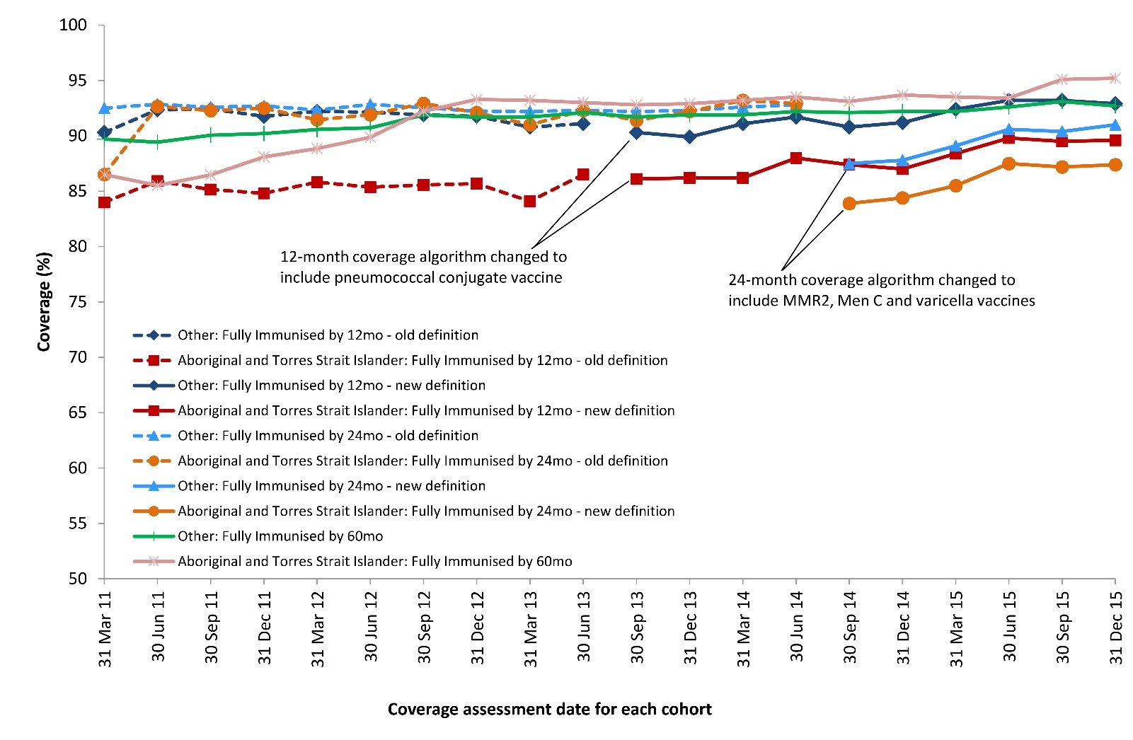
By 3-month birth cohorts and coverage assessment date 12 months after the last date of each cohort.
MMR2: Dose 2 measles, mumps, rubella, given as either MMR or MMRV
Men C: meningococcal C
Source: Australian Childhood Immunisation Register, data as at 31 March 2016
Figure 22: ‘Fully immunised’ coverage at 12 months of age*in Aboriginal and Torres Strait Islander children by Statistical Area 4 (SA4),† Australia, 2015.
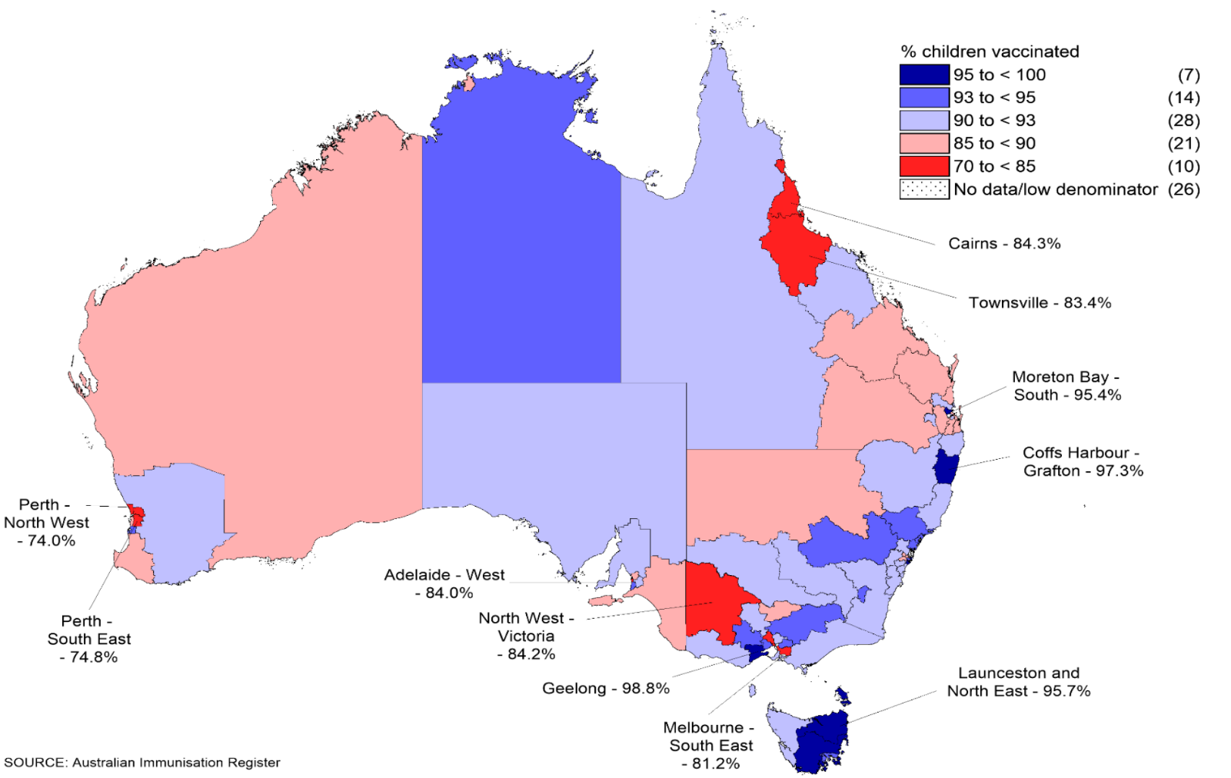
* Cohort born 1 January 2014 – 31 December 2014.
† Number of SA4s in each category in parentheses.
Source: Australian Childhood Immunisation Register, data as at 31 March 2016.
‘Fully immunised’ coverage by 24 months of age was relatively stable for both Aboriginal and Torres Strait Islander and other children between 2011 and mid-2014. Following the amendment of the 24-months coverage assessment algorithm in July 2014 to include a dose of meningococcal vaccine, a dose of varicella vaccine and a second dose of MMR vaccine, ‘fully immunised’ coverage at this milestone age among Aboriginal and Torres Strait Islander children decreased by 9.0 percentage points (compared with 5.3 percentage points decrease for other children). ‘Fully immunised’ coverage by 24 months of age then increased steadily for both Aboriginal and Torres Strait Islander and other children, reaching 87.4% and 91.0%, respectively, in December 2015.
Between 2011 and 2015, the percentage of Aboriginal and Torres Strait Islander and other children ‘fully immunised’ by 60 months of age increased by 8.7 and 3.0 percentage points, respectively, with coverage higher in Aboriginal and Torres Strait Islander children than that in other children since September 2012. In December 2015, ‘fully immunised’ coverage by 60 months of age among Aboriginal and Torres Strait Islander children was 95.2%, 2.5 percentage points higher than that in other children.

Geographic variations of vaccination coverage
Annualised immunisation coverage estimates for 2015 for each of the three milestone ages by Aboriginal and Torres Strait Islander status and jurisdiction are provided in Table 22.
Table 22: Percentage of children ‘fully immunised’ by 12-, 24- and 60-months of age, by Aboriginal and Torres Strait Islander status and jurisdiction, Australia, 2015
 | State or territory
 | ACT | NSW | NT | Qld | SA | Tas | Vic | WA | Australia
12 months – fully immunised*
Aboriginal and Torres Strait Islander | 92.7 | 92.0 | 92.5 | 88.4 | 89.6 | 93.5 | 89.5 | 84.1 | 89.6
Other | 94.6 | 92.9 | 92.7 | 93.4 | 93.1 | 93.2 | 92.9 | 93.0 | 93.0
24 months – fully immunised†
Aboriginal and Torres Strait Islander | 87.6 | 88.9 | 86.2 | 86.2 | 84.2 | 88.8 | 83.9 | 82.7 | 86.4
Other | 91.6 | 89.6 | 88.3 | 90.8 | 88.9 | 89.6 | 89.7 | 88.3 | 89.7
60 months – fully immunised‡
Aboriginal and Torres Strait Islander | 94.6 | 95.6 | 95.1 | 94.1 | 93.3 | 95.8 | 92.4 | 92.8 | 94.4
Other | 93.5 | 93.0 | 90.3 | 92.3 | 91.5 | 93.6 | 92.9 | 91.0 | 92.5
* ‘Fully immunised’ – 3 doses of a diphtheria-tetanus-pertussis (DTPa)-containing vaccine; 3 doses of a polio vaccine; 2 or 3 doses of a PRP-OMP-containing Haemophilus influenzae type b (Hib) vaccine or 3 doses of any other Hib vaccine; 3 doses of a hepatitis B vaccine; and 3 doses of a pneumococcal conjugate vaccine. Cohort born 1 January 2014 – 31 December 2014.
† ‘Fully immunised’ – 3 doses of a DTPa-containing vaccine; 3 doses of a polio vaccine; 3 or 4 doses of a PRP-OMP-containing Hib vaccine or 4 doses of any other Hib vaccine; 3 doses of a hepatitis B vaccine; 2 doses of a measles-mumps-rubella (MMR)-containing vaccine; 1 dose of meningococcal C vaccine; and 1 dose of varicella vaccine. Cohort born 1 January 2013 – 31 December 2013.
‡ ‘Fully immunised’ – 4 doses of a DTPa-containing vaccine; 4 doses of a polio vaccine; and 2 doses of an MMR-containing vaccine. Cohort born 1 January 2010 – 31 December 2010.
ACT = Australian Capital Territory; NSW = New South Wales; NT = Northern Territory; Qld = Queensland; SA = South Australia; Tas = Tasmania; Vic = Victoria; WA = Western Australia
Source: Australian Childhood Immunisation Register, data as at 31 March 2016.
In 2015, ‘fully immunised’ coverage at 12 months of age among Aboriginal and Torres Strait Islander children was lower than that for other children in all jurisdictions except Tasmania, with the differential varying from 8.9 percentage points in Western Australia to 0.2 of a percentage point in the Northern Territory and 3.4 percentage points overall.
‘Fully immunised coverage at 24 months of age in 2015 was 3.3 percentage points lower among Aboriginal and Torres Strait Islander children than that in other children for Australia, with the differential varying from 5.6 percentage points in Western Australia to 0.7 of a percentage point in New South Wales.
‘Fully immunised’ coverage at 60 months of age in 2015 was 1.9 percentage points higher among Aboriginal and Torres Strait Islander children than that in other children, with coverage in Aboriginal and Torres Strait Islander children at this milestone age higher in all jurisdictions except Victoria.
‘Fully immunised’ coverage at 12 months of age for Aboriginal and Torres Strait Islander children is presented by SA4 in Figure 22. It is evident throughout each jurisdiction that there was considerable variation in the percentage of Aboriginal and Torres Strait Islander children assessed as ‘fully immunised’ at 12 months of age. While there were a number of SA4s with coverage below 90%, there were 21 SA4s with coverage in Aboriginal and Torres Strait Islander children at 12 months of age higher than the national figure for ‘fully immunised’ in other children at the same milestone.

Individual vaccines or antigens
The national 2015 coverage estimates for each individual vaccine assessed at the three milestone ages are provided in Table 23 by Aboriginal and Torres Strait Islander status. Coverage was lower among Aboriginal and Torres Strait Islander children for all vaccines at 12 months of age compared with that in other children. For coverage of individual vaccines assessed at 12 months of age, the difference in the estimates for Aboriginal and Torres Strait Islander and other children is similar to the difference in ‘fully immunised’ coverage at this milestone, except for rotavirus vaccine coverage for which there is an upper age limit (refer to Rotavirus vaccines). At 24 months of age, coverage for DTPa, polio, hepatitis B and meningococcal C vaccines was higher among Aboriginal and Torres Strait Islander children than that in other children (Table 23). Similarly, coverage for DTPa, polio and MMR vaccines was higher among Aboriginal and Torres Strait Islander children than that in other children at 60 months of age (Table 23).

Table 23: Vaccination coverage estimates (%) by age, vaccine and Aboriginal and Torres Strait Islander status, Australia, 2015
Vaccine | Milestone age | Aboriginal and Torres Strait Islander children | Other children
Diphtheria, tetanus, acellular pertussis | 12 months* | 89.8 | 94.0
 | 24 months† | 96.1 | 95.8
 | 60 months‡ | 94.9 | 93.1
Polio | 12 months* | 89.8 | 94.0
 | 24 months† | 96.1 | 95.8
 | 60 months‡ | 94.9 | 93.1
Haemophilus influenzae type b | 12 months* | 89.7 | 93.7
 | 24 months† | 93.9 | 94.0
 | 60 months‡ | N/I | N/I
Hepatitis B | 12 months* | 89.7 | 93.6
 | 24 months† | 96.0 | 95.3
 | 60 months‡ | N/I | N/I
Measles, mumps, rubella | 12 months* | N/I | N/I
 | 24 months† | 89.2 | 91.9
 | 60 months‡ | 95.2 | 93.1
Varicella | 12 months* | N/I | N/I
 | 24 months† | 88.3 | 91.7
 | 60 months‡ | N/I | N/I
Meningococcal C conjugate | 12 months* | N/I | N/I
 | 24 months† | 94.9 | 94.3
 | 60 months‡ | N/I | N/I
Pneumococcal conjugate | 12 months* | 89.8 | 93.5
 | 24 months† | N/I | N/I
 | 60 months‡ | N/I | N/I
Rotavirus | 12 months* | 75.4 | 86.0
 | 24 months† | N/I | N/I
 | 60 months‡ | N/I | N/I
* Cohort born 1 January 2014 – 31 December 2014.
† Cohort born 1 January 2013 – 31 December 2013.
‡ Cohort born 1 January 2010 – 31 December 2010.
N/I: Not included in coverage estimates for that group.
Source: Australian Childhood Immunisation Register, data as at 31 March 2016.

Rotavirus vaccines
Rotavirus vaccine coverage was more than 10 percentage points lower in Aboriginal and Torres Strait Islander children. As shown in Figure 23, this differential in rotavirus vaccine varied by vaccine type and dose schedule. In jurisdictions where Rotarix® was given as a 2-dose schedule, the differential was 4.1 percentage points. In jurisdictions where RotaTeq® was given as a 3-dose schedule, the differential was 15.5 percentage points. However, when assessed as two doses of RotaTeq®, an appropriate comparison given the similar spacing between first and second dose across the two vaccines in the NIP schedule and some evidence that two doses of RotaTeq® may have similar vaccine effectiveness to two doses of Rotarix®,⁸⁵ the differential was 6.7 percentage points.
Figure 23: Rotavirus vaccine coverage at 12 months by Aboriginal and Torres Strait Islander status – Rotarix® jurisdictions versus RotaTeq® jurisdictions, 2015
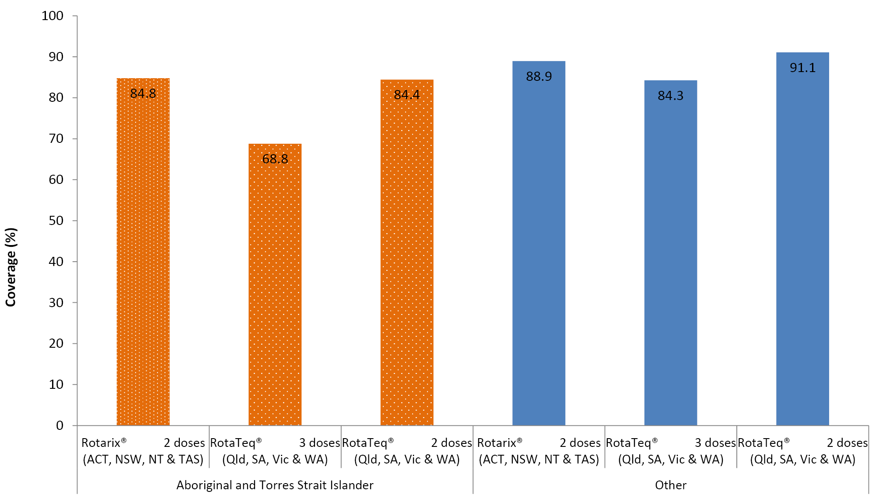
Source: Australian Childhood Immunisation Register, data as at 31 March 2016.

Hepatitis A vaccines
Hepatitis A vaccine has been included on the NIP for Aboriginal and Torres Strait Islander children in the Northern Territory, Queensland, South Australia and Western Australia since November 2005, but was used earlier than this in north Queensland. Initially the two doses of hepatitis A vaccine were administered at 12 and 18 months of age in the Northern Territory and Western Australia and at 18 and 24 months of age in Queensland and South Australia. Following a schedule change in July 2013, the two doses are now administered at 12 and 18 months of age in all four jurisdictions. Between March 2011 and December 2013, coverage of two doses of hepatitis A vaccine among Australian Aboriginal and Torres Strait Islander children (assessed at 30 months of age in Western Australia and the Northern Territory, and at 36 months of age in Queensland and South Australia) increased marginally, from 57.6% to 60.1%. Following the change in assessment age to 30 months for all four jurisdictions, coverage decreased to 51.6% in March 2014. However, coverage then increased throughout 2014 and 2015, and by December 2015, 70.8% of Aboriginal and Torres Strait Islander children in the Northern Territory, Queensland, South Australia and Western Australia had received two doses of hepatitis A vaccine by 30 months of age (Figure 24). Increases in coverage of two doses of hepatitis A vaccine have been achieved for Aboriginal and Torres Strait Islander children in each of the four jurisdictions, although there is a substantial variation – from a low of 62.6% in Western Australia to a high of 83.2% in the Northern Territory.
Figure 24: Trends in coverage estimates for hepatitis A* vaccine for Aboriginal and Torres Strait Islander children by quarter of vaccination and jurisdiction, Australia,† 2011 to 2015
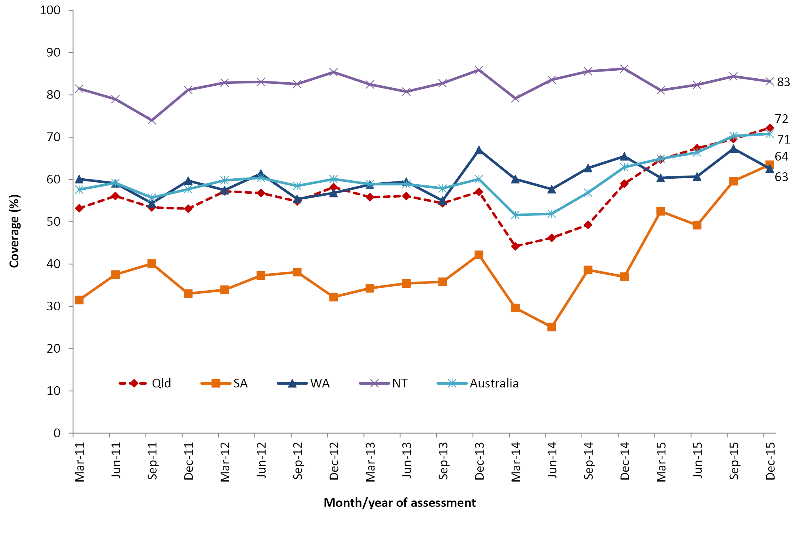
* 18-month dose assessed at 30 months of age in all four jurisdictions from July 2013.
† Northern Territory (NT), Queensland (Qld), South Australia (SA) and Western Australia (WA) only.
Source: Australian Childhood Immunisation Register, data as at 31 March 2016.

Fourth dose of pneumococcal vaccine
A booster (fourth dose) of pneumococcal vaccine at 18–24 months of age has been recommended and funded for Aboriginal and Torres Strait Islander children in the Northern Territory, Queensland, South Australia and Western Australia since 2001, initially as 23-valent pneumococcal polysaccharide vaccine and then as 13-valent pneumococcal conjugate vaccine (13vPCV) from July 2013 in Queensland, South Australia and Western Australia, and from October 2013 in the Northern Territory. Following the 13vPCV catch-up campaign in 2012, coverage of this booster dose for Aboriginal and Torres Strait Islander children increased from 63.4% in December 2011 to 73.1% in December 2012. Coverage fell by 14 percentage points during 2013 before increasing steadily over the next two years, reaching 71% by December 2015 (Figure 25). Aboriginal and Torres Strait Islander coverage estimates of the pneumococcal booster at 18–24 months of age have varied substantially between jurisdictions, with coverage at the end of 2015 ranging from 62.1% in South Australia to 86.0% in the Northern Territory. While the pneumococcal booster coverage estimates in Queensland, Western Australia and the Northern Territory increased steadily during 2014 and 2015, coverage in South Australia more than doubled.
Figure 25: Trends in coverage estimates for the fourth dose of pneumococcal* vaccine for Aboriginal and Torres Strait Islander children by quarter of vaccination and jurisdiction, Australia,† 2011 to 2015
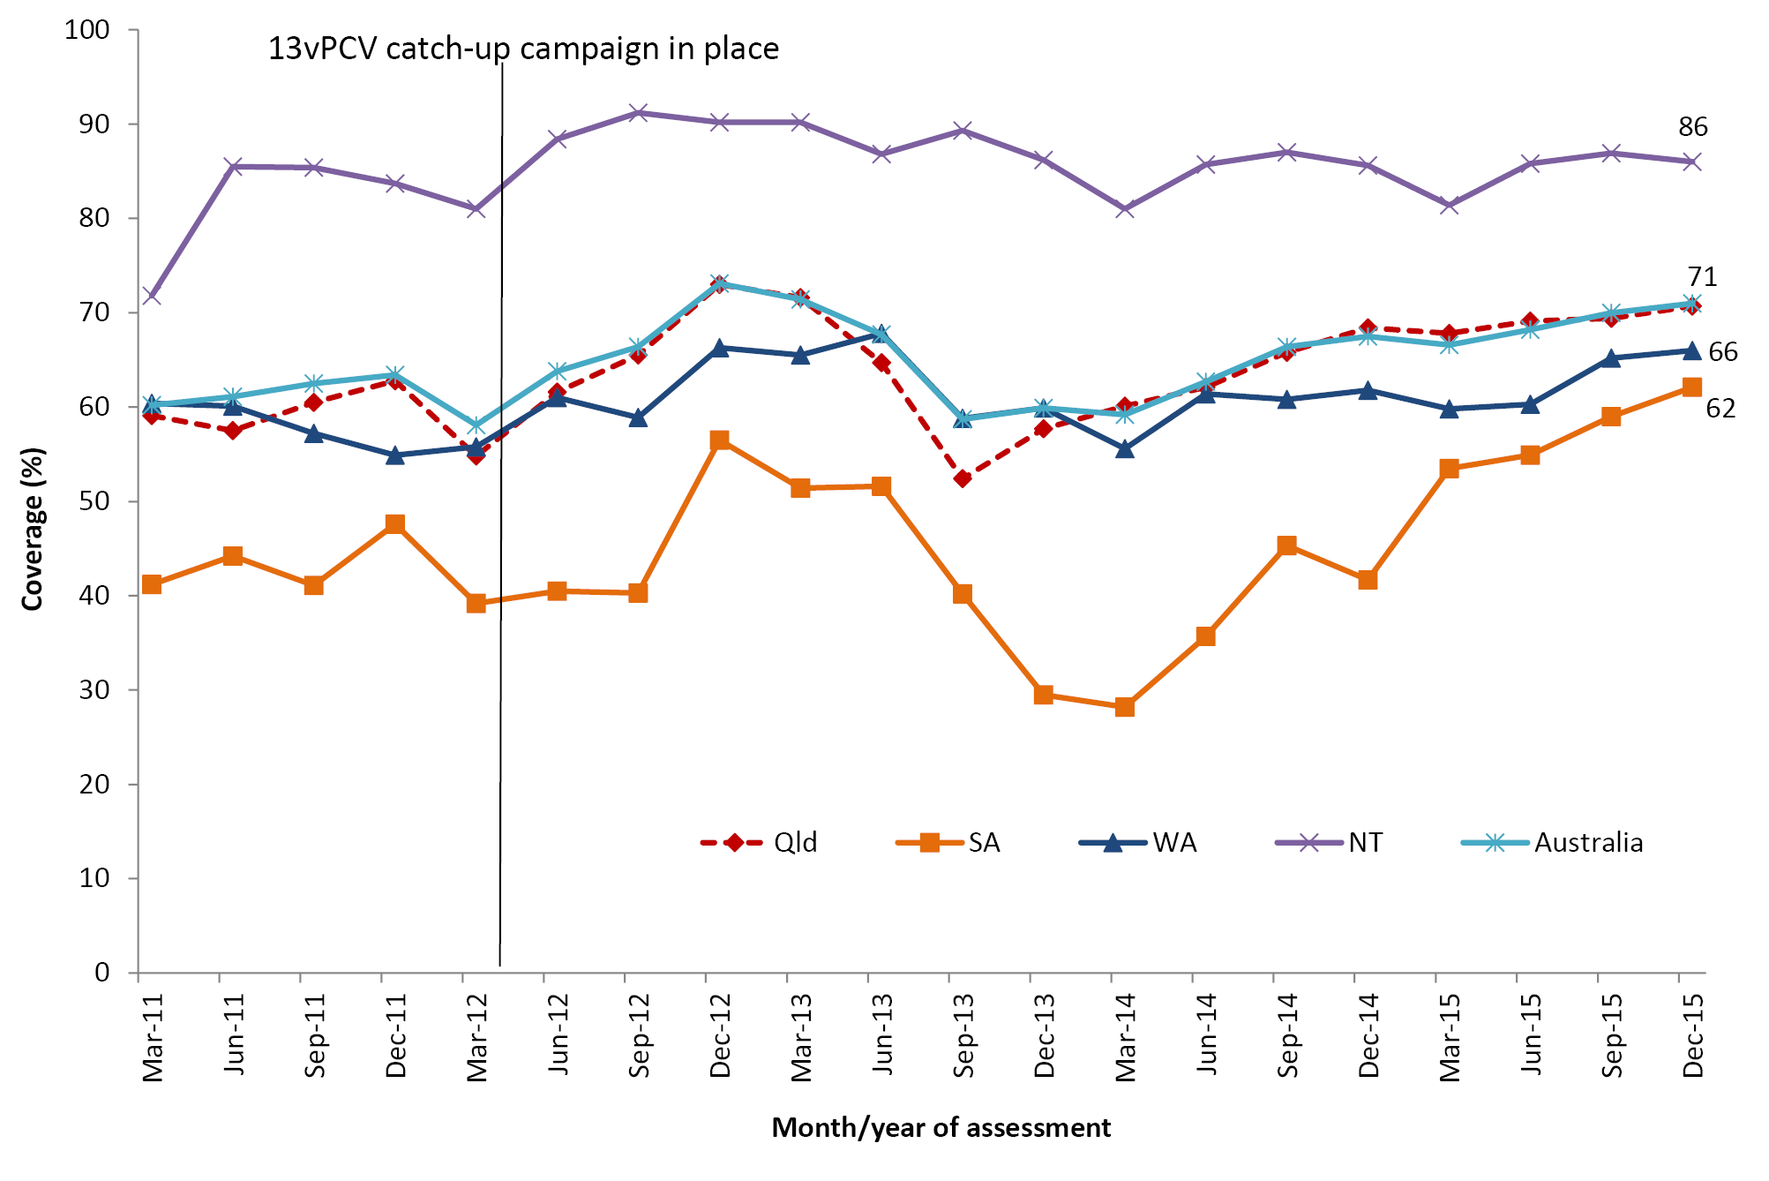
* Excludes cases with unknown serotype
* 18-month dose assessed at 30 months of age in all four jurisdictions from July 2013.
† Northern Territory (NT), Queensland (Qld), South Australia (SA) and Western Australia (WA) only.
13vPCV: 13-valent pneumococcal conjugate vaccine
Source: Australian Childhood Immunisation Register, data as at 31 March 2016.

Seasonal influenza vaccine
In 2015, seasonal influenza vaccine was recommended and funded on the NIP for all Aboriginal and Torres Strait Islander children aged 6 months to <5 years. Prior to this, national recorded coverage of the seasonal influenza vaccine was below 4% for Aboriginal and Torres Strait Islander children. In 2015, recorded coverage of the seasonal influenza vaccine rose to 12.1% for Aboriginal and Torres Strait Islander children, with coverage ranging from 2.7% in Victoria to 54.3% in the Northern Territory. Apart from the Northern Territory, Aboriginal and Torres Strait Islander influenza vaccine coverage was only above 10% in Queensland and Western Australia, at 11.6% and 13.2%, respectively. For other children, coverage was substantially lower in each jurisdiction, ranging from 1.7% in the Northern Territory to 8.0% in Western Australia, and 2.9% overall (Figure 26). However, unlike most other routine childhood vaccines on the NIP, influenza vaccine notifications do not attract notification payments for immunisation providers. As such, influenza vaccine coverage data should be regarded as a minimum estimate due to the potential for under-reporting.
Figure 26: Coverage of at least one dose of seasonal influenza vaccine administered in 2015 to children aged 6 months to <5 years, by jurisdiction and Aboriginal and Torres Strait Islander status
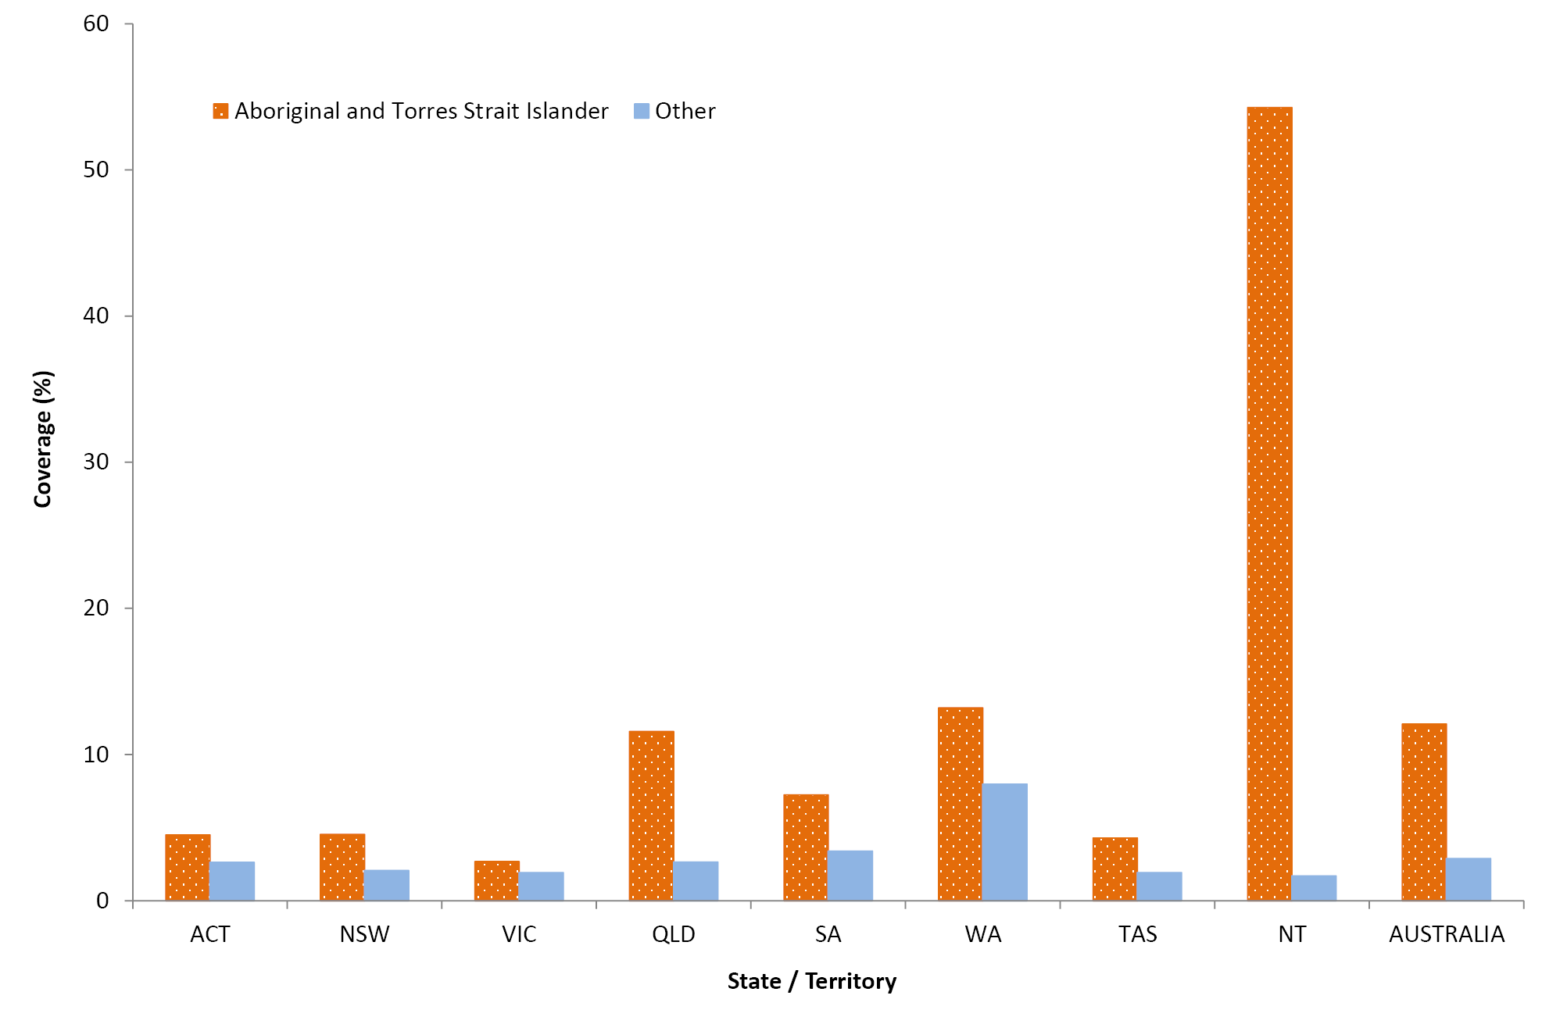

Timeliness of vaccination
Figure 27 shows the percentage of children with delayed receipt of the third dose of DTPa vaccine, the first and second dose of MMR vaccine, and the single dose of meningococcal C vaccine by Aboriginal and Torres Strait Islander status in 2015. The percentage of Aboriginal and Torres Strait Islander children with any delay was substantially higher than the percentage for other children. For each of the four vaccines assessed, most of the delay was relatively short (1–≤2 months after the schedule point) for both Aboriginal and Torres Strait Islander and other children. Only a small percentage of non-Aboriginal and Torres Strait Islander children received the vaccines very late, at ≥7 months after the schedule point, ranging from 1.8% for the first dose of MMR vaccine to 2.9% for the single dose of meningococcal C vaccine. In comparison, the percentage of Aboriginal and Torres Strait Islander children with very late receipt of these vaccines was considerably higher, ranging from 4.0% for the first dose of MMR vaccine to 7.8% for the third dose of DTPa vaccine.
Figure 27: DTP3, MMR1, MENC1 and MMR2 vaccination delay by Aboriginal and Torres Strait Islander status, Australia, 2015
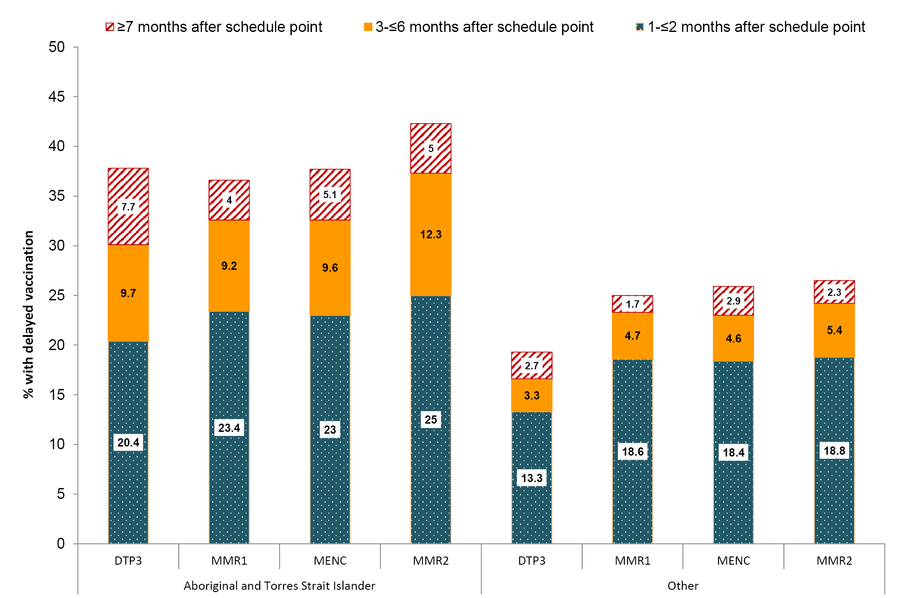
* Percentage covered = number of children who received vaccine dose at particular ages / the total number of children who received the vaccine dose, expressed as a percentage.
Cohort born in 2013.
Source: Australian Childhood Immunisation Register, data as at 31 March 2016.
Cohort born in 2013.
DTPa3 3rd dose of a diphtheria-tetanus- acellular pertussis–containing vaccine (due at 6 months of age)
MMR1 1st dose of a measles-mumps-rubella vaccine (due at 12 months of age)
MENC1 1st dose of a meningococcal C vaccine (due at 12 months of age)
MMR2 2nd dose of a measles-mumps-rubella vaccine (due at 18 months of age)
Source: Australian Childhood Immunisation Register, data as at 31 March 2016
For the third dose of DTPa vaccine, there was an 18.4% differential between the percentage of Aboriginal and Torres Strait Islander and other children vaccinated on-time by 7 months of age in 2015 (Figure 28). Similar differentials were found for timeliness of the first dose of MMR vaccine by 13 months of age (Figure 29) and the second dose of MMR vaccine by 19 months of age (Figure 30), but the differentials were smaller (11.7% and 15.7% for the first and second dose, respectively).
Figure 28: Timeliness* of the third dose of DTPa vaccine (DTP3), by Aboriginal and Torres Strait Islander status, Australia, 2015
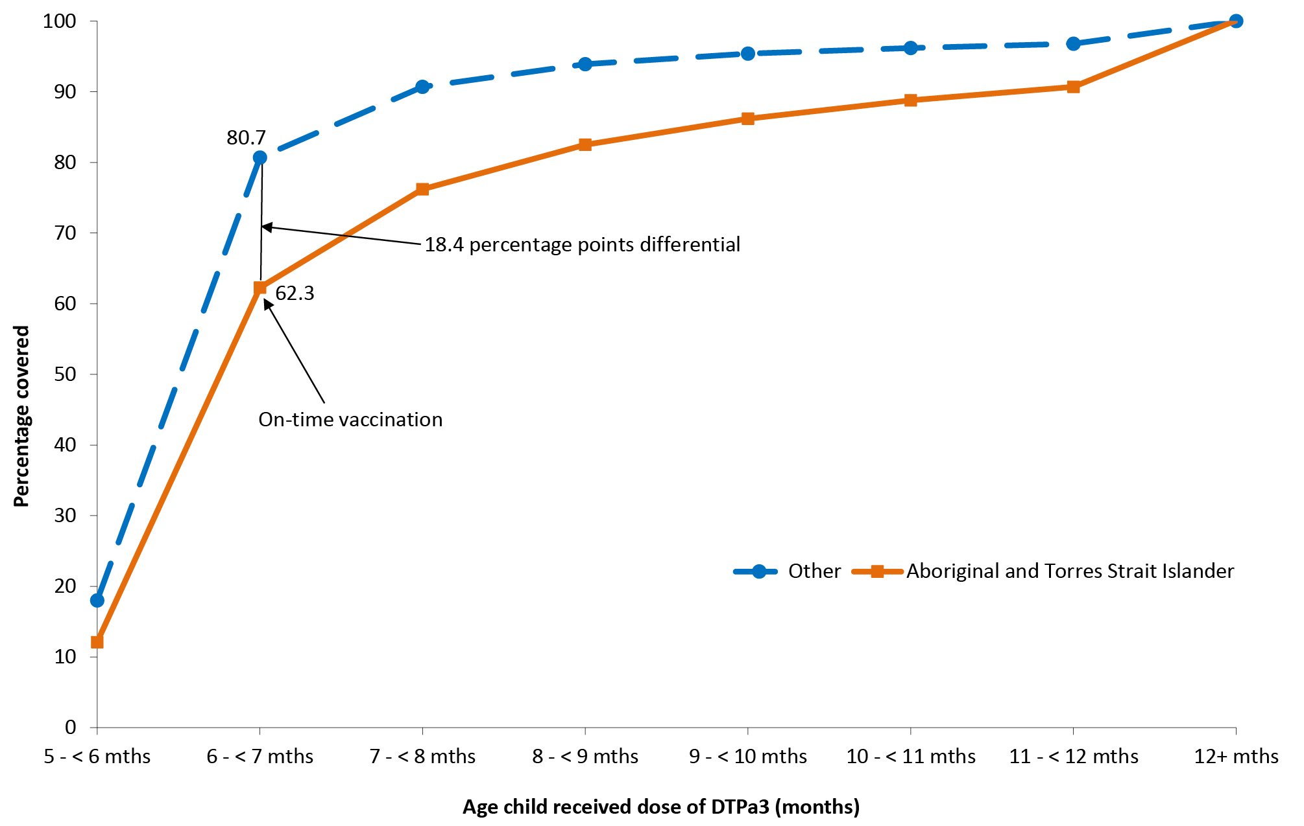
Figure 29: Timeliness* of the first dose of MMR vaccine (MMR1), by Aboriginal and Torres Strait Islander status, Australia, 2015
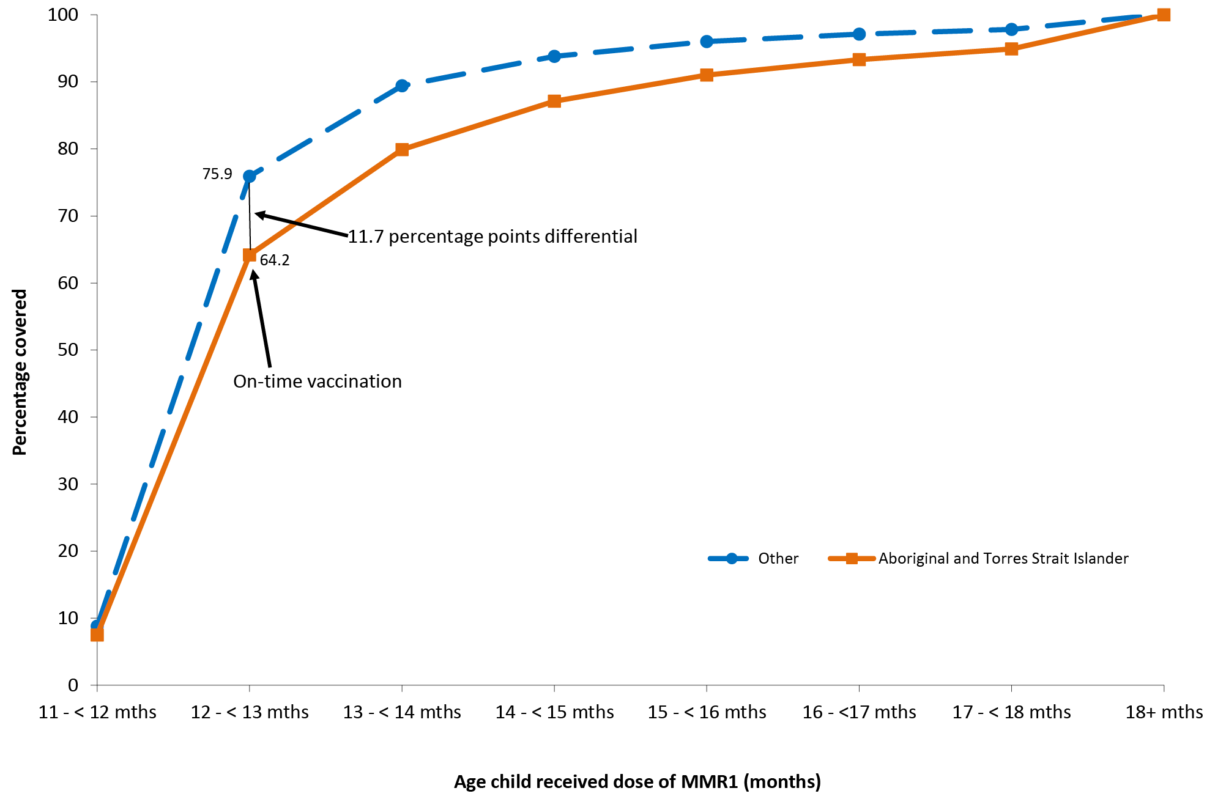
* Percentage covered = number of children who received vaccine dose at particular ages / the total number of children who received the vaccine dose, expressed as a percentage.
Cohort born in 2013.
Source: Australian Childhood Immunisation Register, data as at 31 March 2016.
Figure 30: Timeliness* of the second dose of MMR vaccine (MMR2), by Aboriginal and Torres Strait Islander status, Australia, 2015
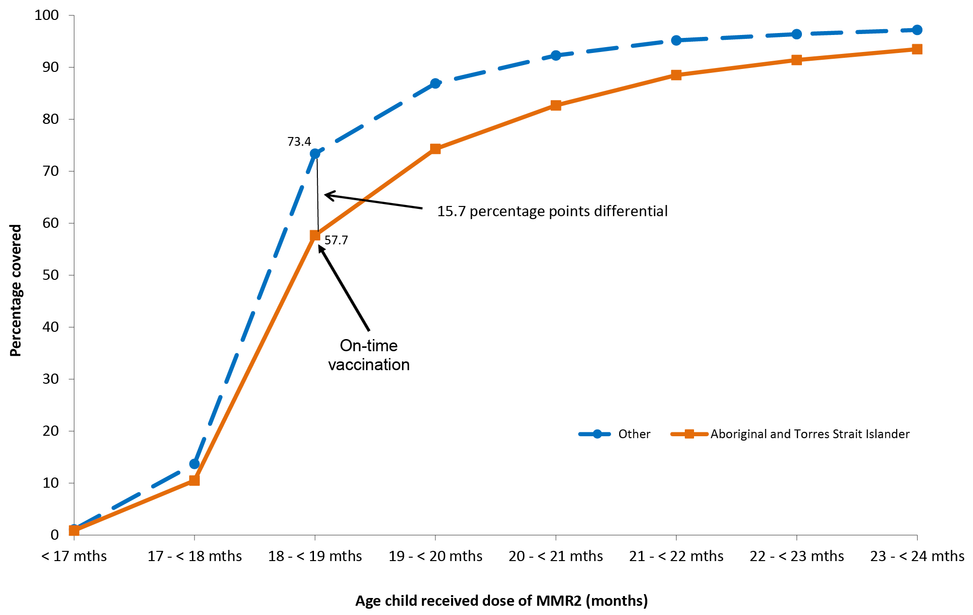
* Percentage covered = number of children who received vaccine dose at particular ages / the total number of children who received the vaccine dose, expressed as a percentage.
Cohort born in 2013.
Source: Australian Childhood Immunisation Register, data as at 31 March 2016.
Delayed receipt of the third dose of DTPa vaccine and the first dose of MMR vaccine by Aboriginal and Torres Strait Islander status and remoteness status in 2015 is shown in Table 24. For both Aboriginal and Torres Strait Islander and other children, most instances of delay were limited to 1–≤2 months after the schedule point for both vaccines and across all remoteness categories. For the third dose of DTPa vaccine, there was a slightly lower percentage of Aboriginal and Torres Strait Islander children living in major cities with delay of 1–≤2 months compared with Aboriginal and Torres Strait Islander children living in remote and very remote areas of Australia (19.1% compared with 24.1%).

Table 24: Vaccination delay, by Aboriginal and Torres Strait Islander and remoteness status for 2-year-olds,* Australia, 2015
Vaccine dose | Aboriginal and Torres Strait Islander status | Remoteness category | 1-<3 months after schedule point (%) | 3-<6 months after schedule point (%) | >7 months after schedule point (%)
DTPa3 | Aboriginal and Torres Strait Islander | Major Cities | 19.1 | 8.5 | 7.7
 |  | Inner and Outer Regional | 20.1 | 9.8 | 8.2
 |  | Remote and Very Remote | 24.1 | 12.2 | 5.9
 | Other | Major Cities | 13.0 | 3.3 | 2.7
 |  | Inner and Outer Regional | 14.1 | 3.6 | 2.7
 |  | Remote and Very Remote | 14.0 | 3.4 | 2.0
MMR1 | Aboriginal and Torres Strait Islander | Major Cities | 23.2 | 9.6 | 4.0
 |  | Inner and Outer Regional | 23.2 | 9.3 | 4.3
 |  | Remote and Very Remote | 24.6 | 7.8 | 3.0
 | Other | Major Cities | 18.5 | 4.7 | 1.7
 |  | Inner and Outer Regional | 18.7 | 4.7 | 1.8
 |  | Remote and Very Remote | 20.4 | 4.4 | 1.3
* The cohort of children born in 2013 and assessed in 2015.
DTPa3 3rd dose of diphtheria-tetanus-acellular pertussis–containing vaccine
MMR1 1st dose of measles, mumps, rubella vaccine
Source: Australian Childhood Immunisation Register, data as at 31 March 2016.
Vaccination delay for Aboriginal and Torres Strait Islander children by jurisdiction in 2015 was measured for the third dose of the pneumococcal conjugate vaccine (Figure 31). The percentage of Aboriginal and Torres Strait Islander children experiencing any delay in the receipt of this vaccine varied between jurisdictions and was highest in Western Australia (47.5%) and South Australia (43.4%), and lowest in the Australian Capital Territory (20.9%). Similar to the timeliness of the other vaccines assessed, the majority of the delay in receiving the third dose of the pneumococcal conjugate vaccine for Aboriginal and Torres Strait Islander children was short (1–≤2 months after the schedule point).
Figure 31: Vaccination delay for Aboriginal and Torres Strait Islander children for the third dose of pneumococcal conjugate vaccine, by jurisdiction, Australia, 2015
Source: Australian Childhood Immunisation Register, data as at 31 March 2016
The percentage of Aboriginal and Torres Strait Islander children vaccinated on time improved between 2011 and 2015, from 49.3% to 71.1% and from 73.5% to 77.3% for the first and second dose of DTPa vaccine, respectively, from 62.5% to 63.7% for the third dose of the pneumococcal conjugate vaccine, and from 58.4% to 64.2% for the first dose of MMR vaccine.

Objection to vaccination and medical contraindication exemptions
Trends in the percentage of Aboriginal and Torres Strait Islander children aged 12 months to <7 years in each of the examined objection categories for the period 2011 to 2015 are shown in Figure 32. In 2011, the percentage of Aboriginal and Torres Strait Islander children aged 12 months to <7 years with a vaccination objection registered on the ACIR was 0.5% (0.2% with no vaccinations recorded and 0.3% with at least one vaccination recorded). This increased over time to 0.9% (0.4% with no vaccinations recorded and 0.5% with at least one vaccination recorded) in 2015. In contrast, the percentage of Aboriginal and Torres Strait Islander children for whom neither vaccinations nor an objection were recorded decreased from 1.6% in 2011 to 0.5% in 2015. The percentage of Aboriginal and Torres Strait Islander children who were partially vaccinated and for whom no objection was recorded also decreased, from 6.2% in 2011 to 2.1% in 2015. The percentage of Aboriginal and Torres Strait Islander children with a registered objection was substantially lower compared with the percentage of other children, in each year examined (data not shown).
Figure 32: Trends in recorded vaccination objection status and vaccination status of Aboriginal and Torres Strait Islander children aged 12 months to <7 years, Australia, 2011–2015
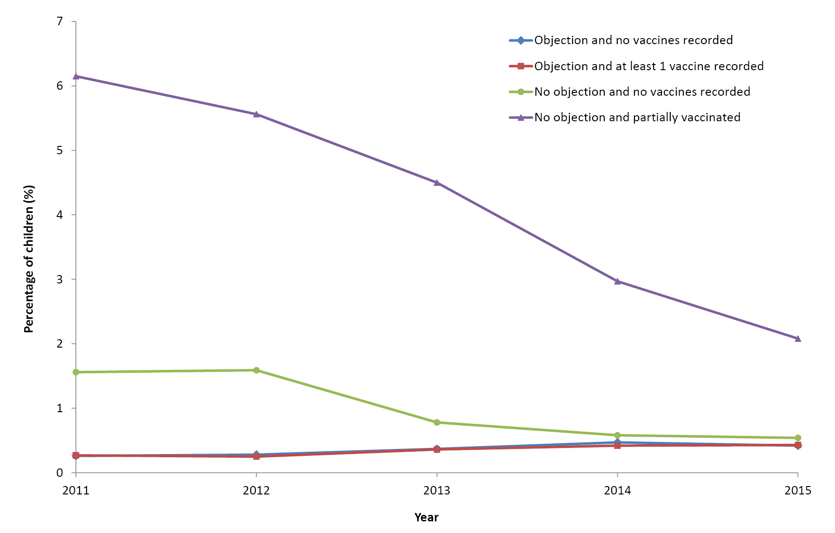
Source: Australian Childhood Immunisation Register, data as at 31 March 2016.
The number of Aboriginal and Torres Strait Islander children with new medical contraindication exemptions recorded on the ACIR, while small, doubled between 2011 (n=12) and 2015 (n=31) (data not shown).

Discussion
Throughout Australia, Aboriginal and Torres Strait Islander coverage estimates for ‘fully immunised’ coverage at 12, 24 and 60 months of age improved between 2011 and 2015. As in the past, Aboriginal and Torres Strait Islander coverage estimates of ‘fully immunised’ at 12, 24 and 60 months varied substantially between jurisdictions in 2015. Nationally, the percentage of Aboriginal and Torres Strait Islander children assessed as ‘fully immunised’ by 12 months of age was lower each year than that of other children. However, the percentage of ‘fully immunised’ Aboriginal and Torres Strait Islander children at this milestone increased more substantially over the 5-year period, such that the coverage differential between Aboriginal and Torres Strait Islander and other children halved. ‘Fully immunised’ coverage estimates at 24 months of age were similar between Aboriginal and Torres Strait Islander and other children up until the coverage algorithm changed in mid-July 2014. The changes included the addition of a dose of meningococcal vaccine, a dose of varicella vaccine and a second dose of MMR vaccine. This change had a greater impact on reducing Aboriginal and Torres Strait Islander estimates and, while coverage at 24 months of age did increase during the latter half of 2014 and throughout 2015, coverage was 4% lower in Aboriginal and Torres Strait Islander children, compared with the coverage in other children, at the end of 2015. ‘Fully immunised’ coverage by 60 months of age among Aboriginal and Torres Strait Islander children improved substantially between 2011 and 2015. Not only did national Aboriginal and Torres Strait Islander coverage at this milestone age improve by almost 10 percentage points in the 5-year period but it was also almost 3 percentage points higher than the coverage in other children by the end of 2015.
The importance of monitoring coverage data on vaccines not included in the ‘fully immunised’ algorithms is highlighted by the lower coverage of rotavirus vaccine. Although coverage of this vaccine at 12 months of age has increased over time, among Aboriginal and Torres Strait Islander children it was still 14 percentage points lower than the percentage assessed as ‘fully immunised’ in 2015. In comparison, the 2015 rotavirus vaccine coverage among other children was 7 percentage points lower than the percentage ‘fully immunised’. The observed lower coverage, particularly in jurisdictions using a 3-dose schedule compared with a 2-dose schedule, most likely reflects the strict upper age limits for administering rotavirus vaccine.²⁷
Coverage estimates for vaccines recommended and funded for Aboriginal and Torres Strait Islander children only (i.e. hepatitis A vaccine, a fourth [booster] dose of pneumococcal vaccine and an annual seasonal influenza vaccine) remain considerably lower than those for vaccines funded for all children. The funded hepatitis A and pneumococcal vaccine booster dose programs are targeted programs limited to Aboriginal and Torres Strait Islander children in the Northern Territory, Queensland, South Australia and Western Australia. Coverage of these vaccines did increase between 2011 and 2015, with improvement varying between the four jurisdictions. The largest increase was observed in South Australia, which is most likely the result of efforts to improve and maintain Aboriginal and Torres Strait Islander immunisation coverage, including the securing of Closing the Gap funding to employ a specific Aboriginal Immunisation Project Coordinator, a promotional strategy aimed at increasing awareness about the need for complete and timely immunisation for Aboriginal and Torres Strait Islander children, coordination of follow-up of overdue children, ongoing data cleaning and education of service providers.⁴⁹ However, coverage of these Aboriginal and Torres Strait Islander–specific vaccines remains suboptimal. The extent of underreporting to the ACIR for the Aboriginal and Torres Strait Islander–specific vaccines is unknown but may be greater than that for other vaccines, given the lack of incentive payments for notification to the ACIR. However, lower coverage for vaccines targeted at Aboriginal and Torres Strait Islander people has been a relatively consistent finding for both children¹⁰² and adults.¹ A lack of provider knowledge about the recommendations for high-risk groups and/or suboptimal identification of Aboriginal and Torres Strait Islander children by immunisation providers are likely important contributing factors to this lower coverage.
As Aboriginal and Torres Strait Islander children are more vulnerable to severe disease, vaccination at the earliest appropriate age should be a public health goal. Although most children do eventually complete the scheduled vaccination series, many still do not do so in a timely manner. While on-time vaccination improved between 2011 and 2015, delayed vaccination has continued to be a persistent concern for Aboriginal and Torres Strait Islander children in Australia. The percentage of Aboriginal and Torres Strait Islander children vaccinated on-time was substantially lower, compared with the percentage of other children, for each vaccine assessed. Further compounding the timeliness issue for Aboriginal and Torres Strait Islander children is the higher percentage receiving these vaccines very late (i.e. at ≥7 months after the schedule point) compared with other children. Key strategies aimed at closing the vaccination timeliness gaps between Aboriginal and Torres Strait Islander and other children have included improving Aboriginal and Torres Strait Islander identification, contacting parents of Aboriginal and Torres Strait Islander children before the child’s vaccination due date (pre-call notices), personalised vaccination calendars/applications, providing immunisation providers with tools to monitor timely coverage data for Aboriginal and Torres Strait Islander children and promoting immunisation in local Aboriginal and Torres Strait Islander communities.^{103–105} A dedicated Aboriginal Immunisation Healthcare Worker Program, funded by NSW Health since 2012, is proving to be an effective public health intervention in that state, improving the timeliness of Aboriginal and Torres Strait Islander childhood vaccinations.¹⁰⁶
Registered objection to vaccination in Aboriginal and Torres Strait Islander children increased between 2011 and 2015, but remained under 1% and substantially lower than that in other children.
Aboriginal and Torres Strait Islander adolescent and adult vaccination coverage data were not available for this reporting period. However, with the immunisation register becoming a ‘whole-of-life’ register from 2016, the reporting of vaccination coverage in Aboriginal and Torres Strait Islander adolescents and adults should be possible in future reports.

References
- Menzies R, Turnour C, Chiu C, McIntyre P. Vaccine preventable diseases and vaccination coverage in Aboriginal and Torres Strait Islander people, Australia 2003 to 2006. Commun Dis Intell Q Rep. 2008;32(Suppl):S2–67.
- Naidu L, Chiu C, Habig A, Lowbridge C, Jayasinghe S, Wang H, et al. Vaccine preventable diseases and vaccination coverage in Aboriginal and Torres Strait Islander people, Australia 2006–2010. Commun Dis Intell Q Rep. 2013;37:S1–95.
- Menzies R, McIntyre P, Beard F. Vaccine preventable diseases and vaccination coverage in Aboriginal and Torres Strait Islander people, Australia, 1999 to 2002. Commun Dis Intell Q Rep. 2004;28:S1–45.
- Australian Institute of Health and Welfare. Australian hospital statistics 2010–11. Cat. No. HSE 117. Health Services Series No. 43. Canberra: AIHW, 2012.
- Australian Institute of Health and Welfare. Indigenous identification in hospital separations data: quality report. Cat. No. IHW 90. Canberra: AIHW, 2013.
- Barry C, Waring J, Stapledon R, Konstantinos A. Tuberculosis notifications in Australia, 2008 and 2009. Commun Dis Intell Q Rep. 2012;36:82–94.
- Australian Institute of Health and Welfare. The health and welfare of Australia’s Aboriginal and Torres Strait Islander peoples 2015. Cat. No. IHW 147. Canberra: AIHW, 2015.
- Plotkin SA, Orenstein WA, Offit PA, Edwards KM, eds.Vaccines. 7th Edition. Philadelphia, PA: Saunders Elsevier; 2018.
- McIntyre P. Vaccines against invasive Haemophilus influenzae type b disease. J Paediatr Child Health. 1994;30:14–8.
- Hanna JN, Wild BE. Bacterial meningitis in children under five years of age in Western Australia. Med J Aust. 1991;155:160–4.
- Horby P, Gilmour R, Wang H, McIntyre P. Progress towards eliminating Hib in Australia: an evaluation of Haemophilus influenzae type b prevention in Australia, 1 July 1993 to 30 June 2000. Commun Dis Intell Q Rep. 2003;27:324–41.
- Menzies RI, Jardine A, McIntyre PB. Pneumonia in Elderly Australians: Reduction in Presumptive Pneumococcal Hospitalizations but No Change in All-Cause Pneumonia Hospitalizations Following 7-Valent Pneumococcal Conjugate Vaccination. Clin Infect Dis. 2015;61:927–33.
- Menzies RI, Bremner KM, Wang H, Beard FH, McIntyre PB. Long-Term Trends in Invasive Haemophilus influenzae Type b Disease among Indigenous Australian Children Following use of PRP-OMP and PRP-T Vaccines. Pediatr Infect Dis J. 2015;34:621–6.
- Ulanova M, Tsang RSW. Invasive Haemophilus influenzae disease: Changing epidemiology and host–parasite interactions in the 21st century. Infect Genet Evol. 2009;9:594–605.
- Jacups SP, Morris PS, Leach AJ. Haemophilus influenzae type b carriage in Indigenous children and children attending childcare centers in the Northern Territory, Australia, spanning pre- and post-vaccine eras. Vaccine. 2011;29:3083–8.
- Guthridge S, McIntyre P, Isaacs D, Hanlon M, Patel M. Differing serologic responses to an Haemophilus influenzae type b polysaccharide–Neisseria meningitidis outer membrane protein conjugate (PRP–OMPC) vaccine in Australian Aboriginal and Caucasian infants — implications for disease epidemiology. Vaccine. 2000;18:2584–91.
- NNDSS Annual Report Writing Group. Australia’s notifiable disease status, 2010: annual report of the National Notifiable Diseases Surveillance System. Commun Dis Intell Q Rep. 2012; 36(1):1–69 Available from: http://europepmc.org/abstract/MED/23153082 .
- OzFoodNet Working Group. Monitoring the incidence and causes of diseases potentially transmitted by food in Australia: Annual report of the OzFoodNet network, 2011. Commun Dis Intell Q Rep. 2015;39:E236–64.
- NNDSS Annual Report Writing Group. Australia’s notifiable disease status, 2014: Annual report of the National Notifiable Diseases Surveillance System. Commun Dis Intell Q Rep. 2016;40:E48–145.
- Thompson C, Dey A, Fearnley E, Polkinghorne B, Beard F. Impact of the national targeted Hepatitis A immunisation program in Australia: 2000–2014. Vaccine. 2017;35:170–6.
- Jayasundara D, Hui BB, Regan DG, Heywood AE, MacIntyre CR, Wood JG. Quantifying the population effects of vaccination and migration on hepatitis A seroepidemiology in Australia. Vaccine. 2017;35:5228–34.
- World Health Organization. WHO position paper on hepatitis A vaccines – June 2012. Wkly Epidemiol Rec. 2012;87:261–76.
- Anonychuk AM, Tricco AC, Bauch CT, Pham B, Gilca V, Duval B, John-Baptiste A, Woo G, Krahn M. Cost-effectiveness analyses of hepatitis A vaccine: a systematic review to explore the effect of methodological quality on the economic attractiveness of vaccination strategies. Pharmacoeconomics. 2008;26(1):17–32.
- Donnan EJ, Fielding JE, Gregory JE, Lalor K, Rowe S, Goldsmith P, et al. A Multistate Outbreak of Hepatitis A Associated With Semidried Tomatoes in Australia, 2009. Clin Infect Dis. 2012;54:775–81.
- Kirby Institute. National blood-borne virus and sexually transmissible infections surveillance and monitoring report. Sydney: Kirby Institute, University of New South Wales, 2013.
- Graham S, Guy RJ, Cowie B, Wand HC, Donovan B, Akre SP, et al. Chronic hepatitis B prevalence among Aboriginal and Torres Strait Islander Australians since universal vaccination: a systematic review and meta-analysis. BMC Infect Dis. 2013;13:403.
- Australian Technical Advisory Group on Immunisation. The Australian Immunisation Handbook. 10th edn ed. Canberra: Australian Government Department of Health and Ageing, 2013.
- Wattiaux AL, Yin JK, Beard F, Wesselingh S, Cowie B, Ward J, et al. Hepatitis B immunization for indigenous adults, Australia. Bull World Health Organ. 2016;94:826–34A.
- Bouvard V, Baan R, Straif K, Grosse Y, Secretan B, El Ghissassi F, Benbrahim-Tallaa L, Guha N, Freeman C, Galichet L, Cogliano V; WHO International Agency for Research on Cancer Monograph Working Group.. A review of human carcinogens--Part B: biological agents. Lancet Oncol. 2009 Apr;10(4):321–2.
- Australian Institute of Health and Welfare. Cervical screening in Australia 2014–2015 (supplementary table S4.11). Cancer series no. 105. Cat. no. CAN 104 Canberra AIHW, 2017.
- Garland SM, Brotherton JM, Condon JR, McIntyre PB, Stevens MP, Smith DW, et al. Human papillomavirus prevalence among indigenous and non-indigenous Australian women prior to a national HPV vaccination program. BMC Med. 2011;9:104.
- Brotherton JM, Murray SL, Hall MA, Andrewartha LK, Banks CA, Meijer D, et al. Human papillomavirus vaccine coverage among female Australian adolescents: success of the school-based approach. Med J Aust. 2013;199:614–7.
- Chesson HW, Dunne EF, Hariri S, Markowitz LE. The Estimated Lifetime Probability of Acquiring Human Papillomavirus in the United States. Sex Transm Dis. 2014;41:660–4.
- Tabrizi SM, Brotherton JM, Kaldor JM, Skinner SR, Liu B, Bateson D, et al. Assessment of herd immunity and cross-protection following a human papillomavirus vaccination programme: a repeat cross-sectional study. Lancet Infect Dis. 2014;14:958–66.
- Machalek DA, Garland SM, Brotherton JML, Bateson D, McNamee K, Stewart M, et al. Very low prevalence of vaccine human papillomavirus (HPV) types among 18 to 35 year old Australian women, nine years following implementation of vaccination. J Infect Dis. 2018;217:1590–600.
- McGregor S, Saulo D, Brotherton JML, Liu B, Phillips S, Skinner SR, et al. Decline in prevalence of human papillomavirus infection following vaccination among Australian Indigenous women, a population at higher risk of cervical cancer: The VIP-I study. Vaccine. 2018;36:4311–6.
- Smith MA, Liu B, McIntyre P, Menzies R, Dey A, Canfell K. Fall in Genital Warts Diagnoses in the General and Indigenous Australian Population Following Implementation of a National Human Papillomavirus Vaccination Program: Analysis of Routinely Collected National Hospital Data. J Infect Dis. 2015;211:91–9.
- Ali H, McManus H, O’Connor CC, Callander D, Kong M, Graham S, et al. Human papillomavirus vaccination and genital warts in young indigenous Australians: National sentinel surveillance data. Med J Aust. 2017;206:204–9.
- Brotherton JM, Fridman M, May CL, Chappell G, Saville AM, Gertig DM. Early effect of the HPV vaccination programme on cervical abnormalities in Victoria, Australia: an ecological study. Lancet. 2011;377:2085–92.
- Brotherton JM, Gertig DM, May C, Chappell G, Saville M. HPV vaccine impact in Australian women: ready for an HPV based screening program. Med J Aust. 2016;204:184.
- Australian Bureau of Statistics. Estimates of Aboriginal and Torres Strait Islander Australians, June 2011. Canberra, 2013.
- Novakovic D, Cheng ATL, Zurynski Y, Booy R, Walker PJ, Berkowitz R, et al. A Prospective Study of the Incidence of Juvenile-Onset Recurrent Respiratory Papillomatosis After Implementation of a National HPV Vaccination Program. J Infect Dis. 2018;217:208–12.
- Drolet M, Laprise J-F, Brotherton JML, Donovan B, Fairley CK, Ali H, et al. The Impact of Human Papillomavirus Catch-Up Vaccination in Australia: Implications for Introduction of Multiple Age Cohort Vaccination and Postvaccination Data Interpretation. J Infect Dis. 2017;216:1205–9.
- Schiller J, Lowy D. Explanations for the high potency of HPV prophylactic vaccines. Vaccine. 2018;36:4768–73.
- Drolet M, Bénard É, Boily M-C, Ali H, Baandrup L, Bauer H, et al. Population-level impact and herd effects following human papillomavirus vaccination programmes: a systematic review and meta-analysis. Lancet Infect Dis. 2015;15:565–80.
- Australian Government Department of Health. National Cervical Screening Program. Accessed on 29th May. Available from: http://www.cancerscreening.gov.au/internet/screening/publishing.nsf/Content/cervical-screening-1.
- National Pathology Accreditation Advisory Council (NPAAC). The Requirements for Laboratories Reporting Tests for the National Cervical Screening Program (First Edition 2017). Australian Government Department of Health.
- Li-Kim-Moy J, Yin JK, Patel C, Beard FH, Chiu C, Macartney KK, et al. Australian vaccine preventable disease epidemiological review series: Influenza 2006 to 2015. Commun Dis Intell Q Rep. 2016;40:E482–95.
- Hull B, Hendry A, Dey A. Annual Immunisation Coverage Report: National Centre for Immunisation Research and Surveillance, 2015. Accessed on January 2018. Available from: http://www.ncirs.edu.au/surveillance/immunisation-coverage/
- Chiew M, Dey A, Martin N, Wang H, Davis S, McIntyre PB. Australian vaccine preventable disease epidemiological review series: measles 2000–2011. Commun Dis Intell Q Rep. 2015;39:E1–9.
- Gidding HF, Martin NV, Stambos V, Tran T, Dey A, Dowse GK, et al. Verification of measles elimination in Australia: Application of World Health Organization regional guidelines. J Epidemiol Glob Health. 2016;6:197–209.
- Pillsbury A, Chiew M, Bag S, Hope K, Norton S, Conaty S, et al. The changing epidemiology of measles in an era of elimination: lessons from health-care-setting transmissions of measles during an outbreak in New South Wales, Australia, 2012. Western Pac Surveil Response J : WPSAR. 2016;7:12–20.
- Najjar Z, Hope K, Clark P, Nguyen O, Rosewell A, Conaty S. Sustained outbreak of measles in New South Wales, 2012: risks for measles elimination in Australia. Western Pac Surveil Response J: WPSAR. 2014;5:14–20.
- Lawrence GL, Wang H, Lahra M, Booy R, McIntyre PB. Meningococcal disease epidemiology in Australia 10 years after implementation of a national conjugate meningococcal C immunization programme. Epidemiol Infect. 2016;144:2382–91.
- Archer BN, Chiu CK, Jayasinghe SH, Richmond PC, McVernon J, Lahra MM, et al. Epidemiology of invasive meningococcal B disease in Australia, 1999–2015: priority populations for vaccination. Med J Aust. 2017;207:382–7.
- Baker M, McNicholas A, Garrett N, Jones N, Stewart J, Koberstein V, et al. Household crowding a major risk factor for epidemic meningococcal disease in Auckland children. Pediatr Infect Dis J. 2000;19:983–90.
- Murray RL, Britton J, Leonardi-Bee J. Second hand smoke exposure and the risk of invasive meningococcal disease in children: systematic review and meta-analysis. BMC Public Health. 2012;12:1062.
- Australian Government Department of Health. Meningococcal W Disease. 2018. Accessed on 15 March 2018. Available from: http://www.health.gov.au/internet/main/publishing.nsf/Content/ohp-meningococcal-W.htm.
- Australian Government Department of Health. Quad-strain meningococcal vaccine to be added to National Immunisation Program. 2018. Accessed on 20 February. Available from: http://www.health.gov.au/internet/ministers/publishing.nsf/Content/health-mediarel-yr2018-hunt016.htm.
- Plotkin SA, Orenstein WA, Offit PA (eds.). Vaccines, 5th ed. Philadelphia, PA: Saunders Elsevier 2008.
- Westphal D, Huppatz C, Eastwood A, Davies J, Lyttle H, Gilles M, et al. The epidemiology of a large mumps outbreak in Western Australia 2015–2016. In: Government of Western Australia Department of Health, PathWest, Australian National University, Telethon Kids Institute, editors. Communicable Diseases Control Conference, Infectious Diseases: a global challenge. Melbourne, Australia: Public Health Association of Australia; 2017.
- Bag S, Dey A, Wang H, Beard F. Australian vaccine preventable disease epidemiological review series: mumps 2008–2012. Commun Dis Intell Q Rep. 2015;39:E10–8.
- Coleman K, Markey P, Krause V. Mumps in the NT. North Territory Dis Control Bull. 2008;15:11–7.
- Bangor-Jones RD, Dowse GK, Giele CM, van Buynder PG, Hodge MM, Whitty MM’ A prolonged mumps outbreak among highly vaccinated Aboriginal people in the Kimberley region of Western Australia. Med J Aust. 2009;191:398–401.
- Albertson JP, Clegg WJ, Reid HD, Arbise BS, Pryde J, Vaid A. Mumps outbreak at a University and Reccomendation for a third Dose of Measles-Mumps-Rubella Vaccine – Illinois 2015–2016. MMWR Morb Mortal Wkly Rep. 2016;65:731–4.
- Deeks SL, Lim GH, Simpson MA, Gagné L, Gubbay J, Kristjanson E, et al. An assessment of mumps vaccine effectiveness by dose during an outbreak in Canada. CMAJ. 2011;183:1014–20.
- Marin M, Marlow M, Moore KL, Patel M. Recommendation of the Advisory Committee on Immunization Practices for Use of a Third Dose of Mumps Virus-Containing Vaccine in Persons at Increased Risk for Mumps During an Outbreak. MMWR Morb Mortal Wkly Rep. 2018;67:33–8.
- Kolos V, Menzies R, McIntyre P. Higher pertussis hospitalization rates in indigenous Australian infants, and delayed vaccination. Vaccine. 2007;25:588–90.
- Dey A, Knox S, Wang H, Beard FH, McIntyre PB. Summary of National Surveillance Data on Vaccine Preventable Diseases in Australia, 2008–2011. Commun Dis Intell Q Rep. 2016; 40 Suppl:S1–70.
- Jayasinghe S, Menzies R, Chiu C, Toms C, Blyth CC, Krause V, et al. Long-term Impact of a “3 + 0” Schedule for 7- and 13-Valent Pneumococcal Conjugate Vaccines on Invasive Pneumococcal Disease in Australia, 2002–2014. Clin Infect Dis. 2017;64:175–83.
- Jayasinghe S, Chiu C, Menzies R, Lehmann D, Cook H, Giele C, et al. Evaluation of impact of 23 valent pneumococcal polysaccharide vaccine following 7 valent pneumococcal conjugate vaccine in Australian Indigenous children. Vaccine. 2015;33:6666–74.
- Lai JY, Cook H, Yip T-W, Berthelsen J, Gourley S, Krause V, et al. Surveillance of pneumococcal serotype 1 carriage during an outbreak of serotype 1 invasive pneumococcal disease in central Australia 2010–2012. BMC Infect Dis. 2013;13:409.
- Cook H, Markey P, O’Hare S, Smith HV, Tindall H, Yip T-W, et al. A lengthy widespread outbreak of serotype-1 invasive pneumococcal disease shows protection with the 10-valent conjugate vaccine and increased pneumonia complications. ISPPD8; 2012 11–15 March Iguacu Falls, Brasil.
- Australian Bureau of Statistics. 4727.0.55.001 – Australian Aboriginal and Torres Strait Islander Health Survey: First Results, Australia, 2012–13 2013. Accessed on 5 March. Available from: http://www.abs.gov.au/ausstats/abs@.nsf/mf/4727.0.55.001.
- Collins DA, Hoskins A, Bowman J, Jones J, Stemberger NA, Richmond PC, et al. High nasopharyngeal carriage of non-vaccine serotypes in Western Australian aboriginal people following 10 years of pneumococcal conjugate vaccination. PloS one. 2013;8:e82280.
- Bruce MG, Singleton R, Bulkow L, Rudolph K, Zulz T, Gounder P, et al. Impact of the 13-valent pneumococcal conjugate vaccine (pcv13) on invasive pneumococcal disease and carriage in Alaska. Vaccine. 2015;33:4813–9.
- Mackenzie GA, Leach AJ, Carapetis JR, Fisher J, Morris PS. Epidemiology of nasopharyngeal carriage of respiratory bacterial pathogens in children and adults: cross-sectional surveys in a population with high rates of pneumococcal disease. BMC Infect Dis. 2010;10:304.
- Daniels CC, Rogers PD, Shelton CM. A Review of Pneumococcal Vaccines: Current Polysaccharide Vaccine Recommendations and Future Protein Antigens. J Pediatr Pharmacol Ther: JPPT. 2016;21:27–35.
- Lambert SB, Faux CE, Hall L, Birrell FA, Peterson KV, Selvey CE, et al. Early evidence for direct and indirect effects of the infant rotavirus vaccine program in Queensland. Med J Aust. 2009;191:157–60.
- Macartney KK, Porwal M, Dalton D, Cripps T, Maldigri T, Isaacs D, et al. Decline in rotavirus hospitalisations following introduction of Australia’s national rotavirus immunisation programme. J Paediatr Child Health. 2011;47:266–70.
- Dey A, Wang H, Menzies R, Macartney K. Changes in hospitalisations for acute gastroenteritis in Australia after the national rotavirus vaccination program. Med J Aust. 2012;197:453–7.
- Zaman K, Anh DD, Victor JC, Shin S, Yunus M, Dallas MJ, et al. Efficacy of pentavalent rotavirus vaccine against severe rotavirus gastroenteritis in infants in developing countries in Asia: a randomised, double-blind, placebo-controlled trial. Lancet. 2010;376:615–23.
- Sheridan SL, Lambert SB, Grimwood K. Impact of rotavirus vaccination on childhood gastroenteriti. Microbiol Aust. 2012;33:56–60.
- Snelling TL, Andrews RM, Kirkwood CD, Culvenor S, Carapetis JR. Case-Control Evaluation of the Effectiveness of the G1P[8] Human Rotavirus Vaccine during an Outbreak of Rotavirus G2P[4] Infection in Central Australia. Clin Infect Dis. 2011;52:191–9.
- Payne DC, Selvarangan R, Azimi PH, Boom JA, Englund JA, Staat MA, et al. Long-term Consistency in Rotavirus Vaccine Protection: RV5 and RV1 Vaccine Effectiveness in US Children, 2012–2013. Clin Infect Dis. 2015;61:1792–9.
- Sheel M, Quinn H, Beard F, Dey A, Kirk M, Koehler A, et al. Australian vaccine preventable disease epidemiological review series: varicella-zoster virus infections, 1998–2015. Commun Dis Intell (2018) https://www.ncbi.nlm.nih.gov/pubmed/30626299.
- Khandaker G, Marshall H, Peadon E, Zurynski Y, Burgner D, Buttery J, et al. Congenital and neonatal varicella: impact of the national varicella vaccination programme in Australia. Arch Dis Child. 2011;96:453–6.
- MacIntyre CR, Stein A, Harrison C, Britt H, Mahimbo A, Cunningham A. Increasing trends of Herpes Zoster in Australia. PLoS One. 2015;10:e0125025.
- Carville KS, Riddell MA, Kelly HA. A decline in varicella but an uncertain impact on zoster following varicella vaccination in Victoria, Australia. Vaccine. 2010;28:2532–8.
- Nelson MR, Britt HC, Harrison CM. Evidence of increasing frequency of herpes zoster management in Australian general practice since the introduction of a varicella vaccine. Med J Aust. 2010;193:110–3.
- Jardine A, Conaty SJ, Vally H. Herpes zoster in Australia: evidence of increase in incidence in adults attributable to varicella immunization? Epidemiol Infect. 2011;139:658–65.
- Sheel M, Beard FH, Dey A, Macartney K, McIntyre PB. Rates of hospitalisation for herpes zoster may warrant vaccinating Indigenous Australians under 70. Med J Aust. 2017;207:395–6.
- Gordon CL, Fagan P, Hennessy J, Baird R. Characterization of Corynebacterium diphtheriae isolates from infected skin lesions in the Northern Territory of Australia. J Clin Microbiol. 2011;49:3960–2.
- Martin N, Paterson BJ, Durrheim DN. Australia’s polio risk. Commun Dis Intell Q Rep. 2014;38:E107–13.
- Gautret P, Wilder-Smith A. Vaccination against tetanus, diphtheria, pertussis and poliomyelitis in adult travellers. Travel Med Infect Dis;8:155–60.
- Song N, Gao Z, Wood JG, Hueston L, Gilbert GL, MacIntyre CR, et al. Current epidemiology of rubella and congenital rubella syndrome in Australia: Progress towards elimination. Vaccine. 2012;30:4073–8.
- Deverell M, Phu A, Zurynski YA, Elliott EJ. Australian Paediatric Surveillance Unit annual report, 2015. Commun Dis Intell Q Rep. 2017;41:E181–5.
- Chan J, Dey A, Wang H, Martin N, Beard F. Australian vaccine preventable disease epidemiological review series: rubella 2008–2012. Commun Dis Intell Q Rep. 2015;39:E19–26.
- Hull BP, McIntyre PB, Heath TC, Sayer GP. Measuring immunisation coverage in Australia: a review of the Australian Childhood Immunisation Register. Aust Fam Physician. 1999;28:55–60.
- Australian Government Department of Health. Immunise Australia Program: Expansion of Registers. 2016. Accessed on 26 JUNE 2019. Available from: https://developer.digitalhealth.gov.au/products/australian-immunisation-register.
- Australian Government Department of Human Services. No Jab No Pay. 2016. Accessed on 23 November 2017. Available from: https://www.ncbi.nlm.nih.gov/pubmed/28490296.
- Hull BP, McIntyre PB. What do we know about 7vPCV coverage in Aboriginal and Torres Strait Islander children? Commun Dis Intell Q Rep. 2004;28:238–43.
- Allan N, Cashman PM. Aboriginal identification in Hunter New England infants. NSW Public Health Bull. 2011;22:221–2.
- Abbott P, Menzies R, Davison J, Moore L, Wang H. Improving immunisation timeliness in Aboriginal children through personalised calendars. BMC Public Health. 2013;13:598.
- Cashman PM, Allan NA, Clark KK, Butler MT, Massey PD, Durrheim DN. Closing the gap in Australian Aboriginal infant immunisation rates – the development and review of a pre-call strategy. BMC Public Health. 2016;16;514.
- Meijer D. Closing the gap in immunisation – the NSW Aboriginal Immunisation Health Care Worker Program. NSW Health: Health Protection Report – Communicable diseases 2015. https://www.health.nsw.gov.au/hpr/Pages/201505-diseases.aspx#gap
- Australian Institute of Health and Welfare. The health and welfare of Australia’s Aboriginal and Torres Strait Islander peoples, 2005. Cat. No, IHW 14. Canberra: AIHW, 2005.
- Australian Institute of Health and Welfare. Improving the quality of Indigenous identification in hospital separations data. Cat. No. HSE 101. Health Services Series No. 25. Canberra: AIHW, 2005.
- Rank C, Menzies RI. How reliable are Australian Childhood Immunisation Register coverage estimates for Indigenous children? An assessment of data quality and coverage. Commun Dis Intell Q Rep. 2007;31:283–7.
- Communicable Diseases Network Australia. Australian national notifiable diseases and case definitions. Accessed on 20 January 2013. Available from: http://www.health.gov.au/internet/main/publishing.nsf/Content/cdna-casedefinitions.htm .
- Australian Institute of Health and Welfare (AIHW). Indigenous identification in hospital separations data: quality report. Cat. No. HSE 85. Health Services Series No. 35. Canberra: AIHW, 2010.
- O’Malley KJ, Cook KF, Price MD, Wildes KR, Hurdle JF, Ashton CM. Measuring diagnoses: ICD code accuracy. Health Serv Res. 2005;40:1620–39.
- Australian Bureau of Statistics. Causes of death: Australia, 2015. Canberra, 2016. Available from: http://www.abs.gov.au/ausstats/abs@.nsf/Lookup/by%20Subject/3303.0~2015~Main%20Features~Australia’s%20leading%20causes%20of%20death,%202015~3.
- Australian Institute of Health and Welfare. Mortality over the twentieth century in Australia: trends and patterns in major causes of death. Cat. No. PHE 73. Mortality Surveillance Series No. 4. Canberra: AIHW, 2006.
- Pinto Carvalho FL, Cordeiro JA, Cury PM. Clinical and pathological disagreement upon the cause of death in a teaching hospital: analysis of 100 autopsy cases in a prospective study. Pathol Int. 2008;58:568–71.
- Crowcroft NS, Andrews N, Rooney C, Brisson M, Miller E. Deaths from pertussis are underestimated in England. Arch Dis Child. 2002;86:336–8.
- Sutter RW, Cochi SL, Brink EW, Sirotkin BI. Assessment of vital statistics and surveillance data for monitoring tetanus mortality, United States, 1979–1984. Am J Epidemiol. 1990;131:132–42.
- Australian Institute of Health and Welfare. Principles on the use of direct age-standardisation in administrative data collections: for measuring the gap between Indigenous and non-Indigenous Australians. Cat. No. CSI 12. Canberra: AIHW, 2011.
- Australian Bureau of Statistics. 3238.0 – Estimates and Projections, Aboriginal and Torres Strait Islander Australians, 2001 to 2026 Canberra, 2009. Available from: http://www.abs.gov.au/AUSSTATS/abs@.nsf/DetailsPage/3238.02001%20to%202026?OpenDocument.
- Australian Bureau of Statistics. 31010DO002_201612 Australian Demographic Statistics, Dec 2016. Canberra, 2017. Available from: https://www.abs.gov.au/AUSSTATS/abs@.nsf/allprimarymainfeatures/432B4729A87614B1CA2581A70015892B?opendocument .
- O’Brien ED, Sam GA, Mead C. Methodology for measuring Australia’s childhood immunisation coverage. Commun Dis Intell. 1998;22:36–7.
- Hull BP, McIntyre PB. Immunisation coverage reporting through the Australian Childhood Immunisation Register – an evaluation of the third-dose assumption. Australian and Aust NZ J Public Health. 2000;24:17–21.
- Hull BP, Lawrence GL, MacIntyre CR, McIntyre PB. Estimating immunisation coverage: is the ‘third dose assumption’ still valid? Commun Dis Intell Q Rep. 2003;27:357–61.
- Australian Bureau of Statistics. Australian Statistical Geography Standard (ASGS). . 2011. Accessed on 17 November 2014. Available from: http://www.abs.gov.au/websitedbs/d3310114.nsf/home/australian+statistical+geography+standard+%28asgs%29 .
- MapInfo. MapInfo Pro version 15.0. Stamford, Connecticut, USA. 2015. 2015. Available from: http://www.pitneybowes.com/.
- Australian Bureau of Statistics. Australian Statistical Geography Standard (ASGS): Correspondences, July 2011 (Cat. no. 1270.0.55.006). 2012. Accessed on 17 November 2014. Available from: http://www.abs.gov.au/AUSSTATS/abs@.nsf/Lookup/1270.0.55.006Main+Features1July%202011?OpenDocument.
- Hugo Centre for Migration and Population Research. Acessibility/Remoteness Index of Australia – ARIA++(2011). 2011. Accessed on 17 November 2017. Available from: http://spatialonline.com.au/ariaorder.
- Australian Government Department of Human Services. Australian Immunisation Register (AIR) – Immunisation medical exemption form (IM011). Accessed on 24 October 2016. Available from: https://www.humanservices.gov.au/organisations/health-professionals/forms/im011.

Appendix A: Technical notes on methods and interpretation of vaccine preventable diseases and vaccination coverage data
The methods used in this report are adapted from those used in the earlier reports in this series.^{1–3}

General issues regarding data on vaccine preventable diseases
Three sources of routinely collected data were used for this report: notification data obtained from the National Notifiable Diseases Surveillance System (NNDSS); hospitalisation data obtained from the Australian Institute of Health and Welfare (AIHW) National Hospital Morbidity Database; and mortality data provided by the Australian Coordinating Registry.
Comparisons between the notification, hospitalisation and death data should be made with caution since these datasets differ in their purposes of collection, reporting mechanisms and accuracy. As there are no unique identifying codes to link records for the same individuals across these datasets, and due to differences in defining a case and in the completeness and the accuracy of the data in each dataset, it is not possible to interpret deaths and hospitalisations as subsets of notifications.
Methodology used for the HPV section of this report differed to that used for other vaccine preventable diseases (VPDs), as HPV infection or HPV-related disease is not notifiable, and hospitalisation and death data are not appropriate data sources. Instead, key data from a variety of sources were summarised and presented, including vaccination coverage, sentinel surveillance of the detection of HPV during cervical screening, rates of genital wart medical presentations and rates of cervical precancer detected through screening.

Aboriginal and Torres Strait Islander status identification in the datasets used in this report
Aboriginal and/or Torres Strait Islander status is classified in this report under two categories: ‘Aboriginal and Torres Strait Islander’ (individuals identified as Aboriginal and/or Torres Strait Islander) and ‘other’ (individuals recorded as not Aboriginal or Torres Strait Islander plus those whose status was not stated or inadequately described).
The quality of Aboriginal and Torres Strait Islander health statistics depends on the accuracy of Aboriginal and Torres Strait Islander population estimates and completeness and reporting accuracy in the collection of Indigenous status information for the disease of interest. Considerable work has been done in recent years by agencies such as the ABS, AIHW and state and territory governments on assessing and improving the quality of Aboriginal and Torres Strait Islander statistics in national and state and territory administrative data collections.^{5,107–109}
More work is needed to improve the quality of the data, as there are large variations in quality between data collections and within the same data collections, between jurisdictions and over time.

Notifications
The NNDSS was established in its current form in 1991 and includes de-identified information about cases of notifiable diseases notified to state and territory authorities under their respective public health legislation. Prior to 2004, state and territory notification criteria were based on the National Health and Medical Research Council (NHMRC) surveillance case definitions, with various modifications applied in different jurisdictions. Since 2004, all jurisdictions have applied national case definitions for notifiable diseases endorsed by the Communicable Diseases Network Australia (CDNA).¹¹⁰ The case definitions for notifications for each of the included VPDs are described on the CDNA website.¹¹⁰
The data collected by the NNDSS are continually updated by jurisdictions. There could be minor variations between NNDSS data in this report and annual reports of the NNDSS (Australia’s Notifiable Disease Status reports)¹⁷ and other reports that include national notifiable diseases data, depending on the date of data extraction. In this report, disease notifications with a date of diagnosis between 1 January 2006 and 31 December 2015 were included (data as of 26 April 2017).
The variables extracted for analysis of each disease were: date of diagnosis, Aboriginal and Torres Strait Islander status, age at diagnosis and the state or territory from which the notification was received. Data for specific serotypes/serogroups of the causal organism have been presented for invasive pneumococcal disease and invasive meningococcal disease.
Notification data are presented for invasive Hib disease, hepatitis A, acute hepatitis B, influenza, measles, meningococcal disease, mumps, pertussis and pneumococcal disease in their respective chapters, and rare diseases (diphtheria, tetanus, poliomyelitis and rubella) in a combined chapter. Summary data are presented in Appendix C. Rotavirus and HPV notification data are not presented, as these diseases are not nationally notifiable. Notification data for varicella-zoster virus infections (chickenpox and herpes zoster) are not presented due to a low level of completeness of Aboriginal and Torres Strait Islander status.

Aboriginal and Torres Strait Islander status identification in notification data
The proportion of notifications that lack identification of Aboriginal and Torres Strait Islander status was examined by jurisdiction, year and disease. An acceptable level of completeness of Aboriginal and Torres Strait Islander status identification was defined as at least 70% for a substantial majority of the diseases analysed. This level of completeness was achieved for all jurisdictions over the period 2006–2015. After establishing that notification incidence estimates were not dominated by any one of the jurisdictions (data not shown), estimates are presented for all jurisdictions and age groups combined, except for influenza and pertussis. While 70% was deemed an acceptable level of completeness of Aboriginal and Torres Strait Islander status, incomplete identification may result in the rates reported underestimating the true incidence of disease in Aboriginal and Torres Strait Islander people. Hence, it is important to continue to strive for higher levels of completeness.
Notification data on influenza are presented only for the three states with acceptable completeness of Aboriginal and Torres Strait Islander status. Notification data for pertussis are presented only for the <5 years age group due to a low proportion of cases with recorded Aboriginal and Torres Strait Islander status in other age groups. These partial data were included on the basis of advice from the report’s Advisory Group, given the importance of these diseases in Aboriginal and Torres Strait Islander people.

Other issues to be noted when interpreting notification data
A major limitation of notification data is that for most diseases they represent only a proportion of all the cases occurring in the community due to under-reporting. This proportion may vary between diseases, over time and across jurisdictions.¹⁷ An infectious disease that is diagnosed by a laboratory test is more likely to be notified than if it is diagnosed only on clinical grounds.
Hospitalisations
The AIHW National Hospital Morbidity Database has received administrative, demographic and clinical information about patients admitted to public and private hospitals in Australia since 1993. Almost all hospitalisation episodes in public and private hospitals are captured.⁴ In contrast to previous reports, hospitalisations were characterised based on date of admission rather than date of separation.
Based on the published recommendations of the AIHW, which states that all jurisdictions are to be included in the national analysis of Aboriginal and Torres Strait Islander hospitalisation data from 2010–2011 onwards,⁵ all states and territories were included in hospitalisation analyses for the period 2011 to 2015. For trend reporting for the period 2006 to 2015, the six jurisdictions (all except Tasmania and the Australian Capital Territory) that met Aboriginal and Torres Strait Islander reporting standards were included on the basis of AIHW recommendations.^{4,5} The analysis of hospitalisation rates over time should be interpreted with caution, as hospitalisation rates for Aboriginal and Torres Strait Islander patients may be affected to a varying degree by improved identification over the period being analysed.^{108,111} To comply with the AIHW’s data release condition that hospitalisation counts <5 be suppressed in published reports, counts between 1 and 4 are reported as a range. Data were extracted based on the International Statistical Classification of Diseases and Related Health Problems, 10th Revision, Australian Modification (ICD-10-AM) codes. The codes used to select the specific condition(s) for reporting of each of the included vaccine preventable diseases are described in Appendix B. Eligible admissions included those with the code of interest listed in the principal diagnosis (the diagnosis chiefly responsible for the episode of hospital admission) or in any other additional diagnosis fields (i.e. conditions or complaints either coexisting with the principal diagnosis or arising during the episode of care). For hepatitis B, only hospitalisation records with acute hepatitis B as the principal diagnosis were included, consistent with previous practice in this report series.^{1–3} For poliomyelitis, only hospitalisation records with acute poliomyelitis as the principal diagnosis were included, due to likely miscoding of hospitalisations relating to post-polio syndrome sequelae.
The variables extracted for analysis of each disease were: age at admission, state or territory of residence, Aboriginal and Torres Strait Islander status, year of admission and separation (discharge) diagnoses (principal and additional diagnoses [up to 50 diagnoses since 2003/2004]).
Hospitalisation data are presented for hepatitis A, acute hepatitis B, influenza, measles, mumps, pertussis, rotavirus and varicella-zoster infections (chickenpox and herpes zoster, separately) in their respective chapters, and rare diseases (diphtheria, tetanus, poliomyelitis, and rubella) in a combined chapter. Summary data are presented in Appendix D. No hospitalisation data are presented for invasive Hib disease, as there is no type-specific code for invasive Hib disease within the ICD-10-AM classification system. Detailed hospitalisation data for invasive meningococcal disease are not presented due to known problems with interpretation due to readmissions. Invasive pneumococcal disease hospitalisation data are not presented due to limitations in accurately identifying cases of IPD using discharge diagnosis codes.

Other issues to be noted when interpreting hospitalisation data
Hospitalisations generally represent the more severe end of the morbidity spectrum of a disease, and the extent to which ICD-coded hospitalisation data reflect the burden of the disease of interest varies between diseases.
There are also limitations associated with the use of ICD codes to identify cases. Errors that cause the ICD code to differ from the true disease include both random and systematic measurement errors. These errors may occur either along the patient pathway (e.g. level of details documented in medical records, clinicians’ experience) or along the paper trail (e.g. transcribing errors, coder errors such as misspecification, unbundling [assigning codes for all the separate parts of a diagnosis rather than the overall diagnosis] and upcoding [using reimbursement values to determine the order of coding]).¹¹² It is difficult to gauge the relative importance of hospitalisations where the coded disease of interest was not the principal diagnosis but was recorded as an additional diagnosis for that hospitalisation episode.
In the National Hospital Morbidity Database, there is one record for each hospital admission/separation episode. This means that there are separate records for each readmission, change in care type or inter-hospital transfer. This is unlikely to have a major impact on the numbers reported for most diseases reviewed in this report, as they are mostly acute illnesses, but the implications of the potential but unquantified impact of this limitation need to be considered for each VPD individually.
Hospitalisation data may also be affected by variations in admission practices over time, between public and private sectors, and across states and territories.⁴ Variation in availability and access to hospitals across different geographic regions should also be noted when comparing and interpreting hospitalisation data for different population groups.

Deaths
The registration of deaths is the responsibility of the eight individual state and territory Registrars of Births, Deaths and Marriages. As part of the registration process, information on the cause of death is supplied by the medical practitioner certifying the death or by a coroner. The information is provided by individual Registrars to the ABS for coding and compilation into aggregate statistics. In addition, the ABS supplements this data with information from the National Coroners Information System.¹¹³
Since 1997, the International Classification of Diseases, 10th Revision (ICD-10) has been used to identify the cause of death. The problems associated with the accuracy of ICD coding used for hospital admissions, discussed under Hospitalisations, may also be relevant for mortality data. The codes used to select the specific condition(s) for reporting of each of the included VPDs are described in Appendix B.
Unit file records of registered deaths from the Australian Coordinating Registry were available for analysis for this report. Following advice received from the Australian Bureau of Statistics via the Australian Coordinating Registry, all jurisdictions were included in the reporting of death data. To comply with the Australian Coordinating Registry’s data release condition that death counts <4 be suppressed in published reports, counts between 1 and 3 are reported as a range.
This report includes data on death records where the disease of interest was documented as either the ‘underlying cause of death’ (i.e. the single disease that ‘initiated the train of morbid events leading directly to death’)¹¹³ or where a disease was one of the multiple causes of death (i.e. ‘either the underlying cause, the immediate cause or any intervening causes, and those conditions which contributed to death but were not related to the disease or condition causing death’).¹¹³ In this report, deaths where the disease was one of the multiple causes, but not the underlying cause, are referred to as an ‘associated’ cause. In keeping with the methods used in relation to poliomyelitis and hepatitis B hospitalisations, only deaths for which poliomyelitis/hepatitis B were the underlying cause were included in this report.

Other issues to be noted when interpreting death data
Mortality data are reported and analysed by the year in which the death occurred. This differs from previous reports in which the year of death registration was used. This may result in incomplete data for the latest available year (although less than 5% of deaths are registered in the subsequent year, the bulk of which are deaths that occurred in December of that calendar year).
In Australia, information on the cause of death is reported routinely for every death on a standard Medical Certificate of Cause of Death completed by a medical practitioner or a coroner. The person completing the certificate must nominate the underlying (principal) cause of death and any associated conditions.¹¹⁴ The accuracy in ascertaining the cause of death may vary according to the experience of the practitioner, the complexity of the disease process, the circumstances of the death, and whether post-mortem autopsy was performed. Studies comparing clinical and autopsy diagnoses have found that infectious diseases were not uncommonly a missed or discordant diagnosis, although vaccine preventable diseases were not specifically identified.¹¹⁵ In the case of pertussis and tetanus, studies have documented that deaths due to these diseases, which can be otherwise identified through disease surveillance systems and hospitalisation records, sometimes go unrecorded on death certificates.^{116,117}

Calculations and statistical methods

Calculation of rates
All rates were calculated using the mid-year estimated resident populations released by the ABS as the population denominator. Rates are presented as annual rates or average annual rates per 100,000 total population, or population by Aboriginal and Torres Strait Islander status and age group as appropriate.
Age-standardised rates by Aboriginal and Torres Strait Islander status, for all age groups in aggregate, are presented for data for the 2011–2015 period, and for varicella and zoster hospitalisation trend data. The direct standardisation method was used to calculate rates for all age groups combined, using the ABS 2011 population estimates as the standardising population. Interpretation and comparison of the standardised rates for each disease between Aboriginal and Torres Strait Islander and ‘other’ Australians should take into account the limitations of age-standardised rates in representing the overall disease burden, including the issues arising from small number of events, age distribution of events, misclassification, population size and distribution, and under-identification of Aboriginal and Torres Strait Islander status. Accordingly, rates were not standardised when case numbers were less than 20.¹¹⁸
Rate ratios for Aboriginal and Torres Strait Islander versus other Australians were calculated, including age-specific rate ratios, where appropriate.
SAS version 9.4 was used for statistical analysis and STATA version 14 to calculate 95% confidence intervals for rates.

Population denominators for calculation of rates
For notification and hospitalisation data, all rates were calculated using the mid-year estimated resident populations for the corresponding calendar year for the respective age group and/or jurisdiction as the population denominator. Estimates from the ABS Estimates and Projections, Aboriginal and Torres Strait Islander Australians, 2001 to 2026 (based on the 2011 Census) were used as the population denominators for calculations of rates for Aboriginal and Torres Strait Islander people.^{119, 120}
The population denominators for calculation of rates for ‘other’ Australians were derived by subtracting the corresponding estimates for Aboriginal and Torres Strait Islander population of the relevant jurisdictions and age groups from the estimates of the total ABS-estimated resident population as at June of the corresponding year based on latest estimates as per 2016 census data.¹²⁰

Vaccination Coverage

Measuring vaccination coverage and vaccination timeliness in children aged <7 years
Using ACIR data up to 31 March 2016, this report details vaccination coverage estimates between 2011 and 2015, with 3-month birth cohorts used for the 2011–2015 time-trend analyses and 12-month-wide cohorts (children born between 1 January and 31 December for each respective 12-month period) used for all other analyses. The cohort method has been used for calculating vaccination coverage at the population level (national and state/territory) since the ACIR’s inception.
Cohort vaccination status was assessed at 12 months of age (for vaccines due at 6 months), 24 months of age (for vaccines due at 12 and 18 months) and 60 months of age (for vaccines due at 48 months). A minimum 3-month lag period was allowed for late notification of vaccinations to the ACIR, but only vaccines given on or before a child’s first, second or fifth respective birthdays were included in the coverage calculations.¹²¹ If a child’s records indicate receipt of the last dose of a vaccine that required more than one dose to complete the series, it was assumed that earlier vaccines in the sequence had been given. This assumption has been shown to be valid in the past.^{122, 123}
The percentage of children designated as ‘fully immunised’ was calculated using the number of children completely immunised with the vaccines of interest by the designated age as the numerator and the total number of Medicare-registered children in the age cohort as the denominator. Aboriginal and Torres Strait Islander status is recorded on the ACIR as ‘Aboriginal and Torres Strait Islander’, ‘non-Indigenous’ or ‘unknown’ and is as reported by the child’s carer to Medicare or by the immunisation provider to the ACIR. For the purposes of analysis in this report, children whose Aboriginal and Torres Strait Islander status was unknown were combined with non-Indigenous children into an ‘other’ category.
The completeness of Aboriginal and Torres Strait Islander identification was 97% (i.e. 3% unknown Aboriginal and Torres Strait islander status) in 2015). ‘Fully immunised’ at 12 months of age was defined as a child having a record on the ACIR of three doses of a diphtheria (D), tetanus (T) and pertussis–containing (P) vaccine; three doses of a polio vaccine; two or three doses of a PRP-OMP containing Haemophilus influenzae type b (Hib) vaccine or three doses of any other Hib vaccine; three doses of hepatitis B vaccine; and three doses of 13-valent pneumococcal conjugate vaccine.
From July 2014, classification as ‘fully immunised’ at 24 months of age changed to being defined as a child having a record on the ACIR of a dose of meningococcal C vaccine, a dose of varicella vaccine and two doses of a measles-containing vaccine (given as either MMR or MMRV) in addition to three doses of diphtheria-tetanus-pertussis, hepatitis B and polio vaccines, and three or four doses of PRP-OMP Hib, Infanrix hexa or Hiberix vaccine (three doses only of Infanrix Hexa or Hiberix if given after 11.5 months of age), or four doses of any other Hib vaccine. ‘Fully immunised’ at 60 months of age was defined as a child having a record on the ACIR of four doses of a DTP-containing vaccine; four doses of a polio vaccine; and two doses of an MMR-containing vaccine.
Vaccination coverage estimates were also calculated for the individual NIP vaccines given in childhood that are not part of the ‘fully immunised’ calculations at 12, 24 and 60 months of age. These included a second or third dose (varied by jurisdiction) of rotavirus vaccine by 12 months of age for both Aboriginal and Torres Strait Islander and other children; the second dose of hepatitis A vaccine and a fourth (booster) dose of pneumococcal vaccine for Aboriginal and Torres Strait Islander children by 30 months of age; and an annual dose of seasonal influenza vaccine for Aboriginal and Torres Strait Islander children aged 6 months to <5 years.
Age-appropriate and on-time vaccination was defined as receipt of a scheduled vaccine dose within 30 days of the recommended age. The delay outcome measure for each dose is categorised as either ‘on-time’, ‘delay of 1–≤2 months’, ‘delay of 3–≤6 months’ or ‘delay ≥7 months’. Children included in the 12-month birth cohorts for the timeliness analyses were assessed at 1–3 years after the doses were due to allow time for late vaccinations to be recorded.
Vaccination coverage and vaccination delay estimates are presented in this report for Australia, as well as by jurisdiction (state/territory). Additional analysis for small areas was done by ABS-defined Statistical Area 4 (SA4),¹²⁴ chosen because each is small enough to show differences within jurisdictions but not too small to render maps unreadable. Maps were created using version 15 of the MapInfo mapping software¹²⁵ and the ABS Census Boundary Information. As postcode is the only geographical indicator available from the ACIR, the ABS Postal Area to SA4 Concordance 2011 was used to match ACIR postcodes to SA4s.¹²⁶ The Accessibility/Remoteness Index of Australia (ARIA++)¹²⁷ was used to define the area of residence as ‘Major cities’, ‘Inner regional’, ‘Outer regional’, ‘Remote’ and ‘Very remote’. ARIA++ is a continuous varying index, with values ranging from 0 (high accessibility) to 15 (high remoteness), and is based on road distance measurements from over 12,000 populated localities to the nearest Service Centre in five categories based on population size. For this report, the two ‘Regional’ categories (‘Inner regional’ and ‘Outer regional’ were combined into one category and the two ‘Remote’ categories (‘Remote’ and ‘Very remote’) were combined into one category. ARIA Accessibility/Remoteness categories were assigned for each child using their current recorded postcode of residence on the ACIR.

Measuring vaccination objection and medical contraindication exemptions
Prior to 1 January 2016, parents who registered vaccination objection were eligible for federal government family assistance payments even if their children were unvaccinated. However, some parents who declined vaccination for their children did not register an objection, or an objection was not registered until one or more vaccines had been administered. Accordingly, four categories were defined as follows: 1) registered objection to vaccination and no vaccinations recorded; 2) registered objection to vaccination and one or more vaccinations recorded; 3) no registered objection to vaccination and no vaccinations recorded; and 4) no registered objection to vaccination and partially vaccinated. The percentage of Aboriginal and Torres Strait Islander children aged 12 months to <7 years in each of these objection categories was examined over time for the years 2011–2015.
A parent of a child can obtain a medical contraindication exemption to vaccination if their child is immunocompromised (due to disease or treatment e.g. chemotherapy) or if their child presents with a contraindication to receiving that vaccine as listed by the manufacturer’s product disclosure insert. The medical basis for vaccine exemption should be based on guidance in The Australian Immunisation Handbook.²⁷ Other medical contraindications include anaphylaxis following a previous dose of the relevant vaccine and anaphylaxis following any component of the relevant vaccine. Medical exemptions can also be obtained on the basis of natural immunity – the number of these is small and data on them are not included in this report. All medical exemptions recorded on the Register are notified using the Immunisation Medical Exemption Form (IMO11)¹²⁸ which can only be completed by a general practitioner. The number of Aboriginal and Torres Strait Islander children aged 6 months to <7 years with at least one new medical exemption recorded on the ACIR during each calendar was calculated for the years 2011–2015.

Measuring vaccination coverage in adolescents and adults
Vaccination coverage data for HPV vaccine, as contained in section 2.4: Human papillomavirus, were sourced from previously published papers.

Appendix B: ICD codes used for hospitalisations and deaths
Disease | ICD-10-AM/ICD-10 code
Diphtheria | A36 (diphtheria)
Hepatitis A | B15 (hepatitis A)
Acute hepatitis B | B16 (acute hepatitis B)
Hib disease | There were no ICD-10-AM/ICD-10 codes which specified Hib as a causative organism. The ICD-10-AM/ICD-10 code used to identify presumed Hib cases was G00.0 (Haemophilus meningitis). (The ICD-10-AM/ICD-10 codes for H. influenzae pneumonia, H. influenzae septicaemia, H. influenzae infection and acute epiglottitis were not included as these were considered insufficiently specific for invasive H. influenzae type b disease)
Influenza | J09 (influenza due to certain identified influenza viruses)  J10 (influenza due to identified influenza virus)  J11 (influenza, virus not identified)
Measles | B05 (measles)
Meningococcal disease | A39 (meningococcal infection). This includes meningococcal meningitis (A39.0), Waterhouse-Friderichsen syndrome (A39.1), acute meningococcaemia (A39.2), chronic meningococcaemia (A39.3), meningococcaemia unspecified (A39.4), meningococcal heart disease (A39.5), other meningococcal infections (A39.8), and meningococcal infection unspecified (A39.9)
Mumps | B26 (mumps)
Pertussis | A37 (whooping cough)
Pneumococcal disease | Deaths: G00.1 (pneumococcal meningitis), A40.3 (pneumococcal septicaemia), J13 (pneumococcal pneumonia)
Poliomyelitis (principal) | A80 (acute poliomyelitis)
Rotavirus | A08.0 (rotaviral enteritis)
Rubella | B06 (rubella [German Measles], excludes congenital rubella)  P35.0 (congenital rubella syndrome)
Tetanus | A34 (obstetrical tetanus)  A35 (other tetanus)
Varicella | B01 (chickenpox)
Zoster | B02 (zoster [shingles])

Appendix C: Summary of notifications in Australia, for vaccine preventable diseases, 2011 to 2015, by Aboriginal and Torres Strait islander status
Disease* | Aboriginal and Torres Strait Islander status | Notifications† (2011-2015)
 |  | N | Rate‡ | Rate ratio§
Diphtheria|| | Aboriginal and Torres Strait Islander | 1 | 0.02 | 2.15
 | Other | 10 | 0.01
Hib disease (invasive) | Aboriginal and Torres Strait Islander | 16 | 0.28 | 4.53
 | Other | 70 | 0.06
Hepatitis A | Aboriginal and Torres Strait Islander | 13 | 0.40 | 0.49
 | Other | 898 | 0.81
Hepatitis B | Aboriginal and Torres Strait Islander | 76 | 2.16 | 3.07
 | Other | 789 | 0.70
Influenza | Aboriginal and Torres Strait Islander | 3,832 | 379.80 | 1.3
 | Other | 62,460 | 297.55
Measles | Aboriginal and Torres Strait Islander | 19 | 0.46 | 1.38
 | Other | 368 | 0.33
Meningococcal disease | Aboriginal and Torres Strait Islander | 101 | 1.86 | 2.37
 | Other | 865 | 0.78
Pertussis | Aboriginal and Torres Strait Islander | 796 | 189.8 | 1.1
 | Meningococcal disease | 12,713 | 178.5
Pneumococcal disease | Aboriginal and Torres Strait Islander | 1,152 | 41.23 | 6.53
 | Other | 7,164 | 6.31
Poliomyelitis | Aboriginal and Torres Strait Islander | 0 | 0.00 | _
 | Other | 0 | 0.00
Rubella (incl congenital rubella syndrome )|| | Aboriginal and Torres Strait Islander | 2 | 0.05 | 0.36
 | Other | 155 | 0.14
Tetanus | Aboriginal and Torres Strait Islander | 0 | 0.00 | 0.00
 | Other | 19 | 0.01
* Influenza data presented for three jurisdictions (South Australia, Western Australia, Northern Territory); pertussis data presented for under 5 years of age only; rotavirus excluded as not a nationally notifiable disease over the report period. Varicella zoster excluded due to the high proportion of disease unspecified. HPV excluded as not notifiable.
† Notifications (all jurisdictions) where the date of diagnosis was between 1 January 2011 and 31 December 2015.
‡ Rates are per 100,000 populations for all ages combined, age-standardised to the Australian Bureau of Statistics Australian population estimates for 2016.
§ Rates standardised to the Australian Bureau of Statistics population estimates for 2016.
|| Rates not standardised due to low number of Aboriginal and Torres Strait Islander cases.

Appendix D: Summary of hospitalisations and deaths in Australia, for vaccine preventable diseases, 2011 to 2015, by Aboriginal and Torres Strait Islander status
Disease | Aboriginal and Torres Strait Islander status | Hospitalisations* (2011-2015)
 |  | N | Rate† | Rate ratio | Deaths (N)‡
Diphtheria | Aboriginal and Torres Strait Islander | 27 | 0.95 | 19.71 | 0
 | Other | 55 | 0.05 |  | 1-3
Hepatitis A | Aboriginal and Torres Strait Islander | 44 | 1.60 | 1.62 | 1-3
 | Other | 1113 | 0.99 |  | 18
Hepatitis B | Aboriginal and Torres Strait Islander | 42 | 1.26 | 2.63 | 64
 | Other | 541 | 0.48 |  | 554
Influenza | Aboriginal and Torres Strait Islander | 3503 | 119.25 | 2.36 | 30
 | Other | 57246 | 50.60 |  | 1108
Measles | Aboriginal and Torres Strait Islander | 19 | 0.46 | 1.38 | 0
 | Other | 368 | 0.33 |  | 1-3
Meningococcal  disease | Aboriginal and Torres Strait Islander | 118 | 2.08 | 1.63 | 6
 | Other | 1412 | 1.28 |  | 47
Mumps | Aboriginal and Torres Strait Islander | 24 | 0.63 | 1.66 | 0
 | Other | 421 | 0.38 |  | 5
Pertussis | Aboriginal and Torres Strait Islander | 307 | 6.29 | 1.66 | 0
 | Other | 4241 | 3.80 |  | 22
Poliomyelitis (principal)§ | Aboriginal and Torres Strait Islander | 0 | 0 | 0.00 | 0
 | Other | 1-4§ | 0.00 |  | 0
Rotavirus | Aboriginal and Torres Strait Islander | 822 | 14.48 | 2.91 | 0
 | Other | 5503 | 4.98 |  | 6
Rubella§ | Aboriginal and Torres Strait Islander | 1-4§ | 0.09 | 0.95 | 1-3
 | Other | 102 | 0.09 |  | 13
Tetanus§ | Aboriginal and Torres Strait Islander | 1-4§ | 0.06 | 0.72 | 0
 | Other | 90 | 0.08 |  | 1-3
Varicella | Aboriginal and Torres Strait Islander | 151 | 3.53 | 1.05 | 1-3
 | Other | 3777 | 3.35 |  | 54
Zoster | Aboriginal and Torres Strait Islander | 562 | 27.75 | 0.93 | 1-3
 | Other | 34255 | 29.70 |  | 476
* Hospital admissions where the date of admission was between 1 January 2011 and 30 December 2015. Hib disease is excluded because there is no type-specific code for hospitalisation. The code for Haemophilus meningitis was used as proxy to identify deaths recorded during the period between 2011 and 2015. There were no deaths due to Haemophilus meningitis.
† Rates are per 100,000 populations for all ages combined, age-standardised to the Australian Bureau of Statistics Australian population estimates for 2016.
‡ Underlying cause of death recorded in from 2011 to 2015.
§ Rates not standardised due to low number of Aboriginal and Torres Strait Islander cases.
Note: To comply with the AIHW’s data release condition that hospitalisation counts <5 be suppressed in published reports, counts between 1 and 4 are reported as a range

Appendix E: Vaccination coverage (%), by state or territory and birth cohort
12-month vaccine coverage (cohort born 1 January 2014 – 31 December 2014)
 | ACT |  | NSW |  | Northern Territory |  | Queensland |  | South Australia |  | Tasmania |  | Victoria |  | Western Australia |  | Australia
 | Aboriginal and  Torres Strait Islander | Other | Aboriginal and  Torres Strait Islander | Other | Aboriginal and  Torres Strait Islander | Other | Aboriginal and  Torres Strait Islander | Other | Aboriginal and  Torres Strait Islander | Other | Aboriginal and  Torres Strait Islander | Other | Aboriginal and  Torres Strait Islander | Other | Aboriginal and  Torres Strait Islander | Other | Aboriginal and  Torres  Strait Islander | Other
Number of children | 137 | 5,524 | 5,062 | 94,251 | 1,302 | 2,346 | 5,410 | 57,237 | 843 | 19,342 | 429 | 5,419 | 1,349 | 76,177 | 2,098 | 32,411 | 16,630 | 292,707
DTP 3 doses | 92.7 | 95.7 | 92.1 | 94.0 | 92.8 | 93.8 | 88.5 | 94.1 | 89.9 | 93.9 | 93.9 | 93.7 | 89.9 | 94.0 | 84.4 | 94.0 | 89.8 | 94.0
Polio 3 doses | 92.7 | 95.6 | 92.1 | 93.9 | 92.8 | 93.8 | 88.5 | 94.1 | 89.9 | 93.9 | 93.7 | 93.7 | 89.8 | 94.0 | 84.4 | 93.9 | 89.8 | 94.0
Hib (2 or 3 doses) | 92.7 | 95.5 | 92.1 | 93.6 | 92.7 | 93.5 | 88.4 | 93.9 | 89.7 | 93.6 | 93.9 | 93.5 | 89.8 | 93.7 | 84.4 | 93.7 | 89.7 | 93.7
Hep B (2 or 3 doses) | 92.7 | 95.1 | 92.1 | 93.6 | 92.8 | 93.5 | 88.4 | 93.8 | 89.7 | 93.5 | 93.9 | 93.5 | 89.9 | 93.5 | 84.4 | 93.5 | 89.7 | 93.6
7vPCV 3 doses | 92.7 | 95.1 | 92.2 | 93.4 | 93.1 | 93.2 | 88.5 | 93.7 | 89.8 | 93.5 | 93.5 | 93.5 | 89.9 | 93.4 | 84.5 | 93.4 | 89.8 | 93.5
Rotavirus (2 or 3 doses) | 88.3 | 91.5 | 85.1 | 88.9 | 83.2 | 90.6 | 70.4 | 84.4 | 68.0 | 86.3 | 84.6 | 86.6 | 74.7 | 84.3 | 61.1 | 82.8 | 75.4 | 86.0
Fully vaccinated# | 92.7 | 94.6 | 92.0 | 92.9 | 92.5 | 92.7 | 88.4 | 93.4 | 89.6 | 93.1 | 93.5 | 93.2 | 89.5 | 92.9 | 84.1 | 93.0 | 89.6 | 93.0

24-month vaccine coverage (cohort born 1 January 2013 - 31 December 2013)
 | ACT |  | NSW |  | Northern Territory |  | Queensland |  | South Australia |  | Tasmania |  | Victoria |  | Western Australia |  | Australia
 | Aboriginal and Torres Strait Islander | Other | Aboriginal and Torres Strait Islander | Other | Aboriginal and Torres Strait Islander | Other | Aboriginal and Torres Strait Islander | Other | Aboriginal and Torres Strait Islander | Other | Aboriginal and Torres Strait Islander | Other | Aboriginal and Torres Strait Islander | Other | Aboriginal and Torres Strait Islander | Other | Aboriginal and Torres Strait Islander | Other
Number of children | 137 | 5,484 | 4,980 | 94,708 | 1,235 | 2,312 | 4,918 | 57,586 | 808 | 19,019 | 428 | 5,566 | 1,160 | 76,142 | 2,022 | 32,118 | 15,688 | 292,935
DTP 3 doses | 97.8 | 97.3 | 96.8 | 95.7 | 96.2 | 94.9 | 95.6 | 95.7 | 96.5 | 95.6 | 94.9 | 95.8 | 95.9 | 96.1 | 95.8 | 95.6 | 96.1 | 95.8
Polio 3 doses | 97.8 | 97.2 | 96.8 | 95.6 | 96.2 | 94.9 | 95.6 | 95.7 | 96.5 | 95.5 | 94.9 | 95.7 | 96.1 | 96.1 | 95.8 | 95.5 | 96.1 | 95.8
Hib (2 or 3 doses) | 94.2 | 95.5 | 95.3 | 94.0 | 93.4 | 93.7 | 94.4 | 94.4 | 93.6 | 93.3 | 93.0 | 94.2 | 91.5 | 93.9 | 91.6 | 93.0 | 93.9 | 94.0
Hep B (2 or 3 doses) | 97.8 | 96.6 | 96.8 | 95.1 | 96.2 | 94.7 | 95.5 | 95.2 | 96.2 | 95.1 | 94.9 | 95.3 | 95.6 | 95.7 | 95.7 | 95.0 | 96.0 | 95.3
MMR first dose | 96.4 | 96.0 | 96.0 | 94.3 | 95.4 | 94.9 | 95.9 | 94.9 | 95.8 | 94.7 | 93.9 | 94.2 | 94.7 | 94.9 | 94.4 | 94.4 | 95.6 | 94.6
MMR second dose | 90.5 | 93.5 | 91.0 | 91.8 | 90.1 | 91.7 | 88.8 | 92.4 | 87.5 | 91.8 | 91.8 | 92.0 | 88.1 | 92.0 | 85.6 | 90.9 | 89.2 | 91.9
Men C 1 dose | 94.2 | 95.6 | 96.1 | 94.3 | 94.2 | 94.2 | 95.3 | 94.6 | 94.9 | 93.7 | 93.2 | 94.7 | 93.5 | 94.5 | 92.9 | 93.4 | 94.9 | 94.3
Varicella 1 dose | 90.5 | 93.5 | 90.4 | 91.6 | 87.8 | 90.4 | 87.9 | 92.0 | 87.1 | 91.5 | 91.4 | 91.5 | 87.1 | 91.9 | 84.8 | 90.5 | 88.3 | 91.7
Fully vaccinated† | 87.6 | 91.6 | 88.9 | 89.6 | 86.2 | 88.3 | 86.2 | 90.8 | 84.2 | 88.9 | 88.8 | 89.6 | 83.9 | 89.7 | 82.7 | 88.3 | 86.4 | 89.7

60-month vaccine coverage (cohort born 1 January 2010 - 31 December 2010)
 | ACT |  | NSW |  | Northern Territory |  | Queensland |  | South Australia |  | Tasmania |  | Victoria |  | Western Australia |  | Australia
 | Aboriginal and Torres Strait Islander | Other | Aboriginal and Torres Strait Islander | Other | Aboriginal and Torres Strait Islander | Other | Aboriginal and Torres Strait Islander | Other | Aboriginal and Torres Strait Islander | Other | Aboriginal and Torres Strait Islander | Other | Aboriginal and Torres Strait Islander | Other | Aboriginal and Torres Strait Islander | Other | Aboriginal and Torres Strait Islander | Other
Number of children | 130 | 5,329 | 4,330 | 96,596 | 1,305 | 2,147 | 4,819 | 60,444 | 787 | 19,483 | 406 | 5,739 | 964 | 75,600 | 1,958 | 32,387 | 14,699 | 297,725
DTP 4 doses | 94.6 | 94.2 | 96.1 | 93.6 | 95.6 | 91.3 | 94.7 | 92.9 | 93.8 | 92.2 | 96.1 | 94.2 | 93.0 | 93.5 | 93.2 | 91.7 | 94.9 | 93.1
Polio 4 doses | 94.6 | 94.2 | 96.1 | 93.6 | 95.6 | 91.3 | 94.7 | 92.9 | 93.8 | 92.2 | 96.1 | 94.2 | 92.8 | 93.5 | 93.2 | 91.7 | 94.9 | 93.1
MMR 2 doses | 94.6 | 94.1 | 96.1 | 93.6 | 95.6 | 91.8 | 94.9 | 92.8 | 94.9 | 92.2 | 96.6 | 94.3 | 93.9 | 93.6 | 94.3 | 91.7 | 95.2 | 93.1
Fully vaccinated‡ | 94.6 | 93.5 | 95.6 | 93.0 | 95.1 | 90.3 | 94.1 | 92.3 | 93.3 | 91.5 | 95.8 | 93.6 | 92.4 | 92.9 | 92.8 | 91.0 | 94.4 | 92.5

Vaccines specifically recommended for Aboriginal and Torres Strait Islander children residing in jurisdictions of high disease incidence (cohort born 1 July 2012 - 30 June 2013)*
 | ACT |  | NSW |  | Northern Territory |  | Queensland |  | South Aust |  | Tasmania |  | Victoria |  | Western Australia |  | Australia
 | Aboriginal and Torres Strait Islander | Other | Aboriginal and Torres Strait Islander | Other | Aboriginal and Torres Strait Islander | Other | Aboriginal and Torres Strait Islander | Other | Aboriginal and Torres Strait Islander | Other | Aboriginal and Torres Strait Islander | Other | Aboriginal and Torres Strait Islander | Other | Aboriginal and Torres Strait Islander | Other | Aboriginal and Torres Strait Islander | Other
Number of children | - | - | - | - | 1,237 | - | 4,979 | - | 793 | - | - | - | - | - | 2,022 | - | 9,031 | -
Hepatitis A 1 dose | - | - | - | - | 90.8 | - | 81.3 | - | 76.4 | - | - | - | - | - | 78.6 | - | 81.6 | -
Hepatitis A 2 doses | - | - | - | - | 82.8 | - | 68.5 | - | 56.4 | - | - | - | - | - | 62.8 | - | 68.1 | -
PPV 1 dose | - | - | - | - | 85.0 | - | 69.3 | - | 57.5 | - | - | - | - | - | 62.9 | - | 69.0 | -
# Fully vaccinated at 12 months of age defined as receipt of 3 doses of a diphtheria-tetanus-pertussis (DTPa)–containing vaccine, 3 doses of polio vaccine, 2 or 3 doses of PRP-OMP-containing Haemophilus influenzae type b (Hib) vaccine or 3 doses of any other Hib vaccine, 3 doses of any hepatitis B vaccine or 2 doses of either Engerix-B (paediatric), Comvax or H-B-VAX II (paediatric), and 3 doses of pneumococcal conjugate vaccine. The 2 or 3 doses of rotavirus vaccine which are also scheduled are not included in the definition because of the strict upper age limits for administering this vaccine.
† Fully vaccinated at 24 months of age defined as receipt of 3 doses of 3 doses of a DTPa-containing vaccine, 3 doses of polio vaccine, 3 or 4 doses of PRP-OMP-containing Hib vaccine or 4 doses of any other Hib vaccine, 3 doses of hepatitis B vaccine, 2 doses of a measles-mumps-rubella (MMR)-containing vaccine, 1 dose of varicella vaccine, and 1 dose of meningococcal C vaccine.
‡ Fully vaccinated at 60 months of age defined as receipt of 4 doses of a DTPa-containing vaccine, 4 doses of polio vaccine, and 2 doses of an MMR-containing vaccine. Source: Australian Childhood Immunisation Register, data as at 31 March 2016.
Source: Australian Childhood Immunisation Register, data as at 31 March 2016.

Communicable Diseases Intelligence
ISSN: 2209-6051 Online

Communicable Diseases Intelligence (CDI) is a peer-reviewed scientific journal published by the Office of Health Protection, Department of Health. The journal aims to disseminate information on the epidemiology, surveillance, prevention and control of communicable diseases of relevance to Australia.

Editor: Cindy Toms
Deputy Editor: Simon Petrie
Design and Production: Kasra Yousefi
Editorial Advisory Board: David Durrheim, Mark Ferson, John Kaldor, Martyn Kirk and Linda Selvey

Website: http://www.health.gov.au/cdi

Contacts
Communicable Diseases Intelligence is produced by:
Health Protection Policy Branch, Office of Health Protection, Australian Government Department of Health
GPO Box 9848, (MDP 6) CANBERRA ACT 2601

Email: cdi.editor@health.gov.au

Submit an Article
You are invited to submit your next communicable disease related article to the Communicable Diseases Intelligence (CDI) for consideration. More information regarding CDI can be found at: http://health.gov.au/cdi.
Further enquiries should be directed to: cdi.editor@health.gov.au.

This journal is indexed by Index Medicus and Medline.

Creative Commons Licence - Attribution-NonCommercial-NoDerivatives CC BY-NC-ND
© 2019 Commonwealth of Australia as represented by the Department of Health
This publication is licensed under a Creative Commons Attribution-NonCommercial-NoDerivatives 4.0 International Licence from https://creativecommons.org/licenses/by-nc-nd/4.0/legalcode (Licence). You must read and understand the Licence before using any material from this publication.

Restrictions
The Licence does not cover, and there is no permission given for, use of any of the following material found in this publication (if any):
- the Commonwealth Coat of Arms (by way of information, the terms under which the Coat of Arms may be used can be found at www.itsanhonour.gov.au);
- any logos (including the Department of Health’s logo) and trademarks;
- any photographs and images;
- any signatures; and
- any material belonging to third parties.

Disclaimer
Opinions expressed in Communicable Diseases Intelligence are those of the authors and not necessarily those of the Australian Government Department of Health or the Communicable Diseases Network Australia. Data may be subject to revision.

Enquiries
Enquiries regarding any other use of this publication should be addressed to the Communication Branch, Department of Health, GPO Box 9848, Canberra ACT 2601, or via e-mail to: copyright@health.gov.au

Communicable Diseases Network Australia
Communicable Diseases Intelligence contributes to the work of the Communicable Diseases Network Australia.
http://www.health.gov.au/cdna

To comply with the Australian Coordinating Registry’s data release condition that death counts <4 be suppressed in published reports, counts between 1 and 3 are reported as a range.
To comply with the Australian Coordinating Registry’s data release condition that death counts <4 be suppressed in published reports, counts between 1 and 3 are reported as a range.
Ibid.
To comply with the Australian Coordinating Registry’s data release condition that death counts <4 be suppressed in published reports, counts between 1 and 3 are reported as a range.
To comply with the AIHW’s data release condition that hospitalisation counts <5 be suppressed in published reports, counts between 1 and 4 are reported as a range
To comply with the Australian Coordinating Registry’s data release condition that death counts <4 be suppressed in published reports, counts between 1 and 3 are reported as a range.
To comply with the AIHW’s data release condition that hospitalisation counts <5 be suppressed in published reports, counts between 1 and 4 are reported as a range
To comply with the Australian Coordinating Registry’s data release condition that death counts <4 be suppressed in published reports, counts between 1 and 3 are reported as a range
To comply with AIHW and Australian Coordinating Registry data release conditions, hospitalisation counts between 1 and 4 and death counts between 1 and 3 are reported as a range

