Surveillance of adverse events following immunisation in Australia annual report, 2017
Aditi Dey, Han Wang, Helen Quinn, Rona Hiam, Nicholas Wood, Frank Beard and Kristine Macartney

Abstract
This report summarises Australian passive surveillance data for adverse events following immunisation (AEFI) for 2017 reported to the Therapeutic Goods Administration and describes reporting trends over the 18-year period 1 January 2000 to 31 December 2017. There were 3,878 AEFI records for vaccines administered in 2017; an annual AEFI reporting rate of 15.8 per 100,000 population. There was a 12% increase in the overall AEFI reporting rate in 2017 compared with 2016. This increase in reported adverse events in 2017 compared to the previous year was likely due to the introduction of the zoster vaccine (Zostavax®) provided free for people aged 70–79 years under the National Immunisation Program (NIP) and also the state- and territory-based meningococcal ACWY conjugate vaccination programs. AEFI reporting rates for most other individual vaccines in 2017 were similar to 2016. The most commonly reported reactions were injection site reaction (34%), pyrexia (17%), rash (15%), vomiting (8%) and pain (7%). The majority of AEFI reports (88%) described non-serious events. Two deaths were reported that were determined to have a causal relationship with vaccination; they occurred in immunocompromised people contraindicated to receive the vaccines.
Keywords: AEFI, adverse events, vaccines, surveillance, immunisation, vaccine

Introduction
This report summarises national passive surveillance data for adverse events following immunisation (AEFI) reported to the Therapeutic Goods Administration (TGA) by 28 February 2018. The report focuses on AEFI reported for vaccines administered during 2017 and trends in AEFI reporting over the 18-year period 1 January 2000 – 31 December 2017.
An adverse event following immunisation is defined as any untoward medical occurrence which follows immunisation and which does not necessarily have a causal relationship with the usage of the vaccine.¹ The adverse event may be any unfavourable or unintended sign, abnormal laboratory finding, symptom or disease.¹
Thus, AEFI may be caused by a vaccine(s) or may be coincidental. Adverse events may also include conditions that occur following the incorrect handling and/or administration of a vaccine(s). The post-marketing surveillance of AEFI is particularly important to detect signals of rare, late onset or unexpected events, which are difficult to detect in pre-registration vaccine trials.
Reports summarising national AEFI surveillance data have been published regularly since 2003.^{2–15} Trends in reported AEFI are heavily influenced by changes to vaccine funding and availability provided through the National Immunisation Program (NIP). These changes impact on the interpretation of trend data and have been described in detail in reports published since 2003.^{2–15} Table 1 shows the chronological listing of the changes.

Table 1: Changes in immunisation policy and the National Immunisation Program (2005–2017)ª
Year | Intervention
2017 | From January to December 2017: meningococcal ACWY conjugate vaccine funded in Western Australia, Victoria and Tasmania for grade 10–12 students; New South Wales for grade 11–12; Queensland grade 10 students and persons aged 15–19 years who no longer attend school. The Northern Territory introduced the vaccine for at-risk people aged 1–19 years living in specified remote regions and all children aged 12 months. From April 2017 – meningococcal B vaccine study commenced in South Australia for grade 10–12 students at participating schools.
2016 | From November 2016: zoster vaccine (Zostavax®) provided free for people aged 70 years under the National Immunisation Program (NIP) with a five year catch-up program for people aged 71–79 years.  From March 2016: free booster dose of the diphtheria, tetanus, and acellular pertussis-containing vaccine (DTPa) at 18 months of age.
2015 | From March 2015: seasonal influenza vaccine funded for Aboriginal and Torres Strait Islander children aged 6 months to less than 5 years.  From March through June 2015, the dTpa vaccine for women during the third trimester of pregnancy was funded by New South Wales, South Australia, Western Australia, the Australian Capital Territory, Victoria and Tasmania. The Northern Territory had funded it since September 2013 and Queensland since July 2014.  In March 2015, a booster dose of DTPa vaccine recommended at 18 months of age (funded in March 2016).  In April 2015, new immunisation requirements for family assistance payments were announced by the federal government (the ‘No Jab, No Pay’ policy), to come into effect on 1 January 2016. Only parents of children (aged less than 20 years) who are ‘fully immunised’ or on a recognised catch-up schedule remain eligible to receive the Child Care Benefit, Child Care Rebate, and/or the Family Tax Benefit Part A end-of-year supplement.
2014 | 4vHPV vaccine catch-up program for males aged 14–15 years ceased in December 2014.  In July 2014, dTpa vaccine was funded by Queensland for women during the third trimester of pregnancy.
2013 | From 1 February 2013: 4vHPV vaccine was extended to males aged 12–13 years, delivered through a school-based program, with a catch-up program for males aged 14–15 years in 2013 and 2014.  From July 2013, the 2nd dose of MMR vaccine, previously given at 4 years, was brought forward to 18 months of age and delivered as MMRV vaccine.  From July 2013, combined Haemophilus influenzae type b (Hib) and meningococcal serogroup C (MenC) vaccine, Menitorix®, was funded for infants aged 12 months. This combination vaccine replaced the single dose of monovalent meningococcal C conjugate vaccine (MenCCV) and booster dose of monovalent Hib vaccine previously scheduled at 12 months of age.  At the end of December 2013, the secondary school Year 7 hepatitis B vaccine catch-up program ceased, as all younger age cohorts were eligible for infant immunisation under the NIP (commenced 2000).  In September 2013, dTpa vaccine funded by NT for women during the third trimester of pregnancy and for parents of infants aged <7 months under cocoon strategy
2012 | From 1 October 2012: a fourth dose of Prevenar 13®, (13vPCV, a 13-valent pneumococcal conjugate vaccine) was listed on the National Immunisation Program (NIP) for Indigenous children, aged 12–18 months, residing in Queensland, South Australia, Western Australia and the Northern Territory. This replaced the booster dose of Pneumovax23®, (23vPPV, a 23-valent pneumococcal polysaccharide vaccine) administered between 18 and 24 months of age for Indigenous children from these jurisdictions.
2011 | From 1 July 2011: Prevenar 13® replaced Prevenar® on the NIP for children at 2, 4 and 6 months of age in all states and territories except the Northern Territory which adopted 13vPCV from 1 October 2011.  1 October 2011 to 30 September 2012 – all children aged between 12 - 35 months who had completed a primary pneumococcal vaccination course with 7vPCV were eligible to receive a free supplementary dose of Prevenar 13®  On 25 March 2011, TGA issued a recall of Batch N3336 of the 23 valent pneumococcal polysaccharide vaccine 23vPPV, Pneumovax® 23. April 2011: health professionals were advised not to administer a second or subsequent dose of Pneumovax 23 vaccine. December 2012: Revised recommendations regarding which patients should be re-vaccinated under the NIP were provided.
2010 | Annual vaccination with seasonal trivalent influenza vaccine (TIV, containing 3 influenza strains: A/H1N1, A/H3N2 and B) was funded under the NIP for people aged ≥6 months with medical risk factors (previously subsidised through the Pharmaceutical Benefits Scheme) and all Indigenous people aged ≥15 years (previously all Indigenous adults ≥50 years and 15–49 years with medical risk factors).  On 23 April 2010, the use of the 2010 seasonal TIV in children <5 years of age was suspended by Australia’s Chief Medical Officer due to an increased number of reports of fever and febrile convulsions post vaccination. A subsequent investigation identified that Fluvax® and Fluvax junior® (CSL Biotherapies), but neither of the other two available brands registered for use in young children, were associated with an unacceptably high risk of febrile convulsions. The recommendation to resume the use of seasonal influenza vaccine in children aged 6 months to 5 years, using brands other than Fluvax® and Fluvax junior®, was made in August 2010.
2009 | By late 2009, all states and territories were using the single hexavalent DTPa-IPV-Hib-HepB (Infanrix hexa®) vaccine for all children at 2, 4 and 6 months of age, due to an international shortage of Haemophilus influenzae type b (Hib) (PedvaxHib® [monovalent] and Comvax® [Hib-HepB]) vaccines.  Pandemic H1N1 2009 influenza vaccine (Panvax®) was rolled out across Australia from 30 September 2009 for people aged ≥10 years. From December 2009, the pandemic vaccine was made available to children aged 6 months to 10 years.
2008 | Western Australia commenced a seasonal influenza vaccination program for all children aged 6 months to <5 years (born after 1 April 2003).  In March 2008, Queensland, South Australia and Victoria changed from using two combination vaccines (quadrivalent DTPa-IPV and Hib-HepB) to the single hexavalent DTPa-IPV-HepB-Hib vaccine.
2007 | From April 2007: funded immunisation against human papillomavirus for all Australian girls aged 12–13 years delivered through a school-based program from April 2007, with a temporary catch-up program through schools or primary care providers for females aged 13–26 years until December 2009.  From July 2007, universal funded immunisation against rotavirus at 2 and 4 months of age (Rotarix®) or at 2, 4 and 6 months of age (Rotateq®).
2005 | From January 2005: universal funded infant 7-valent pneumococcal conjugate vaccine (7vPCV) program replaced the previous targeted childhood program, with a catch-up program for children aged <2 years.  Universal 23-valent pneumococcal polysaccharide vaccine (23vPPV) for adults aged ≥65 years replaced previous subsidy through the Pharmaceutical Benefits Scheme.  From November 2005, universal funded immunisation against varicella at 18 months of age with a school-based catch-up program for children at 10–13 years of age not previously vaccinated and without a history of varicella infection (no funded catch-up for children 2–10 years of age).  IPV was funded to replace OPV, in combination vaccines.
a See references 2, 4, 5, 7, 10, 13, 14, 15, 40
Recent changes that impact on AEFI surveillance data presented in this 2017 report are:
- January to December 2017: Meningococcal ACWY conjugate vaccine funded in Western Australia, Victoria and Tasmania for grade 10–12 students; New South Wales for grade 11–12; Queensland grade 10 students and persons aged 15–19 years who no longer attend school. The Northern Territory introduced the vaccine for at-risk people aged 1–19 years living in specified remote regions and all children aged 12 months. For more details see the meningococcal vaccination history table at http://www.ncirs.edu.au/assets/provider_resources/history/Meningococcal-history-July-2018.pdf
- April 2017: Meningococcal B vaccine herd immunity study that involved meningococcal B vaccination for large number of students commenced in South Australia for grade 10–12 students at participating schools.
- November 2016: Zoster vaccine (Zostavax®) provided free for people aged 70 years under the NIP with a five year catch-up program for people aged 71–79 years.
- March 2016: NIP-funded booster dose of the diphtheria, tetanus, and acellular pertussis-containing vaccine (DTPa) at 18 months of age. This was earlier recommended from March 2015.
- April 2015: New immunisation requirements for family assistance payments were announced by the federal government. With the ‘No Jab, No Pay’ policy coming into effect as of 1 January 2016, only parents of children (aged less than 20 years) who are ‘fully immunised’ or on a recognised catch-up schedule will continue to receive the Child Care Benefit, Child Care Rebate, and/or the Family Tax Benefit Part A end-of-year supplement. Children with medical contraindications or natural immunity for certain diseases continue to be exempt from the requirements; however, conscientious objection is no longer a valid exemption from immunisation requirements.
- From March through June 2015: the dTpa vaccine for women during the third trimester of pregnancy was funded by New South Wales, South Australia, Western Australia, the Australian Capital Territory, Victoria and Tasmania. The Northern Territory had funded it since September 2013 and Queensland since July 2014.
- In March 2015: annual seasonal influenza vaccine was funded for Aboriginal and Torres Strait Islander children aged 6 months to less than 5 years.
To assist readers, at the end of this report there is a glossary of the abbreviations of the vaccines referred to in this report.

Methods
AEFI are notified to the TGA by state and territory health departments, health professionals, vaccine companies and members of the public.¹⁶ All reports are assessed using internationally consistent criteria¹⁷ and entered into the Australian Adverse Events Management System (AEMS) database. Reports are used in data mining and signal detection activities conducted by the TGA. Where there is insufficient information in a report to determine causality for a serious adverse event the TGA will attempt to contact the reporter on up to three occasions to elicit further information.

AEFI data
De-identified information on all AEFI reported to the TGA from 1 January 2000 to 31 December 2017, and stored in the AEMS database, were released to the National Centre for Immunisation Research and Surveillance (NCIRS) in March 2018. Readers are referred to previous AEFI surveillance reports for description of the surveillance system.^{3,6}
Records contained in the AEMS database were eligible for inclusion in the analysis if a vaccine was recorded as ‘suspected’ of causal involvement in the reported adverse event and either
(a) the vaccination occurred between 1 January 2000 and 31 December 2017, or
(b) for records where the vaccination date was not recorded, the date of onset of symptoms or signs occurred between 1 January 2000 and 31 December 2017.

Study definitions of AEFI outcomes and reactions
AEFI were defined as ‘serious’ or ‘non-serious’ based on information in the report sent to the TGA and criteria similar to those used by the World Health Organization¹⁷ and the US Vaccine Adverse Events Reporting System.¹⁸ In this report, an adverse event is defined as “serious” if it meets one or more of the following criteria: (1) results in death; (2) is life-threatening; (3) requires inpatient hospitalisation or prolongation of existing hospitalisation; (4) results in persistent or significant disability/incapacity; (5) is a congenital anomaly/birth defect; or (6) is a medically important event or reaction.
Typically, each record lists several reaction terms that are symptoms, signs and/or diagnoses that have been coded by TGA staff from the reporter’s description into standardised terms using the Medical Dictionary for Regulatory Activities (MedDRA).^{19,20}
In reports published previously, in order to analyse the data, MedDRA coding terms were grouped to create a set of reaction categories that were broadly analogous to the reactions listed in previous editions of the Australian Immunisation Handbook.^{16,21} However, the methodological framework of reporting of adverse events was revised in 2014 and an amended format for AEFI analyses using MedDRA preferred terms (PTs) was adopted.²² For this report, MedDRA PTs are used for analysis. Grouping of reactions using PTs is more comparable with data from other countries and is internationally accepted.^{23–25} In conjunction with the currently used national vaccine-specific reporting form,²⁶ the use of PTs allow better reflection of post-marketing surveillance data on vaccines in Australia.

Data analysis
All data analyses were performed using SAS software version 9.4.²⁷ Average annual population-based reporting rates were calculated for each state and territory and by age group using 2017 population estimates obtained from the Australian Bureau of Statistics.²⁸ All rates are presented as average annual rates per 100,000 population. Reporting rates per 100,000 administered doses were estimated where information was available on the number of doses administered. This was done for vaccines funded through the NIP for children aged <7 years. ﻿The number of administered doses of each of the vaccines given to this age group was obtained from the Australian Immunisation Register (AIR), a national population-based register.²⁹ From 30 September 2016, the Australian Childhood Immunisation Register (ACIR) became the AIR), recording vaccinations given to people of all ages in Australia.³⁰ In the future, as reporting in older age groups (≥7 years) becomes more complete, denominator data on vaccine doses administered in older age groups will be analysed for the purposes of AEFI reporting.

Notes on interpretation
Caution is required when interpreting the data presented in this report. Due to reporting delays and late onset of some AEFI, the data are considered preliminary, particularly for the fourth quarter of 2017. Data published in previous reports may differ from those presented in this report for the same period because this report has been updated to include delayed notifications to the TGA that were not included in prior publications. Data can also differ because records may be updated and recoded when follow-up information is received or when vaccine-specific analyses are conducted.
The information collated in the AEMS database is intended primarily for signal detection and hypothesis generation. While reporting rates can be estimated using appropriate denominators, they cannot be interpreted as incidence rates due to under-reporting and biased reporting of suspected events, and the variable quality and completeness of information provided in individual notifications.^{3–14,31}
It is important to note that this report is based on vaccine information and MedDRA PTs collated in the AEMS database and not on comprehensive clinical notes or case reviews. The reported symptoms, signs and diagnoses in each AEFI record in the AEMS database are temporally associated with vaccination but are not necessarily causally associated with a vaccine or vaccines.

Comparison with online Database of Adverse Events Notifications (DAEN)
In August 2012, the TGA made available to the public on its website a searchable database, the Database of Adverse Event Notifications (DAEN) that contains reports of adverse event reports for medicines and vaccines.³² The data in this report have not been downloaded from DAEN. This report uses data sent to NCIRS by the TGA and includes more detailed information than provided by the DAEN. The numbers published in this report may differ from the numbers in the DAEN database, due to different dates of data extraction and amendment to reports where further information has become available. In addition, this report provides several features that are not available from the DAEN database, including long-term trends and population and dose-based reporting rates, described in the context of changes in vaccine policy and utilisation, and reporting practices.

Results
The AEMS database included a total of 3,878 records where the date of vaccination (or onset of adverse event, if vaccination date was not reported) was between 1 January and 31 December 2017. Of these, 56.6% (2,195) were female, 41.8% (1,622) male and 1.6% (61) missing data on sex. Also, 1.8% (70) were reported in Aboriginal and Torres Strait Islander people.
In 2017, approximately 80% (3,100) of AEFI were reported to the TGA via states and territories, while the rest were reported directly to the TGA by healthcare professionals (9.5%; n=368), members of the public (6.5%; n=253), vaccine companies (2.5%; n=97) and hospitals (1.5%; n=60).

Reporting trends
The overall AEFI reporting rate for 2017 was 15.8 per 100,000 population compared with 14.1 per 100,000 in 2016. The highest rate was observed in 2010 (17.4 per 100,000), predominantly due to reports in children following vaccination with the pandemic and 2010 seasonal trivalent influenza vaccines.¹²
Most reported events in 2017 (from all reporter types) were of a non-serious nature, similar to previous years (Figure 1).^{10,11} Figures 2, 3 and 4 demonstrate marked variations in reporting levels in all age groups associated with changes to the NIP. The increase in reports in 2017 was predominantly associated with the introduction of the state/territory funded meningococcal ACWY conjugate vaccine in schools for grade 10–12 students and also an increase in AEFI reports following zoster vaccination in the elderly (Figure 4).
Figure 1: Adverse events following immunisation, AEMS database, 2000 to 2017, by year and quarter of vaccination
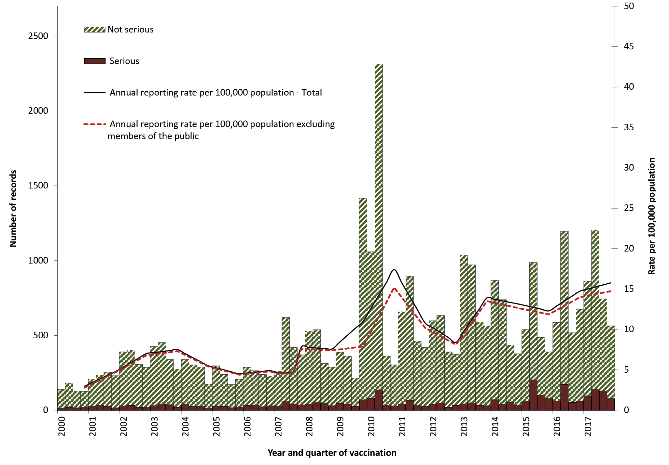

Note: For reports where the date of vaccination was not recorded, the date of onset or date event was reported to TGA was used as a proxy for vaccination date.

Figure 2: Adverse events following immunisation for children aged <1 year, AEMS database, 2000 to 2017, by year and quarter of vaccination
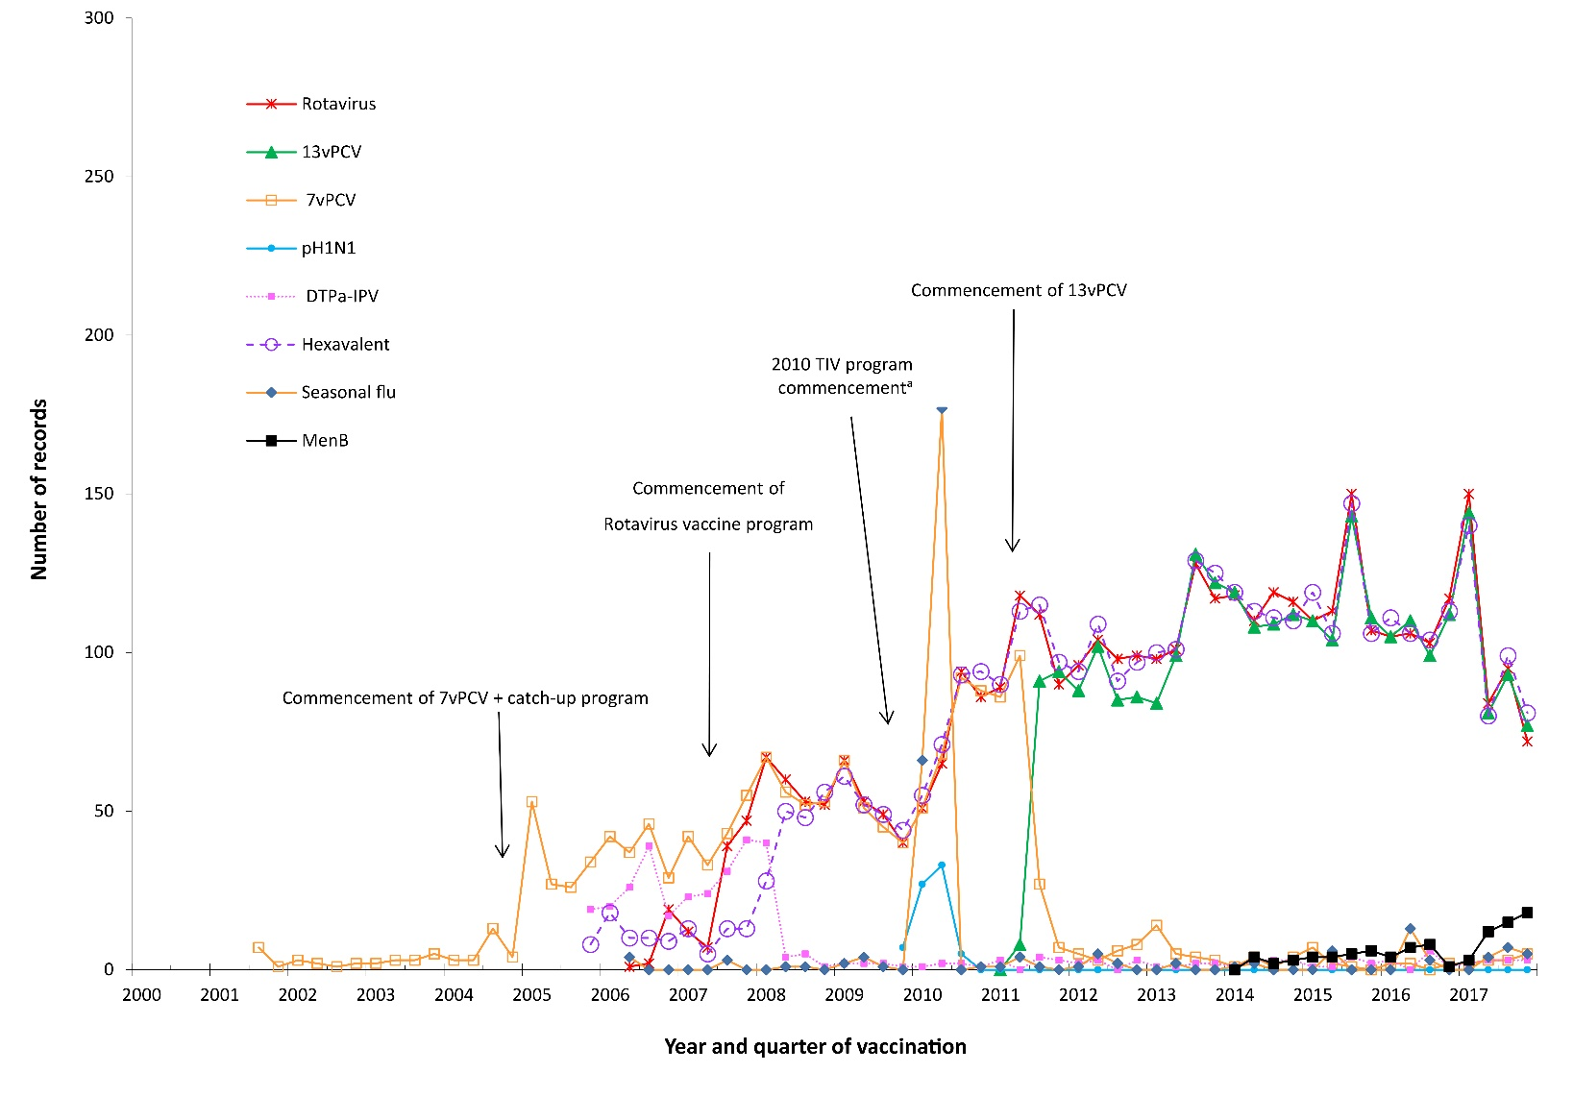
a Safety signal for fever and febrile convulsion found to be due to Seqirus (formerly bioCSL) Fluvax 2010 TIV in children
DTPa-IPV and DTPa-IPV-HepB-Hib (hexavalent) vaccines were introduced into the NIP schedule in November 2005; rotavirus (RotaTeq® and Rotarix®) vaccines on 1 July 2007; pH1N1 influenza vaccine for children 6 months to 10 years on December 2009; seasonal trivalent influenza vaccine in 2010 which was an extension of existing adult and Indigenous programs to at risk populations; and the 13-valent pneumococcal conjugate vaccine (13vPCV) on 1 July 2011. Also, MenB vaccine is recommended for use in those with increased risk of invasive meningococcal disease and is not currently funded under the NIP.
Note: For reports where the date of vaccination was not recorded, the date of onset or date event was reported to TGA was used as a proxy for vaccination date.
A seasonal pattern of AEFI reporting was apparent in 2017 as in previous years, with the highest number of AEFI notifications for vaccinations administered in the first half of the year (Figure 1). This corresponds to the months when influenza vaccine is given and older Australians may be more likely to be given 23vPPV in conjunction with the influenza vaccine (March to June). However, more AEFI reports following influenza vaccination were received in each of the last five years than years prior to 2009 (pre-pandemic era) (Figure 4).
Figure 3: Adverse events following immunisation for children aged 1 to <7 years in frequently reported vaccines, AEMS database, 2000 to 2017, by year and quarter of vaccination
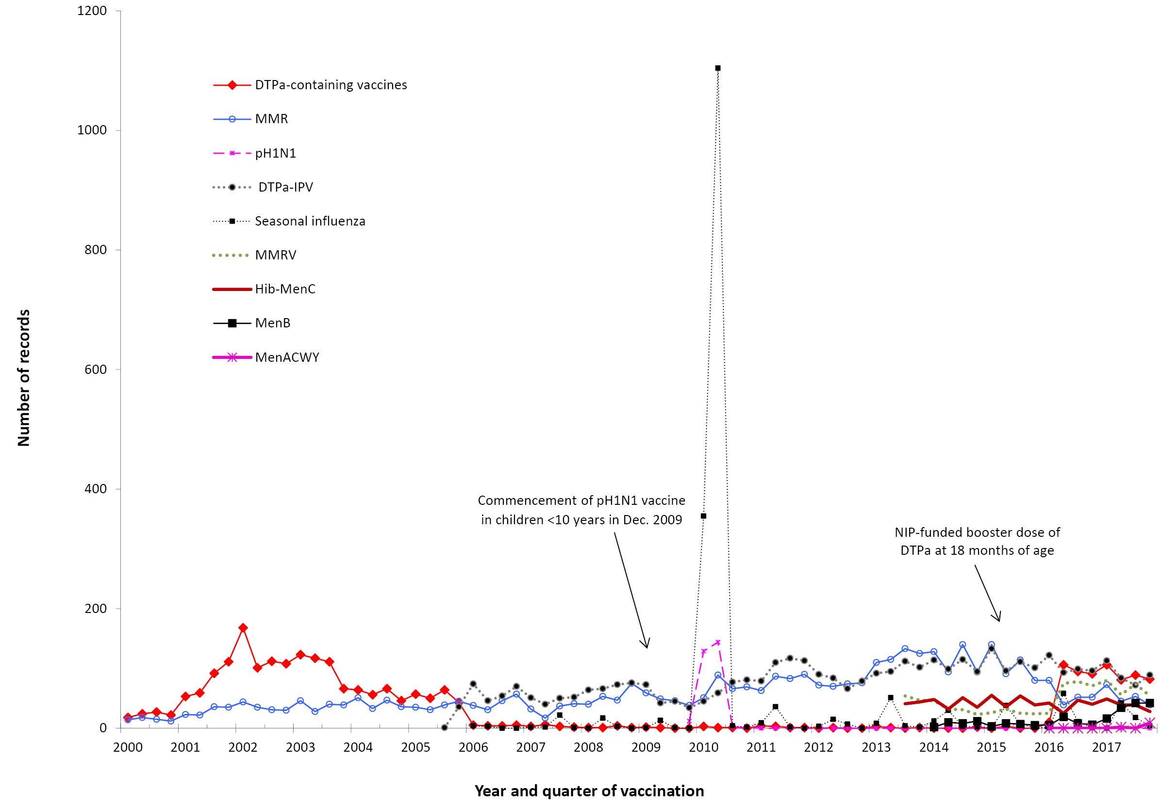
DTPa-IPV vaccine was introduced into the NIP schedule in November 2005 replacing DTPa and OPV vaccines; seasonal trivalent influenza vaccine in 2010 which was an extension of existing adult and Indigenous programs to at risk populations; MMRV and Hib–MenC vaccines on July 2013, and HPV vaccine program extended to boys in February 2013. MenB vaccine is recommended for use in those with increased risk of invasive meningococcal disease and is not currently funded under the NIP. In April 2016 an NIP-funded booster dose of DTPa vaccine was introduced at 18 months of age.
Note: For reports where the date of vaccination was not recorded, the date of onset or date event was reported to TGA was used as a proxy for vaccination date.

Figure 4: Adverse events following immunisation for people aged ≥7 years in frequently reported vaccines, AEMS database, 2000–2017, by year and quarter of vaccination.
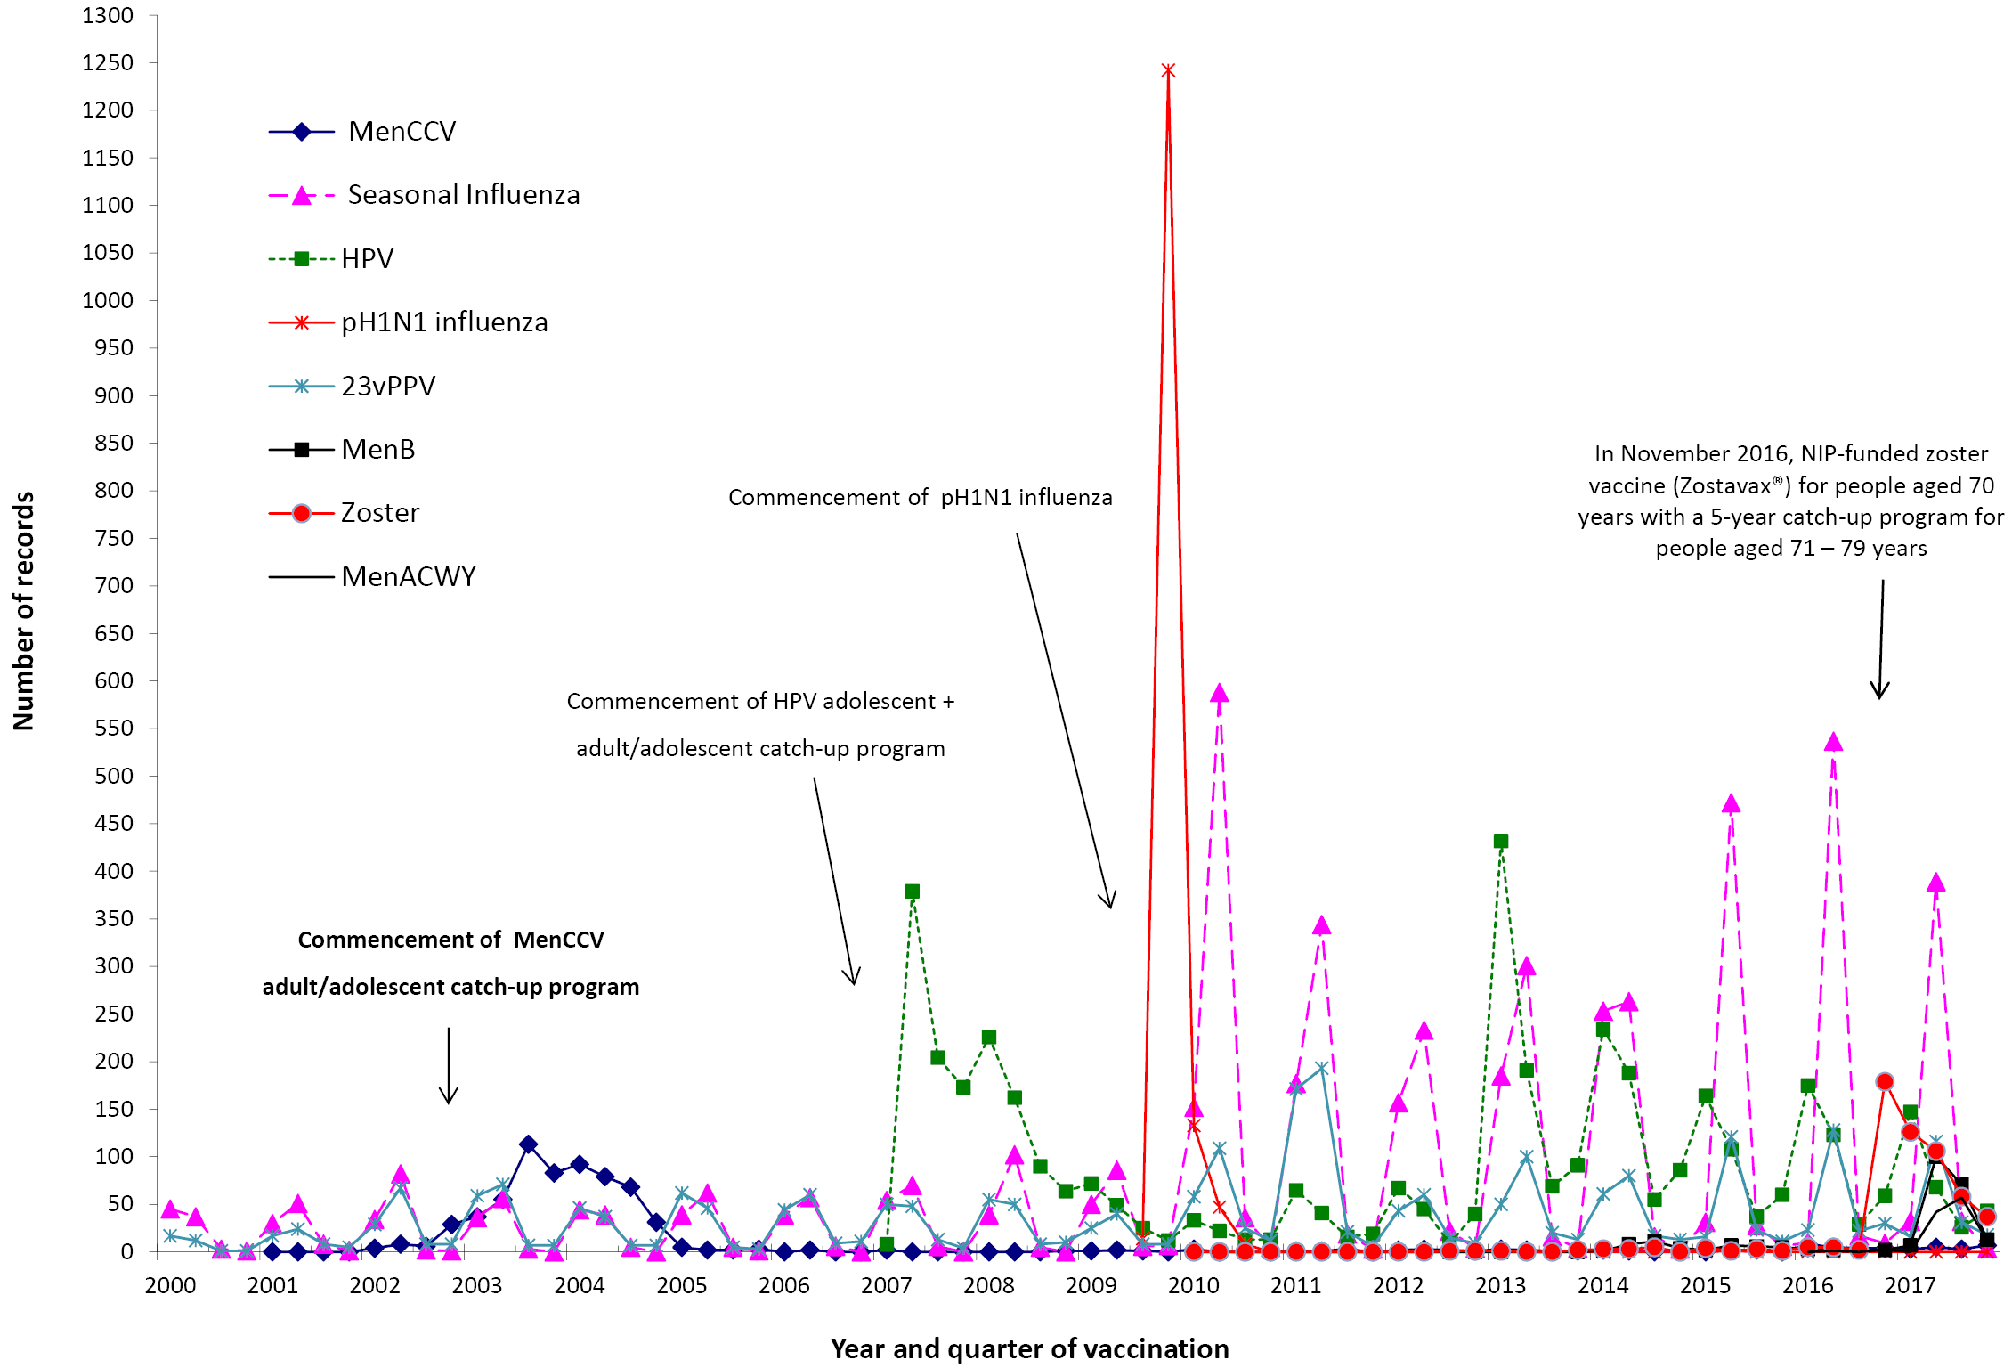
MenCCV was introduced into the NIP schedule on 1 January 2003; pH1N1 influenza vaccine for children 6 months to 10 years on December 2009; pH1N1 vaccination for those ≥10 years commenced on 30 Sep 2009; seasonal trivalent influenza vaccine program extended in 2010 from existing adult and Indigenous programs to at risk populations; and HPV vaccine program extended to boys in February 2013. MenB vaccine is recommended for use in those with increased risk of invasive meningococcal disease and is not currently funded under the NIP.
In November 2016, zoster vaccine (Zostavax®) was NIP-funded for people aged 70 years with a 5-year catch-up program for people aged 71–79 years.
Note: For reports where the date of vaccination was not recorded, the date of onset or date event was reported to TGA was used as a proxy for vaccination date.

Age distribution
The highest age-specific AEFI reporting rate per 100,000 population occurred in children aged 1 to <2 years, the age group that received the booster dose of DTPa at 18 months of age (Figure 5). Compared with 2016, AEFI reporting rates remained relatively stable across most age groups, however, there were increases observed in children aged 1 to <2 years, 7 to <20 years and adults aged 65 years and older (Figure 5).

Figure 5: Reporting rates of adverse events following immunisation per 100,000 population, AEMS database, 2000 to 2017, by age group and year of vaccination
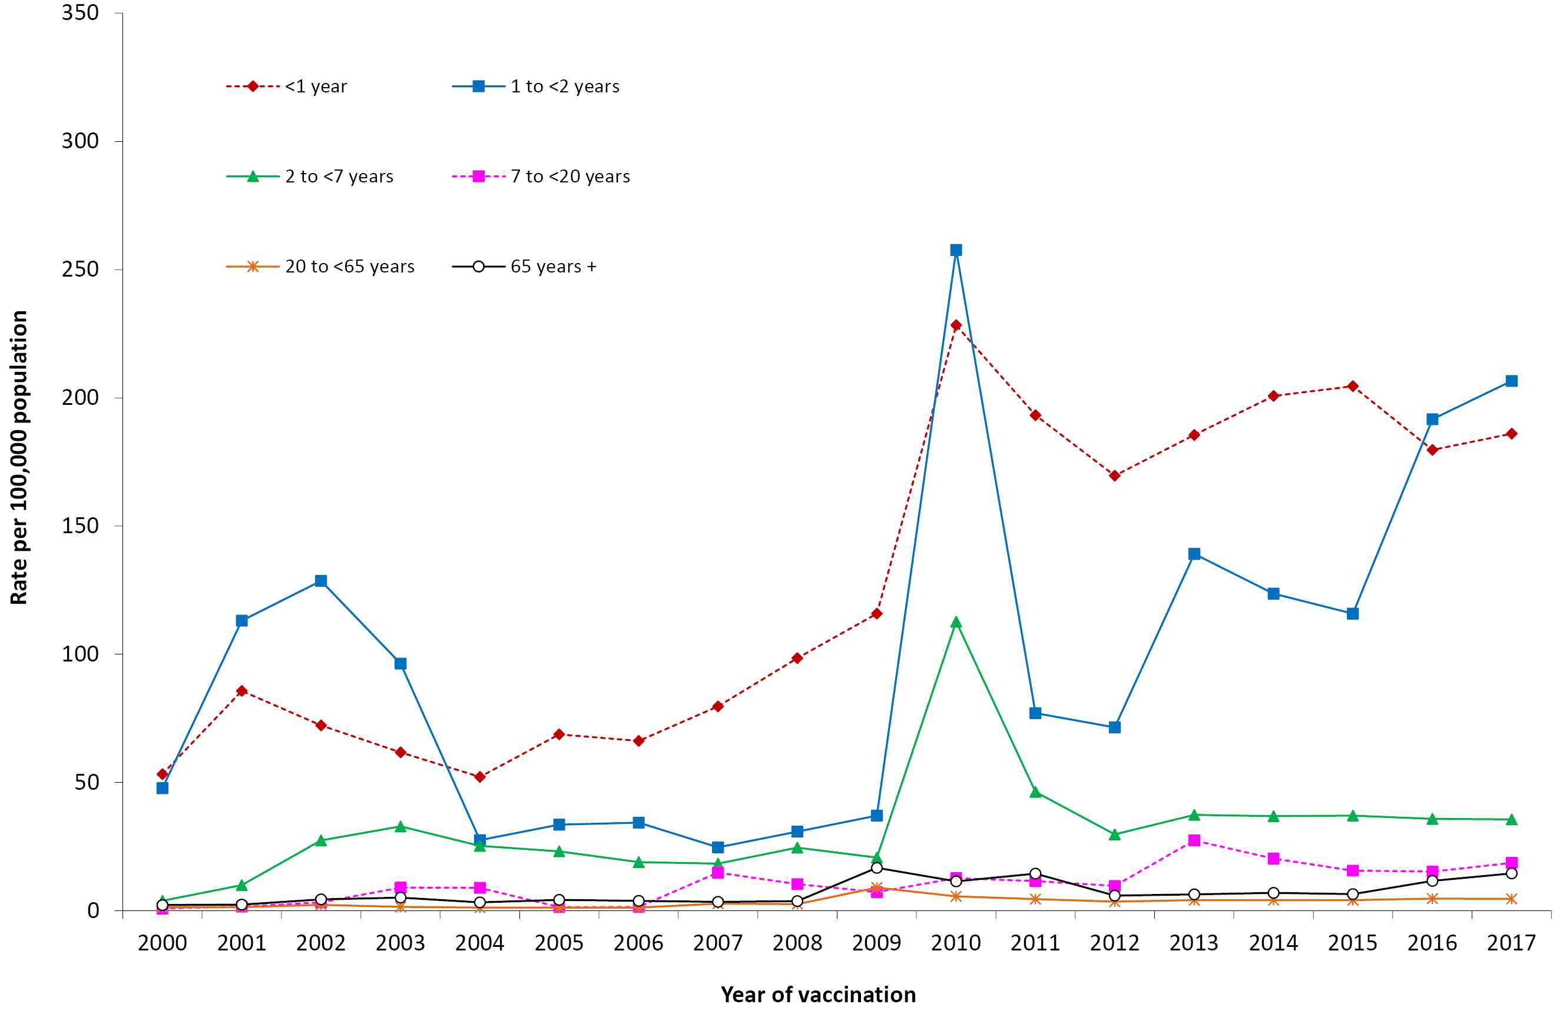
Note: For reports where the date of vaccination was not recorded, the date of onset or date event was reported to TGA was used as a proxy for vaccination date.
There were no significant differences in reporting rates per 100,000 doses for most individual vaccines in 2017 compared to 2016, noting the new additions to the NIP schedule namely zoster and state/territory-based meningococcal ACWY vaccination programs (Table 2).
For children <7 years of age, AEFI reporting rates for varicella, Hib and MenC vaccines should be interpreted with caution since monovalent versions of these vaccines were replaced by combination vaccines in July 2013 and hence very few doses of monovalent vaccine were recorded in 2017.

Table 2: Vaccine types listed as ‘suspected’ in records of adverse events following immunisation by age groups (<7, 7–17, 18–64 and ≥65 years), AEMS database, 2017
Vaccinesª | Reporting rate^{d} per 100,000 doses (95% CI)
 | AEFI records^{b} (n) | Vaccine Doses^{c} 2017 | 2017 | 2016
<7 years |  |  | Rate (95% Confidence Interval)
DTPa-containing vaccines | 1,168 | 1,469,637 | 79.5 (75.0–84.2) | 81.6 (77.0–86.4)
Hexavalent (DTPa-IPV-HepB-Hib) | 434 | 857,981 | 50.6 (45.9–55.6) | 51.5 (46.8–56.4)
DTPa-IPV | 363 | 309,673 | 117.2 (105.5–129.9) | 132.2 (119.7–145.6)
DTPa | 371 | 301,983 | 122.9 (110.7–136.0) | 127.1 (113.1–142.5)
Pneumococcal conjugate -13vPCV | 441 | 873,848 | 50.5 (45.9–55.4) | 47.3 (42.9–52.0)
Rotavirus vaccine | 405 | 675,308 | 60.0 (54.3–66.1) | 56.2 (50.9–61.9)
Measles-mumps-rubella-varicella | 267 | 304,376 | 87.7 (77.5–98.9) | 79.8 (70.1–90.5)
Measles-mumps-rubella | 226 | 320,977 | 70.4 (61.5–80.2) | 63.4 (55.3–72.4)
Meningococcal B | 182 | 151,255 | 120.3 (103.5–139.1) | 175.9 (133.3–228.0)
Hib-MenC | 169 | 309,593 | 54.6 (46.7–63.5) | 49.5 (41.9–58.0)
Seasonal influenza | 80 | 134,893 | 59.3 (47.0–73.8) | 109.0 (87.0–135.0)
Varicella | 23 | 13,296 | 173.0 (109.7–259.6) | 121.0 (66.1–203.0)
Meningococcal C conjugate | 13 | 8,040 | 161.7 (86.1–276.5) | 96.0 (41.4–189.1)
Hepatitis B | 8 | 30,997 | 25.8 (11.1–50.9) | 24.3 (12.1–43.5)
Haemophilus influenzae type b | 3 | 8,175 | 36.7 (7.6–107.2) | 52.8 (17.1–123.1)
Meningococcal ACWY | 12 | n/a
7–17 years
HPV | 277 | n/a | – | –
dTpa | 173 | n/a | – | –
Meningococcal B | 172 | n/a | – | –
Meningococcal ACWY | 83 | n/a
Varicella | 69 | n/a | – | –
Seasonal influenza | 36 | n/a | – | –
dTpa IPV | 14 | n/a | – | –
Measles-mumps-rubella | 13 | n/a | – | –
Meningococcal C conjugate | 12 | n/a | – | –
Hepatitis B | 10 | n/a | – | –
Measles-mumps-rubella-varicella | 7 | n/a | – | –
23vPPV | 3 | n/a | – | –
18–64 years
Seasonal influenza | 308 | n/a | – | –
dTpa | 101 | n/a | – | –
23vPPV | 48 | n/a | – | –
Hepatitis B | 30 | n/a | – | –
MMR | 28 | n/a | – | –
Meningococcal ACWY | 27 | n/a | – | –
Meningococcal B | 17 | n/a | – | –
Varicella | 15 | n/a | – | –
Q fever | 11 | n/a | – | –
≥65 years
Zoster | 331 | n/a | – | –
23vPPV | 130 | n/a | – | –
Seasonal influenza | 113 | n/a | – | –
dTpa | 12 | n/a | – | –
a Records where at least one of the vaccines shown in the table was suspected of causal involvement in the reported adverse event.
b Number of AEFI records in which the vaccine was coded as ‘suspected’ of causal involvement in the reported adverse event and the vaccination was administered between 1 January and 31 December 2017. More than one vaccine may be coded as ‘suspected’ if several were administered at the same time.
c Number of vaccine doses recorded on the AIR and administered between 1 January and 31 December 2017.
d The estimated reporting rate per 100,000 vaccine doses recorded.
n/a Not applicable
Table 3: Adverse events following immunisation (AEFI) records, AEMS database, January to December 2017, by jurisdiction
State or territory | AEFI records |  |  | Annual reporting rate per 100,000 populationª
 | n | (%) | ‘Serious’^{b} | Aged  <7 years | Overall Rate | (95% Confidence Interval)
Australian Capital Territory | 79 | (2.0) | 3.6 | 73.7 | 19.2 | (15.2–23.9)
New South Wales | 683 | (17.6) | 1.2 | 34.3 | 8.7 | (8.0–9.4)
Northern Territory | 73 | (1.9) | 2.0 | 123.2 | 29.5 | (23.1–37.1)
Queensland | 607 | (15.7) | 1.4 | 57.6 | 12.3 | (11.4–13.3)
South Australia | 388 | (10.0) | 1.2 | 68.8 | 22.5 | (20.3–24.9)
Tasmania | 82 | (2.1) | 0.4 | 40.1 | 15.7 | (12.5–19.5)
Victoria | 1,602 | (41.3) | 3.1 | 160.8 | 25.3 | (24.1–26.6)
Western Australia | 363 | (9.4) | 1.7 | 83.8 | 14.1 | (12.7–15.6)
Other^{c} | 1 | (0.0) | n/a | n/a | n/a | –
Total | 3,878 | (100.0) | 1.8 | 81.0 | 15.8 | (15.3–16.3)
a Average annual rates per 100,000 population calculated using mid-2017 population estimates (Australian Bureau of Statistics).
b AEFI records defined as ‘serious’ (i.e. recovery with sequelae, hospitalisation, life-threatening or death).
c Records where the jurisdiction in which the adverse event occurred was not reported or was unclear.

Geographical distribution
Population-based reporting patterns varied between states and territories during 2017 (Table 3). Reporting rates were not significantly different (with overlapping confidence intervals) across most jurisdictions in 2017 compared with 2016.³³ However, significant increases were observed in some states and territories that had state-funded vaccination programs for meningococcal disease (South Australia, Victoria and Tasmania).

Vaccines
There were 3,878 AEFI records reported in 2017 (Table 4). There were moderate variations in the proportions with outcomes defined as ‘serious’, although these remained generally low as in previous years.

Table 4: Vaccine types listed as ‘suspected’ in records of adverse events following immunisation (AEFI), AEMS database, 2017
Suspected vaccine typeª | AEFI records |  | One suspected vaccine only^{b} |  | ‘Serious’^{c} |  | Age group^{d}  <7 years |  | Age group^{d}  ≥7 years
 | n | (%) | n | (%)^{e} | n | (%)^{e} | n | (%)^{e} | n | (%)^{e}
Influenza | 574 | (14.8) | 484 | (84.3) | 55 | (9.6) | 80 | (13.9) | 457 | (79.6)
DTPa-IPV-HepB-Hib | 445 | (11.5) | 30 | (6.7) | 124 | (27.9) | 434 | (97.5) | 6 | (1.3)
13vPCV | 425 | (11.0) | 14 | (3.3) | 121 | (28.5) | 411 | (96.7) | 9 | (2.1)
Rotavirus | 410 | (10.6) | 43 | (10.5) | 119 | (29.0) | 405 | (98.8) | 2 | (0.5)
Meningococcal B | 383 | (9.9) | 357 | (93.2) | 53 | (13.8) | 182 | (47.5) | 191 | (49.9)
DTPa-IPV | 380 | (9.8) | 348 | (91.6) | 19 | (5.0) | 369 | (97.1) | 10 | (2.6)
DTPa | 376 | (9.7) | 127 | (33.8) | 26 | (6.9) | 363 | (96.5) | 11 | (2.9)
Zoster | 342 | (8.8) | 324 | (94.7) | 12 | (3.5) | 1 | (0.3) | 327 | (95.6)
HPV | 299 | (7.7) | 111 | (37.1) | 26 | (8.7) | 3 | (1.0) | 284 | (95.0)
dTpa | 288 | (7.4) | 125 | (43.4) | 22 | (7.6) | 5 | (1.7) | 275 | (95.5)
MMRV | 277 | (7.1) | 45 | (16.2) | 19 | (6.9) | 267 | (96.4) | 7 | (2.5)
MMR | 270 | (7.0) | 68 | (25.2) | 42 | (15.6) | 226 | (83.7) | 42 | (15.6)
23vPPV | 201 | (5.2) | 146 | (62.7) | 18 | (9.0) | 9 | (3.8) | 181 | (96.2)
Hib-MenC | 174 | (4.5) | 14 | (8.0) | 33 | (19.0) | 169 | (97.1) | 4 | (2.3)
Men ACWY | 126 | (3.2) | 114 | (90.5) | 27 | (21.4) | 12 | (9.5) | 111 | (88.1)
Varicella | 114 | (2.9) | 28 | (24.6) | 16 | (14.0) | 23 | (20.2) | 88 | (77.2)
Hepatitis B | 49 | (1.3) | 24 | (49.0) | 9 | (18.4) | 8 | (16.3) | 40 | (81.6)
Hepatitis A | 39 | (1.0) | 10 | (25.6) | 9 | (23.1) | 16 | (41.0) | 22 | (56.4)
MenCCV | 33 | (0.9) | 17 | (51.5) | 4 | (12.1) | 13 | (39.4) | 18 | (54.5)
Typhoid | 22 | (0.6) | 6 | (27.3) | 5 | (22.7) | 3 | (13.6) | 16 | (72.7)
Yellow fever | 19 | (0.5) | 11 | (57.9) | 1 | (5.3) | 1 | (5.3) | 13 | (68.4)
dT | 13 | (0.3) | 8 | (61.5) | 2 | (15.4) | 0 | (0.0) | 11 | (84.6)
Rabies | 13 | (0.3) | 9 | (69.2) | 1 | (7.7) | 1 | (7.7) | 10 | (76.9)
Q fever | 12 | (0.3) | 12 | (100.0) | 1 | (8.3) | 0 | (0.0) | 11 | (91.7)
Hepatitis A + B | 12 | (0.3) | 8 | (66.7) | 0 | (0.0) | 0 | (0.0) | 12 | (100.0)
Hepatitis A-Typhoid | 11 | (0.3) | 5 | (45.5) | 0 | (0.0) | 2 | (18.2) | 9 | (81.8)
BCG | 9 | (0.2) | 7 | (77.8) | 0 | (0.0) | 9 | (100.0) | 0 | (0.0)
Hib | 4 | (0.1) | 0 | (0.0) | 1 | (25.0) | 3 | (75.0) | 1 | (25.0)
Japanese encephalitis | 2 | (0.1) | 1 | (50.0) | 0 | (0.0) | 0 | (0.0) | 2 | (100.0)
Cholera | 1 | (0.0) | 1 | (100.0) | 0 | (0.0) | 1 | (100.0) | 0 | (0.0)
Tetanus | 1 | (0.0) | 0 | (0.0) | 0 | (0.0) | 0 | (0.0) | 1 | (100.0)
a See appendix for abbreviations of vaccine names.
b AEFI records where only one vaccine was suspected of causal involvement in a reported adverse event.
c ‘Serious’ is defined in the Methods section.
d Includes only AEFI records where an age or date of birth has been reported.
e Percentages are calculated for the number of AEFI records where the vaccine was suspected of causal involvement in the event

Table 5: Selected reported adverse eventsª classified by MedDRA Preferred Terms in records of adverse events following immunisation (AEFI), AEMS database, 2017^{b}
MedDRA Preferred Terms  (adverse events) | AEFI records |  | Only adverse event reported^{c} |  |  | ‘Serious’^{d} |  |  | Age group^{e}  <7 years |  |  | Age group^{e}  ≥7 years
 | N | n |  | (%)^{f} | n |  | (%)^{f} | n |  | (%)^{f} | n |  | (%)^{f}
Injection site reaction^{g} | 1,319 | 711 |  | (53.9) | 60 |  | (4.5) | 663 |  | (50.3) | 623 |  | (47.2)
Pyrexia | 669 | 46 |  | (6.9) | 100 |  | (14.9) | 402 |  | (60.1) | 252 |  | (37.7)
Rash^{h} | 592 | 237 |  | (40.0) | 62 |  | (10.5) | 353 |  | (59.6) | 227 |  | (38.3)
Vomiting | 304 | 22 |  | (7.2) | 60 |  | (19.7) | 165 |  | (54.3) | 128 |  | (42.1)
Pain | 280 | 28 |  | (10.0) | 15 |  | (5.4) | 42 |  | (15.0) | 228 |  | (81.4)
Headache | 275 | 7 |  | (2.5) | 20 |  | (7.3) | 14 |  | (5.1) | 251 |  | (91.3)
Nausea | 209 | 2 |  | (1.0) | 12 |  | (5.7) | 9 |  | (4.3) | 190 |  | (90.9)
Urticaria | 171 | 93 |  | (54.4) | 21 |  | (12.3) | 100 |  | (58.5) | 69 |  | (40.4)
Diarrhoea | 154 | 15 |  | (9.7) | 23 |  | (14.9) | 102 |  | (66.2) | 51 |  | (33.1)
Extensive limb swelling | 143 | 91 |  | (63.6) | 5 |  | (3.5) | 90 |  | (62.9) | 52 |  | (36.4)
Syncope | 119 | 74 |  | (62.2) | 16 |  | (13.4) | 13 |  | (10.9) | 99 |  | (83.2)
Irritability | 116 | 3 |  | (2.6) | 17 |  | (14.7) | 109 |  | (94.0) | 6 |  | (5.2)
Malaise | 115 | 2 |  | (1.7) | 11 |  | (9.6) | 22 |  | (19.1) | 88 |  | (76.5)
Lethargy | 113 | 0 |  | (0.0) | 13 |  | (11.5) | 46 |  | (40.7) | 66 |  | (58.4)
Myalgia | 107 | 3 |  | (2.8) | 7 |  | (6.5) | 5 |  | (4.7) | 95 |  | (88.8)
Dizziness | 101 | 2 |  | (2.0) | 11 |  | (10.9) | 3 |  | (3.0) | 96 |  | (95.0)
Chills | 86 | 5 |  | (5.8) | 5 |  | (5.8) | 10 |  | (11.6) | 74 |  | (86.0)
Injected limb mobility decreased | 83 | 3 |  | (3.6) | 1 |  | (1.2) | 8 |  | (9.6) | 74 |  | (89.2)
Erythema | 81 | 12 |  | (14.8) | 8 |  | (9.9) | 45 |  | (55.6) | 36 |  | (44.4)
Pruritus | 78 | 6 |  | (7.7) | 8 |  | (10.3) | 18 |  | (23.1) | 59 |  | (75.6)
Paraesthesia | 78 | 6 |  | (7.7) | 14 |  | (17.9) | 2 |  | (2.6) | 71 |  | (91.0)
Pallor | 65 | 2 |  | (3.1) | 10 |  | (15.4) | 37 |  | (56.9) | 26 |  | (40.0)
Abdominal pain | 64 | 5 |  | (7.8) | 12 |  | (18.8) | 23 |  | (35.9) | 39 |  | (60.9)
Decreased appetite | 63 | 2 |  | (3.2) | 7 |  | (11.1) | 41 |  | (65.1) | 22 |  | (34.9)
Fatigue | 63 | 0 |  | (0.0) | 4 |  | (6.3) | 12 |  | (19.0) | 48 |  | (76.2)
Cough | 60 | 1 |  | (1.7) | 17 |  | (28.3) | 29 |  | (48.3) | 30 |  | (50.0)
Anaphylactic reaction | 59 | 39 |  | (66.1) | 25 |  | (42.4) | 8 |  | (13.6) | 46 |  | (78.0)
Hypotonic-hyporesponsive episode | 55 | 41 |  | (74.5) | 22 |  | (40.0) | 54 |  | (98.2) | 0 |  | (0.0)
Dyspnoea | 47 | 4 |  | (8.5) | 16 |  | (34.0) | 4 |  | (8.5) | 43 |  | (91.5)
Arthralgia | 46 | 2 |  | (4.3) | 3 |  | (6.5) | 4 |  | (8.7) | 40 |  | (87.0)
Presyncope | 45 | 27 |  | (60.0) | 5 |  | (11.1) | 12 |  | (26.7) | 32 |  | (71.1)
Oropharyngeal pain | 41 | 0 |  | (0.0) | 6 |  | (14.6) | 7 |  | (17.1) | 33 |  | (80.5)
Convulsions^{i} | 36 | 23 |  | (63.9) | 24 |  | (66.7) | 33 |  | (91.7) | 2 |  | (5.6)
Rhinorrhoea | 33 | 0 |  | (0.0) | 4 |  | (12.1) | 19 |  | (57.6) | 12 |  | (36.4)
Hyperhidrosis | 30 | 0 |  | (0.0) | 1 |  | (3.3) | 2 |  | (6.7) | 26 |  | (86.7)
Somnolence | 24 | 2 |  | (8.3) | 7 |  | (29.2) | 19 |  | (79.2) | 5 |  | (20.8)
Chest discomfort | 21 | 0 |  | (0.0) | 3 |  | (14.3) | 0 |  | (0.0) | 21 |  | (100.0)
Tachycardia | 19 | 0 |  | (0.0) | 10 |  | (52.6) | 5 |  | (26.3) | 11 |  | (57.9)
Haematochezia | 18 | 3 |  | (16.7) | 4 |  | (22.2) | 16 |  | (88.9) | 2 |  | (11.1)
Blister | 16 | 4 |  | (25.0) | 1 |  | (6.3) | 9 |  | (56.3) | 7 |  | (43.8)
Hypoaesthesia | 14 | 0 |  | (0.0) | 3 |  | (21.4) | 0 |  | (0.0) | 14 |  | (100.0)
Throat irritation | 14 | 0 |  | (0.0) | 10 |  | (71.4) | 0 |  | (0.0) | 14 |  | (100.0)
Tremor | 12 | 1 |  | (8.3) | 3 |  | (25.0) | 3 |  | (25.0) | 9 |  | (75.0)
Intussusception | 9 | 8 |  | (88.9) | 4 |  | (44.4) | 9 |  | (100.0) | 0 |  | (0.0)
Guillain-Barre Syndrome | 4 | 2 |  | (50.0) | 1 |  | (25.0) | 1 |  | (25.0) | 2 |  | (50.0)
Gait disturbance | 4 | 1 |  | (25.0) | 1 |  | (25.0) | 2 |  | (50.0) | 1 |  | (25.0)
Lymphadenitis | 3 | 2 |  | (66.7) | 2 |  | (66.7) | 2 |  | (66.7) | 1 |  | (33.3)
a A complete list of adverse reactions as classified by individual Preferred Terms is available on request.
b Selected reported adverse events reported during Jan-Dec 2017. Note: for injection site reaction, rash and convulsions, PT’s were grouped as described below.
c AEFI records where only one adverse event was reported.
d ‘Serious’ outcomes are defined in the Methods section.
e Includes only AEFI records where an age or date of birth has been reported
f Percentages relate to the number of AEFI records in which the specific adverse event was listed
g Injection site reaction includes the following MedDRA PTs: injection site reaction, injection site swelling, injection site pain, injection site mass, injection site erythema, injection site cellulitis, injection site rash, injection site induration, injection site abscess, injection site pruritus, injection site nodule, injected limb mobility decreased, injection site urticaria, injection site inflammation, injection site bruising, injection site infection, and injection site warmth.
h Rash includes the following MedDRA PTs: rash, rash generalised, rash erythematous, rash pruritic, rash maculo-papular, rash macular, rash vesicular, rash papular, rash morbilliform, and rash pustular.
i Convulsion includes the following MedDRA PTs: febrile convulsion, convulsion, grand mal convulsion, and partial seizures.

The vaccine most frequently reported as associated with AEFI was seasonal influenza vaccine (574 records; 14.8% of 2017 records) followed by hexavalent DTPa-IPV-HepB-Hib (n=445; 11.5%), 13vPCV (n=425, 11.0%), rotavirus vaccine (n=410; 10.6%), meningococcal B (n=383; 9.9%), DTPa-IPV (n=380; n=9.8%) and DTPa (n=376; n=9.7%) (Table 4).
For zoster vaccine (funded on NIP from November 2016), there were 342 AEFI reports in 2017 with only 3.5% (12) of these coded as serious.

Reactions
The most frequently reported adverse events in 2017 were injection site reactions (ISRs) (n=1,319; 34% of total), pyrexia (n=669; 17%), rash (n=592; 15%), vomiting (n=304; 8%), pain (n=280; 7%) and headache (n=275; 7%) (Table 5, Figure 6). Adverse events of particular interest included anaphylaxis (n=59; 1.5%) hypotonic-hyporesponsive episode (n=55; 1.4%), convulsions (n=36; 0.9%), intussusception (n=9; 0.2%) and Guillain-Barré Syndrome (n=4; 0.1%) (Table 5).
Figure 6: Selected frequently reported adverse events following immunisation, AEMS database, 2000 to 2017, by year and quarter of vaccination
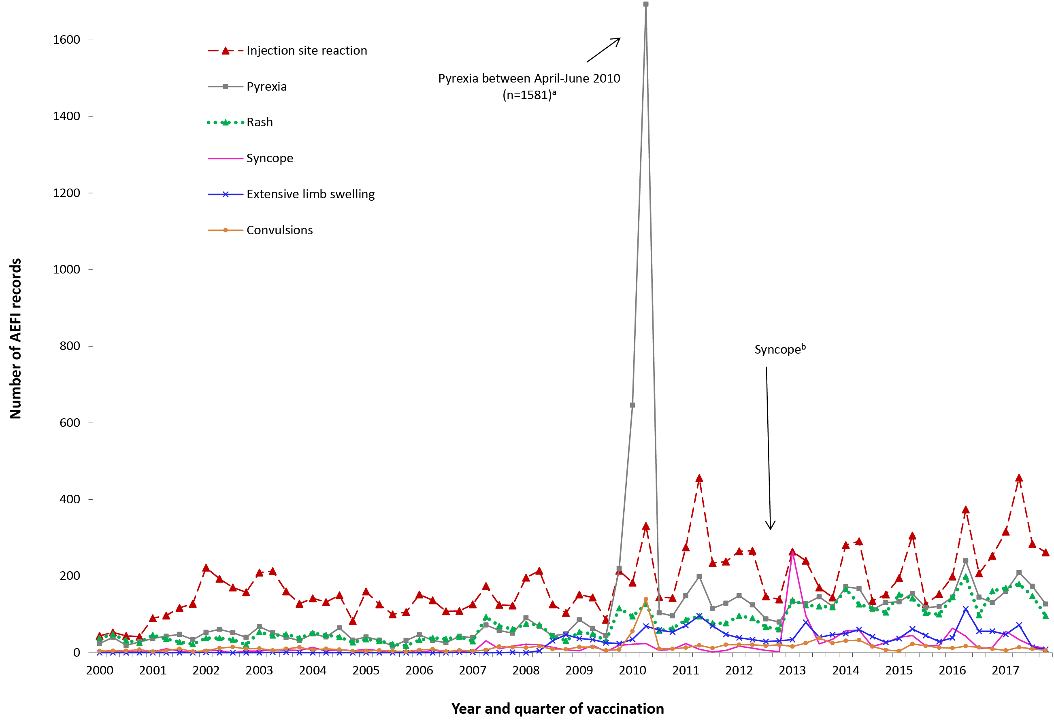
a Associated with administration of Seqirus (formerly bioCSL) Fluvax 2010 TIV and associated stimulated reporting.
b The peak in syncope coincided with the enhanced HPV surveillance program in which there was stimulated reporting of syncope for the first 6 months of 2013.
Note: For reports where the date of vaccination was not recorded, the date of onset or date event was reported to TGA was used as a proxy for vaccination date.
The number of reports of particular adverse events has changed over time (Figure 6). The variation in reporting of ISRs is related to changes in the immunisation schedule for vaccines that are known to have higher rates of ISR, including DTPa-containing vaccines, 23vPPV and HPV vaccine.^{3–14,34,35} Increases in reports of AEFI were largely associated with time periods when new vaccines were added to the NIP, or eligibility extended, in the reporting period, including: 7vPCV (2005) and HPV (2007); the extension of seasonal influenza vaccine on the NIP to include persons <65 years at high risk of influenza in 2010; 13vPCV replacing 7vPCV in July 2011; the extension of HPV to males in 2013; seasonal influenza vaccine funded for Aboriginal and Torres Strait Islander children aged 6 months to less than 5 years in 2015; booster dose of DTPa for children aged 18 months of age in 2016, and zoster vaccine funded for adults aged 70 years with a five-year catch-up program for people aged 71–79 years from November 2016.

Severity of outcomes
The majority of reported adverse events in 2017 were defined as ‘non-serious’ (n=3,430, 88%). Twelve per cent (n=448) were defined as serious, an increase of 34% from 2016 (Figure 1).
Three deaths were reported as temporally associated with receipt of vaccines in this reporting period.
- A 71 year old male died in early January 2017, a month after receiving a dose of the zoster vaccine. The person had chronic lymphocytic leukaemia, a contraindication to the live zoster vaccine. The cause of death was disseminated varicella-zoster virus (Oka strain) infection with meningoencephalitis and aspiration pneumonia resulting in death. This man’s death was investigated by the TGA and a clear causal relationship with vaccination was found.³⁶
- A 24-year old male who was on azathioprine and had recently commenced high dose corticosteroids for a serious medical condition was administered the live varicella vaccine. Over the subsequent two weeks he also received infliximab. He developed disseminated varicella-zoster virus infection (Oka strain) 19 days after vaccination and subsequently developed haemophagocytic lymphohistiocytosis (HLH) and died 3 months after varicella vaccination. This man’s death was determined to be causally related to varicella vaccination.
- A 2-month old male with complex cardiac disease and cardiac surgery four times in first 6 weeks of life died following immunisation. Post-op progress was complicated by multiple cardiac issues, ventilator dependency, sepsis, high volume chylothoraces, steroid dependency and renal dysfunction. One day following vaccination (8 weeks scheduled vaccination) he developed left upper limb focal clonic seizures. He was treated for central nervous system infection but continued to deteriorate and died at 9 weeks of age. This child’s death was considered to be due to complicated medical conditions and sequelae of surgery, coincidental to vaccination.
Furthermore, two miscarriages (spontaneous abortion) were reported in this period:
- A 36 year old female had an anembryonic pregnancy and a subsequent miscarriage. She had conceived a few days before having the influenza vaccine. No further details were available for this case.
- A 44 year old female was given the Fluarix Tetra vaccine in early pregnancy and developed vaginal spotting later on the day of vaccination. Miscarriage occurred 2 days later.
Additionally, two deaths were reported to TGA as vaccine failures, not effects of the vaccine.
- A 40-year old female received a dose of the quadrivalent flu vaccine Fluarix Tetra. Four months later the patient had an influenza-like illness for one week and presented to the emergency department in acute respiratory failure and septic shock. She was transferred to another hospital via ambulance but died en route. The patient tested positive for Influenza B (Phuket strain) found in the 2017 Fluarix Tetra. This was a report of vaccine failure.
- A 10 year old female developed Haemophilus influenzae type b (Hib) epiglottitis and died. She had been age-appropriately vaccinated with Hib vaccine (Comvax, MSD). This was a report of vaccine failure.
In summary, all deaths following immunisation reported to the TGA were investigated by the TGA and where relevant, other relevant authorities, based on the information received from reporters. A clear causal relationship with vaccination was found for two of the seven deaths. Disseminated VZV infection from Oka vaccine strain was causally associated with death in these two cases. The use of live attenuated VZV-containing vaccines in people who are immunocompromised is contraindicated due to the risk of unchecked vaccine virus replication causing serious disease.^{16,36}
One death was assessed as coincidental to vaccination and the two spontaneous abortions reported to TGA did not undergo a causality assessment. Spontaneous abortions are known to occur in 11–22% of all pregnancies.^{37,38} Two deaths were due to vaccine failure, not adverse events following immunisation. Vaccine effectiveness varies by vaccine type, as well as vaccine recipient and pathogen characteristics.
The TGA encourages all reporters to provide sufficient information to allow the TGA to assess any causal relationship between the administration of a vaccine and the adverse event reported.

Discussion
This report uses similar methodology to the previous four annual reports.^{2,15,33,39} Analysis using MedDRA preferred terms allows for clearer reporting of adverse events, but needs to be taken into account when comparing with data from annual reports prior to 2013.
In 2017, there was a 12% increase in the AEFI reporting rate compared with the previous year. This increase was mainly attributable to introduction of the booster dose of DTPa vaccine at 18 months of age in April 2016; zoster vaccine for those aged 70–79 years in November 2016; and state-funded meningococcal vaccination programs in 2017. There is usually an increase in reporting of adverse events when a new program or scheduled dose is rolled out, as immunisation providers are more likely to report milder, less serious AEFI for vaccines they are not as familiar with, or that are being given to a new population group. A reduction and stabilisation of reporting rates over time often occurs thereafter.^{2,4,5,7,10,12–15,33,40} During this second year of implementation of the booster dose of DTPa, there were 376 AEFI reports, although the majority (93%) were not serious. There were 342 AEFI reports in adults who received zoster vaccine, although the majority (96%) were not serious.
Two deaths causally related to varicella zoster virus-containing (VZV) live attenuated vaccines, administered to immunocompromised adults who were contraindicated to receive them, occurred in 2017. One death was reported following Zostavax® vaccination in an immunocompromised adult.^{36,41} An immunocompromised 24-year old also died of disseminated Oka strain VZV infection associated with HLH and complicated inflammatory bowel disease following varicella vaccination. These live vaccines are contraindicated in immunocompromised people.¹⁶
Overall, injection site reaction, pyrexia, rash, vomiting and pain were the most commonly reported reactions to the TGA in 2017. AEFI reporting rates for most individual vaccines in 2017 were similar to 2016. These findings are similar to nationally representative vaccine safety data from AusVaxSafety, which actively monitors the safety of pertussis, zoster, HPV and influenza vaccines in vaccinated people from 269 sentinel surveillance sites nationwide. No safety signals were observed for these vaccines in 2017 in AusVaxSafety.⁴²
The majority of AEFI reports were non-serious events during 2017 and no new safety concerns arose during this period. However, two deaths occurred associated with the use of live VZV-containing vaccines in immunocompromised persons, contraindicated to receive them.^{36,41} These are the first reports of Oka VZV vaccine strain associated death in Australia. A recently published global review reported that disseminated VZV disease after varicella and zoster vaccination was extremely rare and all cases from VZV vaccine (Oka strain) were in immmuncompromised people.⁴³ These unfortunate cases highlight the importance of ensuring that immunisation providers are aware of the important contraindications for the use of live attenuated vaccines, such as varicella, herpes zoster and yellow fever. Numerous additional communication and education activities targeted at immunisation providers have been undertaken to reinforce this.⁴⁴

Conclusion
The number of reported AEFI increased in 2017 compared with 2016 though the majority were non-serious transient events. The data reported here are consistent with an overall high level of safety for vaccines used in Australia when used according to clinical recommendations contained within the Australian Immunisation Handbook.¹⁶

Acknowledgments
We thank Alexandra Hendry, NCIRS, for providing vaccine dose data from the Australian Immunisation Register.
The National Centre for Immunisation Research and Surveillance of Vaccine Preventable Diseases is supported by the Australian Government Department of Health, the New South Wales Department of Health and The Children’s Hospital at Westmead, Australia.

Author details
Aditi Dey,¹ Han Wang,¹ Helen Quinn,¹ Rona Hiam² , Nicholas Wood,¹ Frank Beard¹ and Kristine Macartney¹
- National Centre for Immunisation Research and Surveillance, The University of Sydney and The Children’s Hospital at Westmead, Sydney, Australia
- Pharmacovigilance and Special Access Branch, Therapeutic Goods Administration, Canberra, Australia

Corresponding author
Dr Aditi Dey National Centre for Immunisation Research and Surveillance
Locked Bag 4001 Westmead NSW 2145 Phone: (02) 9845 1416 Fax: (02) 9845 1418 Email: aditi.dey@health.nsw.gov.au

References
- ﻿Council for International Organizations of Medical Sciences (CIOMS) c/o World Health Organization. Definition and Application of Terms for Vaccine Pharmacovigilance: Report of CIOMS/WHO Working Group on Vaccine Pharmacovigilance. 2012.
- Dey A, Wang H, Quinn H, Hill R, Macartney K. Surveillance of adverse events following immunisation in Australia annual report, 2014. Commun Dis Intell Q Rep 2016;40(3):E377–90.
- Lawrence G, Boyd I, McIntyre P, Isaacs D. Surveillance of adverse events following immunisation: Australia 2002 to 2003. Commun Dis Intell Q Rep 2004;28(3):324–38.
- Lawrence G, Boyd I, McIntyre P, Isaacs D. Annual report: surveillance of adverse events following immunisation in Australia, 2005. Commun Dis Intell Q Rep 2006;30(3):319–33.
- Lawrence G, Gold MS, Hill R, Deeks S, Glasswell A, McIntyre PB. Annual report: surveillance of adverse events following immunisation in Australia, 2007. Commun Dis Intell Q Rep 2008;32(4):371–87.
- Lawrence G, Menzies R, Burgess M, McIntyre P, Wood N, Boyd I, et al. Surveillance of adverse events following immunisation: Australia, 2000–2002. Commun Dis Intell Q Rep 2003;27(3):307–23.
- Lawrence GL, Aratchige PE, Boyd I, McIntyre PB, Gold MS. Annual report on surveillance of adverse events following immunisation in Australia, 2006. Commun Dis Intell Q Rep 2007;31(3):269–82.
- Lawrence GL, Boyd I, McIntyre PB, Isaacs D. Annual report: surveillance of adverse events following immunisation in Australia, 2004 Commun Dis Intell Q Rep 2005;29(3):248–62.
- Mahajan D, Cook J, Dey A, Macartney K, Menzies R. Supplementary report: surveillance of adverse events following immunisation among children aged less than seven years in Australia, 1 January to 30 June 2012. Commun Dis Intell Q Rep 2013;37(2):E130–4.
- Mahajan D, Cook J, Dey A, Macartney K, Menzies RI. Annual report: surveillance of adverse events following immunisation in Australia, 2011. Commun Dis Intell Q Rep 2012;36(4):E315–32.
- Mahajan D, Cook J, McIntyre P, Macartney K, Menzies R. Supplementary report: surveillance of adverse events following immunisation among children aged less than seven years in Australia, 1 January to 30 June 2011. Commun Dis Intell Q Rep 2012;36(1):114–9.
- Mahajan D, Cook J, McIntyre PB, Macartney K, Menzies RI. Annual report: surveillance of adverse events following immunisation in Australia, 2010. Commun Dis Intell Q Rep 2011;35(4):263–80.
- Mahajan D, Roomiani I, Gold MS, Lawrence GL, McIntyre PB, Menzies RI. Annual report: surveillance of adverse events following immunisation in Australia, 2009. Commun Dis Intell Q Rep 2010;34(3):259–76.
- Menzies R, Mahajan D, Gold MS, Roomiani I, McIntyre P, Lawrence G. Annual report: surveillance of adverse events following immunisation in Australia, 2008. Commun Dis Intell Q Rep 2009;33(4):365–81.
- Mahajan D, Dey A, Cook J, Harvey B, Menzies R, Macartney K. Surveillance of adverse events following immunisation in Australia annual report, 2013. Commun Dis Intell Q Rep 2015;39(3):E369–86.
- Australian Technical Advisory Group on Immunisation (ATAGI). Australian Immunisation Handbook, Australian Government Department of Health, Canberra. 2018. Accessed on 17 January 2019. Available from: https://beta.health.gov.au/resources/publications/the-australian-immunisation-handbook
- Uppsala Monitoring Centre. WHO Collaborating Centre for International Drug Monitoring. Accessed on 9 July 2014. Available from: http://www.who-umc.org/
- Zhou W, Pool V, Iskander JK, English-Bullard R, Ball R, Wise RP, et al. Surveillance for safety after immunization: Vaccine Adverse Event Reporting System (VAERS)–United States, 1991–2001. [erratum appears in MMWR Morb Mortal Wkly Rep . 2003;52(06):113]. MMWR Surveill Summ 2003;52(1):1–24.
- Brown EG. Using MedDRA: implications for risk management. Drug Saf 2004;27(8):591–602.
- Brown EG, Wood L, Wood S. The medical dictionary for regulatory activities (MedDRA). Drug Saf 1999;20(2):109–17.
- National Health and Medical Research Council. The Australian Immunisation Handbook. 8th edn. Canberra: Australian Government Department of Health and Ageing; 2003.
- Mahajan D, Dey A, Hill R, Harvey B, Menzies R, McIntyre P, et al. Methodological framework for reporting of adverse events following immunisation (AEFI) In: PHAA National Immunisation Conference, 17–19 June, 2014; Melbourne, Australia.
- Leroy Z, Broder K, Menschik D, Shimabukuro T, Martin D. Febrile seizures after 2010–2011 influenza vaccine in young children, United States: a vaccine safety signal from the vaccine adverse event reporting system. Vaccine 2012;30(11):2020–3.
- Moro PL, Broder K, Zheteyeva Y, Revzina N, Tepper N, Kissin D, et al. Adverse events following administration to pregnant women of influenza A (H1N1) 2009 monovalent vaccine reported to the Vaccine Adverse Event Reporting System. Am J Obstet Gynecol 2011;205(5):e1–9.
- Zheteyeva Y, Moro PL, Yue X, Broder K. Safety of meningococcal polysaccharide-protein conjugate vaccine in pregnancy: a review of the Vaccine Adverse Event Reporting System. Am J Obstet Gynecol 2013;208(6):e1–6.
- Australian Government Department of Health, Therapeutic Goods Administration. National Adverse Events Following Immunisation (AEFI) reporting form. Accessed on 26 March 2013. Available from: https://www.tga.gov.au/form/national-adverse-events-following-immunisation-aefi-reporting-form
- SAS Institute Inc. The SAS system for Windows [computer program]. Version 9.4. Cary, N.C. 2012.
- Australian Bureau of Statistics. Australian Demographic Statistics. 2015. http://www.abs.gov.au/AUSSTATS/abs@.nsf/DetailsPage/3101.0Jun%202015?OpenDocument#Time
- Australian Government Department of Human Services. Australian Immunisation Register. Accessed on 21 October 2016. Available from: https://www.humanservices.gov.au/customer/services/medicare/australian-immunisation-register
- Australian Government Department of Health. UPDATE: Expansion of Australia’s Immunisation Registers. Accessed on 21 October 2016. Available from: http://www.immunise.health.gov.au/internet/immunise/publishing.nsf/Content/67D8681A67167949CA257E2E000EE07D/$File/Factsheet-%20Immunisation-Registers-Expansion-23102015.pdf
- Varricchio F, Iskander J, DeStefano F, Ball R, Pless R, Braun M, et al. Understanding vaccine safety information from the Vaccine Adverse Event Reporting System. Pediatr Infect Dis J 2004;23:287–94.
- Australian Government Department of Health, Therapeutic Goods Administration. Database of Adverse Event Notifications. Accessed on 26 March 2013. Available from: https://www.tga.gov.au/database-adverse-event-notifications-daen
- Dey A, Wang H, Quinn H, Cook J, Macartney K. Surveillance of adverse events following immunisation in Australia, 2015. Communicable Diseases Intelligence Q Rep 2017;41:E264-78.
- Simon LS. Pharmacovigilance: towards a better understanding of the benefit to risk ratio. Ann Rheum Dis 2002;61(Suppl 2): ii88–9.
- Reisinger KS, Block SL, Lazcano-Ponce E, Samakoses R, Esser MT, Erick J, et al. Safety and persistent immunogenicity of a quadrivalent human papillomavirus types 6, 11, 16, 18 L1 virus-like particle vaccine in preadolescents and adolescents: a randomized controlled trial. Pediatr Infect Dis J 2007;26(3):201–9.
- Alexander KE, Tong PL, Macartney K, Beresford R, Sheppeard V, Gupta M. Live zoster vaccination in an immunocompromised patient leading to death secondary to disseminated varicella zoster virus infection. Vaccine 2018;36(27):3890–3.
- Rouse CE, Eckert LO, Babarinsa I, Fay E, Gupta M, Harrison MS, et al. Spontaneous abortion and ectopic pregnancy: Case definition & guidelines for data collection, analysis, and presentation of maternal immunization safety data. Vaccine 2017;35(48 Pt A): 6563–74.
- Ammon Avalos L, Galindo C, Li DK. A systematic review to calculate background miscarriage rates using life table analysis. Birth Defects Res A Clin Mol Teratol. 2012;94(6):417–23.
- Dey A, Wang H, Quinn H, Cook J, Macartney K. Surveillance of adverse events following immunisation in Australia annual report, 2016. Commun Dis Intell (2018). 2018;42. pii: S2209-6051(18)00011-8
- Mahajan D, Dey A, Cook J, Harvey B, Menzies R, Macartney K. Surveillance of adverse events following immunisation in Australia annual report, 2012. Commun Dis Intell Q Rep 2014;38(3):E232–46.
- Gowland A, Hiam R, Behm C, Phillips A, Macartney K. Live vaccine administration to immunocompromised patients: use of active surveillance data to enhance vaccine signal investigation. Poster presentation. In: Asian Conference on Pharmacoepidemiology (ACPE); Brisbane.
- National Centre for Immunisation Research and Surveillance. AusVaxSafety. Accessed on 20 September 2017. Available from: http://www.ausvaxsafety.org.au/safety-data
- Willis ED, Woodward M, Brown E, Popmihajlov Z, Saddier P, Annunziato PW, et al. Herpes zoster vaccine live: A 10year review of post-marketing safety experience. Vaccine 2017;35(52):7231–9.
- Therapeutic Goods Administration. Zostavax vaccine: Safety advisory – not to be used in patients with compromised immune function, 7 March 2017. Accessed on 29 November 2017. Available from: https://www.tga.gov.au/alert/zostavax-vaccine

Abbreviations of vaccine types
Abbreviation | Definition
BCG | Bacille Calmette-Guérin (i.e. tuberculosis)
DTPa | diphtheria-tetanus-pertussis (acellular) – paediatric formulation
dTpa | diphtheria-tetanus-pertussis (acellular) – adolescent and adult formulation
DTPa-IPV | combined diphtheria-tetanus-pertussis (acellular) and inactivated poliovirus (quadrivalent)
DTPa-IPV-HepB-Hib | combined diphtheria-tetanus-pertussis (acellular), inactivated poliovirus, hepatitis B and Haemophilus influenzae type b vaccine (hexavalent)
HepB | hepatitis B
Hib | Haemophilus influenzae type b
Hib-HepB | combined Haemophilus influenzae type b and hepatitis B
Hib-MenC | combined Haemophilus influenzae type b and meningococcal C conjugate vaccine
HPV | human papillomavirus
MenACWY | quadrivalent meningococcal (serogroups A, C, W-135, Y) conjugate vaccine
MenB | meningococcal B vaccine
MenCCV | meningococcal C conjugate vaccine
MMR | measles-mumps-rubella
MMRV | measles-mumps-rubella-varicella
pH1N1 | pandemic H1N1 influenza 2009
7vPCV | 7-valent pneumococcal conjugate vaccine
13vPCV | 13-valent pneumococcal conjugate vaccine
23vPPV | 23-valent pneumococcal polysaccharide vaccine

Communicable Diseases Intelligence
ISSN: 2209-6051 Online

Communicable Diseases Intelligence (CDI) is a peer-reviewed scientific journal published by the Office of Health Protection, Department of Health. The journal aims to disseminate information on the epidemiology, surveillance, prevention and control of communicable diseases of relevance to Australia.

Editor: Cindy Toms
Deputy Editor: Simon Petrie
Design and Production: Kasra Yousefi
Editorial Advisory Board: David Durrheim, Mark Ferson, John Kaldor, Martyn Kirk and Linda Selvey

Website: http://www.health.gov.au/cdi

Contacts
Communicable Diseases Intelligence is produced by:
Health Protection Policy Branch, Office of Health Protection, Australian Government Department of Health
GPO Box 9848, (MDP 6) CANBERRA ACT 2601

Email: cdi.editor@health.gov.au

Submit an Article
You are invited to submit your next communicable disease related article to the Communicable Diseases Intelligence (CDI) for consideration. More information regarding CDI can be found at: http://health.gov.au/cdi.
Further enquiries should be directed to: cdi.editor@health.gov.au.

This journal is indexed by Index Medicus and Medline.

Creative Commons Licence - Attribution-NonCommercial-NoDerivatives CC BY-NC-ND
© 2019 Commonwealth of Australia as represented by the Department of Health
This publication is licensed under a Creative Commons Attribution-NonCommercial-NoDerivatives 4.0 International Licence from https://creativecommons.org/licenses/by-nc-nd/4.0/legalcode (Licence). You must read and understand the Licence before using any material from this publication.

Restrictions
The Licence does not cover, and there is no permission given for, use of any of the following material found in this publication (if any):
- the Commonwealth Coat of Arms (by way of information, the terms under which the Coat of Arms may be used can be found at www.itsanhonour.gov.au);
- any logos (including the Department of Health’s logo) and trademarks;
- any photographs and images;
- any signatures; and
- any material belonging to third parties.

Disclaimer
Opinions expressed in Communicable Diseases Intelligence are those of the authors and not necessarily those of the Australian Government Department of Health or the Communicable Diseases Network Australia. Data may be subject to revision.

Enquiries
Enquiries regarding any other use of this publication should be addressed to the Communication Branch, Department of Health, GPO Box 9848, Canberra ACT 2601, or via e-mail to: copyright@health.gov.au

Communicable Diseases Network Australia
Communicable Diseases Intelligence contributes to the work of the Communicable Diseases Network Australia.
http://www.health.gov.au/cdna

The term ‘AEFI record’ is used throughout this report because a single AEFI notification/report to the Office of Product review can generate more than one record in the AEMS database. This may occur if there is a time sequence of separate adverse reactions in a single patient, such as systemic and local reactions.
Vaccines are classified as ‘suspected’ if the report contains sufficient information to be valid and a causal relationship between reported reactions and the vaccine is deemed at least possible.

