Immunisation coverage annual report, 2015
Brynley P Hull, Alexandra J Hendry, Aditi Dey, Frank H Beard, Julia M Brotherton and Peter B McIntyre

Abstract
This 9th annual immunisation coverage report shows data for 2015 derived from the Australian Childhood Immunisation Register and the National Human Papillomavirus (HPV) Vaccination Program Register. This report includes coverage data for ‘fully immunised’ and by individual vaccines at standard age milestones and timeliness of receipt at earlier ages according to Indigenous status. Overall, ‘fully immunised’ coverage has been mostly stable at the 12- and 24-month age milestones since late 2003, but at 60 months of age, coverage reached its highest ever level of 93% during 2015. As in previous years, coverage for ‘fully immunised’ at 12 and 24 months of age among Indigenous children was 3.4% and 3.3% lower than for non-Indigenous children overall, respectively. In 2015, 77.8% of Australian females aged 15 years had 3 documented doses of HPV vaccine (jurisdictional range 68.0–85.6%), and 86.2% had at least one dose, compared to 73.4% and 82.7%, respectively, in 2014. The differential of on-time vaccination between Indigenous and non-Indigenous children in 2015 diminished progressively from 18.4% for vaccines due at 12 months to 15.7% for those due at 24 months of age. In 2015, the proportion of children whose parents had registered an objection to vaccination was 1.2% at the national level, with large regional variations. This was a marked decrease from 1.8% in 2014 and the lowest rate of registered vaccination objection nationally since 2007 when it was 1.1%. Medical contraindication exemptions for Australia were more than double in 2015 compared with the previous year (635 to 1,401).
Keywords: immunisation coverage, immunisation delay, Indigenous immunisation coverage, vaccine objection, human papillomavirus vaccine coverage

Introduction
This is the 9th Annual Immunisation Coverage Report, with the first report having focused on 2007 data.¹⁻⁸ This report complements other reports providing data on immunisation coverage in Australia^{9,10} and highlights important trends and significant issues. It follows the format of previous reports, providing a detailed summary for 2015 that includes vaccination coverage at standard milestone ages, coverage for vaccines not included in standard coverage assessments, timeliness of vaccination, coverage for Indigenous children, analysis of ‘partially immunised’ children, and data for small geographic areas on the prevalence of vaccine objection. This report also includes data on adolescents outside the Australian Childhood Immunisation Register (ACIR) age group from previously published sources. Readers are referred to the first report for a more detailed explanation of the background to this series of annual reports and the range of analyses presented.¹ This report uses the longstanding international practice of reporting at key milestone ages to measure coverage against national targets and to track trends over time. Table 1 shows the Australian National Immunisation Program Schedule for 2015.

Table 1: Australian National Immunisation Program Schedule for children, adolescents and adults in 2015
Age |  |  |  |  |  | Vaccine
Childhood vaccines
Birth | Hep B
2 months | Hep B | DTPa | Hib | Polio |  |  |  |  | 13vPCV | Rotavirus
4 months | Hep B | DTPa | Hib | Polio |  |  |  |  | 13vPCV | Rotavirus
6 months | Hep B | DTPa | Hib | Polio |  |  |  |  | 13vPCV | Rotavirus* |  | Flu††
12 months |  |  | Hib-Men C† |  | MMR |  |  | Hep A‡ | 13vPCV¶ |  |  | Flu††
18 months |  |  |  |  |  |  | MMRV§ | Hep A‡ | 13vPCV¶ |  |  | Flu††
24 months |  |  |  |  |  |  |  | Hep A‡ |  |  |  | Flu††
48 months |  | DTPa |  | Polio | MMR# |  |  |  | 23vPPV** |  |  | Flu††
Adolescent vaccines
12–15 years |  | dTpa |  |  |  |  | VZV |  |  |  |  |  | HPV‡‡
15–49 years |  |  |  |  |  |  |  |  |  |  | Flu†† |  | 23vPPV§§
Adult vaccines
≥50 years |  |  |  |  |  |  |  |  |  |  | Flu†† |  | 23vPPV§§
65 years |  |  |  |  |  |  |  |  |  |  | Flu†† |  | 23vPPV
Pregnant women (any age) |  | dTpa¶¶ |  |  |  |  |  |  |  |  | Flu¶¶
* 3rd dose of rotavirus vaccine at 6 months of age is dependent on vaccine brand used in each state or territory.
† In July 2013, the combined Haemophilus influenzae type b (Hib) and meningococcal serogroup C (Men C) vaccine, Menitorix®, was added to the NIP Schedule at 12 months of age. This combination vaccine replaces the single dose of monovalent meningococcal C conjugate vaccine (Men C) and booster dose of monovalent Hib vaccine previously scheduled at 12 months of age.
‡ Aboriginal and Torres Strait Islander children – doses at 12 months and 18 months of age in the Northern Territory and Western Australia and 18 and 24 months of age in Queensland and South Australia (schedule changed in July 2013 so doses administered at 12 months and 18 months of age in all 4 jurisdictions).
§ Measles-mumps-rubella-varicella vaccine introduced onto NIP Schedule on 1 July 2013.
¶ Booster dose for medically at risk children at 12 months of age and Aboriginal and Torres Strait Islander children in the Northern Territory, Western Australia, Queensland and South Australia at 12–18 months of age.
# To be given only if MMRV vaccine was not given at 18 months of age. The dose of measles-mumps-rubella vaccine at 4 years of age ceased on 1 January 2016.
** Medically at-risk children.
†† Annual vaccination, all Aboriginal and Torres Strait Islander children aged 6 months to < 5 years and all children aged ≥ 6 months with medical risk factors, Aboriginal and Torres Strait Islander people aged ≥15 years, non-Indigenous adults aged ≥65 years.
‡‡ From February 2013, males and females aged 12–13 years received the HPV vaccine at school. Males aged 14–15 years also received the vaccine as part of a catch-up program until the end of the 2014 school year.
§§ Aboriginal and Torres Strait Islander people: aged ≥15 years with medical risk factors; all aged ≥50 years.
¶¶ During the third trimester for dTpa vaccine. At any stage of pregnancy for flu vaccine.

High levels of reporting to the ACIR are maintained by a system of incentive payments for immunisation providers and carers. These have been discussed in detail elsewhere.^{6,11} Important recent changes to immunisation policy, the incentive payment system and changes to the ‘fully immunised’ coverage algorithms are highlighted in Box 1 and also referred to in this report.

Box 1: Significant changes in immunisation policy, immunisation incentives and coverage calculation algorithms, Australia, 2011 to 2015
April 2015 – New immunisation requirements for family assistance payments were announced by the federal government (the ‘No Jab, No Pay’ policy), to come into effect on 1 January 2016. Only parents of children (aged less than 20 years) who are ‘fully immunised’ or on a recognised catch-up schedule remain eligible to receive the Child Care Benefit, Child Care Rebate, and/or the Family Tax Benefit Part A end-of-year supplement. Children with medical contraindications or natural immunity for certain diseases continue to be exempt from the requirements, however conscientious objection and vaccination objection on non-medical grounds are no longer a valid exemption from immunisation requirements.
March 2015 – A booster dose of DTPa recommended at 18 months of age (funded in March 2016). 13vPCV registered for use in children from 6 weeks of age.
Seasonal influenza vaccine funded for Aboriginal and Torres Strait Islander children aged 6 months to less than 5 years. List of population groups for which seasonal influenza vaccination recommended further expanded to include Aboriginal and Torres Strait Islander children aged 5–14 years. The recommended upper age for children requiring 2 doses in the first year they receive influenza vaccine changed from <10 years to <9 years.
March –June 2015 – dTpa funded by New South Wales, South Australia, Western Australia, the Australian Capital Territory, Victoria and Tasmania for women during the third trimester of pregnancy.
December 2014 – a dose of meningococcal vaccine and a dose of varicella vaccine were included in the coverage requirements for ‘fully immunised’ at the 24-month milestone, along with the 2nd dose of MMR instead of the 1st dose as previously. The 2nd dose of MMR remained in the coverage assessment algorithm for the 60-month milestone age
December 2013 – Immunisation coverage assessment algorithm for the 12-month milestone amended to include a 3rd dose of pneumococcal conjugate vaccine (PCV) in the assessment of fully immunised.
July 2013 – Combined Haemophilus influenzae type b (Hib) and meningococcal serogroup C (Men C) conjugate vaccine, Menitorix®, added to the National Immunisation Program (NIP) Schedule at 12 months of age, replacing the single dose of monovalent Men C vaccine and booster dose of monovalent Hib vaccine previously scheduled at 12 months of age.
Combination measles-mumps-rubella-varicella (MMRV) vaccine added to the NIP at 18 months of age, replacing MMR dose previously scheduled at 4 years of age and varicella vaccine dose previously scheduled at 18 months of age. MMR vaccination at 4 years of age continued in parallel until first cohort eligible for MMRV vaccine reached 4 years of age.
Hepatitis A vaccination schedule for Indigenous children changed so that dose 1 administered at 12 months of age and dose 2 at 18 months of age in all four relevant jurisdictions (the Northern Territory, Western Australia, Queensland and South Australia).
February 2013 – Human papillomavirus (HPV) vaccine funded under the NIP for males aged 12–13 years, delivered in school-based programs.
July 2012 – Eligibility for Family Tax Benefit Part A supplement required that children are assessed as fully immunised during the financial years that they turn 1, 2 and 5 years old or have an approved exemption, replacing the Maternity Immunisation Allowance.
October 2011 – 13-valent PCV (13vPCV) replaced 23-valent pneumococcal polysaccharide vaccine as booster dose in Indigenous children living in the Northern Territory, Western Australia, Queensland and South Australia.

Methods

The Australian Childhood Immunisation Register
The ACIR was established on 1 January 1996 by incorporating demographic data from Medicare on all enrolled children under the age of 7 years.¹² Participation in the ACIR is ‘opt-out’ so it constitutes a nearly complete population register, as approximately 99% of children are registered with Medicare by 12 months of age.¹² Children not enrolled in Medicare can also be added to the ACIR via a supplementary number. Since 2001, vaccinations given overseas may be recorded if a provider endorses their validity. Data are transferred to the ACIR when a recognised immunisation provider supplies details of an eligible vaccination. This could occur either automatically from medical practice software or through the internet using the Medicare Australia website or by submitting paper encounter forms. The existence of medical contraindications and ‘conscientious’ objection to immunisation is also recorded on the ACIR. From 2016, conscientious objection is no longer a valid exemption to immunisation linked to family payments and therefore will no longer be recorded on the ACIR.¹³ All vaccination records for a child remain on the register indefinitely, but no new vaccination records are added after the 7th birthday (20th birthday from January 2016). From September 2016, the register has been renamed the Australian Immunisation Register (AIR) and allows the recording of vaccinations given at any age.¹⁴
Vaccinations recorded on the immunisation register must be rendered in accordance with the guidelines issued by the Australian Technical Advisory Group on Immunisation (ATAGI).¹⁵ Notifications falling outside these guidelines, or duplicate notifications, prompt an enquiry with the provider and, if their validity cannot be established, they are rejected.

Measuring immunisation coverage using the ACIR
This report details immunisation coverage using ACIR data up to 31 March 2016. The cohort method has been used for calculating coverage at the population level (national and state/territory)¹⁶ since the ACIR’s inception. Cohort immunisation status is assessed at 12 months of age (for vaccines due at 6 months), 24 months of age (for vaccines due at 12 and 18 months), and 60 months of age (for vaccines due at 48 months). A minimum 3-month lag period is allowed for late notification of vaccinations to the ACIR, but only vaccines given on or before a child’s 1st, 2nd or 5th respective birthdays are included in coverage calculations.¹⁶ If a child’s records indicate receipt of the last dose of a vaccine that requires more than one dose to complete the series, it is assumed that earlier vaccines in the sequence have been given. This assumption has been shown to be valid in the past.^{17,18} Up to date analysis of this assumption has been undertaken for this 2015 report by comparing coverage for receipt of only the 3rd dose of the DTPa/hexavalent vaccine with coverage for receipt of the 1st, 2nd and 3rd doses of the DTPa/hexavalent vaccine.
Three-month birth cohorts are used for time trend analyses, while both 3-month wide and 12-month wide cohorts are used for all other analyses in this report. The 12-month cohorts used in this report are children born between 1 January and 31 December 2014 for the 12-month milestone; between 1 January and 31 December 2013 for the 24-month milestone; between 1 January and 31 December 2010 for the 5-year (60-month) milestone.
The proportion of children designated as ‘fully immunised’ is calculated using the number of children completely immunised with the vaccines of interest by the designated age as the numerator, and the total number of Medicare-registered children in the age cohort as the denominator. ‘Fully immunised’ at 12 months of age is defined as a child having a record on the ACIR of 3 doses of a diphtheria (D), tetanus (T) and pertussis-containing (P) vaccine, 3 doses of polio vaccine, 2 or 3 doses of PRP-OMP containing Haemophilus influenzae type b (Hib) vaccine or 3 doses of any other Hib vaccine, 3 doses of hepatitis B vaccine, and 3 doses of 13-valent pneumococcal conjugate vaccine. From July 2014, classification as ‘fully immunised’ at 24 months of age changed to being defined as a child having a record on the ACIR of a dose of meningococcal vaccine, a dose of varicella vaccine and a 2nd dose of measles-containing vaccine (given as either MMR or MMRV) in addition to 3 doses of diphtheria-tetanus-pertussis, hepatitis B and polio vaccines, and 3 or 4 doses of PRP-OMP Hib, Infanrix Hexa or Hiberix vaccine (3 doses only of Infanrix Hexa or Hiberix if given after 11.5 months of age), or 4 doses of any other Hib vaccine. ‘Fully immunised’ at 60 months of age is defined as a child having a record on the ACIR of 4 doses of a DTP-containing vaccine, 4 doses of polio vaccine, and 2 doses of an MMR-containing vaccine.
Immunisation coverage estimates were also calculated for individual National Immunisation Program (NIP) vaccines, including the 3 NIP vaccines given in early childhood but not routinely reported in the quarterly coverage reports published in Communicable Diseases Intelligence¹⁹ and not part of ‘fully immunised’ calculations at 12, 24 and 60 months of age. These are: a 2nd or 3rd dose of rotavirus vaccine by 12 months of age; a 2nd dose of hepatitis A vaccine in Indigenous children by 30 months of age; and a fourth (booster) dose of pneumococcal vaccine in Indigenous children by 30 months of age.
Coverage for seasonal influenza vaccine was calculated for Indigenous and non-Indigenous children aged 6 months to less than 5 years. The percentage of children who were recorded in the ACIR as having received at least one dose and the percentage having received their first dose of the seasonal influenza vaccine during 2015 was calculated. Of children recorded with a first dose, the percentage who also received a second dose was calculated in line with the recommendation that children under 9 years of age should receive 2 doses in the year their first dose of influenza vaccine is given.¹⁵
Changes to immunisation policy and changes to the ‘fully immunised’ coverage algorithms have had an impact on vaccination coverage presented in this report. In April 2015, new immunisation requirements for family assistance payments were announced by the Australian government, with the ‘No Jab, No Pay’ policy coming into effect on 1 January 2016.²⁰ Under this policy only parents of children (aged less than 20 years) who are ‘fully immunised’ or on a recognised catch-up schedule continue to be eligible for the Child Care Benefit, Child Care Rebate, and/or the Family Tax Benefit Part A end-of-year supplement. Children with medical contraindications (approved by their general practitioner) or natural immunity for certain diseases continue to be exempt from the requirements, but ‘conscientious’ objection to vaccination on non-medical grounds is no longer deemed a valid exemption from immunisation requirements.

Timeliness
Age-appropriate and timely vaccination was defined as receipt of a scheduled vaccine dose within 30 days of the recommended age. For example, a child who received the 1st dose of DTPa (due by 60 days of age) when he or she was more than 90 days of age was classified as late for that dose. For descriptive purposes, we categorised the delay outcome measure for each dose as either ‘delay of 1 – ≤ 2 months’, delay of 3 - ≤ 6 months or ‘delay ≥ 7 months’. Timeliness is measured in 12-month birth cohorts. Children included in the timeliness analysis were assessed at 1–3 years after doses were due, to allow time for late vaccinations to be recorded. Therefore, cohorts assessed for timeliness are not the same as those assessed for coverage milestones. The interval between doses was not evaluated. Timeliness of different vaccines and doses was also compared by plotting the cumulative percentage receiving each vaccine dose by age.

Remoteness status
The area of residence of children was defined as ‘Major cities’, ‘Inner regional’, ‘Outer regional’, ‘Remote’, and ‘Very remote’ using the Accessibility/Remoteness Index of Australia (ARIA+).²¹ ARIA+ is a continuous varying index with values ranging from 0 (high accessibility) to 15 (high remoteness), and is based on road distance measurements from over 12,000 populated localities to the nearest Service Centres in 5 categories based on population size. For analysis, we combined the 2 ‘Regional’ categories (‘Inner Regional’ and ‘Outer Regional’) into one category and the 2 ‘Remote’ categories (‘Remote’ and ‘Very Remote’) into one category. ARIA Accessibility/Remoteness categories were assigned for each child using their recorded postcode of residence on the ACIR.

Indigenous status
Aboriginal and Torres Strait Islander (Indigenous) status on the ACIR is recorded as ‘Indigenous’, ‘non-Indigenous’ or ‘unknown’, as reported by the child’s carer to Medicare or by the immunisation provider to the ACIR. For this report we considered 2 categories of children: ‘Indigenous’ and ‘non-Indigenous’. Children with unknown Indigenous status were presumed to be ‘non-Indigenous’. Coverage estimate time trends are presented from 2002 only, due to poor rates of reporting Indigenous status prior to then.²²

Small area analysis
Analysis for small areas was done by ABS-defined Statistical Area 3 (SA3),²³ chosen because each is small enough to show differences within jurisdictions but not too small to render maps unreadable. Maps were created using version 15 of the MapInfo mapping software²⁴ and the ABS Census Boundary Information. As postcode is the only geographical indicator available from the ACIR, the ABS Postal Area to SA3 Concordance 2011 was used to match ACIR postcodes to SA3s.²⁵

Objection to vaccination
Until 2016, parents who registered vaccination objection were eligible for federal government family assistance payments even if their children were unvaccinated. However, some parents who declined vaccination did not register an objection. We calculated the proportions of children from the cohort of children registered with Medicare and born between 1 October and 31 December 2013 in 4 categories: registered objection and no vaccines recorded on the ACIR, registered objection and at least one vaccine recorded, no registered objection status and no vaccines recorded, and no registered objection and not ‘fully immunised’ by 24 months of age.

Medical contraindication exemptions
A parent of a child can obtain a medical exemption to vaccination if their child is immunocompromised (due to disease or treatment e.g. chemotherapy), or if he or she presents with a contraindication to receiving that vaccine as listed by the manufacturer’s product disclosure insert. The medical basis for vaccine exemption should be based on guidance in The Australian Immunisation Handbook¹⁵ which is also available on the Immunise Australia website (http://www.immunise.health.gov.au). Other medical contraindications include anaphylaxis following a previous dose of the relevant vaccine and anaphylaxis following any component of the relevant vaccine. The ACIR records all notifications from General Practitioners of medical exemptions through the Australian Government Department of Human Services “Immunisation medical exemption form”. This report contains the first published figures of trends in medical exemptions to vaccination.

Human papillomavirus vaccine coverage
Human papillomavirus (HPV) vaccine is included on the NIP, with the vaccine delivered to females and, since 2013, males, through an ongoing school-based program usually in the first year of secondary school. From 2007 to 2009, there was a time-limited catch-up program delivered through schools, general practices and community immunisation services for females up to the age of 26 years. Males were offered a time-limited catch-up program in 2013–2014, at the age of 14–15 years. A full course of HPV immunisation was defined as 3 doses of quadrivalent HPV vaccine. Data on HPV vaccination are provided by the National HPV Vaccination Program Register, which is operated by the Victorian Cytology Service. Data for males represent the vaccination coverage achieved during the catch-up program for 14 to 15-year-old males during 2014–2015. The purpose of this legislated register is to support the implementation of the vaccination program and to provide data for monitoring and evaluation. States and territories provide data to the HPV Register from their school-based programs. Doses administered in general practice or by community providers outside of the school program are notified on a voluntary basis, with a notification payment provided only to GPs during the 2007–2009 catch-up program. The World Health Organization (WHO) recommends using 15 years as the reference age for HPV vaccination coverage for the purposes of international comparison.

Coverage in the elderly
While an Adult Vaccination Survey (AVS)²⁶ has not been undertaken in Australia since 2009, data from a Newspoll Omnibus Survey²⁷ in 2014 can be found in the Annual Immunisation Coverage Report 2014.⁸ The expansion of the immunisation register from September 2016 will enable all vaccines administered throughout a person’s life to be captured.¹⁴

Indigenous adolescent and adult coverage
Data from the 2013-14 Aboriginal and Torres Strait Islander Health Survey are not yet published. Indigenous adolescent and adult coverage estimates from the 2012-13 Aboriginal and Torres Strait Islander Health Survey can be found in the Annual Immunisation Coverage Report 2014.⁸

Results

Coverage estimates

‘Fully immunised’
Coverage estimates in 2015 for full-year birth cohorts at the 3 milestone ages of 12 months, 24 months and 60 months are provided in Tables 2, 3 and 4 respectively. The proportion of Australian children classified as ‘fully immunised’ was 92.9% at 12 months, 89.5% at 24 months and 92.6% at 60 months of age, compared to 2014 coverage estimates at these milestones of 91.5%, 86.8% and 92.0%, respectively. Nationally, and for almost all jurisdictions, ‘fully immunised’ coverage (except at the 24-month age milestone) and coverage for all individual vaccines (except rotavirus vaccine and varicella vaccine) at all 3 age milestones was above 90%.
Figure 1 shows time trends in ‘fully immunised’ childhood vaccination coverage in Australia, assessed at 12 months, 24 months and 60 months of age, for 3-month cohorts born from 1 January 1999 to 31 December 2014. Coverage has been largely stable at the 12- and 24-month age milestones since late 2003. However, during 2013, ‘fully immunised’ coverage at the 12-month age milestone for vaccines due at 6 months of age declined by 1.8 percentage points, partly due to the inclusion of 13-valent pneumococcal conjugate vaccine (PCV) in the coverage assessment algorithm. By the end of 2015, ‘fully immunised’ coverage at the 12-month age milestone, using the new coverage assessment algorithm, had increased to almost 93%. In the latter half of 2014, ‘fully immunised’ coverage at the 24-month age milestone declined by 5.5 percentage points. The bulk of this decrease was due to the coverage assessment algorithm being amended in July 2014 to include a dose of meningococcal vaccine, a dose of varicella vaccine and a 2nd dose of MMR vaccine. However, ‘fully immunised’ coverage at the 24-month age milestone increased to 90.8% in December 2015. For vaccines due at 48 months of age, ‘fully immunised’ coverage dropped to 80.4% in January 2008, following the change in assessment age from 72 months to 60 months, but then rose substantially in 2009 and 2010 and kept increasing throughout 2011–2015. In 2015, ‘fully immunised’ coverage at the 12-month and 60-month age milestones were similar and were both higher than coverage at the 24-month age milestone.
Figure 1: Trends in ‘fully immunised’ vaccination coverage estimates, Australia, 2005 to 2015
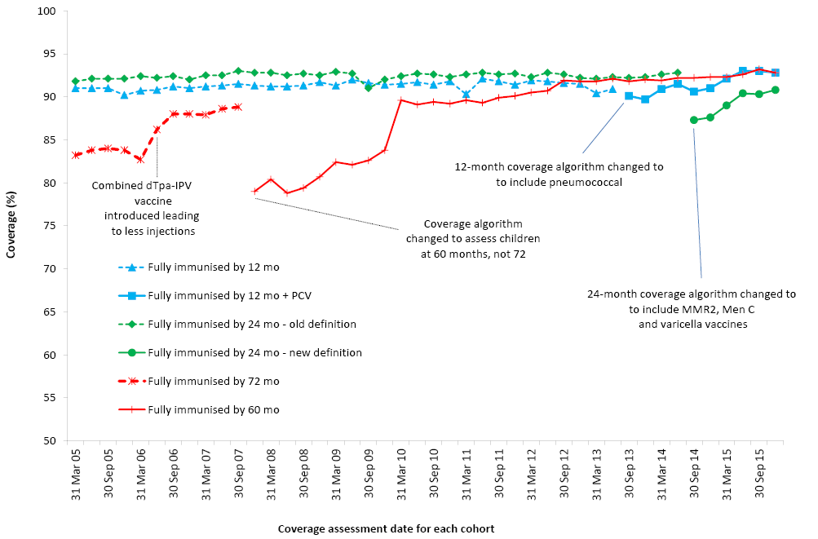
By 3-month birth cohorts born between 1 January 2004 and 31 December 2014. Coverage assessment date was 12 months after the last birth date of each cohort. PCV = pneumococcal conjugate vaccine Source: Australian Childhood Immunisation Register, data as at 31 March 2016.

Individual vaccines

12 months of age
Coverage at 12 months of age for individual antigens in the relevant combination vaccine (DTPa-hepB-polio-Hib) increased by approximately one percentage point between 2014 and the first half of 2015, before plateauing out at just above 93% in the latter half of 2015 (Figure 2). Coverage for 3 doses of PCV by 12 months of age has continued to rise steadily and reached 93.4% in mid-late 2015, which is similar to the level of coverage for all other vaccines assessed at this age except for rotavirus vaccine. After being added to the NIP in July 2007, rotavirus vaccine coverage for 2 or 3 doses (depending on whether the vaccine in use is Rotarix® or RotaTeq®) at 12 months of age rose steeply from about 75% in late 2008 to almost 84% in late 2011 and remained largely stable, with minor fluctuations, until early 2015. From July 2015, rotavirus coverage increased above 85%, reaching 86.1% by the end of 2015. Compared to the other vaccines given at 2, 4 and 6 months of age, rotavirus coverage remains lower nationally (Figure 2) and also has a greater variation between jurisdictions (Table 2). Reported coverage in 2015 at 12 months of age varied from 91.5% in the Australian Capital Territory for 2 doses of Rotarix® vaccine, to 81.5% in Western Australia for 3 doses of RotaTeq® vaccine (Table 2). Figure 3 shows rotavirus coverage at 12 months by Indigenous status comparing Rotarix® using jurisdictions versus RotaTeq® using jurisdictions for both 2 and 3 doses of each vaccine brand. Whilst 3-dose coverage for Indigenous children in RotaTeq® using jurisdictions was 16 percentage points lower than for 2-dose coverage in Rotarix® using jurisdictions, 2-dose coverage was almost the same for both RotaTeq® using and Rotarix® using jurisdictions (Figure 3). In contrast, for non-Indigenous children, 3-dose coverage in RotaTeq® using jurisdictions was only 4.6 percentage points lower than for 2-dose coverage in Rotarix® using jurisdictions.
Table 2: Percentage of children assessed in 2015 as immunised by 12 months of age, by vaccine and state or territory*, Australia
Vaccine | State or territory
 | ACT | NSW | NT | Qld | SA | Tas. | Vic. | WA | Australia
Total number of children | 5,661 | 99,313 | 3,641 | 62,647 | 20,185 | 5,848 | 77,526 | 34,509 | 309,337
Diphtheria, tetanus, pertussis | 95.6 | 93.9 | 93.5 | 93.6 | 93.7 | 93.7 | 93.9 | 93.4 | 93.8
Polio | 95.5 | 93.9 | 93.4 | 93.6 | 93.7 | 93.7 | 93.9 | 93.4 | 93.8
Haemophilus influenzae type b | 95.4 | 93.6 | 93.2 | 93.5 | 93.5 | 93.5 | 93.6 | 93.1 | 93.5
Hepatitis B | 95.0 | 93.5 | 93.3 | 93.4 | 93.4 | 93.5 | 93.5 | 92.9 | 93.4
Pneumococcal conjugate | 95.1 | 93.3 | 93.2 | 93.3 | 93.3 | 93.5 | 93.4 | 92.9 | 93.3
Fully immunised† | 94.6 | 92.8 | 92.6 | 93.0 | 92.9 | 93.2 | 92.8 | 92.4 | 92.9
Rotavirus | 91.5 | 88.7 | 87.9 | 83.2 | 85.5 | 86.5 | 84.1 | 81.5 | 85.4
* Cohort born 1 January 2014 – 31 December 2014.
† ’Fully immunised’ – 3 doses of a diphtheria-tetanus-pertussis (DTPa)-containing vaccine, 3 doses of polio vaccine, 2 or 3 doses of PRP-OMP-containing Haemophilus influenzae type b (Hib) vaccine or 3 doses of any other Hib vaccine, 3 doses of any hepatitis B vaccine or 2 doses of either Engerix-B (paediatric), Comvax or H-B-VAX II (paediatric), and 3 doses of pneumococcal conjugate vaccine.
ACT = Australian Capital Territory; NSW = New South Wales; NT = Northern Territory; Qld = Queensland; SA = South Australia; Tas = Tasmania; Vic = Victoria; WA = Western Australia
Source: Australian Childhood Immunisation Register, data as at 31 March 2016.

Figure 2: Trends in vaccination coverage estimates for individual vaccines* at 12 months of age, Australia, 2005 to 2015
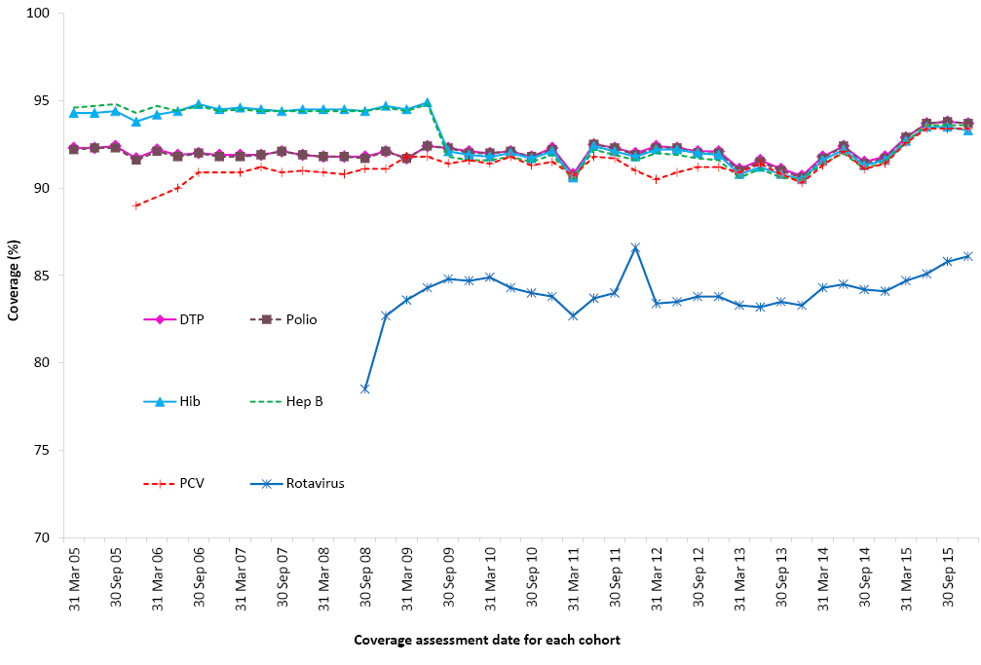
By 3-month birth cohorts born between 1 January 2004 and 31 December 2014. Coverage assessment date was 12 months after the last birth date of each cohort.
* 3rd dose of DTPa, polio and pneumococcal conjugate vaccines, 2nd or 3rd dose of Hib and rotavirus vaccines, and 3rd dose of hepatitis B vaccine.
DTPa = diphtheria-tetanus- acellular pertussis
Hib = Haemophilus influenzae type b
Hep B = Hepatitis B
PCV = Pneumococcal conjugate vaccine
Source: Australian Childhood Immunisation Register data as at 31 March 2016.

Figure 3: Rotavirus coverage at 12 months by Indigenous status - Rotarix® jurisdictions versus RotaTeq® jurisdictions, 2015
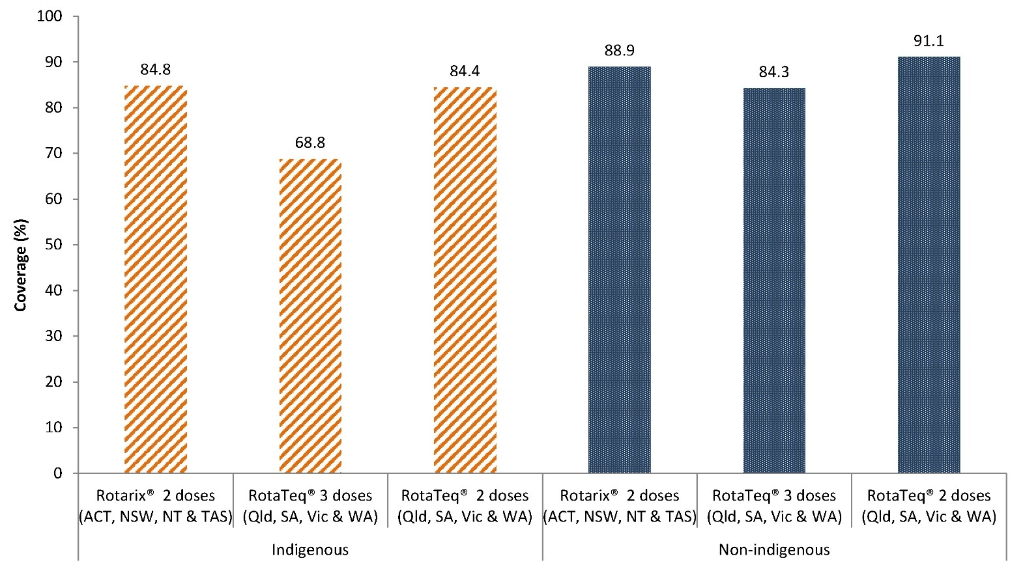
Cohort born 1 January – 31 December 2014.
ACT = Australian Capital Territory; NSW = New South Wales; NT = Northern Territory; Qld = Queensland; SA = South Australia; Tas = Tasmania; Vic = Victoria; WA = Western Australia; AUST = Australia
Source: Australian Childhood Immunisation Register, data as at 31 March 2016.

24 months of age
In 2015, coverage at 24 months of age increased for all vaccines (Figure 4). Coverage estimates were 94% or above for all vaccines, except varicella and the 2nd dose of MMR which were just above 91% (Table 3). Following the decline in MMR coverage in the latter half of 2014 due to the 2nd dose of MMR, now due at 18 months of age, being assessed at 24 months of age for the first time, instead of the 1st dose as previously, coverage for MMR increased to 92.4% by the end of 2015. Varicella coverage at 24 months of age increased sharply in mid-2013, following replacement of monovalent varicella vaccine with measles-mumps-rubella-varicella (MMRV) vaccine as the vaccine due at 18 months of age (see also separate section below comparing varicella coverage before and after introduction of MMRV vaccine) and continued increasing in 2015 (Figure 4). The 18-month schedule point has historically been associated with lower coverage when assessed at the 24-month age milestone, given that there is only a 6-month time period for catch-up. Similar to the 2014 report, we have again compared varicella coverage assessed at 36 months and 60 months of age to that assessed at 24 months, by jurisdiction (Figure 5). Coverage by jurisdiction in 2015 was 5.7 to 10.2 percentage points higher at 60 months, with all jurisdictions reaching over 92% varicella coverage when assessed at 60 months. When assessed at 24 months, varicella coverage ranged from 82.6% in Western Australia to 88.1% in Tasmania and 88.5% in the Australian Capital Territory.
Figure 4: Trends in vaccination coverage estimates for individual vaccines* at 24 months of age, Australia, 2005 to 2015
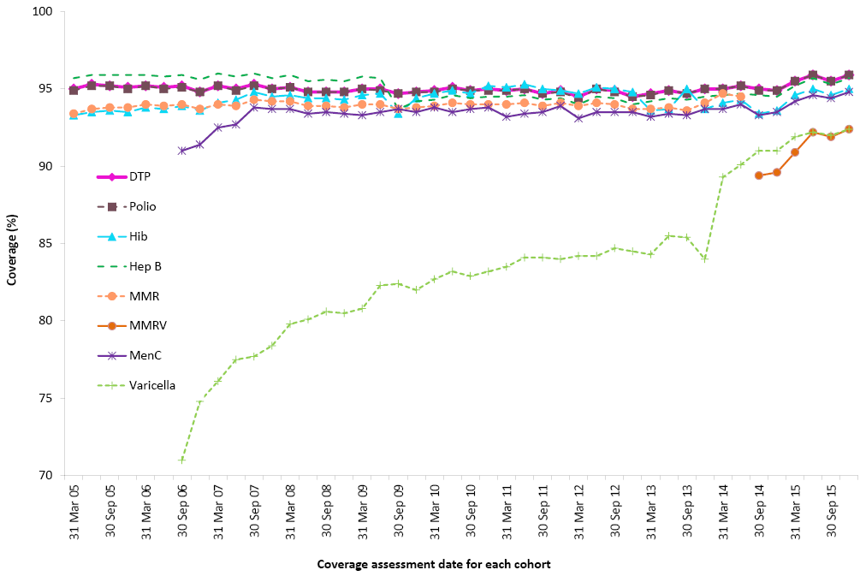
By 3-month birth cohorts born between 1 January 2003 and 31 December 2013.
Coverage assessment date was 12 months after the last birth date of each cohort.
* 3rd dose of DTPa, 3rd dose of polio, 3rd or 4th dose of Hib, 3rd dose of hepatitis B, 2nd dose of MMR (from September 2014), 1st dose of meningococcal C and varicella.
DTPa = Diphtheria-tetanus- acellular pertussis
Hib = Haemophilus influenzae type b
Hep B = Hepatitis B
MMR = Measles-mumps-rubella
MenC = Meningococcal C
MMRV = Measles-mumps-rubella-varicella
Source: Australian Childhood Immunisation Register, data as at 31 March 2016.

Figure 5: Comparison of 1-dose varicella vaccine coverage assessed in December 2015 at 24 months of age versus 36 months of age and 60 months of age, by state or territory, Australia 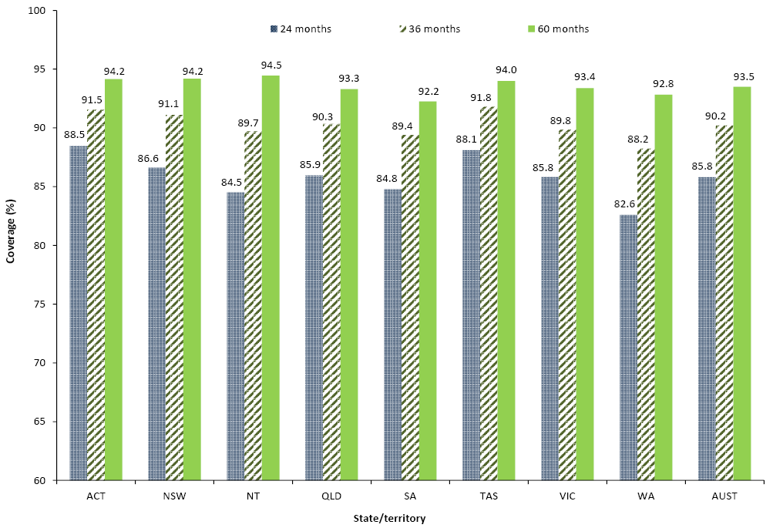Cohort born October – December 2010.
ACT = Australian Capital Territory; NSW = New South Wales; NT = Northern Territory; Qld = Queensland; SA = South Australia; Tas = Tasmania; Vic = Victoria; WA = Western Australia; AUST = Australia
Source: Australian Childhood Immunisation Register, data as at 31 March 2016.

Table 3: Percentage of children assessed in 2015 as immunised by 24 months of age, by vaccine and state or territory*, Australia
Vaccine | State or territory
 | ACT | NSW | NT | Qld | SA | Tas | Vic | WA | Australia
Total number of children | 5,621 | 99,688 | 3,547 | 62,504 | 19,827 | 5,994 | 77,302 | 34,140 | 308,623
Diphtheria, tetanus, pertussis | 97.3 | 95.7 | 95.3 | 95.7 | 95.6 | 95.7 | 96.1 | 95.6 | 95.8
Polio | 97.2 | 95.7 | 95.3 | 95.7 | 95.6 | 95.7 | 96.1 | 95.6 | 95.8
Haemophilus influenzae type b | 95.5 | 94.1 | 93.6 | 94.4 | 93.3 | 94.1 | 93.9 | 92.9 | 94.0
Hepatitis B | 96.6 | 95.2 | 95.2 | 95.3 | 95.2 | 95.2 | 95.7 | 95.0 | 95.3
Measles, mumps, rubella – 1 dose | 96.0 | 94.4 | 95.1 | 94.9 | 94.7 | 94.2 | 94.9 | 94.4 | 94.7
Measles, mumps, rubella – 2 doses | 93.5 | 91.8 | 91.2 | 92.2 | 91.6 | 92.0 | 91.9 | 90.6 | 91.8
Varicella | 93.4 | 91.5 | 89.5 | 91.7 | 91.3 | 91.5 | 91.8 | 90.2 | 91.5
Meningococcal C | 95.6 | 94.4 | 94.2 | 94.7 | 93.7 | 94.6 | 94.5 | 93.4 | 94.4
Fully immunised† | 91.5 | 89.6 | 87.6 | 90.5 | 88.7 | 89.5 | 89.6 | 88.0 | 89.5
* Cohort born 1 January 2013 – 31 December 2013.
† ‘Fully immunised’ – 3 doses of a DTPa-containing vaccine, 3 doses of polio vaccine, 3 or 4 doses of PRP-OMP-containing Hib vaccine or 4 doses of any other Hib vaccine, 3 doses of hepatitis B vaccine, 2 doses of a measles-mumps-rubella (MMR)-containing vaccine, 1 dose of varicella vaccine, and 1 dose of meningococcal C vaccine.
‡ ACT = Australian Capital Territory; NSW = New South Wales; NT = Northern Territory; Qld = Queensland; SA = South Australia; Tas = Tasmania; Vic = Victoria; WA = Western Australia
Source: Australian Childhood Immunisation Register, data as at 31 March 2016.

60 months of age
For vaccines due at 48 months of age, trends in individual vaccine coverage were similar to that seen for ‘fully immunised’ coverage, that is, a marked drop in January 2008 following the change in assessment age from 72 months to 60 months, followed by a marked increase in 2009 and 2010 and ongoing increase to a level higher than when coverage was assessed at 72 months of age (Figure 6). Coverage for all 3 vaccines assessed at 48 months of age (DTPa, polio and MMR) increased in 2015 to greater than 93% for Australia and for most jurisdictions (Figure 6 and Table 4).

Figure 6: Trends in vaccination coverage estimates for individual vaccines* at 60 months of age (assessed at 72 months prior to December 2007), Australia, 2005 to 2015
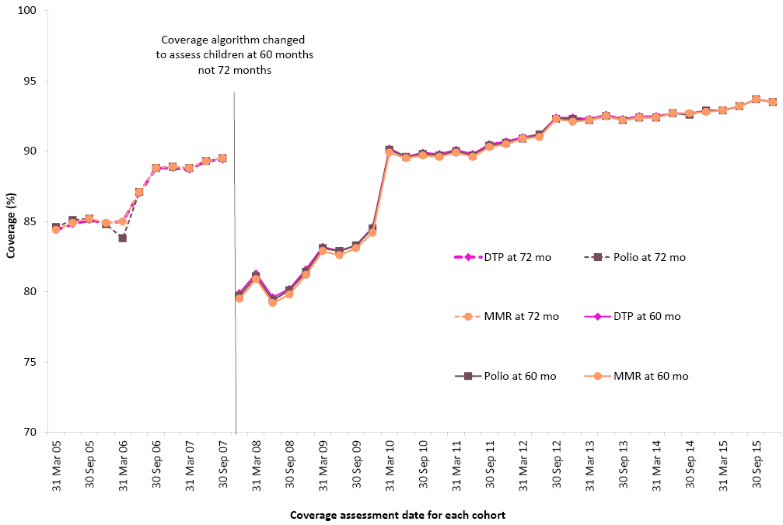
By 3-month birth cohorts born between 1 January 1996 and 31 December 2009. Coverage assessment date was 72 months after the last birth date of each cohort up to December 2007 and then 60 months after the last birth date of each cohort.
* 4th dose of DTPa and polio, 2nd dose of MMR.
DTPa = Diphtheria-tetanus- acellular pertussis
MMR = Measles-mumps-rubella
Source: Australian Childhood Immunisation Register, data as at 31 March 2016.

Table 4: Percentage of children assessed in 2015 as immunised by 60 months of age, by vaccine and state or territory*, Australia
Vaccine | State or territory
 | ACT | NSW | NT | Qld | SA | Tas | Vic | WA | Australia
Total number of children | 5,459 | 100,926 | 3,452 | 65,263 | 20,270 | 6,145 | 76,564 | 34,345 | 312,424
Diphtheria, tetanus, pertussis | 94.2 | 93.7 | 92.9 | 93.0 | 92.2 | 94.3 | 93.5 | 91.8 | 93.2
Polio | 94.2 | 93.7 | 93.0 | 93.0 | 92.3 | 94.3 | 93.5 | 91.8 | 93.2
Measles, mumps, rubella | 94.1 | 93.7 | 93.2 | 93.0 | 92.3 | 94.4 | 93.6 | 91.9 | 93.2
Fully immunised† | 93.5 | 93.1 | 92.1 | 92.5 | 91.6 | 93.7 | 92.9 | 91.1 | 92.6
* Cohort born 1 January 2010 – 31 December 2010.
† ‘Fully immunised’ – 4 or 5 doses of a DTPa-containing vaccine, 4 doses of polio vaccine, and 2 doses of an MMR-containing vaccine.
ACT = Australian Capital Territory; NSW = New South Wales; NT = Northern Territory; Qld = Queensland; SA = South Australia; Tas = Tasmania; Vic = Victoria; WA = Western Australia
Source: Australian Childhood Immunisation Register, data as at 31 March 2016.

Varicella coverage before and after introduction of MMRV vaccine
In July 2013, MMRV was introduced at the 18 months of age schedule point, replacing the single dose of varicella vaccine previously scheduled at this age point and the 2nd dose of MMR previously scheduled at 48 months of age.
Table 5 provides varicella coverage for two 3-month wide birth cohorts 2.5 years apart, allowing comparison of coverage before and after introduction of MMRV vaccine. For Australia as a whole, varicella coverage increased after the introduction of MMRV. In 2015, varicella coverage was 6.4 percentage points higher than coverage before the introduction of MMRV. Varicella coverage, post introduction of MMRV, was higher in all jurisdictions in 2015, compared to coverage before the introduction of MMRV and ranged from 2.5 percentage points higher in the Northern Territory to 9.1 percentage points higher in Tasmania.

Table 5: Comparison of varicella coverage (%) before and after introduction of MMRV vaccine, by state or territory, Australia, 2015
 | State or territory
 | ACT | NSW | NT | Qld | SA | Tas | Vic | WA | Australia
Before MMRV introduction* | 87.2 | 85.2 | 89.2 | 87.9 | 83.7 | 87.1 | 84.9 | 83.9 | 85.6
After MMRV introduction† | 94.4 | 91.9 | 91.7 | 92.5 | 92.1 | 93.2 | 92.1 | 90.4 | 92.0
Difference | 7.2 | 6.7 | 2.5 | 4.6 | 8.4 | 9.1 | 7.2 | 6.5 | 6.4
* Cohort born 1 April – 30 June 2011, assessed at 24 months.
† Cohort born 1 October – 31 December 2013, assessed at 24 months.
MMRV = measles-mumps-rubella-varicella ACT = Australian Capital Territory; NSW = New South Wales; NT = Northern Territory; Qld = Queensland; SA = South Australia; Tas = Tasmania; Vic = Victoria; WA = Western Australia
Source: Australian Childhood Immunisation Register, data as at 31 March 2016.

Indigenous coverage estimates

Individual vaccines
Immunisation coverage estimates in 2015 for the 3 age milestones by Indigenous status, vaccine and jurisdiction are provided in Table 6 (individual vaccine coverage) and Table 7 (‘fully immunised’ by jurisdiction). In 2015, ‘fully immunised’ coverage at 12 months of age among Indigenous children was lower than for non-Indigenous children in all jurisdictions except Tasmania, with the differential varying from 8.9 percentage points in Western Australia to 0.2 of a percentage point in the Northern Territory, and 3.4% overall. ‘Fully immunised’ coverage at 24 months of age among Indigenous children in 2015 was 3.3 percentage points lower for Australia, with the differential varying from 5.6 percentage points in Western Australia to 0.7 of a percentage point in New South Wales. The lower coverage gap for New South Wales coincided with the introduction of the NSW Aboriginal Immunisation Health Care Worker Program, which began as a 3-year pilot program in 2012. ‘Fully immunised’ coverage at 60 months of age in 2015 was 1.9 percentage points higher among Indigenous children compared to non-Indigenous children for Australia, with coverage in Indigenous children at this age milestone higher in all jurisdictions except Victoria.

Table 6: Vaccination coverage estimates (%) by age, vaccine and Indigenous status, Australia, assessed in 2015
Vaccine | Milestone age | Indigenous | Non-Indigenous
Diphtheria, tetanus, acellular pertussis | 12 months* | 89.8 | 94.0
 | 24 months† | 96.1 | 95.8
 | 60 months‡ | 94.9 | 93.1
Polio | 12 months* | 89.8 | 94.0
 | 24 months† | 96.1 | 95.8
 | 60 months‡ | 94.9 | 93.1
Haemophilus influenzae type b | 12 months* | 89.7 | 93.7
 | 24 months† | 93.9 | 94.0
 | 60 months‡ | N/I | N/I
Hepatitis B | 12 months* | 89.7 | 93.6
 | 24 months† | 96.0 | 95.3
 | 60 months‡ | N/I | N/I
Measles, mumps, rubella | 12 months* | N/I | N/I
 | 24 months† | 89.2 | 91.9
 | 60 months‡ | 95.2 | 93.1
Varicella | 12 months* | N/I | N/I
 | 24 months† | 88.3 | 91.7
 | 60 months‡ | N/I | N/I
Meningococcal C conjugate | 12 months* | N/I | N/I
 | 24 months† | 94.9 | 94.3
 | 60 months‡ | N/I | N/I
Pneumococcal conjugate | 12 months* | 89.8 | 93.5
 | 24 months† | N/I | N/I
 | 60 months‡ | N/I | N/I
Rotavirus | 12 months* | 75.4 | 86.0
 | 24 months† | N/I | N/I
 | 60 months‡ | N/I | N/I
* Cohort born 1 January 2014 – 31 December 2014.
† Cohort born 1 January 2013 – 31 December 2013.
‡ Cohort born 1 January 2010 – 31 December 2010.
N/I Not included in coverage estimates for that group.
Source: Australian Childhood Immunisation Register, data as at 31 March 2016.

Table 7: Percentage of children fully immunised by 12 months, 24 months and 60 months of age, by Indigenous status and state or territory, Australia, assessed in 2015
 | State or territory
 | ACT | NSW | NT | Qld | SA | Tas | Vic | WA | Australia
12 months – fully immunised*
Indigenous | 92.7 | 92.0 | 92.5 | 88.4 | 89.6 | 93.5 | 89.5 | 84.1 | 89.6
Non-Indigenous | 94.6 | 92.9 | 92.7 | 93.4 | 93.1 | 93.2 | 92.9 | 93.0 | 93.0
24 months – fully immunised†
Indigenous | 87.6 | 88.9 | 86.2 | 86.2 | 84.2 | 88.8 | 83.9 | 82.7 | 86.4
Non-Indigenous | 91.6 | 89.6 | 88.3 | 90.8 | 88.9 | 89.6 | 89.7 | 88.3 | 89.7
60 months – fully immunised‡
Indigenous | 94.6 | 95.6 | 95.1 | 94.1 | 93.3 | 95.8 | 92.4 | 92.8 | 94.4
Non-Indigenous | 93.5 | 93.0 | 90.3 | 92.3 | 91.5 | 93.6 | 92.9 | 91.0 | 92.5
* ’Fully immunised’ – 3 doses of a diphtheria-tetanus-pertussis (DTPa)-containing vaccine, 3 doses of polio vaccine, 2 or 3 doses of PRP-OMP-containing Haemophilus influenzae type b (Hib) vaccine or 3 doses of any other Hib vaccine, 3 doses of hepatitis B vaccine, and 3 doses of pneumococcal conjugate vaccine. Cohort born 1 January 2014 – 31 December 2014
† ‘Fully immunised’ – 3 doses of a DTPa-containing vaccine, 3 doses of polio vaccine, 3 or 4 doses of PRP-OMP-containing Hib vaccine or 4 doses of any other Hib vaccine, 3 doses of hepatitis B vaccine, 2 doses of a measles-mumps-rubella (MMR)-containing vaccine, 1 dose of meningococcal C vaccine, and 1 dose of varicella vaccine. Cohort born 1 January 2013 – 31 December 2013
‡ ‘Fully immunised’ – 4 doses of a DTPa-containing vaccine, 4 doses of polio vaccine, and 2 doses of an MMR-containing vaccine. Cohort born 1 January 2010 – 31 December 2010
ACT = Australian Capital Territory; NSW = New South Wales; NT = Northern Territory; Qld = Queensland; SA = South Australia; Tas = Tasmania; Vic = Victoria; WA = Western Australia
Source: Australian Childhood Immunisation Register, data as at 31 March 2016.
The coverage differential between Indigenous and non-Indigenous children for individual vaccines varied in 2015, with coverage lower for Indigenous children for all vaccines at 12 months of age, but higher at 24 months of age for DTPa, polio, hepatitis B and meningococcal C vaccines, and at 60 months of age for DTPa, polio and MMR.
The proportion of Indigenous children ‘fully immunised’ by 24 months of age was consistently higher than at 12 and 60 months of age until 2012, when coverage at 60 months rose to levels comparable to that at 24 months (Figure 7). During the latter half of 2014, the proportion of Indigenous children ‘fully immunised’ by 24 months of age decreased by 8.5 percentage points, most likely due to changes to the ‘fully immunised’ coverage algorithm. During 2015, the proportion of Indigenous children ‘fully immunised’ by 12 months, 24 months and 60 months of age steadily increased, however coverage at 24 months was substantially lower than coverage at 60 months.

Figure 7: Trends in ‘fully immunised’ vaccination coverage estimates for Indigenous children in Australia, 2005 to 2015, by age milestones 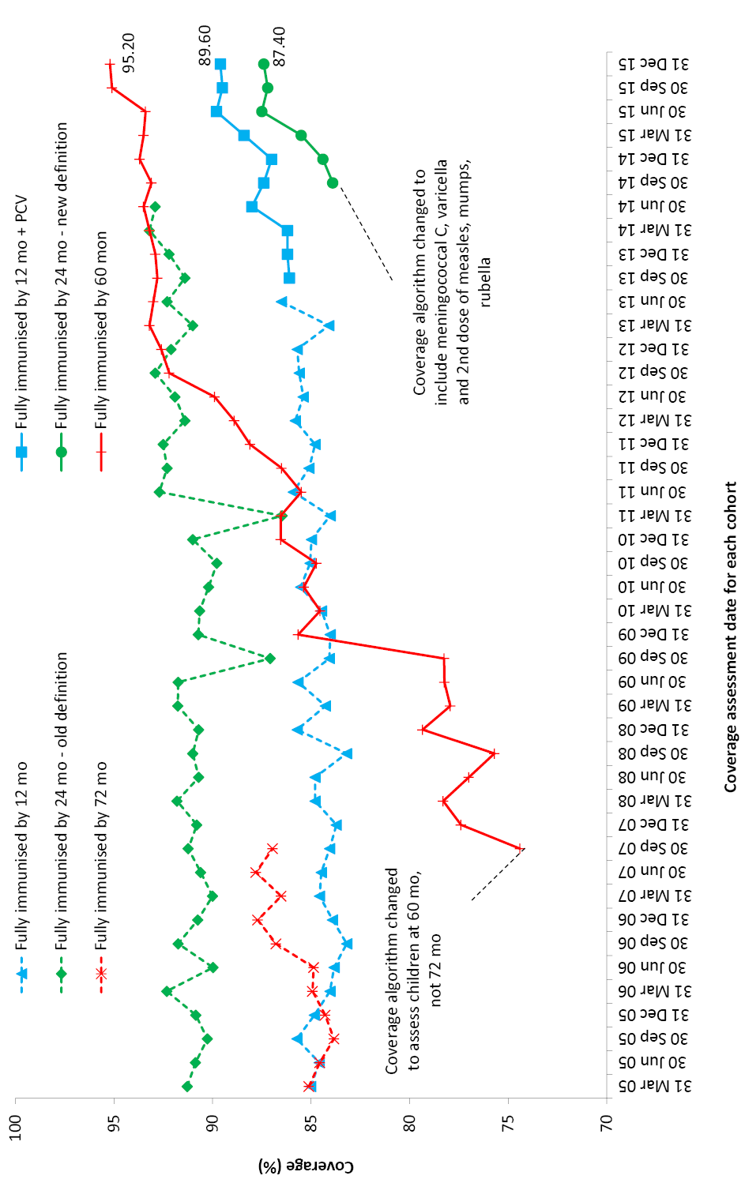Source: Australian Childhood Immunisation Register, data as at 31 March 2016.

Targeted pneumococcal and hepatitis A vaccines
Hepatitis A vaccine has been included on the NIP since November 2005 for Indigenous children in the Northern Territory, Queensland, South Australia and Western Australia, but was used earlier than this in north Queensland. Between March 2007 and December 2013, coverage of 2 doses of hepatitis A vaccine for Indigenous children by 30 months of age in Western Australia and the Northern Territory and 36 months of age in Queensland and South Australia increased from 30.5% to 60.1% (Figure 8). By the latter half of 2014, coverage increased to 62.9%, with all 4 jurisdictions assessing 2 doses at 30 months of age from July 2013. Further increases in coverage were seen in 2015, with 70.8% of Indigenous children across the Northern Territory, Queensland, South Australia and Western Australia having received the 2 doses of hepatitis A vaccine by 30 months of age. Substantial increases in reported hepatitis A vaccine coverage have been achieved in South Australia (from 37% at the end of 2014 to 64% by the end of 2015) and Queensland (from 59% at the end of 2014 to 72% by the end of 2015), however variation between the jurisdictions still exists, from a low of 62.6% in Western Australia to a high of 83.2% in the Northern Territory for 2-dose coverage (Figure 8).

Figure 8: Trends in coverage estimates for hepatitis A* vaccine for Indigenous children by jurisdiction, Australia†, 2007 to 2015 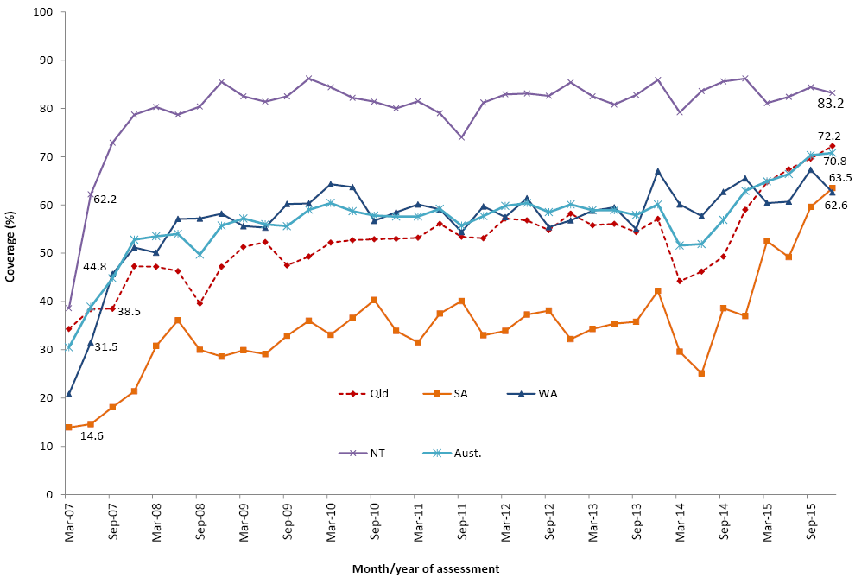* 18-month dose assessed at 30 months of age in all 4 jurisdictions from July 2013.
† Northern Territory (NT), Queensland (Qld), South Australia (SA) and Western Australia (WA) only.
Aust. = Australia
Source: Australian Childhood Immunisation Register, data as at 31 March 2016.
A pneumococcal booster dose at 18–24 months of age has been recommended and funded for Indigenous children in the same 4 jurisdictions (the Northern Territory, Queensland, South Australia and Western Australia) since 2001; initially as 23-valent pneumococcal polysaccharide vaccine, then as 13-valent pneumococcal conjugate vaccine (13vPCV), from July 2013 in Queensland, South Australia and Western Australia, and from October 2013 in the Northern Territory. Coverage gradually increased from 47.0% in March 2007 to 63.4% in December 2011 (Figure 9). In 2012, coverage increased by 15 percentage points following the 13vPCV catch-up campaign that took place that year, coverage fell by 14 percentage points during 2013, but increased by 11 percentage points to 71% by the end of 2015. At the end of 2015, there was a large variation between jurisdictions in coverage for the booster dose of pneumococcal conjugate vaccine, from a low of 62.1% in South Australia to a high of 86% in the Northern Territory, although coverage in South Australia had increased by 22 percentage points from 41.2% in 2014.

Figure 9: Trends in coverage estimates for pneumococcal* vaccine for Indigenous children by jurisdiction†, Australia, 2007 to 2015 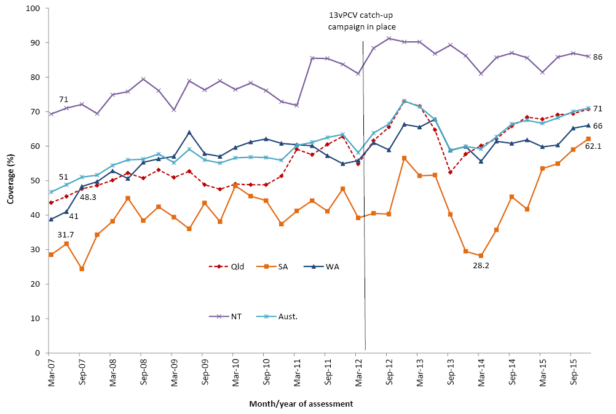* 18-month dose assessed at 30 months of age in all 4 jurisdictions from July 2013.
† Northern Territory (NT), Queensland (Qld), South Australia (SA) and Western Australia (WA) only.
13vPCV = 13-valent pneumococcal conjugate vaccine
Aust. = Australia
Source: Australian Childhood Immunisation Register, data as at 31 March 2016.

Seasonal influenza vaccine coverage
Seasonal influenza vaccine has been recommended and funded for children with underlying medical conditions since 2010. In 2008, a funded seasonal influenza vaccination program for all children aged from 6 months to less than 5 years was introduced in Western Australia. In 2015, it was included on the NIP for all Aboriginal and Torres Strait Islander children aged 6 months to less than 5 years. Figure 10 shows the time trend of influenza vaccine coverage recorded in ACIR between 2005 and 2015 for Indigenous and non-Indigenous Australian children aged 6 months to less than 5 years. Up until the end of 2014, coverage as recorded in the ACIR was less than 2.5% in both Indigenous and non-Indigenous Australian children (excluding Western Australia). Coverage in Western Australian children rose to around 28% in 2009 following introduction of their universal funded program, but decreased substantially following the increases in fever and febrile convulsions post vaccination with one vaccine formulation in 2010. Following the commencement of the funded program for Aboriginal and Torres Strait Islander children, influenza coverage in 2015 rose to 12.3% in the Indigenous population but only to 2.9% in non-Indigenous children (Figure 10). There is substantial variation in reported influenza vaccine coverage between jurisdictions. Recorded coverage for Indigenous children receiving any dose of influenza vaccine ranged from 2.4% in Victoria to 55.8% in the Northern Territory, and for non-Indigenous children from 1.9% in the Northern Territory to 8.0% in Western Australia (data not shown). The majority of the influenza doses on the ACIR for these populations were recorded as first doses. Of children aged 6 months to less than 5 years who received their first dose of influenza vaccine in 2015, approximately half were recorded in the ACIR as having also received their second dose in the same year. Again, there was substantial variation between jurisdictions, especially in the Indigenous population (data not shown). Unlike other vaccines on the NIP, influenza vaccine notifications do not attract notification payments for immunisation providers. As such, influenza vaccine coverage data should be regarded as a minimum estimate due to the potential for under-reporting of seasonal influenza vaccination.
Figure 10: Trends in recorded coverage for seasonal influenza vaccine* in children aged 6 months to less than 5 years, by Indigenous status and state/territory grouping, Australia, 2005 to 2015
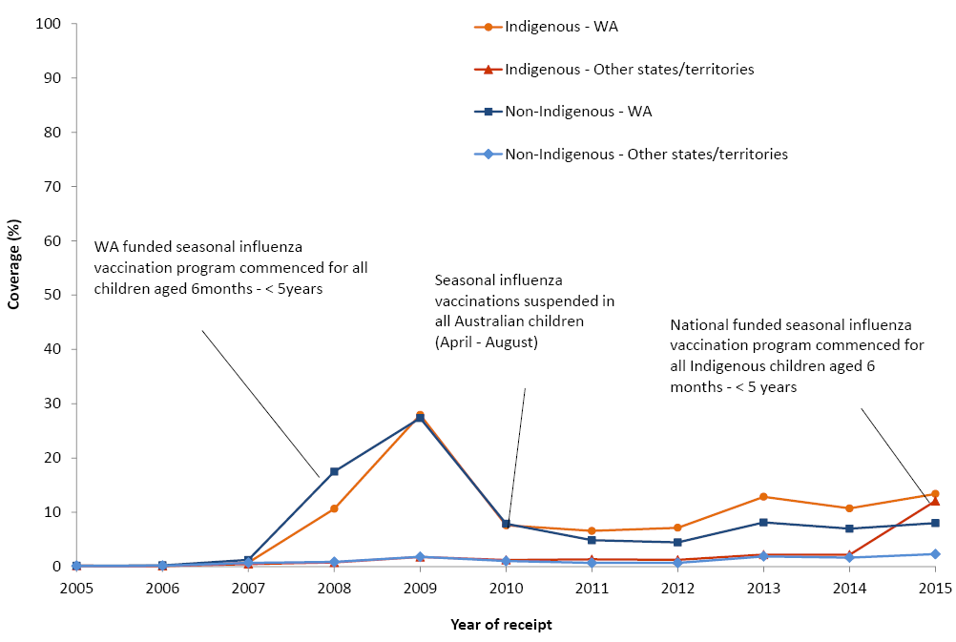
* Any influenza vaccine dose
Source: Australian Childhood Immunisation Register, data as at 31 March 2016.

Timeliness of immunisation
We examined timeliness of immunisation in 2015 for vaccines requiring multiple doses (DTPa, PCV and MMR) or a single dose (meningococcal C) assessed at 12 and 24 months of age.
As demonstrated in previous reports, the proportion with delayed vaccine receipt increased with older age (Figure 11). The greatest proportion with any delay was seen with the 2nd dose of MMR vaccine due at 18 months, with 27.4% of doses given late. For each of the 4 vaccines examined, most delays were relatively short (1-≤2 months after the schedule point), with only 1.8-3.0% given very late, at ≥7 months after the schedule point (Figure 11).

Figure 11: DTPa3, MMR1, MENC1 and MMR2 vaccination delay for cohorts born in 2013 and assessed in 2015, Australia
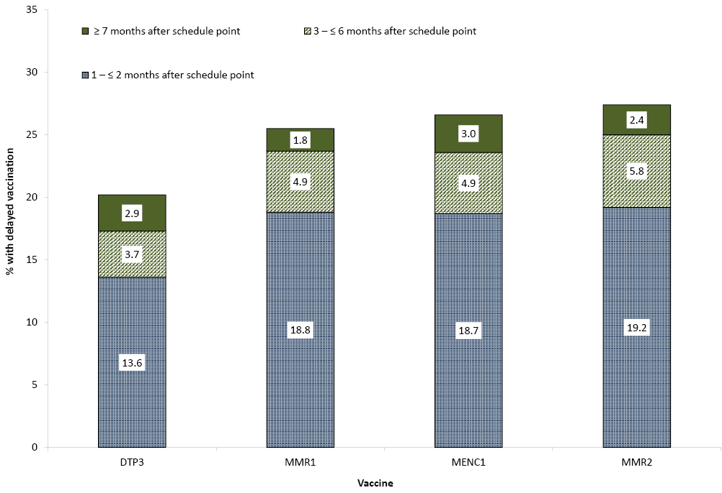
DTPa3 = 3rd dose of a diphtheria-tetanus-acellular pertussis containing vaccine (due at 6 months of age)
MMR1 = 1st dose of a measles-mumps-rubella vaccine (due at 12 months of age)
MENC1 = 1st dose of a meningococcal C vaccine (due at 12 months of age)
MMR2 = 2nd dose of a measles-mumps-rubella vaccine (due at 18 months of age)
Source: Australian Childhood Immunisation Register, data as at 31 March 2016.
For the 3rd dose of DTPa vaccine, there was greater delay for Indigenous children than for non-Indigenous children, with an 18.4% differential in on-time vaccination by 7 months of age (Figure 12). Similar patterns were found for timeliness of the 1st dose of MMR vaccine by 13 months of age (Figure 13) and the 2nd dose of MMR vaccine by 19 months of age (Figure 14), however the differentials were smaller (11.7% and 15.7% for the 1st and 2nd dose respectively). The differential in on-time vaccination between Indigenous and non-Indigenous children for the 3rd dose of DTPa vaccine was slightly improved by 1.8 percentage points from the 2014 report, whereas for the 1st dose of MMR and 2nd dose of MMR, the differential increased by 0.2 of a percentage point and 0.4 of a percentage point respectively.

Figure 12: Timeliness* of the 3rd dose of DTPa vaccine (DTPa3), by Indigenous status, Australia 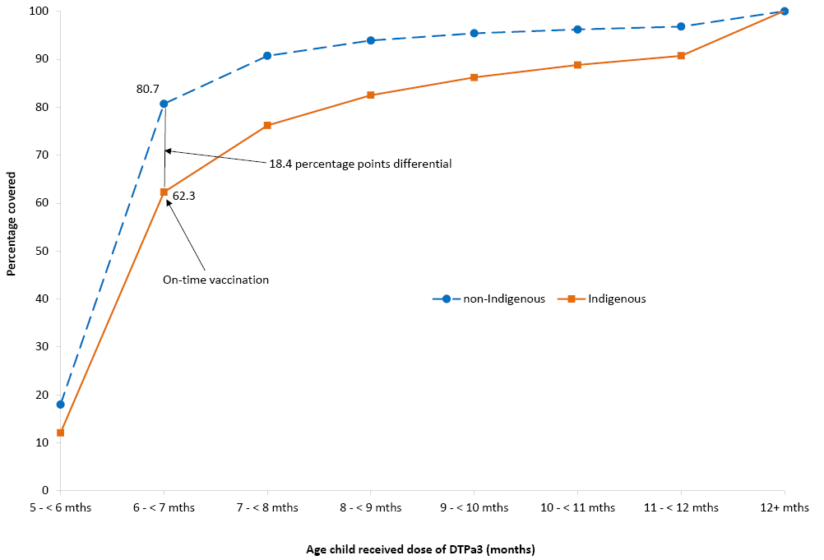
* Percentage covered = number of children who received vaccine dose at particular ages / the total number of children who received the vaccine dose, expressed as a percentage.
Cohort born in 2013.
Source: Australian Childhood Immunisation Register, data as at 31 March 2016.

Figure 13: Timeliness* of the 1st dose of MMR vaccine (MMR1), by Indigenous status, Australia 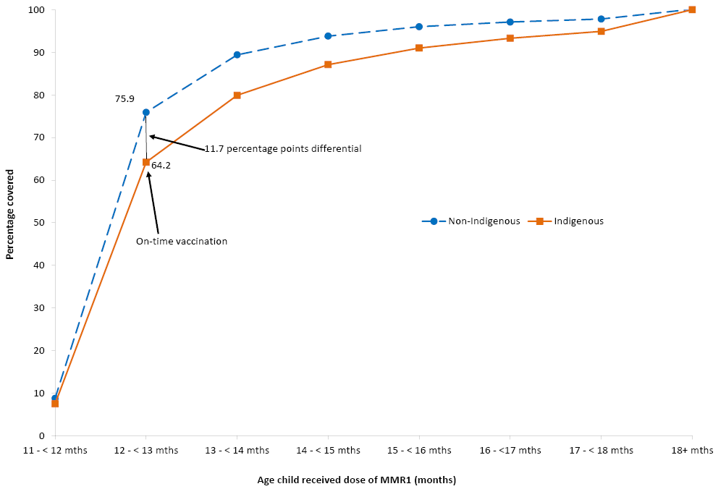
* Percentage covered = number of children who received vaccine dose at particular ages / the total number of children who received the vaccine dose, expressed as a percentage.
Cohort born in 2013.
Source: Australian Childhood Immunisation Register, data as at 31 March 2016.
Figure 14: Timeliness* of the 2nd dose of MMR vaccine (MMR2) due at 18 months, by Indigenous status, Australia 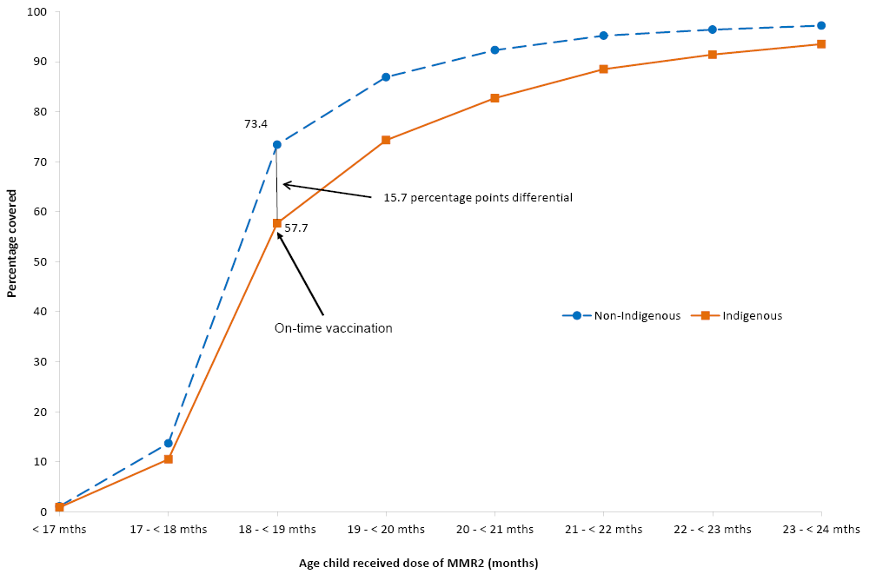
* Percentage covered = number of children who received vaccine dose at particular ages / the total number of children who received the vaccine dose, expressed as a percentage.
Cohort born in 2013.
Source: Australian Childhood Immunisation Register, data as at 31 March 2016.
Delayed receipt of the 3rd dose of DTPa and the 1st dose of MMR by Indigenous and remoteness status is shown in Table 8. For both Indigenous and non-Indigenous children the majority of delay occurred 1-≤2 months after the schedule point for both vaccines and across all remoteness categories. Although there was a slightly lower proportion of Indigenous children living in major cities with delay of 1-≤2 months for the 3rd dose of DTPa compared to Indigenous children living in remote and very remote areas (19.1% vs. 24.1%), differences in very late vaccination (≥7 months after the schedule point for the 3rd dose of DTPa or the 1st dose of MMR) were negligible.

Table 8: Vaccination delay, by Indigenous and remoteness status for 2-year olds,* Australia, 2015
Vaccine dose | Indigenous status | Remoteness category | 1 - ≤2 months after schedule point (%) | 3 - ≤6 months after schedule point (%) | ≥7 months after schedule point (%)
DTPa3 | Indigenous | Major Cities | 19.1 | 8.5 | 7.7
 |  | Inner and Outer Regional | 20.1 | 9.8 | 8.2
 |  | Remote and Very Remote | 24.1 | 12.2 | 5.9
 | Non-Indigenous | Major Cities | 13.0 | 3.3 | 2.7
 |  | Inner and Outer Regional | 14.1 | 3.6 | 2.7
 |  | Remote and Very Remote | 14.0 | 3.4 | 2.0
MMR1 | Indigenous | Major Cities | 23.2 | 9.6 | 4.0
 |  | Inner and Outer Regional | 23.2 | 9.3 | 4.3
 |  | Remote and Very Remote | 24.6 | 7.8 | 3.0
 | Non-Indigenous | Major Cities | 18.5 | 4.7 | 1.7
 |  | Inner and Outer Regional | 18.7 | 4.7 | 1.8
 |  | Remote and Very Remote | 20.4 | 4.4 | 1.3
* The cohort of children born in 2013 and assessed in 2015.
DTPa3 = 3rd dose of diphtheria, tetanus, acellular pertussis vaccine
MMR1 = 1st dose of measles, mumps, rubella vaccine
Source: Australian Childhood Immunisation Register, data as at 31 March 2016.
Vaccination delay for Indigenous children by jurisdiction was measured for the 3rd dose of PCV (Figure 15), with the highest proportions experiencing delays of 1-≤2 months found in Western Australia (24.8%) and South Australia (22.5%). The percentage of children with delays of 3-≤6 months ranged from 2.2% in the Australian Capital Territory to 13.8% in Western Australia, and delays of ≥7 months ranged from 4.0% in Tasmania to 8.9% in Western Australia.

Figure 15: Vaccination delay for Indigenous children for the 3rd dose of pneumococcal conjugate vaccine, by state or territory, Australia, 2015 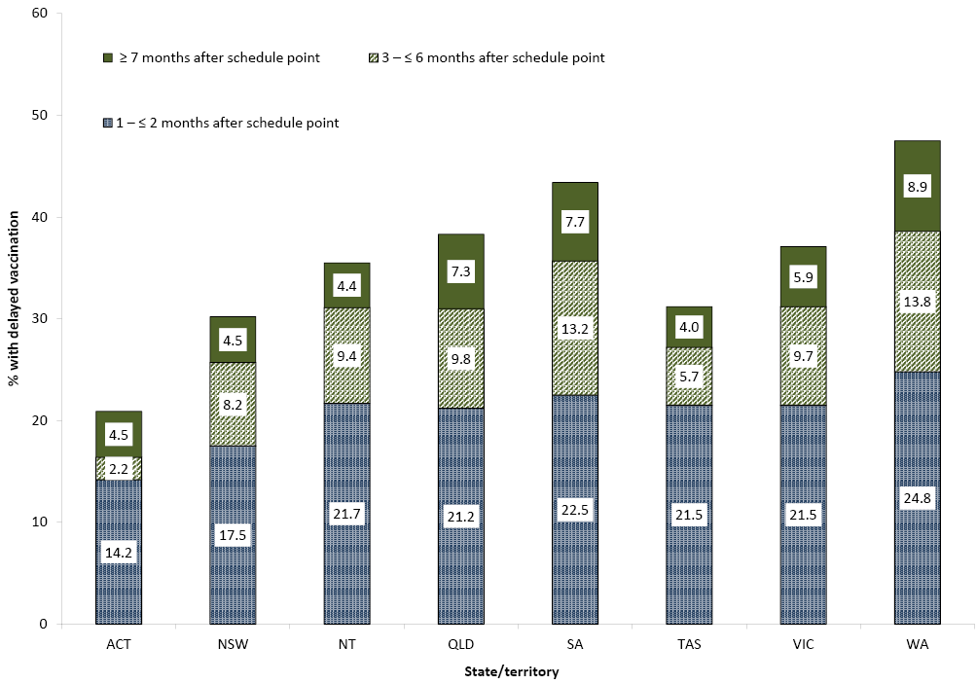Cohort born in 2013.
Source: Australian Childhood Immunisation Register, data as at 31 March 2016.

First dose of DTPa at 6 versus 8 weeks of age
In response to a pertussis epidemic, and to provide early protection to young infants, the Australian Technical Advisory Group on Immunisation (ATAGI) recommended in March 2009 that immunisation providers give the 1st dose of DTPa vaccine at 6 weeks of age instead of 8 weeks (2 months) of age. This was promoted in that year during epidemics in New South Wales and Tasmania and later in other jurisdictions. Prior to this, very few children received the vaccine dose at less than 8 weeks of age. Over the next few years the percentage rose and by late 2015 was greater than 79% in all jurisdictions except Western Australia (Figure 16). Since 2014, the percentage of children in Western Australia and the Northern Territory receiving their 1st dose of DTPa vaccine before 8 weeks of age rose sharply by 29% and 22% respectively.

Figure 16: Percentage of children who received their 1st dose of DTPa/Hexa vaccine at age 6 – < 8 weeks, by state or territory and month of receipt, Australia, 2009 to 2015 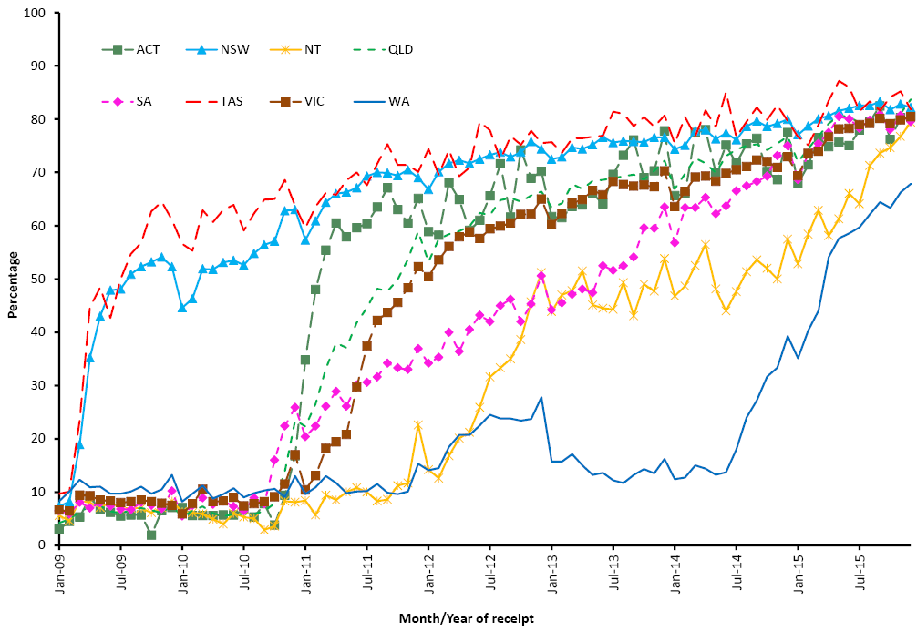DTPa/Hexa = combined diphtheria, tetanus, acellular pertussis, polio, Haemophilus influenzae type b and hepatitis B vaccine.
ACT = Australian Capital Territory; NSW = New South Wales; NT = Northern Territory; Qld = Queensland; SA = South Australia; Tas = Tasmania; Vic = Victoria; WA = Western Australia
Source: Australian Childhood Immunisation Register, data as at 31 March 2016.

Registered objection to vaccination
The proportions of children with registered vaccination objection status and no vaccines recorded on the ACIR, registered vaccination objection status and at least one vaccine recorded on the ACIR, no registered vaccination objection status and no vaccines recorded on the ACIR, and no registered vaccination objection status and not ‘fully immunised’ by 24 months of age (partially immunised), for all jurisdictions and Australia, is shown in Table 9. Some of the children in the latter 2 groups may be incompletely immunised due to unregistered vaccine objection. Of the 4 groups, the largest is no registered objection and partially immunised.

Table 9: Percentage of 2-year-old children* by registered vaccination objection, and whether no/some vaccines recorded on the Australian Childhood Immunisation Register, by state or territory, Australia, assessed in 2015 (numbers in parentheses in 2014)
 | State or territory
 | ACT | NSW | NT | Qld | SA | Tas | Vic | WA | Australia
Total number of children | 1,273 | 22,002 | 737 | 13,716 | 4,383 | 1,270 | 17,280 | 7,334 | 67,995
Objection† and no vaccines recorded | 0.4 (1.0) | 0.8 (1.0) | 0.1 (0.6) | 1.4 (1.7) | 1.0 (1.4) | 0.9 (0.7) | 0.7 (1.0) | 0.9 (1.3) | 0.8 (1.2)
Objection† and at least 1 vaccine recorded | 0.5 (0.6) | 0.3 (0.4) | 0.5 (0.6) | 0.6 (0.7) | 0.4 (0.7) | 0.4 (0.4) | 0.5 (0.6) | 0.5 (0.8) | 0.4 (0.6)
No objection and no vaccines recorded | 1.0 (1.5) | 1.4 (1.7) | 1.8 (2.6) | 1.4 (1.7) | 1.4 (1.6) | 1.1 (0.9) | 1.2 (1.6) | 1.6 (1.8) | 1.4 (1.7)
No objection and partially immunised‡ | 4.5 (6.9) | 6.0 (9.9) | 5.3 (9.2) | 3.8 (7.4) | 5.3 (9.8) | 5.7 (12.5) | 5.6 (9.2) | 6.2 (9.7) | 5.4 (9.2)
* Cohort born 1 October – 31 December 2013 and assessed in 2015.
† ‘Vaccination objection’ recorded on the ACIR.
‡ Record of at least 1 vaccine recorded on the ACIR, no recorded vaccination objection, and not ‘fully immunised’ by 24 months of age. ‘Fully immunised’ – 3 doses of a DTPa-containing vaccine, 3 doses of polio vaccine, 3 or 4 doses of PRP-OMP-containing Hib vaccine or 4 doses of any other Hib vaccine, 3 doses of hepatitis B vaccine, 2 doses of a measles-mumps-rubella (MMR)-containing vaccine, 1 dose of varicella vaccine, and 1 dose of meningococcal C vaccine.
ACT = Australian Capital Territory; NSW = New South Wales; NT = Northern Territory; Qld = Queensland; SA = South Australia; Tas = Tasmania; Vic = Victoria; WA = Western Australia
Source: Australian Childhood Immunisation Register, data as at 31 March 2016.

The proportion of children for whom a vaccination objection was registered in 2015 for Australia was 1.2%, a 33% decrease from 1.8% in 2014. This varied from a high of 2.0% in Queensland to a low of 0.6% in the Northern Territory. This is the lowest proportion nationally since 2007 when it was 1.1%.
The percentages of children with a registered objection to vaccination are presented by Statistical Area 3 (SA3) in Figure 17. As documented in previous years, there are pockets with high levels of registered objection in 2015 in coastal and hinterland areas of south-east Queensland and northern New South Wales, albeit lower than in 2014. Areas previously shown to also have high levels of objection, including northern Queensland, the Adelaide Hills, Mundaring and the Margaret River/Busselton region, no longer have objection rates in the highest bracket.
Figure 17: Proportion of children with recorded vaccination objection, by Statistical Area 3 (SA3), Australia, 2015
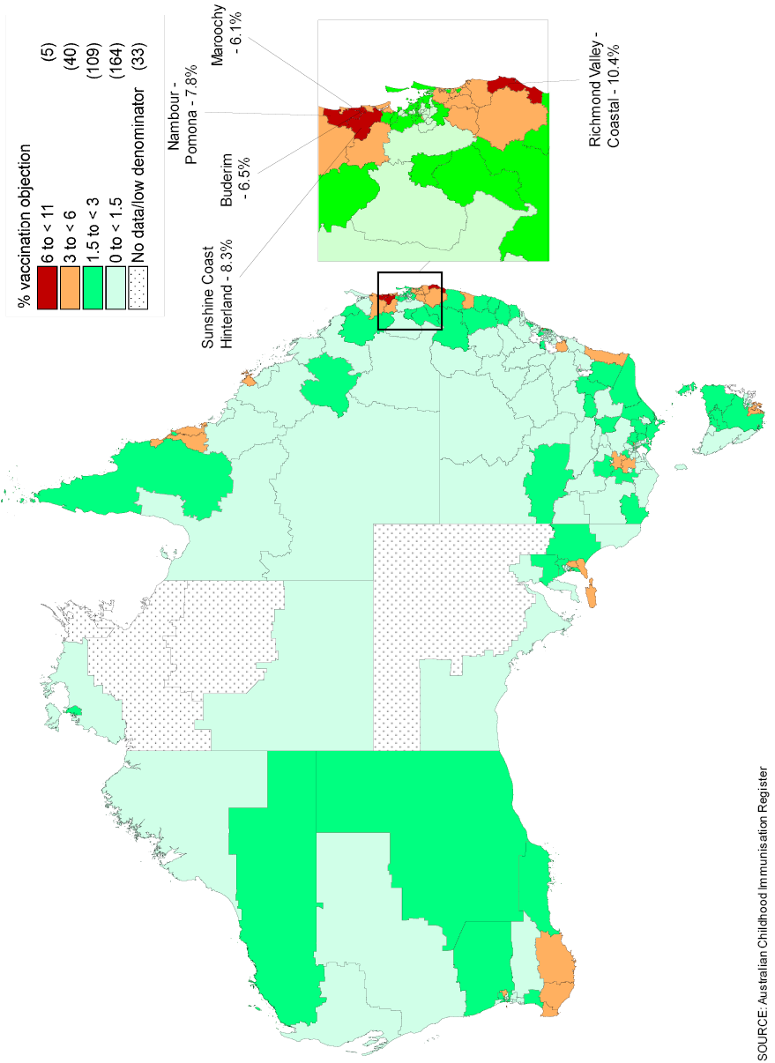
Cohort born January 2013 – December 2013, assessed in 2015.
* Number of SA3s in each category in parentheses.
Source: Australian Childhood Immunisation Register, data as at 31 March 2016.

Partially immunised children
The percentage of children who are partially immunised by 24 months of age and have no recorded vaccination objection by Statistical Area 3 (SA3) in is shown in Figure 18 for Australia and major capital cities. As with registered objection, there are pockets of high levels of partially immunised children in 2015 in coastal and hinterland areas of south-east Queensland and northern New South Wales. Other areas with high levels of partially immunised children include Far North Queensland, the south western region of Western Australia, southern South Australia and the south coast of New South Wales.
Figure 18: Percentage of children who are partially immunised by 24 months of age and have no recorded vaccination objection, by Statistical Area 3 (SA3), Australia and major capital cities, 2015
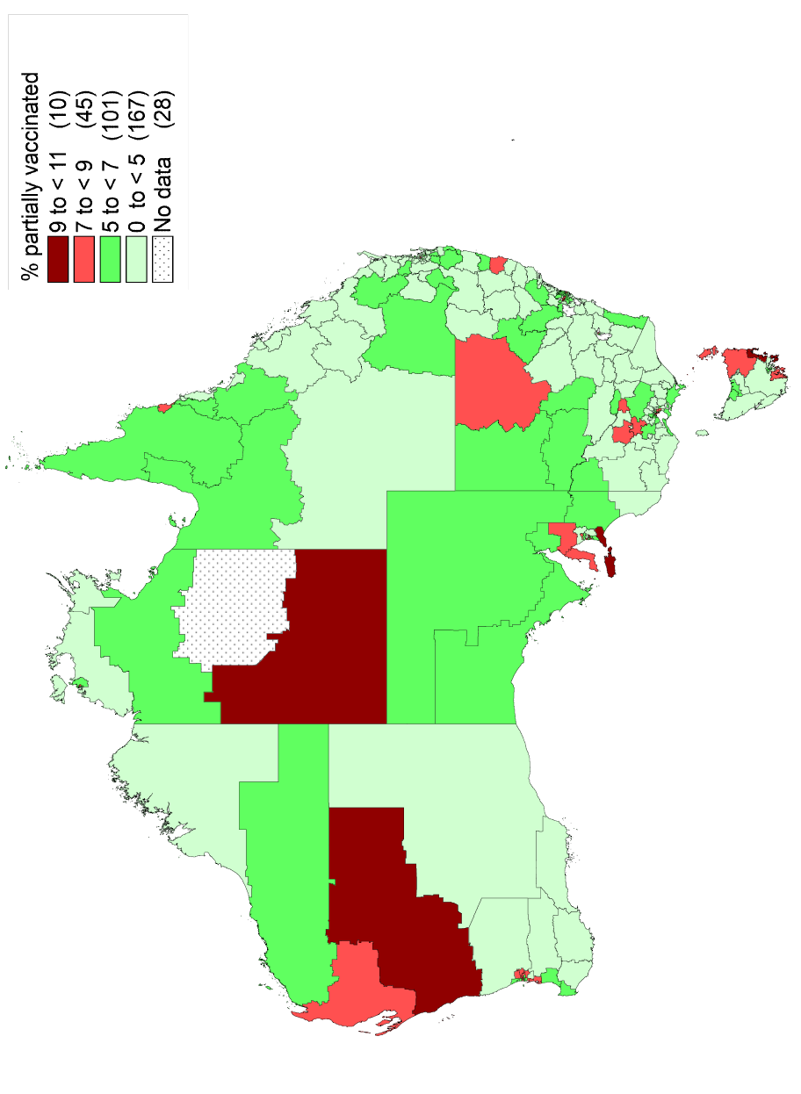

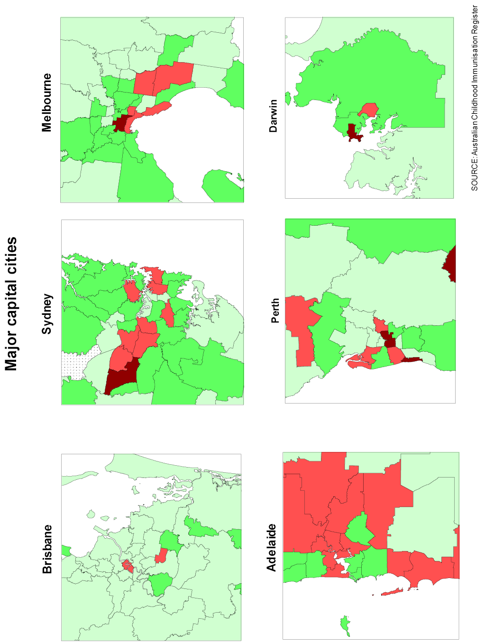

Medical contraindication exemptions
The trends in the number of children with at least one medical contraindication exemption for a vaccine by state/territory are shown in Figure 19. From 2011 to 2015, there is a clear trend of increasing numbers of exemptions. Exemptions for Australia were more than double in 2015, compared with the previous year (635 to 1,401). Exemptions were greatest in New South Wales, Victoria and Queensland.
Figure 19: Trends in the number of children with at least one medical contraindication exemption for a vaccine, by state/territory, Australia 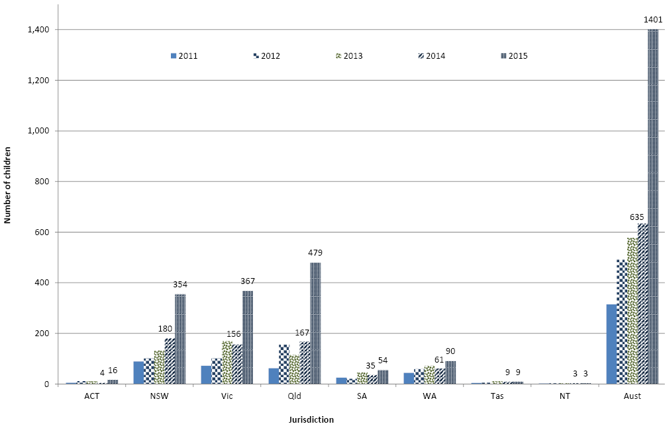

Provider type
During 2015, the large majority of immunisations in Australia were administered in general practice settings (78.1%, up from 72% in 2012; data not shown). Councils and state health departments delivered 12.7%, and community and aboriginal health services delivered 8.1%.

Mechanisms of reporting to the ACIR
The proportion of vaccinations on the ACIR lodged by electronic/online mechanisms in 2015 for Australia was 91.5%, up from 85.2% in 2012 (data not shown).

Third dose assumption
Official “fully immunised” coverage estimates still use the ‘third dose assumption’ discussed in the methods. Figure 20 compares coverage estimates for full immunisation with DTPa when all 3 doses are recorded versus when there is a record of only the 3rd dose, by state or territory. Nationally, it shows DTPa coverage decreases by 5.9 percentage points if all 3 doses are assessed for ‘fully immunised’ status ie if the third dose assumption is not applied. This decrease varied by jurisdiction with an 8.2 percentage points decrease in Tasmania to a 4.3 percentage points decrease in the Australian Capital Territory.
Figure 20: Coverage for DTPa with and without applying third dose assumption by state or territory, Australia 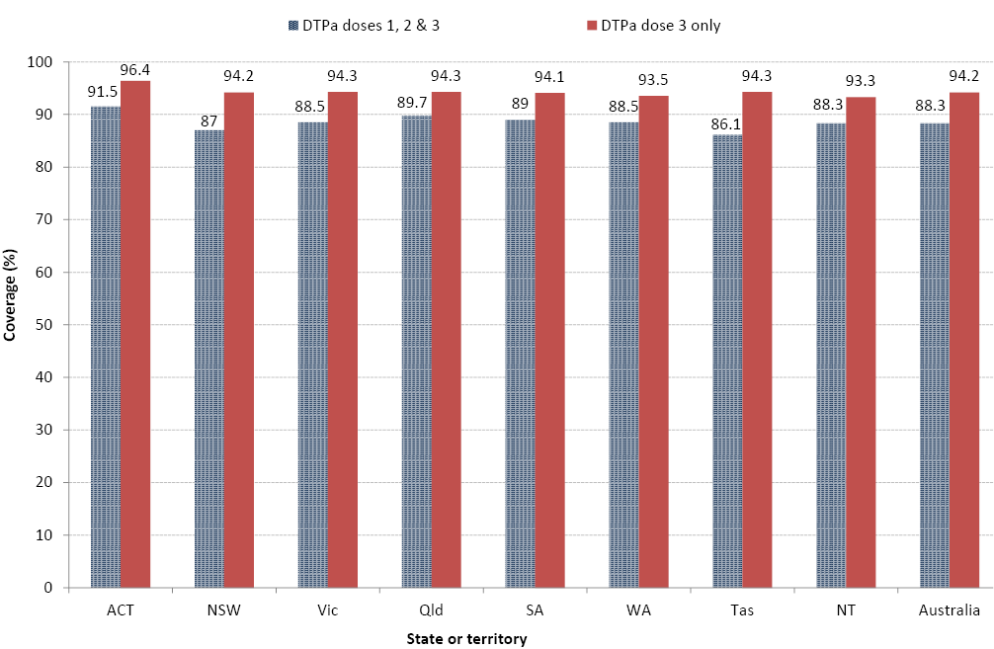
* In some states those aged 12–13 years in 2015 are not eligible for vaccination until 2016. Notification of 2016 doses to the Register is in progress.
Technical notes: Data extracted from the National HPV Vaccination Program Register (HPV Register) as at 12 July 2016. Includes doses that comply with the recommended vaccine dosage and administration as per The Australian Immunisation Handbook (up to 3 doses administered at prescribed intervals). Population is Estimated Resident Population (ERP) 2015 (as at 30/06/2015) from the Australian Bureau of Statistics Cat 3101.0 Australian Demographic Statistics, Tables 51 to 58: Estimated resident population by single year of age by state and territory. Interim data published December 2015. Age is age as at date of ERP estimate (30 June 2015). Coverage is calculated as doses administered and reported to the HPV Register / Estimated Resident Population expressed as a percentage. Excludes consumers who do not wish their details to be recorded on the HPV Register. Dose number is calculated according to the number of doses held by the register for each person. Incoming records are matched to existing records for that person and date of administration is used to determine the dose number. The National HPV Vaccination Program initially provided quadrivalent HPV vaccine for all females aged 12-26 years as at mid-2007 (the school program commenced April 2007 and GP/community program in July 2007) until end December 2009. From 2009 the Program offered HPV vaccination routinely to females in the first year of high school (usually at 12-13 years) from 2013, males were also offered HPV vaccination routinely in the first year of high school (age 12-13 years), with a catch-up program available for males aged 14-15 years in 2013 and 2014. As the ages of students in the first year of high school varies between jurisdictions, age 15 is used as the age for routine review of vaccination coverage that provides the best comparisons to allow for these varying ages in administration, as per World Health Organization (WHO) recommendations. HPV Vaccination doses administered through general practice and in other community settings may be incompletely notified to the HPV Register. The extent of under-notification differs by jurisdiction, with the Northern Territory and Queensland expected to have the most complete notification, due to notification of doses via State based immunisation registers.
Source: National HPV Vaccination Program Register, September 2016.

Human papillomavirus vaccine coverage
Vaccination coverage, as notified to the HPV Register, for dose 3 of the HPV vaccine for females and males aged 15 years in 2015 is shown in Table 10. For females in Australia, 77.8% completed a full course of the vaccine, up from 73.4% in 2014. Coverage varied by jurisdiction from a low of 68.0% in Tasmania to a high of 85.6% in the Northern Territory in 2015. Coverage in New South Wales increased by 10.8 percentage points from 69.8% in 2014 to 80.6% in 2015. Marginal increases were also seen between 2014 and 2015 HPV vaccine coverage estimates in all jurisdictions except for Tasmania and Western Australia. For males in Australia, 67.1% completed a full course of the vaccine, up from 61.4% in 2014 (Table 10). Similar to the jurisdictional variation in female HPV vaccine coverage, coverage for males ranged from 60.4% in Tasmania to 72.1% in Victoria. HPV vaccine coverage in males increased between 2014 and 2015 in all jurisdictions.
Table 10: Coverage (%) for 3 doses of human papillomavirus (HPV) vaccine for girls 15 years of age in 2011, 2012, 2013, 2014 and 2015, and males age 15 years in 2015, by state or territory, Australia
 | State or territory
 | ACT | NSW | NT | Qld | SA | Tas | Vic | WA | Australia
2011 | 74.2 | 74.5 | 87.0 | 72.4 | 68.0 | 66.5 | 76.5 | 64.6 | 72.9
2012 | 74.4 | 71.0 | 84.5 | 69.4 | 71.0 | 64.7 | 74.2 | 70.1 | 71.4
2013 | 74.0 | 68.6 | 81.4 | 71.0 | 72.4 | 64.1 | 75.2 | 71.2 | 71.4
2014 | 70.0 | 69.8 | 77.3 | 73.5 | 73.1 | 67.7 | 77.4 | 76.0 | 73.4
2015* | 76.4 | 80.6 | 85.6 | 75.7 | 74.0 | 68.0 | 79.1 | 74.8 | 77.8
2014 males# | 64.2 | 56.9 | 55.4 | 61.1 | 63.3 | 55.1 | 67.8 | 61.0 | 61.4
2015 males* | 68.0 | 64.2 | 66.5 | 68.0 | 68.7 | 60.4 | 72.1 | 63.4 | 67.1
Includes doses that comply with the recommended vaccine dosage and administration as per The Australian Immunisation Handbook (up to 3 doses administered at prescribed intervals).
ACT = Australian Capital Territory; NSW = New South Wales; NT = Northern Territory; Qld = Queensland; SA = South Australia; Tas = Tasmania; Vic = Victoria; WA = Western Australia
Population is Estimated Resident Population (ERP) provided by the Australian Bureau of Statistics (ABS): CAT 3101.0 Australian Demographics Statistics, Tables 51 to 58 - ERP by Single Year of Age by State and Territory, INTERIM data published DEC 2015.
Age is age as at date of ERP estimate (30th June)
* Source: National HPV Vaccination Program Register website, 19 January 2017.
# Reflects male catch-up vaccination program 2013–2014. Routine immunisation ongoing at age 12–13 years.
Data for the years 2011-2014 are from relevant NCIRS annual immunisation coverage reports, and were originally sourced from the National HPV Vaccination Program Register. These data may differ from those currently available on the National HPV Vaccination Program Register website as data is updated each year to include delayed notifications to the HPV Register.
Coverage in all age groups remains higher for earlier doses. In females, coverage was highest (86.0%) for the 1st dose in the 14–15 year old age group (Figure 21a). Coverage was higher in the younger age groups than the older age groups, with only 56.0% of females aged 20–26 years fully vaccinated compared to 78.0% of females aged 14–15 years. As with data for females, coverage in all male age groups was higher for earlier doses (Figure 21b). In males, coverage for the 1st dose was 79.0% in the 14–15 year old age group and 53% in the 16–17 year old age group. Coverage for the 3rd dose was 45% in males aged 16–17 years.
Figure 21a: HPV vaccination coverage by dose number (Australia) for females by age group in mid-2015 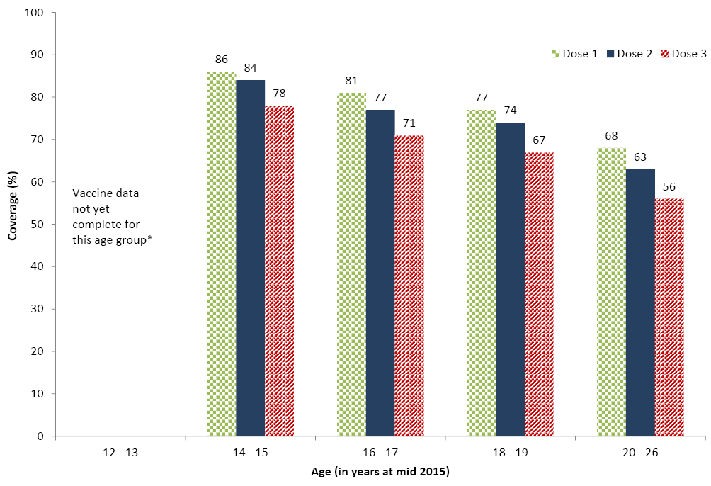* In some states those aged 12–13 years in 2015 are not eligible for vaccination until 2016. Notification of 2016 doses to the Register is in progress. Technical notes: Data extracted from the National HPV Vaccination Program Register (HPV Register) as at 12 July 2016.
Includes doses that comply with the recommended vaccine dosage and administration as per The Australian Immunisation Handbook (up to 3 doses administered at prescribed intervals). Population is Estimated Resident Population (ERP) 2015 (as at 30/06/2015) from the Australian Bureau of Statistics Cat 3101.0 Australian Demographic Statistics, Tables 51 to 58: Estimated resident population by single year of age by state and territory. Interim data published December 2015.
Age is age as at date of ERP estimate (30 June 2015).
Coverage is calculated as doses administered and reported to the HPV Register / Estimated Resident Population expressed as a percentage. Excludes consumers who do not wish their details to be recorded on the HPV Register.
Dose number is calculated according to the number of doses held by the register for each person. Incoming records are matched to existing records for that person and date of administration is used to determine the dose number.
The National HPV Vaccination Program initially provided quadrivalent HPV vaccine for all females aged 12-26 years as at mid-2007 (the school program commenced April 2007 and GP/community program in July 2007) until end December 2009. From 2009 the Program offered HPV vaccination routinely to females in the first year of high school (usually at 12-13 years) from 2013, males were also offered HPV vaccination routinely in the first year of high school (age 12-13 years), with a catch-up program available for males aged 14-15 years in 2013 and 2014.
As the ages of students in the first year of high school varies between jurisdictions, age 15 is used as the age for routine review of vaccination coverage that provides the best comparisons to allow for these varying ages in administration, as per World Health Organization (WHO) recommendations.
HPV Vaccination doses administered through general practice and in other community settings may be incompletely notified to the HPV Register. The extent of under-notification differs by jurisdiction, with the Northern Territory and Queensland expected to have the most complete notification, due to notification of doses via State based immunisation registers.
Source: National HPV Vaccination Program Register, September 2016.
Figure 21b: HPV vaccination coverage by dose number (Australia) for males by age group in mid-2015 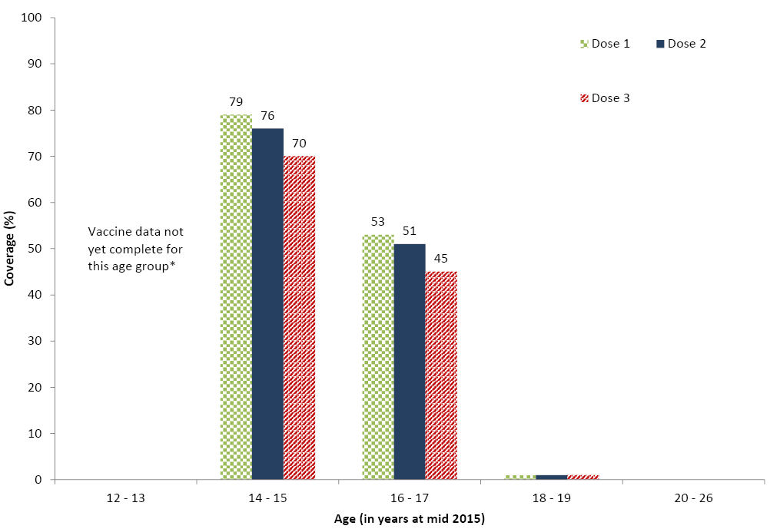
* In some states those aged 12–13 years in 2015 are not eligible for vaccination until 2016. Notification of 2016 doses to the Register is in progress.
Technical notes: Data extracted from the National HPV Vaccination Program Register (HPV Register) as at 12 July 2016.
Includes doses that comply with the recommended vaccine dosage and administration as per The Australian Immunisation Handbook (up to 3 doses administered at prescribed intervals). Population is Estimated Resident Population (ERP) 2015 (as at 30/06/2015) from the Australian Bureau of Statistics Cat 3101.0 Australian Demographic Statistics, Tables 51 to 58: Estimated resident population by single year of age by state and territory. Interim data published December 2015.
Age is age as at date of ERP estimate (30 June 2015). Coverage is calculated as doses administered and reported to the HPV Register / Estimated Resident Population expressed as a percentage.
Excludes consumers who do not wish their details to be recorded on the HPV Register.
Dose number is calculated according to the number of doses held by the register for each person. Incoming records are matched to existing records for that person and date of administration is used to determine the dose number.
The National HPV Vaccination Program initially provided quadrivalent HPV vaccine for all females aged 12-26 years as at mid-2007 (the school program commenced April 2007 and GP/community program in July 2007) until end December 2009. From 2009 the Program offered HPV vaccination routinely to females in the first year of high school (usually at 12-13 years) from 2013, males were also offered HPV vaccination routinely in the first year of high school (age 12-13 years), with a catch-up program available for males aged 14-15 years in 2013 and 2014.
As the ages of students in the first year of high school varies between jurisdictions, age 15 is used as the age for routine review of vaccination coverage that provides the best comparisons to allow for these varying ages in administration, as per World Health Organization (WHO) recommendations.
HPV Vaccination doses administered through general practice and in other community settings may be incompletely notified to the HPV Register. The extent of under-notification differs by jurisdiction, with the Northern Territory and Queensland expected to have the most complete notification, due to notification of doses via State based immunisation registers.
Source: National HPV Vaccination Program Register, September 2016.
HPV coverage by Indigenous status is not available due to limitations in Indigenous status reporting to the HPV Register.

Discussion
In 2015, ‘fully immunised’ coverage was higher than in 2014 nationally for children at all 3 milestone ages of 12, 24 and 60 months of age (92.9%, 89.5%, and 92.6% versus 91.5%, 86.8%, and 92.0%, respectively).
Aside from minor fluctuations and the impact of changes to assessment algorithms, ‘fully immunised’ coverage has been largely stable at the 12- and 24-month age milestones since late 2003, and has continued to improve at the 60-month age milestone.
Coverage estimates for varicella vaccine and the 2nd dose of MMR were substantially lower than for other vaccines included in the algorithm for ‘fully immunised’ at the 24-month milestone. This is probably lower due to the age of administration (18 months). The 18-month schedule point was historically associated with lower coverage levels prior to 2003, when an 18-month pertussis booster was in place. However, when varicella vaccine coverage is assessed at 60 months of age, it increased across all jurisdictions, ranging from 5.7 to 10.2 percentage points higher. We also found that national varicella vaccine coverage at 24 months increased by 6.4 percentage points after the introduction of MMRV vaccine in mid-2013, so further increases in coverage may occur as a result of this schedule change. For rotavirus vaccines, strict upper age limits for administration, which reduce the ability to receive late doses, are likely to explain lower coverage when compared to other vaccines assessed at 12 months of age. However, coverage for rotavirus in 2015 did increase from 2014 in all jurisdictions, ranging from 0.4 of a percentage point to 2 percentage points. The implications of lower coverage for rotavirus and varicella vaccines also differ. In the case of rotavirus vaccine, coverage of 80% or greater has resulted in substantial herd immunity and decreases in rotavirus hospitalisations in Australia and elsewhere.^{28,29} In contrast, modelling studies suggest that low coverage (70–90%) with varicella vaccine may result in a shift of disease to older age groups with higher disease severity.³⁰
Coverage for vaccines recommended for Indigenous children only (i.e. hepatitis A and a booster dose of pneumococcal vaccine) remained suboptimal in 2015. However, hepatitis A coverage in 2015 increased from 2014 in all jurisdictions except for the Northern Territory, with large increases in South Australia (37.0% to 63.5%) and Queensland (59.2% to 72.2%). Coverage of the fourth dose of pneumococcal conjugate vaccine for Indigenous children also increased from 2014 in all jurisdictions where it is supplied under the NIP, with a large increase in South Australia (41.2% to 62.1%). This large increase in coverage for Indigenous children in South Australia is likely due to great efforts in that state to improve and sustain Indigenous immunisation coverage estimates. This includes the securing of Closing the Gap funding to employ a specific Aboriginal Immunisation Project Co-ordinator, a promotional strategy aimed at increasing awareness about the need for complete and timely immunisation for Indigenous children, co-ordination of follow up of overdue children, ongoing data cleaning, and education of service providers. The extent of under-reporting to the ACIR for these vaccines is unknown, but may be more than for ‘universal’ vaccines, given the lack of incentive payments for notification to the ACIR. However, lower coverage for vaccines targeted at Indigenous people has been a relatively consistent finding using a range of different methods for both children³¹ and adults.³² Both a lack of provider knowledge about the recommendations for high-risk groups, and suboptimal identification of Indigenous children by immunisation providers, are likely to be important contributing factors. While coverage for 2 doses of hepatitis A vaccine was only 63%, an additional 20% of Indigenous children received a single dose (data not shown), which provides a protective antibody response in most children.³³
Although most children eventually complete the scheduled vaccination series by the 24-month milestone, many still do not do so in a timely manner. On-time vaccination for vaccines assessed at 12 and 24 months of age in 2015 increased for both Indigenous and non-Indigenous children. However, while the differentials in on-time vaccination between Indigenous and non-Indigenous children in 2015 remained similar to 2014, timeliness is still a significant problem for Indigenous children in Australia. Poorer timeliness in Indigenous children aged 2 years of age has been noted previously.³⁴ Timeliness continued to improve for vaccines assessed at 60 months of age, for both Indigenous and non-Indigenous children. In 2015, more than 79% of children in all jurisdictions except Western Australia received the 1st dose of DTPa vaccine prior to 8 weeks of age, in line with recommendations encouraging early protection of young infants from pertussis infection.
Immunisation at the earliest appropriate age should be a public health goal for countries such as Australia where high levels of vaccine coverage at milestone ages have been achieved. This is especially so for the 2nd dose of the measles vaccine where delay has consistently been an issue. The change in scheduling of this dose to 18 months of age that occurred in mid-2013 has led to an improvement in the timeliness of this dose in both Indigenous and non-Indigenous children during 2015.
Only 1.2% of children were registered in 2015 as having parental vaccination objection, a marked decrease from 1.8 in 2014. This may be related to awareness of the imminent implementation of the No Jab No Pay policy. An NCIRS study estimated that registered and unregistered vaccination objection was likely to be responsible for incomplete immunisation in 3.3% of children in 2013, noting that incomplete immunisation in the absence of objection is usually due to access and logistic issues, rather than objection.³⁵ Further vaccination coverage estimates in small areas have been provided by the National Health Performance Authority for children in 2013–2015.¹⁰
Coverage data for the HPV vaccine derived from the National HPV Vaccination Program Register reflect a successful school-based program with lower but still substantial coverage for the catch-up program in older females.^{36,37} The coverage achieved in the program has resulted in demonstrable decreases in HPV prevalence in young women,³⁸ and in genital warts³⁹ and cervical abnormalities⁴⁰ now extending up to women aged 30.⁴¹ Increased coverage was achieved from 2014 to 2015 and was particularly noticeable in NSW, which changed the approach to delivery of doses missed at school from GP based delivery organised by parents to in-school catch up the following school year.⁴² Coverage continues to rise in males as the program becomes a routine gender-neutral program following the 2013-2014 catch up program. With recent modelling of HPV vaccination programs suggesting that vaccination coverage of 80% in females and males will be sufficient for elimination of targeted HPV types, Australia looks well placed to realise this into the future.⁴³
Data provided in this report reflect continuing successful delivery of the NIP in Australia, especially for Indigenous children in New South Wales and South Australia who have ‘Closing the Gap’ initiatives in place, while identifying some areas for improvement. Coverage for rotavirus vaccine, varicella vaccine and the second dose of MMR vaccine is below that for other vaccines. Timeliness of vaccination could be improved, particularly for Indigenous children, and coverage for vaccines recommended only for Indigenous children is lower than for other vaccines.

Acknowledgements
The National Centre for Immunisation Research and Surveillance of Vaccine Preventable Diseases is supported by the Australian Government Department of Health, the NSW Ministry of Health and The Children’s Hospital at Westmead. The opinions expressed in this paper are those of the authors, and do not necessarily represent the views of these agencies. Thanks to Karen Winch for provision of HPV vaccination coverage data.

Author details
Brynley Hull¹
Alexandra Hendry¹
Aditi Dey¹
Frank Beard¹
Julia Brotherton²
Peter McIntyre¹
- National Centre for Immunisation Research and Surveillance of Vaccine Preventable Diseases The Children’s Hospital at Westmead and University of Sydney Locked Bag 4001, Westmead, NSW 2145
- National HPV Vaccination Program Register, Victorian Cytology Service PO Box 310, East Melbourne, Vic 8002
Corresponding author: Mr Brynley Hull, National Centre for Immunisation Research and Surveillance of Vaccine Preventable Diseases, The Children’s Hospital at Westmead and University of Sydney, Locked Bag 4001, WESTMEAD NSW 2145. Telephone: +61 2 9845 1435. Facsimile: +61 2 9845 1418. Email: brynley.hull@health.nsw.gov.au.

References
- Hull B, Deeks S, Menzies R, McIntyre P. Immunisation coverage annual report, 2007. Communicable Diseases Intelligence 2009;33:170-87.
- Hull BP, Mahajan D, Dey A, Menzies RI, McIntyre PB. Immunisation coverage annual report, 2008. Communicable Diseases Intelligence 2010;34:241-58.
- Hull B, Dey A, Mahajan D, Menzies R, McIntyre PB. Immunisation coverage annual report, 2009. Communicable Diseases Intelligence 2011;35:132-48.
- Hull B, Dey A, Menzies R, McIntyre P. Annual immunisation coverage report, 2010. Communicable Diseases Intelligence 2013;37:E21-39.
- Hull BP, Dey A, Menzies RI, Brotherton JM, McIntyre PB. Immunisation coverage annual report, 2011. Communicable Diseases Intelligence 2013;37:E291-312.
- Hull BP, Dey A, Menzies RI, Brotherton JM, McIntyre PB. Immunisation coverage, 2012. Communicable Diseases Intelligence 2014;38:E208-31.
- Hull BP, Dey A, Beard FH, et al. Immunisation coverage annual report, 2013. Communicable Diseases Intelligence 2016;40:E146-69.
- Hull B, Dey A, Beard F, et al. Annual immunisation coverage report 2014. Sydney: NCIRS; 2016. Available from: http://www.ncirs.edu.au/surveillance/immunisation-coverage/ (Accessed October 2016).
- National Health Performance Authority. Healthy communities: Immunisation rates for children in 2012-13. 2014. Available from: http://www.myhealthycommunities.gov.au/our-reports/immunisation-rates-for-children/march-2014 (Accessed 2 December 2014).
- National Health Performance Authority. Healthy communities: Immunisation rates for children in 2014-15. 2016. Available from: http://www.myhealthycommunities.gov.au/our-reports/immunisation-rates-for-children/february-2016 (Accessed 20 February 2016).
- Hull BP, Deeks SL, McIntyre PB. The Australian Childhood Immunisation Register – a model for universal immunisation registers? Vaccine 2009;27:5054-60.
- Hull BP, McIntyre PB, Heath TC, Sayer GP. Measuring immunisation coverage in Australia: a review of the Australian Childhood Immunisation Register. Australian Family Physician 1999;28:55-60.
- Australian Government Department of Health. Update: No Jab No Pay - Immunisation catch-up arrangements. 2015. Available from: http://www.immunise.health.gov.au/internet/immunise/publishing.nsf/Content/clinical-updates-and-news/$File/Update-No-Jab-No-Pay-Immunisation-Catch-Up-Arrangements(D15-1126865).pdf. (Accessed 30 November 2015).
- Australian Government Department of Health. Immunise Australia Program: Expansion of Registers. 2016. Available from: http://www.immunise.health.gov.au/internet/immunise/publishing.nsf/Content/expansion-registers (Accessed 21 October 2016).
- Australian Technical Advisory Group on Immunisation (ATAGI). The Australian immunisation handbook. 10th ed. Canberra: Australian Government Department of Health and Ageing; 2013. Available from: http://www.immunise.health.gov.au/internet/immunise/publishing.nsf/Content/Handbook10-home.
- O’Brien ED, Sam GA, Mead C. Methodology for measuring Australia’s childhood immunisation coverage. Communicable Diseases Intelligence 1998;22:36-7.
- Hull BP, McIntyre PB. Immunisation coverage reporting through the Australian Childhood Immunisation Register – an evaluation of the third-dose assumption. Australian and New Zealand Journal of Public Health 2000;24:17-21.
- Hull BP, Lawrence GL, MacIntyre CR, McIntyre PB. Estimating immunisation coverage: is the ‘third dose assumption’ still valid? Communicable Diseases Intelligence 2003;27:357-61.
- Hendry A. Australian childhood immunisation coverage, 1 October to 30 September cohort, assessed as at 31 December 2015 [quarterly report]. Communicable Diseases Intelligence 2016;40:E304-5.
- Australian Government Department of Human Services. No Jab No Pay. 2016. Available from: https://www.humanservices.gov.au/corporate/budget/budget-2015-16/budget-measures/families/no-jab-no-pay (Accessed 10 October 2016).
- Australian Population and Migration Research Centre. ARIA and accessibility. Acessibility/Remoteness Index of Australia - ARIA+ (2011). 2011. Available from: http://www.adelaide.edu.au/apmrc/research/projects/category/aria.html. (Accessed 17 November 2014).
- Rank C, Menzies RI. How reliable are Australian Childhood Immunisation Register coverage estimates for Indigenous children? An assessment of data quality and coverage. Communicable Diseases Intelligence 2007;31:283-7.
- Australian Bureau of Statistics. Australian Statistical Geography Standard (ASGS). . 2011. Available from: http://www.abs.gov.au/websitedbs/d3310114.nsf/home/australian+statistical+geography+standard+%28asgs%29. (Accessed 17 November 2014).
- MapInfo Pro version 15.0. Stamford, Connecticut, USA. 2015.
- Australian Bureau of Statistics. Australian Statistical Geography Standard (ASGS): Correspondences, July 2011 (Cat. no. 1270.0.55.006). 2012. Available from: http://www.abs.gov.au/AUSSTATS/abs@.nsf/Lookup/1270.0.55.006Main+Features1July%202011?OpenDocument (Accessed 17 November 2014).
- Australian Institute of Health and Welfare. 2009 Adult Vaccination Survey: summary results. 2011. Available from: http://www.aihw.gov.au/publication-detail/?id=10737418409. (Accessed 2 December 2014).
- Newspoll. Newspoll Omnibus Survey June 2014 - Summary Report Flu Vaccinations. 2014. Available from: http://www.immunise.health.gov.au/internet/immunise/publishing.nsf/Content/762A8FB9101D1759CA257D49002227B6/$File/summ-report-flu-vaccinations-survey2014.pdf. (Accessed 30 November 2015).
- Buttery JP, Lambert SB, Grimwood K, et al. Reduction in rotavirus-associated acute gastroenteritis following introduction of rotavirus vaccine into Australia’s National Childhood vaccine schedule. Pediatric Infectious Disease Journal 2011;30(1 Suppl):S25-9.
- Dey A, Wang H, Menzies R, Macartney K. Changes in hospitalisations for acute gastroenteritis in Australia after the national rotavirus vaccination program. Medical Journal of Australia 2012;197:453-7.
- Brisson M, Edmunds WJ, Gay NJ, Law B, De Serres G. Modelling the impact of immunization on the epidemiology of varicella zoster virus. Epidemiology & Infection 2000;125:651-69.
- Hull BP, McIntyre PB. What do we know about 7vPCV coverage in Aboriginal and Torres Strait Islander children? Communicable Diseases Intelligence 2004;28:238-43.
- Menzies R, Turnour C, Chiu C, McIntyre P. Vaccine preventable diseases and vaccination coverage in Aboriginal and Torres Strait Islander people, Australia 2003 to 2006. Communicable Diseases Intelligence 2008;32(Suppl):S2-67.
- Plotkin S, Orenstein W, Offit P. Vaccines. 5th ed. Philadelphia, PA: Saunders Elsevier; 2008.
- Hull BP, McIntyre PB. Timeliness of childhood immunisation in Australia. Vaccine 2006;24:4403-8.
- Beard FH, Hull BP, Leask J, Dey A, McIntyre PB. Trends and patterns in vaccination objection, Australia, 2002–2013. Medical Journal of Australia 2016;204:275.
- Brotherton J, Gertig D, Chappell G, Rowlands L, Saville M. Catching up with the catch-up: HPV vaccination coverage data for Australian women aged 18-26 years from the National HPV Vaccination Program Register. Communicable Diseases Intelligence Quarterly Report 2011;35:197-201.
- Brotherton JM, Murray SL, Hall MA, et al. Human papillomavirus vaccine coverage among female Australian adolescents: success of the school-based approach. Medical Journal of Australia 2013;199:614-7.
- Tabrizi SN, Brotherton JM, Kaldor JM, et al. Assessment of herd immunity and cross-protection after a human papillomavirus vaccination programme in Australia: a repeat cross-sectional study. The Lancet Infectious Diseases 2014;14:958-66.
- Ali H, Donovan B, Wand H, et al. Genital warts in young Australians five years into national human papillomavirus vaccination programme: national surveillance data.[Erratum appears in BMJ. 2013;346:F2942]. BMJ 2013;346:f2032.
- Gertig DM, Brotherton JM, Budd AC, et al. Impact of a population-based HPV vaccination program on cervical abnormalities: a data linkage study. BMC Medicine 2013;11:227.
- Brotherton JM, Gertig DM, May C, Chappell G, Saville M. HPV vaccine impact in Australian women: ready for an HPV-based screening program. Medical Journal of Australia 2016;204:184-e1.
- Staples C, Butler M, Nguyen J, et al. Opportunities to increase rates of human papillomavirus vaccination in the New South Wales school program through enhanced catch-up. Sexual Health 2016.
- Brisson M, Bénard É, Drolet M, et al. Population-level impact, herd immunity, and elimination after human papillomavirus vaccination: a systematic review and meta-analysis of predictions from transmission-dynamic models. The Lancet Public Health 2016;1:e8-e17.

Abbreviations | Description
7vPCV | 7-valent pneumococcal conjugate vaccine
10vPCV | 10-valent pneumococcal conjugate vaccine
13vPCV | 13-valent pneumococcal conjugate vaccine
23vPPV | 23-valent pneumococcal polysaccharide vaccine
Comvax | Haemophilus influenzae type b conjugate (meningococcal protein conjugate) and hepatitis B (recombinant) vaccine
dTpa | diphtheria-tetanus-acellular pertussis (adults, adolescents and children aged ≥10 years formulation)
DTPa | diphtheria-tetanus-acellular pertussis (children aged <10 years formulation)
DTPa-hepB-IPV-Hib | combined diphtheria-tetanus-acellular pertussis-hepatitis B-inactivated poliovirus-Haemophilus influenzae type b
DTPa-IPV | diphtheria-tetanus-acellular pertussis-inactivated poliovirus
Engerix-B | recombinant DNA hepatitis B vaccine (paediatric formulation)
Flu | influenza
H-B-VAX II | hepatitis B (paediatric formulation)
Hep A | hepatitis A
Hep B | hepatitis B
Hib | Haemophilus influenzae type b
Hib-MenCCV | Haemophilus influenzae type b - meningococcal C conjugate vaccine
HPV | human papillomavirus
IPV | inactivated poliovirus
MenCCV | meningococcal C conjugate vaccine
MMR | measles-mumps-rubella
MMRV | measles-mumps-rubella-varicella
PedvaxHIB | Haemophilus influenzae type b conjugate vaccine (meningococcal protein conjugate)
PCV | pneumococcal conjugate vaccine
PRP-OMP | Haemophilus influenzae type b conjugate vaccine
PRP-T | Haemophilus influenzae type b conjugate vaccine
VZV | varicella-zoster virus

Communicable Diseases Intelligence
ISSN: 2209-6051 Online

Communicable Diseases Intelligence (CDI) is a peer-reviewed scientific journal published by the Office of Health Protection, Department of Health. The journal aims to disseminate information on the epidemiology, surveillance, prevention and control of communicable diseases of relevance to Australia.

Editor: Cindy Toms
Deputy Editor: Phil Wright
Editorial and Production Staff: Leroy Trapani and Kasra Yousefi
Editorial Advisory Board: David Durrheim, Mark Ferson, John Kaldor, Martyn Kirk and Linda Selvey

Website: http://www.health.gov.au/cdi

Contacts
Communicable Diseases Intelligence is produced by:
Health Protection Policy Branch, Office of Health Protection, Australian Government Department of Health
GPO Box 9848, (MDP 6) CANBERRA ACT 2601

Email: cdi.editor@health.gov.au

Submit an Article
You are invited to submit your next communicable disease related article to the Communicable Diseases Intelligence (CDI) for consideration. More information regarding CDI can be found at: http://health.gov.au/cdi.
Further enquiries should be directed to: cdi.editor@health.gov.au.

This journal is indexed by Index Medicus and Medline.

Creative Commons Licence - Attribution-NonCommercial-NoDerivatives CC BY-NC-ND
© 2019 Commonwealth of Australia as represented by the Department of Health
This publication is licensed under a Creative Commons Attribution-NonCommercial-NoDerivatives 4.0 International Licence from https://creativecommons.org/licenses/by-nc-nd/4.0/legalcode (Licence). You must read and understand the Licence before using any material from this publication.

Restrictions
The Licence does not cover, and there is no permission given for, use of any of the following material found in this publication (if any):
- the Commonwealth Coat of Arms (by way of information, the terms under which the Coat of Arms may be used can be found at www.itsanhonour.gov.au);
- any logos (including the Department of Health’s logo) and trademarks;
- any photographs and images;
- any signatures; and
- any material belonging to third parties.

Disclaimer
Opinions expressed in Communicable Diseases Intelligence are those of the authors and not necessarily those of the Australian Government Department of Health or the Communicable Diseases Network Australia. Data may be subject to revision.

Enquiries
Enquiries regarding any other use of this publication should be addressed to the Communication Branch, Department of Health, GPO Box 9848, Canberra ACT 2601, or via e-mail to: copyright@health.gov.au

Communicable Diseases Network Australia
Communicable Diseases Intelligence contributes to the work of the Communicable Diseases Network Australia.
http://www.health.gov.au/cdna

