Flutracking weekly online community survey of influenza-like illness annual report, 2016
Sandra J Carlson, Daniel Cassano, Michelle T Butler, David N Durrheim and Craig B Dalton

Abstract
Flutracking is a national online community influenza-like illness (ILI) surveillance system that monitors weekly ILI attack rates and seriousness of disease in the Australian community. This article reports on the 2016 findings. From 2015 to 2016 there was an 11.4% increase in participants to 30,998 completing at least one survey with a peak weekly response of 27,094 participants and a minimum weekly response of 26,123. The 2016 Flutracking national weekly percentage of participants with fever and cough peaked in late August at 2.7%, one week earlier than the national counts of laboratory confirmed influenza peaked. A lower percentage of participants took 2 or more days off from work or normal duties and sought medical advice in 2016 (peak level 1.6% and 1.0% respectively) compared with 2015 (peak level 2.0% and 1.3% respectively). Flutracking fever and cough peaked in the same week as death rates for influenza and pneumonia recorded by the NSW Registry of Births, Deaths and Marriages. The percentage of participants aged 0 to 14 years with cough and fever was higher than all other age groups in 2016. Overall, Flutracking surveillance demonstrated that the attack rates and seriousness of disease for the 2016 season at the community level were lower than 2015 and 2014.
Keywords: influenza, surveillance, syndromic surveillance, influenza-like illness, survey, Flutracking.

Key Highlights
- Demonstrated success in targeted rural recruitment campaign
- Attack rates and seriousness of disease for the 2016 season at the community level were lower than 2015 and 2014.
- Flutracking ILI activity peaked in the same week as death rates for influenza and pneumonia.
- The percentage of Flutracking participants with fever and cough that were tested for influenza has increased each year from 1.6% in 2013 to 2.9% in 2016.
- The Flutracking participant base has continued to grow in 2016 to 30,998 participants.

Introduction
Flutracking provides weekly community level influenza-like illness (ILI) surveillance that is not biased by health seeking behaviour, clinician testing practices or differences in jurisdictional surveillance methods.^{1–4} Flutracking provides an indication of differential ILI attack rates by age and geography, and seriousness of disease at a community level.^{5,6} The Flutracking surveillance system has been incorporated into the weekly Australian Influenza Surveillance Report since 2009.⁷
The main aims of Flutracking are to:
- contribute community level influenza surveillance to the broader surveillance picture of influenza in Australia;
- provide consistent surveillance of influenza attack rates across all jurisdictions and over time; and
- provide year-to-year comparison of the timing, attack rates, and seriousness of influenza on the community.
In this report, we
- describe the epidemiology of ILI and influenza vaccination in the community for 2016;
- describe the performance characteristics of the Flutracking system; and
- compare Flutracking estimates with notifications for confirmed influenza and death rates for influenza and pneumonia in the 2016 season.

Methods
The Flutracking surveillance system operated for 25 weeks in 2016, from the week ending Sunday 1 May to the week ending Sunday 16 October 2016. In 2016, the recruitment drive was from 14 April to 12 May. Participants may opt out at any time. Recruitment methods in 2016 were similar to those used in 2007–2015.^{1,8,9,10}
The weekly survey questions evolved from 2007–2012.^{1,8} In 2016, in an attempt to reduce the number of unknown influenza laboratory test results, we followed up participants who reported that they had a laboratory test, but did not yet know the result. A follow up question was added at 1, 3, and 5 weeks after participants reported having an influenza test, to ask if they had received the test result yet. Participants who reported an unknown test result in the last 5 weeks of the Flutracking season have less opportunity to receive follow up reminders than participants who reported an ‘unknown’ test result in prior weeks as the survey period is concluded. Therefore, we sent a separate email to these participants to request test results 6 weeks after their initial survey and after the final and concluding survey of the season. The percentage of Flutracking participants with fever and cough that tested positive for influenza was adjusted in 2014 and 2015 (increased by 18%) to account for 2016 laboratory test results being collected over 5 weeks whereas in 2015 (and prior years) laboratory test results were collected in the first week of ILI only. The adjustment factor of 18% was calculated using the difference between the average weekly percent positivity for 2016 without the 1, 3, and 5 week follow up and the average weekly percent positivity for 2016 with follow up.
Because respondents answered ‘no’ to fever or cough in over 95% of surveys for every household member, in 2016 we trialled an express survey to reduce the burden of participants responding on behalf of other household members. An express survey was offered to a random sample of participants (every participant identification number that was divisible by 7) who were responding on behalf of other household members participating in Flutracking. The express survey was offered in place of the traditional weekly survey to assess how a quicker survey impacted upon weekly participation rates and reported ILI percentages. The express survey contained 2 questions asked weekly: ’Did you or <Participant 2> or < Participant n> have fever or cough?’; ‘Did you or <Participant 2> or < Participant n> have an influenza vaccine this year?’ A response of ‘yes’ or ‘don’t know’ to either question triggered more detailed survey questions.
From 2014 onwards, once participants have finished their current survey, they have been able to click on any prior surveys from the past 5 weeks to complete.

Descriptive statistics
Descriptive statistics were tabulated and summarised for each state and territory, by age group, gender, education level, Aboriginal and Torres Strait Islander status, and vaccination status.
A participant was defined as anyone who has a survey submitted by them self or on their behalf. A respondent was anyone who submits a survey either for themself or on behalf of a household member.
The participation rate for state and territory, age group, and gender was calculated using the Australian Bureau of Statistics June 2016 Estimated Resident Population.¹¹ The participation rate for education level was calculated using the 2011 Australian Census data¹², and the participation rate for Aboriginal and Torres Strait Islander status was calculated using June 2011 population estimates¹³.
Unless otherwise stated, a participant with ILI was defined as having both self-reported fever and cough, and both unvaccinated and vaccinated participants were included in ILI analyses. For all ILI analyses any responses of ‘don’t know’ for the ‘fever’ or ‘cough’ or ‘influenza vaccination status’ variables were removed from analysis. This removed 0.9% of all surveys for these analyses. In 2016, reporting of ILI was changed from a prevalence measure to an incidence measure. This adjustment resulted in a weekly average incidence of 2.1% compared to a calculated prevalence of 2.8%. For ILI percentage calculations, the numerator was all persons who completed a survey for the current week and reported new ILI symptoms, and the denominator was all persons who completed a survey for the current week. Where there were consecutive weeks of reporting ILI symptoms, the first week of new symptoms was the incident week. If a person reported ILI symptoms in one week, and then reported at least one week of no symptoms, followed by another report of symptoms, then this second symptom report was considered a new case of ILI.
In 2016, to allow for the delay between receiving influenza vaccination and onset of immunity, the analytic definition for influenza vaccination status was also adjusted. A participant was considered to be effectively vaccinated 2 weeks after they reported to be vaccinated. The exception to this was in the first survey of the year for each participant (for example, if a participant reported having been vaccinated in 2016 prior to commencement of Flutracking surveys or in the week ending 1 May 2016 then their initial vaccination status was retained for all survey weeks).
Weekly ILI percentages were compared by self-reported vaccination status for participants. The unstratified (by vaccination status) ILI percentages were also compared with national laboratory confirmed influenza notifications for 2009 to 2016, and rates of deaths for influenza and pneumonia in NSW for 2011 to 2016. Counts of influenza and pneumonia death registrations were obtained from the NSW Registry of Births, Deaths and Marriages held in the SAPHaRI Death Registration Unit Record File data asset, Centre for Epidemiology and Evidence, NSW Ministry of Health. Weekly death rates were calculated using mid-year estimated resident population for each year¹¹.
We compared the weekly percentage of participants from 2011 to 2016 who had “fever and cough and 2 or more days off work or normal duties” to the weekly percentage of participants from 2011 to 2016 who “visited a general practitioner, emergency department or were admitted to hospital due to fever and cough”.
The average weekly percentage of Flutracking participants with fever and cough that were tested for influenza was compared across states and territories from 2014 to 2016.
The cumulative incidence of ILI (fever and cough) was calculated for 2016, at the national level, by age group. Only the first ILI episode of the 2016 season for each participant was included in this analysis. Participants were only included in this analysis if they completed all 25 weeks of surveys in 2016. If a participant changed age groups part way through the season, then they were included in the age group that they had completed most surveys in. Where a participant completed an equal number of weeks in more than one age group, then the age group that participant was in at the start of the 2016 season was used.

Results

Recruitment in 2016
Participants were encouraged to join at any time during the year. Similar to previous years, the most successful recruitment strategy in 2016 was recruitment through invitations forwarded by previous participants. Eighty one percent (22,250) of participants from the 2015 season participated at least once in 2016. The 2015 participants comprised 72.7% of the 2016 participants. From 1 January to 20 April 2016, 267 people had joined. Prior to launching recruitment in April, the mean number of joins per week in January to March 2016 ranged from 1 to 5 participants
On 27 and 28 April 2016, an email was sent to all active participants (20,320 respondents) requesting respondents invite friends to join the survey. On 27, 28 and 29 April 2016, respectively 253, 1,283 and 706 participants joined. A further 651 participants joined on 2 May, 226 participants joined on 9 May, and 384 participants joined on 16 May: these spikes correspond to the dates the first, second and third Flutracking survey emails were sent to respondents.
With a view to improve rural participation in Flutracking and granularity of ILI data, on 30 June 2016 an email was sent to 5,805 respondents with less than 20 participants in their postcode, requesting them to invite local friends. On 30 June 2016, 1 July 2016 and 4 July 2016, respectively 307, 300 and 178 participants joined (Figure 1). Of the 1,258 targeted postcodes, 18 reached 20 or more participants in the 4 weeks following this email.
Figure 1: Significant Flutracking recruitment events and impact, 2016
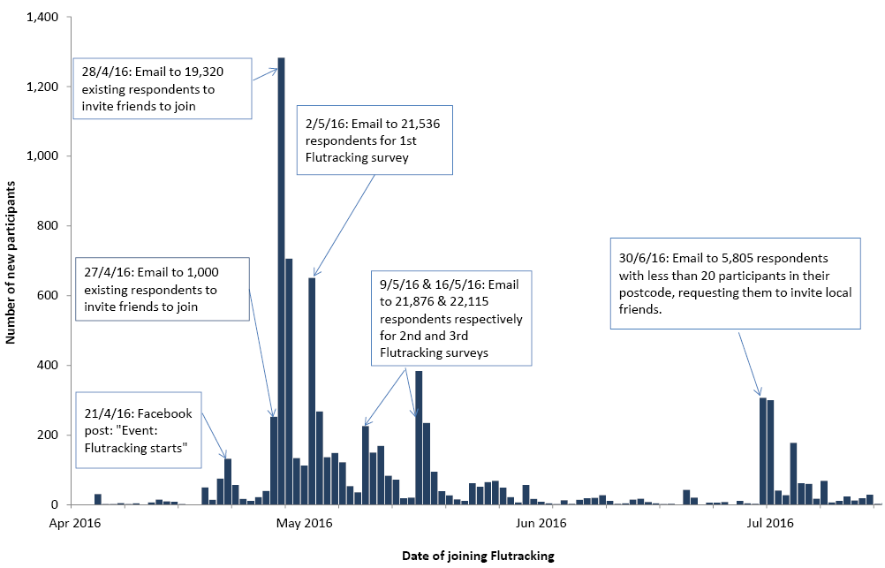
To improve representation of Aboriginal and Torres Strait Islander participants in Flutracking data, on 11 August 2016, an email was sent to 255 existing Aboriginal and Torres Strait Islander participants, asking for participants to post ’join www.flutracking.net to help track flu’ to social media, forward the email to friends inviting them to participate in Flutracking, or ask their workplace to invite employees to participate. On 11 August 2016, 12 August 2016 and 15 August 2016, respectively 8, 3, and 7 Indigenous participants joined.
As a result of the above recruitment strategies and media coverage a total of 8,609 participants joined the survey in 2016, compared with the 9,987 that joined in 2015.

Participation in 2016
At least one survey was completed by 18,194 respondents and 12,804 household members for a total of 30,998 participants. Of the 28,251 participants who completed a survey during the first 4 survey weeks, 63.6% completed all available surveys, and 79.2% completed more than 90% of available surveys.
There was an 11.4% increase in the number of participants who completed at least one survey in 2016, compared with 2015 (Figure 2). At a state and territory level, increases in peak weekly participation were most marked in the Australian Capital Territory, Victoria and New South Wales. Notably Western Australia had a decrease in participation from 2015 to 2016. In 2016, Tasmania had the highest rate of Flutracking participation per 100,000 persons, followed by the Northern Territory and the Australian Capital Territory. New South Wales, Victoria, and Queensland all had lower rates of participation than the general Australian population (Figure 3 and Appendix A).
Figure 2: Number of participants who completed at least one survey, Australia, 2006 to 2016, by year
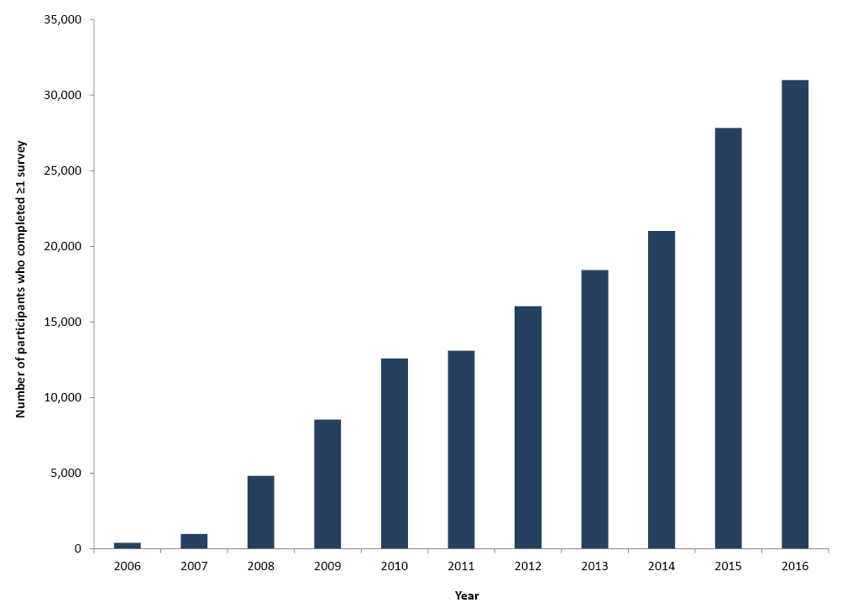

Figure 3: Flutracking participation per 100,000 population for participants who completed at least one survey, Australia, 2016, by state/territory.
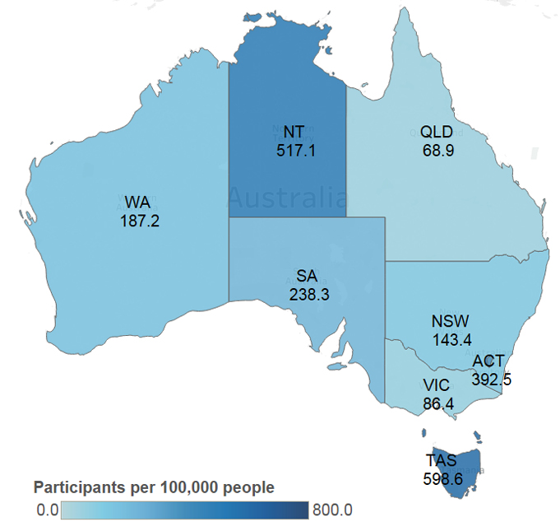

Socio-demographic characteristics
Of the participants who completed at least one survey in 2016 and completed the demographic questions (87.4% of participants completed all demographics relevant for their age), 58.3% were aged 35–64 years, 60.7% were female, 62.8% had completed a bachelor degree, graduate diploma or certificate or postgraduate degree, and 1.5% identified as Aboriginal and/or Torres Strait Islander (Appendix B).

Express survey evaluation
There was a slightly lower survey completion rate for the express survey compared to the non-express survey in participants who had joined prior to the start of the 2015 season (88.8% and 89.7%, respectively). There was a slightly higher survey completion rate for the express survey compared to the non-express survey in participants who had joined in 2016 (82.6% and 80.3%, respectively).
There were similar ILI percentages (total number of ILI cases for the year/total number of surveys for the year) for the express survey compared to the non-express survey in participants who had joined prior to the start of the 2015 season (2.1% and 2.0%, respectively). There was a much lower ILI percentage for the express survey compared to the non-express survey in participants who had joined in 2016 (2.1% and 2.6%, respectively).

Time to respond to survey each week
Most participants responded within 24 hours of the survey being sent, with a mean 24 hour response of 72.9% over the 25 weeks. The 65 years or over age group had a mean 24 hour response of 80.9% over the 25 weeks which was the highest of all age groups.

Percentage of participants vaccinated
Seasonal vaccination levels among participants were similar from 2013 to 2016. At the final survey of each participant for 2016, 58.4% (18,088/30,998) of participants had received the 2016 seasonal vaccine, compared with 59.9% (16,676/27,828) of participants by the end of 2015. Of the 6,159 participants who identified as working face-to-face with patients in 2016, 4,881 (79.2%) received the vaccine compared with 80.0% by the end of 2015. In 2016, 17.8% (422/2,376) of participants less than 10 years of age were vaccinated with the seasonal influenza vaccine by the end of the season, compared with 17.2% in 2015 (Figure 4).
Figure 4: Percentage of participants vaccinated with the seasonal influenza vaccine at the final survey of each participant, by participant characteristics, Australia, 2007 to 2016, by year
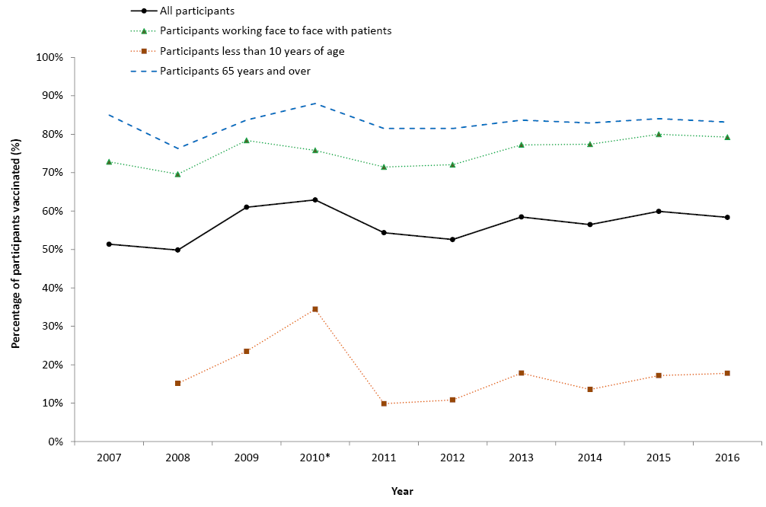
* This percentage calculation for 2010 included participants who received either the monovalent H1N109 influenza vaccine in 2009 or 2010, or received the 2010 seasonal influenza vaccine.

Percentage of participants with influenza-like illness symptoms
Of participants who completed a survey in the national peak week of ILI for 2016, 2.7% reported fever and cough compared with 3.1% in 2015 and 3.4% in 2014. Of participants who completed at least one survey in the national peak 4 weeks of ILI for 2016, 9.6% reported fever and cough, compared with 10.7% in 2015 and 11.5% in 2014.
Detection of influenza-like illness
Figure 5 shows the 2009 to 2016 weekly ILI percentages by vaccination status. Peak ILI activity for 2016 for the unvaccinated group was during the week ending 14 August (3.0%), and for the vaccinated group was during the week ending 28 August (2.5%). Divergence between the vaccinated and unvaccinated participants’ ILI percentages was highest during the week ending 14 August (3.0% in the unvaccinated group and 2.3% in the vaccinated group).
Figure 5: Fever and cough percentage stratified by vaccination status, Australia, 2009 to 2016, by week
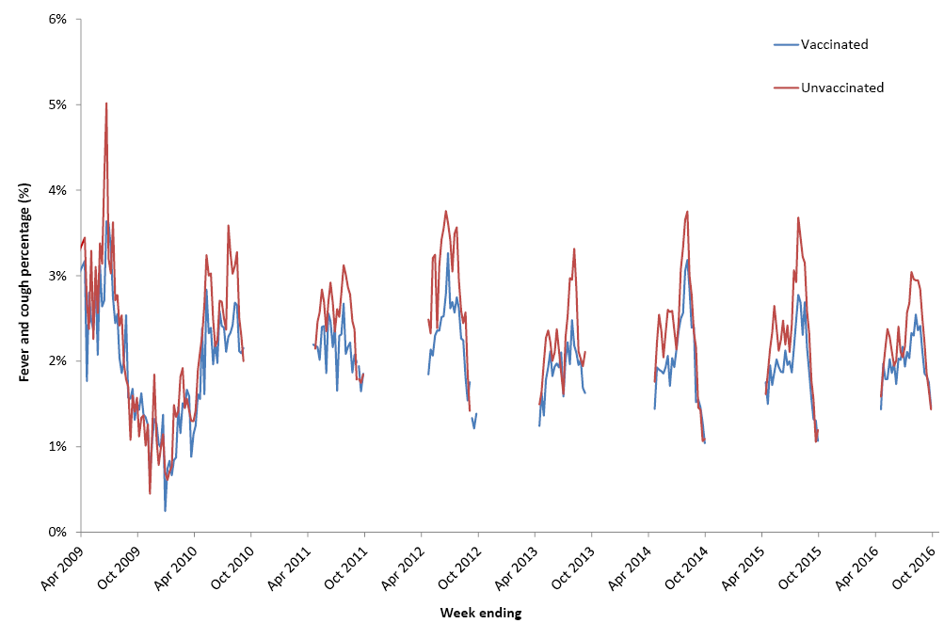

Comparison with national laboratory influenza notifications
There was a decrease in both the peak number of laboratory confirmed cases of influenza reported to the National Notifiable Diseases System and the peak Flutracking ILI percentage unstratified by vaccination status from 2015 to 2016. In 2016, Flutracking ILI levels peaked one week earlier than laboratory notifications of influenza (Figure 6).

Figure 6: Fever and cough percentage, 1 April to 31 October* compared with national influenza laboratory notifications, Australia, 2009 to 2016, by week
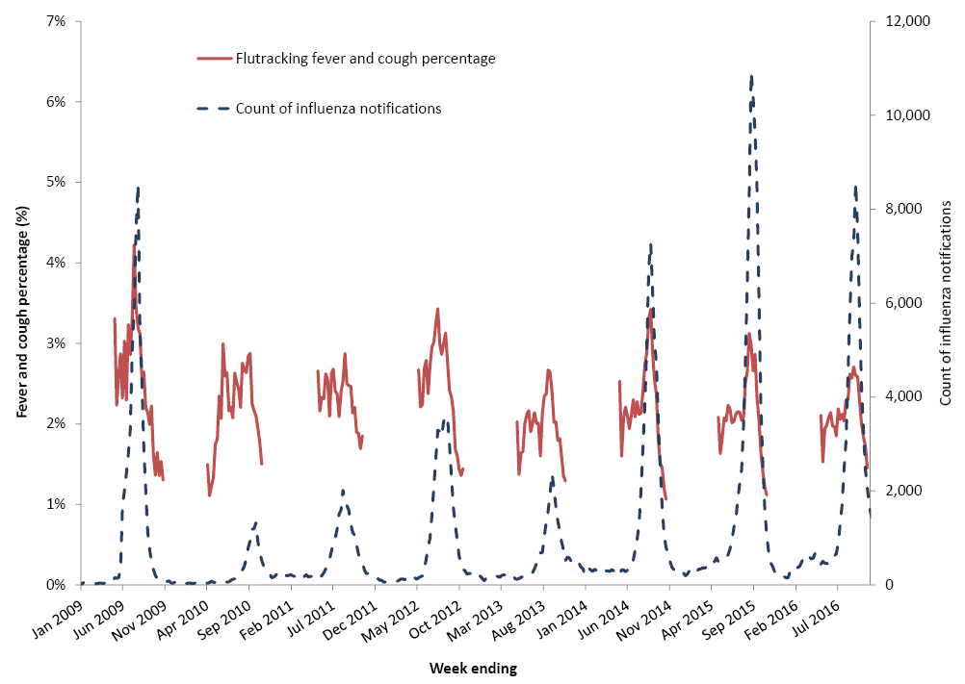
* Not stratified by vaccination status.

Percentage of self-reported laboratory influenza tests
There was considerable diversity of rates of testing across jurisdictions. The average weekly percentage of Flutracking participants with fever and cough that were tested for influenza has increased each year from 2013 to 2016 at the national level, with small increases from 2014 (2.6%) to 2016 (2.9%). This trend was also seen in New South Wales, Queensland, South Australia, and Tasmania. Testing was also at its highest level since 2013 for Northern Territory (Figure 7).

Figure 7. Average weekly percentage of Flutracking participants with fever and cough that were tested for influenza, by state/territory, 2013-2016.
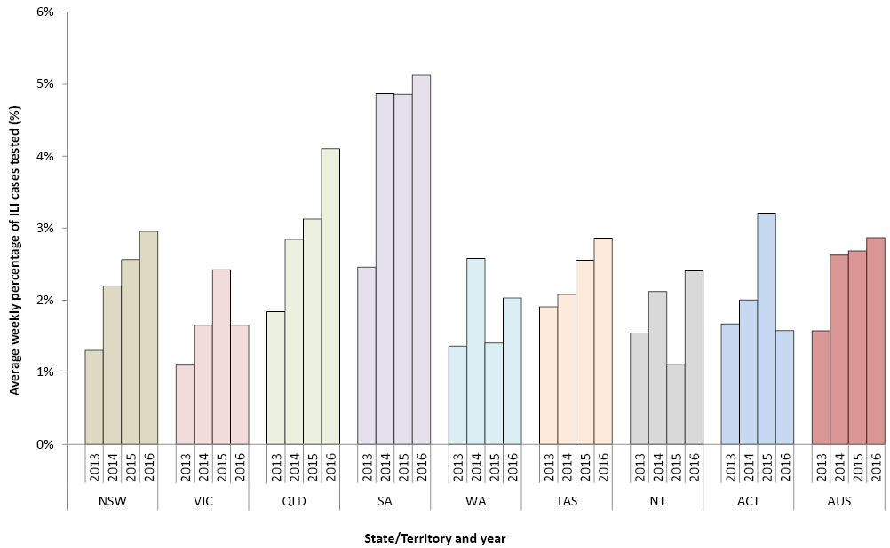

Time off work or normal duties and health seeking behaviour
The peak weekly percentage of participants taking time off work or normal duties was 1.6% in 2016 and 2.0% in 2015, while the peak weekly percentage of participants seeking health advice was 1.0% in 2016 and 1.3% in 2015 (Figure 8).

Figure 8: Influenza-like illness severity, Australia, 2011 to 2016, by week*
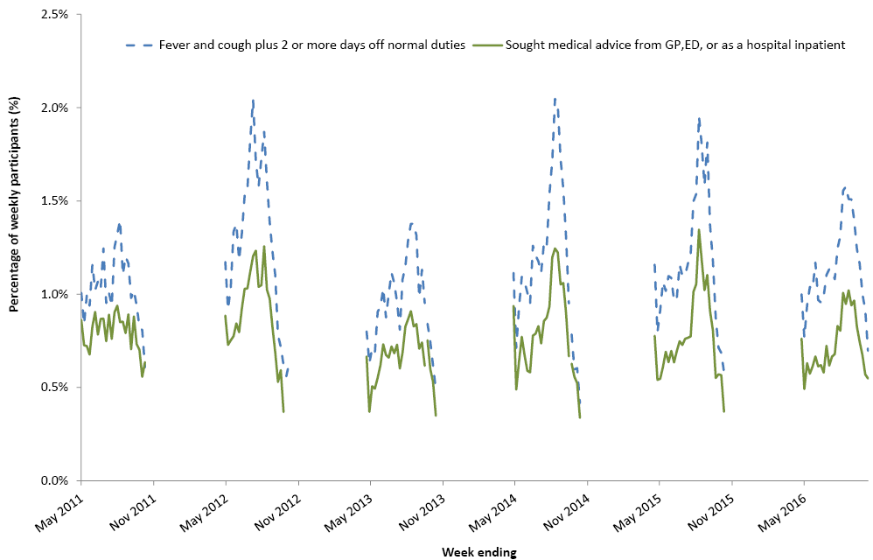
* The denominator is the number of weekly participants.

Comparison of Flutracking influenza-like illness with deaths with pneumonia or influenza reported on the death certificate

The peak rate of deaths classified as caused by pneumonia and influenza was similar in 2016 to 2015, and lower than 2014. In 2016 the timing of the peak week of NSW Flutracking ILI levels (fever and cough) was the same as the timing of the peak week of pneumonia and influenza deaths (week ending 11 September 2016) (Figure 9).

Figure 9: Percentage of Flutracking participants with fever and cough compared with the rate of deaths classified as influenza and pneumonia per 100 000 NSW population, NSW, 2011 to 2016, by week
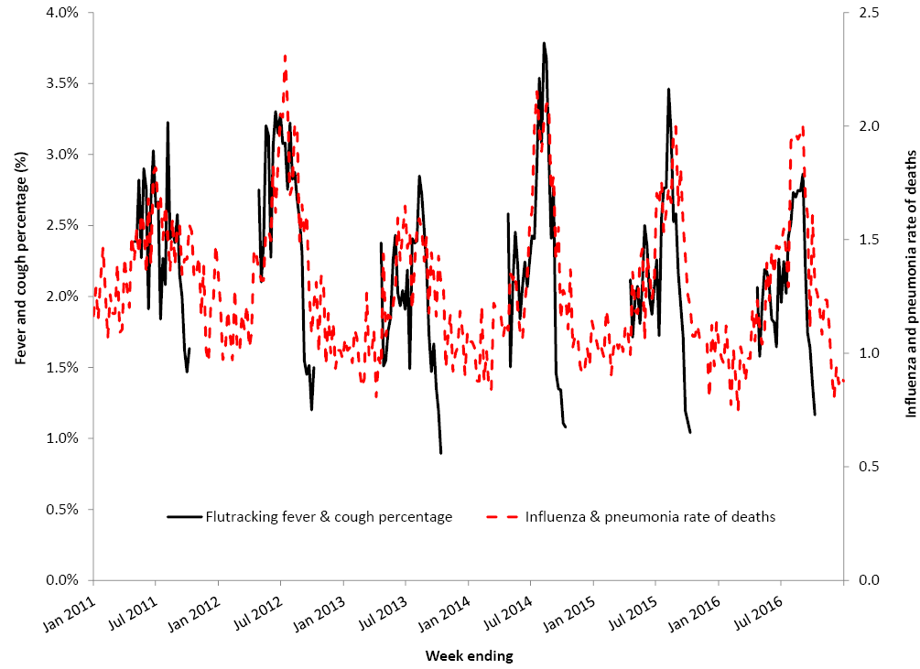

Percentage of participants with influenza-like illness by age group

The highest percentage of Flutracking participants with cough and fever was in those aged 0 to 14 years (Figure 10).

Figure 10: Percentage of participants with fever and cough episodes, by year and age group, Australia, 2012 to 2016*
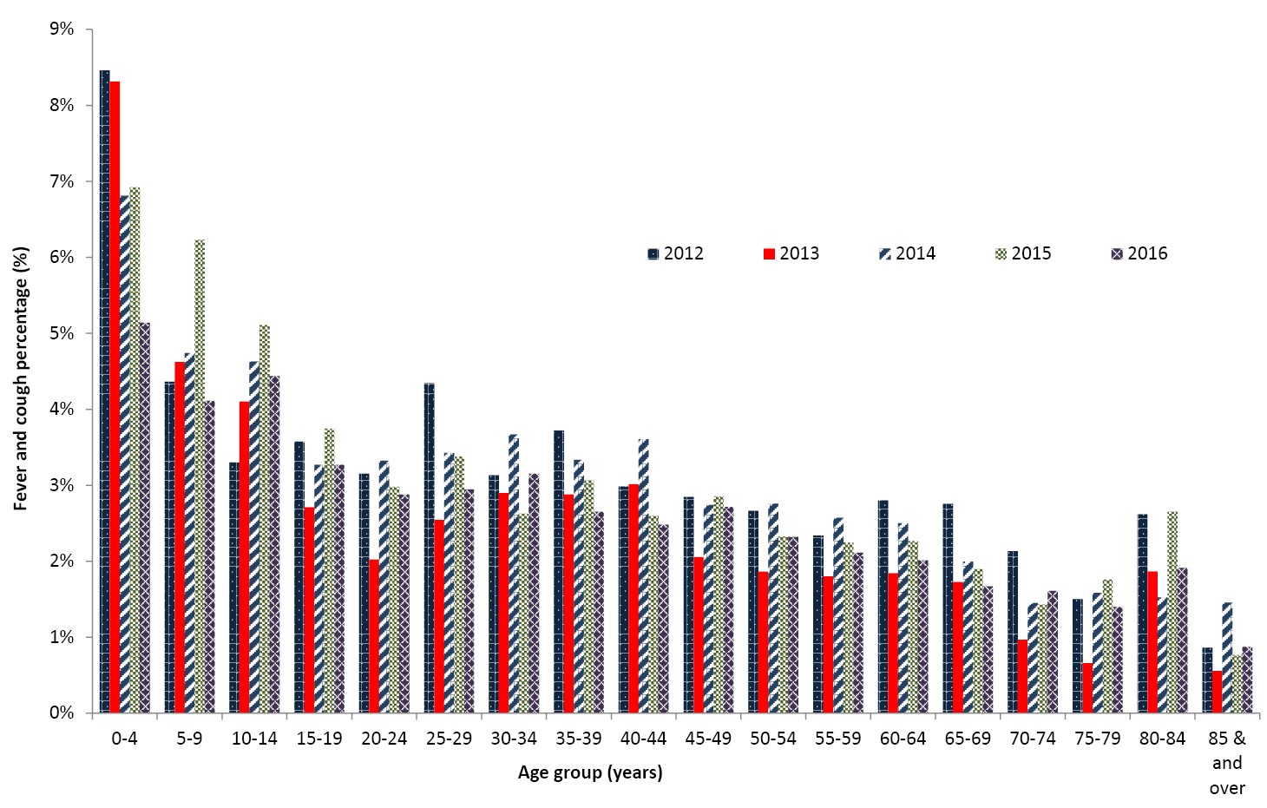
* Only the 4 peak weeks of fever and cough in Australia for each year were included.

Cumulative incidence of influenza-like illness
The cumulative incidence of ILI for 2016 was highest in children, especially those aged 0-4 years (63.3%), and lowest in those aged 65 years or older (23.2%). There was a mostly linear change in cumulative incidence for all age groups, with a sharper rise in ILI during May/June for the 0-4 years age group (Figure 11).
Figure 11: Cumulative incidence of influenza-like illness, by age, Australia, April to October, 2016, by week*
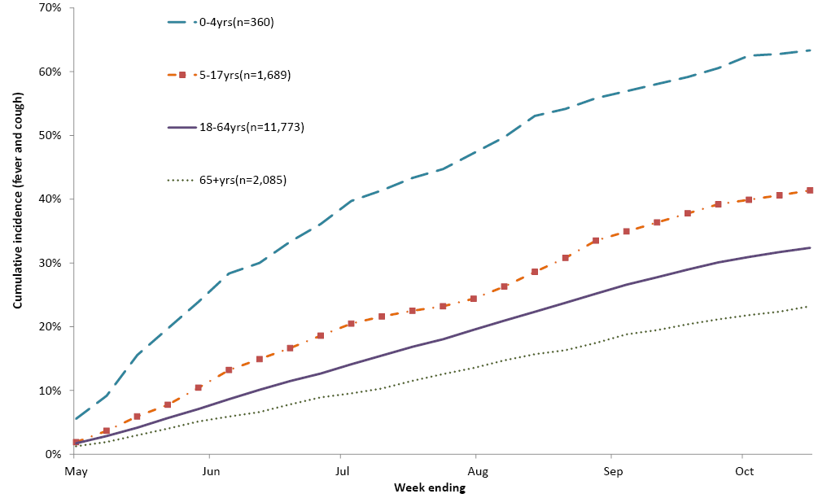
* Only first ILI episode of each participant for the 2016 season were included.

Discussion
The number of participants enrolled in Flutracking has increased each year from 394 participants in 2006 to 30,998 participants in 2016. Over 50% of the national increase in participation in 2016 may be attributed to participants joining in New South Wales (NSW). The highest proportion of Flutracking participants in 2015 were from NSW, and dissemination of email invitations to friends, family and work colleagues of existing participants was the most effective method of recruitment. Western Australia was the only state/territory to have a decrease in participation from 2015 to 2016 (10.8% decrease). In 2015, the Western Australian Department of Health encouraged employees to sign up to Flutracking to participate in a vaccine effectiveness (VE) study. As most new participants from 2015 only signed up for the purpose of the VE study, it was expected that participation numbers may decline in Western Australia in 2016.
As highlighted in the 2015 annual report⁶, the recruitment strategies in 2016 were similar to prior years, with additional targeted recruitment for Indigenous participants and participants from postcodes with small numbers. There is still under-representation of participants in the 0–34 years and 65 years or over age groups, males, participants with non-tertiary education and Aboriginal and Torres Strait Islander participants. A 2017 recruitment campaign is underway liaising with Indigenous community representatives, and targeting social media messages to potential Aboriginal and Torres Strait Islander participants, and future 2017 recruitment will target the remaining underrepresented demographic groups.
Comparing the express survey and non-express survey provided little evidence of improved response rates for the shorter survey. The lower ILI percentage for the express survey compared to the non-express survey in participants who had joined in 2016 may reflect an underestimate of ILI as there is no prompt for asking about each family members’ symptoms.
Based on Flutracking fever and cough weekly percentages, the peak community ILI levels in the 2016 season were lower than the peak community ILI levels in the 2014 and 2015 seasons. There was also a decrease in national influenza laboratory notifications from 2015 to 2016, supporting this decrease in community level ILI. Flutracking analyses also suggest lower levels of time off work or normal duties and health care seeking behaviour at the national level in the community in 2016, as compared to 2015. At the NSW level, the peak rate of deaths attributed to influenza and pneumonia suggested that the 2015 and 2016 seasons were not meaningfully different. There were 5,153 deaths reported in association with influenza and pneumonia in 2016 compared to 5,052 in 2015. Overall, the rate of deaths associated with influenza and pneumonia was slightly higher in 2016 than in 2015¹⁴. This suggests that while community attack rates and health seeking behaviour for ILI was lower in 2016, the impact on those who had confirmed influenza may have been slightly more severe. While the 2015 influenza season was marked by a transition to predominantly influenza B strain circulation⁷, circulation of influenza A dominated the 2016 season at both the NSW and national level. Influenza A(H1N1)pdm09 predominated the season up to July, with influenza A(H3N2) dominating from July onwards⁷. A(H3N2) is typically more prevalent in the elderly than other age groups¹⁵, which may explain this slight increase in severe outcomes from influenza in 2016.
In summary, Flutracking attack rates and seriousness of disease during the 2016 season at the community level was less than 2015 and 2014. The comparison of NSW mortality rates from pneumonia and influenza appear to align with the timing and severity of Flutracking ILI data which is interesting considering they are tracking influenza related illness at different ends of the severity spectrum. We will continue to explore this correlation with adjustment for age and other markers of severity.

Competing interests
All authors declare that they have no competing interests.

Acknowledgements
The authors would like to acknowledge the University of Newcastle for their continued support, and the Australian Government Department of Health and the Hunter Medical Research Institute for their funding and support. We would also like to acknowledge Stephen Clarke for software and database development, and John Fejsa for his contribution to the design of the project, and the thousands of Flutracking participants who give their time freely each week to contribute to influenza surveillance.

Author contributions
Craig Dalton conceived and designed the project, oversaw the statistical analysis, and contributed to writing of the manuscript. Sandra Carlson contributed to the writing of the manuscript and the statistical analysis. Daniel Cassano contributed to the writing of the manuscript and the statistical analysis. David Durrheim contributed to the design of the project and writing of the manuscript. Michelle Butler also contributed to the statistical analysis.

Author details
Ms Sandra J Carlson,¹ Research and Evaluation Officer
Mr Daniel Cassano, ¹ Research and Evaluation Officer
Ms Michelle T Butler,¹ Research and Evaluation Officer
Dr David N Durrheim,^{1,2} Public Health Physician, Conjoint Professor of Public Health Medicine, University of Newcastle
Dr Craig B Dalton,^{1,2} Public Health Physician
- Hunter New England Population Health, Wallsend, New South Wales
- University of Newcastle, Callaghan, NSW and Hunter Medical Research Institute, Newcastle, New South Wales

Corresponding author
Dr Craig B Dalton, Public Health Physician, Hunter New England Population Health, Locked Bag 10, WALLSEND NSW 2287. Facsimile: +61 2 4924 6490. Email: Craig.Dalton@hnehealth.nsw.gov.au

References
- Dalton C, Durrheim D, Fejsa J, Francis L, Carlson S, d’Espaignet ET, et al. Flutracking: a weekly Australian community online survey of influenza-like illness in 2006, 2007 and 2008. Commun Dis Intell 2009;33(3):316–322.
- Parrella A, Dalton CB, Pearce R, Litt JC, Stocks N. ASPREN surveillance system for influenza-like illness – A comparison with FluTracking and the National Notifiable Diseases Surveillance System. Aust Fam Physician 2009;38(11):932–936.
- Carlson SJ, Dalton CB, Tuyl FA, Durrheim DN, Fejsa J, Muscatello DJ, et al. Flutracking surveillance: comparing 2007 New South Wales results with laboratory confirmed influenza notifications. Commun Dis Intell 2009;33(3):323–327.
- Carlson SJ, Dalton CB, Durrheim DN, Fejsa J. Online Flutracking survey of influenza-like illness during pandemic (H1N1) 2009, Australia. Emerg Infect Dis 2010;16(12):1960–1962.
- Pandemic Influenza Severity Assessment (PISA): A WHO guide to assess the severity of influenza epidemics and pandemics. Geneva: World Health Organization; 2017.
- Dalton CB, Carlson SJ, Durrheim DN, Butler MT, Cheng AC, Kelly HA. Flutracking weekly online community survey of influenza-like illness annual report, 2015. Commun Dis Intell 2016;40(4):E512–E520.
- Australian Government Department of Health. Ozflu 2016. Accessed on 21 February 2017. Available from: http://www.health.gov.au/flureport
- Carlson SJ, Dalton CB, Butler MT, Fejsa J, Elvidge E, Durrheim DN. Flutracking weekly online community survey of influenza-like illness annual report 2011 and 2012. Commun Dis Intell 2013;37(4):E398–E406.
- Dalton CB, Carlson SJ, Butler MT, Fejsa J, Elvidge E, Durrheim DN. Flutracking weekly online community survey of influenza-like illness annual report, 2010. Commun Dis Intell 2011; 35(4): E288-E293.
- Dalton CB, Carlson SJ, McCallum L, Butler MT, Fejsa J, Elvidge E, Durrheim DN. Flutracking weekly online community survey of influenza-like illness: 2013 and 2014. Commun Dis Intell 2015; 39(3): E361-E368.
- Australian Bureau of Statistics. Australian demographic statistics, June 2016. Cat. no. 3101.0. Accessed on 22 February 2017. (Online) Available from: http://www.abs.gov.au/ausstats/abs@.nsf/mf/3101.0
- Australian Bureau of Statistics. Census Fact Sheet. Accessed on 5 March 2019. (Online) Available from: http://www.abs.gov.au/websitedbs/censushome.nsf/4a256353001af3ed4b2562bb00121564/mediafactsheets2nd/$file/Topic%20-%20Highest%20Level%20of%20Education.pdf
- Australian Bureau of Statistics. Estimates of Aboriginal and Torres Strait Islander Australians, June 2011. Cat. no. 3238.0.55.001. Accessed on 5 March 2019. (Online) Available from: http://www.abs.gov.au/AUSSTATS/abs@.nsf/DetaiflsPage/3238.0.55.001June%202011?OpenDocument
- NSW Ministry of Health: Influenza Monthly Surveillance Report, NSW: December 2016. Accessed on 21 February 2016. (Online) Available from: https://www.health.nsw.gov.au/Infectious/Influenza/Publications/2016/december-flu-report.pdf
- Australian Influenza Surveillance Report No 11 - 15 October - 28 October 2016. Accessed on 7 December 2018. Available from: http://www.health.gov.au/internet/main/publishing.nsf/Content/ozflu-surveil-no11-16.htm

Appendix A: Recruitment to Flutracking, 2015 and 2016, by state or territory
State or territory | 2015 |  |  | 2016 |  |  | % Distribution of Aust. population | Percentage change
 | Number of participants (peak week) | Flutracking participation per 100,000 population | Per cent of participants (peak week) | Number of participants (peak week) | Flutracking participation per 100,000 population | Per cent of participants (peak week)
NSW | 7,525 | 97.4 | 30.0 | 8,643 | 111.9 | 31.9 | 32.0 | 14.9
Vic | 3,482 | 57.4 | 13.9 | 4,002 | 66.0 | 14.8 | 25.2 | 14.9
Qld | 2,283 | 47.1 | 9.1 | 2,594 | 53.5 | 9.6 | 20.1 | 13.6
SA | 3,355 | 196.4 | 13.4 | 3,471 | 203.2 | 12.8 | 7.1 | 3.5
WA | 4,041 | 154.4 | 16.1 | 3,604 | 137.7 | 13.3 | 10.8 | -10.8
Tas | 2,368 | 456.2 | 9.4 | 2,635 | 507.6 | 9.7 | 2.2 | 11.3
NT | 954 | 389.5 | 3.8 | 921 | 376.1 | 3.4 | 1.0 | -3.5
ACT | 1,062 | 268.1 | 4.2 | 1,224 | 309.0 | 4.5 | 1.6 | 15.3
Total | 25,070 | 103.9 | 100.0 | 27,094 | 112.3 | 100.0 | 100.0 | 8.1

Appendix B: Socio-demographic characteristics of Flutracking participants who completed at least one survey during 2015 and 2016
 | 2015 |  |  | 2016 |  |  | % Distribution of the Australian population
 | Frequency | Per cent | Rate per 100,000* | Frequency | Per cent | Rate per 100,000
Age (years)
0–15 | 3,547 | 12.4 | 73.5 | 4,100 | 12.9 | 84.9 | 20.0
16–34 | 5,300 | 18.6 | 82.3 | 5,479 | 17.3 | 85.1 | 26.7
35–49 | 7,284 | 25.6 | 150.4 | 7,877 | 24.9 | 162.7 | 20.2
50–64 | 9,572 | 33.6 | 220.8 | 10,576 | 33.4 | 243.9 | 18.1
65 and over | 2,792 | 9.8 | 75.8 | 3,635 | 11.5 | 98.7 | 15.0
Total participants | 28,495 | 100.0 | 118.1 | 31,667 | 100.0 | 131.3 | 100.0
Gender
Male | 10,153 | 38.4 | 84.7 | 11,683 | 39.3 | 97.4 | 49.7
Female | 16,253 | 61.6 | 133.9 | 18,015 | 60.7 | 148.5 | 50.3
Total reported | 26,406 | 100.0 | 109.4 | 29,698 | 100.0 | 123.1 | 100.0
Highest level of education completed by participant^
Year 11 or below (or equiv) or Certificate I/II/III/IV | 3,913 | 19.8 | 50.3 | 4,307 | 20.1 | 55.3 | 44.1
Year 12 (or equivalent) | 1,612 | 8.2 | 49.6 | 1,689 | 7.9 | 52.0 | 16.6
Advanced Diploma/Diploma | 1,787 | 9.1 | 101.8 | 1,982 | 9.2 | 112.9 | 8.0
Completed Bachelor Degree | 4,926 | 25.0 | 158.8 | 5,341 | 24.9 | 172.2 | 13.5
Grad Diploma/Grad Certificate | 2,662 | 13.5 | 528.6 | 2,808 | 13.1 | 557.6 | 1.7
Postgraduate Degree | 4,832 | 24.5 | 493.1 | 5,328 | 24.8 | 543.7 | 3.6
Total reported# | 19,732 | 100 |  | 21,455 | 100
Aboriginal and/or Torres Strait Islander
Yes | 304 | 1.3 | 45.4 | 412 | 1.5 | 61.5 | 3
No | 23,641 | 98.7 | 109.1 | 27,016 | 98.5 | 124.7 | 97
Total reported | 23,945 | 100.0 | 107.2 | 27,428 | 100.0 | 122.8 | 100
^ Note that the rate per 100,000 was calculated using participants aged 15–74 years. This age adjustment was necessary to match the age groups in the ABS data.
# Total includes participants aged 15 years or older who nominated an ABS equivalent education level.

Communicable Diseases Intelligence
ISSN: 2209-6051 Online

Communicable Diseases Intelligence (CDI) is a peer-reviewed scientific journal published by the Office of Health Protection, Department of Health. The journal aims to disseminate information on the epidemiology, surveillance, prevention and control of communicable diseases of relevance to Australia.

Editor: Cindy Toms
Deputy Editors: Phil Wright and Simon Petrie
Editorial and Production Staff: Leroy Trapani and Kasra Yousefi
Editorial Advisory Board: David Durrheim, Mark Ferson, John Kaldor, Martyn Kirk and Linda Selvey

Website: http://www.health.gov.au/cdi

Contacts
Communicable Diseases Intelligence is produced by:
Health Protection Policy Branch, Office of Health Protection, Australian Government Department of Health
GPO Box 9848, (MDP 6) CANBERRA ACT 2601

Email: cdi.editor@health.gov.au

Submit an Article
You are invited to submit your next communicable disease related article to the Communicable Diseases Intelligence (CDI) for consideration. More information regarding CDI can be found at: http://health.gov.au/cdi.
Further enquiries should be directed to: cdi.editor@health.gov.au.

This journal is indexed by Index Medicus and Medline.

Creative Commons Licence - Attribution-NonCommercial-NoDerivatives CC BY-NC-ND
© 2019 Commonwealth of Australia as represented by the Department of Health
This publication is licensed under a Creative Commons Attribution-NonCommercial-NoDerivatives 4.0 International Licence from https://creativecommons.org/licenses/by-nc-nd/4.0/legalcode (Licence). You must read and understand the Licence before using any material from this publication.

Restrictions
The Licence does not cover, and there is no permission given for, use of any of the following material found in this publication (if any):
- the Commonwealth Coat of Arms (by way of information, the terms under which the Coat of Arms may be used can be found at www.itsanhonour.gov.au);
- any logos (including the Department of Health’s logo) and trademarks;
- any photographs and images;
- any signatures; and
- any material belonging to third parties.

Disclaimer
Opinions expressed in Communicable Diseases Intelligence are those of the authors and not necessarily those of the Australian Government Department of Health or the Communicable Diseases Network Australia. Data may be subject to revision.

Enquiries
Enquiries regarding any other use of this publication should be addressed to the Communication Branch, Department of Health, GPO Box 9848, Canberra ACT 2601, or via e-mail to: copyright@health.gov.au

Communicable Diseases Network Australia
Communicable Diseases Intelligence contributes to the work of the Communicable Diseases Network Australia.
http://www.health.gov.au/cdna

