Creutzfeldt-Jakob disease surveillance in Australia: update to 31 December 2018
Christiane Stehmann, Matteo Senesi, Victoria Lewis, Mairin Ummi, Marion Simpson, Genevieve Klug, Catriona McLean, Colin Masters and Steven Collins

Abstract
Nationwide surveillance of human prion diseases (also known as transmissible spongiform encephalopathies), the most common being Creutzfeldt-Jakob disease (CJD), is performed by the Australian National Creutzfeldt-Jakob Disease Registry (ANCJDR), based at the University of Melbourne. National surveillance encompasses the period since 1 January 1970, with prospective surveillance occurring from 1 October 1993. Over this prospective surveillance period considerable developments have occurred in relation to pre-mortem diagnostics, the delineation of new disease subtypes and a heightened awareness of prion diseases in health care settings. Surveillance practices of the ANCJDR have evolved and adapted accordingly. This report summarises the activities of the ANCJDR from 1 January to 31 December 2018.
Since the ANCJDR began offering diagnostic cerebrospinal fluid (CSF) 14-3-3 protein testing in Australia in September 1997, the annual number of referrals has steadily increased. In 2018, 465 domestic CSF specimens were referred for 14-3-3 protein testing and 78 persons with suspected human prion disease were formally added to the national register. The majority of the 78 suspect case notifications remain as of 31 December 2018 classified as “incomplete” (42 cases), while eleven cases were excluded by either detailed clinical follow-up (one case) or neuropathological examination (ten cases); 15 cases were classified as “definite” and ten as “probable” prion disease. Sixty-two percent of all suspected human prion disease related deaths underwent neuropathological examination. No cases of variant CJD were confirmed.
Keywords: Creutzfeldt-Jakob disease, prion disease, transmissible spongiform encephalopathy, disease surveillance

Introduction
The Australian National Creutzfeldt-Jakob disease Registry (ANCJDR) was established in 1993 at the University of Melbourne. As described previously,¹ human prion disease mostly arises sporadically but can occur through person-to-person transmission or from a genetic aetiology. In 1993, the Allars inquiry² into the use of cadaver-derived pituitary hormones under the Australian Human Pituitary Hormone Program and the association with four medically acquired (iatrogenic) CJD (iCJD) deaths recommended broadening of the responsibilities of the nascent ANCJDR. In addition to monitoring for further cases of iCJD in Australia, related to cadaveric pituitary hormone treatment for infertility or short stature and contaminated dura mater grafts, the ANCJDR’s activities have evolved to encompass the surveillance of all types of CJD, including sporadic, genetic and variant CJD (vCJD, the zoonotic form related to bovine spongiform encephalopathy: BSE), as well as other prion diseases such as Gerstmann-Sträussler-Scheinker syndrome and fatal sporadic or familial insomnia.
Human prion disease became a notifiable disease in all states and territories of Australia as of June 2006. Most initial case notifications to the ANCJDR arise through diagnostic testing requests made to the ANCJDR; this occurs prior to Health department notification. After a preliminary review of notified cases, those deemed to be genuine suspected human prion disease undergo further detailed evaluation after addition to the national surveillance register, to determine whether a case can be excluded from suspicion or can be classified as a “definite”, “probable” or “possible” prion disease case according to EUROCJD endorsed diagnostic criteria and to determine the aetiology of the illness.³
The incidence of sporadic CJD (sCJD) is commonly reported to be approximately 1 case per million per year; however, in most countries with long-standing surveillance systems in place annual incidence rates have been consistently reported above this quoted figure.⁴ Multi-national collaborative studies support that intensity of surveillance correlates with reported incidence rates.⁵ Temporally, human prion disease incidence rates have increased in most countries, including Australia, as surveillance mechanisms have been optimised and diagnostic testing capabilities improved, in parallel with a generally greater awareness of this rare disease in the health care setting.
In this report, updated national surveillance figures to 31 December 2018 are provided for all retrospective (to 1970) and prospective (from 1993) cases ascertained, including a discussion on case notifications, classifications and overall incidence. In 2018, the annual mortality rate of prion disease in Australia was essentially stable; 78 persons with suspected human prion disease were added to the national register (an additional three cases were known in 2017 and therefore contribute to the 2017 notification numbers), with 63% of all suspected prion disease case deaths undergoing neuropathological examination.
Since the ANCJDR began offering cerebrospinal fluid (CSF) 14-3-3 protein testing in Australia in September 1997, the annual number of referrals has steadily increased. In 2018, the ANCJDR received 465 domestic specimens for 14-3-3 protein diagnostic testing, similar to the 20% increase in CSF diagnostic referrals experienced in 2017, which coincided with the introduction additional CSF biomarker (total-tau protein) testing.

Surveillance Methods
Patients with suspected human prion disease have been prospectively notified to the ANCJDR since 1993. From 1997 onwards, suspected cases have been increasingly notified through referral for CSF 14-3-3 protein western blot testing, which has over time become the predominant initial notification source. Other ascertainment mechanisms include or have included personal communications from clinicians, families, hospitals and CJD-related groups, as well as health record searches through hospitals and health departments.
Once notified to the ANCJDR, referrals undergo a prima facie assessment and if the suspicion of prion disease is supported, the case is added to the register as a formally notified “suspected case” for continued surveillance and evaluation, with the aim of exclusion or classification according to EUROCJD endorsed diagnostic criteria. Investigation of registered cases can be prolonged as the ANCJDR requires next-of-kin consent to access and compile the appropriate clinical information from various health information sources to facilitate a comprehensive review. Response times can vary as the information can be extensive or sources numerous. Medico-demographic questionnaires are offered and forwarded to families, if they are willing to contribute, providing valuable information for analysis and evaluation.
The classification of registered cases remains as “incomplete” until all known available information is gathered and reviewed, or a definitive result from neuropathological assessment is obtained. Cases may be excluded from the register based on neuropathological examination or after thorough clinical evaluation. A “definite” classification requires brain tissue examination, including immunochemistry; “probable” and “possible” cases are reliant on a specific clinical profile and diagnostic test outcomes being met as previously described.³ As of 1 January 2017, the diagnostic criteria were amended to include a positive result in the real-time quaking-induced conversion (RT-QuIC) assay using CSF or other tissues in a person with a progressive neurological syndrome. The updated diagnostic criteria for surveillance of sporadic CJD are listed in Appendix 1. In keeping with previous reports, the total number of confirmed prion disease cases for 2018, including for statistical analyses, are those that have been classified as “definite” or “probable” cases during 2018.
In conjunction with surveillance responsibilities, the ANCJDR provides diagnostic platforms for ante- and post-mortem testing for human prion diseases. The testing of CSF for the presence of a family of low molecular weight proteins called “14-3-3” has been performed weekly by the ANCJDR since 1997. This test has been readily utilised by clinicians. As described previously, the CSF 14-3-3 protein test provides an increasing proportion of initial notifications of suspected human prion disease to the ANCJDR each year. In 2017, the ANCJDR formally added detection of CSF total-tau protein concentrations, which is also NATA/ILAC accredited, for the diagnosis of human prion disease, while continuing to develop and transition to the powerful RT-QuIC assay to detect the presence of misfolded prion protein in CSF. The total-tau ELISA test is performed at the National Dementia Diagnostic Laboratories on a fortnightly basis. The RT-QuIC assay is currently performed at the ANCJDR for research purposes only in consultation with managing clinicians. The ANCJDR also undertakes western blot analysis for misfolded, protease-resistant prion protein in brain and tonsil tissue from biopsies or autopsies to supplement immunohistochemical assessment, as required. Prion protein gene (PRNP) testing for sequence variations in the open reading frame, particularly proven disease-causing mutations, is performed by an external, independent provider as appropriate. The ANCJDR actively promotes all diagnostic tests to clinicians and families to achieve the most accurate diagnosis and classification of persons suspected to suffer from prion disease.
Annual human prion disease incidence rates are calculated using direct age-standardisation, based on the 1970–2018 Australian Bureau of Statistics estimated resident population data for Australia and for each state and territory.⁶ Health information is collected through a combination of public health and surveillance responsibilities, based on the national notification of communicable diseases in observance of the National Health Security Act 2007 and Privacy Act 1988 (Cth) 16B. ANCJDR surveillance activities for 2018 were approved by The University of Melbourne Human Research Ethics Committee.

Results
In 2018, the ANCJDR received 465 domestic CSF specimens for 14-3-3 protein testing. This number reflects a continuing positive trend in annual CSF referral numbers and represents an increased awareness and perceived utility of 14-3-3 protein diagnostic testing by clinicians (Figure 1). In 2018, non-domestic CSF referrals made up 6% of the total CSF specimens received by the ANCJDR; the total number of non-domestic CSF test referrals has also steadily increased over time.

Figure 1: Annual number of CSF specimens referred to the ANCJDR for 14-3-3 protein diagnostic testing, from 1997 to 2018
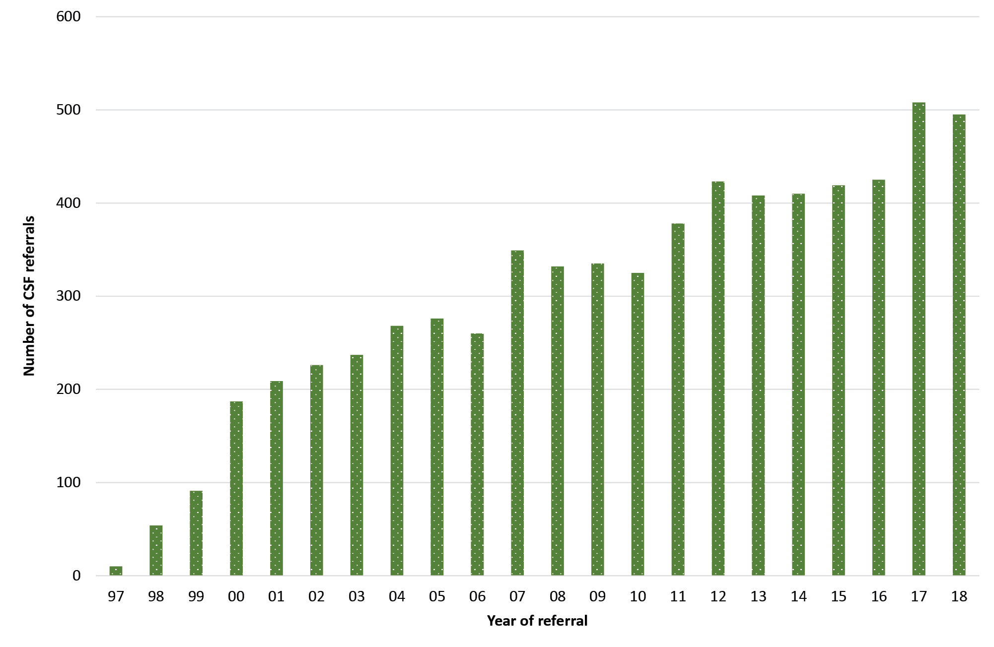
Figure 2. Annual CSF 14-3-3 protein test referrals from 1997 to 2018 by state
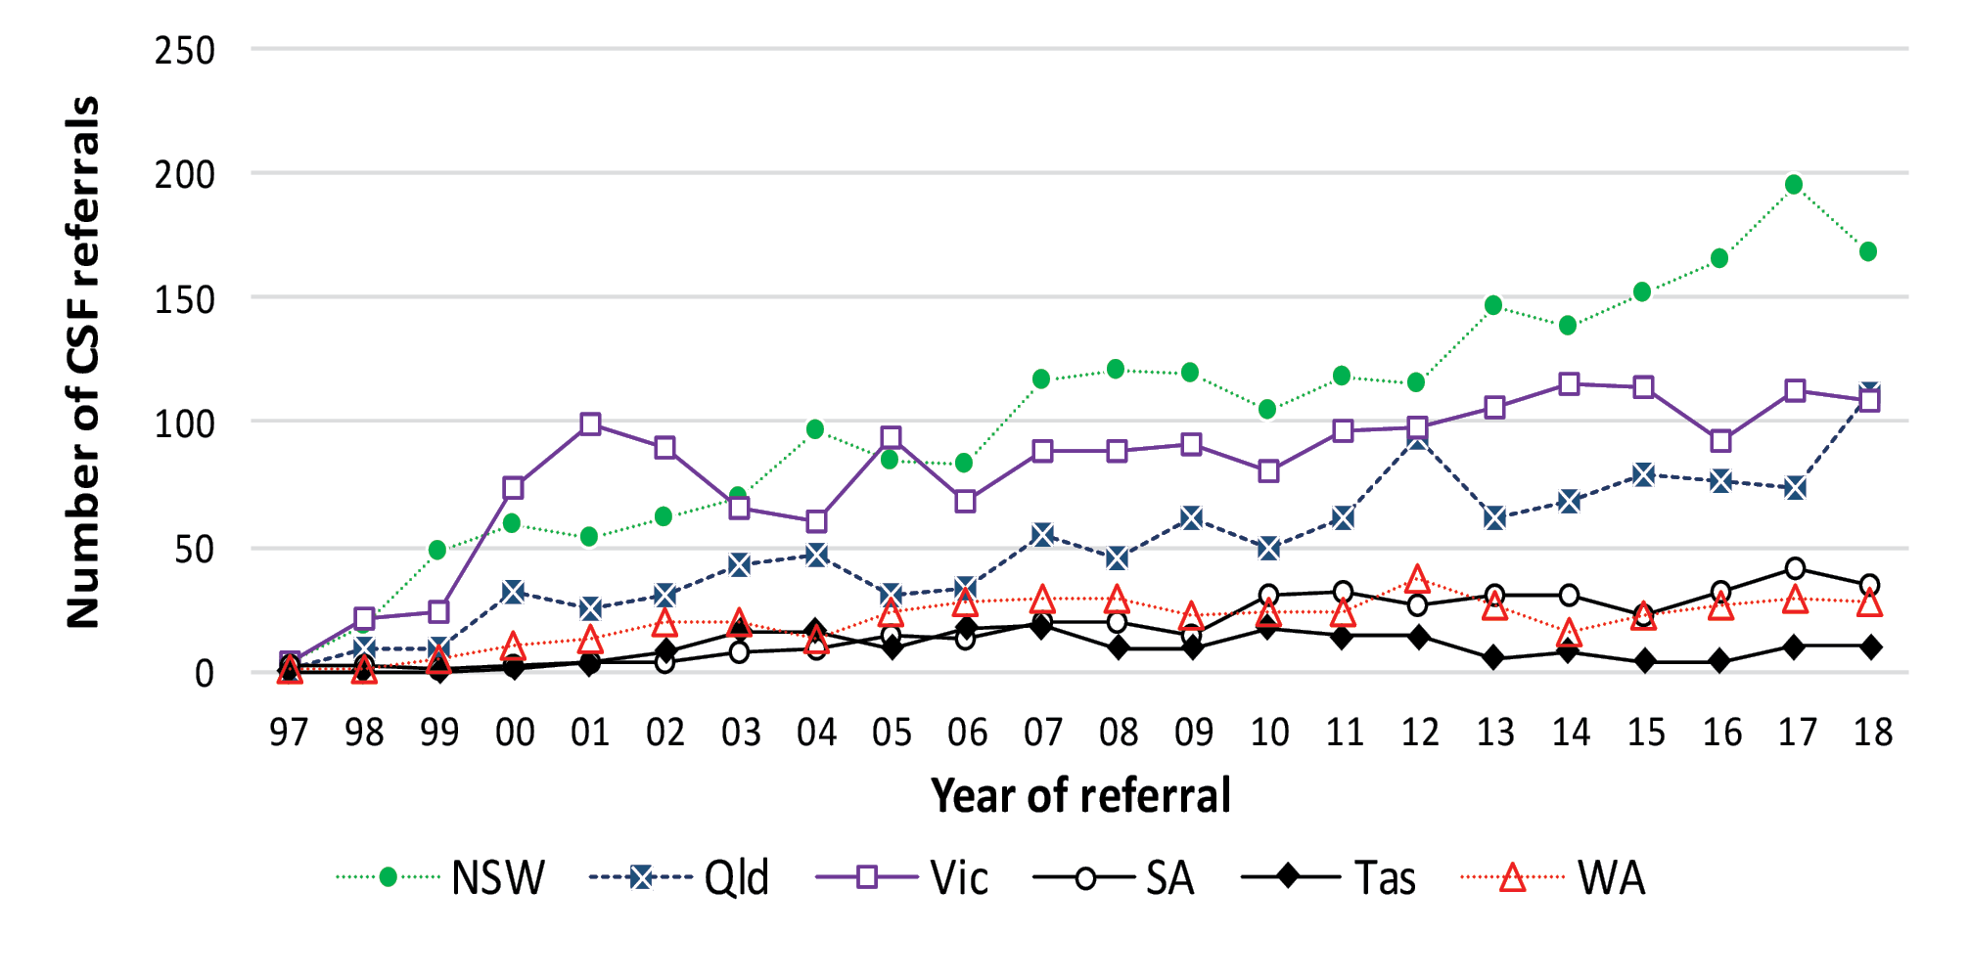
The majority of domestic CSF referrals come from the most populous states (Figure 2), in which there has been a noticeable steady increase in test referrals, while CSF referrals from the ACT, NT and Tasmania have remained relatively unchanged. In 2018, the number of CSF specimens referred from Queensland increased by 52% while the total number of test referrals from NSW modestly decreased.
As summarised in Table 1, of the 465 domestic CSF specimens referred to the ANCJDR for testing, 71 specimens tested “positive” and 15 “atypical positive” (presence of additional non-specific protein bands) in the 14-3-3 protein western blot assay. Of the 290 specimens tested for total-tau protein, 42 specimens returned sufficiently elevated concentrations of total-tau protein (>1072 pg/ml) to support the likelihood of human prion disease. Of the 44 CSF specimens tested using the RT-QuIC assay, 20 returned positive test results. As reported by other national CJD surveillance registries, CSF biomarker results support the complementary utility of the total-tau ELISA and RT-QuIC technologies to the 14-3-3 protein western blot assay to aid in the pre-mortem diagnosis of CJD or other human prion diseases. CSF diagnostic testing resulted in 58 suspect case notifications.
Table 1: Summary of diagnostic test results of CSF specimens tested 1 January to 31 December, 2018
 | Total CSF referrals | Total-tau ELISA results (positive/tested) | RT-QuIC results (positive/tested) | Suspect case notifications
14-3-3  Positive | 71 | → 33/50 | 15/23 | 47
14-3-3  Atypical positive | 15 | → 3/10 | 1/5 | 4
14-3-3  Equivocal | 5 | → 0/3 | 1/2 | 2
14-3-3  Negative | 329 | → 5/223 | 3/13 | 11
Unsuitable specimen  Not tested  Outstanding results | 45 | → 1/4 | 0/1 | 1
Overseas referrals | 30
Total | 495 | 42/290 | 20/44 | 65 (58)*
* 7 suspected cases had two CSF specimens submitted for diagnostic testing; CSF testing resulted in a total of 58 total suspect case notifications. 20 suspect case notifications did not have a CSF referred for diagnostic testing.

Table 2: Source of initial notification of suspected human prion cases ascertained (1970 to 2018)
Method | Notifications 2018 (%) | Notifications 1997–2017 (%)
CSF 14-3-3 protein test request | 56 | 70
Doctors | 23 | 11
Neuropathologists | 12 | 6
Health Department | 5 | 1
CJDSGN | 3 | 2
Hospitals | 1 | 1
ANCJDR historic mechanism  (follow-up, searches) | 0 | 6
Direct family | 0 | 2
Miscellaneous | 0 | 1
Total | 100 | 100
Table 3: Referral proportions of suspected prion disease case deaths undergoing neuropathological examination
 | Neuropathology referrals in 2018  (% of deaths) | Neuropathology referrals during 1993–2017  (% of deaths)
NSW | 71 | 65
Vic | 60 | 64
Qld | 70 | 65
WA | 20 | 61
SA | 63 | 67
ACT | n/a | 52
Tas | 100 | 46
NT | n/a | 44

In 2018, 81 persons with suspected human prion disease were added to the national CJD surveillance register following prima facie review. Of these, three cases were known to the ANCJDR prior to 2018 through CSF referrals. At the time of their initial notification in 2017, these cases were not added to the register due to a low level of suspicion for prion disease after initial case review. Further information ascertained in 2018 increased the likelihood of prion disease resulting in formal notification and addition of the cases to the register. These three cases therefore contribute to the total number of suspect case notifications arising in 2017.
The 78 cases reported for 2018 were initially notified via: request for CSF 14-3-3 protein testing (44 cases); personal communication from clinicians or hospitals (19 cases); neuropathology services (9 cases); health departments (4 cases) and the CJD Support Group Network (2 cases). Sources of suspect case notifications are summarized in Table 2. In 20 suspected case notifications no CSF specimens were received by the ANCJDR for diagnostic testing. Despite the ongoing predominance of initial case notifications through referrals for CSF diagnostic testing, case notifications through treating clinicians, neuropathologists and health departments seeking expert advice and guidance from the ANCJDR have noticeably increased in recent years. Some previous pro-active ANCJDR surveillance mechanisms (e.g. reply-paid mailouts to clinicians and mortality database searches) have been discontinued over time due to human resource constraints.
The number of suspected case notifications to the register in 2018 follows the trend of increasing notification rates. The average annual number of suspected prion disease cases notified to the ANCJDR for the period 1997 (since the introduction of diagnostic testing of CSF) to 2017 is 71.
States and territories exhibited modest fluctuation in the annual number of suspect case notifications for 2018 compared to both the previous year and the longer-term, 10-year average (1997–2017) with the exception of Queensland (Figure 3). In 2017 and 2018, the number of suspect case notifications increased in Queensland, which aligns with the number of diagnostic CSF referrals. In 2018, 26 suspected prion disease cases were notified in Queensland, representing the greatest proportion by state/territory. Over the same period, the number of suspect case notifications in NSW noticeably declined.
Figure 3. Prospective, suspected prion disease notifications to the ANCJDR during 1997 to 2018, by year and state or territory
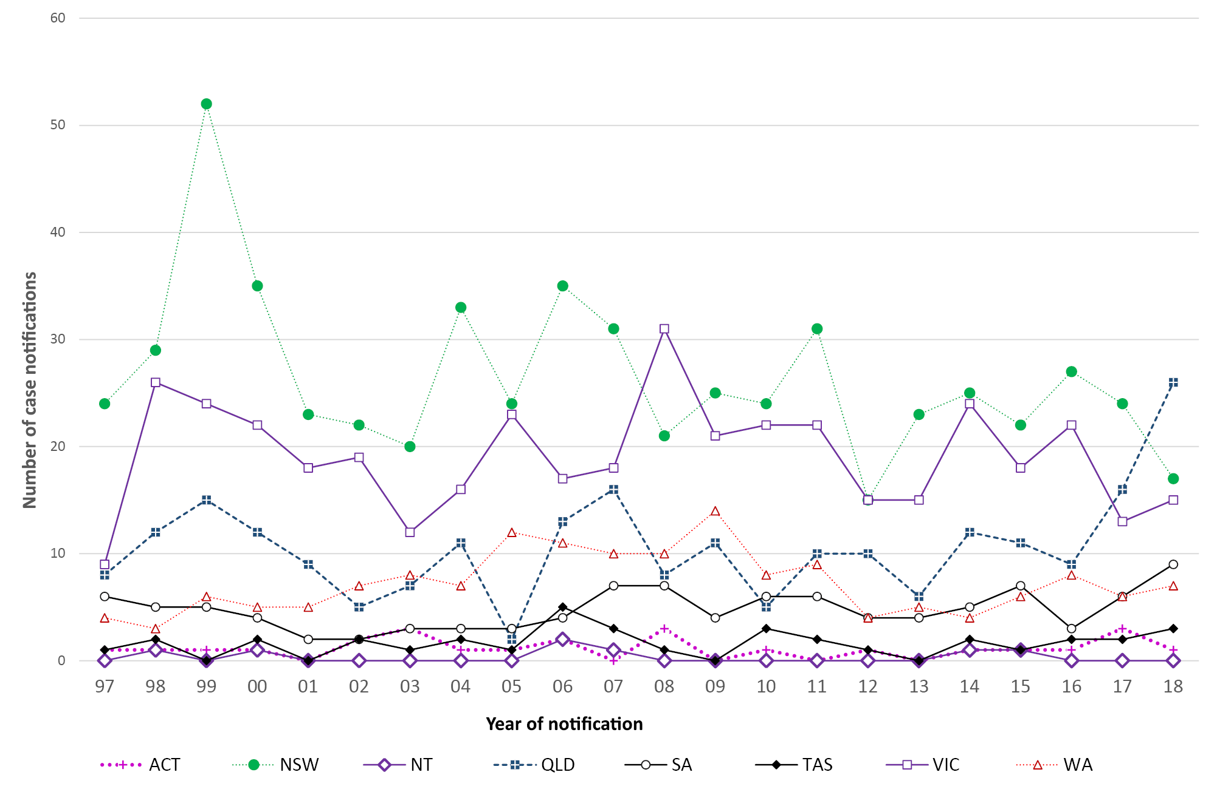
Of the 78 initial suspect case notifications received in 2018, 15 cases were confirmed as “definite” by neuropathological examination and ten cases were classified as “probable” following detailed clinical information review. Ten cases were removed following negative neuropathology and one following case review, while 14 cases were still alive at the end of the 2018; neuropathology reports were pending for 17 deceased cases. It is routine for several months to elapse between when a post-mortem is performed and the completion of the neuropathology report. The remaining 11 cases died, without autopsy, and remain “incomplete” pending detailed case investigation.
Since 1993, there has been a positive trend in the annual number of suspected cases of human prion disease undergoing post-mortem brain examination, or less commonly brain biopsies, beginning with twelve in 1993 to around 30–40 per year for the period from 2005 to 2018 (Figure 4). In 2018, 63 deaths of suspect cases were recorded. Of these, 40 cases were referred for a brain post-mortem examination with two additional patients undergoing pre-mortem brain biopsy.
Figure 4: Number of brain-only post-mortem (PM) examinations and brain biopsies (BBx) completed relative to suspect case deaths from 1993 to 2018, by year
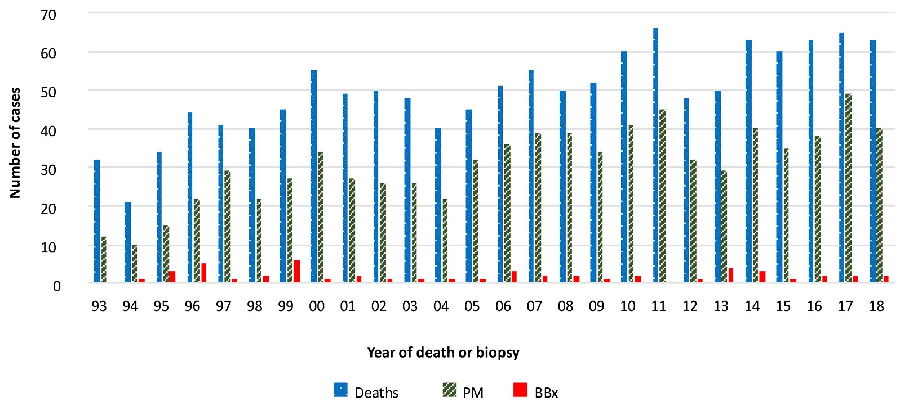

Figure 5: Annual brain-only autopsy referrals for suspected prion disease during 1993 to 2018, by year and selected state
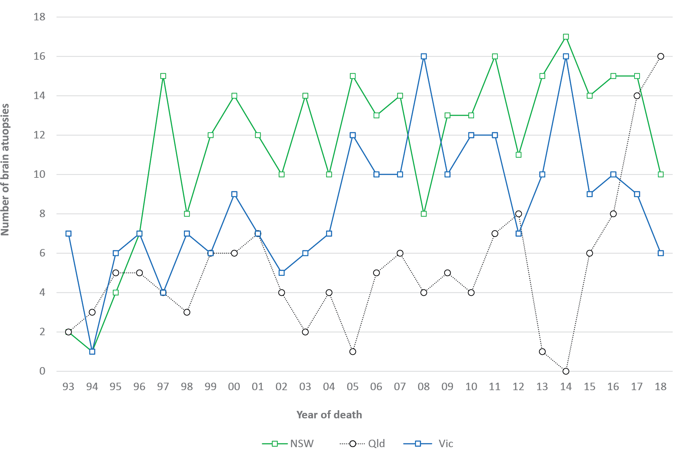
The average annual proportion of suspected prion disease cases on the register between 1993 and 2017 undergoing post-mortem brain examination is 64% (range 38–78%). Proportions of brain autopsy referrals for the states and territories for the 2018 reporting period in comparison to the 1993 to 2017 are listed in Table 3.
Annual brain autopsy referrals by state and territory over the 1993 to 2018 period display considerable fluctuation in each region. In the more populous states, there has generally been an overall temporal increase in brain autopsy referrals. In regions with smaller populations this general positive trend is also present but less robust due to the relative impact of variation in the annual brain autopsy referrals caused by small population sizes and case numbers.
In Queensland, the influence of the diminished access to a facile suspected prion disease brain autopsy service during 2012–2013 is reflected by the sharp decline in the annual neuropathological examination rates (Figure 5). From 2014 onwards, Queensland had a significant increase in brain autopsy neuropathological referrals to the highest number (16) since prion disease surveillance began in 1993 and the highest number of all states and territories in 2018. This increase aligns with the increase in suspected case notifications. The decline of brain autopsy referrals in Victoria and NSW aligns with lower than expected suspect case notifications in both states in 2018.
Based on the Australian population, the crude rate of prion disease related neuropathology referrals in 2018 was 1.6 per million per year; the long-term average from 1993 to 2017 is 1.5 per million per year (range 0.6–2.0). By state and territory, the lowest average rates of suspected prion disease neuropathology referrals over the 25-year surveillance period (1993–2018) are from the NT, Tasmania and the ACT (0.8, 1.0 and 1.0 per million per year, respectively) while the highest rates are in NSW, Victoria and SA (1.7, 1.6 and 1.5 per million per year, respectively). In 2018, Tasmania had the highest annual neuropathology referral rate of 3.8/million/year, with the rates in Queensland and South Australia peaking at 3.2 and 2.9/million/year; WA experienced its lowest annual neuropathology referral rate over the 25-year surveillance period with 0.4/million/year.
As of 31 December 2018, there were 1,259 notified cases on the register with 967 of these being classified as “probable” or “definite” prion disease cases. An additional “definite” iatrogenic case who was treated in Australia but died in the UK is included in Table 4; this case is not classified as an Australian case due to their location at death and is thereby excluded from the overall statistical analysis of Australian prion disease cases. Since the start of prospective surveillance in 1993, 770 suspected prion disease cases have been excluded from the register after detailed follow-up.
Table 4. Overall summary of Australian human prion disease cases by classification, 1 January 1970 to 31 December 2018
Classification | Sporadic | Familial | Iatrogenic | Variant CJD | Unclassified | Total
Definite | 583 | 57 | 5* | 0 | 0 | 645
Probable | 301 | 17 | 4 | 0 | 0 | 322
Possible | 14 | 0 | 1 | 0 | 0 | 15
Incomplete |  | 6 | 0 | 0 | 271 | 277
Total | 898 | 80 | 10 | 0 | 271 | 1259
* includes one definite iatrogenic case who received pituitary hormone treatment in Australia but disease onset and death occurred while a resident of the United Kingdom. This case is not included in statistical analysis since morbidity and mortality did not occur within Australia.
In 2018, 33 cases were re-classified from “incomplete” to “definite” prion disease and 27 cases to “probable” prion disease; no further cases of “possible” prion disease were classified. The total number of “possible” cases remains at 15, 14 of which were sporadic and one iCJD (Table 4). In 2018, the total number of “incomplete” cases under evaluation was the same as in 2017.
The age-standardised mortality rate for 2018 is ~0.82 per million. This figure is provisional and almost certainly an underestimate, as 17 neuropathology reports are pending and 11 cases who died in 2018 remain under investigation. Annual age-standardised mortality rates for human prion disease in Australia during the period of 1970 to 2018 have generally increased. The mean annual age-standardised mortality rate during the period from 1970 to 2018 is one death per million (range 0.1–1.8). For the prospective surveillance period of 1993 to 2018, the annual mean age-standardised mortality rate is 1.3 deaths per million (range 0.7–1.8). By state and territory, the majority of regions in Australia have an average age-standardised mortality rate equivalent to or above one case per million per year between 1993 and 2017 (Table 5). Tasmania and the Northern Territory recorded 0.75 and 0.73 deaths per million per year, respectively, which is unlikely to represent a significant difference to other states and territories, given the small population numbers.

Table 5. “Definite” and “probable” cases of human prion disease from 1993 to 2018, by year and state or territory
 | ACT | NSW | NT | Qld | SA | Tas | Vic | WA | Australia
1993 | 0 | 2 | 0 | 5 | 1 | 0 | 10 | 2 | 20
1994 | 1 | 3 | 0 | 2 | 3 | 0 | 0 | 3 | 12
1995 | 0 | 7 | 0 | 5 | 2 | 0 | 4 | 3 | 21
1996 | 0 | 6 | 0 | 6 | 3 | 1 | 8 | 4 | 28
1997 | 0 | 10 | 0 | 3 | 3 | 0 | 5 | 3 | 24
1998 | 0 | 10 | 1 | 3 | 1 | 0 | 9 | 3 | 27
1999 | 1 | 13 | 0 | 7 | 3 | 0 | 3 | 1 | 28
2000 | 0 | 12 | 0 | 7 | 2 | 0 | 9 | 2 | 32
2001 | 0 | 9 | 0 | 3 | 0 | 0 | 10 | 1 | 23
2002 | 1 | 7 | 0 | 4 | 0 | 2 | 5 | 2 | 21
2003 | 0 | 7 | 0 | 3 | 1 | 0 | 9 | 3 | 23
2004 | 1 | 11 | 0 | 0 | 2 | 0 | 5 | 2 | 21
2005 | 0 | 10 | 0 | 0 | 1 | 1 | 11 | 5 | 28
2006 | 1 | 12 | 2 | 7 | 1 | 2 | 10 | 4 | 39
2007 | 0 | 10 | 1 | 2 | 3 | 0 | 6 | 6 | 28
2008 | 2 | 6 | 0 | 4 | 5 | 0 | 13 | 4 | 34
2009 | 0 | 11 | 0 | 4 | 2 | 0 | 9 | 5 | 31
2010 | 1 | 5 | 0 | 2 | 4 | 0 | 13 | 4 | 29
2011 | 0 | 14 | 0 | 6 | 5 | 1 | 9 | 5 | 40
2012 | 0 | 7 | 0 | 6 | 2 | 1 | 13 | 3 | 32
2013 | 1 | 11 | 0 | 4 | 3 | 0 | 8 | 2 | 29
2014 | 1 | 11 | 0 | 0 | 2 | 2 | 14 | 2 | 32
2015 | 0 | 11 | 1 | 8 | 4 | 0 | 9 | 4 | 37
2016 | 0 | 14 | 0 | 6 | 3 | 0 | 13 | 4 | 40
2017 | 2 | 16 | 0 | 12 | 4 | 1 | 8 | 6 | 49
2018 | 1 | 7 | 0 | 5 | 3 | 1 | 6 | 2 | 25
Total | 13 | 242 | 5 | 114 | 63 | 12 | 219 | 83 | 753
Long term average 1993–2017 | 0 | 9 | 0 | 4 | 2 | 0 | 9 | 3 | 29
Average ASR (dths/mill/yr) | 1.46 | 1.27 | 0.73 | 1.03 | 1.40 | 0.75 | 1.54 | 1.50 | 1.30

A breakdown of annual case numbers and mortality rates is shown in Figure 6 and Table 5. The highest annual number of “probable” and “definite” prion disease cases reported, since surveillance commenced in 1993, was 49 in 2017, resulting in an annual age-standardised mortality rate of 1.64 deaths per million. Although this rate is higher than the long-term average of 1.3 deaths per million, similar mortality rates were reported in 1996, 2000, 2006 and 2011.
The overall geographical distribution of Australian prion disease cases is depicted in Figure 7.
Figure 6. Human prion disease in Australia from 1993 to 2018; number of cases and age-standardised mortality rates (ASR), by year
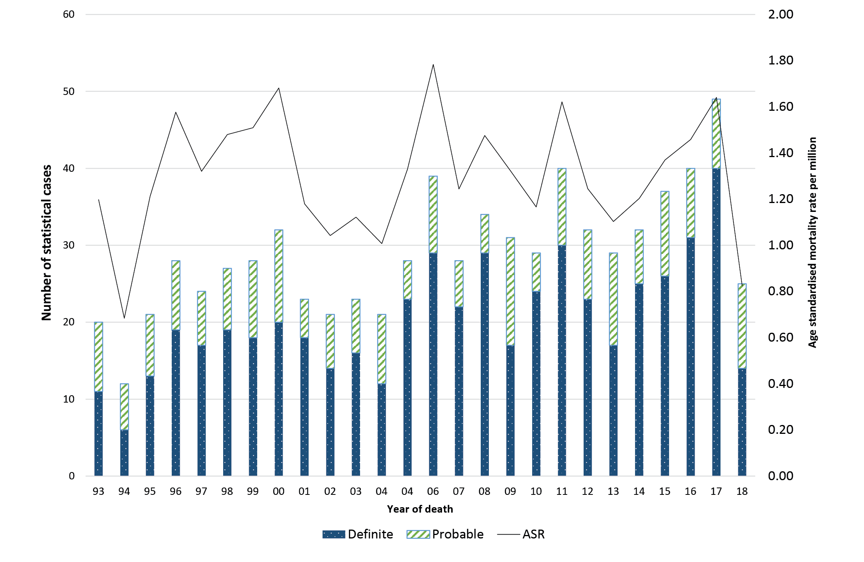

Figure 7. Geographical distribution of “definite” and “probable” cases of human prion disease from 1970 to 2018, by state and territory
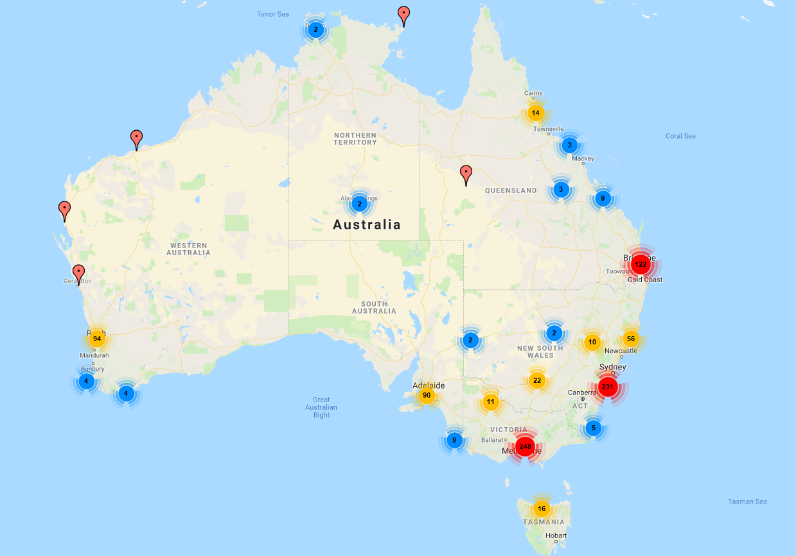
The proportions of human prion disease aetiologies on the ANCJDR register for 2018 remained similar to previous years (Figure 8); the vast majority of the 967 statistical cases of human prion disease are “sporadic” (91%) while genetic and iatrogenic cases represent 8% and <1%, respectively, of all “definite” and “probable” cases recorded.

Figure 8. “Definite” and “probable” human prion disease cases 1970 to 2018, by year and aetiology
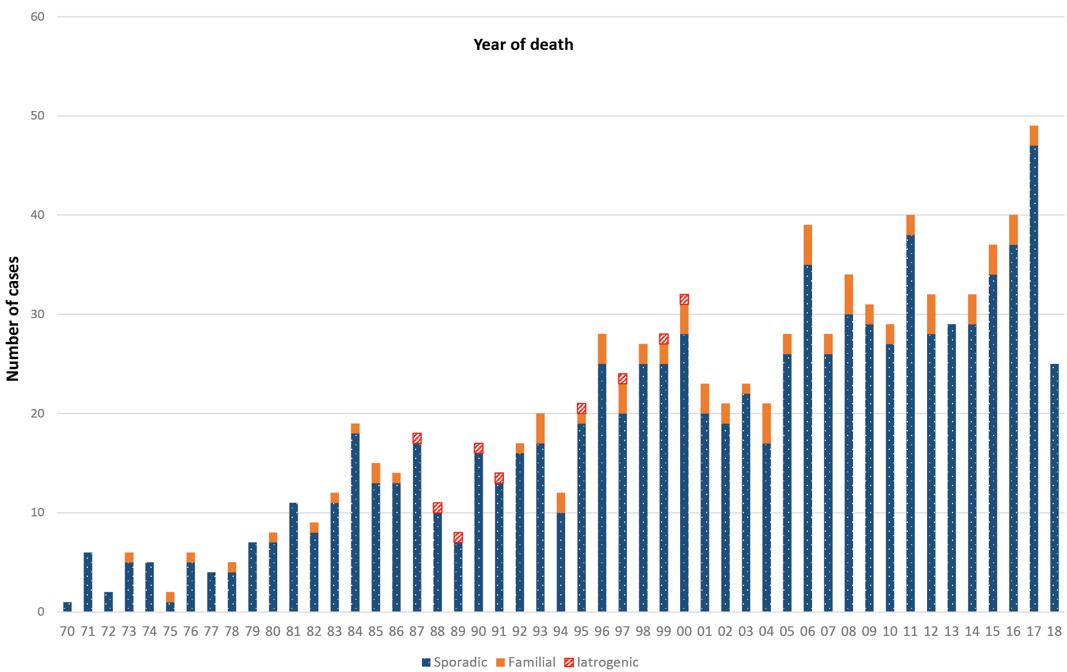
* includes one definite iatrogenic case who received pituitary hormone treatment in Australia but disease onset and death occurred while a resident of the United Kingdom. This case is not included in statistical analysis since morbidity and mortality did not occur within Australia.
There are currently 884 “definite” and “probable” sporadic prion disease cases on the ANCJDR register. The distribution is almost equal between the males (47%) and females (53%) with the slight predominance in females reflecting their longer life expectancy. The average age at death is 66.9 years, with a median of 68 years, ranging in age from 19 to 90 years. The average duration of illness is 6.3 months, with a median of 3.5 months, ranging from 0.9 to 60 months.
Genetic prion disease has been confirmed in 74 individuals, with 57% females. The average age at death for genetic prion disease is 58.2 years, with the mean duration of disease 14.2 months. The average age at death in females is 59.4 years, with a median of 62 years, ranging in age from 18 to 82 years. The average age at death in males is 56.7 years, with a median of 59 years ranging in age from 20 to 83 years. The average duration of illness is 14.2 months, with a median of 5.8 months, ranging from 1.3 to 192 months.
There are currently 46 families affected by genetic prion disease on the ANCJDR register, comprising 74 individuals (57 “definite” and 17 “probable” cases); three prion protein gene (PRNP) mutation carriers were removed from the register after brain autopsies excluded prion disease. Six cases remain under investigation on the register without a neuropathological or case classification outcome; however there is a documented concern for genetic prion disease. Three families are of unspecified PRNP status although there is a recorded family history of prion disease. The range of PRNP mutations in Australian genetic prion disease cases is shown in Table 6.

Table 6. Prion protein gene (PRNP) mutations/polymorphisms identified in Australian cases
Mutation/Polymorphism | Definite/Probable  cases | Cases  PM proven  Not CJD
E200K | 34 | 3
D178N | 11 | 0
V210I | 8 | 0
P105T | 5 | 0
P102L | 4 | 0
Insert unspecified | 1 | 0
7OPRIª | 1 | 0
4OPRIª | 1 | 0
2OPRIª | 1 | 0
G131V | 1 | 0
T188A | 1 | 0
V180I | 1 | 0
A133V | 1 | 0
V176G | 1 | 0
Not determined | 3 | 0
a OPRI stands for octapeptide repeat insertion

No vCJD or further iatrogenic prion disease cases were confirmed in Australia during 2018. The most recent human-derived pituitary gonadotrophin-related CJD death occurred in 1991, while the most recent Lyodura-related CJD death occurred in 2000.
Since vCJD was first reported in 1996, a total of 231 patients with this disease from 12 countries have been identified (Table 7). Two of the four US cases, two of the four cases from Ireland, one of the two cases from Canada, and the single case from Japan were most likely exposed to the BSE agent while travelling or residing within the United Kingdom (UK).

Table 7. Global variant CJD cases to 31 December 2018
Country | Number of cases
Canada | 2
France | 27
Ireland | 4
Italy | 3
Japan | 1
Netherlands | 3
Portugal | 2
Saudi Arabia | 1
Spain | 5
Taiwan | 1
United Kingdom | 178ª
United States | 4
Total | 231
a Case 178 from the UK was the first recorded definite heterozygous case at codon 129 of the PRNP gene. Death occurred in 2016
Source: references 4 and 7
The most recent vCJD case (death occurred in 2016) from the UK was the first to be reported as methionine-valine heterozygous at codon 129 of the PRNP gene;⁷ all cases previously had been methionine homozygous. The patient was 36 years old when he presented with psychiatric symptoms prior to onset of neurological features that included cognitive decline, ataxia and myoclonus, dying after an illness of 20 months. CSF 14-3-3 and RT-QuIC were negative. Brain MRI revealed features more typical of classical sporadic prion disease (bilateral high signal in basal ganglia) without any posterior thalamic high signal (‘pulvinar sign’). The patient did not meet the epidemiologic diagnostic surveillance criteria for “probable” or “possible” vCJD, although fulfilled criteria for “probable” classical CJD; neuropathology, including western blot glycotyping were typical of vCJD. It remains uncertain whether this case marks the start of a second wave of vCJD affecting those heterozygous for methionine-valine at codon 129. This case also underscores the importance of performing suspect CJD brain autopsy examinations and the benefits of maintaining high level surveillance within Australia.

Discussion
In 2018, the number of suspected prion disease notifications and confirmed cases broadly matched the long-term average (1997–2017) and Australia continued to be free of vCJD. By state and territory, generally only modest fluctuations in the number of suspected case notifications compared to the previous year were observed during 2018 and are within previously observed ranges. In 2017 however, the highest recorded number of “definite” and “probable” prion disease cases in Queensland was observed contributing to an annual age-standardised mortality rate of 1.98 deaths per million in 2017. Occasional high mortality rates have been reported previously in Queensland in 1999 and 2000. During 2012 and 2013, the reduced number of cases in Queensland was attributed to several possible factors including the temporary interruption of a facile suspected prion disease autopsy service, changes to the approach of recording suspected cases on the national case register for investigation by the ANCJDR and natural fluctuations. Since the restoration of the routine suspected prion disease autopsy service through the Royal Brisbane Hospital towards the end of 2014, expected rates of prion disease-related post-mortems have been observed; a corresponding increase in statistical (“definite” or “probable”) cases has been observed.
Fluctuations in annual suspect case notifications and prion disease mortality rates are not surprising given the small absolute case numbers involved and the potential impact of extraneous factors. For example, higher notification rates were experienced in 1998 and 1999 when the 14-3-3 protein test was first introduced and in 2006 when notifiable disease legislation was completed in all states; however, the higher number of case notifications in 2017 continued in 2018 and although likely to be an under-estimate of final case classifications (until all post-mortem reports and case reviews are finalized) the currently observed rates are comparable to previous years and contribute to a period of stable case ascertainment. Increased case classifications since 2015 have also contributed to stabilizing the number of “incomplete” cases currently under investigation. Prior to 2015, the addition of new suspect cases considerably exceeded fully evaluated cases with an outcome.
Long-term national surveillance units report differing annual prion disease mortality rates, ranging from 0.22 to 8.69 per million population.^{4,8} Higher rates of human prion disease over short time frames have also been recognised and investigated in various global settings with inconclusive outcomes.⁹ The explanation for fluctuations and differences in national mortality rates is uncertain although variation in case ascertainment is one potentially contributing factor.⁵
Spatio-temporal clustering of CJD has previously been recognised in NSW and Victoria.^{9,10} Detailed epidemiological assessment by the ANCJDR did not disclose any likely horizontal transmission event but instead uncovered a heightened intensity of surveillance.⁹ This more intense level of surveillance was reflected by the significantly higher rates of referrals of suspect prion disease cases for evaluation and diagnostic testing to the ANCJDR, as well as higher neuropathological examination rates in suspected patients.^{5,9,10} Monitoring of the geographical distribution of suspected case referrals and confirmed cases remains an important facet of ANCJDR national surveillance.
Ascertainment mechanisms in 2018 were generally similar to previous years, with the majority of initial referrals coming through requests for diagnostic CSF 14-3-3 protein testing. Some pro-active ascertainment mechanisms, such as state health department and tertiary hospital mortality data base searches, have ceased while other case detection methods have increased. In 2018, in addition to CSF 14-3-3 diagnostic testing requests, 23% of suspect case notifications to the ANCJDR were initially through direct communications from treating clinicians, 12% through neuropathology referrals and 5% through communications with health departments. The number of CSF referrals to the ANCJDR for diagnostic (14-3-3 protein) testing remained high for 2018. A 20% increase in diagnostic test referrals coincided with the introduction of CSF total-tau protein estimation in 2017. Estimation of total-tau protein in CSF is NATA accredited and complementary to 14-3-3 protein testing to support a pre-mortem diagnosis of sporadic CJD. The identification of misfolded prion protein in CSF by RT-QuIC continues to be developed by the ANCJDR as a diagnostic test and is currently selectively performed for cases after discussion with clinicians. The addition of CSF total-tau protein estimation to 14-3-3 protein detection as a biomarker for the pre-mortem evaluation of suspected sCJD offers modestly enhanced diagnostic capacity while the ANCJDR completes transition to clearly superior protein amplification techniques such as RT-QuIC.
The proportion of post-mortems being performed in suspect prion disease cases remains high and aligns with the long-term average brain autopsy referral percentage of approximately 60% (of suspected case deaths) between 1993 and 2017. This contrasts with the findings of an Australian healthcare setting survey where the national hospital post-mortem rate was 12% in 2002–2003;¹¹ more recently, a major Australian tertiary centre audit of hospital autopsy data has described an autopsy rate of 6.6% in 2011–2013.¹² The high suspected prion disease-related post-mortem rate underpins the high and consistent number of confirmed Australian human prion disease cases recorded over the more recent prospective surveillance time period, and provides confident understanding of the cause of death in suspected cases ultimately determined as non-prion disease.

Acknowledgements
The ANCJDR wishes to thank families, as well as medical practitioners and associated staff for their generous support of Australian CJD surveillance. The ANCJDR also thanks Associate Professor Handan Wand, Professor Matthew Law and Professor John Kaldor (The Kirby Centre; formerly the National Centre in HIV Epidemiology and Clinical Research at the University of New South Wales) for their expert ad hoc epidemiological and statistical support, as well as the CJD Support Group Network for their assistance in surveillance activities.

Author details
Dr Christiane Stehmann – Coordinator, Australian National Creutzfeldt-Jakob Disease Registry (ANCJDR)¹
Dr Matteo Senesi – Research Fellow, ANCJDR¹
Dr Victoria Lewis – Research Fellow, ANCJDR¹
Ms Mairin Ummi – Administrative Assistant, ANCJDR²
Dr Marion Simpson – Neurologist, ANCJDR²
Ms Genevieve Klug – Research Assistant, ANCJDR² Professor Catriona A McLean – Neuropathologist, ANCJDR^{1,3}
Professor Colin L Masters – Director, ANCJDR¹ Professor Steven J Collins – Director, ANCJDR²
- The Florey Institute, The University of Melbourne, Victoria, 3010, Australia
- Department of Medicine, The University of Melbourne, Victoria, 3010, Australia
- The Alfred Hospital, Department of Anatomical Pathology, 55 Commercial Rd, Melbourne Vic 3004 Australia

Corresponding author
Prof Steven Collins, Australian National Creutzfeldt-Jakob Disease Registry, Department of Medicine, The University of Melbourne, Victoria, 3010, Australia.
Telephone: +61 8344 1949.
Facsimile: +61 9349 5105.
Email: s.collins@unimelb.edu.au

Appendix 1
Diagnostic criteria for surveillance of sporadic CJD from 1 January 2017
Definite:
Progressive neurological syndrome AND Neuropathologically or immunohistochemically or biochemically confirmed
Probable:
I + two of II and typical EEGª
OR
1.2.2 I + two of II and typical MRI brain scan^{b}
OR 1.2.3 I + two of II and positive CSF 14-3-3
OR 1.2.4 Progressive neurological syndrome and positive RT-QuIC in CSF or other tissues
Possible:
I + two of II + duration < 2 years
I Rapid progressive cognitive impairment
II A Myoclonus
B Visual or cerebellar problems
C Pyramidal or extrapyramidal features
D Akinetic mutism

a Generalised periodic complexes
b High signal in caudate/putamen and MRI brain scan or at least two cortical regions (temporal, parietal, occipital) either on DWI or FLAIR

References
- Klug GM, Boyd A, Zhao T, Stehmann C, Simpson M, McLean CA et al. Surveillance for Creutzfeldt-Jakob disease in Australia: update to December 2012. Commun Dis Intell Q Rep. 2013;37(2):E115–20.
- Allars M. Report of the inquiry into the use of pituitary derived hormones in Australia and Creutzfeldt-Jakob disease. Canberra: AGPS, 1994.
- Zerr I, et al. Updated clinical diagnostic criteria for sporadic Creutzfeldt-Jakob disease. Brain. 2009; 132: 2659-2668.
- Creutzfeldt-Jakob Disease International Surveillance Network: Surveillance Data. [Internet]. Available from: http://www.eurocjd.ed.ac.uk/surveillance%20data%201.html
- Klug GM, Wand H, Simpson M, Boyd A, Law M, Masters CL et al. Intensity of human prion disease surveillance predicts observed disease incidence. J Neurol Neurosurg Psychiatry. 2013;84(2):1372–7.
- Australian Bureau of Statistics. 3101.0 Australian Demographic Statistics – June 2018. Tables 51 to 59. Accessed on 17 January 2019. Available from: http://www.abs.gov.au/AUSSTATS/abs@.nsf/DetailsPage/3101.0Sep%202017?OpenDocument
- Mok T, Jaunmuktane Z, Joiner S, Campbell T, Morgan C, Wakerley B et al. Variant Creutzfeldt–Jakob disease in a patient with heterozygosity at PRNP codon 129. N Engl J Med. 2017;376(3):292–4.
- Glatzel M, Rogivue C, Ghani A, Streffer JR, Amsler L, Aguzzi A. Incidence of Creutzfeldt-Jakob disease in Switzerland. Lancet 2002;360(9327):139–41.
- Klug GM, Wand H, Boyd A, Law M, Whyte S, Kaldor J et al. Enhanced geographically restricted surveillance simulates sporadic Creutzfeldt-Jakob disease cluster. Brain. 2009:132(2);493–501.
- Collins S, Boyd A, Fletcher A, Kaldor J, Hill A, Farish S et al. Creutzfeldt-Jakob disease cluster in an Australian rural city. Ann Neurol. 2002;52(1):115–8.
- The Royal College of Pathologists of Australasia Autopsy Working Party. The decline of the hospital autopsy: a safety and quality issue for healthcare in Australia. Med J Aust. 2004;180(6):281–5.(https://www.ncbi.nlm.nih.gov/pubmed/15012566?dopt=Abstract )
- Jackett L, McLean C. Hospital autopsy audit: discordant primary clinical diagnoses are found in 20% of cases in a reducing autopsy case load. Selection bias or significant findings? Pathology. 2015;47(6):499–502.

Communicable Diseases Intelligence
ISSN: 2209-6051 Online

Communicable Diseases Intelligence (CDI) is a peer-reviewed scientific journal published by the Office of Health Protection, Department of Health. The journal aims to disseminate information on the epidemiology, surveillance, prevention and control of communicable diseases of relevance to Australia.

Editor: Cindy Toms
Deputy Editor: Simon Petrie
Design and Production: Kasra Yousefi
Editorial Advisory Board: David Durrheim, Mark Ferson, John Kaldor, Martyn Kirk and Linda Selvey

Website: http://www.health.gov.au/cdi

Contacts
Communicable Diseases Intelligence is produced by:
Health Protection Policy Branch, Office of Health Protection, Australian Government Department of Health
GPO Box 9848, (MDP 6) CANBERRA ACT 2601

Email: cdi.editor@health.gov.au

Submit an Article
You are invited to submit your next communicable disease related article to the Communicable Diseases Intelligence (CDI) for consideration. More information regarding CDI can be found at: http://health.gov.au/cdi.
Further enquiries should be directed to: cdi.editor@health.gov.au.

This journal is indexed by Index Medicus and Medline.

Creative Commons Licence - Attribution-NonCommercial-NoDerivatives CC BY-NC-ND
© 2019 Commonwealth of Australia as represented by the Department of Health
This publication is licensed under a Creative Commons Attribution-NonCommercial-NoDerivatives 4.0 International Licence from https://creativecommons.org/licenses/by-nc-nd/4.0/legalcode (Licence). You must read and understand the Licence before using any material from this publication.

Restrictions
The Licence does not cover, and there is no permission given for, use of any of the following material found in this publication (if any):
- the Commonwealth Coat of Arms (by way of information, the terms under which the Coat of Arms may be used can be found at www.itsanhonour.gov.au);
- any logos (including the Department of Health’s logo) and trademarks;
- any photographs and images;
- any signatures; and
- any material belonging to third parties.

Disclaimer
Opinions expressed in Communicable Diseases Intelligence are those of the authors and not necessarily those of the Australian Government Department of Health or the Communicable Diseases Network Australia. Data may be subject to revision.

Enquiries
Enquiries regarding any other use of this publication should be addressed to the Communication Branch, Department of Health, GPO Box 9848, Canberra ACT 2601, or via e-mail to: copyright@health.gov.au

Communicable Diseases Network Australia
Communicable Diseases Intelligence contributes to the work of the Communicable Diseases Network Australia.
http://www.health.gov.au/cdna

