Annual Immunisation Coverage Report 2016
Brynley Hull, Alexandra Hendry, Aditi Dey, Frank Beard, Julia Brotherton and Peter McIntyre

Abstract
This tenth annual immunisation coverage report shows data for the calendar year 2016 derived from the Australian Immunisation Register (AIR) and the National Human Papillomavirus (HPV) Vaccination Program Register. After a decade of being largely stable at around 90%, ‘fully immunised’ coverage at the 12-month assessment age increased in 2016 to reach 93.7% for the age assessment quarterly data point in December 2016, similar to the 93.4% for the age assessment quarterly data point in December 2016 for 60 months of age. Implementation of the ‘No Jab No Pay’ policy may have contributed to these increases. While ‘fully immunised’ coverage at the 24-month age assessment milestone decreased marginally from 90.8%, in December 2015, to 89.6% for the age assessment quarterly data point in December 2016, this was likely due to the assessment algorithm being amended in December 2016 to include four doses of DTPa vaccine instead of three, following reintroduction of the 18-month booster dose. Among Indigenous children, the gap in coverage assessed at 12 months of age decreased fourfold, from 6.7 percentage points in March 2013 to only 1.7 percentage points lower than non-Indigenous children in December 2016. Since late 2012, ‘fully immunised’ coverage among Indigenous children at 60 months of age has been higher than for non-Indigenous children. Vaccine coverage for the nationally funded seasonal influenza vaccine program for Indigenous children aged 6 months to <5 years, which commenced in 2015, remained suboptimal nationally in 2016 at 11.6%. Changes in MMR coverage in adolescents were evaluated for the first time. Of the 411,157 ten- to nineteen-year-olds who were not recorded as receiving a second dose of MMR vaccine by 31 December 2015, 43,103 (10.5%) of them had received it by the end of 2016. Many of these catch-up doses are likely to have been administered as a result of the introduction on 1 January 2016 of the Australian Government’s ‘No Jab No Pay’ policy. In 2016, 78.6% of girls aged 15 years had three documented doses of HPV vaccine (jurisdictional range 67.8–82.9%), whereas 72.9% of boys (up from 67.1 % in 2015) had received three doses.
Keywords: immunisation coverage, immunisation delay, Indigenous immunisation coverage, influenza vaccination, human papillomavirus vaccine coverage

Introduction
This is the 10th Annual Immunisation Coverage Report, with analysis now encompassing the years 2007–2016 with the publication of this report.¹⁻⁹ This report adds to and complements other reports providing data on immunisation coverage in Australia^{10,11} and highlights important trends, as well as policy and program changes in relation to them. It follows the format of previous reports, covering data for the calendar year 2016, and also includes new coverage data on adolescents and adolescent coverage data from previously published sources. Readers are referred to the first report for a more detailed explanation of the background, methods, and range of analyses presented.¹ This report uses the longstanding international practice of reporting at key milestone ages to measure coverage against national targets, and to track trends over time. Table 1 shows the Australian National Immunisation Program Schedule for 2016.¹²

Table 1: Australian National Immunisation Program Schedule for children, adolescents and adults in 2016ª
Age | Vaccine
Childhood vaccines
Birth | Hep B
2 months | Hep B | DTPa | Hib | Polio |  |  |  | 13vPCV | Rotavirus
4 months | Hep B | DTPa | Hib | Polio |  |  |  | 13vPCV | Rotavirus
6 months | Hep B | DTPa | Hib | Polio |  |  |  | 13vPCV | Rotavirus^{b} | Flu^{c}
12 months |  |  | Hib-Men C^{d} |  | MMR |  | Hep A^{e} | 13vPCV^{f} |  | Flu^{c}
18 months |  | DTPa |  |  |  | MMRV^{g} | Hep A^{e} | 13vPCV^{f} |  | Flu^{c}
24 months |  |  |  |  |  |  | Hep A^{e} |  |  | Flu^{c}
48 months |  | DTPa |  | Polio | MMR^{h} |  |  | 23vPPV^{i} |  | Flu^{c}
Adolescent vaccines
12–15 years |  | dTpa |  |  |  | VZV^{j} |  |  |  |  | HPV^{k}
15–49 years |  |  |  |  |  |  |  |  |  | Flu^{c} | 23vPPV^{l}
Adult vaccines
≥50 years |  |  |  |  |  |  |  |  |  | Flu^{c} | 23vPPV^{l}
65 years |  |  |  |  |  |  |  |  |  | Flu^{c} | 23vPPV
Pregnant women (any age) |  |  |  |  |  |  |  |  |  | Flu^{m}
70 years |  |  |  |  |  | HZ^{n}
a See Appendix A for vaccine abbreviations.
b 3rd dose of rotavirus vaccine at 6 months of age is dependent on vaccine brand used in each state or territory.
c Annual vaccination, all Aboriginal and Torres Strait Islander children aged 6 months to < 5 years and all children aged ≥ 6 months with medical risk factors, Aboriginal and Torres Strait Islander people aged ≥15 years, non-Indigenous adults aged ≥65 years.
d In July 2013, the combined Haemophilus influenzae type b (Hib) and meningococcal serogroup C (Men C) vaccine, Menitorix®, was added to the NIP Schedule at 12 months of age. This combination vaccine replaces the single dose of monovalent meningococcal C conjugate vaccine (Men C) and booster dose of monovalent Hib vaccine previously scheduled at 12 months of age.
e Aboriginal and Torres Strait Islander children—doses at 12 months and 18 months of age in the Northern Territory and Western Australia and 18 and 24 months of age in Queensland and South Australia (schedule changed in July 2013 so doses administered at 12 months and 18 months of age in all four jurisdictions).
f Booster dose for medically at-risk children at 12 months of age, and Aboriginal and Torres Strait Islander children in the Northern Territory, Western Australia, Queensland and South Australia at 12–18 months of age. Due at 12 months of age in South Australia and Western Australia, and at 18 months of age in the Northern Territory and Queensland.
g Measles-mumps-rubella-varicella vaccine introduced onto NIP Schedule on 1 July 2013.
h To be given only if MMRV vaccine was not given at 18 months of age. The dose of measles-mumps-rubella vaccine at 4 years of age ceased on 1 January 2016.
i Medically at-risk children
j Catch-up program for vaccine naïve individuals until 2017.
k From February 2013, males and females aged 12–13 years received the HPV vaccine at school. Males aged 14–15 years also received the vaccine as part of a catch-up program until the end of the 2014 school year.
l Aboriginal and Torres Strait Islander people: aged ≥15 years with medical risk factors; all aged ≥50 years.
m At any stage of pregnancy for flu vaccine.
n A single dose of herpes zoster (HZ) vaccine is funded for adults aged 70 years (with a 5-year catch-up for 71- to 79-year-olds) who have not previously received a dose of zoster vaccine.
Source: Australian Government Department of Health¹²

High levels of reporting to the Australian Immunisation Register (AIR), previously known as the Australian Childhood Immunisation Registration (ACIR), are maintained by a system of incentive payments for immunisation providers and carers. These have been discussed in detail elsewhere.^{6,13,14}
The Australian Childhood Immunisation Register (ACIR) was established on 1 January 1996 by incorporating demographic data from Medicare on all enrolled children under the age of 7 years.¹⁵ On 30 September 2016, the ACIR expanded to become the Australian Immunisation Register (AIR) to collect data on vaccinations given from birth to death.¹⁶ All people registered with Medicare are automatically added to the AIR. Participation in the AIR is ‘opt-out’ and so constitutes a nearly complete population register for Australian resident persons, as approximately 99% of persons are registered with Medicare by 12 months of age.¹⁵ Persons not enrolled in Medicare can also be added to the AIR via a supplementary number. Since 2001, vaccinations given overseas may be recorded if a provider endorses their validity. Data are transferred to the AIR when a recognised immunisation provider supplies details of an eligible vaccination. This could occur either automatically from medical practice management software or through the internet using the AIR website or by submitting paper encounter or history forms. There is potential for under-reporting of some vaccinations to the AIR, especially ‘non-universal’ vaccines, given the lack of incentive payments for notification of these vaccines to the AIR. The existence of medical contraindications to immunisation is also recorded on the AIR. From 1 January 2016, conscientious objection is no longer a valid exemption to immunisation linked to family payments and therefore is no longer recorded on the AIR.¹⁴ All vaccination records for a person remain on the register indefinitely.
Vaccinations recorded on the immunisation register must be rendered in accordance with the guidelines issued by the Australian Technical Advisory Group on Immunisation (ATAGI).¹⁷ Notifications falling outside these guidelines, or duplicate notifications, prompt an enquiry with the provider and, if their validity cannot be established, they are rejected.
Important recent changes to immunisation policy, the incentive payment system, and the ‘fully immunised’ coverage algorithms are highlighted in Box 1.¹⁸ New immunisation requirements for family assistance payments (the ‘No Jab No Pay’ policy) came into effect on 1 January 2016.¹⁹ Under this policy, only parents of children (aged less than 20 years) who are ‘fully immunised’ or on a recognised catch-up schedule are eligible for the Child Care Benefit, Child Care Rebate, and/or the Family Tax Benefit Part A end-of-year supplement. Children with medical contraindications or natural immunity to certain diseases (as reported by their general practitioner, and based on guidance in The Australian Immunisation Handbook,¹⁷ a vaccination provider factsheet,¹⁴ and the AIR Medical Exemption Form²⁰) continue to be exempt from the requirements, but ‘conscientious’ objection to vaccination on non-medical grounds is no longer a valid exemption from immunisation requirements. In March 2016, a booster dose of DTPa was funded at 18 months of age, almost 13 years after it was removed from the NIP, and, in November 2016, a funded national herpes zoster vaccine (HZ) program commenced, with a single dose of herpes zoster vaccine at 70 years of age (with a 5-year catch-up for 71- to 79-year-olds) for persons who have not previously received a dose of zoster vaccine.¹²

Box 1: Significant changes in immunisation policy, immunisation incentives and coverage calculation algorithms, Australia, 2012 to 2016
November 2016: Funded national herpes zoster vaccine (HZ) program commenced, with a single dose of herpes zoster vaccine at 70 years of age for persons who have not previously received a dose of zoster vaccine and a catch-up program for persons aged 71–79 years.

March 2016: A booster dose of DTPa funded at 18 months of age.

1 January 2016: New immunisation requirements for federal government family assistance payments (the ‘No Jab No Pay’ policy), came into effect. Only parents of children (aged less than 20 years) who are ‘fully immunised’^{i} or on a recognised catch-up schedule are eligible to receive the Child Care Benefit, Child Care Rebate, and/or the Family Tax Benefit Part A end-of-year supplement. Children with medical contraindications or natural immunity for certain diseases continue to be exempt from the requirements, however objection on non-medical grounds is no longer a valid exemption.

July 2014 – June 2015: State/territory funded dTpa programs, for women during the third trimester of pregnancy, commenced in all jurisdictions.

March 2015: Advice provided that the 1st dose of 13vPCV could be given as early as 6 weeks of age.
Seasonal influenza vaccine funded for Aboriginal and Torres Strait Islander children aged 6 months to less than 5 years. The recommended upper age for children requiring 2 doses in the first year they receive influenza vaccine changed from <10 years to <9 years.

December 2014: Immunisation coverage assessment algorithm for ‘fully immunised’ at the 24-month milestone amended to require a dose of meningococcal C vaccine and a dose of varicella vaccine, along with the 2nd dose of MMR instead of the 1st dose as previously. The 2nd dose of MMR remained in the coverage assessment algorithm for the 60-month milestone age.

December 2013: Immunisation coverage assessment algorithm for ‘fully immunised’ at the 12-month milestone amended to include a 3rd dose of pneumococcal conjugate vaccine (PCV).

July 2013: Combined Haemophilus influenzae type b (Hib) and meningococcal serogroup C (Men C) conjugate vaccine, Menitorix, funded in the National Immunisation Program (NIP) Schedule at 12 months of age, replacing the single dose of monovalent Men C vaccine and booster dose of monovalent Hib vaccine previously scheduled at 12 months of age.
Combination measles-mumps-rubella-varicella (MMRV) vaccine funded in the NIP at 18 months of age, replacing the MMR dose previously scheduled at 4 years of age and the varicella vaccine dose previously scheduled at 18 months of age. MMR vaccination at 4 years of age continued in parallel until the first cohort eligible for MMRV vaccine reached 4 years of age.
Hepatitis A vaccination schedule for Indigenous children changed so that dose 1 administered at 12 months of age and dose 2 at 18 months of age in all four relevant jurisdictions (the Northern Territory, Western Australia, Queensland and South Australia).

February 2013: Human papillomavirus (HPV) vaccine funded under the NIP for males aged 12–13 years, delivered in school-based programs. Catch-up to age 15 to end of 2014.

July 2012: Eligibility for Family Tax Benefit Part A supplement required that children are assessed as ‘fully immunised’ during the financial years that they turn 1, 2 and 5 years old or have an approved exemption, replacing the Maternity Immunisation Allowance.
Source: NCIRS History of Vaccination¹⁸
i Excludes adolescent doses in school-based programs.

Methods

Measuring immunisation coverage using the AIR
This report details immunisation coverage using AIR data up to 31st March 2017. The cohort method has been used for calculating coverage at the population level (national and state/territory)²¹ since the ACIR’s inception. Cohort immunisation status was assessed at 12 months of age (for vaccines due at 6 months), 24 months of age (for vaccines due at 12 and 18 months), and 60 months of age (for vaccines due at 48 months). A minimum 3-month lag period was allowed for late notification of vaccinations to the AIR, but only vaccines given on or before a child’s 1st, 2nd or 5th respective birthdays were included in coverage calculations.²¹ If a child’s records indicate receipt of the last dose of a vaccine that requires more than 1 dose to complete the series, it was assumed that earlier vaccines in the sequence have been given. This assumption has been shown to be valid in the past.^{22,23}
Three-month-wide birth cohorts were used for time trend analyses, while both 3-month-wide and 12-month-wide cohorts were used for all other analyses in this report. The 12-month-wide cohorts used in this report were children born between 1 January 2015 and 31 December 2015 for the 12-month milestone; between 1 January 2014 and 31 December 2014 for the 24-month milestone; and between 1 January 2011 and 31 December 2011 for the 5-year (60-month) milestone.
The proportion of children designated as ‘fully immunised’ was calculated using the number of children completely immunised with the vaccines of interest by the designated age as the numerator, and the total number of Medicare-registered children in the age cohort as the denominator. ‘Fully immunised’ at 12 months of age was defined as a child having a record on the AIR of a 3rd dose of a diphtheria (D), tetanus (T) and pertussis-containing (P) vaccine, a 3rd dose of polio vaccine, a 2nd or 3rd dose of PRP-OMP containing Haemophilus influenzae type b (Hib) vaccine or a 3rd dose of any other Hib vaccine, a 3rd dose of hepatitis B vaccine, and a 3rd dose of 13-valent pneumococcal conjugate vaccine. From 1 January to 30 September 2016, ‘fully immunised’ at 24 months of age was defined as a child having a record on the AIR of a 3rd dose of diphtheria-tetanus-pertussis, a 3rd dose of hepatitis B and polio vaccines, a 3rd or 4th dose of PRP-OMP Hib, Infanrix Hexa or Hiberix vaccine (a 3rd dose only of Infanrix Hexa or Hiberix if given after 11.5 months of age), or a 4th dose of any other Hib vaccine, a dose of meningococcal C vaccine, a dose of varicella vaccine, and a 2nd dose of measles-containing vaccine (given as either MMR or MMRV). As at 1 October 2016, the 24-month coverage algorithm changed to require a 4th dose of diphtheria-tetanus-pertussis vaccine. ‘Fully immunised’ at 60 months of age was defined as a child having a record on the AIR of a 5th dose of a DTP-containing vaccine, a 4th dose of polio vaccine, and a 2nd dose of a MMR-containing vaccine.
Immunisation coverage estimates were also calculated for individual National Immunisation Program (NIP) vaccines, including the three NIP vaccines given in early childhood but not routinely reported on and not part of ‘fully immunised’ calculations at 12, 24 and 60 months of age. These are: a 2nd or 3rd dose of rotavirus vaccine by 12 months of age; a 2nd dose of hepatitis A vaccine in Indigenous children by 30 months of age; and a 4th (booster) dose of pneumococcal vaccine in Indigenous children by 30 months of age.
Coverage for seasonal influenza vaccine was calculated for Indigenous and non-Indigenous children aged 6 months to less than 5 years. The percentage of children who were recorded in the AIR as having received at least one dose of the seasonal influenza vaccine during 2016 was calculated.

Timeliness
‘On-time’ vaccination was defined as receipt of a scheduled vaccine dose within 30 days of the recommended age. For example, a child who received the first dose of DTPa (due by 60 days of age) when he or she was more than 90 days of age was classified as late for that dose. For descriptive purposes, we categorised the delay outcome measure for each dose as either ‘delay of 1 – < 3 months’, ‘delay of 3 – < 7 months’ or ‘delay ≥ 7 months’. On-time vaccination was measured in 12-month-wide birth cohorts. Children included in the on-time vaccination analysis were assessed at 1–3 years after doses were due, to allow time for late vaccinations to be recorded. Therefore, these cohorts are not the same as those assessed for coverage milestones. The interval between doses was not evaluated. On-time vaccination for different vaccines and doses was also compared by plotting the cumulative percentage receiving each vaccine dose by age.

Remoteness status
The area of residence of children was defined as ‘Major cities’, ‘Inner regional’, ‘Outer regional’, ‘Remote’, and ‘Very remote’ using the Accessibility/Remoteness Index of Australia (ARIA++).²⁴ ARIA++ is a continuously varying index with values ranging from 0 (high accessibility) to 15 (high remoteness), and is based on road distance measurements from over 12,000 populated localities to the nearest service centres in five categories based on population size. For analysis in this report, we combined the two ‘Regional’ categories (‘Inner regional’ and ‘Outer regional’) into one category and the two ‘Remote’ categories (‘Remote’ and ‘Very remote’) into one category. ARIA Accessibility/Remoteness categories were assigned for each child using their current recorded postcode of residence on the AIR.

Indigenous status
Aboriginal and Torres Strait Islander (Indigenous) status on the AIR is recorded as ‘Indigenous’, ‘non-Indigenous’ or ‘unknown’, as reported by the child’s carer to Medicare or by the immunisation provider to the AIR. For this report we considered two categories of children: ‘Indigenous’ and ‘non-Indigenous’; children with unknown Indigenous status were presumed to be ‘non-Indigenous’. Coverage estimate time trends are presented from 2002 only, due to poor rates of reporting Indigenous status prior to then.²⁵

Small area analysis
Analysis for small areas was done by ABS-defined Statistical Area 3 (SA3),²⁶ chosen because each is small enough to show differences within jurisdictions but not too small to render maps unreadable. Maps were created using version 15 of the MapInfo mapping software²⁷ and the ABS Census Boundary Information. As postcode is the only geographical indicator available from the AIR, the ABS Postal Area to SA3 Concordance 2011 was used to match AIR postcodes to SA3s.²⁸

Adolescent immunisation coverage as recorded on the AIR
Coverage estimates as recorded on the AIR for catch-up doses of the 2nd dose of MMR vaccine for adolescents were assessed at 10–19 years of age for all jurisdictions. We focused on the 2nd dose of MMR vaccine as it is not delivered via the school-based program. The 2nd dose was chosen rather than the 1st as some children might already have had the 1st dose previously i.e. partially vaccinated. We examined these catch-up doses in order to assess the potential impact of the ‘No Jab No Pay’ legislation, acknowledging that some of the children who received MMR2 in 2016 may have received it for unrelated reasons (e.g. prior to overseas travel or enrolment in a health-related training course).

Medical contraindication exemptions
The trends in the number of children aged 6 months to less than 10 years with at least one new vaccination exemption due to a medical contraindication or a natural immunity entered into the AIR during each year were calculated by state/territory for the years 2011–2016 using AIR data.

Human papillomavirus vaccine coverage
Data on HPV vaccination were provided by the National HPV Vaccination Program Register, which is operated by the Victorian Cytology Service. Coverage for a full course of HPV vaccine (defined as three doses of quadrivalent HPV vaccine at acceptable minimum dose intervals) was assessed for females and males aged 15 years (as recommended by the World Health Organization for the purposes of international comparison) in 2016. As HPV vaccination is delivered routinely in early high school usually at the age of 12–13 years, all children in each cohort have had the opportunity to complete the vaccination course by age 15. Numerator data comprise valid doses allocated to the child’s state of residence and denominator data comprise Australian Bureau of Statistics (ABS) Estimated Resident Population (ERP) data, in contrast to Medicare enrolment data used as the denominator for AIR reporting and in the rest of this report. A previous study has found that ABS ERP denominator data produce coverage estimates comparable to Medicare enrolment data when applied to the early adolescent age group.²⁹ HPV coverage estimates were also provided separately for doses 1, 2 and 3 and by four age groups: 14–15 years; 16–17 years; 18–19 years; and 20–26 years of age.

Results

Coverage estimates

‘Fully immunised’
Figure 1 shows time trends in quarterly ‘fully immunised’ vaccination coverage estimates in Australia, assessed at 12 months, 24 months and 60 months of age, for 3-month-wide cohorts born from 1 January 2000 to 31 December 2015. ‘Fully immunised’ coverage at the 12-month assessment age milestone, which was largely stable at around 90% through until 2014, increased in 2015 and 2016, reaching 93.7% for the age assessment quarterly data point in December 2016.

Figure 1: Trends in ‘fully immunised’ vaccination coverage estimates, Australia, 2006 to 2016^{a,b}
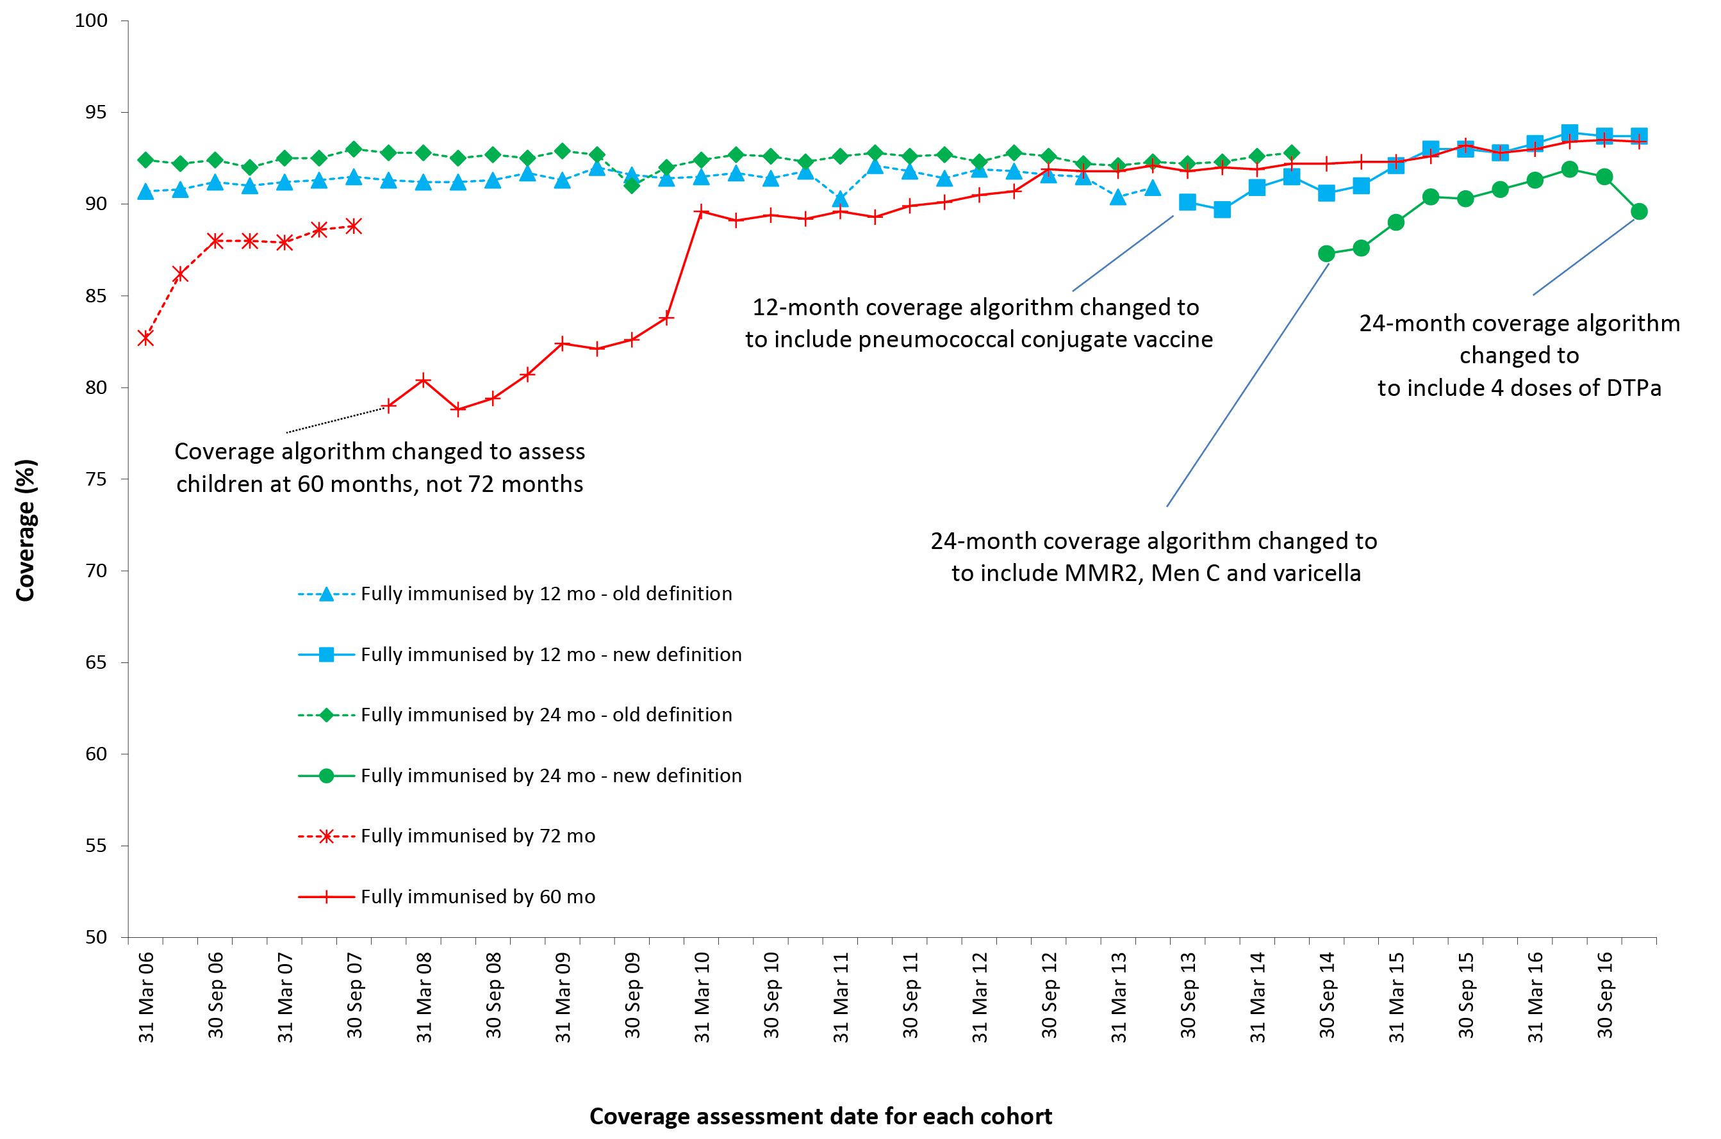
a By 3-month-wide birth cohorts born between 1 January 2000 and 31 December 2015. Source: Australian Immunisation Register, data as at 31 March 2017.
b See Appendix A for vaccine abbreviations.

‘Fully immunised’ coverage at the 24-month assessment age milestone was also largely stable at around 92–93% through until 2014, but then declined by 5.5 percentage points in the latter half of 2014. The bulk of this decrease was due to the assessment algorithm being amended in July 2014 to include additional requirements: a dose of meningococcal vaccine, a dose of varicella vaccine and a second dose of MMR vaccine. ‘Fully immunised’ coverage at 24 months increased to 90.8% in December 2015 but decreased marginally to 89.6% for the age assessment quarterly data point in December 2016. This was likely due to the coverage assessment algorithm being amended in December 2016 to require four doses of DTPa vaccine, reflecting NIP inclusion of a dose at 18 months of age.
In contrast, ‘fully immunised’ coverage at the 60-month assessment age milestone, for which requirements have not changed for many years, has increased steadily since 2009, reaching 93.4% for the age assessment quarterly data point in December 2016.

Individual antigens within single or combination vaccines

12 months of age
Coverage at the 12-months age assessment milestone for antigens in the relevant combination vaccine (DTPa-hepB-polio-Hib) increased by around three percentage points between late 2014 and the end of 2016 (91.6% to 94.5%) (Figure 2). Coverage for the third dose of PCV by 12 months of age has continued to rise steadily and reached 94.1% in late 2016, similar to the level of coverage for all other vaccines/antigens assessed at this age except for rotavirus vaccine. Rotavirus coverage is lower, due to strict upper age limits for administration, but has also increased since late 2014, reaching 87.5% in December 2016 (Figure 2).
Figure 2: Trends in vaccination coverage estimates for individual vaccines/antigensª at 12 months of age, Australia, 2006 to 2016^{b,c}
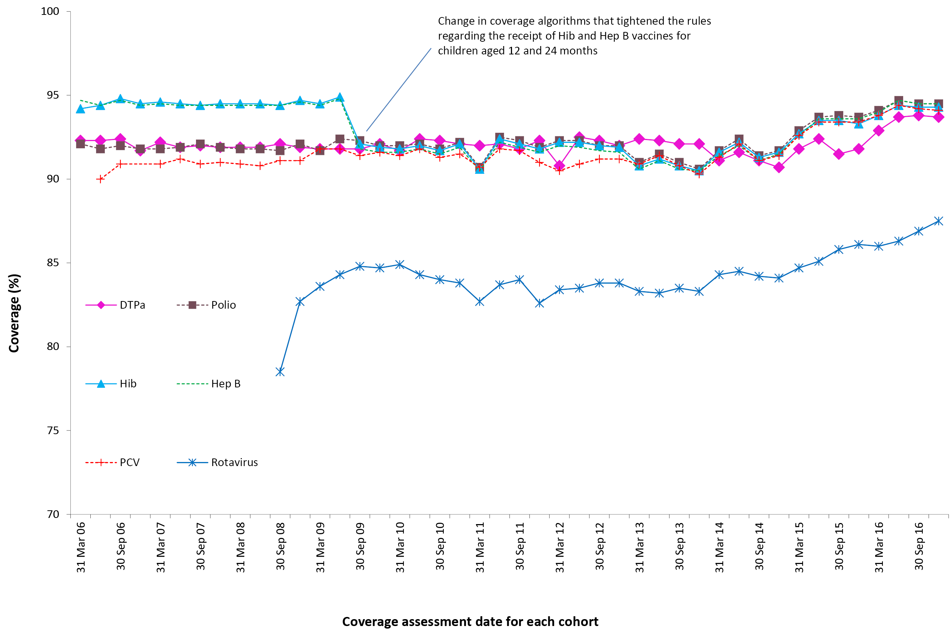
a 3rd dose of DTPa, polio, PCV and hepatitis B, 2nd or 3rd dose of Hib and rotavirus.
b By 3-month-wide birth cohorts born between 1 January 2005 and 31 December 2015. Coverage assessment date was 12 months after the last birth date of each cohort. Source: Australian Immunisation Register, data as at 31 March 2017.
c See Appendix A for vaccine abbreviations.

24 months of age
In 2016, coverage at the 24-months age assessment milestone increased for all vaccines/antigens except DTPa (Figure 3). Coverage estimates for the age assessment quarterly data points in December 2016 were 94% or greater for all vaccines/antigens except DTPa (91.8%) and MMRV (93.3%) (Figure 3). The decrease in DTPa coverage from 96% is due to the coverage assessment algorithm being amended in late 2016 to include a 4th dose of DTPa instead of a 3rd dose (reflecting the change in the NIP). Following the decline in MMR coverage in the latter half of 2014, due to the 2nd dose of MMR-containing vaccine being assessed at 24 months of age for the first time instead of the 1st dose as previously, coverage steadily increased over 2015 and 2016.

Figure 3: Trends in vaccination coverage estimates for individual vaccines/antigensª at 24 months of age, Australia, 2006 to 2016^{b,c}
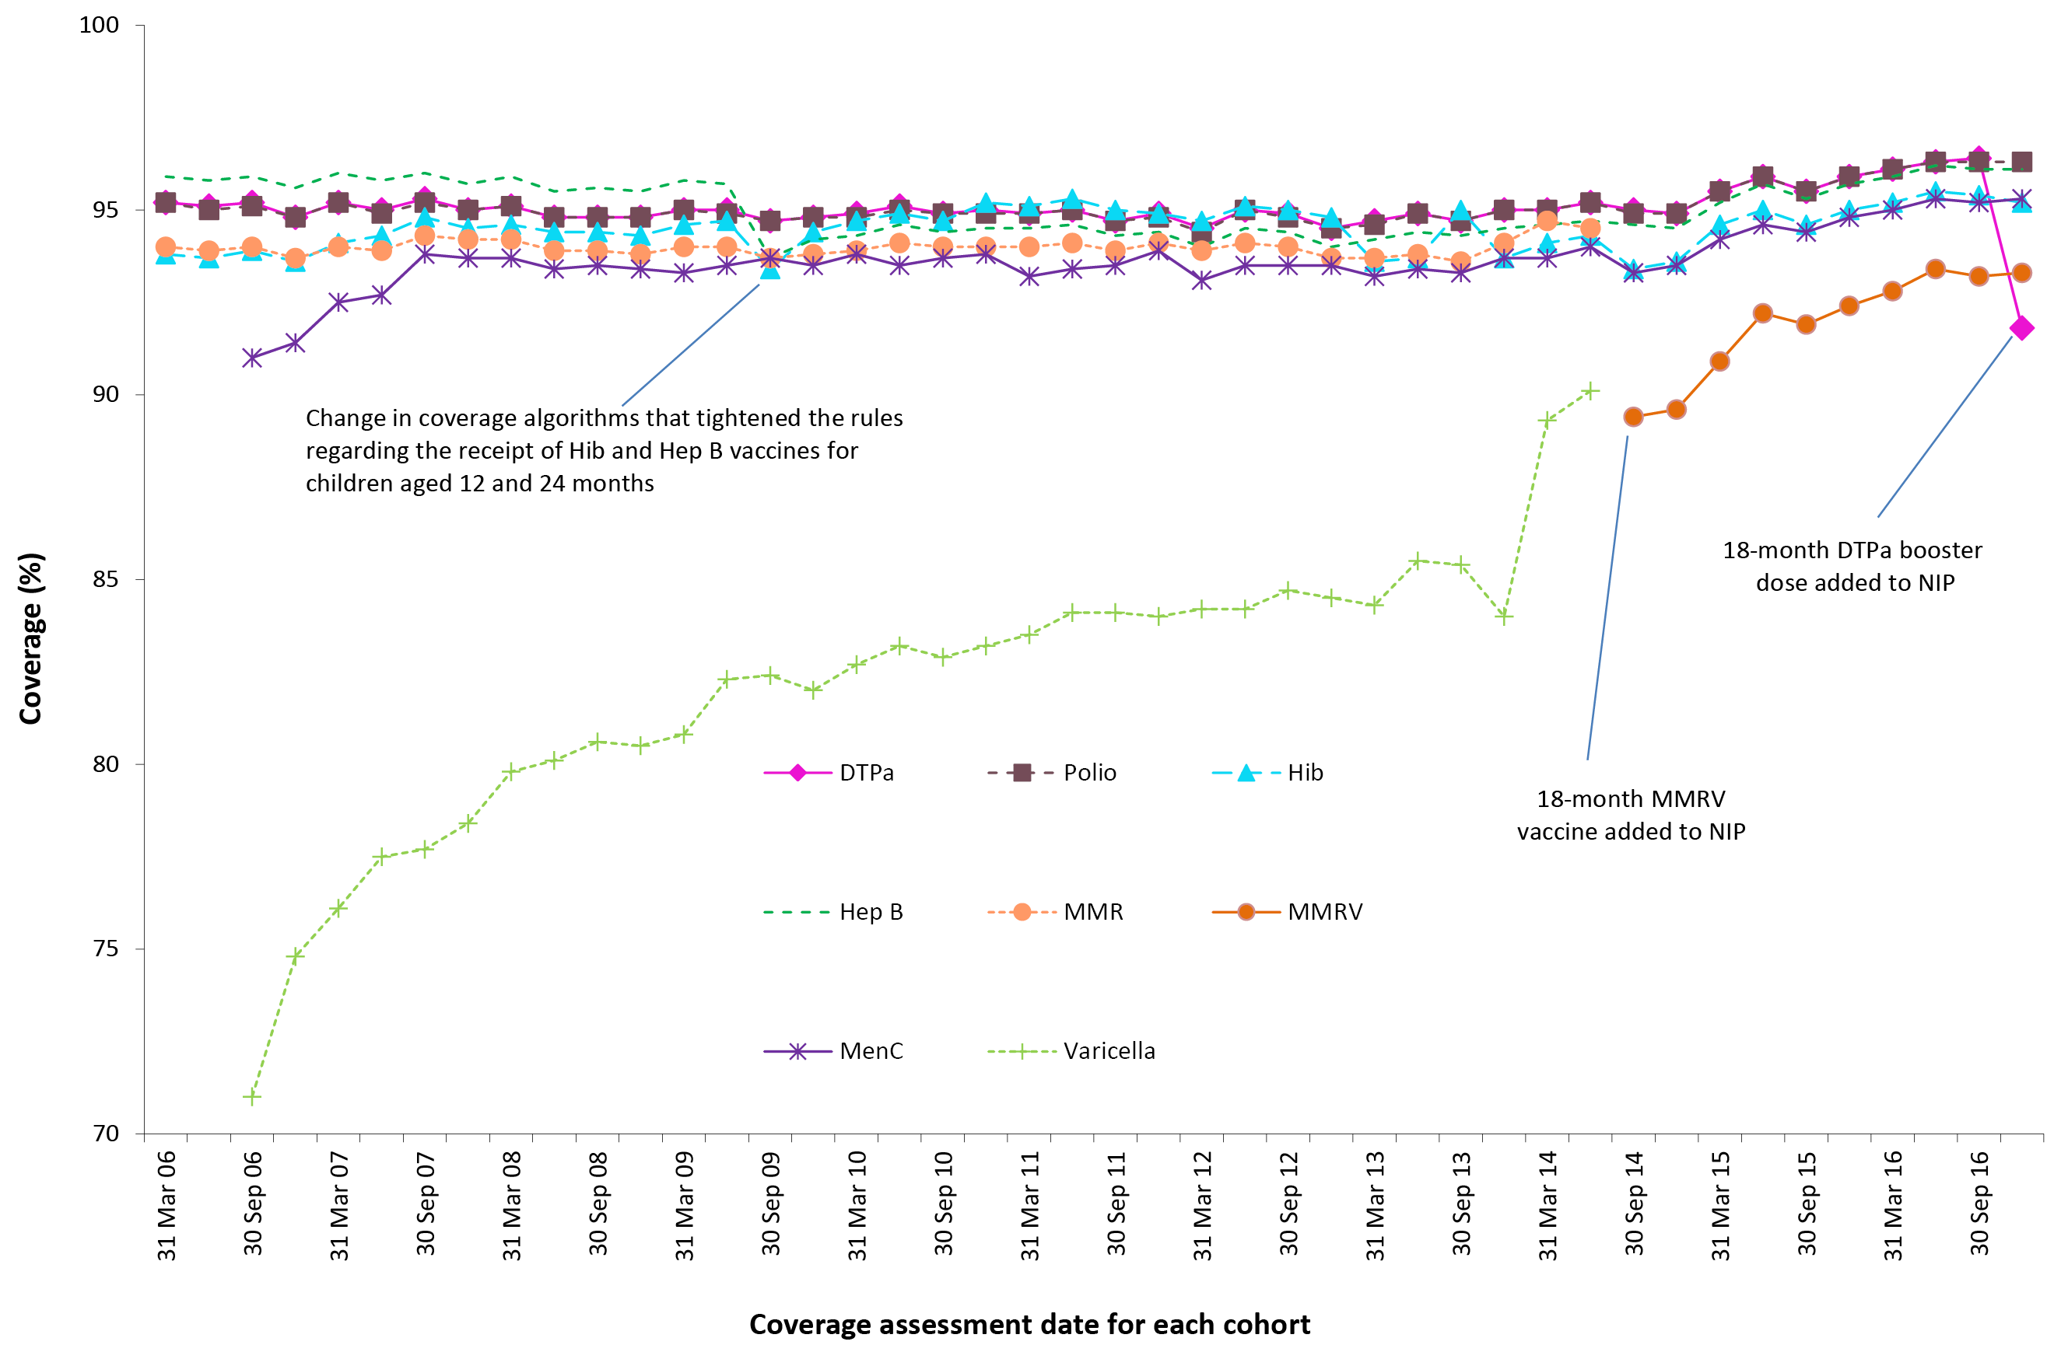
a 4th dose of DTPa (from October 2016), 3rd dose of polio, 3rd or 4th dose of Hib, 3rd dose of hepatitis B, 2nd dose of MMRV (from September 2014), 1st dose of meningococcal C.
b By 3-month-wide birth cohorts born between 1 January 2004 and 31 December 2014. Coverage assessment date was 24 months after the last birth date of each cohort. Source: Australian Immunisation Register, data as at 31 March 2017.
c See Appendix A for vaccine abbreviations.

60 months of age
For vaccines due at 48 months of age, trends in individual vaccine/antigen coverage were similar to that seen for ‘fully immunised’ coverage (Figure 4). Coverage for DTPa, polio and MMR all increased in 2016 to greater than 94% for the age assessment quarterly data points in December 2016 (Figure 4).
Figure 4: Trends in vaccination coverage estimates for individual vaccines/antigensª at 60 months of age (assessed at 72 months prior to December 2007), Australia, 2006 to 2016^{b,c}
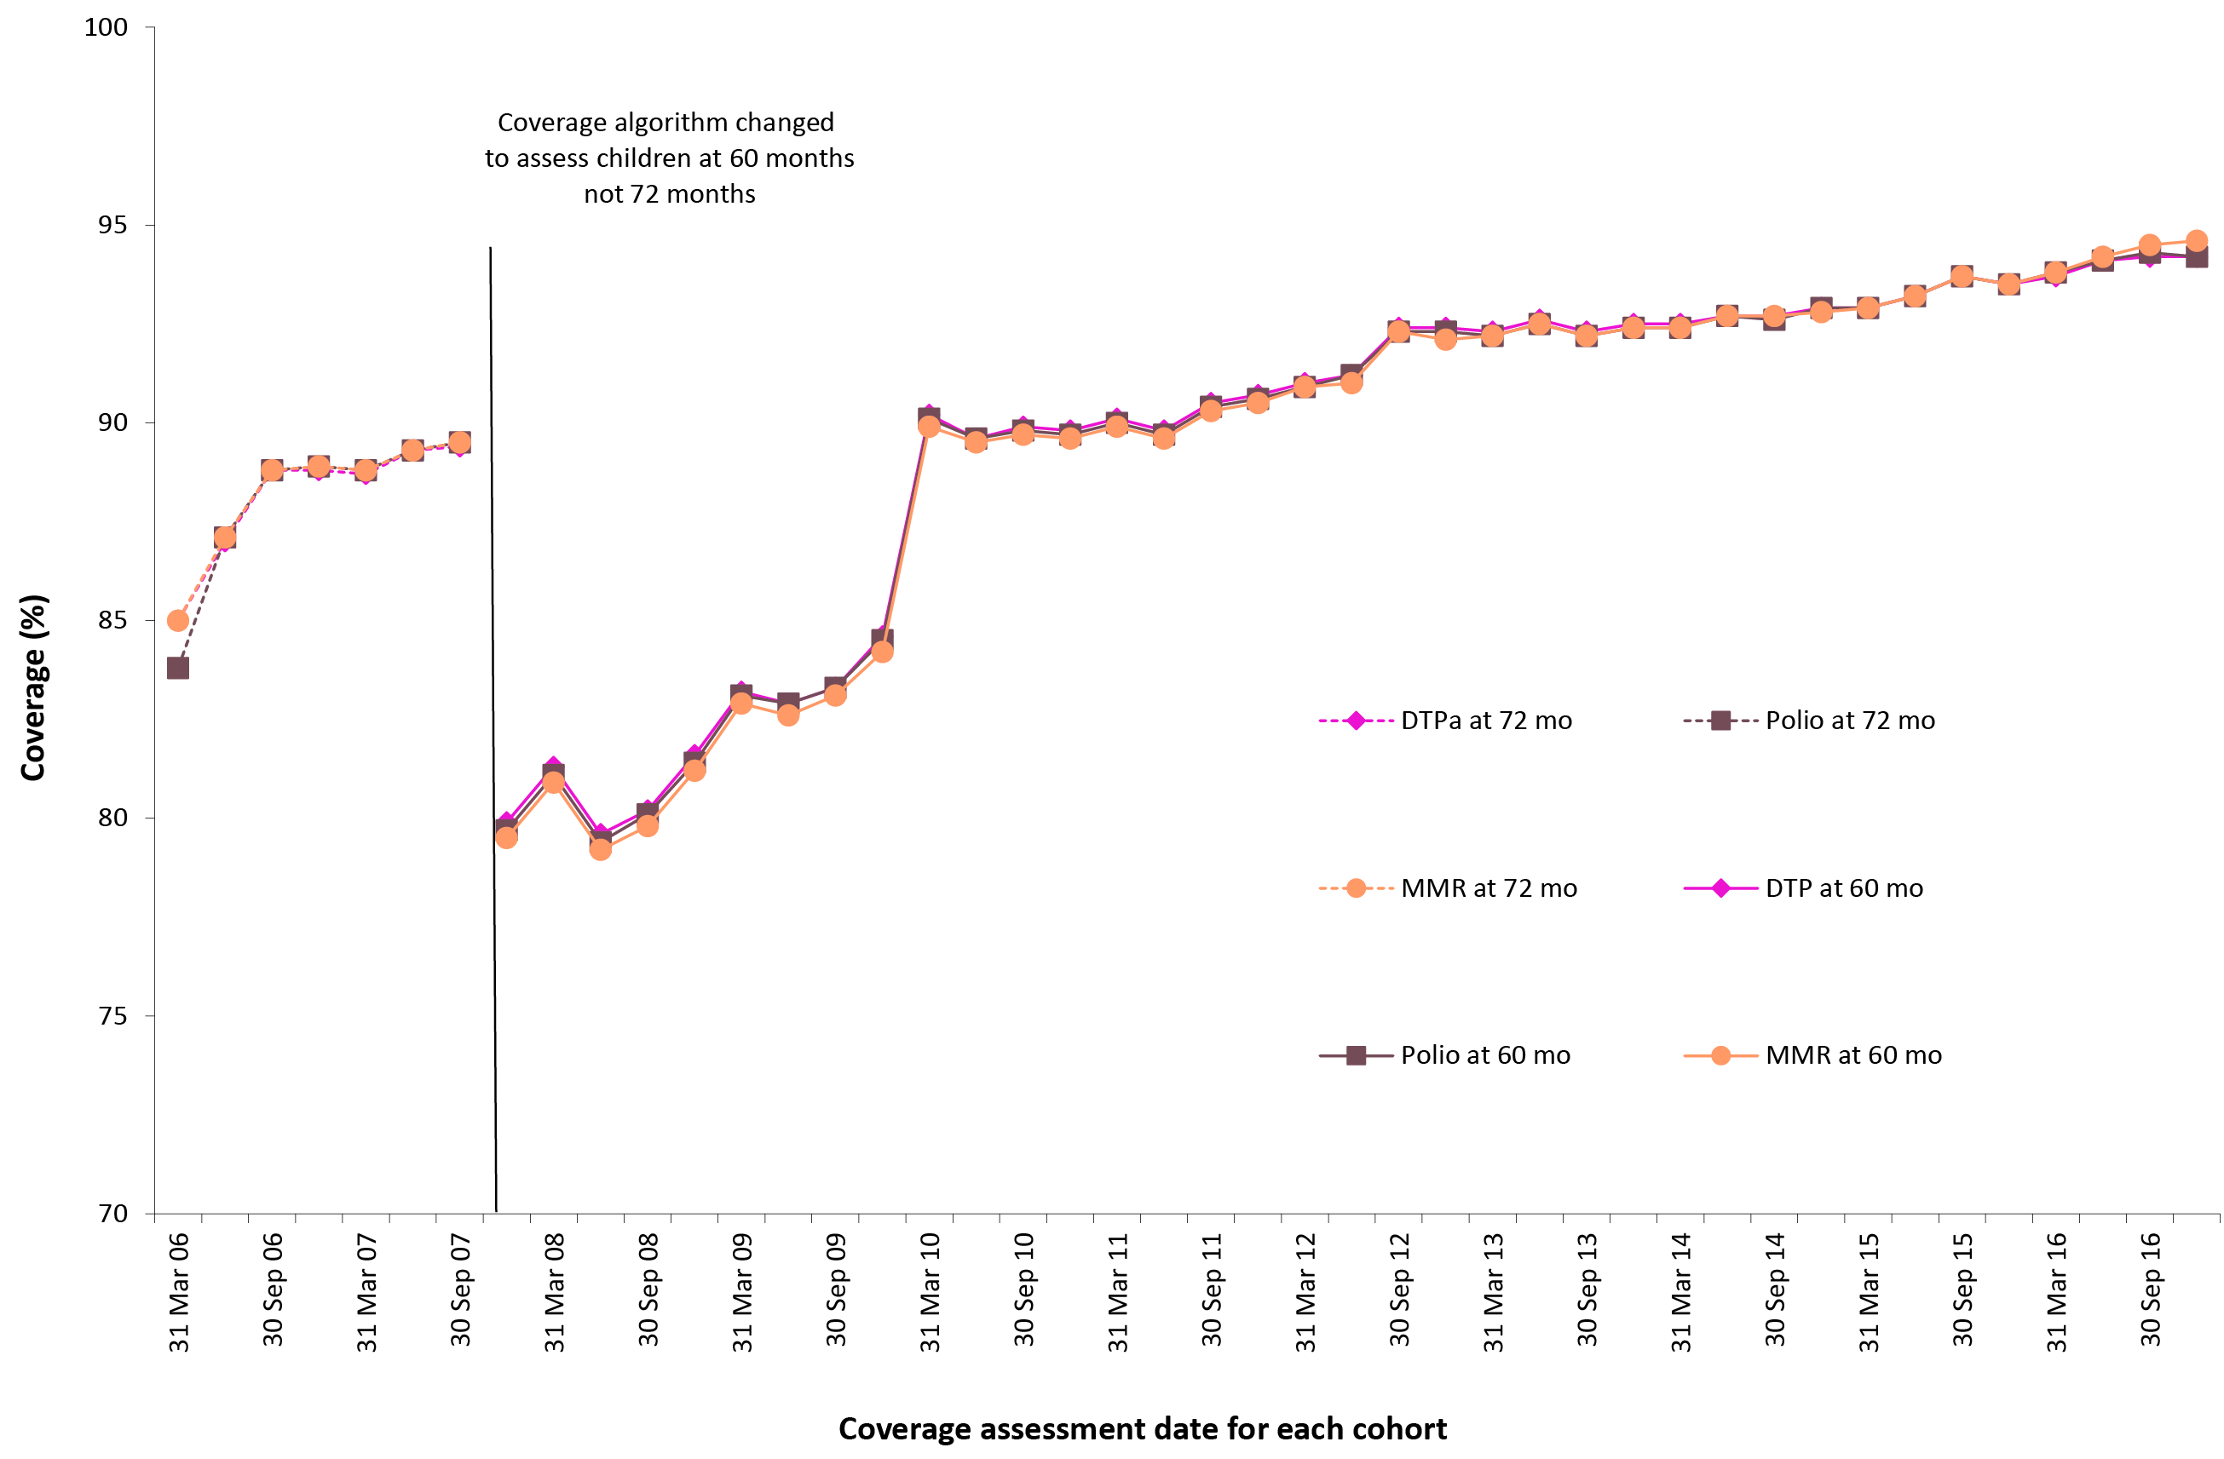
a 4th dose of DTPa and polio, 2nd dose of MMR.
b By 3-month-wide birth cohorts born between 1 January 2000 and 31 December 2011. Coverage assessment date was 72 months after the last birth date of each cohort up to December 2007 and then 60 months after the last birth date of each cohort. Source: Australian Immunisation Register, data as at 31 March 2017.
c See Appendix A for vaccine abbreviations.

Indigenous coverage estimates

‘Fully immunised’
The proportion of Indigenous children ‘fully immunised’ by 24 months of age was consistently higher than at either the 12- or 60-month milestones until 2012, when coverage at 60 months rose to comparable levels (Figures 5, 6 and 7). ‘Fully immunised’ coverage at 12 and 60 months in Indigenous children has steadily increased since 2012, reaching 92.1% and 95.4%, respectively, by the end of 2016. During the latter half of 2014, the proportion of Indigenous children ‘fully immunised’ by 24 months of age decreased by 8.5 percentage points, coinciding with the changes to the ‘fully immunised’ coverage algorithm (Figure 6). ’Fully immunised’ coverage at 24 months in Indigenous children then increased to 90.4% in mid-2016 but fell to 87.2% at the end of 2016, when the coverage assessment algorithm was amended in the last quarter of 2016 to include a 4th dose of DTPa instead of a 3rd dose.

Figure 5: Trends in ‘fully immunised’ vaccination coverage at 12 months of age,ª Indigenous compared to non-Indigenous in Australia, 2006 to 2016
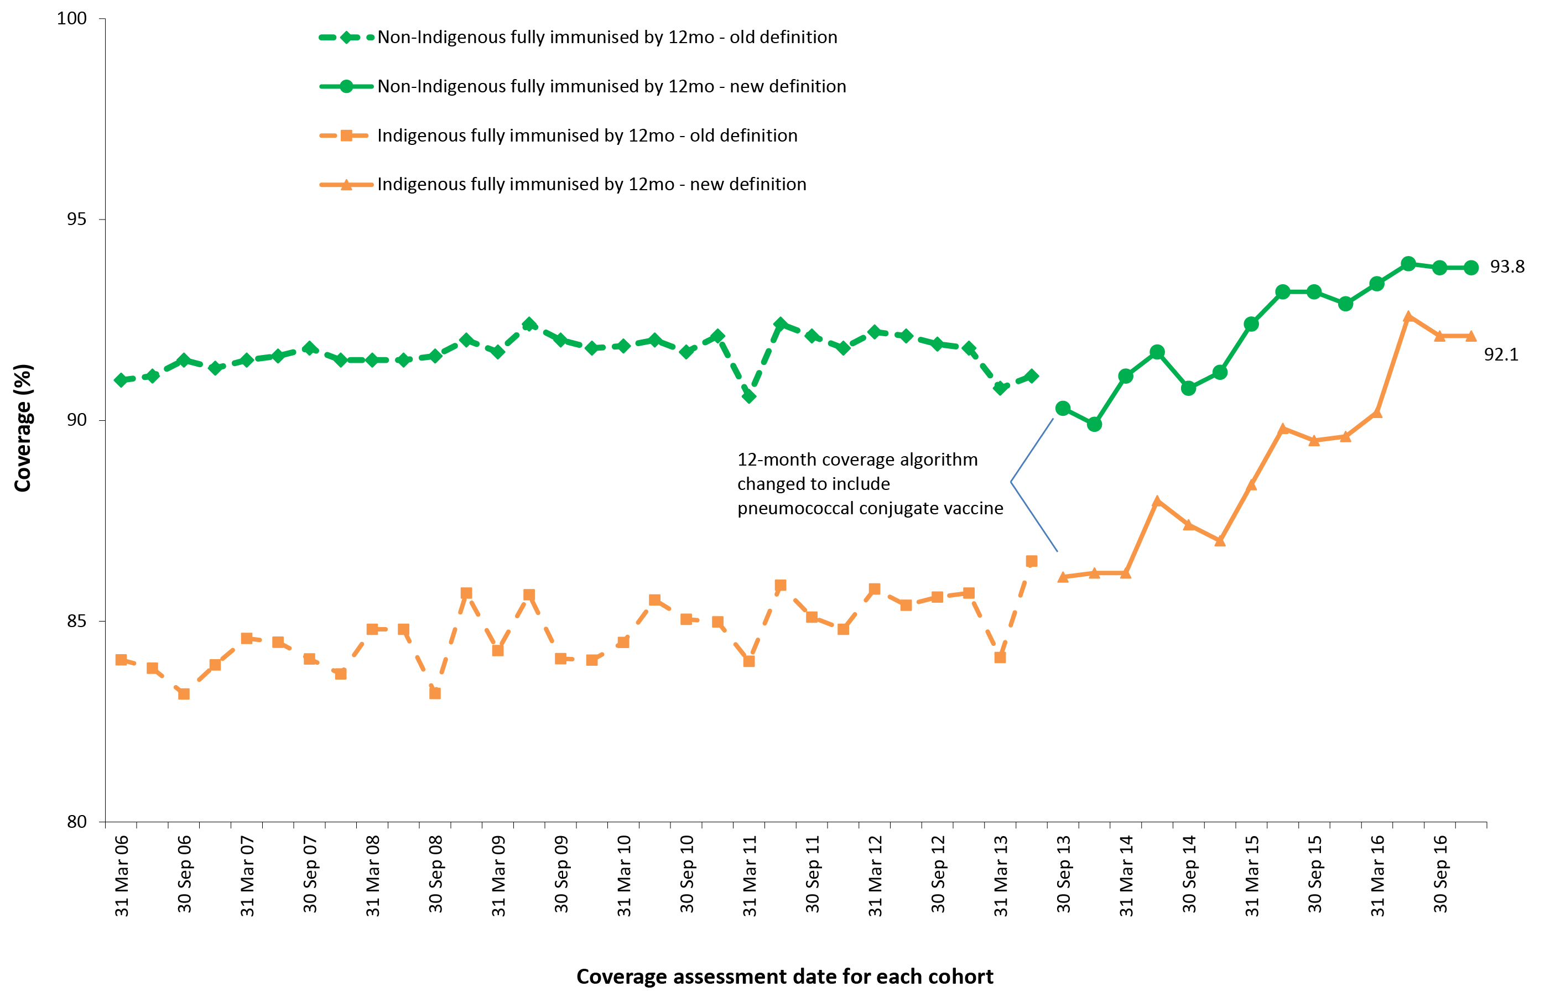
a By 3-month-wide birth cohorts born between 1 January 2005 and 31 December 2015. Coverage assessment date was 12 months after the last birth date of each cohort. Source: Australian Immunisation Register, data as at 31 March 2017.
Figure 6: Trends in ‘fully immunised’ vaccination coverage at 24 months of age,ª Indigenous compared to non-Indigenous in Australia, 2006 to 2016
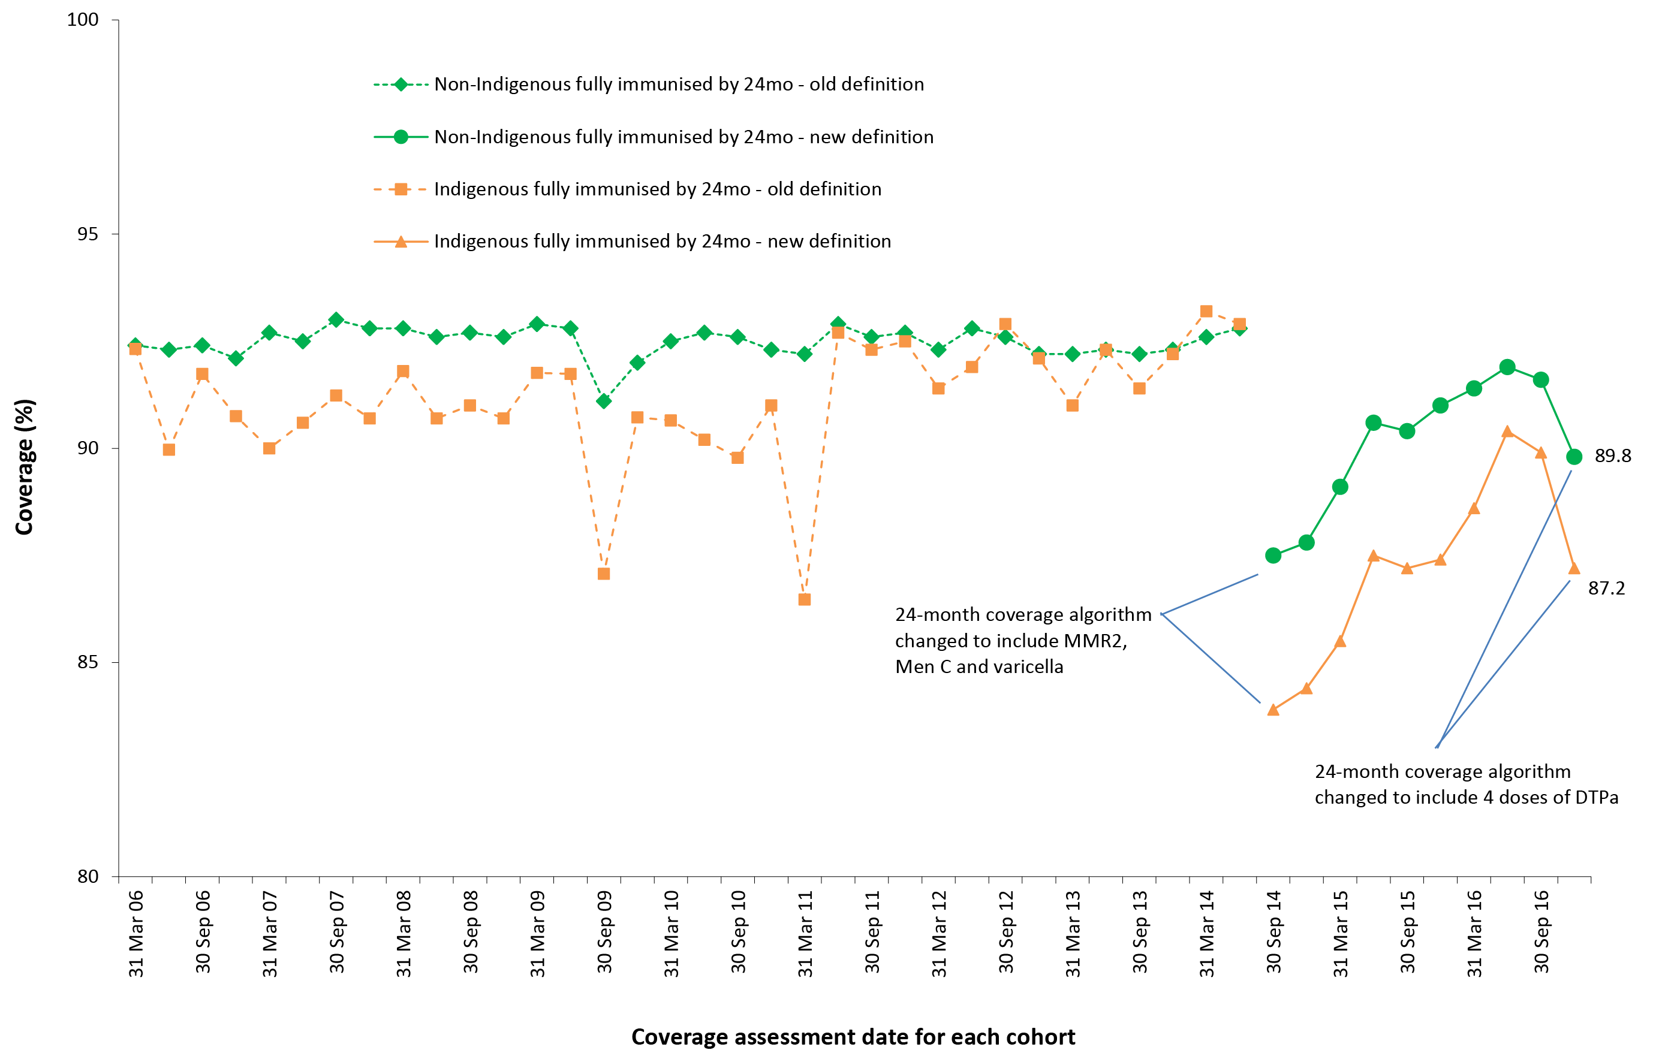
a By 3-month-wide birth cohorts born between 1 January 2004 and 31 December 2014. Coverage assessment date was 24 months after the last birth date of each cohort. Source: Australian Immunisation Register, data as at 31 March 2017.
Figure 5 shows ‘fully immunised’ vaccination coverage at 12 months of age for Indigenous children compared to non-Indigenous children. From 2006, coverage for Indigenous children tracked well below coverage for non-Indigenous children. However, from mid-2013 the gap in coverage has progressively decreased, from 6.7 percentage points in March 2013 to 1.7 percentage points in December 2016.
Figure 6 shows ‘fully immunised’ vaccination coverage at 24 months of age for Indigenous children compared to non-Indigenous children. From 2006 to early 2011, coverage for Indigenous children tracked a few percentage points below coverage for non-Indigenous children. From 2011 to mid-2014 coverage was similar for both groups. Following the amendment of the 24-month coverage algorithm in 2014 to include a 2nd dose of MMR vaccine, one dose of meningococcal C vaccine, and one dose of varicella vaccine, coverage has been considerably lower for Indigenous children, and was 2.6 percentage points lower in December 2016.
Figure 7 shows ‘fully immunised’ vaccination coverage at 60 months of age for Indigenous children compared to non-Indigenous children. From 2007 to 2011 coverage for Indigenous children tracked several percentage points below coverage for non-Indigenous children. However, from late 2012 onwards, coverage for Indigenous children has been higher than for non-Indigenous children, reaching 2.1 percentage points higher in December 2016.
Figure 7: Trends in ‘fully immunised’ vaccination coverage at 60 months of age,ª Indigenous compared to non-Indigenous in Australia, 2006 to 2016
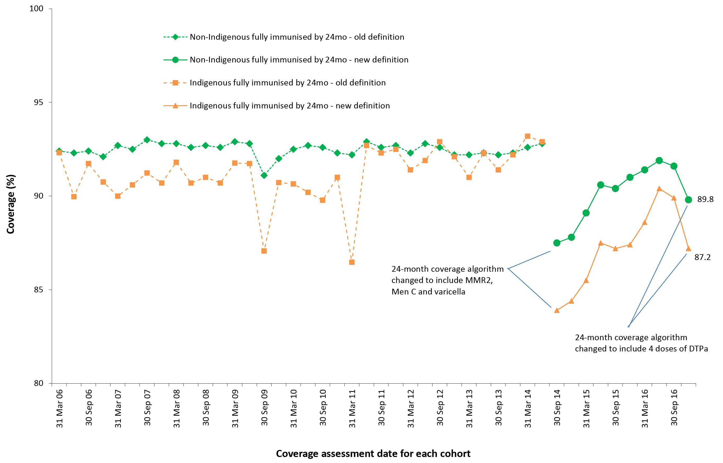
a By 3-month-wide birth cohorts born between 1 January 2000 and 31 December 2011. Coverage assessment date was 72 months after the last birth date of each cohort up to December 2007 and then 60 months after the last birth date of each cohort. Source: Australian Immunisation Register, data as at 31 March 2017.

Individual antigens within single or combination vaccines
Immunisation coverage estimates in 2016 for the three age milestones by Indigenous status and vaccine/antigen are provided in Table 2 (individual vaccine/antigen coverage). Coverage was lower for Indigenous children, compared to non-Indigenous children, for all vaccines/antigens at 12 months of age, but higher at 24 months of age for DTPa, polio, Hib, hepatitis B and meningococcal C, and higher at 60 months of age for DTPa, polio and MMR.

Table 2: Vaccination coverage estimates (%) by age assessment milestone, vaccine/antigen and Indigenous status, Australia, 12-month-wide cohorts assessed during 2016ª
Vaccine/antigen | Milestone age | Indigenous (%) | Non-Indigenous (%)
Diphtheria, tetanus, acellular pertussis | 12 months^{b} | 92.3 | 94.9
 | 24 months^{c} | 96.9 | 96.4
 | 60 months^{d} | 96.1 | 93.7
Polio | 12 months^{b} | 92.3 | 94.8
 | 24 months^{c} | 96.8 | 96.2
 | 60 months^{d} | 96.1 | 93.7
Haemophilus influenzae type b | 12 months^{b} | 92.2 | 94.6
 | 24 months^{c} | 95.8 | 94.7
 | 60 months^{d} | N/I | N/I
Hepatitis B | 12 months^{b} | 92.2 | 94.4
 | 24 months^{c} | 96.8 | 95.7
 | 60 months^{d} | N/I | N/I
Measles, mumps, rubella | 12 months^{b} | N/I | N/I
 | 24 months^{c} | 92.1 | 93.1
 | 60 months^{d} | 96.5 | 94.0
Varicella | 12 months^{b} | N/I | N/I
 | 24 months^{c} | 91.2 | 92.8
 | 60 months^{d} | N/I | N/I
Meningococcal C conjugate | 12 months^{b} | N/I | N/I
 | 24 months^{c} | 96.1 | 94.9
 | 60 months^{d} | N/I | N/I
Pneumococcal conjugate | 12 months^{b} | 92.3 | 94.2
 | 24 months^{c} | N/I | N/I
 | 60 months^{d} | N/I | N/I
Rotavirus | 12 months^{b} | 78.3 | 87.2
 | 24 months^{c} | N/I | N/I
 | 60 months^{d} | N/I | N/I
a Source: Australian Immunisation Register, data as at 31 March 2017.
b Cohort born 1 January 2015 – 31 December 2015.
c Cohort born 1 January 2014 – 31 December 2014.
d Cohort born 1 January 2011 – 31 December 2011.
N/I Not included in coverage estimates for that group.

Hepatitis A vaccine for Indigenous children
For the four jurisdictions in which hepatitis A vaccine is funded for Indigenous children (Northern Territory, Queensland, South Australia and Western Australia), combined coverage of the second dose of hepatitis A vaccine by 30 months of age was steady at close to 60% from 2010 to 2014 but then increased, reaching 72.4% by the end of 2016 (Figure 8). Coverage has consistently been highest in the Northern Territory (86.2% at the end of 2016). By late 2016, coverage was greater than 64% in all jurisdictions (Figure 8).
Figure 8: Trends in coverage estimates for hepatitis Aª vaccine for Indigenous children by jurisdiction,^{b} Australia, 2007 to 2016
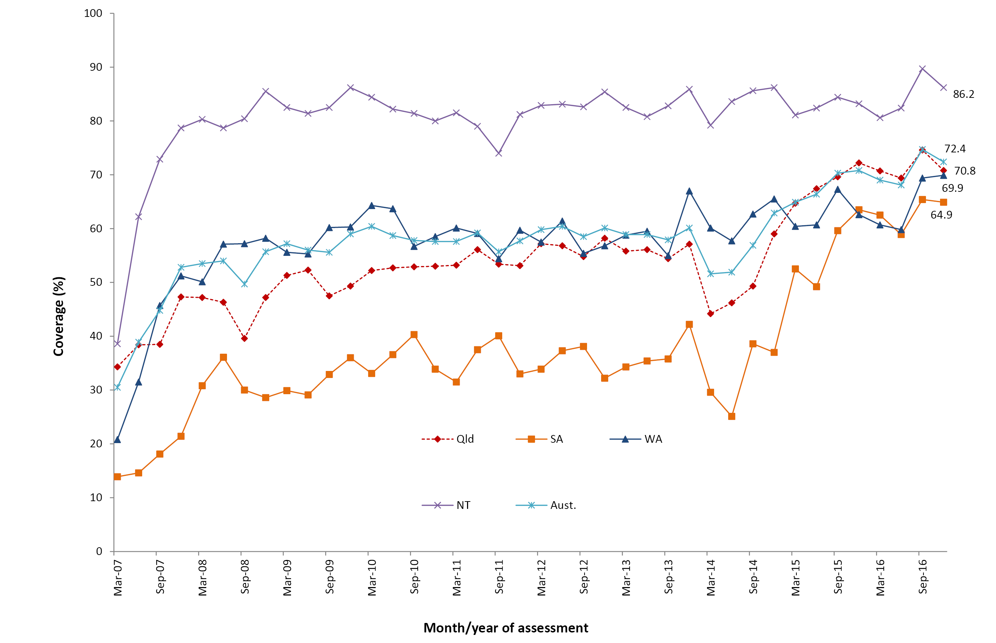
a 18-month dose assessed at 30 months of age in all four jurisdictions. Source: Australian Immunisation Register, data as at 31 March 2017.
b Northern Territory (NT), Queensland (Qld), South Australia (SA) and Western Australia (WA) only. Aust. = NT + Qld + SA + WA.

Pneumococcal vaccine for Indigenous children
For the four jurisdictions in which an 18-month booster dose of pneumococcal conjugate vaccine is funded for Indigenous children (Northern Territory, Queensland, South Australia and Western Australia) combined coverage increased following the 13vPCV catch-up campaign in 2012, fell in 2013, but then increased again reaching 74.3% by the end of 2016 (Figure 9). Coverage has consistently been highest in the Northern Territory (86.5% at the end of 2016). By late 2016, coverage was greater than 68% in all jurisdictions (Figure 9).
Figure 9: Trends in coverage estimates for pneumococcalª vaccine for Indigenous children by jurisdiction,^{b} Australia, 2007 to 2016
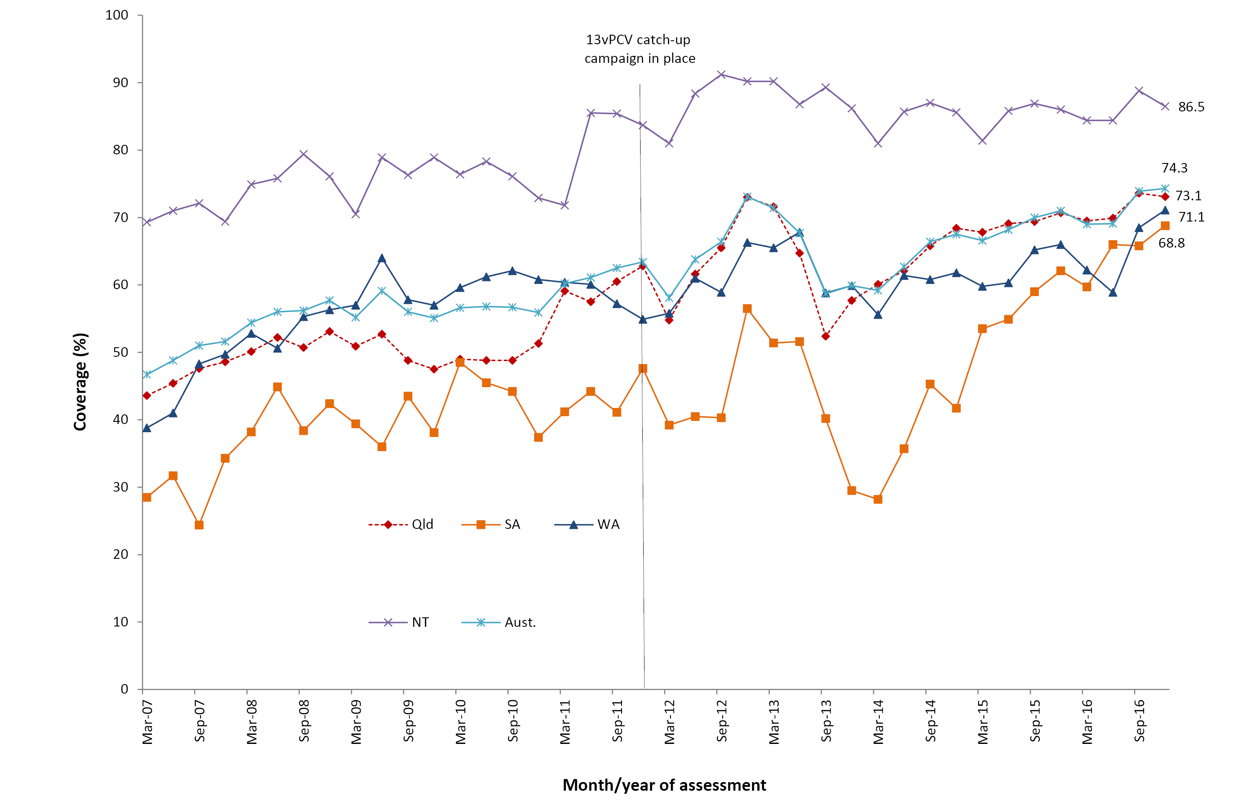
a 18-month booster dose assessed at 30 months of age in all four jurisdictions. Source: Australian Immunisation Register, data as at 31 March 2017. See Appendix A for vaccine abbreviations.
b Northern Territory (NT), Queensland (Qld), South Australia (SA) and Western Australia (WA) only. Aust. = NT + Qld + SA + WA

Recorded influenza vaccine coverage for Indigenous children aged 6 months to <5 years
Recorded influenza vaccine coverage in Indigenous children aged 6 months to <5 years was generally low across Australia in 2016, with overall national coverage of 11.6%. There was substantial variation in recorded coverage between the jurisdictions (Figure 10). Apart from the Northern Territory (55.5%), coverage was only above 10% in Queensland and Western Australia (12.6% and 12.2%, respectively). For non-Indigenous children aged 6 months to <5 years, coverage of the seasonal influenza vaccine in 2016 was recorded as 2.7% in Australia, and coverage in all jurisdictions was below 10% (Figure 10).

Figure 10: Recorded coverage of any dose of seasonal influenza vaccineª administered during 2016 to children aged 6 months to less than 5 years, by Indigenous status and jurisdiction^{b}
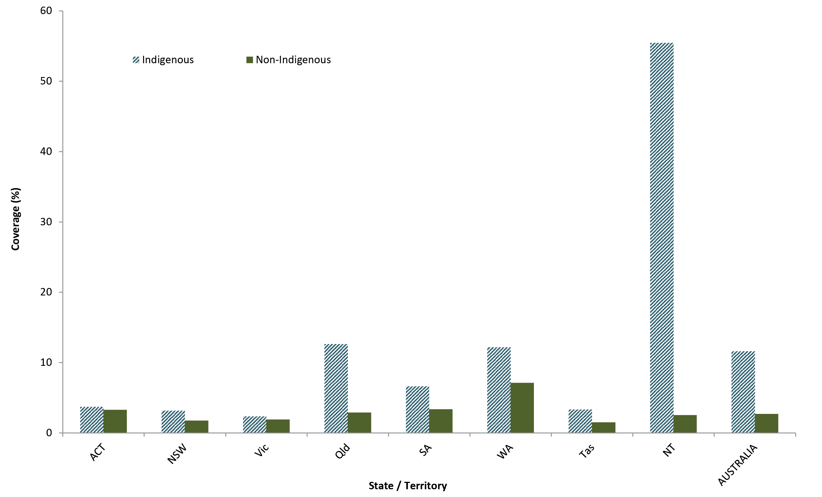
a Any influenza vaccine dose. Source: Australian Immunisation Register, data as at 31 March 2017.
b ACT = Australian Capital Territory; NSW = New South Wales; NT = Northern Territory; Qld = Queensland; SA = South Australia; Tas = Tasmania; Vic = Victoria; WA = Western Australia.
There was also substantial variation in 2016 in influenza vaccine coverage by age within the 6 months to <5 years age group of Indigenous children (Figure 11). Coverage at a national level was highest in the youngest age group (6 months to <1 year; 15.1%) and lowest in the oldest age group (4–<5 years; 8.0%). Lower coverage in the 2–<3 year age group, compared to the 3–<4 year age group, may reflect the lack of any scheduled vaccination milestones in the former.
Figure 11: Recorded coverage of any dose of seasonal influenza vaccineª administered during 2016 to Indigenous children aged 6 months to less than 5 years, by jurisdiction^{b} and age group
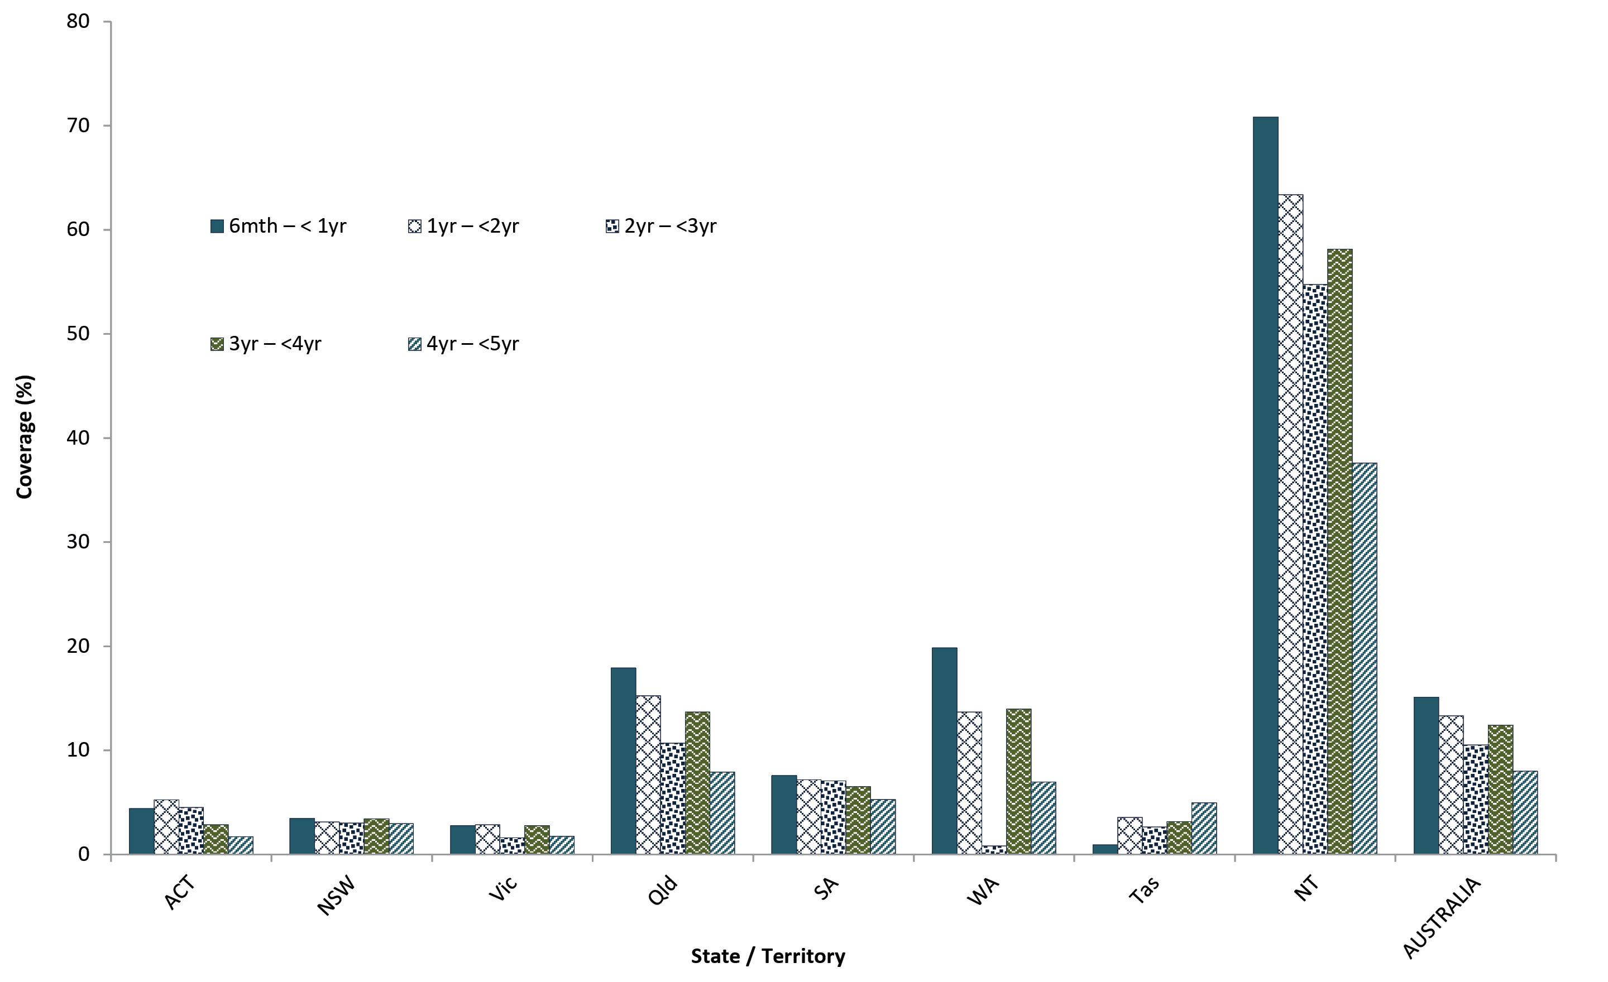
a Any influenza vaccine dose. Source: Australian Immunisation Register, data as at 31 March 2017.
b ACT = Australian Capital Territory; NSW = New South Wales; NT = Northern Territory; Qld = Queensland; SA = South Australia; Tas = Tasmania; Vic = Victoria; WA = Western Australia.
Figure 12 shows the time trend of seasonal influenza vaccine coverage recorded on the AIR between 2007 and 2016 for Indigenous children aged 6 months to <5 years, by jurisdiction. Coverage in Western Australia peaked at 28% in 2009 following the introduction in 2008 of a state-funded universal immunisation program for all children aged 6 months to <5 years. However, it was substantially lower in subsequent years due to suspension of the program in 2010 following increased febrile reactions, later shown to be related to a single brand of influenza vaccine. Following the commencement of the nationally funded program for Indigenous children aged 6 months to <5 years in 2015, seasonal influenza vaccine coverage rose to 12.1% nationally in 2015, with a slight decrease to 11.6% in 2016 (Figure 12). Similar upward trends in coverage over time were seen for all jurisdictions, but coverage remains highest in the Northern Territory, Queensland and Western Australia. Compared with 2014, influenza vaccine coverage in 2016 has increased almost 12-fold in the Northern Territory and 5-fold in Queensland.

Figure 12: Trends in recorded coverage of any dose of seasonal influenza vaccineª amongst Indigenous children aged 6 months to less than 5 years, by jurisdiction,^{b} 2007–2016
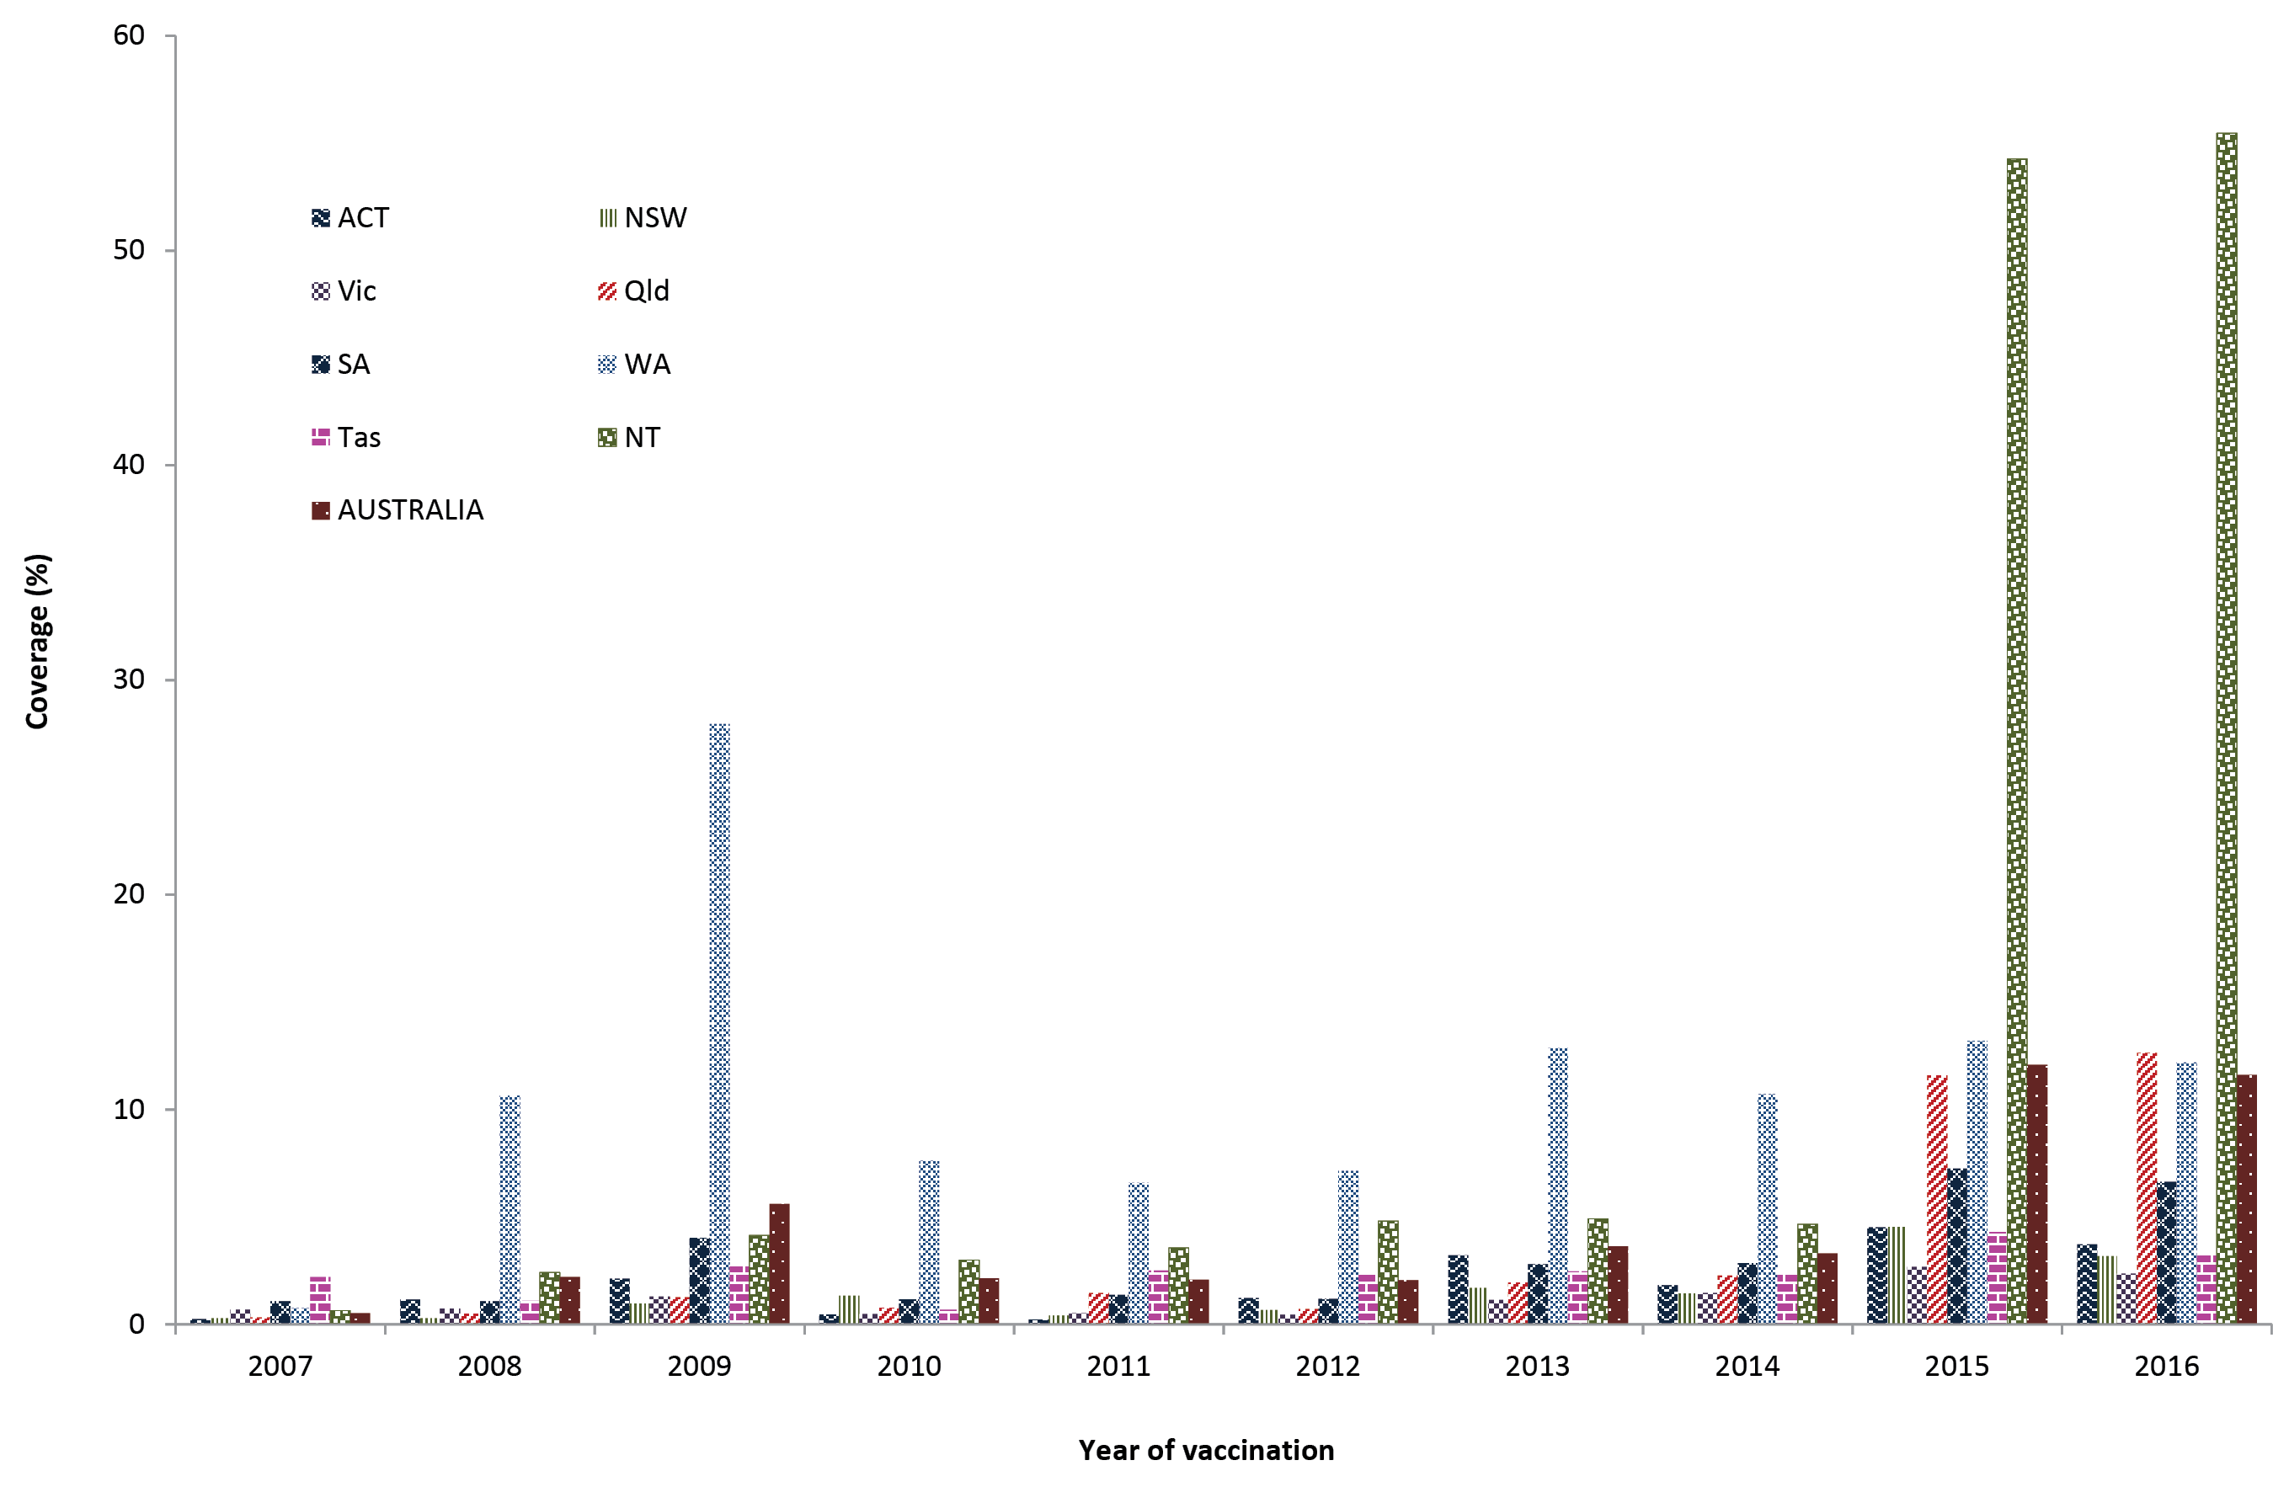
a Any influenza vaccine dose. Source: Australian Immunisation Register, data as at 31 March 2017.
b ACT = Australian Capital Territory; NSW = New South Wales; NT = Northern Territory; Qld = Queensland; SA = South Australia; Tas = Tasmania; Vic = Victoria; WA = Western Australia.
Figure 13 shows the percentage of influenza vaccines given to Indigenous children aged 6 months – <5 years at/not at the same time as other scheduled vaccinations. More than half received their first reported dose of influenza vaccine on a separate day to other scheduled vaccines. This proportion increased with subsequent doses. This likely reflects subsequent doses being predominantly given at older ages where there are less scheduled vaccination points. Of those receiving an influenza vaccine on the same day as other scheduled vaccines, the largest proportion was administered with vaccines due at the 4-year-old milestone. This may reflect less frequent visits of older children to providers, and hence less opportunities for vaccination at other times.
Figure 13: Proportion of influenza vaccinations administered to Indigenous children aged 6 months to less than 5 years of age at/not at same time as scheduled vaccinations, Australia, 2016ª
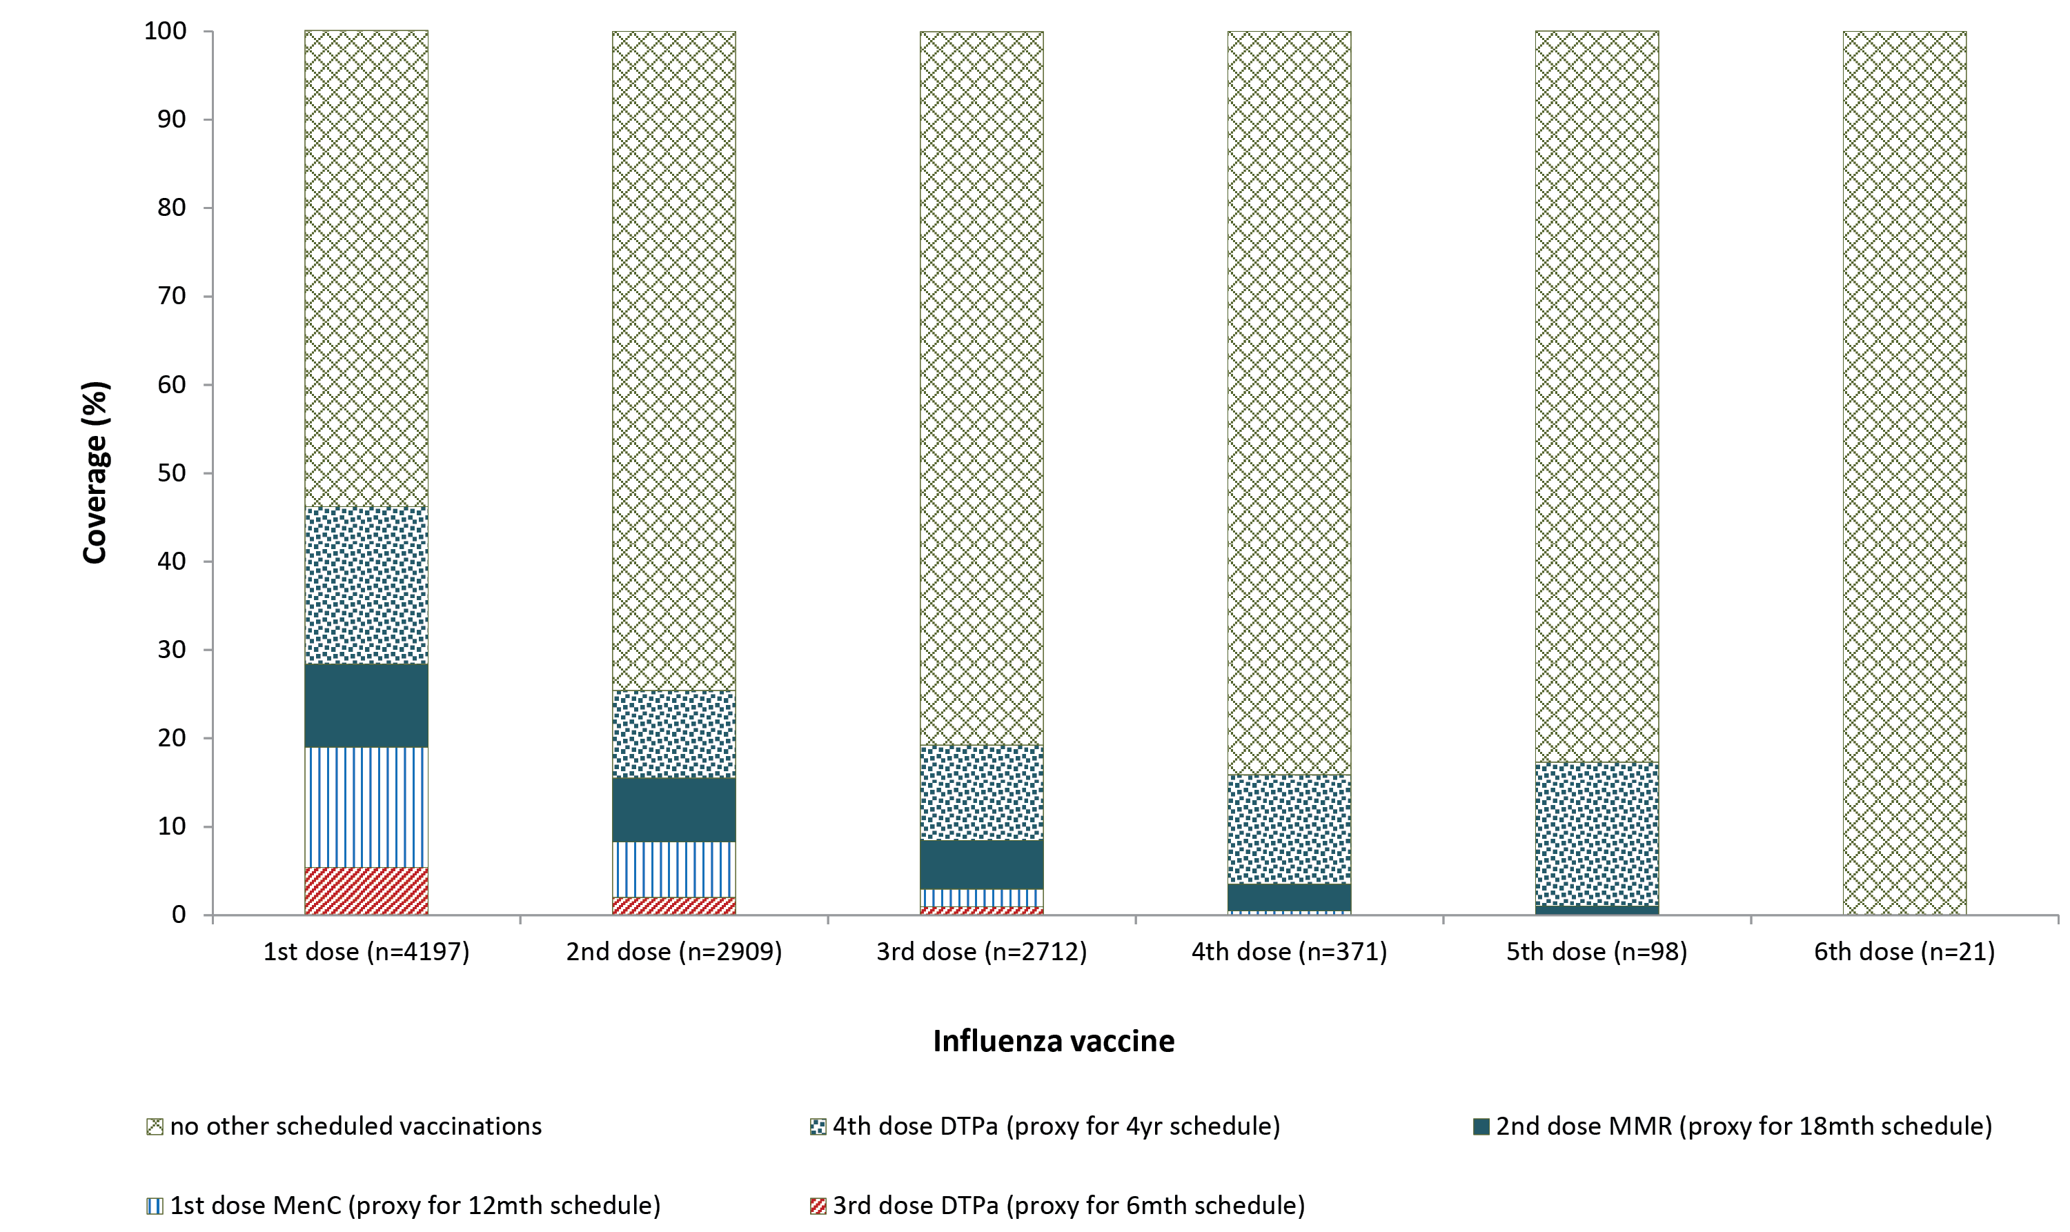
a Source: Australian Immunisation Register, data as at 31 March 2017. See Appendix A for vaccine abbreviations.

Timeliness of immunisation
Timeliness for the 2nd and 3rd doses of DTPa by Indigenous status is shown in Figure 14. The differential between Indigenous and non-Indigenous children was 13.6% and 17.5% lower, respectively. The differential for the 3rd dose of DTPa was 0.9 of a percentage point lower compared to 2015.
Figure 14: Timelinessª of the second and third doses of DTPa vaccines, by Indigenous status, Australia, 2016^{b}
Second dose (DTPa2)
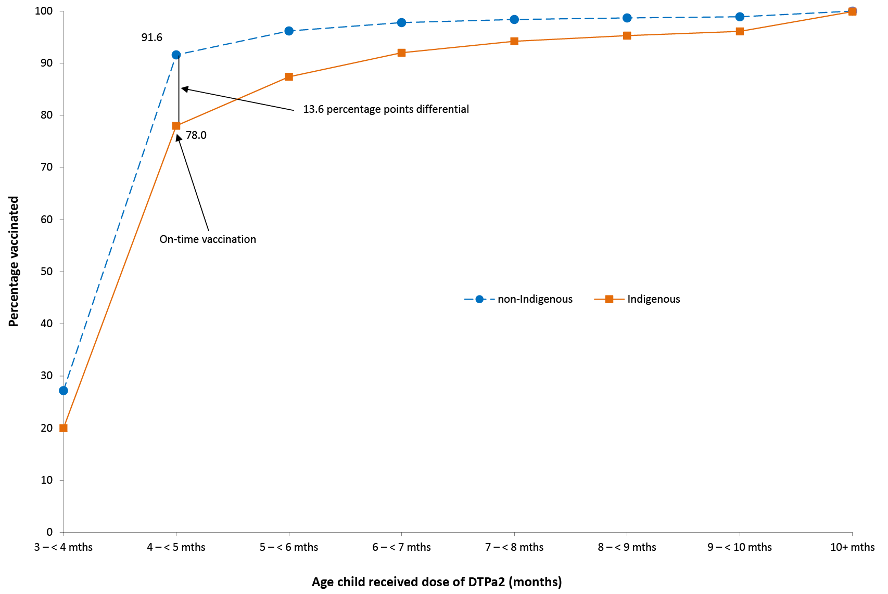
Third dose (DTPa3)
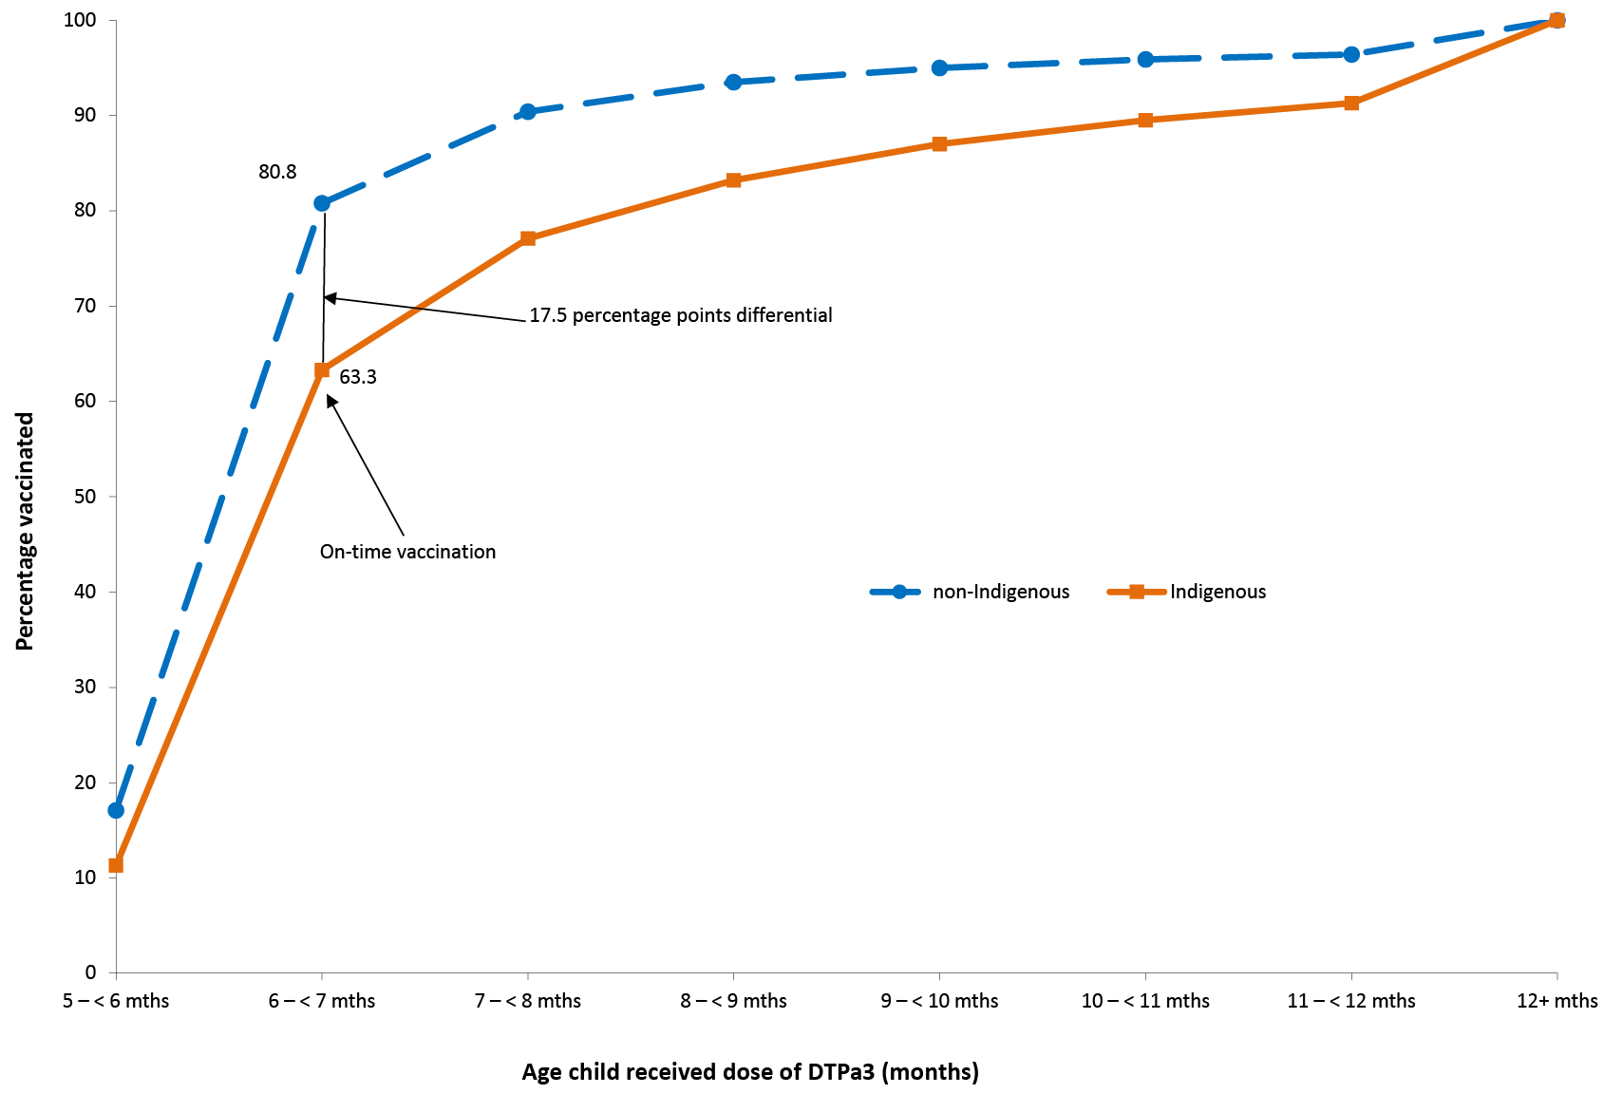
a Percentage vaccinated = number of children who received vaccine dose at particular ages / the total number of children who received the vaccine dose, expressed as a percentage. Source: Australian Immunisation Register, data as at 31 March 2017.
b Cohort born in 2014.
Similar patterns were found for timeliness of the 1st dose of MMR vaccine by 13 months of age and the 2nd dose of MMR vaccine by 19 months of age (Figure 15), although the differentials were smaller (11.5% and 15.7% for the 1st and 2nd dose, respectively). The differential for the 1st dose of MMR was 0.2 of a percentage point lower compared to 2015, while the differential for the 2nd dose of MMR was unchanged.
Figure 15: Timelinessª of the first dose and second dose of MMR vaccines, by Indigenous status, Australia, 2016^{b}
First dose (MMR1)
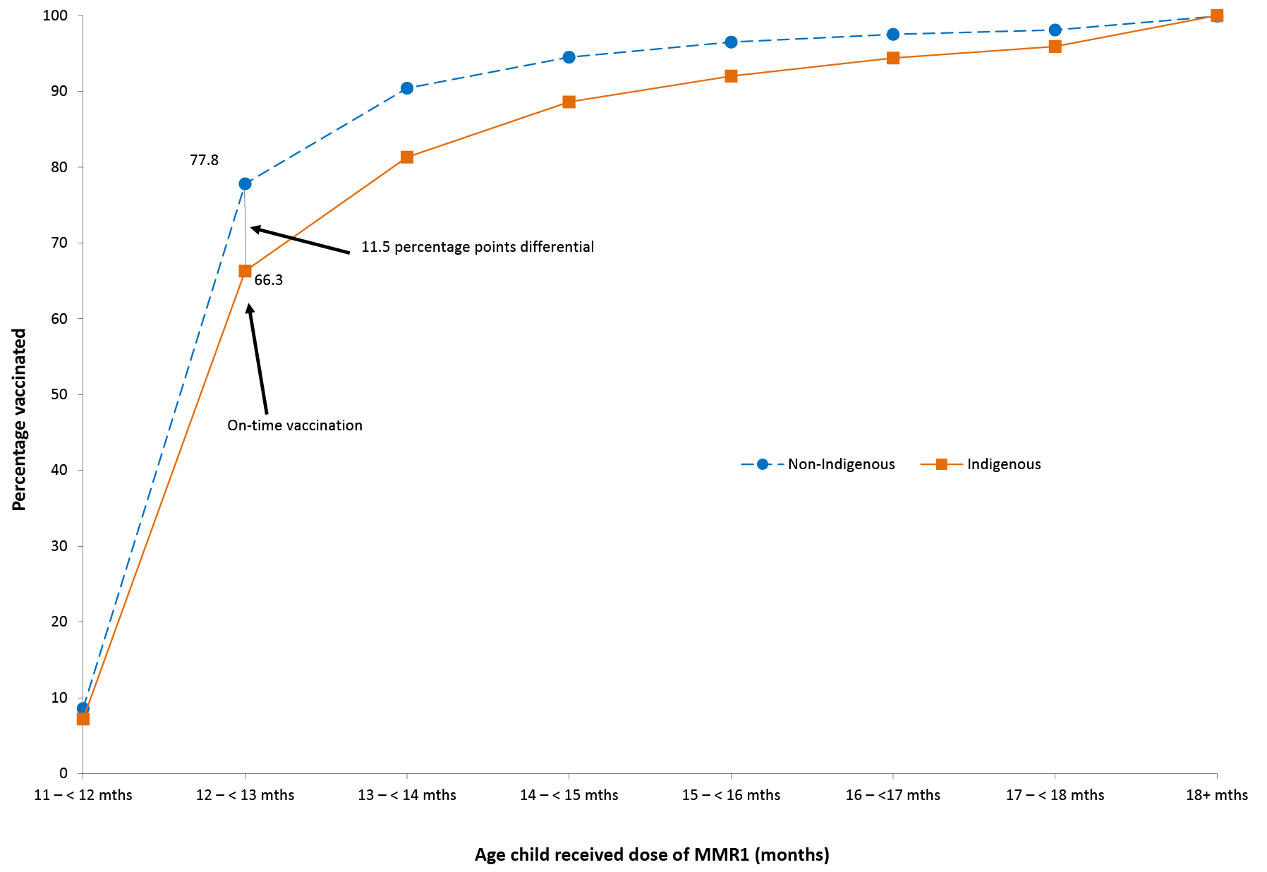
Second dose (MMR2)
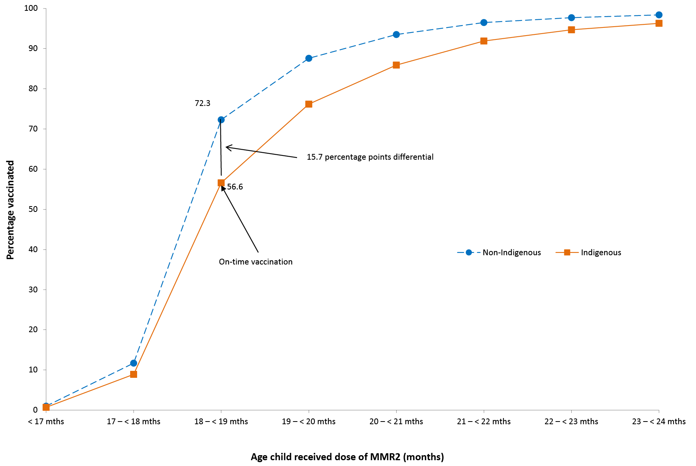
a Percentage vaccinated = number of children who received vaccine dose at particular ages / the total number of children who received the vaccine dose, expressed as a percentage. Source: Australian Immunisation Register, data as at 31 March 2017.
b Cohort born in 2014.
Delayed receipt of the 3rd dose of DTPa, the 1st dose of MMR, and the 2nd dose of MMR vaccines by Indigenous and remoteness status in 2016 is shown in Table 3. For both Indigenous and non-Indigenous children, the majority of delay occurred 1 – <3 months after the schedule point for all three vaccine doses, and across all remoteness categories. The proportion of Indigenous children living in major cities with a delay of 1 – <3 months for the 3rd dose of DTPa and the 2nd dose of MMR was lower compared to Indigenous children living in remote and very remote areas (18.6% vs. 23.3%, and 23.8% vs. 26.9%, respectively), but the proportion with very late vaccination (≥7 months after the schedule point) was higher (7.1% vs. 5.9% and 7.3% vs. 5.8%, respectively) (Table 3).
Table 3: Vaccination delay, by Indigenous and remoteness status, Australia, 2016ª
Vaccine dose | Indigenous status | Remoteness category | 1 – < 3 months after schedule point (%) | 3 – < 7 months after schedule point (%) | ≥7 months after schedule point (%)
DTPa3^{b,c} | Indigenous | Major Cities | 18.6 | 8.6 | 7.1
 |  | Inner and Outer Regional | 19.5 | 9.7 | 7.8
 |  | Remote and Very Remote | 23.3 | 12.0 | 5.9
 | Non-Indigenous | Major Cities | 12.4 | 3.3 | 3.3
 |  | Inner and Outer Regional | 13.4 | 3.9 | 2.9
 |  | Remote and Very Remote | 12.9 | 3.1 | 2.1
MMR1^{b,c} | Indigenous | Major Cities | 22.2 | 8.6 | 2.9
 |  | Inner and Outer Regional | 23.5 | 8.6 | 2.9
 |  | Remote and Very Remote | 22.5 | 9.0 | 3.0
 | Non-Indigenous | Major Cities | 17.2 | 4.3 | 1.3
 |  | Inner and Outer Regional | 17.5 | 4.2 | 1.3
 |  | Remote and Very Remote | 17.7 | 4.0 | 1.1
MMR2^{c,d} | Indigenous | Major Cities | 23.8 | 10.9 | 7.3
 |  | Inner and Outer Regional | 24.2 | 12.6 | 7.3
 |  | Remote and Very Remote | 26.9 | 13.1 | 5.8
 | Non-Indigenous | Major Cities | 18.2 | 5.3 | 1.3
 |  | Inner and Outer Regional | 19.4 | 5.9 | 3.5
 |  | Remote and Very Remote | 19.3 | 6.2 | 2.9
a Source: Australian Immunisation Register, data as at 31 March 2017.
b The cohort of children born in 2014 and assessed in 2016.
c DTPa3 = third dose of diphtheria, tetanus, acellular pertussis vaccine; MMR1, MMR2 = first and second dose of measles, mumps, rubella vaccine
d The cohort of children born in 2013 and assessed in 2016.
Vaccination delay for Indigenous children by jurisdiction in 2016 was measured for the 3rd dose of PCV (Figure 16), with the highest proportions experiencing delay of 1 – <3 months found in Western Australia (23.8%) and the Northern Territory (23.2%). The proportion with delay of 3 – <7 months ranged from 3.1% in the Australian Capital Territory to 14.0% in Western Australia, and the proportion with delay of ≥7 months ranged from 2.4% in Tasmania to 7.9% in Western Australia.

Figure 16: Vaccination delay for Indigenous children for the 3rd dose of pneumococcal conjugate vaccine, by state or territory, Australia, 2016ª
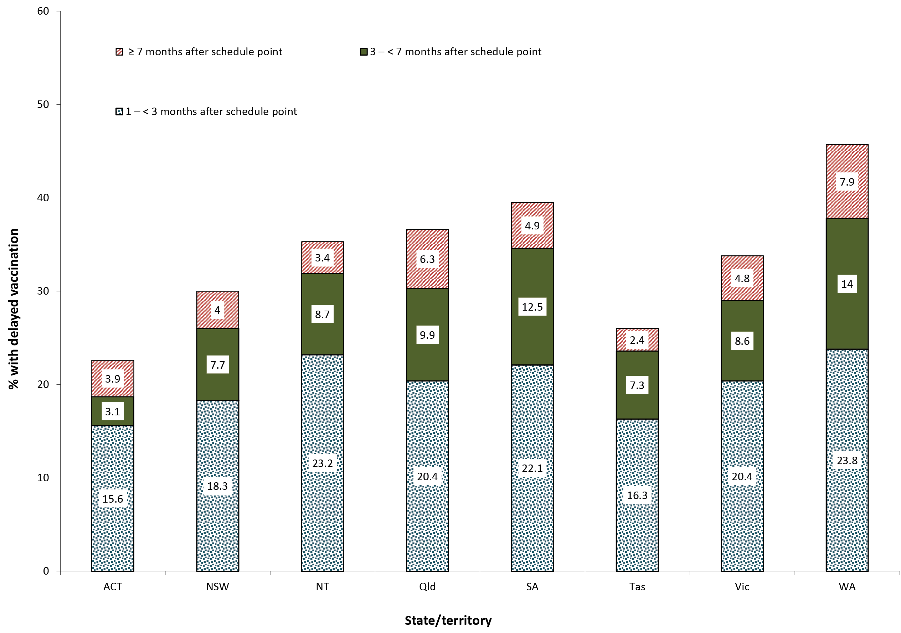
a ACT = Australian Capital Territory; NSW = New South Wales; NT = Northern Territory; Qld = Queensland; SA = South Australia; Tas = Tasmania; Vic = Victoria; WA = Western Australia.

Figure 17: Pneumococcal conjugate vaccine coverage at 12 months of age (three doses) by SA3, Australia and major capital cities, 2016
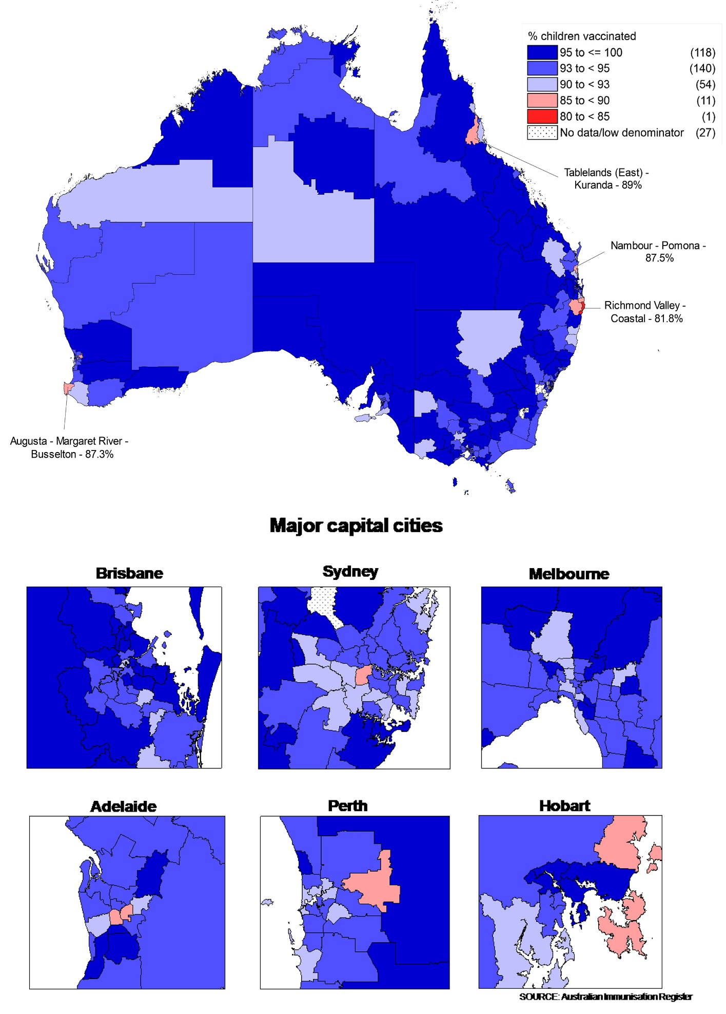

Figure 18: Measles, mumps, rubella (MMR) coverage at 24 months of age (two doses) by SA3, Australia and major capital cities, 2016
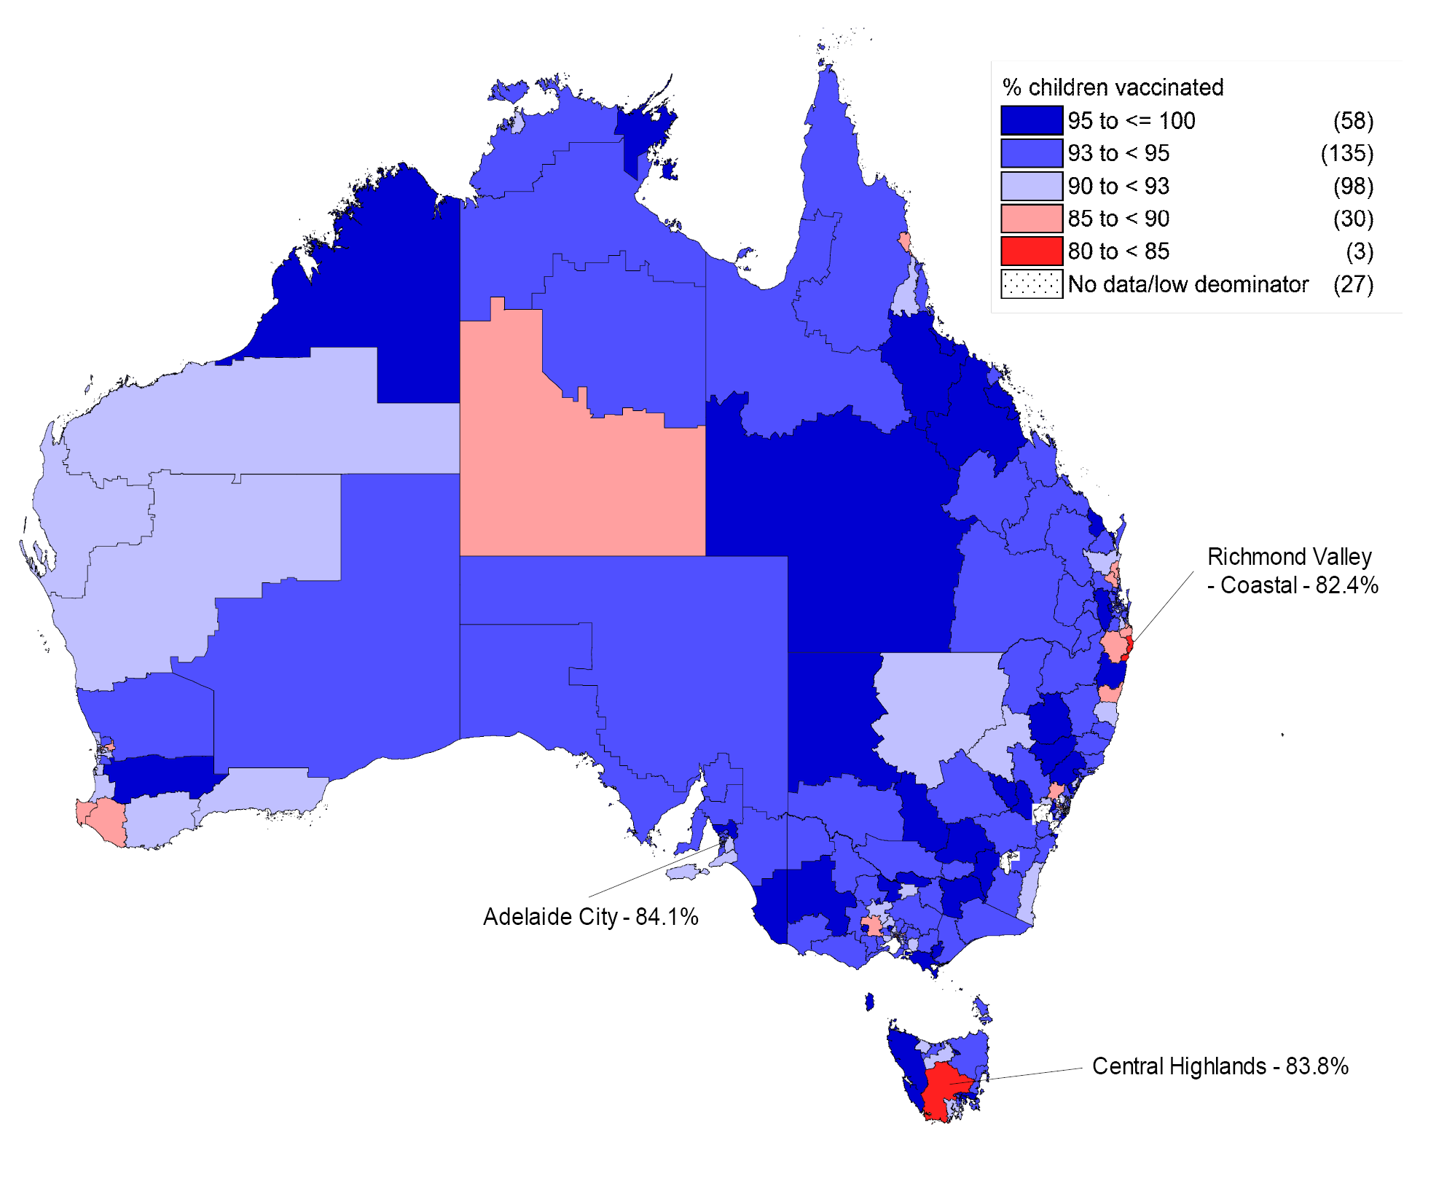
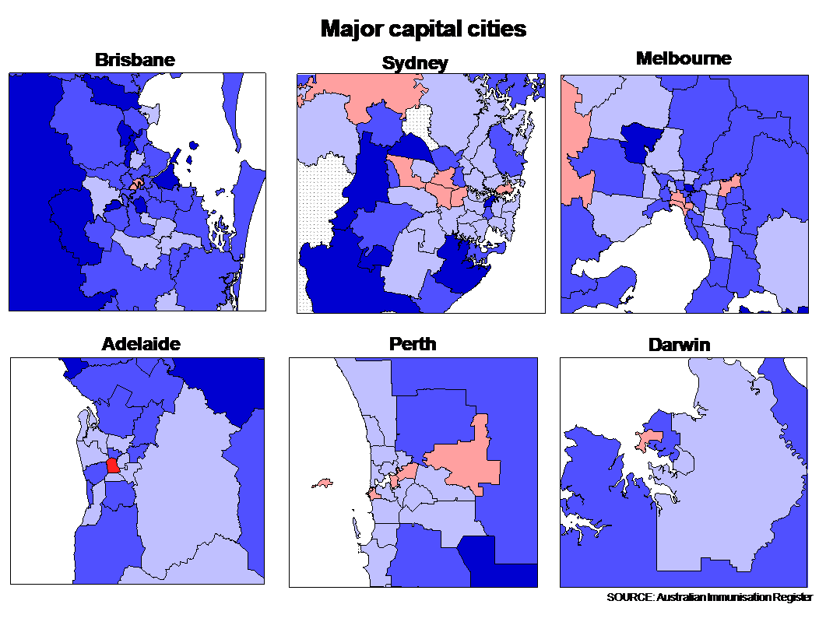
Figure 19: Diphtheria, tetanus, acellular pertussis (DTPa) coverage at 24 months of age (four doses) by SA3, Australia and major capital cities, 2016 (cohort of children born 1 October – 31 December 2014 due 4 doses of DTPa)
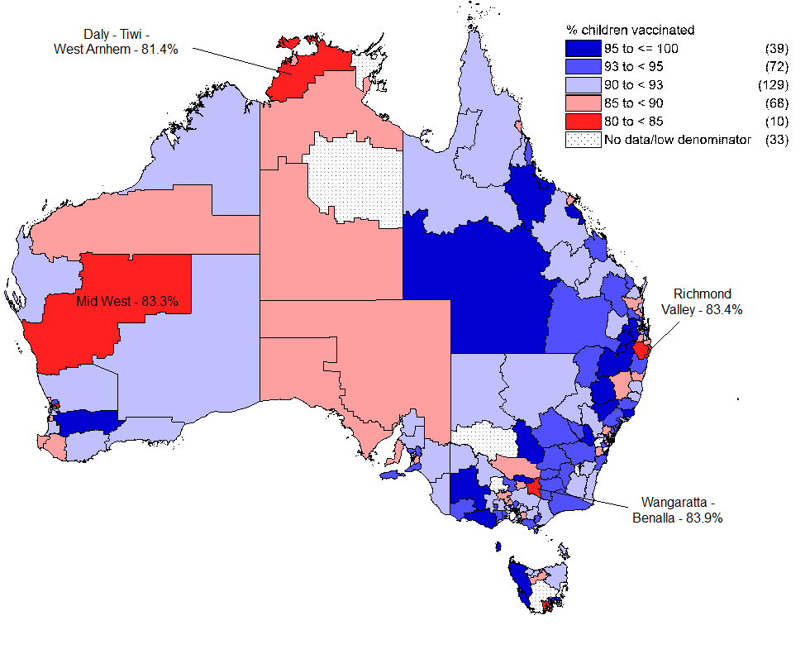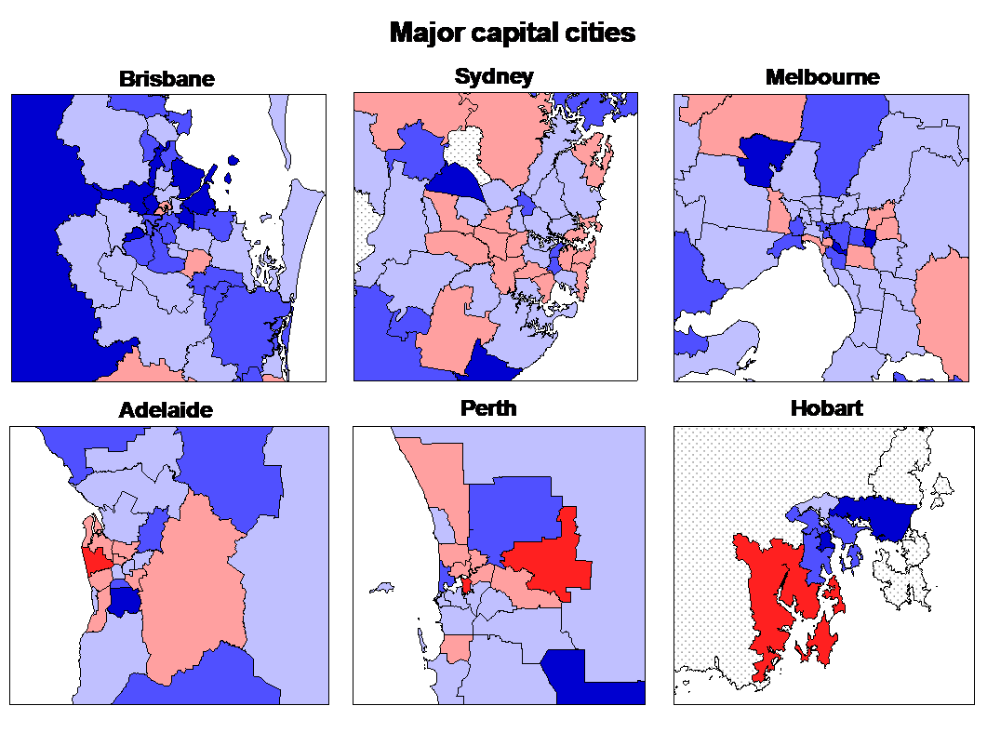

Small area coverage analysis
Immunisation coverage in Australia in 2016 varied substantially within jurisdictions and major capital cities, with some areas substantially below the national averages, especially for vaccines due at an older age (Figures 17–19). For the fourth dose of DTPa by 24 months of age, there were ten SA3s with coverage below 85% (Figure 19).

Adolescent immunisation catch-up coverage for 2nd dose of MMR
Table 4 shows 2nd dose MMR catch-up coverage estimates for adolescents aged 10–19 years of age recorded as not having received a second dose of MMR vaccine prior to the introduction of the ‘No Jab No Pay’ policy on 1 January 2016, who received their 2nd dose of MMR during 2016, by jurisdiction. For Australia, 43,103 (10.5%) of the 411,157 adolescents aged 10–19 years recorded as not having received MMR2 by 31 December 2015 received a catch-up 2nd dose of MMR vaccine during 2016. This proportion varied by jurisdiction, from 7.3% in the Australian Capital Territory to 16.3% in South Australia.

Table 4: Catch-up coverage for adolescents aged 10–19 years of age not recorded as having received their second dose of MMR (MMR2) prior to 1 January 2016 who received MMR2 during 2016, by state or territory, Australia^{a,b}
 | State or territory^{c}
 | ACT | NSW | NT | Qld | SA | Tas | Vic | WA | Australia
MMR2 encounters | 466 | 10,880 | 415 | 9,690 | 4,559 | 814 | 11,140 | 5,139 | 43,103
MMR2 % | 7.3 | 8.8 | 8.7 | 10.5 | 16.3 | 13.5 | 12.6 | 8.3 | 10.5
a Cohort born 1 April 1997 – 31 March 2007, vaccinations given 1 January – 31 December 2016.
b Source: Australian Immunisation Register, data as at 31 March 2017.
c ACT = Australian Capital Territory; NSW = New South Wales; NT = Northern Territory; Qld = Queensland; SA = South Australia; Tas = Tasmania; Vic = Victoria; WA = Western Australia.

Medical contraindication exemptions
Figure 20 shows the trends in the number of children aged 6 months to less than 10 years with at least one new vaccination exemption due to a medical contraindication or a natural immunity entered into the AIR during each year, by state/territory, from 2011 to 2016. From 2011 to 2015 there was a clear trend of increasing numbers of exemptions. Exemptions more than doubled in 2015 compared with 2014 (635 to 1,401), but decreased in all jurisdictions in 2016. The highest numbers of exemptions were in New South Wales, Victoria and Queensland.

Figure 20: Trends in the number of children aged 6 months to less than 10 years with at least one new vaccination exemption due to medical contraindication or natural immunity entered into the Australian Immunisation Register during each year, 2011–2016, by state/territory, Australiaª
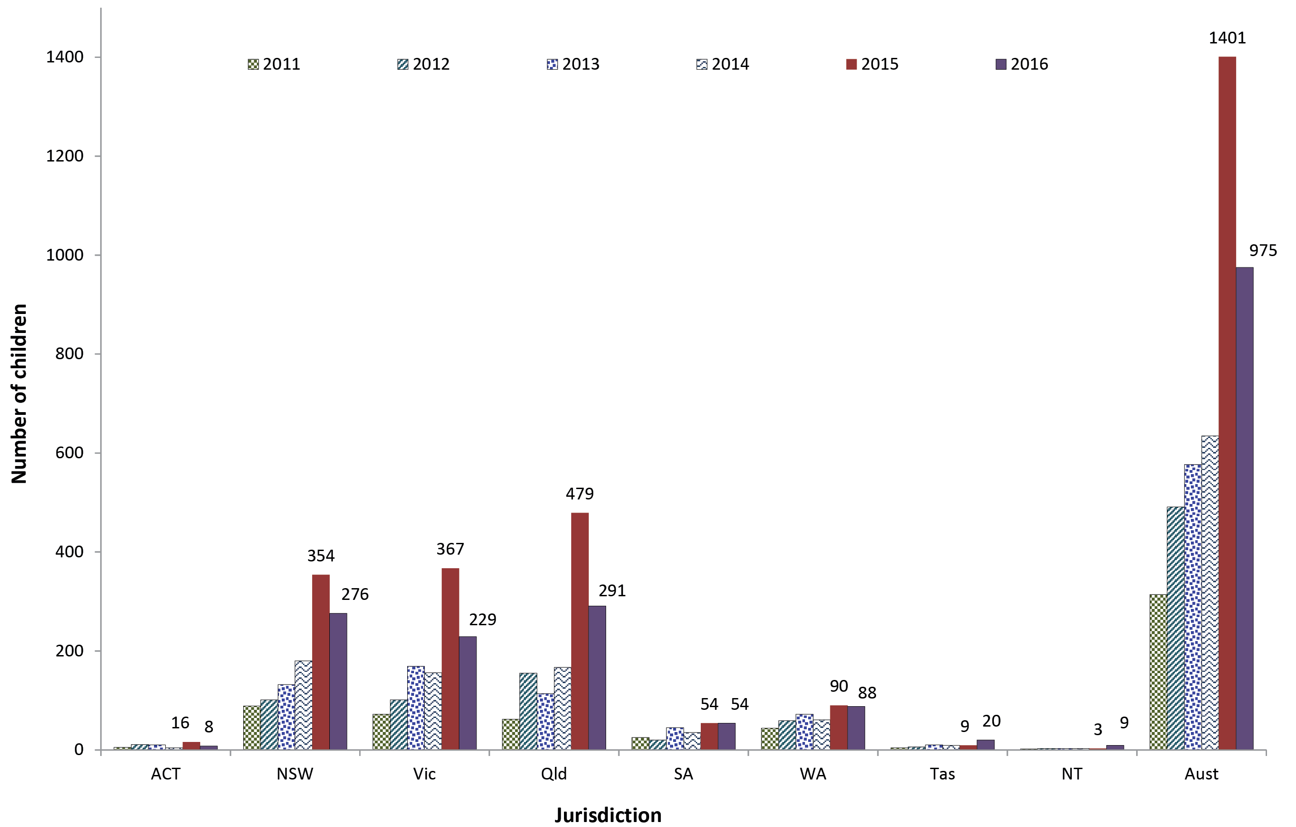

a Source: Australian Immunisation Register, data as at 31 March 2017.

Provider type
In 2016, the large majority of vaccinations in Australia were administered in general practice settings (78.8%, up from 72% in 2012; data not shown). Councils delivered 8.9%, and Community and Aboriginal Health Services delivered 7.5%.

Mechanisms of reporting to the AIR
The proportion of vaccinations on the AIR lodged by electronic/online mechanisms in 2016 for Australia was 96.1%, up from 85.2% in 2012 (data not shown).

Human papillomavirus vaccine coverage
Vaccination coverage, as notified to the National HPV Vaccination Program Register, for dose 3 of the HPV vaccine for females and males aged 15 years in 2016, is shown in Table 5. For females in Australia, 78.6% completed a full course of the vaccine, up from 77.8% in 2015. Coverage in females varied by jurisdiction from a low of 67.8% in Tasmania to a high of 82.9% in the Northern Territory. In Western Australia, HPV coverage in females increased by 2.3 percentage points from 74.8% in 2015 to 77.1% in 2016; marginal increases were also seen in other jurisdictions. For males in Australia, 72.9% completed a full course of the vaccine in 2016, up from 67.1% in 2015 (Table 5). Coverage for males ranged from 61.4% in Tasmania to 76.1% in Western Australia. HPV vaccine coverage in males increased between 2015 and 2016 in all jurisdictions, with the largest increase in Western Australia (12.7 percentage points).

Table 5: Coverage (%) for 3 doses of human papillomavirus (HPV) vaccine for females aged 15 years in 2011–2016, and males aged 15 years in 2014–2016, by state/territory, Australiaª
 | State/territory
 | ACT | NSW | NT | Qld | SA | Tas | Vic | WA | Australia
2011 females | 74.2 | 74.5 | 87.0 | 72.4 | 68.0 | 66.5 | 76.5 | 64.6 | 72.9
2012 females | 74.7 | 71.1 | 85.4 | 69.5 | 71.2 | 65.1 | 74.4 | 70.2 | 71.5
2013 females | 73.9 | 68.9 | 83.9 | 71.3 | 72.9 | 64.3 | 75.7 | 71.6 | 71.7
2014 females | 70.3 | 70.6 | 80.7 | 74.0 | 74.0 | 68.4 | 78.0 | 76.9 | 74.1
2015 females | 76.2 | 80.6 | 86.3 | 75.9 | 74.3 | 68.3 | 79.4 | 74.9 | 78.0
2016 females^{b} | 77.0 | 81.4 | 82.9 | 76.8 | 75.3 | 67.8 | 79.1 | 77.1 | 78.6
2014 males^{c} | 65.0 | 57.3 | 61.2 | 61.7 | 64.2 | 56.4 | 68.4 | 61.9 | 62.0
2015 males | 67.8 | 64.3 | 68.0 | 68.0 | 69.0 | 60.5 | 72.3 | 63.5 | 67.2
2016 males^{b} | 70.5 | 73.5 | 73.5 | 70.0 | 72.0 | 61.4 | 74.7 | 76.1 | 72.9
a Technical notes:
Includes doses that comply with the recommended vaccine dosage and administration as per The Australian Immunisation Handbook (up to 3 doses administered at prescribed intervals).
ACT = Australian Capital Territory; NSW = New South Wales; NT = Northern Territory; Qld = Queensland; SA = South Australia; Tas = Tasmania; Vic = Victoria; WA = Western Australia.
Population is Estimated Resident Population (ERP) provided by the Australian Bureau of Statistics (ABS): CAT 3101.0 Australian Demographics Statistics, Tables 51 to 58 – ERP by Single Year of Age by state and territory, preliminary data published Dec 2016.
Age is age as at date of ERP estimate (30th June 2016).
Data for the years 2011–2015 were sourced from the National HPV Vaccination Program Register.
b Source: National HPV Vaccination Program Register website, November 2017.
c Reflects male catch-up vaccination program 2013–2014. Routine immunisation ongoing at age 12–13 years.

Coverage in all age groups remains higher for earlier doses. In females, coverage was highest (87%) for the 1st dose in the 14- to 15-year-old age group (Figure 21). Coverage was higher in the younger age groups than the older age groups, with only 59% of females aged 20–26 years fully vaccinated compared to 79% of females aged 14–15 years. As with data for females, male coverage in all age groups was higher for earlier doses (Figure 22). In males, coverage for the 1st dose in the 14- to 15-year-old age group was up three percentage points from 2015 at 83%, and up twenty percentage points from 2015 at 74% in the 16- to 17-year-old age group. Coverage for the 3rd dose was 63% in males aged 16–17 years.
HPV coverage estimates by Indigenous status are not currently available due to limitations in Indigenous status reporting to the HPV Register.
Figure 21: HPV vaccination coverage by dose number (Australia) for females by age group in mid-2016ª
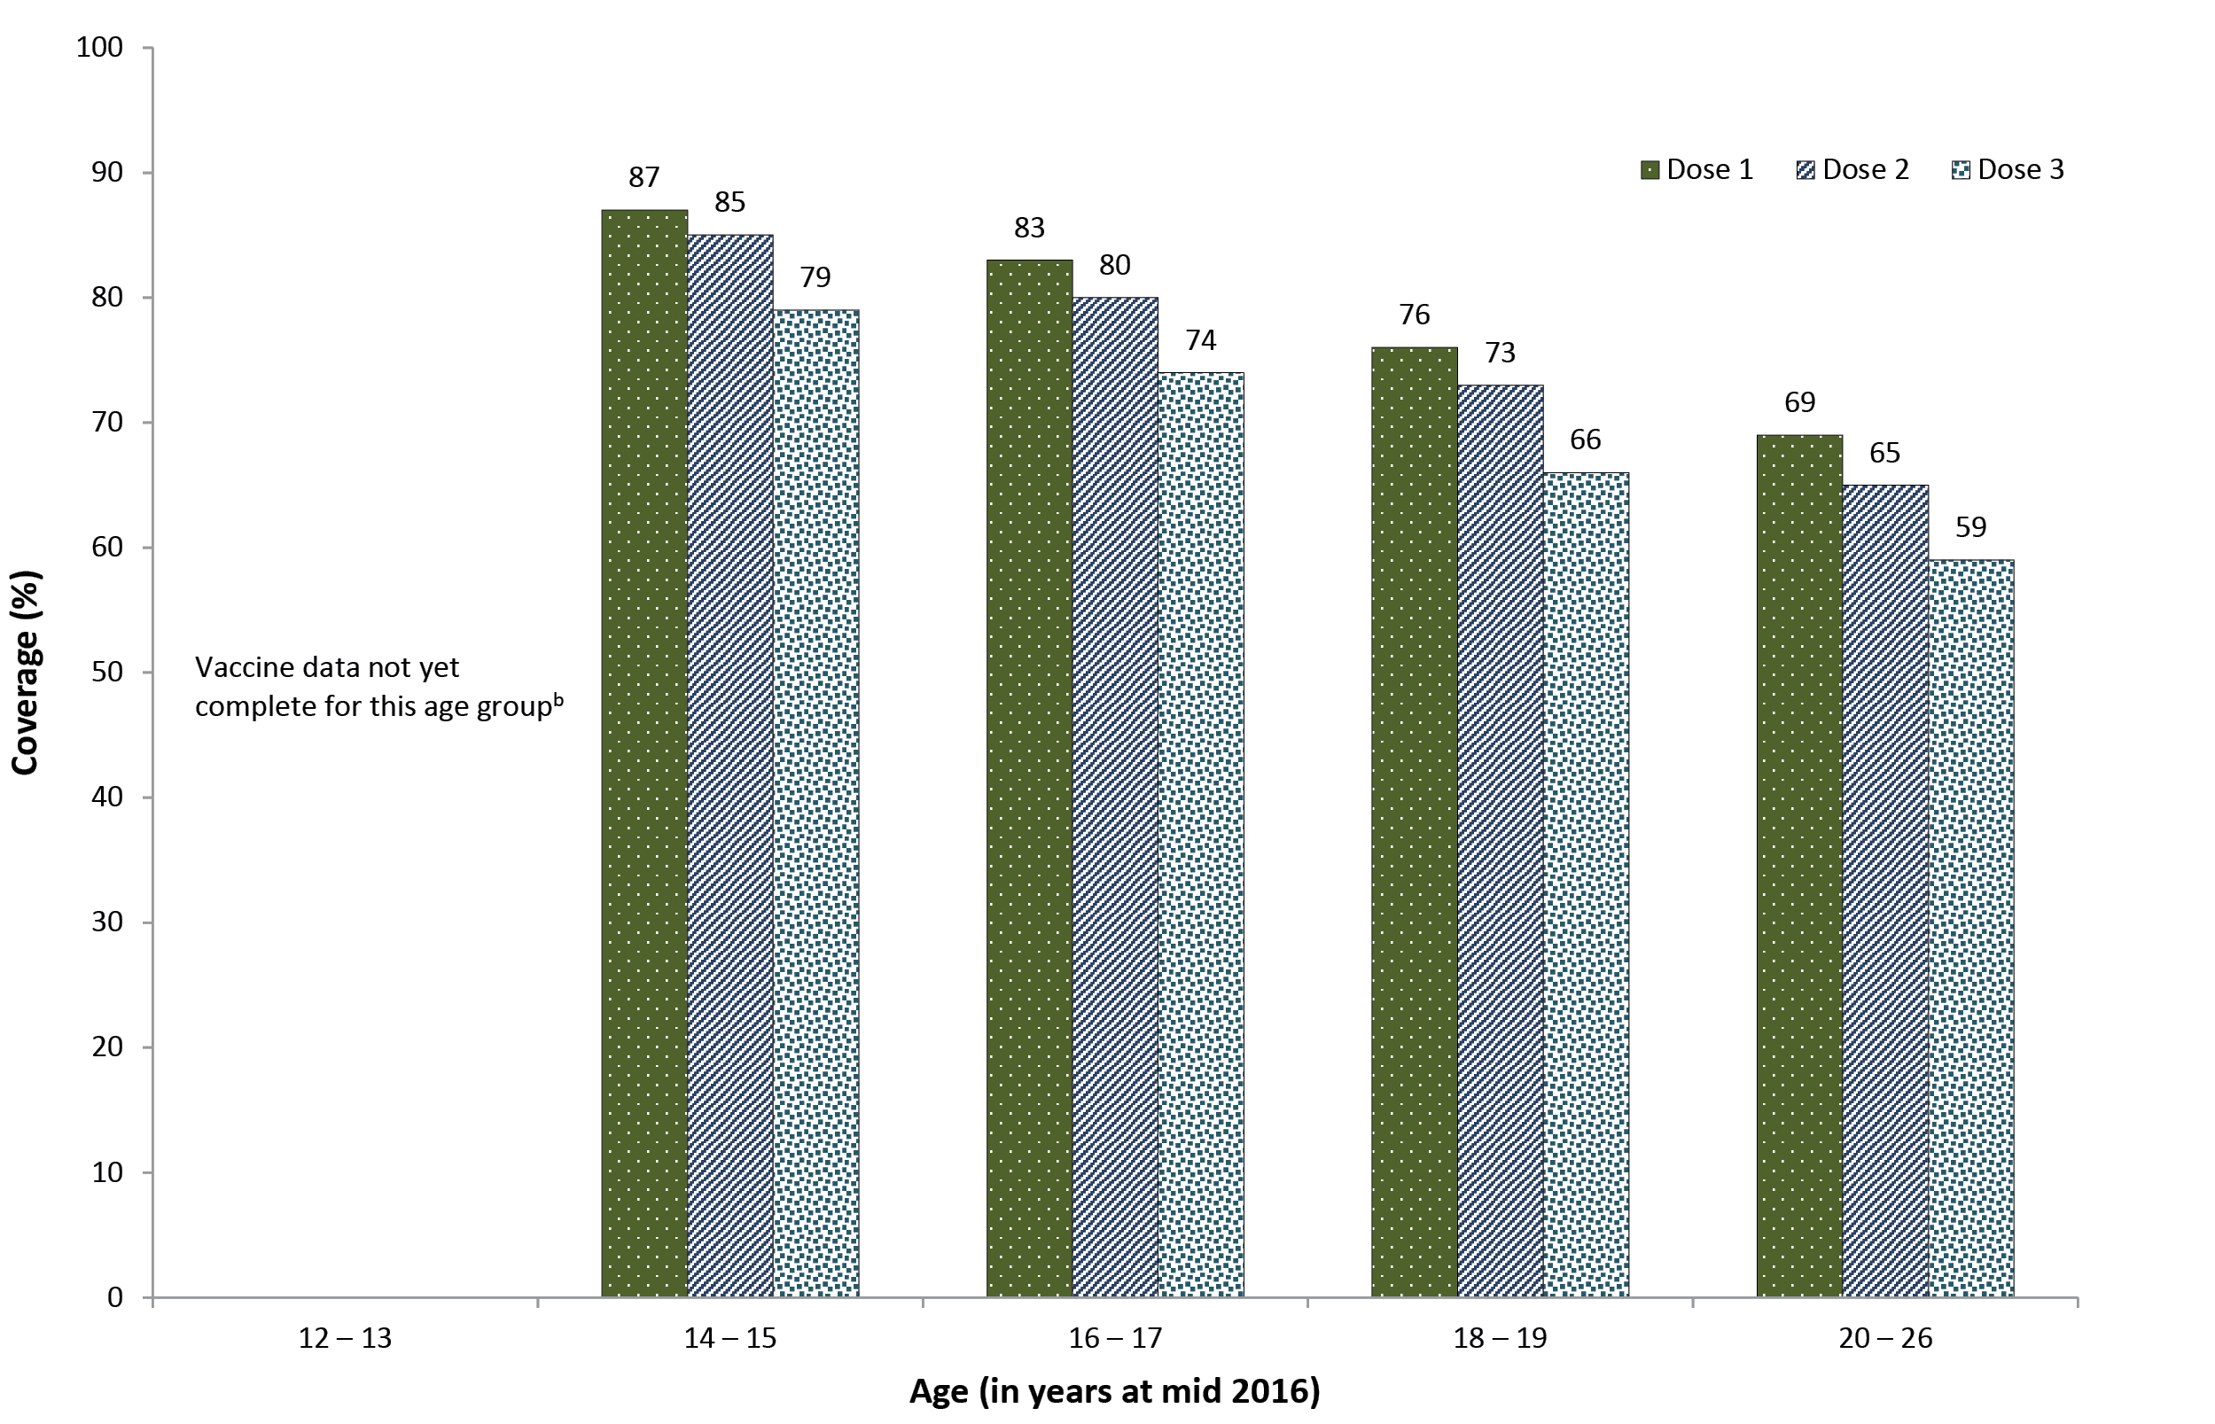
a Technical notes:
Data extracted from the National HPV Vaccination Program Register (HPV Register) as at 12 July 2017.
Population is Estimated Resident Population (ERP) 2016 (as at 30/06/2016) from the Australian Bureau of Statistics Cat 3101.0 Australian Demographic Statistics, Tables 51 to 58: Estimated resident population by single year of age by state and territory. Preliminary data published December 2016.
Age is age as at date of ERP estimate (30 June 2016).
Coverage is calculated as doses administered and reported to the HPV Register / Estimated Resident Population expressed as a percentage.
Source: National HPV Vaccination Program Register, November 2017.
b In some states those aged 12–13 years in 2016 are not eligible for vaccination until 2017. Notification of 2017 doses to the Register is in progress.
Figure 22: HPV vaccination coverage by dose number (Australia) for males by age group in mid-2016ª
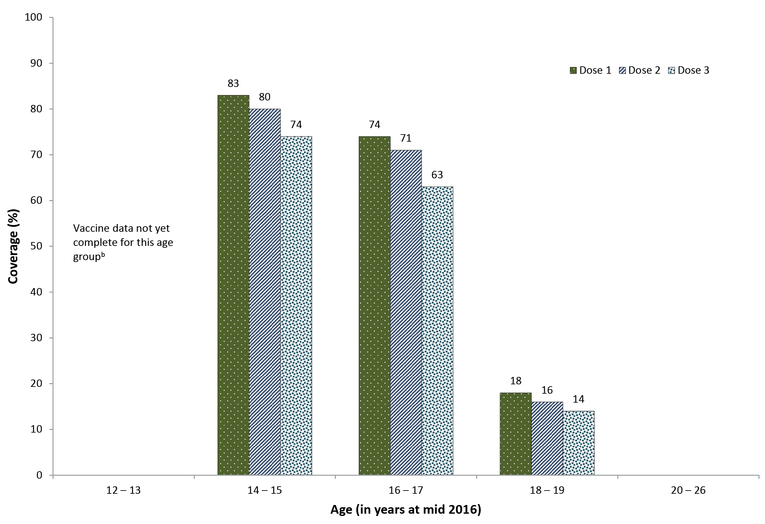
a Technical notes:
Data extracted from the National HPV Vaccination Program Register (HPV Register) as at 12 July 2017.
Population is Estimated Resident Population (ERP) 2016 (as at 30/06/2016) from the Australian Bureau of Statistics Cat 3101.0 Australian Demographic Statistics, Tables 51 to 58: Estimated resident population by single year of age by state and territory. Preliminary data published December 2016.
Age is age as at date of ERP estimate (30 June 2016).
Coverage is calculated as doses administered and reported to the HPV Register / Estimated Resident Population expressed as a percentage.
Source: National HPV Vaccination Program Register, November 2017.
b In some states those aged 12–13 years in 2016 are not eligible for vaccination until 2017. Notification of 2017 doses to the Register is in progress.

Discussion
‘Fully immunised’ coverage at the 12-month age assessment milestone, after a decade of being largely stable at around 90%, increased in 2015 and 2016 reaching 93.7% for the age assessment quarterly data point in December 2016. ‘Fully immunised’ coverage at the 60-month age assessment milestone has continued to increase steadily since 2009 and reached 93.4% for the age assessment quarterly data point in December 2016. These increases in coverage are likely to have been contributed to by measures such as implementation of the ‘No Jab No Pay’ policy, and state-based initiatives such as ‘No Jab No Play’. While ‘fully immunised’ coverage at the 24-month age milestone decreased to below 90% for the age assessment quarterly data point in December 2016, this was likely due to the assessment algorithm being amended to include a 4th dose of DTPa vaccine instead of a 3rd dose, following reintroduction of the 18-month booster dose. Rotavirus coverage has steadily increased, reaching 87.5% for the age assessment quarterly data point in December 2016. Although lower than other vaccines due to the strict upper age limits for rotavirus vaccine administration, the coverage achieved has resulted in substantial herd immunity and decreases in rotavirus hospitalisations in Australia.^{30,31}
‘Fully immunised’ coverage at 12 and 60 months of age in Indigenous children has steadily increased since 2012, reaching 92.1% and 95.4%, respectively, for the age assessment quarterly data points in December 2016. The gap in ‘fully immunised’ coverage between Indigenous and non-Indigenous children at 12 months of age has closed considerably from 6.7 percentage points in 2013 to 1.7 percentage points for the age assessment quarterly data point in December 2016. Coverage for Indigenous children at 60 months of age has been higher than in non-Indigenous children since 2012. In contrast, at 24 months of age, ‘fully immunised’ coverage, while similar in Indigenous and non-Indigenous children from 2011 to 2013, was more disparate with a gap of 2.6% at the end of 2016. This is likely due to the incorporation of additional vaccine doses in the 24-month coverage algorithm in 2014 and 2016, with a differential impact on assessment of coverage in Indigenous children related to timeliness issues.
Recorded coverage in the influenza immunisation program for Indigenous children aged 6 months to <5 years (which commenced in 2015) was low in 2016, with overall national coverage of 11.6%, and only the Northern Territory (55.5%) achieving coverage above 15%. However, upward trends in coverage of Indigenous children over time were seen for all jurisdictions, with coverage highest in the Northern Territory, Queensland and Western Australia. Compared with 2014, influenza vaccine coverage in 2016 has increased almost 12-fold in the Northern Territory and 5-fold in Queensland. Unlike other vaccines on the NIP, influenza vaccine notifications do not attract notification payments for immunisation providers. As such, influenza vaccine coverage data should be regarded as a minimum estimate due to the potential for under-reporting. Other factors contributing to the low coverage may include parental and provider attitudes and concerns, along with other issues such as the seasonal nature of the program, the two doses required in the first year a child under 9 years of age receives influenza vaccine, and the ‘gap’ in NIP funding for 5- to 14-year-old Indigenous children.
Coverage for established programs of vaccines targeted specifically at Indigenous children (i.e. hepatitis A and a booster dose of pneumococcal conjugate vaccine) have increased in recent years but still remain suboptimal. Both these vaccines are included on the NIP for Indigenous children in the Northern Territory, Queensland, South Australia, and Western Australia. From 2007 to the end of 2016, coverage for the 2nd dose of hepatitis A vaccine increased considerably from around 30% to 72.4% for these four jurisdictions combined, and was higher than 64% in each. The national hepatitis A immunisation program has been shown to have had a significant impact in the targeted population with relatively modest vaccine coverage, with evidence suggestive of substantial herd protection effects.³² Coverage of the pneumococcal booster dose increased to 74.3% for the four jurisdictions combined, and was greater than 68% in each. The extent of under-reporting to the AIR for hepatitis A vaccine and the pneumococcal booster is unknown, but may be more than for ‘universal’ vaccines, given the lack of incentive payments for notification to the AIR. However, lower coverage for vaccines targeted specifically at Indigenous people has been a relatively consistent finding for both children³³ and adults.³⁴ Both a lack of provider knowledge about the recommendations for high-risk groups, and suboptimal identification of Indigenous children by immunisation providers, are likely to be important contributing factors.
Although most children eventually complete the scheduled vaccination series, many still do not do so in a timely manner. On-time vaccination (within 30 days of the recommended age) for the 3rd dose of DTPa, and the 1st dose of MMR, in 2016 increased for both Indigenous and non-Indigenous children, compared to 2015. However, timeliness remains an ongoing problem for Indigenous children in Australia. As younger children are often more vulnerable to severe disease, immunisation at the earliest appropriate age should be a public health goal for countries such as Australia where high levels of vaccine coverage at milestone ages have been achieved.
Of adolescents aged 10–19 years recorded as not having received their second dose of MMR vaccine by 31 December 2015, 43,103 (10.5%) received it in 2016. Many of these doses are likely to have been administered as a result of the introduction on 1 January 2016 of the Australian Government’s ‘No Jab No Pay’ policy, which included special provisions for catch-up doses. This policy introduced annual immunisation requirements for eligibility for federal government family assistance payments through to 19 years of age, and removed non-medical exemptions. This additional MMR vaccination of adolescents is of importance considering that, following a 2nd MMR vaccine dose, approximately 99% of subjects overall will be immune to measles.
In 2016, parental vaccination objection could not be estimated as data is no longer collected by the AIR. The number of children aged 6 months to 10 years of age with new medical exemptions, which had increased sharply in 2015, decreased in all jurisdictions in 2016. This decrease is likely due to the stricter eligibility criteria introduced in 2016.³⁵ Exploration of children with at least one medical exemption for a vaccine by geographical area, looking for any ‘hotspots’, will be undertaken as part of a separate report.
Coverage for the HPV vaccine, as derived from the National HPV Vaccination Program Register, continues to increase reflecting a successful school-based program.^{36,37} The rapid and substantial decrease in HPV prevalence in young women,³⁸ and the comparable decreases in genital warts³⁹ and cervical abnormalities,^{40,41} reflect this high coverage as well as the substantial initial catch-up component, which played a major role in bringing forward the benefits of vaccination in the population.⁴² Coverage continues to rise in males as the program has become a routine gender-neutral program. With recent modelling of HPV vaccination programs suggesting that sustained vaccination coverage of over 80% in females and males will be sufficient for elimination of targeted HPV types, Australia looks well placed to realise this into the future.⁴³
In conclusion, data provided in this report reflect continuing successful delivery of the NIP in Australia, while identifying some areas for improvement, particularly in timeliness of vaccination for Indigenous children and in coverage of vaccines specifically targeted to Indigenous children.

Acknowledgements
The National Centre for Immunisation Research and Surveillance of Vaccine Preventable Diseases is supported by the Australian Government Department of Health, the NSW Ministry of Health and The Children’s Hospital at Westmead. The opinions expressed in this report are those of the authors, and do not necessarily represent the views of these agencies.

Author details
Brynley Hull¹
Alexandra Hendry¹
Aditi Dey¹
Frank Beard¹
Julia Brotherton²
Peter McIntyre¹
- National Centre for Immunisation Research and Surveillance of Vaccine Preventable Diseases, The Children’s Hospital at Westmead and University of Sydney, Locked Bag 4001, Westmead, NSW 2145
- National HPV Vaccination Program Register, Victorian Cytology Service, PO Box 310, East Melbourne, Vic 8002 1st

Corresponding author
Mr Brynley Hull
National Centre for Immunisation Research and Surveillance of Vaccine Preventable Diseases, The Children’s Hospital at Westmead and University of Sydney
Locked Bag 4001, WESTMEAD NSW 2145.
Telephone: +61 2 9845 1435.
Facsimile: +61 2 9845 1418.
Email: brynley.hull@health.nsw.gov.au

References
- Hull B, Deeks S, Menzies R, McIntyre P. Immunisation coverage annual report, 2007. Commun Dis Intell Q Rep. 2009;33(2):170–87.
- Hull BP, Mahajan D, Dey A, Menzies RI, McIntyre PB. Immunisation coverage annual report, 2008. Commun Dis Intell Q Rep. 2010;34(3):241–58.
- Hull B, Dey A, Mahajan D, Menzies R, McIntyre PB. Immunisation coverage annual report, 2009. Commun Dis Intell Q Rep. 2011;35(2):132–48.
- Hull B, Dey A, Menzies R, McIntyre P. Annual immunisation coverage report, 2010. Commun Dis Intell Q Rep. 2013;37(1):E21–39.
- Hull BP, Dey A, Menzies RI, Brotherton JM, McIntyre PB. Immunisation coverage annual report, 2011. Commun Dis Intell Q Rep. 2013;37(4):E291–312.
- Hull BP, Dey A, Menzies RI, Brotherton JM, McIntyre PB. Immunisation coverage, 2012. Commun Dis Intell Q Rep. 2014;38(3):E208–31.
- Hull BP, Dey A, Beard FH, Menzies RI, Brotherton JM, McIntyre PB. Immunisation coverage annual report, 2013. Commun Dis Intell Q Rep. 2016;40(1):E146–69.
- Hull BP, Hendry AJ, Dey A, Beard FH, Brotherton JM, McIntyre PB. Immunisation coverage annual report, 2014. Commun Dis Intell Q Rep. 2017;41(1):E68–90.
- Hull B, Hendry A, Dey A, Beard F, Brotherton J, McIntyre P.I Immunisation coverage annual report, 2015. Commun Dis Intell (2018). 2019;43. https://doi.org/ 10.33321/cdi.2019.43.11.
- Australian Institute of Health and Welfare. Immunisation rates for children in 2012–13. Australian Government, Australian Institute of Health and Welfare; 2014. Available from: https://www.aihw.gov.au/reports/immunisation/immunisation-rates-for-children-in-2012-13/contents/summary
- Australian Institute of Health and Welfare. Immunisation rates for children in 2014–15. Australian Government, Australian Institute of Health and Welfare; 2016. Available from: https://www.aihw.gov.au/reports/immunisation/immunisation-rates-for-children-in-2014-15/contents/summary
- Department of Health. National Immunisation Program Schedule. Australian Government, Department of Heath, Canberra; 2016. [Accessed 20 February 2018.] Available from: https://beta.health.gov.au/topics/immunisation/immunisation-throughout-life/national-immunisation-program-schedule
- Hull BP, Deeks SL, McIntyre PB. The Australian Childhood Immunisation Register – a model for universal immunisation registers? Vaccine. 2009;27(37):5054–60.
- Department of Health. No Jab, No Pay – New Immunisation Requirements for Family Assistance Payments: Fact sheet for vaccination providers. Australian Government, Department of Health, Canberra; 2016. [Accessed 23 November 2017.] Available from: http://www.immunise.health.gov.au/internet/immunise/publishing.nsf/Content/67D8681A67167949CA257E2E000EE07D/$File/No-Jab-No-Pay-FSheet.pdf
- Hull BP, McIntyre PB, Heath TC, Sayer GP. Measuring immunisation coverage in Australia: a review of the Australian Childhood Immunisation Register. Aust Fam Physician. 1999;28(1):55–60.
- Department of Health. Immunise Australia Program: Expansion of Registers. Australian Government, Department of Health, Canberra; 2016. [Accessed 21 October 2016.] Available from: http://www.immunise.health.gov.au/internet/immunise/publishing.nsf/Content/expansion-registers
- Australian Technical Advisory Group on Immunisation (ATAGI). Australian Immunisation Handbook. Australian Government, Department of Health, Canberra; 2018. Available from: https://immunisationhandbook.health.gov.au.
- National Centre For Immunisation Research and Surveillance. History of vaccination in Australia. National Centre for Immunisation Research and Surveillance, Sydney; 2019. Available from: http://www.ncirs.org.au/health-professionals/history-immunisation-australia
- Department of Human Services. No Jab No Pay. Australian Government, Department of Human Services, Canberra; 2016. [Accessed 23 November 2017.] Available from: http://www.immunise.health.gov.au/internet/immunise/publishing.nsf/Content/67D8681A67167949CA257E2E000EE07D/$File/No-Jab-No-Pay-FSheet.pdf
- Department of Human Services. Australian Immunisation Register (AIR) – Immunisation medical exemption form (IM011). Australian Government, Department of Human Services, Canberra; 2016. [Accessed 24 October 2016.] Available from: https://www.humanservices.gov.au/organisations/health-professionals/forms/im011
- O’Brien ED, Sam GA, Mead C. Methodology for measuring Australia’s childhood immunisation coverage. Commun Dis Intell. 1998;22(3):36–7.
- Hull BP, McIntyre PB. Immunisation coverage reporting through the Australian Childhood Immunisation Register – an evaluation of the third-dose assumption. Aust N Z J Public Health. 2000;24(1):17–21.
- Hull BP, Lawrence GL, MacIntyre CR, McIntyre PB. Estimating immunisation coverage: is the ‘third dose assumption’ still valid? Commun Dis Intell Q Rep. 2003;27(3):357–61.
- Hugo Centre for Migration and Population Research. Acessibility/Remoteness Index of Australia – ARIA++(2011). University of Adelaide, Hugo Centre for Migration and Population Research, Adelaide; 2011. [Accessed 17 November 2017.] Available from: https://www.adelaide.edu.au/hugo-centre/services/aria
- Rank C, Menzies RI. How reliable are Australian Childhood Immunisation Register coverage estimates for Indigenous children? An assessment of data quality and coverage. Commun Dis Intell Q Rep. 2007;31(3):283–7.
- Australian Bureau of Statistics. Australian Statistical Geography Standard (ASGS). Australian Government, Australian Bureau of Statistics, Canberra; 2011. [Accessed 17 November 2014.] Available from: http://www.abs.gov.au/websitedbs/d3310114.nsf/home/australian+statistical+geography+standard+%28asgs%29
- MapInfo. MapInfo Pro version 15.0. Pitney Bowes Software, Stamford, Connecticut, USA; 2015.
- Australian Bureau of Statistics. Australian Statistical Geography Standard (ASGS): Correspondences, July 2011 (Cat. no. 1270.0.55.006). Australian Government, Australian Bureau of Statistics, Canberra; 2012. [Accessed 17 November 2014.] Available from: http://www.abs.gov.au/AUSSTATS/abs@.nsf/Lookup/1270.0.55.006Main+Features1July%202011?OpenDocument
- Barbaro B, Brotherton JM. Measuring HPV vaccination coverage in Australia: comparing two alternative population-based denominators. Aust N Z J Public Health. 2015;39(4):326–30.
- Buttery JP, Lambert SB, Grimwood K, Nissen MD, Field EJ, Macartney KK, et al. Reduction in rotavirus-associated acute gastroenteritis following introduction of rotavirus vaccine into Australia’s National Childhood vaccine schedule. Pediatr Infect Dis J. 2011;30(1 Suppl):S25–9.
- Dey A, Wang H, Menzies R, Macartney K. Changes in hospitalisations for acute gastroenteritis in Australia after the national rotavirus vaccination program. Med J Aust. 2012;197(8):453–7.
- Thompson C, Dey A, Fearnley E, Polkinghorne B, Beard F. Impact of the national targeted Hepatitis A immunisation program in Australia: 2000–2014. Vaccine. 2017;35(1):170–6.
- Hull BP, McIntyre PB. What do we know about 7vPCV coverage in Aboriginal and Torres Strait Islander children? Commun Dis Intell Q Rep. 2004;28(2):238–43.
- Menzies R, Turnour C, Chiu C, McIntyre P. Vaccine preventable diseases and vaccination coverage in Aboriginal and Torres Strait Islander people, Australia 2003 to 2006. Commun Dis Intell Q Rep. 2008;32 (Suppl):S2–67.
- Beard FH, Wood N. To sign or not to sign. Dealing with requests for vaccination exemption. Medicine Today. 2017;18(4):63–65. [Accessed 13 December 2017.] Available from: https://medicinetoday.com.au/2017/april/regular-series/sign-or-not-sign-dealing-requests-vaccination-exemption.
- Brotherton J, Gertig D, Chappell G, Rowlands L, Saville M. Catching up with the catch-up: HPV vaccination coverage data for Australian women aged 18–26 years from the National HPV Vaccination Program Register. Commun Dis Intell Q Rep. 2011;35(2):197–201.
- Brotherton JM, Murray SL, Hall MA, Andrewartha LK, Banks CA, Meijer D, et al. Human papillomavirus vaccine coverage among female Australian adolescents: success of the school-based approach. Med J Aust. 2013;199(9):614–7.
- Tabrizi SN, Brotherton JM, Kaldor JM, Skinner SR, Liu B, Bateson D, et al. Assessment of herd immunity and cross-protection after a human papillomavirus vaccination programme in Australia: a repeat cross-sectional study. Lancet Infect Dis. 2014;14(10):958–66.
- Ali H, Donovan B, Wand H, Read TR, Regan DG, Grulich AE, et al. Genital warts in young Australians five years into national human papillomavirus vaccination programme: national surveillance data. . BMJ. 2013;346:f2032. [Erratum appears in BMJ. 2013;346:F2942]
- Gertig DM, Brotherton JM, Budd AC, Drennan K, Chappell G, Saville AM. Impact of a population-based HPV vaccination program on cervical abnormalities: a data linkage study. BMC Med. 2013;11:227.
- Brotherton JM, Gertig DM, May C, Chappell G, Saville M.. HPV vaccine impact in Australian women: ready for an HPV-based screening program. Med J Aust. 2016;204(5):184-e1.
- Drolet M, Laprise JF, Brotherton JML, Donovan B, Fairley CK, Ali H, et al. The impact of human papillomavirus catch-up vaccination in Australia: implications for introduction of multiple age cohort vaccination and postvaccination data interpretation. J Infect Dis. 2017;216(10):1205–9.
- Brisson M, Bénard É, Drolet M, Bogaards JA, Baussano I, Vänskä S, et al. Population-level impact, herd immunity, and elimination after human papillomavirus vaccination: a systematic review and meta-analysis of predictions from transmission-dynamic models. Lancet Public Health. 2016;1(1):e8–17.

Appendix A: List of vaccine abbreviations
Abbreviation | Description
13vPCV | 13-valent pneumococcal conjugate vaccine
23vPPV | 23-valent pneumococcal polysaccharide vaccine
dTpa | diphtheria-tetanus-acellular pertussis (adults, adolescents and children aged ≥10 years formulation)
DTPa | diphtheria-tetanus-acellular pertussis (children aged <10 years formulation)
Flu | influenza
Hep A | hepatitis A
Hep B | hepatitis B
Hib | Haemophilus influenzae type b
Hib-Men C | combined Haemophilus influenzae type b and meningococcal C vaccine
HPV | human papillomavirus
HZ | herpes zoster
Men C | meningococcal C
MMR | measles-mumps-rubella
MMRV | measles-mumps-rubella-varicella
PCV | pneumococcal conjugate vaccine
PRP-OMP | Haemophilus influenzae type b conjugate vaccine (meningococcal outer membrane conjugate)
VZV | varicella-zoster virus

Communicable Diseases Intelligence
ISSN: 2209-6051 Online

Communicable Diseases Intelligence (CDI) is a peer-reviewed scientific journal published by the Office of Health Protection, Department of Health. The journal aims to disseminate information on the epidemiology, surveillance, prevention and control of communicable diseases of relevance to Australia.

Editor: Cindy Toms
Deputy Editor: Simon Petrie
Design and Production: Kasra Yousefi
Editorial Advisory Board: David Durrheim, Mark Ferson, John Kaldor, Martyn Kirk and Linda Selvey

Website: http://www.health.gov.au/cdi

Contacts
Communicable Diseases Intelligence is produced by:
Health Protection Policy Branch, Office of Health Protection, Australian Government Department of Health
GPO Box 9848, (MDP 6) CANBERRA ACT 2601

Email: cdi.editor@health.gov.au

Submit an Article
You are invited to submit your next communicable disease related article to the Communicable Diseases Intelligence (CDI) for consideration. More information regarding CDI can be found at: http://health.gov.au/cdi.
Further enquiries should be directed to: cdi.editor@health.gov.au.

This journal is indexed by Index Medicus and Medline.

Creative Commons Licence - Attribution-NonCommercial-NoDerivatives CC BY-NC-ND
© 2019 Commonwealth of Australia as represented by the Department of Health
This publication is licensed under a Creative Commons Attribution-NonCommercial-NoDerivatives 4.0 International Licence from https://creativecommons.org/licenses/by-nc-nd/4.0/legalcode (Licence). You must read and understand the Licence before using any material from this publication.

Restrictions
The Licence does not cover, and there is no permission given for, use of any of the following material found in this publication (if any):
- the Commonwealth Coat of Arms (by way of information, the terms under which the Coat of Arms may be used can be found at www.itsanhonour.gov.au);
- any logos (including the Department of Health’s logo) and trademarks;
- any photographs and images;
- any signatures; and
- any material belonging to third parties.

Disclaimer
Opinions expressed in Communicable Diseases Intelligence are those of the authors and not necessarily those of the Australian Government Department of Health or the Communicable Diseases Network Australia. Data may be subject to revision.

Enquiries
Enquiries regarding any other use of this publication should be addressed to the Communication Branch, Department of Health, GPO Box 9848, Canberra ACT 2601, or via e-mail to: copyright@health.gov.au

Communicable Diseases Network Australia
Communicable Diseases Intelligence contributes to the work of the Communicable Diseases Network Australia.
http://www.health.gov.au/cdna

