An outbreak of Bacillus cereus toxin-mediated emetic and diarrhoeal syndromes at a restaurant in Canberra, Australia 2018
C. E. Thirkell, T. S. Sloan-Gardner, M. C. Kaczmarek and B. G. Polkinghorne

Abstract
A cluster of gastrointestinal illness was detected following receipt of a complaint of becoming ill after a multi-course dinner at a restaurant in Canberra, Australian Capital Territory (ACT), Australia. The complaint led to an investigation by ACT Health.
Food samples retained by the restaurant for microbiological analysis returned an unsatisfactory level of Bacillus cereus in beef (19,000 colony forming units/gram [cfu/g]) and a satisfactory level in arancini (50 cfu/g). These positive samples underwent whole genome sequencing and genes encoding diarrhoeal toxins were detected with no laboratory evidence of the emetic toxin. No stool specimens were collected.
A cohort study was undertaken and 80% (33/41) of patrons took part in a structured interview. There was no significant difference in age or sex between those ill and not ill. Due to universal exposure most foods were unable to be statistically analysed and no significant results were found from the food history. The ill cohort diverged into two distinct groups based on incubation period and symptoms suggesting this outbreak involved B. cereus intoxication with both diarrhoeal and potentially emetic toxins. Some hygiene practices during food preparation were noted to be inadequate and heating and cooling procedures were unverified when questioned.
A combination of the incubation periods and symptom profile, food laboratory evidence, and genomic sequencing of the B. cereus diarrhoeal gene suggest a probable aetiology of B. cereus intoxication. Public health action included the restaurant rectifying hygiene practices and documenting heating/cooling procedures.
Keywords: Bacillus cereus, universal exposure, emetic syndrome, diarrhoeal syndrome, genomic sequencing, gastroenteritis, foodborne disease.

Introduction
Four people reported gastrointestinal illness to a restaurant in Canberra, Australian Capital Territory (ACT), Australia the morning after attending a multi-course dinner. The restaurant subsequently self-reported the cluster of illness to ACT Health. The restaurant had three seatings each night during the period of concern: early, middle and late. This report describes the outbreak investigation of Bacillus cereus toxin mediated emetic and diarrhoeal syndromes associated with that multi-course dinner, and the first published use of whole genome sequencing (WGS) in a B. cereus foodborne outbreak investigation in Australia.
Foodborne illness is estimated to cause 4.1 million cases of gastroenteritis and 3,350 episodes of B. cereus each year in Australia; the majority of these are not reported.¹ B. cereus toxin-mediated gastroenteritis is not notifiable in Australia; however outbreaks are reported by all states and territories and captured in the OzFoodNet outbreak register.¹ A foodborne outbreak is defined as a similar illness in ≥2 people after consuming a common food and epidemiological and/or microbiological evidence implicates food as the source of illness.² B. cereus was officially attributed to just ten outbreaks on the register between 2001 and 2013, likely due to the short duration of illness and relatively mild symptoms limiting reporting.³
B. cereus is ubiquitous in the environment, particularly in soil and vegetation⁴ and can cause two type of illnesses referred to as emetic-type and diarrhoeal-type illness.⁵ Emetic-type illness occurs from the production of the toxin cereulide. This toxin is pre-formed in the food with a temperature production range of 12–37 °C. It is heat stable to 100 °C for >2 hours and results in emetic illness which typically has an average incubation of 1–6 hours and symptom duration of 6–24 hours.^{5,6} Foods commonly associated with emetic illness include rice, pasta and pastries and are generally linked to improper surface cleaning, cross contamination or temperature abuse through inadequate heating and cooling.^{6–8} The infective dose has not been determined for the emetic toxin. However, although it has been reported as low as 10³ cfu/g, in most cases it is above 10⁵ cfu/g.⁹
Diarrhoeal-type illness results from one or a number of associated toxins including: enterotoxin FM which is not pathogenic but contributes to the severity of diarrhoeal illness; haemolysin BL (Hbl); cytotoxin K (CytK); and non-haemolytic enterotoxin (Nhe).¹⁰ The illness is caused by the ingestion of dormant spores which then germinate and proliferate in the small intestine and then produce the toxins. Diarrhoeal-type illness has an average incubation of 8–16 hours and symptom duration of 12–24 hours.⁶ Spores should be eliminated by heating to 100 °C for 3 minutes when appropriate heating and cooling processes are adhered to. Foods commonly associated with diarrhoeal illness include protein foods such as meat products, soups, vegetables and sauces, and practices linked to contamination including poor heating and cooling in particular.⁶ The infective dose is generally considered to be 10⁵–10⁸ cfu.⁹

Methods

Epidemiological investigation
A retrospective cohort study was performed using a standard gastrointestinal outbreak questionnaire adapted to the menu used on the implicated night. A contact from each table was obtained from the restaurant and phone interviews were conducted. Non-respondents were called back either until they responded or six attempts to make contact were unsuccessful. A case was defined as someone who ate dinner at the specified restaurant on the implicated date and experienced gastrointestinal symptoms (nausea, vomiting, diarrhoea and abdominal pain) within 24 hours. A line-list was entered into Microsoft Excel 2013 and analysed using STATA 15.0.¹¹ Univariate analysis included generating odds ratios using logistic regression, and exact logistic regression where this was not possible due to zero cell counts. Age was compared using a two-sample t-test, after confirming a normal distribution. Gender was compared using a two-tailed Fisher’s exact test. Ethics approval was not sought as this is not required under the ACT Public Health Act 1997 for the purposes of a public health investigation.¹² Australian National University has a waiver of consent for research performed as part of an outbreak investigation under protocol: 2017/909.

Environmental health investigation
An Environmental Health Officer from ACT Health attended the restaurant to perform a routine food premises inspection. Samples of all retained food served on the implicated night were taken for laboratory analysis as required by the ACT Food Act 2001.¹³ Two follow-up visits were conducted with ACT Health staff to discuss food preparation techniques and laboratory results.

Laboratory investigation
No stool specimens were received from cases. Food samples were tested at the ACT Government Analytical Laboratory (ACTGAL) for Staphylococcus aureus, B. cereus and Clostridium perfringens using a spread plate method and standard plate counts. Microbiological results for B. cereus are classified as satisfactory (<100 cfu/g), marginal (100 – <1,000 cfu/g), unsatisfactory (1,000 – <100,000 cfu/g) and potentially hazardous (>100,000 cfu/g).¹⁴ Further into the investigation WGS was performed by the Queensland Health Molecular Epidemiology Unit utilising the Illumina NextSeq genome sequencing platform to detect enterotoxin genes for all food isolates which grew B. cereus.

Results

Epidemiological
A total of 45 patrons dined in three separate sittings at the restaurant on the night, across 15 tables. We were able to contact 41 patrons (91%) from 14 tables. Of the 41 who were contacted, an ill status was gathered for all (100%) and a food history was obtained for 33 patrons (80%). The attack rate for those who attended on the night was 37% (15/41) (Figure 1).
Figure 1: Epidemiological curve of cases by onset of illness time after attending dinner at restaurant (n = 15)
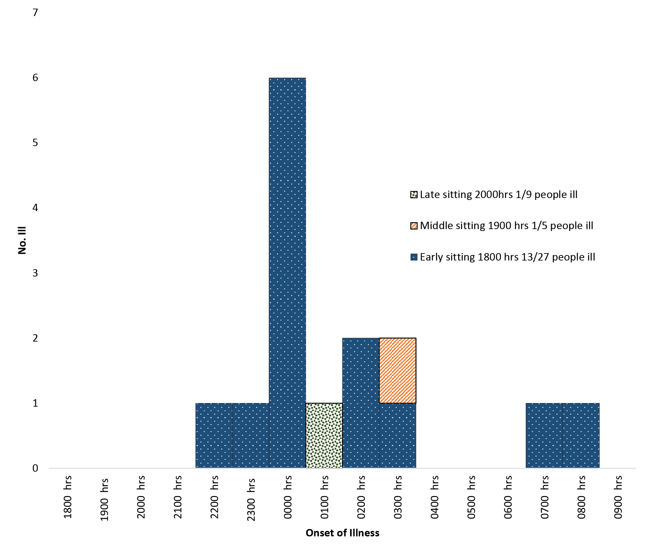
There was no statistically significant difference in gender (p=0.51) or age (p=0.93) between those ill and not ill. No cases required treatment in-hospital.
More than eight courses were served and ten foods were captured during interview (Table 1). Universal exposure was present for four foods (pastry, crocodile, arancini and salmon) and >90% ate another four foods (beef, apple lolly, apple sour and scallops). The two other foods were alternate foods provided for taste or intolerance to menu foods (oysters, raspberry). Statistical analysis of ill status and exposure to foods provided no evidence of a contaminated food source. All confidence intervals crossed one and no odds ratios with significant p-values were produced.
Table 1: Univariate analysis of food exposures (n = 33)
 | Exposed |  |  | Not Exposed
Food | Ill | Not ill | AR (%) | Ill | Not ill | AR (%) | Odds ratio (95% CI) | p-value
Oysters | 3 | 4 | 43 | 10 | 15 | 40 | 0.76 (0.33 – 1.76) | 0.52
Pastry | 13 | 20 | 39 | 0 | 0 | 0 | ª
Crocodile | 13 | 20 | 39 | 0 | 0 | 0 | ª
Scallops | 13 | 19 | 40 | 0 | 1 | 0 | 0.65 (0.02 – ∞)^{b} | 1.0
Arancini | 13 | 17 | 43 | 0 | 0 | 0 | 0.88 (0 – 1.18)^{b} | 0.42
Salmon | 13 | 20 | 39 | 0 | 0 | 0 | ª
Beef | 12 | 20 | 38 | 1 | 0 | 100 | 0.65 (0 – 25.35)^{b} | 0.79
Apple lolly | 12 | 18 | 40 | 1 | 2 | 33 | 1.3 (0.11–16.39) | 0.82
Apple sour | 12 | 18 | 40 | 1 | 2 | 33 | 1.3 (0.11–16.39) | 0.82
Raspberry | 2 | 7 | 22 | 4 | 9 | 31 | 1.19 (0.99–1.42) | 0.06
a Logistic and exact regression unable to be calculated due to zero cell counts and collinearity
b Calculated using exact logistic regression.
Denominator differs by food due to unknown data
Illness was concentrated in the early sitting (1800 hrs) with an attack rate of 48%, 20% for the middle sitting (1900 hrs), and 11% for the late sitting (2000 hrs). No significant differences (p>0.05) were noted in age, sex or general health between those who were ill or not ill in the early sitting.
No clusters among tables were observed with a broad distribution of illness across the 15 tables. Food history was available for 13 of 15 ill patrons and 20 of 26 not ill patrons. No staff were interviewed but all staff were reported to eat the same food on the night prior to opening except for the beef and none were reported to be ill.
Two distinct ill cohorts emerged based on incubation period and duration of symptoms (Figure 2). All emetic syndrome cases (nine) had vomiting and all diarrhoeal syndrome cases (six) had diarrhoea.

Figure 2: Incubation period by duration of symptoms for 14 of 15 casesª
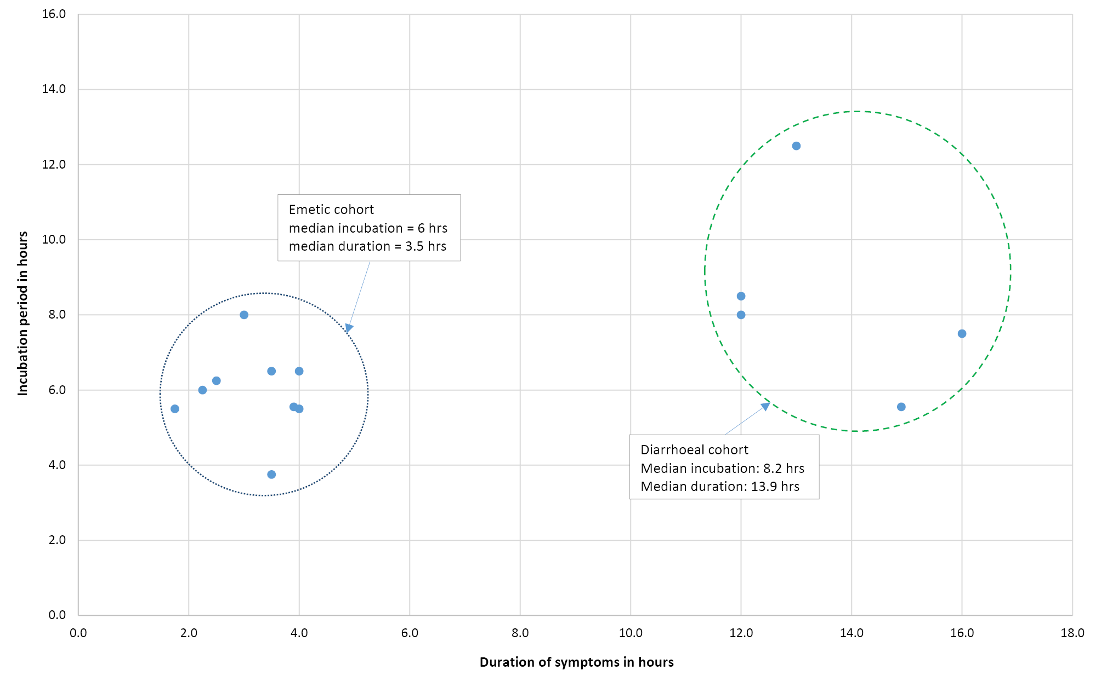
a One diarrhoeal syndrome case excluded from graph due to duration of 48 hrs (incubation of 14 hrs). This case had rice as a starter with no other differences noted (no other cases reported eating rice other than the arancini)

Environmental
The environmental health officer collected three frozen samples each of crocodile, beef and arancini during their first inspection. Following discussions with the restaurant chef, it was discovered that the beef dish was cooked for 12 hours at 85 °C before being de-boned. The de-boning process was interrupted by the arrival of fresh fruit and vegetables which the staff unloaded and then returned to meat preparation with no hand hygiene performed. The beef was then spread across large metal trays which were stacked and placed in the cool-room for 25 minutes. The meat was then pressed and placed in the cool-room overnight. The following day, 12 individual servings were placed into 2 kilogram (kg) vacuum sealed bags and then frozen. Prior to serving, the 2 kg bag was reportedly thawed in a water bath held at 55 °C for 35 minutes, then just prior to serving a single-serving size of beef was added to a jus sauce heated to 78 °C for <5 min. The heating, cooling and re-heating process was not documented or verified with thermometers. Three to four bags were reported to be used on the night, however the restaurant was unable to confirm whether they were from the same batch of cooking, nor whether the bags were used concurrently or consecutively.

Laboratory
Initial testing of retained food specimens demonstrated growth of B. cereus at unsatisfactory levels in the beef dish and at detectable but satisfactory levels in the arancini balls. No pathogens were detected in any other samples. The restaurant requested testing of a second sample of the beef dish retained by the laboratory, and another 2 kg bag of frozen beef the restaurant had retained. The second beef sample demonstrated growth of B. cereus at lower levels than the first sample but still unsatisfactory. No pathogens were detected in the 2 kg frozen sample (Table 2﻿). Whole genome sequencing was performed on isolates from the two positive beef samples and one positive arancini sample. The diarrhoeal toxin genes Hbl, Nhe and CytK were detected in both the beef and arancini balls. All three positive isolates had the same multi locus sequence type (MLST) 177. The emetic toxin, cereulide, was not detected in any of the three isolates tested. No stool samples were received from cases.
Table 2: Food related laboratory testing and results
Food Tested | Organism or toxin testing for | Test | Result | Interpretation
Beef first sample | S. aureus | Spread plate | <50 cfu/g | Satisfactory
 | B. cereus | Spread plate | 19,000 cfu/g | Unsatisfactory
 | C. perfringens | Pour plate | <50 cfu/g | Satisfactory
Crocodile | S. aureus | Spread plate | <50 cfu/g | Satisfactory
 | B. cereus | Spread plate | <50 cfu/g | Satisfactory
 | C. perfringens | Pour plate | <50 cfu/g | Satisfactory
Arancini balls | S. aureus | Spread plate | <50 cfu/g | Satisfactory
 | B. cereus | Spread plate | 50 cfu/g | Satisfactory
 | C. perfringens | Pour plate | <50 cfu/g | Satisfactory
Beef second sample | B. cereus | Spread plate | 3,500 cfu/g | Unsatisfactory
2 kg frozen bag of beef | B. cereus | Spread plate | <50 cfu/g | Satisfactory

Discussion
The food laboratory evidence along with duration, incubation and symptom history provides evidence of a probable outbreak of B. cereus intoxication caused by diarrhoeal and potentially emetic toxins. According to OzFoodNet and the US Centers for Disease Control and Prevention (CDC) guidelines, definitive evidence would require case specimens or isolation of at least 100,000 cfu/g from food samples.^{2,15} The evidence to support this cfu/g threshold is not clear with some variance in other investigation reports¹⁰ and this outbreak suggesting lower levels may be appropriate. Re-heating of the beef for service indicates both emetic-toxin-mediated and diarrhoeal-toxin-mediated gastroenteritis are biologically plausible because being placed in 55 °C water for thirty-five minutes followed by briefly being placed in the jus may not destroy either the pre-formed emetic toxin or the diarrhoeal spores. Evidence suggests the risk of meat contamination increases with multiple stages of preparation¹⁶ which is consistent with the complex meat preparation implicated in this outbreak.
Although the majority of illness was concentrated in the early sitting, the reason for this is unknown. Contamination appears to have occurred in batches, however investigations were unable to identify differences in food preparation or plating. The fresh fruit and vegetables arrived during the deboning process following initial cooking and it is postulated that contamination may have occurred at this stage. The process of cooling then involved stacking the trays of beef directly on top of each other in the cool room. It is possible the middle trays were not cooled to the same extent or as quickly resulting in batched contamination.
The MLST identified was last reported in human isolates in Europe in 2003/04 on PubMLST (a global database for molecular typing). This is the first documented whole genome sequencing of B. cereus isolates following an outbreak in Australia. Although the arancini did not produce unsatisfactory levels of B. cereus, the isolated genes and MLST type found matched those of the beef. This suggests there was cross contamination between the beef and the arancini and potentially undetected cross contamination with other foods. Beef is one of the predominant food types associated with B. cereus diarrhoeal syndrome⁵ and therefore biologically plausible and consistent with the cases who presented with diarrhoeal symptoms in this outbreak. The majority were unwell with emetic symptoms suggesting either another source of illness or the beef producing both toxins. Improvement of hygiene policies with increased hand hygiene was a public health action from this investigation which may help prevent the introduction of organisms into the food and also prevent cross-contamination within the kitchen.
Literature has traditionally suggested it is rare to have both forms of illness; however, a 2016 review of French B. cereus outbreaks has challenged this thought and this outbreak supports this notion.^{5,17} It was noted that 57% (42/74) of B. cereus related outbreaks resulted in both emetic and diarrhoeal symptoms with variability in incubation periods. The two distinct illness profiles in this outbreak present as a typical example of emetic and diarrhoeal syndromes, although the emetic cases with a median incubation of 6 hours support the suggestion of a longer incubation period because of a low dose of the emetic toxin. Isolating the B. cereus diarrhoeal gene in the food provides strong evidence of the cause of the diarrhoeal syndrome even though only 6/15 cases presented with typical diarrhoeal symptoms. Not isolating the B. cereus emetic toxin does not rule out its presence – it is still considered the likely cause of the emetic syndrome based on the case profiles and is consistent with recent evidence.¹⁷ It is well accepted that the emetic toxin is difficult to isolate in food and stool samples which emphasises the importance of epidemiological evidence.¹⁸
Limitations of this investigation included no stool samples being received; however, nearly all the ill patrons had recovered by the time they were contacted. Steps to minimise this bias included a standard detailed questionnaire. This questionnaire also helped to highlight differences in incubation/duration times. Eight people were unable to be contacted, of which two were ill. A variety of food was available on the implicated night with only three foods available for analysis. Near-universal exposure hampered statistical testing due to zero cell counts, and attack rates were not high. For example, the one person who did not report eating beef did report being ill, hence a statistically insignificant, protective odds ratio was produced. This highlights the importance of gathering a portfolio of evidence including descriptive epidemiological and microbiological food evidence.
This investigation is a good example of a public health response that combined detailed epidemiological, microbiological, whole genome sequencing and environmental health expertise to provide strong evidence of a likely pathogen and cause of contamination. This led to recommendations regarding hygiene and food preparation practices and no further reports of illness. The restaurant in question was very cooperative and positively engaged in the investigation: self-reporting in a timely manner, retaining specimens for testing and responding to all public health requests.

Conclusion
Following a thorough and rapid investigation, the probable aetiology of this outbreak was B. cereus intoxication with diarrhoeal and potentially emetic toxins due to cross contamination of food. This was corroborated by the symptom profile and food sample laboratory evidence, including genome sequencing of the diarrhoeal gene. Although rarely reported in Australia, this outbreak provides evidence of the ongoing risk of B. cereus in food produced in restaurants, and highlights the need for continued vigilance in food preparation techniques.

Author Details
Callum E. Thirkell^{1, 2}
Timothy S. Sloan-Gardner^{2,3}
Dr Marlena C. Kaczmarek²
Dr Ben Polkinghorne¹
- National Centre for Epidemiology and Population Health, Australian National University, Canberra, Australia.
- Communicable Disease Control Section, Health Protection Service, Population Health, Protection and Regulation, ACT Health.
- OzFoodNet – Australia’s enhanced foodborne disease surveillance network.

Corresponding author
Callum Thirkell
25 Mulley Street, Holder ACT 2611
Telephone: +61 4 26279691
Email: callum.thirkell@act.gov.au

Acknowledgements
We would like to thank:
ACT Health environmental health staff: William Mude and Radomir Krsteski
ACTGAL staff: Deborah Denehy and Dr Victoria Wansink
ACT Health CDC staff: Debbie Clark, Sue Reid, Rachel Crane, Dr Vanessa Johnston
Queensland Health Molecular Epidemiology: Dr Amy Jennison

References
- Kirk M, Ford L, Glass K, Hall G. Foodborne illness, Australia, circa 2000 and circa 2010. Emerg Infect Dis. 2014;20(11):1857–64.
- OzFoodNet Working Group. OzFoodNet Outbreak Register Data Dictionary. Australian Government, Department of Health, OzFoodNet; 2016.
- May FJ, Polkinghorne BG, Fearnley EJ. Epidemiology of bacterial toxin-mediated foodborne gastroenteritis outbreaks in Australia, 2001 to 2013. Commun Dis Intell Q Rep. 2016;40(4):E460–9.
- Food and Drug Administration. Bad Bug Book, Foodborne Pathogenic Microorganisms and Natural Toxins. Second edition. United States Food & Drug Administration; 2012. [cited 21 May 2018.] 292 pp. Available from: https://www.fda.gov/downloads/Food/FoodborneIllnessContaminants/UCM297627.pdf
- Food Standards Australia New Zealand. Bacillus cereus. [Internet.] Australian Government, Department of Health, Food Standards Australia New Zealand; 2013. [cited 21 May 2018.] Available from: https://www.foodstandards.gov.au/publications/Documents/Bacillus cereus.pdf
- Granum PE, Lund T. Bacillus cereus and its food poisoning toxins. FEMS Microbiol Lett. 2006;157(2):223–8.
- Ehling-Schulz M, Fricker M, Scherer S. Identification of emetic toxin producing Bacillus cereus strains by a novel molecular assay. FEMS Microbiol Lett. 2004;232(2):189–95.
- Osimani A, Aquilanti L, Clementi F. Bacillus cereus foodborne outbreaks in mass catering. Int J Hosp Manag. 2018;72:145–53.
- Stenfors Arnesen LP, Fagerlund A, Granum PE. From soil to gut: Bacillus cereus and its food poisoning toxins. FEMS Microbiol Rev. 2008;32(4):579–606.
- Walker-York-Moore L, Moore SC, Fox EM. Characterization of enterotoxigenic Bacillus cereus sensu lato and Staphylococcus aureus isolates and associated enterotoxin production dynamics in milk or meat-based broth. Toxins (Basel). 2017;9(7). pii: E225.
- StataCorp. Stata Statistical Software: Release 15. [Internet.] College Station; 2017. Available from: https://www.stata.com/support/faqs/resources/citing-software-documentation-faqs/
- Australian Capital Territory Government. Public Health Act 1997. [Internet.] Australian Capital Territory Public Health Act 1997. Available from: http://www.legislation.act.gov.au/a/1997-69/current/pdf/1997-69.pdf
- Australian Capital Territory Government. Food Act 2001. [Internet.] Australian Capital Territory Food Act 2001. Available from: http://www.legislation.act.gov.au/a/2001-66/20141120-59637/pdf/2001-66.pdf
- Food Standards Australia New Zealand. Compendium of Microbiological Criteria for Food. Australian Government, Department of Health, Food Standards Australia New Zealand; 2016. [cited 10 July 2018.] 50 pp. Available from: https://www.foodstandards.gov.au/publications/Documents/Compedium of Microbiological Criteria/Compendium of Microbiological Criteria.pdf
- Centers for Disease Control and Prevention. Guide to confirming an Etiology in Foodborne Disease Outbreak. [Internet.] Atlanta, GA: U.S. Department of Health and Human Services, Centers for Disease Control and Prevention; 2015. Available from: https://www.cdc.gov/foodsafety/outbreaks/investigating-outbreaks/confirming_diagnosis.html
- Tewari A, Abdullah S. Bacillus cereus food poisoning: international and Indian perspective. J Food Sci Technol. 2015;52(5):2500–11.
- Glasset B, Herbin S, Guillier L, Cadel-Six S, Vignaud ML, Grout J, et al. Bacillus cereus-induced food-borne outbreaks in France, 2007 to 2014: epidemiology and genetic characterisation. Euro Surveill. 2016;21(48). pii: 30413.
- Phat C, Kim S, Park J, Lee C. Detection of emetic toxin genes in Bacillus cereus isolated from food and their production of cereulide in liquid culture. J Food Saf. 2017;37(1):e12293.

Communicable Diseases Intelligence
ISSN: 2209-6051 Online

Communicable Diseases Intelligence (CDI) is a peer-reviewed scientific journal published by the Office of Health Protection, Department of Health. The journal aims to disseminate information on the epidemiology, surveillance, prevention and control of communicable diseases of relevance to Australia.

Editor: Cindy Toms
Deputy Editor: Simon Petrie
Design and Production: Kasra Yousefi
Editorial Advisory Board: David Durrheim, Mark Ferson, John Kaldor, Martyn Kirk and Linda Selvey

Website: http://www.health.gov.au/cdi

Contacts
Communicable Diseases Intelligence is produced by:
Health Protection Policy Branch, Office of Health Protection, Australian Government Department of Health
GPO Box 9848, (MDP 6) CANBERRA ACT 2601

Email: cdi.editor@health.gov.au

Submit an Article
You are invited to submit your next communicable disease related article to the Communicable Diseases Intelligence (CDI) for consideration. More information regarding CDI can be found at: http://health.gov.au/cdi.
Further enquiries should be directed to: cdi.editor@health.gov.au.

This journal is indexed by Index Medicus and Medline.

Creative Commons Licence - Attribution-NonCommercial-NoDerivatives CC BY-NC-ND
© 2019 Commonwealth of Australia as represented by the Department of Health
This publication is licensed under a Creative Commons Attribution-NonCommercial-NoDerivatives 4.0 International Licence from https://creativecommons.org/licenses/by-nc-nd/4.0/legalcode (Licence). You must read and understand the Licence before using any material from this publication.

Restrictions
The Licence does not cover, and there is no permission given for, use of any of the following material found in this publication (if any):
- the Commonwealth Coat of Arms (by way of information, the terms under which the Coat of Arms may be used can be found at www.itsanhonour.gov.au);
- any logos (including the Department of Health’s logo) and trademarks;
- any photographs and images;
- any signatures; and
- any material belonging to third parties.

Disclaimer
Opinions expressed in Communicable Diseases Intelligence are those of the authors and not necessarily those of the Australian Government Department of Health or the Communicable Diseases Network Australia. Data may be subject to revision.

Enquiries
Enquiries regarding any other use of this publication should be addressed to the Communication Branch, Department of Health, GPO Box 9848, Canberra ACT 2601, or via e-mail to: copyright@health.gov.au

Communicable Diseases Network Australia
Communicable Diseases Intelligence contributes to the work of the Communicable Diseases Network Australia.
http://www.health.gov.au/cdna

