Influenza vaccination uptake in Australia in 2020: impact of the COVID-19 pandemic?
Frank Beard, Alexandra Hendry, Kristine Macartney
Annual influenza vaccination is strongly recommended and funded on the National Immunisation Program (NIP) for all children aged 6 months to < 5 years, all adults aged ≥ 65 years, all Aboriginal and Torres Strait Islander people aged ≥ 6 months, pregnant women and anyone aged ≥ 6 months with specified medical conditions.¹ We previously reported an eightfold increase in influenza vaccine uptake in children aged 6 months to < 5 years, from 5.0% in 2017 to 39.7% in 2019,² following introduction of funded programs. In the context of the COVID-19 pandemic, we aimed to review influenza vaccine uptake in young children in 2020, the first year of NIP-funding in this age group, along with other groups – older adults (≥ 65 years of age) and Aboriginal and Torres Strait Islander people of all ages – for whom reporting to the Australian Immunisation Register (AIR) is likely most complete.
We analysed de-identified AIR data as at 30 September 2020. Influenza vaccine uptake estimates were calculated weekly for the 1 March to 31 August 2020 period, and for the same period in 2019, by age and Indigenous status, using the number of individuals with ≥ 1 dose of influenza vaccine as the numerator, and the number of individuals in each group registered in AIR by month’s start as the denominator. All people registered with Medicare are automatically added to AIR; as participation in AIR is ‘opt-out’ it constitutes a nearly-complete population register for Australian residents, with individuals not enrolled in Medicare also able to be added.³
Between March and August 2020, 43.9% of children aged 6 months to < 5 years had ≥ 1 dose of influenza vaccine recorded, 4.2 percentage points higher than in 2019 (Figure 1). Vaccine uptake was recorded as 64.0% for adults aged ≥ 65 years, 6.0 percentage points higher than in 2019. While true coverage in older adults is likely 10 to 20 percentage points higher, based on knowledge of vaccine doses distributed and previous national data,^{4–6} completeness of reporting to AIR has steadily improved with coverage increasing from 31.5% in 2017 and 46.3% in 2018.⁵

Figure 1: Cumulative influenza vaccine uptake (≥ 1 dose) in young children and older adults, Australia, 1 March to 31 August, 2019 and 2020
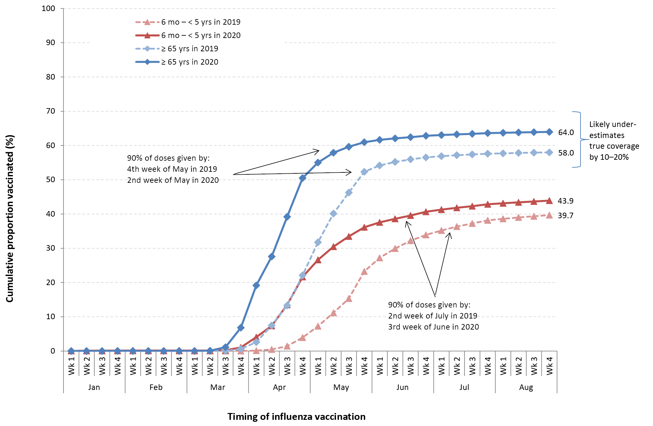
Recorded influenza vaccine uptake in Aboriginal and Torres Strait Islander children aged 6 months to < 5 years was slightly higher in 2020 (40.1%) than in 2019 (39.9%) (Figure 2), but lower than in non-Indigenous children (44.1%). In contrast, uptake in Aboriginal and Torres Strait Islander adults aged ≥ 65 years was higher in 2020 than 2019 (76.2% versus 75.1%) (Figure 2) and substantially higher than in non-Indigenous adults (63.8%). Recorded uptake for Aboriginal and Torres Strait Islander people in the 5–14, 15–49 and 50–64 year age groups was higher in 2020 at 32.5%, 32.1% and 56.4%, respectively, compared to 2019 (30.0%, 28.9% and 52.0%). While uptake in younger Aboriginal and Torres Strait Islander adults was lower than in those aged ≥ 65 years, it was similar to the most recent (2012/2013) National Aboriginal and Torres Strait Islander Health Survey.⁷

Figure 2: Cumulative influenza vaccine uptake (≥ 1 dose) in Indigenous young children and older adults, Australia, 1 March to 31 August, 2019 and 2020
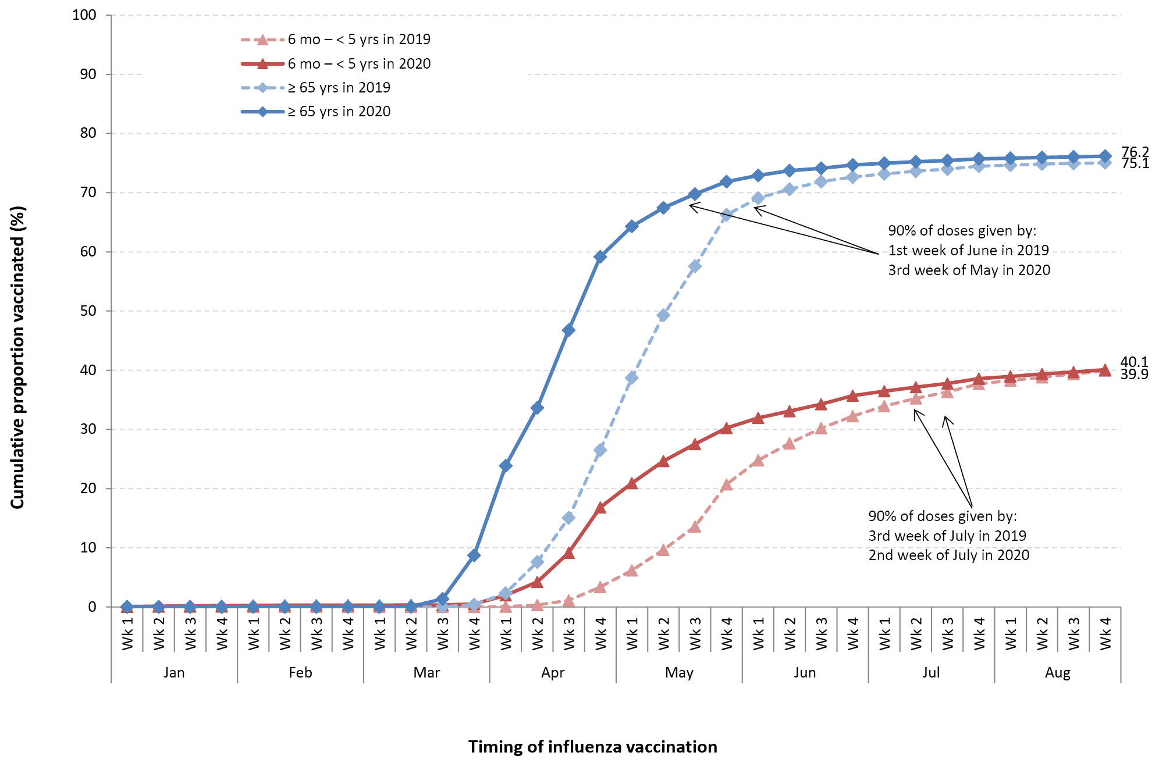
Different vaccination patterns were also observed in 2020. Vaccination commenced and peaked several weeks earlier than in 2019, due to the early program rollout stimulated by the COVID-19 pandemic, and was several weeks earlier in adults aged ≥ 65 years than in young children in both years, consistent with prioritisation strategies.
In conclusion, 2020 saw increases in recorded influenza vaccine uptake. This could be due both to increased completeness of reporting, and to true increases in coverage due to early rollout and public messaging. However, AIR data still vastly underestimates true influenza vaccine uptake. In 2020, there were 18 million doses of influenza vaccine distributed,⁸ but only half (9 million) were recorded in AIR as of the end of September. While data completeness has improved substantially, it is still suboptimal given that this whole-of-life register has been in place for more than four years. Under-reporting of influenza vaccination to AIR is likely greatest in non-Indigenous adults aged < 65 years, in whom many non-NIP-funded influenza vaccinations are administered in workplaces, pharmacies and other non-GP settings.⁵ We need to redouble our efforts to improve reporting of influenza vaccinations, and indeed vaccinations of any type in individuals of any age, to AIR. Complete reporting of vaccination will be critically important to monitoring the uptake, effectiveness and safety of COVID-19 vaccines. The mandatory reporting requirements that are being introduced, for both COVID-19 and other NIP vaccines,⁹ are a welcome step towards optimising completeness and utility of the AIR.

Author details
Dr Frank Beard^{1,2}
Dr Alexandra Hendry¹
Prof Kristine Macartney^{1,2}
- National Centre for Immunisation Research and Surveillance, Westmead, NSW, Australia
- The University of Sydney, NSW, Australia

Corresponding author
Dr Frank Beard
Associate Director, Surveillance, Coverage, Evaluation and Social Science National Centre for Immunisation Research and Surveillance Locked Bag 4001, Westmead NSW 2145
Phone: (02) 9845 1406
Email: frank.beard@health.nsw.gov.au

References
- Australian Technical Advisory Group on Immunisation (ATAGI). Australian Immunisation Handbook. [Internet.] Canberra: Australian Government Department of Health; 2020. [Accessed 20 October 2020.] Available from: https://immunisationhandbook.health.gov.au.
- Beard F, Hendry A, Macartney K. Influenza vaccination uptake in our most vulnerable groups: how well are we protecting them in 2019? Commun Dis Intell (2018). 2020;44. doi: https://doi.org/10.33321/cdi.2020.44.27.
- Hull B, Hendry A, Dey A, Brotherton J, Macartney K, Beard F. Annual immunisation coverage report 2017. Commun Dis Intell (2018). 2019;43. doi: https://doi.org/10.33321/cdi.2019.43.47.
- Cheng AC, Holmes M, Dwyer DE, Senanayake S, Cooley L, Irving LB et al. Influenza epidemiology in patients admitted to sentinel Australian hospitals in 2018: the Influenza Complications Alert Network (FluCAN). Commun Dis Intell (2018). 2019;43. doi: https://doi.org/10.33321/cdi.2019.43.48.
- Hull B, Hendry A, Dey A, Macartney K, McIntyre P, Beard F. Exploratory analysis of the first 2 years of adult vaccination data recorded on AIR: November 2019. Sydney: National Centre for Immunisation Research and Surveillance Australia (NCIRS); 2019. [Accessed on 20 October 2020.] Available from: http://ncirs.org.au/sites/default/files/2019-11/Analysis%20of%20adult%20vaccination%20data%20on%20AIR_Nov%202019.pdf.
- Newspoll. Newspoll Omnibus Survey: June 2014. Summary report: Flu vaccinations. Department of Health. Canberra: Australian Government Department of Health; 23 June 2014. [Accessed on 20 October 2020.] Available from: https://beta.health.gov.au/resources/publications/newspoll-omnibus-survey-on-adult-flu-vaccinations-summary-report.
- Webster F, Gidding H, Matthews V, Taylor R, Menzies R. What isn’t measured isn’t done – eight years with no progress in Aboriginal and Torres Strait Islander adult influenza and pneumococcal vaccination. Aust N Z J Public Health. 2019;43(6):558–62.
- The Hon Greg Hunt MP, Minister for Health and Aged Care, Australian Government. Record flu vaccines in 2020 to protect Australians. [Internet.] Canberra: Australian Government Department of Health; 27 May 2020. [Accessed on 20 October 2020.] Available from: https://www.health.gov.au/ministers/the-hon-greg-hunt-mp/media/record-flu-vaccines-in-2020-to-protect-australians.
- The Hon Greg Hunt MP, Minister for Health and Aged Care, Australian Government. Strengthening Australia’s immunisation program. [Internet.] Canberra: Australian Government Department of Health; 3 December 2020. [Accessed on 21 January 2021.] Available from: https://www.health.gov.au/ministers/the-hon-greg-hunt-mp/media/strengthening-australias-immunisation-program.
Communicable Diseases Intelligence
ISSN: 2209-6051 Online

Communicable Diseases Intelligence (CDI) is a peer-reviewed scientific journal published by the Office of Health Protection and Response, Department of Health. The journal aims to disseminate information on the epidemiology, surveillance, prevention and control of communicable diseases of relevance to Australia.

Editor: Tanja Farmer
Deputy Editor: Simon Petrie
Design and Production: Kasra Yousefi
Editorial Advisory Board: David Durrheim, Mark Ferson, John Kaldor, Martyn Kirk and Linda Selvey

Website: http://www.health.gov.au/cdi

Contacts
CDI is produced by Environmental Health and Health Protection Policy Branch, Office of Health Protection and Response, Australian Government Department of Health, GPO Box 9848, (MDP 6) CANBERRA ACT 2601

Email: cdi.editor@health.gov.au

Submit an Article
You are invited to submit your next communicable disease related article to the Communicable Diseases Intelligence (CDI) for consideration. More information regarding CDI can be found at: http://health.gov.au/cdi.
Further enquiries should be directed to: cdi.editor@health.gov.au.

This journal is indexed by Index Medicus and Medline.

Creative Commons Licence - Attribution-NonCommercial-NoDerivatives CC BY-NC-ND
© 2021 Commonwealth of Australia as represented by the Department of Health
This publication is licensed under a Creative Commons Attribution-NonCommercial-NoDerivatives 4.0 International Licence from https://creativecommons.org/licenses/by-nc-nd/4.0/legalcode (Licence). You must read and understand the Licence before using any material from this publication.

Restrictions
The Licence does not cover, and there is no permission given for, use of any of the following material found in this publication (if any):
- the Commonwealth Coat of Arms (by way of information, the terms under which the Coat of Arms may be used can be found at www.itsanhonour.gov.au);
- any logos (including the Department of Health’s logo) and trademarks;
- any photographs and images;
- any signatures; and
- any material belonging to third parties.

Disclaimer
Opinions expressed in Communicable Diseases Intelligence are those of the authors and not necessarily those of the Australian Government Department of Health or the Communicable Diseases Network Australia. Data may be subject to revision.

Enquiries
Enquiries regarding any other use of this publication should be addressed to the Communication Branch, Department of Health, GPO Box 9848, Canberra ACT 2601, or via e-mail to: copyright@health.gov.au

Communicable Diseases Network Australia
Communicable Diseases Intelligence contributes to the work of the Communicable Diseases Network Australia.
http://www.health.gov.au/cdna

This study was exempted from ethics approval by The Sydney Children’s Hospital Network Human Research Ethics Committee on the basis that it involved analysis of de-identified, population-based, administrative data for surveillance activities, under the approval of the Australian Government Department of Health.

