The epidemiology of the COVID-19 pandemic in the small, low-resource country of Timor-Leste, January 2020 – June 2022
Maria AV Niha, Anthony DK Draper, Odete da Silva Viegas, Rui M de Araujo, Josefina C Joao, Endang da Silva, Ismail Barreto, Nevio Sarmento, Tessa Oakley, Filipe de Neri Machado, Nicholas SS Fancourt, Ian Marr, Liliana N dos Santos Fernandes, Noemia Martins, Paul Arkell, Ari JP Tilman, Benjamin Dingle, Carlito C Freitas, Partha S Bhowmick, Sarah Sheridan, Benjamin P Howden, Jennifer Yan, Joshua R Francis, Nelson Martins

Abstract
Timor-Leste, a small, mountainous half-island nation which shares a land border with Indonesia and which is 550 km from Australia, has a population of 1.3 million and achieved independence for the second time in 2002. It is one of the poorest nations in Asia. In response to the global coronavirus disease 2019 (COVID-19) pandemic, the Timor-Leste Ministry of Health undertook surveillance and contact tracing activities on all notified COVID-19 cases. Between 1 January 2020 and 30 June 2022, there were 22,957 cases of COVID-19 notified which occurred in three waves, the first which was delayed until April 2021 (community transmission of B.1.466.2 variant following major flooding), followed by waves in August 2021 (B.1.617.2 Delta variant transmission) and February 2022 (B.1.1.529 Omicron variant transmission). There were 753 people hospitalised due to COVID-19 and 133 deaths. Of the 133 deaths, 122 (92%) were considered not fully vaccinated (< 2 COVID-19 vaccines) and none had received boosters. Timor-Leste implemented measures to control COVID-19, including: rapid closure of international borders; isolation of cases; quarantining of international arrivals and close contacts; restrictions on internal travel; social and physical distancing; and, finally, a country-wide vaccination program. The health system’s capacity was never exceeded.
Keywords: Coronavirus disease 2019; COVID-19; surveillance; Timor-Leste; low-resource setting; contact tracing.

Background
Timor-Leste is a small, mountainous half-island nation which shares a land border with Indonesia and is 550 kilometres (km) from Australia.¹ Timor-Leste has a population of 1.3 million and achieved independence for the second time in 2002. It is one of the poorest nations in Asia.²
On 30 January 2020, the World Health Organization (WHO) declared the worldwide coronavirus 2019 disease (COVID-19) outbreak a Public Health Emergency of International Concern,³ and by 11 March 2020 it was declared a global pandemic.⁴
On 21 March 2020, the first case of COVID-19 was notified in Timor-Leste: a traveller who had come to Dili from Europe, via Malaysia.
To protect its health system, Timor-Leste established the Centro Integrado de Gestão de Crise (CIGC: Integrated Centre for Crisis Management) in March 2020,⁵ which coordinated the work of the nine pillars of the COVID-19 response (Table 1).⁶
Timor-Leste rapidly closed its international borders in March 2020; introduced mandatory quarantine for limited international arrivals; placed restrictions on internal travel; and placed limits on social and physical interaction. Finally, a national COVID-19 vaccination program commenced on 7 April 2021.⁷
Table 1: The nine pillars of the Timor-Leste COVID-19 response and their responsibilities
Pillar | Responsibilities
I | Coordination, planning and monitoring
II | Risk communication and community engagement
III | Surveillance and epidemiology
IV | Point of entry control
V | Laboratory testing
VI | Infection prevention and control (IPC)
VII | Case management
VIII | Operations and logistics
IX | Maintaining essential health

Aim
We aim to describe the epidemiology of the COVID-19 pandemic in Timor-Leste from 1 January 2020 to 30 June 2022.

Methods
We undertook surveillance and response activities according to Timorese Ministry of Health (MoH) guidelines,⁸ adapted from WHO guidelines.⁹ A confirmed case required detection of severe acute respiratory syndrome coronavirus-2 (SARS-CoV-2) by a polymerase chain reaction (PCR) assay from a nasal and/or oropharyngeal swab. Testing was accessible in the capital Dili and all municipalities, with a focus on municipalities bordering Indonesia. For the first 18 months of the pandemic, all confirmed cases were isolated in COVID-19 treatment/isolation facilities or hospital facilities that were established in early 2020. Home isolation was made available from 12 July 2021,¹⁰ when increased case numbers dictated a change in policy; those requiring oxygen or treatment were still admitted to a treatment facility or hospital. A close contact was defined as anyone who had face-to-face contact with a confirmed COVID-19 case for more than 15 minutes cumulatively or continuously (e.g. household setting or healthcare setting without appropriate use of personal protective equipment) or who was in the same room with an infectious case for more than two hours (e.g. school room, work place) while a case was symptomatic or in the 24 hours prior to symptom onset. A death with COVID-19 was defined as anyone who tested positive for COVID-19 in the 14 days prior to death or anyone admitted to a COVID-19 treatment facility or intensive care unit with COVID-19, who subsequently died in that facility with COVID-19 contributing to the death. The testing strategy in Timor-Leste focused on symptomatic individuals, on close contacts of confirmed cases, on asymptomatic people wishing to travel internationally or between municipalities in Timor-Leste, and on international arrivals in quarantine.
Case information, including demographics, vaccination status, and severity of illness, was collected using a case report form and entered into the MoH online COVID-19 dashboard, an online epidemiological database developed specifically for the COVID-19 response in Timor-Leste. Analysis and graphs were produced using Microsoft Excel 2016 (Microsoft, USA).
Ethics approval was not sought as our activities were conducted under the auspices of routine communicable disease surveillance activity and published with the approval of the Director General of Health Services, Timor-Leste Ministry of Health.

Results
In total, there were 22,957 cases of COVID-19 notified in Timor-Leste between 1 January 2020 and 30 June 2022 (Figure 1).
From March 2020 to March 2021, COVID-19 cases in Timor-Leste were confined to returned travellers in supervised quarantine, until community transmission was observed in the capital, Dili in March 2021. Community transmission most likely resulted from undetected border crossings from the neighbouring Indonesian province, Nusa Tenggara Timur (where community transmission was already occurring), or possibly from quarantine breaches. The Timorese Government issued a notice for mandatory home confinement in Dili on 8 March 2021 which was extended, in an attempt to suppress transmission.¹¹
On 4 April 2021, however, devastating floods occurred in the wake of Cyclone Seroja resulting in widespread destruction. A State of Calamity was declared on 8 April 2021, along with suspension of mandatory confinement orders.¹² Crowding at both private homes and evacuation facilities, and the disruption to mandated home confinement, likely hastened transmission of COVID-19; the peak of the first wave of transmission occurred in May 2021 (4,727 cases notified in that month), with transmission predominantly due to the B.1.466.2 variant of SARS-CoV-2, which was also dominant in Indonesia at the time.¹³ A national COVID-19 vaccination program commenced during this first wave, with prioritisation of healthcare and other essential workers, and of high-risk populations (based on age and comorbidities).⁷
The second wave of transmission occurred between August and October 2021 (due largely to the B.1.617.2 Delta variant) and peaked with 5,789 cases notified during August 2021. Quarantine for international arrivals was removed in December 2021 and the final wave of transmission peaked in February 2022 (predominantly B.1.1.529 Omicron variant) with 2,747 cases notified in that month. All international arrivals required a negative PCR test prior to travelling to Timor-Leste, until this requirement was removed on 17 March 2022.¹⁴ The two most populated municipalities, Dili and Baucau, had the highest rates of disease, followed by the municipality of Covalima which shares a border with Indonesia (Table 2).
In total, 753 people were hospitalised due to COVID-19 (the first on 20 March 2021); 133 people died with COVID-19 (the first on 6 April 2021). Of the 133 people who died, 122 (92%) were eligible for, but had not received, ≥ 2 COVID-19 vaccinations prior to their death, and none had received boosters. The median age of those who died was 58.5 years (inter-quartile range 42–68 years). The majority of deaths (96/133, 72.2%) and hospitalisations (404/753, 54%) occurred during the Delta variant wave (Figure 2).
As of 30 June 2022, 86.9% of the Timor-Leste population aged ≥ 12 years had received at least one dose of COVID-19 vaccine; 74.3% had received two doses. Of the population who received two doses of vaccine, 72% received Oxford-AstraZeneca, 21% Pfizer-BioNTech and 6% CoronaVac (Sinovac COVID-19 vaccine). Booster doses were given to 14.7% of the population aged ≥ 18 years.

Figure 1: Epidemic curve of COVID-19 cases notified in Timor-Leste between 1 January 2020 and 30 June 2022
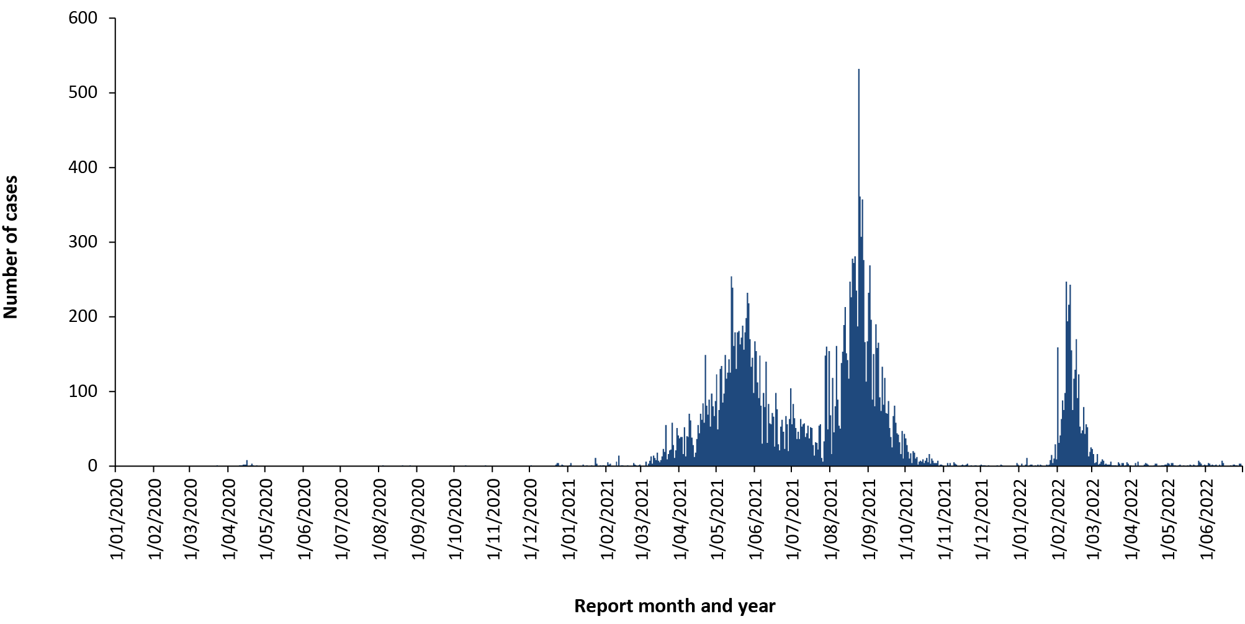
Table 2: Number of COVID-19 cases, incidence rate (per 100,000 population) and deaths, by municipality, Timor-Leste, 1 January 2020 – 30 June 2022
Municipality | Cases | Incidence rate (per 100,000 population) | Deaths
Aileu | 136 | 242 | 1
Ainaro | 303 | 463 | 3
Baucau | 1,626 | 1,280 | 7
Bobonaro | 755 | 756 | 11
Covalima | 838 | 1,194 | 3
Dili | 16,367 | 4,642 | 90
Ermera | 1,120 | 802 | 2
Lautem | 187 | 279 | 5
Liquiça | 132 | 162 | 1
Manatuto | 240 | 486 | 2
Manufahi | 272 | 470 | 0
Oecusse | 462 | 641 | 3
Viqueque | 519 | 656 | 5
Total | 22,957 | 1,742 | 133

Figure 2: Admissions to COVID-19 treatment facilities and reported deaths with COVID-19, Timor-Leste, 1 March 2021 to 30 June 2022
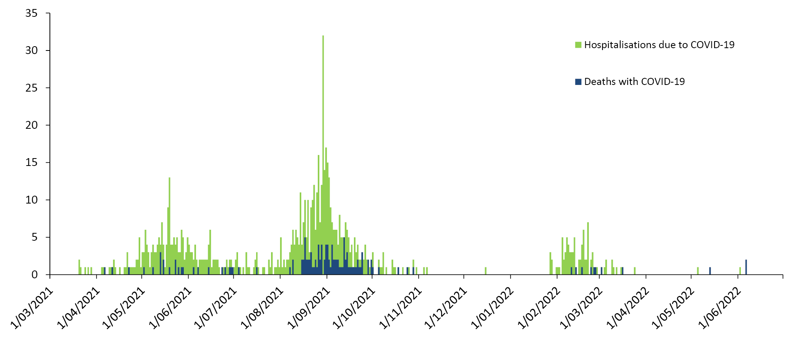
The low observed mortality (case fatality rate 0.6% compared to 2.6% in neighbouring Indonesia)¹⁵ is possibly due to the relatively younger population of Timor-Leste (median age 19.6 years¹⁶ compared to 29.5 years in Indonesia);¹⁷ routine testing of asymptomatic people (including close contacts, incoming and outgoing travellers); and early closure of international borders and, for 18 months, with effective quarantine (which allowed time for greater preparation of the health system and administration of vaccines). By 1 August 2021—when the Delta variant wave was commencing—38.2% of the eligible population aged over 18 years had received at least one dose of a COVID-19 vaccine. Under-ascertainment of cases and deaths is also highly likely, with some refusing post-mortem COVID-19 testing of their relatives who died at home. The health system’s capacity (COVID-19 treatment centres and hospitals), although stretched, never exceeded capacity during the pandemic.

Conclusion
The public health measures implemented to control COVID-19 in Timor-Leste enabled the nation to avoid widespread community transmission until March 2021. In that time, Timor-Leste was able to upscale testing capability and to prepare facilities for treatment of an expected high number of cases requiring care. Public health measures, followed by a successful national vaccination campaign, meant that the health care system did not exceed its capacity during the pandemic.

Acknowledgements
We acknowledge the workers of Timor-Leste from the nine pillars of the COVID-19 response for their tireless efforts. We acknowledge the international sequencing and analysis team at the Microbiological Diagnostic Unit Public Health Laboratory (MDU PHL), University of Melbourne at the Peter Doherty Institute for Infection and Immunity, for performing whole genome sequencing and genomic analysis on isolates from Timor-Leste. We acknowledge the staff at Territory Pathology at Royal Darwin Hospital, particularly Professor Rob Baird and Mr Kevin Freeman for processing samples from Timor-Leste while PCR testing capability was being established. We acknowledge funding support for Menzies School of Health Research from the Australian Government Department of Foreign Affairs and Trade’s Indo-Pacific Centre for Health Security. We thank Dr Dongbao Yu from WHO. Most importantly we acknowledge the people of Timor-Leste for their collective action.

Author details
Maria AV Niha,^{1,2}
Anthony DK Draper,^{3,4,5}
Odete da Silva Viegas,¹
Rui M de Araujo,⁶
Josefina C Joao,¹
Endang da Silva,⁸
Ismail Barreto,²
Nevio Sarmento,⁴
Tessa Oakley,⁴
Filipe de Neri Machado,¹
Nicholas SS Fancourt,⁴
Ian Marr,⁴
Liliana N dos Santos Fernandes,¹
Noemia Martins,¹
Paul Arkell,⁴
Ari JP Tilman,⁸
Benjamin Dingle,⁴
Carlito C Freitas,¹
Partha S Bhowmick,²
Sarah Sheridan,⁹
Benjamin P Howden,^{10,11,12}
Jennifer Yan,^{4,7}
Joshua R Francis,^{4,7}
Nelson Martins⁴
- Ministry of Health, Caicoli, Timor-Leste
- World Health Organization, Timor-Leste Office, Caicoli, Timor-Leste
- Centre for Disease Control, Public Health Unit, Top End Health Service, Northern Territory Government Department of Health, Darwin, Northern Territory, Australia.
- Menzies School of Health Research, Charles Darwin University, Darwin, Northern Territory, Australia.
- National Centre for Epidemiology and Population Health, Australian National University, Canberra, Australia
- Centro Integrado de Gestão de Crise, Timor-Leste Government, Dili, Timor-Leste
- Paediatric Department, Royal Darwin Hospital, Northern Territory Department of Health, Darwin, Australia
- Laboratorio Nacional da Saude, Bidau, Timor-Leste
- National Centre for Immunisation Research and Surveillance, The Children’s Hospital at Westmead, Westmead, Australia.
- Microbiological Diagnostic Unit Public Health Laboratory, Department of Microbiology & Immunology, University of Melbourne at the Peter Doherty Institute for Infection & Immunity, Melbourne, Victoria, Australia.
- Department of Infectious Diseases, Austin Health, Heidelberg, Victoria, Australia
- Doherty Applied Microbial Genomics, Department of Microbiology & Immunology, University of Melbourne, Victoria, Australia

Corresponding author
Anthony DK Draper
Centre for Disease Control, Public Health Unit, Top End Health Service, Northern Territory Government Department of Health, PO Box 45096, Casuarina NT 0811.
Telephone: +61 8 8922 7635.
Facsimile: +61 8 8922 8310.
Email: anthony.draper@nt.gov.au.

References
- Government of Timor-Leste. About Timor-Leste. [Internet.] Dili: Government of Timor-Leste; 2022. Available from: http://timor-leste.gov.tl/?p=547&lang=en.
- World Bank. The World Bank in Timor-Leste: Overview. [Internet.] Washington DC: World Bank; April 2022. Available from: https://www.worldbank.org/en/country/timor-leste/overview.
- World Health Organization (WHO). WHO Director-General’s statement on IHR Emergency Committee on Novel Coronavirus (2019-nCoV). [Internet.] Geneva: WHO; 30 January 2020. Available from: https://www.who.int/dg/speeches/detail/who-director-general-s-statement-on-ihr-emergency-committee-on-novel-coronavirus-(2019-ncov).
- WHO. WHO Director-General’s opening remarks at the media briefing on COVID-19 - 11 March 2020. [Internet.] Geneva: WHO; 11 March 2020. Available from: https://www.who.int/director-general/speeches/detail/who-director-general-s-opening-remarks-at-the-media-briefing-on-covid-19---11-march-2020.
- Government of Timor-Leste, 2020. Jornal da República – Publicação Oficial da República Democrática de Timor-Leste. Numero Extraordinario. Diploma Ministerial N.º 14 /2020 de 31 de Março. Estabelece a sala de situação do Centro Integrado de Gestão de Crises. Dili: Government of Timor-Leste; 31 March 2020. Available from: https://www.mj.gov.tl/jornal/public/docs/2020/serie_1/SERIE_I_NO_13_C.pdf.
- Martins N. Estratejia ba Prevensaun no Mitigasaun Surtu Covid-19 iha Timor Leste. [Oral presentation at Universidade da Paz, Dili, Timor-Leste,19 December 2020.] Transcript available from: https://www.researchgate.net/publication/350006753_Estratejia_ba_Prevensaun_no_Mitigasaun_Surtu_Covid-19_iha_Timor_Leste.
- Government of Timor-Leste. Timor-Leste begins national vaccination plan against COVID-19. [Internet.] Dili: Government of Timor-Leste; 7 April 2021. Available from: http://timor-leste.gov.tl/?p=27573&lang=en.
- Timor-Leste Ministry of Health. National Guidance on Surveillance and Contact Management of COVID-19 for Timor-Leste. Dili: Government of Timor-Leste, Ministry of Health; 2020.
- WHO. Public health surveillance for COVID-19. Interim guidance: 16 December 2020. Geneva: WHO; 16 December 2020. Available from: https://apps.who.int/iris/bitstream/handle/10665/337897/WHO-2019-nCoV-SurveillanceGuidance-2020.8-eng.pdf.
- Government of Timor-Leste. Jornal da República – Publicação Oficial da República Democrática de Timor-Leste. Numero Extraordinario. Diploma Ministerial N.º 42 /2021 de 12 de Julho. Define as regras de cumprimento do isolamento terapêutico obrigatório na residência. Dili: Government of Timor-Leste; 12 July 2021. Available from: http://timor-leste.gov.tl/wp-content/uploads/2021/07/SERIE-I-N.-28-C1.pdf.
- Government of Timor-Leste, 2021. Extraordinary Meeting of the Council of Ministers of March 8th, 2021. [Internet.] Dili: Government of Timor-Leste; 8 March 2021. Accessed from: http://timor-leste.gov.tl/?p=27134&lang=en.
- Government of Timor-Leste, Office of the Prime Minister. Timor-Leste declares the State of Calamity. [Internet.] Dili: Government of Timor-Leste, Primeiro Ministro; 9 April 2021. Accessed from: https://www.gpm.gov.tl/en/timor-leste-iha-estadu-kalamidade/.
- Zhu M, Zeng Q, Saputro BIL, Chew SP, Chew I, Frendy H et al. Tracking the molecular evolution and transmission patterns of SARS-CoV-2 lineage B.1.466.2 in Indonesia based on genomic surveillance data. Virol J. 2022;19(1):103. doi: https://doi.org/10.1186/s12985-022-01830-1.
- Government of Timor-Leste. Jornal da República – Publicação Oficial da República Democrática de Timor-Leste. Numero Extraordinario. Diploma Ministerial Serie I, N.º 12A/2022 de 17 de Março. Decreto-Lei N.º 12/2022 de 17 de Março. Dili: Government of Timor-Leste; 17 March 2022. Available from: https://www.mj.gov.tl/jornal/public/docs/2022/serie_1/SERIE_I_NO_12_A.pdf.
- WHO Indonesia. Coronavirus Disease 2019 (COVID-19) Situation Report – 92. Jakarta: WHO Indonesia; 13 July 2022. Available from: https://cdn.who.int/media/docs/default-source/searo/indonesia/covid19/external-situation-report-92_13-july-2022.pdf.
- Government of Timor-Leste. Timor-Leste em Números / Timor-Leste in Figures: 6th edition, 2015. Dili: Government of Timor-Leste, General Directorate of Statistics; October 2015. Available from: https://www.statistics.gov.tl/wp-content/uploads/2017/02/Timor-Leste-em-Numeros-20151.pdf.
- United Nations Population Fund (UNFPA) Indonesia. UNFPA Indonesia Monograph Series: No. 1: Indonesia on the Threshold of Population Ageing. July 2014. Jakarta: UNFPA Indonesia; July 2014. Available online from: https://indonesia.unfpa.org/sites/default/files/pub-pdf/BUKU_Monograph_No1_Ageing_03_Low-res.pdf.

Communicable Diseases Intelligence
ISSN: 2209-6051 Online

Communicable Diseases Intelligence (CDI) is a peer-reviewed scientific journal published by the Office of Health Protection and Response, Department of Health and Aged Care. The journal aims to disseminate information on the epidemiology, surveillance, prevention and control of communicable diseases of relevance to Australia.

Editor: Noel Lally
Deputy Editor: Simon Petrie
Design and Production: Kasra Yousefi
Editorial Advisory Board: David Durrheim, Mark Ferson, John Kaldor, Martyn Kirk and Linda Selvey

Website: http://www.health.gov.au/cdi

Contacts
CDI is produced by the Office of Health Protection and Response, Australian Government Department of Health and Aged Care, GPO Box 9848, (MDP 6) CANBERRA ACT 2601

Email: cdi.editor@health.gov.au

Submit an Article
You are invited to submit your next communicable disease related article to the Communicable Diseases Intelligence (CDI) for consideration. More information regarding CDI can be found at: http://health.gov.au/cdi.
Further enquiries should be directed to: cdi.editor@health.gov.au.

This journal is indexed by Index Medicus and Medline.

Creative Commons Licence - Attribution-NonCommercial-NoDerivatives CC BY-NC-ND
© 2022 Commonwealth of Australia as represented by the Department of Health and Aged Care
This publication is licensed under a Creative Commons Attribution-NonCommercial-NoDerivatives 4.0 International Licence from https://creativecommons.org/licenses/by-nc-nd/4.0/legalcode (Licence). You must read and understand the Licence before using any material from this publication.

Restrictions
The Licence does not cover, and there is no permission given for, use of any of the following material found in this publication (if any):
- the Commonwealth Coat of Arms (by way of information, the terms under which the Coat of Arms may be used can be found at www.itsanhonour.gov.au);
- any logos (including the Department of Health and Aged Care’s logo) and trademarks;
- any photographs and images;
- any signatures; and
- any material belonging to third parties.

Disclaimer
Opinions expressed in Communicable Diseases Intelligence are those of the authors and not necessarily those of the Australian Government Department of Health and Aged Care or the Communicable Diseases Network Australia. Data may be subject to revision.

Enquiries
Enquiries regarding any other use of this publication should be addressed to the Communication Branch, Department of Health and Aged Care, GPO Box 9848, Canberra ACT 2601, or via e-mail to: copyright@health.gov.au

Communicable Diseases Network Australia
Communicable Diseases Intelligence contributes to the work of the Communicable Diseases Network Australia.
http://www.health.gov.au/cdna

