Communicable Diseases Intelligence, Year 2023, Volume 47
https://doi.org/10.33321/cdi.2023.47.53
Publication date: 21/09/2023
http://health.gov.au/cdi

Several confirmed and probable zoonotic cases of toxigenic Corynebacterium ulcerans, Queensland, Australia
Vicki G Slinko, Christine JD Guglielmino, Alexandra M Uren, James KG Smith, Deborah Neucom, Nicolas R Smoll, Rikki MA Graham, Ning-Xia Fang, Helen V Smith, Amanda E Armstrong, Alison A Kenny, Janet L Farmer, Catherine A Quagliotto, Amy V Jennison

Abstract

Background
Toxigenic Corynebacterium ulcerans is an emerging zoonosis globally, causing both cutaneous and respiratory diphtheria-like illness. In Queensland, human infection with toxigenic C. ulcerans is rare, with only three cases reported before October 2015. This case series describes five subsequent cases of toxigenic C. ulcerans in Queensland with links to companion animals.

Methods
All data were collected as part of routine public health response, and strains were whole genome sequenced for further characterisation. Household contacts were screened, treated with appropriate antibiotics, and received a diphtheria toxoid-containing vaccine if more than five years had elapsed since their last dose.

Findings
No epidemiological or genomic links could be established between any of the five patients, including between the two cases notified from the same locality within eight days of each other. The C. ulcerans strains from Cases Two, Four and Five were closely related to the strains isolated from their respective pets by whole genome sequencing. Domestic dogs were identified as the most likely mode of transmission for Cases One and Three; however, this was unable to be laboratory confirmed, since Case One’s dog was treated with antibiotics before it could be tested, and Case Three’s dog was euthanised and cremated prior to case notification.

Interpretation
These are the first reported Australian cases of this emerging zoonosis with links to companion animals. These cases demonstrate the likely transmission route between companion animals and humans, with no evidence of human-to-human transmission. The existing requirement in the Queensland Health Public Health Management Guidelines, of restrictions on cases and some contacts while awaiting swab results, is currently under review.
Keywords: Corynebacterium ulcerans; Australia; diphtheria toxoid; zoonoses; public health; whole genome sequencing

Background
Toxigenic Corynebacterium ulcerans is an emerging zoonosis globally, causing diphtheria-like illness,^{1–4} and is notifiable in Queensland for both respiratory and cutaneous infections.⁵ C. ulcerans infections without the toxin gene detected are not notifiable or followed up in Queensland. Respiratory pseudomembranous disease with toxin production is clinically indistinguishable from toxigenic C. diphtheriae infections and can be fatal.^{3,6} Cutaneous disease, usually on the extremities, has been described as hard, rolled-edge ulcers with a greyish membrane, and is understood to be more contagious than respiratory infection due to greater environmental contamination.⁷ Corynebacteriophages carrying the tox gene, consisting of A and B subunits, can theoretically transform non-toxin gene-bearing Corynebacterium spp. into toxigenic strains.⁸ Transmission to humans was previously typically associated with cattle or raw dairy products but a variety of animals, including domestic animals,¹ have now been implicated in transmitting infection to humans.
In Queensland, cases with toxigenic C. ulcerans and their contacts are followed up according to the Diphtheria Queensland Health Guidelines for Public Health Units.⁹ For cases, this includes treatment with appropriate antibiotics with cutaneous wounds covered; droplet restrictions imposed until throat and nasopharyngeal (NP) swabs are negative for C. ulcerans, or until there has been 72 hours of appropriate antibiotic therapy; and then a diphtheria toxoid containing vaccine (DTCV) during convalescence. Contacts are considered those who have been in contact with the case since the infection was noted, and are household-like or of a sexual nature; have had direct contact with the wound without wearing gloves and a mask; or have had more than 20 hours of close contact if the wound was uncovered. For contacts, throat and NP swabs are taken to exclude colonisation with the organism; treatment with appropriate antibiotics is given as they may be incubating the disease; vaccination with a DTCV is provided if it is more than five years since their last dose; and contacts are restricted from occupations involving contacts with infants aged six months or under, care of the sick, elderly or those dependant on care, and immunosuppressed individuals.
We present five cases of a rare toxin gene-bearing C. ulcerans infection with likely or proven associations with household pets during 2015–2023 in Queensland, Australia, two of which were notified from the same locality within eight days of each other. While described on other continents, we know of no other documented zoonotic cases in Australia.

Methods
All data were collected as part of routine public health response to a notifiable condition.
Consent for publication with de-identified details was obtained from all cases. Details of the cases and contact tracing were carried out as part of normal follow-up for notifiable diseases in Queensland. West Moreton Ethics Committee Chair advised that, following The Royal Melbourne Hospital guidance, Human Research Ethics Committee Review was not required as the cases had provided written consent, the report did not contain identifying information and publication involved negligible risk to the patients and others who may be affected in Queensland Health.
Isolates of C. ulcerans were referred to QHFSS for toxin gene testing. The presence of the tox gene was confirmed by previously described methods.^{10,11} Whole genome sequencing (WGS) was performed on the Illumina NextSeq 500 platform with Nextera XT library preparation (Illumina, CA). Reads were trimmed with Trimmomatic¹² and assembled with Spades.¹³ Sequence data are available in SRA BioProject PRJEB60670. Multi-locus sequence typing (MLST) and toxin type were determined in silico using the C. diphtheriae scheme.¹⁴ Core single nucleotide polymorphism (SNP) analysis¹⁵ was performed using the Snippy package (v4.3.6) with C. ulcerans strain 0102 (NCBI accession NC_018101.1) as a reference for ST325 and C. ulcerans strain BR-AD22 (NCBI accession NC_015683.1) as a reference for ST514.

Findings

Case One
On 8 October 2015, Metro North Public Health Unit (MNPHU) was notified of toxin gene-bearing C. ulcerans isolated from a throat swab of a 37-year-old woman who had a persistent cough of several months’ duration. The cough was productive of yellow sputum though she reported no other symptoms. She described a primary course of DTCV and a booster 20 years before onset. She completed a ten-day course of doxycycline, was isolated at home until completion of clearance swabs and was administered DTCV but not given diphtheria antitoxin because of the mild nature of her illness and the lack of characteristic clinical features of respiratory diphtheria. Two people were identified as household-like close contacts; both had antibiotics prescribed and were given DTCV, and neither tested positive for C. ulcerans on screening swabs.
The case denied any recent overseas travel, contact with livestock or consumption of unpasteurised milk; however, she lived with a household dog. The dog was noted to have had a weeping leg wound that had been previously treated with antibiotics and wound dressings. After the case’s diagnosis, wound and respiratory swabs were taken from the dog, but C. ulcerans was not cultured from any of these specimens.

Case Two
A 53-year-old male with no travel history presented to his general practitioner (GP) on 13 November 2018 with a non-healing lower leg ulcer, sustained after a workplace injury two weeks earlier. He had no respiratory symptoms. Flucloxacillin was commenced, and a swab cultured. On 20 November 2018, toxin gene-bearing C. ulcerans was notified to West Moreton Public Health Unit (WMPHU) and the patient commenced erythromycin and received DTCV. Pre- and post-treatment nasopharyngeal swabs reported only normal flora. Figure 1 shows the patient’s wound post treatment. Three household contacts and the GP who provided wound care received erythromycin prophylaxis; none of their nasopharyngeal swabs isolated Corynebacterium. The GP and one household contact received a DTCV, the other two household contacts were considered up to date.
The case lived with two dogs, whose mouth swabs tested positive for toxin gene-bearing C. ulcerans which matched the owner’s sample on genome sequencing prior to treatment with erythromycin. Post-treatment swabs from the dogs were negative. Infection control advice was provided to the short-term kennel facility attended by one of the dogs.

Figure 1: Left lower leg ulcer of Case Two, four weeks after initial swab collection which was positive for toxigenic C. ulcerans and two weeks after completing 14 days of erythromycin treatment
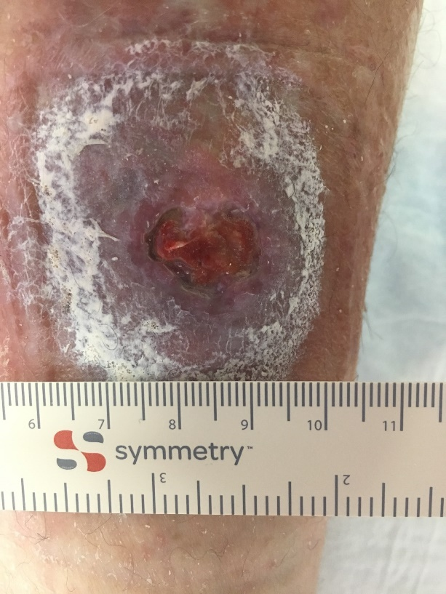

Case Three
A 44-year-old female with type 2 diabetes mellitus and no travel history presented to her GP on 19 November 2018 with a week of painful discharge from a non-healing toe amputation wound from three years previously. She had no respiratory symptoms. The wound was dressed, and its swab cultured. On 28 November 2018, toxin gene-bearing C. ulcerans was notified to WMPHU. The patient commenced erythromycin prophylaxis and received DTCV. Pre- and post-treatment nasopharyngeal swabs did not isolate C. ulcerans. The wound healed post treatment (Figure 2). All five household and household-like or intimate contacts identified were asymptomatic, received erythromycin prophylaxis and were offered DTCV with nasopharyngeal and throat swabs culture negative.
A healthy cat in the household did not have C. ulcerans isolated from nasopharyngeal swabs. A household dog with an offensive-smelling ear discharge was euthanised and cremated two weeks before the case developed symptoms. Another immunocompromised human contact of this dog was negative for C. ulcerans from nasopharyngeal swabs.

Figure 2: Wound from previous right great toe amputation of Case Three: (A) before debridement, (B) after debridement, and (C) after completion of erythromycin treatment
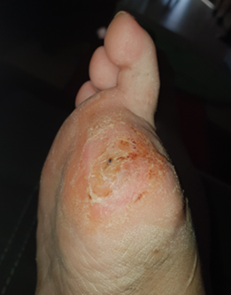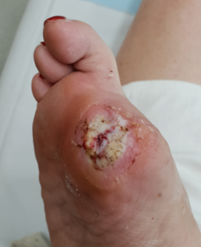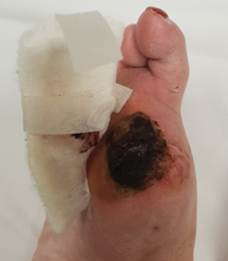

Case Four
A 22-year-old female presented to her local GP in September 2020 after a burn injury at home. The initial injury was described as light pink covering the dorsal surface of the right foot. Five days later there was change in colour and increase in slough, with infection confirmed by a wound swab revealing heavy growth of Staphylococcus aureus and Corynebacterium ulcerans, with moderate growth of Streptococcus sp. The C. ulcerans isolate was toxin gene positive and notified to MNPHU. Interview revealed no history of overseas travel, and no contact with raw animal products or animals other than a household dog. The case reported no direct wound contact with the dog and kept the wound covered other than for showers, although dog hair was reported to be common in the environment. One household contact was identified, who was well and was up to date with vaccinations. Antibiotics were organised for both case and household contact and the case was provided with a booster DTCV. Infectious Disease specialist advice was sought due to penicillin resistance of the C. ulcerans isolate, resulting in switching from flucloxacillin to doxycycline for treatment. The wound completely healed within days of commencing doxycycline. Nose and throat swabs of the case and contact did not have Corynebacterium isolated.
The dog was asymptomatic with no visible skin infections; however, nose swabs were positive for C. ulcerans, with toxin gene polymerase chain reaction (PCR) also positive. On advice from Biosecurity Queensland veterinarians, the dog was treated with doxycycline for 14 days. After another 14 days the dog was re-swabbed but showed persistent nasal carriage of C. ulcerans. Despite being advised of the risks, the case declined further treatment or swabbing of the dog. Advice was provided to the case regarding cleaning the home to minimise exposure to potential environmental contamination.

Case Five
An 85-year-old female was admitted to hospital on 27 January 2023 with a non-healing wound on her right knee after a fall while visiting an island off the Queensland coast in November 2022. The wound accumulated fluid and was drained under sterile conditions by her GP two days after the fall, but the wound continued to discharge. She had no respiratory symptoms. She commenced clindamycin on admission after a swab was taken. Toxin gene-bearing C. ulcerans was notified to Sunshine Coast Public Health Unit on 3 February 2023. Antibiotics had been changed to vancomycin several days before notification because of concerns about multi-resistant Staphylococcus aureus. Culture found a C. ulcerans resistant to penicillin and clindamycin, with sensitivity to vancomycin, tetracycline, and erythromycin. A nasal swab performed after the receipt of four days of intravenous vancomycin did not detect C. ulcerans. The throat swabs of close contacts were negative for Corynebacterium. They received erythromycin with their DTCV status considered up to date.
There were four companion animals (two dogs and two cats) in the household. All four had pharyngeal throat swabs taken that were positive for toxin gene-bearing C. ulcerans, with the same antimicrobial sensitivities detected in the sample obtained from the case. All animals received a course of erythromycin, but no clearance swabs were performed.

Laboratory findings
Table 1 shows the number of C. ulcerans isolates referred to QHFSS for toxin gene testing and the number and percentage positive for the toxin gene over the years of this case series (January 2015 – February 2023). Some of these referred isolates may come from cases outside Queensland. The toxin gene was detected in approximately 45% of isolates; but as identification of an isolate as C. ulcerans relies on the information provided by the submitting laboratory, the proportion of C. ulcerans carrying the toxin gene may actually be lower.
MLST analysis showed that the isolates of human cases and their respective animals were the same typing where animal samples were available. Cases One, Three and Four were sequence type (ST) 325, as was Case Four’s dog, with the other human cases and their respective animals ST514 (Table 2). With no epidemiological links, spatial or temporal association, these strains were unsurprisingly distantly related via higher resolution core SNP analysis (Figure 3). Figure 3A and 3B show separate phylogenetic trees built using core SNP analysis for the cases and their pets, together with the previously sequenced strains. ST325 and ST514 isolates were analysed separately due to there being a large genetic distance between these two STs. Core SNP typing showed the strains from cases and their pets were more closely related to each other than to the other cases as demonstrated by the long branch lengths between cases in Figure 3, and the relatively short branch lengths between cases and their pets.
Analysis of the full length of the tox genes revealed Cases One, Three and Four to have the same toxin gene sequence as C. ulcerans strain 0102 (Genbank accession AP012284), whereas the toxin gene sequence for Cases Two and Five varied from this sequence by one amino acid and were identical to C. ulcerans strain FRC58 (Genbank accession CP011913).
Table 1: Number of C. ulcerans isolates referred to QHFSS, and percentage with toxin gene detected, January 2015 – February 2023
Year | Total C. ulcerans isolates referred | Toxin gene detected  Number (%)
2015 | 4 | 3 (75)
2016 | 1 | 0 (0)
2017 | 2 | 1 (50)
2018 | 8 | 3 (38)
2019 | 0 | 0 (0)
2020 | 8 | 3 (38)
2021 | 3 | 2 (67)
2022 | 1 | 0 (0)
2023 (to February) | 2 | 1 (50)
Total | 29 | 13 (45)

Table 2: Case details and laboratory typing
Case | Year | Patient strain | Companion animal strains | MLST
One | 2015 | C1 | None available | ST325
Two | 2018 | C2 | C2 Dog 1  C2 Dog2 | ST514
Three | 2018 | C3 | None available | ST325
Four | 2020 | C4 | C4 Dog sample 1  C4 Dog sample 2 | ST325
Five | 2023 | C5 | C5 Cat 1  C5 Cat 2  C5 Dog 1  C5 Dog 2 | ST514
Figure 3: Phylogenetic maximum likelihood tree built using SNP typing of (A) ST325 and (B) ST514 C. ulcerans isolatesª
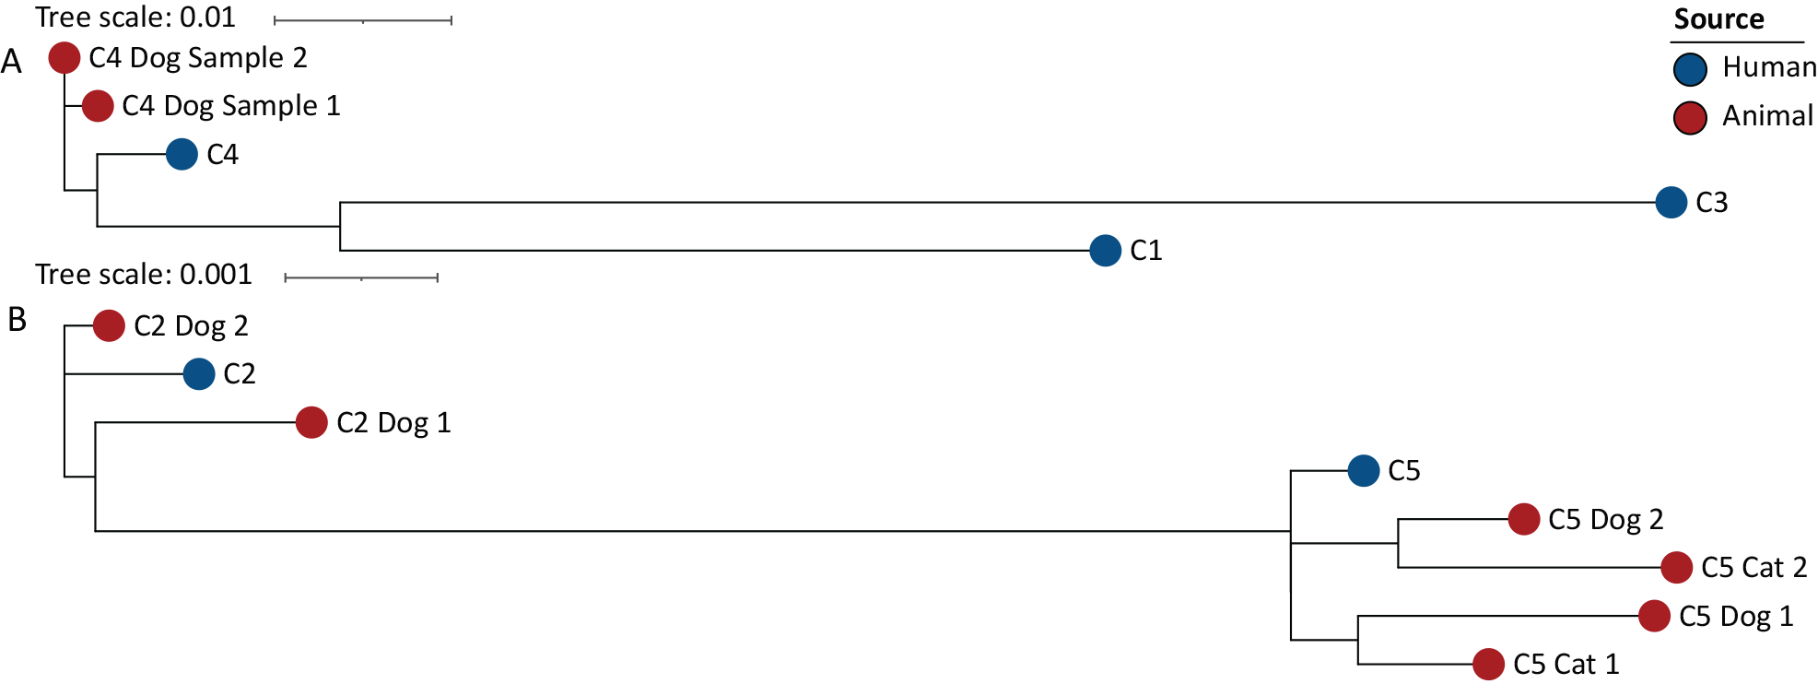
a Isolates from the two ST groups were analysed separately to aid in visualisation of the branch lengths on the trees. Related isolates have labels in the same colour and the colour of the circles indicates the source of the isolate (human or animal) as indicated in the legend. Labels indicate cases as detailed in Table 2. Branch length represents genetic distance as indicated in the scale bars.

Discussion
No secondary or co-primary cases were identified among household contacts of these five cases. Consistent with guidelines in other jurisdictions, previous Queensland guidelines advocated for the same isolation and quarantine restrictions for cases and contacts of toxigenic C. ulcerans as for toxigenic C. diphtheriae. The rationale for these restrictions was application of the precautionary principle in the context of uncertainty around whether transmission of C. ulcerans was purely zoonotic. The possibility of human-to-human transmission of C. ulcerans has previously been raised, although reports of these rare instances speculate whether other identified cases have been co-primary or secondary infections.^{1,16} Likely transmission of C. ulcerans among rhesus macaques has also been reported.¹⁷ In contrast to the spread of C. diphtheriae, the authors are not aware of any clearly described transmission of C. ulcerans between humans. Management of cases and contacts with prolonged periods of restriction therefore appears unwarranted. Findings of this case series support a move away from quarantine/exclusion of close contacts in the most recent Queensland diphtheria guidelines.⁹ Principles of caution are still maintained in the guidelines, particularly in relation to ascertainment of co-primary cases through respiratory screening (as well as detecting the theoretical possibility of secondary cases) together with vaccination and clearance antibiotic administration.
Worldwide, reports of toxigenic C. ulcerans detections are increasing, although it is possible that the relatively recent introduction of matrix assisted laser desorption/ionization time-of-flight (MALDI-TOF) mass spectrometry has enabled the increase in the number of isolates undergoing testing for tox genes, rather than a true increase in disease incidence.^{1,6,18} In Queensland, however, toxigenic C. ulcerans is still a rare disease, with a total of just nine cases notified between 2005 and 2023.
Though there are no proven links from Cases One and Three to domestic pets, there is considerable circumstantial evidence to implicate these transmission links: both pets had discharges from a wound or ear, but the first had been treated with antibiotics and the other was cremated before swabbing for C. ulcerans could be done.
The other cases have convincing evidence of transmission, though the direction of transmission is unknown. Case two appears to be the first reported proven instance of transmission between dogs and a human with cutaneous diphtheria disease in Australia.
Interestingly, ST325 was the sequence type identified for the toxin gene positive C. ulcerans isolates from Cases One, Three and Four, and from Case Four’s dog. This ST has been previously reported as a potentially zoonotic ST isolated from both symptomatic and asymptomatic humans and companion animals in Europe.^{19,20} Cases Two and Five and their pets were identified to be positive for toxin gene-bearing C. ulcerans ST514. This ST has also been previously reported as being present within a human case and corresponding contact animal.²¹ This highlights the ongoing need for appropriate sampling of companion animals and molecular typing to continue to expand understanding around risk of zoonotic transmission and association with particular genotypes.
Cases Two and Three clustered temporally and geographically, but there were no epidemiological links and isolates were of different sequence types.
The co-operation between human and veterinary health practitioners to safeguard human health via a One Health approach was an important aspect of these investigations. Although toxigenic C. ulcerans carriage is not notifiable to veterinary authorities in Queensland, support from Biosecurity Queensland was necessary to eradicate colonisation from the dogs.
As toxigenic C. ulcerans has caused respiratory diphtheria and toxin-mediated disease, this report also serves as a reminder for the need to maintain high coverage rates of diphtheria vaccination to ensure this emerging zoonosis does not result in future diphtheria fatalities.

Funding
This work received no specific grant from any funding agency.

Acknowledgements
The authors wish to thank staff at Metro North, West Moreton, Metro South and Sunshine Coast Public Health Units for contact tracing; Janine Barrett, Fiona Thompson and Joanne Mollinger from Biosecurity, Department of Agriculture and Fisheries, Queensland for support in testing the dogs, sourcing veterinarian advice and advising their veterinarians on appropriate courses of antibiotics; private pathology laboratory staff for culturing swabs; and all the Public Health Physicians around Queensland who participated in numerous Expert Advisory Groups for these cases. This publication made use of the Corynebacterium diphtheriae MLST website (https://pubmlst.org/cdiphtheriae/) sited at the University of Oxford and funded by the Welcome Trust.

Author details
Dr Vicki G Slinko,^{1,2} Ms Christine JD Guglielmino,³ Dr Alexandra M Uren,⁴ Dr James KG Smith,⁴ Ms Deborah Neucom,⁵ Dr Nicolas R Smoll,⁵ Dr Rikki MA Graham,³ Dr Ning-Xia Fang,³ Ms Helen V Smith,³ Ms Amanda E Armstrong,¹ Ms Alison A Kenny,¹ Ms Janet L Farmer,¹ Dr Catherine A Quagliotto,¹ Dr Amy V Jennison³
- West Moreton Public Health Unit, Queensland Health, Ipswich, Australia
- School of Public Health, University of Queensland, Herston, Australia
- Public Health Microbiology, Queensland Health Forensic and Scientific Services, Brisbane, Australia
- Metro North Public Health Unit, Queensland Health, Brisbane, Australia
- Sunshine Coast Public Health Unit, Queensland Health, Maroochydore, Australia

Corresponding author
Dr Vicki G Slinko
Gold Coast Public Health Unit, 45 Chisholm Road, Carrara, Queensland 4211.
Phone 07 5667 3200
Email: vicki.slinko@health.qld.gov.au

References
- Wagner KS, White JM, Lucenko I, Mercer D, Crowcroft NS, Neal S et al. Diphtheria in the postepidemic period, Europe, 2000–2009. Emerg Infect Dis. 2012;18(2):217–25. doi: https://doi.org/10.3201/eid1802.110987.
- Urakawa T, Seto J, Yamamoto A, Nakajima T, Goto S. Subcutaneous abscess formation in the upper extremity caused by toxigenic Corynebacterium ulcerans. J Med Microbiol. 2013;62(3):489–93. doi: https://doi.org/10.1099/jmm.0.051458-0.
- Tiwari TSP, Golaz A, Yu DT, Ehresmann KR, Jones TF, Hill HE et al. Investigations of 2 cases of diphtheria-like illness due to toxigenic Corynebacterium ulcerans. Clin Infect Dis. 2008;46(3):395–401. doi: https://doi.org/10.1086/525262.
- DeWinter LM, Bernard KA, Romney MG. Human clinical isolates of Corynebacterium diphtheriae and Corynebacterium ulcerans collected in Canada from 1999 to 2003 but not fitting reporting criteria for cases of diphtheria. J Clin Microbiol. 2005;43(7):3447–9. doi: https://doi.org/10.1128/JCM.43.7.3447-3449.2005.
- Queensland State Government, Office of the Queensland Parliamentary Counsel. Public Health Act 2005. [Legislation.] Brisbane: Queensland Health; 2005. Available from: https://www.legislation.qld.gov.au/view/html/inforce/current/act-2005-048.
- Dias AA, Santos LS, Sabbadini PS, Santos CS, Silva Junior FC, Napoleão F et al. Difteria pelo Corynebacterium ulcerans: uma zoonose emergente no Brasil e no mundo. [Corynebacterium ulcerans diphtheria: an emerging zoonosis in Brazil and worldwide.] Rev Saúde Pública. 2011;45(6):1176–91. doi: https://doi.org/10.1590/S0034-89102011000600021.
- Koopman JS, Campbell J. The role of cutaneous diphtheria infections in a diphtheria epidemic. J Infect Dis. 1975;131(3):239–44. doi: https://doi.org/10.1093/infdis/131.3.239.
- Zakikhany K, Neal S, Efstratiou A. Emergence and molecular characterisation of non-toxigenic tox gene-bearing Corynebacterium diphtheriae biovar mitis in the United Kingdom, 2003–2012. Euro Surveill. 2014;19(22):20819. doi: https://doi.org/10.2807/1560-7917.ES2014.19.22.20819.
- Queensland Health. Diphtheria: Queensland Health Guidelines for Public Health Units. [Internet.] Brisbane: Queensland Health; June 2019. [Accessed on 11 May 2023.] Available from: https://www.health.qld.gov.au/cdcg/index/diphtheria.
- Nakao H, Popovic T. Development of a direct PCR assay for detection of the diphtheria toxin gene. J Clin Microbiol. 1997;35(7):1651–5. doi: https://doi.org/10.1128/jcm.35.7.1651-1655.1997.
- Schuhegger R, Lindermayer M, Kugler R, Heesemann J, Busch U, Sing A. Detection of toxigenic Corynebacterium diphtheriae and Corynebacterium ulcerans strains by a novel real-time PCR. J Clin Microbiol. 2008;46(8):2822–3. doi: https://doi.org/10.1128/JCM.01010-08.
- Bolger AM, Lohse M, Usadel B. Trimmomatic: a flexible trimmer for Illumina sequence data. Bioinformatics. 2014;30(15):2114–20. doi: https://doi.org/10.1093/bioinformatics/btu170.
- Bankevich A, Nurk S, Antipov D, Gurevich AA, Dvorkin M, Kulikov AS et al. SPAdes: a new genome assembly algorithm and its applications to single-cell sequencing. J Comput Biol. 2012;19(5):455–77. doi: https://doi.org/10.1089/cmb.2012.0021.
- Bolt F, Cassiday P, Tondella ML, Dezoysa A, Efstratiou A, Sing A et al. Multilocus sequence typing identifies evidence for recombination and two distinct lineages of Corynebacterium diphtheriae. J Clin Microbiol. 2010;48(11):4177–85. doi: https://doi.org/10.1128/JCM.00274-10.
- Seemann T. Snippy. San Francisco: Github; February 24 2023. [Accessed on March 1 2023.] Available from: https://github.com/tseemann/snippy.
- Konrad R, Hörmansdorfer S, Sing A. Possible human-to-human transmission of toxigenic Corynebacterium ulcerans. Clin Microbiol Infect. 2015;21(8):768–71. doi: https://doi.org/10.1016/j.cmi.2015.05.021.
- Thomas A, Slifka AM, Hendrickson SM, Amanna IJ, Slifka MK. Active circulation of Corynebacterium ulcerans among nonhuman primates. Microbiol Spectr. 2022;10(4):e0089422. doi: https://doi.org/10.1128/spectrum.00894-22.
- Martini H, Soetens O, Litt D, Fry NK, Detemmerman L, Wybo I et al. Diphtheria in Belgium: 2010–2017. J Med Microbiol. 2019;68(10):1517–25. doi: https://doi.org/10.1099/jmm.0.001039.
- König C, Meinel DM, Margos G, Konrad R, Sing A. Multilocus sequence typing of Corynebacterium ulcerans provides evidence for zoonotic transmission and for increased prevalence of certain sequence types among toxigenic strains. J Clin Microbiol. 2014;52(12):4318–24. doi: https://doi.org/10.1128/JCM.02291-14.
- Carfora V, Scarampella F, Iurescia M, Donati V, Stravino F, Lorenzetti S et al. Non-toxigenic Corynebacterium ulcerans sequence types 325 and 339 isolated from two dogs with ulcerative lesions in Italy. J Vet Diagn Invest. 2018;30(3):447–50. doi: https://doi.org/10.1177/1040638718764786.
- Hoefer A, Pampaka D, Herrera-León S, Peiró S, Varona S, López-Perea N et al. Molecular and epidemiological characterization of toxigenic and nontoxigenic Corynebacterium diphtheriae, Corynebacterium belfantii, Corynebacterium rouxii, and Corynebacterium ulcerans isolates identified in Spain from 2014 to 2019. J Clin Microbiol. 2021;59(3):e02410-20. doi: https://doi.org/10.1128/JCM.02410-20.

Communicable Diseases Intelligence
ISSN: 2209-6051 Online

Communicable Diseases Intelligence (CDI) is a peer-reviewed scientific journal published by the Office of Health Protection, Department of Health and Aged Care. The journal aims to disseminate information on the epidemiology, surveillance, prevention and control of communicable diseases of relevance to Australia.

Editor: Christina Bareja
Deputy Editor: Simon Petrie
Design and Production: Kasra Yousefi
Editorial Advisory Board: David Durrheim, Mark Ferson, Clare Huppatz, John Kaldor, Martyn Kirk, Meru Sheel and Steph Williams

Website: http://www.health.gov.au/cdi

Contacts
CDI is produced by the Office of Health Protection, Australian Government Department of Health and Aged Care, GPO Box 9848, (MDP 6) CANBERRA ACT 2601

Email: cdi.editor@health.gov.au

Submit an Article
You are invited to submit your next communicable disease related article to the Communicable Diseases Intelligence (CDI) for consideration. More information regarding CDI can be found at: http://health.gov.au/cdi.
Further enquiries should be directed to: cdi.editor@health.gov.au.

This journal is indexed by Index Medicus and Medline.

Creative Commons Licence - Attribution-NonCommercial-NoDerivatives CC BY-NC-ND
© 2023 Commonwealth of Australia as represented by the Department of Health and Aged Care
This publication is licensed under a Creative Commons Attribution-NonCommercial-NoDerivatives 4.0 International Licence from https://creativecommons.org/licenses/by-nc-nd/4.0/legalcode (Licence). You must read and understand the Licence before using any material from this publication.

Restrictions
The Licence does not cover, and there is no permission given for, use of any of the following material found in this publication (if any):
- the Commonwealth Coat of Arms (by way of information, the terms under which the Coat of Arms may be used can be found at www.itsanhonour.gov.au);
- any logos (including the Department of Health and Aged Care’s logo) and trademarks;
- any photographs and images;
- any signatures; and
- any material belonging to third parties.

Disclaimer
Opinions expressed in Communicable Diseases Intelligence are those of the authors and not necessarily those of the Australian Government Department of Health and Aged Care or the Communicable Diseases Network Australia. Data may be subject to revision.

Enquiries
Enquiries regarding any other use of this publication should be addressed to the Communication Branch, Department of Health and Aged Care, GPO Box 9848, Canberra ACT 2601, or via e-mail to: copyright@health.gov.au

Communicable Diseases Network Australia
Communicable Diseases Intelligence contributes to the work of the Communicable Diseases Network Australia.
http://www.health.gov.au/cdna

