COVID-19 Australia: Epidemiology Report 50
Reporting period ending 12 September 2021
COVID-19 National Incident Room Surveillance Team

Summary

Two-week reporting period:
Trends – The weekly number of new COVID-19 cases has been increasing since mid-June 2021. The daily average of 1,626 cases for this reporting period was 1.7 times the previous fortnight’s daily average of 934 cases. There were 22,766 cases of COVID-19 this fortnight, bringing the 2021 cumulative case count to 46,729.
Local cases – There were 20,671 locally-acquired cases reported this fortnight, representing 91% (20,671/22,766) of cases in Australia. In addition, 2,043 cases were under investigation at the time of reporting. The majority of locally-acquired cases this fortnight were reported in New South Wales (89%; 18,344/20,671), followed by Victoria (10%; 2,068/20,671).
Clusters and high-risk settings – The size of the outbreak in metropolitan Sydney, New South Wales continued to increase during the reporting period. As at 12 September 2021, there were 38,856 locally-acquired cases in New South Wales, including 183 deaths, since the first case on 16 June 2021. Genomic testing showed that this case was infected with the ‘Delta’ SARS-CoV-2 variant of concern (B.1.617.2). Several cases in other states have also been linked to this cluster. Whilst the outbreak started in south-east Sydney, the largest proportion of recently-reported cases continued to be among residents of south-western and western Sydney, with cases also reported in residents of regional and remote areas in New South Wales, particularly in western New South Wales. Locally-acquired cases reported in Victoria were linked to cases first reported on 5 August 2021. As at 12 September 2021, there were 4,646 cases associated with the Victorian outbreaks, which involved the Delta variant and which were closely associated with the current New South Wales and recent July 2021 Victorian outbreaks. Most cases in the Victorian outbreaks were in Greater Melbourne; however, cases had also been reported in Shepparton in regional Victoria. The outbreak in the Australian Capital Territory increased during the reporting period. The primary case in the outbreak was reported on 12 August 2021 and was infected with the Delta variant. As at 12 September 2021, a total of 506 cases had been reported as part of this outbreak. In Queensland, most locally-acquired cases notified during the reporting period were part of an outbreak linked to travellers from New South Wales, with the first cases reported on 5 September 2021. As at 12 September 2021, a total of 7 cases were linked to this outbreak.
Aboriginal and Torres Strait Islander persons – During the reporting period, 810 new cases were notified in Aboriginal and Torres Strait Islander people, with 795 from New South Wales, nine from the Australian Capital Territory, and three each from Queensland and Victoria. In 2021 to date, there have been 1,615 confirmed cases of COVID-19, including three deaths, notified in Aboriginal and Torres Strait Islander people. Of locally-acquired cases notified in 2021, 41% (653/1,600) lived in a regional or remote area.
Overseas cases – There were 48 overseas-acquired cases this reporting period, with the largest number of cases reported in New South Wales (50%; 24/48), followed by South Australia (21%; 10/48).
Vaccinations – As at 12 September 2021, there have been 22,802,573 doses of COVID-19 vaccine administered in Australia.
Severity – In 2021, based on the highest level of severity reported for cases with an illness onset up to 29 August 2021, 1% of cases were reported to have died, 2% of cases required intensive care and a further 14% required admission to hospital. Given the delay between illness onset and severe illness, to provide a more accurate assessment of the highest level of severity, cases with an onset in the last two weeks were excluded from the analysis.

Four-week reporting period:
Virology – Nationally, SARS-CoV-2 strains from 41% of COVID-19 cases have been sequenced during the pandemic. During 2021, there has been an increase in the number of cases infected with SARS-CoV-2 variants of concern (VOC) in Australia. AusTrakka is actively monitoring and reporting on these variants and has so far identified 11,044 samples of Delta (B.1.617.2); 554 samples of Alpha (B.1.1.7); 129 samples of Kappa (B.1.617.1); 99 samples of Beta (B.1.351); and eight samples of Gamma (P.1) in Australia.
International situation – Cumulative global COVID-19 cases stood at more than 224 million, with over 4.6 million deaths reported globally, as of 12 September 2021. In Australia’s near region, the South East Asia and Western Pacific Regions reported almost 4.3 million newly-confirmed cases and almost 77,000 deaths in the four-week period to 12 September 2021.

Vaccinations – As at 12 September 2021, there have been 22,802,573 doses of COVID-19 vaccine administered in Australia.
Severity – In 2021, based on the highest level of severity reported for cases with an illness onset up to 29 August 2021, 1% of cases were reported to have died, 2% of cases required intensive care and a further 14% required admission to hospital. Given the delay between illness onset and severe illness, to provide a more accurate assessment of the highest level of severity, cases with an onset in the last two weeks were excluded from the analysis.

Four-week reporting period:
Virology – Nationally, SARS-CoV-2 strains from 41% of COVID-19 cases have been sequenced during the pandemic. During 2021, there has been an increase in the number of cases infected with SARS-CoV-2 variants of concern (VOC) in Australia. AusTrakka is actively monitoring and reporting on these variants and has so far identified 11,044 samples of Delta (B.1.617.2); 554 samples of Alpha (B.1.1.7); 129 samples of Kappa (B.1.617.1); 99 samples of Beta (B.1.351); and eight samples of Gamma (P.1) in Australia.
International situation – According to the World Health Organization (WHO), cumulative global COVID-19 cases stood at more than 224 million, with over 4.6 million deaths reported globally, as of 12 September 2021. In Australia’s near region, the South East Asia and Western Pacific Regions reported almost 4.3 million newly-confirmed cases and almost 77,000 deaths in the four-week period to 12 September 2021.

Keywords: SARS-CoV-2; novel coronavirus; 2019-nCoV; coronavirus disease 2019; COVID-19; acute respiratory disease; epidemiology; Australia

Two-week reporting period (30 August–12 September 2021)

This reporting period covers the two-week period 30 August – 12 September 2021, with data for this period compared to that from the previous two-week reporting period (16–29 August 2021).¹ The focus of this report is on the epidemiological situation in Australia since the beginning of 2021. Readers are encouraged to consult prior reports in this series for information on the epidemiology of cases in Australia in 2020.
Included in this report, with a reporting period of four weeks, are sections on genomic surveillance and virology, acute respiratory illness, testing, public health response measures, and the international situation. The reporting period for these topics is 16 August – 12 September 2021. For comparability, the previous reporting period is the preceding four weeks (19 July – 15 August 2021).²
From report 47 onward, the section on severity is now included in the two-week reporting period, where previously a four-week reporting period had been adopted for that section.
From report 46 onward, and unless otherwise specified, tabulated data and data within the text are extracted from the National Interoperable Notifiable Diseases Surveillance System (NINDSS) based on ‘notification received date’ rather than ‘diagnosis date’ (see the Technical Supplement for definitions). As a case’s diagnosis date can be several days prior to the date of its notification, there is potential for newly-notified cases to be excluded from the case count in the current reporting period when reporting by ‘diagnosis date’. Using ‘notification received date’ ensures that the case count for the reporting period better reflects the number of newly-notified cases. As the graphs presented in this report, based on NINDSS data, reflect a larger time period (i.e. year to date and entire pandemic), these will continue to be based on diagnosis date to enable a more accurate understanding of infection risk and local transmission.

Background and data sources
See the Technical Supplement for general information on COVID-19 including modes of transmission, common symptoms and severity.³

Activity

COVID-19 trends

(NINDSS and jurisdictional reporting to NIR)
The number of cases reported this fortnight was 1.7 times that reported in the previous fortnight. A total of 22,766 cases were notified in this two-week reporting period (an average of 1,626 cases per day), compared to 13,076 cases (an average of 934 cases per day) in the previous reporting period. The majority of cases occurred in New South Wales (82%; 18,737/22,766) and Victoria (16%; 3,743/22,766). The Northern Territory and Tasmania did not report any cases during the reporting period (Table 1).
Table 1: COVID-19 notifications by jurisdiction and source of acquisition, with a notification received date of 30 August – 12 September 2021ª
Source^{b} | ACT | NSW | NT | Qld | SA | Tas. | Vic. | WA | Australia
Overseas | 0 | 24 | 0 | 8 | 10 | 0 | 5 | 1 | 48
Local | 248 | 18,344 | 0 | 9 | 2 | 0 | 2,068 | 0 | 20,671
source known | 211 | 3,403 | 0 | 9 | 0 | 0 | 2,067 | 0 | 5,690
source unknown | 33 | 107 | 0 | 0 | 0 | 0 | 1 | 0 | 141
interstate, source known | 1 | 5 | 0 | 0 | 0 | 0 | 0 | 0 | 6
interstate, source unknown | 3 | 0 | 0 | 0 | 2 | 0 | 0 | 0 | 5
investigation ongoing | 0 | 14,829 | 0 | 0 | 0 | 0 | 0 | 0 | 14,829
Under initial investigation | 3 | 368 | 0 | 2 | 0 | 0 | 1,670 | 0 | 2,043
Missing source of acquisition | 0 | 1 | 0 | 1 | 1 | 0 | 0 | 1 | 4
Total | 251 | 18,737 | 0 | 20 | 13 | 0 | 3,743 | 2 | 22,766
a Source: NINDSS extract from 14 September 2021 for notifications to 12 September 2021.
b ACT: Australian Capital Territory; NSW: New South Wales; NT: Northern Territory; Qld: Queensland; SA: South Australia; Tas.: Tasmania; Vic.: Victoria; WA: Western Australia.
In the year to date, from 1 January 2021 to 12 September 2021, there have been 46,729 COVID-19 cases reported nationally (Figure 1). Until the week ending 20 June 2021, the number of weekly cases diagnosed this year had been below 180 cases per week. Since then, there has been a continuing increase in new cases (Figure 1), with each week of the latest reporting fortnight exceeding 9,000 cases diagnosed per week. The number of cases in each week of the current reporting period far exceeded the two distinct peaks experienced in March and July of 2020, when the number of weekly cases diagnosed reached approximately 2,700 and 3,000 respectively (Figure 2). Cumulatively, since the beginning of the epidemic in Australia, there have been 75,139 COVID-19 cases reported in Australia.
Figure 1: COVID-19 notified cases by source of acquisition and diagnosis date, 28 December 2020 – 12 September 2021^{a,b}
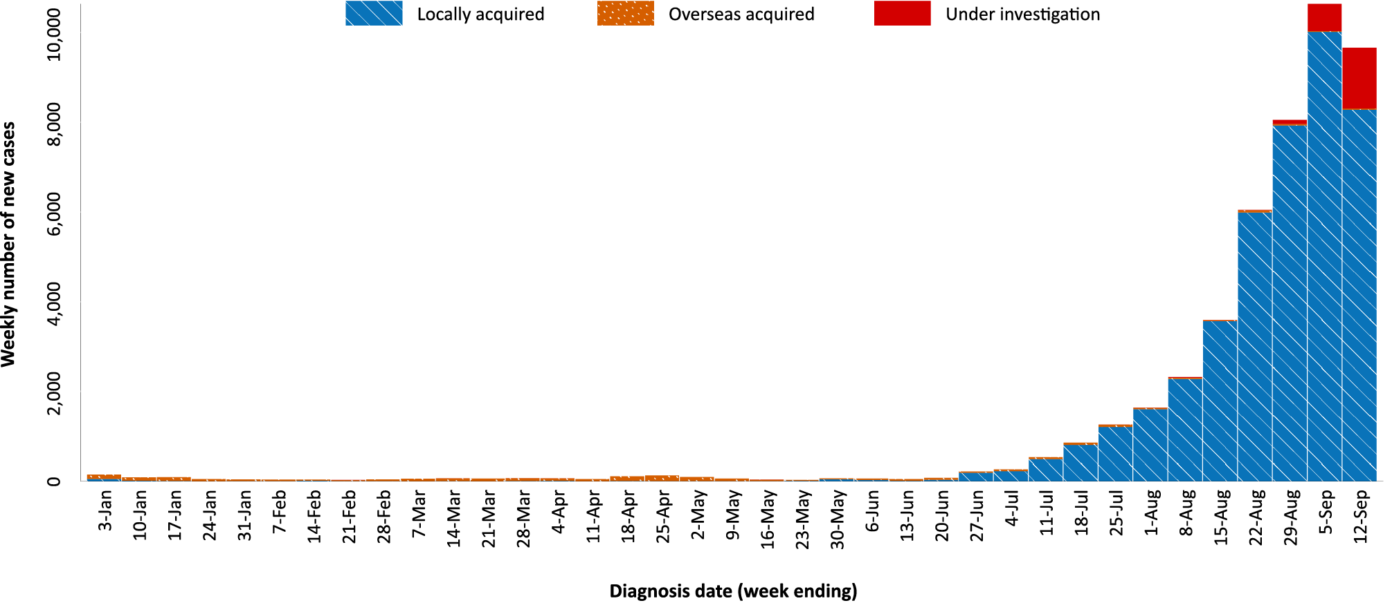
a Source: NINDSS, extract from 14 September 2021 for notifications to 12 September 2021.
b As noted in the text, there is potential for newly-notified cases to be excluded from the case count in the current reporting period when reporting by diagnosis date.
Figure 2: Cumulative COVID-19 notified cases by source of acquisition and diagnosis date, 2 March 2020 – 12 September 2021^{a,b}
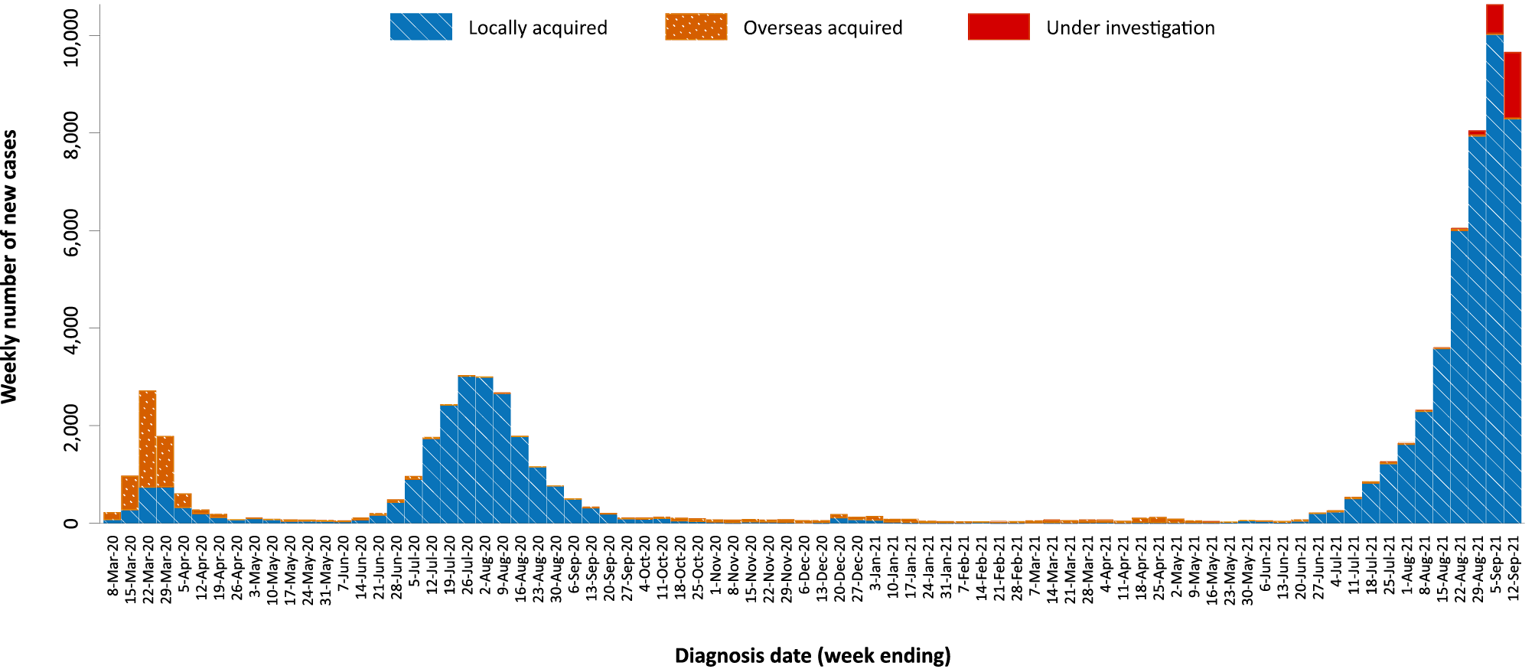
a Source: NINDSS, extract from 14 September 2021 for notifications to 12 September 2021.
b As noted in the text, there is potential for newly-notified cases to be excluded from the case count in the current reporting period when reporting by diagnosis date.

Source of acquisition

(NINDSS)
In this reporting period, 91% (20,671/22,766) of cases notified were locally acquired and < 1% (48/22,766) were overseas acquired. At the end of the reporting period, there were 9% (2,043/22,766) of cases under investigation: 1,670 from Victoria, 368 from New South Wales, three from the Australian Capital Territory and two from Queensland (Table 1).
New South Wales reported the majority of locally-acquired cases (89%; 18,344/20,671) in this fortnight, followed by Victoria (10%; 2,068/20,671). In the reporting period, 28% (5,696/20,671) of locally-acquired cases had a known contact or link to a cluster; 146 cases had an unknown (local or interstate) source; and, at the end of the reporting period, the source of infection was under ongoing investigation for 71% (14,829/20,671) of cases, all from New South Wales.
For 2021 to date, New South Wales had the highest infection rate for locally-acquired cases with 472.2 infections per 100,000 population, followed by the Australian Capital Territory with a rate of 118.0 infections per 100,000 population (Table 2). Based on cases notified up to 12 September 2021, Tasmania reported that it had been more than a year since the last locally-acquired case (Table 3).
Table 2: Locally-acquired COVID-19 case numbers and rates per 100,000 population by jurisdiction and reporting period, Australia, with a notification received date from 1 January to 12 September 2021ª
Jurisdiction | Reporting period | Reporting period | Cases this year
 | 30 August 2021 – 12 September 2021 | 16–29 August 2021 | 1 January 2021 – 12 September 2021
 | Number of cases^{b} | Number of cases^{b} | Number of cases^{b} | Rate per 100,000 population^{c}
ACT | 248 | 238 | 509 | 118.0
NSW | 18,344 | 11,876 | 38,571 | 472.2
NT | 0 | 0 | 11 | 4.5
Qld | 9 | 4 | 222 | 4.3
SA | 2 | 0 | 30 | 1.7
Tas. | 0 | 0 | 1 | 0.2
Vic. | 2,068 | 855 | 3,508 | 52.4
WA | 0 | 0 | 16 | 0.6
Australia | 20,671 | 12,973 | 42,868 | 166.8
a Source: NINDSS extract from 14 September 2021 for notifications to 12 September 2021.
b This total does not include cases that are under initial investigation.
c Population data based on Australian Bureau of Statistics (ABS) Estimated Resident Population (ERP) as at June 2020.

Table 3: Days since last locally-acquired COVID-19 case (source unknown and source known), by jurisdiction and diagnosis date, 12 September 2021ª
Jurisdiction | Locally acquired — source unknown^{b} |  | Locally acquired — source known^{b}
 | Date of last case | Days since last case | Date of last case | Days since last case
ACT | 11 September 2021 | 1 | 12 September 2021 | 0
NSW | 12 September 2021 | 0 | 12 September 2021 | 0
NT | NA^{c} | NA^{c} | 6 July 2021 | 68
Qld | 6 August 2021 | 37 | 11 September 2021 | 1
SA | 24 March 2020 | 537 | 3 August 2021 | 40
Tas. | 9 August 2020 | 399 | 24 April 2020 | 506
Vic. | 6 September 2021 | 6 | 12 September 2021 | 0
WA | 3 April 2020 | 527 | 2 August 2021 | 41
a Source: NINDSS, extract from 14 September 2021 for notifications to 12 September 2021.
b This does not include locally-acquired cases that were interstate acquired.
c NA: not applicable. The Northern Territory has not reported any locally-acquired cases with an unknown source of infection.
In the reporting period, New South Wales reported the largest number of cases (50%; 24/48) that were overseas acquired, followed by South Australia (21%; 10/48). In the past 28 days (16 August – 12 September 2021), 31% (40/131) of overseas-acquired cases reported an unknown country of acquisition. Cases acquired at sea (46%; 42/91) were the most frequent of those with an identified country of acquisition in the past 28 days, followed by cases acquired in the Philippines (8%; 7/91) and Afghanistan (5%; 5/91). The number of cases acquired in different countries is influenced by travel patterns of returning Australians, travel restrictions, and the prevalence of COVID-19 in the country of travel.

Demographic features

(NINDSS)
In this reporting period, the largest proportion of cases occurred in those aged 20 to 29 years (22%; 4,964/22,766). For this year, the highest rate of infection has been in those aged 20 to 29 years with a rate of 286.5 infections per 100,000 population (Figure 3; Appendix A, Table A.1). Adults aged 70 to 79 years have had the lowest rate of infection this year.
In 2021, notification rates were similar among males and females in those aged 0 to 19 and over 80 years old. In all other age groups, notification rates were higher among males than females (Figure 3; Appendix A, Table A.1). The median age of cases in this reporting period was 29 years (range: 0 to 101 years; interquartile range, IQR: 17 to 44 years).

Figure 3: Cumulative COVID-19 cases for the calendar year to date, by age group and sex, Australia, with a diagnosis date of 1 January 2021 – 12 September 2021ª
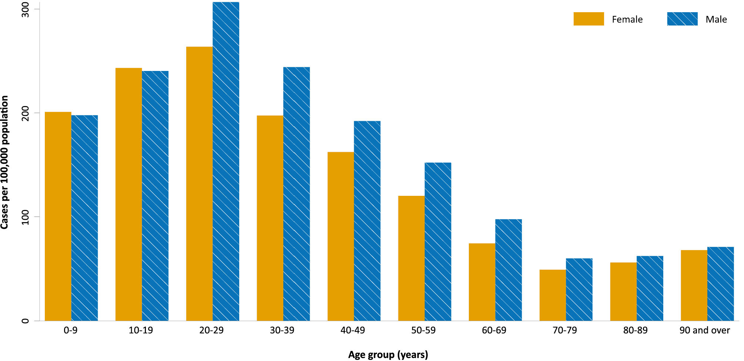
a Source: NINDSS, extract from 14 September 2021 for notifications to 12 September 2021.

Aboriginal and Torres Strait Islander persons

(NINDSS)
During the reporting period, there were 810 new cases notified in Aboriginal and Torres Strait Islander people: with 795 from New South Wales; nine from the Australian Capital Territory; and three each from Queensland and Victoria. Since the beginning of 2021, there have been 1,615 confirmed cases of COVID-19 notified in Aboriginal and Torres Strait Islander people, representing 3% (1,615/46,729) of all confirmed cases this year. Of the locally-acquired cases notified in 2021, 41% (653/1,600) resided in a regional or remote area.
The majority of cases reported in Aboriginal and Torres Strait Islander people in 2021 have been associated with the Sydney metropolitan and western regional outbreaks in New South Wales, with 1,584 locally acquired cases reported in Aboriginal and Torres Strait Islander people in New South Wales since 16 June 2021 when the outbreak began. Since the start of the pandemic, there have been three COVID-19 associated deaths in Aboriginal and Torres Strait Islander people, which were associated with the current Western New South Wales regional outbreak.
In total, up to 12 September 2021, there have been 1,762 cases in Aboriginal and Torres Strait Islander people, representing approximately 2% (1,762/75,139) of all confirmed cases in Australia, since January 2020. Indigenous status was unknown for approximately 25% (18,476/75,139) of confirmed cases, with the majority of these associated with more recently reported cases, especially in New South Wales.
As at 12 September 2021, it had been zero days since the last locally-acquired Aboriginal and Torres Strait Islander case was diagnosed and 57 days since the last overseas-acquired Aboriginal and Torres Strait Islander case was diagnosed. To date, the majority of Aboriginal and Torres Strait Islander cases were reported as locally acquired (97%; 1,715/1,762), with 37 cases overseas acquired and ten cases under investigation. The median age of locally-acquired Aboriginal and Torres Strait Islander cases was 24 years old (range 0 to 99 years), while the median age of overseas-acquired cases was 40 years old (range 7 to 75 years). Overall, there has been a slightly higher proportion of cases among females (52%; 918/1,760) than among males (48%; 842/1,760), with the denominator being cases where sex was known.

Vaccinations

(Department of Health)
As of 15 August 2021, a total of 22,802,573 doses of COVID-19 vaccine had been administered (Table 4), including 859,976 doses provided to aged care and disability residents.
Table 4: Total number of vaccinations administered, by jurisdiction, Australia, 12 September 2021ª
Jurisdiction | Total number of doses administered
ACT | 541,271
NSW | 8,177,988
NT | 235,794
Qld | 3,980,510
SA | 1,439,865
Tas. | 506,654
Vic. | 5,881,075
WA | 2,039,416
Aged care and disability facilities^{b} | 859,976
Primary care^{c} | 12,243,145
Total | 22,802,573
a Source: Australian Government Department of Health website.⁴
b Commonwealth vaccine doses administered in aged care and disability facilities.
c Commonwealth vaccine doses administered in primary care settings.

Clusters and outbreaks

New South Wales
In total, as at 12 September 2021, there had been 38,856 locally-acquired cases in New South Wales, including 183 deaths, reported following notification of the first case in this outbreak on 16 June 2021. Genomic testing results showed that the first case was infected with the Delta SARS-CoV-2 variant of concern (B.1.617.2); however, the sequence did not match cases from the Victorian Delta variant outbreak that occurred from May to June 2021. This sequence had not been seen in Australia previously, but matched one from the United States of America.
The size of the New South Wales outbreak continued to increase during the reporting period, with 18,344 locally-acquired cases reported, compared to 11,876 locally-acquired cases reported in the previous reporting period. Whilst the outbreak started in south-east Sydney, the majority of recently-reported cases continued to be among residents of south-western and western Sydney, with cases also reported in residents of regional and remote areas in New South Wales, particularly in western New South Wales.

Victoria
As at 12 September 2021, there had been 4,646 locally-acquired cases been reported in Victoria since two unlinked cases were reported on 5 August 2021. Genomic testing determined these outbreaks were due to the Delta variant and were genomically closely associated with recent clusters in New South Wales and the previous two seeding events in Victoria from July 2021.
The size of the Victorian outbreak continued to increase during the reporting period. The number of locally-acquired and under-initial-investigation cases in Victoria this reporting period (3,738 cases) was more than four times that of the previous reporting period (870 cases). Most cases in the outbreak were in Greater Melbourne. However, since 20 August 2021, cases were reported in Shepparton in regional Victoria. As at 12 September 2021, there had been 132 cases reported in Shepparton.

Australian Capital Territory
As at 12 September 2021, a total of 506 cases had been reported as part of this outbreak. The first case in this outbreak, which was the first locally-acquired case in the Australian Capital Territory in over a year, was reported on 12 August 2021 and was confirmed to have the Delta variant. The source of infection remained under investigation at the end of this reporting period, though it was genomically related to the Sydney Metropolitan Outbreak. The number of new cases in the Australian Capital Territory during this reporting period (251) was similar to the previous reporting period (238).

Queensland
As at 12 September 2021, a total of 7 cases have been reported as part of an outbreak in Sunnybank, Brisbane, Queensland. The outbreak commenced on 5 September 2021, with the first cases reported among a small group of people who travelled from New South Wales to Queensland for essential work. As at 12 September 2021, the latest date that a case was infectious in the community was 10 September 2021.

Severity

(NINDSS, FluCAN, SPRINT-SARI)

Hospitalisation and intensive care unit admission
Given the delay between illness onset and severe illness, to provide a more accurate assessment of the highest level of severity, cases with an onset in the last two weeks were excluded from the analysis. Nationally in 2021, based on the highest level of severity reported for cases with an illness onset up to 29 August 2021, 1% of cases were reported to have died, 2% of cases required intensive care and a further 14% required admission to hospital (Table 5). The majority of hospitalisations in 2021 were associated with the current outbreak in New South Wales. Note that hospitalisation data in NINDSS should be interpreted with caution: hospitalisation is not always reflective of severe illness, as cases may be hospitalised for reasons other than clinical COVID-19 related care; additionally, hospitalisation and intensive care unit (ICU) status in NINDSS is likely incomplete.

Table 5: COVID-19 cases by age and highest level of severity, Australia, 1 January – 29 August 2021, by age groupª
Age group | Count |  |  |  |  | % of total cases by age group
 | Not severe^{b} | Hospitalised only | ICU | Died | Total cases | Hospitalised only | ICU | Died
 |  | (not ICU or died) | (but not died) |  |  | (not ICU or died) | (but not died)
0–4 | 1,656 | 126 | 2 | 0 | 1,784 | 7% | < 1% | 0%
5–11 | 2,379 | 120 | 2 | 0 | 2,501 | 5% | < 1% | 0%
12–15 | 1,469 | 99 | 2 | 1 | 1,571 | 6% | < 1% | < 1%
16–17 | 851 | 51 | 5 | 0 | 907 | 6% | 1% | 0%
18–29 | 6,267 | 728 | 49 | 2 | 7,046 | 10% | 1% | < 1%
30–39 | 3,937 | 744 | 60 | 5 | 4,746 | 16% | 1% | < 1%
40–49 | 2,506 | 619 | 87 | 4 | 3,216 | 19% | 3% | < 1%
50–59 | 1,807 | 548 | 101 | 12 | 2,468 | 22% | 4% | < 1%
60–69 | 816 | 356 | 83 | 18 | 1,273 | 28% | 7% | 1%
70–79 | 263 | 208 | 38 | 41 | 550 | 38% | 7% | 7%
80–89 | 75 | 135 | 9 | 52 | 271 | 50% | 3% | 19%
90+ | 20 | 42 | 0 | 20 | 82 | 51% | 0% | 24%
Unknown | 1 | 0 | 0 | 0 | 1 | 0% | 0% | 0%
Total | 22,047 | 3,776 | 438 | 155 | 26,416 | 14% | 2% | 1%
a Source: NINDSS, extract from 14 September 2021 for notifications to 29 August 2021.
b ‘Not severe’ includes all cases that were not hospitalised, admitted to ICU or died.

In the year to date, there were 777 COVID-19 cases admitted to ICUs participating in the sentinel surveillance system, Short Period Incidence Study of Severe Acute Respiratory Infection (SPRINT-SARI),⁵ with 260 of these admitted during this reporting period (30 August – 12 September 2021).

Risk factors for severe disease
The proportion of cases who were admitted to hospital increased as a person’s age increased (Table 5).
Comorbidity data extracted from SPRINT-SARI reflect the sickest patients with COVID-19 managed in ICU; data are therefore not generalisable to all cases (Table 6). In patients admitted to ICU with COVID-19 since 1 February 2021, the most prevalent comorbidity was obesity (a body mass index of > 30 or weight exceeding 120 kg), followed by diabetes. Of those patients aged 18 years and older admitted to ICU this year, 61% (362/595) had at least one comorbidity; 39% of patients (233/595) had none of the listed comorbidities recorded.

COVID-19 deaths
In the past two weeks, there were 94 deaths associated with COVID-19: 89 from New South Wales and five from Victoria. The crude case fatality rate (CFR) for all cases reported in Australia in 2021 to date was 0.4%, with 189 deaths reported this year (Table 7). For the epidemic to date, the CFR was at 1.5%.
Table 6: Comorbidities for adult COVID-19 cases (age ≥ 18 years) amongst those admitted to ICU, Australia, 1 February – 12 September 2021ª
Comorbidity | ICU casesª (n = 758) (%)
Cardiac disease (n = 585) | 55 (9)
Chronic respiratory condition (n = 586) ^{b} | 80 (14)
Diabetes (n = 587) | 172 (29)
Obesity (n = 566) | 187 (33)
Chronic renal disease (n = 584) | 28 (5)
Chronic neurological condition (n = 584) | 3 (17)
Malignancy (n = 584) | 23 (4)
Chronic liver disease (n = 585) | 16 (3)
Immunosuppression (n = 583) | 20 (3)
Number of specified comorbidities (n = 595) ^{c,d}
One or more | 362 (61)
Two or more | 152 (26)
Three or more | 55 (9)
No comorbidities | 233 (39)
a Source: SPRINT-SARI, extract from 17 September 2021 for data up to 12 September 2021. Only includes adult cases (≥ 18 years old) and excludes those with missing data on comorbidities or where comorbidity is unknown.
b Includes asthma.
c Includes chronic respiratory conditions, cardiac disease (excluding hypertension), immunosuppressive condition/therapy, diabetes, obesity, liver disease, renal disease and neurological disorder.
d Excludes cases where comorbidity data is missing or unknown for all comorbidities.
Table 7: Deaths associated with COVID-19 by reporting period, Australia, 1 January 2020 – 12 September 2021ª
 | Number of deaths
Reporting period 30 August – 12 September 2021 | 94
Year to date (2021) 1 January – 12 September 2021 | 189
Epidemic to date 1 January 2020 – 12 September 2021 | 1,098
a Source: NINDSS, extract from 14 September 2021 for notifications to 12 September 2021, based on notification received date.

Four-week reporting period (16 August – 12 September 2021)

Genomic surveillance and virology

(Communicable Disease Genomics Network, AusTrakka and jurisdictional sequencing laboratories)
Nationally, 41% of COVID-19 cases have been sequenced over the duration of the pandemic, based on jurisdictional reporting (Table 8).
Table 8: Australian SARS-CoV-2 genome sequences and proportion of positive cases sequenced, 16 August – 12 September 2021 and cumulative to date
Measure | Reporting period 16 August to 12 September 2021 | Cumulative 23 January 2020 to 12 September 2021
SARS-CoV-2 cases sequencedª | 3,996 | 28,636
Percentage of positive cases sequenced^{b} | 13% | 41%
a Based on individual jurisdictional reports of sequences and case numbers. Calculations of the percentage of cases sequenced based on the number of sequences available in AusTrakka may not always be up-to-date, since this may include duplicate samples from cases and may not represent all available sequence data.
b In most jurisdictions, sequencing has been attempted on all suitable samples (one sample per case). Sequencing of samples from cases identified in the reporting period may be in process at the time of reporting. Remaining unsequenced samples may be due to jurisdictional sequencing strategy, or where samples have been deemed unsuitable for sequencing (typically, because viral loads were too low for sequencing to be successful).
Table 9: Australian SARS-CoV-2 genome sequences in AusTrakka identified as variants of concern, 23 January 2020 – 12 September 2021
VOC lineage | Number of samples
B.1.1.7 (Alpha) | 554
B.1.351 (Beta) | 99
P.1 (Gamma) | 8
B.1.617.1 (Kappa) | 129
B.1.617.2 (Delta) | 11,044

Variants of concern
AusTrakka is actively monitoring and reporting on the four lineages designated Variants of Concern (VOC) by international organisations, including the World Health Organization (WHO): Alpha (B.1.1.7); Beta (B.1.351); Gamma (P.1); and Delta (B.1.617.2). All four VOCs display characteristic sets of mutation, including a number of variations in the genomic region encoding the spike protein thought to have the potential to increase transmissibility and/or immune evasion.⁷ On 1 June 2021, WHO announced a new nomenclature system for VOCs, using letters of the Greek alphabet,⁸ to facilitate communication and reduce stigmatisation associated with geography-based colloquial terms. In addition to the four internationally-recognised VOCs, AusTrakka is also actively monitoring Kappa (B.1.617.1) as a variant of concern.
Further information on variants is available in the Technical Supplement.³
Figure 4: Samples in AusTrakka from 29 March to 13 September 2021, by lineage and date of collectionª
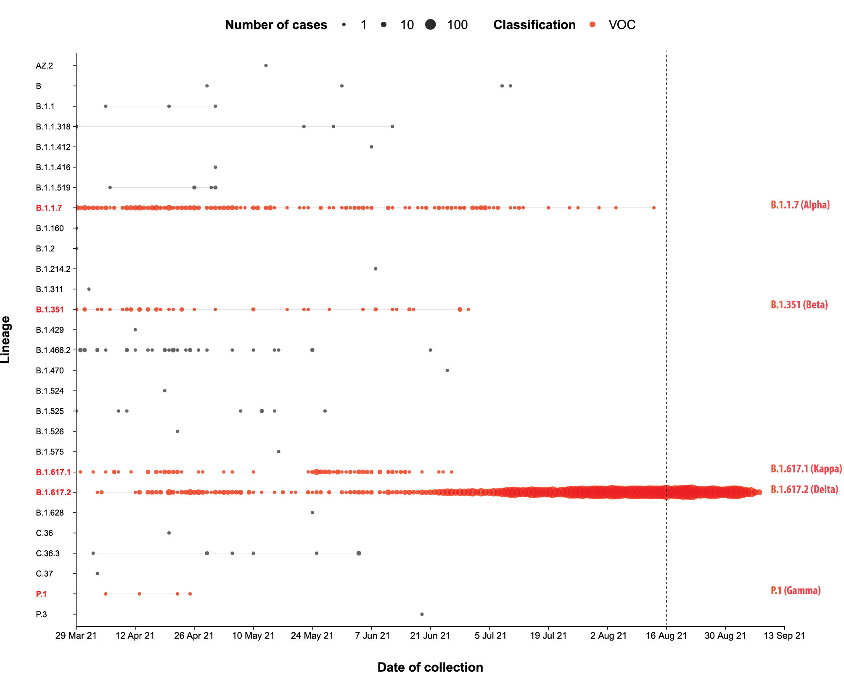
a The start of the current reporting period (16 August – 12 September 2021) is marked by the dotted line, and variant-of-concern samples are coloured red. The size of the circle is proportional to the number of samples in the lineage at each time point.

Testing

(State and territory reporting)
During this four-week reporting period, over 4.2 million individuals were tested nationally, with a positivity rate of 0.6%, noting that data were not available for New South Wales or the Australian Capital Territory from 28 August to 3 September 2021 and that individuals tested in different weeks could be counted more than once (Table 10). Jurisdictional testing rates are driven by both current case numbers and numbers of people experiencing symptoms.
Testing rates increased substantially from the week ending 23 July 2021 onwards, due to the re-inclusion of data from New South Wales in testing rates (Figure 5). Excluding the week of 28 August to 3 September 2021, where data was incomplete, testing rates remained high during the reporting period. Those aged 20 to 39 years continued to have the highest rates of testing, followed by those aged 40 to 59 years old.

Table 10: Individuals undergoing diagnostic tests for SARS-CoV-2,ª by jurisdiction and reporting period, with a notification received date of 1 January – 10 September 2021
Jurisdiction | Individuals testedª |  |  | Individuals testedª |  |  | Cumulative individuals testedª  in 2021 to 10 September
 | 28 August – 10 September 2021 |  |  | 14 August – 27 August 2021
 | n | Positivity (%) | Per 1,000 population^{b} | n | Positivity  (%) | Per 1,000 population^{b} | n | Positivity  (%) | Per 1,000 population^{b}
ACT | 19,834c | 0.6c | 46.0c | 88,853 | 0.3 | 206.0 | 265,149c | 0.2c | 615.7c
NSW | 720,691c | 1.3^{c} | 88.2^{c} | 1,530,196 | 0.8 | 187.3 | 6,880,221^{c} | 0.4^{c} | 842.3^{c}
NT | 12,032 | <0.01 | 48.9 | 16,192 | 0.02 | 65.7 | 186,782 | 0.06 | 758.4
Qld | 130,867 | 0.01 | 25.3 | 138,569 | 0.02 | 26.8 | 1,992,391 | 0.03 | 384.9
SA | 63,020 | 0.02 | 35.6 | 60,920 | <0.01 | 34.4 | 1,114,048 | 0.02 | 629.2
Tas. | 12,999 | - | 24.0 | 15,217 | – | 28.1 | 186,803 | <0.01 | 345.4
Vic. | 713,074 | 0.5 | 106.5 | 620,838 | 0.1 | 92.7 | 5,942,954 | 0.09 | 887.5
WA | 44,710 | <0.01 | 16.8 | 50,646 | 0.05 | 19.0 | 854,293 | 0.09 | 320.7
Australia | 1,717,227^{c} | 0.8^{c} | 66.8^{c} | 2,521,431 | 0.5 | 98.1 | 17,422,641^{c} | 0.2^{c} | 678.0^{c}
a In order to more accurately reflect positivity rates, numbers of individuals tested is presented rather than total number of tests. The number of individuals tested is the sum of number of individuals tested in each week (Saturday to Friday) in each jurisdiction. Individuals who were tested in more than one week could be counted more than once.
b Population data based on Australian Bureau of Statistics (ABS) Estimated Resident Population (ERP) as at June 2020.
C From 19 June 2021 to 16 July 2021, data for New South Wales were unavailable. From 28 August 2021 to 3 September 2021, data for New South Wales and the Australian Capital Territory were unavailable. Positivity rates are calculated using the number of cases reported in time periods where testing data were available.

Figure 5: SARS-CoV-2 polymerase chain reaction (PCR) testing rates per 1,000 population per week by age group and notification received date, Australia, 1 January – 12 September 2021^{a,b,c}
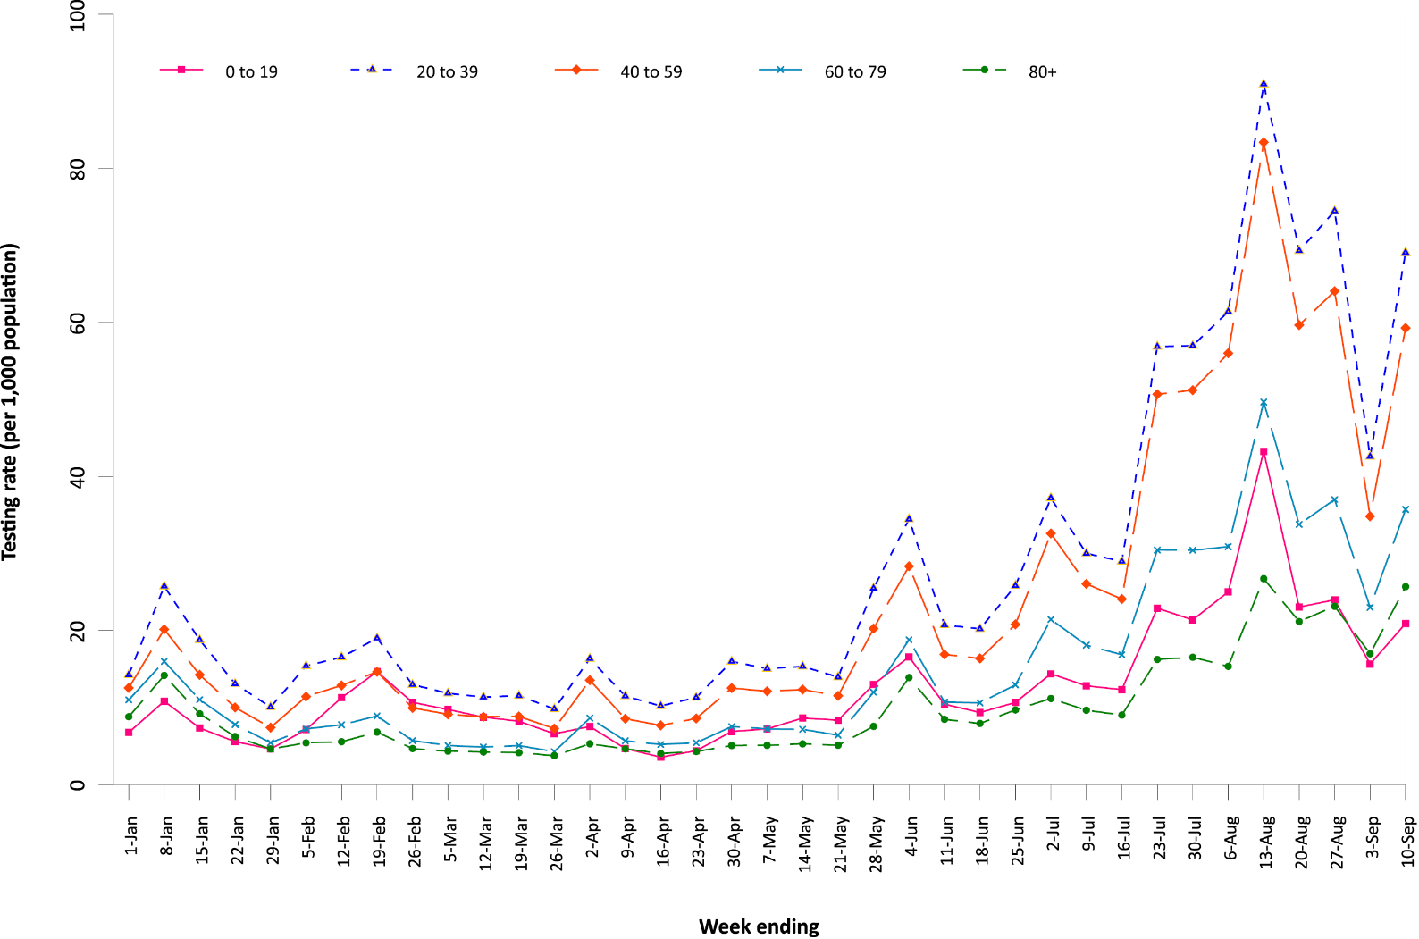
a Source: data provided by jurisdictions to the NIR weekly, current to 12 September 2021.
b The jurisdictions reporting each week (i.e. the denominator population) may vary.
c From 19 June 2021 to 16 July 2021, data for New South Wales were unavailable. From 28 August to 3 September 2021, data for New South Wales and the Australian Capital Territory were unavailable.

Figure 6: Weekly trends in respiratory illness amongst FluTracking survey participants (age-standardised) compared to the average of the previous five years, Australia, by epidemiological week,ª 1 March 2020 – 12 September 2021^{b}
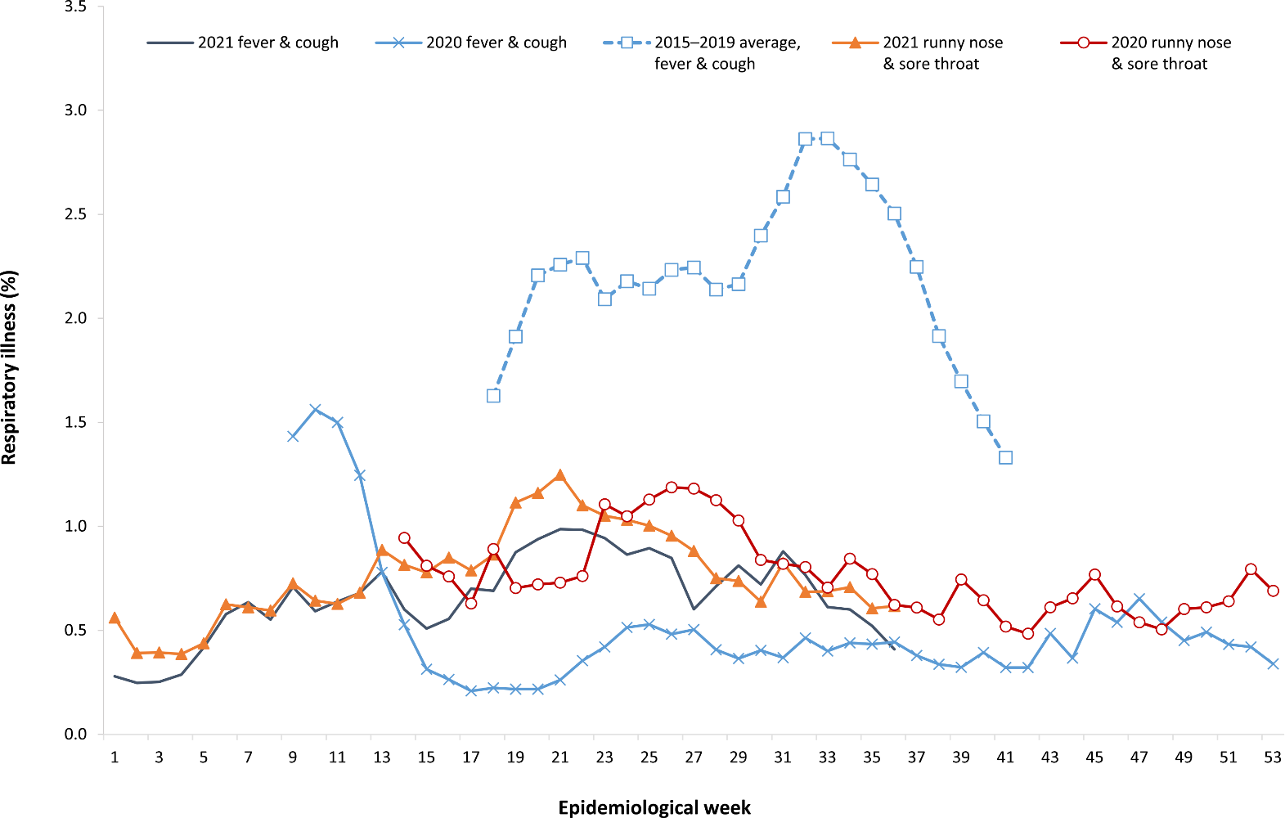
a Epidemiological weeks are a standardised method for numbering weeks across years, with the first epidemiological week of any year ending on the first Saturday in January.
b In years prior to 2020, FluTracking was activated during the main Influenza season from May to October. A historical average beyond the week ending 11 October (epidemiological week 41) is therefore not available. In 2020, FluTracking commenced ten weeks early to capture data for COVID-19. Data on runny nose and sore throat were only collected systematically after 29 March 2020, therefore a historical average for this symptom profile is unavailable.

Acute respiratory illness

(FluTracking, ASPREN, and Commonwealth Respiratory Clinics)
Based on self-reported FluTracking data,⁹ prevalence of fever and cough in the community remained at < 1%, and was slightly lower than that reported in the previous four-week reporting period (Figure 6). Runny nose and sore throat symptoms in the community were similar during this reporting period compared to the previous four weeks, with the prevalence in the community remaining low at < 1%.
In this reporting period, acute respiratory illness was highest in those aged 0 to 9 years and 30 to 39 years, based on both self-reported FluTracking data and presentations to Commonwealth Respiratory Clinics. Females reported respiratory illness more frequently than males. Rates of fever and cough by jurisdiction ranged from 2.0/1,000 FluTracking participants in New South Wales to 7.7/1,000 participants in Western Australia.
FluTracking data indicated that 50% of those in the community with ‘fever and cough’ and 40% of those with ‘runny nose and sore throat’ were tested for SARS-CoV-2. This represents a slight decrease in SARS-CoV-2 testing for ‘sore throat and runny nose’ and for ‘fever and cough’ since the previous reporting period. In the four-week reporting period, testing rates were highest in Victoria and lowest in Western Australia for both sets of symptoms. It is important to acknowledge that there may be legitimate reasons why people did not get tested, including barriers to accessing testing. Symptoms reported to FluTracking are not specific to COVID-19 and may also be due to chronic diseases.
During this reporting period, there were 155,951 assessments at Commonwealth Respiratory Clinics. Of these, there were 141,358 assessments with consent to share information, with 97% (137,055/141,358) tested for SARS-CoV-2. There were 250 cases reported at these clinics in this reporting period, representing a percent positivity of < 1% (250/137,055).
Among those tested through the Australian Sentinel Practice Research Network (ASPREN) and Victorian Sentinel Practice Influenza Network (VicSPIN) general practitioner sentinel surveillance systems, rhinovirus was the most common respiratory virus detected in patients presenting with influenza-like illness in this reporting period.

Public health response measures
Since COVID-19 first emerged internationally, Australia has implemented public health measures informed by the disease’s epidemiology. States and territories have decision-making authority in relation to public health measures and have implemented or eased restrictions at their own pace (Figure 7; Appendix A, Table A.2), depending on the local public health and epidemiological situation, and in line with the ‘Framework for National Reopening’.¹⁰ Nationwide requirements regarding air travel, including pre-flight testing for travellers entering Australia and requirements to wear face masks when flying domestically or internationally, remain in place. During the current reporting period, there was community transmission occurring in the Australian Capital Territory, New South Wales, the Northern Territory, Queensland, and Victoria.

Figure 7: COVID-19 notifications in Australia by week of diagnosis and jurisdiction, 1 January – 12 September 2021, with timing of key public health measures
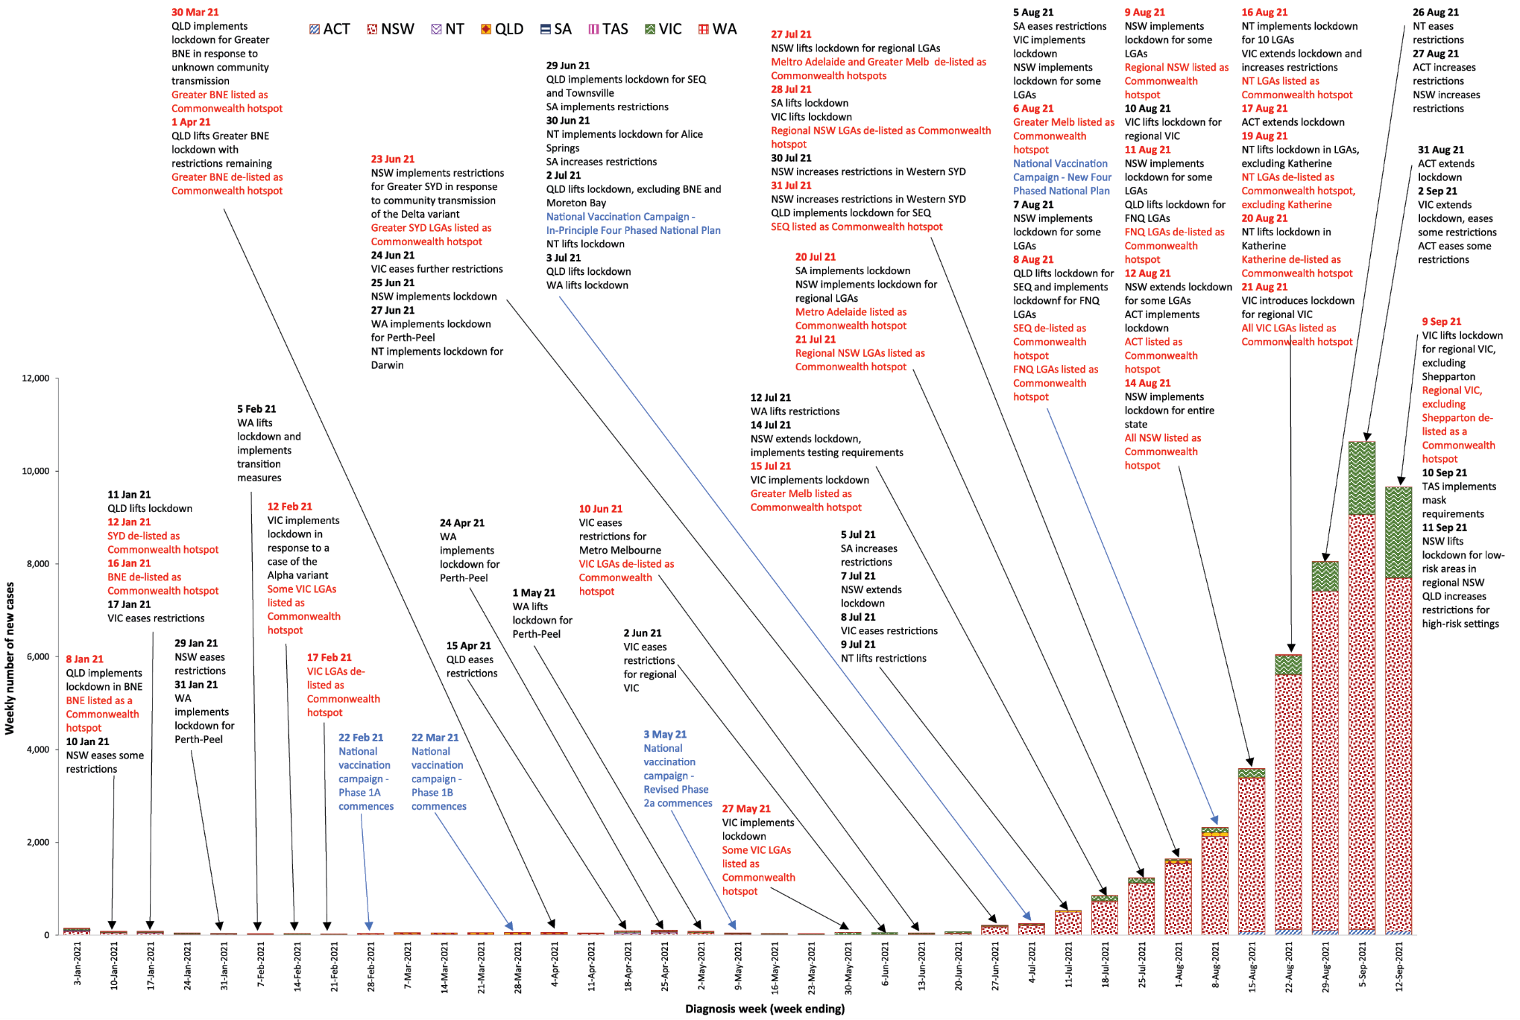

Countries and territories in Australia’s near region
According to WHO, countries and territories in the South East Asian and Western Pacific regions reported 4,295,172 newly-confirmed cases and 76,966 deaths in the four-week period to 12 September 2021, bringing the cumulative cases in the two regions to over 49 million, and cumulative deaths in these regions to 762,788.¹¹ New case numbers and death incidence have continued to trend downward in the south east Asian region, driven by decreasing cases in India, Indonesia and Thailand. The Western Pacific region has experienced an exponential increase in cases and deaths for nearly two months. However, the increase in cases and deaths has slowed in recent weeks. The highest numbers of new cases in the Western Pacific region during the four-week period to 12 September 2021 were in Malaysia, Japan, and the Philippines.¹²
Table 11 outlines the new cases and deaths in the four-week period to 12 September 2021 and cumulative cases and deaths for the pandemic in selected countries with the highest number of new cases in the South East Asian region and the Western Pacific region.
As of 12 September 2021, over 224 million COVID-19 cases and 4.6 million deaths have been reported globally, with a global CFR of 2%. The two regions reporting the largest burden of disease over the past four weeks were the Region of the Americas (36%) and the European Region (27%).
Table 11: Cumulative cases and deaths, and new cases and deaths reported in the four-week period to 12 September 2021 for selected countries in Australia’s near region according to WHOª
Country | Cumulative cases | New cases reported in the last 4 weeks | Change in new cases in the last 4 weeks^{b} | Cumulative deaths | New deaths reported in the last 4 weeks | Change in new deaths in the last 4 weeks^{b}
South East Asian region
India | 33,236,921 | 1,044,345 | -4% | 442,655 | 11,430 | -35%
Thailand | 1,382,173 | 475,016 | -6% | 14,353 | 6,801 | +62%
Indonesia | 4,167,511 | 313,157 | -68% | 138,889 | 21,301 | -52%
Sri Lanka | 485,922 | 130,954 | +87% | 11,296 | 5,257 | +127%
Bangladesh | 1,530,413 | 111,511 | -65% | 26,931 | 2,756 | -56%
Western Pacific region
Malaysia | 1,960,500 | 576,147 | +20% | 20,419 | 8,191 | +53%
Japan | 1,623,091 | 494,709 | +71% | 16,742 | 1,342 | +273%
Philippines | 2,205,956 | 479,089 | +113% | 34,978 | 4,908 | +41%
Viet Nam | 601,349 | 335,885 | +57% | 15,018 | 9,581 | +84%
Mongolia | 240,938 | 59,647 | +68% | 976 | 104 | -29%
a Source: World Health Organization Coronavirus (COVID-19) Dashboard,11 accessed 14 September 2021.
b Percent change in the number of newly confirmed cases/deaths in the past 4 weeks compared to the 4 weeks prior.

Acknowledgements
We thank public health staff from incident emergency operations centres and public health units in state and territory health departments, and the Australian Government Department of Health, along with state and territory public health laboratories. We thank those who have provided data from surveillance systems, such as Commonwealth respiratory clinics, ASPREN, FluTracking, FluCAN, SPRINT-SARI, Communicable Disease Genomics Network, AusTrakka and jurisdictional sequencing laboratories.

Author details

Corresponding author
COVID-19 National Incident Room Surveillance Team
Australian Government Department of Health, GPO Box 9484, MDP 14, Canberra, ACT 2601. Email: epi.coronavirus@health.gov.au

References
- COVID-19 National Incident Room Surveillance Team. COVID-19 Australia: Epidemiology Report 49: Reporting period ending 29 August 2021. Commun Dis Intell (2018). 2021;45. doi: https://doi.org/10.33321/cdi.2021.45.49.
- COVID-19 National Incident Room Surveillance Team. COVID-19 Australia: Epidemiology Report 48: Reporting period ending 15 August 2021. Commun Dis Intell (2018). 2021;45. doi: https://doi.org/10.33321/cdi.2021.45.48.
- COVID-19 National Incident Room Surveillance Team. Technical supplement. COVID-19 Australia: Epidemiology reporting. Commun Dis Intell (2018). 2021;45. doi: https://doi.org/10.33321/cdi.2021.45.2.
- Australian Government Department of Health. Getting vaccinated for COVID-19: Australia’s vaccine rollout. [Internet.] Canberra: Australian Government Department of Health; 2021. [Accessed on 13 September 2021.] Available from: https://www.health.gov.au/initiatives-and-programs/covid-19-vaccines/getting-vaccinated-for-covid-19#australias-vaccine-rollout.
- Australian and New Zealand Intensive Care Research Centre (ANZIC-RC). SPRINT-SARI: Short period incidence study of severe acute respiratory infection. [Internet.] Melbourne: Monash University, ANZIC-RC; 2020. Available from: https://www.monash.edu/medicine/sphpm/anzicrc/research/sprint-sari.
- Communicable Diseases Genomics Network (CDGN). AusTrakka. [Website.] Melbourne: CDGN; 2020. Available from: https://www.cdgn.org.au/austrakka.
- World Health Organization (WHO). Coronavirus disease (COVID-19) Weekly Epidemiological Update and Weekly Operational Update. [Internet.] Geneva: WHO; June 2021. [Accessed on 25 June 2021.] Available from: https://www.who.int/emergencies/diseases/novel-coronavirus-2019/situation-reports/.
- WHO. Tracking SARS-CoV-2 variants. [Internet.] Geneva: WHO; 15 June 2021. [Accessed on 25 June 2021.] Available from: https://www.who.int/en/activities/tracking-SARS-CoV-2-variants/.
- Dalton C, Durrheim D, Fejsa J, Francis L, Carlson S, d’Espaignet ET et al. Flutracking: a weekly Australian community online survey of influenza-like illness in 2006, 2007 and 2008. Commun Dis Intell Q Rep. 2009;33(3):316–22.
- Australian Government Department of Health. Framework for national reopening – October 2020. [Internet.] Canberra: Australian Government Department of Health; 23 October 2020. [Accessed on 10 November 2020.] Available from: https://www.health.gov.au/resources/publications/framework-for-national-reopening-october-2020.
- WHO. WHO Coronavirus Disease (COVID-19) dashboard. [Internet.] Geneva: WHO; 2021. Available from: https://covid19.who.int/.
- WHO. Weekly epidemiological update on COVID-19 – 14 September 2021. [Internet.] Geneva: WHO; 14 September 2021. [Accessed on 16 September 2021.] Available from: https://www.who.int/publications/m/item/weekly-epidemiological-update-on-covid-19---14-september-2021.
- Australian Capital Territory Government. COVID-19 Update: Changes to your visit to ACT Health Facilities. [Internet.] Canberra: Australian Capital Territory Government; 12 August 2021. [Accessed on 18 August 2021.] Available from: https://www.health.act.gov.au/news/covid-19-update-changes-your-visit-act-health-facilities.
- Australian Capital Territory Government. ACT COVID-19 Update – 17 August 2021. [Internet.] Canberra: Australian Capital Territory Government; 17 August 2021. [Accessed on 15 September 2021.] Available from: https://www.covid19.act.gov.au/news-articles/act-covid-19-update-17-august-2021.
- Australian Capital Territory Government. Non-essential construction works not allowed during lockdown. [Internet.] Canberra: Australian Capital Territory Government; 17 August 2021. [Accessed on 15 September 2021.] Available from: https://www.covid19.act.gov.au/news-articles/non-essential-construction-works-not-allowed-during-lockdown.
- Australian Capital Territory Government. NSW residents with a COVID-19 vaccination booking in the ACT. [Internet.] Canberra: Australian Capital Territory Government; 20 August 2021. [Accessed on 15 September 2021.] Available from: https://www.covid19.act.gov.au/news-articles/nsw-residents-with-a-covid-19-vaccination-booking-in-the-act.
- Australian Capital Territory Government. Vaccine registration open for 16 to 29-year-olds. [Internet.] Canberra: Australian Capital Territory Government; 23 August 2021. [Accessed on 15 September 2021.] Available from: https://www.covid19.act.gov.au/news-articles/vaccine-registration-open-for-16-to-29-year-olds.
- Australian Capital Territory Government. Student nurses and midwives to join ACT’s COVID-19 response. [Internet.] Canberra: Australian Capital Territory Government; 25 August 2021. [Accessed on 15 September 2021.] Available from: https://www.covid19.act.gov.au/news-articles/student-nurses-and-midwives-to-join-acts-covid-19-response.
- Australian Capital Territory Government. ACT COVID-19 Update – 27 August 2021. [Internet.] Canberra: Australian Capital Territory Government; 27 August 2021. [Accessed on 15 September 2021.] Available from: https://www.covid19.act.gov.au/news-articles/act-covid-19-update-27-august-2021.
- Australian Capital Territory Government. ACT COVID-19 Update – 31 August 2021. [Internet.] Canberra: Australian Capital Territory Government; 31 August 2021. [Accessed on 15 September 2021.] Available from: https://www.covid19.act.gov.au/news-articles/act-covid-19-update-31-august-2021.
- Australian Capital Territory Government. Free public transport to ACT Government COVID-19 vaccination clinics. [Internet.] Canberra: Australian Capital Territory Government; 2 September 2021. [Accessed on 15 September 2021.] Available from: https://www.covid19.act.gov.au/news-articles/free-public-transport-to-act-government-covid-19-vaccination-clinics.
- Australian Capital Territory Government. AstraZeneca interval reduced to 4 - 8 weeks due to Delta outbreak. [Internet.] Canberra: Australian Capital Territory Government; 6 September 2021. [Accessed on 15 September 2021.] Available from: https://www.covid19.act.gov.au/news-articles/astrazeneca-interval-reduced-to-4-8-weeks-due-to-delta-outbreak.
- Government of New South Wales Department of Health (NSW Health). More than 500k Pfizer doses for those aged16-39 in LGAs of concern. [Internet.] Sydney: Government of New South Wales, NSW Health; 18 August 2021. [Accessed on 15 September 2021.] Available from: https://www.health.nsw.gov.au/news/Pages/20210818_00.aspx.
- NSW Health. Private hospital staff join pandemic response. [Internet.] Sydney: Government of New South Wales, NSW Health; 18 August 2021. [Accessed on 15 September 2021.] Available from: https://www.health.nsw.gov.au/news/Pages/20210818_02.aspx.
- NSW Health. Permits for travel to regional NSW. [Internet.] Sydney: Government of New South Wales, NSW Health; 20 August 2021. [Accessed on 15 September 2021.] Available from: https://www.health.nsw.gov.au/news/Pages/20210820_00.aspx.
- Government of New South Wales. New freedoms for vaccinated first step on state roadmap out of COVID. [Internet.] Sydney: Government of New South Wales; 26 August 2021. [Accessed on 15 September 2021.] Available from: https://www.nsw.gov.au/media-releases/new-freedoms-for-vaccinated-first-step-on-state-roadmap-out-of-covid.
- NSW Health. Vaccination requirements for authorised workers. [Internet.] Sydney: Government of New South Wales, NSW Health; 27 August 2021. [Accessed on 15 September 2021.] Available from: https://www.health.nsw.gov.au/news/Pages/20210827_01.aspx.
- Government of New South Wales. ‘Let’s do this’ campaign launched to encourage NSW to get vaccinated. [Internet.] Sydney: Government of New South Wales; 29 August 2021. [Accessed on 15 September 2021.] Available from: https://www.nsw.gov.au/media-releases/lets-do-campaign-launched-to-encourage-nsw-to-get-vaccinated.
- Government of New South Wales. Targeted COVID-19 support for Aboriginal communities. [Internet.] Sydney: Government of New South Wales; 30 August 2021. [Accessed on 15 September 2021.] Available from: https://www.nsw.gov.au/media-releases/targeted-covid-19-support-for-aboriginal-communities.
- NSW Health. Vaccination deadline extended for authorised workers from areas of concern. [Internet.] Sydney: Government of New South Wales, NSW Health; 5 September 2021. [Accessed on 15 September 2021.] Available from: https://www.health.nsw.gov.au/news/Pages/20210905_01.aspx.
- Government of New South Wales. Roadmap to freedom unveiled for the fully vaccinated. [Internet.] Sydney: Government of New South Wales; 5 September 2021. [Accessed on 15 September 2021.] Available from:https://www.nsw.gov.au/media-releases/roadmap-to-freedom-unveiled-for-fully-vaccinated.
- Government of New South Wales. Lockdown lifted in parts of regional NSW. [Internet.] Sydney: Government of New South Wales; 9 September 2021. [Accessed on 15 September 2021.] Available from: https://www.nsw.gov.au/media-releases/lockdown-lifted-parts-of-regional-nsw.
- Northern Territory Government. Lockdown restrictions in place. [Internet.] Darwin: Northern Territory Government; 16 August 2021. [Accessed on 15 September 2021.] Available from: https://coronavirus.nt.gov.au/updates/items/2021-08-16-lockdown-restrictions-in-place.
- Northern Territory Government. Lockdown, Restrictions & Border Entry Requirements. [Internet.] Darwin: Northern Territory Government; 19 August 2021. [Accessed on 15 September 2021.] Available from: https://coronavirus.nt.gov.au/updates/items/2021-08-19-lockdown,-restrictions-and-border-entry-requirements.
- Northern Territory Government. Lockdown Lifted Katherine. [Internet.] Darwin: Northern Territory Government; 20 August 2021. [Accessed on 15 September 2021.] Available from: https://coronavirus.nt.gov.au/updates/items/2021-08-20-lockdown-lifted-katherine.
- Northern Territory Government. COVID-19 Restrictions Lifted – Greater Darwin & Katherine. [Internet.] Darwin: Northern Territory Government; 26 August 2021. [Accessed on 15 September 2021.] Available from: https://coronavirus.nt.gov.au/updates/items/2021-08-26-covid-19-restrictions-lifted-greater-darwin-and-katherine.
- Northern Territory Government. Vaccine eligibility extended to all Territorians aged 12 and over. [Internet.] Darwin: Northern Territory Government; 26 August 2021. [Accessed on 15 September 2021.] Available from: https://coronavirus.nt.gov.au/updates/items/vaccine-eligibility-extended-to-all-territorians-aged-12-and-over.
- Northern Territory Government. All Territorians Aged 60+ Now Eligible For Pfizer. [Internet.] Darwin: Northern Territory Government; 9 September 2021. [Accessed on 15 September 2021.] Available from: https://coronavirus.nt.gov.au/updates/items/all-territorians-aged-60-now-eligible-for-pfizer.
- Queensland Health. Queensland COVID-19 Update: 16 August 2021. [Internet.] Brisbane: Queensland Government, Queensland Health; 16 August 2021. [Accessed on 15 September 2021.] Available from: https://www.health.qld.gov.au/news-events/doh-media-releases/releases/queensland-covid-19-update17.
- Queensland Health. COVID-19 Update: 3 September 2021. [Internet.] Brisbane: Queensland Government, Queensland Health; 3 September 2021. [Accessed on 15 September 2021.] Available from: https://www.health.qld.gov.au/news-events/doh-media-releases/releases/covid-19-update4.
- Queensland Health. Queensland COVID-19 Update: 10 September 2021. [Internet.] Brisbane: Queensland Government, Queensland Health; 10 September 2021. [Accessed on 15 September 2021.] Available from: https://www.health.qld.gov.au/news-events/doh-media-releases/releases/queensland-covid-19-update18.
- Tasmanian Government. Further protection for Tasmania against the Delta strain. [Internet.] Hobart: Tasmanian Government; 17 August 2021. [Accessed on 15 September 2021.] Available from: https://www.coronavirus.tas.gov.au/media-releases/further-protection-for-tasmania-against-the-delta-strain.
- Tasmanian Government. Planning for a lockdown in Tasmania. Hobart: Tasmanian Government; August 2021. [Accessed on 15 September 2021.] Available from: https://www.coronavirus.tas.gov.au/__data/assets/pdf_file/0022/182209/V1.8_KOTOC_Planning-for-a-lockdown-Tas.pdf.
- Tasmanian Government. Planning for a lockdown in Tasmania. [Internet.] Hobart: Tasmanian Government; 20 August 2021. [Accessed on 15 September 2021.] Available from: https://www.coronavirus.tas.gov.au/media-releases/planning-for-a-lockdown-in-tasmania.
- Tasmanian Government. Schools vaccination program starts at Elizabeth College. [Internet.] Hobart: Tasmanian Government; 22 August 2021. [Accessed on 15 September 2021.] Available from: https://www.coronavirus.tas.gov.au/media-releases/schools-vaccination-program-starts-at-elizabeth-college.
- Tasmanian Government. Tasmanians must check in at business premises or face fines. [Internet.] Hobart: Tasmanian Government; 25 August 2021. [Accessed on 15 September 2021.] Available from: https://www.coronavirus.tas.gov.au/media-releases/tasmanians-must-check-in-at-business-premises-or-face-fines.
- Tasmanian Government. Checking in on public transport. [Internet.] Hobart: Tasmanian Government; 2 September 2021. [Accessed on 15 September 2021.] Available from: https://www.coronavirus.tas.gov.au/media-releases/checking-in-on-public-transport.
- Tasmanian Government. Vaccination to be mandatory for health care workers. [Internet.] Hobart: Tasmanian Government; 3 September 2021. [Accessed on 15 September 2021.] Available from: https://www.coronavirus.tas.gov.au/media-releases/vaccination-to-be-mandatory-for-health-care-workers.
- Tasmanian Government. Seasonal worker agreement extended with Victoria. [Internet.] Hobart: Tasmanian Government; 7 September 2021. [Accessed on 15 September 2021.] Available from: https://www.coronavirus.tas.gov.au/media-releases/2021-22-sport-and-recreation-equipment-grants-program-are-now-open.
- Tasmanian Government. Additional measures to keep Tasmanians safe. [Internet.] Hobart: Tasmanian Government; 10 September 2021. [Accessed on 15 September 2021.] Available from: https://www.coronavirus.tas.gov.au/media-releases/additional-measures-to-keep-tasmanians-safe.
- Victoria State Government Department of Health and Human Services (DHHS). Coronavirus update for Victoria - 16 August 2021. [Internet.] Melbourne: Victoria State Government, DHHS; 16 August 2021. [Accessed on 15 September 2021.] Available from: https://www.dhhs.vic.gov.au/coronavirus-update-victoria-16-august-2021.
- Premier of Victoria. Extended Melbourne Lockdown to Keep Victorians Safe. [Internet.] Melbourne: Victoria State Government, Office of the Premier; 16 August 2021. [Accessed on 15 September 2021.] Available from: https://www.premier.vic.gov.au/extended-melbourne-lockdown-keep-victorians-safe-0.
- Premier of Victoria. Lockdown Across Regional Victoria To Keep Us Safe. [Internet.] Melbourne: Victoria State Government, Office of the Premier; 21 August 2021. [Accessed on 15 September 2021.] Available from: https://www.premier.vic.gov.au/lockdown-across-regional-victoria-keep-us-safe.
- DHHS. Coronavirus update for Victoria - 2 September 2021. [Internet.] Melbourne: Victoria State Government, DHHS; 2 September 2021. [Accessed on 15 September 2021.] Available from: https://www.dhhs.vic.gov.au/coronavirus-update-victoria-2-september-2021.
- DHHS. Coronavirus update for Victoria - 4 September 2021. [Internet.] Melbourne: Victoria State Government, DHHS; 4 September 2021. [Accessed on 15 September 2021.] Available from: https://www.dhhs.vic.gov.au/coronavirus-update-victoria-4-september-2021.
- Premier of Victoria. Coronavirus Restrictions To Lift For Regional Victoria. [Internet.] Melbourne: Victoria State Government, Office of the Premier; 8 September 2021. [Accessed on 15 September 2021.] Available from: https://www.premier.vic.gov.au/coronavirus-restrictions-lift-regional-victoria-0.
- DHHS. Coronavirus update for Victoria - 10 September 2021. [Internet.] Melbourne: Victoria State Government, DHHS; 10 September 2021. [Accessed on 15 September 2021.] Available from: https://www.dhhs.vic.gov.au/coronavirus-update-victoria-10-september-2021.
- Western Australia Department of Health. COVID-19 vaccine bookings open to everyone 16 years and over. [Internet.] Perth: Government of Western Australia, Department of the Premier and Cabinet; 16 August 2021. [Accessed on 15 September 2021.] Available from: https://www.wa.gov.au/government/announcements/covid-19-vaccine-bookings-open-everyone-16-years-and-over.
- Western Australia Department of Health. Mandatory COVID-19 vaccines for Western Australian health care workers. [Internet.] Perth: Government of Western Australia, Department of the Premier and Cabinet; 2 September 2021. [Accessed on 15 September 2021.] Available from: https://www.wa.gov.au/government/announcements/mandatory-covid-19-vaccines-western-australian-health-care-workers.
- Western Australia Department of Health. New requirements for transport, freight and logistics drivers coming into WA. [Internet.] Perth: Government of Western Australia, Department of the Premier and Cabinet; 8 September 2021. [Accessed on 15 September 2021.] Available from: https://www.wa.gov.au/government/announcements/new-requirements-transport-freight-and-logistics-drivers-coming-wa.

Appendix A: Supplementary figures and tables
Table A.1: COVID-19 cases and rates per 100,000 population, by age group, sex, and diagnosis date, Australia, 12 September 2021^{a,b}
Age group | This reporting period |  |  |  |  |  | This year^{c}
 | 30 August 2021 – 12 September 2021 |  |  |  |  |  | 1 January 2021 – 12 September 2021
 | Cases |  |  | Rate per 100,000 population |  |  | Cases |  |  | Rate per 100,000 population
 | Male | Female | People | Male | Female | People | Male | Female | People | Male | Female | People
0–9 | 1,599 | 1,554 | 3,176 | 98 | 100 | 100 | 3,237 | 3,112 | 6,404 | 197.8 | 201.0 | 201.1
10–19 | 1,832 | 1,710 | 3,566 | 116 | 114 | 116 | 3,813 | 3,652 | 7,498 | 240.4 | 243.3 | 242.9
20–29 | 2,681 | 2,256 | 4,964 | 146 | 127 | 137 | 5,645 | 4,688 | 10,368 | 306.7 | 263.7 | 286.5
30–39 | 2,210 | 1,801 | 4,028 | 119 | 95 | 107 | 4,533 | 3,754 | 8,315 | 244.1 | 197.5 | 221.3
40–49 | 1,605 | 1,359 | 2,986 | 98 | 82 | 91 | 3,135 | 2,705 | 5,868 | 192.2 | 162.4 | 178.0
50–59 | 1,091 | 883 | 1,995 | 72 | 55 | 64 | 2,318 | 1,921 | 4,267 | 152.2 | 120.2 | 136.7
60–69 | 637 | 542 | 1,191 | 49 | 39 | 44 | 1,277 | 1,035 | 2,328 | 97.7 | 74.5 | 86.3
70–79 | 263 | 270 | 538 | 29 | 28 | 29 | 547 | 476 | 1,030 | 60.0 | 49.2 | 54.8
80–89 | 117 | 129 | 249 | 32 | 27 | 30 | 231 | 266 | 500 | 62.3 | 56.1 | 59.2
90 and over | 25 | 44 | 69 | 34 | 32 | 33 | 52 | 94 | 146 | 71.0 | 68.0 | 69.1
a Source: NINDSS, extract from 14 September 2021 for notifications up to 12 September 2021.
b Population data based on Australian Bureau of Statistics (ABS) Estimated Resident Population (ERP) as at June 2020.
c Note the change to focus on rates in this year only. For cumulative rates since the beginning of the epidemic in Australia, readers are encouraged to consult previous reports.

Table A.2: State and territory changes to COVID-19 restrictions, Australia, 16 August – 12 September 2021
ACT
From 16 August, the ACT ceased all non-urgent, non-essential and non-admitted health care.¹³
From 17 August, ACT extended the lockdown until 2 September and restricted construction works to essential urgent repair and maintenance services.^{14,15}
From 20 August, ACT announced only approved residents in NSW can enter ACT for COVID-19 vaccination.¹⁶
From 23 August, residents aged 16 to 29 years are eligible for COVID-19 vaccination.¹⁷
From 25 August, ACT announced its COVID-19 response workforce will be enhanced with qualified student health practitioners permitted to give COVID-19 vaccinations.¹⁸
From 27 August, ACT announced essential businesses are required to operate using click and collect for contactless pickup or delivery only, gyms and wellness centres can allow two people to attend to stream or broadcast classes to patrons, and real estate businesses can allow one person to conduct property inspections required by law for the sale of a property to proceed, including film and photography purposes.¹⁹
From 31 August, ACT extended the lockdown until 17 September with amendments to restrictions from 2 September including:²⁰
- one household (any size) or up to 5 people can gather outdoors for up to 2 hours for exercise or non-organised recreation;
- outdoor playgrounds, fitness stations and dog parks reopen;
- no more than 20 people can attend funerals (excluding the people necessary to conduct the funeral);
- no more than 10 attendees at weddings (excluding the celebrant, but including persons being married and two witnesses);
- other religious ceremonies which are time critical are permitted to go ahead with no more than 10 people (excluding those conducting the service);
- the recommencement of outdoor services where physical distancing can be maintained, such as outdoor maintenance and gardening, and dog grooming;
From 3 September, Transport Canberra will provide free transport on bus and light rail for anyone travelling to any ACT Government COVID-19 vaccination clinic.²¹
From 6 September, residents can get their second dose of AstraZeneca between four and eight weeks after their first dose to better protect them from the COVID-19 Delta variant.²²
NSW
From 18 August, NSW announced residents aged 16 to 39 years old within the 12 LGAs of concern will receive priority access to COVID-19 vaccination,23 and private hospital staff across NSW will be deployed to assist with the outbreak response.²⁴
From 21 August, NSW announced a permit system to allow travel between Greater Sydney and regional NSW.²⁵
From 23 August, non-elective surgery will be postponed at some private hospitals.²⁴
From 26 August, NSW announced eased restrictions for residents who have received both doses of a COVID-19 vaccine, coming into effect from 13 September, including:²⁶
- For those who live outside the LGAs of concern, outdoor gatherings of up to five people (including children) will be allowed in a person’s LGA or within 5km of home;
- For those who live in the LGAs of concern, households with all adults vaccinated will be able to gather outdoors for recreation (including picnics) within the existing rules (for one hour only, outside curfew hours and within 5km of home). This is in addition to the one hour allowed for exercise.
From 27 August, NSW announced for authorised workers to work outside their area of concern, they must get their first dose of a COVID-19 vaccine by 6 September.²⁷
From 29 August, NSW launched the next phase of its state-wide COVID-19 advertising campaign aimed at encouraging people across NSW to get vaccinated.²⁸
From 30 August, NSW announced its Aboriginal Community Response Program.²⁹
From 5 September, NSW announced the deadline for authorised workers to receive their first dose of COVID-19 vaccine is extended to 19 September, provided they booked the appointment by 8 September.³⁰
From 9 September, NSW announced stay-at-home orders would be lifted from 13 September for residents who have received both doses once the state reached its 70 per cent vaccination threshold. Eased restrictions for fully vaccinated individuals and those with a medical exemption include:³¹
- Gatherings in the home and public spaces: up to five visitors will be allowed in a home where all adults are vaccinated (not including children 12 and under) and up to 20 people can gather in outdoor settings;
- Venues including hospitality, retail stores and gyms:
  - hospitality venues can reopen subject to one person per 4sqm inside and one person per 2sqm outside, with standing while drinking permitted outside,
  - retail stores can reopen under the one person per 4sqm rule (unvaccinated people will continue to only be able to access critical retail),
  - personal services such as hairdressers and nail salons can open with one person per 4sqm, capped at five clients per premises,
  - gyms and indoor recreation facilities can open under the one person per 4sqm rule and can offer classes for up to 20 people, and
  - sporting facilities including swimming pools can reopen;
- Stadiums, theatres and major outdoor recreation facilities:
  - major recreation outdoor facilities including stadiums, racecourses, theme parks and zoos can reopen with one person per 4sqm, capped at 5,000 people,
  - up to 500 people can attend ticketed and seated outdoor events, and
  - indoor entertainment and information facilities including cinemas, theatres, music halls, museums and galleries can reopen with one person per 4sqm or 75 per cent fixed seated capacity;
- Weddings, funerals and places of worship:
  - up to 50 guests can attend weddings, with dancing permitted and eating and drinking only while seated,
  - up to 50 guests can attend funerals, with eating and drinking while seated, and
  - churches and places of worship to open subject to one person per 4sqm rule, with no singing;
- Travel:
  - domestic travel, including trips to regional NSW, will be permitted,
  - caravan parks and camping grounds can open,
  - carpooling will be permitted,
  - non-vaccinated young people aged under 16 will be able to access all outdoor settings but will only be able to visit indoor venues with members of their household, and
  - employers must continue to allow employees to work from home if the employee is able to do so; and
- Masks:
  - masks will remain mandatory for all indoor public venues, including public transport, front-of-house hospitality, retail and business premises, on planes and at airports,
  - only hospitality staff will be required to wear a mask when outdoors, and
  - children aged under 12 will not need to wear a mask indoors.
From 11 September, NSW announced the lockdown would be lifted for parts of regional NSW that are deemed low-risk and have had zero cases for at least 14 days, with some restrictions including:³²
- Gatherings in the home and public spaces: consistent with above;
- Venues including hospitality, retail stores and gyms: consistent with above;
- Schools will re-open with Level 3 COVIDSafe measures in place;
- Stadiums, theatres and major outdoor recreation facilities: consistent with above;
- Weddings, funerals and places of worship: consistent with above;
- Travel: Caravan parks and camping grounds can open, and carpooling will be permitted; and
- Masks: consistent with above.
NT
From 16 August, NT announced a 72-hour lockdown for the LGAs of the City of Darwin, City of Palmerston, Litchfield Council, Wagait Shire, Belyuen Shire, Dundee, Bynoe, Charlotte, Cox Peninsula, and the Municipality of Katherine including Tindal.³³
From 19 August, NT extended the lockdown for the Municipality of Katherine including Tindal and lifted the lockdown for Greater Darwin with some restrictions including:³⁴
- Travel will be permitted across the NT but restrictions continue to apply if you travel outside of the former Greater Darwin lockdown area;
- Face masks must be worn when you are unable to physically distance – this includes at places like the supermarket, shops, the hairdresser and on public transport. Workers who come into close contact with patrons, or who work in crowded environments will need to wear a mask;
- The Territory Check-In App is mandatory for business, organisations and places. Customers and visitors must check-in every time, no matter how long they are there for;
- You can have a private gathering of up to 10 people at a time in your home;
- Restaurants, cafes and pubs will re-open for seated service only. Patrons will be required to wear a mask when at the bar. Dance floors will remain closed;
- Markets will remain closed;
- Non-contact sports are permitted. Indoor exercise including at gyms, Zumba, barre, Pilates, and yoga studios will remain closed;
- There are no additional requirements for major events, but mask rules apply and The Territory Check-In App must be used. Darwin Festival Park is considered an outdoor restaurant and people must be seated for eating and drinking. Masks must be worn when gathering around others; and
Schools and childcare centres will open for learning from tomorrow. Children in Middle School and Senior School will be required to wear a mask, but those students at primary school who are under 12 years are encouraged but not required to.
From 20 August, NT lifted the lockdown in Katherine with restrictions consistent with Greater Darwin.³⁵
From 26 August, NT lifted restrictions for Greater Darwin and Katherine,36 and announced residents aged 12 years and over can receive a COVID-19 vaccine.³⁷
From 10 September, NT announced residents aged 60 years and older will be eligible to receive the Pfizer vaccine.³⁸
QLD
From 16 August, QLD announced only essential workers from NSW can enter with a border exemption and at least one dose of a COVID-19 vaccine by 21 August.³⁹
From 3 September, QLD announced visitor restrictions for aged care facilities, disability services and hospitals in the Logan City Council area.⁴⁰
From 11 September, QLD announced visitor restrictions for prisons, aged care facilities, disability services and hospitals in the Logan City Council area, and the Brisbane City Council, south of the Brisbane River.⁴¹
From 13 September, QLD announced amendments to restrictions for the NSW border, allowing essential workers and students to travel between QLD and 12 NSW LGAs within the border zone. Individuals must not have travelled to, or been in contact with a person from, locked down areas of NSW. Travel is only permitted for essential purposes including:⁴¹
- To get food or other essential goods or services for household needs or other household purposes;
- To get medical care or supplies or other health care services including a scheduled COVID-19 vaccination (you cannot enter for a walk-in appointment), which cannot reasonably be obtained in NSW;
- To comply with an order to attend a court or tribunal in person in the border zone;
- To donate blood;
- To perform any work that cannot be done from home or to provide emergency volunteering;
- To attend school, tertiary education or childcare;
- To provide assistance, care or support to a vulnerable person or family member or visit a terminally ill relative;
- To fulfil an obligation relating to shared parenting, child contact or contact between siblings;
- In an emergency situation; and
- For safety reasons.
- as directed by an emergency officer.
SA
Nil.
TAS
From 17 August, TAS announced individuals approved for travel from a high risk – level 1 location such as NSW, will be required to produce a negative COVID-19 test within 72 hours of their travel, with test results able to be uploaded into the G2G system prior to travel.⁴²
From 20 August, TAS announced its lockdown plan should a circuit-breaker lockdown be required in the state.^{43,44}
From 22 August, TAS announced the commencement of its school vaccination program for students aged 16 years and older.⁴⁵
From 25 August, TAS announced three days of action from TAS Police to increase compliance with QR codes and the Check In TAS app, conducted in Hobart on 26 August, Launceston on 27 August and Burnie on 30 August.⁴⁶
From 3 September, TAS announced Check in TAS app requirements are expanding to include more locations such as public transport,47 and all health care workers in State health care settings, both public and private, are required to be vaccinated with a first dose by 31 October.⁴⁸
From 7 September, TAS announced the extension of its seasonal worker agreement with VIC, including assuming responsibility of quarantining an additional 1,500 Pacific Island workers.⁴⁹
From 10 September, TAS announced a mask mandate for indoor or outdoor events where 1,000 or more people will be in attendance from 18 September.⁵⁰
VIC
From 16 August, VIC extended the lockdown to 2 September with increased restrictions including:^{51,52}
- A curfew imposed from 9pm to 5am every night;
- Permits required to leave the house for authorised work;
- At large scale construction sites, staffing must reduce to 25 per cent or five workers on site, whichever is higher;
- Authorised workers required to carry permits when working, and when travelling for work, from 17 August. The permits need to be certified by an employer;
- Permits will also need to be carried by higher education students who are on the Authorised Provider list;
- Playgrounds, basketball hoops, skate parks and outdoor exercise equipment will now be closed;
- People will not be able to remove their masks to drink alcoholic beverages in public; and
- Exercise limited to just you and one other person, plus dependants if they can’t be left at home.
From 21 August, VIC extended the increased lockdown restrictions to regional VIC until 2 September, with workforce permits required to leave the house for authorised work from 23 August.⁵³
From 2 September, VIC announced lockdown restrictions would remain until 70 per cent of the state had at least one dose of a COVID-19 vaccine.⁵⁴
VIC announced playgrounds will open for children under 12 with only one parent or carer, and adults should not remove their masks to eat or drink. Playgrounds will also have QR codes for checking in. In-home care, such as babysitters, will also be expanded to school aged children but only if both parents are authorised workers.⁵⁴
VIC also announced crossing the NSW border will no longer be permitted to attend physical recreation facilities and the number of communities in the border bubble will also be reduced, stating that the six VIC LGAs of Greater Bendigo, Greater Shepparton, City of Benalla, Buloke, Loddon, Yarriambiack and two NSW LGAs - Broken Hill and Edward River - will no longer be defined as cross border communities.⁵⁴
From 3 September, VIC announced the Specified Worker List will reduce and testing obligations will increase for individuals with a Specified Worker Permit, including the need to be tested within 72 hours of entering Victoria, on days 6, 7 or 8 after entry and again on day 13 or 14.⁵⁴
From 4 September, VIC announced priority vaccination access for Year 12 students from 7 to 19 September to ensure students can sit exams.⁵⁵
From 9 September, VIC lifted restrictions for regional VIC, excluding Greater Shepparton.⁵⁶
From 10 September, VIC announced freight and healthcare workers entering VIC under the Specified Worker (Multiple Entry) Permit must have had at least one vaccination dose before entry from 23 September.⁵⁷
WA
From 16 August, WA announced residents aged 16 years and over can receive a COVID-19 vaccination.⁵⁸
From 2 September, WA announced its staged approach to mandate vaccinations for health care and health support workers in public and private hospitals, with individuals requiring:⁵⁹
- At least one dose by 1O ctober, and the second dose by 1 November to access tier one facilities, which include intensive care units, high dependency units, respiratory wards, emergency departments, COVID-19 clinics, COVID-19 vaccination clinics and hospital wards with designated respiratory beds in certain regional hospitals;
- At least 1 dose by 1 November, and the second dose by 1 December to access tier two facilities, which include all public and private hospitals; or
- At least 1 dose by 1 December, and the second dose by 1 January 2022 to access tier two facilities, which include all public and private hospitals – for all other health support workers.
From 8 September, WA announced amendments for entry for Transport, Freight and Logistics drivers including:⁶⁰
- Drivers who have been in a high risk or extreme risk jurisdictions in the previous 14 days are required to show proof of having had COVID-19 test with a negative result within the previous 72 hours in order to enter WA:
  - If those drivers have not yet received their test result, they will be required to undertake a Rapid Antigen Test (RAT) at the WA border at Eucla or Kununurra and wait for a negative result before being granted entry;
- Drivers who have not been in a high risk or extreme risk jurisdiction in the previous 14 days will remain subject to the seven-day testing protocol. Any driver who cannot provide evidence of a negative COVID-19 test within the previous five days will be required to test within 24 hours of entering WA; and
- Drivers from low, medium, high, or extreme risk jurisdictions must not enter businesses or public indoor spaces unless:
  - it is part of the driver’s duties,
  - to get food, beverage, fuel or other necessities, which can’t be delivered to the driver, or
  - to access goods or services for health or medical purposes.

Communicable Diseases Intelligence
ISSN: 2209-6051 Online

Communicable Diseases Intelligence (CDI) is a peer-reviewed scientific journal published by the Office of Health Protection and Response, Department of Health. The journal aims to disseminate information on the epidemiology, surveillance, prevention and control of communicable diseases of relevance to Australia.

Editor: Jennie Hood
Deputy Editor: Simon Petrie
Design and Production: Kasra Yousefi
Editorial Advisory Board: David Durrheim, Mark Ferson, John Kaldor, Martyn Kirk and Linda Selvey

Website: http://www.health.gov.au/cdi

Contacts
CDI is produced by the Office of Health Protection and Response, Australian Government Department of Health, GPO Box 9848, (MDP 6) CANBERRA ACT 2601

Email: cdi.editor@health.gov.au

Submit an Article
You are invited to submit your next communicable disease related article to the Communicable Diseases Intelligence (CDI) for consideration. More information regarding CDI can be found at: http://health.gov.au/cdi.
Further enquiries should be directed to: cdi.editor@health.gov.au.

This journal is indexed by Index Medicus and Medline.

Creative Commons Licence - Attribution-NonCommercial-NoDerivatives CC BY-NC-ND
© 2021 Commonwealth of Australia as represented by the Department of Health
This publication is licensed under a Creative Commons Attribution-NonCommercial-NoDerivatives 4.0 International Licence from https://creativecommons.org/licenses/by-nc-nd/4.0/legalcode (Licence). You must read and understand the Licence before using any material from this publication.

Restrictions
The Licence does not cover, and there is no permission given for, use of any of the following material found in this publication (if any):
- the Commonwealth Coat of Arms (by way of information, the terms under which the Coat of Arms may be used can be found at www.itsanhonour.gov.au);
- any logos (including the Department of Health’s logo) and trademarks;
- any photographs and images;
- any signatures; and
- any material belonging to third parties.

Disclaimer
Opinions expressed in Communicable Diseases Intelligence are those of the authors and not necessarily those of the Australian Government Department of Health or the Communicable Diseases Network Australia. Data may be subject to revision.

Enquiries
Enquiries regarding any other use of this publication should be addressed to the Communication Branch, Department of Health, GPO Box 9848, Canberra ACT 2601, or via e-mail to: copyright@health.gov.au

Communicable Diseases Network Australia
Communicable Diseases Intelligence contributes to the work of the Communicable Diseases Network Australia.
http://www.health.gov.au/cdna

SARS-CoV-2 testing (to 10 September 2021) does not align precisely with the epidemiology report’s stated effective date, consistent with the regular reporting arrangements for those data sources.
Previously known as the National Notifiable Diseases Surveillance System (NNDSS).
These data are provided by the national pathogen genomic sequence and analysis platform, AusTrakka,⁶ and from jurisdictional pathogen sequencing laboratories to summarise the genomic epidemiology of SARS-CoV-2 in Australia. Numbers are subject to change retrospectively and sequences are not able to be obtained from all samples (see Technical Supplement).³

