COVID-19 Australia: Epidemiology Report 48
Reporting period ending 15 August 2021
COVID-19 National Incident Room Surveillance Team

Summary

Two-week reporting period:
Trends – The weekly number of new COVID-19 cases has been increasing since mid-June 2021. The daily average of 352 cases for this reporting period was nearly double the previous fortnight’s daily average of 187 cases. There were 4,927 cases of COVID-19 this fortnight, bringing the 2021 cumulative case count to 10,793.
Local cases – There were 4,839 locally-acquired cases reported in Australia this fortnight, representing 98% (4,839/4,927) of cases overall. The majority of locally-acquired cases this fortnight were reported in New South Wales (92%; 4,499/4,839), followed by Victoria (4%; 214/4,839).
Clusters and high-risk settings – The size of the Sydney Metropolitan Outbreak in New South Wales continued to increase during the reporting period. As at 15 August 2021, there have been 8,218 locally-acquired cases in New South Wales, including 54 deaths, reported following notification of the first case on 16 June 2021. Genomic testing results showed that this case was infected with the ‘Delta’ SARS-CoV-2 variant of concern (B.1.617.2). Several cases in other states have also been linked to this cluster. Most locally-acquired cases reported in Victoria were linked to cases first reported on 5 August 2021. As at 15 August 2021, there were 205 cases associated with these outbreaks, which involve the Delta variant and are closely associated with the current New South Wales and recent Victoria outbreaks. The exact source of infection for these outbreaks is still being investigated. In Queensland, most cases during the reporting period were part of an outbreak that has been genomically linked to returned travellers with the Delta variant, with the first case reported on 30 July 2021. As at 15 August 2021, a total of 143 cases were linked to this outbreak. On 12 August 2021, the Australian Capital Territory reported its first locally-acquired case in over a year. The case has been genomically linked to the Sydney Metropolitan Outbreak. As at 15 August 2021, a total of 28 cases have been reported as part of this outbreak.
Aboriginal and Torres Strait Islander persons – During the reporting period, 108 new Aboriginal and Torres Strait Islander cases were notified, all of which were from New South Wales. In 2021 to date, there have been 145 cases reported in Aboriginal and Torres Strait Islander people.
Overseas cases – There were 57 overseas-acquired cases this reporting period, with the largest number of cases reported in New South Wales (51%; 29/57), followed by Queensland (35%; 20/57).
Vaccinations – As at 15 August 2021, there have been 15,338,926 doses of COVID-19 vaccine administered in Australia.
Severity – Based on data from selected jurisdictions, from 1 January to 15 August 2021 the estimated proportion of cases hospitalised was 10% (1,057/10,068) and the proportion admitted to intensive care unit (ICU) was 2% (212/10,068). In 2021, the overall case fatality rate for the year to date was 1% (63/10,793), with 41 new COVID-19-associated deaths notified during this reporting period.

Four-week reporting period:
Virology – Nationally, SARS-CoV-2 strains from 59% of COVID-19 cases have been sequenced during the pandemic. During 2021, there has been an increase in the number of cases infected with SARS-CoV-2 variants of concern (VOC) in Australia. AusTrakka is actively monitoring and reporting on these variants and has so far identified 4,664 samples of Delta (B.1.617.2); 550 samples of Alpha (B.1.1.7); 128 samples of Kappa (B.1.617.1); 99 samples of Beta (B.1.351); and seven samples of Gamma (P.1) in Australia.
International situation – Cumulative global COVID-19 cases now stand at more than 206 million, with over 4.3 million deaths reported globally. In Australia’s near region, the South East Asia and Western Pacific Regions reported over 4.8 million newly-confirmed cases and over 105,000 deaths in the four-week period to 15 August 2021.

Keywords: SARS-CoV-2; novel coronavirus; 2019-nCoV; coronavirus disease 2019; COVID-19; acute respiratory disease; epidemiology; Australia

Two-week reporting period (2–15 August 2021)
This reporting period covers the two-week period 2–15 August 2021, with data for this period compared to that from the previous two-week reporting period (19 July – 1 August 2021).¹ The focus of this report is on the epidemiological situation in Australia since the beginning of 2021. Readers are encouraged to consult prior reports in this series for information on the epidemiology of cases in Australia in 2020.
Included in this report, with a reporting period of four weeks, are sections on genomic surveillance and virology, acute respiratory illness, testing, public health response measures, and the international situation. The reporting period for these topics is 19 July – 15 August 2021. For comparability, the previous reporting period is the preceding four weeks (21 June – 18 July 2021).²
From report 47 onward, the section on severity is now included in the two-week reporting period, where previously a four-week reporting period had been adopted for that section.
From report 46 onward, and unless otherwise specified, tabulated data and data within the text are extracted from the National Notifiable Diseases Surveillance System (NNDSS) based on ‘notification received date’ rather than ‘diagnosis date’ (see the Technical Supplement for definitions). As a case’s diagnosis date can be several days prior to the date of its notification, there is potential for newly-notified cases to be excluded from the case count in the current reporting period when reporting by ‘diagnosis date’. Using ‘notification received date’ ensures that the case count for the reporting period better reflects the number of newly-notified cases. As the graphs presented in this report, based on NNDSS data, reflect a larger time period (i.e. year to date and entire pandemic), these will continue to be based on diagnosis date to enable a more accurate understanding of infection risk and local transmission.

Background and data sources
See the Technical Supplement for general information on COVID-19 including modes of transmission, common symptoms and severity.³

Activity

COVID-19 trends

(NNDSS and jurisdictional reporting to NIR)
The number of cases reported this fortnight was nearly double that reported in the previous fortnight. A total of 4,927 cases had a notification received date within this two-week reporting period (an average of 352 cases per day), compared to 2,622 cases (an average of 187 cases per day) in the previous reporting period. The majority of cases reported in the last 14 days occurred in New South Wales (92%; 4,544/4,927), followed by Victoria (5%; 225/4,927). This fortnight, Tasmania and the Australian Capital Territory each reported their first locally-acquired cases in more than a year.
In the year to date, from 1 January 2021 to 15 August 2021, there have been 10,793 COVID-19 cases reported nationally (Figure 1).
Until the week ending 20 June 2021, the number of weekly cases diagnosed this year had been below 180 cases per week. Since then, there has been a continuing increase in new cases (Figure 1), with each week of the latest reporting fortnight exceeding 2,000 cases diagnosed per week. Nonetheless, weekly cases in 2021 remain lower than the two distinct peaks experienced in March and July of 2020, when the number of weekly cases diagnosed reached approximately 2,700 and 3,000 respectively (Figure 2). Cumulatively, since the beginning of the epidemic in Australia, there have been 39,200 COVID-19 cases reported in Australia.

Figure 1: COVID-19 notified cases by source of acquisition and diagnosis date, 28 December 2020 – 15 August 2021^{a,b}
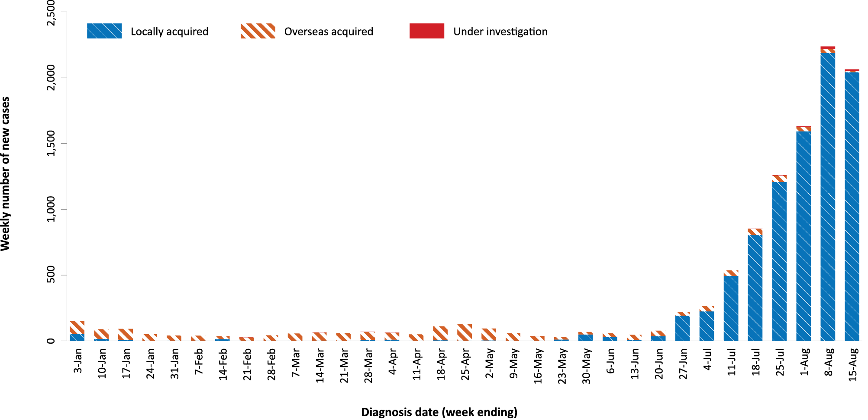
a Source: NNDSS, extract from 19 August 2021 for notifications to 15 August 2021.
b As noted in the text, there is potential for newly-notified cases to be excluded from the case count in the current reporting period when reporting by diagnosis date.
Figure 2: Cumulative COVID-19 notified cases by source of acquisition and diagnosis date, 2 March 2020 – 15 August 2021^{a,b}
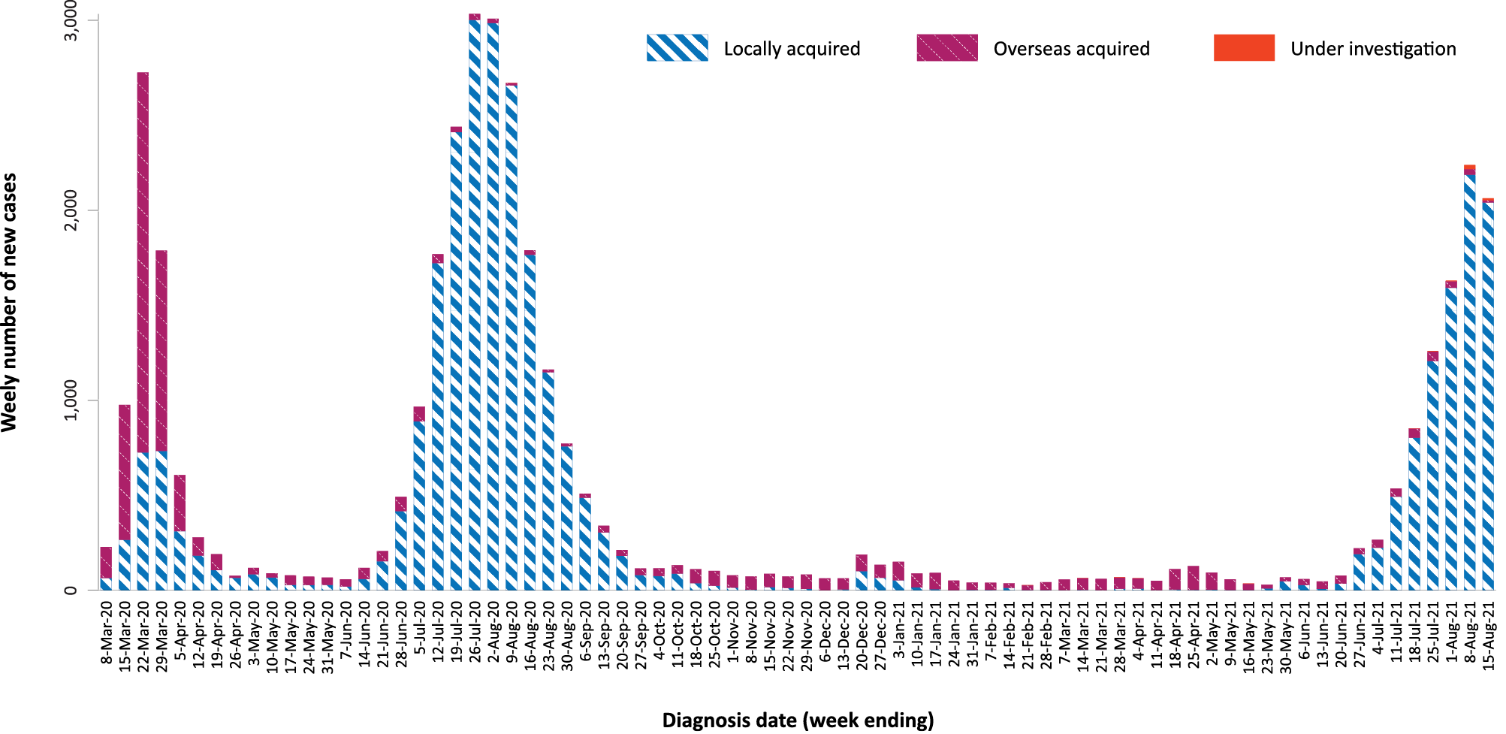
a Source: NNDSS, extract from 19 August 2021 for notifications to 15 August 2021.
b As noted in the text, there is potential for newly-notified cases to be excluded from the case count in the current reporting period when reporting by diagnosis date.

Source of acquisition

(NNDSS)
In this reporting period, 98% (4,839/4,927) of cases notified were locally acquired and 1% (57/4,927) were overseas acquired. At the end of the reporting period, there were 31 cases under investigation: 16 from New South Wales, seven from Victoria, five from Queensland and three from the Australian Capital Territory (Table 1).
New South Wales reported the majority of locally-acquired cases (92%; 4,499/4,839) in this fortnight, followed by Victoria (4%; 215/4,839). In the reporting period, 56% (2,731/4,839) of locally-acquired cases had a known contact or link to a cluster; 30 cases had an unknown (local or interstate) source; and, at the end of the reporting period, the source of infection was under ongoing investigation for 43% (2,078/4,839) of cases, all from New South Wales.
For 2021 to date, New South Wales had the highest infection rate for locally-acquired cases with 100.1 infections per 100,000 population, followed by Victoria with a rate of 8.8 infections per 100,000 population (Table 2). Based on cases notified to the NNDSS to 15 August 2021 for the current reporting period, the diagnosis date of the last locally-acquired case with known source was on 15 August 2021, 0 days prior to the reporting period’s end. (Table 3).
New South Wales reported the largest number of cases (51%; 29/57) that were overseas acquired, followed by Queensland (35%; 20/57). In the past 28 days (19 July to 15 August 2021), 28% (42/148) of overseas-acquired cases reported an unknown country of acquisition. Cases acquired at sea (54%; 57/106) were the most frequent of those with an identified country of acquisition in the past 28 days, followed by cases from India (8%; 8/106) and the United Kingdom (5%; 5/106) The number of cases acquired in different countries is influenced by travel patterns of returning Australians, travel restrictions, and the prevalence of COVID-19 in the country of travel.

Table 1: COVID-19 notifications by jurisdiction and source of acquisition, with a notification received date of
2–15 August 2021ª
Source^{b} | ACT | NSW | NT | Qld | SA | Tas. | Vic. | WA | Australia
Overseas | 0 | 29 | 1 | 20 | 2 | 0 | 3 | 2 | 57
Local | 20 | 4,499 | 1 | 101 | 1 | 1 | 215 | 1 | 4,839
- source known | 20 | 2,400 | 0 | 99 | 1 | 0 | 210 | 1 | 2,731
- source unknown | 0 | 21 | 0 | 2 | 0 | 0 | 5 | 0 | 28
- interstate, source known | 0 | 0 | 0 | 0 | 0 | 0 | 0 | 0 | 0
- interstate, source unknown | 0 | 0 | 1 | 0 | 0 | 1 | 0 | 0 | 2
- investigation ongoing | 0 | 2,078 | 0 | 0 | 0 | 0 | 0 | 0 | 2,078
Under initial investigation | 3 | 16 | 0 | 5 | 0 | 0 | 7 | 0 | 31
Missing source of acquisition | 0 | 0 | 0 | 0 | 0 | 0 | 0 | 0 | 0
Total | 23 | 4,544 | 2 | 126 | 3 | 1 | 225 | 3 | 4,927
a Source: NNDSS extract from 19 August 2021 for notifications to 15 August 2021.
b ACT: Australian Capital Territory; NSW: New South Wales; NT: Northern Territory; Qld: Queensland; SA: South Australia; Tas.: Tasmania; Vic.: Victoria; WA: Western Australia.

Table 2: Locally-acquired COVID-19 case numbers and rates per 100,000 population by jurisdiction and reporting period, Australia, with a notification received date from 1 January to 15 August 2021ª
Jurisdiction | Reporting period  2–15 August 2021 | Reporting period  19 July – 1 August 2021 | Cases this year  1 January – 15 August 2021^{b}
 | Number of cases^{b} | Number of cases^{b} | Number of cases^{b} | Rate per 100,000 population^{c}
ACT | 20 | 0 | 20 | 4.6
NSW | 4,499 | 2,310 | 8,222 | 100.1
NT | 1 | 0 | 11 | 4.5
Qld | 101 | 42 | 211 | 4.1
SA | 1 | 21 | 28 | 1.6
Tas. | 1 | 0 | 1 | 0.2
Vic. | 215 | 147 | 588 | 8.8
WA | 1 | 0 | 16 | 0.6
Australia | 4,839 | 2,520 | 9,097 | 35.4
a Source: NNDSS extract from 17 August 2021 for notifications to 15 August 2021.
b This total does not include cases that are under initial investigation.
c Population data based on Australian Bureau of Statistics (ABS) Estimated Resident Population (ERP) as at June 2020.

Table 3: Days since last locally-acquired COVID-19 case (source unknown and source known), by jurisdiction and diagnosis date, 15 August 2021ª
 | Locally acquired – source unknown^{b} |  | Locally acquired – source known^{b}
Jurisdiction | Date of last case | Days since last case | Date of last case | Days since last case
ACT | 21 March 2020 | 512 | 14 August 2021 | 1
NSW | 15 August 2021 | 0 | 15 August 2021 | 0
NT | NA^{c} | NA^{c} | 6 July 2021 | 40
Qld | 6 August 2021 | 9 | 13 August 2021 | 2
SA | 24 March 2020 | 509 | 3 August 2021 | 12
Tas. | 9 August 2020 | 371 | 24 April 2020 | 478
Vic. | 10 August 2021 | 5 | 15 August 2021 | 0
WA | 3 April 2020 | 499 | 2 August 2021 | 13
a Source: NNDSS, extract from 19 August 2021 for notifications to 15 August 2021.
b This does not include locally-acquired cases that were interstate acquired.
c NA: not applicable. The Northern Territory has not reported any locally-acquired cases with an unknown source of infection.

Demographic features

(NNDSS)
In this reporting period, the largest proportion of cases occurred in those aged 20 to 29 years (22%; 1,072/4,927). For this year, the highest rate of infection has been in those aged 20 to 29 years with a rate of 63.7 infections per 100,000 population (Figure 3; Appendix A, Table A.1). Adults aged 70 to 79 years have had the lowest rate of infection this year.
In 2021, notification rates were higher in males than in females for all age groups except those aged 0 to 19 years (Figure 3). The largest proportional difference by sex, in rates this year, was in the 60 to 69 years age group, where the cumulative rate among males was 25.9 cases per 100,000 population and among females was 17.0 cases per 100,000 population (Appendix A, Table A.1). The median age of cases in this reporting period was 27 years (range: 0 to 98 years; interquartile range, IQR: 16 to 43 years).
Figure 3: Cumulative COVID-19 cases for the calendar year to date, by age group and sex, Australia, with a diagnosis date of 1 January 2021 – 15 August 2021ª
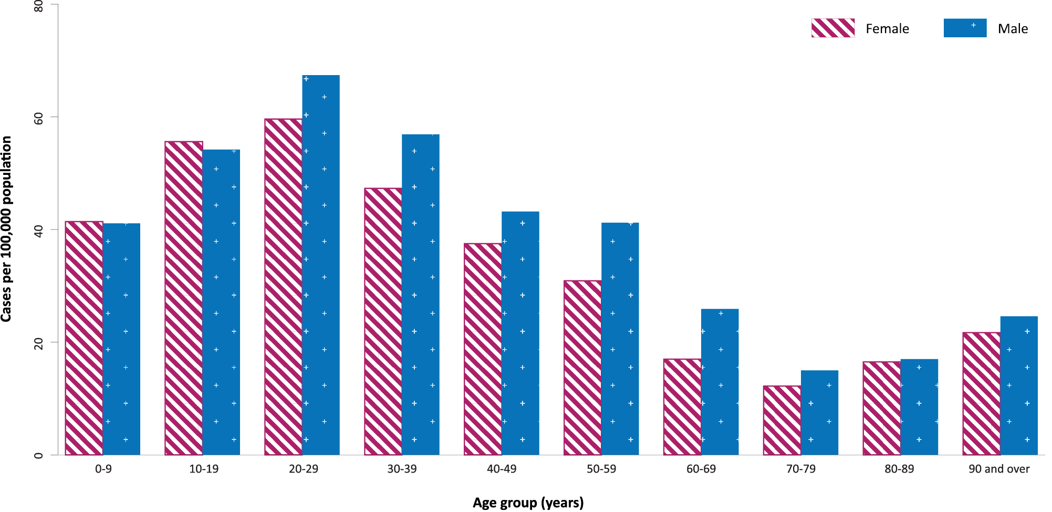
a Source: NNDSS, extract from 19 August 2021 for notifications to 15 August 2021.

Aboriginal and Torres Strait Islander persons

(NNDSS)
Since the beginning of 2021, there have been 145 confirmed cases of COVID-19 notified in Aboriginal and Torres Strait Islander people, representing 1% (145/10,793) of all confirmed cases this year. During the reporting period, 108 new cases were notified in Aboriginal and Torres Strait Islander people, all from New South Wales.
As at 15 August 2021, it has been zero days since the last locally-acquired Aboriginal and Torres Strait Islander case was diagnosed and 29 days since the last overseas-acquired Aboriginal and Torres Strait Islander case was diagnosed. The majority of cases in Aboriginal and Torres Strait Islander people in 2021 have been reported as locally acquired (97%; 140/145), with five cases overseas acquired. The median age of all Aboriginal and Torres Strait Islander cases this year is 19 years old (range: 0 to 69 years; IQR: 13 to 31 years) and there have been similar numbers of cases in females (52%; 75/145) and males (48%; 70/145).

Vaccinations
(Department of Health)
As of 15 August 2021, a total of 15,338,926 doses of COVID-19 vaccine had been administered (Table 4), including 660,961 doses provided to aged care and disability residents.
Table 4: Total number of vaccinations administered, by jurisdiction, Australia, 15 August 2021ª
Jurisdiction | Total number of doses administered
ACT | 356,518
NSW | 5,170,324
NT | 178,041
Qld | 2,837,758
SA | 1,040,250
Tas. | 379,599
Vic. | 3,981,941
WA | 1,394,495
Aged care and disability facilities^{b} | 660,961
Primary care^{c} | 8,274,354
Total | 15,338,926
a Source: Australian Government Department of Health website.⁴
b Commonwealth vaccine doses administered in aged care and disability facilities.
c Commonwealth vaccine doses administered in primary care settings.

Clusters and outbreaks

New South Wales
The size of the Sydney Metropolitan Outbreak in New South Wales continued to increase during the reporting period. As at 15 August 2021, there have been 8,218 locally-acquired cases in New South Wales, including 54 deaths, reported following notification of the first case on 16 June 2021. Genomic testing results showed that the first case was infected with the Delta SARS-CoV-2 variant of concern (B.1.617.2); however, the sequence did not match cases from the Victorian Delta variant outbreak that occurred from May to June 2021. This sequence had not been seen in Australia previously, but matches one from the United States of America.
While the outbreak started in south-east Sydney, the majority of recently reported cases are among residents of south-western and western Sydney, with some cases also reported in residents of regional and remote areas in New South Wales, particularly in western New South Wales.

Victoria
Most locally-acquired cases reported in Victoria during the reporting period were part of four outbreaks in Melbourne, with the first cases reported on 5 August 2021. As at 15 August 2021, there were 205 cases associated with these outbreaks. The outbreaks involved the Delta variant and were closely associated with the recent New South Wales and earlier Victoria outbreaks. The exact source of infection for these outbreaks remained under investigation at the end of this reporting period. Locally-acquired cases in Victoria reported before the 5 August 2021 were associated with two previous seeding events of the Delta variant associated with travellers from New South Wales to Victoria.

Queensland
Most locally-acquired cases reported in Queensland during the reporting period were part of an outbreak linked to a Brisbane high school (Indooroopilly cluster). The first case in this outbreak was reported on 30 July 2021. The outbreak has been genomically linked to returned overseas travellers with the Delta variant. The epidemiological link remained under investigation at the end of this reporting period. As at 15 August 2021, a total of 143 cases were linked to this outbreak.

Australian Capital Territory
During the reporting period, the Australian Capital Territory reported its first locally-acquired cases in over a year. The first case in this outbreak was reported on 12 August 2021. As at 15 August 2021, a total of 28 cases had been reported as part of this outbreak. The source of infection remained under investigation at the end of this reporting period, though it has been genomically linked to the Sydney Metropolitan Outbreak.

Severity

(NNDSS, FluCAN, SPRINT-SARI)

Hospitalisation and intensive care unit admission
In 2021 to date, for cases where hospitalisation data were reliable and complete, the estimated national hospitalisation rate was 10% of cases, and the estimated ICU admission rate was 2% of cases (Table 5). This was based on data from six states/territories with reliable data across both hospitalisation and ICU data fields in the NNDSS, and which did not routinely hospitalise cases for isolation purposes (Australian Capital Territory, New South Wales, South Australia, Tasmania, Victoria and Western Australia). Among these jurisdictions, the majority of hospitalisations in 2021 were associated with the current outbreak in New South Wales.

Table 5: COVID-19 cases by hospitalisation, ICU admissions and associated death status, selected jurisdictions, 1 January – 15 August 2021, by age group^{a,b}
Age group | Count |  |  |  | % of cases
 | Cases | Hospitalised | ICU | Died | Hospitalised | ICU | Died
0–9 | 1,235 | 32 | 1 | 0 | 3% | < 1% | 0%
10–19 | 1,629 | 47 | 5 | 1 | 3% | < 1% | < 1%
20–29 | 2,182 | 163 | 23 | 1 | 7% | 1% | 0%
30–39 | 1,789 | 154 | 18 | 2 | 9% | 1% | < 1%
40–49 | 1,224 | 140 | 23 | 3 | 11% | 2% | < 1%
50–59 | 1,048 | 189 | 51 | 2 | 18% | 5% | < 1%
60–69 | 529 | 132 | 48 | 7 | 25% | 9% | 1%
70–79 | 240 | 96 | 31 | 12 | 40% | 13% | 5%
80–89 | 138 | 82 | 12 | 23 | 59% | 9% | 17%
90+ | 49 | 22 | 0 | 11 | 45% | 0% | 22%
Age group unknown | 5 | 0 | 0 | 0 | 0% | 0% | 0%
Total | 10,068 | 1,057 | 212 | 62 | 10% | 2% | 1%
a Source: NNDSS, extract from 19 August 2021 for notifications to 15 August 2021.
b Data included from six jurisdictions with the most reliable data across both hospital and ICU data fields: Australian Capital Territory, New South Wales, South Australia, Tasmania, Victoria and Western Australia. This is based on an assessment of data from SPRINT-SARI5 and NNDSS.

In the year to date, there have been 304 COVID-19 cases admitted to ICUs participating in the sentinel surveillance system, Short Period Incidence Study of Severe Acute Respiratory Infection (SPRINT-SARI),⁵ with 127 of these admitted during this reporting period (2–15 August 2021).

Risk factors for severe disease
In the year to date, higher proportions of cases in older age groups have been admitted to hospital than is the case among younger age groups.
Comorbidity data extracted from SPRINT-SARI reflect the sickest patients with COVID-19 managed in ICU; data are therefore not generalisable to all cases (Table 6). In patients admitted to ICU with COVID-19 since 1 February 2021, the most prevalent comorbidity was diabetes, following by obesity (a body mass index of > 30 or weight exceeding 120 kg). Of those patients admitted to ICU this year, 55% (128/231) had at least one comorbidity; 45% of patients (103/231) had none of the listed comorbidities recorded.

Table 6: Comorbidities for adult COVID-19 cases (age ≥ 18 years) amongst those admitted to ICU, Australia, 1 February – 15 August 2021ª
Comorbidity | ICU casesª (n = 300) (%)
Cardiac disease (n = 225) | 23 (10)
Chronic respiratory condition (n = 224) ^{b} | 24 (11)
Diabetes (n = 226) | 64 (28)
Obesity (n = 213) | 52 (24)
Chronic renal disease (n = 222) | 10 (5)
Chronic neurological condition (n = 224) | 3 (1)
Malignancy (n = 224) | 8 (4)
Chronic liver disease (n = 224) | 9 (4)
Immunosuppression (n = 224) | 7 (3)
Number of specified comorbidities (n = 231) ^{c,d}
One or more | 128 (55)
Two or more | 49 (21)
Three or more | 16 (7)
No comorbidities | 103 (45)
a Source: SPRINT-SARI. Only includes adult cases (≥ 18 years old) and excludes those with missing data on comorbidities or where comorbidity is unknown.
b Includes asthma.
c Includes chronic respiratory conditions, cardiac disease (excluding hypertension), immunosuppressive condition/therapy, diabetes, obesity, liver disease, renal disease and neurological disorder.
d Excludes cases where comorbidity data is missing or unknown for all comorbidities.

COVID-19 deaths
In the past four weeks, there were 41 deaths associated with COVID-19, all from New South Wales, corresponding to a crude case fatality rate (CFR) of 1%. Overall, the CFR remains at 3%, while for all cases reported in Australia in 2021 to date, the CFR is 1% (Table 7). The ratio of deaths to cases in the year to date has decreased in comparison to this time last year, noting substantially lower case numbers this year and the difference in age distributions of those infected in 2021 versus 2020.
Table 7: Deaths associated with COVID-19 by reporting period, Australia, 1 January 2020 – 15 August 2021ª
 | Number of deaths^{b} | Crude case fatality rate
Reporting period 2 August – 15 August 2021 | 41/4,927 | 1%
Year to date (2021) 1 January – 15 August 2021 | 63/10,793 | 1%
Year to date (2020) 1 January – 15 August 2020 | 743/22,922 | 3%
Epidemic to date 1 January 2020 – 15 August 2021 | 972/39,200 | 3%
a Source: NNDSS, extract from 19 August 2021 for notifications to 15 August 2021, based on notification received date.
b Expressed as deaths/case numbers.

Four-week reporting period (19 July – 15 August 2021)

Genomic surveillance and virology

(Communicable Disease Genomics Network, AusTrakka and jurisdictional sequencing laboratories)
Nationally, 58% of COVID-19 cases have been sequenced over the duration of the pandemic (Table 8, Figure 4).
Table 8: Australian SARS-CoV-2 genome sequences and proportion of positive cases sequenced, 19 July – 15 August 2021 and cumulative to date
Measure | Reporting period  19 July – 15 August 2021 | Cumulative  23 January 2020 – 15 August 2021
SARS-CoV-2 cases sequencedª | 2,661 | 22,778
Percentage of positive cases sequenced^{b} | 35% | 58%
a Based on individual jurisdictional reports of sequences and case numbers. Calculations of the percentage of cases sequenced based on the number of sequences available in AusTrakka may not always be up-to-date, since this may include duplicate samples from cases and may not represent all available sequence data.
b In most jurisdictions, sequencing has been attempted on all suitable samples (one sample per case). Sequencing of samples from cases identified in the reporting period may be in process at the time of reporting. Remaining unsequenced samples may be due to jurisdictional sequencing strategy, or where samples have been deemed unsuitable for sequencing (typically, because viral loads were too low for sequencing to be successful).

Variants of concern
AusTrakka actively monitors and reports on SARS-CoV-2 lineages designated Variants of Concern (VOC) by international organisations, including the World Health Organization (WHO): B.1.1.7; B.1.351; P.1; and B.1.617 (and the latter’s sublineages B.1.617.1, B.1.617.2 and B.1.617.3) (Table 9). These variants all display characteristic sets of mutation, including a number of variations in the genomic region encoding the spike protein thought to have the potential to increase transmissibility and/or immune evasion.⁷ On 1 June 2021, WHO announced a new nomenclature system for VOCs, using letters of the Greek alphabet,⁸ to facilitate communication and reduce stigmatisation associated with geography-based colloquial terms.
Further information on variants is available in the Technical Supplement.³

Table 9: Australian SARS-CoV-2 genome sequences in AusTrakka identified as variants of concern, 23 January 2020 – 15 August 2021
VOC lineage | Number of samples
B.1.1.7 (Alpha) | 550
B.1.351 (Beta) | 99
P.1 (Gamma) | 7
B.1.617.1 (Kappa) | 128
B.1.617.2 (Delta) | 4,664

Testing

(State and territory reporting)
As at 13 August 2021, a cumulative total of 13,183,983 individuals had undergone diagnostic testing for SARS-CoV-2 in Australia this year since 1 January 2021. The cumulative nationwide proportion of positive tests for 2021 has remained low at 0.08% (10,378/13,183,983) (Table 10).
During this four-week reporting period, over 4 million individuals were tested nationally, with a positivity rate of 0.1%. Jurisdictional testing rates are driven by both current case numbers and numbers of people experiencing symptoms.
Testing rates increased substantially from the week ending 23 July onwards, due to the re-inclusion of New South Wales in testing rates (Figure 5). Those aged 20 to 39 years continued to have the highest rates of testing, followed by those aged 40 to 59 years old.

Acute respiratory illness

(FluTracking, ASPREN, and Commonwealth Respiratory Clinics)
Based on self-reported FluTracking data,⁹ prevalence of fever and cough in the community remained at < 1%, which is consistent with the previous four-week reporting period (Figure 6). Runny nose and sore throat symptoms in the community decreased slightly during this reporting period compared to the previous four weeks, with the prevalence in the community remaining low at < 1%.
In this reporting period, acute respiratory illness was highest in those aged 0 to 9 years and 30 to 39 years, based on both self-reported FluTracking data and presentations to Commonwealth Respiratory Clinics. Females reported respiratory illness more frequently than males. Rates of fever and cough by jurisdiction ranged from 2.6/1,000 FluTracking participants in South Australia to 8.3/1,000 participants in the Australian Capital Territory.
FluTracking data indicated that 52% of those in the community with ‘fever and cough’ and 42% of those with ‘runny nose and sore throat’ were tested for SARS-CoV-2. This represents an increase in SARS-CoV-2 testing for ‘sore throat Figure 4: Samples in AusTrakka from 1 March to 15 August 2021, by lineage and date of collectionª

Figure 4: Samples in AusTrakka from 1 March to 15 August 2021, by lineage and date of collectionª
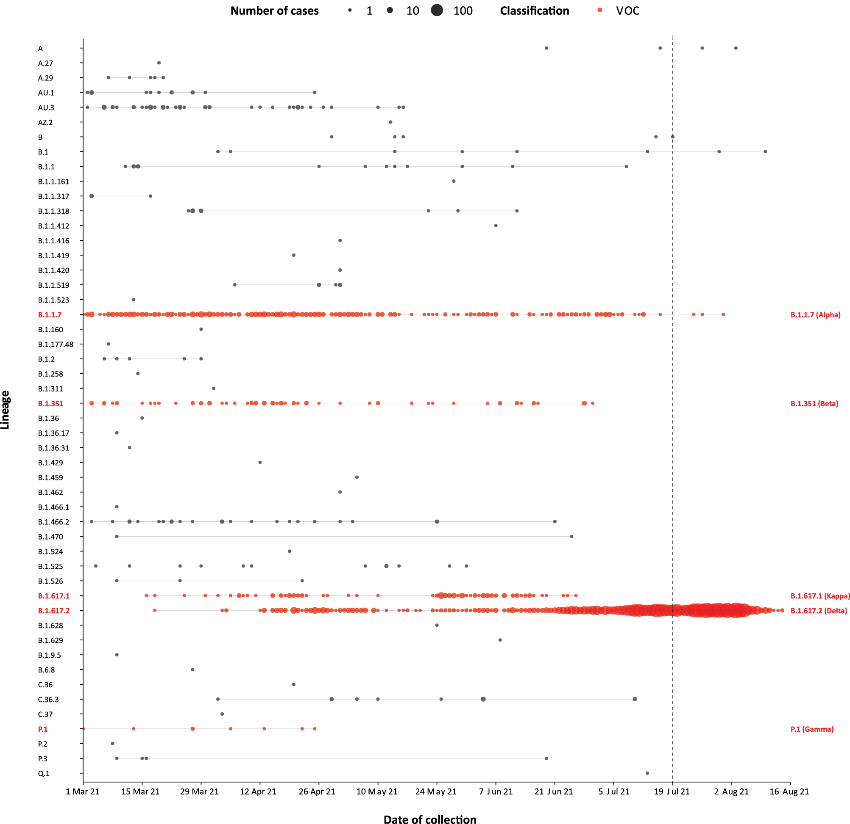
a The start of the current reporting period (19 July – 15 August 2021) is marked by the dotted line, and variant-of-concern samples are coloured red. The size of the circle is proportional to the number of samples in the lineage at each time point.
and runny nose’ and a slight decrease in testing for ‘fever and cough’ since the previous reporting period. In the four-week reporting period, testing rates were highest in South Australia for ‘fever and cough’ and in Victoria for ‘runny nose and sore throat’, and lowest in Western Australia for both sets of symptoms. It is important to acknowledge that there may be legitimate reasons why people did not get tested, including barriers to accessing testing. Symptoms reported to FluTracking are not specific to COVID-19 and may also be due to chronic diseases.
During this reporting period, there were 170,027 assessments at Commonwealth Respiratory Clinics. Of these, there were 155,044 assessments with consent to share information, with 90% (139,475/155,044) tested for SARS-CoV-2. There were 70 cases reported at these clinics in this reporting period, representing a percent positivity of < 1% (70/139,475).
Among those tested through the Australian Sentinel Practice Research Network (ASPREN) and Victorian Sentinel Practice Influenza Network (VicSPIN) general practitioner sentinel surveillance systems, rhinovirus was the most common respiratory virus detected in patients presenting with influenza-like illness in this reporting period.

Public health response measures
Since COVID-19 first emerged internationally, Australia has implemented public health measures informed by the disease’s epidemiology. States and territories have decision-making authority in relation to public health measures and have implemented or eased restrictions at their own pace (Figure 7; Appendix A, Table A.2), depending on the local public health and epidemiological situation, and in line with the ‘Framework for National Reopening’.¹⁰ Nationwide requirements regarding air travel, including pre-flight testing for travellers entering Australia and requirements to wear face masks when flying domestically or internationally, remain in place. During the current reporting period, there was community transmission occurring in the Australian Capital Territory, New South Wales, Queensland, South Australia, and Victoria.

Countries and territories in Australia’s near region
According to WHO, countries and territories in the South East Asian (SEARO) and Western Pacific (WPRO) regions reported 4,508,380 newly-confirmed cases and 99,131 deaths in the four-week period to 15 August 2021, bringing the cumulative cases in the two regions to over 45 million, and cumulative deaths to 685,822.¹¹ Case numbers and death incidence continues to trend downward in the South East Asian region, driven by decreasing cases in India. However, trends in many other countries in the region continue to increase, including in Indonesia and Thailand. The Western Pacific Region has experienced an exponential increase in cases and deaths for nearly two months. The highest numbers of new cases during the four-week period to 15 August 2021 were in Malaysia, Japan, and the Philippines.¹²
Table 11 outlines the new cases and deaths in the four-week period to 15 August 2021 and cumulative cases and deaths for the pandemic in selected countries with the highest number of new cases in the South East Asian and Western Pacific regions.
As of 15 August 2021, over 206 million COVID-19 cases and 4.3 million deaths have been reported globally, with a global CFR of 2%. On 5 August 2021, the cumulative number of COVID-19 cases worldwide reached 200 million, taking 6 months after first exceeding 100 million cases. The two regions reporting the largest burden of disease over the past four weeks were the Region of the Americas (32%) and the European Region (27%).

Table 10: Individuals undergoing diagnostic tests for SARS-CoV-2,ª by jurisdiction and reporting period, with a notification received date of 1 January – 13 August 2021
Jurisdiction | Individuals tested |  |  | Individuals tested |  |  | Cumulative individuals tested
 | 31 July– 13 August 2021 |  |  | 17 July – 30 July 2021 |  |  | in 2021 to 13 August
 | n | Positivity (%) | Per 1,000 population^{b} | n | Positivity  (%) | Per 1,000 population^{b} | n | Positivity  (%) | Per 1,000 population^{b}
ACT | 18,823 | 0.1 | 43.6 | 15,584 | – | 36.1 | 156,462 | 0.02 | 362.7
NSW | 1,295,115 | 0.3 | 158.6 | 1,058,508 | 0.2 | 129.6 | 4,629,334 | 0.20 | 566.8
NT | 14,979 | 0.01 | 60.8 | 12,113 | 0.05 | 49.2 | 158,558 | 0.07 | 643.8
Qld | 919,704 | 0.02 | 177.7 | 174,066 | 0.03 | 33.6 | 1,722,955 | 0.03 | 332.9
SA | 79,298 | < 0.01 | 44.8 | 194,694 | 0.01 | 110.0 | 990,108 | 0.02 | 559.2
Tas. | 18,286 | 0.01 | 33.8 | 16,316 | – | 30.2 | 158,587 | <0.01 | 293.3
Vic. | 459,865 | 0.04 | 68.7 | 567,002 | 0.03 | 84.7 | 4,609,042 | 0.02 | 688.3
WA | 54,200 | 0.01 | 20.3 | 47,197 | 0.03 | 17.7 | 758,937 | 0.02 | 284.9
Australia | 2,860,270 | 0.2 | 111.3 | 2,085,480 | 0.1 | 81.2 | 13,183,983 | 0.08 | 513.0
a In order to more accurately reflect positivity rates, numbers of individuals tested is presented rather than total number of tests.
b Population data based on Australian Bureau of Statistics (ABS) Estimated Resident Population (ERP) as at June 2021. Note that small discrepancies in rates between previous reports and this report will be due to the updated reference population (previous reports used June 2020)

Figure 5: SARS-CoV-2 polymerase chain reaction (PCR) testing rates per 1,000 population per week by age group and notification received date, Australia, 1 January – 13 August 2021^{a,b,c}
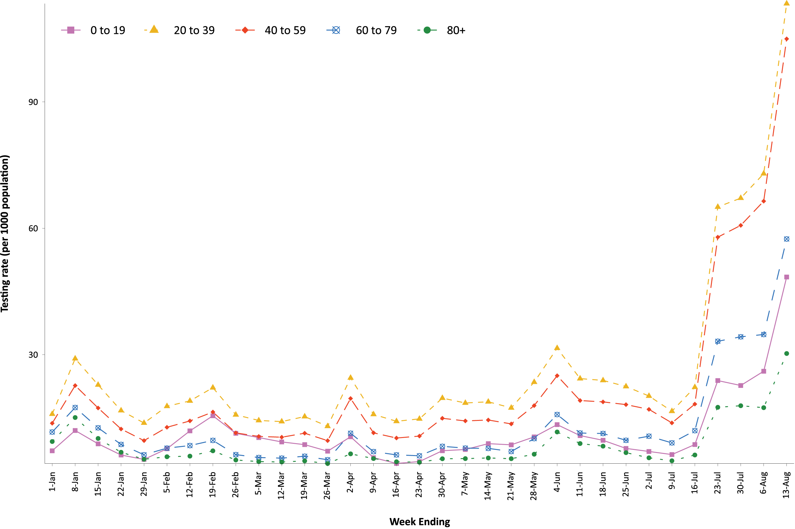
a Source: data provided by jurisdictions to the NIR weekly, current to 13 August 2021.
b The jurisdictions reporting each week (i.e. the denominator population) may vary.
c From 19 June 2021 to 16 July 2021, data for New South Wales were unavailable.

Figure 6: Weekly trends in respiratory illness amongst FluTracking survey participants (age-standardised) compared to the average of the previous five years, Australia, by epidemiological week,ª 1 March 2020 – 15 August 2021^{b}
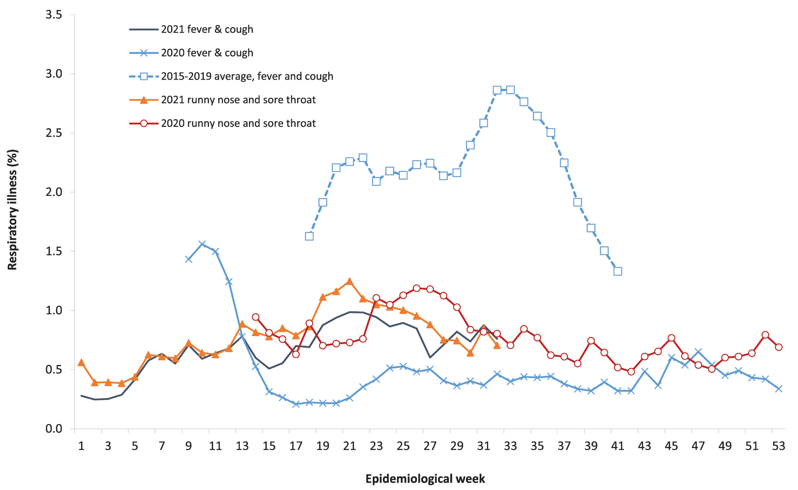
a Epidemiological weeks are a standardised method for numbering weeks across years, with the first epidemiological week of any year ending on the first Saturday in January.
b In years prior to 2020, FluTracking was activated during the main Influenza season from May to October. A historical average beyond the week ending 11 October (epidemiological week 41) is therefore not available. In 2020, FluTracking commenced ten weeks early to capture data for COVID-19. Data on runny nose and sore throat were only collected systematically after 29 March 2020, therefore a historical average for this symptom profile is unavailable.

Figure 7: COVID-19 notifications in Australia by week of diagnosis and jurisdiction, 1 January – 15 August 2021, with timing of key public health measures
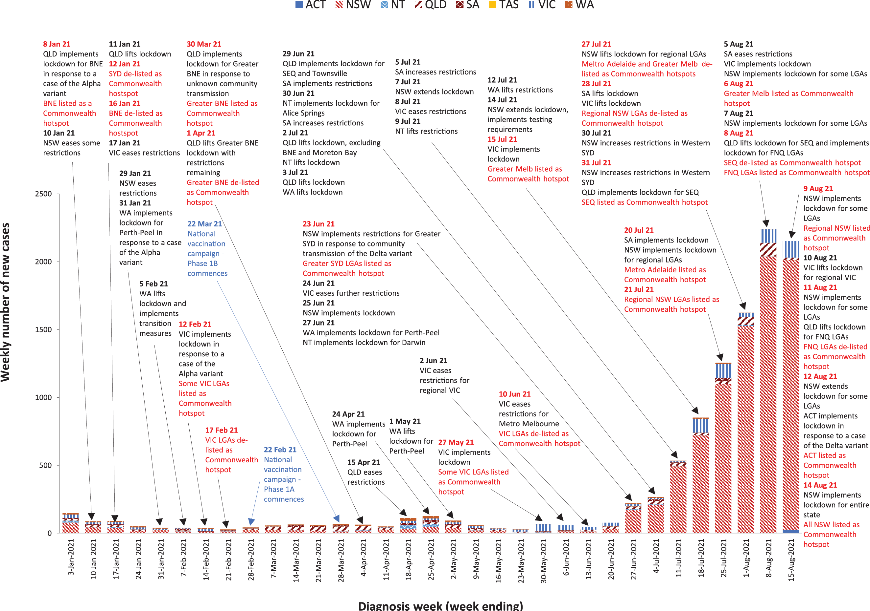

Table 11: Cumulative cases and deaths, and new cases and deaths reported in the four-week period to 15 August 2021 for selected countries in Australia’s near region according to WHOª
Country | Cumulative cases | New cases reported in the last 4 weeks | Change in new cases in the last 4 weeks^{b} | Cumulative deaths | New deaths reported in the last 4 weeks | Change in new deaths in the last 4 weeks^{b}
South East Asian region
India | 32,192,576 | 1,086,511 | -11% | 431,225 | 17,616 | -35%
Indonesia | 3,854,354 | 976,878 | +10% | 117,588 | 44,006 | +133%
Thailand | 907,157 | 503,771 | +172% | 7,552 | 4,211 | +146%
Bangladesh | 1,418,902 | 314,913 | -63% | 24,175 | 6,281 | +54%
Myanmar | 354,279 | 124,758 | +53% | 13,263 | 8,263 | +375%
Western Pacific region
Malaysia | 1,384,353 | 478,502 | -92% | 12,228 | 5,362 | +113%
Japan | 1,128,382 | 289,950 | +433% | 15,400 | 360 | -44%
Philippines | 1,726,867 | 224,523 | +51% | 30,070 | 3,472 | +13%
Viet Nam | 265,464 | 214,462 | +464% | 5,437 | 5,212 | +3158%
Republic of Korea | 223,925 | 45,974 | +72% | 2,156 | 99 | +80%
a Source: World Health Organization Coronavirus (COVID-19) Dashboard,¹¹ accessed 25 August 2021.
b Percent change in the number of newly confirmed cases/deaths in the past 4 weeks compared to the 4 weeks prior.

Acknowledgements
We thank public health staff from incident emergency operations centres and public health units in state and territory health departments, and the Australian Government Department of Health, along with state and territory public health laboratories. We thank those who have provided data from surveillance systems, such as Commonwealth respiratory clinics, ASPREN, FluTracking, FluCAN, SPRINT-SARI, Communicable Disease Genomics Network, AusTrakka and jurisdictional sequencing laboratories.

Author details

Corresponding author
COVID-19 National Incident Room Surveillance Team
Australian Government Department of Health, GPO Box 9484, MDP 14, Canberra, ACT 2601. Email: epi.coronavirus@health.gov.au

References
- COVID-19 National Incident Room Surveillance Team. COVID-19 Australia: Epidemiology Report 47: Reporting period ending 1 August 2021. Commun Dis Intell (2018). 2021;45. doi: https://doi.org/10.33321/cdi.2021.45.41.
- COVID-19 National Incident Room Surveillance Team. COVID-19 Australia: Epidemiology Report 46: Reporting period ending 18 July 2021. Commun Dis Intell (2018). 2021;45. doi: https://doi.org/10.33321/cdi.2021.45.39.
- COVID-19 National Incident Room Surveillance Team. Technical supplement. COVID-19 Australia: Epidemiology reporting. Commun Dis Intell (2018). 2021;45. doi: https://doi.org/10.33321/cdi.2021.45.2.
- Australian Government Department of Health. Getting vaccinated for COVID-19: Australia’s vaccine rollout. [Internet.] Canberra: Australian Government Department of Health; 2021. [Accessed on 16 August 2021.] Available from: https://www.health.gov.au/initiatives-and-programs/covid-19-vaccines/getting-vaccinated-for-covid-19#australias-vaccine-rollout.
- Australian and New Zealand Intensive Care Research Centre (ANZIC-RC). SPRINT-SARI: Short period incidence study of severe acute respiratory infection. [Internet.] Melbourne: Monash University 2020. Available from: https://www.monash.edu/medicine/sphpm/anzicrc/research/sprint-sari.
- Communicable Diseases Genomics Network (CDGN). AusTrakka. [Website.] Melbourne: CDGN; 2020. Available from: https://www.cdgn.org.au/austrakka.
- World Health Organization (WHO). Coronavirus disease (COVID-19) Weekly Epidemiological Update and Weekly Operational Update. [Internet.] Geneva: WHO; June 2021. [Accessed on 25 June 2021.] Available from: https://www.who.int/emergencies/diseases/novel-coronavirus-2019/situation-reports/.
- WHO. Tracking SARS-CoV-2 variants. [Internet.] Geneva: WHO; 15 June 2021. [Accessed on 25 June 2021.] Available from: https://www.who.int/en/activities/tracking-SARS-CoV-2-variants/.
- Dalton C, Durrheim D, Fejsa J, Francis L, Carlson S, d’Espaignet ET et al. Flutracking: a weekly Australian community online survey of influenza-like illness in 2006, 2007 and 2008. Commun Dis Intell Q Rep. 2009;33(3):316–22.
- Australian Government Department of Health. Framework for national reopening – October 2020. [Internet.] Canberra: Australian Government Department of Health; 23 October 2020. [Accessed on 10 November 2020.] Available from: https://www.health.gov.au/resources/publications/framework-for-national-reopening-october-2020.
- WHO. WHO Coronavirus Disease (COVID-19) dashboard. [Internet.] Geneva: WHO; 2021. Available from: https://covid19.who.int/.
- WHO. Weekly epidemiological update on COVID-19 – 17 August 2021. [Internet.] Geneva: WHO; 17 August 2021. [Accessed on 19 August 2021.] Available from: https://www.who.int/publications/m/item/weekly-epidemiological-update-on-covid-19---17-august-2021.
- Australian Capital Territory Government. Seven-day lockdown for the ACT. [Internet.] Canberra: Australian Capital Territory Government; 12 August 2021. [Accessed on 18 August 2021.] Available from: https://www.covid19.act.gov.au/news-articles/seven-day-lockdown-for-the-act.
- Australian Capital Territory Government Department of Health (ACT Health). COVID-19 Update: Changes to your visit to ACT Health Facilities. [Internet.] Canberra: Australian Capital Territory Government, ACT Health; 12 August 2021. [Accessed on 18 August 2021.] Available from: https://www.health.act.gov.au/news/covid-19-update-changes-your-visit-act-health-facilities.
- Government of New South Wales Department of Health (NSW Health). Stay-at-home order for Orange, Blayney and Cabonne. [Internet.] Sydney: Government of New South Wales, NSW Health; 20 July 2021. [Accessed on 18 August 2021.] Available from: https://www.health.nsw.gov.au/news/pages/20210720_02.aspx.
- NSW Health. Stay-at-home orders to lift for Orange, Blayney, Cabonne. [Internet.] Sydney: Government of New South Wales, NSW Health; 27 July 2021. [Accessed on 18 August 2021.] Available from: https://www.health.nsw.gov.au/news/pages/20210727_01.aspx.
- Government of New South Wales. Certainty for the community as restrictions adjusted and vaccines ramped up. [Internet.] Sydney: Government of New South Wales; 28 July 2021. [Accessed on 18 August 2021.] Available from: https://www.nsw.gov.au/media-releases/certainty-for-community-as-restrictions-adjusted-and-vaccines-ramped-up.
- NSW Health. Fighting the Delta outbreak with new restrictions for local government areas (LGAs) of concern. [Internet.] Sydney: Government of New South Wales, NSW Health; 30 July 2021. [Accessed on 18 August 2021.] Available from: https://www.health.nsw.gov.au/news/pages/20210730_01.aspx
- NSW Health. New surveillance testing requirements for Canterbury-Bankstown from Saturday. [Internet.] Sydney: Government of New South Wales, NSW Health; 28 July 2021. [Accessed on 18 August 2021.] Available from: https://www.health.nsw.gov.au/news/pages/20210728_02.aspx.
- NSW Health. Non-urgent elective surgery suspended in Greater Sydney. [Internet.] Sydney: Government of New South Wales, NSW Health; 30 July 2021. [Accessed on 18 August 2021.] Available from: https://www.health.nsw.gov.au/news/pages/20210730_02.aspx.
- NSW Health. Stay-at-home order for new areas of concern. [Internet.] Sydney: Government of New South Wales, NSW Health; 5 August 2021. [Accessed on 18 August 2021.] Available from: https://www.health.nsw.gov.au/news/pages/20210805_01.aspx.
- NSW Health. Public health alert - Armidale regional LGA. [Internet.] Sydney: Government of New South Wales, NSW Health; 7 August 2021. [Accessed on 18 August 2021.] Available from: https://www.health.nsw.gov.au/news/pages/20210807_03.aspx.
- NSW Health. Stay-at-home Order for four NSW North Coast LGAs from 6pm. [Internet.] Sydney: Government of New South Wales, NSW Health; 9 August 2021. [Accessed on 18 August 2021.] Available from: https://www.health.nsw.gov.au/news/pages/20210809_02.aspx.
- NSW Health. Stay-at-home Order for Tamworth from 5pm today. [Internet.] Sydney: Government of New South Wales, NSW Health; 9 August 2021. [Accessed on 18 August 2021.] Available from: https://www.health.nsw.gov.au/news/pages/20210809_04.aspx.
- NSW Health. Stay-at-home orders - Western NSW. [Internet.] Sydney: Government of New South Wales, NSW Health; 11 August 2021. [Accessed on 18 August 2021.] Available from: https://www.health.nsw.gov.au/news/pages/20210811_02.aspx.
- NSW Health. Stay-at-home order for Australian Capital Territory, additional Local Government Areas of concern and Newcastle and Hunter restrictions extended. [Internet.] Sydney: Government of New South Wales, NSW Health; 12 August 2021. [Accessed on 18 August 2021.] Available from: https://www.health.nsw.gov.au/news/pages/20210812_01.aspx.
- NSW Health. Non-urgent elective surgery suspended in Dubbo. [Internet.] Sydney: Government of New South Wales, NSW Health; 13 August 2021. [Accessed on 18 August 2021.] Available from: https://www.health.nsw.gov.au/news/pages/20210813_01.aspx.
- NSW Health. Stay-at-home orders for regional NSW from 5pm today. [Internet.] Sydney: Government of New South Wales, NSW Health; 14 August 2021. [Accessed on 18 August 2021.] Available from: https://www.health.nsw.gov.au/news/pages/20210814_03.aspx.
- Queensland Health. New measures to reduce risk of COVID-19 spread in Queensland. [Internet.] Brisbane: Queensland Government, Queensland Health; 22 July 2021. [Accessed on 18 August 2021.] Available from: https://www.health.qld.gov.au/news-events/doh-media-releases/releases/new-measures-to-reduce-risk-of-covid-19-spread-in-queensland.
- Queensland Health. Mask wearing in South East Queensland continued for another week. [Internet.] Brisbane: Queensland Government, Queensland Health; 29 July 2021. [Accessed on 18 August 2021.] Available from: https://www.health.qld.gov.au/news-events/doh-media-releases/releases/mask-wearing-in-south-east-queensland-continued-for-another-week2.
- Queensland Health. Queensland COVID-19 update: 1 August 2021. [Internet.] Brisbane: Queensland Government, Queensland Health; 1 August 2021. [Accessed on 18 August 2021.] Available from: https://www.health.qld.gov.au/news-events/doh-media-releases/releases/queensland-covid-19-update12.
- Queensland Health. SEQ testing capacity bolstered during lockdown. [Internet.] Brisbane: Queensland Government, Queensland Health; 1 August 2021. [Accessed on 18 August 2021.] Available from: https://www.health.qld.gov.au/news-events/doh-media-releases/releases/seq-testing-capacity-bolstered-during-lockdown.
- Queensland Health. Queensland COVID-19 Update: 2 August 2021. [Internet.] Brisbane: Queensland Government, Queensland Health; 2 August 2021. [Accessed on 18 August 2021.] Available from: https://www.health.qld.gov.au/news-events/doh-media-releases/releases/queensland-covid-19-update13.
- Queensland Health. Queensland COVID-19 Update: 11 August 2021. [Internet.] Brisbane: Queensland Government, Queensland Health; 11 August 2021. [Accessed on 18 August 2021.] Available from: https://www.health.qld.gov.au/news-events/doh-media-releases/releases/queensland-covid-19-update16.
- SA Health. COVID-19 update 20 July 2021. [Internet.] Adelaide: Government of South Australia, SA Health; 20 July 2021. [Accessed on 18 August 2021.] Available from: https://www.sahealth.sa.gov.au/wps/wcm/connect/public+content/sa+health+internet/about+us/news+and+media/all+media+releases/covid-19+update+20+july+2021.
- SA Health. COVID-19 update 28 July 2021. [Internet.] Adelaide: Government of South Australia, SA Health; 28 July 2021. [Accessed on 18 August 2021.] Available from: https://www.sahealth.sa.gov.au/wps/wcm/connect/public+content/sa+health+internet/about+us/news+and+media/all+media+releases/covid-19+update+28+july+2021.
- SA Health. COVID-19 update 2 August 2021. [Internet.] Adelaide: Government of South Australia, SA Health; 2 August 2021. [Accessed on 18 August 2021.] Available from: https://www.sahealth.sa.gov.au/wps/wcm/connect/public+content/sa+health+internet/about+us/news+and+media/all+media+releases/covid-19+update+2+august+2021.
- SA Health. COVID-19 update 14 August 2021. [Internet.] Adelaide: Government of South Australia, SA Health; 14 August 2021. [Accessed on 18 August 2021.] Available from: https://www.sahealth.sa.gov.au/wps/wcm/connect/public+content/sa+health+internet/about+us/news+and+media/all+media+releases/covid-19+update+14+august+2021.
- Tasmanian Government. Important community updates. [Internet.] Hobart: Tasmanian Government; August 2021. [Accessed on 18 August 2021.] Available from: https://www.coronavirus.tas.gov.au/facts/important-community-updates.
- Premier of Victoria. Extended Lockdown And Stronger Borders To Keep Us Safe. [Internet.] Melbourne: Victoria State Government, Office of the Premier; 20 July 2021. [Accessed on 18 August 2021.] Available from: https://www.premier.vic.gov.au/extended-lockdown-and-stronger-borders-keep-us-safe.
- Premier of Victoria. Seven Day Lockdown To Keep Victorians Safe. [Internet.] Melbourne: Victoria State Government, Office of the Premier; 5 August 2021. [Accessed on 18 August 2021.] https://www.premier.vic.gov.au/seven-day-lockdown-keep-victorians-safe.
- Premier of Victoria. Lockdown To Lift In Regional Victoria. [Internet.] Melbourne: Victoria State Government, Office of the Premier; 9 August 2021. [Accessed on 18 August 2021.] https://www.premier.vic.gov.au/lockdown-lift-regional-victoria.
- Premier of Victoria. Extended Melbourne Lockdown To Keep Victorians Safe. [Internet.] Melbourne: Victoria State Government, Office of the Premier; 11 August 2021. [Accessed on 18 August 2021.] https://www.premier.vic.gov.au/extended-melbourne-lockdown-keep-victorians-safe.
- Victoria State Government Department of Health and Human Services (DHHS). Coronavirus update for Victoria - 13 August 2021. [Internet.] Melbourne: Victoria State Government, DHHS; 13 August 2021. [Accessed on 18 August 2021.] Available from: https://www.dhhs.vic.gov.au/coronavirus-update-victoria-13-august-2021.
- Western Australia Department of Health. COVID-19 Update 4 August 2021: Precautionary approach to unusual case. [Internet.] Perth: Government of Western Australia, Department of Health; 4 August 2021. [Accessed on 18 August 2021.] Available from: https://ww2.health.wa.gov.au/Media-releases/2021/COVID-19-Update-4-August-2021-Precautionary-approach-to-unusual-case.
- Western Australia Department of Health. COVID-19 update 9 August 2021: Aged care facility worker vaccinations to protect vulnerable residents. [Internet.] Perth: Government of Western Australia, Department of Health; 9 August 2021. [Accessed on 18 August 2021.] Available from: https://ww2.health.wa.gov.au/Media-releases/2021/COVID-19-update-9-August-2021-Aged-care-facility-worker-vaccinations-to-protect-vulnerable-residents.

Appendix A: Supplementary figures and tables

Table A.1: COVID-19 cases and rates per 100,000 population, by age group, sex and diagnosis date Australia, 15 August 2021^{a,b}
Age group | This reporting period |  |  |  |  |  | This year^{c}
 | 2 August – 15 August 2021 |  |  |  |  |  | 1 January – 15 August 2021
 | Cases |  |  | Rate per 100,000 population |  |  | Cases |  |  | Rate per 100,000 population
 | Male | Female | People | Male | Female | People | Male | Female | People | Male | Female | People
0 to 9 | 341 | 337 | 683 | 20.8 | 21.8 | 21.4 | 673 | 641 | 1,326 | 41.1 | 41.4 | 41.6
10 to 19 | 469 | 478 | 949 | 29.6 | 31.8 | 30.7 | 859 | 834 | 1,696 | 54.2 | 55.6 | 54.9
20 to 29 | 593 | 479 | 1,072 | 32.2 | 26.9 | 29.6 | 1,241 | 1,059 | 2,305 | 67.4 | 59.6 | 63.7
30 to 39 | 400 | 360 | 761 | 21.5 | 18.9 | 20.2 | 1,057 | 900 | 1,962 | 56.9 | 47.3 | 52.2
40 to 49 | 284 | 290 | 577 | 17.4 | 17.4 | 17.5 | 705 | 625 | 1,335 | 43.2 | 37.5 | 40.5
50 to 59 | 247 | 204 | 453 | 16.2 | 12.8 | 14.5 | 627 | 493 | 1,125 | 41.2 | 30.9 | 36.0
60 to 69 | 125 | 99 | 226 | 9.6 | 7.1 | 8.4 | 338 | 237 | 577 | 25.9 | 17.0 | 21.4
70 to 79 | 56 | 50 | 106 | 6.1 | 5.2 | 5.6 | 137 | 118 | 256 | 15.0 | 12.2 | 13.6
80 to 89 | 29 | 32 | 61 | 7.8 | 6.8 | 7.2 | 63 | 78 | 141 | 17.0 | 16.5 | 16.7
90 and over | 10 | 20 | 30 | 13.7 | 14.5 | 14.2 | 18 | 30 | 49 | 24.6 | 21.7 | 23.2
a Source: NNDSS, extract from 19 August 2021 for notifications up to 15 August 2021.
b Population data based on Australian Bureau of Statistics (ABS) Estimated Resident Population (ERP) as at June 2020.
c Note the change to focus on rates in this year only. For cumulative rates since the beginning of the epidemic in Australia, readers are encouraged to consult previous reports.

Table A.2: State and territory changes to COVID-19 restrictions, Australia, 19 July – 15 August 2021

Australian Capital Territory
From 12 August 2021, the ACT implemented a 7-day lockdown for the entire region, individuals can only leave home for essential reasons and must always wear a mask, including in workplaces.¹³
From 16 August, the ACT ceased all non-urgent, non-essential and non-admitted health care.¹⁴

New South Wales
From 20 July 2021, NSW implemented a 7-day lockdown for the Orange City Council, Blayney Shire Council, and Cabonne Shire Council areas, individuals can only leave home for essential reasons.¹⁵
From 27 July 2021, NSW lifted the lockdown for the Orange City Council, Blayney Shire Council, and Cabonne Shire Council areas, with restrictions to align with regional NSW.¹⁶
From 28 July 2021, NSW extended the lockdown across Greater Sydney, including the Central Coast, Blue Mountains, Wollongong, and Shellharbour for an additional 4 weeks, individuals can only leave their home for essential reasons within 10 km of their home.¹⁷
From 30 July 2021, NSW reduced the distance limit to leave home from 10 km to 5 km within the LGAs of concern, including Canterbury-Bankstown, Fairfield, Liverpool, Blacktown, Cumberland, Parramatta, Campbelltown, and Georges River.¹⁸
From 31 July 2021, NSW announced authorised workers from Canterbury-Bankstown must have been tested in the previous 72 hours to work outside their LGA, and individuals who live in the Fairfield and Cumberland LGAs who work as health or aged care workers must be tested once every 3 days to work outside their LGA.19 NSW also announced construction in non-occupied settings outside of the LGAs of concern can reopen subject to the 4 sqm rule, and a singles bubble was introduced.¹⁷
From 2 August 2021, NSW announced non-urgent elective surgery will be postponed at hospitals in Greater Sydney, excluding the Illawarra Shoalhaven and Central Coast areas.²⁰
From 5 August 2021, NSW implemented a 7-day lockdown for the Newcastle, Lake Macquarie, Maitland, Port Stephens, Singleton, Dungog, Muswellbrook and Cessnock areas, individuals can only leave home for essential reasons within 10 km of their home.²¹
From 7 August 2021, NSW implemented a 7-day lockdown for the Armidale Regional LGA, including the towns of Armidale and Guyra, with the same restrictions as those already in place across Greater Sydney, including the Central Coast, and Newcastle, Lake Macquarie, Maitland, Port Stephens, Singleton, Dungog, Muswellbrook and Cessnock.²²
From 9 August 2021, NSW implemented a 7-day lockdown for the Byron Shire, Richmond Valley, Lismore, Ballina Shire, and Tamworth LGAs, with the same restrictions already in place across Greater Sydney.^{23,24}
From 11 August 2021, NSW implemented a 7-day lockdown for the Bogan, Bourke, Brewarrina, Coonamble, Gilgandra, Narromine, Walgett, and Warren LGAs, with the same restrictions already in place across Greater Sydney.²⁵
From 12 August 2021, NSW aligned restrictions for the Bayside, Burwood and Strathfield LGAs with the LGAs of concern, including Blacktown, Campbelltown, Canterbury-Bankstown, Cumberland, Fairfield, Georges River, Liverpool, Parramatta, and Penrith; individuals can only leave their home for essential reasons within 5 km of their home. NSW also extended the lockdown for the Newcastle and Hunter region to 20 August 2021.²⁶
From 13 August 2021, NSW announced non-urgent elective surgery will be postponed at the Dubbo Base Hospital.²⁷
From 14 August 2021, NSW implemented a lockdown for all of NSW to 22 August, excluding Greater Sydney, with the entire state under the same restrictions.²⁸

Northern Territory
Nil.

Queensland
From 22 July 2021, QLD announced masks continue to be mandatory in South East QLD (SEQ) for an additional 7 days, stadiums that seat more than 20,000 will be restricted to 75 per cent capacity, and spectators will be required to wear masks at all times unless eating or drinking.²⁹
From 29 July 2021, QLD announced masks continue to be mandatory in SEQ for an additional 7 days.³⁰
From 1 August 2021, QLD implemented a 3-day lockdown for SEQ, individuals can only leave home for essential reasons within 10 km of their home,31 and some non-urgent surgeries and outpatient appointments were postponed due to workforce issues as a result of staff required to isolate.³²
From 2 August 2021, QLD extended the SEQ lockdown for an additional 5 days.³³
From 8 August 2021, QLD lifted the SEQ lockdown with some restrictions, including mask wearing, to remain in place for an additional 2 weeks. QLD also implemented a 3-day lockdown for Cairns, individuals can only leave their home for essential reasons.³³
From 11 August 2021, QLD lifted the lockdown for Cairns.³⁴

South Australia
From 20 July 2021, SA implemented a 7-day lockdown, individuals can only leave their home for essential reasons within 2.5 km of their home, elective surgery was ceased, and construction work was also ceased.³⁵
From 28 July 2021, SA lifted the lockdown with some restrictions to remain in place.³⁶
From 5 August 2021, SA eased further restrictions.³⁷
From 14 August 2021, SA revoked the NSW Cross Border corridor for cross border community members.³⁸

Tasmania
From 31 July 2021, TAS expanded the mandatory Check in TAS app to more locations, with individuals required to use the app regardless of how long they stay.³⁹
From 5 August 2021, TAS provided advice to individuals who attended exposure sites to isolate as a precaution during investigations into a case who travelled via NSW and VIC without a valid G2G pass.³⁹
From 6 August 2021, TAS announced mandatory mask wearing in hospitals and residential aged care facilities for all individuals while on the premises, excluding patients and residents.³⁹
From 13 August 2021, TAS announced all taxis, rideshare, luxury hire, and restricted hire vehicles require a QR code for the Check in TAS app.³⁹

Victoria
From 20 July 2021, VIC extended the lockdown for an additional 7 days.⁴⁰
From 28 July 2021, VIC lifted the lockdown with some restrictions remaining, including mask wearing.
From 5 August 2021, VIC implemented a 7-day lockdown for the entire state in response to 6 cases, individuals can only leave their home for essential reasons within 5 km of their home.⁴¹
From 10 August 2021, VIC lifted the lockdown for regional Victoria with some restrictions remaining.⁴²
From 11 August 2021, VIC extended the lockdown in Melbourne for an additional 7 days.⁴³
From 13 August 2021, VIC announced cross-border residents require a permit to cross the NSW border for any reason.⁴⁴

Western Australia
From 4 August 2021, WA provided advice to individuals who attended exposure sites between 20 July and 2 August to get tested and isolate until a negative result is returned in response to a weak-positive case.⁴⁵
From 9 August 2021, WA’s CHO directions were updated to mandate vaccination for all individuals working at a Residential Aged Care Facility, with individuals to receive their first dose by 17 September.⁴⁶

Communicable Diseases Intelligence
ISSN: 2209-6051 Online

Communicable Diseases Intelligence (CDI) is a peer-reviewed scientific journal published by the Office of Health Protection and Response, Department of Health. The journal aims to disseminate information on the epidemiology, surveillance, prevention and control of communicable diseases of relevance to Australia.

Editor: Jennie Hood
Deputy Editor: Simon Petrie
Design and Production: Kasra Yousefi
Editorial Advisory Board: David Durrheim, Mark Ferson, John Kaldor, Martyn Kirk and Linda Selvey

Website: http://www.health.gov.au/cdi

Contacts
CDI is produced by the Office of Health Protection and Response, Australian Government Department of Health, GPO Box 9848, (MDP 6) CANBERRA ACT 2601

Email: cdi.editor@health.gov.au

Submit an Article
You are invited to submit your next communicable disease related article to the Communicable Diseases Intelligence (CDI) for consideration. More information regarding CDI can be found at: http://health.gov.au/cdi.
Further enquiries should be directed to: cdi.editor@health.gov.au.

This journal is indexed by Index Medicus and Medline.

Creative Commons Licence - Attribution-NonCommercial-NoDerivatives CC BY-NC-ND
© 2021 Commonwealth of Australia as represented by the Department of Health
This publication is licensed under a Creative Commons Attribution-NonCommercial-NoDerivatives 4.0 International Licence from https://creativecommons.org/licenses/by-nc-nd/4.0/legalcode (Licence). You must read and understand the Licence before using any material from this publication.

Restrictions
The Licence does not cover, and there is no permission given for, use of any of the following material found in this publication (if any):
- the Commonwealth Coat of Arms (by way of information, the terms under which the Coat of Arms may be used can be found at www.itsanhonour.gov.au);
- any logos (including the Department of Health’s logo) and trademarks;
- any photographs and images;
- any signatures; and
- any material belonging to third parties.

Disclaimer
Opinions expressed in Communicable Diseases Intelligence are those of the authors and not necessarily those of the Australian Government Department of Health or the Communicable Diseases Network Australia. Data may be subject to revision.

Enquiries
Enquiries regarding any other use of this publication should be addressed to the Communication Branch, Department of Health, GPO Box 9848, Canberra ACT 2601, or via e-mail to: copyright@health.gov.au

Communicable Diseases Network Australia
Communicable Diseases Intelligence contributes to the work of the Communicable Diseases Network Australia.
http://www.health.gov.au/cdna

SARS-CoV-2 testing (to 13 August 2021) does not align precisely with the epidemiology report’s stated effective date, consistent with the regular reporting arrangements for those data sources.
These data are provided by the national pathogen genomic sequence and analysis platform, AusTrakka,6 and from jurisdictional pathogen sequencing laboratories to summarise the genomic epidemiology of SARS-CoV-2 in Australia. Numbers are subject to change retrospectively and sequences are not able to be obtained from all samples (see Technical Supplement).³
SARS-CoV-2 testing (to 13 August 2021) does not align precisely with the epidemiology report’s stated effective date, consistent with the regular reporting arrangements for those data sources.

