COVID-19 Australia: Epidemiology Report 47
Reporting period ending 1 August 2021
COVID-19 National Incident Room Surveillance Team

Summary
Trends – There has been an increase in the weekly number of new cases of COVID-19 since mid-June 2021. The daily average of 175 cases for this reporting period was more than double the previous fortnight’s daily average of 85 cases. There were 2,456 cases of COVID-19 this fortnight, bringing the 2021 cumulative case count to 5,680.
Local cases – There were 2,356 locally-acquired cases reported in Australia this fortnight, representing 96% (2,356/2,456) of cases overall. The majority of locally-acquired cases this fortnight were reported in New South Wales (92%; 2,159/2,356), followed by Victoria (6%; 145/2,356).
Clusters and high-risk settings
- The size of the Sydney Metropolitan Outbreak in New South Wales continued to increase this reporting period. The first case in this outbreak, reported on 16 June 2021, was a driver transporting international flight crew. Genomic test results showed that this case was infected with the Delta SARS-CoV-2 variant (B.1.617.2). As at 1 August 2021, New South Wales reported 3,634 locally-acquired cases since 16 June 2021. Several interstate-acquired cases have also been linked to this cluster, including 216 in Victoria, 21 in South Australia, six in Western Australia, and five in Queensland.
- All locally-acquired cases reported in Victoria in the reporting period were part of two community outbreaks: the Coolaroo Community Outbreak and Maribyrnong Community Outbreak. Almost all of these cases were detected in people already in quarantine. These outbreaks began following two seeding events of the Delta variant associated with travellers from New South Wales to Victoria. The first cases in the Coolaroo Community Outbreak, reported on 13 and 14 July 2021, were among a family of four that had returned from Greater Sydney on a red zone permit. As at 1 August 2021, there were 18 cases linked to this outbreak. The Maribyrnong Community Outbreak was first reported on 14 July 2021, with several cases linked to removalists from Greater Sydney. As at 1 August 2021, there were 196 cases, which were part of several interconnected outbreaks associated with the apartment complex initially visited by the removalists.
- Most locally-acquired cases reported in Queensland during the reporting period were part of an outbreak linked to a Brisbane high school. The first case in this outbreak was reported on 30 July 2021. The outbreak has been genomically linked to returned overseas travellers with the Delta variant. At the time of this report’s release, the epidemiological link was still under investigation. As at 1 August 2021, a total of 24 cases were linked to this outbreak: two overseas-acquired cases and 22 community cases.
- All locally-acquired cased reported in South Australia in the reporting period were part of the Modbury cluster. The first case in the cluster was reported on 19 July 2021, and was a person who returned from overseas. Whilst in hotel quarantine in New South Wales, the person spent 10 days in a Sydney hospital for an unrelated illness before returning to South Australia. The case became symptomatic in South Australia and got tested on 18 July 2021. The source of infection for this case was still under investigation at the time of this report’s release. Genomic testing confirmed that the person was infected with the Delta variant. As at 1 August 2021, there were 21 cases linked to this outbreak.
Aboriginal and Torres Strait Islander persons – During the reporting period, 15 new Aboriginal and Torres Strait Islander cases were notified, of which 14 were locally acquired from New South Wales and one was overseas acquired from Queensland. In 2021 to date, there were 32 cases reported in Aboriginal and Torres Strait Islander people.
Overseas cases – There were 91 overseas-acquired cases this reporting period, with the largest number of cases reported in Queensland (33%; 30/91), followed by New South Wales (25%; 23/91) and Western Australia (22%; 20/91).
Severity – Based on data from selected jurisdictions, from 1 January to 1 August 2021 the estimated proportion of cases hospitalised was 11.6% (592/5,095) and the proportion admitted to an intensive care unit (ICU) was 2.3% (117/5,095). In 2021, the case fatality rate for the year to date was 0.3% (16/5,680), with 11 new COVID-19-associated deaths notified during this reporting period.
Vaccinations – As at 1 August 2021, there have been 12,393,893 doses of COVID-19 vaccine administered in Australia.
Keywords: SARS-CoV-2; novel coronavirus; 2019-nCoV; coronavirus disease 2019; COVID-19; acute respiratory disease; epidemiology; Australia
This reporting period covers the two-week period 19 July – 1 August 2021, with data for this period compared to that from the previous two-week reporting period (5–18 July 2021).¹ The focus of this report is on the epidemiological situation in Australia since the beginning of 2021. Readers are encouraged to consult prior reports in this series for information on the epidemiology of cases in Australia in 2020.
Acute respiratory illness, testing, public health response measures, virology and the international situation are reported in detail on a four-weekly basis and are not included in this report. The latest information on these topics can be found in Epidemiology Report 46,¹ state and territory health websites, the World Health Organization’s weekly situation reports, and the Department of Health’s current situation and case numbers webpage.
From report 46 onward, and unless otherwise specified, tabulated data and data within the text are extracted from the National Notifiable Diseases Surveillance System (NNDSS) based on ‘notification received date’ rather than ‘diagnosis date’ (see the Technical Supplement for definitions).² As a case’s diagnosis date can be several days prior to the date of its notification, there is potential for newly-notified cases to be excluded from the case count in the current reporting period when reporting by ‘diagnosis date’. Using ‘notification received date’ ensures that the case count for the reporting period better reflects the number of newly-notified cases. As the graphs presented in this report, based on NNDSS data, reflect a larger time period (i.e. year to date and entire pandemic), these will continue to be based on diagnosis date to enable a more accurate understanding of infection risk and local transmission.

Background and data sources
See the Technical Supplement for general information on COVID-19 including modes of transmission, common symptoms and severity.²

Activity

COVID-19 trends

(NNDSS and jurisdictional reporting to NIR)
This fortnight, there were more than double the number of cases reported in the previous fortnight. A total of 2,456 cases had a notification received date within this two-week reporting period (an average of 175 cases per day), compared to 1,192 cases (an average of 85 cases per day) in the previous reporting period. The majority of cases reported in the last 14 days occurred in New South Wales (89%; 2,190/2,456), followed by Victoria (6%; 153/2,456). The Australian Capital Territory and Tasmania did not report any cases during the reporting period (Table 1).
Table 1: COVID-19 notifications by jurisdiction and source of acquisition, with a notification received date of 19 July – 1 August 2021ª
Source^{b} | ACT | NSW | NT | Qld | SA | Tas. | Vic. | WA | Australia
Overseas | 0 | 23 | 7 | 30 | 4 | 0 | 7 | 20 | 91
Local | 0 | 2,159 | 0 | 31 | 21 | 0 | 145 | 0 | 2,356
source known | 0 | 1,364 | 0 | 31 | 20 | 0 | 145 | 0 | 1,560
source unknown | 0 | 12 | 0 | 0 | 0 | 0 | 0 | 0 | 12
interstate, source known | 0 | 0 | 0 | 0 | 0 | 0 | 0 | 0 | 0
interstate, source unknown | 0 | 0 | 0 | 0 | 1 | 0 | 0 | 0 | 1
investigation ongoing | 0 | 783 | 0 | 0 | 0 | 0 | 0 | 0 | 783
Under initial investigation | 0 | 8 | 0 | 0 | 0 | 0 | 1 | 0 | 9
Missing source of acquisition | 0 | 0 | 0 | 0 | 0 | 0 | 0 | 0 | 0
Total | 0 | 2,190 | 7 | 61 | 25 | 0 | 153 | 20 | 2,456
a Source: NNDSS extract from 3 August 2021 for notifications to 1 August 2021.
b ACT: Australian Capital Territory; NSW: New South Wales; NT: Northern Territory; Qld: Queensland; SA: South Australia; Tas.: Tasmania; Vic.: Victoria; WA: Western Australia.
In the year to date, from 1 January 2021 to 1 August 2021, there have been 5,680 COVID-19 cases reported nationally. This year, until the week ending 20 June 2021, the number of weekly cases diagnosed remained below 180 cases per week (Figure 1). While there has been an increase in cases since mid-June 2021, cases in 2021 have remained low in contrast to the two distinct peaks experienced in March and July of 2020, when the number of weekly cases diagnosed reached approximately 2,700 and 3,000 respectively (Figure 2). Cumulatively, since the beginning of the epidemic in Australia, there have been 34,084 COVID-19 cases reported in Australia.

Figure 1: COVID-19 notified cases by source of acquisition and diagnosis date, 28 December 2020 – 1 August 2021ª
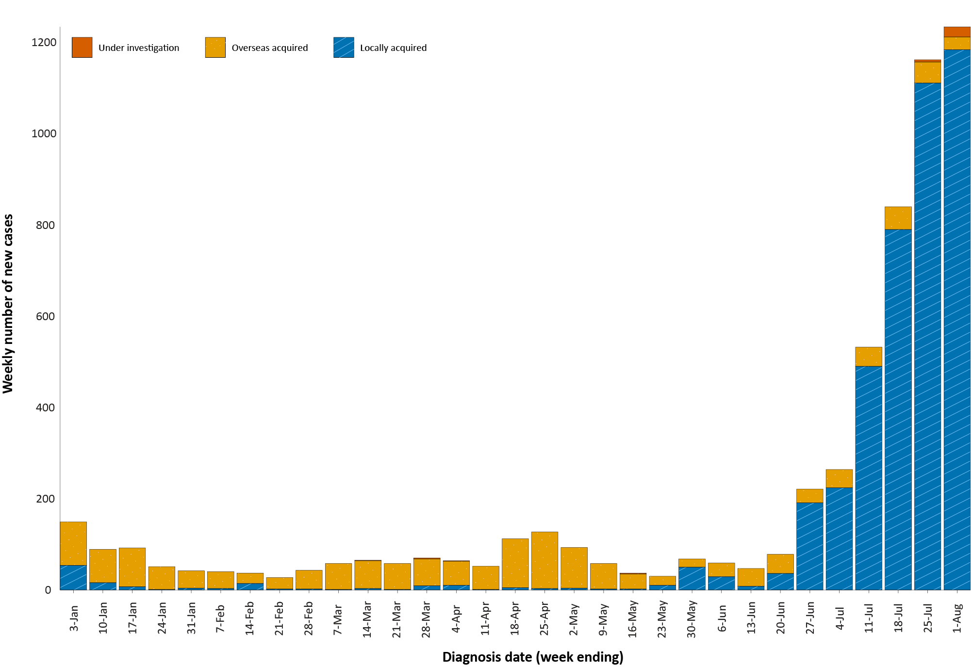
a Source: NNDSS, extract from 3 August 2021 for notifications to 1 August 2021.

Figure 2: Cumulative COVID-19 notified cases by source of acquisition and diagnosis date, 2 March 2020 – 1 August 2021ª
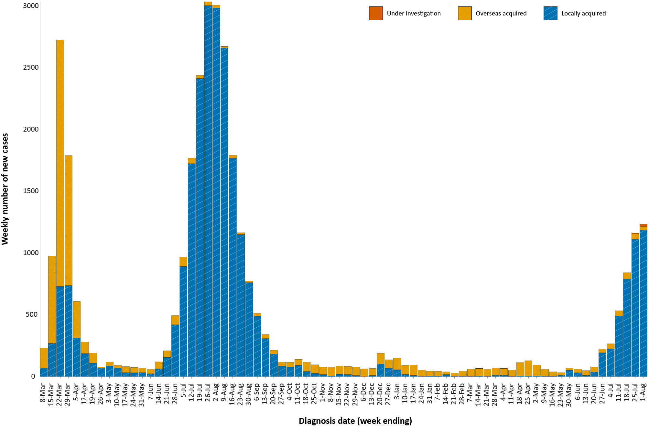
a Source: NNDSS, extract from 3 August 2021 for notifications to 1 August 2021.

Source of acquisition

(NNDSS)
In this reporting period, 96% (2,356/2,456) of cases notified were locally acquired and 4% (91/2,456) were overseas acquired. At the end of the reporting period, there were nine cases under initial investigation, eight from New South Wales and one from Victoria (Table 1).
New South Wales reported the majority of locally-acquired cases (92%; 2,159/2,356) in this fortnight, followed by Victoria (6%; 145/2,356). In the reporting period, 66% (1,560/2,356) of locally-acquired cases had a known contact or link to a cluster, and 13 cases (12 in New South Wales and one in South Australia) had an unknown source. At the end of the reporting period, the source of infection was under ongoing investigation for 783 cases from New South Wales.
For 2021 to date, New South Wales had the highest infection rate for locally-acquired cases with 43.5 infections per 100,000 population, followed by Victoria with a rate of 5.5 infections per 100,000 population (Table 2). Based on cases notified up to 1 August 2021, both the Australian Capital Territory and Tasmania reported that it had been more than a year since the last locally-acquired case within either jurisdiction (Table 3).

Table 2: Locally-acquired COVID-19 case numbers and rates per 100,000 population by jurisdiction and reporting period, Australia, with a notification received date from 1 January to 1 August 2021ª
Jurisdiction | Reporting period  19 July–1 August 2021 | Reporting period  5–18 July 2021 | Cases this year  1 January – 1 August 2021^{b}
 | Number of cases^{b} | Number of cases^{b} | Number of cases^{b} | Rate per 100,000 population^{c}
ACT | 0 | 0 | 0 | —
NSW | 2,159 | 1,017 | 3,549 | 43.5
NT | 0 | 2 | 10 | 4.1
Qld | 31 | 9 | 99 | 1.9
SA | 21 | 0 | 27 | 1.5
Tas. | 0 | 0 | 0 | —
Vic. | 145 | 72 | 371 | 5.5
WA | 0 | 3 | 15 | 0.6
Australia | 2,356 | 1,103 | 4,071 | 15.9
a Source: NNDSS, data extract from 3 August 2021 for notifications to 1 August 2021.
b This total does not include cases that are under initial investigation.
c Population data based on Australian Bureau of Statistics (ABS) Estimated Resident Population (ERP) as at June 2020.
Table 3: Days since last locally-acquired COVID-19 case (source unknown and source known), by jurisdiction and diagnosis date, 1 August 2021ª
Jurisdiction | Locally acquired — source unknown^{b} |  | Locally acquired — source known^{b}
 | Date of last case | Days since last case | Date of last case | Days since last case
ACT | 21 March 2020 | 498 | 7 July 2020 | 390
NSW | 1 August 2021 | 0 | 1 August 2021 | 0
NT | NA^{c} | NA^{c} | 6 July 2020 | 26
Qld | 13 July 2021 | 19 | 1 August 2021 | 0
SA | 24 March 2020 | 495 | 28 July 2021 | 4
Tas. | 9 August 2020 | 357 | 24 April 2020 | 464
Vic. | 31 May 2021 | 62 | 31 July 2021 | 1
WA | 3 Apr 2020 | 485 | 2 July 2021 | 30
a Source: NNDSS, extract from 3 August 2021 for notifications to 1 August 2021.
b This does not include locally-acquired cases that were interstate acquired.
c NA: not applicable. The Northern Territory has not reported any locally-acquired cases with an unknown source of infection.

Queensland reported the largest number of cases (33%; 30/91) that were overseas acquired, followed by New South Wales (25%; 23/91) and Western Australia (22%; 20/91). In the past 28 days (5 July to 1 August 2021), 38% (66/175) of overseas-acquired cases reported an unknown country of acquisition. Cases acquired at sea (23%; 25/109) were the most frequent of those with an identified country of acquisition in the past 28 days, followed by cases from India and the United Kingdom, each contributing to 10% of overseas cases (11/109) (Figure 7). The number of cases acquired in different countries is influenced by travel patterns of returning Australians, travel restrictions, and the prevalence of COVID-19 in the country of travel.

Demographic features

(NNDSS)
In this reporting period, the largest proportion of cases occurred in those aged 20 to 29 years (21%; 523/2,456). For this year, the highest rate of infection was in those aged 20 to 29 years with a rate of 33.0 infections per 100,000 population (Figure 3; Appendix A, Table A.1). Adults aged 70 to 79 years had the lowest rate of infection this year.
Figure 3: Cumulative COVID-19 cases for the calendar year to date, by age group and sex, Australia, with a diagnosis date of 1 January 2021 – 1 August 2021ª
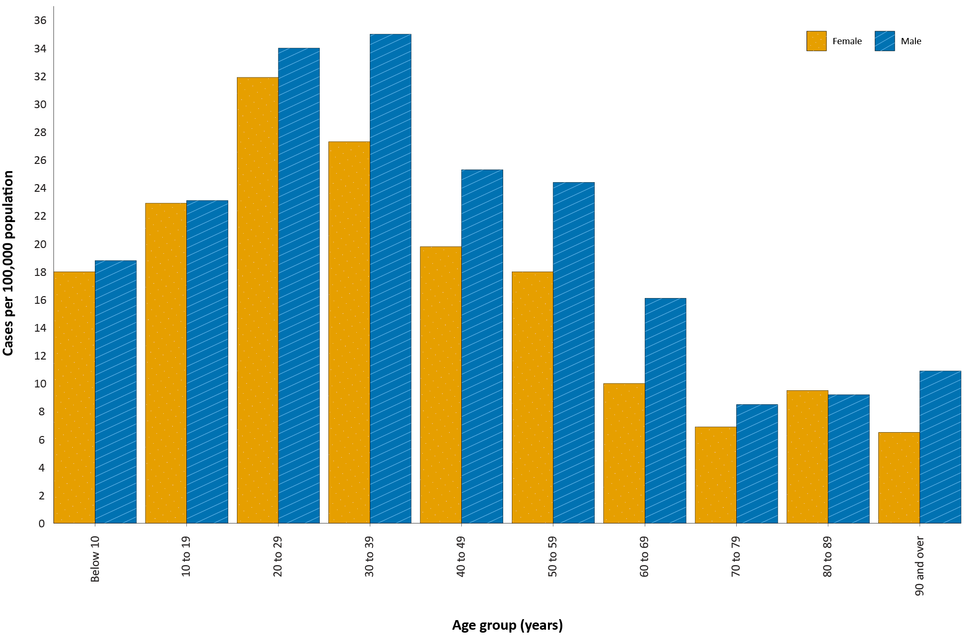
a Source: NNDSS, extract from 3 August 2021 for notifications to 1 August 2021.
In 2021, notification rates were higher in males than in females for all age groups except those aged 80 to 89 years (Figure 3). The largest proportional difference by sex, in rates this year, was in the 60 to 69 years age group, where the cumulative rate among males was 16.1 cases per 100,000 population and among females was 10.0 cases per 100,000 population (Appendix A, Table A.1). The median age of cases in this reporting period was 31 years (range: 0 to 96 years; interquartile range, IQR: 20 to 48 years).

Aboriginal and Torres Strait Islander persons
(NNDSS)
Since the beginning of 2021, there have been 32 confirmed cases of COVID-19 notified in Aboriginal and Torres Strait Islander people, representing 0.6% (32/5,680) of all confirmed cases this year. During the reporting period, 15 new Aboriginal and Torres Strait Islander cases were notified, of which 14 were locally acquired from New South Wales and one was overseas acquired from Queensland.
As at 1 August 2021, it has been one day since the last locally-acquired Aboriginal and Torres Strait Islander case was diagnosed and 15 days since the last overseas-acquired Aboriginal and Torres Strait Islander case was diagnosed. The majority of Aboriginal and Torres Strait Islander cases in 2021 have been reported as locally acquired (84%; 27/32), with five cases overseas acquired. The median age of all Aboriginal and Torres Strait Islander cases this year is 25 years old (range: 2 to 66 years; IQR: 13 to 45 years) and the distribution of cases between males and females is equal, with 16 cases each.

Vaccinations

(Department of Health)
As of 1 August 2021, a total of 12,393,893 doses of COVID-19 vaccine had been administered (Table 4), including 524,237 doses provided to aged care and disability residents.
Table 4: Total number of vaccinations administered, by jurisdiction, Australia, 1 August 2021ª
Jurisdiction | Total number of doses administered
ACT | 140,539
NSW | 1,509,706
NT | 90,907
Qld | 921,750
SA | 396,440
Tas. | 166,836
Vic. | 1,660,319
WA | 512,012
Aged care and disability facilities^{b} | 524,237
Primary care^{c} | 6,471,147
Total | 12,393,893
a Source: Australian Government Department of Health website.³
b Commonwealth vaccine doses administered in aged care and disability facilities.
c Commonwealth vaccine doses administered in primary care settings.

Clusters and outbreaks

Sydney Metropolitan Outbreak
The size of the Sydney Metropolitan Outbreak in NSW continued to increase this reporting fortnight, with 2,159 cases reported to NNDSS. The first case in the cluster, reported on 16 June 2021, was a driver transporting international flight crew. Genomic testing results showed that this case was infected with the Delta SARS-CoV-2 variant of concern (B.1.617.2); however, the sequence did not match cases from the Victorian Delta variant outbreak that occurred from May to June 2021. This sequence had not been seen in Australia previously, but matched one from the United States of America.
Up to 1 August 2021, in New South Wales there have been 3,634 locally-acquired cases, including 14 deaths, reported since 16 June 2021. Several interstate-acquired cases have also been linked to this outbreak, including 216 in Victoria, 21 in South Australia, six in Western Australia and five in Queensland.

Victoria
All locally-acquired cases reported in Victoria in the reporting period were part of two community outbreaks: the Coolaroo Community Outbreak and Maribyrnong Community Outbreak. Almost all of these cases were detected in people already in quarantine. These outbreaks began following two seeding events of the Delta variant associated with travellers from New South Wales to Victoria.
The first cases in the Coolaroo Community Outbreak, reported on 13 and 14 July 2021, were among a family of four that had returned from Greater Sydney on a red zone permit. As at 1 August 2021, there were 18 cases linked to this outbreak.
The Maribyrnong Community Outbreak was first reported on 14 July 2021, with several cases linked to removalists from Greater Sydney who delivered furniture to an apartment in western Melbourne on 8 July 2021. As at 1 August 2021, there were 196 cases linked to this outbreak. These cases were part of several interconnected outbreaks associated with the apartment complex initially visited by the removalists.

Queensland
Most locally-acquired cases reported in Queensland during the reporting period were part of an outbreak linked to a Brisbane high school. The first case in this outbreak was reported on 30 July 2021. The outbreak has been genomically linked to returned overseas travellers with the Delta variant. The epidemiological link is still being investigated. As at 1 August 2021, a total of 24 cases were linked to this outbreak: two overseas-acquired cases and 22 community cases.

South Australia
All locally-acquired cases reported in South Australia in the reporting period were part of the Modbury cluster. The first case in this cluster was reported on 19 July 2021, and was a person who returned from overseas. Whilst in hotel quarantine in New South Wales, the person spent 10 days in a Sydney hospital for an unrelated illness before returning to South Australia. The case became symptomatic in South Australia and presented to an Adelaide hospital and got tested on 18 July 2021. The source of infection for this case is still under investigation. Genomic testing confirmed that the person was infected with the Delta variant. As at 1 August 2021, there were 21 cases linked to this outbreak.

Severity

(NNDSS, FluCAN, SPRINT-SARI)

Hospitalisation and intensive care unit admission
In 2021, for cases where hospitalisation and intensive care unit (ICU) data were reliable and complete, the estimated hospitalisation rate was 11.6% of cases, and the estimated ICU admission rate was 2.3% of cases (Table 5). This is based on data from six states/territories that have reliable data across both hospitalisation and ICU data fields in the NNDSS, and who do not routinely hospitalise cases for isolation purposes (Australian Capital Territory, New South Wales, South Australia, Tasmania, Victoria and Western Australia).
Table 5: Numbers of COVID-19 case hospitalisations and admissions to ICU due to COVID-19, 1 January 2021 – 1 August 2021^{a,b}
Age group | Cases | Hospitalisations |  | ICU admission
 | Total | n | Cases hospitalised (%) | n | Cases admitted to ICU (%)
0–9 | 530 | 13 | 2.5% | 0 | 0.0%
10–19 | 682 | 20 | 2.9% | 4 | 0.6%
20–29 | 1084 | 84 | 7.7% | 13 | 1.2%
30–39 | 1019 | 89 | 8.7% | 12 | 1.2%
40–49 | 658 | 81 | 12.3% | 10 | 1.5%
50–59 | 594 | 114 | 19.2% | 26 | 4.4%
60–69 | 304 | 81 | 26.6% | 34 | 11.2%
70–79 | 130 | 56 | 43.1% | 13 | 10.0%
80–89 | 77 | 43 | 55.8% | 5 | 6.5%
90+ | 17 | 11 | 64.7% | 0 | 0.0%
Total | 5,095 | 592 | 11.6% | 117 | 2.3%
a Source: NNDSS, extract from 3 August 2021, based on notification received date.
b Data included from six jurisdictions with the most reliable data across both hospital and ICU data fields: Australian Capital Territory, New South Wales, South Australia, Tasmania, Victoria and Western Australia. This is based on an assessment of data from SPRINT-SARI and NNDSS.
In the year to date to 1 August 2021, there have been 171 COVID-19 cases admitted to ICUs participating in the sentinel surveillance system, Short Period Incidence Study of Severe Acute Respiratory Infection (SPRINT-SARI),⁴ with 90 of these admitted during this reporting period (19 July – 1 August 2021).

Risk factors for severe disease
The hospitalisation rate for COVID-19 cases in the year to date has increased with advancing 10-year age bracket (Table 5).
Comorbidity data extracted from SPRINT-SARI reflect the sickest patients with COVID-19 managed in ICU; data are therefore not generalisable to all cases (Table 6). In patients admitted to ICU with COVID-19 since 1 February 2021, the most prevalent comorbidity was diabetes, following by obesity (a body mass index of > 30 or weight over 120 kg). Of those adult patients admitted to ICU this year for whom comorbidity data was known, 55% (85/154) had at least one comorbidity; 45% (69/154) of patients had none of the listed comorbidities recorded.
Table 6: Comorbidities for adult COVID-19 cases (aged greater than or equal to 18 years) amongst those admitted to ICU, Australia, 1 February 2021 – 18 July 2021ª
Comorbidity | ICU casesª  (n = 169)  (%)
Cardiac disease (n = 149) | 13 (9)
Chronic respiratory condition (n = 148) ^{b} | 12 (8)
Diabetes (n = 150) | 46 (31)
Obesity (n = 139) | 36 (26)
Chronic renal disease (n = 146) | 5 (3)
Chronic neurological condition (n = 148) | 1 (1)
Malignancy (n = 148) | 3 (2)
Chronic liver disease (n = 148) | 4 (3)
Immunosuppression (n = 148) | 3 (2)
Number of specified comorbidities (n = 154) ^{c,d}
One or more | 85 (55)
Two or more | 26 (17)
Three or more | 8 (5)
No comorbidities | 69 (45)
a Source: SPRINT-SARI. Only includes adult cases (≥ 18 years old) and excludes those with missing data on comorbidities or where comorbidity is unknown.
b Includes asthma.
c Includes chronic respiratory conditions, cardiac disease (excluding hypertension), immunosuppressive condition/therapy, diabetes, obesity, liver disease, renal disease and neurological disorder.
d Excludes cases where comorbidity data is missing or unknown for all comorbidities.

COVID-19 deaths
In the reporting fortnight, there were 11 deaths associated with COVID-19, all from New South Wales. The overall crude case fatality rate (CFR) since the start of the epidemic was 2.71% (Table 7). The ratio of deaths to cases in the year to date has decreased in comparison to this time last year, noting substantially lower case numbers this year and the difference in age distributions of those infected in 2021 versus 2020.

Table 7: Deaths associated with COVID-19 by reporting period, Australia, 1 January 2020 – 1 August 2021ª
Reporting period | Number of deaths^{b} | CFR^{c}
19 July – 1 August 2021 | 11/2,456 | 0.45%
Year to date (2021) 1 January – 1 August 2021 | 16/5,680 | 0.28%
Year to date (2020) 1 January – 1 August 2020 | 468/17,045 | 2.75%
Epidemic to date 1 January 2020 – 1 August 2021 | 925/34,084 | 2.71%
a Source: NNDSS, extract from 3 August 2021, based on notification received date.
b Expressed as deaths/case numbers.
c CFR: Crude case fatality rate.

Acknowledgements
We thank public health staff from incident emergency operations centres and public health units in state and territory health departments, and the Australian Government Department of Health, along with state and territory public health laboratories.

Author details

Corresponding author
COVID-19 National Incident Room Surveillance Team
Australian Government Department of Health, GPO Box 9484, MDP 14, Canberra, ACT 2601.
Email: epi.coronavirus@health.gov.au

References
- COVID-19 National Incident Room Surveillance Team. COVID-19 Australia: Epidemiology Report 46: Reporting period ending 18 July 2021. Commun Dis Intell (2018). 2021;45. doi: https://doi.org/10.33321/cdi.2021.45.39.
- COVID-19 National Incident Room Surveillance Team. Technical supplement. COVID-19 Australia: Epidemiology reporting. Commun Dis Intell (2018). 2021;45. doi: https://doi.org/10.33321/cdi.2021.45.2.
- Australian Government Department of Health. Getting vaccinated for COVID-19: Australia’s vaccine rollout. [Internet.] Canberra: Australian Government Department of Health; 2021. [Accessed on 2 August 2021.] Available from: https://www.health.gov.au/initiatives-and-programs/covid-19-vaccines/getting-vaccinated-for-covid-19#australias-vaccine-rollout.
- Australian and New Zealand Intensive Care Society (ANZICS). SPRINT-SARI: Short period incidence study of severe acute respiratory infection. [Internet.] Camberwell: ANZICS; 2020. Available from: https://www.anzics.com.au/current-active-endorsed-research/sprint-sari/.

Appendix A: Supplementary figures and tables
Table A.1: COVID-19 cases and rates per 100,000 population, by age group, sex and diagnosis date Australia, 1 August 2021^{a,b}
Age group | This reporting period |  |  |  |  |  | This year^{c}
 | 19 July – 1 August 2021 |  |  |  |  |  | 1 January 2021 – 1 August 2021
 | Cases |  |  | Rate per 100,000 population |  |  | Cases |  |  | Rate per 100,000 population
 | Male | Female | People | Male | Female | People | Male | Female | People | Male | Female | People
0 to 9 | 126 | 130 | 256 | 7.7 | 8.4 | 8 | 308 | 279 | 587 | 18.8 | 18 | 18.4
10 to 19 | 170 | 176 | 346 | 10.7 | 11.7 | 11.2 | 367 | 344 | 711 | 23.1 | 22.9 | 23
20 to 29 | 295 | 226 | 521 | 16 | 12.7 | 14.4 | 626 | 567 | 1,193 | 34.0 | 31.9 | 33
30 to 39 | 265 | 209 | 474 | 14.3 | 11 | 12.6 | 650 | 520 | 1,170 | 35.0 | 27.3 | 31.1
40 to 49 | 124 | 143 | 267 | 7.6 | 8.6 | 8.1 | 413 | 330 | 743 | 25.3 | 19.8 | 22.5
50 to 59 | 165 | 132 | 297 | 10.8 | 8.3 | 9.5 | 372 | 287 | 659 | 24.4 | 18.0 | 21.1
60 to 69 | 93 | 68 | 161 | 7.1 | 4.9 | 6 | 210 | 138 | 348 | 16.1 | 10.0 | 13
70 to 79 | 35 | 35 | 70 | 3.8 | 3.6 | 3.7 | 77 | 67 | 144 | 8.5 | 6.9 | 7.7
80 to 89 | 21 | 25 | 46 | 5.7 | 5.3 | 5.4 | 34 | 45 | 79 | 9.2 | 9.5 | 9.4
90 and over | 6 | 4 | 10 | 8.2 | 2.9 | 4.7 | 8 | 9 | 17 | 10.9 | 6.5 | 8
a Source: NNDSS, extract from 3 August 2021 for notifications up to 1 August 2021. Excludes cases where age or sex data is missing.
b Population data based on Australian Bureau of Statistics (ABS) Estimated Resident Population (ERP) as at June 2020.
c Note the change to focus on rates in this year only. For cumulative rates since the beginning of the epidemic in Australia, readers are encouraged to consult previous reports.

Communicable Diseases Intelligence
ISSN: 2209-6051 Online

Communicable Diseases Intelligence (CDI) is a peer-reviewed scientific journal published by the Office of Health Protection and Response, Department of Health. The journal aims to disseminate information on the epidemiology, surveillance, prevention and control of communicable diseases of relevance to Australia.

Editor: Jennie Hood
Deputy Editor: Simon Petrie
Design and Production: Kasra Yousefi
Editorial Advisory Board: David Durrheim, Mark Ferson, John Kaldor, Martyn Kirk and Linda Selvey

Website: http://www.health.gov.au/cdi

Contacts
CDI is produced by the Office of Health Protection and Response, Australian Government Department of Health, GPO Box 9848, (MDP 6) CANBERRA ACT 2601

Email: cdi.editor@health.gov.au

Submit an Article
You are invited to submit your next communicable disease related article to the Communicable Diseases Intelligence (CDI) for consideration. More information regarding CDI can be found at: http://health.gov.au/cdi.
Further enquiries should be directed to: cdi.editor@health.gov.au.

This journal is indexed by Index Medicus and Medline.

Creative Commons Licence - Attribution-NonCommercial-NoDerivatives CC BY-NC-ND
© 2021 Commonwealth of Australia as represented by the Department of Health
This publication is licensed under a Creative Commons Attribution-NonCommercial-NoDerivatives 4.0 International Licence from https://creativecommons.org/licenses/by-nc-nd/4.0/legalcode (Licence). You must read and understand the Licence before using any material from this publication.

Restrictions
The Licence does not cover, and there is no permission given for, use of any of the following material found in this publication (if any):
- the Commonwealth Coat of Arms (by way of information, the terms under which the Coat of Arms may be used can be found at www.itsanhonour.gov.au);
- any logos (including the Department of Health’s logo) and trademarks;
- any photographs and images;
- any signatures; and
- any material belonging to third parties.

Disclaimer
Opinions expressed in Communicable Diseases Intelligence are those of the authors and not necessarily those of the Australian Government Department of Health or the Communicable Diseases Network Australia. Data may be subject to revision.

Enquiries
Enquiries regarding any other use of this publication should be addressed to the Communication Branch, Department of Health, GPO Box 9848, Canberra ACT 2601, or via e-mail to: copyright@health.gov.au

Communicable Diseases Network Australia
Communicable Diseases Intelligence contributes to the work of the Communicable Diseases Network Australia.
http://www.health.gov.au/cdna

https://www.health.gov.au/news/health-alerts/novel-coronavirus-2019-ncov-health-alert#local-outbreak-information.
https://www.who.int/emergencies/diseases/novel-coronavirus-2019/situation-reports/.
https://www.health.gov.au/news/health-alerts/novel-coronavirus-2019-ncov-health-alert/coronavirus-covid-19-current-situation-and-case-numbers.

