Utilisation of antimicrobials used to treat bacterial pneumonia in principal referral hospitals during the COVID-19 pandemic, Australia, 2020
Erratum to Commun Dis Intell (2018) 2022;46 (https://doi.org/10.33321/cdi.2021.46.6)
Erin Connor, Kavita Rasiah, Nadine Hillock
Figure 4 of this article, as originally published, was incorrect due to truncation of one data series. The corrected figure is published below.
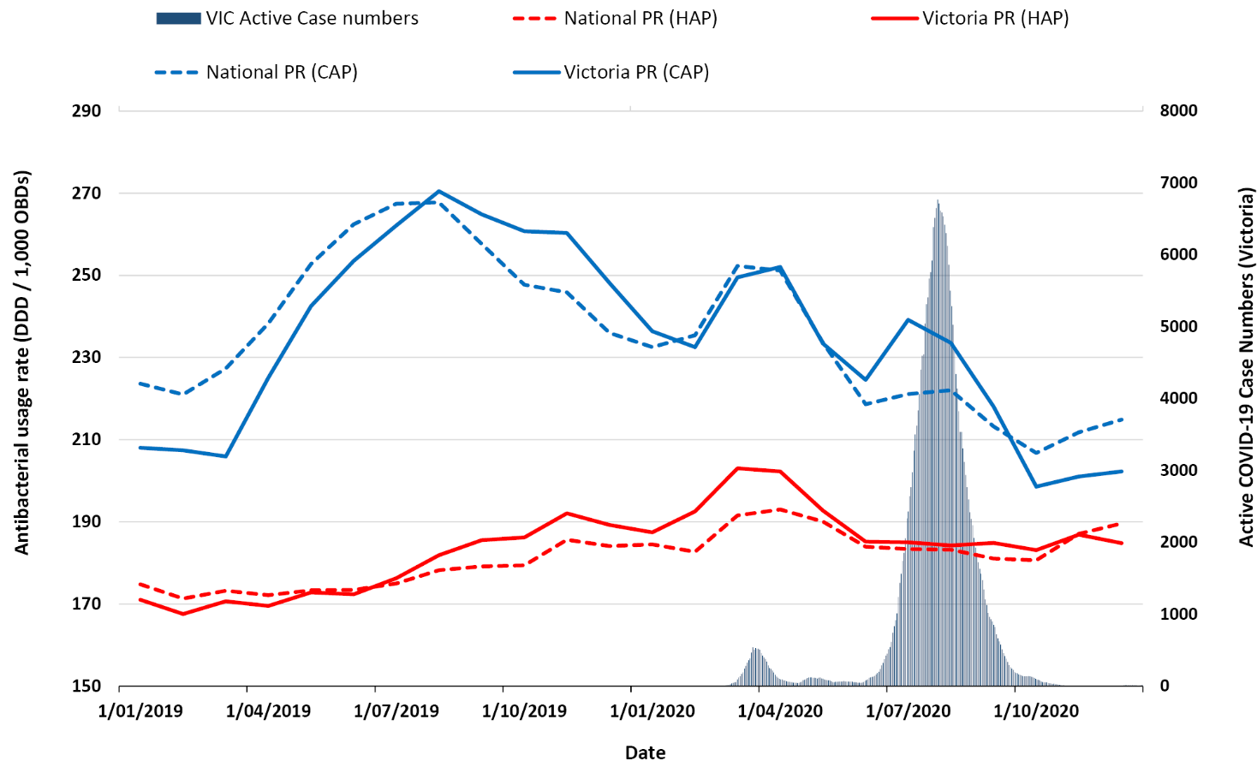
a CAP antibacterials (parenteral and oral): doxycycline, ceftriaxone, amoxicillin), azithromycin, benzylpenicillin, cefuroxime, moxifloxacin. b HAP antibacterials (parenteral): ceftriaxone, piperacillin-tazobactam, metronidazole, gentamicin, amoxicillin-clavulanate, cefepime.

Communicable Diseases Intelligence
ISSN: 2209-6051 Online

Communicable Diseases Intelligence (CDI) is a peer-reviewed scientific journal published by the Office of Health Protection and Response, Department of Health and Aged Care. The journal aims to disseminate information on the epidemiology, surveillance, prevention and control of communicable diseases of relevance to Australia.

Editor: Noel Lally
Deputy Editor: Simon Petrie
Design and Production: Kasra Yousefi
Editorial Advisory Board: David Durrheim, Mark Ferson, John Kaldor, Martyn Kirk and Linda Selvey

Website: http://www.health.gov.au/cdi

Contacts
CDI is produced by the Office of Health Protection and Response, Australian Government Department of Health and Aged Care, GPO Box 9848, (MDP 6) CANBERRA ACT 2601

Email: cdi.editor@health.gov.au

Submit an Article
You are invited to submit your next communicable disease related article to the Communicable Diseases Intelligence (CDI) for consideration. More information regarding CDI can be found at: http://health.gov.au/cdi.
Further enquiries should be directed to: cdi.editor@health.gov.au.

This journal is indexed by Index Medicus and Medline.

Creative Commons Licence - Attribution-NonCommercial-NoDerivatives CC BY-NC-ND
© 2022 Commonwealth of Australia as represented by the Department of Health and Aged Care
This publication is licensed under a Creative Commons Attribution-NonCommercial-NoDerivatives 4.0 International Licence from https://creativecommons.org/licenses/by-nc-nd/4.0/legalcode (Licence). You must read and understand the Licence before using any material from this publication.

Restrictions
The Licence does not cover, and there is no permission given for, use of any of the following material found in this publication (if any):
- the Commonwealth Coat of Arms (by way of information, the terms under which the Coat of Arms may be used can be found at www.itsanhonour.gov.au);
- any logos (including the Department of Health and Aged Care’s logo) and trademarks;
- any photographs and images;
- any signatures; and
- any material belonging to third parties.

Disclaimer
Opinions expressed in Communicable Diseases Intelligence are those of the authors and not necessarily those of the Australian Government Department of Health and Aged Care or the Communicable Diseases Network Australia. Data may be subject to revision.

Enquiries
Enquiries regarding any other use of this publication should be addressed to the Communication Branch, Department of Health and Aged Care, GPO Box 9848, Canberra ACT 2601, or via e-mail to: copyright@health.gov.au

Communicable Diseases Network Australia
Communicable Diseases Intelligence contributes to the work of the Communicable Diseases Network Australia.
http://www.health.gov.au/cdna

