Australian vaccine preventable disease epidemiological review series: Pertussis, 2013–2018
Kushani S Marshall, Helen E Quinn, Alexis J Pillsbury, Julia E Maguire, Robyn M Lucas, Aditi Dey, Frank H Beard, Kristine K Macartney, Peter B McIntyre

Abstract

Introduction
Significant recent changes in Australian pertussis immunisation policy include the progressive introduction of funded pertussis immunisation programs for pregnant women, from late 2014 to mid-2015 at jurisdictional level and then under the National Immunisation Program from July 2018, and reintroduction of the 18-month booster dose in 2016. This study analyses pertussis notification, hospitalisation, and mortality data from 2013 to 2018 in the context of trends since 1995.

Methods
This study used data from the National Notifiable Diseases Surveillance System, the National Hospital Morbidity Database, and the Australian Coordinating Registry, for descriptive analysis of pertussis notifications, hospitalisations and deaths in Australia by Aboriginal and Torres Strait Islander (Indigenous) status from 2013 to 2018, examining trends between 1995 and 2012 at both the national and jurisdictional level. Incidence rate ratios (IRR) were utilised to compare pertussis incidence in infants aged < 2 months and 6–11 months for each year from the 2015–2018 (post-maternal-vaccination) period against the 2010–2013 (pre-maternal-vaccination) period.

Results and Discussion
Annual national all-age incidence of pertussis notifications between 2013 and 2018 was 63.6 per 100,000 population, 40% less than between 2006 and 2012. Between 2016 and 2018, infants aged < 2 months had the lowest notification rates of age groups < 5 years old, with the highest notification rates in pre-adolescents aged 9–11 years. Compared with the baseline period (2010–2013), the IRR for infants aged < 2 months decreased in each year during the post-maternal-vaccination period from 0.4 (95% confidence interval [95% CI]: 0.3–0.5) in 2015 to 0.1 (95% CI: 0.1–0.2) in 2018. For infants aged 6–11 months, the IRR was 0.9 (95% CI: 0.8–1.0) in 2015, 1.1 (95% CI: 1.0–1.2) in 2016 and declined to 0.7 (95% CI: 0.6–0.8) in 2017 and 2018. Notification and hospitalisation rates in Indigenous children were 3–8 times as high as rates in non-Indigenous children across all age groups < 5 years old.

Conclusion
Pertussis remains the second most frequently notified vaccine preventable disease in Australia, after influenza, but dramatic decreases in incidence have been observed in infants too young to receive any doses of pertussis-containing vaccine.
Keywords: Pertussis, disease surveillance, immunisation, epidemiology, vaccine preventable disease

Introduction
Pertussis, commonly known as ‘whooping cough’, is a highly-contagious respiratory disease caused by infection with the bacterium Bordetella pertussis.¹ Symptoms include an irritating intermittent cough that gradually becomes paroxysmal and may last for 1–2 months.² Symptoms differ by age (infants and children versus adults) and in vaccinated compared with unvaccinated people. Unvaccinated infants aged < 3 months may present with apnoeic episodes prior to development of cough.² Complications include pneumonia, atelectasis (partial or complete lung collapse), seizures, encephalopathy (disturbed brain function), and death.²
Since 2016, the National Immunisation Program (NIP) schedule of acellular pertussis-containing vaccination consists of 5 doses at 2, 4, 6, 18 months, and 4 years of age.³ Infants may be given their first dose from 6 weeks of age.³ A funded booster dose is delivered through schools at 11–13 years and pregnant women are recommended to receive a dose of pertussis vaccine in each pregnancy.³ It is currently recommended, but not funded, that adults aged ≥ 65 years receive a pertussis-containing vaccine if their last dose was more than 10 years ago.³ Pertussis severity varies with age and immunisation status, with unimmunised infants at greatest risk of hospitalisation and death.^{4,5} The main goal of pertussis immunisation programs is therefore to prevent pertussis infection and mitigate disease severity in infants.¹ The source of infant infection is typically a sibling, parent or other family member.⁵⁻⁷
Worldwide, pertussis continues to be an important cause of infant morbidity and mortality.⁸ In Australia, pertussis is the second most frequently notified vaccine preventable disease (after influenza), despite longstanding high pertussis vaccination coverage. ^{9,10}
Interpretation of trends in the epidemiology of pertussis in Australia is complex, with substantial changes in vaccine type, immunisation schedule, diagnostic testing methods, and surveillance practices over time.¹¹ The most recent change was that, following recommendation of a dTpa (reduced antigen diphtheria-tetanus-acellular pertussis) dose during the third trimester of pregnancy in March 2013, there was progressive introduction of jurisdictionally-funded pertussis immunisation programs for pregnant women between August 2014 and June 2015,^{11,12} with national funding through the NIP from July 2018.^{11,12} From April 2019, the recommended optimal timing of pertussis vaccination during pregnancy was expanded from 28–32 to 20–32 weeks gestation.³ The other recent change in funded recommendations was re-instatement on the NIP schedule of the 18-month booster dose from March 2016. An unfunded recommendation for a pertussis-containing vaccine for adults aged ≥ 65 years was included in the Australian Immunisation Handbook from March 2013.
Two comprehensive reviews of Australian pertussis epidemiology examined the periods 1995–2005 and 2006–2012, prior to the changes to pertussis immunisation outlined above.^{13,14} In this review, we use similar datasets (notification, hospitalisation and death) to describe the epidemiology of pertussis in Australia during the 6 years, 2013–2018, in the context of previous trends in pertussis over more than two decades (1995–2018), nationally and for each jurisdiction.

Methods
An observational descriptive study was conducted of all confirmed and probable pertussis notifications, and pertussis-related hospitalisations and deaths, in Australia from 2013 to 2018. These data were compared to those from 1995 to 2012. Data were analysed by age group, sex, Aboriginal and Torres Strait Islander status (hereafter respectfully referred to as ‘Indigenous’), and sub-groups based on eligibility for pertussis vaccination by birth cohort.

Data Sources

Notifications
Pertussis is nationally notifiable in Australia.¹⁵ Identified cases are required to be reported to jurisdictional health departments, primarily by laboratories, based on positive diagnostic tests. The Communicable Diseases Network Australia states that both confirmed and probable cases of pertussis, in accordance with the national case definition, should be notified and information on cases provided to the National Notifiable Diseases Surveillance System (NNDSS).¹⁵ Laboratory diagnostic testing data were available from the NNDSS for the 1995–2018 period.
For this review, pertussis notifications with a diagnosis date between 1 January 1995 and 31 December 2018 were obtained from the NNDSS. Diagnosis date is a derived field in the NNDSS and is either the true onset date if known, or otherwise the earliest of either the specimen date, notification date or date when the notification was received.

Hospitalisation data
Hospitalisation data were obtained from the Australian Institute of Health and Welfare (AIHW) National Hospital Morbidity Database (NHMD). The NHMD is compiled from data supplied by state and territory health authorities. It is a collection of confidential electronic summary records for separations (episodes of care) in public and private hospitals in Australia. This study included all hospital separations admitted between 1 July 2001 and 30 June 2018 (the most recent data available). Pertussis-specific codes (A37.0–A37.9) from the International Statistical Classification of Diseases and Related Health Problems, 10th Revision, Australian Modification (ICD-10-AM), were used to identify eligible hospitalisations (from the principal or additional diagnosis data fields). Annual hospitalisation rates were calculated up to 2017, the most recent complete calendar year available.

Mortality data
Mortality data were obtained from the Australian Coordinating Registry (ACR) for the 1 January 2006 – 31 December 2018 period. Deaths were identified from the ACR datasets using the underlying cause of death field and pertussis-specific ICD-10 codes. Mortality data were also obtained from the NNDSS ‘died of disease’ field.

Population estimates
National, jurisdictional, age-specific and Indigenous mid-year estimated resident population estimates were obtained from the Australian Bureau of Statistics (ABS) for calculating relevant population rates.

Data management
Date of birth was not included in the NNDSS data provided. Age was calculated in months from the age in weeks field for notified cases < 2 years of age as follows: 4 weeks = 1 month; 8 weeks = 2 months; 16 weeks = 4 months; 26 weeks = 6 months; 52 weeks = 12 months and 78 weeks = 18 months. We created age groups for analysis using the birth month and year field in NNDSS data, and extracted the month and year of diagnosis from the diagnosis date.
Annual rates, including age-specific and geographic region-specific rates, were estimated using the number of notifications, hospitalisations or deaths as the numerator and the relevant ABS mid-year estimated resident population as the denominator. To estimate rates in those younger than 1 year of age, the estimated resident population (which is provided by the ABS in single years of age) was divided by 2 (for 0–5 and 6–11 month rates) or by 6 (for < 2, 2–3 and 4–5 month rates). All rate data are presented per 100,000 population. Average annual rates were calculated by dividing the total number of cases for the period under investigation by the sum of the annual populations for the same period.

Data analysis
Pertussis notification rates were summarised according to jurisdiction, age group, sex, Indigenous status and nationally for the 2013–2018 period; these summary rates were then compared with those of previous analyses from 1995–2012. To compare annual notification rates in each jurisdiction from 2013 to 2018 with the jurisdictional average over the entire 2013–2018 period, incidence rate ratios (IRR) with their 95% confidence intervals (95% CI) were calculated; a p-value of < 0.05 was considered to define a statistically significant change in annual incidence. Analysis was undertaken of pertussis notification data for children aged < 5 years by Indigenous status for the 2013–2018 period, as the completeness of the Indigenous status field nationally was consistently above 90% for children aged < 5 years during this time. Notifications where Indigenous status was unknown were excluded from this analysis.
Laboratory diagnostic method data from 2006 onwards were examined. Proportions were estimated of pertussis notifications recorded as diagnosed by culture of Bordetella pertussis; of detection by nucleic acid amplification tests, also known as nucleic acid tests such as polymerase chain reaction; and by serology. Further estimates were made of age group and time period specific proportions.
Data on pertussis-related hospitalisations were extracted and analysed at a national level and by jurisdiction. Hospitalisation rates per 100,000 population were calculated by age group, sex and jurisdiction. The median length of stay per hospital admission and interquartile range was calculated separately according to age group.
The number of deaths recorded as due to pertussis between 2006 and 2018 was examined for underlying cause of death and by age group and Indigenous status.
Calculation of IRR values (with 95% CI and p-values) was undertaken to compare Indigenous notification and hospitalisation rates to non-Indigenous rates, particularly for the < 5 years age group.
To assess the impact of maternal vaccination during pregnancy, IRR values were calculated for infant notifications aged < 2 months (presumed most impacted by maternal vaccination) versus 6–11 months (presumed not impacted) for the pre-maternal-vaccination (2010–2013) and post-maternal-vaccination (2015–2018) periods. Data from 2014 were excluded from this analysis as programs were implemented in that year in two jurisdictions (Queensland and the Northern Territory) only.
All IRR calculations are accompanied by 95% CI and exact p-values; a p-value of < 0.05 was considered to denote statistical significance.
Data were analysed using Stata 14.2. Tables, graphs and figures were constructed using Microsoft Excel 2010.

Ethics approval
Ethics approval for this study was provided by the Australian National University Human Research Ethics Committee (Protocol 2019/871).

Results

Secular trends
There were 91,780 pertussis notifications recorded nationally over the 2013–2018 study period (Table 1) and 324,197 notifications for the 24 years from 1995 to 2018. The average annual all-age national notification rate for 2013–2018 was 63.6 per 100,000 population, varying from a high of 94.8 in 2015 to a low of 49.7 in 2017. An epidemic peak was observed nationally in late 2015 (Figure 1), largely reflecting the notification pattern in New South Wales (NSW), but this was not uniform across jurisdictions (Appendix A, Figures A.1, A.2, and A.3). The degree of variation in annual notification rates compared to jurisdictional averages over the 6 years from 2013 to 2018 differed across jurisdictions. Incidence was stable in Western Australia (WA), with an IRR centred around 1.0, while at the other extreme, the IRR in Tasmania was 2.9 in 2013 (highest IRR shown as footnote in Table 1). At the national level, there was seasonal variation in notification patterns, with the highest numbers recorded in spring (usually November) and the lowest numbers between April and June each year (Figure 1). However, seasonal patterns may have varied by region (Appendix A, Figures A.1, A.2, and A.3), with national data driven by large numbers of notifications in south-eastern Australia.
During 2013–2017, pertussis was the principal diagnosis for 62.9% (n = 2,077) of the 3,301 hospitalisations with ICD-10-AM codes for pertussis in any diagnosis field. Hospitalisations were skewed towards the very young, and the proportion of hospitalisations with pertussis coded as the principal diagnosis progressively fell with increasing age from a maximum of 87.6% in the 2–3 months age group to 44.0% for those ≥ 65 years of age. It is notable that while annual peaks in notifications each year from 2009 were two- or threefold higher than those of the 1998–2008 period, peaks in hospitalisations coded as pertussis varied much less (Figure 1).
Table 1: All-age pertussis notification and hospitalisation rates per 100,000 population, Australia, 2013–2018,^{a,b} by jurisdiction
 |  | State or territory^{c,d,e}
Year | Data source | ACT | NSW | NT | Qld | SA | Tas. | Vic. | WA | Australia
2013 | Notifications | 62.1 | 31.6 | 44.7 | 82.0 | 48.6 | 101.9 | 50.3 | 65.8 | 53.5
 | Hospitalisations | 1.0 | 2.3 | 1.2 | 3.4 | 2.3 | 4.1 | 2.2 | 2.5 | 2.5
2014 | Notifications | 59.9 | 41.7 | 34.2 | 29.7 | 29.9 | 13.2 | 80.1 | 69.5 | 50.7
 | Hospitalisations | 1.5 | 2.0 | 2.1 | 3.2 | 1.7 | 1.6 | 2.9 | 2.1 | 2.5
2015 | Notifications | 123.0 | 160.8 | 24.1 | 39.0 | 78.3 | 6.0 | 77.8 | 73.4 | 94.8
 | Hospitalisations | 2.3 | 3.9 | 0.4 | 3.6 | 2.8 | 1.6 | 3.0 | 1.7 | 3.2
2016 | Notifications | 125.5 | 140.1 | 91.2 | 44.5 | 114.4 | 5.8 | 46.8 | 59.5 | 83.2
 | Hospitalisations | 1.7 | 3.8 | 2.8 | 3.8 | 5.1 | 1.0 | 2.3 | 1.2 | 3.1
2017 | Notifications | 61.6 | 67.0 | 44.4 | 27.3 | 101.0 | 7.7 | 31.2 | 58.6 | 49.7
 | Hospitalisations | 1.5 | 2.5 | 4.8 | 2.7 | 5.9 | 0.2 | 1.5 | 2.6 | 2.5
2018 | Notifications | 65.2 | 79.6 | 27.5 | 35.2 | 40.6 | 78.7 | 26.2 | 50.6 | 50.4
Total number of notifications |  | 1,992 | 40,173 | 652 | 12,341 | 7,056 | 1,107 | 18,866 | 9,593 | 91,780
Total number of hospitalisations |  | 32 | 1,104 | 28 | 797 | 303 | 43 | 714 | 257 | 3,301
Average rate of notifications |  | 82.9 | 87.1 | 44.4 | 42.7 | 69.0 | 35.6 | 51.5 | 62.8 | 63.6
Average rate of hospitalisations |  | 1.6 | 2.9 | 2.3 | 3.3 | 3.6 | 1.7 | 2.4 | 2.0 | 2.8
a Hospitalisations up to 2017.
b Data source: NNDSS (notification data), NHMD (hospitalisation data).
c ACT: Australian Capital Territory; NSW: New South Wales; NT: Northern Territory; Qld: Queensland; SA: South Australia; Tas.: Tasmania; Vic.: Victoria; WA: Western Australia.
d Highest incidence rate ratio (IRR) for each jurisdiction in descending order: Tas 2.9 (2013); NT 2.1 (2016); Qld 1.9 (2013); NSW 1.8 (2015); SA 1.7 (2016); Vic 1.6 (2014); ACT 1.5 (2016); WA 1.2 (2015).
e Bold text denotes an IRR significantly higher (p < 0.05) than the jurisdiction average for 2013–2018.

Figure 1: Pertussis notifications and hospitalisations, Australia, January 1995 to December 2018 (for notifications) by month and year of diagnosis, June 2001 to June 2018 (for hospitalisations) by month and year of admission^{a,b}
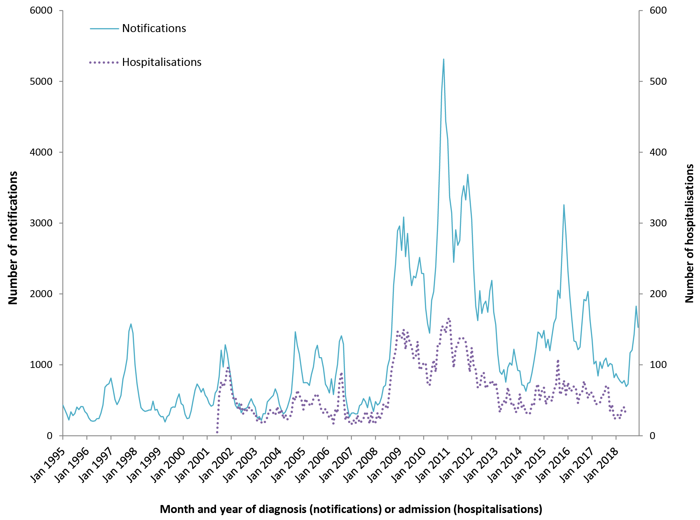
a Data source: NNDSS (notification data), NHMD (hospitalisation data).
b Scales differ between primary and secondary vertical axes.

State and territory variations
New South Wales had the highest average annual notification rate for the six-year period 2013–2018, at 87.1 per 100,000 population, and also recorded the highest annual notification rate of 160.8 per 100,000 in 2015 (Table 1). Notifications from NSW made up 43.8% of all notifications nationally in 2013–2018, more than expected as a proportion of the Australian population (32.0%). Every jurisdiction experienced a heightened level of epidemic activity in the years immediately preceding the study period 2013–2018, but epidemic patterns and the length of inter-epidemic periods were highly variable (Appendix A, Figures A.1, A.2, and A.3). States and territories with smaller populations and lower population density, such as the Northern Territory (NT), Tasmania and WA, had longer intervals between more marked epidemic peaks, so longer periods of observation provided a clearer picture of pertussis notification patterns, as exemplified by the data from WA. The highest average jurisdictional hospitalisation rate for the 2013–2017 period was observed in South Australia (SA), at 3.6 per 100,000 population, followed by Queensland at 3.3 per 100,000 population. Jurisdictional hospitalisation peaks largely reflected notification patterns (Appendix A, Figures A.1, A.2, and A.3).

Age and sex distribution
Over the 1995–2012 period, the median age of cases notified with pertussis was 29 years (age range: 0–104 years) and of these, 56% of notified cases were female. Over the 2013–2018 period, the median age of notified cases was 16 years (age range: 0–103), and a similar proportion of notified cases were female (55%). The highest notification rates in the 2013–2018 period were seen in children aged 9–11 years (264.2 and 232.5 per 100,000 population for females and males, respectively) (Figure 2). A smaller peak in notification rates was seen at 3 years of age (159.2 and 156.5 per 100,000 population for females and males, respectively). Notification rates were lower for both sexes in adolescence and early adulthood. A minor peak was observed in both males and females in their mid-forties and another small peak in notifications among females in their mid-sixties. A substantial gap in notification rates between males and females emerges in late adolescence, with females having 18.5% more notifications at 17 years of age, with the maximum difference in notification rates at 39 years (50.8%), and minimal to no difference after 75 years.
Figure 2: Pertussis notification rates by age and sex, Australia, 2013–2018ª
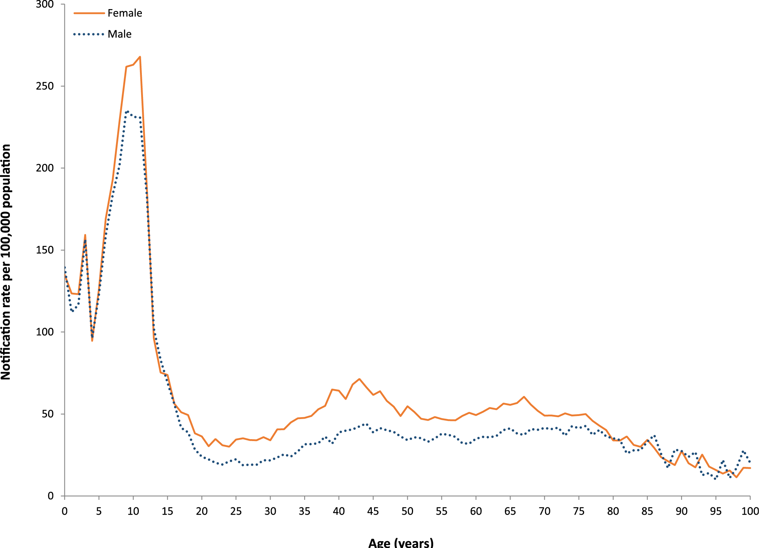
a Data source: NNDSS (notification data).
Prominent changes in the age distribution of notified cases under two years of age were observed between 1995 and 2018, shown in Figure 3 by week of age, from birth to 104 weeks (two years). Between 1995 and 2014, there were substantial peaks in the number of notifications in infants under 20 weeks of age and particularly between 5 and 10 weeks of age. In contrast, in the final 4-year period (2015–2018), the peak in incidence between 5 and 10 weeks was not seen, with numbers of notifications by week of age relatively constant from 5–6 weeks until the age of two years (Figure 3).
Figure 3: Number of pertussis notifications in children under two years (104 weeks) of age, Australia, 1995–2018ª
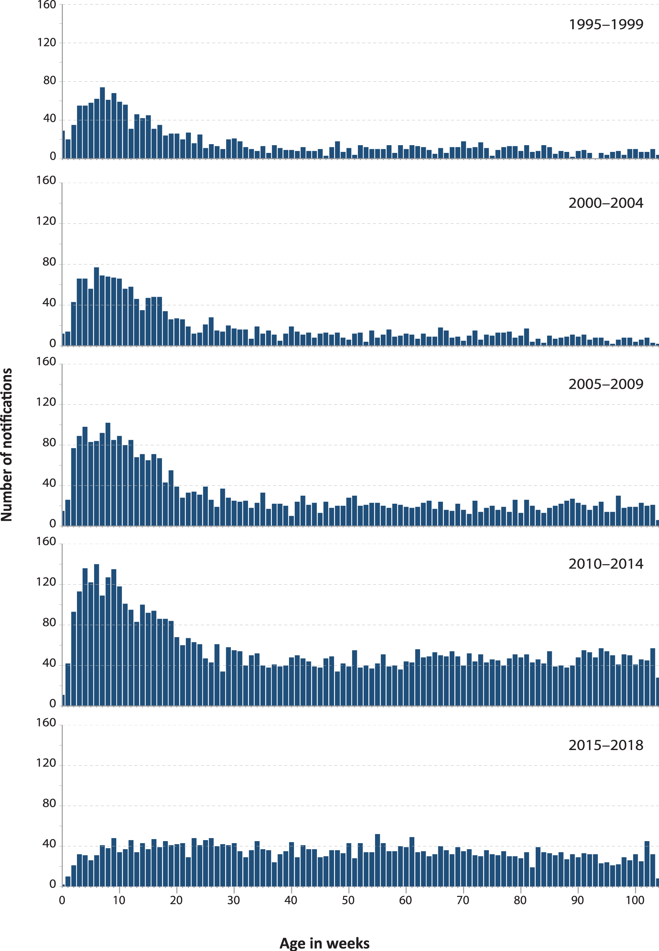
a Data source: NNDSS (notification data).
Until mid–2011, among all cases under five years of age, notification rates were highest in infants aged 2–3 months, followed by infants aged < 2 months and 4–5 months (Figure 4a). From 2015 onwards, the lowest notification rates were in infants < 2 months and the highest in infants aged 4–5 months (Figure 4a). Notification rates for cases aged 6–11 months, 12–17 months and 18 months to 4 years were fairly similar over the 2013 to 2018 period (Figure 4b). Among cases aged ≥ 1 year in the 2013 to 2018 period, notification rates were highest in the 5–9 years age group (with an average of 187.5 notifications per 100,000 population per year), similar to the rates seen in the 10–14 years age group (average of 172.8 notifications per 100,000 population per year), with the lowest rates in 15–19 year olds from 2007 onwards (Figure 4c). From 2005 to 2014, notification rates in individuals ≥ 20 years of age generally exceeded those in 15–19 year olds, but from 2015 the 15–19 years age group consistently had the highest notification rates, compared with the 40–64 and ≥ 65 years age groups (Figure 4d).
In the 2013 to 2017 period, for which complete-year hospitalisation data were available, hospitalisation rates were highest in infants aged < 2 months, followed by infants aged 2–3 months (with averages of 143.2 and 137.8 per 100,000 population per year respectively) (Figure 5). These rates were considerably lower than during the previous period (2002–2012), where hospitalisation rates for infants aged < 2 months and 2–3 months were more than twice as high at 317.7 and 297.0 per 100,000 population respectively. However, from 2015 to 2017, hospitalisation rates for infants aged < 2 months did not fall to the same degree as notification rates: notification rates fell by 43.8% compared to 38.7% for hospitalisation rates. During the 2013–2017 period, among age groups ≥ 5 years old, hospitalisation rates for admissions with pertussis as the principal diagnosis were orders of magnitude lower than for infants, but highest in those aged ≥ 65 years, followed by children aged 5–9 years (Figure 6).
Figure 4a–d: Pertussis notification rates by age group, Australia, 1995–2018ª
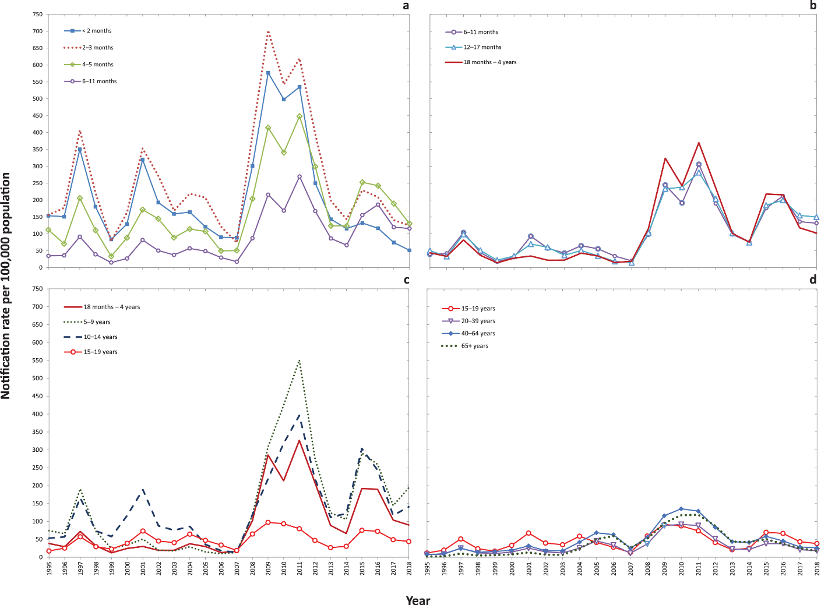
a Data source: NNDSS (notification data).
Figure 5: Pertussis hospitalisation rates by age group for children aged < 5 years (any diagnosis), Australia, 2002–2017ª
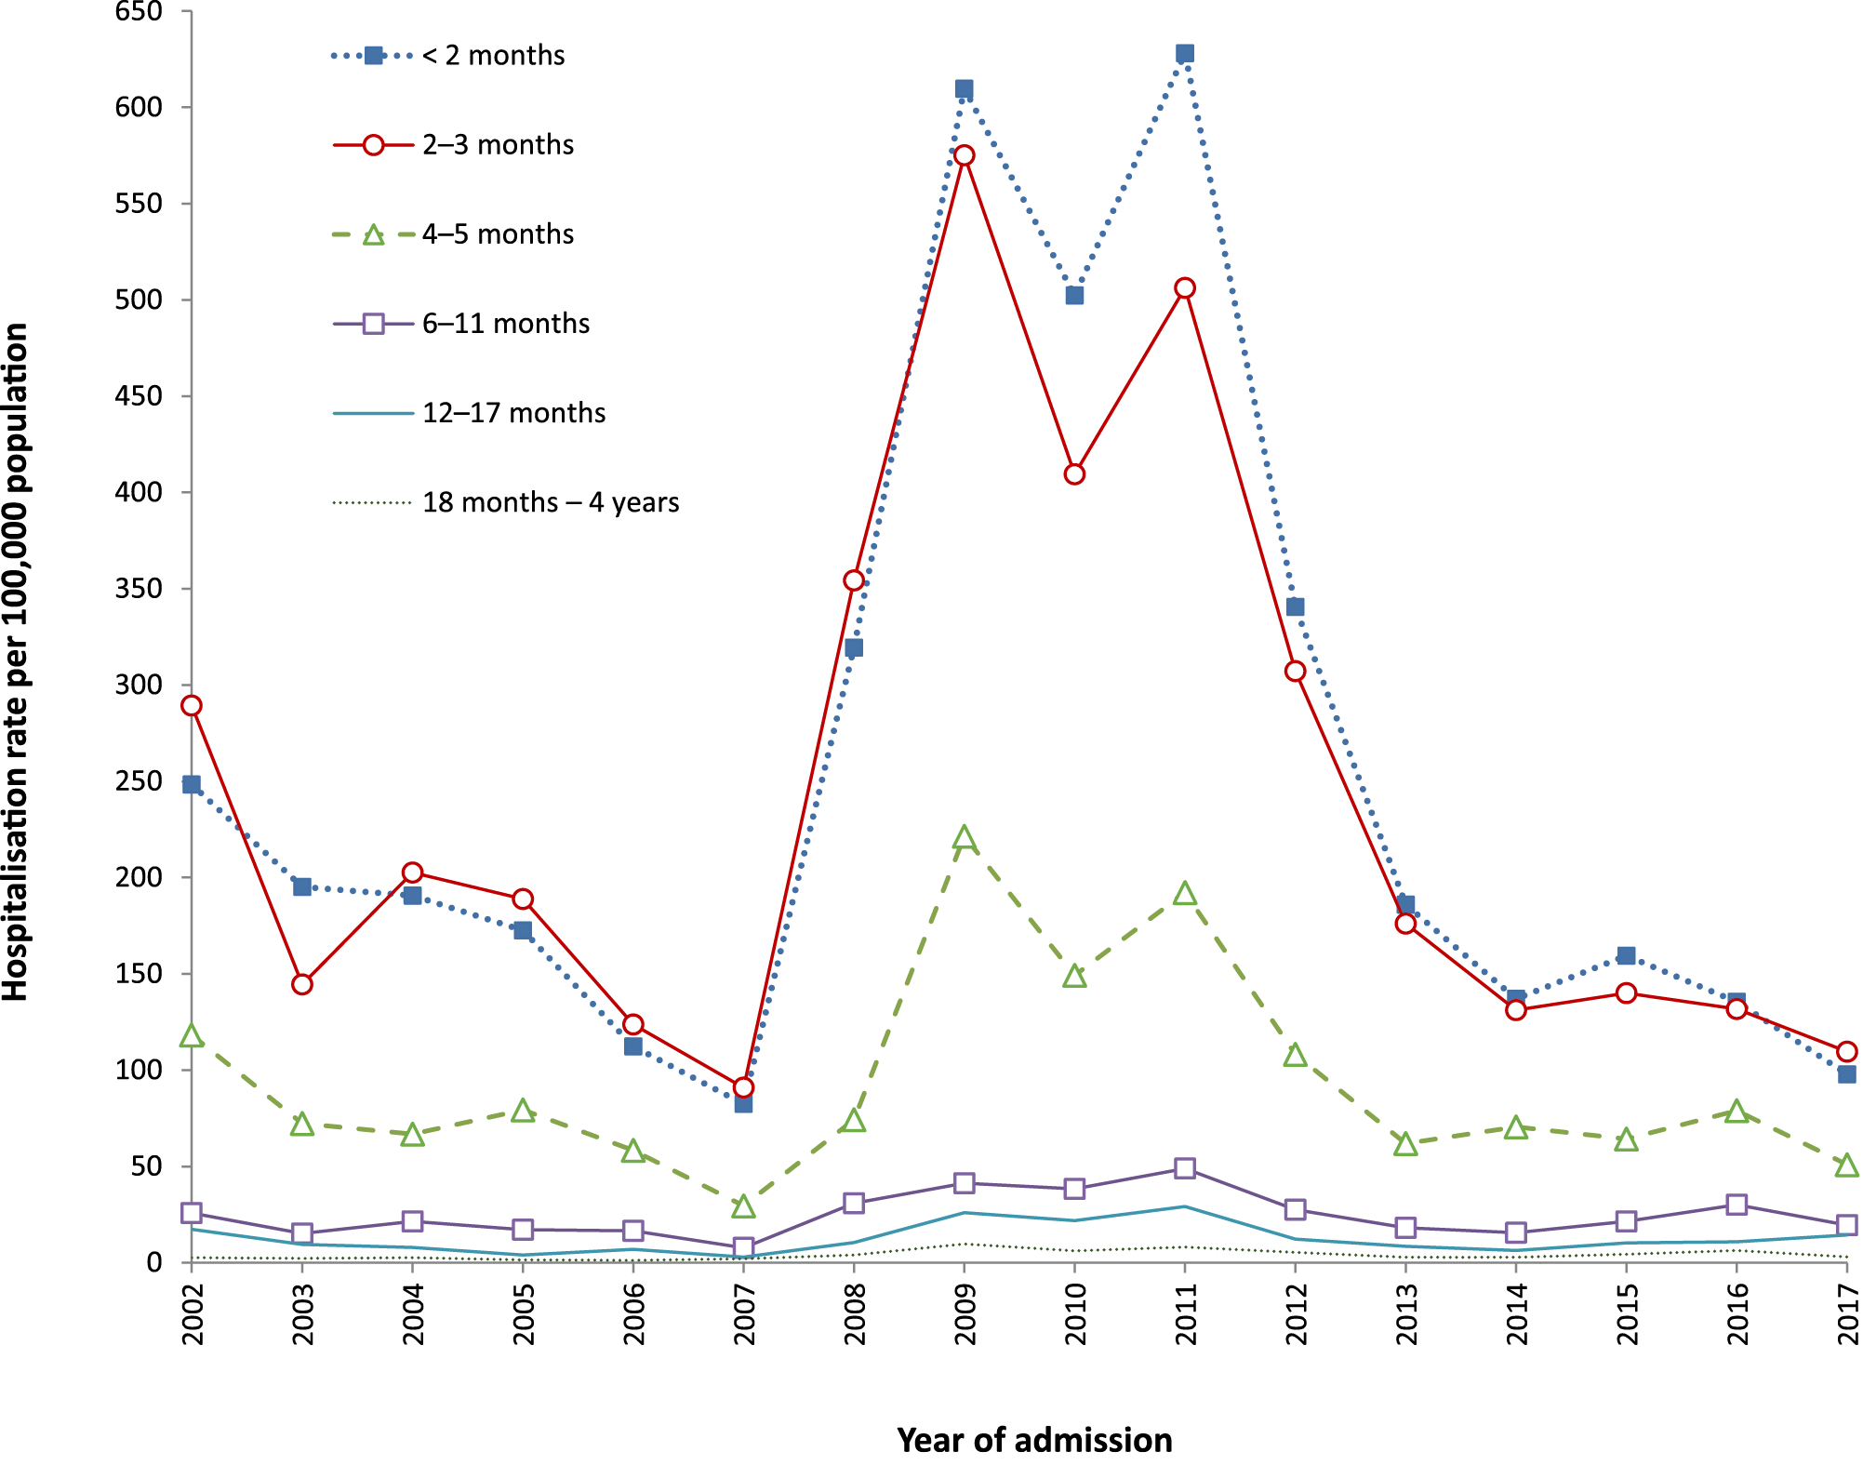
a Data source: NHMD (hospitalisation data).

Figure 6: Pertussis hospitalisation rates by age group for ≥ 5 year olds (principal diagnosis only), Australia, 2002–2017ª
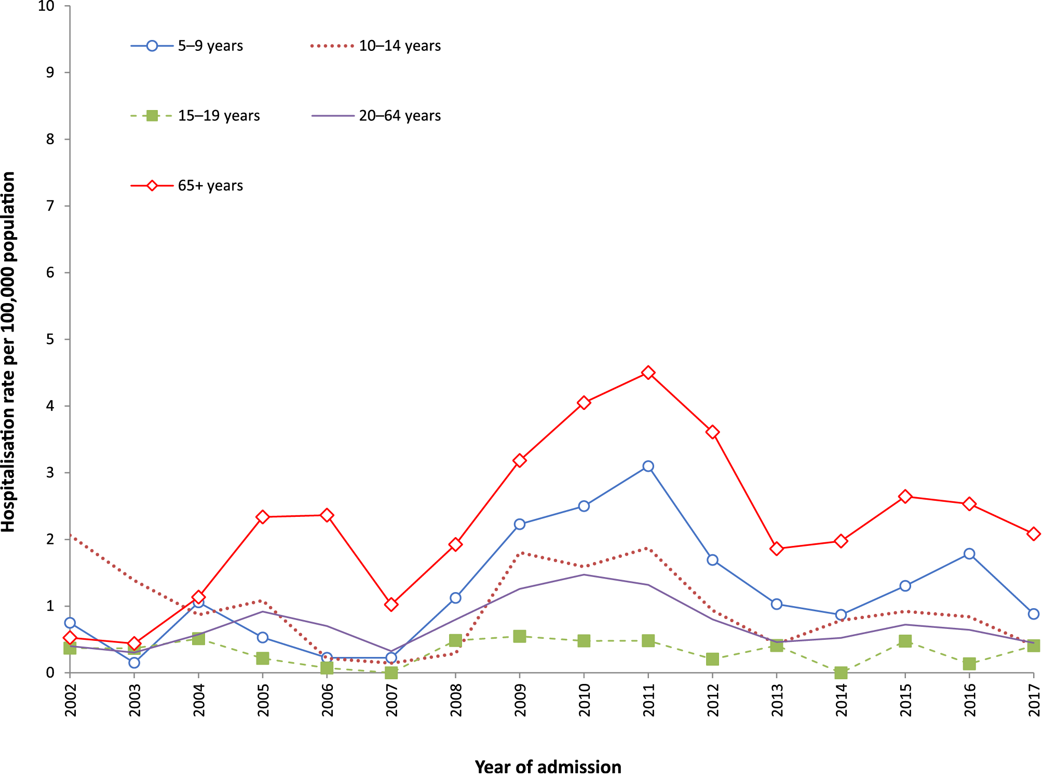
a Data source: NHMD (hospitalisation data).

Indigenous status
Pertussis notification rates during the 2013–2018 period were higher for Indigenous children than for non-Indigenous children across all age groups under 5 years of age. Notification rates were greatest among Indigenous children aged 2–3 months, who were six times as likely to have a notification for pertussis as were non-Indigenous children in this age group (IRR 6.0, with average notification rates of 856.8 and 142.4 notifications per 100,000 per year respectively). Indigenous children aged < 5 years were also more likely to be hospitalised due to pertussis than were non-Indigenous children, with the largest disparity in hospitalisation rate in the 4–5 months age group (IRR 8.1: 424.6 Indigenous vs. 52.6 per 100,000 for non-Indigenous) (Table 2). The IRRs comparing Indigenous to non–Indigenous notification and hospitalisation rates were significantly higher for infants < 6 months of age than for children ≥ 6 months, and this difference was particularly marked for hospitalisations.
Table 2: Pertussis notification and hospitalisation rates per 100,000 population for < 5 year olds, Australia, 2013–2018,ª by age group and Indigenous status
 | Age group | Indigenous status |  |  |  | IRR by age group (95% CI)^{b}
 |  | Non-Indigenous |  | Indigenous
 |  | n | Rate per 100,000 | n | Rate per 100,000
Notifications | <2 months | 282 | 91.3 | 37 | 391.4 | 4.3 (3.0–6.0)
 | 2–3 months | 440 | 142.4 | 81 | 856.8 | 6.0 (4.7–7.6)
 | 4–5 months | 457 | 147.9 | 73 | 772.2 | 5.2 (4.1–6.7)
 | 6–11 months | 987 | 106.5 | 97 | 342.0 | 3.2 (2.6–4.0)
 | 12–17 months | 1,019 | 109.1 | 84 | 304.7 | 2.8 (2.2–3.5)
 | 18 months–<5 years | 6,820 | 104.0 | 484 | 261.4 | 2.5 (2.3–2.8)
Hospitalisations | <2 months | 332 | 128.5 | 38 | 489.0 | 3.8 (2.7–5.3)
 | 2–3 months | 307 | 118.8 | 49 | 630.5 | 5.3 (3.9–7.2)
 | 4–5 months | 136 | 52.6 | 33 | 424.6 | 8.1 (5.5–11.8)
 | 6–11 months | 149 | 19.2 | 14 | 60.0 | 3.1 (1.8–5.4)
 | 12–17 months | 75 | 9.6 | 4 | 17.7 | 1.8 (0.7–5.0)
 | 18 months–<5 years | 195 | 3.6 | 18 | 11.8 | 3.3 (2.0–5.3)
a Data source: NNDSS (notification data), NHMD (hospitalisation data, available to June 2018).
b Bold IRR denotes statistical significance (p-value < 0.05).

Diagnostic method
Over the six-year period 2013–2018, the predominant method of laboratory testing for pertussis was detection of B. pertussis by nucleic acid tests (NAT), such as polymerase chain reaction (PCR). Of all diagnostic tests for pertussis performed over this time, NAT comprised 72.6% and serology the remaining 27.4%. The percentage of notifications based on NAT for pertussis increased from 54.0% in 2013 to 88.2% in 2018, while serology tests fell from 46.0% to 11.7% (Figure 7). The proportion of notifications based on serological testing has progressively fallen in all age groups, with more than 50% of notifications based on NAT since 2006 in children under 5 years of age; since 2007 for children aged 5–9 years; since 2008–2009 for those aged 10–19 years; since 2010 for adults aged 20–29 years; since 2015 for adults aged 30–64 years; and since 2018 for notifications in persons 65 years of age and older (Figure 8, Figure 9).
The proportion of notifications reported with a positive culture for B. pertussis was low over the past decade (< 1%) and very low (0.05%) in the 2013–2018 period. There were 50 positive cultures for B. pertussis reported during 2013–2018: < 6 months (6; 12% of the 50 positive cultures), 6–18 months (9; 18%), 5–9 years (11; 22%), 10–64 years (15; 30%) and ≥ 65 years (9; 18%).
Figure 7: Diagnostic methods for pertussis notifications, Australia, 2006–2018,ª for all age groups
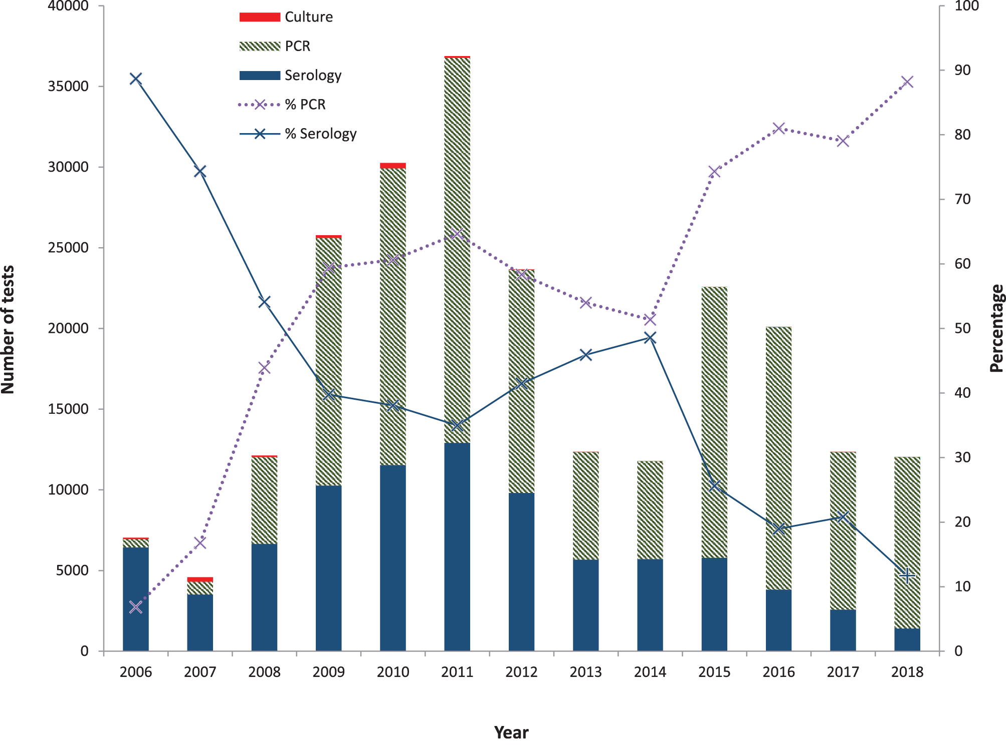
a Data source: NNDSS (notification data).

Figure 8: Diagnostic methods for pertussis notifications, Australia, 2006–2018,ª by age group, among children younger than 15 years^{b}
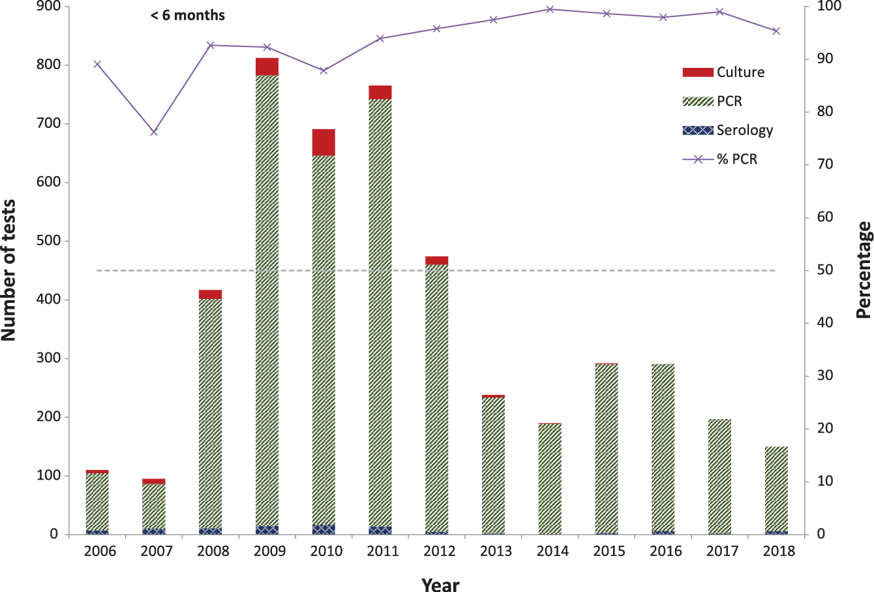
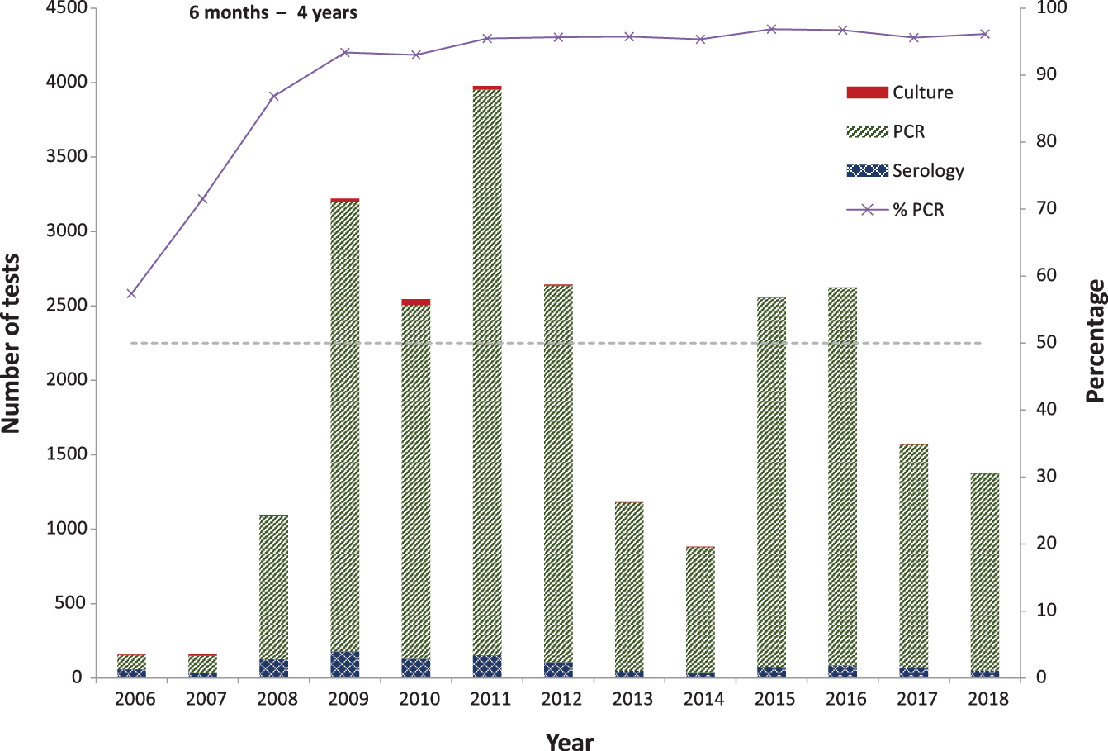
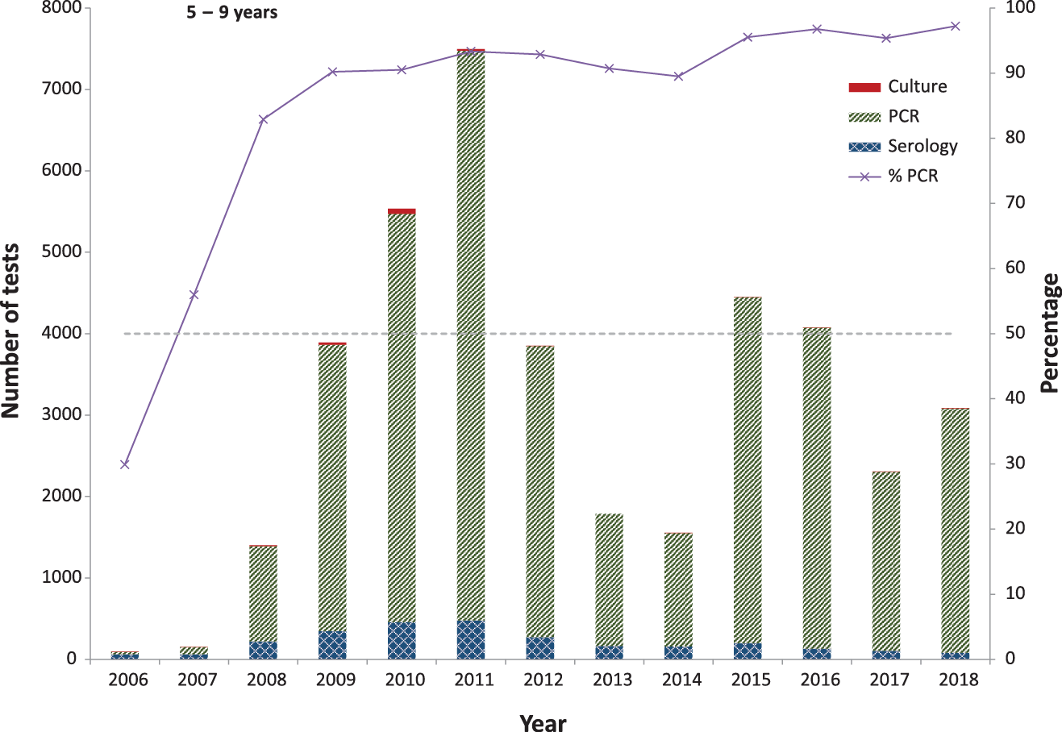
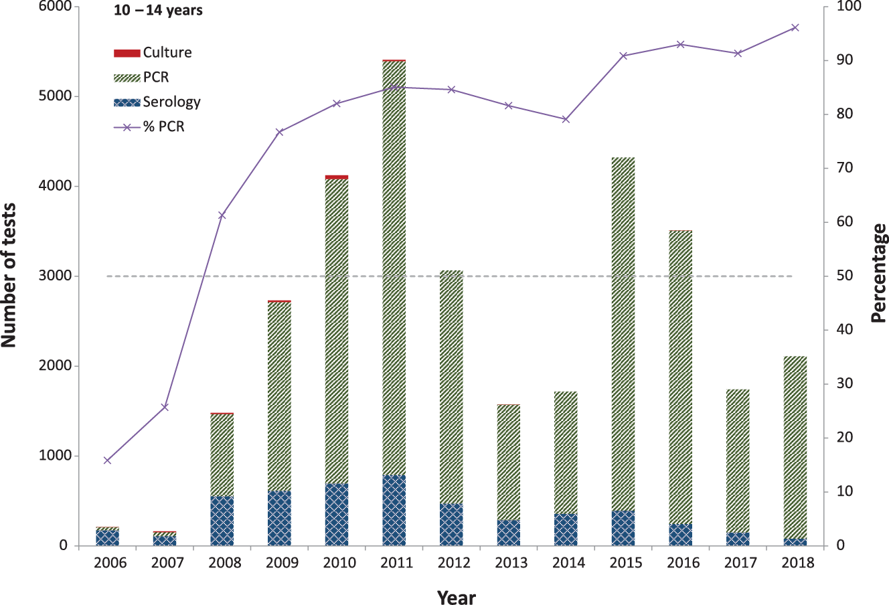

a Data source: NNDSS (notification data).
b ‘Number of test’ scales differ between age groups.

Figure 9: Diagnostic methods for pertussis notifications, Australia, 2006–2018,ª by age group, among those 15 years of age and older^{b}

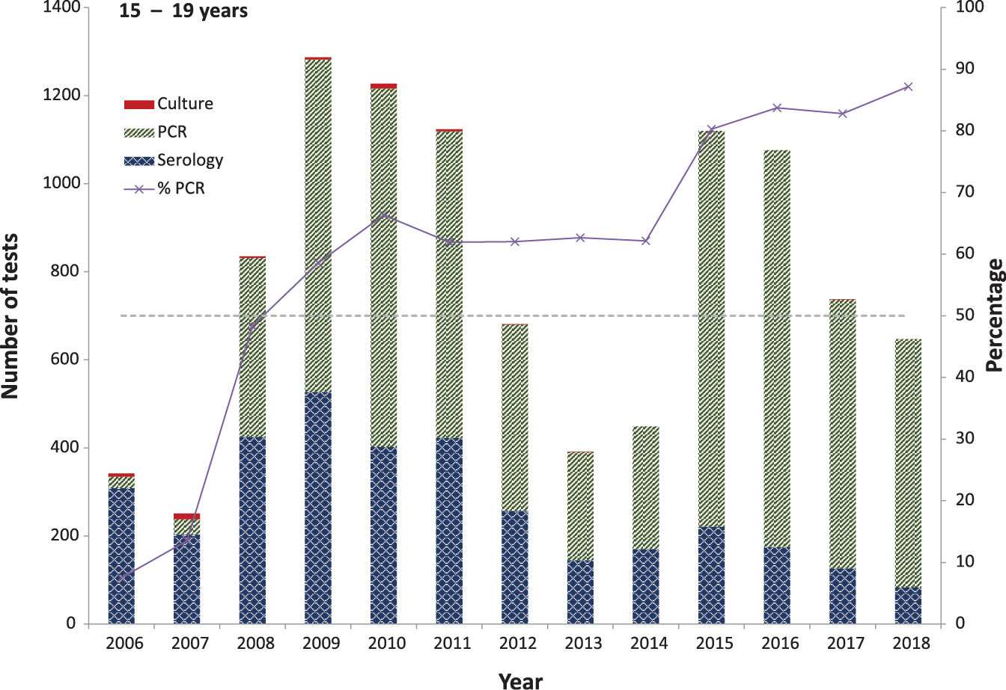
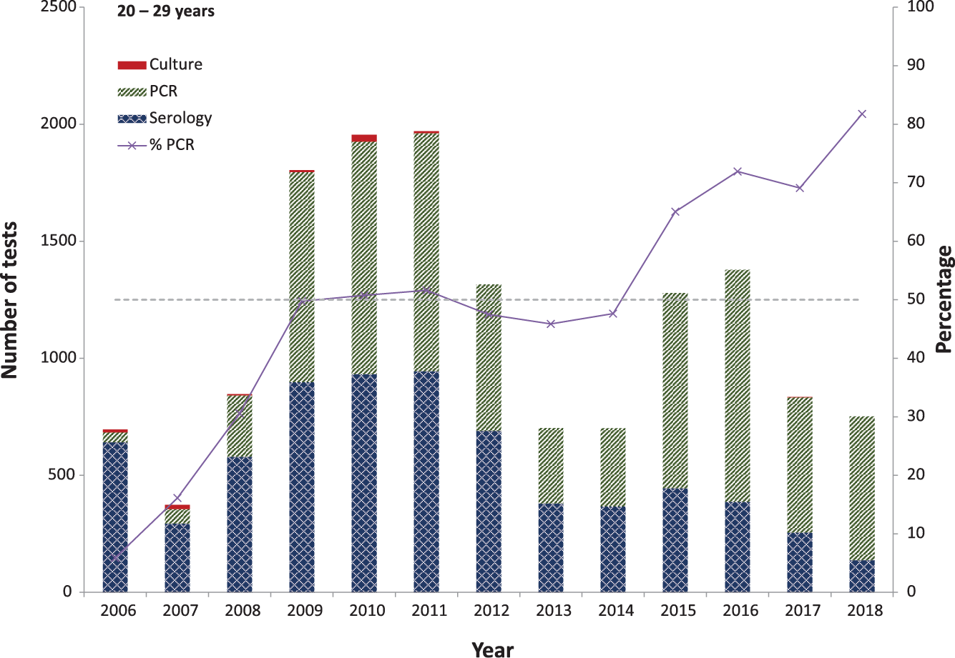
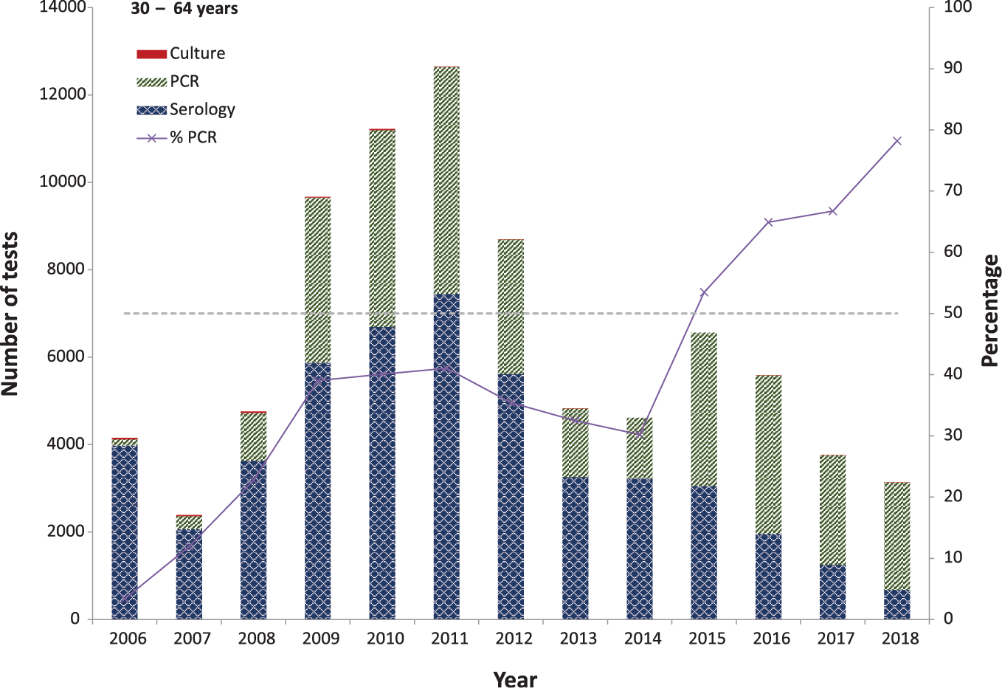
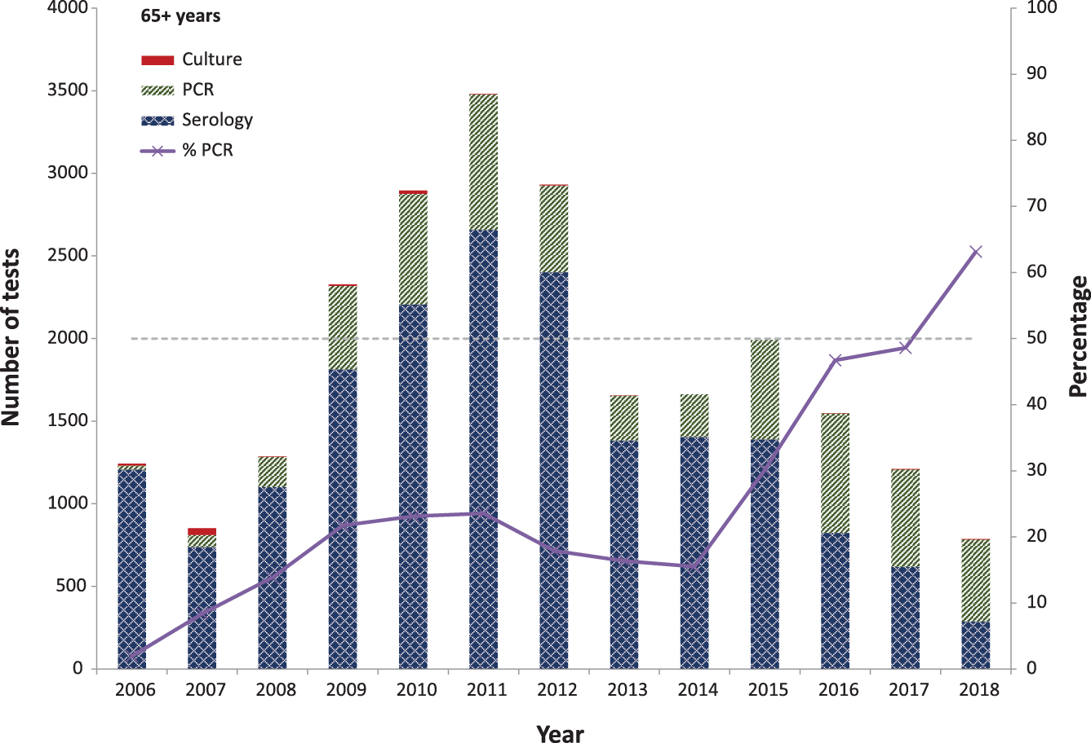
a Data source: NNDSS (notification data).
b ‘Number of test’ scales differ between age groups.

Impact of maternal vaccination during pregnancy
Overall, for the period 2015–2018 (compared to 2010–2013), pertussis notification rates significantly decreased in both the < 2 months age group (IRR = 0.3; 95% CI: 0.2–0.3; p < 0.05) and the 6–11 months age group (IRR=0.8; 95% CI: 0.8–0.9; p < 0.05) following the introduction of maternal pertussis vaccination during pregnancy (Table 3). Notification rates progressively declined in each year of the post-maternal-vaccination era from 2015 to 2018 for the < 2 months age group, and from 2017 among infants aged 6–11 months (Table 3).

Table 3: Incidence rate of pertussis notifications per 100,000 population by infant age group, Australia, during the pre-(2010–2013) and post-(2015–2018) maternal-vaccination periodsª
Age group | Maternal-vaccination period |  |  |  |  | IRR by year and age  group  (95% CI)^{b}
 | Pre-(2010–2013) |  | Post-(2015–2018)
 | n | Rate per 100,000 population per year | Year | n | Rate per 100,000 population
< 2 months | 707 | 352.8 | 2015 | 68 | 132.3 | 0.4 (0.3–0.5)
 |  |  | 2016 | 62 | 116.7 | 0.3 (0.3–0.4)
 |  |  | 2017 | 38 | 74.3 | 0.2 (0.2–0.3)
 |  |  | 2018 | 26 | 51.4 | 0.1 (0.1–0.2)
 |  |  | 2015–2018 | 194 | 94.1 | 0.3 (0.2–0.3)
6–11 months | 1,032 | 171.6 | 2015 | 240 | 155.6 | 0.9 (0.8–1.0)
 |  |  | 2016 | 298 | 186.9 | 1.1 (1.0–1.2)
 |  |  | 2017 | 184 | 119.9 | 0.7 (0.6–0.8)
 |  |  | 2018 | 176 | 116.0 | 0.7 (0.6–0.8)
 |  |  | 2015–2018 | 898 | 145.1 | 0.8 (0.8–0.9)
a Data source: NNDSS (notification data).
b Bold IRR denotes significance (p-value < 0.05).

Severe morbidity and mortality
The median length of stay per hospital admission was 3 days (interquartile range: 1–6 days), but this varied with age (Table 4). Length of stay was longer for older adults (median: 5 days for the 65–79 years age group; 7 days for those aged ≥ 80 years) than for infants. Length of stay has remained stable for older adults in the 2013–2017 period compared to the 2002–2012 period. Median length of stay fell slightly for infants from 3 to 2 days between the two time periods. Hospital admission rates have remained relatively stable across all age groups, except among infants where hospitalisation rates have approximately halved in the 2013–2017 period, largely reflecting notification patterns.
Length of stay also varied by Indigenous status in very young infants. Indigenous infants aged < 4 months had a slightly longer median length of stay than did non–Indigenous infants of the same age, but this could be attributed to the need for remote or regional transfers.
During the period 2006–2018, there were 30 people recorded with pertussis as the underlying cause of death in the Australian Coordinating Registry (ACR), whereas the NNDSS recorded 18 deaths over the same period. The NNDSS recorded three additional deaths among infants (14) compared to the ACR (11), with three of the 14 infant deaths recorded in the NNDSS being Indigenous infants. For adults aged ≥ 50 years, almost five times as many pertussis-coded deaths were recorded in the ACR (19) as in the NNDSS (4) (Table 5). Of non-infant deaths recorded in the NNDSS during 2006–2018, three were in adults aged ≥ 70 years, and only one of these was confirmed by NAT or culture.

Table 4: Number of pertussis-coded hospitalisations, median length of stay and interquartile range by age group, Australia, 2002–2012 and 2013–2017ª
Age group | Hospital admissions |  |  |  | Length of stay (days)
 | 2002–2012 |  | 2013–2017 |  | 2002–2012 |  | 2013–2017
 | n | Rate per 100,000 population  per year | n | Rate per 100,000 population per year | Median | Inter–quartile range | Median | Inter–quartile range
< 1 year | 4,068 | 134.0 | 1,058 | 68.2 | 3 | 1–6 | 2 | 1–4
1–4 years | 721 | 6.1 | 313 | 5.0 | 1 | 1–3 | 1 | 1–2
5–9 years | 242 | 1.6 | 136 | 1.8 | 1 | 1–2 | 1 | 1–2
10–19 years | 345 | 1.1 | 118 | 0.8 | 2 | 1–4 | 1 | 1–3
20–49 years | 1,122 | 1.1 | 410 | 0.8 | 3 | 1–5 | 2 | 1–5
50–64 years | 814 | 2.0 | 349 | 1.6 | 4 | 2–7 | 4 | 1–6
65–79 years | 850 | 3.8 | 524 | 4.0 | 5 | 3–9 | 5 | 3–8
80+ years | 574 | 7.0 | 376 | 8.2 | 7 | 4–12 | 7 | 4–12
All ages | 8,736 | 3.8 | 3,284 | 2.8 | 3 | 1–6 | 3 | 1–6
a Data source: National Hospital Morbidity Database (hospitalisation data).
Table 5: Deaths due to pertussis by data source and age group, Australia, 2006–2018ª
Age group | 2006–2011 |  | 2012–2018
 | ACR  (Underlying cause of death)^{b} | NNDSS  (Deaths recorded among notified cases) | ACR  (Underlying cause of death)^{b} | NNDSS  (Deaths recorded among notified cases)
< 2 months | 1–5 | 7 | 1–5 | 4
2–11 months | 1–5 | 1 | 1–5 | 2
50+ years | 8 | 1 | 11 | 3
Total | 13 | 9 | 17 | 9
a Data source: Australian Coordinating Registry (ACR; cause of death data), NNDSS (notification data).
b To comply with the ACR’s data release condition that death counts < 6 be suppressed in published reports, counts between 1 and 5 are reported as a range.

Discussion
In the six-year period 2013–2018, pertussis was second only to influenza as the most frequently-notified vaccine preventable disease in Australia, with an average annual all-age national notification rate of 63.6 per 100,000 population. This is around 40% lower than the previous review period (2006–2012), when the average annual national notification rate was 103.1 per 100,000 population, which in turn was 2.5-fold higher than 1995–2005 (39.6 per 100,000 population).^{13,14} Although comparison of the incidence of notified pertussis is problematic because of changes in diagnostic and surveillance practices, these changes were much less between 2013–2018 and 2006–2012 than occurred between 1995–2005 and 2006–2012, as summarised in Table 6. In the 2013–2018 period, pertussis notification rates declined in all jurisdictions compared to 2006–2012, but with a wide range, from a reduction of 65% in Queensland (122.5 to 42.7 per 100,000 population) and around 60% in South Australia (178.5 to 69.0) and the Northern Territory (116.4 to 44.4) to a much lower 6% decline in Western Australia (66.9 to 62.8). However, in all jurisdictions, the peak annual notification rates seen in 2013–2018 (lowest in Western Australia [73.4] and highest in New South Wales [160.8]) were substantially lower than peak rates in 2006–2012, which ranged from 454.9 per 100,000 population in South Australia (2010) to 156.5 per 100,000 population in Victoria (2011). The decline in the average rate of coded hospitalisations at the national level for 2013–2018 compared to 2006–2012 was less marked (39% reduction; from 4.6 to 2.8 per 100,000 population), but as for notifications, was greatest in the Northern Territory (68% reduction; from 7.2 to 2.3) and South Australia (51% reduction; from 7.3 to 3.6) and least in the Australian Capital Territory (27% reduction; from 2.2 to 1.6) and Western Australia (31% reduction; from 2.9 to 2.0)(Table 6).

Table 6: All–age peak and average pertussis notification and hospitalisation rates per 100,000 population, Australia, 2006–2012 and 2013 to 2018,ª by state or territory
Period | ACT | NSW | NT | Qld | SA | Tas. | Vic. | WA | Australia
Peak notification rate 2006–2012 | 225.3  (2011) | 182.8  (2011) | 217.4  (2008) | 200.7  (2011) | 454.9  (2010) | 249.5  (2012) | 156.5  (2011) | 169.6  (2011) | 173.5  (2011)
Peak notification rate 2013–2018 | 125.5  (2016) | 160.8  (2015) | 91.2  (2016) | 82.0  (2013) | 114.4  (2016) | 101.9  (2013) | 80.1  (2014) | 73.4  (2015) | 94.8  (2015)
Peak hospitalisation rate 2006–2012 | 5.2  (2011) | 9.3  (2009) | 13.6  (2008) | 7.0  (2011) | 17.0  (2010) | 6.6  (2012) | 7.0  (2011) | 5.8  (2011) | 6.9  (2011)
Peak hospitalisation rate 2013–2017 | 2.3  (2015) | 3.9  (2015) | 4.8  (2017) | 3.8  (2016) | 5.9  (2017) | 4.1  (2013) | 3.0  (2015) | 2.6  (2017) | 3.2  (2015)
Average notification rate 2006–2012 | 113.5 | 108.9 | 116.4 | 122.5 | 178.5 | 79.4 | 75.5 | 66.9 | 103.6
Average notification rate 2013–2018 | 82.9 | 87.1 | 44.4 | 42.7 | 69.0 | 35.6 | 51.5 | 62.8 | 63.6
Average hospitalisation rate 2006–2012 | 2.2 | 5.1 | 7.2 | 4.9 | 7.3 | 2.9 | 3.5 | 2.9 | 4.6
Average hospitalisation rate 2013–2017 | 1.6 | 2.9 | 2.3 | 3.3 | 3.6 | 1.7 | 2.4 | 2.0 | 2.8
a Data source: NNDSS (notification data), NHMD (hospitalisation data, to 2017).

When the annual pattern of notifications was examined at a national level over the entire 24-year period, there appeared to be peaks at approximately 3–4 year intervals in 1997–1998, 2001–2002 and 2005–2006. Incidence moved to a higher baseline after 2008, likely relating to increased testing with access to NAT at primary care level from 2008, with high incidence in 2009–2012 and again in 2016.¹⁶ However, national patterns disguise marked regional variation. Periodic epidemic peaks were clearly evident in Tasmania, South Australia and Western Australia but were much less apparent in Queensland, New South Wales, the Australian Capital Territory, Victoria and the Northern Territory, although all regions had substantially higher pertussis notifications in the period 2009–2011. There was an apparent seasonal peak in November each year, supported by a recent detailed study of regional pertussis data, which found spring/summer peaks in all regions of Australia including the tropics.¹⁷
There were substantial changes in age-specific notification patterns in 2013–2018. Since 1995, the highest notification rates of any age group were in the youngest infants (aged < 2 months and 2–3 months), with progressive reductions in incidence among infants 4–5 months and 6–11 months, coinciding with receipt of the first three doses of pertussis-containing vaccine from 6–8 weeks to 6 months of age. However, from 2015, incidence in infants aged < 2 months was, for the first time, below that for the next three infant age groups, and progressively decreased in 2017 and 2018, such that incidence was lower than in any age group below 15 years. As observed since 2008, the 5–9 years age group had the next highest incidence, similar to 10–14 year olds, with incidence among 15–19 year olds remaining significantly lower than among 5–14 year olds. However, also since 2015, incidence among the age groups 20–39, 40–64, and ≥ 65 years has been below that for 15–19 year olds. Hospitalisation rates in children aged less than 5 years, since 2002, have consistently been highest for infants aged < 2 months and those aged 2–3 months, followed by infants aged 4–5 months, with very low rates observed in those aged from 6 months to 4 years. The most recent data, for the calendar year 2017, showed a trend toward lower hospitalisation rates among infants aged < 2 months, but this was not as dramatic as that seen for notifications, and rates were similar to those previously documented for 2007.
Adding to the clear trends in age–specific notification for infants aged < 2 months, we further examined patterns in notification data to evaluate potential impact on early infant pertussis from the introduction of maternal immunisation in 2015 onwards. Data from Victoria and Western Australia, which are likely applicable nationally, suggest that uptake of maternal immunisation in pregnancy was up to 80% over this period and data from New South Wales are consistent with the 80–90% effectiveness of maternal immunisation against early infant pertussis reported from England.^{18–23} First, when notifications since 1995 by week of age were examined from birth to 24 months of age, the distinct peak consistently seen from 5 to 10 weeks of age in all previous years disappeared for infants born from 2015 to 2018. Second, when notification rates for infants < 2 months of age for each of the years 2015 to 2018 were compared with baseline incidence for 2010–2013, allowing for a wash-in year in 2014, there was a progressive reduction in the relative incidence of pertussis notifications for the < 2 months age group in each year from 2015 (IRR 0.4) to 2016 (0.3), 2017 (0.2) and 2018 (0.1). This compared with more modest, though still statistically significant, reduction in the IRR among 6–11 month old infants for 2017 and 2018 (0.7; 95% CI: 0.6–0.8). Taken together, these descriptive analyses provide highly suggestive evidence of a significant impact of maternal pertussis immunisation programs in Australia.
In addition to maternal immunisation, other recent NIP schedule changes may also have had an impact on early infant pertussis. These include reinstatement of the 18-month booster dose in March 2016 and the recommendation for a pertussis-containing vaccine for adults aged ≥ 65 years in March 2013. It is possible that both have influenced pertussis notification rates among young infants through reduced transmission from preschool-aged siblings and grandparents. Available data show that uptake of the 18-month pertussis dose is 92.8% and around 20% for persons ≥ 65 years.^{10,24}
Previous reviews have highlighted the issue of waning vaccine-induced immunity from acellular vaccines.²⁵ We found continuing high incidence of pertussis in pre-adolescent (9–11 years) and early adolescent children. Although severe disease causing hospitalisation is uncommon in this age group, pertussis can be associated with significant morbidity in children of this age.²⁶
Completeness of Indigenous status in the NNDSS has improved markedly and met completeness criteria for infants aged < 6 months in 2004 and has been greater than 90% for all children aged < 5 years since 2010. Significant disparities exist in pertussis notification and hospitalisation rates between Indigenous and non-Indigenous children and are present in all age groups < 5 years and particularly pronounced for infants < 6 months of age. We found that Indigenous infants are between 3.2 and 6.0 times as likely to be notified and between 3.1 and 8.1 times as likely to be hospitalised with pertussis as are non-Indigenous children in the same age groups. An important remedial factor for this disparity is improvements in vaccination timeliness.^{27–30}
Laboratory diagnostic trends for pertussis detection have continued on a similar trajectory since the previous review period. From 2007, the proportion of notifications by NAT increased sharply, and by 2012, such testing accounted for just over 62.0% of diagnostic tests for pertussis in 15–19 year olds, and 32.7% in individuals aged ≥ 20 years.¹⁶ By 2018, NAT had become the dominant method of laboratory diagnosis in all age groups: 87.2% in 15–19 year olds and 76.3% in those aged ≥20 years. In those ≥ 65 years of age, serology still comprised a third of tests performed in 2018, but the validity of serologic diagnoses, particularly when not accompanied by individual case follow-up, remains questionable.³¹ Culture has become increasingly rare, and the low number of positive cultures between 2013 and 2018 has important implications for the continuing ability to track pertussis strain variation over time.³²
This review highlights differences in the ascertainment of deaths due to pertussis when examining death certificate and notification data. The NNDSS recorded fewer deaths in older age groups, which may reflect lower levels of public health follow-up in adults. Application of capture-recapture methods in the Netherlands has shown that there is likely to be continued under-ascertainment of deaths from pertussis.³³
Australia continues to have substantially higher rates of pertussis notification and coded hospitalisation than do comparable countries in Europe and North America, although at least part of this difference is likely due to under-ascertainment of pertussis in those countries compared with Australia.^{33–36} However, Australia also now has one of the most comprehensive immunisation programs of any country, targeting pertussis across the lifespan, with high uptake of a six-dose schedule under the age of 14 years and high uptake of maternal vaccination in pregnancy, along with recommendations for vaccination of older adults. This review has identified strong evidence of significant reductions in pertussis in the post-maternal-vaccination era for newborn infants too young to receive even their first infant vaccine dose, the most important target group for prevention of pertussis, given they are at highest risk of severe disease and death.

Acknowledgements
We thank the Australian Coordinating Registry, state and territory registries of births, deaths and marriages, state and territory coroners, and the National Coronial Information System, for providing access to cause-of-death data. NCIRS is supported by the Australian Government Department of Health, the New South Wales Ministry of Health, and The Sydney Children’s Hospitals Network. The opinions expressed in this report are those of the authors, and do not necessarily represent the views of these agencies. Dr Marshall is supported by a Master of Applied Epidemiology Scholarship from the Australian National University.

Author details
Dr Kushani Marshall ^{1, 2} – Master of Philosophy (Applied Epidemiology) Scholar
Dr Helen Quinn ^{1, 3} – Senior Research Fellow and Senior Lecturer
Ms Alexis Pillsbury ^{1, 3} – Senior Research Officer and Lecturer
Ms Julia Maguire ^{1, 3} – Epidemiologist and Lecturer
Prof Robyn Lucas ² – Professor and Head, National Centre for Epidemiology and Population Health
Dr Aditi Dey ^{1, 3} – Senior Research Fellow and Senior Lecturer
Dr Frank Beard ^{1, 3} – Associate Director and Senior Lecturer
Prof Kristine Macartney ^{1, 3} – Director of NCIRS and Staff Specialist
Prof Peter McIntyre ^{1, 3, 4} – Senior Professorial Fellow
- National Centre for Immunisation Research and Surveillance, Westmead, New South Wales, Australia
- The Australian National University, Canberra, Australian Capital Territory, Australia
- The University of Sydney, New South Wales, Australia
- The University of Otago, Dunedin, New Zealand

Corresponding author
Dr Kushani Marshall,
National Centre for Immunisation Research and Surveillance, Locked Bag 4001, Westmead NSW 2145, Australia Kushani.Marshall@health.nsw.gov.au +61 2 9845 0646

References
- Rohani P, Scarpino SV. Pertussis: Epidemiology, Immunology, and Evolution. United Kingdom: Oxford University Press; 2018.
- Heymann DL. Control of communicable diseases manual. Washington DC: American Public Health Association; 2015.
- Australian Government Department of Health. Australian immunisation handbook. [Website.] Canberra: Australian Government Department of Health, Australian Technical Advisory Group on Immunisation (ATAGI); 2018. [Accessed on 21 October 2019.] Available from: https://immunisationhandbook.health.gov.au/.
- Marshall H, Clarke M, Rasiah K, Richmond P, Buttery J, Reynolds G et al. Predictors of disease severity in children hospitalized for pertussis during an epidemic. Pediatr Infect Dis J. 2015;34(4):339–45.
- Chuk LMR, Lambert SB, May ML, Beard FH, Sloots TP, Selvey CE et al. Pertussis in infants: how to protect the vulnerable? Commun Dis Intell Q Rep. 2008;32(4):449–56.
- Bisgard KM, Pascual FB, Ehresmann KR, Miller CA, Cianfrini C, Jennings CE et al. Infant pertussis: who was the source? Pediatr Infect Dis J. 2004;23(11):985–9.
- Bertilone C, Wallace T, Selvey LA. Finding the ‘who’ in whooping cough: vaccinated siblings are important pertussis sources in infants 6 months of age and under. Commun Dis Intell Q Rep. 2014;38(3):E195–200.
- World Health Organization (WHO). Pertussis vaccines: WHO position paper—August 2015. Wkly Epidemiol Rec. 2015;90(35):433–60.
- Dey A, Wang H, Beard F, Macartney K, McIntyre P. Summary of national surveillance data on vaccine preventable diseases in Australia, 2012–2015. Commun Dis Intell (2018). 2019;43. doi: https://doi.org/10.33321/cdi.2019.43.58.
- National Centre for Immunisation Research and Surveillance (NCIRS). Annual Immunisation Coverage Report 2018. Sydney: NCIRS; November 2019. Available from: https://www.ncirs.org.au/sites/default/files/2019-11/NCIRS%20Annual%20Immunisation%20Coverage%20Report%202018.pdf.
- NCIRS. Significant events in diphtheria, tetanus and pertussis vaccination practice in Australia. Sydney: NCIRS; July 2018. [Accessed on 27 June 2019.] Available from: http://www.ncirs.org.au/sites/default/files/2018-11/Diphtheria-tetanus-pertussis-history-July-2018.pdf.
- Beard FH. Pertussis immunisation in pregnancy: a summary of funded Australian state and territory programs. Commun Dis Intell Q Rep. 2015;39(3):E329–36.
- Quinn HE, McIntyre PB. Pertussis epidemiology in Australia over the decade 1995–2005—trends by region and age group. Commun Dis Intell Q Rep. 2007;31(2):205–15.
- Pillsbury A, Quinn HE, McIntyre PB. Australian vaccine preventable disease epidemiological review series: pertussis, 2006–2012. Commun Dis Intell Q Rep. 2014;38(3):E179–94.
- Australian Government Department of Health. Pertussis case definition. [Internet.] Canberra: Australian Government Department of Health; 16 January 2014. [Accessed on 15 July 2019.] Available from: https://www.health.gov.au/internet/main/publishing.nsf/Content/cda-surveil-nndss-casedefs-cd_pertus.htm.
- Kaczmarek MC, Ware RS, Lambert SB. The contribution of PCR testing to influenza and pertussis notifications in Australia. Epidemiol Infect. 2016;144(2):306–14.
- Leong RNF, Wood JG, Turner RM, Newall AT. Estimating seasonal variation in Australian pertussis notifications from 1991 to 2016: evidence of spring to summer peaks. Epidemiol Infect. 2019;147. doi: https://doi.org/10.1017/S0950268818003680.
- Amirthalingam G, Campbell H, Ribeiro S, Fry NK, Ramsay M, Miller E et al. Sustained effectiveness of the maternal pertussis immunization program in England 3 years following introduction. Clin Infect Dis. 2016;63(suppl 4):S236–43.
- Rowe SL, Perrett KP, Morey R, Stephens N, Cowie BC, Nolan TM et al. Influenza and pertussis vaccination of women during pregnancy in Victoria, 2015–2017. Med J Aust. 2019;210(10):454–62.
- Saul N, Wang K, Bag S, Baldwin H, Alexander K, Chandra M et al. Effectiveness of maternal pertussis vaccination in preventing infection and disease in infants: the NSW Public Health Network case-control study. Vaccine. 2018;36(14):1887–92.
- Lotter K, Regan AK, Thomas T, Effler PV, Mak DB. Antenatal influenza and pertussis vaccine uptake among Aboriginal mothers in Western Australia. Aust N Z J Obstet Gynaecol. 2018;58(4):417–24.
- Van Buynder PG, Van Buynder JL, Menton L, Thompson G, Sun J. Antigen specific vaccine hesitancy in pregnancy. Vaccine. 2019;37(21):2814–20.
- Amirthalingam G, Andrews N, Campbell H, Ribeiro S, Kara E, Donegan K et al. Effectiveness of maternal pertussis vaccination in England: an observational study. Lancet. 2014;384(9953):1521–8.
- Dyda A, McIntyre P, Karki S, MacIntyre CR, Newall AT, Banks E et al. Pertussis vaccination in a cohort of older Australian adults following a cocooning vaccination program. Vaccine. 2018;36(29):4157–60.
- Sheridan SL, Frith K, Snelling TL, Grimwood K, McIntyre PB, Lambert SB. Waning vaccine immunity in teenagers primed with whole cell and acellular pertussis vaccine: recent epidemiology. Expert Rev Vaccines. 2014;13(9):1081–106.
- Staff M, Nyinawingeri A, Denniss K, Ingleton A, Jelfs J, Corben P. Pertussis morbidity in children 12–59 months of age: a NSW Public Health Network study. Pediatr Infect Dis J. 2019;38(6):553–8.
- Ioannides S, Beard F, Larter N, Clark K, Wang H, Hendry A et al. Vaccine preventable diseases and vaccination coverage in Aboriginal and Torres Strait Islander people, Australia, 2011–2015. Commun Dis Intell (2018). 2019;43. doi: https://doi.org//10.33321/cdi.2019.43.36.
- Kolos V, Menzies R, McIntyre P. Higher pertussis hospitalization rates in indigenous Australian infants, and delayed vaccination. Vaccine. 2007;25(4):588–90.
- Gidding HF, Flack LK, Sheridan S, Liu B, Fathima P, Sheppeard V et al. Infant, maternal and demographic predictors of delayed vaccination: a population-based cohort study. Vaccine. 2019;38(38):6057–64.
- Hendry AJ, Beard FH, Dey A, Meijer D, Campbell-Lloyd, Clark KK et al. Closing the vaccination coverage gap in New South Wales: the Aboriginal Immunisation Healthcare Worker Program. Med J Aust. 2018;209(1):24–8.
- Liu BC, He WQ, Newall AT, Quinn HE, Bartlett M, Hayen A et al. Effectiveness of acellular pertussis vaccine in older adults: nested matched case-control study. Clin Infect Dis. 2020;71(2):340–50.
- Xu Z, Octavia S, Luu LDW, Payne M, Timms V, Tay CY et al. Pertactin-negative and filamentous hemagglutinin-negative Bordetella pertussis, Australia, 2013–2017. Emerg Infect Dis. 2019;25(6):1196–9.
- van der Maas N, Hoes J, Sanders EAM, de Melker HE. Severe underestimation of pertussis related hospitalizations and deaths in the Netherlands: a capture-recapture analysis. Vaccine. 2017;35(33):4162–6.
- Amirthalingam G, Gupta S, Campbell H. Pertussis immunisation and control in England and Wales, 1957 to 2012: a historical review. Euro Surveill. 2013;18(38):20587. doi: https://doi.org/10.2807/1560-7917.es2013.18.38.20587.
- Masseria C, Martin CK, Krishnarajah G, Becker LK, Buikema A, Tan TQ. Incidence and burden of pertussis among infants less than 1 year of age. Pediatr Infect Dis J. 2017;36(3):e54–61.
- Crowcroft NS, Johnson C, Chen C, Li Y, Marchand-Austin A, Bolotin S et al. Under-reporting of pertussis in Ontario: a Canadian Immunization Research Network (CIRN) study using capture-recapture. PloS One. 2018;13(5). doi: https://doi.org/10.1371/journal.pone.0195984.

Appendix A: Supplementary figures and tables
Figure A.1: Pertussis notifications and hospitalisations by jurisdiction for the Australian Capital Territory, the Northern Territory, and Tasmania, January 1995 to December 2018 (for notifications) by month and year of diagnosis, June 2001 to June 2018 (for hospitalisations) by month and year of admissionª
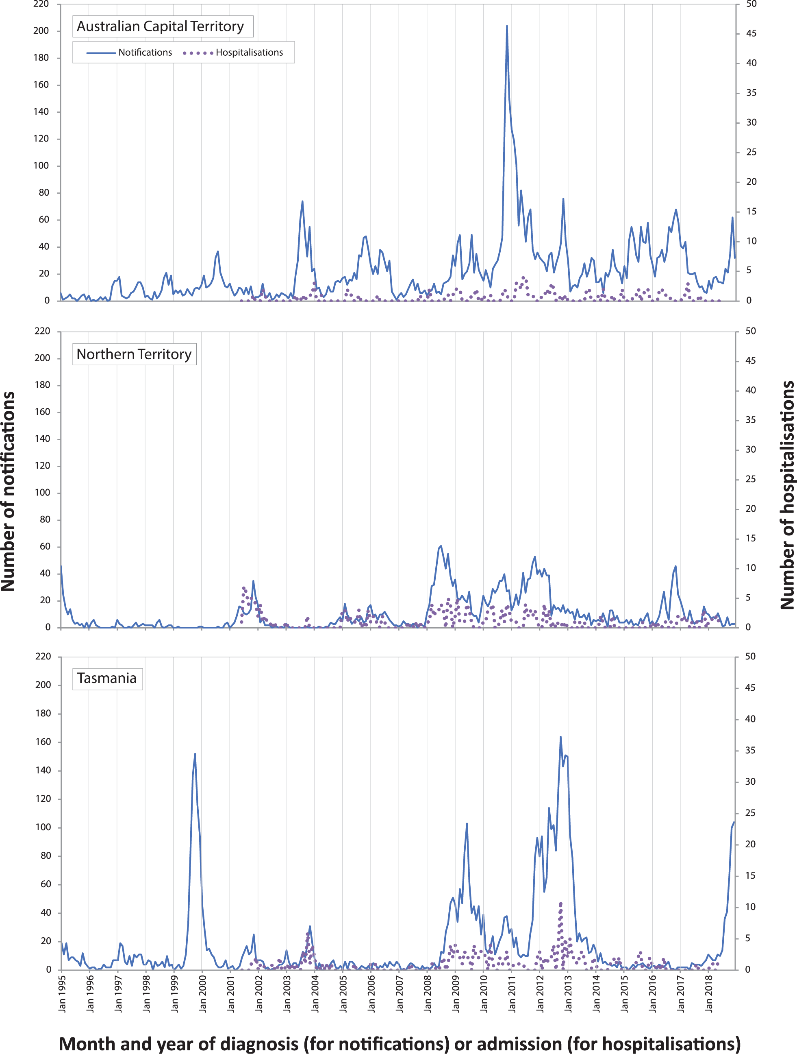
a Data source: NNDSS (notification data), NHMD (hospitalisation data). Scales are the same for all three jurisdictions.
Figure A.2: Pertussis notifications and hospitalisations by jurisdiction for New South Wales, Queensland, and Victoria, January 1995 to December 2018 (for notifications) by month and year of diagnosis, June 2001 to June 2018 (for hospitalisations) by month and year of admissionª
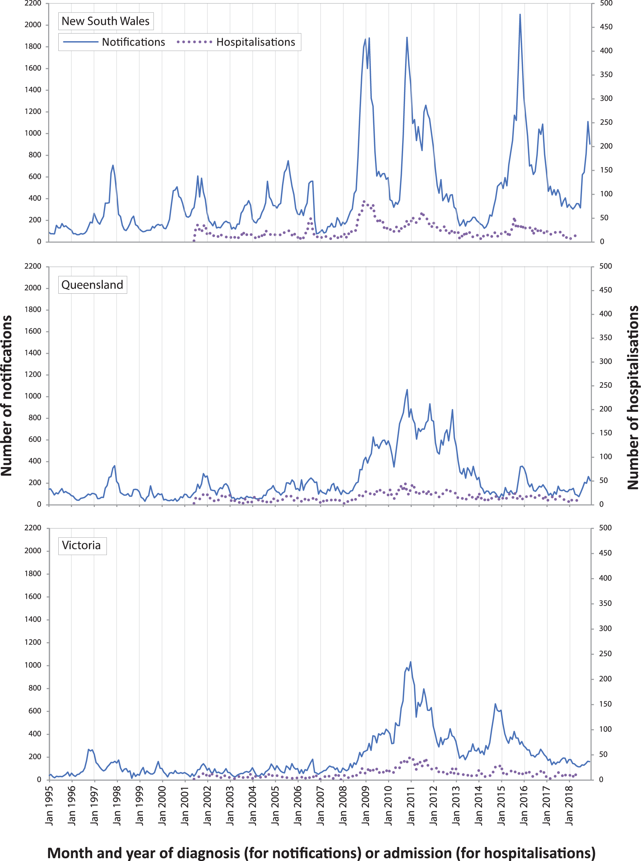
a Data source: NNDSS (notification data), NHMD (hospitalisation data). Scales are the same for all three jurisdictions.
Figure A.3: Pertussis notifications and hospitalisations by jurisdiction for South Australia and Western Australia, January 1995 to December 2018 (for notifications) by month and year of diagnosis, June 2001 to June 2018 (for hospitalisations) by month and year of admissionª
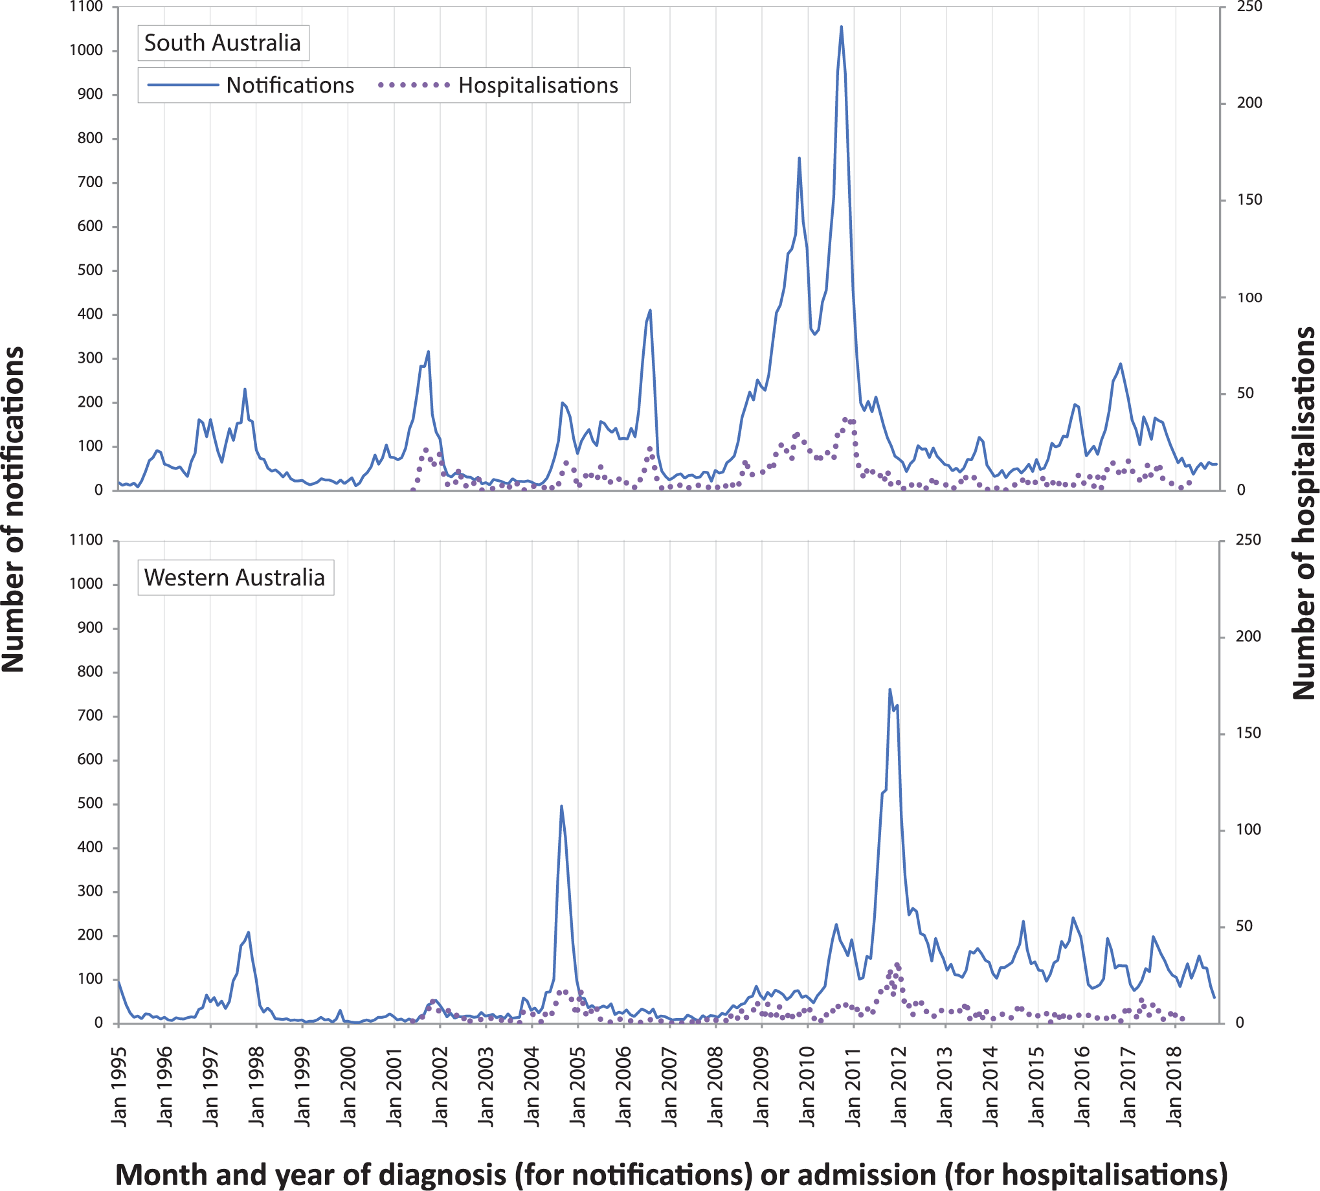
a Data source: NNDSS (notification data), NHMD (hospitalisation data). Scales are the same for both jurisdictions.
Table A.1: Age–specific notification and hospitalisation rates per 100,000 population for pertussis, Australia, 2013–2018,ª by jurisdiction
 |  | Age group
State or territory | Data source | < 6 months | 6 months – 4 years | 5–9 years | 10–14 years | 15–19 years | 20–64 years | ≥ 65 years
ACT
2013 | Notifications | 0.0 | 34.0 | 125.3 | 165.1 | 12.3 | 47.8 | 106.1
 | Hospitalisations | 72.8 | 0.0 | 0.0 | 0.0 | 0.0 | 0.4 | 2.3
2014 | Notifications | 72.1 | 24.9 | 75.1 | 51.7 | 69.1 | 52.7 | 107.8
 | Hospitalisations | 36.1 | 4.2 | 4.2 | 0.0 | 0.0 | 1.2 | 0.0
2015 | Notifications | 106.2 | 114.0 | 291.6 | 435.5 | 80.6 | 89.0 | 98.8
 | Hospitalisations | 35.4 | 8.1 | 0.0 | 0.0 | 0.0 | 0.8 | 8.4
2016 | Notifications | 70.2 | 130.9 | 256.1 | 360.8 | 120.5 | 95.8 | 106.9
 | Hospitalisations | 35.1 | 7.9 | 3.9 | 0.0 | 0.0 | 0.8 | 2.0
2017 | Notifications | 35.7 | 124.9 | 67.1 | 104.3 | 40.5 | 52.8 | 63.9
 | Hospitalisations | 0.0 | 7.8 | 3.7 | 0.0 | 4.1 | 0.4 | 1.9
2018 | Notifications | 0.0 | 66.6 | 154.9 | 254.8 | 89.2 | 40.8 | 44.8
Total number notifications |  | 8 | 124 | 247 | 305 | 102 | 954 | 252
Total number hospitalisations |  | 5 | 7 | 3 | 0 | 1 | 9 | 7
Average rate notifications |  | 48.0 | 83.5 | 162.0 | 229.0 | 68.9 | 63.0 | 86.5
Average rate hospitalisations |  | 35.7 | 5.7 | 2.4 | 0.0 | 0.8 | 0.7 | 2.9
NSW
2013 | Notifications | 110.9 | 88.9 | 110.4 | 62.7 | 14.9 | 18.6 | 18.9
 | Hospitalisations | 131.0 | 5.9 | 1.1 | 0.4 | 0.6 | 0.7 | 3.2
2014 | Notifications | 93.4 | 79.8 | 133.3 | 116.5 | 26.3 | 25.0 | 29.2
 | Hospitalisations | 87.1 | 4.5 | 0.4 | 0.4 | 0.0 | 0.8 | 4.3
2015 | Notifications | 362.9 | 384.0 | 629.7 | 601.8 | 148.2 | 72.4 | 50.8
 | Hospitalisations | 189.6 | 12.3 | 3.5 | 2.2 | 0.4 | 1.5 | 4.5
2016 | Notifications | 342.5 | 397.5 | 535.5 | 430.6 | 121.4 | 68.2 | 44.4
 | Hospitalisations | 181.1 | 12.2 | 3.4 | 1.3 | 0.6 | 1.3 | 4.8
2017 | Notifications | 179.2 | 188.4 | 240.5 | 153.5 | 70.4 | 36.5 | 28.7
 | Hospitalisations | 93.7 | 8.2 | 1.6 | 1.1 | 0.0 | 0.9 | 4.4
2018 | Notifications | 158.4 | 180.9 | 370.7 | 248.1 | 69.3 | 36.9 | 24.4
Total number notifications |  | 617 | 5,916 | 9,996 | 7,355 | 2,100 | 11,823 | 2,362
Total number hospitalisations |  | 338 | 193 | 49 | 25 | 8 | 233 | 251
Average rate notifications |  | 208.9 | 220.5 | 339.7 | 268.6 | 75.1 | 43.1 | 32.8
Average rate hospitalisations |  | 137.0 | 8.6 | 2.0 | 1.1 | 0.3 | 1.0 | 4.2
a Data source: NNDSS (notification data), NHMD (hospitalisation data). Hospitalisations up to 2017.
 |  | Age group
State or territory | Data source | < 6 months | 6 months – 4 years | 5–9 years | 10–14 years | 15–19 years | 20–64 years | ≥ 65 years
NT
2013 | Notifications | 50.2 | 52.1 | 56.8 | 42.1 | 12.6 | 39.3 | 115.7
 | Hospitalisations | 50.2 | 5.8 | 0.0 | 0.0 | 0.0 | 0.6 | 0.0
2014 | Notifications | 102.5 | 11.6 | 16.9 | 6.1 | 13.0 | 40.9 | 51.7
 | Hospitalisations | 51.2 | 0.0 | 0.0 | 0.0 | 0.0 | 2.5 | 0.0
2015 | Notifications | 50.7 | 29.0 | 11.1 | 12.4 | 13.4 | 25.0 | 43.1
 | Hospitalisations | 0.0 | 0.0 | 0.0 | 0.0 | 0.0 | 0.6 | 0.0
2016 | Notifications | 147.0 | 104.0 | 312.5 | 412.4 | 100.5 | 33.1 | 70.8
 | Hospitalisations | 195.9 | 0.0 | 0.0 | 0.0 | 0.0 | 0.6 | 5.9
2017 | Notifications | 359.1 | 93.1 | 97.4 | 74.1 | 73.0 | 26.1 | 22.5
 | Hospitalisations | 461.7 | 11.6 | 0.0 | 6.2 | 0.0 | 0.0 | 0.0
2018 | Notifications | 381.8 | 47.9 | 43.6 | 48.5 | 13.2 | 19.4 | 21.3
Total number notifications |  | 21 | 58 | 98 | 96 | 34 | 293 | 52
Total number hospitalisations |  | 15 | 3 | 0 | 1 | 0 | 7 | 1
Average rate notifications |  | 178.8 | 56.3 | 90.4 | 98.2 | 37.3 | 30.6 | 52.1
Average rate hospitalisations |  | 151.4 | 3.5 | 0.0 | 1.2 | 0.0 | 0.9 | 1.2
Qld
2013 | Notifications | 214.3 | 122.4 | 160.5 | 178.1 | 41.6 | 60.5 | 87.6
 | Hospitalisations | 141.8 | 6.0 | 3.5 | 1.0 | 1.0 | 1.0 | 7.7
2014 | Notifications | 111.1 | 53.4 | 69.8 | 79.2 | 19.2 | 19.0 | 24.3
 | Hospitalisations | 92.1 | 4.2 | 1.6 | 2.0 | 0.3 | 1.3 | 9.3
2015 | Notifications | 90.1 | 76.2 | 126.1 | 150.3 | 24.8 | 19.9 | 16.6
 | Hospitalisations | 93.4 | 3.5 | 1.5 | 1.3 | 1.0 | 1.3 | 11.7
2016 | Notifications | 99.1 | 117.1 | 141.9 | 146.8 | 39.4 | 23.2 | 11.8
 | Hospitalisations | 99.1 | 10.1 | 2.4 | 3.3 | 0.7 | 2.2 | 5.9
2017 | Notifications | 81.8 | 59.6 | 90.0 | 72.9 | 25.4 | 14.5 | 15.6
 | Hospitalisations | 49.1 | 3.8 | 0.6 | 0.3 | 0.3 | 1.2 | 8.8
2018 | Notifications | 55.7 | 66.0 | 165.9 | 108.8 | 29.4 | 16.2 | 9.6
Total number notifications |  | 204 | 1,415 | 2,457 | 2,255 | 555 | 4,352 | 1,103
Total number hospitalisations |  | 149 | 79 | 31 | 24 | 10 | 205 | 297
Average rate notifications |  | 109.3 | 82.4 | 125.8 | 122.1 | 30.0 | 25.3 | 26.2
Average rate hospitalisations |  | 95.4 | 5.5 | 1.9 | 1.6 | 0.6 | 1.4 | 8.7

State or territory | Data source | < 6 months | 6 months – 4 years | 5–9 years | 10–14 years | 15–19 years | 20–64 years | ≥ 65 years
SA
2013 | Notifications | 195.8 | 82.5 | 182.1 | 137.7 | 23.8 | 30.7 | 27.2
 | Hospitalisations | 156.7 | 3.3 | 2.0 | 0.0 | 0.0 | 1.2 | 1.8
2014 | Notifications | 99.0 | 34.8 | 75.7 | 74.2 | 21.9 | 23.1 | 21.6
 | Hospitalisations | 69.3 | 3.3 | 1.0 | 1.0 | 0.0 | 1.0 | 2.1
2015 | Notifications | 159.4 | 133.2 | 221.3 | 361.7 | 54.5 | 45.1 | 36.6
 | Hospitalisations | 109.6 | 8.7 | 1.9 | 5.2 | 0.0 | 1.1 | 3.7
2016 | Notifications | 232.2 | 173.6 | 319.7 | 428.3 | 123.2 | 70.4 | 63.3
 | Hospitalisations | 125.8 | 19.4 | 6.7 | 4.1 | 0.0 | 1.3 | 10.6
2017 | Notifications | 237.9 | 205.0 | 309.9 | 322.8 | 116.9 | 60.8 | 49.2
 | Hospitalisations | 217.2 | 16.3 | 5.7 | 4.0 | 5.8 | 1.8 | 10.0
2018 | Notifications | 42.4 | 67.1 | 163.4 | 100.7 | 43.7 | 26.3 | 17.5
Total number notifications |  | 97 | 641 | 1,312 | 1,395 | 399 | 2,565 | 647
Total number hospitalisations |  | 68 | 47 | 18 | 14 | 6 | 64 | 85
Average rate notifications |  | 162.2 | 116.3 | 213.1 | 236.9 | 63.8 | 42.8 | 36.0
Average rate hospitalisations |  | 135.0 | 10.2 | 3.5 | 2.9 | 1.1 | 1.3 | 5.8
Tas.
2013 | Notifications | 296.2 | 353.6 | 367.6 | 138.8 | 42.3 | 69.5 | 37.3
 | Hospitalisations | 263.3 | 7.1 | 3.2 | 3.2 | 0.0 | 1.0 | 4.5
2014 | Notifications | 33.6 | 25.2 | 21.7 | 9.7 | 12.2 | 10.8 | 15.3
 | Hospitalisations | 33.6 | 0.0 | 0.0 | 0.0 | 0.0 | 1.7 | 2.2
2015 | Notifications | 0.0 | 21.9 | 6.2 | 6.5 | 12.4 | 3.4 | 7.4
 | Hospitalisations | 34.6 | 3.7 | 3.1 | 0.0 | 9.3 | 0.0 | 2.1
2016 | Notifications | 33.1 | 22.2 | 21.6 | 13.0 | 6.3 | 2.0 | 4.1
 | Hospitalisations | 0.0 | 7.4 | 3.1 | 0.0 | 0.0 | 0.7 | 0.0
2017 | Notifications | 0.0 | 3.7 | 24.8 | 16.0 | 3.1 | 5.7 | 7.9
 | Hospitalisations | 0.0 | 3.7 | 0.0 | 0.0 | 0.0 | 0.0 | 0.0
2018 | Notifications | 111.3 | 74.7 | 377.7 | 386.5 | 66.4 | 37.4 | 14.4
Total number notifications |  | 14 | 140 | 261 | 182 | 46 | 383 | 81
Total number hospitalisations |  | 10 | 6 | 3 | 1 | 3 | 10 | 8
Average rate notifications |  | 80.3 | 85.3 | 135.3 | 97.2 | 23.8 | 21.5 | 14.1
Average rate hospitalisations |  | 67.9 | 4.4 | 1.9 | 0.6 | 1.9 | 0.7 | 1.7

 |  | Age group
State or territory | Data source | < 6 months | 6 months – 4 years | 5–9 years | 10–14 years | 15–19 years | 20–64 years | ≥ 65 years
Vic.
2013 | Notifications | 138.0 | 49.9 | 86.8 | 92.6 | 23.8 | 42.4 | 57.8
 | Hospitalisations | 143.2 | 3.0 | 0.6 | 0.9 | 0.0 | 0.7 | 3.8
2014 | Notifications | 213.8 | 82.2 | 133.7 | 198.4 | 42.7 | 64.8 | 81.8
 | Hospitalisations | 177.3 | 6.7 | 1.4 | 1.5 | 0.0 | 1.0 | 3.9
2015 | Notifications | 151.6 | 101.5 | 127.4 | 145.7 | 45.7 | 63.7 | 88.1
 | Hospitalisations | 107.9 | 4.3 | 1.1 | 0.3 | 0.0 | 1.5 | 7.1
2016 | Notifications | 75.2 | 51.9 | 71.3 | 75.4 | 35.8 | 40.0 | 53.2
 | Hospitalisations | 77.7 | 5.6 | 1.5 | 0.6 | 0.3 | 1.0 | 4.5
2017 | Notifications | 56.2 | 28.3 | 48.6 | 50.0 | 22.7 | 27.2 | 35.3
 | Hospitalisations | 43.5 | 2.5 | 0.8 | 0.8 | 0.3 | 0.5 | 4.0
2018 | Notifications | 48.7 | 36.7 | 46.5 | 49.6 | 19.1 | 21.6 | 25.1
Total number notifications |  | 266 | 1,230 | 1,927 | 2,115 | 700 | 9,511 | 3,065
Total number hospitalisations |  | 214 | 77 | 20 | 14 | 2 | 171 | 210
Average rate notifications |  | 113.2 | 58.0 | 84.6 | 100.4 | 31.6 | 42.8 | 55.9
Average rate hospitalisations |  | 109.2 | 4.4 | 1.1 | 0.8 | 0.1 | 0.9 | 4.7
WA
2013 | Notifications | 180.0 | 81.0 | 95.8 | 145.0 | 43.4 | 53.2 | 72.2
 | Hospitalisations | 156.8 | 8.6 | 3.1 | 2.0 | 1.3 | 0.4 | 2.2
2014 | Notifications | 92.5 | 57.4 | 83.0 | 132.3 | 44.7 | 59.3 | 98.8
 | Hospitalisations | 127.2 | 3.3 | 0.0 | 0.0 | 0.0 | 1.0 | 3.4
2015 | Notifications | 80.3 | 99.6 | 118.0 | 120.7 | 61.6 | 57.3 | 97.8
 | Hospitalisations | 51.6 | 4.5 | 0.6 | 0.0 | 0.6 | 0.7 | 3.9
2016 | Notifications | 128.7 | 92.8 | 114.6 | 163.6 | 49.1 | 40.9 | 56.0
 | Hospitalisations | 50.4 | 5.2 | 0.6 | 0.0 | 0.0 | 0.2 | 2.6
2017 | Notifications | 184.2 | 127.9 | 126.5 | 148.4 | 59.1 | 36.1 | 48.1
 | Hospitalisations | 138.1 | 6.4 | 2.3 | 0.6 | 0.0 | 1.1 | 3.1
2018 | Notifications | 112.5 | 96.1 | 83.8 | 72.1 | 50.0 | 40.1 | 48.4
Total number notifications |  | 135 | 858 | 1,042 | 1,204 | 478 | 4,457 | 1,419
Total number hospitalisations |  | 91 | 43 | 11 | 4 | 3 | 52 | 51
Average rate notifications |  | 129.7 | 92.6 | 103.8 | 129.9 | 51.3 | 47.8 | 69.2
Average rate hospitalisations |  | 104.4 | 5.6 | 1.3 | 0.5 | 0.4 | 0.7 | 3.0

Communicable Diseases Intelligence
ISSN: 2209-6051 Online

Communicable Diseases Intelligence (CDI) is a peer-reviewed scientific journal published by the Office of Health Protection and Response, Department of Health. The journal aims to disseminate information on the epidemiology, surveillance, prevention and control of communicable diseases of relevance to Australia.

Editor: Jennie Hood
Deputy Editor: Simon Petrie
Design and Production: Kasra Yousefi
Editorial Advisory Board: David Durrheim, Mark Ferson, John Kaldor, Martyn Kirk and Linda Selvey

Website: http://www.health.gov.au/cdi

Contacts
CDI is produced by the Office of Health Protection and Response, Australian Government Department of Health, GPO Box 9848, (MDP 6) CANBERRA ACT 2601

Email: cdi.editor@health.gov.au

Submit an Article
You are invited to submit your next communicable disease related article to the Communicable Diseases Intelligence (CDI) for consideration. More information regarding CDI can be found at: http://health.gov.au/cdi.
Further enquiries should be directed to: cdi.editor@health.gov.au.

This journal is indexed by Index Medicus and Medline.

Creative Commons Licence - Attribution-NonCommercial-NoDerivatives CC BY-NC-ND
© 2022 Commonwealth of Australia as represented by the Department of Health
This publication is licensed under a Creative Commons Attribution-NonCommercial-NoDerivatives 4.0 International Licence from https://creativecommons.org/licenses/by-nc-nd/4.0/legalcode (Licence). You must read and understand the Licence before using any material from this publication.

Restrictions
The Licence does not cover, and there is no permission given for, use of any of the following material found in this publication (if any):
- the Commonwealth Coat of Arms (by way of information, the terms under which the Coat of Arms may be used can be found at www.itsanhonour.gov.au);
- any logos (including the Department of Health’s logo) and trademarks;
- any photographs and images;
- any signatures; and
- any material belonging to third parties.

Disclaimer
Opinions expressed in Communicable Diseases Intelligence are those of the authors and not necessarily those of the Australian Government Department of Health or the Communicable Diseases Network Australia. Data may be subject to revision.

Enquiries
Enquiries regarding any other use of this publication should be addressed to the Communication Branch, Department of Health, GPO Box 9848, Canberra ACT 2601, or via e-mail to: copyright@health.gov.au

Communicable Diseases Network Australia
Communicable Diseases Intelligence contributes to the work of the Communicable Diseases Network Australia.
http://www.health.gov.au/cdna

