| Logo | Australian InfluenzaSurveillance Report **No. 9, 2013, REPORTING PERIOD:**  **28 September to 11 October 2013** |
| --- | --- |

The Department of Health acknowledges the providers of the many sources of data used in this report and greatly appreciates their contribution.

## KEY INDICATORS

Influenza activity and severity in the community is monitored using the following indicators and surveillance systems:

|  |  |
| --- | --- |
| **Is the situation changing?** | Indicated by trends in:   * laboratory confirmed cases reported to the National Notifiable Diseases Surveillance System (NNDSS); * influenza associated hospitalisations; * emergency department (ED) presentations for influenza-like illness (ILI); * general practitioner (GP) consultations for ILI; * ILI-related call centre calls and community level surveys of ILI; and * sentinel laboratory test results. |
| **How severe is the disease, and is severity changing?** | Indicated by trends in:   * hospitalisations, intensive care unit (ICU) admissions and deaths; and * clinical severity in hospitalised cases and ICU admissions. |
| **Is the virus changing?** | Indicated by trends in:   * drug resistance; and * antigenic drift or shift of the circulating viruses. |

## SUMMARY

* Nationally, influenza activity continued to decrease this fortnight. Influenza activity in Tasmania is currently reported as widespread whereas all other jurisdictions are reporting either unchanged or decreasing activity compared to the previous fortnight.
* As at 11 October 2013, there have been 22,983 cases of laboratory confirmed influenza reported, which is slightly more than half of the notifications received for the same period in 2012.
* Over the 2012-13 inter-seasonal period, higher than usual numbers of influenza notifications were reported from most jurisdictions. The seasonal increase in influenza notifications commenced in early July and persisted over a shorter period than 2011 and 2012. The season peak of weekly notifications was similar to 2011 and occurred at the end of August.
* Influenza activity peaked at the end of August in the majority of jurisdictions. Tasmania and the Northern Territory experienced a late peak while Western Australia reported extended increased activity from mid-August through September.
* Nationally influenza A was the predominant influenza virus type. Influenza A(H1N1)pdm09 re-emerged this season and represented over 15% of overall notifications, compared to <1% of notifications in 2012. Additionally, the proportion of influenza B this season has been higher than in recent years.
* Across jurisdictions, the distribution of influenza types and subtypes has been variable. In Victoria there was a predominance of influenza type B throughout the season, with all other jurisdictions reporting mostly influenza A. In Western Australia, influenza A(H3N2) was the predominant subtype, whereas New South Wales and other eastern jurisdictions reported mostly A(H1N1)pdm09. Towards the end of the season while the proportion of influenza B remained stable nationally, increases were observed in New South Wales, South Australia and Queensland and the proportion of A(H1N1)pdm09 increased in Western Australia.
* Notification data show that there was a predominance of influenza B infections in those aged less than 15 years, with influenza A infections most prevalent in the 0-4 and 30-34 years age groups. Consistent with A(H1N1)pdm09 dominated years, there were very few notifications of this subtype in those aged 65 years and over.
* The rate of influenza associated hospitalisations has started to decline over the past fortnight. Both the 2012 and 2013 influenza seasons saw around 12% of influenza cases admitted directly to ICU with a high proportion of cases had known medical co-morbidities reported. In Australia it has been estimated that that there have been over 4,500 influenza-associated hospitalisations since April 2013. The age distribution of hospital admissions shows a peak in the 0-9 year age group as is typical of seasons with high levels of influenza B circulating.
* The WHO has reported that influenza activity has continued to decline in all temperate countries of the southern hemisphere, while influenza-like illness has started to increase in many European countries. Seasonal influenza transmission has not yet been detected in the northern temperate zone.
* The Australian Influenza Vaccine Committee (AIVC) agreed to adopt the WHO recommendations for the composition of the 2014 southern hemisphere influenza season vaccine. This recommendation is consistent with the WHO recommendations made for vaccines relating to the 2013/14 northern hemisphere season.
* This will be the final Australian Influenza Surveillance Report for 2013, unless unusual activity becomes apparent over the summer months.

## 1. Geographic Spread of Influenza Activity in Australia

In the fortnight ending 11 October 2013, influenza activity was variable across Australia. The geographic spread of influenza activity reported by state and territory health departments was ‘widespread’ in Tasmania (Tas); ‘regional’ in Victoria (Vic), South Australia (SA), the Top End Northern Territory (NT) and in the southern zone of Western Australia (WA); and ‘localised’ in the central zone of NT, New South Wales (NSW) and southern and central zones of Queensland (Qld). All other areas reported sporadic activity (figure 1). Influenza activity has stabilised or decreased in all jurisdictions suggesting that the season has peaked nationally. Further, during this period no jurisdictions reported elevated ILI activity detected through syndromic surveillance systems.

###### Figure 1. Map of influenza activity by state and territory, 28 September to 11 October 2013

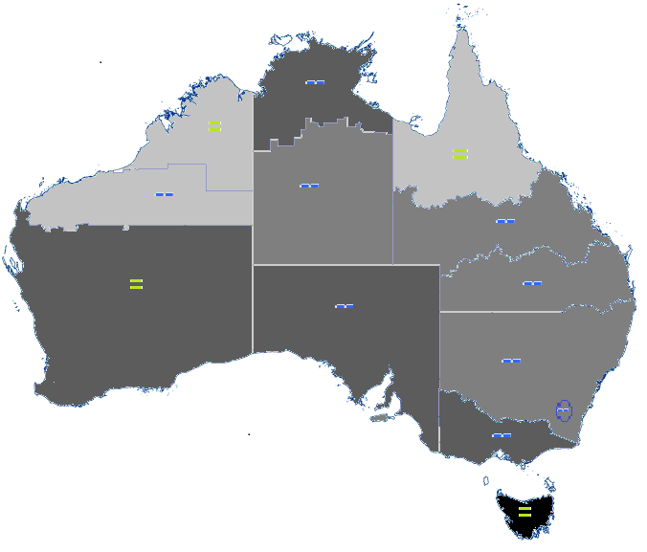

Legend Activity Map

## 2. Influenza-like Illness Activity

### Community Level Surveillance

#### FluTracking

FluTracking, a national online system for collecting data on ILI in the community, indicated that in the week ending 13 October 2013, fever and cough was reported by 1.7% of vaccinated participants and 1.9% of unvaccinated participants (figure 2).[1] Fever, cough and absence from normal duties was reported by 0.9% of vaccinated participants and 1.0% of unvaccinated participants. Rates of ILI among FluTracking participants have continued to decrease to inter-seasonal levels, down from the season’s apparent peak that occurred in late August. Overall rates of ILI this season have been moderate and were within the range of recent seasons (figure 3). In the week ending 13 October 2013, 60% of participants reported having received the seasonal vaccine so far. Of the participants who identified as working face-to-face with patients, 79% have received the vaccine.

****Figure 2. Proportion of cough and fever among FluTracking participants, week ending 28 April to 13 October 2013, by vaccination status and week****

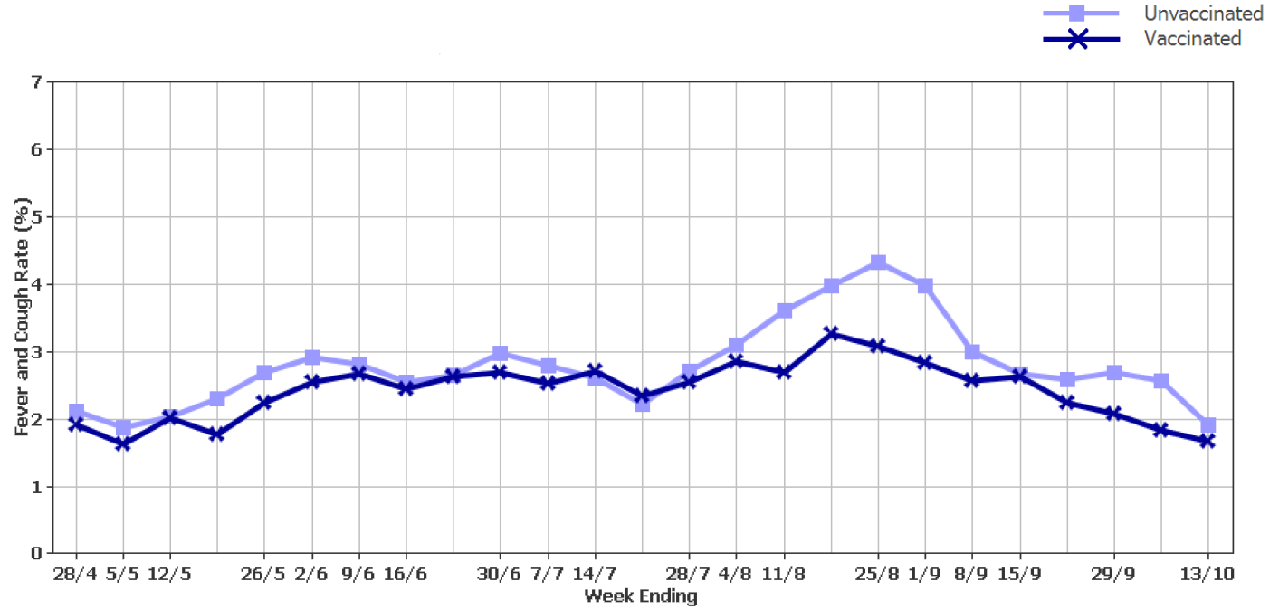

Source: FluTracking1

###### **Figure 3. Proportion of fever and cough among FluTracking participants, between May and October, 2009 to 2013, by week**

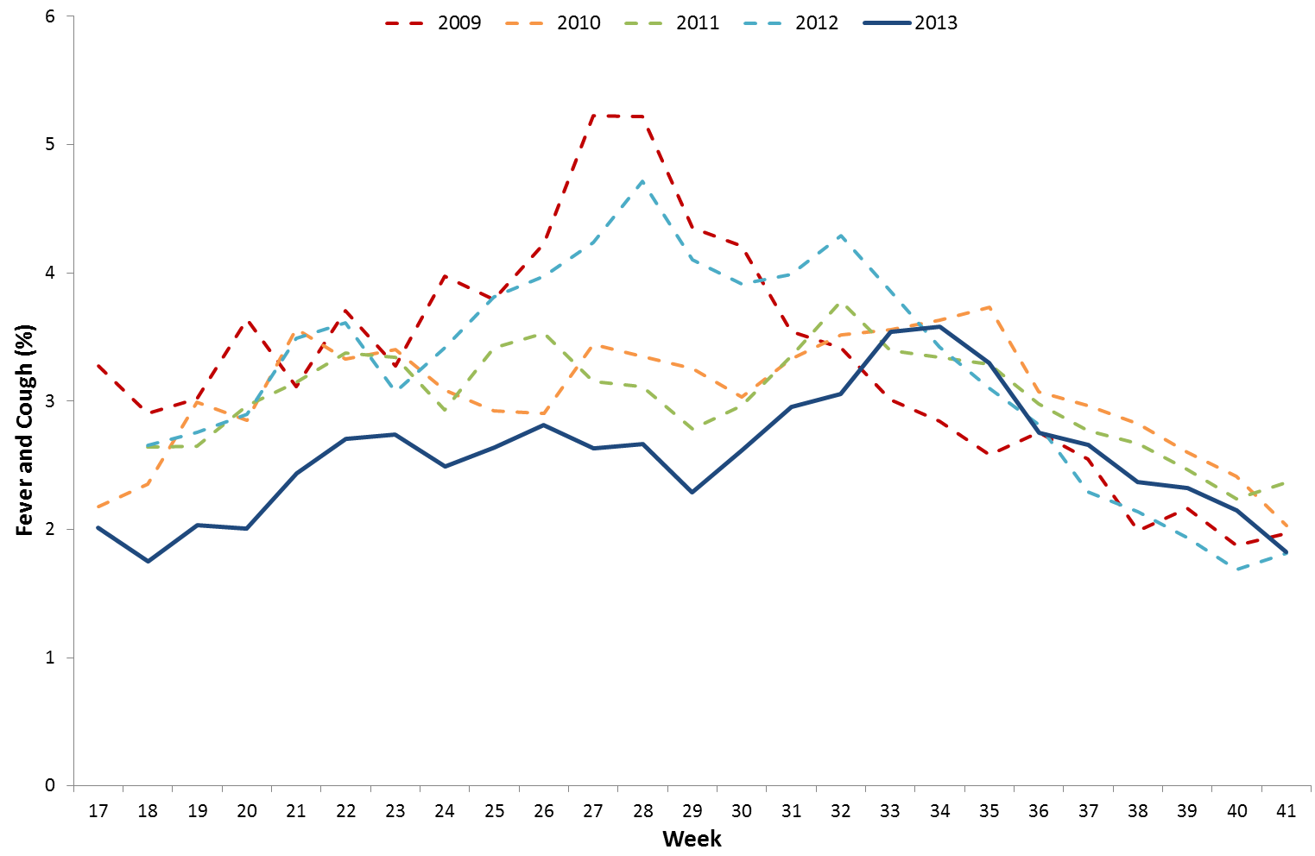

Source: FluTracking1

#### National Health Call Centre Network

ILI related calls to the National Health Call Centre Network (NHCCN) were highest between mid-June and early September at approximately 1,100 calls per week, and represented approximately 7.5% of all calls over this period (figure 4). Since the week ending 8 September, there has been a steady decline in both the number and proportion of influenza-related calls to the NHCCN with around 700 calls (5.2% of all calls) being reported this period. While the number of ILI-related calls to the NHCCN during the peak of activity in 2013 was similar to 2010 and 2011, the peak in the proportion of calls related to ILI has been lower.

###### **Figure 4. Number of calls to the NHCCN related to ILI and percentage of total calls, Australia, 1 January 2009 to 29 September 2013, by week**

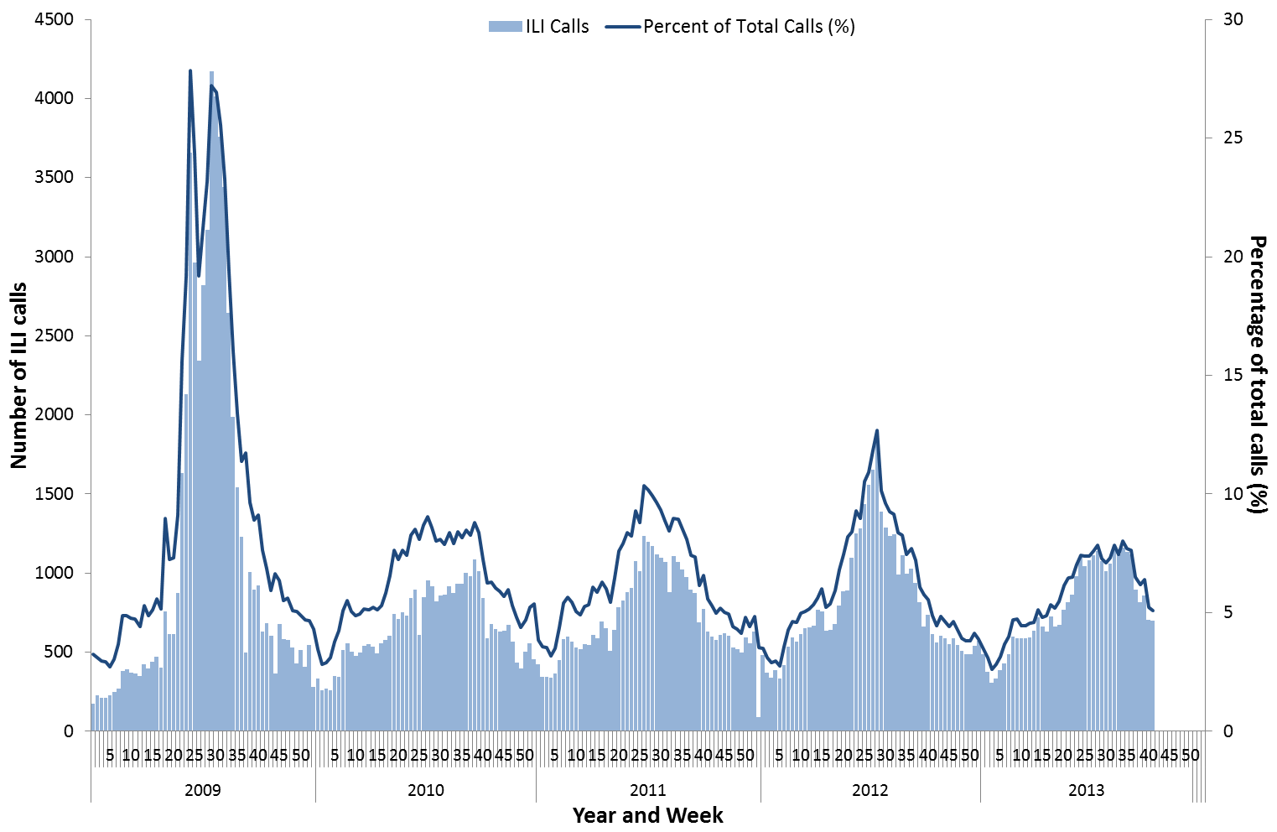

Note: NHCCN data do not include Queensland and Victoria

Source: NHCCN

### Sentinel General Practice Surveillance

In the fortnight ending 13 October 2013, the sentinel general practitioner ILI consultation rate dropped considerably from 10.6 down to 6.3 cases per 1,000 consultations (figure 5). The ILI consultation rate appears to have peaked later in comparison to the 2011 and 2012 seasons, with the peak rate lower than in previous years.

###### **Figure 5. Weekly rate of ILI reported from GP ILI surveillance systems, 1 January 2009 to 13 October 2013, by week\***

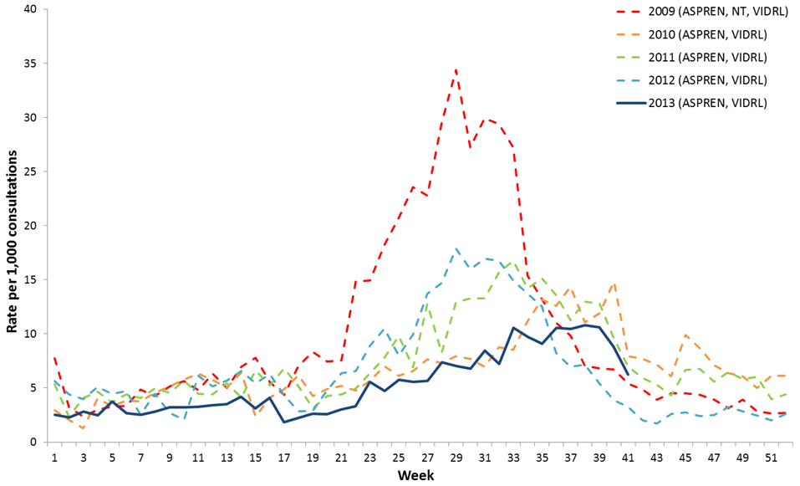

* Delays in the reporting of data may cause data to change retrospectively. As data from the previous Northern Territory surveillance scheme were combined with ASPREN and VIDRL surveillance data in 2009, rates may not be directly comparable with 2010-2013 trends.

SOURCE: ASPREN and VIDRL[2] GP surveillance systems.

In the week ending 13 October 2013, specimens were collected from around 29% of Australian Sentinel Practices Research Network (ASPREN) general practitioner ILI patients. Of these patients, 19.2% were positive for influenza, which is a marked reduction from 29.5% detected in the previous fortnight. The majority of these specimens were positive for influenza type A (figure 6 and table 1). Almost a third of ILI patients tested this period were positive for other respiratory viruses, with human metapneumovirus detected most commonly.

###### **Table 1. ASPREN laboratory respiratory viral test results of ILI consultations, 1 January to 13 October 2013**

|  |  |  |
| --- | --- | --- |
|  | **Fortnight**  (30 September – 13 October 2013) | **YTD**  (1 January – 13 October 2013) |
| **Total specimens tested** | **73** | **2113** |
| **Total Influenza Positive (%)** | **19.2** | **18.5** |
| **Influenza A (%)** | **12.3** | **12.0** |
| *A (H1N1) pdm09 (%)* | *4.1* | *5.4* |
| *A (H3N2) (%)* | *2.7* | *5.6* |
| *A (unsubtyped) (%)* | *5.5* | *0.9* |
| **Influenza B (%)** | **5.5** | **6.4** |
| **Other Resp. Viruses (%)\*** | **31.5** | **30.3** |

* Other respiratory viruses include human metapneumovirus, RSV, parainfluenza, adenovirus and rhinovirus.

###### **Figure 6. Proportion of respiratory viral tests positive for influenza in ASPREN ILI patients and ASPREN ILI consultation rate, 1 January to 13 October 2013, by week**

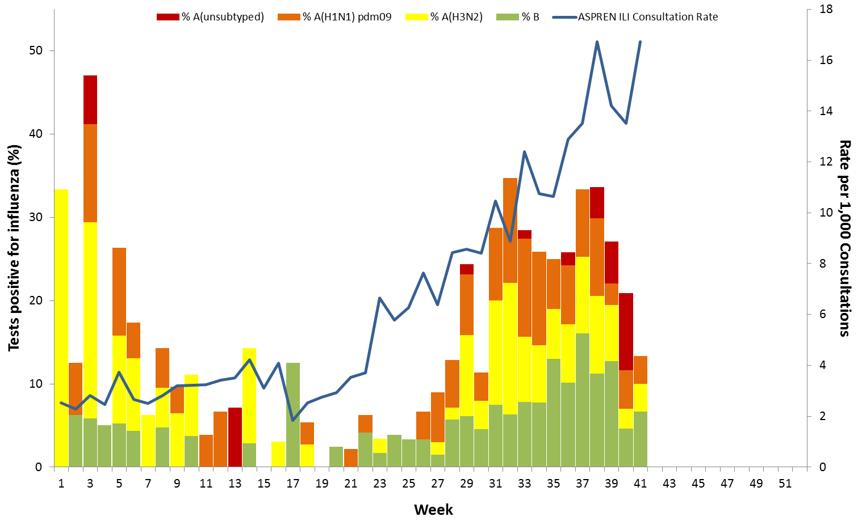

SOURCE: ASPREN and WA SPN

### Sentinel Emergency Department Surveillance

#### Western Australia Emergency Departments

Viral respiratory presentations to WA emergency departments fell markedly this reporting period and currently represent 70% of the season peak observed at the beginning of September. However, the number of admissions was relatively stable (figure 7). Overall the number of respiratory viral presentations to WA Emergency Departments in 2013 was within the range of levels reported in previous years and was well below the peak levels experienced in 2009 and 2012.

###### **Figure 7. Number of respiratory viral presentations to Western Australia emergency departments, 1 January 2009 to 13 October 2013, by week**

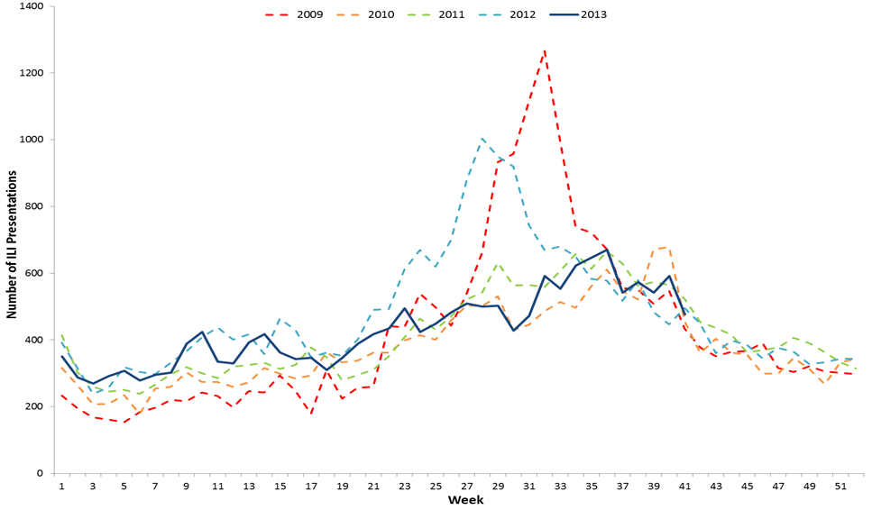

Source: WA ‘Virus Watch’ Report[3]

#### New South Wales Emergency Departments

In the week ending 11 October 2013, the rate of patients presenting to NSW emergency departments with influenza-like illness decreased slightly to 0.8 cases per 1,000 presentations following a recent sharp decline from the season peak of 3.0 cases per 1,000 presentations that occurred in early September. The 2013 season peak presentation rate was greater than the peaks observed in 2010 and 2011 (figure 8). Combined ILI and pneumonia admissions to critical care wards decreased significantly this week and were within the usual range for this time of year. The NSW emergency department surveillance system uses a statistic called the ‘index of increase’, with a value of 15 suggesting that influenza is circulating widely in the NSW community. Currently the ‘index of increase’ for influenza-like illness presentations have decreased to 4.1, which is consistent with the end of the current year’s influenza season which commenced in late June and peaked on 20 August 2013.[4]

****Figure 8. Rate of influenza-like illness presentations to New South Wales emergency departments, between May and October, 2009 to 2013, by week****

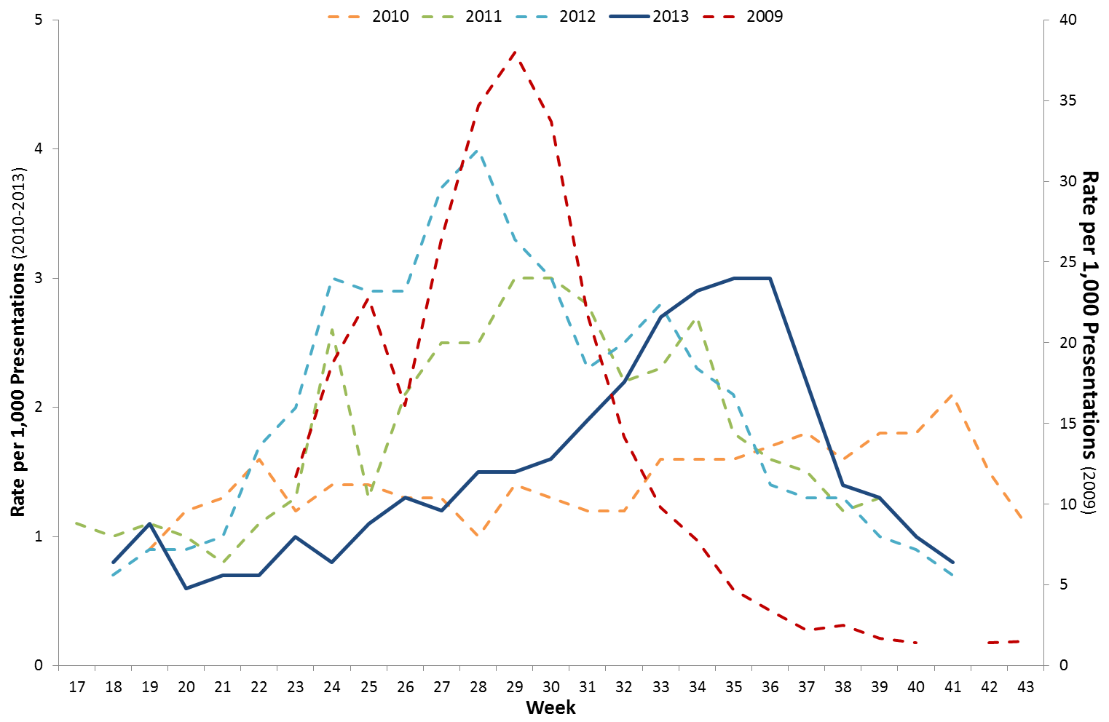

Source: ‘NSW Health Influenza Surveillance Report’4

#### Northern Territory Emergency Departments

During the current reporting period, the number of ILI presentations to NT emergency departments decreased considerably to 170 from the apparent season peak of 241 that occurred in the week ending 14 September. The number of ILI presentations to NT emergency departments this year was relatively stable with a small seasonal increase observed during August and September. Overall presentations were slightly lower than the usual range observed in previous years (figure 9).

###### **Figure 9. Number of ILI presentations to Northern Territory emergency departments, 1 January 2009 to 12 October 2013, by week**

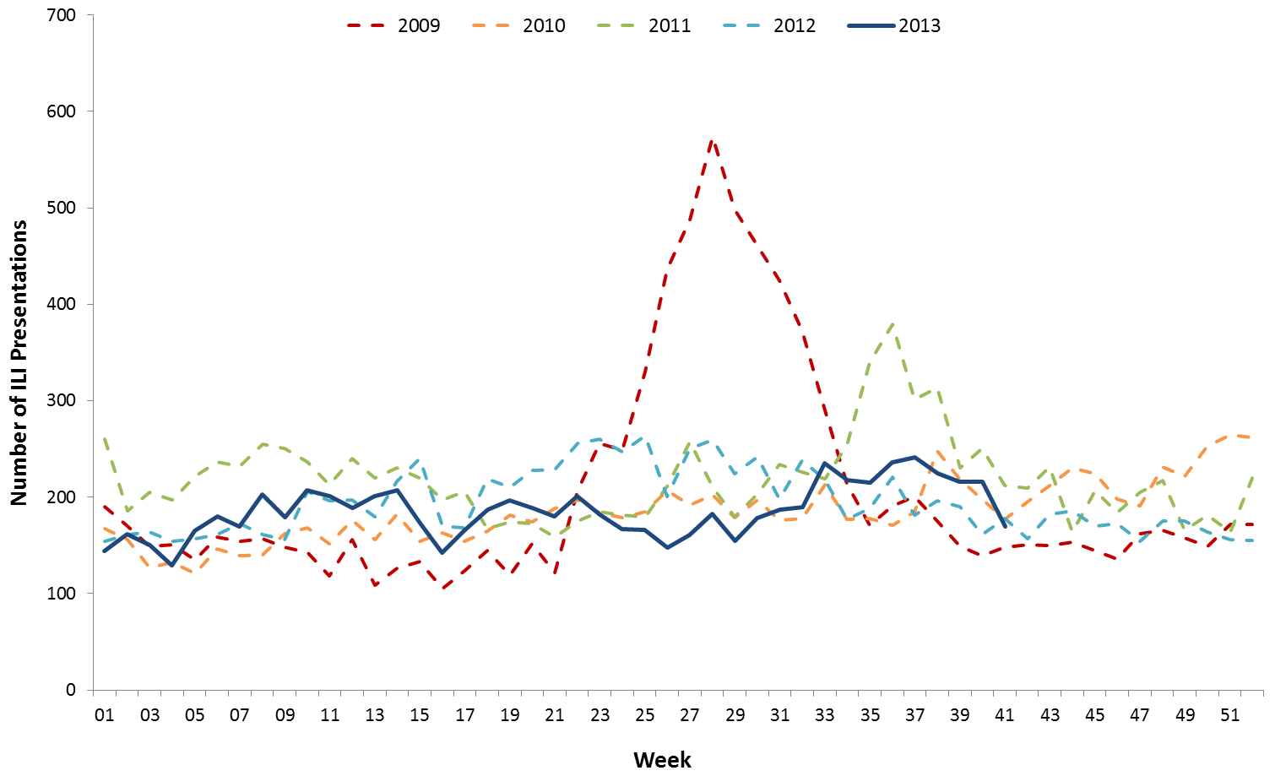

Source: Centre for Disease Control, Department of Health, Northern Territory Government

## 3. Laboratory Confirmed Influenza Activity

### Notifications of Influenza to Health Departments

In the fortnight ending 11 October 2013 there were 1,548 notifications reported to the NNDSS, a 36% decrease on notifications following the previous fortnight (2,415) (figure 10). Nationally, notifications have continued to decline following the peak at the end of August 2013. NSW (352), Qld (335) and SA (321) together contributed over 60% of notifications this fortnight followed by Vic (279), WA (182), Tas (40), NT (22) and ACT (17). A weekly breakdown of notification trends by jurisdiction shows that influenza activity peaked at the end of August in most jurisdictions and was followed by a steady decline (figure 11). Notifications in SA and especially WA declined slowly producing a plateau that lasted for a number of weeks rather than a sharp peak while NT and Tas experienced delayed season peaks compared to the rest of Australia.

###### **Figure 10. Notifications of laboratory confirmed influenza, Australia, 1 January to 11 October 2013, by state or territory and week**

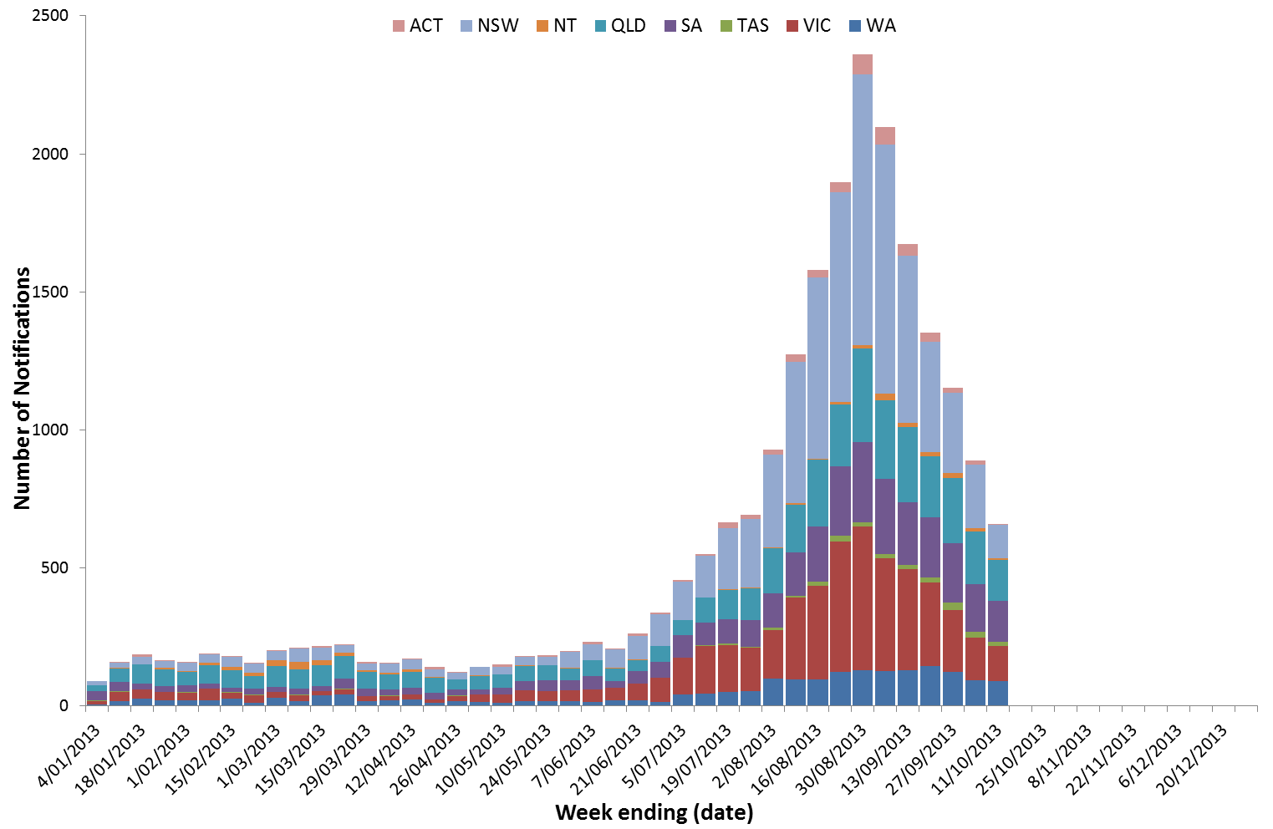Source: NNDSS

###### **Figure 11. Notifications of laboratory confirmed influenza, 1 January to 11 October 2013, by state or territory and week**

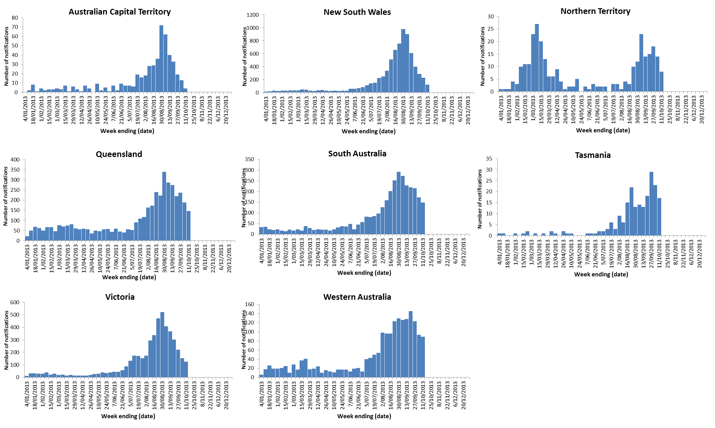

Source: NNDSS

Up to 11 October, there have been 22,983 laboratory confirmed notifications of influenza diagnosed during 2013 representing around half of the number recorded over the same period in 2012 (figure 12). Of the 2013 notifications, there have been 7,568 in NSW, 4,814 in Vic, 4,297 in Qld, 3,360 in SA, 1,928 in WA, 503 in ACT, 300 in NT and 213 in Tas. Over the 2012-13 inter-seasonal period, higher than usual numbers of influenza notifications were reported from most jurisdictions. In comparison to 2011 and 2012, the 2013 influenza season commenced later and occurred over a shorter period.

****Figure 12. Notifications of laboratory confirmed influenza, Australia, 1 January 2009 to 11 October 2013, by week****

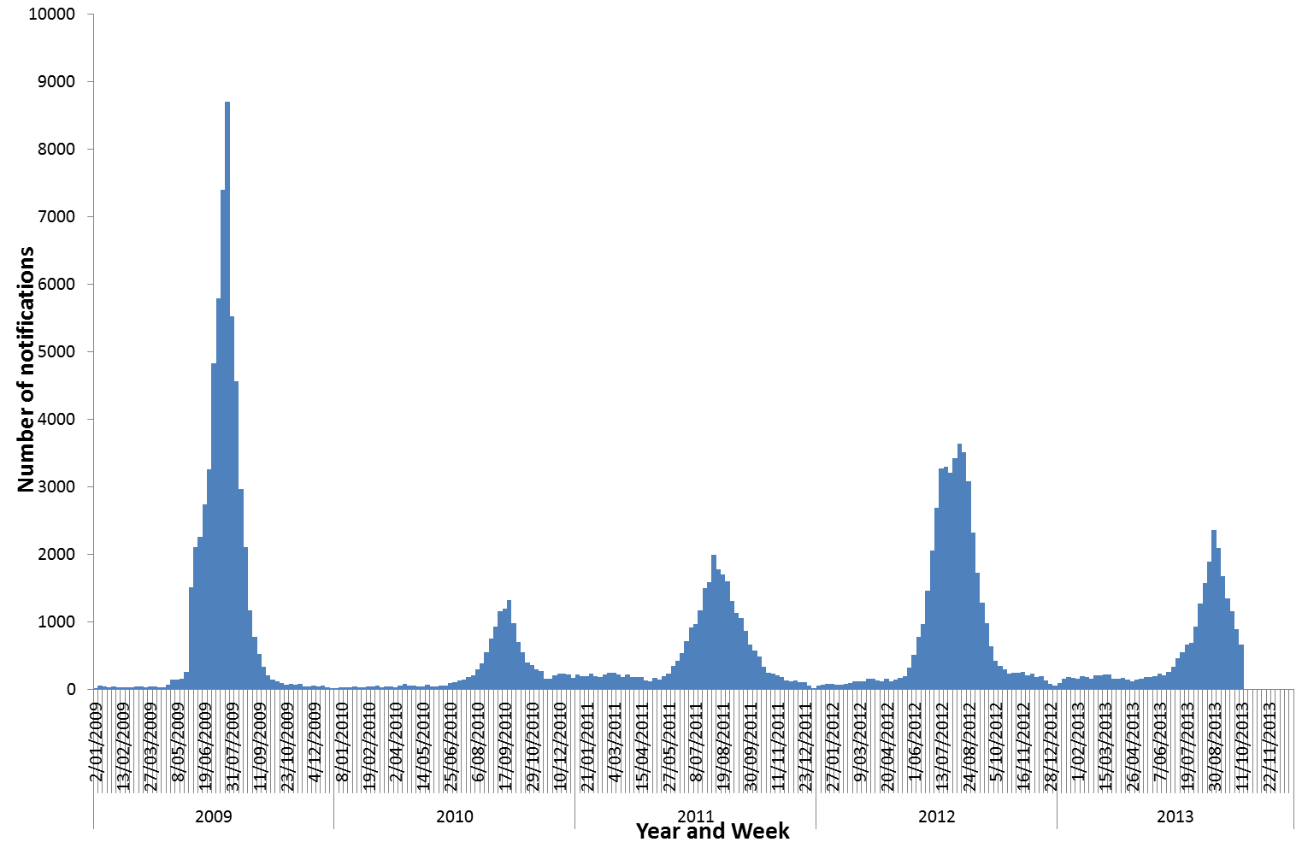Source: NNDSS

In seasons dominated by the influenza A(H1N1)pdm09 virus, such as 2009, 2010 and 2011, the age distribution of influenza notifications showed a downward trend with increasing age. For comparison, in 2012 which was strongly dominated by influenza A(H3N2), the age distribution of influenza notifications was bimodal with peaks in those aged under 10 years and in those aged 70 years and over, and a small peak among those aged 30-44 years. The 2013 influenza season has been characterised by co-circulation of A (H1N1)pdm09, influenza A(H3N2) and influenza B viruses. Figure 13 highlights a predominance of influenza B infections in those aged less than 15 years, with influenza A infections peaking in the 0-4 and 30-34 years age groups. Consistent with influenza A(H1N1)pdm09 dominant years, there are very few notifications of this subtype in those aged 65 years and over.

****Figure 13. Notifications of laboratory confirmed influenza, 1 January to 11 October 2013, by subtype and age group.****

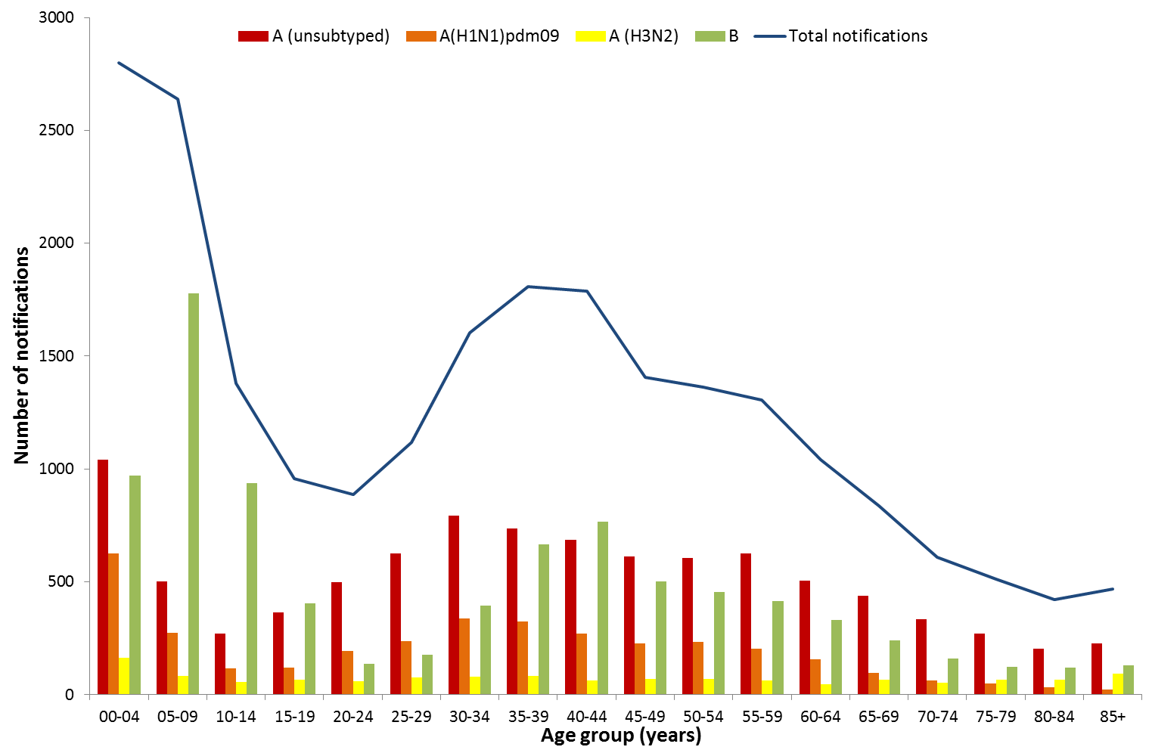Source: NNDSS

Of the 2,415 influenza notifications reported to the NNDSS this reporting period, 953 (62%) were influenza A (630 (41%) A(unsubtyped), 211 (14%) A(H1N1)pdm09 and 112 (7%) A(H3N2)), 586 (38%) were influenza B, four (<1%) were influenza A&B co-infections and five (<1%) were untyped (figure 14).

This reporting period, influenza A continued to remain the predominant influenza virus type nationally, with the distribution of the influenza A(H1N1)pdm09 and A(H3N2) subtypes varying by jurisdiction. In WA and the ACT, A(H3N2) was the predominant subtype representing up to a third of their current notifications. All other jurisdictions report influenza A(H1N1)pdm09 as the most commonly reported influenza A subtype. Over the past fortnight the proportion of influenza B nationally has dropped from 40% to around 20% in NT, WA and Vic and increased to 61% of notifications in SA. The proportion of influenza B notifications in other jurisdictions was stable.

For the calendar year to 11 October 2013, 62% of cases were reported as influenza A (41% A(unsubtyped), 16% A(H1N1)pdm09 and 6% A(H3N2)) and 38% were influenza B. Less than 1% were reported as either influenza A&B co-infection or untyped (figure 14). In 2013, whilst the majority of influenza A reports are unsubtyped, over 15% of overall notifications have been reported as influenza A(H1N1) pdm09, compared with less than 1% in 2012. Further the proportion of influenza B reported in 2013 has been higher than previous years.

###### **Figure 14. Notifications of laboratory confirmed influenza, Australia, 1 January to 11 October 2013, by sub-type and week**

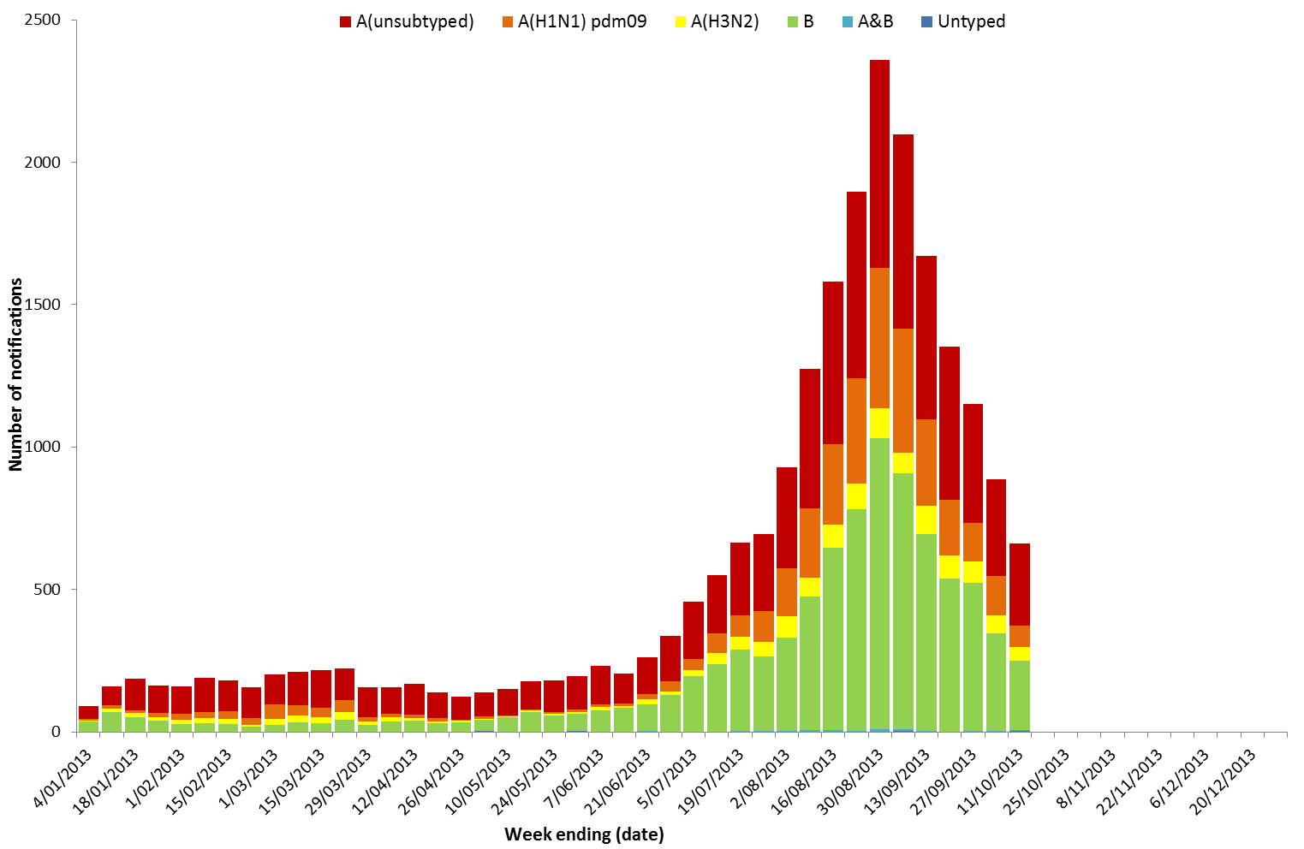Source: NNDSS

### Sentinel Laboratory Surveillance

Results from sentinel laboratory surveillance systems for this reporting period show that approximately 14% of the respiratory viral tests conducted over this period were positive for influenza (table 2), a small decrease from 16% in the previous fortnight. Across these sentinel laboratory sites, there continues to be a mixed distribution of the influenza types and subtypes reported, with WA and NSW currently reporting a higher proportion of influenza A(H3N2) compared to the other laboratory sites where the proportion of A(H1N1)pdm09 is more dominant. Figure 15 shows a breakdown of subtypes within this positive proportion by fortnight. Since 20 July 2013, influenza virus has been the most commonly detected respiratory virus in WA and Tas while other respiratory viruses now dominate in NSW and Vic.

###### **Table 2. Sentinel laboratory respiratory virus testing results, 28 September to 11 October 2013**

|  |  |  |  |  |
| --- | --- | --- | --- | --- |
|  | **NSW NIC** | **WA NIC** | **VIC NIC** | **TAS**  (PCR Testing Data) |
| **Total specimens tested** | **377** | **857** | **177** | **210** |
| **Total influenza positive** | **31** | **139** | **18** | **36** |
| **Positive influenza A** | **22** | **107** | **16** | **23** |
| *A(H1N1) pdm09* | *6* | *46* | *14* | *17* |
| *A(H3N2)* | *5* | *60* | *2* | *0* |
| *A(unsubtyped)* | *11* | *1* | *0* | *6* |
| **Positive influenza B** | **9** | **32** | **2** | **13** |
| **Positive influenza A&B** | **0** | **0** | **0** | **0** |
| ***Proportion Influenza Positive (%)*** | **8.2%** | **16.2%** | **10.2%** | **17.1%** |
| **Most common respiratory virus detected** | **Parainfluenza** | **Influenza** | **Picornavirus** | **Influenza** |

Source: National Influenza Centres (WA, Vic, NSW) and Tasmanian public hospital laboratory PCR testing

###### **Figure 15. Proportion of sentinel laboratory tests positive for influenza, 08 June to 11 October 2013, by subtype and fortnight**

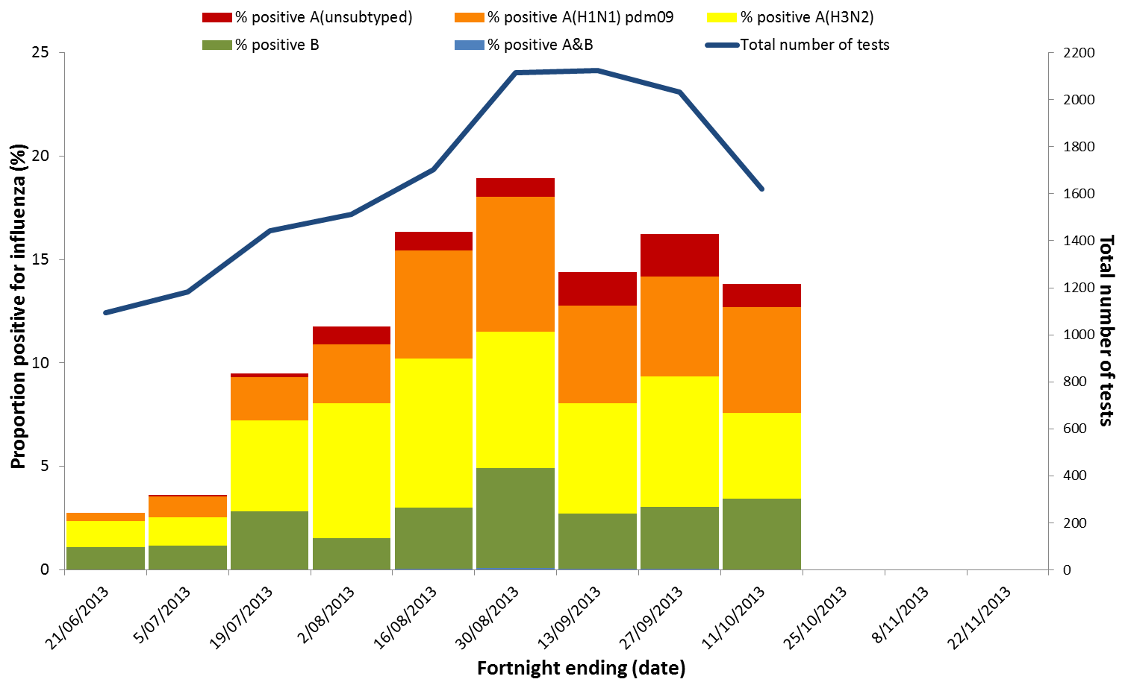

Source: National Influenza Centres (WA, Vic, NSW) and Tasmanian laboratories (PCR testing)

### Hospitalisations

#### Influenza Complications Alert Network (FluCAN)

The Influenza Complications Alert Network (FluCAN) sentinel hospital surveillance system has reported that over the last fortnight there have been 43 admissions with confirmed influenza. Since 30 March 2013, 10% of influenza patients have been admitted directly to ICU and the majority of overall influenza admissions have been with influenza A, with 32% of cases due to influenza B (figure 16). Around 32% of the cases are aged 65 years and over (median age 57 years) and 79% of all cases had known medical co-morbidities reported. Over the past fortnight, there has been a marked decrease in the number of cases following a five week seasonal peak during August and September 2013.

Based on the ratio of beds participating in FluCAN to the total number of hospital beds nationally, it has been estimated that since April there have been over 4,500 admissions associated with influenza infection in Australia.

Each year, the influenza vaccine is evaluated for its ability to prevent infection with influenza viruses. Vaccine effectiveness was recently studied in the northern hemisphere (in the 2012/13 season) and the southern hemisphere (2013 season to date). The interim results suggest that immunization with the seasonal influenza vaccine reduces a person’s risk of requiring medical treatment or hospitalisation with confirmed infection with any influenza virus by 40-64% in these studies. The 2013 trivalent influenza vaccine was estimated to be more effective against infection with influenza B viruses than influenza A viruses.

****Figure 16. Number of influenza hospitalisations at sentinel hospitals, 30 March to 11 October 2013, by week and influenza subtype****

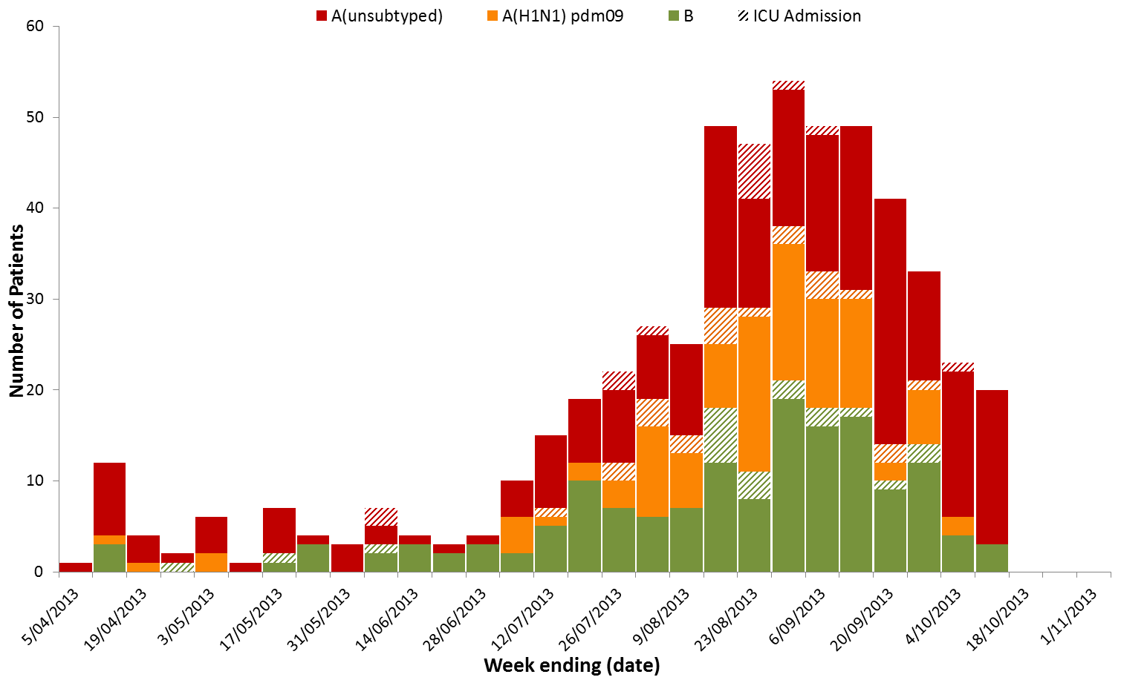

Source: FluCAN Sentinel Hospitals

#### Queensland Public Hospital Admissions (EpiLog)

Admissions to public hospitals in Queensland of confirmed influenza are detected through the EpiLog system. Up to 13 October 2013, there have been 376 admissions of confirmed influenza this year, including 49 to intensive care units (figure 17). The number of patient admissions of confirmed influenza has been elevated since the first week of September. The age distribution of confirmed influenza admissions in 2013 continues to show a peak in the 0-9 year age group, with very few admissions reported in the 10-19 and 20-29 years age groups. The median age of hospitalised cases is 44 years with a range of <1 to 97 years.

###### **Figure 17. Number of influenza admissions to Queensland public hospitals, with onset from 1 January to 13 October 2013, by week and type of admission**

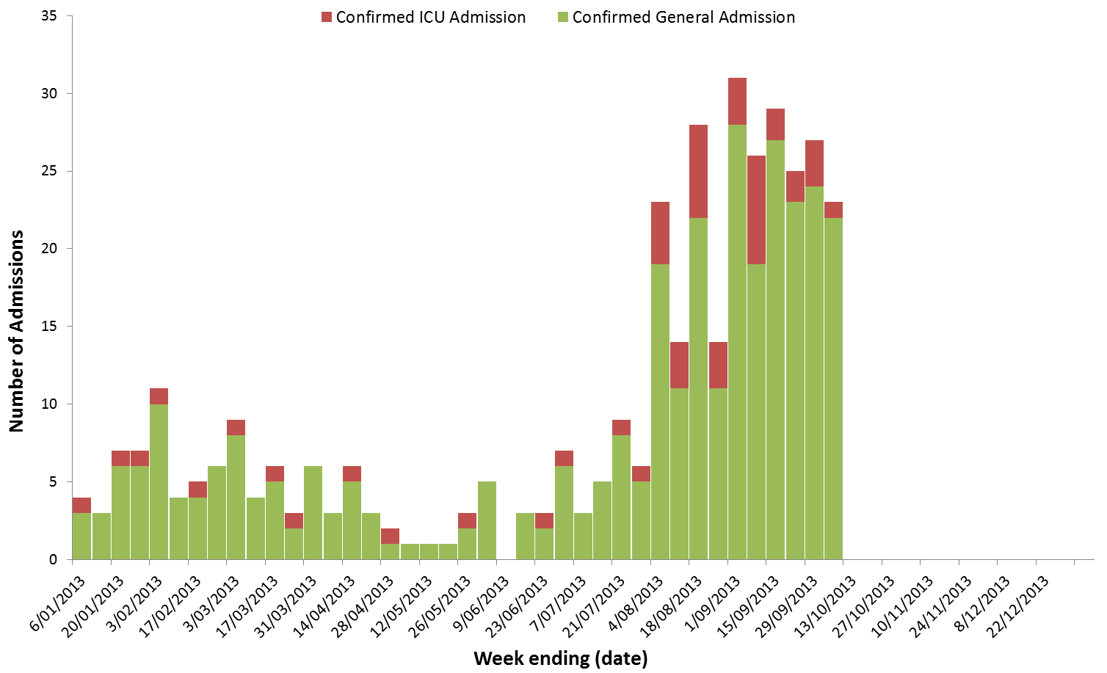

Source: Queensland Health EpiLog data

#### Paediatric Severe Complications of Influenza

The Australian Paediatric Surveillance Unit conducts seasonal surveillance of children aged 15 years and under who are hospitalised with severe complications of influenza. For the calendar year to 30 September 2013, there were 17 hospitalisations associated with severe complications of influenza reported. Of the 11 cases for which there is further information, seven of the cases were associated with influenza B infections and three required admission to ICU. The median age of cases was 4.3 years (range 1.4 to 11.5 years).

### Deaths Associated with Influenza and Pneumonia

#### Nationally Notified Influenza Associated Deaths

So far in 2013, 28 influenza associated deaths have been notified to the NNDSS, with a median age of 63 years (range 27 to 97 years). Influenza type A infection was reported in 86% of the reported influenza associated deaths. The number of influenza associated deaths reported to the NNDSS is reliant on the follow up of cases to determine the outcome of their infection and most likely does not represent the true mortality impact associated with this disease.

## 4. Virological Surveillance

### Typing and Antigenic Characterisation

#### WHO Collaborating Centre for Reference & Research on Influenza (WHO CC), Melbourne

From 1 January to 14 October 2013, there were 959 Australian influenza viruses subtyped by the WHO CC with 46% being A(H1N1)pdm09, 17% influenza A(H3N2) and 37% influenza B. The majority of influenza B viruses were from the B/Yamagata lineage (table 3).

****Table 3.Australian influenza viruses typed by HI or PCR from the WHO Collaborating Centre, 1 January to 14 October 2013****

|  |  |  |  |  |  |  |  |  |  |
| --- | --- | --- | --- | --- | --- | --- | --- | --- | --- |
| **Type/Subtype** | **ACT** | **NSW** | **NT\*** | **QLD** | **SA** | **TAS** | **VIC** | **WA** | **TOTAL** |
| **A(H1N1) pdm09** | 18 | 48 | 32 | 137 | 52 | 26 | 94 | 38 | **445** |
| **A(H3N2)** | 2 | 15 | 10 | 35 | 7 | 1 | 29 | 63 | **162** |
| **B/Victoria lineage** | 2 | 3 | 0 | 12 | 5 | 0 | 3 | 1 | **26** |
| **B/Yamagata lineage** | 16 | 35 | 3 | 42 | 24 | 9 | 174 | 23 | **326** |
| **Total** | **38** | **101** | **45** | **226** | **88** | **36** | **300** | **125** | **959** |

SOURCE: WHO CC

Note: Viruses tested by the WHO CC are not necessarily a random sample of all those in the community.

State indicates the location the sample originated from, not the submitting laboratory

There may be up to a month delay on reporting of samples.

### Antiviral Resistance

The WHO CC has reported that from 1 January to 14 October 2013, four influenza viruses (out of 1047 tested) have shown reduced inhibition to the neuraminidase inhibitor oseltamivir by enzyme inhibition assay. All four viruses were subtyped as A(H1N1)pdm09 and had the H275Y mutation in the neuraminidase gene, which is known to confer resistance to oseltamivir.

### 2014 Southern Hemisphere Vaccine

The Australian Influenza Vaccine Committee (AIVC) met at TGA, Canberra, on 10 October 2013, to recommend influenza viruses to be used in the composition of the influenza vaccines for 2014. During this meeting, the expert committee reviewed and evaluated data related to epidemiology, antigenic and genetic characteristics of recent influenza isolates circulating in Australia and the Southern Hemisphere, serological responses to 2012-2013 vaccines, and the availability of candidate vaccines viruses and reagents.

The committee recommended that the TGA should adopt the September WHO recommendations and therefore the trivalent influenza vaccine components for the Australian 2014 influenza season should contain the following:

* A (H1N1): an A/California/7/2009 (H1N1) - like virus, 15 µg HA per dose
* A (H3N2): an A/Texas/50/2012 (H3N2) - like virus*, 15 µg HA per dose
* B: a B/Massachusetts/02/2012 - like virus, 15 µg HA per dose

* A/Texas/50/2012 is an A(H3N2) virus that following adaptation to growth in eggs has maintained antigenic properties similar to the majority of recently circulating cell-propagated A(H3N2) viruses including A/Victoria/361/2011.

Further, the AVIC supported the WHO recommendation that quadrivalent vaccines include an additional influenza B virus (B/Brisbane/60/2008-like virus at 15 µg HA per dose) intended to provide vaccine coverage for both influenza B lineages.

The TGA has accepted the recommendations of the AIVC. The TGA considers the viruses or reassortants listed on the WHO Influenza vaccine web pages are suitable vaccine strains[5].

## 5. International Influenza Surveillance

The WHO[6] has reported that as at 14 October 2013, in many European countries influenza-like illness activity has started to increase, overall influenza activity in the northern hemisphere temperate zones remained at inter-seasonal levels. In most regions of tropical Asia influenza activity was at a low level, with the exception of Hong Kong Special Administrative Region, China, where influenza transmission increased due to influenza A(H3N2). Influenza transmission in southern and South East Asia was low in most countries. Both influenza A(H1N1)pdm09 and A(H3N2) viruses were reported in this area. In the Caribbean region of Central America and tropical South America countries, cases of influenza decreased. While acute respiratory illness remained stable in the Caribbean and Central America. Respiratory syncytial virus (RSV) predominated but the RSV activity remained within expected seasonal levels. Influenza activity peaked in the temperate countries of South America and in South Africa in late June. Temperate South American countries reported acute respiratory disease activity within expected seasonal levels, and RSV activity largely declined.

In New Zealand[7], through sentinel surveillance the national ILI consultation rate was 20.6 per 100,000 patient population for the week ending 13 October 2013. The current rate of ILI remains below the baseline level of activity (50 ILI consultations per 100,000 patient population). The apparent peak in ILI activity appears to have occurred at the beginning of September and was below the established baseline level of activity. Virological surveillance through both sentinel and non-sentinel laboratories shows that so far this year, 40% have been influenza type B viruses, mostly from the B/Yamagata lineage; 43% influenza A(H3N2); 10% were influenza A(unsubtyped); and 7% were A(H1N1)pdm09 virus detections.

National Influenza Centres (NICs) and other national influenza laboratories from 81 countries, areas or territories reported that for the period 15 September to 28 September 2013, a total of 1,277 specimens were positive for influenza viruses with 78% being influenza A and 22% influenza B. Of the sub-typed influenza A viruses, 248 (31.1%) were influenza A(H1N1)pdm09 and 549 (68.9%) were influenza A(H3N2). Of the characterized B viruses, 23 (69.7%) belong to the B-Yamagata lineage and 10 (30.3%) to the B-Victoria lineage.[8]

#### Human infection caused by the avian influenza A (H7N9) virus - China[9],[10],[11],[12]

On 16 October an additional case of human infection with influenza A(H7N9) has been reported to the WHO. This is the first new confirmed case since 11 August 2013 (Figure 18). Since March 2013, a total of 136 laboratory-confirmed cases of human infection with avian influenza A(H7N9) have been reported to WHO, including 45 deaths. All of the cases were acquired in China with one case exported to Taiwan. This outbreak represents the first time that human infection with the avian influenza A(H7N9) subtype had been detected.

Most cases have occurred in middle-aged or older men and most cases have been considered severe. Human infection appears to be related to exposure to live poultry or contaminated environments, however investigations are ongoing regarding the animal reservoir(s) which the virus is circulating in, the main exposures and routes of transmission, and the scope of the virus spread among people and animals.

Whilst four small human clusters have been reported, evidence does not support sustained human-to-human transmission.

As the A(H7N9) virus appears to transmit from animals to humans more readily than the highly pathogenic avian influenza A(H5N1) viruses, and little or no immunity against the novel A(H7N9) virus exits in the human population, WHO have noted that they are actively working with Member States and partners on effective responses and preparedness. As part of these efforts, candidate vaccine viruses are being developed and made available by the WHO GISRS. Based on genetic and antigenic analysis, it is recommended that an A/Anhui/1/2013-like virus be used for the development of influenza A(H7N9) vaccines for pandemic preparedness purposes.

###### **Figure 18. Epidemiological curve of confirmed cases of avian influenza A(H7N9) reported to WHO to 11 August, 2013, by date of onset**

Please refer above for detailed description. SOURCE: WHO[13]

#### Novel Influenza A Viruses – United States of America[14],[15],[16]

A total of 20 variant influenza A virus infections, 19 H3N2v and 2 H1N1v, have been reported over the United States 2013 summer period. Of these cases, one person has been hospitalised as a result of variant influenza illness and no deaths have occurred. At this stage, no ongoing human-to-human transmission has been identified and all cases have reported close contact with swine in the week prior to illness onset.

With regard to the A(H3N2) variant virus, this is a mixture of an influenza A(H3N2) virus, already present in pigs in North America, with the matrix (M) gene from the A(H1N1)pdm09 virus; and was first detected in humans in 2011. In 2011, 12 cases of A(H3N2)v infection were detected in the United States, and the virus was associated with a multi-state outbreak in 2012 with a further 309 cases, including 16 hospitalisations and one death. Limited human-to-human spread of the virus had been detected in 2012, however no sustained community transmission was identified. Illness associated with influenza A(H3N2)v infection has been mostly mild with symptoms similar to seasonal influenza. Of the 16 A(H3N2)v hospitalised patients in 2012, most were at increased risk for complications of influenza due to age or the presence of an underlying medical condition.

In addition, influenza A(H3N2)v has now been detected in commercially slaughtered pigs in South Korea. This is the first report of influenza A(H3N2)v infection outside of North America.

## 6. Data Considerations

The information in this report is reliant on the surveillance sources available to the Department of Health. As access to sources increase as the season progresses, this report will be updated with the additional information.

This report aims to increase awareness of influenza activity in Australia by providing an analysis of the various surveillance data sources throughout Australia. While every care has been taken in preparing this report, the Commonwealth does not accept liability for any injury or loss or damage arising from the use of, or reliance upon, the content of the report. Delays in the reporting of data may cause data to change retrospectively. For further details about information contained in this report please contact the [Influenza Surveillance Team](mailto:flu@health.gov.au) (flu@health.gov.au).

###### **Geographic Spread of Influenza Activity**

1. **Influenza Activity Levels**

|  |  |  |  |
| --- | --- | --- | --- |
| **Activity level** | **Laboratory notifications** |  | **Influenza outbreaks** |
| Sporadic | Small number of lab confirmed influenza detections (not above expected background level)+ | AND | No outbreaks |
| Localised | Recent increase in lab confirmed influenza detections above background level  ++ in less than 50% of the influenza surveillance regions** within the state or area | OR | Single outbreak only |
| Regional | Significant*** recent increase in lab confirmed influenza detections above baseline in less than 50% of the influenza surveillance regions within the state or area | OR | > 1 outbreaks occurring in less than 50% of the influenza surveillance regions within  the state or area+++ |
| Widespread | Significant recent increase in lab confirmed influenza detections above baseline in equal to or greater than 50% of the influenza surveillance regions within the state or area | OR | > 1 outbreaks occurring in equal to or greater than 50% of the influenza surveillance regions within the state or area |

+ Small no of lab detections = not above expected background level as defined by state epidemiologists.

++ Increase in lab confirmed influenza detections = above expected threshold as defined by state epidemiologists.

** Influenza surveillance region within the state/area as defined by state epidemiologists.

*** Significant increase is a second threshold to be determined by the state epidemiologists to indicate level is significantly above the expected baseline.

+++ Areas to be subdivision of NT (2 regions), WA (3 regions) and QLD (3 regions) that reflect significant climatic differences within those states resulting in differences in the timing of seasonal influenza activity on a regular basis.

Recent = within the current reporting period.

1. **Syndromic Surveillance Activity**

|  |
| --- |
| **Syndromic surveillance systems\*** |
| No evidence of increase in ILI via syndromic surveillance systems |
| Evidence of increase in ILI via syndromic surveillance systems |

* Syndromic surveillance systems = GP sentinel surveillance, ED ILI surveillance, Flu tracking (this may be due to a variety of respiratory viruses so the report could add a note to indicate if other evidence suggests that the increase is suspected to be influenza activity or due to another respiratory pathogen). Syndromic surveillance is reported on a state wide basis only

###### **FluTracking**

FluTracking is a project of the University of Newcastle, the Hunter New England Area Health Service and the Hunter Medical Research Institute. FluTracking is an online health surveillance system to detect epidemics of influenza. It involves participants from around Australia completing a simple online weekly survey, which collects data on the rate of ILI symptoms in communities. Further information on FluTracking is available from the [FluTracking website](http://www.flutracking.net/index.html) (www.flutracking.net/index.html).

###### **National Health Call Centre Network**

The National Health Call Centre Network (NHCCN) provides a nationally consistent approach for telephone based health advice to the community through registered nurses and is supported by electronic decision support algorithms. Data collected through the NHCCN is provided to the Department to enable monitoring of the number and proportion of calls relating to predefined patient guidelines. These guidelines have been grouped to create an influenza-like illness syndrome to enable monitoring of community disease activity. These data currently do not include Queensland or Victoria. Further information about the NHCCN, please refer to the [Health Direct website](http://www.healthdirect.org.au/) (http://www.healthdirect.org.au).

###### **Sentinel General Practice Surveillance**

The sentinel general practice ILI surveillance data between 2009 and 2013 consists of two main general practitioner schemes, the Australian Sentinel Practices Research Network (ASPREN) and a Victorian Infectious Disease Reference Laboratory (VIDRL) coordinated sentinel GP ILI surveillance program. Additionally, between 2008 and 2009 a Northern Territory surveillance scheme also operated, however this scheme has since been incorporated in to the ASPREN scheme. The national case definition for ILI is presentation with fever, cough and fatigue.

The ASPREN currently has sentinel GPs who report ILI presentation rates in NSW, NT, SA, ACT, VIC, QLD, TAS and WA. The VIDRL scheme operates in metropolitan and rural general practice sentinel sites throughout Victoria and also incorporates ILI presentation data from the Melbourne Medical Deputising Service. As jurisdictions joined ASPREN at different times and the number of GPs reporting has changed over time, the representativeness of sentinel general practice ILI surveillance data in 2013 may be different from that of previous years.

ASPREN ILI surveillance data are provided to the Department on a weekly basis throughout the year, whereas data from the VIDRL coordinated sentinel GP ILI surveillance program is provided between May and October each year.

Approximately 30% of all ILI patients presenting to ASPREN sentinel GPs are swabbed for laboratory testing. Please note the results of ASPREN ILI laboratory respiratory viral tests now include Western Australia.

Further information on ASPREN is available at the [ASPREN website](http://www.dmac.adelaide.edu.au/aspren) (www.dmac.adelaide.edu.au/aspren) and information regarding the VIDRL coordinated sentinel GP ILI surveillance program is available at from the [VIDRL website](https://www.victorianflusurveillance.com.au/) (www.victorianflusurveillance.com.au).

###### **Sentinel Emergency Department Data**

1. *Western Australia* – Emergency Department ILI surveillance data are extracted from the Western Australian ‘Virus Watch’ Report. This report is produced weekly. Emergency Department data are provided by the Emergency Department Information System (EDIS), which incorporates data from the following hospitals: Royal Perth Hospital, Sir Charles Gairdner Hospital, Fremantle Hospital, Princess Margaret Hospital, King Edward Memorial Hospital, Bunbury Hospital, Armadale Hospital, Joondalup Health Campus, Swan District Hospital and Rockingham General Hospital. For further information, please refer to the [Western Australian Department of Health Virus WAtch website](http://www.public.health.wa.gov.au/3/487/3/virus_watch.pm) (www.public.health.wa.gov.au/3/487/3/virus_watch.pm).
2. *New South Wales* – Emergency Department ILI surveillance data are extracted from the ‘NSW Health Influenza Surveillance Report’. NSW Health Public Health Real-time Emergency Department Surveillance System (PHREDSS) managed by the Centre for Epidemiology and Evidence, NSW Ministry of Health. Data from 59 NSW emergency departments (ED) are included. Comparisons are made with data for the preceding five years. Recent counts are subject to change. For further information, please refer to the NSW Health Influenza Surveillance website (www.health.nsw.gov.au/Infectious/Influenza/Pages/reports.aspx).
3. *Northern Territory* – this sentinel program collects data from the following hospitals: Royal Darwin, Gove District, Katherine District, Tennant Creek and Alice Springs. The definition of ILI is presentation to ED in the NT with one of the following presentations: febrile illness, cough, respiratory infection, or viral illness.

###### **National Notifiable Diseases Surveillance System (NNDSS)**

Laboratory confirmed influenza (all types) is notifiable under public health legislation in all jurisdictions in Australia. Confirmed cases of influenza are notified through the NNDSS by all jurisdictions. The national case definition is available from the Department of Healths website (www.health.gov.au/internet/main/publishing.nsf/Content/cda-surveil-nndss-casedefs-cd_flu.htm). Analyses of Australian notifications are based on the diagnosis date, which is the earliest of the onset date, specimen date or notification date.

###### **Sentinel Laboratory Surveillance data**

Laboratory testing data are provided weekly directly from PathWest (WA), VIDRL (VIC), ICPMR (NSW), and Tasmanian public hospital laboratory PCR testing results. For Tasmania, the PCR results represent testing at a major Tasmanian public hospital laboratory, which also accepts referred specimens from all departments of emergency medicine and hospital inpatients from across the state.

###### **Influenza Complications Alert Network (FluCAN)**

The Influenza Complications Alert Network (FluCAN) sentinel hospital system monitors influenza hospitalisations at the following sites:

* Australian Capital Territory – the Canberra Hospital and Calvary Hospital;
* New South Wales – John Hunter Hospital and Westmead Hospital;
* Northern Territory – Alice Springs Hospital;
* Queensland – the Mater Hospital, Princess Alexandria Hospital and Cairns Base Hospital;
* South Australia – Royal Adelaide Hospital;
* Tasmania – Royal Hobart Hospital;
* Victoria – Geelong Hospital, Royal Melbourne Hospital, Monash Medical Centre and Alfred Hospital;
* Western Australia – Royal Perth Hospital.

Influenza counts are based on active surveillance at each site for admissions with PCR-confirmed influenza in adults. Some adjustments may be made in previous periods as test results become available. ICU status is as determined at the time of admission and does not include patients subsequently transferred to ICU.

###### **Queensland Public Hospital Admissions (EpiLog)**

EpiLog is a web based application developed by Queensland Health. This surveillance system generates admission records for confirmed influenza cases through interfaces with the inpatient information and public laboratory databases. Records are also able to be generated manually. Admissions data reported are based on date of reported onset. For further information refer to [Qld Health’s Influenza Surveillance website](http://www.health.qld.gov.au/ph/cdb/sru_influenza.asp) (www.health.qld.gov.au/ph/cdb/sru_influenza.asp).

###### **Deaths associated with influenza and pneumonia**

Nationally reported influenza associated deaths are notified by jurisdictions to the NNDSS, which is maintained by the Department of Health. Notifications of influenza associated deaths are likely to underestimate the true number of influenza associated deaths occurring in the community.

NSW influenza and pneumonia deaths data are collected from the NSW Registry of Births, Deaths and Marriages. Figure 16 is extracted from the ‘NSW Health Influenza Surveillance Report’. NSW Registered Death Certificates are routinely reviewed for deaths attributed to pneumonia or influenza. While pneumonia has many causes, a well-known indicator of seasonal and pandemic influenza activity is an increase in the number of death certificates that mention pneumonia or influenza as a cause of death. The predicted seasonal baseline estimates the predicted rate of influenza or pneumonia deaths in the absence of influenza epidemics. If deaths exceed the epidemic threshold, then it may be an indication that influenza is beginning to circulate widely.

###### **WHO Collaborating Centre for Reference & Research on Influenza**

Data on Australian influenza viruses are provided weekly to the Department from the WHO Collaborating Centre for Reference & Research on Influenza based in Melbourne, Australia.

1. FluTracking, FluTracking Weekly Interim Report, Week #42 – ending 13 October 2013. Available from the [FluTracking website](http://www.flutracking.net/survey/Reports.cfm) (www.flutracking.net/survey/Reports.cfm) [Accessed 18 October 2013].
2. Victorian Infectious Disease Reference Laboratory, The 2013 Victorian Influenza Vaccine Effectiveness Audit Report, Report 24, Week Ending 13 October 2013. Available from the Victorian Infectious Disease Reference Laboratory website (www.victorianflusurveillance.com.au) [Accessed 18 October 2013].
3. Western Australia Department of Health, Virus WAtch, Week Ending 13 October 2013. Available from the [Western Australia Department of Health website](http://www.public.health.wa.gov.au/3/487/3/virus_watch.pm) (www.public.health.wa.gov.au/3/487/3/virus_watch.pm) [Accessed 18 October 2013].
4. NSW Health Influenza Surveillance Report, Week 39 – Ending 11 October 2013. Available from the [NSW Health website](http://www.health.nsw.gov.au/Infectious/Influenza/Pages/reports.aspx) (www.health.nsw.gov.au/Infectious/Influenza/Pages/reports.aspx) [Accessed 18 October 2013].
5. WHO Influenza vaccine viruses and reagents. Available from the [WHO website](http://www.who.int/influenza/vaccines/virus/en/) (http:// www.who.int /influenza/vaccines/virus/en/) [Accessed 18 October 2013]
6. WHO, Influenza Update No. 196, 14 October 2013. Available from the [WHO website](http://www.who.int/influenza/surveillance_monitoring/updates/en/) (www.who.int/influenza/surveillance_monitoring/updates/en/) [Accessed 18 October 2013].
7. New Zealand Institute of Environmental Science and Research Ltd, Influenza Weekly Update, 2013/41: 7-13 October 2013. Available from the [New Zealand Institute of Environmental Science and Research website](http://www.surv.esr.cri.nz/virology/influenza_weekly_update.php) (www.surv.esr.cri.nz/virology/influenza_weekly_update.php) [Accessed 18 October 2013].
8. WHO, Influenza virus activity in the world, 14 October 2013. Available from the [WHO website](http://www.who.int/influenza/gisrs_laboratory/updates/summaryreport/en/index.html) (www.who.int/influenza/gisrs_laboratory/updates/summaryreport/en/index.html) [Accessed 18 October 2013].
9. WHO, Global Alert and Response, Human infection with avian influenza A(H7N9) virus – update 16 October 2013. Available from the [WHO website](http://www.who.int/csr/don/2013_08_11/en/index.html) (www.who.int/csr/don/2013_08_11/en/index.html) [Accessed 18 October 2013]
10. WHO, WHO Risk Assessment, Human infections with avian influenza A(H7N9) virus, 7 June 2013. Available from the [WHO website](http://www.who.int/influenza/human_animal_interface/influenza_h7n9/RiskAssessment_H7N9_07Jun13.pdf) (www.who.int/influenza/human_animal_interface/influenza_h7n9/RiskAssessment_H7N9_07Jun13.pdf) [Accessed 1 July 2013].
11. WHO, Overview of the emergence and characteristics of the avian influenza A(H7N9) virus. Available from the [WHO website](http://www.who.int/influenza/human_animal_interface/influenza_h7n9/WHO_H7N9_review_31May13.pdf) (www.who.int/influenza/human_animal_interface/influenza_h7n9/WHO_H7N9_review_31May13.pdf) [Accessed 1 July 2013].
12. WHO, WHO recommendation on influenza A(H7N9) vaccine virus, 26 September 2013. Available from the [WHO website](http://www.who.int/influenza/human_animal_interface/influenza_h7n9/201309_h7n9_recommendation.pdf) (www.who.int/influenza/human_animal_interface/influenza_h7n9/201309_h7n9_recommendation.pdf) [Accessed 9 October 2013).
13. WHO, Number of confirmed human cases of avian influenza A(H7N9) reported to WHO, Report 9 – data in WHO/HQ as of 12 August 2013, 14:45 GMT+1. Available from the [WHO website](http://www.who.int/influenza/human_animal_interface/influenza_h7n9/09_ReportWebH7N9Number.pdf) (www.who.int/influenza/human_animal_interface/influenza_h7n9/09_ReportWebH7N9Number.pdf) [Accessed 23 August 2013].
14. United States Centers for Disease Control and Prevention, FluView, 2013-2014 Influenza Season Week 41 ending October 12, 2013. Available from the [United States Centers for Disease Control and Prevention website](http://www.cdc.gov/flu/weekly/) (www.cdc.gov/flu/weekly/) [Accessed 18 October 2013].
15. United States Centers for Disease Control and Prevention, Situation Summary on Influenza A (H3N2) Variant Viruses (“H3N2v”). Available from the [United States Centers for Disease Control and Prevention website](http://www.cdc.gov/flu/swineflu/h3n2v-situation.htm) (www.cdc.gov/flu/swineflu/h3n2v-situation.htm). [Accessed 18 October 2013].
16. United States Centers for Disease Control and Prevention, Health Alert Network - Variant Influenza Virus (H3N2v) Infections – 5 July 2013. Available from the [United States Centers for Disease Control and Prevention website](http://emergency.cdc.gov/HAN/han00351.asp) (emergency.cdc.gov/HAN/han00351.asp). [Accessed 23 September 2013].